STEM S1 learning sequence – Outside game

Resource considerations
This lesson sequence allows for continuity of student learning and could be adapted to fit in with your existing teaching and learning program. Students will be supported to meet outcomes across integrated key learning areas. Each task has a duration of 30 minutes and could be used in conjunction with your framework, designed using the K-6 template. This lesson sequence uses a balance of synchronous and asynchronous learning strategies. The tasks provide options for students with and without technology and can be used with any online platform. Suggestions about how your school will plan students’ learning from home and ways to communicate with students can be found through the Learning from home page. Assessment strategies linked to the success criteria are included to ensure evidence of learning is monitored and collected.

Syllabus outcomes

Science and technology
ST1-1WS-S – observes, questions and collects data to communicate and compare ideas
ST1-10ES-S – recognises observable changes occurring in the sky and on the land and identifies Earth’s resources
ST1-7MW-T – describes how the properties of materials determine their use.
ST1-3DP-T – describes, follows and represents algorithms to solve problems.

Mathematics
MA1-13MG – Describes, compares and orders duration of events.

English
EN1-11D – responds to and composes a range of texts about familiar aspects of the world and their own experiences

PD/H/PE
PD1-10 - Describes and practises interpersonal skills to promote inclusion to make themselves and others feel they belong.
PD1-11 - Incorporates elements of space, time, objects, effort and people in creating and performing simple movement sequences.

Learning sequence overview
Science and technology: Students are introduced to regular atmospheric and astronomical events and their effect on the Earth. Students identify how properties of materials determine their use.
Mathematics: Students describe the environmental characteristics of each season and recognise that in some cultures seasonal changes mark the passing of time as well as use informal units of time.
English: Students understand that different types of texts have identifiable text structures and language that help the text serve its purpose. Students draw on personal experience and feelings as subject matter to compose imaginative texts for different purposes.
PD/H/PE: Students describe and practise ways to develop caring and respectful relationships and include others to make them feel they belong, for example by demonstrating an understanding of what it means to be inclusive and respectful to others. Students also create and participate in games with and without equipment and invent games with rules using one or two pieces of equipment.
Key language – summer, autumn, winter, spring, rain, snow, hot, cold, heat, sun, wind, hibernate, migrate, Noongar, positive, negative, clothing, deciduous, evergreen, empathy, equipment, materials, invention, unique, properties

Driving question
How can we invent an outside game that can be played in both the winter and summer seasons?

Aim of lesson sequence
This STEM learning sequence enables students to inquire, plan, investigate and develop solutions to an authentic problem posed: How can we invent an outside game that can be played in both the winter and summer seasons?

Teacher notes
This learning sequence aligns with four Stage One learning sequences published on the NSW Department of Education Learning from Home website: science and technology (earth and space), mathematics (patterns), English (narrative/poetry), PD/H/PE (movement, skill and performance).
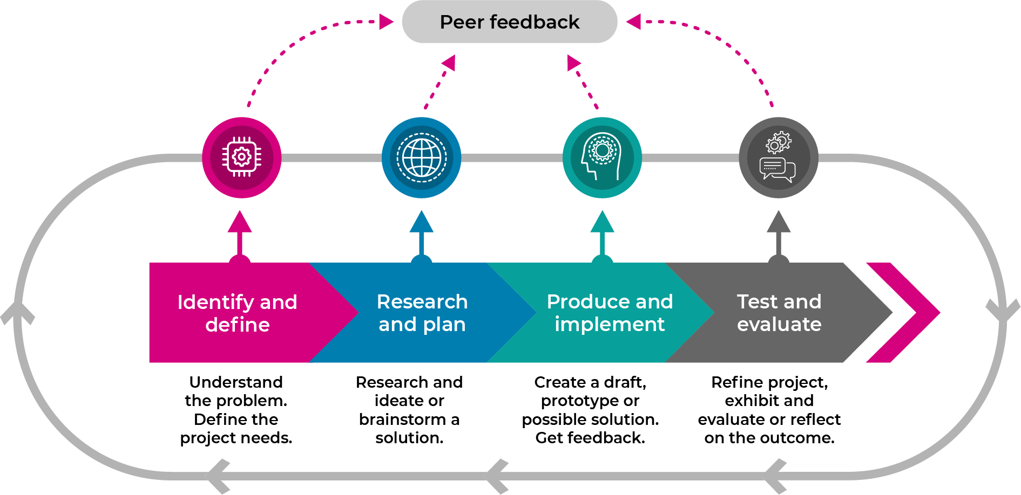
This learning sequence models an integrated approach to learning where the student solves an authentic problem by employing design thinking skills.
  - build the empathy of the student to the focus of the problem: different people like to do different activities outside. How do we cater for everyone for every season?
  - Identify and define the task: the seasons and how we can play outside all year round
  - develop the skills of ideating: imagine, create and express new and innovative ideas (often in a rapid format)
  - allow the student to prototype their idea: experimenting with solutions
  - test and evaluate the validity of the solution: allow for refinement
  - share: interrogate the solution with lots of praise and support

Activity 1

Science and mathematics: Let’s talk about the seasons
The student will:
- question and investigate how the different seasons could change:
  - Clothing - what do we need to protect ourselves from the weather?
  - Animals - hibernate or migrate
  - Plants - deciduous or evergreen
- complete the cut and paste, drawing and writing activities in the student Stage 1 STEM workbook that explore how seasons can change living things
- investigate the Aboriginal Noongar season chart and think about how the different seasons affect Aboriginal life.

Activity 2

English- poetry: Let’s rhyme your favourite season
The student will:
- complete the poem in the workbook to make it their own
- draw a picture of themselves in their poem (digitally or non-digitally)
- discuss how their choice of clothing in the poem demonstrates that season and how it protects them.

Activity 3

Science and technology: What’s great about playing outside in the summer and winter? What’s not?
The student will:
- complete task in Stage 1 workbook: + - (plus-minus) chart to show the positives and negatives of playing outside in winter and summer
- develop a solution for each problem.

Activity 4

STEM – empathise: Let’s talk about how different people use playgrounds in different ways
The student will:
- interview children younger than themselves to recall reactions to playgrounds, including siblings, cousins or neighbours
- recall their own experiences and reactions
- select words from the adjectives tree in the student workbook to describe how they felt
- think about children with different abilities and interests and their needs to safely enjoy a playground
  - my name is Georgia and I like to climb
  - my name is Jacob and I love to swing high
  - my name is Luca and I love to sort puzzles in the quiet
  - my name is Priya and I love to play pretend
- complete task in Stage 1 workbook.

Activity 5

Science and technology: Let’s see what materials playgrounds are made from?
The student will:
- list and examine the ‘non-living’ or human made objects around them
- investigate what materials they are made from and why that material would have been chosen to make that object. Students compete the ‘cross-tick’ table to display the data collected
- record a list of objects or materials that are suitable to be used in a children’s play area based on their properties.

Activity 6

Mathematics: making winter and summer play timetables.
The student will:
- complete the two outdoor play timetables for summer and winter
- colour the sessions:
  - green that children could play outdoors comfortably
  - red that children may not be comfortable outside (due to cold, sun, heat).

Activity 7

Science and technology, PDHPE: Activities for spring and autumn without fixed playground equipment
The student will:
- think of two activities that could be enjoyable for children to do outside for the spring and autumn seasons. These activities don’t use large playground equipment but instead use the environment around them. For example, in winter season, children could make patterns in the snow with food colouring
- complete the spring and autumn grid with your ideas.

Activity 8

STEM – identify and define: Let’s talk about our question
Ask this driving question: How can we invent an outside game that can be played in both the winter and summer seasons?
The student will:
- define that an invention is a new and unique idea
- consider how we can change (adjust) parts of the game so it can be played in both summer and winter by asking these questions:
About the space we play in
- Does the game need to be moved to a concrete area in the winter when it is wet with rain or slippery with snow?
- Can the game be played under shelter if it’s raining or very hot?
- Where’s the best place to play this game when it’s very hot or very cold?
About the equipment we use
- If we play near the beach in summer should we use an inflatable ball that doesn’t sink?
- Would metal equipment be extra cold in winter, or extra hot in summer?
- Can we use different types of equipment for the game? could it be made from materials we find at home like bubble wrap or pool noodles?
About the clothes we wear to protect ourselves from the weather
- Why would you wear a hat in summer and gloves in winter?
About the rules of the game
- How many people can play the game?
- How long do we play the game?
- Do people need a water break if it’s hot?
About the time of day the game is played
- Can it be played safely in the heat, in the cold, at sunrise and at sunset?

Activity 9

STEM – ideate: Let’s think of some ideas about our question
The student will:
- quickly draw 4 crazy (but simple) game ideas in the Stage 1 STEM student workbook, encourage rapid, innovative ideas
- share their ideas with the teacher or parent
- select their best game idea while thinking about how it could be changed (adjusted) to be played both in the summer and winter.

Activity 10

STEM – prototype and test: Let’s make and test your best idea
The student will:
- plan, draw and label their best game idea in detail in the student workbook
- show what parts of the game will change, depending on if it is played in winter or summer.
NOTE: The space, equipment, clothes, rules and time are all ways students can adjust their game.
- make, design and select any equipment, clothes or rules needed to play the game
- test their game outside with parent supervision.
NOTE: All summer and winter changes should be tested (where possible).

Activity 11

STEM – share: Let’s share your innovations
The student will:
- organise family members to play their game with them in different types of weather over a week (with parent supervision)
- prepare the game setup for either summer or winter, or both if possible
- play the game and have fun!
- take some pictures (or ask someone to help) to add to their student workbook
- ask their family members to give them feedback on their game using the feedback questions in the student workbook
- interpret the data and present their findings
- choose 3 ‘fixes’ to make to their game better
- share their planning and thoughts with their teacher through their booklet and a conference via preferred digital platform, for example, phone, Zoom or MS Teams.

Differentiation
Differentiation is a targeted process recognising that individuals learn at different rates and in different ways. Differentiation refers to deliberate adjustments to meet the specific learning needs of all students.
Here are some questions that you might consider when adapting the learning sequence to meet the needs of your students:
- Why do we need to play outside?
- Why is it important for children to stay fit?
- Why is it a problem if not all children are allowed to play?
- Why is it a problem if we play unfairly?
What adjustments might you put in place for students who require additional support to access the task? For example, how will they get help when needed?
Do you need to adjust the content to ensure it is adequately challenging and allows students to operate at their own level of thinking, skill and knowledge?
Will you adapt the instructions so they are provided in a way that EAL/D students can easily interpret them? For example, through the use of visuals, checklists, diagrams or flow charts.
Could you suggest ways that home language can be used as a tool to support learning? For example, bilingual dictionaries.
Can you demonstrate that you value the Identity, culture, heritage and language of your Aboriginal students through your teaching practices?

Assessment
- Quality and completion of Stage 1 student workbook.
- Teacher/student conference to explain their game design, test and feedback.

Activity resources
- Lead pencil
- Coloured pencils and markers
- Glue and safety scissors
Optional:
- Camera and printer
- Internet connection and device

