STEM workbook Weather Early Stage 1
Name:
Class:

Overview
You will learn about how things are affected when the weather changes each day. You will design a new way to protect a favourite toy from the effects of the weather.

Resources
Activity 1
- old magazines
- scissors
- glue
- coloured pencils
Activity 2
- coloured pencils
- glue and scissors (if taking a photo)
Activity 3
- coloured pencils,
- a spoon from the kitchen
Activity 4
- coloured pencils
Activity 5
- a making box (see parent notes)
- watering can or hose
- refrigerator
Activity 6
- table for a showcase

Activity 1
During this activity you will think about the different kinds of weather
Resources – colour pencils, old magazines, scissors, glue

Let’s talk about the weather
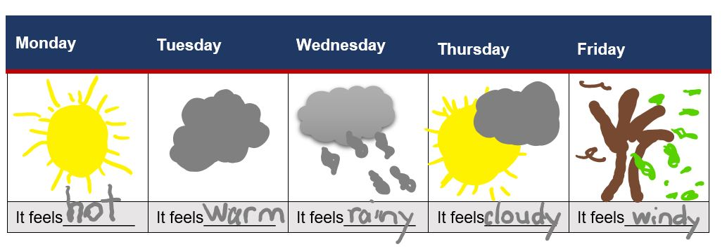
Look at this weather chart. Is this like the weather that you have had at home?
Search in old magazines for some pictures of people outside in different kinds of weather - a sunny day, a cold day and a rainy day.
Cut pictures out and glue them onto the next 3 pages with the words that match the weather.

Sunny weather

Cold weather

Rainy weather

Activity 2
During this activity you will think about where you play and measure it.
Resources – coloured pencils, glue and scissors (if taking a photo)

Let’s talk about your play place
Where do you play outside? Draw a picture or glue your photo of you and your outside play space here. Label the objects in your play space.

How many of your big steps is your outside play space on the longest side? ___________
How many of your big steps is your outside play space on the shortest side? ___________
How many big steps from the biggest object to the smallest object? __________________
Which object is the closest to you? ___________________________________

Activity 3
During this activity you will think about your favourite toy, measure it and use your imagination.
Resources – coloured pencils, a large spoon from the kitchen

Let’s talk about your toys
Talk to your parents about these questions.
- what are their favourite toys?
- do your toys need to be protected from the weather?
- what would happen to your toy if it was left out in the hot/cold/wet weather?
- what would your toy need to protect it from the weather?

Let’s measure your favourite toy
Draw your favourite toy here

How many spoons tall is your toy? _________________________________________
How many spoons long is your toy? _________________________________________
How many spoons wide is your toy? __________________________________________

Let’s imagine about our favourite toy
imagine: if your toy was alive, what might it
- say about being left outside in the weather?
- think about being left outside in the weather?
- feel if it was left outside in the weather?
- do about being left outside in the weather?

Draw and write about your toy in Think, Feel, Say and Do.
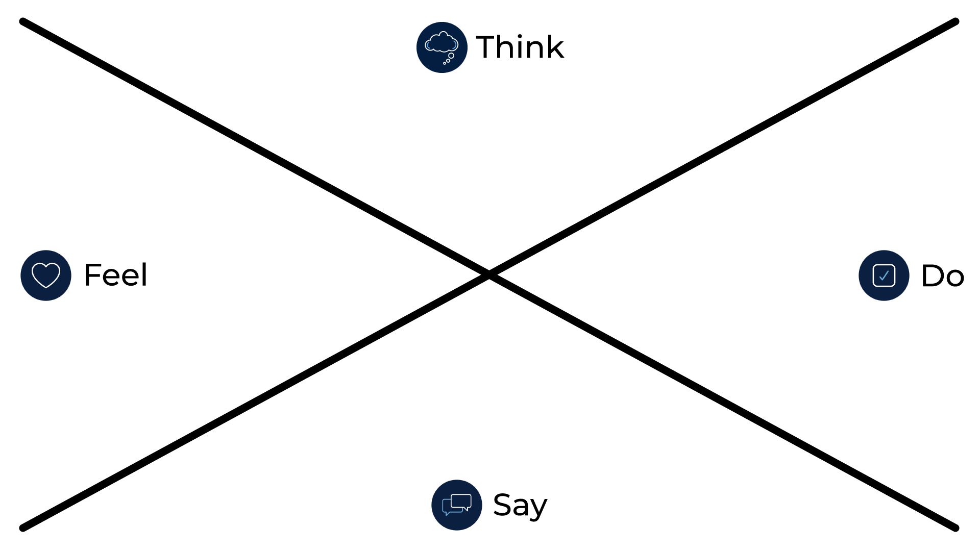

Activity 4

Let’s talk about our question and create ideas
During this activity you will create ideas about how to protect your favourite toy from the changes in the weather.
coloured pencils
Share this driving question:
How can I protect my favourite toy from the changes in the weather?
Talk to your parent/carer about
• what does it mean to protect something?
• what is your favourite toy?
• what does it mean for something to change?
• how does the weather change?

Quickly draw 4 crazy ideas to protect the toy from changes in weather in the boxes
Crazy idea 1

Crazy idea 2

Crazy idea 3

Crazy idea 4

Activity 5

Let’s make and test your best idea
During this activity you will make and test your best idea about how to protect your favourite toy from the changes in the weather.
a making box: containing materials found at home or school such as cardboard boxes, cylinders, tape, glue, pipe cleaners, materials, empty PET bottles
testing materials: watering can or hose, a warm place and a refrigerator
Make (engineer) your best idea that protects your toy from the weather using materials found at home or school.
Test your innovation in all types of weather:
- a shower of rain - leave your toy under its protection and use a watering can or hose
- a hot day - leave your toy under its protection in the sun
- a cold day - leave you toy and it’s protection in the refrigerator for the night

Draw a picture or glue a photo of your toy and its protection here.
in the rain

in the heat

in the cold

Activity 6

Let’s share your innovations
During this activity you will showcase your STEM innovation of how to protect your favourite toy from the changes in the weather.
showcase space (a special table in your play space)
Organise a showcase display of your STEM innovation in your outside play space
- prepare for the weather with the correct clothes and weather protection
- invite your family and toys to the showcase
- explain your learning from science and technology, engineering and mathematics.
- perhaps you might like to make invitations and set up a special STEM display space
- ask a family member to take some photos for you and print them out
- glue the photos here

Activity 7

Reflection
Think about what you have learnt in this activity. Use the two stars and a wish structure to guide your reflection.
Star  Something that went well! | Star  Something that went well! | Wish  A goal for next time…

