Vehicles
STEM student workbook ES1
Name:
Class:

Overview
You will learn about vehicles and how they move. You will design a most magnificent vehicle that you will use to deliver a thank you message to someone special.

Activity 1.2

Feelings and appearances
Before you do this activity, you will listen to a reading of the book called ‘The Most Magnificent Thing’ that is written and illustrated by Ashley Spires.
Think about the girl in the story. There is a difference between how the girl looks on the outside and how she feels on the inside.
Feelings on the inside cannot be seen, but looks on the outside can be seen.
On the next 2 pages you will find some words to describe the girl in ‘The Most Magnificent Thing’. Sort the words into how the girl looks and feels in the book. Cut and paste the words onto the outside space or the inside space of the picture.

Outside – how she looks | Inside – how she feels
 | 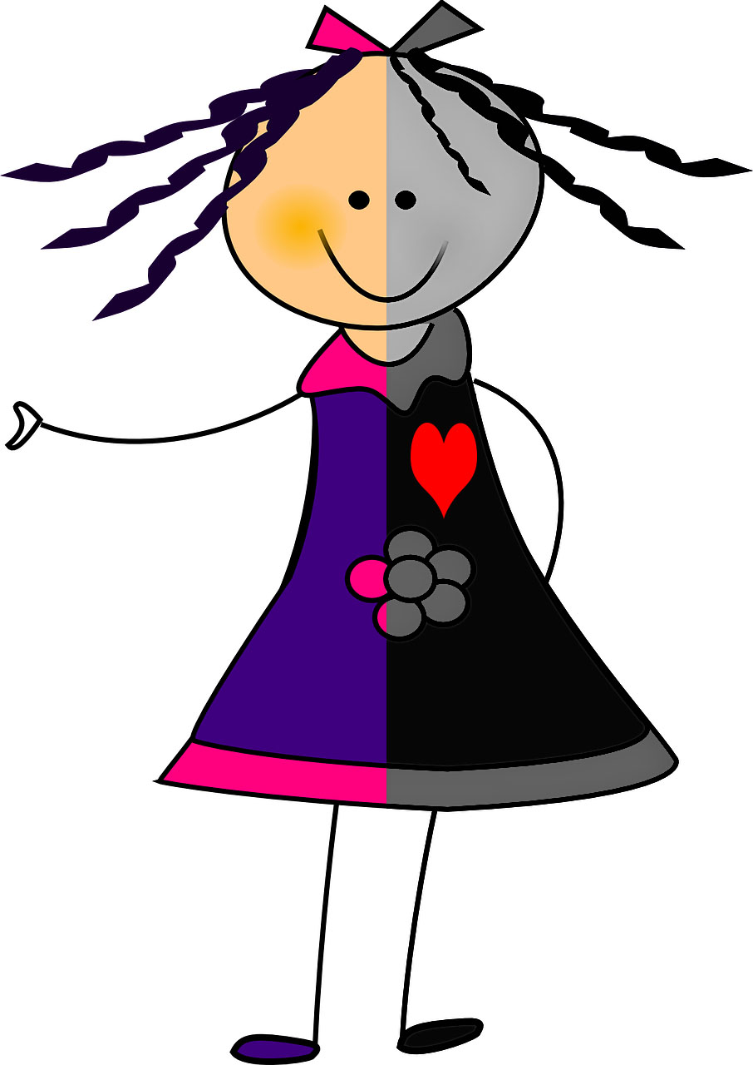

Cut and paste words
pigtails | happy | confused | girl
pink bow | mad | never gives up | excited
little | big smile | curly hair | loving
purple dress | clever | smiling | thin legs

Activity 1.3

What have you made or designed?
In the story, ‘The Most Magnificent Thing’, the girl makes things.
‘She knows just how it will look. She knows just how it will work. All she has to do is make it, and she makes things all the time. Easy-peasy!’
In the box on the next page, draw something that you have made. Finish the sentence to name and describes the thing. Label the materials you used.
What I have made or designed
This is my _____________________________. It has ____________________________________
_________________________________________________________________________________.
It is made from ____________________________________________________________________.

Activity 2.1

How do things move?
Find objects that will move. Match the objects that you have found to these 4 ways of moving. Draw your objects in the boxes – you do not have to fill all the spaces.

Sliding | Rolling | Spinning | Bouncing

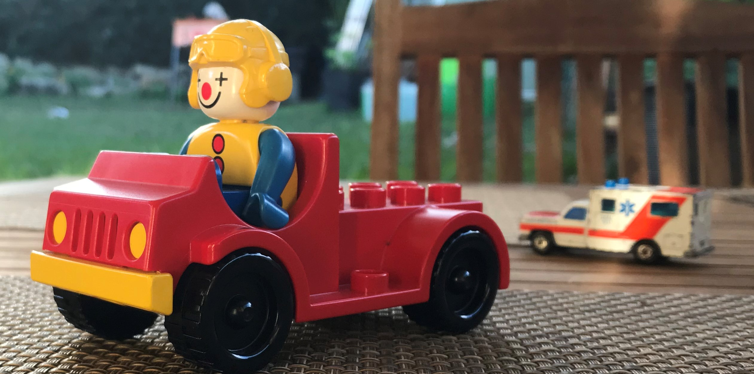Activity 2.2

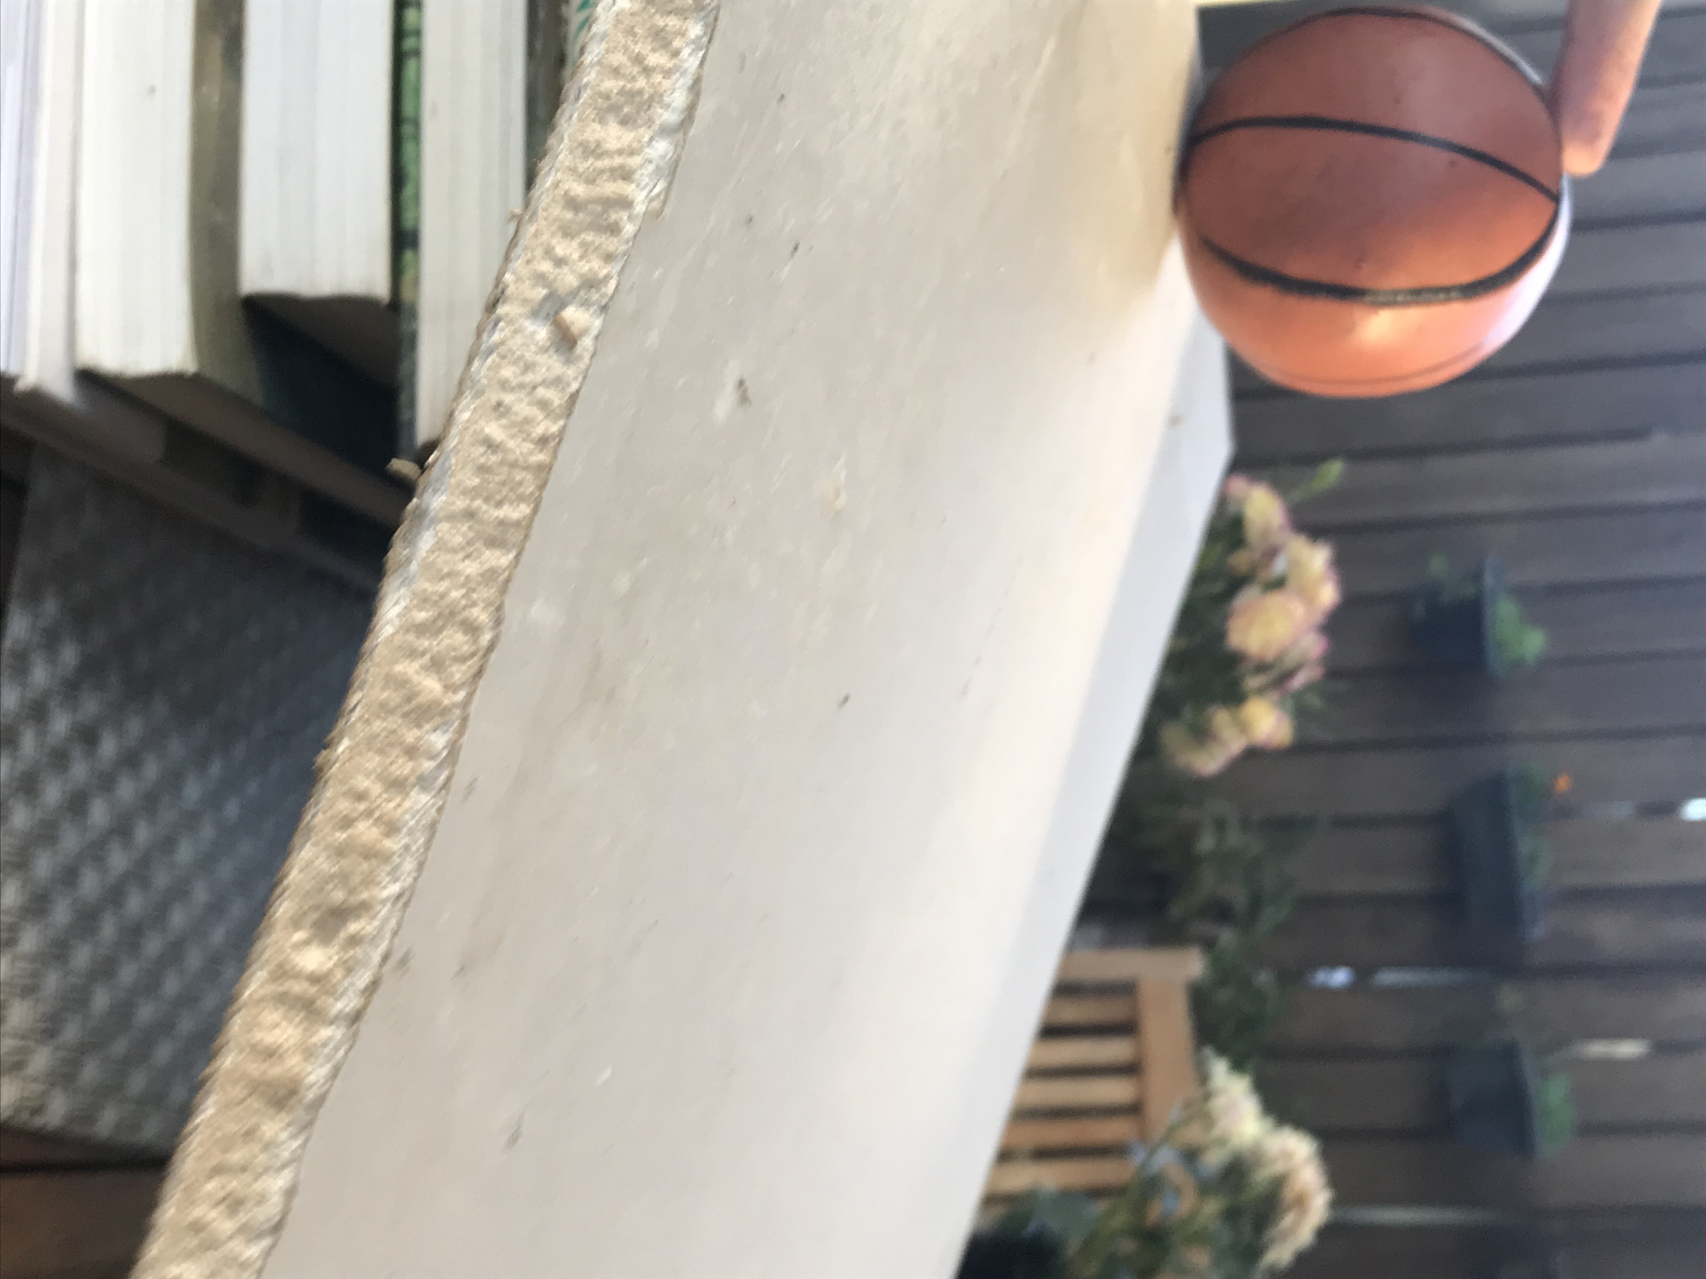Race-a-ramp
Construct a race-ramp using some strong cardboard or a length of timber. Use lots of books to lift one end of the ramp.
Draw a picture or take a photo of your ramp and put it here
How fast will your objects race? Have fun!

Activity 3.2

My 2D dog
Use the 2D shapes on the next page to make the dog from the book ‘The Most Magnificent Thing’. Glue the shapes for the dog into the box and label all the squares, triangles, rectangles and circles you can see in your picture.
2D shapes: The dog from ‘The most magnificent thing’

Use this page to cut out your shapes
2D shapes
Small grey

Activity 4.2

Thank you message
On the next page, write a message to someone special to thank them for something that they have done. Draw a picture on the message or decorate the page to make it special.
Here are some words to help you and some empty spaces for your family to help you.
.
Thank you words
thank | you | making | playing
love | kind | caring | helping
taking | gardening | cooking | reading
teacher | mum | dad | neighbour
grandmother | grandfather | brother | sister
friend | park | school | home

This page will be removed for your design project.

My message
Dear _______________________________________________
____________________________________________________
____________________________________________________
____________________________________________________
____________________________________________________
____________________________________________________
from _______________________________________________

Activity 5.1

All about vehicles
Put a tick under the images of a vehicle or a cross under the ones that are not a vehicle. Discuss with your parent or teacher.
Is it a vehicle?
 | 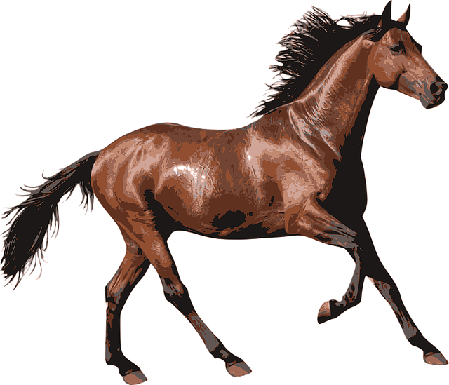
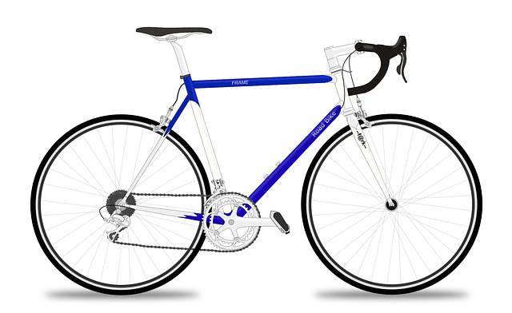 | 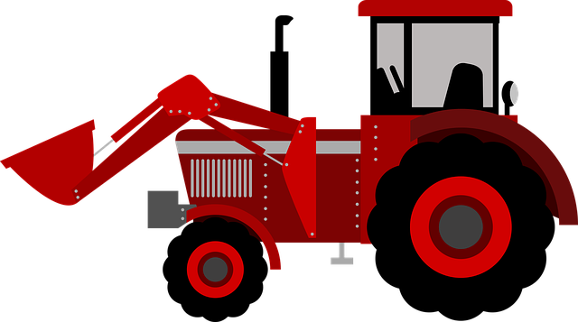
 | 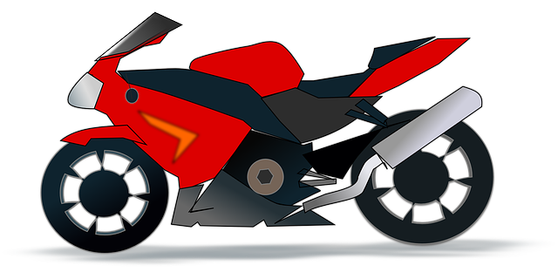

Activity 5.2

Crazy ideas
Quickly draw 4 crazy ideas for a vehicle to deliver your message
Crazy idea 1

Crazy idea 2

Crazy idea 3

Crazy idea 4

Activity 6.2

My prototype
A prototype is a draft model or drawing of your design idea. Draw an illustration or glue a photograph of your prototype here.

Activity 7.1

My special person’s place
Draw the special person that you are going to deliver your thank you message to.
Think about a special place where your special person likes to be. This is where you will want to send the message to.
My special person’s place
Write a sentence about the person and the place. Use these words to help you.
Position words
between | next to | behind | inside
near | nearer | right | middle
close to | closer | far | under

Activity 8.1

Let’s share your innovations
Organise a showcase display of your STEM innovation and invite your family and special friends. Set up a special STEM display space. Remember to explain your learning from science and technology, engineering and mathematics. Ask a family member to take some photos for you and print them out.
Use this space to display your photos.

Activity 8.2

2 stars and a wish
Think about what you have learnt in this activity. Use the two stars and a wish structure to guide your reflection.

Star  Something that went well! | Star  Something that went well! | Wish  A goal for next time…

