STEM learning framework overview
The STEM learning frameworks are a resource developed to assist teachers when planning STEM learning sequences. They provide teachers with markers for skill development, question prompts to guide the learning and possible learning tools to monitor students’ progress.
The design thinking model can be applied as a scaffold to understand and unpack a STEM problem identified within the project-based learning. The model follows four key phases; Identify and define, Research and plan, Produce and implement, and Test and evaluate. As students manage projects to completion, they engage in critical and creative thinking, problem-solving, communication and collaboration. Throughout the design thinking process, students communicate and share their ideas with others and reflect on feedback to improve their design solution. The processes embedded in design thinking are represented in the following Design thinking model graphic.
Figure 1 Design thinking model
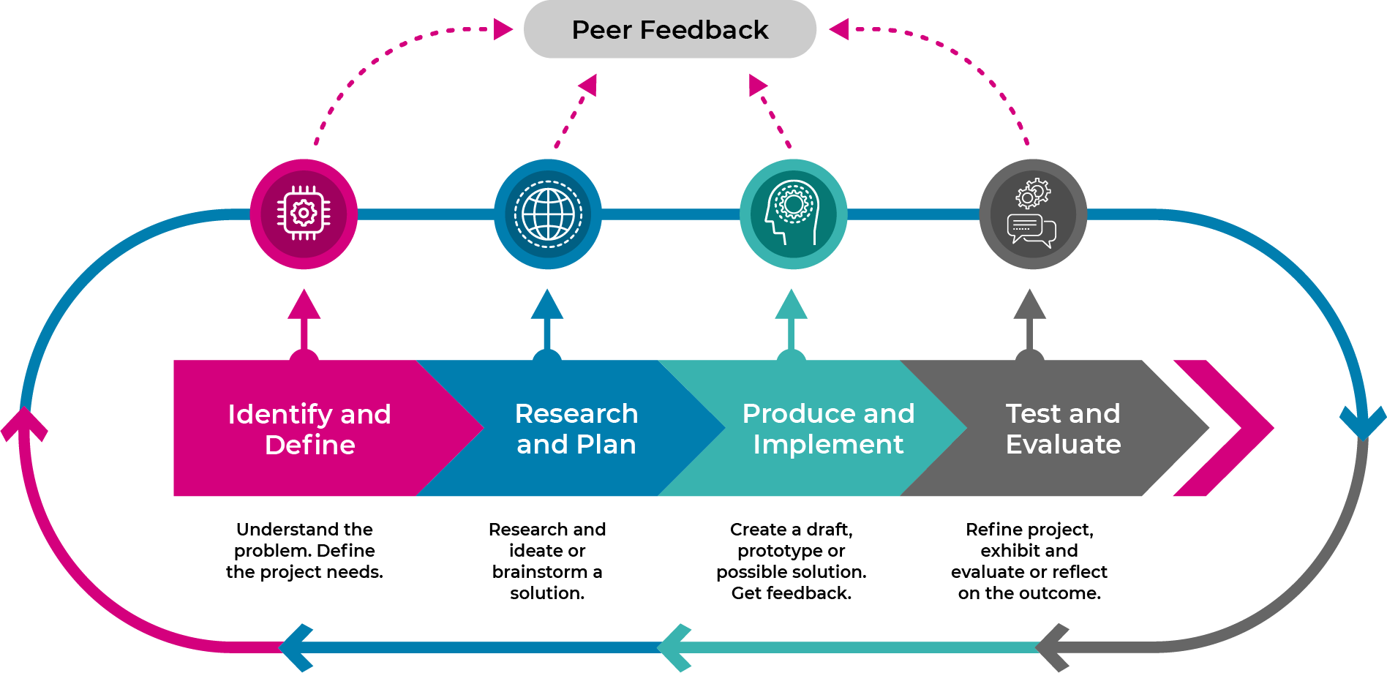

Identify and define phase
Figure 2 What to look for in the identify and define phase
Early Stage 1 | Stage 1 | Stage 2 | Stage 3
Explore and identify how people design and produce familiar products services and environments. | Identify how people design and produce familiar products, services and environments. | Recognise the role of people in design solutions. | Examine how people use design thinking.
Identify and explore familiar information and ideas during a discussion or investigation. | Identify and explore information and ideas from source materials. | Identify main ideas and select and clarify information from a range of sources. | Identify and clarify relevant information and prioritise ideas.
Identify that others have different needs. | Identify and explore other’s needs. | Explore users’ needs and how they think, feel, and behave. | Identify users’ needs, and how they think, feel, and behave.
Share understanding of the terminology within the driving question. | Share and discuss understanding of the terminology within the driving question. | Share and discuss understanding of the terminology within the driving question and contributing questions. | Share and discuss understanding of the terminology within the driving question and frame contributing questions to support learning.

Research and plan phase
Figure 3 What to look for in the research and plan phase
Early Stage 1 | Stage 1 | Stage 2 | Stage 3
Identify and describe needs or opportunities when designing. | Recognise needs or opportunities when designing solutions. | Review needs or opportunities when designing solutions. | Examine needs, opportunities or modifications when designing solutions.
Pose questions based on interests and life experiences that relate to the problem. | Pose purposeful questions to clarify issues and compare information to their world. | Pose questions and link multiple perspectives about the problem. | Pose questions to clarify information with the purpose of discovering how ideas are linked.
Explore similar information or representations from given sources. | Explore, identify and organise information from given resources. | Identify main ideas, select, compare and categorise information from a range of sources. | Analyse, prioritise, condense and combine information from multiple sources to identify relevancy.
Consider sustainability to meet personal and local community needs. | Consider sustainability to meet personal and local community needs. | Explore factors, including sustainability that impact on the design of products, services and environments to meet community need. | Examine differing concerns, including sustainability when designing solutions for future use.
Connect information from one setting to another. | Use information from a previous experience to inform a new idea. | Apply knowledge gained from one context to another unrelated context and identify new meaning | Apply knowledge gained from one context to another unrelated context and identify new meaning.
Make predictions in a given situation when putting ideas into action. | Investigate options and predict possible outcomes when putting ideas into action. | Experiment with a range of options when seeking solutions and putting ideas into action. | Assess and test options to identify the most effective solution to put ideas into action.
Use imagination to view or create and make simple connections between ideas. | Apply prior knowledge to create ideas and possibilities in ways that are new. | Expand on known ideas to create new and imaginative combinations. | Combine ideas in a variety of ways and from a range of sources to create new possibilities.
Suggest alternative and creative strategies to approach a given situation or task. | Identify and compare creative ideas to think broadly about a given situation or problem. | Apply creative ideas to propose a range of alternatives about a given situation or task. | Identify situations and challenge existing ideas to generate alternative solutions.
Share and discuss ideas from feedback. | Share, discuss and develop feedback to inform and build ideas. | Share, discuss and develop feedback to inform and build ideas. | Discuss and critique feedback from others to improve and transform ideas.

Produce and implement phase
Figure 4 What to look for in the produce and implement phase
Early Stage 1 | Stage 1 | Stage 2 | Stage 3
Develop and record design ideas through describing, drawing and modelling. | Generate, develop and record design ideas through describing, drawing and modelling. | Generate, develop, and communicate design ideas and decisions using appropriate technical terms and graphical representation techniques. | Generate, develop and communicate design ideas and processes for audiences using appropriate technical terms and graphical representation techniques.
Identify and share the thinking used to solve problems. | Identify reasoning used in choices or actions when presented with new information to solve problems. | Identify and apply appropriate reasoning, prior knowledge and thinking strategies for a design solution. | Assess whether there is adequate reasoning and evidence to justify a claim, idea, or concept in a conclusion or outcome to solve problems in a given situation.
Develop solutions to an identified need using found materials. | Use materials, tools and equipment to develop solutions for a need or opportunity. | Select and use materials, tools and equipment to develop solutions for a need or opportunity. | Plan and use materials, tools and equipment to develop solutions for a need or opportunity.
Use simple plans to create a design solution. | Use planning materials to create an idea. | Demonstrates the use of planning materials when developing their solution. | Produce and follows an accurate planning document.

Test and evaluate phase
Figure 5 What to look for in the test and evaluate phase
Early Stage 1 | Stage 1 | Stage 2 | Stage 3
Evaluate success of design ideas, processes or solutions according to personal preferences and/or predetermined criteria. | Evaluate the success of design ideas, processes and solutions according to a scale of personal preference. | Develop a set of criteria for success with guidance to evaluate the design solution. | Negotiate criteria for success, based on defined needs, sustainability and aesthetics to evaluate the design solution.
Consider and discuss the impact of a design solution within an environment. | Identify the positive and negative impact of a design solution within an environment. | Evaluate the positive and negative impact of a design solution within an environment. | Evaluate and justify the positive and negative impact of a design solution within an environment.
Communicate creative ideas with known audiences for feedback. | Communicate creative ideas and products with known and local audiences to gather different forms of feedback for design choices. | Communicate creative ideas and products with known, unknown, local and wider audiences to gather different forms of feedback to inform design choices. | Communicate creative ideas with known, unknown, local and global audiences within an authentic context for feedback to transform learning.
Identify the thinking used to solve problems. | Identify reasoning used in choices or actions in specific situations. | Identify and apply appropriate reasoning and thinking strategies for particular outcomes. | Justify the reasoning and thinking strategies used to solve more complex problems.
Upon completion of the design process, connect feedback to learning for improvement. | Upon completion of the design process, identify the use of feedback to connect with new learning opportunities | Upon completion of the design process, evaluate and justify the effectiveness of all feedback to inform future learning. | Evaluate and justify the effectiveness of feedback to inform future learning.
Describe what they are thinking and give reasons why. | Describe the thinking strategies used in given situations and tasks. | Identify pertinent information in the design and communicate separate smaller parts or ideas. | Reflect on assumptions made, consider reasonable criticism and adjust their thinking if necessary.
Identify and share their thinking about possible courses of action. | Identify alternative courses of action or possible conclusions when presenting information. | Reflect on, explain and check the processes used to come to conclusions. | Scrutinise ideas or concepts and use evidence when choosing a course of action or drawing a conclusion to share learning.
Check whether they are satisfied with the outcome of tasks or actions. | Explain personal accomplishment of the tasks or actions undertaken. | Explain and justify ideas and outcomes. | Evaluate the effectiveness of ideas, products, performances, methods and courses of action against given criteria.
Use appropriate terms and concepts when presenting to a known audience. | Use appropriate forms to communicate their understandings to an audience. | Present their findings using a variety of media to communicate their understandings to an audience. | Combine visual and digital elements for a variety of audiences and purposes to communicate their understandings.

