Parental advice and support

STEM ES1 learning sequence
This sequence develops skills and understandings in science and technology, and mathematics. Your child will apply these skills and understandings as they inquire into their world and solve a complex, authentic problem.

Background notes
STEM education is an approach to teaching science and technology, and mathematics that fosters inquiry learning in our complex world.
This sequence applies a simplified design thinking model to encourage your child to solve difficult problems in a structured and purposeful manner. This model follows 4 phases:
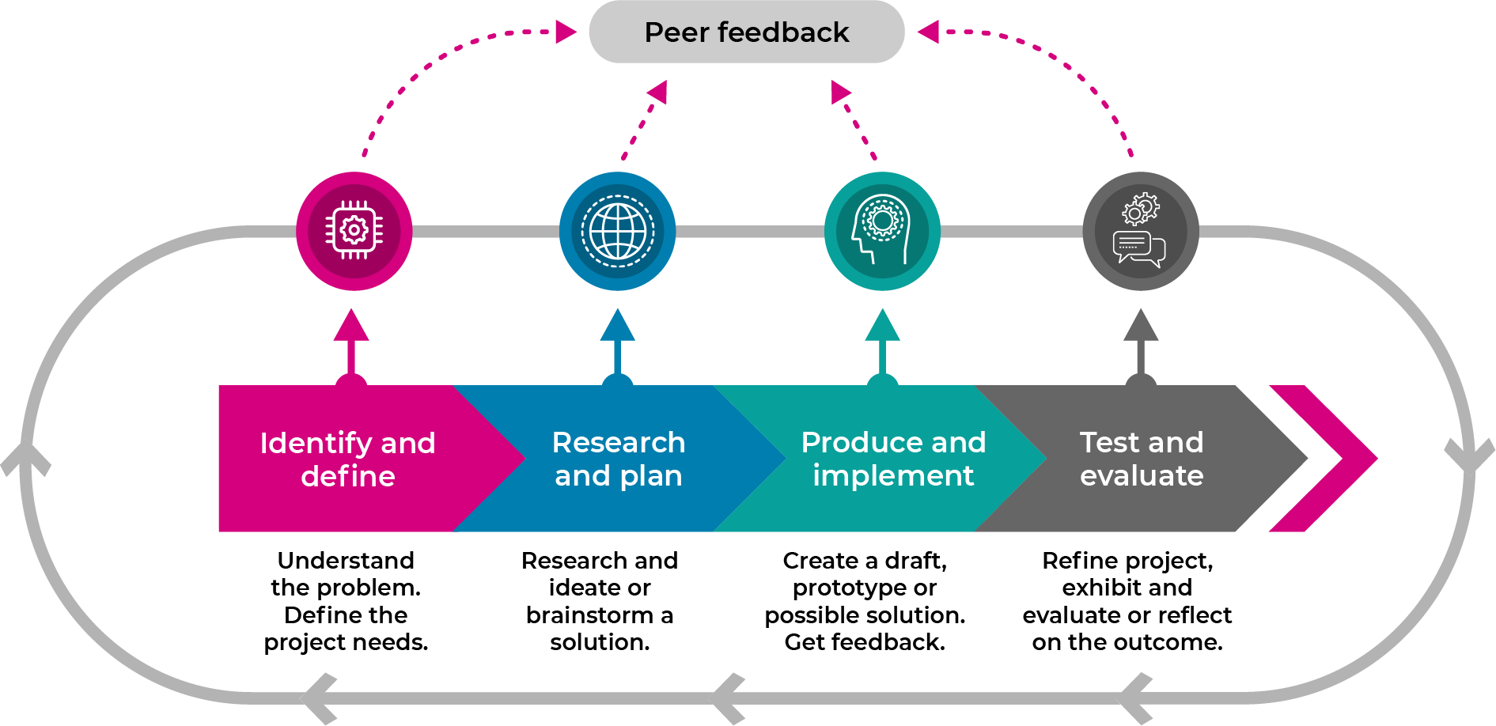
Design thinking in STEM education provides an overview of the processes and stages and an explanatory video that may be an informative resource for all parents.

Resources
You are an important support for your child in their learning. Key opportunities for you to help your child are at the beginning of most activities.
Your child may complete their learning using the associated student workbook.
During this sequence your child will also need the following resources.
- Coloured pencils
- Scissors
- Glue
- Old magazines that can be cut up
- Teaspoon, peg or a building block
- A making box – large cardboard box filled with a collection of everyday small materials that are useful for construction such as empty boxes (for example, cereal, biscuits), cardboard cylinders (toilet rolls, kitchen wrap), empty milk cartons, egg cartons, pet bottles, ribbon, string, tape
- Watering can or hose

Further support
For support or more information please contact your school or class teacher or visit Learning from home - parents and carers
The learning in this sequence contributes to student achievement of:
NSW K-6 Science and Technology Syllabus outcomes – STe-2DP-T, STe-6ES-S
NSW K-10 Mathematics Syllabus outcomes – MAe-1WM, MAe-2WM, MAe-3WM, MAe-4NA, MAe-9MG
NSW K-6 Geography Syllabus outcome – GEe-1

