STEM ES1 weather learning sequence

Resource considerations
This lesson sequence allows for continuity of student learning and could be adapted to fit in with your existing teaching and learning program.
- Students will be supported to meet outcomes from specific Key Learning Areas.
- Most tasks have a duration of approximately 30 minutes and could be used in conjunction with your framework, designed using the K-6 template.
- This lesson sequence uses a balance of synchronous and asynchronous learning strategies.
- The tasks provide options for students with and without technology. They can be used with any online platform.
- Assessment strategies linked to the success criteria are included to ensure evidence of learning is monitored and collected.

Syllabus outcomes

Science and technology
STe-2DP-T – develops solutions to an identified need
STe-6ES-S – identifies how daily and seasonal changes in the environment affect humans and other living things

Mathematics
MAe-1WM – describes mathematical situations using everyday language, actions, materials and informal recordings
MAe-2WM – uses objects, actions, technology and/or trial and error to explore mathematical problems
MAe-3WM – uses concrete materials and/or pictorial representations to support conclusions
MAe-4NA – counts to 30, and orders, reads and represents numbers in the range 0 to 20
MAe-9MG – describes and compares lengths and distances using everyday language

Geography
GEe-1 – identifies places and develops an understanding of the importance of places to people

Learning sequence overview
Students will identify different types of weather and how the weather changes. Students will identify a place to play and how the weather affects its use. Students will design a solution to an authentic problem for their favourite toy: How can I protect my favourite toy from the changes in weather? Students will apply their knowledge of measurement and number within the design solution.

Key concepts – Science and Technology: daily changes in the weather; Mathematics: measurement – length; Geography: students understand that the places they belong to, and are important to them, may be similar and different for other people.
Key language – weather, sunny, cloudy, rainy, windy, stormy, warm, hot, cool, cold, change; Mathematics: length, end, long, longer than, longest, short, shorter than, shortest, high, higher than, highest, tall, taller than, tallest, low, lower than, lowest, the same as, near, nearer, far, further, close, closer.
Driving question: How can I protect my favourite toy from the changes in weather?

Aim of lesson sequence
This STEM learning sequence enables students to inquire, plan investigate and develop solutions to an authentic problem posed: How can I protect my favourite toy from the changes in weather? They will apply their understanding of scientific concepts of the effects of changes of weather. They will apply their understanding of mathematical concepts of measurement and number. They will apply their understanding of geographical concepts as they explore the interactions between people and places.

Teacher notes
This learning sequence aligns with three Early Stage One learning sequences published on the NSW Department of Education Learning from Home website: science and technology (earth and space), mathematics, and geography (people in in places).
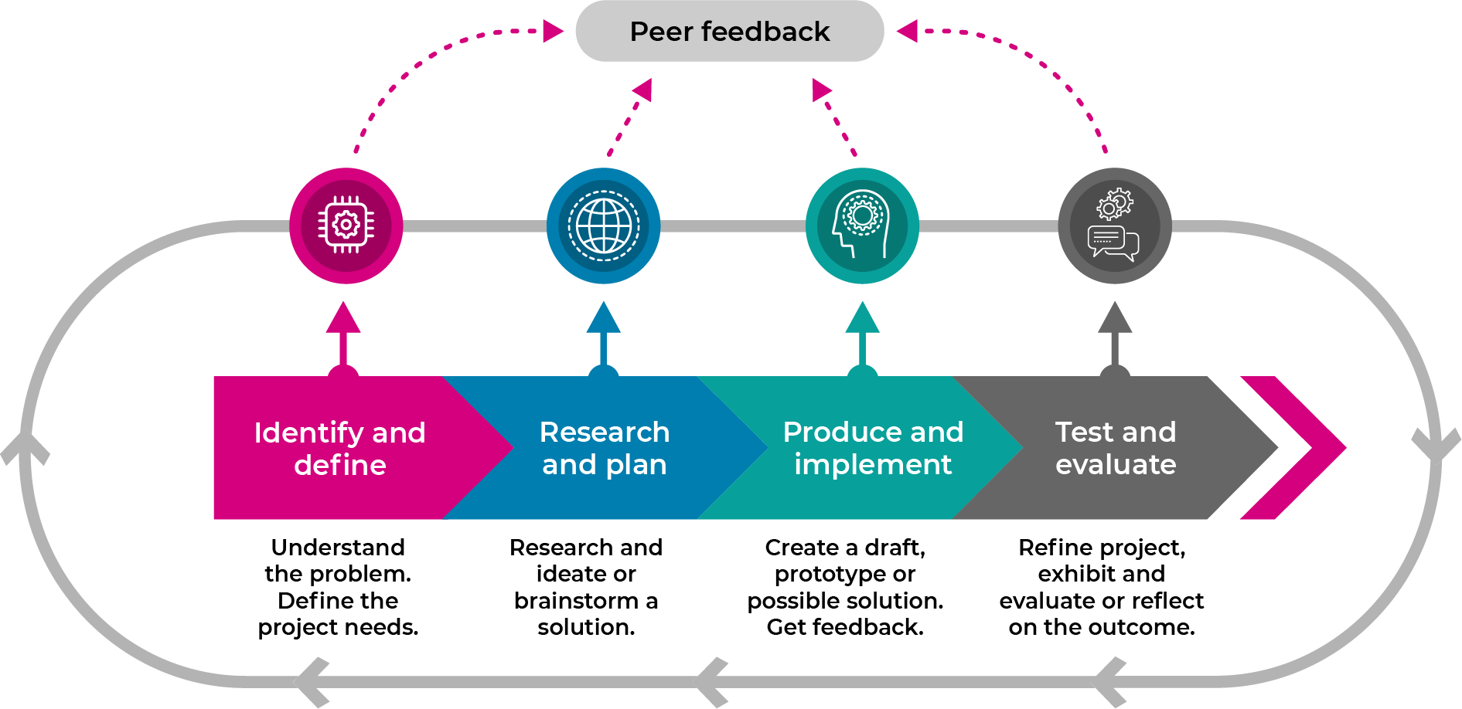
This learning sequence models an integrated approach to learning where the student solves an authentic problem by employing design thinking skills.
  - Build the empathy of the student to the focus of the problem: the toy being left out in the weather.
  - Identify and define the task: the types of weather, what it may mean to protect something
  - Develop the skills of ideating: imagine, create and express new and innovative ideas (often in a rapid format)
  - Allow the student to prototype (produce and implement) their idea: experimenting with solutions
  - Test and evaluate the validity of the solution: allow for refinement
  - Share: interrogate the solution with lots of praise and support

Activity 1

Science: Let’s talk about the weather
- Review weather chart recorded in the STEM ES1 student workbook. Discuss predictions of the weather.
- Search magazines for pictures of people outside on a sunny day, a cold day and a rainy day. Cut out and glue down the pictures into the STEM ES1 student workbook
- Share ideas about the clothing and the protection that people are needing for different weather. Focus on the following topics.
  - Wet weather – clothing such as a raincoat and gumboots, protection such as an umbrella
  - Hot weather – clothing such as shorts, t-shirt and sandals, protection such as a hat, sunglasses and sunscreen
  - Cold weather – clothing such as a jumper, coat and boots, protection such as scarf, beanie or even snow goggles
  - Ask: Are there other ways to protect us from the weather?

Activity 2

Geography: Let’s talk about your play place

Digital activities
- Take a photo of a place in the natural environment where they are allowed to play.
- Print the photo, draw a picture of themselves in the play space, and label the play spaces (for example, cubbyhouse, lawn, swings).
- Glue photo into the STEM ES1 student workbook.

Non-digital activities
- Draw a picture in the STEM ES1 student workbook of a place outside the student’s home where they are allowed to play such as balcony, backyard or park
- Label the objects in the play spaces (for example, cubbyhouse, lawn, swings).

Mathematics: Let’s measure your play space
- Use everyday language to describe the length of the play space (for example, long, short, high, tall, low).
- Use comparative language to describe length of the sides, for example longer, longest, the same as.
- How many of your footprints (heel to toe) is needed to measure the longest side of your play space?
- How many of your footprints (heel to toe) is needed to measure the shortest side of your play space?
- How many footprints (heel to toe) from the biggest object to the smallest object?
- Record the number of footprints in your STEM ES1 student workbook
- Use everyday language to describe distance from the play space to other objects in the backyard, park or home for example near, far, nearer, further, closer
- Record which object is closest to them

Activity 3

STEM: Let’s talk about your toys
- What are your favourite toys?
- Do your toys need to be protected from the weather?
- What would happen to your toy if it was left out in the hot/cold/wet weather?
- What would your toy need to protect it from the weather?

Mathematics: Let’s measure your favourite toy
- Draw your favourite toy.
- Measure your toy with a teaspoon, peg or a building block.
- Record the number of spoons in your STEM ES1 student workbook
  - How many teaspoons, pegs or building blocks tall is your toy?
  - How many teaspoons, pegs or building blocks long is your toy?
  - How many teaspoons, pegs or building blocks wide is your toy?

STEM: Let’s imagine about our toy
Imagine if your toy was alive, what might it:
- ‘Say’ about being left outside in the weather?
- ‘Think’ about being left outside in the weather?
- ‘Feel’ if it was left outside in the weather?
- ‘Do’ about being left outside in the weather?
Complete the empathy map in STEM ES1 student workbook with drawings and labels of your toy in think, feel, say and do

Activity 4

STEM (identify and define, research and plan): Let’s talk about our question and create ideas
How can I protect my favourite toy from the changes in the weather?
- What does it mean to protect something?
- What is your favourite toy?
- What does it mean for something to change?
- How does the weather change?
Quickly draw 4 ‘crazy’ ideas to protect the toy from changes in weather in STEM ES1 student workbook –encourage rapid, innovative ideas
Share your ideas with the teacher or parent.
Select your best idea.

Activity 5

STEM (prototype/test): Let’s make and test your best idea

Digital activities
- Make (engineer) your best idea that protects your toy from the weather using materials found at home or school (a making box) such as cardboard boxes, cylinders, tape, glue, pipe cleaners, materials, empty PET bottles, or any other resources that you can find
- Test your innovation in all types of weather. Here are some ideas for you to try.
  - A shower of rain (leave your toy under its protection and use a watering can or hose).
  - A hot day (leave your toy under its protection in the sun).
  - A cold day (leave you toy and it’s protection in the refrigerator for the night).
- Take photographs of your toy and its protection in the 3 kinds of weather
- Print them out.
- Paste them into your STEM ES1 student workbook.
- Describe the results of your tests. Was your toy protected?

Non-digital activities
- Make (engineer) your best idea that protects your toy from the weather using materials found at home or school (a making box) such as cardboard boxes, cylinders, tape, glue, pipe cleaners, materials, empty PET bottles, or any other resources that you can find
- Test your innovation in all types of weather. Here are some ideas for you to try.
  - A shower of rain (leave your toy under its protection and use a watering can or hose).
  - A hot day (leave your toy under its protection in the sun).
  - A cold day (leave you toy and it’s protection in the refrigerator for the night).
- Draw your toy and it’s protection in the 3 kinds of weather, in your STEM ES1 student workbook
- Describe the results of your tests. Was your toy protected?

Activity 6

STEM (share): Let’s share your innovations
- Organise a showcase display of your STEM innovation in your outside play space (perhaps you might like to make invitations and set up a special STEM display space).
- Prepare for the weather with the correct clothes and weather protection.
- Invite your family and toys to the showcase.
- Explain your learning from science and technology, engineering and mathematics. Don’t forget your geography too!
- Ask a family member to take some photos for you and print them out please (the student should be too busy to do this).
- Paste the photos into your STEM ES1 student workbook and write a sentence about your success.
- Share it with your teacher.

Differentiation
Differentiation is a targeted process recognising that individuals learn at different rates and in different ways. Differentiation refers to deliberate adjustments to meet the specific learning needs of all students.
Here are some questions that you might consider when adapting the learning sequence to meet the needs of your students.
- Why do we need to protect ourselves from the weather?
- Why is it a problem if we get effected by the weather?
- Why is a problem if the weather makes us sick or hurts us?
- Why is a problem if we are sick and cannot go to school?
- Why do we need to protect our toys from the weather?
- Why is it a problem if our toys get effected by the weather?
- Why is a problem if the weather damages our toys?
- Why is a problem if our toys won’t work?
- Why is a problem if we throw our toys away?
What adjustments might you put in place for students who require additional support to access the task? For example, how will they get help when needed?
Do you need to adjust the content to ensure it is adequately challenging and allows students to operate at their own level of thinking, skill and knowledge?
Will you adapt the instructions so they are provided in a way that EAL/D students can easily interpret them? For example, through the use of visuals, checklists, diagrams or flow charts.
Could you suggest ways that home language can be used as a tool to support learning? For example, bilingual dictionaries.
Can you demonstrate that you value the Identity, culture, heritage and language of your Aboriginal students through your teaching practices?

Assessment
- Review of STEM ES1 student workbook
  - Activity 2: labelled play space and measurements
  - Activity 5: evidence of testing
- Two stars and a wish strategy to review final product/solution.

Activity resources
- Student printed workbooks.
- Parent/caregiver advice (a short explanation of the lesson sequence and the role they will play).
- Coloured pencils.
- Scissors.
- Glue.
- Old magazines that they can cut up.
- Teaspoon, peg or a Building block.
- A making box – large cardboard box filled with a collection of everyday small materials that are useful for construction such as empty boxes (e.g. Cereal, biscuits), cardboard cylinders (toilet rolls, kitchen wrap), empty milk cartons, egg cartons, PET bottles, ribbon, string, tape.
- Watering can or hose.

