Magnificent vehicles
STEM Stage ES1 learning sequence
Driving question
How can a most magnificent vehicle carry a thank you message to someone special?
Learning sequence description
Students will design a solution to an authentic problem: How can a most magnificent vehicle carry a thank you message to someone special? They will identify the characteristics of different objects including their materials and their movement. Students will explore the effects of these characteristics. Students will investigate how push and pull forces create movement. Students will apply their knowledge of 2D shapes, measurement and position within their design solution. Students will identify someone special in their life to whom they would like to express gratitude, and will demonstrate communication skills to express these feelings. Students will understand how Aboriginal nations expressed gratitude and respect.

Syllabus outcomes and content

Science and technology
STe-2DP-T – develops solutions to an identified need
- plan, design and evaluate a product considering an identified need or opportunity
STe-4MW-ST – identifies that objects are made of materials that have observable properties
- observe and describe some properties of a range of materials
STe-5PW-ST – observes the way objects move and relates changes in motion to push and pull forces
- observe the way a variety of familiar objects move, for example: sliding, rolling, spinning, bouncing

Mathematics
MAe-1WM – describes mathematical situations using everyday language, actions, materials and informal recordings
- manipulate circles, triangles, squares and rectangles, and describe their features using everyday language
MAe-3WM – uses concrete materials and/or pictorial representations to support conclusions
- record length comparisons informally by drawing, tracing, or cutting and pasting, and by using words and numerals
MAe-9MG – describes and compares lengths and distances using everyday language
- use comparative language to describe distance, eg close, closer, closer than, further, further than
MAe-15MG – manipulates, sorts and describes representations of two-dimensional shapes, including circles, triangles, squares and rectangles, using everyday language
- make pictures and designs using a selection of shapes, eg make a magnificent vehicle using squares, rectangles and circles
MAe-16MG – describes position and gives and follows simple directions using everyday language
- Describe position and movement: give and follow simple directions to position an object or themselves, for example, near the tree, close to the house

English
ENe-10C – thinks imaginatively and creatively about familiar topics, simple ideas and the basic features of texts when responding to and composing texts
- respond to a range of imaginative and creative texts, including visual media

Geography
GEe-1 – identifies places and develops an understanding of the importance of places to people
- investigate the importance of places they live in and belong to, for example:
  - identification of places they live in and belong to
  - discussion of why places are special and how people care for them

PDHPE
PDe-3 – communicates ways to be caring, inclusive and respectful of others
- read and view stories about adventures and communicate how characters feel and react when facing challenges
- communicate in appropriate ways, eg use verbal and nonverbal communication to demonstrate understanding
PDe-10 – uses interpersonal skills to effectively interact with others
- learn and use appropriate strategies to communicate their feelings in different situations
Science and Technology K-6 Syllabus © 2017 NSW Education Standards Authority (NESA) for and on behalf of the Crown in right of the State of New South Wales.
Mathematics K-10 Syllabus © 2012 Copyright Board of Studies NSW for and on behalf of the Crown in right of the State of New South Wales
English K-10 Syllabus © 2012 Copyright Board of Studies, Teaching and Educational Standards NSW for and on behalf of the Crown in right of the State of New South Wales.
Geography K-10 Syllabus © 2015 Copyright Board of Studies, Teaching and Educational Standards NSW for and on behalf of the Crown in right of the State of New South Wales.
PDHPE K-10 Syllabus © 2018 NSW Education Standards Authority (NESA) for and on behalf of the Crown in right of the State of New South Wales.

Resource considerations
This lesson sequence allows for continuity of student learning and could be adapted to fit in with your existing teaching and learning program. Students will be supported to meet outcomes from a number of key learning areas. Most tasks have a duration of approximately 30 minutes and could be used in conjunction with your existing frameworks. The tasks provide options for students with and without technology. They can be used with any online platform. Suggestions about how your school will plan students’ learning from home and ways to communicate with students can be found through the STEM Stage ES1 learning sequence: hub on our website. Assessment strategies linked to the success criteria are included to ensure evidence of learning is monitored and collected.
All images used, unless otherwise specified, are owned by the NSW Department of Education or are copyright free through Pixabay.

Teacher notes
This learning sequence models an integrated approach to learning where the student solves an authentic problem by employing design thinking skills.
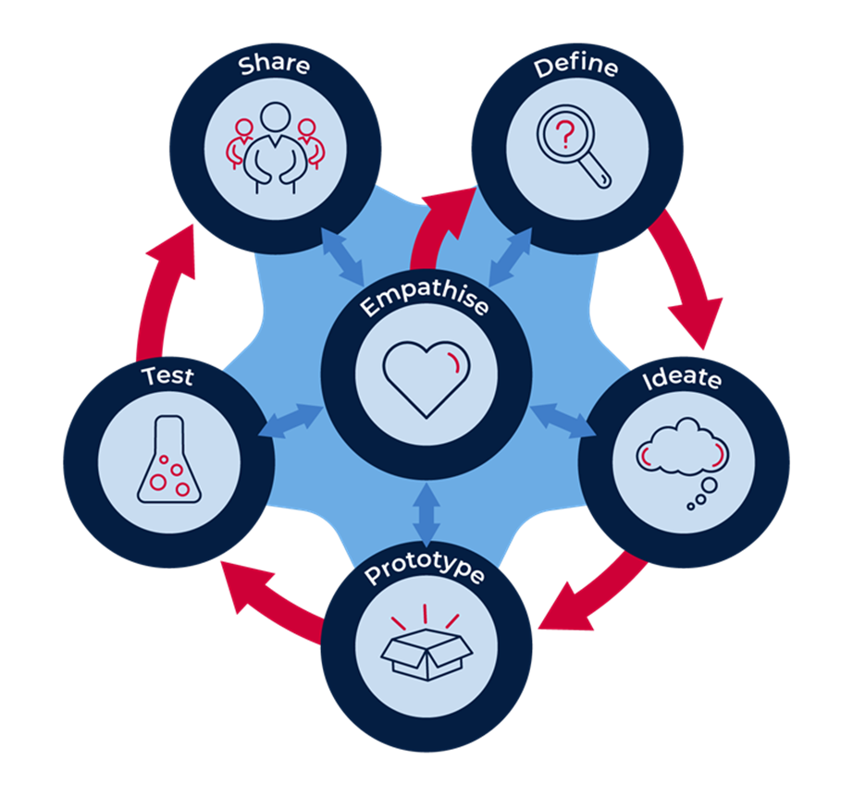
The model, as shown above, has 6 dynamic stages with Empathise at the centre or core. This model demonstrates the interactions and flow between the other 5 stages and empathy.
When initially introducing the model to learners, the flow is sequential; that is from Empathise to Define, to Ideate, to Prototype, to Test, to Share. As students and teachers become more familiar with the approach, regular and rapid movement backwards and forwards between the stages is to be expected and encouraged. In practice, students may move from Test back to Ideate or Empathise; they may then jump forward to Prototype. The fluid movement between the stages frequently results in a more comprehensive outcome.
- Empathise: build the empathy of the student to the focus on the problem; expressing gratitude to someone special
- Define the task: consider all stakeholders, understand the terminology; who has been helping the student, why it is important to thank others
- Ideate: develop the skills of generating rapid ideas: imagine, create and express new and innovative ideas
- Prototype: allow the student to plan and develop their idea, experimenting with solutions.
- Test the validity of the solution, allow for refinement.
- Share and interrogate the solution with lots of praise and support.

Resources
STEM Early Stage 1 magnificent vehicles student workbook
The Most Magnificent Thing video
Design thinking poster

Learning experiences

Activity 1
Students are learning to:
- listen carefully to a story
- pay attention to the illustrations
- think about the author’s message

1.1 (approximately 30 mins)

English: shared reading
As an introduction to STEM and designing, read the book ‘The Most Magnificent Thing’ by Ashley Spires. This is available as The Most Magnificent Thing video or you may have a copy of the book ‘The Most Magnificent Thing’ by Ashley Spires, published by Kids Can Press in your school library. Another alternative is you may be able to find a reading of this book on a digital sharing platform, such as YouTube.
The students are learning to think critically when listening to a story. They need to know that people bring different experiences, thoughts and ideas to a story, and this can change how we understand it. They are learning to look at a story and think about the author and illustrator’s message. This lesson will help students use new vocabulary.
At the end of the video, talk about aspects of the story. Ask questions and prompt responses to extend the students beyond the basic, obvious facts. For example:
- I wonder how the girl imagined all her different ideas.
- Do you think the people in the street knew how magnificent the inventions were?
- Tell me about the dog and girl’s relationship using the illustrations to support your thoughts.
- Talk about how the girl’s feelings changed she went for a walk with her dog after she had exploded.
- Tell me about how the girl may have felt after she had success with her final invention.

1.2 (approximately 30 mins)

English: character development
Discuss how people look and feel, and the words we use to describe appearance and feelings. Feelings are on the inside and cannot be seen. Appearance are the observable features on the outside.
Discuss the observable features of the students’ friends and family members. Then share the feelings that each may have.
In the story, The Most Magnificent Thing, there is a difference between how the girl in the story looks on the outside and how she feels on the inside. How do we know this? How do her feelings influence the way she reacts?
Discuss the feelings and emotions of the girl and the dog. How did the dog help the girl solve her problems?
Complete Activity 1.2 in the ES1 student workbook: students discuss the image of the girl. On the left-hand side, we can see that she has lots of colours. On the right-hand side, her heart is the only colourful part. Why is this?
Match the words that describe the girl’s appearance to the Outside section of the page, match the words to the girl’s feelings on the Inside section of the page.

1.3 (approximately 30 mins)

STEM: Opportunity for monitoring student learning; formative assessment

All about designing
What to look for:
- understanding of difference between designing and making
- explanation of how to make things
- use of appropriate materials
Discuss with students things that they have designed or made. Encourage them through prompts such as:
- Have you made anything at home by yourself? Tell me about it. Accept all options Lego models, cake baking, card making/decorating
- How did you know what to make?: from books, cards
- What did you make it out of?: recyclable boxes and containers, cylinders from paper products, making box materials
- Where did you find the materials to make it?: found objects, the shed, the kitchen, the garden
- What tools did you use to make it?: encourage safety discussions concerning sharp implements including scissors
- How did you know how to make it?: instructions, recipes, my imagination
Relate to ‘The Most Magnificent Thing’ text: ‘She knows just how it will look. She knows just how it will work. All she has to do is make it, and she makes things all the time. Easy-peasy!’
In ES1 student workbook, students complete Activity 1.3 by drawing a picture of something that they have made or designed. Write a sentence to describe the thing and, if appropriate, label with the materials they used. Ask students to draw or write about the tools that they used.

Activity 2
Students are learning to:
- observe and classify the way familiar objects move
- alter the way objects move
- respond to a text through improvisation

2.1 (approximately 20 mins)

Science: force and motion
Students move around the room to music using a movement of the teacher’s choice: include sliding, rolling, spinning, bouncing. When the music stops, last one/s moving are out. Discuss body movements.
Find familiar objects that can move in similar ways. Students describe the movement of the object as teachers scribe the words on a STEM word wall: sliding, rolling, spinning, bouncing. Students complete the table of movement in the ES1 Student workbook, Activity 2.1
Students discuss the force needed as a push or pull movement. They then group these objects into the appropriate categories using a Venn diagram created with hoops. Note that some objects use both push and pull.

2.2 (approximately 30 mins)

Science: force and motion
We change the way objects move, for example starting, stopping, changing speed or direction. Push and pull forces change the motion.
Create a ‘race-a-ramp’ using found materials in the classroom or at home. Use a length of strong cardboard (or light timber if available) for a race ramp, elevate it slightly at one end using books or boxes. Gather different size and weight objects: some that will roll, and some that will slide – for example foam balls, tennis balls, marbles, wheels. rocks, blocks. Ask students to predict which object will move the fastest using a small push. Students race their objects to test their predictions. Increase the height of the ramp by adding extra books and repeat the test. Record with photos to add to the ES1 STEM workbook, Activity 2.2.

2.3 (approximately 30 mins)

English: Revisit the text: improvisation
View again, or reread, ‘The Most Magnificent Thing’ and listen to the doing words (verbs). Just like the Science words of sliding, rolling, spinning, bouncing, the girl and the dog are moving things/doing things.
As you view or read the story, ask the students to respond to the text through role-play with a partner – taking turns to be the girl or the dog. Focus on the actions – predict the meaning of the verbs that may be difficult: tinker, wrench, tweak, fastens, pummel, nudge, and pounce. Mention words that may have more than one meaning as a noun or a verb: jam, circle, fiddle, and hammer.
Use the strategy of frozen moments to explore the feelings of the girl and the dog: At a signal given by teacher, students improvise movements in the text. Teacher assists with suggestions as required. Stop the action at random moments and ask the students to freeze. Select students to speak the thoughts of the moment in role to assist them to build belief in their roles and the situation. Refer also to Activity 1.2, the character’s feelings are on the inside and the appearance is on the outside.

Activity 3
Students are learning to:
- Identify circles, triangles, squares and rectangles, and describe their features using everyday language
- make pictures and designs using a selection of shapes
- use imagination to represent aspects of an experiences using drawings.

3.1 (approximately 20 mins)

Mathematics: Illustrations that use 2D shapes
Collect reference block shapes: square, circle, triangle, and rectangle. Discuss/review the names of the shapes. On STEM word wall, teacher scribes the features of each shape as students identify such as a square has 4 sides that are the same (equal).
Refer to The most magnificent thing (p18 or slide 15). ‘She tries all different ways to make it better. She makes it square, she makes it round. She gives it legs. She adds antennae’ Ask students to identify the invention that is closest to square. What shape would you draw if you made it round?
Draw students’ attention to the illustrations in the text, ‘The most magnificent thing’ by Ashley Spires, who is both the author and illustrator. In particular, look at the background drawings. What do you notice? There are a lot of 2D shapes especially in the buildings. Ask students to name and describe them. Teachers may choose to print out the scene on Slide 10 where the girl and her assistant set up in an out of the way spot. Colour the 2D shapes that you can see.

3.2 (approximately 20 mins)

Mathematics: Make-a-dog from 2D shapes
Return students’ attention to the illustrations in the text, ‘The most magnificent thing’ by Ashley Spires, who is both the author and illustrator. Review how Ashley Spires has used shapes throughout the book. Now focus on the dog. Look at the dog on Slide 9, name the shapes of the ears, the eyes and nose/mouth. Go to Slide 14, sometimes the body of the dog looks like a …..shape? What shape name would be best here?
Students complete the activity in the ES1 student workbook, Activity 3.2: cut out and move the shapes around to make the dog from the story. You can put smaller shape on top of bigger ones. Glue you dog into your workbook and label the shapes.

Activity 4
Students are learning to:
- use appropriate strategies to communicate their feelings of gratitude in different situations
- understand that writing and representing can be used to convey an idea or message
- understand a problem from different viewpoints.

4.1 (approximately 20 mins)

STEM: empathise; PDHPE: Let’s talk about thanking others
Discuss with students saying ‘Thank you’. Can you say thank you in another language?
Think of ways of saying ‘Thank you’ without our voice – body language: face, hands, whole body; writing – cards, signs, letters, words in the sky; drawing – pictures and posters. Create a mindmap with the students – consider who do we thank, how do we thank, when do we thank, how often do we thank.

An Aboriginal perspective
In Aboriginal culture there are over 250 languages across Australia. Not all Aboriginal people understood each other. As they moved between mobs and across lands, they would always welcome visitors with a welcoming ceremony and offer a respectful acknowledgement of the mob and their land. There is no Aboriginal word for thank you. Learn to say hello: watch Play School Acknowledgement of Country – the first 5 minutes.

Thanking others in 2020
Discuss current thank you wishes to nurses, doctors, teachers, fire fighters (up to 1:42 mins), and helpers in the drought communities.
Discuss why it is important to say thank you – respectful relationships, interact positively. Think about the girl in the book, The most magnificent thing – review the slides and images. Did she say thank you to anyone? Who could she have said thank you to? Who could have said thank you to her? Use the drama strategy of role play with the girl thanking … the dog, the lady on the walk; with people from the text thanking the girl … for the magnificent things.

4.2 (approx. 30 mins)

English: Let’s write a thank you message
Share a message of thanks that you as a teacher (or parent) have received. Share how it made you feel; did you read it again? Did you keep it?
Discuss the difference between an email and letter and other messages. Discuss text messages, balloon messages, sky writing.
Make a shared list of people who the children would like to write a thank you message to. Assist the students to note what the person has done for the student/s. Prompt the students for acts of kindness that they have received.
Students write a letter to someone special to say ‘Thank you’ in ES1 STEM workbook. Students draw an image to illustrate the message and decorate as required. Activity 4.2. Note: this page will need to be removed from the workbook during the design task.

4.3 (15 mins)

STEM: design thinking
Introduce the students to design thinking. Show the design thinking model poster. Discuss the stages using the metalanguage of empathise, define, ideate, prototype, test and share. Ask the students to predict from the icons (and the words) what the stages mean. Empathise has a heart icon and is at the centre – what do you think that means? Define has the magnifying glass. What do you use that for? We will look closely at the question. Ideate has the thinking cloud. Do you think we will be getting lots of ideas? Prototype has a box icon with lines coming out. What do think will happen here? Test has a bottle with lots of bubbles. Do you think we might be testing something? Share has the people icon. What do you think that means? Draw the students’ attention to the arrows. Discuss briefly the reason.
Return discussion to empathise. We have been using our heart when we think of thanking people.

Activity 5
Students are learning to:
- share their understanding of the terminology within the driving question
- define and identify vehicles
- develop the skills of generating rapid ideas to solve a problem.

5.1 (approx. 30 mins)

STEM (define/ideate): Let’s talk about our question and create ideas
Driving question
How can a most magnificent vehicle carry a thank you message to someone special?
Display the driving question prominently on the STEM word wall. Help students understand the language of the driving question. By asking questions such as:
- What does it mean for something to be magnificent?
- What is a vehicle?
- What does your vehicle need to do?
- What does it mean to carry a message?
- Where does the vehicle have to go to carry the message?
- What is my thank you message?
- Who is your ‘someone special’?

All about vehicles
Follow the discussion about vehicles with a quick focus on what a vehicle may be.
List ideas from the students and compile a student devised definition – a machine, usually with wheels and an engine that is used for transporting people or goods from one place to another.
Discuss images in ES1 Student Workbook activity 5.1. Place a tick under a vehicle and a cross under the non-vehicles

5.2 (approx. 20 mins)

Let’s ideate
In the ES1 Student workbook Activity 5.2, students quickly draw 4 ‘crazy’ ideas for a most magnificent vehicle. Remind the students that it has to be MAGNIFICENT, and it has to move to carry the message. Encourage the students to be quick and draw fast, clever, new ideas. Remind the students that the ideas all need to be different. If appropriate, ask the students to label the ideas.

Activity 6
Students are learning to:
- observe and describe some properties of materials
- identify and model a simple solution to a problem.

6.1 (approx 20 mins)

Science and technology: materials
Students go for a walk to find and identify different types of materials. Collect a variety of items and, without any direction, ask students to classify them. Discuss the strategies – perhaps by colour, perhaps by location found, perhaps by use. Collect all items and ask students to classify by what they are made from: wood, metal, paper, plastic. Discuss how the materials look and feel.
Return focus to the text ‘The most Magnificent Machine’. Observe the illustrations carefully. The girl is using a variety of materials in her ideas. Students try to identify the materials. Why is she using these materials? Discuss the materials that they may decide to use for their magnificent machine.
Students review their crazy ideas and select their favourite idea to make a most magnificent vehicle to deliver their special thank you message.

6.2 (approx. 40 mins)

STEM: Prototype; opportunity for monitoring student learning – investigation and problem-solving
What to look for:
- selection of materials that approximate a real-life solution
- construction of a model that moves
- altering movement using pushing or pulling.
Students make (engineer) their best idea that for the most magnificent machine to deliver their thank you message using materials found at home or school (a making box) such as cardboard boxes, cylinders, tape, glue, pipe cleaners, materials, empty PET bottles, or any other resources that are available.
Remind students of the 2D shapes Activity 3.2. Can these shapes be used in the design?
Remind students that the vehicle has to move to deliver the message – ask them how they will do this. Refer to Activity 21.2 and Activity 2.2 in the ES1 student workbook.
Remind students to choose their materials so that the vehicle will look MAGNIFICENT. Refer to Activity 5.2. Students may wish to decorate their vehicle to add to its magnificence.
Students draw the solution (or paste in a photograph) in their ES1 student workbook Activity 6.2

Activity 7
Students are learning to:
- demonstrate and test their idea with peers
- use comparative language to describe distance
- give and follow simple directions to position an object.

7.1 (approx. 30 mins)

STEM: Test; Mathematics: distance, position
Note: For the student who is thanking their teacher, the starting position of the test may be the student’s chair, the end position may be the teacher’s desk. If the students wants to thank a family member, the starting position may be the front door of the house and the end position may be a favourite place in a room in the house or the garden.
Discuss with the students the position of the special person and ask them to describe the position using everyday language, for example ‘my grandmother is in her garden near the gate’. In the ES1 Student workbook Activity 7.1, students then draw the person in their special place and label the position. Students should be encouraged to use the language of between, next to, behind, inside, outside, left, right.
Discuss with the students the distance that the magnificent vehicle will need to travel by suggesting an appropriate starting. Using comparative language, discuss the distance for example ‘the gate is closer to the house. I will start there’ or ‘my vehicle will travel further than the gate’. Students should be encouraged to use the language of near, far, nearer, further, close, closer.
Ask the students to test their solution by trying to deliver the message. Does the most magnificent vehicle deliver the thank you message? Does the prototype need adjusting?

Activity 8
Students are learning to:
- share design solutions with peers and family
- communicate their ideas clearly
- reflect on the success of their solution.

8.1 (approx. 30 mins)

STEM: Opportunity for monitoring student learning – Share
What to look for:
- a solution which answers the question: How can a most magnificent vehicle carry a thank you message to someone special?
- student confidence to share the solution with others
- student acceptance of feedback.
Organise a showcase display of the students’ work. Alternatively, encourage students to plan their own STEM showcase at home. Students may be able to design invitations and set up a special STEM display spaces.
Encourage students to prepare for the showcase by bringing their vehicle to school with a copy of their Thank You message. Students will need to explain their design and how they used their learning from science and technology, engineering and mathematics to parents, students and teachers.
Take photos of the solution and print for students to paste into their ES1 Student workbook Activity 8.1.

8.2 (approx 15 mins)

Reflection
2 stars and a wish
Reflection and evaluation
These simple questions may help you reflect on your students’ learning and plan for next steps.
What worked well and why?
What didn’t work and why?
What might I do differently next time?
What are the next steps for student learning based on the evidence gathered?

