Design a wombat’s environment
Early Stage 1 sample STEM activity
Contents
Design a wombat’s environment 1
Activity 2
Syllabus outcomes 2
Context 3
Learning experiences 4
Part 1 (20 mins) 4
Part 2 (20 mins) 5
Part 3 (30 mins) 6
Part 4 (30 mins) 8
Part 5 (40 mins) 9

Driving question
How can I design an environment for a visiting wombat?
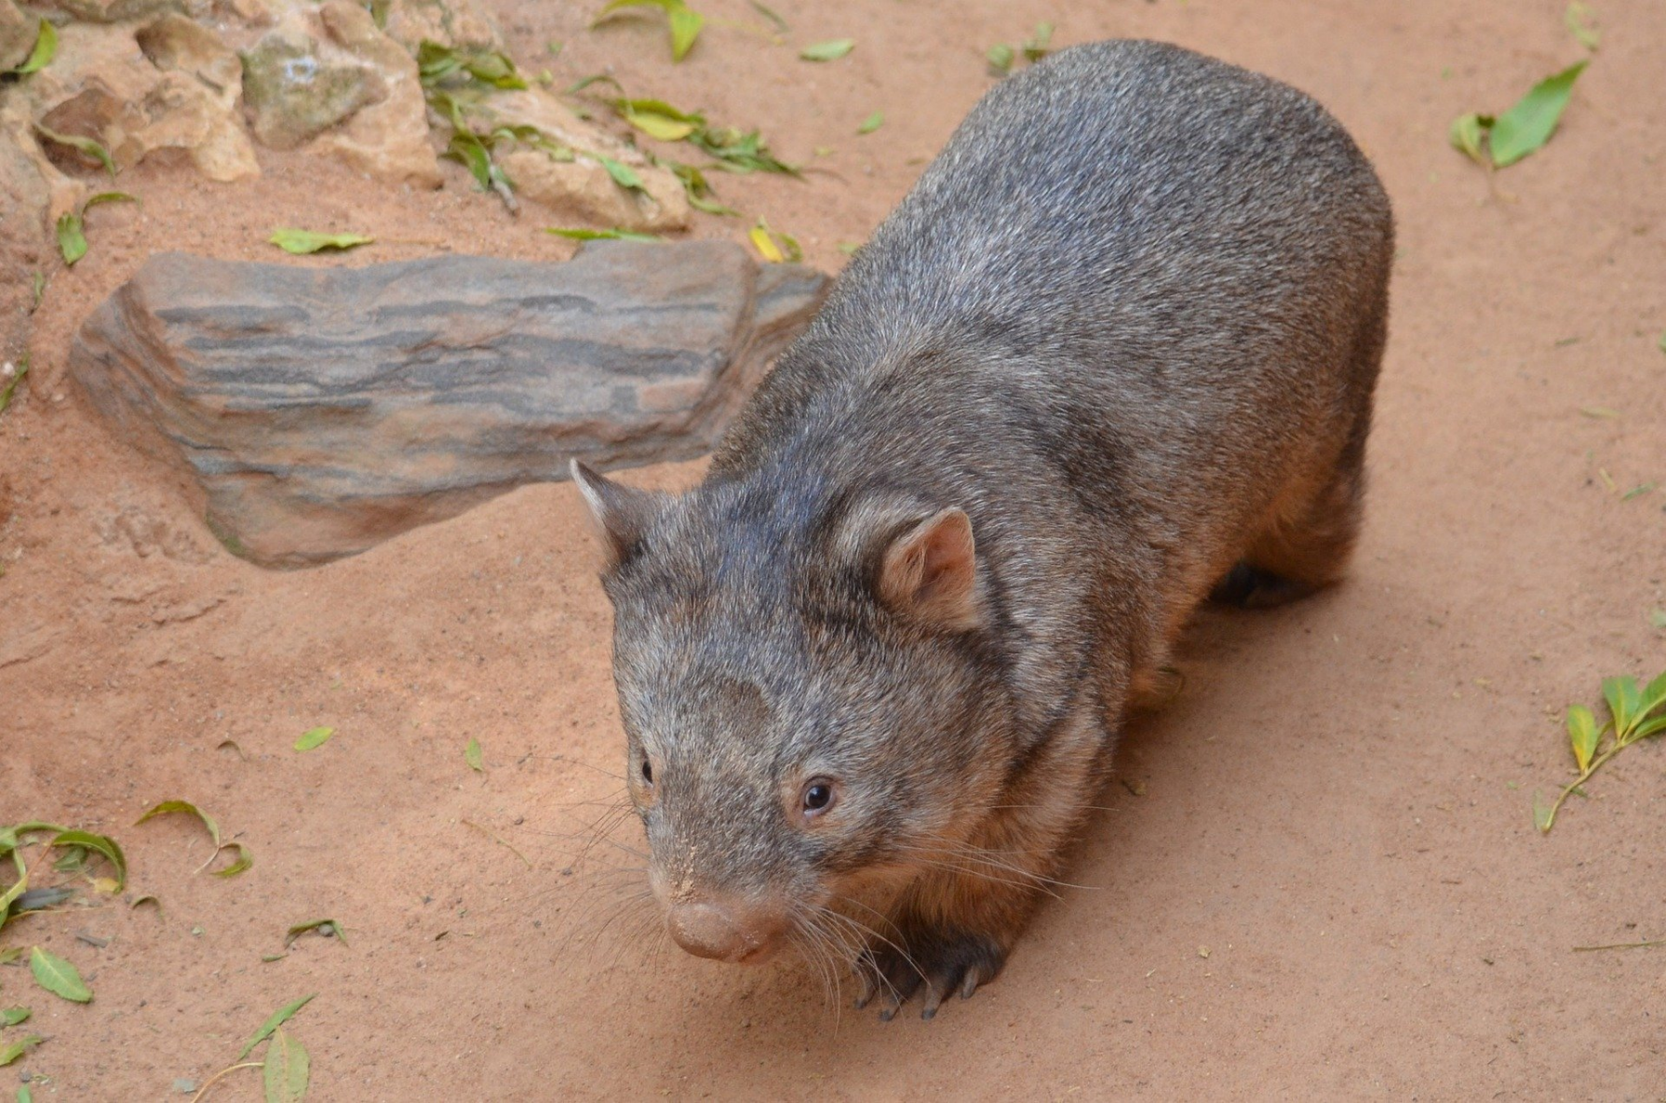
Figure 1 Wombat licenced under a CC0 license.

Activity
Students design a solution to a simple problem from a storybook: to design an environment for a visiting wombat. They identify the characteristics of a living thing – a wombat - a character in ‘Diary of a Wombat’ by Jackie French. They apply their knowledge of the needs and behaviours of living things. Students use everyday language of measurement to describe their environment solution.

Syllabus outcomes
Science and technology:
- STe-2DP-T – develops solutions to an identified need
- STe-3LW-ST – explores the characteristics, needs and uses of living things
- STe-4MW-ST – identifies that objects are made of materials that have observable properties
Mathematics:
- MAe-1WM – describes mathematical situations using everyday language, actions, materials and informal recordings
- MAe-3WM – uses concrete materials and/or pictorial representations to support conclusions
Science and technology K-6 © 2017 NSW Education Standards Authority (NESA) for and on behalf of the Crown in right of the State of New South Wales.
Mathematics K-10 © 2012 NSW Education Standards Authority (NESA) for and on behalf of the Crown in right of the State of New South Wales

Context
This Early Stage 1 STEM activity may form a component of a character study from the picture book, ‘Diary of a Wombat’ by Jackie French. Prior to this activity, students may have participated in guided science investigations to identify the living things in their local environment, and their basic needs and characteristics. Through this activity, students will deepen their understanding of these characteristics and basic needs of the wombat and compare its needs to other living things.
Task duration – estimated to be 2½ hours, which can be delivered over a sequence of lessons

Learning experiences

Part 1 (20 mins)
Students are learning to:
- identify and explore familiar information and ideas during a discussion or investigation
- identify the characteristics of a wombat
- identify the needs of all living things

Learning sequence
As an introduction for the activity, students participate in a shared reading of ‘Diary of a Wombat’ by Jackie French.
Discuss with the students what they remember about the wombat. Create a shared list of words to describe it.
Sort the list into categories:
- what the wombat looked like
- things the wombat did
- things the wombat ‘thought’.
Ask the students to decide what things wombats really need:
- do they really need to scratch?
- do they need to dig?
- what were the things that wombats really cannot live without?
Guide the discussion to previous lessons on the needs of living things - food, air and water (although we never see the wombat drinking). Review the concept that these are common needs for all living things.
Discuss with the class why the wombat in the story got up to so much mischief. Why did he dig a hole? Predict the success of the tunnel that the wombat dug under the house as a good shelter.
Use the simple graphic organiser WWWWWH chart to record student response to who, what, when, where why and how about the wombat in the book.

Resources
- Wattle the wombat (1:00) video
- Wombat facts NSW Department of Planning, Industry and Environment
- Simple graphic organiser Digital learning selector

Part 2 (20 mins)
Students are learning to:
- describe and compare lengths and distances, and masses of objects using everyday language

Learning sequence
- Watch Wattle the wombat (1:00 min) add words to describe a wombat to the shared list.
Background information – Wombats have a large head, small eyes and ears, and a short, muscular neck. They have sharp claws and short, powerful legs. They are strong diggers.
- Share information about the wombat’s natural environment. Where do they shelter?
- Measuring a wombat and its tunnel.
Students use comparative language to describe features of a wombat.
- Wombats grow to about 1.3 metres in length. How big is that? Compare to the length of a student desk. Discuss using language of ‘longer or ‘shorter than’.
- A baby wombat is less than 3 centimetres long when it is born. How big is that? Compare to a toy or a jelly baby.
- A baby wombat stays in the pouch for about 7 months. How much time is that? Connect to a familiar event such as ‘until’ a celebration.
- Wombats can weigh up to 36 kilograms. How heavy is that? Compare mass to 2 children on a see-saw and a wombat at the other end. The wombat would still be heavier.
Students use comparative language to describe a wombat’s burrow.
- A wombat’s burrow might be 3 metres long. How long is that? Compare to the length of a whiteboard wall. Discuss using longer or shorter than.
- OR a wombat’s burrow can be 30 metres long. How long is that? Compare to the length of the classroom. Discuss using longer or shorter than.
- A wombat’s burrow can be about 50 centimetres wide. How wide is that? Compare to the gymnastics crawling tunnel. Provide opportunities for the students to crawl through and imagine this is the wombat’s tunnel.

Resource
- gymnastics crawling tunnel

Part 3 (30 mins)
Students are learning to:
- share understanding of the terminology within the driving question
- pose questions and wonderings related to the problem based on their interests and life experiences
- use imagination to create and make simple connections between ideas
- record and model design ideas.

Learning sequence
- Share the information about the author, Jackie French, regarding her love of nature, her garden and the wombats that visit it.
- Encourage the students with the design challenge scenario: imagine that you live in a part of Australia where wombats freely wander; your family has a big backyard with lots of garden spaces for growing flowers and food – perhaps carrots; with lots of trees and lots and lots of native grasses.
- Introduce the driving question: How can I design an environment for a visiting wombat?
- Discuss the terminology of the driving question: design, an environment, visiting, for students to gain understanding and clarity.
- Develop and record ‘I wonder …’ statements together about wombats, environments, living things, display on your STEM Wonder Wall.
- Distribute mini whiteboards. Students draw a quick solution to the design challenge - record the solutions with digital camera.
Prompt questions:
- How does your idea work?
- Does your idea match the things we know about wombats? (characteristics)
- What is special about this idea?
- Why did you include …
- Does this environment give a wombat everything they need?

Resources
- Living with wildlife Jackie French
- STEM Wonder Wall
- Mini whiteboards
- Teacher – digital camera

Opportunity to monitor student progress
- Discuss – Does a burrow give the wombat all it needs to survive?
- Ask students to turn and talk with their thinking partner about their wombat environment. Partners share their thoughts about the ideas.
- Pose questions
  - Do you agree with what your thinking buddy said about your idea?
  - Will you change your ideas now? How?
- Using mini whiteboards, students redesign their wombat environment from feedback.

Part 4 (30 mins)
Students are learning to:
- observe and describe some properties of materials
- identify and model a simple solution to a problem.

Learning sequence
- Take students for a walk to find and identify different types of materials in the playground.
- Collect a variety of items and, without any direction, ask students to classify them.
- Discuss the strategies – perhaps by colour, perhaps by location found, perhaps by use.
- Collect all items and ask students to classify by what they are made from: wood, metal, paper, plastic.
- Discuss how the materials look and what they feel like.
- Discuss with the students the materials they may need to create a model of their wombat environment: cardboard cylinders (for tunnels), sticks, dirt, grass, playdough, cardboard (for model base), glue …
- Question students regarding their choices focusing on the properties of the materials or what they represent. For example, the cardboard cylinder represents the space the wombat may dig out or the earth; the cellophane represents the water in the pond.
- Students work individually or in pairs to construct a solution which solves the problem: an environment for a visiting wombat that supplies their needs

Resources
- found materials from the playground
- making resources – cardboard for model bases; paper for construction; glue; playdough
Note – collect lots of cardboard cylinders

Opportunity to monitor student progress
Video record the solution on digital device

Resource
- Digital device

Part 5 (40 mins)
Students are learning to:
- share design solutions with peers and family
- communicate their ideas clearly

Learning sequence
Organise a showcase display of the student’s work at school. Encourage students to prepare for the day by:
- rehearsing how to explain their design to invited family and guests
- rehearsing how to explain the links to science and technology, engineering and mathematics in their solution
Students may be able to design invitations and set up special STEM display space.

Resources
- students’ models of wombat environments
- photographs displayed of model iterations.
Teacher notes: Creating a wombat-friendly garden
All images from CC0 Pixabay

