Physics Module 3: Waves and Thermodynamics

Table of contents
Physics Module 3: Waves and Thermodynamics 1
Table of contents 2
Acknowledgements 3
Course overview 3
Teaching the Year 11 Modules 3
Module summary 4
Inquiry Questions 5
Big Ideas 7
Observation and measurement 7
Models and representations 7
Relationship to other modules 12
Core Concepts 15
Opportunities for extending concepts 15
Musical instruments 15
Optical instruments 15
Water pearl science 16
Simple Harmonic motion and Hooke’s Law 16
The physics of sidewinder snake movement 16
Herschel’s infrared experiment 17
Misconceptions 18
Suggested teaching strategies 20
Wave Properties 21
Sound Waves 24
Ray Model of Light 33
Thermodynamics 41
Appendices 46
Appendix 1: Wave demonstrations 46
Appendix 2: 3Blue1Brown 46
Appendix 3: Inverse-square law 46
Appendix 4: Snakey sine waves 48
Appendix 5: Simple Harmonic Motion 49
Appendix 6: Resources on active-learning approaches to teaching physics: 51

Acknowledgements
All images and diagrams, unless otherwise stated, have been produced by the authors of this document.
NSW Physics Syllabus © NSW Education Standards Authority (NESA) for and on behalf of the Crown in right of the State of New South Wales 2017.
Science Years 7–10 Syllabus © NSW Education Standards Authority (NESA) for and on behalf of the Crown in right of the State of New South Wales 2018.

Course overview
Year 11 physics offers students the opportunity to observe and measure a wide range of physical phenomena in the world around them including motion, mechanical interactions, mechanical waves, geometrical optics, heat transfer, electricity, and magnetism. Students learn to describe and make sense of these phenomena in terms of a limited number of physical laws.
These include:
- fundamental interactions (forces) between matter particles such as gravity and electric and magnetic forces, as well as
- laws which govern how these interactions change the motion of particles and systems of particles, including Newton’s three laws of motion, and conservation laws such as conservation of energy, linear momentum and charge.
Students strengthen and communicate their understanding using a range of representations including descriptions, diagrams, graphs and mathematical models.

Teaching the Year 11 Modules
Students begin senior physics with substantial experience of the world around them and, as a result, have developed explanations to make sense of their observations. Some of these beliefs may be inconsistent with accepted physics, for example the idea that objects tend to naturally come to rest in the absence of a force, or that there is no gravity in space. Due to the apparent explanatory power of these ideas in students’ everyday experience (they see objects consistently come to rest and know that astronauts float in the international space station), these misconceptions (also known as ‘alternate conceptions’ or ‘common naïve conceptions’) can be quite resistant to change. To shift these existing conceptions, it is necessary that students find the explanations which physics provides for everyday physical phenomena more convincing than their own existing beliefs.
Physics education research has established that ‘traditional’ instruction styles in which students watch and listen to an exposition of physics theory, complete ‘cookbook’ style practical investigations and textbook problems which emphasise calculations and equation manipulation, are substantially less effective at improving students’ conceptual understanding of physics than ‘active learning’ approaches (Hake, 1998). These approaches are characterised by students’ active participation in constructing meaning, and results in a substantial gain in student conceptual understanding, approximately double that obtained from a ‘traditional’ approach (Hake, 1998).
Active learning activities which promote interactive engagement will generally:
- encourage students to actively express their thinking about physical phenomena in verbal or written form, or via other representations such as diagrams, graphs or mathematical models (rather than passively listening, copying or following directions in practical work without thinking critically about what they are doing)
- involve receiving immediate/interactive feedback about their thinking from peers, a teacher and/or their own observations
- utilise (as far as possible) real physical systems which require students to make observations and measurements, as well as making decisions about the most appropriate way to analyse (model and represent) these observations
- encourage students to reflect on their own thinking and how the physics they are learning ‘fits together’ as an interrelated and coherent whole
- value and check for conceptual understanding in diagnostic, formative and summative assessment.

Module summary
This module examines the nature and behaviour of mechanical and electromagnetic waves in a variety of contexts and situations. Like waves, thermodynamics deals with transfers of energy.
Students’ conception of waves is developed by describing various waves as electromagnetic or mechanical, transverse or longitudinal, and examining the various properties of simple waves. Phenomena such as reflection, refraction, diffraction, superpositi345on and resonance are introduced. These concepts are then examined within the context of sound alongside an introduction to beats and the doppler effect, and in the context of light alongside Snell’s Law and the Inverse Square Law for light.
Thermodynamics examines the transfer of thermal energy, making use of the particle model of matter to understand heat in terms of the kinetic energy of particles. This is then extended through the concepts of specific heat capacity, thermal conduction and latent heat.

Inquiry Questions
Wave Properties: What are the properties of all waves and wave motion?
After this inquiry question, students should understand how energy is transferred across a medium by both longitudinal and transverse waves. They can construct and interpret the graphical representation of waves from both 1st hand and secondary data sources. Apply the wave equation ($v=fλ)$ to solve a range of problems from a wide range of situations. Practical investigations form a solid foundation in which students can build these ideas and creating links to real-world applications is vital.
Wave Behaviour: How do waves behave?
Students should be confident in recognising distinct wave behaviours observed in primary investigations and secondary data sources. Through observing wave phenomena and researching students should develop a depth of understanding in recognising wave properties in the world around them.
Sound Waves: What evidence suggests that sound is a mechanical?
Investigating sound waves allows students to explore wave properties through observation and to draw on their everyday experiences. Studying sound waves requires students to develop their skills in using a variety of instruments for observing and measuring, including oscilloscopes, data loggers, mobile phone apps such as phyphox, and software such as Audacity. Opportunities exist to study the science behind musical instruments and focus on the creation of standing waves and their properties.
Ray model of light: What properties can be demonstrated when using the ray model of light?
This first opportunity to investigate light provides vital foundational understanding for further modules in the Stage 6 Course. Investigating light’s interactions with lens’s and surfaces can engage students in explaining real-world phenomena using scientific models. Through observation and measurement, students will have the opportunity to assess gathered data and evaluate their predictions. Students will also gain valuable experiences in using a wide range of equations to predict/solve outcomes from a range of scenarios.
Thermodynamics: How are temperature, thermal energy and particle motion related?
This topic has strong links with the Stage 6 Chemistry course. Students will observe and measure heat transfers and explain them using a particle model. Investigating latent heat supports student understanding of the conservation of energy and the importance of defining the system when problem solving. This inquiry question also presents an opportunity to discuss and challenge misconceptions that are linked to students’ everyday lives through experimentation and secondary research.

Big Ideas

Observation and measurement
This module continues to develop student understanding of the importance of accurately measuring the world around them to better understand the phenomena at play.
The syllabus requires students to measure the loudness of sound, though there is no explicit requirement for students to understand decibels and the nature of log scales in great depth.
Investigating resonance, specific heat capacity and latent heat are excellent opportunities to develop the concept of indirect measurement in this module.
The value of technologies that enable real-time measurement and feedback can be emphasised in the sound topic, with students benefiting from an ability to quickly measure frequencies using oscilloscopes or apps such as Arduino Science Journal. Audacity allows for spectrum analysis to determine peak frequencies but also allows for many qualitative demonstrations.
Linking theoretical predictions to experimental observations made from ray traces when using lenses, measurements of critical angles and refractive indices of various materials. Classroom discussions can centre around accuracy, consistency, and the validity of gathered data.
The use of measurement technologies including thermometers and data loggers if available will help students gain valuable insights into the transfer of energy and allow them to test their ideas. By designing and conducting well thought out experiments, ideas about the transfer of energy through mediums can be tested. Water heaters, cooling systems and cooking methods are all familiar contexts in which students can observe, measure and discover.

Models and representations
The use of models in science is central in developing students understanding of waves and the transfer of energy in systems. Students are exposed to many technologies which utilise waves but visualising what is happening is often difficult. Modelling the formation of waves, showing the relationship between matter movement and energy transfer, and the formation of standing waves all help in consolidating students learning.
Using ray diagrams to represent waves allows students to visualise physical phenomena and allows them to make clear connections between theory and real-world situations. The ability to assess the effectiveness of models is an important skill for students as they begin investigating interactions that cannot be directly observed because of the scales of space and time in which they occur. The ability to create good representations of physical phenomena will help students understand the more abstract concepts in the Stage 6 Physics course.

Energy flow diagrams and work-energy bar charts
Energy flow diagrams (EFDs), together with Work-energy bar charts (WEBCs) are representations that students can use to analyse interactions using conservation of energy or work-energy approach (depending on their choice of a system). They assist students in reason and solve problems involving energy in a manner that is analogous to the way that free body diagrams facilitate solving problems involving forces.

Energy flow diagrams
Energy flow diagrams make the choice of system explicit, as well as providing a means to represent and distinguish an energy flow into/out of a system from energy transformations that occur within a system.
A circle is drawn which encompasses all objects that are to be included in the system to be analysed. Any objects outside the circle are part of the “environment”. Arrows inside the circle represent energy transformations within the system, while arrows crossing between the environment and the system represent energy transfers to or from the system. An example EFD is shown in
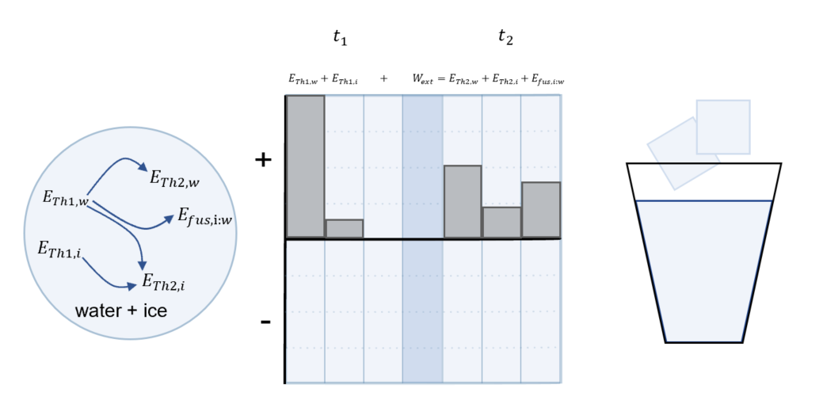
Figure 1: (Left) Energy flow diagram and (centre) work-energy bar chart for a piece of melting ice, with water and ice chosen as the system. (Right) At time $t_{1}$ the ice (initial temperature $=-18℃$) is added to the water (initial temperature is $=50℃$). At time $t_{2}$, the system has reached thermal equilibrium. Diagram adapted from Perimeter Institute: A Deeper Understanding of Energy.

Work-energy bar charts
A work-energy bar chart represents the initial energy stored in a system as a series of bars on the left side of the diagram, each labelled with a form of stored energy (for example gravitational potential energy, potential energy due to the compression of a spring, kinetic energy, mass-energy, chemical energy, heat/thermal energy). The height of each bar on the left represents qualitatively the amount of each type of energy stored in the system initially (at time $t_{1}$). The shaded bar in the centre is used to represent energy flows into or out of the system between the two times considered, for example, due to external work done on the system. The columns on the right represent the energy stored in different forms in the system at the time $t_{2}$. Note that the zero point for energy is arbitrary, and only changes in how much energy is stored in each form are physically significant.
Work-energy bar charts can also be drawn “split” so that the bar chart showing how energy is stored in the system before the energy transfer and/or transformation is shown on the left of the Energy flow diagram, and the bar chart showing how energy is stored in the system after the transfer/transformation is shown on the right. Drawn in this manner they are known as “LOL” diagrams.
Energy conservation requires that the total initial energy stored in the system + energy flows in or out = total final energy stored in the system.

Resources: energy flow diagrams and work-energy bar charts
- “Visualising Energy”( https://www.hschub.nsw.edu.au/science-items/visualising-energy). Hosted on the HSC hub and designed for NSW physics teachers, this video workshop from the Perimeter Institute introduces the value of using energy flow diagrams and work-energy bar charts and examples for how they can be used.
- “A deeper Understanding of Energy” (https://resources.perimeterinstitute.ca/products/a-deeper-understanding-of-energy) written resource from the Perimeter Institute explaining in detail how this representation can be used for a broad range of examples. It includes many ideas for hands-on learning activities to explore energy conservation with students in a range of contexts.

Interactions
Waves involve transfers of energy. In sound waves, the energy transfer can be considered in terms of physical interactions between the many particles that constitute the medium. A simple demonstration to visualise the movement of air particles involves burning a birthday candle in front of a sub-woofer and watching the flame shift both forwards and backwards, showing that the air particles oscillate in position. This particle level treatment is distinct from the more macroscopic demonstration of compressions and rarefactions achieved with a Rubens tube.
In thermodynamics, energy transfer is considered in terms of conduction, convection and radiation. Conduction and convection are similar processes, both involving the storage and transfer of heat energy within and between warm objects.
Radiant heat (that is, energy transfer via radiation) is quite distinct from these other processes and instead shares many of its characteristics with light.
Von Baeyer describes this differentiation as follows and goes on to highlight its importance, along with differentiating between heat and temperature in shaping our understanding of thermodynamics.
“The fact that warm matter pours out infrared radiation does not imply that warmth is stored in the form of radiant heat any more than that the light emitted by a candle is originally stored in the wax, or that the sound of a bell was once buried in the metal. Stored heat is, in fact, entirely different from radiant heat.”
Conduction can be considered as a process at the particle level where each particle interaction can exchange thermal energy. Students may be more familiar with conduction in solids; conduction in liquids can easily be modelled by resting a test tube of cold water in a beaker of hot water. Monitoring the temperature of each should show that the energy required to heat the cold water came from the thermal energy of the hot water (if the masses of the two water samples are known the equilibrium temperature can be predicted).
Convection too should be considered as an interaction at the particle level. The process can be considered in terms of both liquids and gases. A simple demonstration involving two coloured water of different temperatures can be used to show that warm, less dense water will move upwards and this is linked to the behaviour of the molecules.
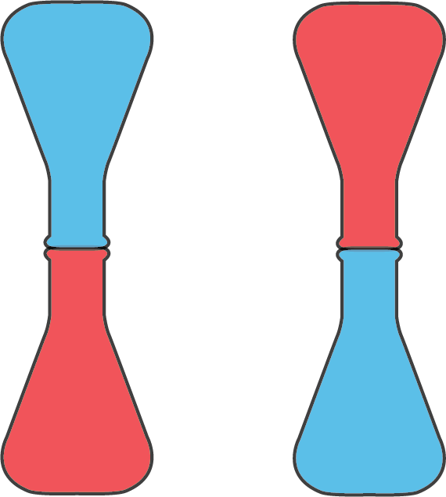
Figure 3: Two flasks with two different temperatures represented red as warm and blue as relatively cooler. The diagram on the left indicates the warmer water on the bottom and on the right it has moved to the top flask.
It can be difficult to investigate radiation in isolation as hot objects will lose heat by convection into the surrounding air. Involve students in a discussion of how to limit convection, for example by conducting a radiation experiment in a vacuum jar. Consider the implications of this concept for cooling electrical components in space where convection cooling would be ineffective.

Systems and conservation
Investigations in thermodynamics provide valuable opportunities for students to explore conservation of energy and work-energy concepts. The investigation of latent heat allows for the nature of the closed system to be highlighted. For example, when ice is melted using the heat energy contained within warm water, the system can be considered closed.
If a spirit burner is used to provide heat energy, some discussion is warranted regarding whether the burner is considered part of the system and the chemical energy of the fuel acknowledged, or if the system is better conceived as receiving energy from an outside source (work done on the system).
Radiation can be investigated by considering the Earth as a system, we can see incident energy from the Sun and energy re-radiated by the Earth in terms of equilibrium. When the incident radiation exceeds the re-radiated energy, the system has a net gain of thermal energy. This can be linked to the insulating effect of greenhouse gases as well as the compounding reduction in emissivity due to receding ice caps. It is useful at this stage to introduce the general concept of black body radiation as it helps cultivate a richer understanding of radiation, and will also make this concept more familiar when encountered in Modules 7 and 8.

Relationship to other modules
Connecting ideas across modules play an important part in developing students understanding of how scientific knowledge is interrelated. The idea of a body of scientific theories, models and laws do not sit as individual silos but rather connect to create a web is important in science. In teaching modules, the skills and content being taught must be consistently linked to assist in deepening students’ understanding. The flow charts below highlight some areas of connections.
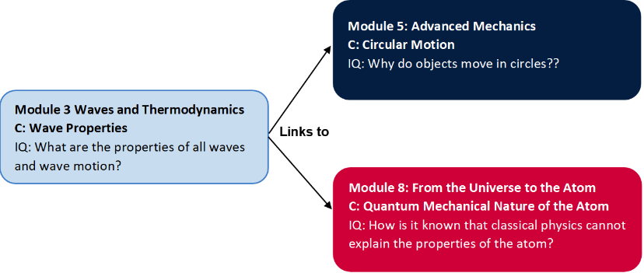
Figure 4: Module 3, Wave properties in the preliminary course has content and skills which link to both module 5 and 8. Circular motion and Quantum nature of the atom.
How does it fit?
Waves and the motion of satellites are both periodic phenomena. As such, they share a common language for describing and modelling their features. Students will further develop and apply their understanding of frequency, period, and speed in Module 5.
Students will use the wave equation in Module 7 & 8 when solving problems as it describes the relationship between frequency and wavelength.
Students should be confident in converting and applying relevant units for wavelengths of light (for example, using nm and/or scientific notation)

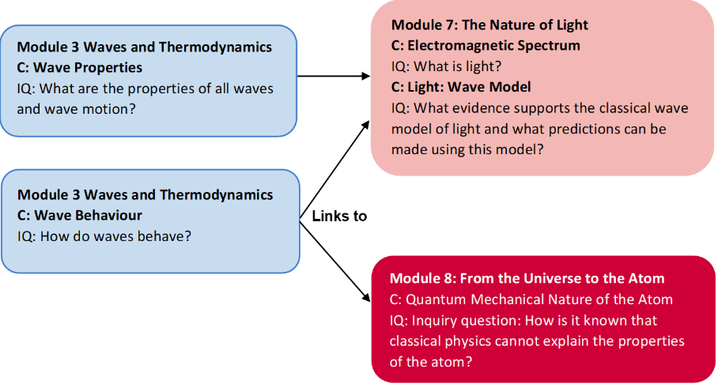
Figure 5: Module 7 has links back to both Wave properties and wave behaviour from module 3. Whilst Model 8 draws links into module 3 wave behaviour.
How does it fit?
The classical theory of electromagnetism explains the production and propagation of light using a wave model. Wave behaviour + Wave properties provide the foundational understanding of Maxwell’s work in Module 7.
Superposition and diffraction play a vital role in understanding interference patterns and being able to analyse results from single and double-slit experiments.
Early quantum models of the atom in Module 8 (de Broglie) apply a wave model to the electron and explain the quantisation of electron energy levels through the formation of standing waves.

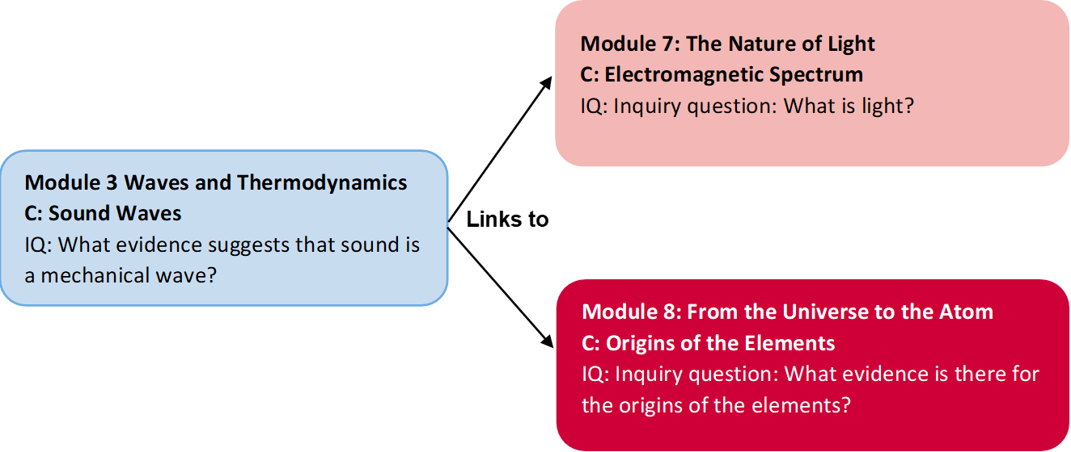
Figure 6: Module 3, sound waves provides good foundational links to both module 7: electromagnetic spectrum and module 8: Electromagnetic spectrum.
How does it fit?
The Doppler effect is used to interpret some features of star spectra and provides information about the motion of a star in module 7. (Note: For light and other electromagnetic waves, the relationship must be modified to be consistent with the Lorentz transformation)
Understanding the Doppler effect will help students grasp the evidence leading to Hubble’s discovery of an expanding universe in module 8.

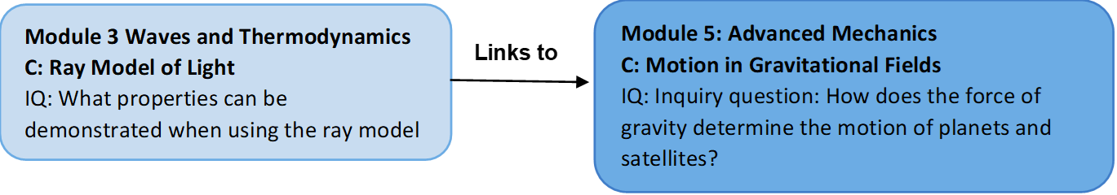
Figure 7: Module 3: ray model of light provides links into better understanding some concepts in Module 5: Motion in gravitational fields.
How does it fit?
An understanding of the mathematical relationship presented in the inverse square law between variables can be utilised to explain other phenomena which have the following relationship.
$$y= \frac{1}{x^{2}}$$
This includes gravitational fields.

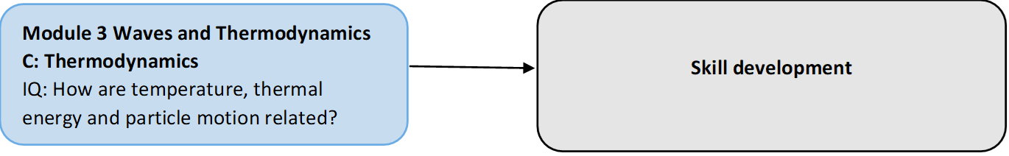
Figure 8: Module 3: Thermodynamics opportunities to develop skills which are linked across all aspects of the course.
How does it fit?

Systems, conservation of energy and work-energy theory are powerful concepts in Physics. They are valuable in unpacking, clarifying, or simplifying complex scenarios that involve energy transfer.

Having students critically engage with a range of unfamiliar systems engages their analysis and problem-solving skills to form ideas and conclusions.

Core Concepts
Waves and Thermodynamics allow students to apply their skills of observation, measurement and the use of models to understanding the world around them which may be invisible to them. This module continues to build students understanding of working scientifically skills from modules 1 and 2, as they learn new content. Understanding of basic wave properties and behaviour, build the first steps of students understanding towards their journey of understanding the Quantum nature of the atom and we have built our understating of not only the world we live in but to our place in the universe.
In your Teaching of Module 3, it can be a good idea to start drawing links with future modules to show the relevance of the learning taking place in the context of the whole Stage 6 course. A continued focus on skills whilst learning new content should start building students’ capacity to link ideas across modules and start creating an idea of the scope of physics in understanding phenomena and changing ideas based on evidence.
When teaching inquiry question 5 a basic introduction to the Laws of Thermodynamics can provide valuable background for students. The links below showcase these laws and could provide context to the learning which will take place during the lessons. Whilst not required, it provides a good level of perspective to the learning which will take place and help students see the relevance of developing this understanding to their surroundings.
These links below can be a series of short introductory YouTube clips into the module.
What is the Zeroth Law of Thermodynamics?
What is the First Law of Thermodynamics?
What is the Second Law of Thermodynamics?
What is the Third Law of Thermodynamics?

Opportunities for extending concepts

Musical instruments
An investigation into the physics of the design of a range of musical instruments (wind/string) presents an opportunity to research the mathematical relationships which dictate their design.
- investigate and model the behaviour of standing waves on strings and/or in pipes to relate quantitatively the fundamental and harmonic frequencies of the waves that are produced to the physical characteristics (eg length, mass, tension, wave velocity) of the medium (ACSPH072)
Activity 7 under teaching strategies has a basic outline of how this activity can be used in the classroom.

Optical instruments
Students can gain an in-depth understanding of lens and reflective surfaces by measuring key properties for a range of curvatures (focal lengths). Students can use a combination of the lenses to the construction of basic telescopes based on calculations. Extension activities can introduce calculations of magnification and verify a range of mathematical models used in the construction of optical instruments. (Lens Formula & Magnification)
- conduct a practical investigation to analyse the formation of images in mirrors and lenses via reflection and refraction using the ray model of light (ACSPH075)
Activity 11: Constructing a telescope has a basic outline of how this activity can be used in the classroom.

Water pearl science
Water pearls are superabsorbent polyacrylate beads that can expand about 200 times when submerged in water. They are an excellent tool for investigating refraction in the classroom. Instructions for introductory class investigations are provided in this AAPT Optics collection Digikit.
The Milner-Bolotin article that inspired this resource outlines some challenges that students could attempt, for example:
- Devise water pearl experiments to illustrate how images are created. Construct ray diagrams and describe each of the images created.
- Predict how the focal distance of the water pearl lens will change when submersed in vegetable oil. Device an investigation to test your prediction.
- Devise an experiment to investigate how the curvature of the lens affects its focal distance.

Simple Harmonic motion and Hooke’s Law
Investigating simple harmonic motion and Hooke’s laws provide a great opportunity to connect to the Mathematics course. Especially if students in the class has a cross over with the Mathematics Extension 2 course. This will expose students to the role both physics and mathematics play in describing natural phenomena.
By proposing a question to students and focus the lesson around inquiry, students can investigate simple harmonic motion and Hooke’s law and go beyond the syllabus.
For example, students can focus their inquiry around ‘What factors influence the motion of an object that has a repeated or periodic motion?’
A suggested model to approach this activity can be found in appendix 5

The physics of sidewinder snake movement
The role of physics in the wider scheme of understudying the world around us and how it links across different disciplines is of great development of a student’s ability to link abstract ideas.
Mathematics’ is the obvious link to physics and one student would be familiar with. In this activity students are using their understanding of waves to help explain the motion of a sidewinder snake. An outline of this activity can be found in appendix 4
A Teaching and learning focus within the course, to the real world and other disciplines, better prepare students to analyse and apply their understanding to unfamiliar situations. A vital skill in the Stage 6 course and for future endeavours.

Herschel’s infrared experiment
William Herschel’s discovery of infrared radiation in 1800 can be recreated in the classroom using readily available equipment. The experiment makes use of a prism to disperse sunlight and thermometers to measure the radiant heat transferred by its visible, UV and infrared components. Instructions for Herschel’s infrared experiment and background information can be found on the Institute of Physics (IOP) website.
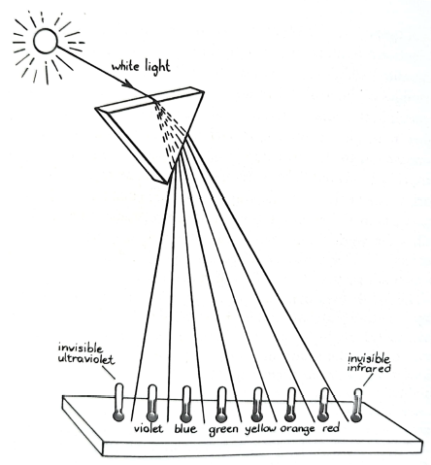
Figure 9: A model of Herschel’s infrared experiment. Image credit: von Baeyer, H. C. (1984). Rainbows, Snowflakes, and Quarks: Physics and the World Around Us. McGraw-Hill.

Misconceptions
Changing a student’s pre-understanding of phenomena or a misconception has to be addressed sensitively in class. Instead of challenging a belief a possible approach is to showcase the phenomena and then ask probing questions. This cannot guarantee a change in mindset but it allows a student’s understanding to be interrogated by themselves and others.
The table below has some common student misconceptions relating to Module 3 and presents possible strategies to open up conversations regarding their observations.
Possible Misconception | Stage 6 observation | Strategy/ Question
The energy of the waves is carried by particles that move steadily with the wave front | Creating waves in slinkies  Observation of water waves in a ripple tank (floating cork or linked to surfers waiting) | Ask students to record observations linked to a single particle. In their observation and linked movement between particle motion versus energy direction
When you open the door do you let the cold air in or does the heat escape? | Two different temperature liquids (one above room temperature and one below) and record temperature changes until equilibrium. | Have students explain the observations and link them to the direction of movement of heat energy.  Ask students if they leave the door open on a hot day, is the cold air moving out or hot in, how can they investigate this?
Conceptual difficulties
Content | Strategy/s
Mechanisms behind the refraction and diffraction of waves | Refraction – using the analogy of a row of soldiers walking in a row on grass approach heavy muddy ground at an angle and how their ‘speed’ would change is a good analogy to help student’s visual refraction.  GCSE Science Revision Physics "Refraction of Waves" - YouTube  Diffraction – using Huygens representations of the creation of wavefronts can help students visualise how waves ‘bend’ around objects.  Wave Diffraction - YouTube
Inverse square relationship | A visual representation of the relationship between the radius from the source and surface area covered in conjunction with the mathematical relationship can help students understand why it is a squared relationship.  Appendix 3: visual representation of energy spread over an increasing area.  Activity 9  Physics 8.1.03a - The Inverse Square Law - YouTube
Distinguishing between thermal and kinetic energies, heat and temperature | Ensure in teaching activities the correct terminology is used regularly and an emphasis brought to it. This for EAL/D students can include the creation of a glossary list which is used in conjunction with a formulae sheet when answering questions.  Consider creating a concept map including these terms and the relationships between them.  Misconceptions About Heat - YouTube  Misconceptions About Temperature - YouTube
Everyday usage of thermodynamics terms. For example, heat, heating and cold. | A teacher leads a discussion regarding the metalanguage specifically used in physics e.g. deacceleration versus acceleration in Module 1. Questions centred around what is cold and why isn’t the term relevant in thermodynamics is a good conversation starter.  There's No Such Thing As Cold - YouTube
Superposition of waves | Students observe and record changes in the waves as they interact and provide reasons on why the change has happened?  Listening to two different frequencies of sound independently and when together. Questions directed around is there a new source of sound why are they hearing something different?

Suggested teaching strategies
Students should be familiar with a basic understanding of waves for their study in Stage 4 & 5.
A good activity before starting a new module is to gain an insight into students prior understanding and develop a sense of any misconceptions they may have regarding the new content. This can be achieved via an informal assessment of their prior learning by a short topic test based on their Stage 5 work, a Kahoot styled lesson, creating concept maps based on their previous work or a traffic light activity in were students highlight content points of the new material as either green, amber or red (green indicated they have a good understanding, amber some understanding and red no understanding).
The importance of gathering this initial data will allow you to adjust your teaching and learning sequence to meet the needs of your class and use activities that will help your students succeed in building their knowledge and skills base.
A focus on modelling and analysing practical investigations is suggested in teaching Module 3 to allow students to interact with waves as a purely theoretical approach may not allow students to build a depth of understanding or test their ideas.
The following activities are some suggested examples to help students build their working scientifically skills whilst building their understanding of waves and thermodynamics.

Wave Properties
Inquiry question: What are the properties of all waves and wave motion?

Activity 1. Investigating waves; An introduction to waves.
Most texts books will have traditional methods for exploring waves using slinkies or ropes. This can be utilised as a small introduction to a lesson in waves highlighting the major features and explore how the external factors influence the created wave.
Most will have student’s layout a slinky on a smooth flat floor or standing up and create waves with the movement of one end whilst the other is fixed. Students should be able to reproduce waves as shown in figure 10 below.
This Photo by Unknown Author is licensed under CC BY-SA
Figure 10: a piece of rope oscillating to create a standing wave of 1 ½ wavelengths.
Utilising software such as Desmos should help students connect what they have seen to modelling software (Desmos | Beautiful, Free Math). This software is free to use (web-based) and resources can be incorporated into your teaching activities. A basic resource is provided below as an introductory lesson to the major features of waves using Desmos.
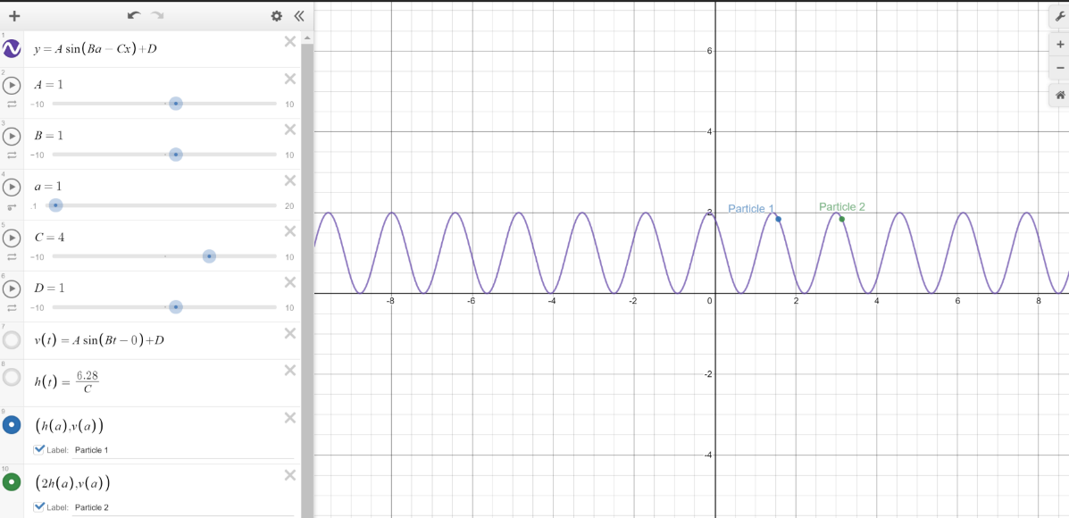
Figure 11. Shows a screenshot from Desmos software with a simple sin wave and the sliders on the right-hand side can be used to change the major features of the phone.
The variables in the slider control amplitude (A), movement in the x-direction (B), time (a), wavelength (C) and movement in the y-plane.
Students can draw comparisons between the slinky/rope demonstration and the wave they have generated or use the software to model their observations Their analysis can focus on learning the major features of the wave and the use of models in physics/science to increase our understanding of the world around us. Introduction wave properties in this manner will enable students to investigate the properties of waves and simultaneously develop skills in interpreting graphical information regarding waves.
YouTube contains a vast number of help guides in using Desmos if you would like to explore and further enhance your skills in this program to create more advanced lessons. Desmos - YouTube.
The mathematics state-wide staff room also offer a range of resources for DESMOS. (Statewide staffrooms)
Incorporating the wave equation could be sequenced into your teaching sequence depending on the capabilities of your students. The steps could be first; can students gather data from the information and then apply the wave equation.
Teacher notes
This activity is generally best completed as a demonstration. Having a pair of students create pulses at the front of the class room and discussions centred around their observations. Using modelling software such as DESMOS will help students further explore the wave equation. As this may be the first-time students have used such a program enough time and resources should be allocated for this lesson. Wave Behaviour
Inquiry question: How do waves behave?

Many of the wave behaviour inquiry questions can be completed in conjunction with practical activities in sound waves and the ray model of light. By specifically linking observable phenomena to light and sound waves can build students an appreciation of why the particle-wave model was such a significant change and also matter waves in electrons which are studied in Year 12 (Modules 7 & 8).
The section from the syllabus has been linked to the activities which can be addressed within other inquiry questions in module 3. The linking across modules and inquiry questions may benefit students to build connections between ideas. Teacher judgement regarding classes’ ability is used to either construct straight forward connections or more complex abstract ideas. In either case, building these skills are vital for students and even starting to make connections within a module can be built upon throughout their studies.
When connecting ideas across inquiry questions or modules, it is valuable to highlight these links and explain the connections. For example, when creating standing waves in a rope, the wave is reflected at the fixed point and returns half a wavelength out of phase from the original. The combination (constructive and deconstructive interference) create the observed wave pattern. In explaining the formation of standing waves multiple outcomes are connected.
Activity links
Students:
- explain the behaviour of waves in a variety of situations by investigating the phenomena of:
  - reflection (Activity 1, 2 & 5)
  - refraction (Activity 10 & 11)
  - diffraction (Activity 4)
  - wave superposition – (Activity 1, 2 & 5)
- conduct an investigation to distinguish between progressive and standing waves (ACSPH072)
- conduct an investigation to explore resonance in mechanical systems and the relationships between: (Activity 3)
  - driving frequency
  - natural frequency of the oscillating system
  - amplitude of motion
  - transfer/transformation of energy within the system (ACSPH073)

Sound Waves
Inquiry question: What evidence suggests that sound is a mechanical wave?

Activity 2: Standing waves (Standing Wave on Long Spring)
Figure 12 The picture below the formation of four different standing waves from the left; half a wavelength, complete wavelength, 1 ½ wavelengths and two wavelengths in the same length of string.
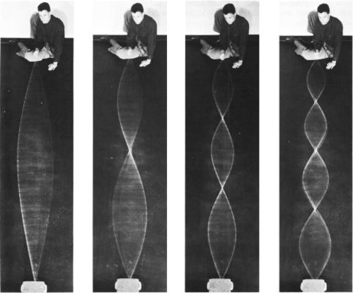
This Photo by Unknown Author is licensed under CC BY-SA-NC
This activity builds on the skills from Investigating waves; An introduction to waves. The first activity focused on identify features of a wave and know the focus is on studying the conditions which lead to a formation of a standing wave pattern.
A classic physics demonstration that holds much value in the modern-day classroom is the demonstration of standing waves in a long spring. Usually conducted with to people holding a spring/rope and either end, one holding their side fixed and the other providing the energy/movement. Alternatively, fix one side to an object such as a door handle (consider safety and suitability when tying spring to an object)
Building up to a creating of a standing wave could assist in students building their understanding. By sending a single pulse student should notice the wave reflected half a wavelength out of phase. A good question to ask at this point is what would happen if a continuous pulse was now applied.
To build depth of understanding it is best practice to have students record and suggest reasons behind their observations, such as; what is the shape of the wave? How much effort is being applied? What happens in between the stable wave formation? How is it being formed? Is there a pattern?
By taking photos or recording the creation of standing waves could form the basis of a classroom discussion. The analysis could show the reflection of the wave from a fixed point and the superposition between the initial wave and reflected (assuming consistent oscillation at one end).
It is difficult to create observable waves beyond the 3rd and clips and simulators can help, but this activity is a great initial point of investigation.
This video could be used to support students after they have had some time trying to creating waves Standing Wave Demo: Slinky - YouTube.
The following link is to a DESMOS simulation showing the interaction between two waves and the resulting wave formation due to the interaction. Standing waves (desmos.com)
Teacher notes
This activity can be completed in conjunction with activity 1. Initial exploration into wave properties extended into investigation the creation of standing waves.
By making accurate observations of the standing waves produced and noticing the ‘irregular' wave patterns in between may lead students to the mathematical relationship;
The standing wave that results must have a node at both ends of the string and the adjacent nodes are one half-wavelength ($\frac{λ}{2}$) apart,
$$λ_{n}=\frac{2l}{n} (n=1 ,2, 3,…n)$$
Using this model students may be able to test predictions made by the equation, students should also begin to understand the requirements and conditions necessary to form a standing wave.
It is important to highlight to students that there are necessary conditions for the creation of standing waves. A link can be made into musically instruments and the wave model of the atom depending on the ability of the class.

Activity 3: Resonant Rings
This Photo by Unknown Author is licensed under CC BY-SA-NC
Figure 13: five circle rings of various diameters sticky taped to a small rectangular piece of cardboard.
A good short introduction activity for resonance can be found in the following link Ring on the Resonance! - Scientific American. It is advised that this activity be used in conjunction with an extension activity focussed on student’s research skills and presenting their findings in a real-world context.
After conducting a practical investigation, students can research into the Millennium Bridge collapse (How Did Engineers Fix London's Wobbly Millennium Bridge?) or using sound to break wine glasses. Student-directed research in the context of resonance can also be done.
A scaffolded focus on research skills and building students capacity to link abstract ideas is vital for success in the course. By building a small research component modelling on skills required in a depth study is a good opportunity to build their skills either for a depth study assessment or make refinements after feedback if they have completed one.
Teacher notes
This activity can be used as a singular point in time or introductory investigation for a research project. Student could be given the resonance device and asked to make sense of what they see and how it relates to the ‘real world’. This will challenge students into explaining unfamiliar observations in the context of their learning.

Activity 4: Observation of diffraction
Diffraction is another wave behaviour that is observable in both sound waves and light waves. Diffraction of light can be examined using diffraction gratings, single slit and double-slit interference patterns with an optical bench if desired, and this may assist in Module 7 when students are asked to quantitatively analyse interference patterns from double-slit apparatus. A ripple tank is a very effective way of demonstrating the diffraction of mechanical waves and the use of this as a model may help students better understand diffraction in sound waves.
If a wave tank is unavailable small clear plastic tubs can be utilised with a light source above and students observe the shadows below. A small block with a simple handle can be used to create disturbances in the water and objects placed in the path of the created wave. This method is not perfect but should be able to demonstrate simple diffraction patterns and start conversions regarding errors. A simple outline of an investigation can be found using the following link Activity: Wave Patterns in a Ripple Tank
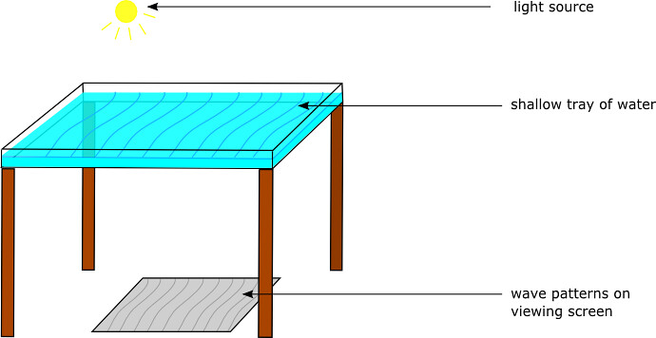
This Photo by Unknown Author is licensed under CC BY
Figure 14: A pictorial representation of a shallow tray of water below a light source. Shadow of wavefronts is shown on the ground below from the water.
The simulator from phet could be an easier alternative if access to reliable technology is available. ﷟ Wave Interference‬ (colorado.edu)‬‬‬‬‬‬‬‬‬‬‬‬‬‬‬‬‬‬‬‬‬‬‬‬
Teacher notes
Whilst simulations and diffraction of light demonstrations are helpful in visualising the end ‘diffraction pattern’. The use of a wave pool can help students visualise the complete process. If a wave pool is unavailable the use of clips from the internet are also a great visual aid. Lesson 2 - Water Waves - Diffraction - YouTube

Activity 5. Waves on a string (PhET)
Using the pHet simulation waves on a string (Wave on a String - Waves | PhET Interactive Simulations) allows for some inquiry lessons which can embed a focus on working scientifically skills.
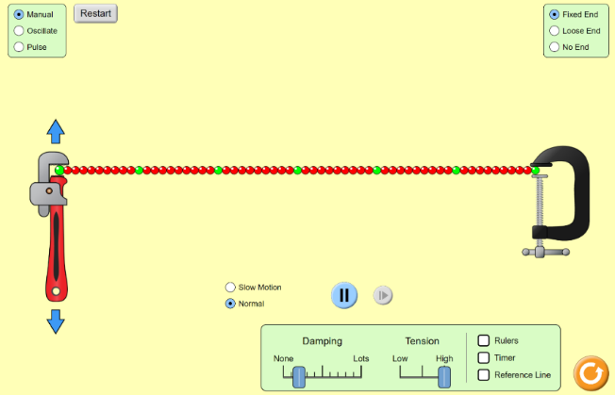
Figure 16: A screenshot of the pHet simulation waves on a string. It has string represented by beads that can be oscillated and students can change variables such as tension, damping, type of oscillation and take measurements.
Students could be to hypothesis how changing tension, damping or oscillation force/rate would impact the generated wave and provide the reasoning behind their thought process. The simulation allows to measure simple wave properties and students should be able to gather data, for example, wavelength, amplitude etc.
To build skills into this activity students could go further into designing a physical experiment within the limitations of the resources available to them. Leading students through the design process and methodology of scientific experimentation can provide an opportunity for extension.
Analysis and evaluation of their gathered data compared to trends identified in the simulation could help build their critical thinking skills. Linking this understanding to stringed instruments to engage students based on their interest and allow more opportunity to real-world applications. Also, would give the chance to work across inquiry questions (wave behaviour and sound waves) to cover the course efficiently if time is becoming an issue without compromising students learning in year 11.
PhET does contain a ‘for teacher section’ and there are resources linked to the simulation. These activities would need to be evaluated and a decision made regarding their suitability to your class.
Teacher notes
The simulation can be used as a great modelling tool for students to investigate wave properties. Students should be encouraged to gather data from the simulation. If access to string instruments is available, students can apply their investigation to relating frequency to tension in guitar strings as seen in the link provided Standing Waves on a String (gsu.edu)

Activity 6: Using audacity to study sound
The Doppler effect has implications for measurement in doppler ultrasound; this can be modelled using audio analysis to estimate the velocity of a moving object. Simply recording audio using a tool like Audacity and then using the ‘Plot Spectrum’ analysis tool on each part of the waveform allows you to determine the frequency of any peaks. This will work best if you have a clean sound source such as a tone generator, and it is quite loud. Remember you can move the recording device and leave the sound source stationary if this is easier.
Audacity may prove useful for many different investigations in this module and is an excellent tool to have at your disposal. Likewise, a guitar tuner that provides a digital frequency (not just a note value) would be highly recommended; many free apps provide this functionality including the very handy Arduino Science Journal mobile app.
Superposition can be easily investigated using Desmos (simply add, and, then click ‘all’ to add the variables as sliders. A similar result can be achieved in Excel, as shown.
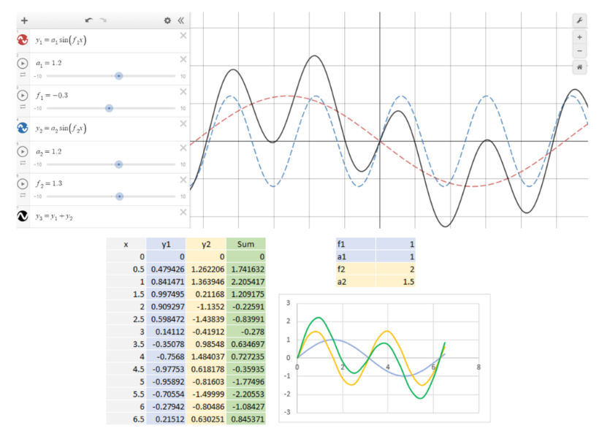
Figure 17: Generating graphs to demonstrate the superposition of two waves. (Top) desmos graph showing two component waves (red and blue) and their resultant wave (black). Interact with this graph on desmos.com. (Bottom) A similar activity can be constructed using Microsoft Excel.
A guitar is a simple and familiar context in which to examine many of the concepts of sound waves. A simple demonstration of resonance involves playing the fundamental frequency of the lowest string, typically 82 Hz, and observing visually the vibration of the string. Doubling this frequency allows the stationary node at the 12th fret to be easily observed. Moving to higher frequencies, the phenomena may be less visible but will become audible as the string will continue to resonate at the resonant harmonic frequency after the tone generator has been turned off. This activity is most effective when the driving frequency is loud.
The harmonic frequencies can also be observed by gently resting a finger at the nodal point and plucking at the predicted maxima; for the second harmonic place your finger at the 12th fret to divide the string in half. One third the length of the string (the third harmonic) can be found at the 7th fret, one quarter at the fifth, and two fifths at the 9th fret.
Guitars allow for the investigation of a range of wave behaviours and phenomena. String length can be easily modified with a capo, tension can be modified with the tuning heads and so on.
Beats should be observed between two sources of known wavelength, but it is worth demonstrating that beats are often used to tune a guitar, as the 5th fret harmonic on one string should equal the 7th fret harmonic on the next. When they are slightly out of tune with each other, beats are audible and the tuning is adjusted until the beats disappear.
Beats and other patterns of destructive superposition can be convincingly demonstrated using Audacity. Simply generating two tones of similar pitch (‘Generate>Tone’) and panning one left and one right allows beat interference between two sources clearly audible. For complete destructive interference, simply generate two identical tones, pan left and right, zoom in, copy and paste half a wavelength to make the two waveforms out of phase. If you have speakers that can be independently adjusted, or even if one speaker can be unplugged, the phenomena can be quite striking.
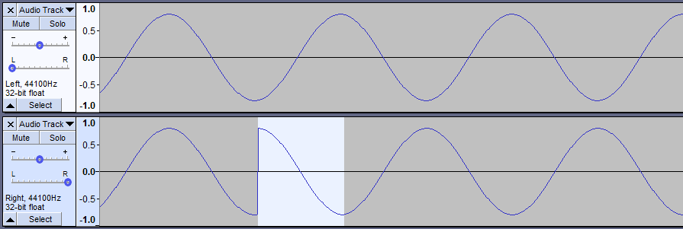
Figure 18: A screen from audacity to shown two wave fronts which are out of phase to create interference between waves of the same frequency 44100Hz.

Further tools for visualising the superposition of waves
- Desmos simulation of standing waves: This simulation can be used to demonstrate how standing waves are formed by two waves travelling in opposite directions (for example, when sound is reflected in a cavity). Wave speed and wavelengths can be changed using the sliders in the constants folder.
- Desmos simulation of beat formation: This simulation shows the component and resultant waveform when two waves of similar frequencies are superimposed.
- PhET Fourier: Making Waves: Explore how complex waveforms can be created by the addition of simple sine waves. This can be related to harmonics and the analysis of the sound waves from musical instruments. The wave game is challenging and engages students as they try to match the wave.
Teacher notes
Audacity can be a student-centred activity into exploring sound waves and is best used in a class room environment if students have their own head phones. To best utilise any visualisation software a lesson may be dedicated on how to use the software either my teacher direction or the use of online resources showing basic functions.

Activity 7: Creating a musical instrument
Musical instruments and music, in general, is something most students can relate to. This could form a small in-class depth study that can give students an engaging manner to research, test and create their musical instrument and go beyond the normal scope of the syllabus
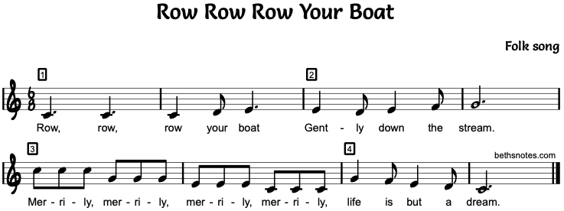.
This Photo by Unknown Author is licensed under CC BY-NC-ND
Figure 19: A sheet of music for ‘row, row, row, your boat that students could use as a starting point to design their instrument.
For example, students can be given a simple piece of sheet music and they have to research, experiment and create a musical instrument that is capable of playing the required song or students can choose an appropriate piece of music for themselves. At a minimum standard an instrument that produces a set range of frequencies.
It is suggested that students focus either on wind or stringed instruments for this task.
It is important to ensure with any building task used in physics, the science is not lost in the task. An initial step could focus on the theoretical design of the instrument and an explanation behind how it works. This followed by a range of tests to create the required frequencies and analysis of their data to identify trends in their design.
Focus questions could be centred around;
- Type of string used (density, tension and material).
- Length of the instrument.
- Length and diameter of pipes.
- Materials used.
Research questions during the activity could centre around, find a meaningful relationship that can be exploited to create the instrument. This can help keep scientific inquiry at the forefront of the task.
Information to build a range of instruments can be found on this webpage Challenge No.2 – Build a Musical Instrument! | UBC Physics & Astronomy Outreach and form the initial step into research and experimentation
This activity may require a range of materials and access to building equipment. Working with the TAS faculty at your school would be beneficial to source materials. Planning for students who may not have access to sufficient materials should also be considered and can the faculty budget support the purchase of materials or use of recycled materials.
It can be a theoretical approach and experimentation to create a plan of a design. The design would be supported with data gathered from experiments in class and reduced the need for large quantities of materials.
Teacher notes
Students in this activity should have the opportunity to start connecting ideas and applying them. The ability to test ideas and then apply them to a state problem will help develop a depth of understanding and reinforce skills used in science.
Skills in experimental design and conducting valid research to support reasoning is a key skill when assessing student’s success in this type of activity rather than a focus on the final physical product.

Ray Model of Light

Activity 8: Inverse square Law

Activity 8a: Inverse-square law: Investigation in comparing phone sensors to school data loggers (or compare phones).
Making use of a student’s phone as data loggers using either phyphox or Science journal. This investigation is best conducted in a darkened room and students well spread out. Sometimes experimenting in cupboards can help reduce the impact of other light sources if safe to conduct in your laboratory setting.
From a set light source student can record values of light intensity and graph their findings. Students can compare data from each different phone, comment on differences and identify common trends. This can also be completed for investigation of the inverse square law when applied to a sound source and compare on the trends found.
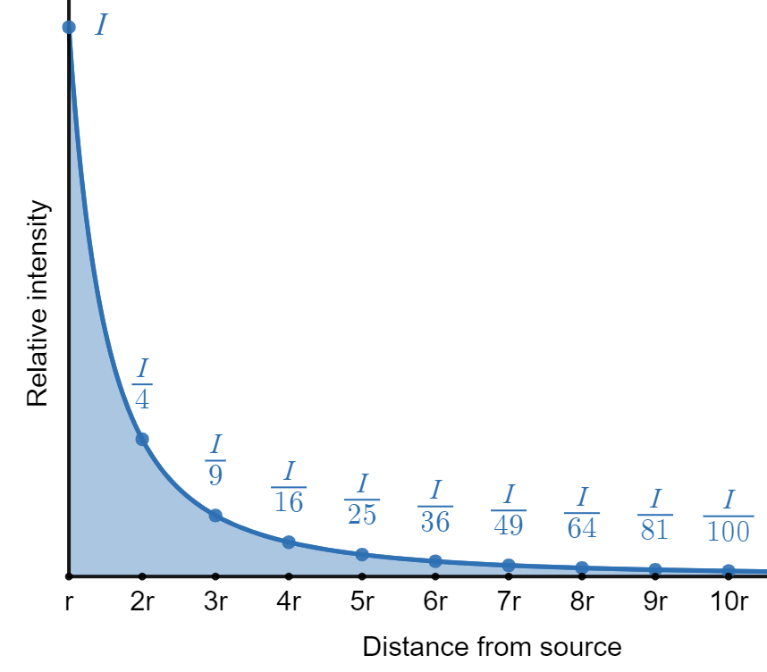
Figure 20: This is a graph of an ideal trend shown in the inverse square relationship. The graph shows how intensity decreases versus distance. Intensity changes in inverse proportion to the square of the distance from the source.
Students can also draw a comparison to ideal data sources and account for differences.
A detailed lesson sequence can be found in the link below. This trend between two variables which have an inversely proportional relationship appears across the physics course and the ability to manipulate the data to create a linear relationship is an important skill. For example, graphing Intensity versus one over the distance squared will give a linear relationship.
Link to activity for the inverse square law from the science state-wide staffroom m3-inverse-square-law-science-physics.docx

Activity 8b: Inverse-square law
An alternative activity that could help students better visualise the inverse square and develop a sense of why the relationship is represented mathematically as;
$$I ∝ \frac{1}{d^{2}}$$
The gathered data regarding the area could also help students construct diagrams like the one found in appendix 3.
Introduction
You are to conduct a first-hand investigation to experimentally model the inverse square law for light by measuring the brightness of light projected onto a surface by a light bulb at different distances. Follow the method provided and answer the questions.

Background
The amount of light received per unit area on a surface is called brightness. Brightness is a function of the distance of a surface from a light source.
Relative Brightness
The relative brightness B for a surface that is a distance d from the light sources is determined by the following relationship: B = $\frac{A_{o}}{A}$
Where A_{o} is the surface area illuminated by the light at a standard distance. In this investigation, the standard distance between the light source and the surface is 10 cm. A is the surface area illuminated by the light at a distance d from the light source.
Experimental setup
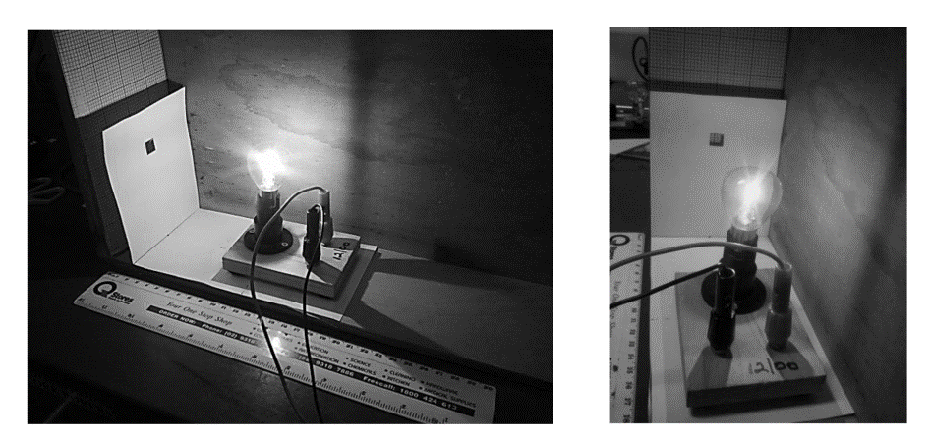
Figure 21: An experimental setup of a light bulb set 10cm from a small 1 X 1 cm window cut from a piece of cardboard.
Method
- Place the light bulb at a distance of 10 cm from the graph paper. The window card should be pressed up against the graph paper.
- Count how many squares on the graph paper are illuminated.
- Change the distance from the graph paper to the window card (to 4, 5, 8, 10 cm) and count how many squares on the graph paper are illuminated at each distance.
Note:
Both the bulb and window card move as a single unit (distance from window card to the centre of the bulb is to remain at 10 cm, see Figure 5(b)). Make sure to measure the distance from the window card to the graph paper surface.
Determine the area illuminated for each distance by calculating the area of each square.
This alternative to activity 9a enables students to visualise the inverse square law and verify the relationship between distance and intensity. Both activities could be utilised in conjunction to compare and evaluate both methods in verifying the inverse square law.
Teacher notes
The suggested activities should give students an insight into the inverse square law. Students should be able to apply the equation $I_{1}r_{1}^{2}=I_{2}r_{2}^{2}$ and the inverse square relationship $I α \frac{1}{r^{2}}$ to solve a range of mathematical problems. Students should also be able to provide explanations of the application of the Law to describe a range of situations and justify their response using calculations.
Some students may require additional help in using the equation to describe algebraic relationships. A brief example using a visual aid can be found in appendix 3.

Activity 9: Refractive index
Most schools have ray boxes and these can be used to gather data to measure the refractive index of a material, commonly Perspex.
If the standard method is being employed it is good practice to have students graph both angles of incidence vs refraction and sin of both angles. This could be a good method to show students the importance of processing data to produce linear relationships in physics is a vital tool.

Figure 22: shows a non-linear relationship between the angle of incidence and refraction for an unknown material

Figure 23: shows the linear relationship between the sin of the angle of incidence and refraction.
Some students do find it difficult to recognise how to use the gradient of a graph in calculations and interpret its ‘meaning’.
Having students work with variables in the first instance rather than calculate numerical answers could help give meaning to the values obtained and deepen their understanding of how variables are connected. The process is outlined below;
$$Gradient= \frac{y_{2}- y_{1}}{x_{2}- x_{1}}= \frac{Rise}{Run}$$
$$Gradient= \frac{\sin{θ_{r}}}{\sin{θ_{i}}}$$
$Given= n_{1}\sin{θ_{1}}= n_{2}\sin{θ_{2} }$…(1) Snell’s Law
$$using subscript from experiment gives n_{i}\sin{θ_{i}}= n_{r}\sin{θ_{r} }$$
$$\frac{{\sin{θ}}_{i}}{{\sin{θ}}_{r}}= \frac{n_{r}}{n_{i}}$$
Assuming the refractive index of air (n_{i}) = 1 (1.0002760 @ 15°C),
$$\frac{{\sin{θ}}_{i}}{{\sin{θ}}_{r}}=n_{r}$$
Therefore, the inverse of the gradient will equal the refractive index of the medium (n_{r}).
$${Gradient}^{-1}= \frac{\sin{θ_{i}}}{\sin{θ_{r}}}= n_{r}$$
Having students explain and discuss their thinking process should help them build a depth of understanding. Having students use their understanding of graphs and algebra applied to a range of unfamiliar situations should reinforce this skill.
There should be an emphasis on how to collect precise data from this experiment. First hand investigations are a good opportunity for students to develop targeted working scientifically skills from the Stage 6 Physics Syllabus.
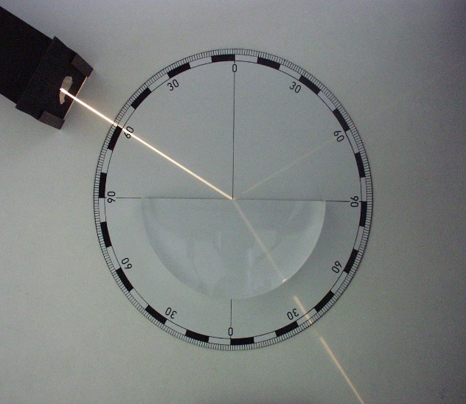
This Photo by Unknown Author is licensed under CC BY-SA
Figure 24: A ray box streaming a single beam of light into a semi-circle piece of Perspex showing the ray path refracting.
This will allow students to think think more deeply about experimental methods employed in class and how the design/execution of an experimental procedure can impact conclusions drawn from a set of results.
For example, students can be asked questions regarding the set up shown in figure 24;
- where they trace the ray path and how this impacts the results?
- Does the dispersing of the light have an impact on results?
Students could build inquiry questions around utilising Snell’s Law, for example, can they identify a relationship between sugar content in water angle of refraction? How would they transfer this understanding to calculate the refractive index of fluids?
Teacher notes
At the first instant students should be comfortable in obtaining data from this practical and able to correctly calculate the refractive index of the material to within reason. Students should be comfortable with using Snell’s law to calculate numerical answers using Snell’s Law. The practical approach should also give rise develop their working scientifically skills, in terms of collecting and using data.
An empathises on the need for precise measurements can be demonstrated in this practical. By comparing data from across the class/s and final refractive index values, students can discuss the importance of scientific rigour in practical investigations.

Activity 10: Constructing a telescope
To extend students understanding of the formations of images using a combination of the lens in constructing a telescope can be used. This provides a link between the learning in the classroom and a real-life application they may be familiar with.
The links below have basic instructions on how to construct a simple working telescope.
Make a telescope: National Geographic Kids
Building a Telescope: NASA
Introducing equations specific to simple light telescopes and using them to predict or test ideas will allow extension beyond the scope of the syllabus in terms of content but will help deepen their understanding of skills and problem-solving. A possible sequence of lessons can begin with creating ray diagrams from a range of lenses and recording measurements of focal length. Qualitative investigations can also be initially used to observe the path of light rays between two lenses.
The next step in the sequence could be having students investigate how changing variables in a two-lens telescope impacts its properties.
Magnification
$M= \frac{f_{o}}{f_{e}}$ (1)
Equation 1: calculating the magnification of the telescope. M = Magnification, f_{e} = focal length of eyepiece and f_{o} focal length of the objective lens.
Length of telescope
$L= f_{e}+ f_{o}$ (2)
Equation 2: Calculating the length of the telescope. L = length f_{e} = focal length of eyepiece and f_{o} focal length of the objective lens.
To build a research task into this activity, Students could be asked to research the different types of telescopes used and how this impacts their design. This linked to their gathered experimentally data to provide opportunity for extension and building a depth of understanding regarding the application of physics.
Teacher notes
Students should gain an appreciation and application of the use of the ray diagrams. By providing context in terms of a telescope students should be able to reinforce this concept. At the conclusion, students could apply this understanding to explain a range of optical instruments and how they use lenses to use light or other forms of the electromagnetic spectrum.
This activity is an extension on the material prescribed in the syllabus and does require the school has access to a range of optical lens.

Activity 11: Pinhole camera
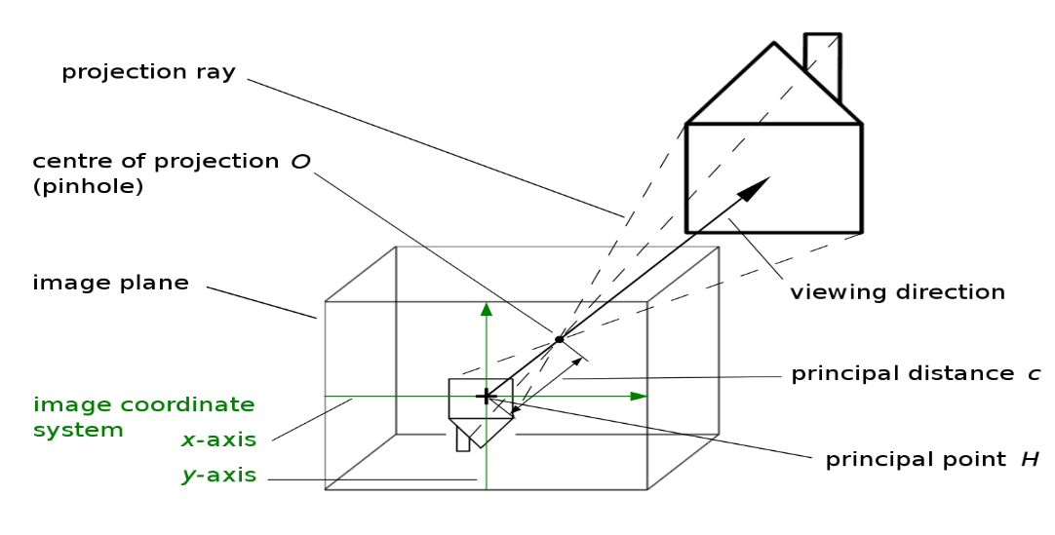
This Photo by Unknown Author is licensed under CC BY-SA
Figure 25: Ray diagram illustrating path light rays take to form an image in a pin hole camera.
Students can follow the basic instruction to build a pin hole camera. An inquiry lesson can be built around a practical investigation centred around a particular question. For example;

• What happens to the size and height of the image as the object is moved away
from the camera? What if you could change the length of the box? How would
that affect the image?
• How does the sharpness of focus change with distance? What determines the
the sharpness of the image?
• Make your pinhole camera with a moveable back screen. What happens when you adjust the back distance? Can you suggest a reason why this happens?

The following link is a sample lesson that could be modified and utilised in your classroom Community Construction with Pinholes | Exploratorium Teacher Institute Professional Development Resource

Teacher notes
Students should be able to apply their working scientific skills in their investigation of a pinhole camera. By first constructing a simple camera, students can gather some initial data and propose an investigation based on their initial observations. Students should have the opportunity to demonstrate their skills in planning investigations and presenting their finding in a range of formats.

Thermodynamics

Activity 12: Transfer and storage of thermal energy
Derek Muller’s Veritasium video “Misconceptions about Temperature” explores the way thermal conductivity impacts our experience of temperature by surveying members of the public about their intuitive understandings of temperature using aluminium and paper.
Non-contact instant-read thermometers can be purchased cheaply and are useful for several simple experiments and demonstrations. Simply measuring the temperature of the floor and ceiling of a room provides evidence for convection. The device itself exemplifies an application of thermal radiation and allows for the investigation of the behaviour of IR waves.
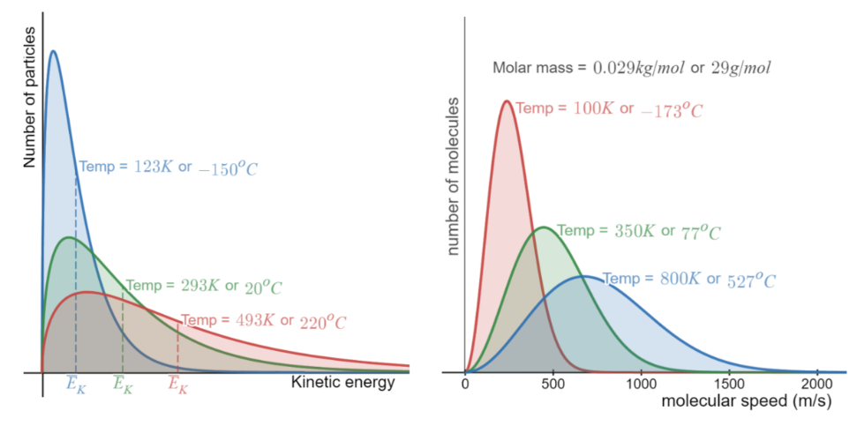
Figure 6: Graphs exploring the relationship between the temperature of a gas and (left) the kinetic energies and (right) the molecular speeds of the particles within it. Interact with these graphs on desmos.com (Temperature and kinetic energy, Molecular speed).
The interactive graph on the left of Figure 6 can be used to explore and explain the relationship between the temperature of an object and the kinetic energy of the particles within it. Students can use this interactive to explore the following questions.
- What is the relationship between the average kinetic energy of particles and their temperature?
- Why does water still evaporate at temperatures well below its boiling point?
- What happens to the kinetic energy of the particles in a substance as it is cooled to extremely low temperatures?
- Why does heating increase the rate of chemical reactions?
Teacher notes
Students should be able to correctly use terms related to thermal energy and temperature to describe observations. They should also understand the relationship between the kinetic energy of the particles and the measured temperature using the principles of physics.

Activity 13: Heat transfers and thermal conductivity
Thermal conductivity can be challenging to measure. Apparatus exist that hold one side of test material in contact with steam while the other is in contact with a block of ice to establish a temperature gradient of 100ºC, with the amount of ice melted being used to calculate the heat transferred through the material over time.
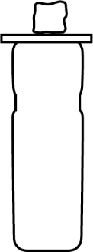
Figure 27: Vacuum flask with sample and ice cube on top.
A simpler model of this apparatus could involve a thermos flask full of freshly boiled water, thin sheets of various metals, glass, plastic and timber, and an ice cube. The time for the ice cube to melt is measured, the heat energy required to melt the cube is calculated based on its initial mass, and the thermal conductivity of the material can be calculated using $\frac{Q}{t}=\frac{kA∆T}{d}$.
A simpler model again involves calculating the thermal conduction through the sides of a cup of tea (with a lid). Assumptions involve the thermal conductivity of the ceramic and the temperature of the outside surface of the cup.
Teacher notes
Students should be applying the thermal conductivity equation to a wide range of unfamiliar situations to use calculations to support explanations on heat transfer. If all three modes are used students should be able to evaluate each model and describe its ability to demonstrate key principals of heat transfer.

Activity 14: How hot is a Bunsen flame? Applying specific heat.
A simple but practical investigation using specific heat can be used to calculate the temperature of a Bunsen flame. A metal block of known specific heat and mass is held in the flame until it reaches thermal equilibrium (usually around 30 seconds). The block is then dropped into a beaker containing a known mass of water and the temperature change is monitored. By calculating the increase in heat energy in the water, equating this with the heat energy of the hot block allows its peak temperature to be estimated. Iron and stainless steel are ideal metals to use due to their high melting points. Avoid using aluminium ($M.P.= 660℃$) as it may melt in the Bunsen flame.
This experiment is quick to perform and will generally result in a wide range of values for the temperature of the flame. This creates an opportunity for a class to share and evaluate their data, discuss and improve their method, and then conduct the experiment again for comparison. Consider plotting results using a box-and-whisker plot to highlight the variation in the temperature values measured.
Teacher notes
Students gain experience in using the specific heat equation to calculate the value of unknown temperature source. Furthermore, reflecting on the data gather and comparing to other groups will engage them in critically analysing data and they should be able to reflect on the procedure and explain the differences in their results using scientific reasoning skills.

Activity 15: Latent heat
A simple investigation to analyse the latent heat involved in the change of state involves monitoring the cooling curve of stearic acid. Stearic acid has a melting/freezing point of $66℃$ which allows its latent heat of fusion to be easily studied in a school laboratory. This is done by first heating test tubes of stearic acid to around $80℃$ using a water bath and hot plate and then allowing the tubes and water bath to cool. By recording the temperature of the acid and the water every 3-5 minutes, students can observe the temperature of the stearic acid stabilise near its melting point while the water continues to cool. The energy transfers involved as the stearic acid solidifies are shown in Figure 7. Further details and sample data is provided on MrReid.org Experiments That Actually Work: Latent heat of fusion.
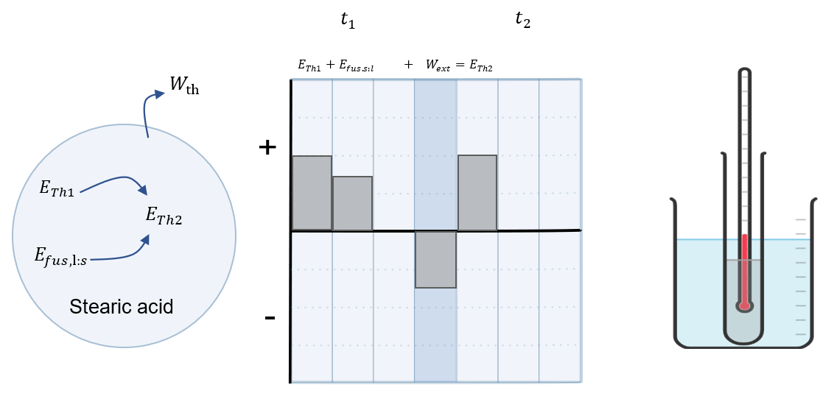
Figure 28: (Left) Energy flow diagram and (centre) work-energy bar chart for the cooling of the stearic acid at t₁ before it begins solidifying and t₂ once it has finished solidifying. Note that the thermal energy (and temperature) of the stearic acid does not change even though heat is lost to the surroundings (which includes the thermometer in this case). This is because of the bond formation during the phase change from liquid to solid heats the stearic acid. (right) Diagram of water bath setup made in Chemix.
Latent heat of fusion can also be investigated quantitatively by adding ice cubes to water in an insulated cup. This is a convincing example of conservation of energy as it is an obviously isolated system. Students can be tasked with predicting the final temperature of the system once it has reached thermal equilibrium (given the relevant specific and latent heats) or could use the final temperature to calculate the latent heat of fusion for ice/water. A sample of the Energy-flow diagram and Work-energy bar chart describing this investigation is included in the Big ideas section.
For both of the above investigations, students could be collecting data in small groups or a single demonstration could be run by using a temperature probe and data logger to project the results in real-time for all students to see.
Further activities on thermodynamics
By passing current through a nichrome coil in a calorimeter of water and monitoring the temperature change allows for the calculation of the specific heat of the water. Alternatively, the specific heat can be provided, and the temperature change predicted and confirmed. The thermal energy gained by the water in the calorimeter ($Q=mcΔT$) is equivalent to the electrical energy dissipated by the coil ($E=VIt$). This exercise helps to reinforce that electrical and thermal energy can be considered interchangeably, and links well with electric circuits in Module 4.
Module 3 thermodynamics unit plan: This sample program includes a range of classroom activities and flipped learning resources and is located on the NSW curriculum website.
The Physics classroom – Introduction to Thermal Physics: Students can work through the sections in this introduction at their own pace, completing questions to check their understanding as they go. The sequence covers most of the concepts required for Module 3 with suitable depth.
Interactive Molecular Dynamics: This interactive simulation could be used to investigate, describe or explain a variety of scientific concepts. The included pre-sets, include models of different states of matter and energy that can be added or removed by clicking 'Slower' or 'Faster'. Quantitative data can also be generated and easily exported to Excel for analysis.
Sample learning goals
- Relate increases/decreases in particle energy to changes in particle movement.
- Investigate the relationship between particle movement, heat and changes of state.
- Explain changes in density resulting from thermal expansion.
- Investigate gas laws.
Teacher notes
Students can explain and apply the equations of thermodynamics to a range of unfamiliar situations to determine outcomes based on understanding and supported by calculations (if applicable). This could include explanations at a molecular level linked to what we observe in our world.
A focus on practical investigation should also develop students’ skills in collecting and analysing data to support explanations of their observations.

Appendices

Appendix 1: Wave demonstrations
The clip below is an engaging series of demonstrations some of which can be conducted at school or required slight modifications depending on equipment. Alternatively, the clip can be shown at the beginning of the module and students try to explain what is happening. Link: CYMATICS: Science Vs. Music - Nigel Stanford

Appendix 2: 3Blue1Brown
A collection of YouTube clips that build a depth of understanding supported by great visuals. The content is linked better to module 7 and 8, however, can be used in this module to help students understand the significance of waves plays in our understanding of the quantum world. Building these connections through the course will allow students to see the significance of the learning they are currently doing and help make the learning meaningful. Channel Link: 3Blue1Brown - YouTube

Appendix 3: Inverse-square law
Diagrams like the one below can help students visually see and understand the inverse square law. It is usually a good idea to construct the diagram in steps and ask questions about what will happen next as the radius is increased from a set point.
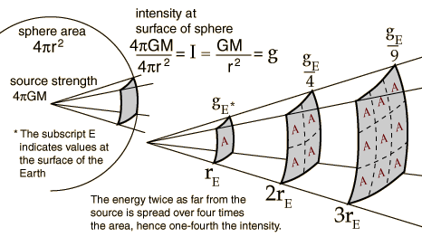
This Photo by Unknown Author is licensed under CC BY-SA
Figure 29: A representation of intensity form a source in 3 dimensions covering an increasing surface area away from the source. At a one radius length away spread of a single square, two radius ways covering four squares and at three radii was covering nine squares.
Using figure 29, students may develop a greater understanding on how to use the inverse square law to explain changes in intensity given changes in radius. They can use either a purely mathematical approach or logical reasoning.
Logical reasoning
At distance “r” from the light source, some light energy falls on an area of A²units. At twice that distance (2r) the same amount of light would fall on an area of 4A².
The intensity of the light must be only 1/4 as much (since the same amount of light is falling on 4 times the area.)
Mathematically
Method | Reasoning
$$I_{1}({d_{1})}^{2}= I_{2}({d_{2})}^{2}$$ | Write down the inverse square relationship
$$I_{1}({d_{1})}^{2}= I_{2}(2{d_{1})}^{2}$$ | Substitute new conditions. As distance has double from initial radius in this case d₁, this can be represented as twice the original distance in the right-hand side of the equation.  $$d_{2} = 2d_{1}$$
$$I_{1}(d_{1}^{2})= I_{2}(4d_{1}^{2})$$ | Expand both set of brackets, noting both ‘2’ and distances both are squared.
$$I_{2}= I_{1}\frac{d_{1}^{2}}{4d_{1}^{2}}$$ | Make $I_{2}$ the subject of the formulae and simplify the right-hand side of the equation.
$$I_{2}= I_{1}\frac{1}{4}$$ | Therefore, the intensity must be a quarter at double the distance.

Appendix 4: Snakey sine waves
Introduction
The physics of sidewinder snake movement. It looks at how specific snakes have adaptations that allow them to move in the motion of sine waves and reduce friction.

Snakey sine waves: The physics of sidewinder snake movement

LINKED TO SCIENCE INQUIRY SKILLS
Questioning and predicting
- What questions do you think scientists might have asked to lead them to this research?
- How do you think this research could change or refine peoples’ scientific understanding?
- How do you think this scientific understanding could be used to influence future technology?
- What do you think the researchers’ next steps might be?
Evaluating
- What scientific knowledge and understanding do you think was required to conduct this research?
- What technology do you think has been used in this research?
- What STEM careers and disciplines might have collaborated on this work?
Communicating
- In your own words, briefly describe how sidewinder snakes move.
- Draw the wave that represents the motion of the snake, labelling the amplitude, wavelength and frequency.
- How do you think this wave would change as the snake moved quicker? Why do you think that?
- What specific adaptations do these snakes have to allow them to move in this way?
- How does the skin of the sidewinder snakes compare to the skin of slithering snakes? Why is there a difference?
- How are the slithering snakes adapted to increase friction? Why do you think they need more friction?
- How have sidewinder snakes reduced friction between their bodies and the sand?

Appendix 5: Simple Harmonic Motion
Simple Harmonic motion is not explicitly part of the Stage 6 Physics course; however, it is a useful principle that underlies a wide variety of periodic behaviours.
‘What factors influence the motion of an object that has a repeated or periodic motion?’
Simple harmonic motion generally describes the ideal motion of a body or system subject to a force proportional to the distance from some equilibrium position, that causes that body or system to move back and forth about that equilibrium position.
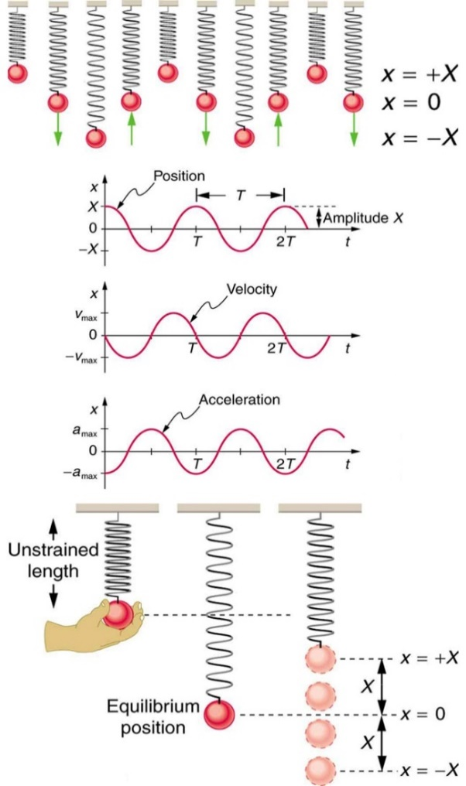
This Photo by Unknown Author is licensed under CC BY
Figure 30: Shows the simple harmonic motion of an object on a spring and presents graphs of x, v, and a versus time. Note that the initial position has the vertical displacement at its maximum value X; v is initially zero and then negative as the object moves down; and the initial acceleration is negative, back toward the equilibrium position and becomes zero at that point.
When the system is at rest (no oscillation with a mass attached), the force directed towards the ground ($F_{w}= {ma}_{g}$) due to gravity is balanced with the upward force exerted by the stretched spring ($F= -kx)$.
F_{w} is the weight force, m is the mass and a_{g} acceleration due to gravity, F is force, k is the spring constant and x the distance from the equilibrium position (note the negative sign indicates the restoring force of the spring is in the opposite direction of the weight force).
In the initial stage of this investigation, students can apply their understanding of dynamics from Module 2 to explain a new system in terms of forces.
The most basic setup that could be utilised, is to set up a retort stand, boss head and clamp to fix a spring that is capable of being attached to a small mass. If data loggers are available the setup can be adjusted to include different modes of measurements.
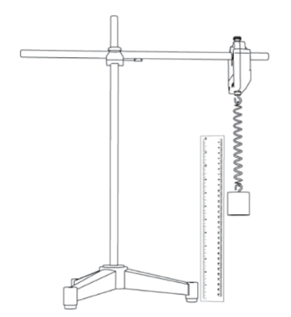
Image Source: Simple harmonic motion experimental procedure
Figure 31: A representation of an experimental setup of a mass attached to a spring held by a boss head and clamp. Which is attached to a retort side.
If the equipment is not available the following simulation from phet site could be utilised instead. Masses and Springs - Periodic Motion | Hooke's Law | Conservation of Energy - PhET Interactive Simulations (colorado.edu)
As an initial theoretical approach assuming a perfect ideal system where there is no air resistance or internal friction, students can first describe qualitatively what they expect to observe. From this initial observation, they can attempt to come up with an equation that will predict the position of the mass relative to time. The following link contains an explanation of the simple harmonic motion equation shown below. Equation for simple harmonic oscillators (video) | Khan Academy
$$x\left(t\right)=ACos\left(ωt\right)$$
An analysis of the system in terms of energy could be used as three forms of energy are present, kinetic energy, gravitational potential energy, and spring potential energy. In a perfect ideal system where there is no air resistance or internal friction, the sum of these three would be constant.
Students could then gather data regarding displacement versus time and then form an inquiry question to investigate the impact of a variable of their choice on the motion. This data can also be used to create velocity-time graphs and acceleration time graphs based on their understanding of Module 1.
The Desmos interactive graph Simple harmonic motion can be used to visualise simple harmonic and see how it is linked to circular motion which is covered in Module 5.

Appendix 6: Resources on active-learning approaches to teaching physics:
- Characteristics of research-based, effective physics teaching are available:
  - McKagan, S. (2016). What makes research-based teaching methods in physics work? PhysPort.
  - Meltzer, D. E., & Thornton, R. K. (2012). Resource Letter ALIP–1: Active-Learning Instruction in Physics. American Journal of Physics, 80(6), 478–496.
- Perimeter Institute. (2020). Tools for Teaching Science. A catalogue of a broad range of teaching strategies which could be used to support effective teaching in senior physics.
- Books:
  - Knight, R. (2004). Five Easy Lessons: Strategies for Successful Physics Teaching. Pearson. Recommended for both beginning and experienced physics teachers – it is a very practical and readable guide to teaching physics effectively. Questions focusing on conceptual understanding are provided for each topic, as well as detailed suggestions for ‘active learning’ activities to use with students.
  - Arons, A. B. (1996). Teaching Introductory Physics. Wiley. This is a more substantial text written by one of the pioneers of physics education research. Suggestions for research-based, conceptual questions which can be used with students are provided throughout. Primarily aimed at tertiary physics teachers (but with many sections appropriate for secondary teachers).
  - Redish, E. F. (2003). Teaching Physics with the Physics Suite. Wiley. A preprint is available online. This is an extremely engaging text from a very experienced physics educator which gives an overview of several research-based approaches to teaching physics. Redish provides a concise and convincing summary of how findings from cognitive science as well as physics education research can be utilised to teach physics effectively.
  - An introduction to Peer Instruction by Eric Mazur. Engaging and convincing description of how ubiquitous student misconceptions are, even amongst high achieving students. Abridged version, full version
Educational psychology and cognitive science also offer insights into how to assist students to retain and improve their understanding following initial instruction in a topic. Some of these findings include:
- That learning is most effective when interactions with a concept are spaced out over time (known as ‘distributed practice’). A ‘spiral teaching approach’ features in a freely available curriculum developed by D’Alessandris. The term ‘spiral teaching’ is also used as a general term in physics education to refer to the technique of returning to a concept in more depth or a more sophisticated context.
- Practice is most effective when questions do not focus on a single topic, but different topics are interleaved, requiring students to make decisions about what physics principles and knowledge they need to use, rather than simply relying on their short-term memory to use the same approach as they used in the previous question.
- Practice testing is much more effective than more passive approaches such as re-reading and highlighting, as the process of recall under test conditions changes the way that information is stored in the brain.
Resources on applying the results of education psychology and cognitive science to teaching:
- Dunlosky, J., Rawson, K. A., Marsh, E. J., Nathan, M. J., & Willingham, D. T. (2013). Improving Students’ Learning With Effective Learning Techniques. Psychological Science in the Public Interest, 14(1), 4–58. Full text available:.
- Reif, F. (2010). Applying Cognitive Science to Education: Thinking and Learning in Scientific and Other Complex Domains (A Bradford Book). This text offers a thorough discussion of the implications of cognitive science for education, with a strong focus on physics.

This is convincingly demonstrated by Derek Muller in his ‘Veritasium’ video on ‘Three incorrect laws of motion‘
Hake, Richard R., ‘Interactive engagement versus traditional methods: A six-thousand student survey of mechanics test data for introductory physics courses’. Am J. Phys. 66(1) (1998). Full-text available
Van Heuvelen, A., & Zou, X. (2001). Multiple representations of work–energy processes. Am. J. Phys., 69(2), 184–194. https://doi.org/10.1119/1.1286662
von Baeyer, H. C. (1984). Rainbows, Snowflakes, and Quarks: Physics and the World Around Us. McGraw-Hill.
Milner-Bolotin, M. (2012). Water Pearls Optics Challenges for Everybody. The Physics Teacher, 50(3), 144–145. https://doi.org/10.1119/1.3685108
Adapted from RiAus
- D’Alessandris, P. (1994). Spiral Physics Downloads. Compadre.

