Physics Module 1: Kinematics

Table of contents
Physics Module 1: Kinematics 1
Table of contents 2
Acknowledgements 3
Course overview 3
Teaching the Year 11 Modules 3
Module summary 6
Big Ideas 7
Observation and measurement 7
Models and representations 8
Interactions 8
Systems and conservation 9
Relationship to other modules 9
Cross module (Working Scientifically skills) 9
Module 2 10
Module 5 11
Core concepts 11
Motion in a straight line 11
Motion on a plane 12
Opportunities for extending concepts 13
Inertial reference frames 13
Skills in evaluating scientific data 13
Analysing more complex motion 13
Misconceptions 14
Conceptual difficulties 14
Mathematical modelling 15
Teaching strategies 16
Overall approach 16
One-dimensional motion 17
Motion on a plane 29
Relative velocity 30
Appendices 33
Video analysis of a ball throw with Tracker 33
Deriving relationships for accelerated motion 34
Sample data for activities 39
Non-uniform acceleration examples 44

Acknowledgements
All images and diagrams, unless otherwise stated, have been produced by the authors of this document.
NSW Physics Syllabus © NSW Education Standards Authority (NESA) for and on behalf of the Crown in right of the State of New South Wales 2017.
Science Years 7–10 Syllabus © NSW Education Standards Authority (NESA) for and on behalf of the Crown in right of the State of New South Wales 2018.

Course overview
Year 11 physics offers students the opportunity to observe and measure a wide range of physical phenomena in the world around them including motion, mechanical interactions, mechanical waves, geometrical optics, heat transfer, electricity, and magnetism. Students learn to describe and make sense of these phenomena in terms of a limited number of physical laws.
These include:
- fundamental interactions (forces) between matter particles such as gravity and electric and magnetic forces, as well as
- laws which govern how these interactions change the motion of particles and systems of particles, including Newton’s three laws of motion, and conservation laws such as conservation of energy, linear momentum and charge.
Students strengthen and communicate their understanding using a range of representations including descriptions, diagrams, graphs and mathematical models.

Teaching the Year 11 Modules
Students begin senior physics with substantial experience of the world around them and, as a result, have developed explanations to make sense of their observations. Some of these beliefs may be inconsistent with accepted physics, for example the idea that objects tend to naturally come to rest in the absence of a force, or that there is no gravity in space. Due to the apparent explanatory power of these ideas in students’ everyday experience (they see objects consistently come to rest and know that astronauts float in the international space station), these misconceptions (also known as ‘alternate conceptions’ or ‘common naïve conceptions’) can be quite resistant to change. To shift these existing conceptions, it is necessary that students find the explanations which physics provides for everyday physical phenomena more convincing than their own existing beliefs.
Physics education research has established that ‘traditional’ instruction styles in which students watch and listen to an exposition of physics theory, complete ‘cookbook’ style practical investigations and textbook problems which emphasise calculations and equation manipulation, are substantially less effective at improving students’ conceptual understanding of physics than ‘active learning’ approaches (Hake, 1998). These approaches are characterised by students’ active participation in constructing meaning, and results in a substantial gain in student conceptual understanding, approximately double that obtained from a ‘traditional’ approach (Hake, 1998).
Active learning activities which promote interactive engagement will generally:
- encourage students to actively express their thinking about physical phenomena in verbal or written form, or via other representations such as diagrams, graphs or mathematical models (rather than passively listening, copying or following directions in practical work without thinking critically about what they are doing)
- involve receiving immediate/interactive feedback about their thinking from peers, a teacher and/or their own observations
- utilise (as far as possible) real physical systems which require students to make observations and measurements, as well as making decisions about the most appropriate way to analyse (model and represent) these observations
- encourage students to reflect on their own thinking and how the physics they are learning ‘fits together’ as an interrelated and coherent whole
- value and check for conceptual understanding in diagnostic, formative and summative assessment.
Resources on active-learning approaches to teaching physics:
- Characteristics of research-based, effective physics teaching are available:
  - McKagan, S. (2016). What makes research-based teaching methods in physics work? PhysPort.
  - Meltzer, D. E., & Thornton, R. K. (2012). Resource Letter ALIP–1: Active-Learning Instruction in Physics. American Journal of Physics, 80(6), 478–496.
- Perimeter Institute. (2020). Tools for Teaching Science. A catalogue of a broad range of teaching strategies which could be used to support effective teaching in senior physics.
- Books:
  - Knight, R. (2004). Five Easy Lessons: Strategies for Successful Physics Teaching. Pearson. Recommended for both beginning and experienced physics teachers – it is a very practical and readable guide to teaching physics effectively. Questions focusing on conceptual understanding are provided for each topic, as well as detailed suggestions for ‘active learning’ activities to use with students.
  - Arons, A. B. (1996). Teaching Introductory Physics. Wiley. This is a more substantial text written by one of the pioneers of physics education research. Suggestions for research-based, conceptual questions which can be used with students are provided throughout. Primarily aimed at tertiary physics teachers (but with many sections appropriate for secondary teachers).
  - Redish, E. F. (2003). Teaching Physics with the Physics Suite. Wiley. A preprint is available online. This is an extremely engaging text from a very experienced physics educator which gives an overview of several research-based approaches to teaching physics. Redish provides a concise and convincing summary of how findings from cognitive science as well as physics education research can be utilised to teach physics effectively.
  - An introduction to Peer Instruction by Eric Mazur. Engaging and convincing description of how ubiquitous student misconceptions are, even amongst high achieving students. Abridged version, full version
Educational psychology and cognitive science also offer insights into how to assist students to retain and improve their understanding following initial instruction in a topic. Some of these findings include:
- That learning is most effective when interactions with a concept are spaced out over time (known as ‘distributed practice’). A ‘spiral teaching approach’ features in a freely available curriculum developed by D’Alessandris. The term ‘spiral teaching’ is also used as a general term in physics education to refer to the technique of returning to a concept in more depth or a more sophisticated context.
- Practice is most effective when questions do not focus on a single topic, but different topics are interleaved, requiring students to make decisions about what physics principles and knowledge they need to use, rather than simply relying on their short-term memory to use the same approach as they used in the previous question.
- Practice testing is much more effective than more passive approaches such as re-reading and highlighting, as the process of recall under test conditions changes the way that information is stored in the brain.
Resources on applying the results of education psychology and cognitive science to teaching:
- Dunlosky, J., Rawson, K. A., Marsh, E. J., Nathan, M. J., & Willingham, D. T. (2013). Improving Students’ Learning With Effective Learning Techniques. Psychological Science in the Public Interest, 14(1), 4–58. Full text available:.
- Reif, F. (2010). Applying Cognitive Science to Education: Thinking and Learning in Scientific and Other Complex Domains (A Bradford Book). This text offers a thorough discussion of the implications of cognitive science for education, with a strong focus on physics.

Module summary
Studying kinematics involves observing, describing, measuring, and analysing motion. Developing precise scientific language and other tools used to describe and communicate features of motion is an important first step in the study of mechanics.
Kinematics focuses only on the motion of objects, such as their velocity (rate of change of position) or acceleration (rate of change of velocity). It does not consider the masses of objects or the forces acting on them, nor does it seek to explain why the motion is produced.
This is an important distinction between the first two modules of the Stage 6 Physics course and the value of making this distinction is discussed in the ‘Relationships to other modules’ section.
In this module, students investigate uniformly accelerated motion in one and two dimensions. To do this, they will:
- learn and apply a variety of representations of motion including vector diagrams, displacement-time and velocity-time graphs and equations
- measure or calculate quantities including time, displacement, velocity, and acceleration
- derive relationships between the above quantities for uniformly accelerated motion, and
- analyse the relative motion of objects moving with respect to one another.
On completing this module, students will be confident in describing and analysing motion from primary and secondary data. They will also have developed many of the skills required to investigate and model more complex motion in Module 5, ‘Advanced Mechanics’ including projectile motion.

Big Ideas

Observation and measurement
Observation and measurement are essential aspects of physics. They are the basis upon which theories and models are proposed as well as being how the predictions of these theories and models can be tested.
In the context of the Stage 6 physics course, observation and measurement are an important subset of the Working Scientifically skills students develop as they engage with the content in the syllabus.
Technologies enable motion to be observed, measured and analysed. The motion of some objects is too fast/slow or too small/large to be investigated just using our senses. Consider the vibration of a tuning fork or the rapid acceleration of a falling object. Technologies enable us to push the scale of measurement to better understand common phenomena and have been the catalyst for countless scientific discoveries (for example, the telescope and the discovery of the moons of Jupiter).
Module 1 focuses on observing, measuring, and describing motion, and so provides an excellent context to establish students’ Working scientifically skills early in the course. It is an opportunity for students to develop proficiency in using tools that can be utilised again in later modules and depth studies.
Technologies that enhance the study of motion generally improve the resolution of measurements. Most technologies allow positions and times to be measured more precisely and many digital technologies also increase the frequency at which measurements are recorded (for example, a slow-motion camera recording at 240 fps or a ticker timer recording positions at 50Hz). Other practical technologies quickly collect and process data and output a value of interest, for example, light gates or motion sensors can report the velocity of an object in real-time.
Technologies for observing motion could be introduced in this topic include:
- Tracker (free video motion analysis software)
- free physics phone apps (such as phyphox, Google science journal or Physics toolbox suite), as well as
- ticker timers, stopwatches and rulers and measuring tapes, motion sensors, motion encoder carts and light gates.

Models and representations
The process of describing motion using a mathematical model, graph or vectors can assist students to make correct connections between kinematics concepts such as displacement, velocity and acceleration as well as challenge students’ intuition or preconceptions about motion.
The use of multiple representations (for example, describing the motion of an object using motion diagrams, velocity-time graphs as well as formulae) provides a means for students to organise their knowledge and effectively communicate understanding. A student’s ability to use multiple representations is a good indicator that they have a deep understanding of a concept. Incorporating different representations into teaching, learning and assessment activities will support student understanding.
As students move between models of motion and observations and measurements of motion, they also develop the ability to think critically about the assumptions made in these models. For example, by graphing the velocity versus time and assessing whether the data is linear, students can investigate the validity of the assumption that acceleration is constant for an object thrown in the air or for a cart moving up and down a ramp (sample data for a dynamics cart for which friction is not negligible is shown in Figure 15 in the appendix).
Students should also build their skills in recognising and accounting for any assumptions made in a wide range of models. The ability to evaluate a range of given scientific models and the implications they hold is a key skill in devolving a student's critical thinking skills. Carefully chosen examples or demonstrations can focus class discussions when assessing the purpose, strengths and limitations of models and will help build students’ confidence in applying their understanding to unfamiliar scenarios.

Interactions
While this module does not deal with the origin of changes in motion, kinematics builds essential foundations that students need to successfully describe interactions (forces and energy transfers and transformations) in the following modules. Many students begin physics with a poor understanding of the distinction between velocity and acceleration (see the section on ‘Misconceptions’). By focusing on establishing a clear understanding of the distinction between velocity and acceleration, as well as skills such as graphing and using vectors and mathematical models in kinematics, students will be well equipped to study forces and the changes in motion which occur in response to these in Module 2.

Systems and conservation
The idea of a system of particles is a powerful tool in physics as it allows us to reason about the behaviour of a collection of particles using conservation laws. While the concept of a system of particles first appears in Module 2, Module 1 lays the foundations for understanding the motion of a collection of particles by providing students with opportunities to clearly describe the motion of a single particle. The difference between a single particle or rigid extended object and a system of particles or a deformable object can also be explicitly introduced during this module.

Relationship to other modules

Cross module (Working Scientifically skills)
Kinematics provides an opportunity to build students’ skills in observation and measurement, developing and evaluating mathematical models, graphing and representing physical quantities using vectors. All aspects of working scientifically can be addressed during Module 1, providing a valuable opportunity to build essential skills that can be utilised throughout the physics course.
Throughout the Stage 6 physics course, students will be given the opportunity to analyse motion in a variety of situations. A focus on the skills required to analyse a system in terms of vectors and its variables is essential across all modules. Module 1 provides the first opportunity for students to build on their understanding from Stage 5 and to deepen their understanding of the use of mathematical models as a tool to predict the outcome of practical investigations.

Module 2
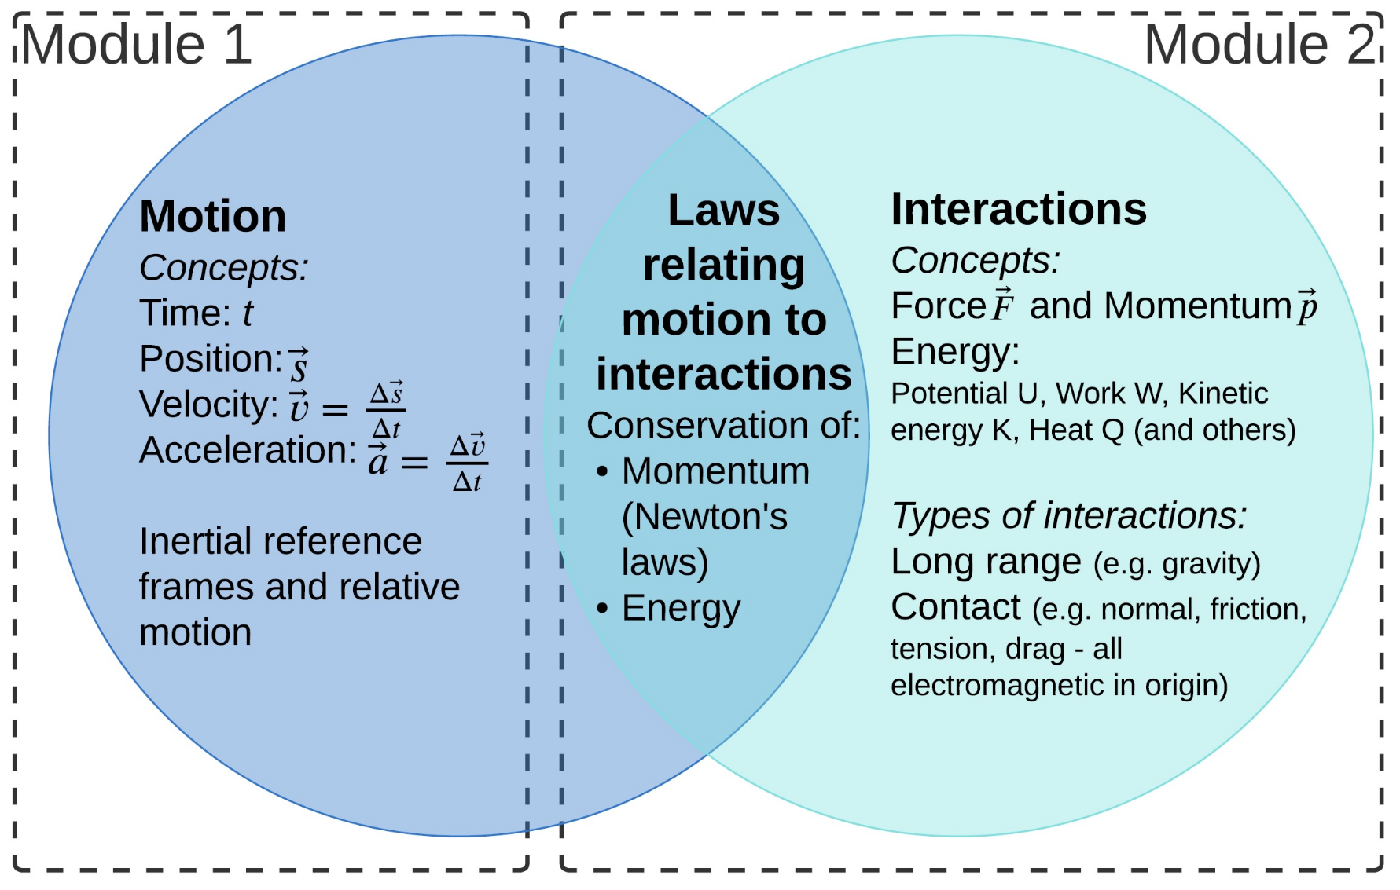
Figure 1: Venn diagram illustration of the structure of mechanics: Motion (velocity and acceleration) and interactions (forces and energy transfers and transformations) are linked by the laws which govern how these interactions change motion. Adapted from Figure 9.7 in F. Reif (2010), ‘Applying Cognitive Science to Education’ (MIT press), pg. 152.
Vector notation
Note that the vector quantities in Figure 1 are notated using an arrow above the symbol (for example, $\vec{s}, \vec{v} and \vec{p}$). The same convention is applied to some, but not all vector, quantities on the Physics formulae sheet, datasheet and periodic table. Students may also encounter different conventions (for example, $\overset{̰}{v}, v and \overline{v})$for notating vectors in their other Stage 6 subjects or when working independently online.
To understand the idea that an unbalanced force changes the velocity of a particle in Module 2, students need to develop a clear understanding of the distinction between velocity and acceleration. Module 1 provides an important opportunity for students to clarify their understanding of these concepts by explicitly addressing and correcting misconceptions about motion.
As mentioned in the introduction, research in educational psychology suggests that ‘spaced repetition’ (also known in physics education as a ‘spiral’ approach) is particularly effective in improving student learning. If students observe and measure, as well as model and represent the motion of objects in a variety of scenarios in Module 1, then these skills can be revisited in Module 2 in the context of analysing how unbalanced forces change the motion of objects. Each time students make use of their existing knowledge in a new or richer context their understanding will become less context-dependent and more robust.

Module 5
The first Year 12 module, Advanced mechanics, builds directly upon the understanding of motion and forces that students establish in Modules 1 and 2. In Module 5 students will study projectile motion and uniform circular motion as two special cases of two-dimensional motion.
The skills in observation and measurement, as well as in representing motion using motion diagrams, graphs, vectors and mathematical models that students develop in this module provide an essential foundation for Module 5. In particular, the use of motion diagrams with velocity vectors provides an intuitive way for students to make sense of centripetal acceleration by examining the difference between velocity vectors over small time intervals in Module 5.
Investing time during Module 1 in assisting students to use:
- techniques such as video motion analysis (Tracker)
- acceleration sensors in their mobile phones, and
- other available equipment (such as motion sensors or ticker tape timers)
means that students can readily utilise these techniques to conduct practical investigations and/or depth studies in Module 5.

Core concepts

Motion in a straight line
Students:
- Develop a clear understanding of the distinction between displacement, velocity and acceleration, and how these relate to each other in terms of rates of change.
- Distinguish between scalars (physical quantities with magnitude only, such as speed or distance) and vectors (physical quantities with both magnitude and direction, such as displacement, velocity and acceleration), and represent vector quantities as an arrow with the length proportional to the magnitude of the vector and pointing in the direction of the vector.
- Develop proficiency in using a range of technologies (for example, rulers and stopwatches, video analysis, use of phone accelerometers, ticker timers or motion sensors) to record the motion of objects.
- Analyse the data obtained from measurements to represent kinematics concepts (speed, distance, displacement, velocity and acceleration) using diagrams, vectors, graphs and mathematical models, in particular, students apply the ‘suvat’ equations to situations in which acceleration is constant (or approximately constant). Note that students’ own representations of motion provide insight into the extent to which they have formed correct understandings of the distinctions between displacement, velocity and acceleration.
- Determine the relative velocity of two objects moving in a common direction (1D relative motion)

Motion on a plane
Students:
- Extend the use of vectors to two-dimensions. Add two-dimensional vectors graphically ‘tip-to-tail’ (sometimes called the triangle method), subtract two-dimensional vectors by flipping the direction of the vector to be subtracted and adding ‘tip-to-tail’.
- Add (or subtract) two-dimensional vectors by resolving vectors into components in orthogonal directions and recombining components to obtain the magnitude and direction of the resultant vector. Relevant contexts may include objects moving accelerating on an inclined plane, or objects moving on a surface which experience changes in displacement or velocity in 2-dimensions.
- Analyse relative motion in two-dimensions. Examples of relevant contexts include people walking on trains, powerboats moving through a current, planes flying in a crosswind.
oPhysics kinematics site contains interactive activities demonstrating the triangle, parallelogram, and component methods for adding and subtracting vectors. Note that students studying engineering will apply these methods throughout the Year 11 course and Mathematics Extension 1 students use these methods in the Introduction to Vectors subtopic in Year 12.

Opportunities for extending concepts

Inertial reference frames
There is opportunity in this module to discuss the significance of inertial reference frames in physics. A suitable focus for this discussion would be Galileo’s ‘moving ship’ thought experiment. Galileo was the first to suggest that the laws of physics (specifically, forces and accelerations, along with conservation of momentum and conservation of energy) are the same in all inertial reference frames – this builds a solid foundation for the independence of horizontal and vertical motion in projectile motion in Module 5 and as well as providing background for special relativity in Module 7.

Skills in evaluating scientific data
Students who quickly assimilate concepts in kinematics may be extended and engaged via more sophisticated approaches to measuring and analysing data in their practical activities in this module. They can, for example, be encouraged to consider evaluating the uncertainty in their measurements using the procedures outlined in the document ‘Evaluating scientific data, stages 4-6’, available at: NSW Department of Education. (2020, September 14). Evaluating scientific data Stages 4-6.

Analysing more complex motion
Advanced students can also be extended with opportunities to measure and make sense of more complex motion, such as simple harmonic motion of a mass on a spring or a pendulum, using free apps on their phone to measure acceleration (such as phyphox). The phyphox developers have produced quality videos demonstrating how their app can be used to take data in these situations, so students can potentially use these resources to work independently.

Misconceptions
Misconceptions/preconceptions commonly held by students about kinematics include:
- Conflation of velocity and acceleration. Students tend not to have a well-developed conception of acceleration and may respond to questions about acceleration using their ideas about the velocity of the object. For example, students will commonly assert that the acceleration of a ball thrown in the air is positive as it moves upwards, zero at the top of its path and negative as it moves down.
- When interpreting graphs of motion, students often have difficulty separating the shape of the graph from the path of the motion. Activities that require students to work between or translate verbal descriptions, position-time and velocity-time graphs can identify student misconceptions. Inquiry-based approaches that are focused around answering a scientific question, collecting data, and forming evidenced-based arguments will support deep student conceptual understanding. For example, students could investigate the question “how is velocity represented on a position-time graph?” by collecting, plotting, and analysing primary data.
- Students also incorrectly infer that,
  - if a position-time graph is increasing, then the velocity is increasing (and vice-versa if it is decreasing)
  - changes in direction of the motion occur when the position is zero in a position-time graph.
- For determining the ‘area under a graph’ students may simply determine the area between the curve and the bottom of the graph paper, ignoring the $v=0$ axis (note that the area under the curve is the area between the curve and $v=0$ axis, incorporating ‘sign’ - negative areas in a velocity-time graph correspond to displacements in the negative direction).

Conceptual difficulties
Conceptual difficulties may include:
- Students may have trouble distinguishing between ‘clock reading’ (time that has passed since $t=0$) and a time interval, $Δt$. This leads to difficulties in making sense of the difference between $x/t$ and $Δx/Δt$, that is, between the co-ordinates of a point on a position-time graph (or the average velocity) and the instantaneous velocity of the object when it is at that position. Similarly, there may be difficulties distinguishing between $v/t$ and $Δv/Δt$.
As a result, it may be thought that objects passing each other (so at the same position at the same time) must share a common velocity at that moment in time.
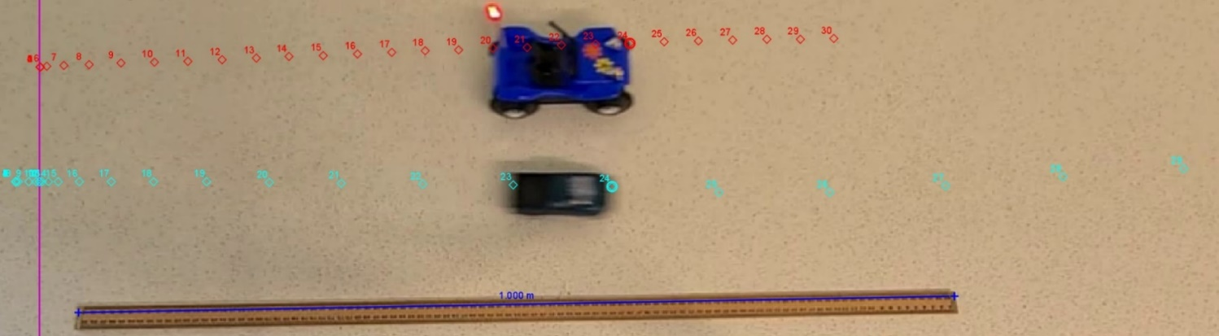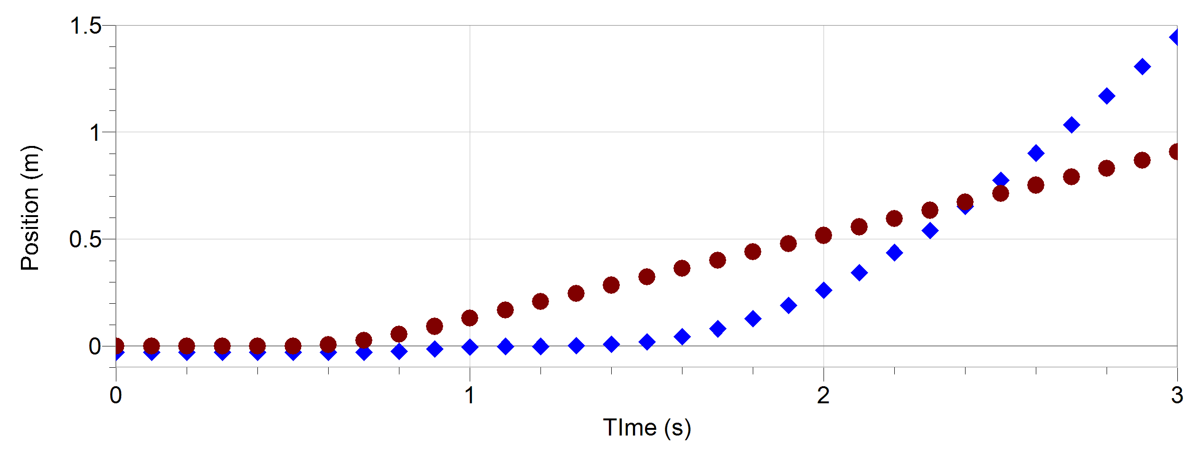
Figure 2: (Top) Two toy cars, one moving at a constant velocity (red) and one moving with an increasing velocity (blue). The cars have different instantaneous velocities when they have the same x-position.

Similarly, objects which momentarily have the same velocity may be thought to have the same acceleration.
- Relative motion, especially two-dimensional, is a challenging part of this module for most students. Many students consider velocity to be an intrinsic property of an object and will not consider the impact of the observer’s reference frame. They will generally use the ground frame of reference without explicitly acknowledging it. Explicitly establishing a frame of reference is a crucial early step in problem solving.

Mathematical modelling
Deriving the mathematical relationships in rectilinear motion from graphs and other modelling is introduced in Module 1. This is likely the first time many students will have been required to derive mathematical relationships in Science. Students completing the Stage 6 Physics course will later be required to derive relationships for:
- projectile motion, escape velocity and total energy of a satellite (Module 5)
- the interactions between charged particles and uniform electric fields (Module 6).

Teaching strategies

Overall approach
Understanding your students’ prior knowledge, understanding and skills will inform your teaching of this module. A pre-test could be given that focuses on relevant working scientific skills and the following content statement from Stage 5 Physical World.
PW2 The motion of objects can be described and predicted using the laws of physics. (ACSSU229)
Students:
describe the relationship between force, mass and acceleration
explain the relationship between distance, speed and time
relate acceleration to a change in speed and/or direction as a result of a net force
analyse everyday situations involving motion in terms of Newton's laws
Skills in representing quantities, use of units and manipulation of simple equations could also be assessed before the commencement of the course.
Effective activities to begin the module will provide ‘hands-on’ opportunities for students to observe the motion of real objects, record this using a range of measurement technologies, as well as use a variety of representations and mathematical models to describe their observations. Research suggests that students should also engage in the reverse process of producing motion presented as graphs (for example by walking or moving their hand or a motion cart).
Emphasising ‘sense-making’ over numerical calculations in learning activities for this module. That is, promoting activities that engage students in actively trying to figure out or make sense of the way the world works. These types of activities will produce the best outcomes in terms of addressing student misconceptions and promoting deep conceptual understanding.
Sense-making activities are effective when students:
- are focussed on making sense of an interesting or relevant phenomenon
- are engaged in making observations, measurements or collecting secondary data
- use reasoning and evidence to formulate explanations.
In Module 1, this may include investigating how objects behave in real-world scenarios such as investigating the speeds at which cars move through the school zone, determining the average acceleration of an object as it is launched from a toy or determining the terminal velocity of a raindrop. Problem solving around how to measure quantities of motion could also be integrated into learning activities.
Teaching the detailed process for resolving vectors into components for the purposes of adding or subtracting can be deferred to the second part of the module on motion on a plane so that students’ first taste of Stage 6 physics is highly engaging and reflects the important role played by observation of real-world phenomena and analysis of those observations in physics.

One-dimensional motion
One possible sequence of activities, which emphasises a series of what could be called ‘touchstone examples’ is given below. Some of these scenarios are useful to revisit in a richer context in Module 2 (that is, to use as part of a ‘spiral teaching’/spaced-repetition approach).
The learning activities are intended to:
- provide opportunities for students to clarify their understanding of displacement and velocity and the relationship between these variables and distance and speed
- introduce students to tools they can use to represent motion, such as ‘motion diagrams’ (a series of dots representing the position at regular time intervals), vectors, motion graphs and mathematical models to describe uniformly accelerated motion.
- introduce students to a range of techniques and technologies for measuring motion.

Activity 1: Motion diagrams

Purpose/background
To introduce ‘motion diagrams’ in the context of objects moving at a constant speed, for example:
- A student walks across the room at a constant speed
- A motorised toy car moves at a constant speed (for example, toy car speed trap - calculating speed // Homemade Science with Bruce Yeany. (2017, January 13). [Video]. YouTube.
- Cars driving along the street in front of the school (possible inquiry question: What fraction of cars driving on the street near our school are speeding?) or other students in the school as they walk along corridors (possible inquiry question: is the average speed of a junior student walking to class faster or slower than that of a senior student?)
A motion diagram consists of a series of dots which represent the position of a particle at constant time intervals. Drawing motion diagrams assists students to distinguish between position and a displacement (a change in position) and between ‘clock reading’ (time since the motion began) and a time interval.
Beginning motion diagrams here will lay the groundwork for using them to determine accelerations (as a change in velocity over time) and allow them to be utilised again when students investigate centripetal acceleration during uniform circular motion as well as constant acceleration in projectile motion in Module 5.
Videos demonstrating the production of ‘real life’ motion diagrams (using instructors on rollerblades dropping sandbags at constant time intervals) are available at the resources site for ISLE (Investigative Science Learning Environment). Other good resources on motion diagrams have been produced by C.A. Rotter, Eberly College, the University of West Virginia and by the Physics Classroom:

Measurement Technology options
Ruler/measuring tape/trundle wheel and stopwatch, Ticker timer, video analysis (for example, Tracker), or strobes (for qualitative observations).
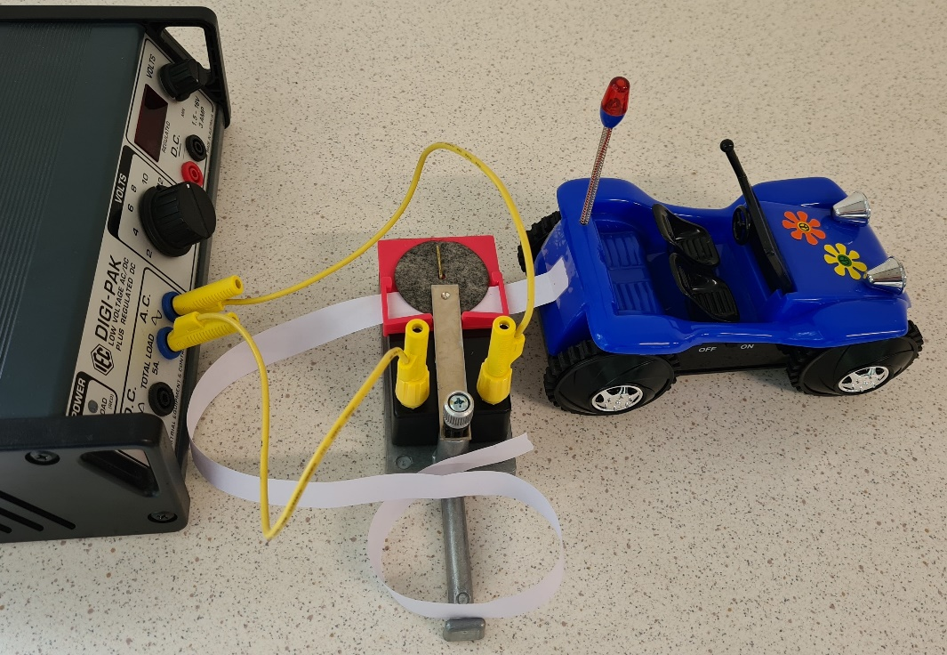
Figure 3: A motorised toy car attached to a ticker tape. Dots are made on the tape at a rate of 50Hz by a recording timer attached to a 12V AC supply.
Motion diagrams can be produced directly using a Ticker timer tape attached to an object such as a motorised toy car, or by video analysis of objects such as cars or people (where students mark the position of the object at each frame of the video by ‘tracking’ the object manually). Alternatively, if the object is moving slowly enough students could mark it’s position at each time interval with a sticker or other marker on the floor.
Students could convert position-time coordinates they have obtained from timing cars driving (or other students walking) past landmarks at the school to a motion diagram.

Activity to observe and represent/model motion:
Students observe the motion of an object and use appropriate measurement technology to collect data. They produce a motion diagram by drawing dots to represent the position of the object at regular time intervals.
Figure 4: A ticker tape motion diagram for the toy motorised car in figure 1. The spacing of the dots increases as the car is released from rest and then spacing becomes constant as it moves at a constant speed. The arrows below the dots represent the average velocity of the car during some of the time intervals.
Students learn how to represent the displacement during each time interval as a vector located at the dot with a length proportional to the displacement, pointing in the direction of motion. These arrows, drawn between the dots, also represent the velocity vector during each time interval. Students can use this method to quickly see and describe changes in an object's velocity. Note: if the spacing between dots is very small, arrows could instead be drawn between sets of five dots. This can be done manually for a ticker timer tape, or automatically using motion analysis software. Further information on using the free Tracker software is provided in the appendix.
Students are led to reason that when the spacing of the dots is equal, the displacement of the object during each time period is the same, so the velocity is constant.

Activity 2: Reference frames and motion graphs with positive and negative velocity

Purpose/Background
To introduce the concept of reference frames when analysing motion, and the concepts of positive and negative position, displacement and velocity in the context of position-time and velocity-time graphs. Objects moving at constant speed in both the positive and negative directions are suitable for this purpose, for example:
- A student walks across the room at a constant speed and then back again at a faster/slower speed
- A ‘tumbling’ motorised toy car moves at a constant speed to a wall then moves off in the opposite direction.

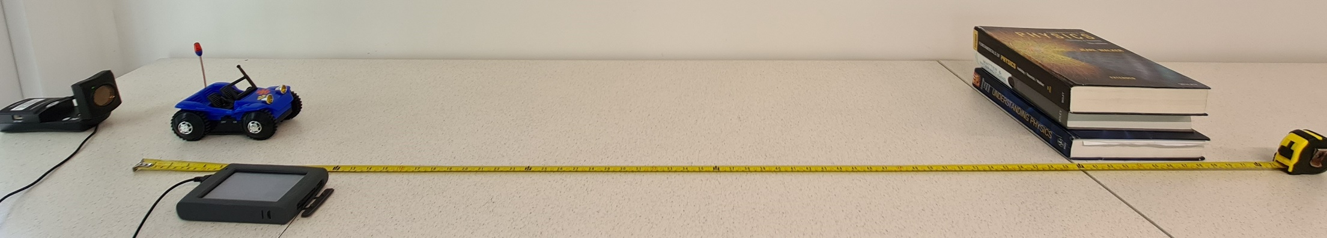
Figure 5: An example setup for measuring positive and negative velocities - a motion sensor (left) and motorised toy ‘tumbling’ car and obstacle to allow the car to tumble and return towards the sensor. Video demonstration of this setup.

Measurement Technology options
Ruler/measuring tape/trundle wheel and stopwatch, ticker timer, light gates, strobes (for qualitative observations), video analysis (for example, Tracker) or a motion detector (graphs produced using video software and motion detectors can be used to check student predictions).

Activity to observe and represent/model motion
Introduce the concept of measuring motion relative to a particular reference frame with one of the axes aligned along the direction of motion and note that motion can occur in either the positive or negative direction along this axis.
Students explicitly choose a ‘zero’ position and the positive and negative directions for their axis. They observe the motion and represent this using a motion diagram. Students then translate this information into a position-time graph, and a velocity-time graph.
Important points to draw out in discussions with students during in this activity:
- Average velocity as the gradient of the position-time graph between two data points. A constant gradient on a position-time graph corresponds to a constant (horizontal) line on a velocity-time graph.
- A positive gradient on a position-time graph means that the object is moving in the positive direction (even if its current position is negative – this is worth pointing out explicitly while students observe the motion again, after they have constructed their graph). A negative gradient means the object is moving in the negative direction, even if it is located at a positive position.
- The distinction between distance travelled and displacement, and between average speed and average velocity.
- The area under the velocity-time graph is the displacement of the particle – note that you cannot determine the initial position of the particle from the velocity-time graph.
It is possible to run this activity as a ‘predict’ then ‘measure’ activity if a technology that produces position-time graphs directly is used, such as video analysis or motion detectors.
This activity could potentially follow on directly from activity 1 (depending upon the choice of object – a motorised toy tumbling car, will allow the use of a ticker timer for activity 1 and a measuring tape and stopwatch or motion sensor for activity 2).
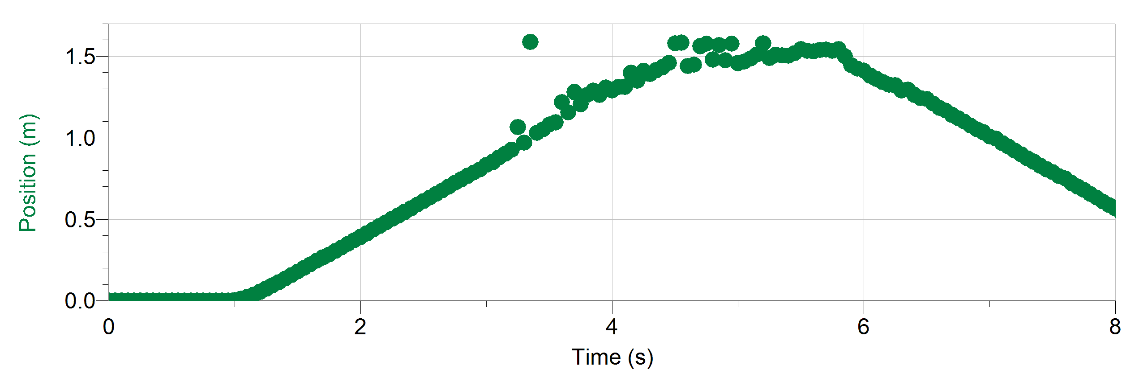
Figure 6: Motion sensor data for the position versus time of a toy tumbling car as it moves towards an obstacle, tumbles, and returns.

Differentiation:
As noted earlier in the section on ‘Opportunities for extending concepts’, for students who already have a strong understanding of motion, and the relationship between variables such as velocity and acceleration, this activity and the following activities can be adjusted to emphasise data analysis skills that are likely to be new, such as a determination of the uncertainty of the measurements they make in these investigations. These students can also be taught to include error bars on their graphs to determine the uncertainty of a gradient, for an example see pg. 27 in Physics Skills in Experimentation activity book from UNSW.

Follow-on activities
Motion detector software provides ‘graph match’ activities, where students are presented with a position-time (or velocity-time) graph, which they need to match by moving in front of the motion detector (or sometimes this works better if students hold the motion detector and move towards or away from a wall). This provides students with physical experience in translating ‘backwards’ from the information on a graph to the motion which it represents.
The Graphing Stories activity on desmos can be used to guide students in representing motion using position-time graphs. Students view a video of motion, sketch the relationship, and then compare their sketch to the answer. Alternatively, The Tortoise and the Hare activity could be used to reinforce the basics of graphical representations of motion.
The Paris-Lyon 1885 train schedule, created by E.J. Marey, is a fascinating example of how position-time graphs can be used to represent and analyse everyday phenomena. This could instead be used as an introductory activity. Students will require a brief introduction to help them recognise it as position-time graph with the angled lines representing the motion of trains between stations. They can then be guided in interpreting the significance of its features including:
- the slope or gradient of the lines including positive and negative
- the length of the small horizontal sections at stations
- the vertical spacing between stations
- how it could be used to plan a journey.

Activity 3: Interpreting graphs and mathematical models for constant acceleration

Purpose/background:
To use motion diagrams and graphs to establish the concept of acceleration as the rate of change of the velocity of an object.
Students link variation in the displacement of an object over constant time intervals in a motion diagram with a change in velocity. Students observe that accelerations can be positive (even when the velocity is negative) or negative (even when the velocity is positive). Acceleration can be constant even while the velocity is zero (for example at the top of the motion of a ball thrown upwards).
Students produce a mathematical model of motion under constant acceleration using the ‘suvat’ equations and apply this model appropriately.

Measurement Technology options:
Ticker timer, motion detector, the accelerometer on students’ smartphones (using free apps such as phyphox or video analysis (for example, Tracker), motion detectors, strobes (for qualitative observations), motion or fan carts with data logging capabilities.
For this section of the module, it is useful to use at least a couple of different measurement technologies. One technology could be chosen to allow students to compare the motion diagrams for an accelerating object with those produced by objects moving with constant velocity in the previous section, for example, a ticker timer, video analysis or a strobe. Another technology could be chosen that allows students to directly check their predictions for graphs of displacement-time, velocity-time and acceleration-time, for example, video analysis, accelerometers on students’ phones, motion detectors or motion/fan carts with data logging capabilities.
For cost effectiveness, it is possible to use data logging technology as a class demonstration, in conjunction with other activities which utilise other technologies which can be used by students themselves. Data from the motion of the object can be projected in real-time for the class to view. Students can predict the motion graphs for a particular object and then immediately test these predictions against the recorded data.

Activity to represent/model motion:
At this point in the module, students have gained experience both in representing motion using motion diagrams and graphs, as well as in using measurement technologies. For the next part of the module, a suitable teaching approach would be to use ‘Predict, Explain, Observe, Explain (PEOE)’ (for an excellent discussion of this and a range of other relevant teaching approaches, please see the Perimeter Institute resource ‘Tools for teaching science’)
Students observe the motion of an accelerated object and produce predicted motion diagrams and displacement-time and velocity-time graphs (acceleration-time graphs as well if acceleration is constant) and explain these predictions. This can be on paper, or whiteboards if students feel more comfortable making their predictions on a ‘non-permanent’ surface. Encourage students to draw the corresponding displacement and velocity-time graphs one above the other. This will ensure that critical events in the objects motion will be aligned on each graph and will support sense-making.
A strobe could be used effectively at this point to allow students to immediately qualitatively check their predicted motion diagram prior to checking their graphs.
Students then record data for the accelerated object and analyse this data to check their predictions, explaining any discrepancies between their predictions and the measured data.
The following are examples of accelerated motions that could be observed.
Dropping a ball or throwing a ball vertically upwards in the air. This can be recorded by students using the camera on their phone and then analysed in Tracker to produce a motion diagram and graphs of displacement-time and velocity-time (a linear fit can then be used to find acceleration).
Note that students should predict the motion diagram and associated position-time, velocity-time and acceleration-time graphs before analysing data. This can be done quantitatively for a ball dropped from a specific height once students are familiar with the equations for constant acceleration. A brief video tutorial on how to use Tracker to do this is provided in an appendix.
Free fall data can also be recorded with a motion sensor which provides ‘real-time’ graphs of position-time and velocity-time for students, but it can be challenging to keep the ball ‘in sight’ of the sensor unless a large ball (for example, an exercise ball) is used. Alternatively, it is also effective to mount a motion sensor at the top of a pipe with a ball held up on a ‘pin’ inside (see Figure 7). This is pulled out and clean data (including bounces) can be obtained (sample motion sensor data is provided in the appendix).

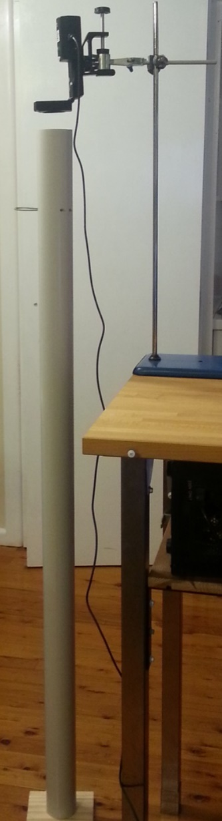
Figure 7: A motion sensor can be used to measure position versus time for a ball dropped inside a tube. A removable wire pin is used to release the ball.

A cart/car/ball rolling up a ramp and/or down a ramp (see the next section on non-uniform acceleration for an example which combines this motion with a collision with a spring). This can be videoed by students and analysed using Tracker, or recorded with a motion sensor, or a cart with data logging capabilities can be used to obtain very ‘clean’ data. Students’ phones could be considered as a means to measure acceleration directly if attached (very securely!) to a cart on a low ramp.
A person walking more slowly/quickly as they move across the room. Video analysis could be used (noting that students should use a fairly ‘rigid’ part of the body to track, such as the head or top of the shoulder) or motion detectors (however it can be challenging to obtain ‘clean data’ with the motion detector pointed at the person – it can be more effective for the person to hold the motion detector and walk towards a large flat object such as a wall)
Cars braking/speeding up at traffic lights near the school. This motion would be amenable to video analysis.
Pull back cars, ‘fan’ carts, or a motion cart or ball slowing down due to friction as it rolls along a horizontal track. For these objects, video analysis, or ticker timer (this can be laborious for acceleration calculations, but forces students to notice the changing spacing of the dots as an indicator of acceleration) or motion sensors could be used (or data logging, for carts equipped with this technology).
Time should be spent analysing the data to draw out the following ideas.
- Using the motion diagram, note that the change in velocity vector divided by the time between steps is the average acceleration vector. Encourage students to ‘think iteratively’ about motion: $v_{f}=v_{i}+Δv=v_{i}+a_{av}Δt$ (which can be represented as vectors)
- Emphasise the relationships between the displacement-time, velocity-time and acceleration-time graphs. The velocity at any moment in time is the rate of change of the displacement (students should be encouraged to look at their graphs and visually/qualitatively observe this in the shape of the graphs), and the acceleration is the rate of change of the velocity (again, this should be explicitly observed on the graphs). Students should be given the opportunity to work ‘forwards’ from knowing the displacement-time graph to predicting the acceleration-time graph, and working ‘backwards’, from the acceleration-time graph to determining the displacement-time graph. The Match That Graph Concept Builder on the Physics Classroom activity demonstrates a style of graph matching that could be used to assess student understanding of the relationship between kinematics graphs.
- For uniformly accelerated motion, the equation for displacement $s=ut+\frac{1}{2}at^{2}$ should be linked directly to the shape of the displacement-time graph – students note that it is parabolic, with the coefficient of the leading term ($\frac{1}{2}a$) determining whether the parabola is concave up (for positive accelerations) or concave down (for negative accelerations). This enables students to make links between kinematics and the work they have done in maths on graphing quadratic equations. The equation for the velocity of the particle for constant acceleration, $v = u+at$ is linear, and students should notice that the gradient of a velocity-time graph is constant for uniformly accelerated motion, and equal to the acceleration. The y-intercept corresponds to the initial velocity of the object.
- Highlight that, for the examples of a ball thrown in the air, or a (low friction) cart moving up a ramp and then down again, the acceleration is constant for the entire motion – despite the velocity being zero at the top. A motion diagram can be used as a tool to question students to assist them make sense of this.
- Draw out the physical significance of the area under the acceleration-time graph. It can be useful to consider a situation where the overall displacement is zero, such as a ball thrown into the air, or a cart moving up a ramp and back down, to help students see they need to consider the area between the acceleration curve and the position-axis (not the bottom of the graph paper).

Follow on activities:
- The physics classroom resource
- This would be a good point to use the excellent ‘graphs and tracks’ resource. This provides students with an opportunity to strengthen their understanding of the links between the motion of an object and features of the graph and mathematical models that describe the motion.
- Tracker also has a fantastic in-built library of motion videos – the ‘Tracker video analysis: Relative motion of two carts’ in the ‘Moving reference frames’ folder could be used to probe for the misconception that two carts have the same speed when they are passing.
- The ‘ISLE’ group YouTube channel has many motion videos that are designed for students to analyse.
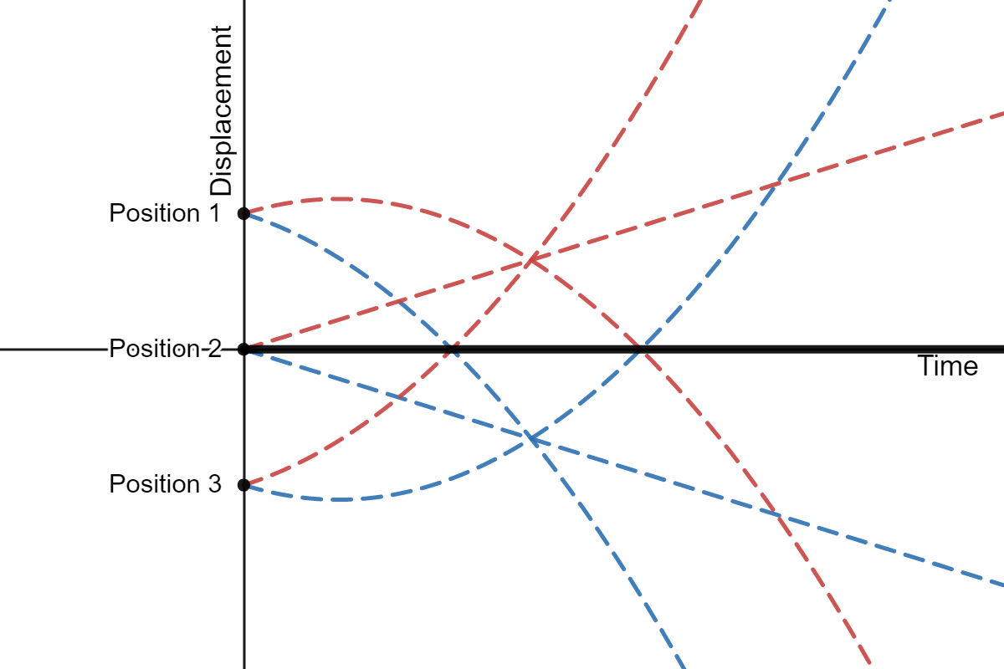
Figure 8: Match the graph activities can be used to explore the representations of velocity and acceleration. This figure shows the displacement-time graphs for six objects. Students can explore how velocity and acceleration are represented on displacement-time graphs by using the sliders to match the various graphs. Interact with this graph on desmos.com.

Equations of constant acceleration
Once students have substantial experience representing and modelling the motion of real objects, the focus can shift to using the equations of constant acceleration in a range of scenarios. One way to clearly link this to student’s earlier work is to use a mechanics ‘worksheet’ approach can be used to make connections between earlier work using motion diagrams and the use of equations.
In this approach, the same problem is described using multiple representations such as a pictorial representation, motion diagram and equations (and later, in mechanics, a free body diagram or work energy bar chart). This provides a scaffold for highlighting the relationship between different representations of the same information as well as modelling for students how to methodically make sense of a problem and develop a solution.

Motion on a plane
Depending on the ability of your students before introducing motion in a plane, it maybe a good idea to revise trigonometry at this stage. It is important to ensure students have the mathematical skills to apply both right and non-right-angle trigonometry to a range of situations.
Learning activities relating to resolving vectors into two perpendicular components and adding and subtracting two-dimensional vectors are well-covered in Year 11 textbooks. Vector addition using the parallelogram, triangle and component methods are demonstrated on the oPhysics: Interactive Physics Simulations site. Graph paper with large squares makes it simpler to resolve the components of a vector as students can simply count the squares or read off the scale of the horizontal and vertical axes as shown in Figure 9.
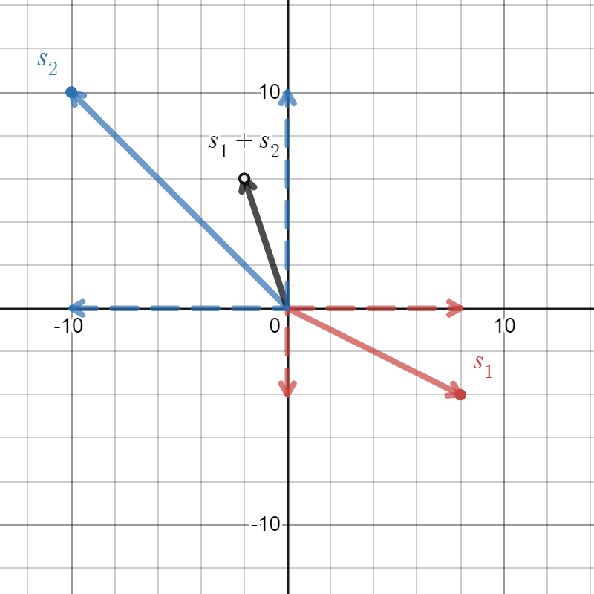
Figure 9: Graph demonstrating the resolution of vectors $s_{1}$ and $s_{2}$ into their component vectors (drawn in dashed red and blue respectively). The resultant $s_{1}+ s_{2}$ is drawn in black. Interact with this graph on desmos.com.

Relative velocity
Excellent learning activities for the 1D and 2D relative motion sections of the syllabus are covered in a text by Camp and Clement which utilises a teaching strategy the authors call ‘bridging’. In this approach an ‘anchor example’, a correct conception that students feel intuitively confident about, is used to lead students, by discussion, interaction with peers and/or experiments via intermediate ‘bridging examples‘ to understanding a ‘target problem’, about which students may initially have held misconceptions. The use of bridging analogies can be a powerful approach as it is generally very difficult to change students’ minds about ideas they feel confident about (even if they are incorrect) without providing a new, more convincing idea to replace the incorrect conception.
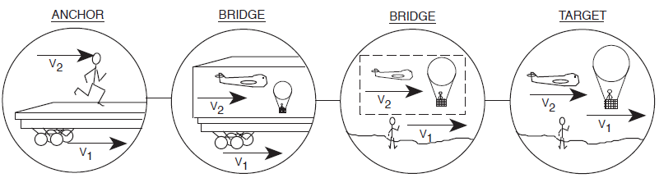
Figure 10: Diagram from Camp and Clement⁹ showing a progression of bridging examples that could be used to improving student conception of relative motion involving aeroplanes and crosswinds. Looking left to right, v₁, the velocity of the train is used as a bridge for the wind velocity and v₂, the velocity of the person running an anchor for the aeroplane’s velocity. The third diagram in the sequence has a large box of air travelling to the right with a velocity, v₁.
The chapter on relative motion in the Camp and Clement text is particularly useful for Module 1 as it leads students from one-dimensional relative motion scenarios they feel confident about (such as a person walking on a moving train) by a sequence of bridging analogies to more complex two-dimensional situations such as powerboats moving across rivers and planes flying in crosswinds.
Working scientifically: Communicating
Relative motion between two objects often confuses students, especially when applied to unfamiliar situations. New mathematical notation and translating information into a correct diagram can be challenging for students. Be explicit in stating the connections between mathematical representations such as $v_{a,b}$, and the quantities they describe to assists students in reading, writing and translating information in physics.
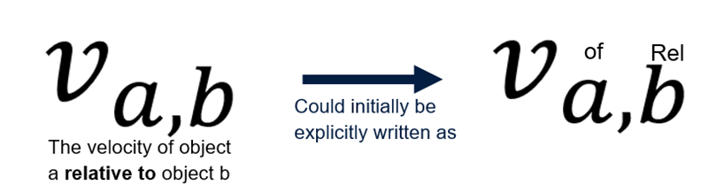

Example (1-D)
$$v_{a,b}=v_{a}–v_{b}$$
This equation can be used to determine the relative velocity of a to b. It is important to discuss the notation used in these questions. Also bring students attention to the negative sign and the importance of direction in calculations involving vectors.
Two footballers approach each other on a field, player A is running at $1.4 ms^{-1}$ East and player B, $2.0 ms^{-1}$ West. What is the relative motion of player a to b?
Step 1: Diagram and definitions
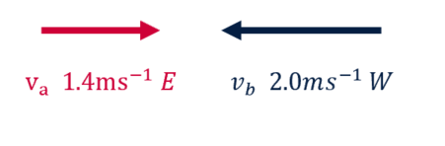
(Note: negative at this stage is directional information, highlighting this is important for student understanding)
Asking students to explicitly define East as the positive direction ensures they recognise this as an important step in defining a frame of reference and allows them to code the directional information and rewrite the vectors algebraically.
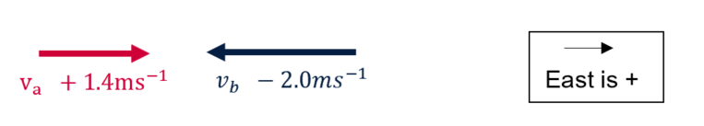
Step 2: Equation
Step | Notes
$$v_{a,b}=v_{a}-v_{b}$$ | Velocity of A relative to B = velocity of A – velocity of B
$$v_{a,b}=1.4-\left(-2.0\right)$$ | Encourage students to substitute values including negative signs. Brackets can be included to distinguish negative values when substituting.
$$v_{a,b}=1.4+2.0=3.4 ms^{-1} East$$ | Expand brackets to resolve the sign.  East was defined as positive in Step 1. Therefore, the direction of the relative velocity of A relative to B is East.
If solved algebraically, have students draw a vector diagram for analysis and discuss the answer, does it make sense? Is this the same as player A running at player at rest at $3.4 ms^{-1}$?
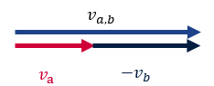
Note: for ${-v}_{b}$, the negative sign has ‘flipped the vector’

Example (2-D)
Using the same variable above and only changing the direction can help students feel at ease when introducing 2-D relative motion.
Player A is running East at $1.4 ms^{-1}$ and another player is approaching from the South at $2.0 ms^{-1}$. What is the relative velocity of player A to B in this case?
A good method to evaluating student ability is to word questions slightly different, this helps them engage with information instead of repeating a set method to a set question type. For example, in this case, player B could be described as travelling $2 ms^{-1}$ North rather than as approaching from the South.
This comparison of 1 and 2 D relative motion will bring an opportunity to discuss the methods used and highlight the importance of ensuring directional information is included in calculations and answers.

Appendices

Video analysis of a ball throw with Tracker
Below is a photo of a ball toss in which a motion diagram showing velocity vectors has been generated by Tracker (only every second data point is shown for clarity).
Students should draw their own predicted motion diagram before analysing the video in Tracker. By drawing velocity vectors, they can reason about the sign of the acceleration at each point in the motion. In this analysis the positive acceleration prior to release has been included to provide students with the opportunity to reason about real situations (there is a positive acceleration as the ball speeds up, but once it is released the velocity vectors become smaller in magnitude, so the acceleration must be downwards, even though velocity is upwards).
A brief video tutorial has been made to demonstrate how Tracker can be used to analyse a ball toss. The video is captioned so that it could be used in class by students to assist them to analyse their own video without the need for sound.

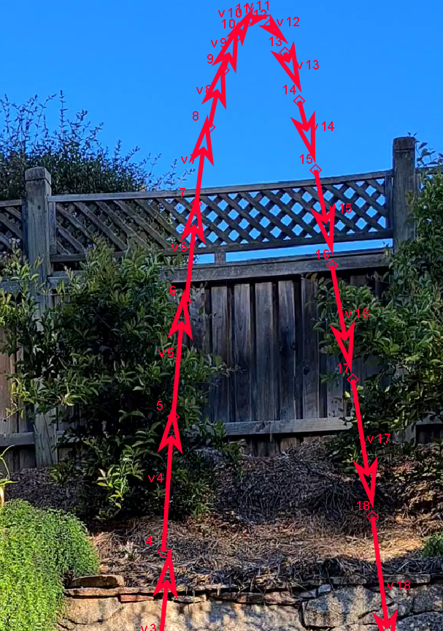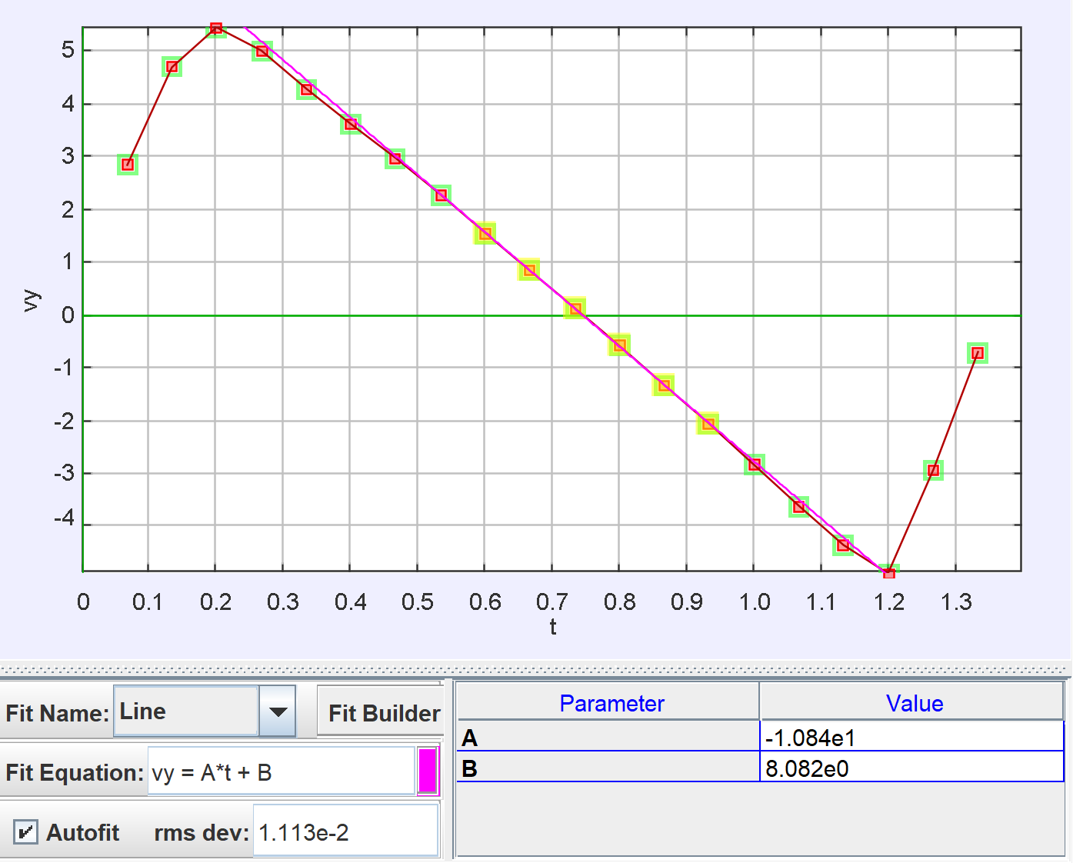
Figure 11: (left) A ball toss with a motion diagram produced using Tracker. (right) The velocity versus time graph for a ball toss (including the initial acceleration by the hand). A linear fit has been performed for the time the ball is in the air using Tracker.

Deriving relationships for accelerated motion
In Module 1, students use mathematical modelling and graphs to analyse and derive relationships between quantities of motion occurring in one dimension. The mathematical relationships specified in the syllabus are stated below.
$$s=ut+\frac{1}{2}at^{2}$$
$$v=u+at$$
$$v^{2}=u^{2}+2as$$
Students can derive some of these relationships:
- from primary data, or
- from graphs of motion.

From primary data
To collect relevant data, students will require the following.
- A method of applying a uniform, non-zero acceleration to an object.
Free-fall provides uniform acceleration due to gravity, but the high rate of acceleration makes it challenging to collect accurate data without the use of video analysis.
Inclined planes a very useful in reducing the acceleration under gravity, allowing accurate time and distance measurements to be taken using manual instruments.
Alternatively, a pulley and mass arrangement (the half-Atwood machine) can be used to control the acceleration of an object moving horizontally across a desk.
- Measurement technologies that ensure the accuracy of measurements and allow for efficient data collection.
Stopwatches may be suitable as long the time intervals recorded are relatively long compared to the reaction time errors. That is, they are most suitable for timing intervals longer than one second. Averaging multiple measurements or applying a linear regression (demonstrated below) will mediate some of the random errors associated with manual timing. Light gates, data loggers and video analysis provide superior accuracy for shorter time intervals.
The distances studied classroom investigations can usually be measured using a standard 1-metre ruler.
Light gates, including standalone units with digital displays provide quick and accurate measurements of (approximately) instantaneous velocity.
Acceleration can be measured using the accelerometer on a mobile phone, dedicated data logging equipment or using an Arduino or Micro:bit microcontroller.

Deriving distance-time relationship for an inclined plane
- Setup an inclined plane, mark a ‘finish line’ with masking tape. Measure and record the angle of incline.
- Release a trolley from 10 cm up the ramp and record time taken to reach the finish line using a stopwatch. Repeat and record a few runs from this height.
- Collect data on the time taken for the object to travel a range of distances.
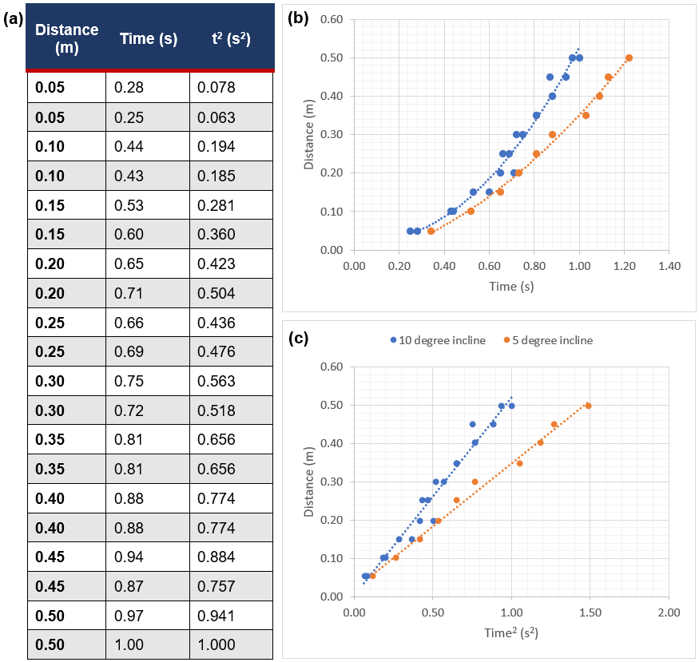
Figure 12 Sample data collected for a trolley rolling down an inclined plane. (a) Table of results when incline set to 10 degrees. (b) distance-time graph showing parabolic relationship between distance and time using a 10-degree (blue) and 5-degree (orange) incline. (c) distance-time² graph showing linear relationship between distance and time squared for 10- and 5-degree inclines.
Working scientifically: Processing data and information
Deriving relationships between quantities of motion is a good context for processing data. In the above investigation, students will need to linearise the data before they can confirm the quantities are directly proportional and apply a straight-line model to determine their mathematical relationship.
That is, they must first manipulate one of the quantities on the horizontal or veritcal axis and check that the data points line up. In the graph below, the horizontal axis has been manipulated to show the value of time squared, $t^{2}$, for each measurement.

Step | Notes
$$y=mx+b$$ | Modelling the relationship between distance, s, and time squared, t², as a linear relationship from graph with a gradient, m, and y-intercept, b.
$$s=mt^{2}$$ | Let $y=s$, $x=t^{2}$ and $b=0$ (from graph)
$$m=\frac{rise}{run}=\frac{\left(0.42-0.26\right)m}{\left(0.70-0.50\right)s^{2}}=0.80ms^{-2}$$ | Using two points on the line-of-best-fit for 10-degree incline data. Note the units for the gradient are the same as for acceleration.
$$s=0.80t^{2}$$ | Substituting m into the previous equation. Note that this result supports the model for uniformly accelerated motion ($s=ut+\frac{1}{2}at^{2}$) as $u=0$ (marble was initially stationary) and the displacement is directly proportional to the square of the time.
Given that $s=ut+\frac{1}{2}at^{2}$ where $u=0$  $$s=\frac{1}{2}at^{2}$$  $$s=0.80t^{2}$$ | The acceleration could also be calculated using the above model and then compared to a theoretical prediction of the acceleration for an object on an inclined plane.
$$\frac{1}{2}at^{2}=0.80t^{2}$$ | Dividing both sides of the equation by $t^{2}$ and rearranging.
$$a=\left(2\right)\left(0.80\right)=1.60ms^{-2}$$ | Which is close to the expected value of $a=g\sin{θ}=9.8sin10=1.70ms^{-2}$

From graphs of motion
Two of the formulae describing the relationships between quantities of motion can be derived by analysing velocity-time graphs and applying some basic assumptions.
Given that acceleration and displacement is represented respectively as the gradient and area under a velocity-time graph, students can derive the formulae $v=u+at$ and $s=ut+\frac{1}{2}at^{2}$.
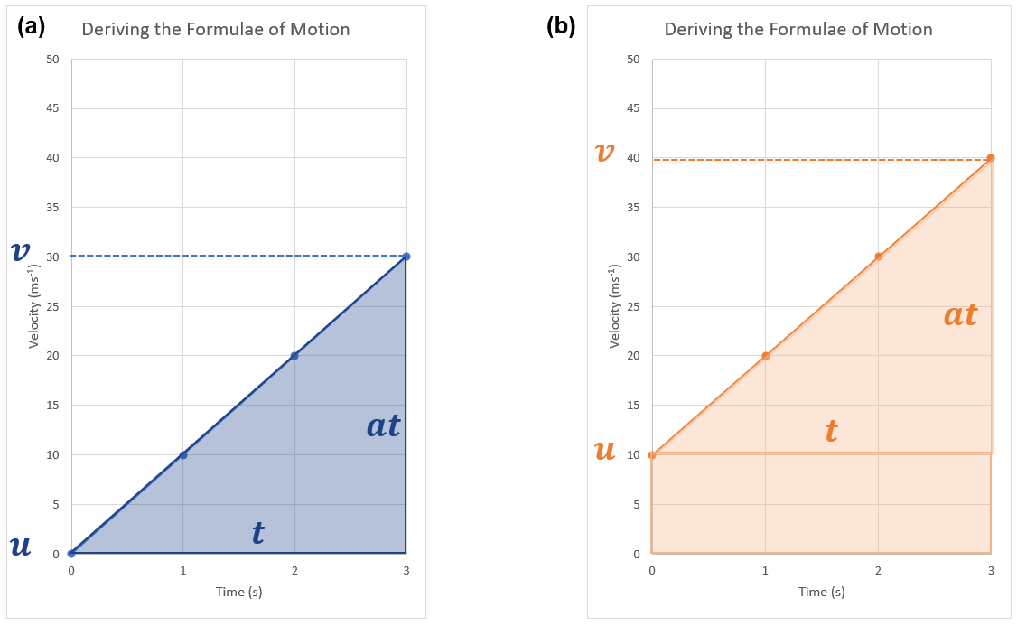
Figure 13: Velocity-time (v-t) graphs with annotations to support the derivation of kinematics formulae. (a) v-t graph of object with uniform acceleration and $u=0$. (b) v-t graph of object with uniform acceleration and $u>0.$
Deriving $v=u+at$ from (a)
Step | Notes
$$a=gradient=\frac{rise}{run}=\frac{∆v}{t}$$ | Where $∆v=final velocity-initial velocity=v-u$
$$a=\frac{v-u}{t}$$ | Rearrange to make v the subject
$$v=u+at$$
Deriving $s=ut+\frac{1}{2}at^{2}$ from (b)
Step | Notes
$$s=area=lw+\frac{1}{2}bh$$ | area of rectangle is $lw=length×width$  area of triangle is $\frac{1}{2}bh=\frac{1}{2}base×height$
$$s=\left(t\right)\left(u\right)+\frac{1}{2}\left(t\right)\left(at\right)$$ | Substituting values from the velocity-time graph
$$s=ut+\frac{1}{2}at^{2}$$ | Expanding the brackets
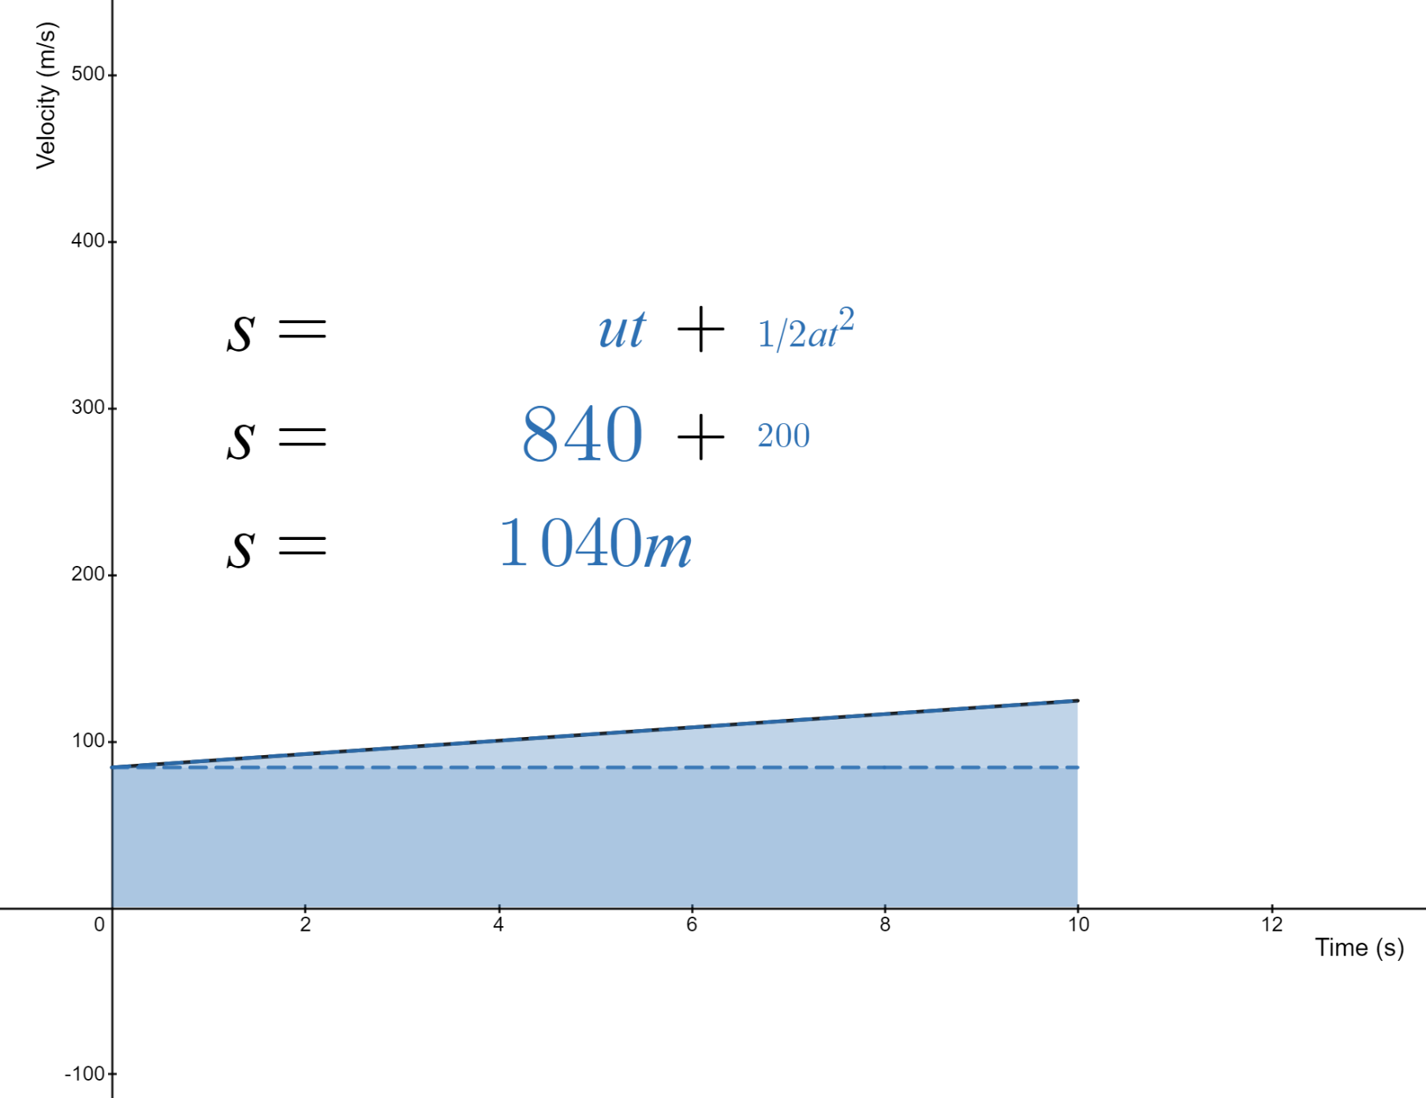
Figure 14: Multiple representations of displacement. The two terms on the right-hand side of the kinematics equation, $s=ut+\frac{1}{2}at^{2}$, can be related to the area ‘under’ a velocity-time graph. The contributions relating to the initial velocity, $ut$, and the accelerations, $\frac{1}{2}at^{2}$, correspond respectively with the component areas of the rectangle and triangle. Interact with this graph on desmos.com.

Sample data for activities

Dynamics cart rolling up and then down an inclined plane
The following position-time (and calculated velocity-time) data was taken using a motion encoder cart with non-negligible friction rolling up an inclined plane in the negative x-direction and then down again. Notice the change in the gradient when friction acts in the same direction to gravity (as the cart moves up the plane) compared to when friction acts in the opposite direction to gravity (as the cart moves down the plane).
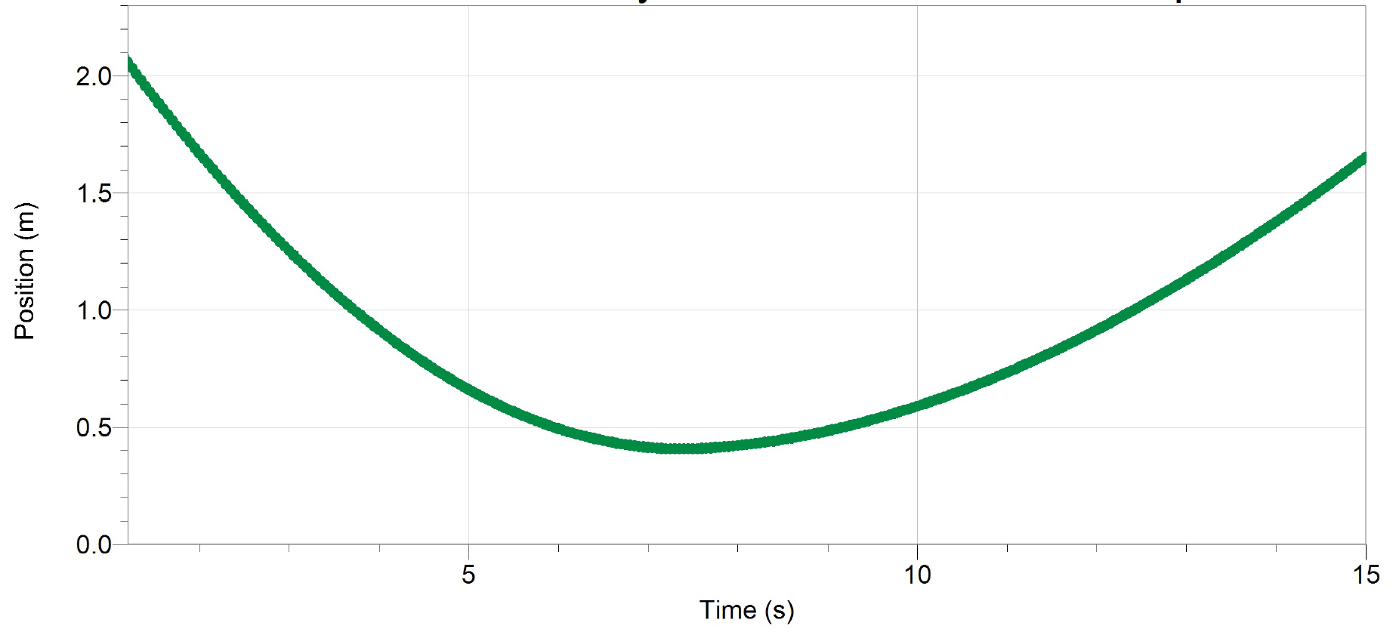
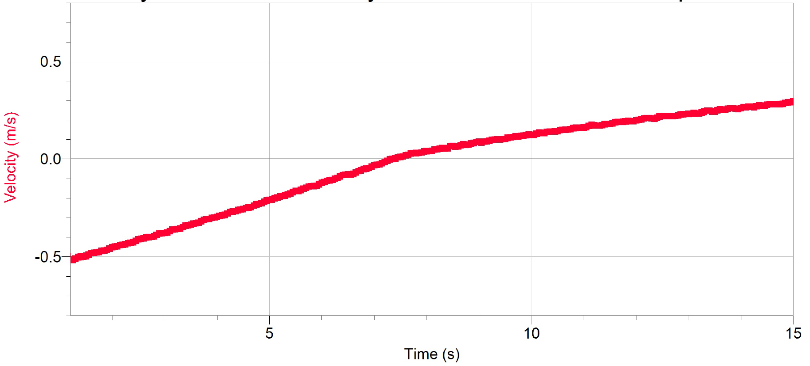
Figure 15: Position-time and velocity-time graphs describing the motion of a cart rolling up and incline plane then rolling down again.
Using a low friction cart will ensure that the acceleration is constant (if that is intended). Advanced students seem to enjoy the opportunity to reason about the origin of the ‘kink’ in the graph. This type of data can be obtained as a whole class activity (and displayed in real time on the projector as the cart moves) to lower the cost of using data logging technology.

Accelerating down an inclined plane to collide with a spring
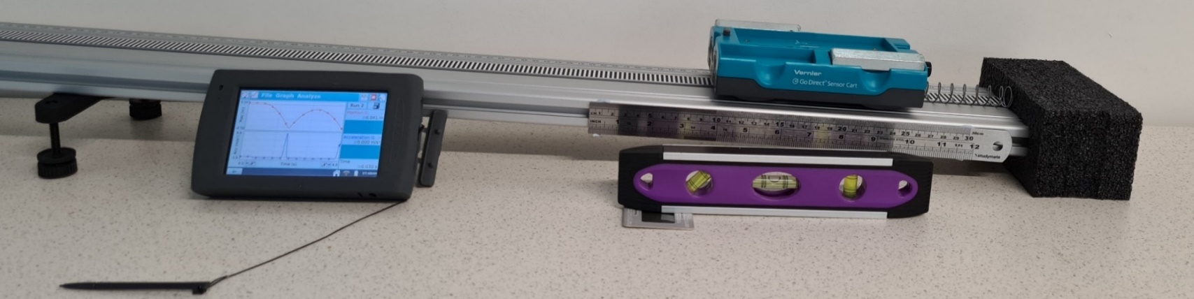
This data was recorded using the motion encoder on the cart for the motion in this video.
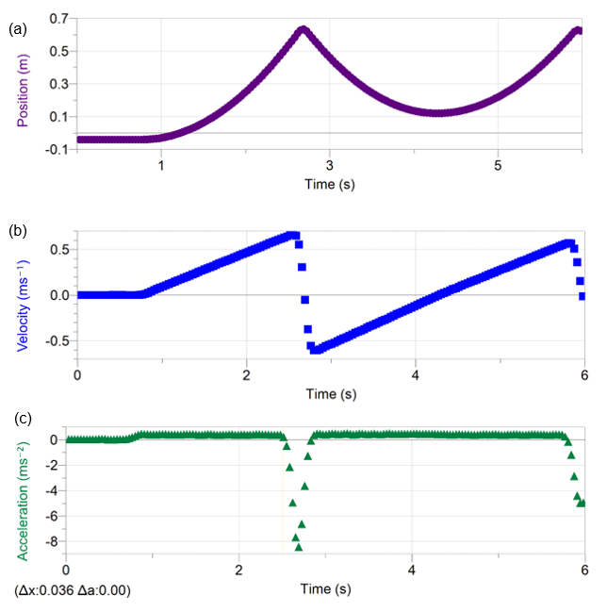
Figure 16: Three graphs representing the (a) position-time, (b) velocity-time and (c) acceleration-time graphs of the carts motion as it bounces off a spring on an inclined plane. Arranging these representations vertically and aligning the time axis allows students to work between them more easily, aiding deeper analysis. Images generated by the authors.
Features that students may note when analysing these graphs.
- For the position-time graph, the shape of the graph is parabolic and concave down.
- On the velocity-time graph, the shape during the time the cart rolls down the plane is linear with a postive gradient. During the bounce it is negative and close to linear.
- On the acceleration-time graph, the acceleration is small, constant and postive as it rolls down the plane and large and negative during the bounce.
This motion can also be analysed effectively using Tracker – so any cart can be used.
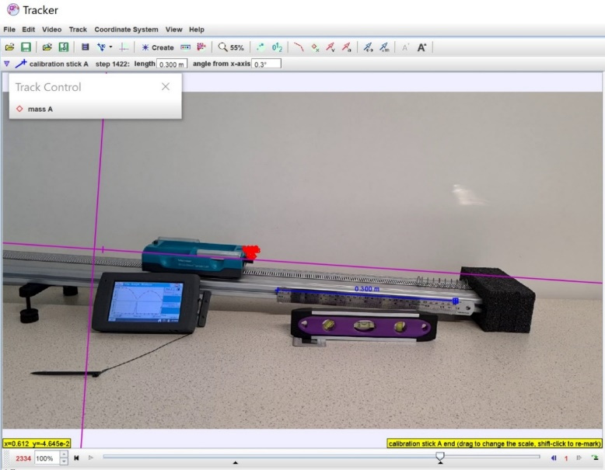
The position as a function of time, velocity as a function of time measured in Tracker. As the motion was recorded at 240fps, there is sufficient detail that it is possible to ‘zoom in’ on the motion of the cart during the collision with the spring (below right).
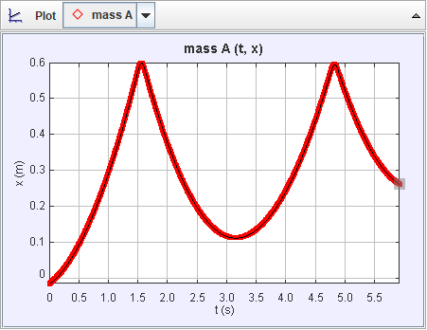
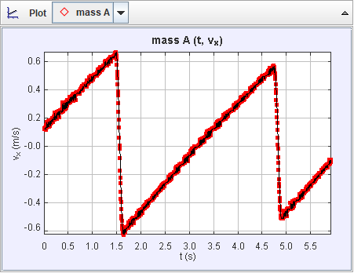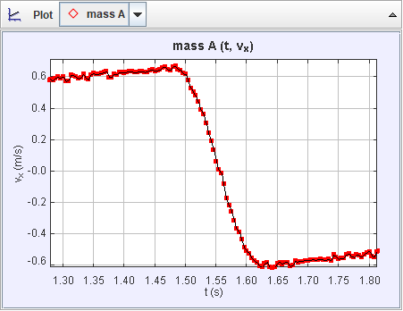

A bouncing ball
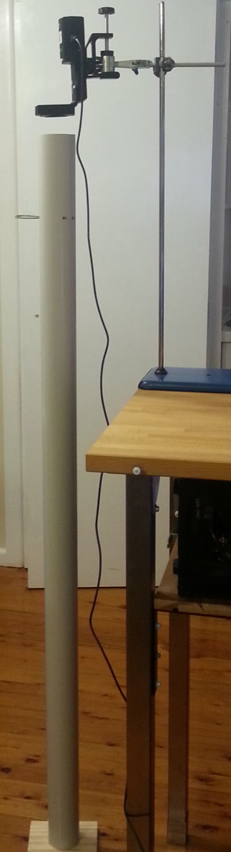
The following data was taken using a motion sensor fixed above a tube. A ‘pin’ holds a bouncy ball inside the tube and can be pulled out to release the ball. The ‘Triggering’ function can be used to begin taking data when the ball begins to fall. Reasonably clean data can be obtained without too much effort (the ball appears to have had a glancing collision with the wall of the tube during the initial fall in this data set). It is effective to question students about the direction of acceleration during the ‘bounce’, and what feature of the data gives them information about whether the acceleration during the bounce was bigger or smaller than that during the fall.
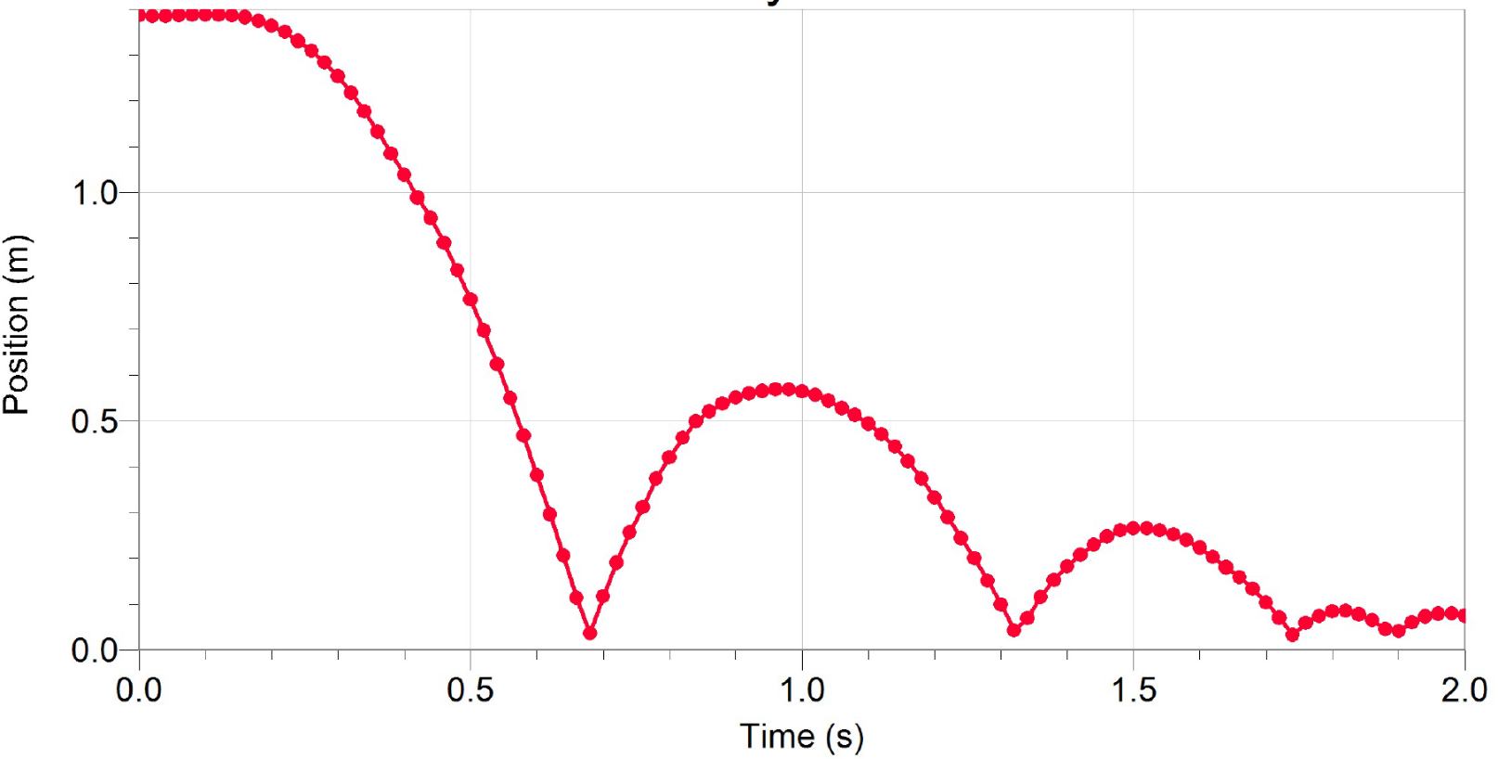
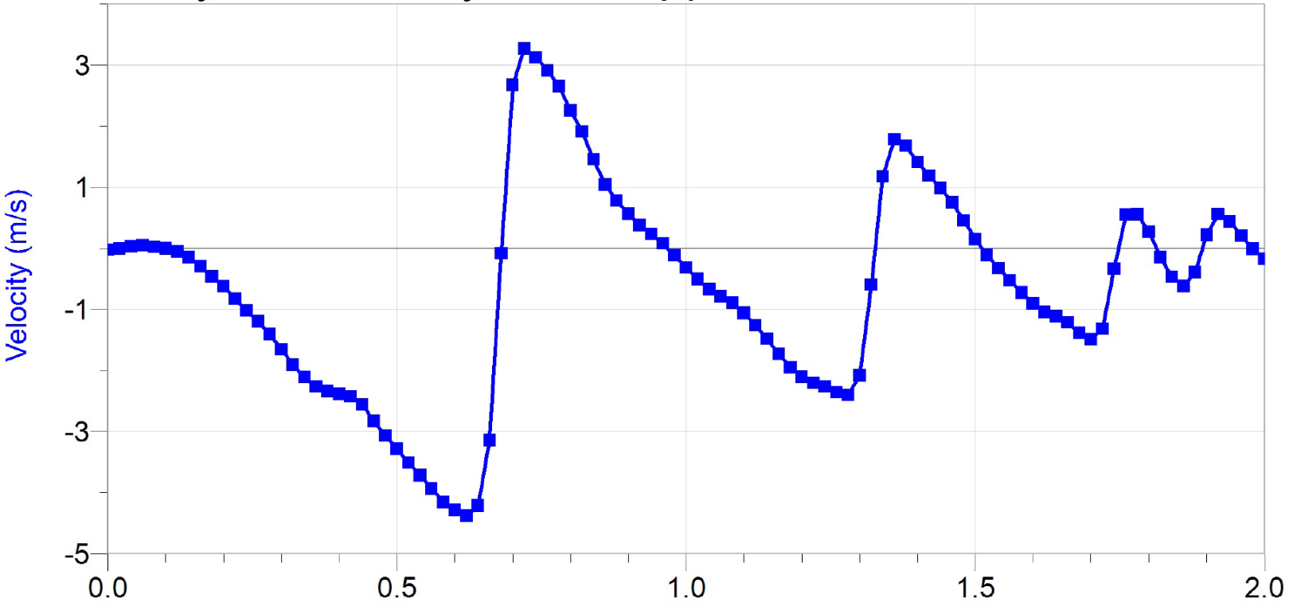

Non-uniform acceleration examples
In preparation for analysing collisions in Module 2, it is good to analyse situations in which the acceleration is not uniform. This will add depth to the topic if time permits. This also provides an opportunity for students to explicitly notice the assumption they are making when the use the equations of constant acceleration.
Suitable examples would include the motion of a cart as it collides with a spring or with a magnetic bumper attached to a wall. A spring offers the advantage that its compression can be related to the force applied to compress it from its equilibrium length. If a soft spring is used then the collision can occur over a few frames so that it could be analysed with video analysis, or alternatively measurement could be done using a motion sensor (or sensors built into the cart). A ‘soft’ collision would also be suitable for measuring acceleration with a phone running phyphox which is attached securely to the cart.
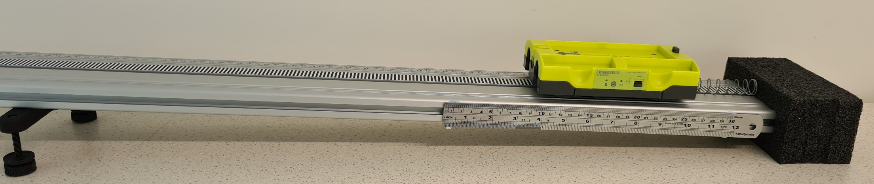
Figure 17: A motion cart collides with a ‘soft’ spring. The acceleration is initially in the direction of motion down the ramp, but then in the opposite direction to motion as it initially collides with the spring. See Figure 16 for sample data.
Students will need to analyse collisions in Module 3, and in this context, they often still confuse the direction of acceleration with the direction that the cart is moving during the collision. Prior experience analysing acceleration during collisions in Module 1 will provide a solid background when these ideas are revisited later.
As mentioned earlier, an excellent extension opportunity is to analyse simple harmonic motion of a mass on a string or of a small-amplitude pendulum. Beautiful data can be taken painlessly using a motion sensor. Students can predict the velocity-time, and acceleration-time graphs after measuring the position versus time. Free physics measurement apps (such as google science journal or phyphox) on students’ smartphones can also be used very effectively for this purpose – a video on measuring pendulum motion is available on the phyphox website.
Phones can be placed in a bag (for example a glasses case) on a spring so that they undergo (gentle!) oscillations and acceleration data recorded. This data can easily be exported and graphed in Excel or google sheets. Students can predict the position-time, velocity-time and motion diagram corresponding to the acceleration-time data.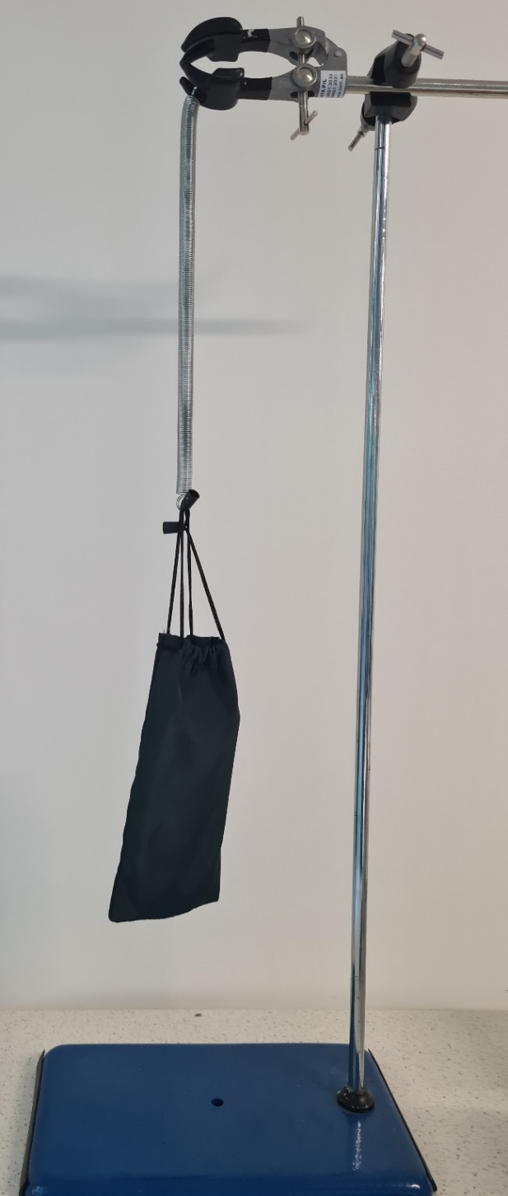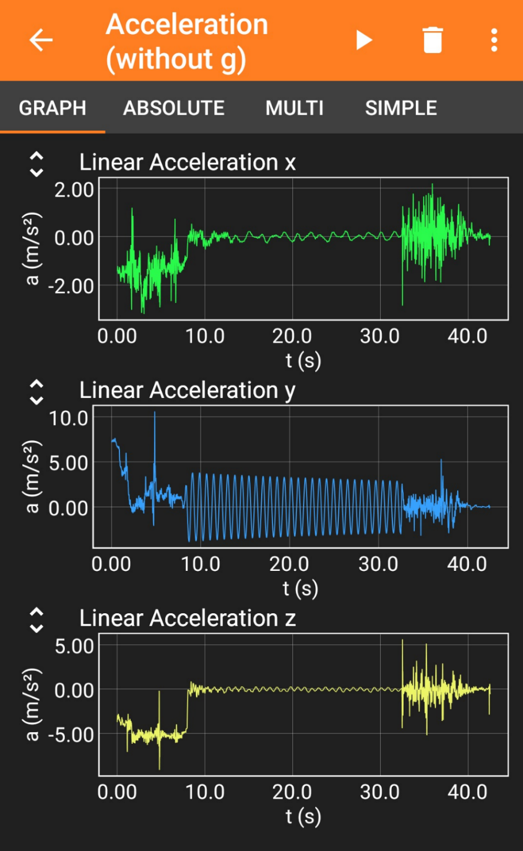
Figure 18 (Left): Mobile phone in a glasses case attached to a spring
Figure 19 (Right): Screenshot of acceleration-time data obtained in phyphox from a mobile phone oscillating on a spring

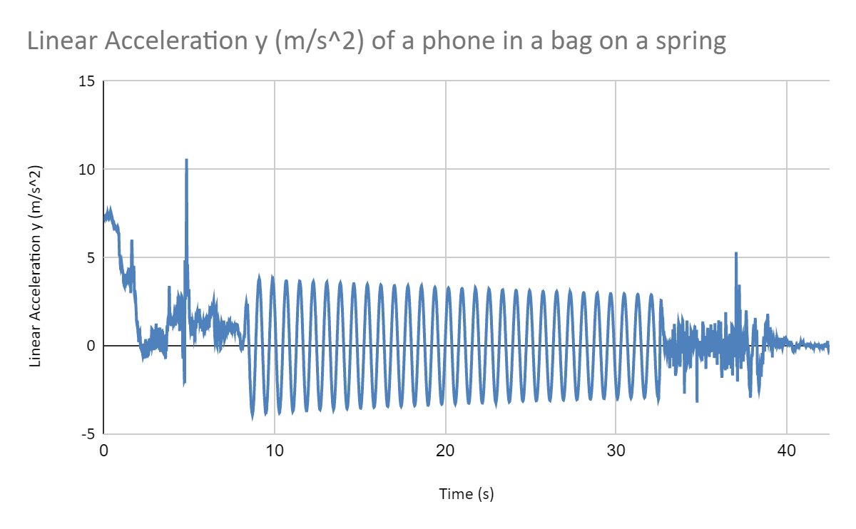
Figure 20: Data imported into google sheets from phyphox for vertical (y-) acceleration of a phone on a spring.
Finally, students can also use their smartphones to record data for the motion of objects of their own choice by video (and analysis in Tracker) or by measuring acceleration directly. A good example that can be referred to again Module 2 in the context of energy would be to video a student jumping. Noting that they are not a rigid object, students can compare the motion of, say, the students’ shoulder and compare that to the motion of their feet. Example inquiry questions could be: What is the maximum speed and/or acceleration you achieve when you jump? How does the acceleration of your shoulder compare to your knees or your feet? Can you change how you jump to maximise or minimise this?

This is convincingly demonstrated by Derek Muller in his ‘Veritasium’ video on ‘Three incorrect laws of motion‘
Hake, Richard R., ‘Interactive engagement versus traditional methods: A six-thousand student survey of mechanics test data for introductory physics courses’. Am J. Phys. 66(1) (1998). Full-text available
- D’Alessandris, P. (1994). Spiral Physics Downloads. Compadre.
Resource Letter: PER-1: Physics Education Research Lillian C. McDermott, and Edward F. Redish Citation: American Journal of Physics 67, 755 (1999); doi: 10.1119/1.19122 View online
Berryhill, E., Herrington, D., & Oliver, K. (2016). Kinematics Card Sort Activity: Insight into Students’ Thinking. Peer Reviewed Articles. 47.
McDermott, L. C., Rosenquist, M. L., & van Zee, E. H. (1987). Student difficulties in connecting graphs and physics: Examples from kinematics. American Journal of Physics, 55(6), 503–513.
Rutgers, The State University of New Jersey. (2015). Learning Cycle on Motion with a Constant Rate and Motion with a Constantly Changing Rate.
Rotter, C. A. (1999). KINEMATICS KIT. West Virgina University Eberly College of Arts and Sciences. Provides many examples of motion diagrams and useful questions for use in diagnostic, formative or summative assessment.
The physics classroom has resources on drawing motion diagrams, including lesson notes and a YouTube video. The video might be a little slow for students but gives a good introduction for teachers.
Camp, J. J., & Clement, C. W. (2020). Preconceptions in Mechanics: Lessons Dealing with Student’s Conceptual Difficulties (Second Edition). AAPT. A preprint is available online.

