Physics Module 8: from the Universe to the atom

Table of contents
Table of contents 2
Teaching the year 12 modules 3
Course overview 3
Module summary 5
Big ideas 5
Evidence 5
The development, role and limitations of theories and models in science 6
Conservation of energy 6
Relationship to other modules 7
Core concepts 7
Origin of the elements 7
Quantisation – charge and energy changes occur in discrete quantities 7
Developing models of the atom 8
Radioactivity 8
Energy-mass equivalence – there is a quantifiable relationship between mass and energy 9
The Standard Model – and what’s next 9
Opportunities for extended concepts 10
Average binding energy per nucleon 10
Further nucleosynthesis reactions 10
Beyond $E=mc2$ 10
Australia’s contribution to particle physics 12
Developing models of the atom 13
Alternative conceptions and misconceptions 13
Star colour and its relationship to temperature 13
The half-life model and activity 13
Models of the atom 14
The Standard Model 14
Conceptual difficulties 15
Scales of time and space 15
Exponential and logarithmic functions 15
Schrödinger’s contribution 15
Suggested teaching strategies 16
Origin of the elements 16
Developing models of the atom 17
Quantum mechanical nature of the atom 19
Deep inside the atom 20
Suggested investigations 20
Origin of the elements 20
Structure of the atom 20
Resources 23
YouTube 24
PhET simulations 24
The Perimeter Institute 25
Appendix 26
Appendix 1: Modelling evidence for an expanding Universe 26

Teaching the year 12 modules
The new Stage 6 Physics course was implemented in NSW schools in 2018-2019. This syllabus incorporates new content and learning activities such as Depth Studies. The syllabus is designed around inquiry questions and formal assessment tasks emphasise the skills for working scientifically.
The Year 12 course provides avenues for students to apply the concepts they were introduced to in Year 11 to motion in two dimensions, electromagnetism, theories of light, the atom and the Universe.
Therefore, pedagogies that promote inquiry and deep learning should be employed in the Physics classroom. The challenge presented by the additional content and the change in pedagogical approach were the catalysts for the preparation of these module guides for Stage 6. These guides are intended to assist teachers deliver Physics effectively by outlining overarching concepts (big ideas), core and extended ideas, strategies for teaching the modules, uncovering of alternative conceptions, and strategies to address them. The guides support the teacher in facilitating the development of deep knowledge structures, such as the relationships between concepts. The module guides do not cover all aspects of the syllabus, as that was not within the scope of the project.
It is essential that teachers note that the module guides do not substitute the syllabus, but only support teachers to teach it. The information contained in these documents are correct at the time of publication. While every effort has been made to eliminate errors, any errors or omission that are identified after the release of these documents will be corrected and released as resource updates. It is recommended that teachers access the Curriculum website for the latest version of these documents.

Course overview
The Year 11 course introduces fundamental concepts of motion, forces, fields, energy and momentum. It provides opportunities for students to develop Working Scientifically skills, including those related to the quantitative analysis and modelling of physical systems.
The Year 12 course further develops these concepts and applies them to the analysis of phenomena and technologies that are relevant to society and to contemporary physics. The Law of conservation of energy, along with the development of theories and models form common themes across each of the modules. The role of scientific investigation and evidence in advancing our understanding is explored in detail in modules 7 and 8.
Inquiry questions are included in the course content and are used to frame the syllabus. The depth of understanding required to fully address the inquiry questions may vary. This allows for differentiation of the course content to cater for the diversity of learners.
During the teaching of the Year 11 course, it is expected that students have been provided opportunities to develop all seven of the Working Scientifically skills. Ideally, these would be embedded into the teaching of the Knowledge and Understanding components of the course. In preparation for the Year 12 course, students in Year 11 could benefit from work that engages them in the following areas:
- Propose hypotheses, design and conduct valid and reliable practical investigations that effectively use technologies to collect and analyse data. Teachers should look for opportunities to engage students in these beyond where the syllabus explicitly states the need to conduct a practical investigation.
- Construct and analyse graphical data for both primary and secondary sources. This should include describing relationships between variables, particularly time-varying quantities such as displacement and velocity. Emphasis should be placed on extracting qualitative and quantitative information from the gradient or the area under a graph.
- Evaluate and improve the quality of data collected. Students should be encouraged to recognise errors, uncertainty and limitations in the data they collect. Practical investigations provide opportunities to practice quantifying errors, including the calculation of absolute and relative errors, along with techniques such as the use of a line-of-best fit to minimise the impact of random errors in measurement.
- Assess the uses, benefits and limitations of various types of scientific models. Models are a powerful tool in science, allowing phenomena to be more easily explained and predicted by capturing and highlighting only the most important features of a system. For example, when analysing gravitational potential energy (GPE) in module 2, it is beneficial to employ a model in which acceleration due to gravity is a constant 9.8 ms⁻² and arbitrarily set $GPE=0$ at the Earth’s surface. This model is suitable for analysing the motion of objects close to the Earth’s surface including projectiles, pendulums, rollercoasters, and so on. However, students should also be encouraged to consider the limitations of such models. For example, the model above would not be appropriate, or effective, for analysing the motion of satellites as acceleration due to gravity cannot reasonably be considered constant over large distances.
- Studying the rates of change of quantities including displacement, velocity, temperature and energy to support deeper insights into physical phenomena. Rates of change are particularly important to the understanding of electromagnetism in Year 12.
- Collect relevant information from secondary sources and determine the accuracy, reliability and validity. Many of the investigations will require students to obtain information from the Internet or other sources. Students will benefit from learning how to access suitable information and appreciate how new evidence can change prevailing views.
- Developing an awareness of the interconnectedness of physics concepts, including the application of conservation of energy and momentum to the understanding of diverse phenomena.
- Developing confidence in the selection and manipulation of units for physical quantities. Students should be provided opportunities to practice converting units, along with calculating and communicating quantities using scientific notation.
- Creating and analysing diagrams that represent vector quantities including free-body, field and ray diagrams. Students should develop confidence in resolving 2-dimensional vectors into their components and in adding multiple vectors to find the resultant.

Module summary
This module broadly covers astronomy, atomic physics, nuclear physics and particle physics. The first inquiry question focuses on the origin of the universe to the formation of matters, celestial systems and evolution of stars. The second and third enquiry questions retrace the development of the atomic theory from the plum pudding model by J. J. Thomson to the current model. The fourth inquiry question investigates the properties of the nucleus and the fifth explores the development of the Standard Model of matter.
Module 8 explores the following inquiry questions:
- IQ8-1: What evidence is there for the origins of the elements?
- IQ8-2: How is it known that atoms are made up of protons, neutrons and electrons?
- IQ8-3: How is it known that classical physics cannot explain the properties of the atom?
- IQ8-4: How can the energy of the atomic nucleus be harnessed?
- IQ8-5: How is it known that human understanding of matter is still incomplete?

Big ideas

Evidence
This module focusses on the role of experimental evidence in developing robust explanatory models that deepen our understanding of the Universe, from its beginning to its current state and further to its future. Scientific discovery is the process or product of a successful scientific inquiry with the objects of discovery being things, events, properties as well as theories. This module guides students through the inquiries that led to the discovery of the expanding Universe, the origin of the elements, the developing models of the atom and ultimately to our current understanding of matter.
The gathering of experimental evidence is in turn strongly dependent on the development of technology. New technology allows us to observe phenomena that was previously unseen, challenge our understanding of the world and catalyse the formation of new theories and models. The development of vacuum tubes, harnessing of radioactive sources and construction of increasingly powerful particle accelerators have shaped the development of modern physics.

The development, role and limitations of theories and models in science
Scientific theories explain natural phenomena. They should have explanatory power, be able to generate useful predictions and be confirmed by a significant body of experimental evidence. This dependence on evidential support makes theories open to criticism and potential abandonment if they are unable to explain new experimental observations. It has been argued, notably by Karl Popper, that in addition to being informative, a good scientific theory should also be surprising and in a sense, improbable.
Models are representations of ideas, objects or phenomena that aid understanding and allow predictions to be made. Their value lies in their ability to simplify and communicate complex or unobservable phenomena, often drawing on more familiar contexts that have similar properties to the phenomena they represent. When employing models, it is important that their limitations are recognised. As with many theories, models are developed to fit experimental observations and are subject to revision in response to new evidence. This module outlines the historical development of atomic models, highlighting the important experimental observations that have catalysed advances in our understanding.

Conservation of energy
Conservation laws are important in physics as they allow some behaviours of a system to be predicted without the need to consider the underlying mechanics. In Module 2, students applied conservation of momentum and energy to predict the motion of objects resulting from collisions and changes in vertical position without the need to invoke Newton’s laws of motion. In Module 8, students will apply these laws to the investigation of phenomena occurring at the smallest scales of space and time. The discrete transformations of the quantum world are investigated, and conservation laws play an important role in making predictions and in suggesting and verifying models of matter.
The mass-energy equivalence extends the conservation of energy to include matter, allowing matter to be considered as a form of energy that can be transformed into or from other forms of energy.
Conservation laws can be used to describe which processes can and cannot occur in nature. Conservation of mass/energy, momentum, charge, leptons and baryons provide a framework for describing reactions and transformations that can and cannot occur. This is applied to nuclear transformations, production of emission spectra and to the production and transformation of fundamental particles.

Relationship to other modules
During modules 1-7, students have developed their understanding of a diverse range of physics concepts. In Module 8, students are required to apply this understanding in new contexts. For this reason, it is suggested that From the Universe to the Atom is taught as the final module in Year 12.
- Quantisation is first introduced with relation to light in the photoelectric effect and is further developed to include the energy levels of electrons within the atom.
- The law of conservation of energy is applied across all modules and is critical to the interpretation of experimental evidence for models of the atom and to understanding nuclear physics.
- A sound understanding of diffraction, introduced in Module 7, is required to interpret the experimental evidence for de Broglie’s matter waves, namely the Davisson-Germer experiment. The concept that particles have wave-like properties further develops the wave-particle duality of light from Module 7.
- The investigation of spectroscopy in Module 7 overlaps much of the content in this module, as does the energy-mass equivalence relationship.

Core concepts

Origin of the elements
Students investigate the origin of the elements, beginning shortly after the ‘Big Bang’ with the transformation of radiation into matter, through to the nucleosynthesis of heavy elements in stars. Our current understanding of the physical processes involved at each stage along with the evidence supporting this understanding should be presented. Skills in constructing and interpreting nuclear equations and Hertzsprung-Russell diagrams are central to understanding and communicating the relevant concepts and processes.

Quantisation – charge and energy changes occur in discrete quantities
Quantum physics describes and explains the nature at the smallest scales of space, time and energy. Fundamental to this is the hypothesis of quantisation, which asserts that certain physical properties can only take on discrete values rather than the continuous range of values allowed in classical physics. In turn, a quantum (plural: quanta) describes the smallest allowable amount of a property (charge, energy, mass, and so on) that can be involved in an interaction. Module 7 introduced the quantisation of energy in Einstein’s photon model of light to explain the photoelectric effect. Module 8 extends this concept to include the quantisation of electric charge and of the energy levels of electrons in atoms. Quantum models of the atom have been successful in explaining and predicting phenomena occurring at the atomic and subatomic scales. The Bohr model of the hydrogen atom is a notable example and is studied in detail in this module.

Developing models of the atom
John Dalton’s ‘billiard ball’ model of the atom, proposed in 1803, was the generally accepted view of atomic structure for 100 years. Observations of cathode rays, enabled by the invention of the Geissler tube in 1855 (later modified by Sir William Crookes in 1878) challenged this model, resulting in the development of Thomson’s ‘Plum Pudding’ model following the discovery of the electron and its properties.
Radioactive substances became an important tool for revealing the internal structure of the atom as demonstrated with sources of alpha particles being integral to the Geiger-Marsden and Chadwick investigations which resulted in the nuclear model of the atom.
Bohr’s model of the atom, although limited by its inclusion of the classical conception of electrons orbiting a nucleus, is useful in explaining the emission spectra of hydrogen by quantising their allowable energy levels (more accurately his model quantised the angular momentum of electrons). By including the conception of electrons orbiting the nucleus, both Rutherford’s and Bohr’s atomic models were unable to account for the stability of their orbits. Electromagnetic theory suggests that when a charged particle is accelerated, it will emit radiation, losing energy and eventually spiralling in towards the nucleus. The Bohr model was also unable to explain the spectra produced by more complex atoms, the relative intensity of spectral lines or the splitting of energy levels in the presence of strong magnetic fields.
The reconceptualization of electrons in the atom as both particles and waves led to the development of the wave equation by Erwin Schrödinger. His wave equation could be used to accurately calculate the energy levels of electrons in atoms and was later used in the development of quantum mechanics.

Radioactivity
The discovery of radioactivity is closely related to the development of the nuclear model of the atom. First discovered in 1896 by physicist Henri Becquerel, radioactivity demonstrated that the atom was neither indivisible nor immutable. The analysis of the spontaneous decay of atomic nuclei will require students to describe the properties of alpha, beta and gamma radiation in terms of their penetrating power and ionising potential. The model of half-life in radioactive decay uses the exponential relationship $N_{t}{=N}_{0 }e^{-kt}$ to investigate and predict the future activity of radioactive samples. In addition to these spontaneous decay processes, students will investigate a range of artificial nuclear transmutations including nuclear fission and fusion. All decays and transmutations should be described using nuclear equations.

Energy-mass equivalence – there is a quantifiable relationship between mass and energy
Module 7 introduces the mass-energy equivalence relationship$E={mc}^{2}$, predicted by special relativity. A suitable interpretation of this equation is to consider mass, m, to be just a form or store of energy. In this way, nuclear decays and transmutations can be analysed and accounted for using the law of conservation of energy, with mass simply being transformed in other forms of energy or vice versa.
Mass defect and binding energy are useful models for understanding and predicting the energy released in reactions. The mass of a nucleus is always less than the sum of the individual nucleons (protons and neutrons) that it contains. The difference between these two masses is known as the mass defect $∆m$, which is a measure of the binding energy of the nucleus. The two values are related by the expression $inding energy=∆mc^{2}$ . Separating a nucleus into its constituent components would require an energy equal to its binding energy.

The Standard Model – and what’s next
This module explores the Standard Model which describes the fundamental particles that make up matter and mediate the fundamental forces. The Standard Model was essentially completed in 1967 and is based on the notion that the world is made up of fundamental particles. Fundamental particles are point-like objects that have properties associated with them, for example mass, charge, spin. That is, they have no size, cannot be divided into smaller components, and they have no internal structure.
The Standard Model describes the 12 fermions, the quarks and leptons, which make up all the matter in the Universe along with the ‘rules’ for how they interact with one another. The ‘rules’ are the two theories that describe the fundamental interactions (forces).
- Quantum chromodynamics (QCD), describes the strong interaction between quarks using gluons as a force carrier particle (boson).
- The electroweak theory, describes both the electromagnetic interaction (carried by the photon) and the weak interaction (carried by the W and Z bosons).
The electron was the first fundamental particle to be discovered. Protons and neutrons have since been shown not to be themselves fundamental but instead to be combinations of quarks. The Standard Model describes forces by the exchange of force-carrying particles called bosons, with each fundamental force having a corresponding boson(s).
The Standard Model is a triumph of modern physics, representing our best understanding of fundamental building blocks of matter and three of the four fundamental forces. Studies of the Standard Model should focus on the important evidence leading to its discovery and subsequent testing with an emphasis on the role of particle accelerators. Limitations of the model, particularly relating to gravity, as well as future directions for research should also be considered.

Opportunities for extended concepts

Average binding energy per nucleon
Introducing the quantity of average binding energy per nucleon. This quantity can be used to predict whether a given fission or fusion reaction is likely to result in the release of energy from the nucleus. This concept can be applied to explain the iron limit of nucleosynthesis in post-main sequence stars as well as the choice of fuel for nuclear fission or fusion reactions.

Further nucleosynthesis reactions
Investigating a wider range of nucleosynthesis reactions. Both listed nucleosynthesis reactions (proton-proton chain and CNO cycle) occur in main sequence stars and result in the same net reaction that is $4{}_{1}^{1}H⟶{}_{2}^{4}{He}+2e^{+}+2γ+2ν$. The two neutrinos,$2v$, produced in this reaction are often ignored without significant consequences for student understanding. However, for completeness students could be introduced to the conservation of lepton number and other quantised properties to account for their production.
The fusion reactions in post-main sequence stars including the triple-alpha reaction are quite straight forward by comparison to the CNO cycle. A comparison of the average binding energies for hydrogen, helium and carbon provide students with a sound explanation for the relative lifetimes of main sequence and post-main sequence stars along with the need for energy input from events such as supernovae to synthesise elements heavier than iron.

Beyond $E={mc}^{2}$
Introducing students to the more general form of this expression can assist in building conceptual links between the topics studied in Modules 7 & 8. (See minute physics $E={mc}^{2}$ is incomplete – duration 2:50)
This equation can be written in a more general form as follows:
$$E^{2}={\left(mc^{2}\right)}^{2}+{\left(pc\right)}^{2}$$
Essentially, it states that the energy stored in a particle is related to both its rest mass, m, and its momentum, p. E=mc² is Incomplete (duration 2:50) from Minute Physics provides a clear introduction to this extended topic and outlines a method for visualising the total energy relating to Pythagoras’s theorem.
This general expression simplifies to more familiar expressions for two special cases:
- When a particle is not moving $(p=0),$ then $E={mc}^{2}.$ In this case we often write $E_{0}={mc}^{2}$ where $E_{0}$ refers to the rest energy of the particle
- When a particle has no mass (for example a photon) then $E=pc$. This expression describes the relationship between the energy and momentum of a photon. This can be linked to the formulation of de Broglie’s matter wave equation.
The particles produced by collisions in particle accelerators are more easily understood by incorporating their momentum as well as their rest energy. For example, unstable particles including Z-bosons are produced and studied in experiments at the LHC. These particles quickly transform into other more stable particles so they cannot be detected directly. Their properties including their rest mass is ‘reconstructed’ by studying their transformation (decay) products.
One of the paths by which the Z-boson transforms results in the production of muon-antimuon pairs. Their momenta are measured by the curvature of their tracks through the particle detectors.
When a particle’s speed is near the speed of light, its momentum increases as described by special relativity, that is
$$p_{v}=\frac{m_{0}v}{\sqrt{\left(1-v^{2}/c^{2}\right)}}$$
This means that the energy stored in the muon’s momentum continues to increase with higher speeds whilst its rest energy remains constant. At ultra-relativistic speeds the rest mass becomes insignificant and we can closely approximate the energy as the magnitude of the particle momentum. This approximation allows the total energy content of each muon pair to be determined from their momenta alone.
Graph showing the relative contributions of rest energy and momentum to the total energy content of a particle
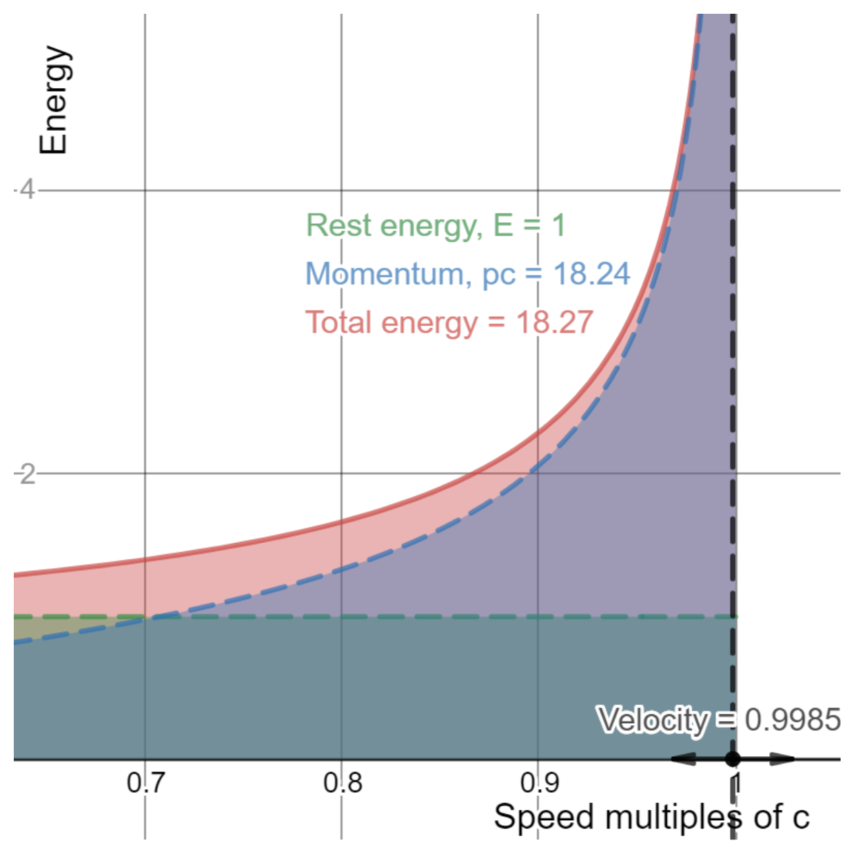
From the above graph we can see that a particle with a speed = 0.9985c (or 99.85% the speed of light), that its momentum (18.24) is very close to its total energy (18.27). That is, the momentum is within 1-2% the total energy. Try changing the slider on this desmos interactive graph.

Australia’s contribution to particle physics
Australia makes significant contributions to the investigation and application of particle physics. Through ANSTO’s landmark facilities, including the Australian Centre for Neutron Scattering, the Australian Synchrotron and the OPAL multi-purpose reactor, Australia supports materials, medical and particle physics research as well as producing a range of radiopharmaceuticals for medical use.
The Australian Synchrotron is an example of a particle accelerator that is used in the testing and/or validating of theories. It accelerates electrons to just under the speed of light, about 299,792 kilometres a second, around a 200-metre circular track using powerful magnets. This produces synchrotron radiation in the form of intense beams of light more than a million times brighter than the sun. This intense light can be used to study a wide range of molecular structures including human tissues, plants, metals and more.
Calibrating TAIPAN, one of ANSTO’s neutron diffraction instruments is a detailed extension activity that would be suitable as part of a depth study based on this module. In completing this activity students are required to use Excel to process, analyse and model real data collected as part of ANSTO’s operating procedures. The activity addresses the need for calibration of measuring instruments and assesses random and systematic errors that affect these measurements. It would be most suited for students with a keen interest in mathematics as it reinforces many techniques employed in Stage 6 mathematics.
As partner of the ARC Centre of Excellence for Dark Matter Particle Physics, ANSTO is collaborating in the construction and operation of a new dark matter experiment located in Victoria. The Stawell Underground Physics Laboratory (SUPL) will house a state-of-the-art detector 729 m underground at the Stawell gold mine and will attempt to directly detect dark matter particles as they interact with the doped sodium iodide crystals in the SABRE experiment. Each interaction produces a flash of light which can be detected and measured.

Developing models of the atom
As an alternative to the ‘Rolling with Rutherford’ activity outlined in the suggested investigation section, S’Cool LAB at CERN have developed a 3D-printable experiment to model the evidence supporting the nuclear model of the atom. Interchangeable representations of different atomic models are placed under the centre cover and must be predicted using the scattering patterns observed. Students could potentially predict, collect and present detailed data and analysis relevant to the development of atomic models using this apparatus.

Alternative conceptions and misconceptions

Star colour and its relationship to temperature
Students will have encountered the use of colours to represent temperatures. The most common of these, the use of ‘colour temperature’ for describing the ‘warmth’ or ‘coolness’ of colours, particularly for LED lighting, can be problematic. Most colour temperature scales provide a quantitative kelvin scale ranging from 2000 – 6500 K, which corresponds to the colour of stars with a similar effective temperature. However, the use of ‘warm white’ to describe low temperatures and ‘cool white’ to describe high temperatures is inconsistent with the model required.

The half-life model and activity
The half-life model demonstrates the predictable nature of decay of radioactive substances. It is a simple and valuable model that can be used to compare the stability of radioactive isotopes and predict the activity of a radioactive source at some time in the future.
Students will often try to map the features of this model to the properties of individual nuclei, giving them a predictable and deterministic rate of decay.
The half-life model relies on the law of large numbers, with its predictable nature arising from the large number of atoms in a sample. The behaviour of each nucleus is ultimately probabilistic, with each radioactive nucleus having a certain probability per unit time to decay.
Higher probabilities of decay per unit time correspond with shorter half-lives when observations are scaled up to the very large numbers of nuclei present in even a tiny sample.

Models of the atom
The nature of the atomic world is vastly different to the macroscopic world of our everyday experience. Teachers and students often employ models in the form of analogies or pictorial representations to apply some familiar characteristics of the macroscopic world to aid their descriptions and explanations of atomic phenomena.
For example, drawing the generations of fundamental particles as balls of increasing size to correspond with their increasing mass. According to the Standard Model, all fundamental particles are point-like objects, having properties such as mass, charge and spin but they could each be infinitely small. Instead, physicists describe an effective size for them based on their ‘cross section’ which is a measure of how easily they are to hit.
Many analogies are very effective, but they can, along with the terminology used to describe early models of the atom, potentially reinforce alternative conceptions and impede student understanding of the Standard Model. See the suggested teaching strategies for developing models of the atom for more details on student conceptions relating to this topic.

The Standard Model
The Standard Model is not actually a model. It is an incredibly successful theory that provides an effectively complete description of the subatomic particles and forces (except for gravity). The success of this theory is in part due to its simplistic nature, being guided only by quantum mechanics, relativity and the data that was available in the 1960’s when it was proposed.
In the decades following, the Standard Model has been repeatedly tested using increasingly precise experiments and yet there are no significant discrepancies between the predictions of the theory and the experimental observations.
It should be noted that the Standard Model does have some limitations. For example, it does not predict the masses of the fermions (quarks and leptons). These, along with some other values, must be measured experimentally and input into the theory in order to make predictions. Despite this, the theory is arguably the most successful scientific theory ever proposed.

Conceptual difficulties

Scales of time and space
The phenomena studied in this module generally occur on a scale of time and/or space that is difficult or impossible for students to observe directly. The expansion of the Universe, radioactive decay of nuclei along with atomic models and the Standard Model are notable examples. Models and analogies can be effective aids for developing student understanding and intuition about these phenomena.
Effective use of analogies requires an understanding of what an analogy is and how it can support learning. Analogies are comparisons of the similarities of complex or unfamiliar science concepts (the target) in terms of something familiar to the learner (the analog). When employing analogies to support student learning it is crucial that care is taken to scaffold them by making explicit both the similarities and differences between the analog and target concepts.
Further details on the use of analogies in science can be found in ‘Making science concepts meaningful to students: teaching with analogies’ by Shawn M. Glynn.

Exponential and logarithmic functions
The introduction of radioactivity concepts requires students to substitute into and manipulate exponential decay functions. A student’s familiarity and confidence in using these functions will be influenced by the level of mathematics incorporated into their pattern of study. For example:
- Students studying Mathematics Standard 2 are introduced to simple exponential relationships of the form $y=a^{x}$ or $y=a^{-x}$ in Year 12.
- Students studying Mathematics Advanced complete a topic on exponential and logarithmic functions in Year 11. This includes exponential functions of the form $y=a^{x}$ along with the modelling of exponential functions to solve practical problems.
- Students studying Mathematics Extension 1 are required to manipulate, substitute into and apply exponential functions of the form $N(t)={Ae}^{kt}$ as part of a subtopic on rates of change in Year 11. Radioactive decay is also suggested as a relevant application in the syllabus.

Schrödinger’s contribution
The mathematics of Schrödinger’s wave equation go far beyond the scope of high school mathematics. However, the purpose and impact of Schrödinger’s contribution is still relatively accessible to students.
Following Louis de Broglie’s proposition that electrons have both wave and particle behaviours and his matter waves, $λ=\frac{h}{mv}$, Schrödinger sought to formalise this wave nature with an appropriate wave equation. His equation was a success, as it allowed the energies of electrons to be reliably calculated and corresponded well with experimental results. This success provided a sound theoretical footing for the wave-particle duality of electrons and his contribution led in part to the development of quantum mechanics.

Suggested teaching strategies
Delivering this module in a timely manner is an important consideration as it includes five inquiry questions and a significant amount of detail in each. Bringing forward related content from module 8 into the other modules may assist in achieving this goal. For example:
- The operation of particle accelerators could be introduced in Module 6, inquiry question 1, Charged Particles, Conductors and Electric and Magnetic Fields.
- The qualitative investigation of the spectra of stars could be incorporated into Module 7 inquiry question 1, What is Light?
Alternatively, technologies and methods from Module 8 can be used as examples when teaching the relevant concepts earlier in the course. For example:
- Experiments examining cathode rays, Thomson’s’ charge-to-mass experiment and Millikan’s oil drop experiment can be modelled in Module 6 as examples for analysing the net forces acting on charged particles in electric or magnetic fields.
- So too could examples relating to the acceleration and manipulation of charged particles include examples of the operation of particle accelerators.

Origin of the elements
Investigating the evidence that led to the discovery of the expansion of the Universe is a great opportunity for students to engage in modelling and to interpret and evaluate data. Balloons or dressmaker’s elastic can be used to model the evidence used by Hubble in this discovery. A sample investigation is included in the Appendix.
Investigating the processes leading to the transformation of radiation into matter can be used to reinforce the quantum nature of particles. That is, matter can only be created in discrete ‘lumps’ or quanta with the smallest of these being an electron. Students can be guided in calculating the photon energies required to produce a range of fundamental particles. This pair production process is the reverse of the particle-antiparticle annihilations studied in Module 7.
Simulations including Neon lights and other discharge lamps from PhET allow students to observe and investigate the relationship between electron energy levels in atoms and the production of absorption and emission spectra. This simulation can be revisited when investigating the Bohr model.
The Astrophysics for Senior Physics website provides information and activities relating to nucleosynthesis reactions in stars that are suitable for Year 12 students. Essentially, both the proton-proton chain and the CNO cycle can be presented as different mechanisms for undergoing the same net reaction:
$$4{}_{1}^{1}H⟶{}_{2}^{4}{He}+2e^{+}+2γ+2ν$$
Balancing nuclear equations could be introduced at this stage as students will apply them later in this module to describe nuclear decay and other particle processes. Emphasis should be placed on the conservation rules governing the reactions including conservation of mass number and charge. In the reaction above, the 2 neutrinos (ν), produced with the positrons in the reaction are required to conserve the lepton number.

Developing models of the atom
The content related to the historical development of models explaining the structure of matter is spread across three topics within this module, specifically;
- the Structure of the atom topic includes the discovery of the electron and development of the nuclear model of the atom
- the Quantum mechanical nature of the atom topic highlights the transition from a classical model of the atom to a quantum model, and
- Deep inside the atom investigates are current and most fundamental description of the subatomic constituents of atoms and their interactions.
Asking students to ‘begin at the beginning’ with atomic models may risk further embedding problematic conceptions of matter and the repeated learning and discarding of outdated models may exhaust students willingness to invest in understanding of each new atomic model before they reach our current and most fundamental models of matter.
Consider instead beginning with our best models to ensure that students develop a consistent and accurate conception of matter that they can then apply when describing and explaining the evidence supporting our current, and previous, atomic models.
See article “Introducing 12 year-olds to elementary particles” for more detail on this approach to introducing students to the standard model. It outlines many of the alternative conceptions that students may have regarding the nature of matter and provides a range of strategies to address these.
Covering the historical development of atomic models is a broad and challenging topic. The associated inquiry question should be used to provide insight into how it could be presented to students.

IQ8-2: How is it known that atoms are made up of protons, neutrons and electrons?
Early experiments examining cathode rays can be reproduced in the classroom using Crooke’s tubes, magnets and a high voltage power source or spark-gap generator. The similarities between these tubes the modified tube used by Thomson in his investigations should be highlighted for students.
Millikan’s evidence can be modelled using domino’s, M&M’s, or other small objects with consistent mass. Making the testing ‘blind’ by disguising the number of objects measured will ensure that students must rely on their observations. Question 15 in NESA’s Physics 2017 additional sample HSC questions outlines a suitable investigation and includes supporting data.

IQ8-3: How is it known that classical physics cannot explain the properties of the atom?
This indicates that the topic could be presented as a story of the transition of atomic models from those that are wholly classical (Rutherford) to classical-quantum hybrid (Bohr) and to fully quantum (De Broglie and Schrödinger).
For example:
- Rutherford’s nuclear model was limited by its inability to explain the stability of electron orbits. Classical electromagnetism predicted that accelerating charged particles should emit radiation, thus loosing energy and collapsing into the nucleus.
- Bohr’s model introduced 'stationary states', in which electrons can remain without losing energy through the emission of radiation but does not attempt to explain them.
- The discrete emission spectrum of hydrogen provides evidence for the quantum nature of the atom and is successfully explained by Bohr's model
- In assessing the limitations of the Rutherford and Bohr atomic models, examples outlined in the previous Physics syllabus (in the Quanta to Quarks option topic) are suitable. For example, its inability to completely explain the spectra of larger atoms, the relative intensity of spectral lines, etc.
- A key feature of the Rutherford-Bohr model is its reliance on a classical representation of an electron as a particle orbiting the nucleus. That is, it is a hybrid model that introduces an element of quantisation (of angular momentum) to a classical model of the atom.
- This leads on nicely to de Broglie's matter waves. They can account for these stationary states (as standing waves) without the need to conceptualise electrons as classical particles, that is, it creates a truly quantum model of the atom.
- Schrödinger then discards these physical representations all together leading to the quantum mechanical model of the atom.
The long list of models, experiments, people and dates introduced across these topics can create confusion for students. Linking the names to experiments and to discoveries or the development of new models can be supported by the construction of timelines or matching activities.
Question 27 from the 12 Physics problem set could be used to assess student understanding of these topics. It includes a marking rubric and sample answer.

Quantum mechanical nature of the atom
Investigations and simulations relating to the Bohr model of the atom can be found in the Suggested investigations section. Students can compare theoretical predictions of the Balmer series emission lines made using the Rydberg equation to observations of the hydrogen spectrum or using simulated data.
The challenge of quantum reality is a lesson compilation produced by the Perimeter Institute. Watching the video presentation and completing Activity 1 would provide a suitable introduction to the wave-particle duality. Activity 4: Investigating the nature of the electron includes a hands-on investigation that demonstrates the formation of interference patterns as light passes through two slits. It is accompanied by a video and other activities to support student understanding of the wave-particle duality as it applies to electrons and de Broglie’s matter waves.

Properties of the nucleus
An example investigation of the half-life model of radioactive decay is outlined in the Suggested investigations section of this document.
Activity 5 in the Perimeter Institute resource, A deeper understanding of energy, includes hands on investigations, sample questions and teacher background information to support the introduction of mass-energy equivalence and binding energy concepts to Year 12 students. The resource also highlights the role that using multiple representations of energy has in deepening student understanding. Work-energy bar charts (WEBCs) and energy flow diagrams (EFDs) are simple visual representations that enable students to engage with energy processes without the additional cognitive load of applying equations.
Questions 24-26 in the Year 12 modules problem set can be used to assess student understanding of concepts related to radioactive decay and half-life. The questions include marking guidelines and sample answers.

Deep inside the atom
Cloud chambers provide clear evidence for the existence of other subatomic particles apart from protons, neutrons and electrons. Cloud chamber operation and their use as early particle detectors attached to large accelerator facilities also provide a suitable entry point for students into understanding modern accelerators and detector systems. Both involve the use of electric and magnetic fields to manipulate steams of charged particles and analyse the collision or transformation products.
When investigating the Standard Model of matter, students should begin with the understanding that all stable matter is composed of only four different fundamental particles; up quarks, down quarks, electrons and neutrinos. These four particles make up almost all the matter in the Universe.
The model can then be extended to include the second and third generations of particles along with their antiparticles.
The activities outlined in the Suggested investigations section of this document support an inquiry-based approach to introducing the Standard Model, engaging students in questioning and predicting and giving priority to the evidence collected in the 1950’s and 1960’s that led to its development and acceptance.
Other useful activities can be found in the Resources section.

Suggested investigations

Origin of the elements
A sample investigation into the evidence leading to the discovery of the expanding Universe is included in the Appendix.
Plotting Hertzsprung-Russell (H-R ) diagrams from, star circles or real datasets, in Excel or on a whiteboard can be an engaging way to introduce students to the use of H-R diagrams in determining stellar features.

Structure of the atom

Modelling Millikan’s oil drop experiment
An apparatus can be purchased for use in schools that can be used to conduct this investigation in class, allowing students to appreciate the time taken to collect data along with issues of data quality. Alternatively, a Millikan oil drop simulation could be used to model a similar method.
This simulation of Millikan’s experiment runs directly in a web browser and is extremely simple to operate. Each student determines the charge on ten different oil drops and then shares their data with the class to produce a larger data set. From this data, the quanta of charge can be determined.
These methods are suitable for modelling Millikan’s evidence, however, for a more detailed outline of Millikan’s methods and analysis watch Millikan's Oil Drop Experiment - A Level Physics(duration 11:43).

Modelling evidence for the nuclear model of the atom
In the investigation, Rolling with Rutherford – QuarkNet students will model the experimental evidence supporting the nuclear model of the atom.

Questioning and predicting
Either before running the investigation or after completing a round of trials, students can be guided to make predictions of the impact that changing factors would have on their observations. For example, what if the size of the marble rolled were changed? How would the average number of hits be affected if the size or number of targets were to be modified? What might be the physical significance of the changes they suggest?

Processing data and information
Processing of data from multiple trials and by multiple investigators can be used to simulate contemporary practices in particle physics. The production of histograms to summarise and present their data models an important method used in particle physics to interpret noisy data and make determinations about events that are inherently probabilistic. The sharing of data between groups to improve the overall ability to make these determinations provides a discussion point about the need for open collaboration and sharing of data. These principles are reflected in research practices of experimental collaborations such as ATLAS and CMS at the Large Hadron Collider.

Quantum mechanical nature of the atom

Spectroscopy
A wide range of spectroscopes are available for use in the physics classroom, from simple prism or diffraction based handheld spectroscopes to expensive digital spectrophotometers that can be used to plot spectra for more detailed analysis. Even a DIY spectroscope using a CD and a cardboard tube will allow students to observe and investigate a wide range of spectra.
Made for purpose discharge lamps that include bulbs for different elements are excellent in demonstrating the unique spectral signatures of the elements and in investigating the Balmer series. However, viewing fluorescent lighting in the classroom is enough to observe a typical emission spectrum.
Use different elements, if available, and have students identify each using a spectral chart. Alternatively, the PhET simulation, Neon lights & other discharge lamps, depicts the emission process and resulting spectra of different elements effectively by showing the physical representation of atoms side-by-side with the energy profile diagram and spectroscope readout. Students can also use the simulation to predict and explore the relationship between electron energy configurations and emission spectra by designing their own atoms.

Investigate the Balmer series in hydrogen
Students may have previously observed the emission spectra produced by various elements as described above or in Module 7.
Students now use the Rydberg equation $\frac{1}{λ}=R\left[\frac{1}{n_{f}^{2}}-\frac{1}{n_{i}^{2}}\right]$to predict the wavelengths that should be observed in the visible spectrum for hydrogen. These can then be tested using hand spectroscopes, digital spectroscopes or using the simulation above.

Properties of the nucleus

Modelling half-life
As discussed in the conceptual difficulties section, models and analogies are useful in supporting student understanding of concepts in this model but care should be taken to make clear which features of the analogy or model correspond to the target concept and which do not.
In the article Teaching radioactive decay and radiometric dating: An analog activity based on fluid dynamics, the author outlines a teaching that goes beyond the flipping of M&Ms to include substances with different half-lives along with decay series.
Rolling dice and tabulating the number of dice remaining after each roll could be used to explore the relationship between the chance of decay occurring per unit time, the decay constant and half-life. Groups of students could each be assigned different rules for which nuclei decay and the results compared as a class afterwards.

Deep inside the atom

Bubble chamber detective – Perimeter Institute
These activities guide students in analysing images from bubble chambers in order to investigate and discover a range of fundamental particles. Students apply electromagnetism to determine the properties of a range of particles observed in the images and use conservation laws to infer the properties of any unseen particles involved in the collisions. Resources include videos, worksheets and diagnostic questions.
Students can apply their knowledge to investigate real bubble chamber images collected at CERN, and can find more classroom activities on the S’Cool LAB site.

Do-it-yourself cloud chamber
The instruction manual, developed by the educators at the S’Cool LAB at CERN includes detailed instructions with tips and troubleshooting advice to build your own cloud chamber at school. The chamber can be built on a very modest budget and using easily obtained items (dry ice slices can usually be obtained from bottled gas suppliers).

Taming the particle zoo – Perimeter Institute or Shuffling the particle deck - QuarkNET
Either of these resources could be used to investigate how the explosion in the number of new particles discovered in particle accelerators during the 1950’s and 1960’s led to the development of the Standard Model. The activities are inquiry-based and support high levels of student engagement along with the development of skills in working scientifically. Watching the video, The Standard Model with Harry Cliff (duration 12:09) would be a suitable follow up activity to consolidate student understanding.

Resources
- Astrophysics for Senior Physics – based on the Astrophysics option topic from the previous syllabus, this website contains a comprehensive set of notes, examples and activities to support learning in Year 12. Some of the topics presented on this site are no longer part of the Year 12 course but may still be relevant in supporting student depth studies. The spectroscopy and ‘life and death of stars’ topics remain relevant to students currently studying Physics in Year 12.
- Structure of the atom An infographic from Compound Interest showing the development of atomic models from John Daltons ‘billiard ball’ to Erwin Schrödinger’s quantum mechanical model. Each model is presented with a simple diagram, description, strengths and limitations.
- The particle adventure provides a clear and at times humorous introduction to the Standard Model of matter and is at a good level for high school students. It also includes links to range of student worksheets and activities.
- CERN S'cool LAB - quark puzzle has an inquiry learning template which tasks students with using the 3D printed quark puzzle pieces to develop a set of rules that can predict the possible and impossible combinations of quarks.
- The physics aviary - a large collection of interactive simulations that help students to deepen or visualise the concept studied. Some of the simulations/labs relevant to this module include: Emission spectra, Half-life, Millikan oil drop and Thomson’s cathode ray tube.
- History Programs from American Institute of Physics - Students who are interested in the history side of physics can use the History Programs from American Institute of Physics to learn about the scientists behind the experiments. The History of Science Web Exhibits contain a wealth of information that students might be interested in. Sample exhibits include:
  - Discovery of the electron
  - Lawrence and the cyclotron
  - Papers of great American physicists
  - Rutherford’s nuclear world

YouTube
- Veritasium YouTube channel by Derek Muller; teachers can subscribe to be kept up to date with new materials. Derek Muller created many video clips to help breaking some alternative conceptions in physics.
  - alternative conceptions about the universe (duration 9:46)
  - Physics Nobel Prize 2011 – Brian Schmidt (duration 7:12)
  - Where does the Sun get its energy? (duration 6:00)
  - Make plasma with grapes in the microwave! (duration 5:30)
  - Radiation vs radiation atoms (duration 3:00)
  - What are atoms and isotopes? (duration 2:57)
  - First image of a black hole (duration 5:28)
  - How to understand the image of a black hole (duration 9:18)
- What’s the difference between a scientific law and theory? – Matt Anticole (duration 5:11). TED-Ed video outlining the contrasting roles of theories and laws in science. This animation can provide an engaging introduction to the development and acceptance of theories. It is also useful in addressing the common alternative conception that scientific theories are “just a theory” by encouraging learners to look beyond the name of the theory to the evidence and acceptance by the scientific community before evaluating its merit.

PhET simulations
- Neon lights & other discharge lamps, depicts the emission process and resulting spectra of different elements effectively by showing the physical representation of atoms side-by-side with the energy profile diagram spectroscope readout. Students could use the simulation to predict and explore the relationship between electron energy configurations and emission spectra by designing their own atoms or by trying to reproduce a given spectrum.
- Rutherford scattering - students can change the energy level of alpha particles, the number of protons and neutrons of the nucleus and observe the scattering of the alpha particles at different scales.
- Models of the hydrogen atom - students can view different models of the hydrogen atom (billiard ball, plum pudding, solar system, Bohr, de Broglie, Schrödinger) and investigate how they interact with incident photons.
- Alpha decay and beta decay - simple simulations, students can visualise a single nucleus or multiple nuclei undergo alpha or beta decay.
- Radioactive dating game - this could be used as an extension activity or to provided further depth or context to half-life concepts, students can visualise percentage decay graph
- Molecules and light - this could be used as an extension activity that applies the quantisation of energy levels to understand how molecules interact (vibrate, rotate, and so on) with microwave, infrared, visible or UV light. This is also closely related to the spectroscopy included in Module 8 of the Chemistry course.
- Nuclear fission - students have the choice of firing neutrons at a single nucleus, or to investigate the requirements for chain reactions.

The Perimeter Institute
The Perimeter Institute produce high-quality resources to support inquiry-based learning in high school physics classrooms. The following resources contain activities relevant to Module 8.
- The challenge of quantum reality is a lesson compilation produced by the Perimeter Institute. Watching the video presentation and completing activity 1 would provide a suitable introduction to the wave-particle duality. Activity 4: Investigating the nature of the electron includes a hands-on investigation that demonstrates the formation of interference patterns as light passes through two slits. It is accompanied by a video and other activities to support student understanding of the wave-particle duality as it applied to electrons. This activity could be introduced during this module and later completed in Module 8 when studying De Broglie’s matter waves.
- Beyond the atom: remodelling particle physics, includes atomic structure, Standard Model, detectors in the LHC and Rutherford scattering.
- A deeper understanding of energy, includes mass-energy equivalence, binding energy and the expanding Universe.
- Contemporary Physics, includes detector physics and models of the hydrogen atom.

Appendix

Appendix 1: Modelling evidence for an expanding Universe
Models of an expanding Universe used in science classrooms often take the form of inflating balloons or stretching elastic. The purpose of these models is to assist students in making sense of the evidence presented by Hubble. In addition, investigating the evidence through modelling provides opportunities to develop student capabilities in working scientifically, in processing and analysing data and in constructing evidence-based arguments.
Hubble’s original paper “A relation between distance and radial velocity among extra-galactic nebulae (1929)” and a later article “Hubble’s diagram and cosmic expansion (2004)” provide useful background reading for teachers when planning for this topic. The latter article contains both a plot of Hubble’s original data, along with a second plot showing the refinement of estimates for the Hubble constant. The second plot could be used in class to highlight the contestable nature of scientific knowledge and could be used to lead discussion towards recent observations suggesting that the rate of expansion is accelerating.
The Australia Telescope National Facility (ATNF) resource on Edwin Hubble & the Expanding Universe is targeted at senior physics students and provides an excellent overview of the evidence leading to the discovery of an expanding Universe including how the data was collected and interpreted.

The use of models
As analogies, there are many similarities and some differences (positive and negative mappings of features) between the model and our Universe that should be made clear for students. For example:
- elastic materials and Space are similar in that their expansion is uniform across space and in all directions, however, the elastic and balloon models only represent space in one and two dimensions respectively. The single dimension in the elastic can be a useful simplification as Hubble’s red shift data is also limited in determining the motion of galaxies along a single dimension.
- using pictures or other fixed markers to represent galaxies ensures that galaxies themselves do not expand in the model. This is an important feature of the expanding Universe and should be made clear to students to avoid the common misconception that our galaxy, and all the stars, planets and people it contains expand. It is only the space between galaxies that expands.
- The method of measuring the recession velocity of distant galaxies is very different to that used to collect Hubble’s data. Using kinematics to measure the velocity can aid understanding as it is familiar to students and provides more tangible evidence compared to the red shift data used by Hubble.
The model below involves the placement of markers to represent galaxies, followed by the step-by-step expansion of the elastic material and measurement of distances between markers.
Diagram showing the setup of the model with G1, G2, and so on representing the galaxies
Gap 1-2
Gap 2-3
Gap 3-4
Gap 4-5
G1
G2
G3
G4
G5
Students are assigned a role as either an ‘end of the Universe’ or in measuring distance or ‘gap’ between two galaxies. The students at each end of the Universe each take a step back at each point in time, with the other students making a measurement after each step.
Sample data and corresponding graphs has been included in the image below. The columns show each of the gap measurements along with the cumulative distance between galaxy one (representing the Milky Way) and each respective galaxy.
Sample data
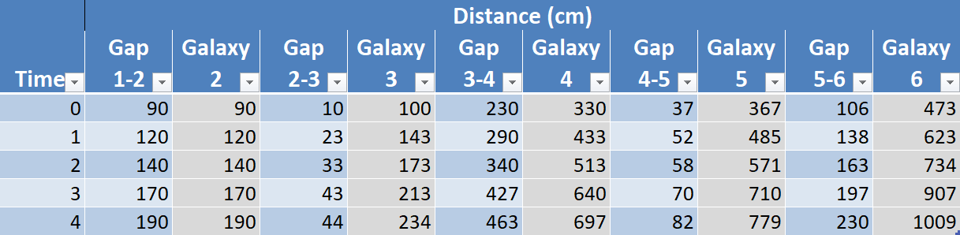
Sample graphs showing the changing distances between galaxies
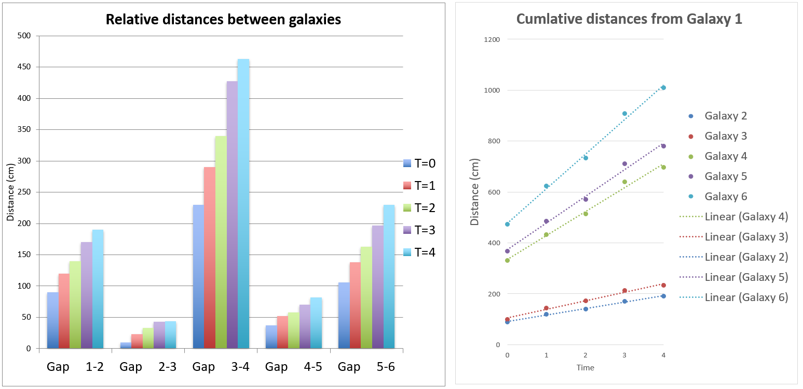
The graph on the above left shows the relative increases in the gaps between galaxies. Students should note the larger gaps increase at a greater rate. This supports the notion that it is the space itself that is expanding and not the galaxies.
The graph on the above right is a distance-time graph and the gradient of each trendline corresponds to the recession velocity of each galaxy. Student should note that the further a galaxy is initially from Galaxy 1, there greater its gradient and therefore the greater its recession velocity.
Further analysis could include measuring the velocity from each gradient (manually using rise/run or using Excel) and then plotting a scatterplot of initial distance versus recessional velocity to recreate a similar plot to that presented by Hubble (included below).
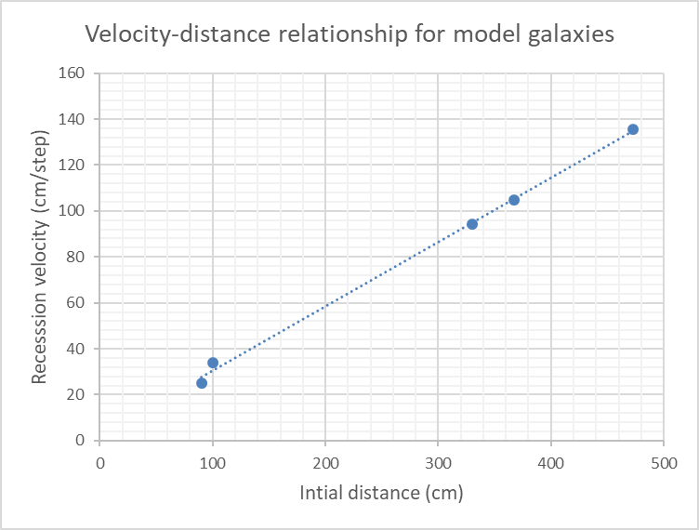
We can conclude from the above graph that recession velocity is directly proportional to a galaxies initial distance from the observer. This is evident in the linear relationship between the two variables. This result is a direct consequence of the uniform expansion of the elastic used and for this reason it is a good analog for the expansion of Space proposed by Hubble.

