Review: The big picture of electromagnetism in HSC physics

1

Contents
Review: The big picture of electromagnetism in HSC physics 0
The “big ideas” of Electromagnetism (as an interactive presentation) 3
Ideas for using this with students 3
The “big” ideas of Electromagnetism (as a word document) 4
Content in module 6 4
Reference frames in electromagnetism 6
Revision: Electromagnetism content covered elsewhere in the syllabus 6
Year 11 – module 4 6
Year 12 – module 7 7
Electromagnetic Induction questions 8
Energy conservation, eddy currents and Lenz’s Law for a falling magnet 8
Working scientifically-focussed questions on electromagnetic induction 11
Hair raiser ride at Luna Park 11
A magnet on a pendulum above a conducting loop 15
Videos of past HSC questions 18
2003 Q20 18
2012 Q22 19
2011 Q25 20
Example questions for the sorting activity 21
Set 1 22
Question 1 (2002 HSC Q9) 22
Question 2 (2003 HSC Q10) 23
Question 3 (2018 Q13) 24
Question 4 (2007 HSC Q7) 24
Question 5 (2010 HSC Q20) 25
Question 6 (2012 HSC Q6) 26
Set 2 27
Question 1 (2011 HSC Q19) 27
Question 2 (2007 Q13) 27
Question 3 (2015 Q12) 28
Question 4 (2011 HSC Q14) 29
Question 5 (2006 HSC Q9) 30
Question 6 (2011 HSC Q6) 30
Set 3 31
Question 1 (2016 Q2) 31
Question 2 (2009 HSC Q8) 31
Question 3 (2014 HSC Q17) 32
Question 4 (2010 HSC Q15) 32
Question 5 (2016 Q5) 33
Question 6 (2006 HSC Q6) 33
Set 4 34
Question 1 (HSC 2009 Q9) 34
Question 2 (1995 Q11) 34
Question 3 (2012 HSC Q14) 35
Question 4 (2009 Q7) 36
Question 5 (2017 Q16) 37
Question 6 (2016 Q17) 38
Answers to multiple-choice questions 39
Set 1 39
Set 2 39
Set 3 39
Set 4 39

The “big ideas” of Electromagnetism (as an interactive presentation)
A link to this material in the form of a click-through Prezi presentation: Overview of electromagnetism with embedded videos in a Prezi presentation

Ideas for using this with students
One way to use the above presentation in class is to show students the introduction video, then ask them to work in groups to decide which “big idea” each section of the syllabus (modules 4, 6 and 7) relates to. Once students have completed this task, the videos for each section can be played one-by-one. In between each video, students can discuss (as a class) what material from the syllabus they have allocated to that idea. This activity could be extended to asking students to sort a set of exam questions by the idea/s they relate to. Four sets of six multiple-choice questions drawn from past HSC exams have been included at the end of this document for this purpose.
Note that the presentation is intended to identify the “big ideas”. It does not explicitly address the sections of the syllabus related to applications of these big ideas (such as transformers and motors and generators). Students must be encouraged to see these as applications of the fundamental physics ideas. The above activity should support the development of this understanding.
The part of the presentation on “reference frames” focuses on the idea that some phenomena (for example the production of an emf by a generator or back emf) can be explained in terms of ‘motional emf’ OR ‘electromagnetic induction’. This gives students options in how they choose to understand and answer questions. It also means that students can see that some syllabus content can be classified as belonging to either of these “big ideas”.
Some applications, such as induction motors or electromagnetic braking utilise both electromagnetic induction and the “motor effect” in their operation.
It is hoped that this will generate rich discussion amongst students!

The “big” ideas of Electromagnetism (as a word document)
The “big picture” of electromagnetism can be summarised as follows:
- Charges produce electric fields, and electric fields exert forces on charges.
- Moving charges produce magnetic fields, and magnetic fields exert forces on moving charges.
- Changing magnetic fields produce electric fields and changing electric fields produce magnetic fields.
Introduction video to the Big Ideas in Electromagnetism (duration 0:52)

Content in module 6
Three of these big ideas in electromagnetism are covered in module 6:
- Electric fields exert forces on charges.
  - Charges in a uniform electric field (such as between two parallel charged plates) experience a constant force of $\vec{F}=q\vec{E}$. This results in constant acceleration so that the charge undergoes parabolic motion in a manner analogous to the motion of projectiles in gravitational fields.
    - Force acting on charges in a uniform electric field (duration 0:58)
- Magnetic fields exert forces on moving charges.
  - For isolated moving charges, the magnitude of this force is described by $F=qvB\sin{θ}$.
    - Force on free charges moving in a magnetic field (duration 0:58)
  - This force is also experienced by charges in a conductor that is itself moving through a magnetic field (called “Motional emf”).
    - Motional emf (duration 0:18)
  - For charges moving as part of a current in a conductor, it can be shown that the magnitude of this force is given by $F=ILB\sin{θ}$ (the “motor” effect).
    - Force on a current-carrying conductor in a magnetic field (the motor effect) (duration 0:57)
  - Parallel current-carrying conductors exert attractive or repulsive forces on each other as the current in one wire experiences a force due to the magnetic field produced by the other wire.
    - Force between parallel current-carrying conductors (duration 1:03)
In all three situations, the direction of the force experienced by moving charges is perpendicular to the direction of motion of the charge and the direction of the magnetic field, as described by the right-hand rule.

- A changing magnetic field produces an electric field.
  - The electric fields generated by changing magnetic flux point in continuous loops. We describe the work done per unit charge by this field in terms of an emf (instead of an electrical potential difference, as would be used for electric fields produced across the terminals of a battery). The units of emf are volts (V).
  - Magnetic flux ($Φ=BA\cos{θ}$) can change over time if:
    - The magnetic field strength B changes (for example by changing the current in a wire or a solenoid, or moving a permanent magnet)
    - The area of the loop (or the area within the B field) changes
    - The angle between the loop and the magnetic field changes
    - Changing magnetic flux (duration 0:36)
  - The emf due to the electric field produced by a changing magnetic field around a closed loop is given by Faraday’s law $ε= -N\frac{ΔΦ}{Δt}$.
    - Electromagnetic induction (Faraday's law) (duration 0:24)
  - The induced emf can drive a current if a conductor or a complete conducting loop is present to allow free charges to experience a force due to the electric field. If the resistance of the loop is R, then the induced current is $I= ε/R$.
  - Lenz’s law: The direction of the current induced by the emf is such that the magnetic field of the induced current opposes the change in the magnetic flux.
Problems involving Lenz’s law can be solved using a “4 step” approach as follows.
- Which way is the external magnetic field directed (e.g. into or out of the page, up or down the page)?
- Is the B flux in this direction through the area of interest increasing or decreasing in magnitude?
- Which way would the magnetic field due to the induced current need to point to oppose this change?
- Use the RH grip rule, with your fingers pointing in the direction you have determined in part 3 to determine the direction of the induced current.
A discussion of the relationship between Lenz’s law and conservation of energy, as well as an application of this approach in some situations, is given here: Conservation of energy and Lenz's law (duration 6:27). The videos on motional emf, magnetic flux, Faraday’s law and reference frames in electromagnetism should be viewed before this video.

Reference frames in electromagnetism
In the introduction to his 1905 paper on Special Relativity, Einstein discusses the example of a magnet moving into a coil of wire connected to a galvanometer. He notes that in the reference frame of the coil, where the charges are stationary, and the magnet is moving, the force on charges in the coil is attributed to the electric field induced by the changing magnetic flux through the coil. However, in the reference frame of the magnet, the charges are moving in a magnetic field, so producing a force on the charges (a motional emf). The force, in either case, is the same (this is an expression of Einstein’s postulate that the laws of physics are the same in all inertial reference frames), however in one reference frame it is an electric force, and in the other a magnetic force.
The value of this is that it provides options for students – some questions are easier to solve or visualise in one reference frame than another.
Reference frames in electromagnetism (duration 1:54)

Revision: Electromagnetism content covered elsewhere in the syllabus

Year 11 – module 4
Several big ideas are covered in module 4, and since these are considered to be assumed knowledge for the HSC, it is helpful for students to be reminded of them during revision for the HSC:
- Point charges produce electric fields that begin on positive charges and end on negative charges.
  - Electric field due to point charges (duration 0:14)
- The principle of superposition can be used to find the electric field produced by pairs of charges, dipoles and parallel charged plates.
  - Electric field due to parallel charged plates (duration 0:22)
- Electric fields exert forces on charges via the equation $\overset{⃑}{F}=q\overset{⃑}{E}$.
- Moving charges (e.g. electrical currents) produce magnetic fields that do not start or end, but instead point in closed loops.
- For a wire, the strength of this magnetic field at a distance r is given by $B= \frac{μ_{0}I}{2πr}$.
  - Amperes law (duration 0:25)
- For a solenoid of length L with N turns the magnetic field in the centre is given by $B= \frac{μ_{0}NI}{L}$.
  - Magnetic field produced by a solenoid (duration 0:57)
- For ferromagnetic materials, the moving charges making the magnetic field are electrons in orbit around atoms.

Year 12 – module 7
The final big idea in electromagnetism (module 7) can be (qualitatively) discussed in Maxwell’s contribution to electromagnetism. Maxwell contributions include:
- Describing how a changing electric field produces a magnetic field. (Maxwell’s law of induction). Together with Faraday’s law that a changing magnetic field produces an electric field, these laws explain the propagation of EM radiation.
- Developing equations to unify electricity and magnetism.
- Using these equations to predict the existence and properties of EM waves.
- Predicting the velocity of electromagnetic waves and demonstrating that this is consistent with the previously experimentally determined speed of visible light.

Electromagnetic Induction questions

Energy conservation, eddy currents and Lenz’s Law for a falling magnet
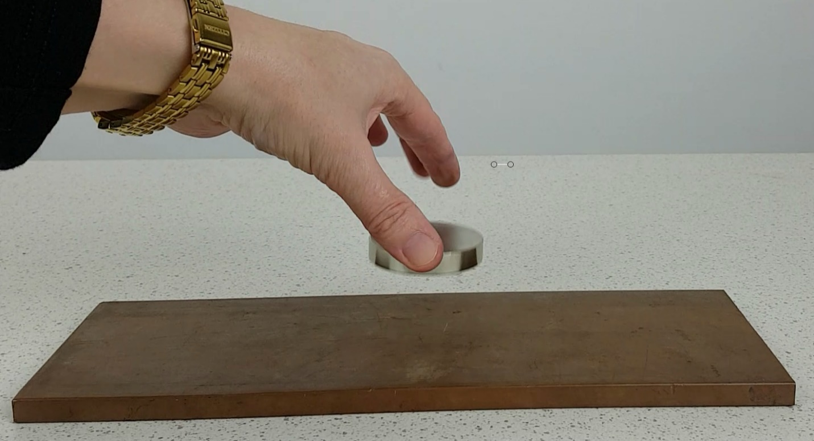
Figure 1 - A strong magnet falls onto a thick copper block.
A strong magnet dropped onto a copper block (duration 0:08)
- A strong magnet falls onto a thick copper block with its south side facing downwards towards the copper.
  - In the space below, draw the eddy currents which flow in the copper block as the south pole of the magnet faces the block.
Diagram (Top view of the block):

  - Use Lenz’s law to explain your answer.

  - Use conservation of energy to explain why a strong magnet dropped from a small height lands gently on a thick copper surface.

- Instead of dropping the magnet onto the block, the magnet can be moving horizontally across the surface of the block, as shown in the following video:
Magnet moving across copper (duration 0:01)
  - Draw a diagram of the eddy currents induced in the copper if the magnet was moving horizontally from right to left with its north pole just above the surface.
Diagram (Top view of block):

  - Use the motor effect to explain how the magnet exerts a force on the eddy currents to cause the copper to move over the rollers, as shown in the video.
Suggested answers:
- Magnet falling onto block
- Top view of block:
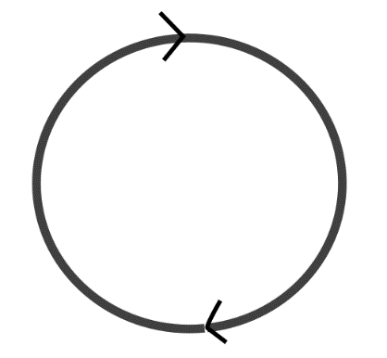
Note this is the direction of conventional current (not electrons) in the copper.
- Lenz’s law states that the magnetic field of the induced current (here eddy current) opposes the change in magnetic flux. Here as the south side of the magnet is falling towards the copper, the magnetic flux out of the page is increasing. The magnetic field of the induced current must be directed into the page to oppose this change. Using the right-hand grip rule with your fingers directed into the centre of the eddy current, your thumb points in a clockwise direction.
- As the magnet falls, potential energy is converted into kinetic energy. As the magnet nears the surface of the copper, kinetic energy and the remaining potential energy are converted into electrical energy in the form of eddy currents. As these eddy currents flow, the electrical energy is converted to heat energy in the copper, so that energy is conserved.
- Magnet moving horizontally across the block
  - Eddy currents are generated at the leading and trailing edge of the magnetic field, where the magnetic flux through the copper is changing.
The direction is given by Lenz’s law, so that the current flows in a direction so that its magnetic field opposes the change in flux. This is anticlockwise at the leading edge to oppose the increase in flux and clockwise at the trailing edge to oppose the decrease in flux.
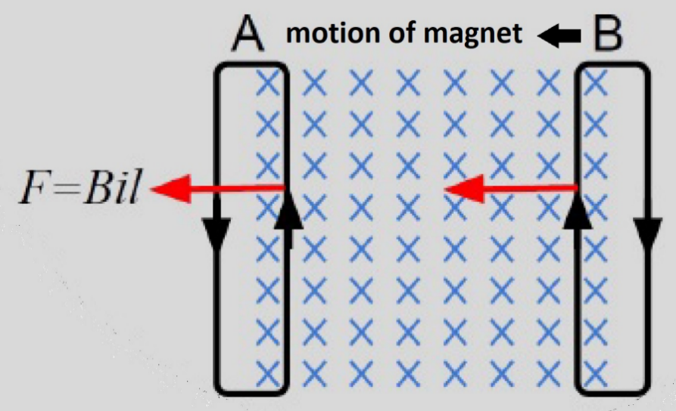
  - The eddy currents inside the magnetic field experience a force due to the “motor” effect (the force on current carrying conductors in a magnetic field) that is directed in the same direction as the magnet is moving (using the right hand grip rule the fingers are directed into the page, the thumb in the direction the charges (here conventional current) are moving, which is up the page, and then the palm points in the direction of the force acting on the current, shown with red arrows in the diagram above).
This force pulls the copper along with the magnet, as shown in the video.

Working scientifically questions on electromagnetic induction
Note: The following two questions are expected to be challenging for most students and would likely to be most useful to use as group activities so that students can assist each other in making sense of the real data associated with the question.

Hair raiser ride at Luna Park
In the Luna Park ride “The Hair-raiser”, a gondola (platform) carrying riders is lifted into the air and then dropped. The gondola falls freely for some distance, then before it reaches the ground strong permanent magnets underneath the gondola pass close to copper fins on the tower in order to produce a “fail safe” braking system.

Watch Hair raiser ride at Luna Park (annotated) (duration 0:42)
The graph below shows data for vertical acceleration versus time for the gondola measured with a smart phone app. The time begins at the moment that the gondola is released at the top of the ride.
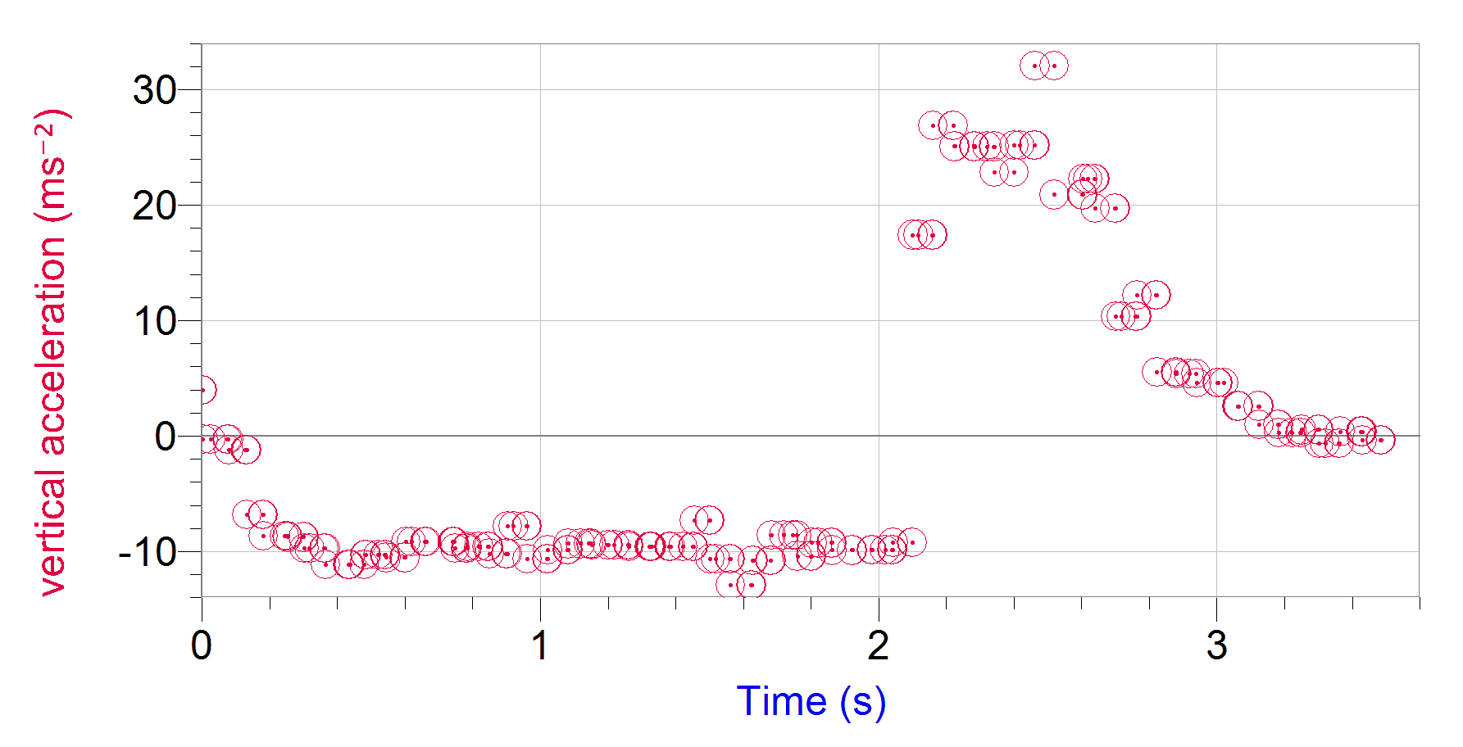
(Link to data set: Spreadsheet containing acceleration time data for the hair raiser ride)
- The time at which the gondola begins to drop is noted in the video.
  - By viewing the video, identify the time during the fall at which the permanent magnets (at the base of the gondola) reach the conducting rails.

  - Explain whether the data from the video for the time of free-fall is consistent with the acceleration data.

- Use the acceleration data to estimate the maximum speed reached by the gondola?

- How far does the gondola fall during the free-fall section of the ride?

- Sketch a graph of the velocity versus time for the gondola from the time it is dropped to the time it comes to rest. Plot the time and value of the maximum velocity you obtained in part b)
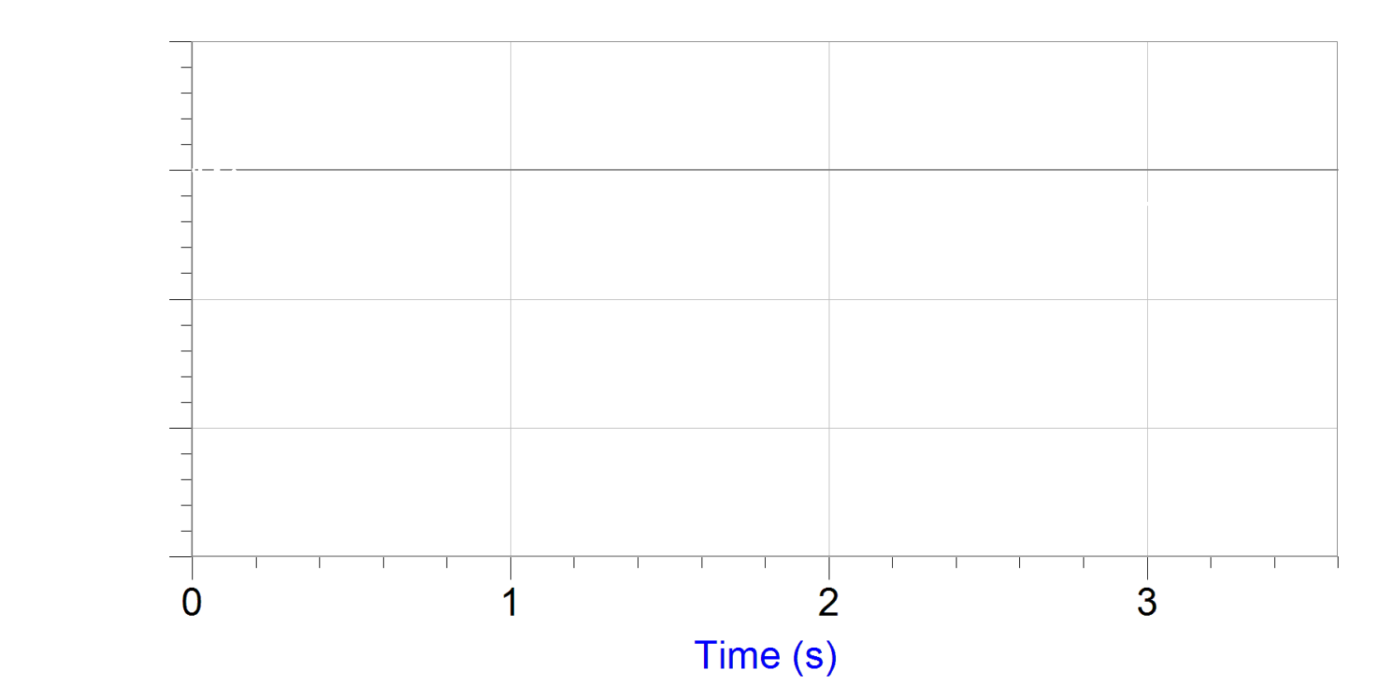
- What feature of the acceleration-time data is consistent with a deceleration caused by electromagnetic braking?

- Explain how the motion of the permanent magnets past the conducting rails produces a braking force on the gondola.

- How is energy conserved during the drop?

Sample answers:

  - At about 35s, 2s after the gondola was dropped.
  - Yes, the acceleration data indicates an acceleration of approximately -10ms⁻² (free-fall acceleration) for about 2s.

- The maximum speed, can be obtained using the equations for constant acceleration $v=u+at$, where the initial velocity is zero, the acceleration is the free-fall acceleration (students might use different approaches here – assuming -9.8ms⁻² or assuming -10ms⁻²) and the time is approximately 2s. Students should obtain a maximum velocity close to -20ms⁻¹, so a maximum speed of 20ms⁻¹.

- The distance fallen during free fall is approximately $s=ut+\frac{1}{2}at^{2}=0.5×\left(-9.8\right)×2^{2}=20m$.

- The graph drawn by students should be linear with a gradient of approximately -10ms⁻² from t=0.2s to t=2.2s and reach a maximum negative value of -20ms⁻¹ at t=2.2s. From t=2.2 to t = 3.2 the velocity should increase (become less negative) with an initial positive gradient of 25ms⁻² which then decreases smoothly to zero gradient at about 3.2s, as the velocity reaches zero.

Here is the actual integrated acceleration time data (the area under the acceleration-time graph shown in the question).
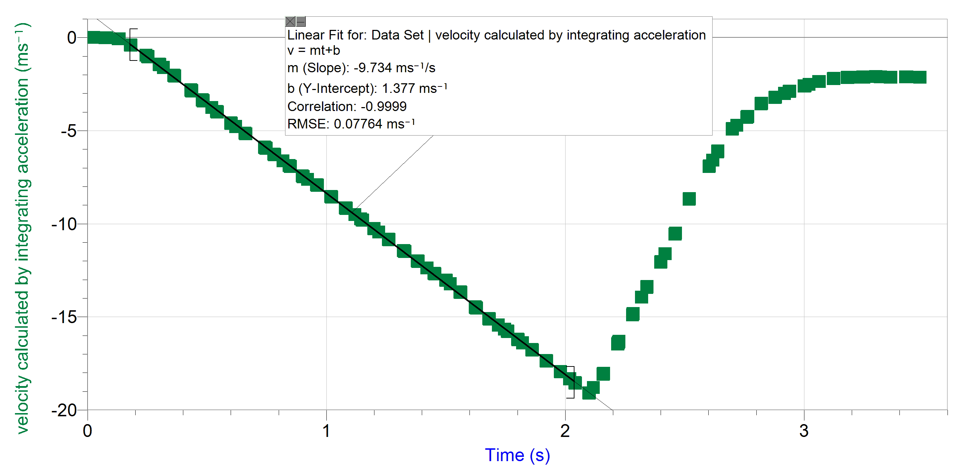
An aside: Note that it is clear from the video that the final velocity of the gondola is zero, whereas this is not the result obtained by integrating the acceleration. The most likely reason for this is the existence of bias (a deviation from zero acceleration when the phone is not accelerating as phone accelerometers are not built to be precision accelerometers) which might well be large for higher accelerations. This appears during integration as each point is effectively “added” to all the others, so small deviations sum to large total errors. This is a well-documented challenge in using accelerometers for measure velocity and distance, see the section on “drift rate" at wikipedia.org/wiki/Inertial_navigation_system. For applications such as aviation, highly accurate accelerometers are used to determine the position of an aircraft without reliance on GPS. The “Engineer Guy” has made an excellent video on accelerometers that can be used to introduce students to using their phone as a measuring device: www.youtube.com/watch?v=KZVgKu6v808). (duration 4:24).

- The magnitude of the acceleration, and so the magnitude of the braking force, is largest when the gondola is moving most rapidly. This is consistent with electromagnetic braking, where the size of the induced emf, and so the eddy currents produced, is proportional to the rate of change of magnetic flux – this is largest when the gondola is moving most rapidly.

- As the permanent magnets move past the copper conductors, they cause a change in magnetic flux through the conductors. This changing magnetic flux induces an emf due to Faraday’s law , which induces a current in a direction such that the magnetic field of the induced current opposes the change in magnetic flux (Lenz’s law). In this case, the magnetic field induced by the eddy currents in the copper exerts an upwards force on the magnets in the gondola that is much larger than the weight force in order to produce a large upwards acceleration.

- As the gondola is lifted, the gravitational potential energy of the system increases. As the gondola falls freely under gravity, this gravitational potential energy is converted to kinetic energy. As the electromagnetic braking occurs, eddy currents are generated which convert this kinetic energy (and remaining gravitational potential energy) of the gondola to electrical energy which is then converted to heat in the conducting rails.

A magnet on a pendulum above a conducting loop
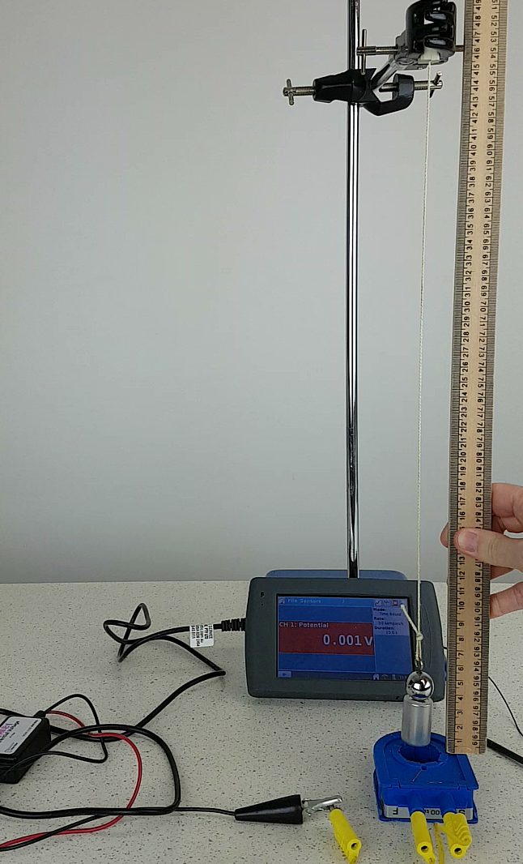
A strong magnet attached to a steel pendulum bob hangs on a string just above a conducting loop of copper wire. As the magnet swings, the emf generated in the loop is recorded by a voltage probe connected to a data logger, as shown in the video:
Magnet on a pendulum swinging over a conducting loop (duration 0:30)
The emf as a function of time that was recorded while the magnet was swinging is shown below.
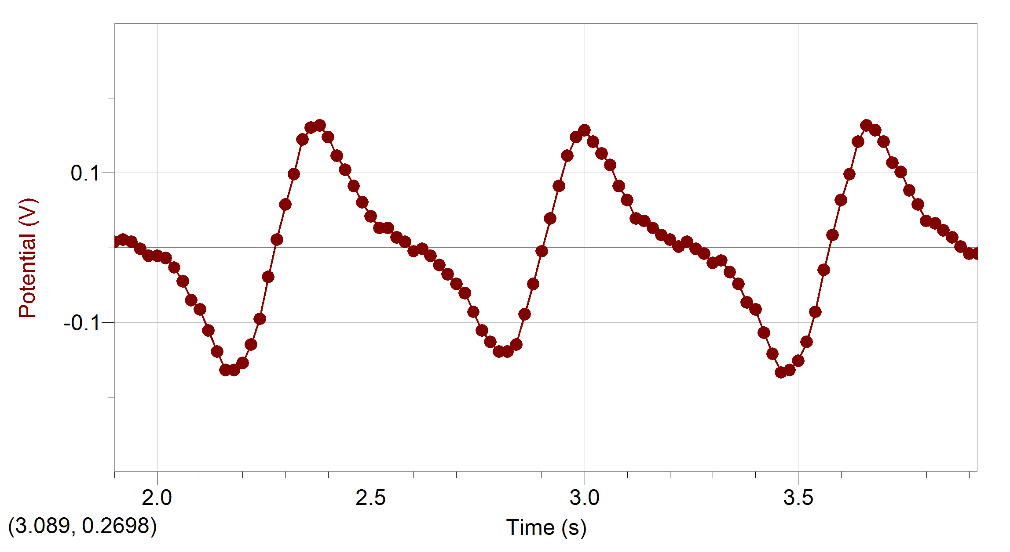
The period of a pendulum (time for it to complete a full oscillation), $T$, depends on its length l and the acceleration due to gravity $g$ according to the equation
$$T=2π\sqrt{\frac{l}{g}}$$
The period does NOT depend on the amplitude of the oscillations, as long as the amplitude relatively small (approximately $<10$ degrees).
The length of the pendulum in the first video was 0.45cm, with the base of the magnet 5mm above the top of the conducting loop.
- If the string length is kept constant, but the amplitude is increased (but remains $<10$ degrees) predict how the emf will vary with time.
Draw your prediction on this copy of the emf versus time from the first video.
Here is a magnet on a pendulum with a larger initial amplitude (same length) (duration 0:20)
- The string length is now halved, but the suspension point of the pendulum is lowered so that the magnet remains 5mm above the coil. The amplitude of the oscillation is kept the same as in the first video.
Predict how the emf will vary with time. Draw your prediction on this copy of the emf versus time from the first video.
Watch a magnet on a pendulum with half the length (same amplitude). (duration 0:38)
Solutions (data for each case):
  - If the amplitude is increased (but the amplitude remains relatively small) the period remains the same as in the first case, however the amplitude of the emf increases. This is because the magnet must travel a further distance in the same time, so is travelling with a larger velocity as it passes over the coil. This means the flux changes at a greater rate through the coil producing a greater emf.
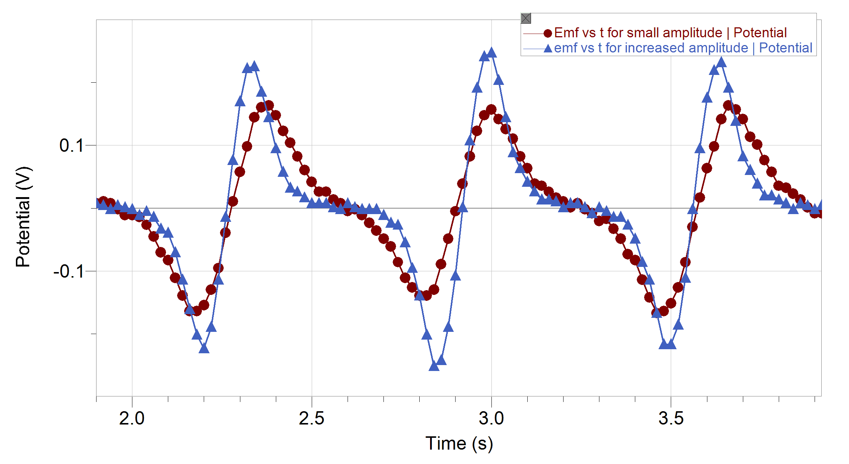
  - If the length of the pendulum is halved, the period will be reduced by a factor of $\frac{1}{\sqrt{2}}≈0.7$. The period for the original data was approximately 0.7s (so that three periods occurred over the 2s of data shown). The new period will be approximately $0.7×0.7≈0.5s$, so that four periods now fit in the 2s of data shown.
In addition, as the period is shorter, the magnitude of the emf will be greater than in the first situation, as the same change in magnetic flux is occurring over a shorter time period.
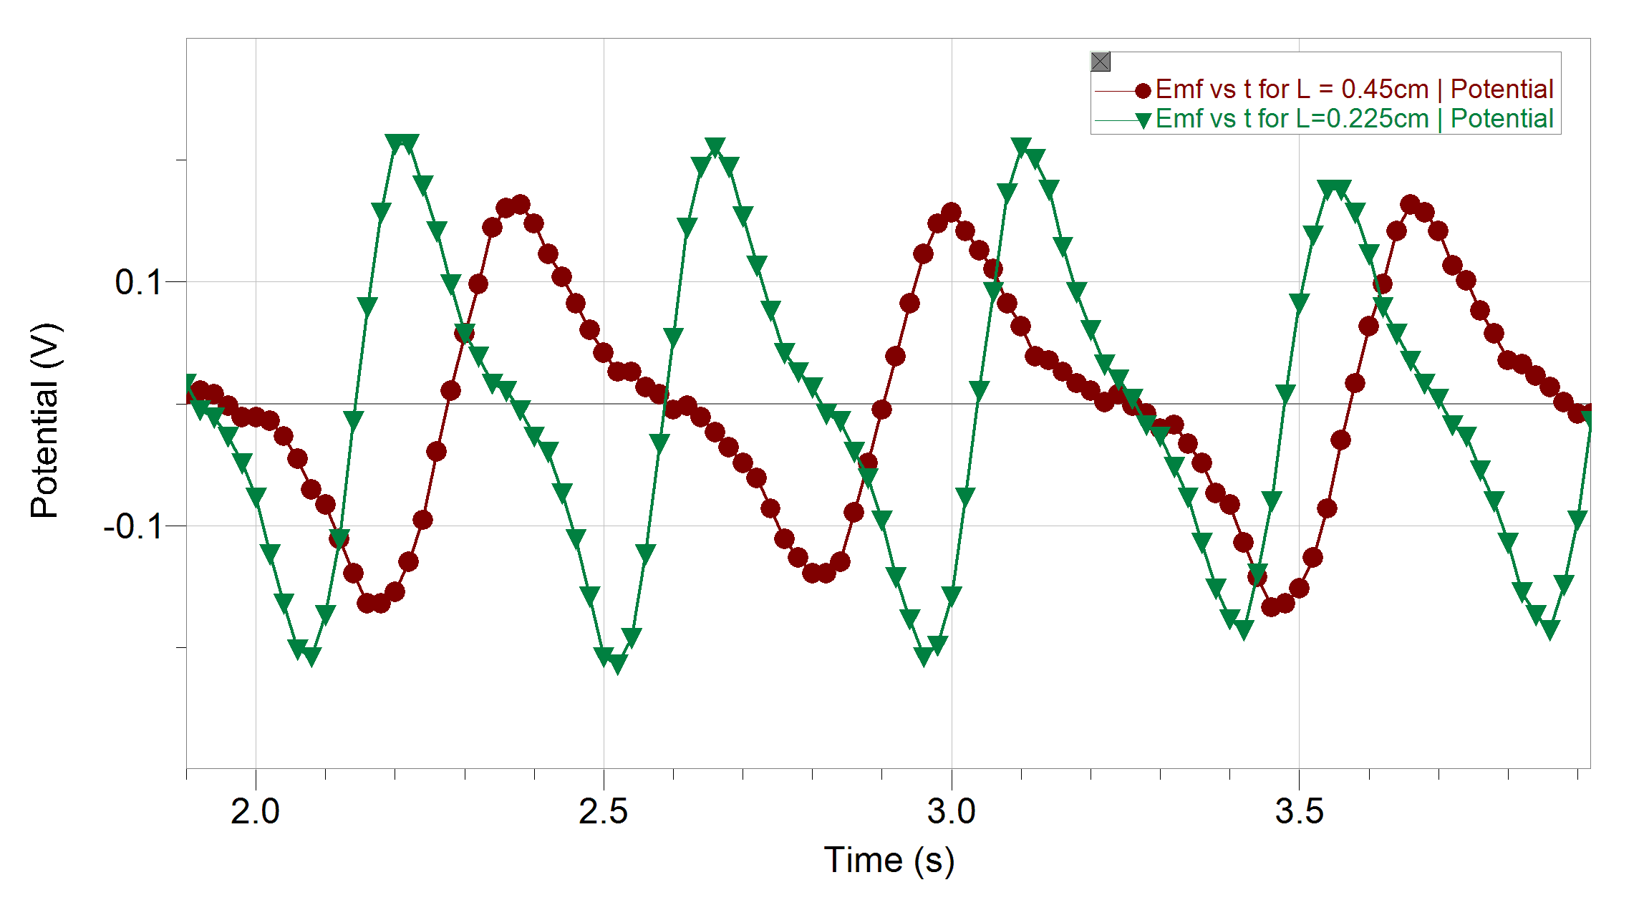

Videos of past HSC questions
All exam questions detailed below are from past HSC papers. Physics 2019 HSC Exam pack and NSW HSC Examination Papers 1995 – 2000 © NSW Education Standards Authority (NESA) for and on behalf of the Crown in right of the State of New South Wales 2019.
The year of issue is included in each question for your reference.

2003 Q20
Video for this question: setup for 2003 Q20 setup (coil swing) (duration 0:26)
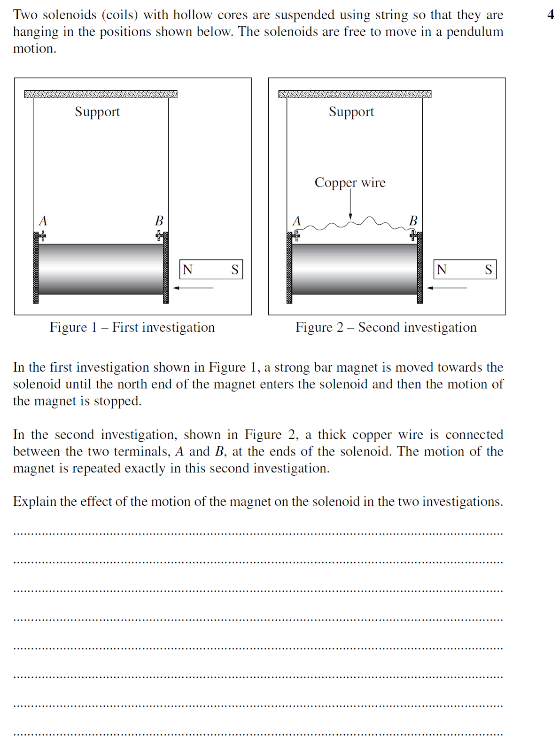

2012 Q22
Video for this question: setup for 2012 Q22 Mass of a magnet on scales (duration 0:44)
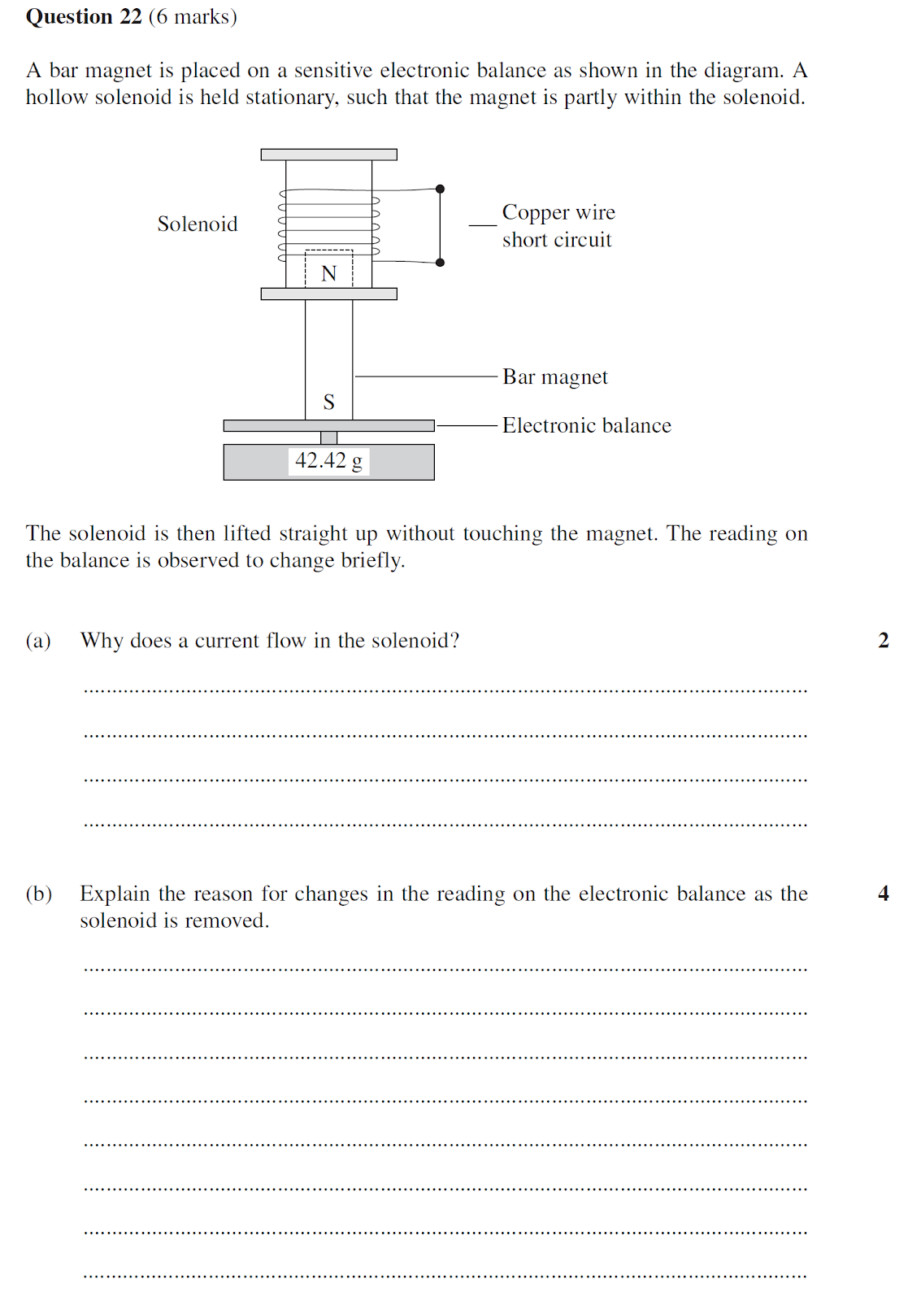

2011 Q25
setup for 2011 Q22 Magnet drop (duration 0:08)
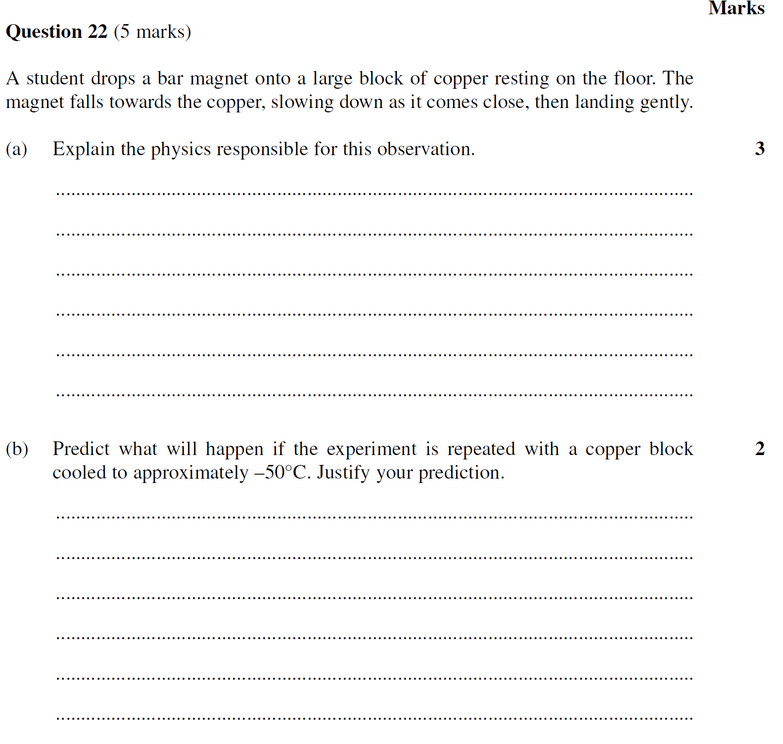

Example questions for the sorting activity
All exam questions detailed below are from past HSC papers. Physics 2019 HSC Exam pack and NSW HSC Examination Papers 1995 – 2000 © NSW Education Standards Authority (NESA) for and on behalf of the Crown in right of the State of New South Wales 2019.
The year of issue is included in each question for your reference.

Set 1

Question 1 (2002 HSC Q9)
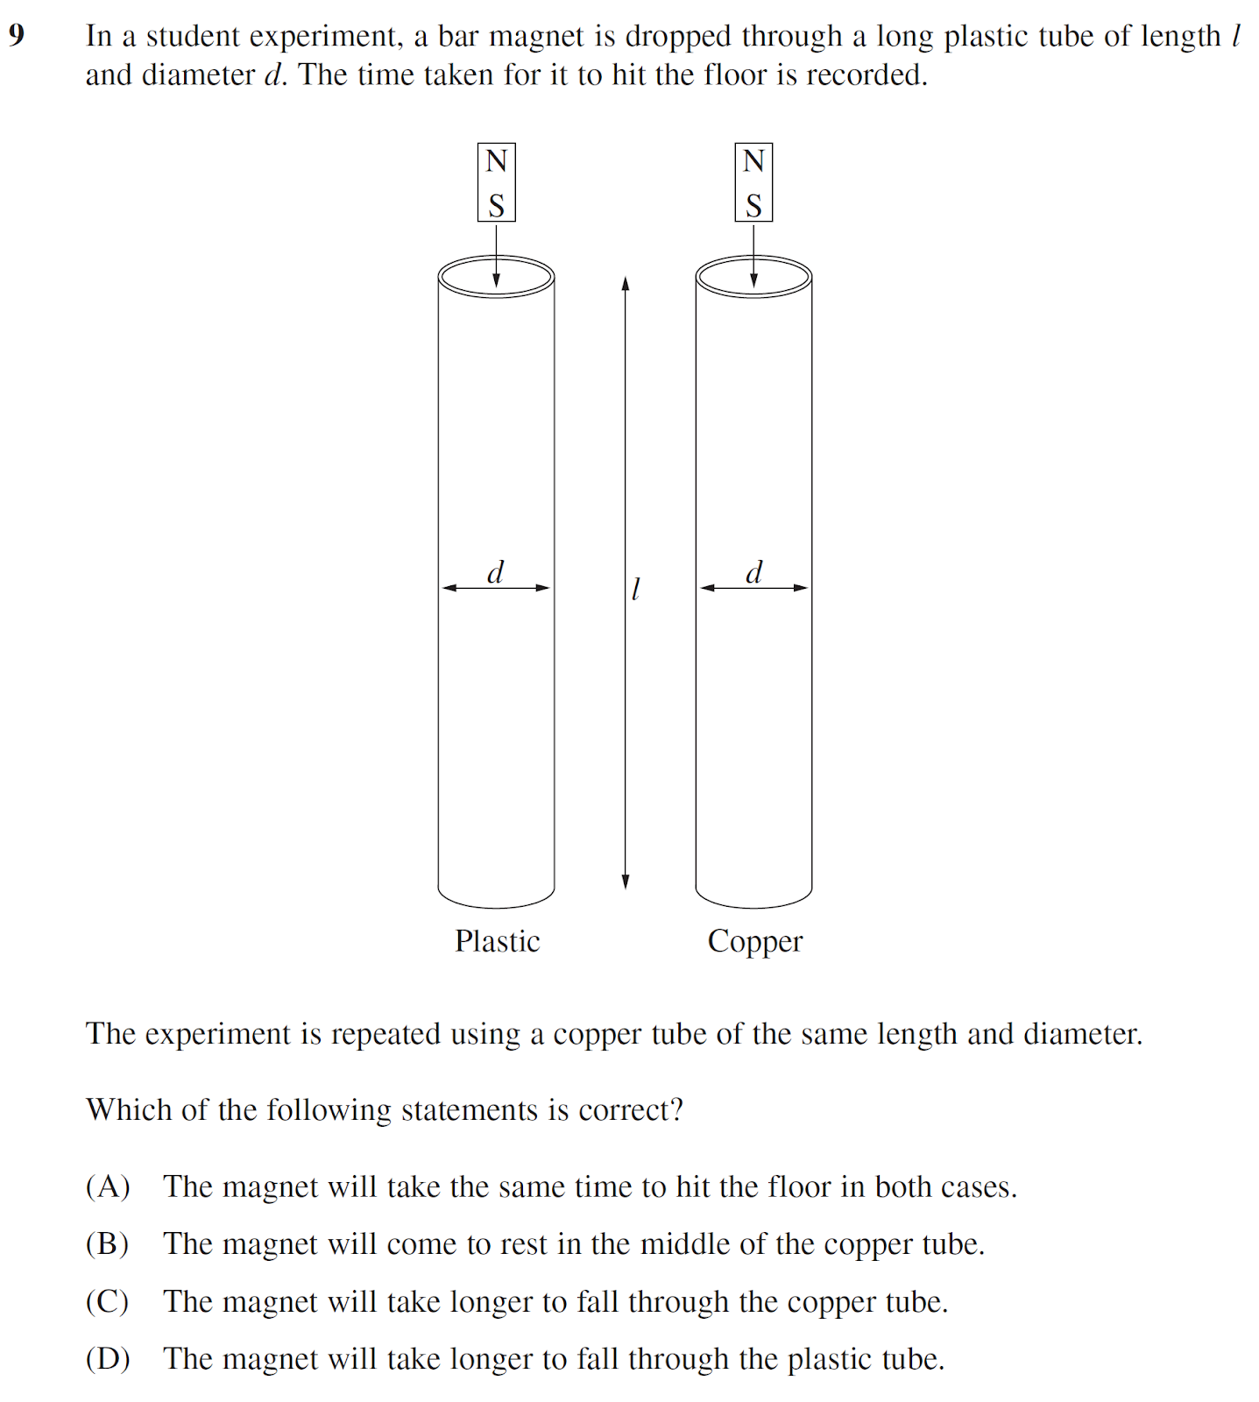

Question 2 (2003 HSC Q10)
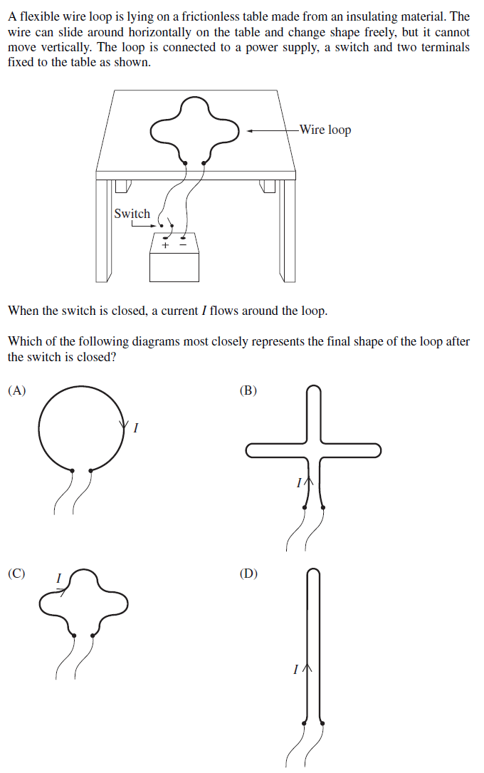

Question 3 (2018 Q13)
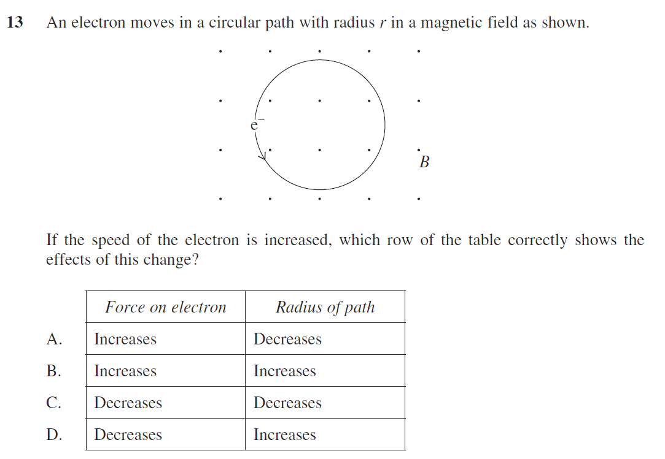

Question 4 (2007 HSC Q7)
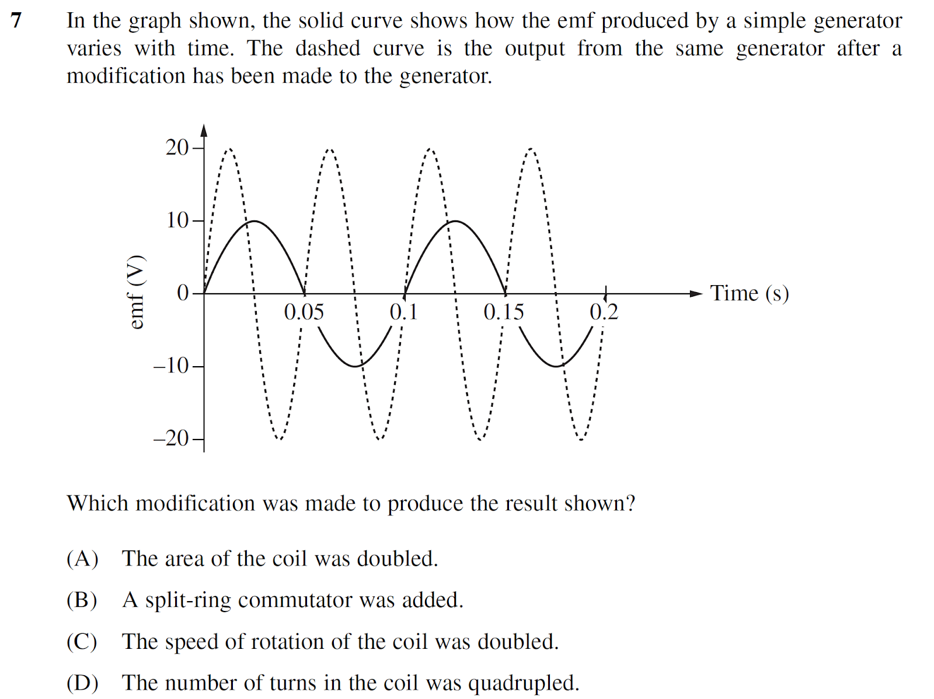

Question 5 (2010 HSC Q20)
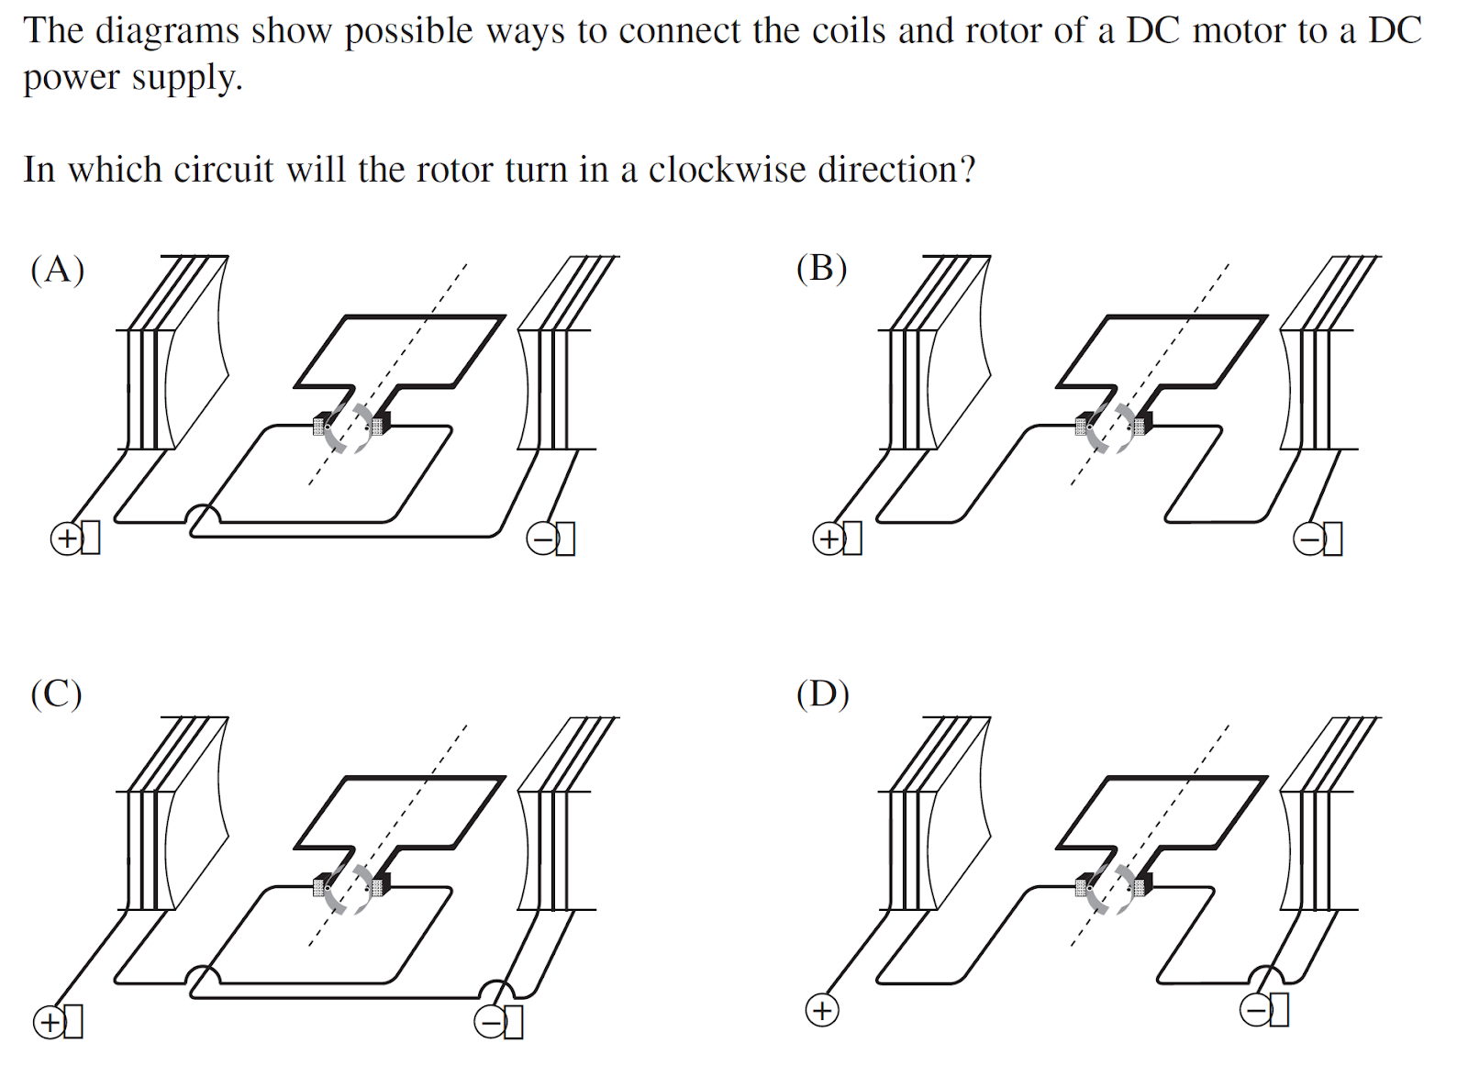

Question 6 (2012 HSC Q6)
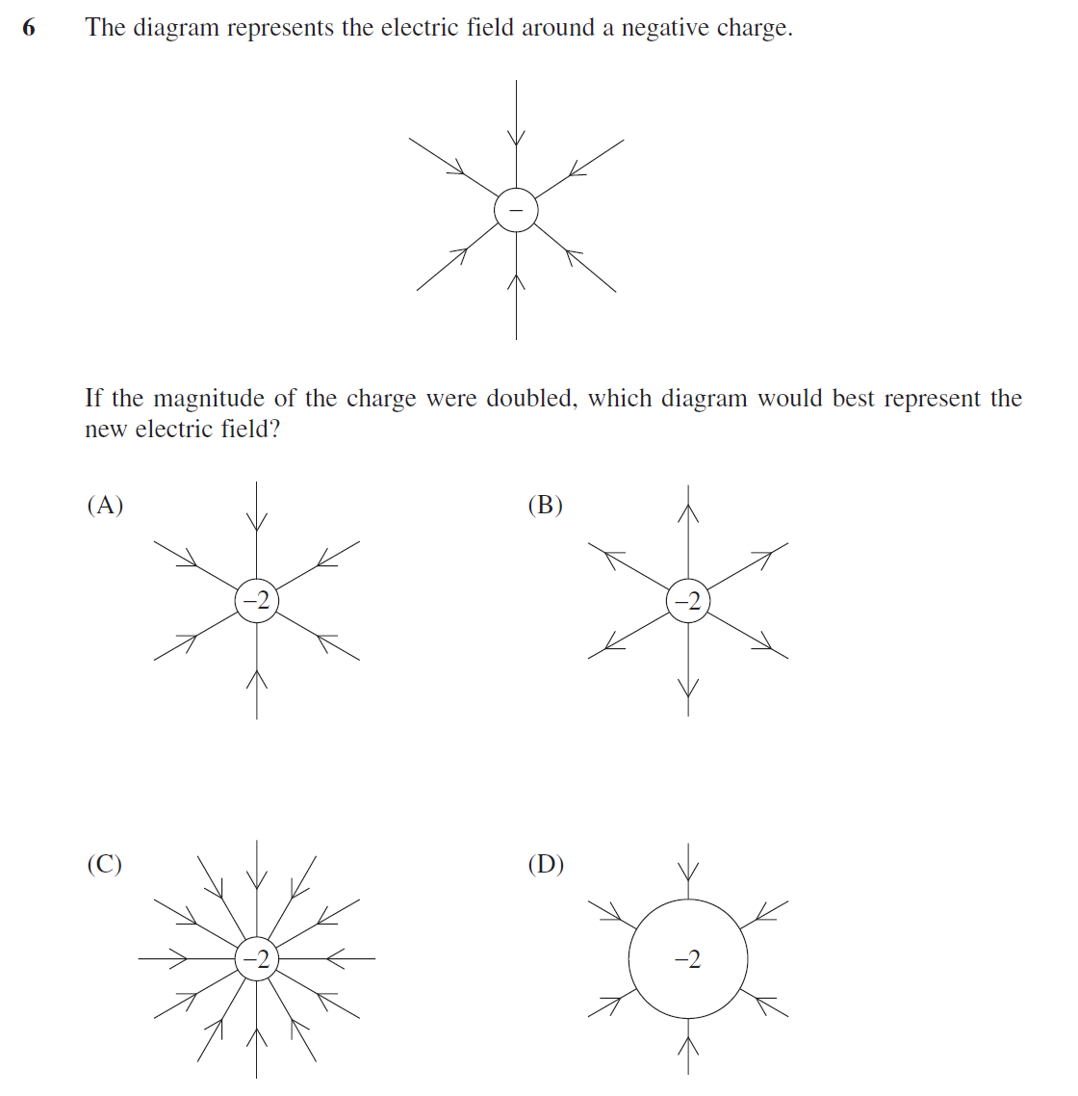

Set 2

Question 1 (2011 HSC Q19)
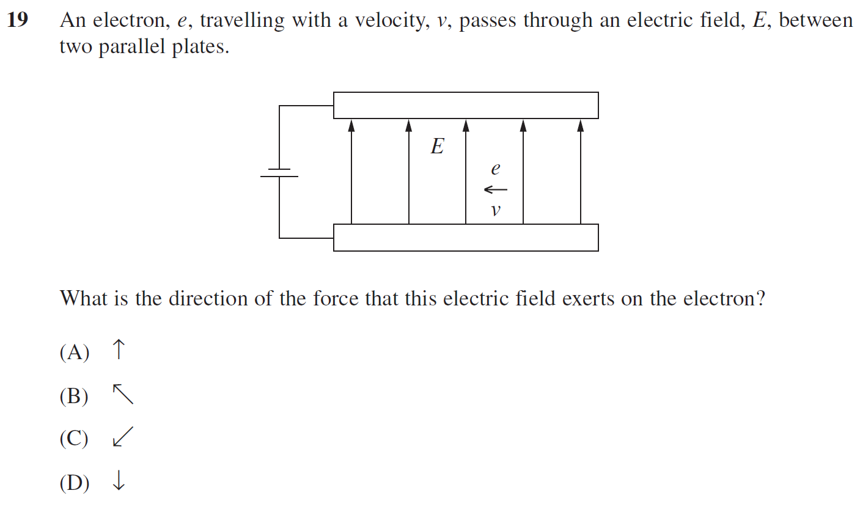

Question 2 (2007 Q13)
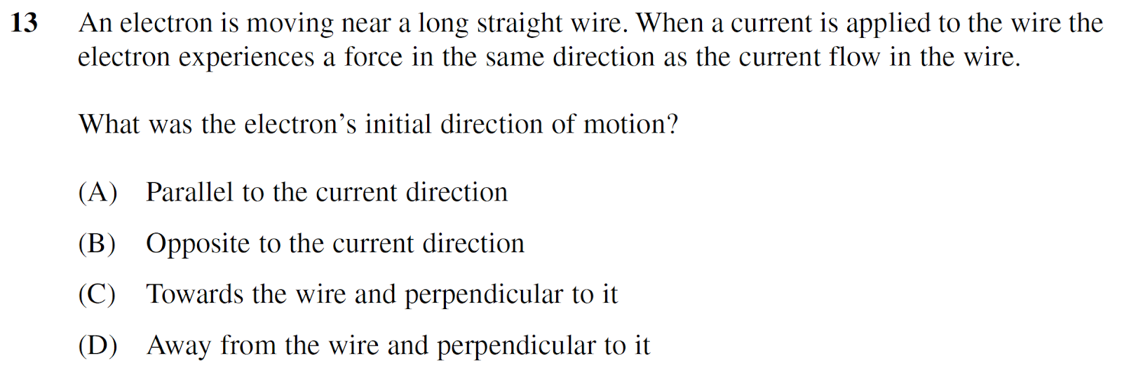

Question 3 (2015 Q12)
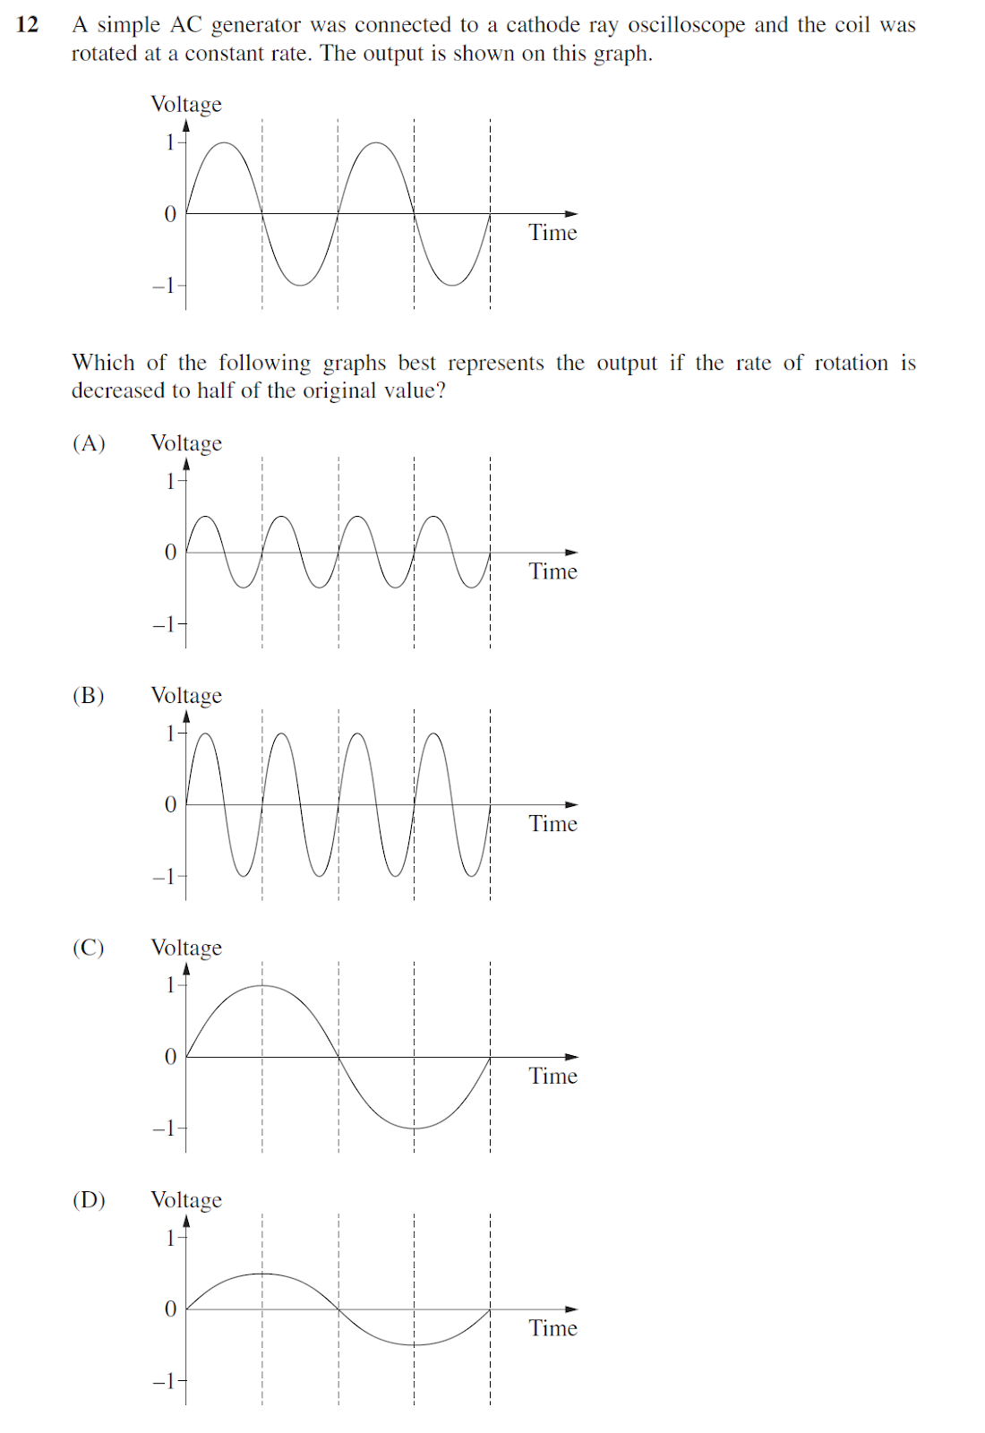

Question 4 (2011 HSC Q14)
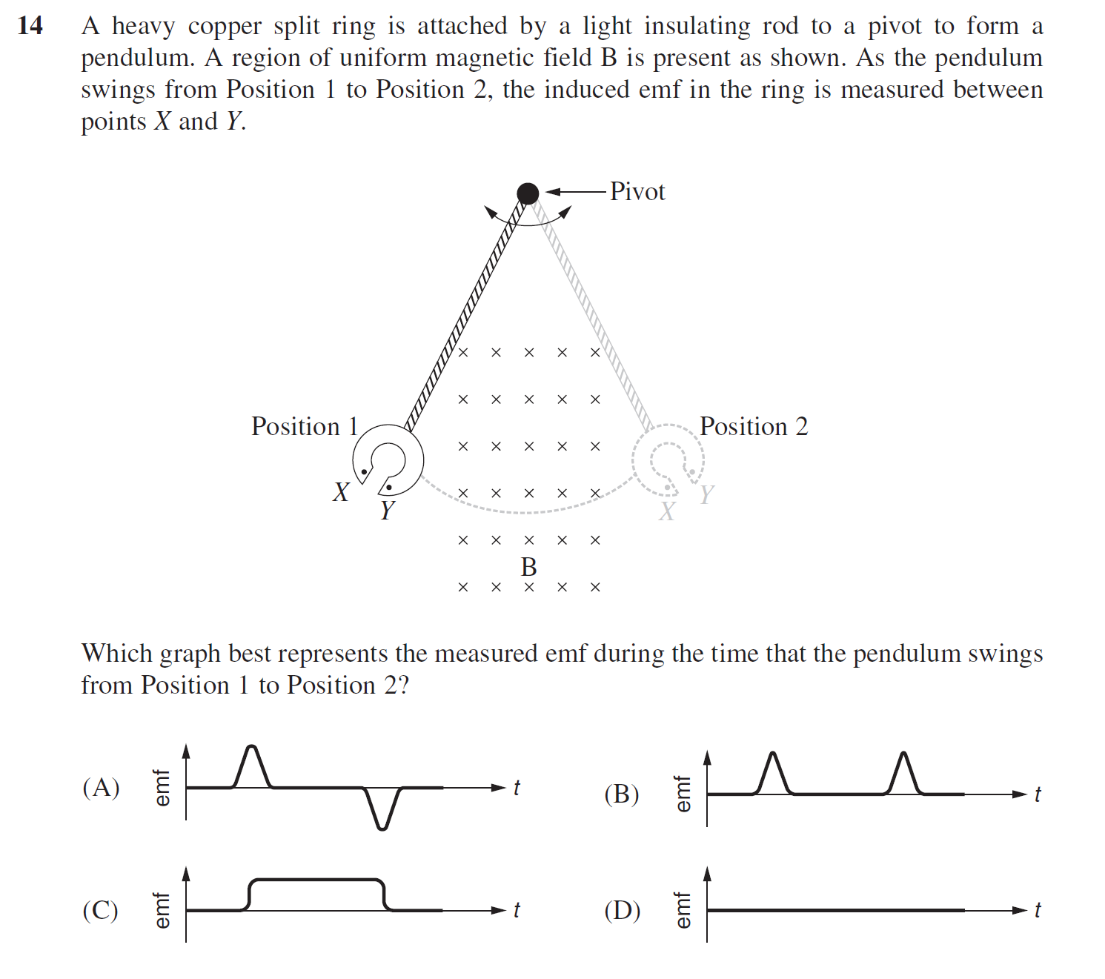

Question 5 (2006 HSC Q9)
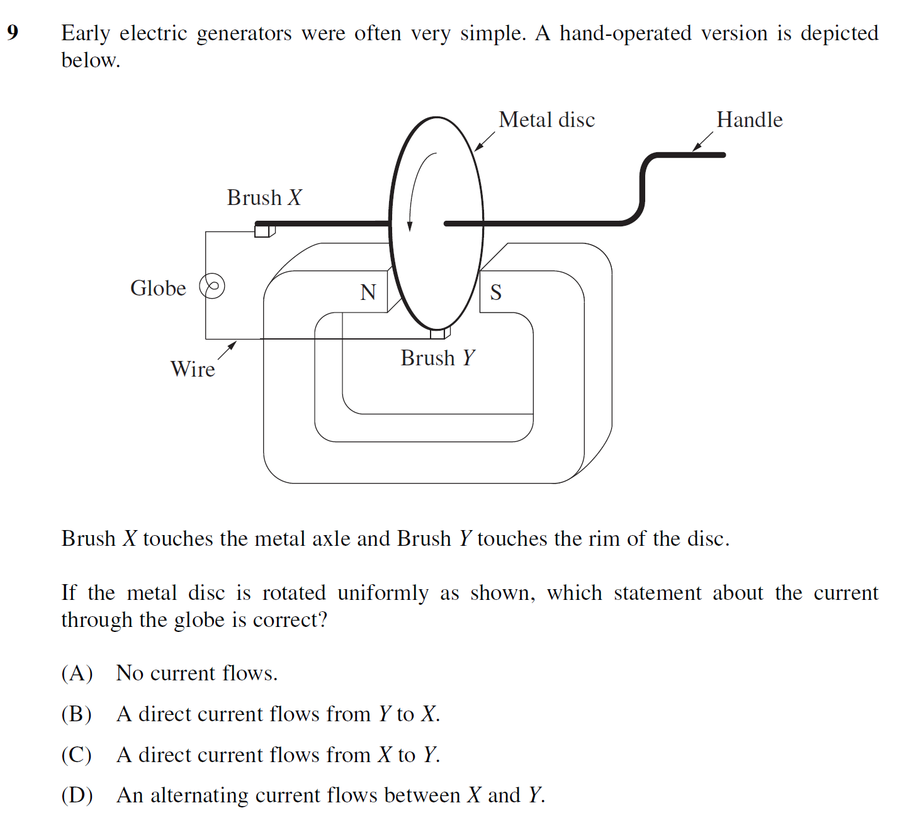

Question 6 (2011 HSC Q6)
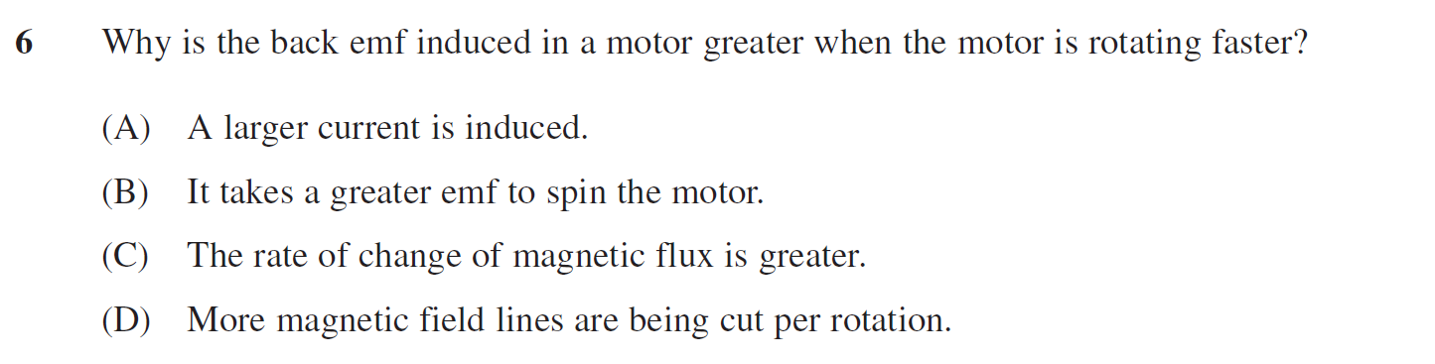

Set 3

Question 1 (2016 Q2)
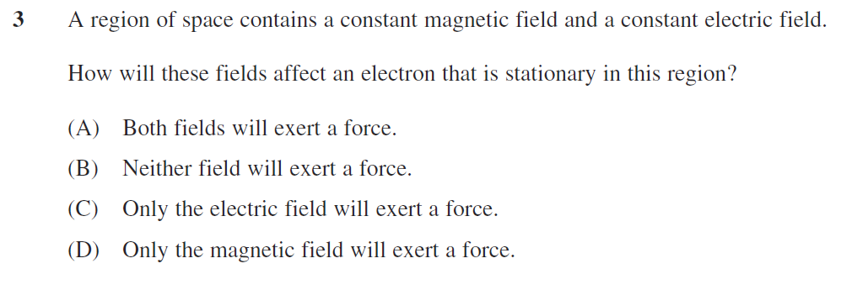

Question 2 (2009 HSC Q8)
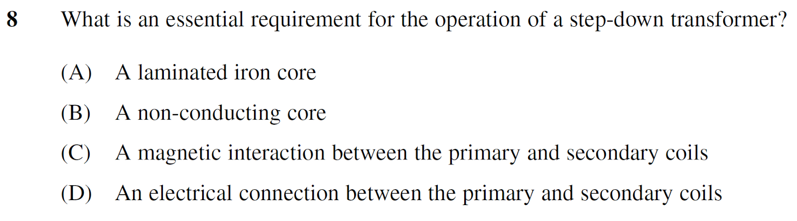

Question 3 (2014 HSC Q17)
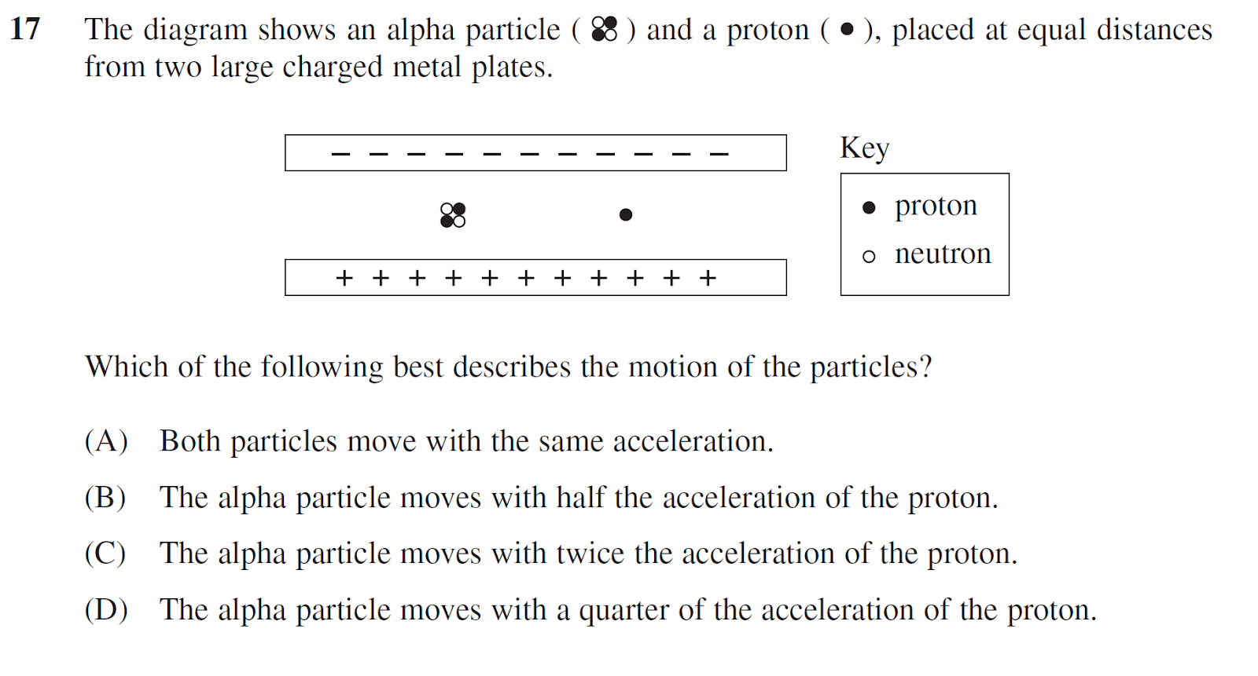

Question 4 (2010 HSC Q15)
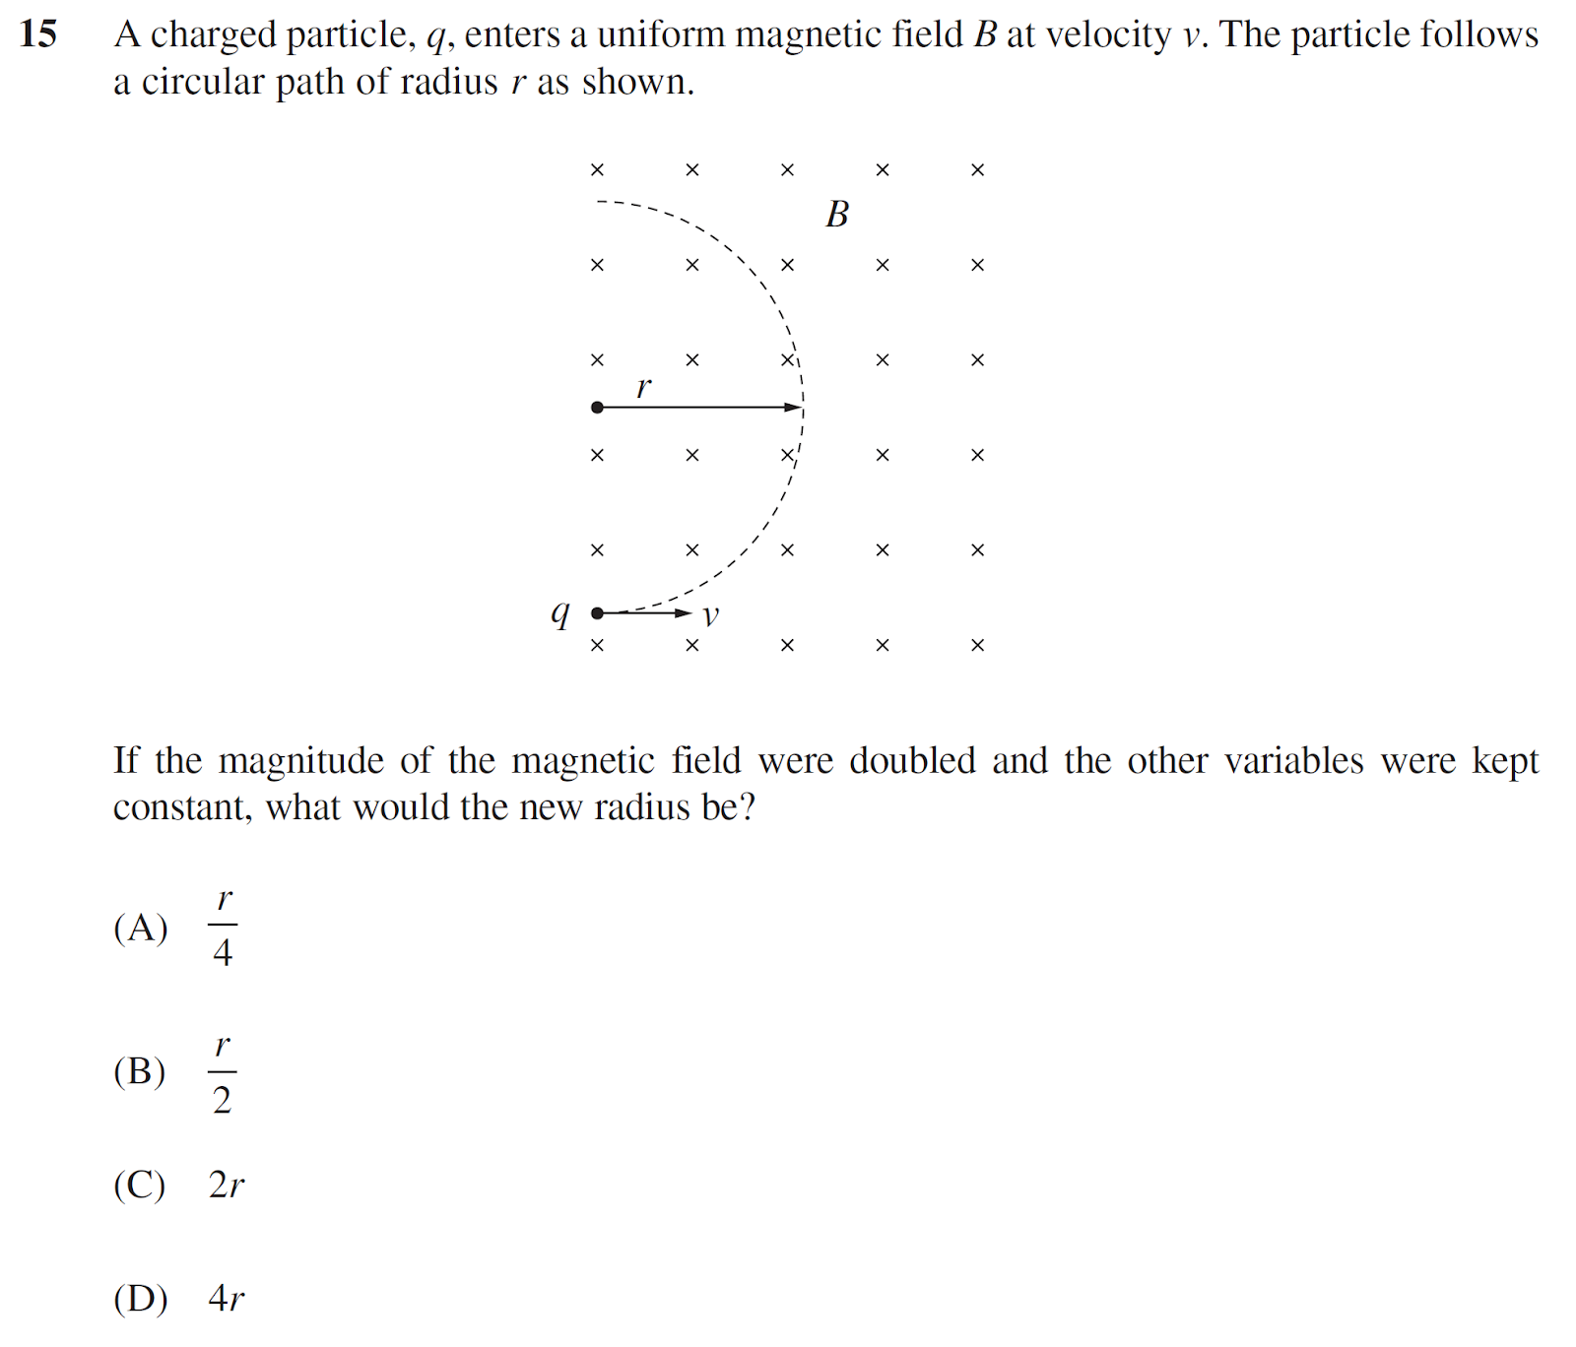

Question 5 (2016 Q5)
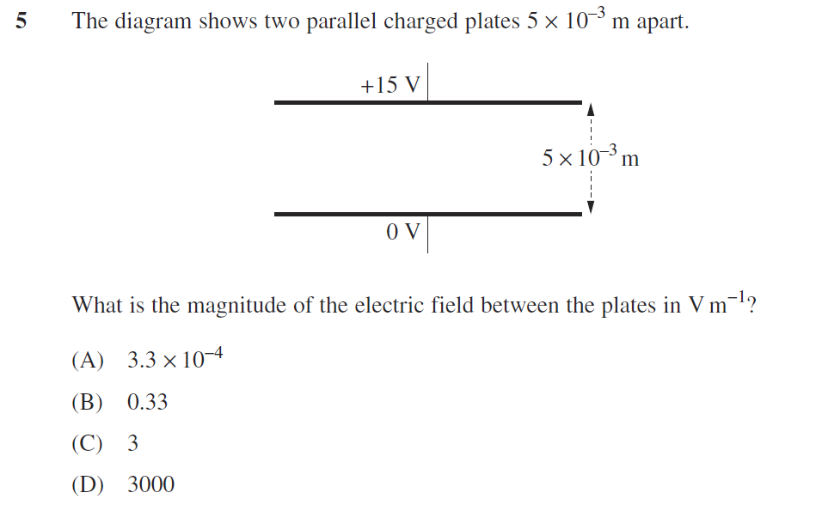

Question 6 (2006 HSC Q6)
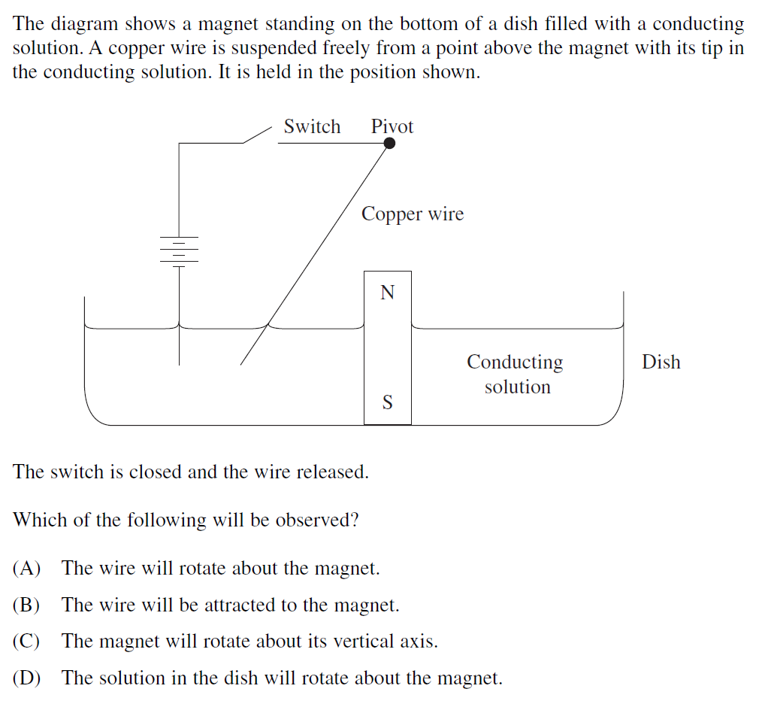

Set 4

Question 1 (HSC 2009 Q9)
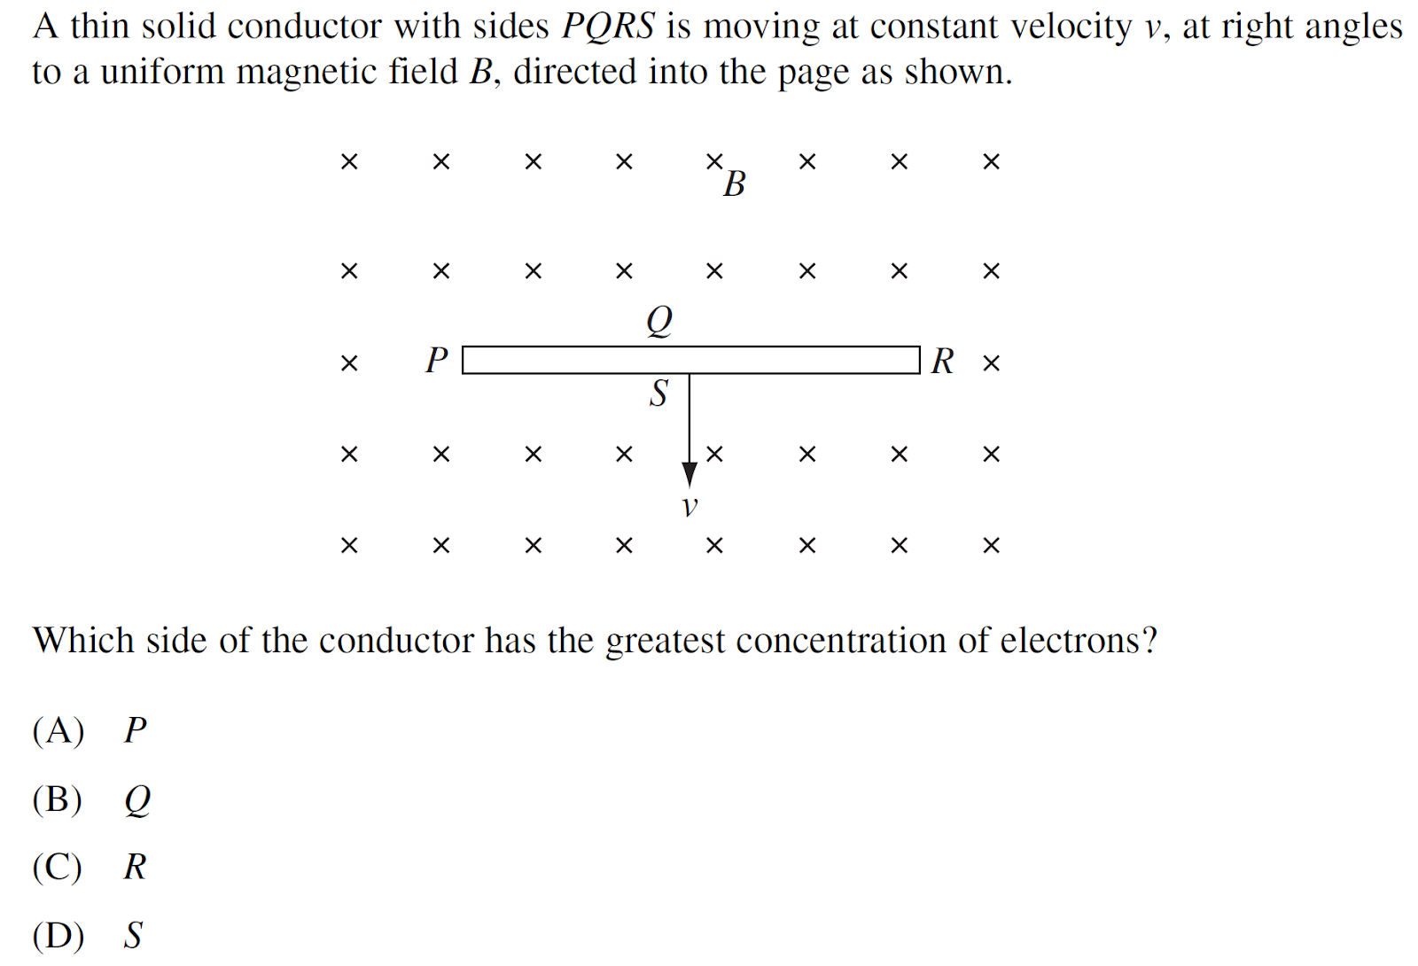

Question 2 (1995 Q11)
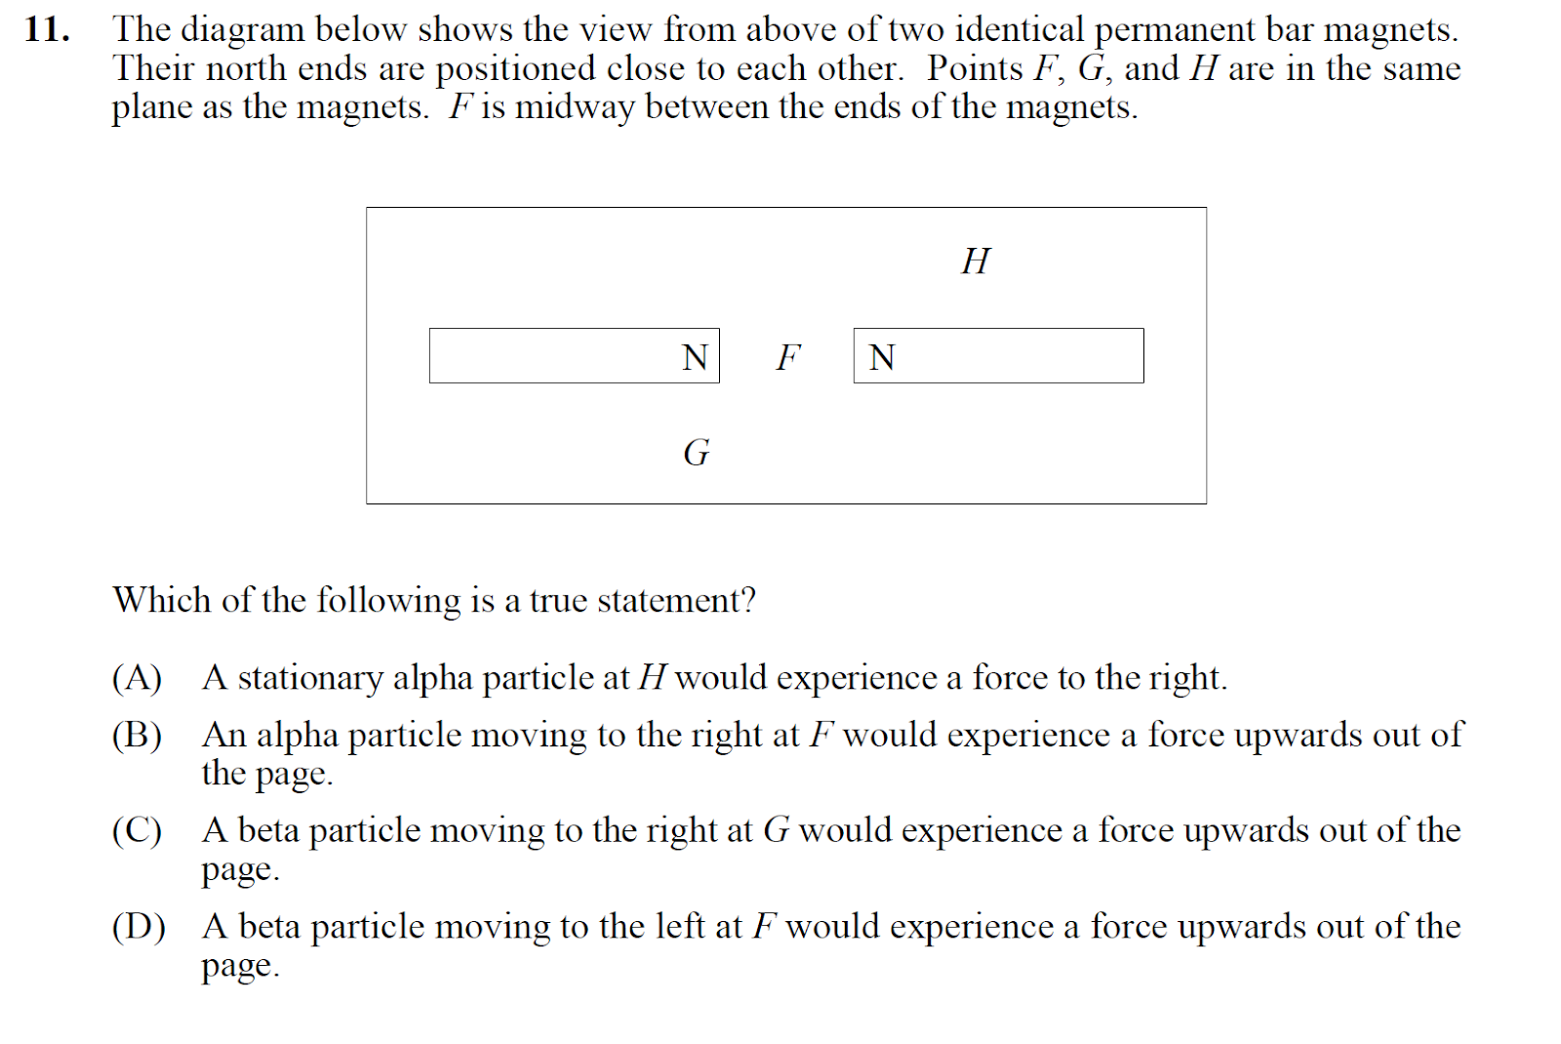

Question 3 (2012 HSC Q14)
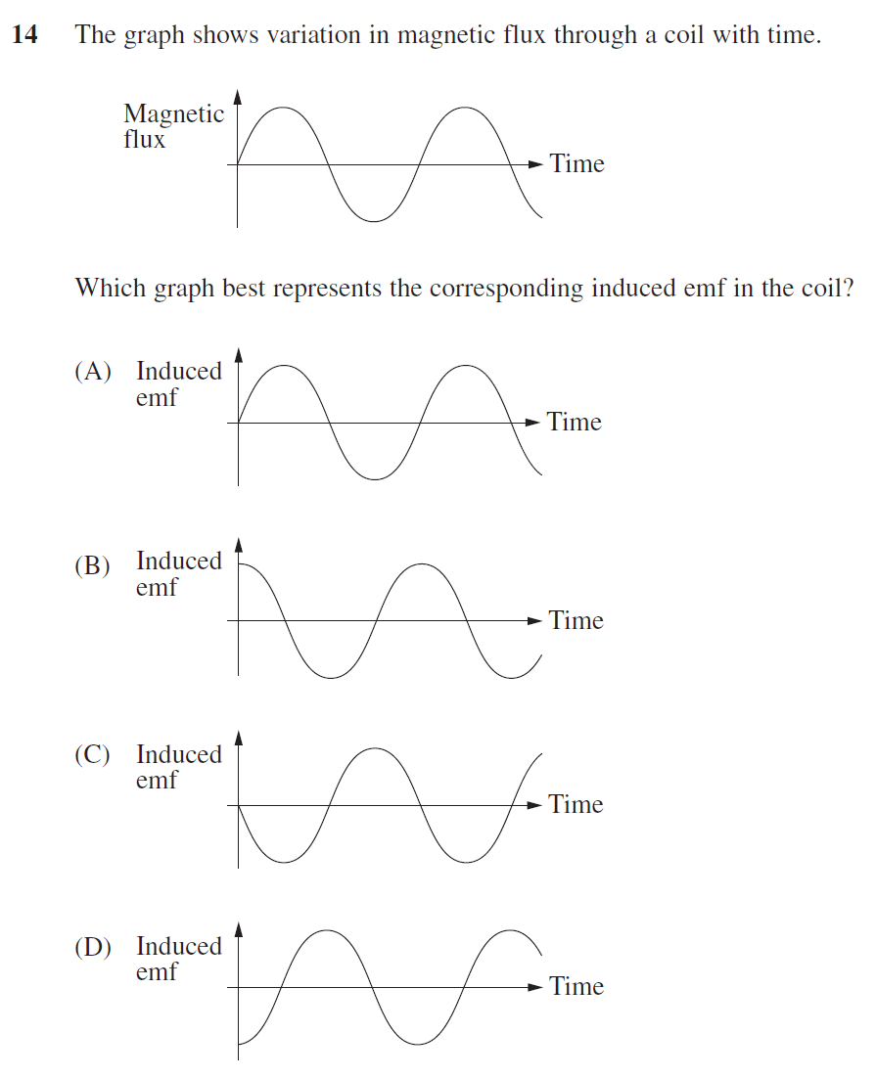

Question 4 (2009 Q7)
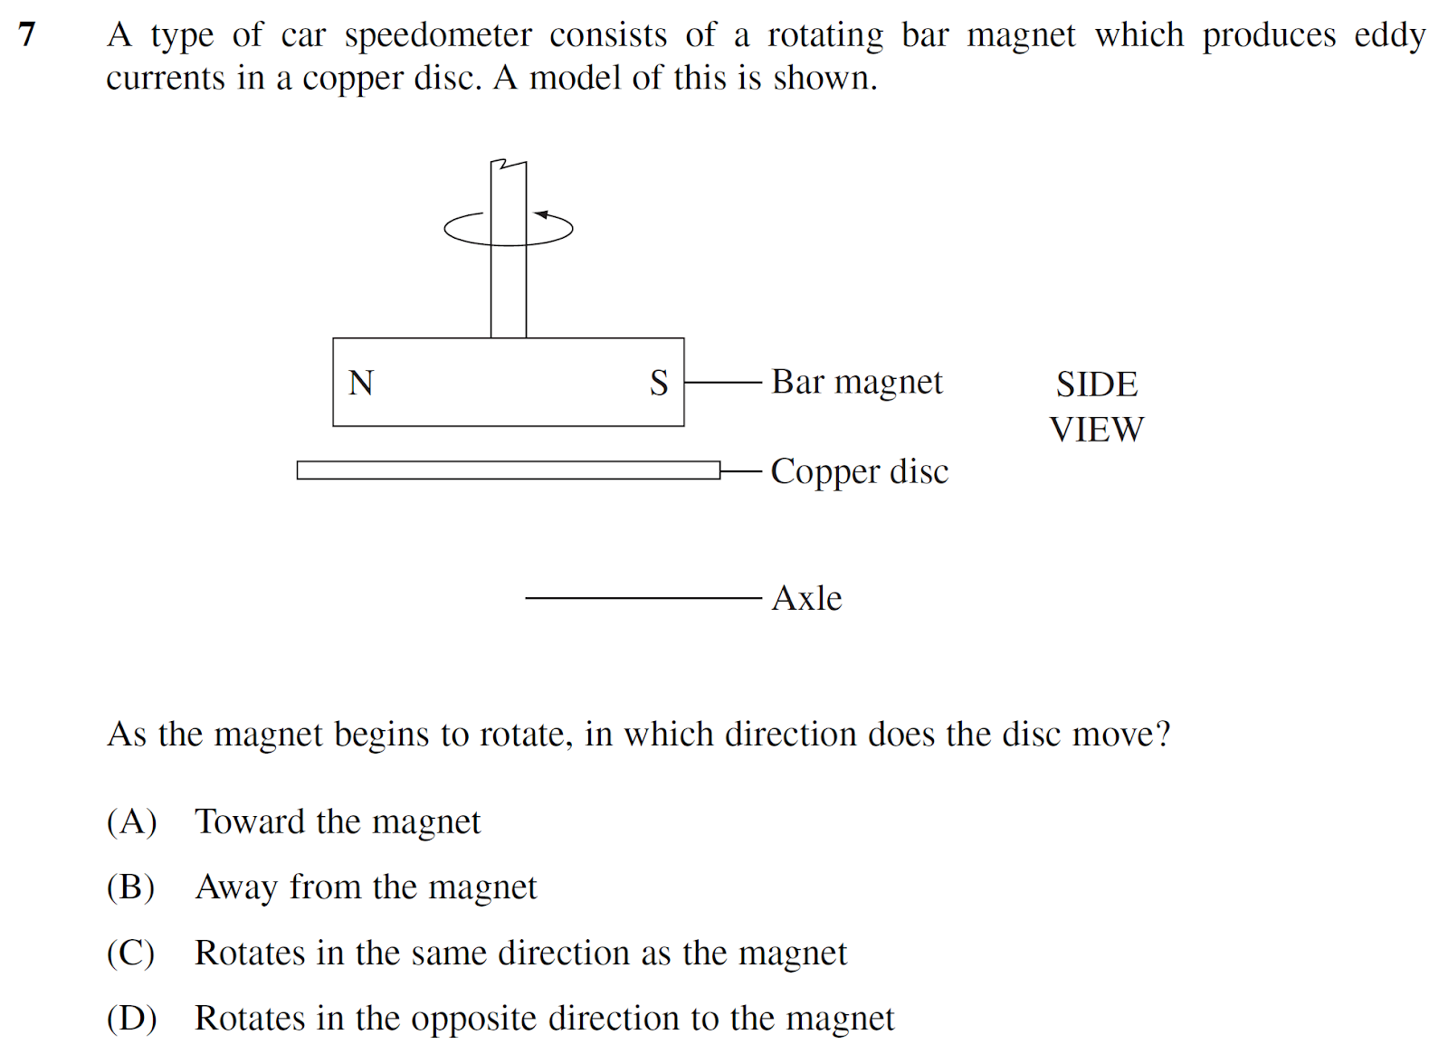

Question 5 (2017 Q16)
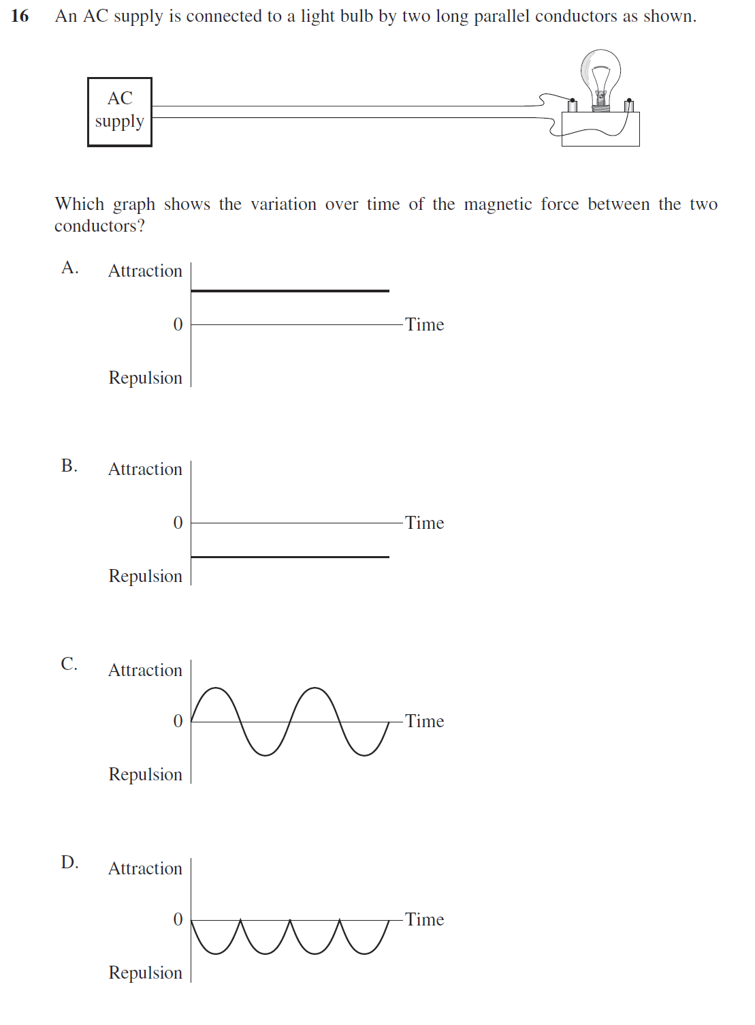

Question 6 (2016 Q17)
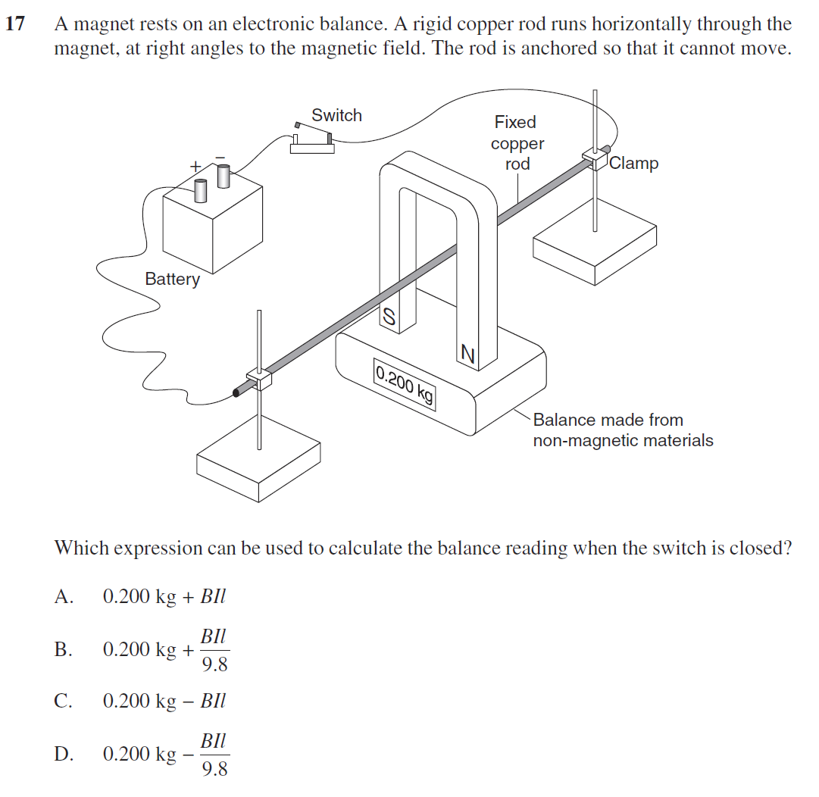

Answers to multiple-choice questions

Set 1
- C
- A
- B
- C
- B
- C

Set 2
- D
- C
- D
- A
- B
- C

Set 3
- C
- C
- B
- B
- D
- A

Set 4
- A
- C
- D
- C
- D
- B

