Improve your writing in Investigating Science
This resource aims to improve your capability to access and respond to questions in examinations and assessment tasks and maximise achievement. In this critical analysis guide, the following areas will be examined:
- Breaking down case study narratives into systematic summaries reflecting the scientific method, so summaries can be applied broadly and effectively in responses.
- Identifying key terms and what they mean when responding to questions.
- Critically evaluating written exam questions and responses by breaking down the components of the question and identifying how to respond effectively.
- Evaluating a student response to an assessment task against the marking criteria to clarify the level of achievement.
- Evaluating a student essay, by annotating it and then identifying key features of the informational text.
Your ability to demonstrate your understanding in longer responses will be guided by your understanding of key terms and how to respond effectively. You should also be guided by the marking criteria to identify critical elements for inclusion. However, the marking criteria alone does not necessarily identify how you can demonstrate your understanding on a deeper level. Students often use the marking criteria to tick off whether they have included different elements but not how well they have been addressed.
To improve your writing, consider the performance band descriptors and the National Literacy Learning Progression to help you identify the degree to which you effectively convey your meaning, similar to the consideration of elements of creating texts explicitly in other courses, namely English. In Science, you will be considering only the creation of informational texts.

Table of Contents
Improve your writing in Investigating Science 0
Critically analysing questions and written responses 2
1. Breaking down the narrative 2
2. Identifying key terms and elements to structure a response to exam questions 7
3. Critically evaluating written exam questions and/or responses 15
4. Evaluating a Year 11 in-class student response 19
5. Examining a Year 12 take home secondary research task 24
Appendices 0
Appendix 1: Performance Band Descriptions and the Literacy Progression 0
Appendix 2: Key word scaffolds 0
Acknowledgements 2

Critically analysing questions and written responses

1. Breaking down the narrative

Why break down the narrative?
By breaking down the narrative of case studies and systematically summarising it using specific terminology and relating it to the scientific method, you will be better prepared to adapt your understanding to any kind of question that could be asked. This is because you will be able to more effectively demonstrate your understanding of the nature and practice of science in real life. By summarising each example critically through the lens of the scientific method rather than simply remembering the narrative of the scenario, you will be able to apply your understanding to any question more easily and respond with greater depth and clarity.

How to break up the narrative?
You are encouraged to delve deeper into the examples given in the syllabus. In stage 6 science, you learn to conduct secondary research investigations, and this should be applied to the case studies within the course. The following sample question relates to the systematic process of science through the scientific method. This example stems from Module 8, Inquiry Question 1, which highlights past scientific studies and their influence on the public image of science, but does not ask how past events affected public image of science, it asks the student to evaluate the design of the investigation. This means that you must address the process of the investigation (and the Working Scientifically skills) because the process can be critical to understanding influential factors. However, recognising where different examples are in the syllabus will assist you in identifying key elements you need to understand about the case study.
In the NESA sample examination Question 23, reproduced later in this booklet, you are provided with a short description of Jenner’s development of the smallpox vaccine. To respond effectively you need to have a more detailed understanding of the scientific methodology, scientific reasoning and evidence that supports the reasoning. In the following activity you will use an article as an example on how to breakdown the narrative and apply the summary to the case study. You do not need an in-depth knowledge of Jenner’s investigation, rather you are applying your knowledge of the investigative design. However, this example is in the syllabus in Module 8, and it is likely any question about this example will require some relationship to the effect of the application on society, ethics, safety and the need for regulation.
Very often in HSC examinations, you are required to apply the Working Scientifically skills to the knowledge and understanding of syllabus examples and to unfamiliar contexts. Breaking down a narrative in a systematic way will build your capacity in applying the Working Scientifically skills. Therefore, you may choose any investigation on which to practise your skills in breaking down the narrative.
First you will need to access a research article that is scholarly in nature, referenced and published by reputable sources. For example, you may access an article about Jenner and the history of smallpox (Module 8, IQ1):
Riedel, S. (2005, January). Edward Jenner and the history of smallpox and vaccination. In Baylor University Medical Center Proceedings (Vol. 18, No. 1, pp. 21-25). Taylor & Francis.
Belongia, E. A., & Naleway, A. L. (2003). Smallpox vaccine: the good, the bad, and the ugly. Clinical medicine & research, 1(2), 87-92.
Or you may choose other articles, such as:

- peptic ulcers (Module 5, IQ 1 and IQ2). discovermagazine.com/health/the-doctor-who-drank-infectious-broth-gave-himself-an-ulcer-and-solved-a-medical-mystery
- the Doppler effect (Module 5, IQ2). physicstoday.scitation.org/doi/10.1063/PT.3.4429
- Priestly and oxygen (Module 5, IQ2). American Chemical Society International Historic Chemical Landmarks. Discovery of Oxygen by Joseph Priestley. acs.org/content/acs/en/education/whatischemistry/landmarks/josephpriestleyoxygen.html (accessed 7th August, 2020).

As you read the article and complete the questions, you should notice:
- Scholarly articles are more likely to have a greater depth of the scientific process embedded in the narrative.
- The case study highlights the nature and practice of science, the influences of science and how solutions to problems and improvements are suggested.
- Note how the scientific method is voiced.

Activity 1: Critical questions in breaking down the narrative.
Download and read the article provided. Take notes under the following points:
- Title, author and publisher

- What was the accepted scientific thinking just prior to the investigation?
- What were the initial observations that lead to the investigation? What were they noticing?
- What were the scientists investigating? Why was this important?
- What hypothesis was made? (include the independent and dependent variable and the purpose.)
- Identify the methodology, the type of investigation and whether the variables were controlled.
- Were there any ethical considerations to be considered?
- Technological considerations. What equipment was utilised?
- Safety and ethical considerations
- Method: What steps were taken in this investigation?
- Explain whether there was a deviation in this method from accepted practices at the time.
- Was the method reliable? How do you know?

- Examine the validity of the method
- Explain whether the conclusions were valid.
- Could this investigation be described as accurate? Why / why not?
- What were the external influences surrounding this investigation?
- What were the impacts of this investigation on Science and scientific thinking?
- What were the impacts of this investigation on society and the public perceptions of science?

2. Identifying key terms and elements to structure a response to exam questions
In this thinking/planning exercise you are planning a response to a practice question to help your strategic thinking and planning of longer responses in exam situations. You are applying your knowledge of scientific investigations to new situations.
NESA HSC Investigating Science sample examination materials, © 2019 NSW Education Standards Authority (NESA) for and on behalf of the Crown in right of the State of New South Wales.
Question 23 (7 marks)
In the 18th century, smallpox was fatal to about 30 per cent of people who contracted the disease whereas cowpox was not a fatal disease.
In 1796 Dr Edward Jenner observed that milkmaids who had contracted cowpox in the past did not show any symptoms of smallpox when exposed to it. Jenner tested the idea that having had cowpox afforded protection against smallpox in an experiment involving two children, Sarah and James.
Dr Jenner took material from a cowpox sore on Sarah’s hand and inoculated it into James’s arm. Months later, Jenner exposed James a number of times to the smallpox virus, but James did not develop smallpox. More experiments followed, and, in 1801, Jenner published his discoveries and expressed his hope that smallpox would be eliminated through vaccination.
(b) Evaluate the design of Jenner’s investigation. (5 marks)
Activity 2A: Drafting a long response
You are to draft a long response to NESA HSC Investigating Science sample examination materials, Question 23 (7 marks). © 2019 NSW Education Standards Authority (NESA) for and on behalf of the Crown in right of the State of New South Wales.
In the appendices, are scaffolds for key words and for the construction of responses. Refer to the scaffolds to help you answer the questions.
Complete each of the following to assist you in planning your final response:
- Understanding the key verb in the question: what do you need to do to respond effectively to the verb evaluate?

- Identify specific key terms within the text that relate to this topic area.

- What are the key elements of effective experimental design? Hint: this will relate the scientific method with consideration to ethical practice.

- Draft your response

- Use the Question 23 (b) marking criteria to check your response
Criteria | Marks
- Makes an informed judgement (implicitly or explicitly) about the design of Jenner’s investigation  - Shows thorough knowledge and understanding of the ethical, safety, validity and reliability considerations associated with the investigation | 5
- Makes some judgement (implicitly or explicitly) about the design of Jenner’s investigation  - Shows sound knowledge and understanding of the ethical and safety considerations associated with the investigation  - Shows sound understanding of validity and/or reliability considerations | 4
- Shows some understanding of ethical and/or safety and/or validity and/or reliability considerations associated with the investigation | 2-3
- Provides some relevant information | 1
Table 1 – Marking Criteria for Question 23 (b) Investigating Science - Sample examination materials © 2019 NSW Education Standards Authority (NESA) for and on behalf of the Crown in right of the State of New South Wales.

- Reflection - How can this strategy of breaking down the text before responding assist you in responding to questions more effectively?

Activity 2B: Breaking down a response into key elements
Complete the steps below for the HSC Question provided
NESA Investigating Science 2019 HSC examination, © 2019 NSW Education Standards Authority (NESA) for and on behalf of the Crown in right of the State of New South Wales.
Question 29 (4 marks)
(b) How is science advanced by having peer reviews of scientific papers? Include an example to support your answer.
- What are the key terms from the question you should consider (such as ‘advanced’)?
- Outline the peer review process.
- What does peer review achieve? Hint: refer to accuracy, reliability, methodology and interpretation.
- Link the peer review process to scientific advancement using a specific example.

- Draft your response
- Use the marking criteria to check your response
Criteria | Marks
Provides positive effects of peer review on the advancement of science Includes a specific example | 4
Provides a positive effect of peer review on the advancement of science Includes a specific example  or  Provides positive effects of peer review on the advancement of science  or  Provides positive effects of peer review • Includes a general example | 3
Provides a positive effect of peer review on the advancement of science  or  Outlines an example | 2
Provides some relevant information | 1
Table 2 – Marking Criteria for 2019 HSC Question 29 (b). 2019 HSC Investigating Science Marking Guidelines © 2019 NSW Education Standards Authority (NESA) for and on behalf of the Crown in right of the State of New South Wales.
(Note: the state mean for this question was 2.5 out of a possible 4 marks in 2019)

- Describe how considering your response in smaller steps can assist you in answering longer response questions

3. Critically evaluating written exam questions and/or responses
Activity 3A: Breaking down sample responses to their critical elements and evaluating their effectiveness
Read through the sample answer and complete the following questions
Investigating Science 2019 HSC examination, © 2019 NSW Education Standards Authority (NESA) for and on behalf of the Crown in right of the State of New South Wales.
Question 28 (7 marks)
Discuss TWO types of misuse of scientific evidence by the tobacco industry in relation to lung cancer. Support your answer with an example of each type of misuse.
Sample answer: (2019 HSC Investigating Science Marking Guidelines. © 2019 NSW Education Standards Authority (NESA) for and on behalf of the Crown in right of the State of New South Wales)
There was a conflict between the tobacco industry and knowledge of tobacco’s link to lung cancer. If it became widespread public knowledge, large amounts of revenue could be lost by the companies and there could be potential litigation for compensation from victims. This led the tobacco industry to misrepresent and suppress the scientific evidence.
The tobacco industry misrepresented information about lung cancer. For example, in the 1950s, a group of tobacco companies such as Phillip Morris, Brown and Williamson stated that ‘there is no conclusive scientific proof of a link between smoking and cancer. Medical research points to many possible causes of cancer.’ This was published in hundreds of newspapers across America. There was a deliberate conspiracy between tobacco companies to misrepresent the data.
In addition, scientific evidence was suppressed. For example, the research division for the RJ Reynolds tobacco company was shut down in 1970 by the company’s legal department in order to prevent further research when it appeared that there may be a link between smoking and lung cancer.

- Identify whether the sample answer responds to the verb ‘discuss’ appropriately. Why or why not?
- Identify how evidence is used in this response.
- Mark the answer according to the marking criteria below and explain your reasoning
Criteria | Marks
- Provides detailed examples of misrepresentation and/or misinterpretation and/or suppression  - Describes issues associated with the misuse of scientific evidence  - Produces a logical, coherent discussion of the issues | 7
- Provides examples of misrepresentation and/or misinterpretation and/or suppression  - Describes issue(s) associated with the misuse of scientific evidence | 5-6
- Provides example(s) of misuse  - Describes issue(s) associated with the misuse of scientific evidence | 3-4
- Provides relevant example(s)  OR  - Outlines issue(s) associated with the misuse of scientific evidence | 1-2
Table 3 – Marking Criteria for 2019 Investigating Science HSC Question 28. © 2019 NSW Education Standards Authority (NESA) for and on behalf of the Crown in right of the State of New South Wales.
(Note: the state mean for this question was 3.14 out of a possible 7 marks in 2019).
Your reasoning:
Activity 3B: Assessing a question to identify key elements for inclusion in the response as guided by the syllabus and key terms.
Answer the questions below to help you predict the marking criteria
Investigating Science 2019 HSC examination, © 2019 NSW Education Standards Authority (NESA) for and on behalf of the Crown in right of the State of New South Wales.
Question 34 (7 marks)
Analyse the impact that both government and large corporations have on scientific research. Include examples, other than from the tobacco industry, to support your answer.
- What part/s of the syllabus is this question referring to? How do you know?
- Based on the question’s relationship to the syllabus, what key words do you need to include to demonstrate extensive understanding?
- What do you need to include to respond to the verb analyse?
- What are some positive and negative impacts?
- How can you link government, industry and science?
- Which specific example incorporates these aspects?
- Use the key ideas identified above, performance band descriptions and/or the literacy continuum information (see Appendix) to complete the marking criteria for this question. Hint: use the components of Question 28 to guide you.
Criteria | Marks
 | 7
 | 5-6
 | 3-4
 | 1-2
Table 4 – Create your own Marking Criteria for 2019 HSC Question 34.
(Note: the state mean for this question was 2.8 out of a possible 7 marks in 2019).

4. Evaluating a Year 11 in-class student response
Year 11 students were required to build and display a model, then evaluate the model for an in-class writing task. We are going to evaluate a student-produced sample model.
Context and Task
This depth study draws on knowledge about the importance of scientific models to develop a scientific understanding of concepts and the explaining of concepts to an audience.
This task requires you to ask a question about something you have wondered about, and then build a working model to explain the answer. The model must show the dynamics behind the answer to your question such that it can be used to make and explain future predictions. In other words, you must be able to:
- change something in your model
- see a corresponding change in your model’s predicted outcome
- use the model to infer a logical explanation for the predicted outcome.
Your working model will be presented at a science fair during which the audience will provide feedback and 'audience favourite' prizes will be awarded.
Activity 4A: You are to evaluate the student sample model below and its application in simply predicting and explaining scientific phenomena, as well as the effectiveness of the materials used in the model. Your response should show detailed and extensive understanding of the scientific concept/s demonstrated in the model. Your response should also explain any suggested improvements to the model and its explanation.
Please note: An evaluation requires you to make a judgement and provide supporting evidence.
To assist you in constructing a response to a sample student model, the marking criteria is in the following table.

Table 5 – Marking Criteria for Year 11 Model Evaluation
Criteria
Elementary achievement  (1 mark) | Basic Achievement  (2 marks) | Sound Achievement  (3 marks) | High Achievement  (4 marks) | Excellent Achievement  (5 marks)
Demonstrates a limited understanding of the scientific concepts/s demonstrated in the model. | Demonstrates a basic understanding of the scientific concepts/s demonstrated in the model. | Demonstrates a satisfactory understanding of the scientific concepts/s demonstrated in the model. | Demonstrates a good understanding of the scientific concepts/s demonstrated in the model. | Demonstrates an extensive understanding of the scientific concepts/s demonstrated in the model.
The model shows a limited connection to the scientific phenomena described. | Describes some of the applications present in the model.  Identifies materials used in the model.  Suggests an irrelevant or illogical improvement to the model. | Relates the model to scientific phenomena being explained.  Justifies materials used in the model.  Suggests a logical improvement to the model. | Evaluates the model and its application in explaining the scientific phenomena described.  Evaluates materials used in the model.  Suggests a logical improvement to the model. | Evaluates the model and its application in simply predicting and explaining scientific phenomena described.  Evaluates materials used in the model.  Logically explains proposed improvement/s to the model.
Student Sample Model
Student Sample Model for evaluation. One student created a sand erosion model similar to that shown in Figure 4. An explanation of this type of model can be found in the video, Erosion at the beach,
Figure 4 – Sand erosion model similar to that created by the student
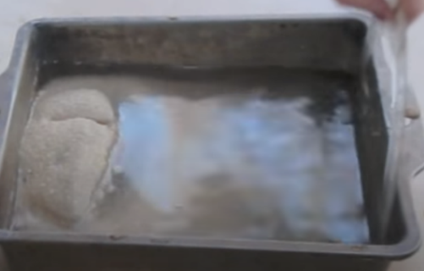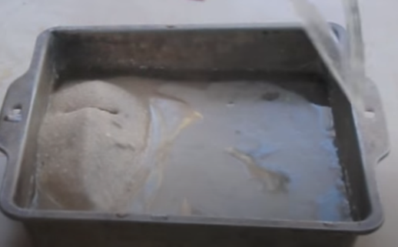
Student response with coding for logical progression and use of terminology:
Sand erosion was my scientific phenomena that I was testing (1). There were many positive/negatives that came with my model such as; the materials not being right of the sand not behaving the way I wanted it to (2). I used a foil base to hold my liquid experiment which was a big mistake as it bends out of shape and is not for tested, but then with the help from my teacher I realised that I can make this experiment more fair tested by using a clear plastic container (3). When water comes into contact to sand, sand tends to sit at the base, that happened to me so I needed a way to make the sand at one side, so I made a “wave beach water’, with laminated paper, that I wet to make the same beach every time (for a valid experiment)(4), since I was testing sand erosion I had to make sure to have very simple instructions and a warning sign saying ‘Do not spill, Do not mix’, this helped my end product A lot Because throughout the science fair I saw people taking that warning sign very seriously(5). In the future I would make couple of changes, first being using a longer container to make sure that the waves were being made easily to avoid spillage But also to avoid over mixing (6) this was a problem Because in my feedback people were saying how I could have shown a really good concept of sand erosion and the way we use the model would improve.
As the waves are stronger it takes more of the sand away from the base But it also made the house that I built with wooden stamps slide away showing us humans should stay away from building near beaches and such bodies of water.(7)
As smaller waves were made you can see by moving the ‘wavemaker’ , that nothing much happened but over time that will have a very huge impact on the way sand is being taken out and also spat back at the beach.(8)
While I was working on making the model I came across websites that was built by scientists, they were talking about sand erosion is not only about taking sand away from the beach, but also same sand being spat back at the beach making shore I had that information in my head I started building my model, (9) I used thicker sand from the beach on the side while childrens play sand on the base, later realised this was a mistake as everything blended at the end.(10) But eather way sand erosion was on display in smaller and quicker version though my experiment.(11)
Evaluate the student sample model:
- Use the marking criteria in table 5 to mark this work.
- Use the Performance Band Descriptions (see the Appendix) to justify the performance band this work would fall under.
Sample evaluation: The student explained elements of their methodology, problems encountered and steps to overcome the issues and manage the variables. The student also identified how to make their model fair and valid. Further, the student identified how the model is dynamic and the effect of changing the independent variable: wave size. Finally, the student refers to background research that found similar results to that shown by their model.
To help us identify the strengths in this response and opportunities for improvement, we are going to break it down in terms of the scientific process. The coding number can be seen in the student response.
Table 6 - examination of logical progression and use of terminology in the student response
Scientific Process | Increasing cohesion and using specific terminology
question
purpose | (1) The process of sand erosion is the phenomenon being investigated and modelled.
hypothesis | (2) It is expected that smaller waves will erode the beach sand to a lesser extent than larger waves which have greater energy.
background information | (9) Background information conducted identified sand erosion models similar to that showed sand is both taken from the beach and returned to it as the tide moves in and out.
safety
materials
variables | (4) The controlled variable was a laminated piece of paper which was used to create waves of a similar size.  (7) The independent variable was the size of the waves created.
methodology | (4), (5) and (6). The methodology in this student sample was loosely addressed and interlaced with other aspects of the process.
problems  /amendments | (3) Some of the materials chosen needed greater consideration, for example the foil trays used initially warped easily, reducing reproducibility. To ensure testing was fair, foil trays were replaced with firm plastic trays.  (9) The use of two sand types in the model did not help in making observations or understanding the phenomenon as they blended through the process.
results | (7 & 8) Small waves have no overall impact on the sand mound. Sand appears to be removed and replaced from the edge of the beach and does not encroach deeper into the mound where the house was located. Larger waves removed significantly more sand which was not replaced with the water movement in and out. This resulted in the erosion encroaching into the mound and destabilising the house which collapsed.
analysis of results | (7 & 8) The use of stronger waves in this model resulted in a larger amount of sand being removed from the mound mimicking the coastline. This resulted in the destabilisation of the foundation piers of house being compromised and sliding into the water. These results demonstrate that houses built along a coastline could be considered dangerous when the subsoil is made of sand and swell is high. By contrast, small modelled waves did not have a significant impact on the sand mound or house stability because the energy of the waves was not enough to erode sand beyond the waters’ edge, and this was readily replaced with the water movement.
evaluation | (11) The model was successful in demonstrating that wave energy and associated wave size leads to significant sand erosion which can affect houses built on sandy subsoil near the beach. In addition, the model highlighted that smaller waves with less energy did not erode sand to the detriment of the beach as the eroded sand was readily replaced with wave movement.
Referring to table 6, where the student work is sorted into a more logical sequence and utilising more specific terminology, explain how this reorganisation and language refinement could improve the student’s performance against the performance band descriptors.

5. Examining a Year 12 take home secondary research task
Activity 5A: You are to conduct an analysis of a student scientific research investigation as outlined below. The following is the task and a student sample of work. Read this sample and then answer the questions that follow.
Context and task
You are to undertake a secondary research investigation to analyse and evaluate the methodology used by a scientist in a firsthand investigation of your choosing. The focus of your investigation is to be a peer-reviewed scientific report. You cannot choose a report that has been analysed in class, nor any other report that you have studied as part of another Stage 6 Science assessment task.
You are to submit a 900 – 1000-word essay in which you:
- Identify a scientist and the research that led to a new understanding in a chosen branch of science.
- State the purpose of their investigation and explore the reasons behind their decision.
- Explain and evaluate the methodologies used in this investigation.
- Identify and evaluate the type of data collected in terms of its validity, accuracy and reliability. Suggest ways in which this could have been improved.
- Explore how their findings impacted the fields of science involved and whether it initiated further investigation.
Use appropriate language, paragraph and referencing conventions as identified in class.
Include a word count (excluding reference list).
You are advised to use the following scaffold to organise your investigation and structure your essay. You will have three lessons in class to work on your task.
Table 6 – Scaffold for analysing peer-reviewed research

Analysing research
What is the purpose of the investigation?
What prior work was done in this field?
What specific observations led to the investigation?
Did the scientist work alone or collaboratively?
How did the scientist perform the investigation? (methodology)
Independent variable
Dependent variable
Controlled variables
Experimental controls or standards
What kind of equipment was used?
Was it readily available?
Was it new technology?
Was the equipment costly?
Were there any risks involved in using the equipment?
Were there any ethical considerations?
How long was the timeframe for this investigation?
What sort of data was collected?
How much data was collected?
How was the data organised?
Any issues with the data?

Student sample of a take home assessment essay
Analysis on the Research of Transgenic Cavendish Bananas with Resistance to TR4
The Banana (Musa spp.) is a fundamental component of more than 400 million people’s diets, with majority of the banana export industry surrounding Cavendish Bananas. This particular subgroup of bananas is currently being threatened by a malignant fungus labelled Fusarium Oxysporum f.sp. cubenese tropical race 4 (TR4). As almost the entire subgroup has virtually the same genetic composition, the disease has the potential to wipe out all Cavendish Bananas. The fungus is rapidly spreading, already having reached Asia, Australia, Africa and the Middle East. However, a wild, inedible banana from Indonesia was identified as resistant to the TR4 fungus and the gene responsible for its resistance was isolated and was labelled RGA2. From this, a group of researchers created transgenic RGA2 banana plants to test the effectiveness of the gene in fighting the TR4 fungus in the Cavendish Banana cultivar (Dale, et al. 2017). Prior research was also conducted to create a TR4 resistant plant in Taiwan. Researchers created somaclonal variants of the Giant Cavendish Banana (GCTCV) with differing levels of tolerance to TR4 (Smith, M. K. et al. 2006). However, this investigation only provided a short term solution due to the varying levels of resistance and defective agronomic traits.
To conduct the field trial, plants were selected and regenerated from embryogenic cell suspensions, which were prepared from immature male flowers and transformed using the centrifugation assisted A. tumefaciens-mediated method. 6 RGA2 lines were generated utilising this method and plants that were generated from non-transgenic cells were used as controls. Before being placed in the field, the tissue-culture plants were acclimatised in a shade house for 3 months until they grew to 35cm. The location of the field trial was a commercial plantation with a history of Cavendish TR4 infection, in Northern Territory, Australia. The transgenic plant lines were placed in the field in a randomised design with no identifying information to remove bias. Rows contained 10 blocks of transgenic plants, each block separated by 4 control plants. These control plants were: Grand Nain and Williams (Cavendish Cultivars particularly susceptible to TR4), GCTCv 218 - (Giant Cavendish with some tolerance to TR4) and DPM25 (Dwarf Parfitt, resistant to (STR4)). To increase the uniformity of the TR4 infection throughout the field, TR4 infected pseudostems were buried between each plant.
The initial crop plants were strategically harvested so that they provided a continuous cycle of crops. Due to this, the trial was able to harvest the initial plant crop and 3 ratoon crops. The trial was initially meant to be conducted for 5 years, however it was shortened to 3 years due to a forced quarantine termination order triggered by another disease. The plants were regularly inspected over the trial period for any characteristic external symptoms of TR4 such as yellow leaves, wilting and loss of leaves. They were then analysed to confirm TR4 infection through the appearance of internal reddish brown vascular discolouration. After the trial period, all surviving plants were inspected for internal symptoms through the use of fungal isolation and PCR based assays. At certain times, the amount of hands per bunch of healthy plants was recorded.
The methodology was thorough in terms of reliability, accuracy and validity. It successfully controlled all appropriate variables and tested the hypothesis. The effectiveness of the presence of the gene was also tested through multiple crops over a substantial trial period and all trial plants provided results that correlated with previous research. However, the methodology could be improved for relevancy as the primary aim of the investigation was to create TR4 resistant replicas of the widely consumed Cavendish Bananas. In order to achieve this, the trial should have also collected data on the taste, time taken to ripen and texture of the transgenic bananas and compared them to a regular Cavendish to ensure that the gene did not alter highly desirable traits that are valued by the majority of consumers. The impact of this methodology can be seen in recent investigations. For example, researchers searching for the most efficient gene-editing system (Naim et al., 2018), used a similar method to regenerate plants that had been genetically modified by CRISPR. Similar to this methodology, the plants were regenerated from embryogenic cell suspensions, prepared from the same flower and used the same mediated method, only without the centrifugation assistance.
In total, 19 lines of crops were planted in the field trial: 6 contained the RGA2 gene, 4 were the non-transgenic control lines and 9 were transgenic nematode-derived Ced9. The trial consisted of 196 plants: 60 control plants, 51 RGA2 transgenic plants and 85 Ced9 transgenic plants. The data collected from the trial was the number of transgenic plants, number of plants which contracted TR4, time taken for the TR4 to develop and the amount of bananas produced by certain plants. After the completion of the trial, 2 of the transgenic lines (one RGA2, the other Ced9) were determined to be TR4 free, indicating a strong correlation between the presence of transgenes and resistance. Naturally occurring RGA2 homologs were also detected in the control Cavendish, though less potent than the most resistant transgenic plants. Developing these homologs could potentially lead to a non-transgenic pathway to resistance. In the final assessment, all surviving pseudo-stems were analysed for vascular discolouration and a portion were tested for TR4. From the 118 surviving samples, 107 indicated no signs of vascular discolouration and tested negative for TR4, the remaining 11 samples all displayed vascular discolouration and 10 tested positive for TR4. Of the non-transgenic control plants, between 67% and 100% of them died or were infected and all of them displayed signs of vascular discolouration. The fungus was also found to have developed earlier in the control plants and increased at a rate of around 20% per year. The DPM25 cultivar was reportedly the most susceptible and the GCTCV and the Williams Cavendish were concluded to be equally as susceptible. These results indicate a feasible solution to the TR4 infection through the use of transgenics as well as a potential non-transgenic pathway through elevating already existing homologs.
References
Dale, J., James, A., Paul, J.Y., Khanna, H., Smith, M., Peraza-Echeverria, S., Garcia-Bastidas, F., Kema, G., Waterhouse, P., Mengersen, K. and Harding, R., 2017. Transgenic Cavendish bananas with resistance to Fusarium wilt tropical race 4. Nature communications, 8(1), p.1496.
Naim, F., Dugdale, B., Kleidon, J., Brinin, A., Shand, K., Waterhouse, P. and Dale, J., 2018. Gene editing the phytoene desaturase alleles of Cavendish banana using CRISPR/Cas9. Transgenic research, 27(5), pp.451-460.
Smith, M.K., Hamill, S.D., Langdon, P.W., Giles, J.E., Doogan, V.J. and Pegg, K.G., 2006. Towards the development of a Cavendish banana resistant to race 4 of fusarium wilt: gamma irradiation of micropropagated Dwarf Parfitt (Musa spp., AAA group, Cavendish subgroup). Australian Journal of Experimental Agriculture, 46(1), pp.107-113.

Analysis of the student sample
1. Use the annotations in Table 7 to identify these elements in the student’s work.
Table 7 – Annotations for analysing the student essay
Analysing student writing
- The student considers the methodology and identifies other variables which could be measured. Demonstrates critical understanding of further factors affecting saleability. | - This section evaluates the methodology specifically by providing evidence from the methodology. Note: methodology is discussed sequentially and identified.
- In this section the student is providing reader context for the report’s broader research topic, field trial. | - Note the referencing style used. Ensure you use the style recommended and use it consistently throughout.
- Here to help orientate the reader, the introduction starts with general background information. This sets the scene for the report. | - At the end of the report, the student provides a summative statement and acknowledges alternate pathways for investigation.
- Student identifies why the research was undertaken. | - Future possible outcomes of this study are identified incorporating specific metalanguage.
- In this section, the student is providing a brief methodology. This provides further context for the reader. | - Student identifies how the research has impacted science in different contexts citing specific examples.
2. Using the Literacy Progression (see Appendix) as a guide, identify what the student does well in addressing the following areas of creating this informational text. Provide specific examples for each Literacy Progression sub-element.
Crafting ideas
Text form and features
Vocabulary
3. Use the attached marking criteria (Table 8) to mark this work.
4. Identify whether there is a relationship between syllabus content and writing elements. Determine whether this is important.

Table 8– Marking Criteria for the essay analysing a peer-reviewed scientific report
The Student has consistently demonstrated the ability to:
Syllabus areas  The student: | Elementary Achievement  (1-2 marks) | Basic Achievement  (3-4 marks) | Sound Achievement  (5-6 marks) | High Achievement  (7-8 marks) | Excellent Achievement  (9-10 marks)
Develops and evaluates the process of undertaking scientific investigations  INS12-12 | Identifies a scientist/s and outlines their research and what they discovered | Identifies the purpose of an investigation undertaken by a scientist/s  Describes the investigation. | Identifies the purpose of the investigation and outlines the observations that initiated this investigation  Describes the investigation.  Identifies how the findings impacted the research area | Describes the chosen scientific investigation, explaining the history and observations that led to the purpose of the investigation  Describes how the findings impacted the research area  Identifies if the findings were used in further investigations | Explains how a scientist began and performed a specific investigation  Evaluates the purpose of the investigation in terms of prior research within the area of research  Explains how the findings impacted the research area  Outlines how the findings were used in further investigations
Designs and evaluates scientific investigations  INS11/12- 2 | Independent, dependent and controlled variables are correctly identified | Identifies the experimental variables  Justifies one or more controlled variables  Experimental control or standard is identified | Justifies the experimental variables and the experimental control or standard | - | -
Conducts scientific investigations  INS11/12-3 | Does not analyse peer-reviewed literature or analyses peer-reviewed literature modified for primary school students.  Attempts to use referencing style | Analyses peer-reviewed literature (may be modified for high school students)  Correct referencing style (APA or Harvard) | - | - | -
Analyses data and information  INS11/12-5 | Outlines the data collection method | Outlines the data collection method  Attempts to discuss the collected data in terms of accuracy, validity and/or reliability | Describes the data collection method. Discusses the collected data in terms of accuracy, validity or reliability | Evaluates the data collection method and the collected data in terms of accuracy, validity and reliability. | Evaluates the data collection method and the collected data in terms of accuracy, validity and reliability, and proposes logical improvements
Communicates scientific information  INS11/12-7 | Presents general information and attempts to use some scientific terms | Presents some scientific information  Uses some scientific terms correctly | Presents scientific information  Scientific terms are widely used and generally appropriate  Scientific terms are usually correct | Communicates scientific information with depth and detail, using a range of appropriate scientific terms  Analysis is mostly logical | Communicates scientific information with depth and detail, using a range of appropriate scientific terms  Analysis demonstrates logical thinking and is supported with evidence
Communicates scientific information  INS11/12-7 | Attempts to write in an essay format  Word count is below 600 or above 1300 | Clear essay structure with an introduction, body and conclusion  Word count is 600–800 or 1100-1300 | Clear essay structure  Written in 3rd person with formal language  850-1050 words | Sound criterion plus:  Mostly appropriate paragraph structure (e.g. PEEL)  Paragraph sequence is mostly logical  900-1000 words | High criterion plus:  Effective use of language, topic sentences, paragraph structure, and organisation (sequencing)

Appendices

Appendix 1: Performance Band Descriptions and the Literacy Progression
The following tables show the National Literacy Learning Progression alongside the Stage 6 Science Performance Band Descriptions. It is not intended to show alignment between the two but to highlight features and characteristics in higher levels of performance and writing in each.

Table 9 – Comparing Band 6 Science Performance Descriptions to the Literacy Progression
Band 6 – CrT11
Performance Band Descriptors | Informational Text Indicators
- demonstrates an extensive knowledge and understanding of scientific concepts, including complex and abstract ideas  - communicates scientific understanding succinctly, logically, and consistently using correct and precise scientific terms and application of nomenclature in a variety of formats and wide range of contexts  - designs and plans investigations to obtain accurate, reliable, valid and relevant primary and secondary data, evaluating risks, mitigating where applicable, and making modifications in response to new evidence  - selects, processes, and interprets accurate, reliable, valid, and relevant qualitative and quantitative, primary or secondary data, and represents it using a range of scientific formats to derive trends, show patterns and relationships, explain phenomena, and make predictions  - designs solutions to scientific problems, questions, or hypotheses using selected accurate, reliable, valid, and relevant primary and secondary data, and scientific evidence, by applying processes, modelling and formats  - applies knowledge and information to unfamiliar situations to propose comprehensive solutions or explanations for scientific issues or scenarios | Crafting ideas  - writes sustained, informative texts that precisely explain, analyse and evaluate concepts or abstract entities  - uses structural features flexibly to organise ideas strategically (includes a defined, cogent conclusion /summation)  - uses classification to organise ideas and information (types of landscapes, Australian state government)  - writes texts with forms and features combined strategically for purpose (describes a historical event from the perspective of a secondary source)  - uses evidence and references  - writes succinct short-answer explanatory texts as well as complex, multi-staged extended texts  Text forms and features  - maintains tone appropriate to the audience  - uses extended noun groups including adjectival phrases (a sturdy construction with modern design features) (see Grammar)  - judiciously uses language and multimodal resources to emotionally or intellectually affect audience  Vocabulary  - uses complex abstractions (economic, sociocultural)
Table 10 – Comparing Band 5 Science Performance Descriptions to the Literacy Progression
Band 5 – CrT10
Performance Band Descriptors | Informational Text Indicators
- demonstrates thorough knowledge and understanding of scientific concepts, including complex and abstract ideas  - communicates scientific understanding, logically, and effectively using correct scientific terms and application of nomenclature in a variety of formats and wide range of contexts  - designs and plans investigations to obtain accurate, reliable, valid and relevant primary and secondary data, evaluating risks, mitigating where applicable, and making some modifications in response to new evidence  - selects, processes, and interprets accurate, reliable, valid, and relevant qualitative and quantitative, primary or secondary data, and represents it using a range of scientific formats to derive trends, show patterns and relationships  - designs solutions to scientific problems, questions, or hypotheses using selected accurate, reliable, and valid primary and secondary data, and scientific evidence, by applying processes, and formats  - applies knowledge and information to unfamiliar situations to propose explanations for scientific issues or scenarios | Crafting ideas  - writes to explain and analyse (analyses how artists use visual conventions in artworks)  - writes to compare and contrast phenomena (identify the differences between elements)  - orients the reader to the topic or concept (using a definition or classification in the opening paragraph)  - intentionally selects structural elements for effect (includes an appropriate conclusion that summarises, restates or synthesises)  - uses evidence and research including multimodal resources to  - expand upon information and concepts and add authority  Text forms and features  - varies sentence structure for effect (see Grammar)  - uses more elaborate noun groups that include classifying adjectives and specific nouns (mineral component of sedimentary rocks)  - creates cohesive flow by condensing previous information into a summarising noun (In history, a sequence of events which are together)  - uses passive voice and nominalisation strategically (the results were analysed) (see Grammar)  Vocabulary  - uses discipline-specific terminology to provide accurate and explicit information (discipline metalanguage)  - uses a range of synonyms for frequently occurring words, in a longer text (repair, fix, remedy)  - uses vocabulary to indicate and describe relationships (additionally, similarly)  Generic indicators  - organises related information and ideas into paragraphs/sections  - uses a range of complex punctuation flexibly and correctly (see Punctuation)  - spells complex and most challenging words correctly (see Spelling)  - uses a range of sentence types for effect  - writes paragraphs which develop one main idea

Table 11 – Comparing Band 4 Science Performance Descriptions to the Literacy Progression
Band 4 – CrT9
- demonstrates sound knowledge and understanding of scientific concepts  - communicates scientific understanding effectively using scientific terms and application of nomenclature  - designs and plans investigations to obtain primary and secondary data and evaluates risks  - processes and interprets primary and secondary data, and represents it using a range of scientific formats  - identifies scientific problems, questions, or hypotheses and applies processes, and formats to primary or secondary data  - applies knowledge and information relevant to scientific issues or scenarios | Crafting ideas  - writes informative texts for a broad range of learning area purposes that describe, explain and document (describe an art work, document the materials and explain why it was created)  - selects structural elements to suit the purpose (a fact sheet includes an opening statement, labelled diagrams and text boxes)  - develops ideas with details and examples  - uses ideas derived from research  - uses written and visual supporting evidence  - uses a topic sentence and supporting evidence or examples in a paragraph  Text forms and features  - includes salient multimodal features to expand on written information (creates graphs and other technical diagrams from authentic data)  Vocabulary  - uses a range of learnt, technical and discipline-specific terms (adapt, survive)  - uses words to express cause and effect (therefore)  Generic indicators  - maintains appropriate tense throughout the text (see Grammar)  - uses a range of sentences including correctly structured complex sentences (see Grammar)  - spells simple, most complex and some challenging words correctly (see Spelling) and uses complex punctuation correctly (apostrophes of possession) (see Punctuation)

Appendix 2: Key word scaffolds
In 2002, the Department of Education released scaffolds for the following key words: analyse, assess, compare, describe, discuss, explain, evaluate and justify. These scaffolds can be accessed from home.kooee.com.au/mulhearn. Modified versions of these scaffolds are shown in Figure 1. The verb scaffolds are a strong visual reminder to help clarify the meaning of commonly used terms in questions and what should be included in the response.
Figure 1 – Verb scaffolds © State of New South Wales (Department of Education), 2020
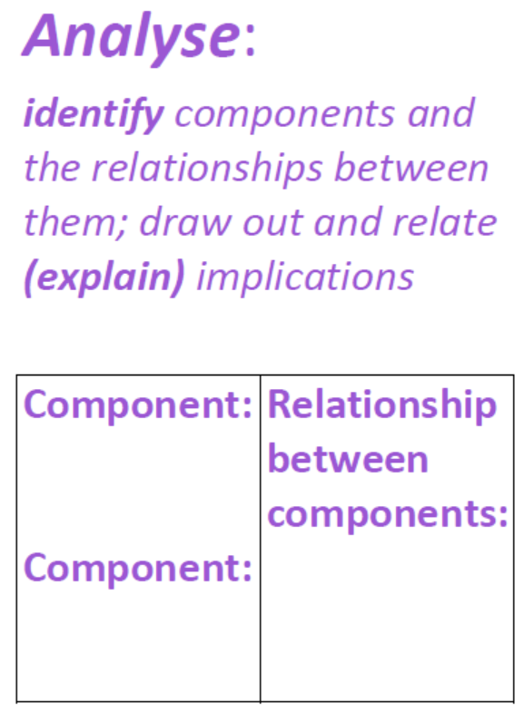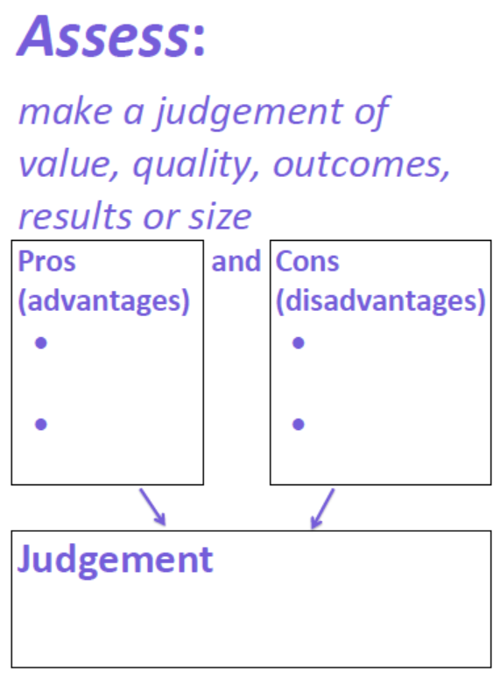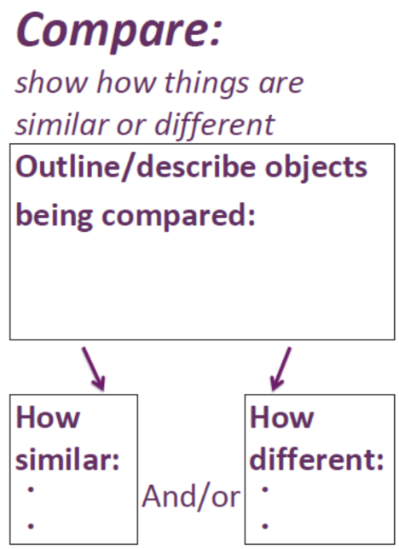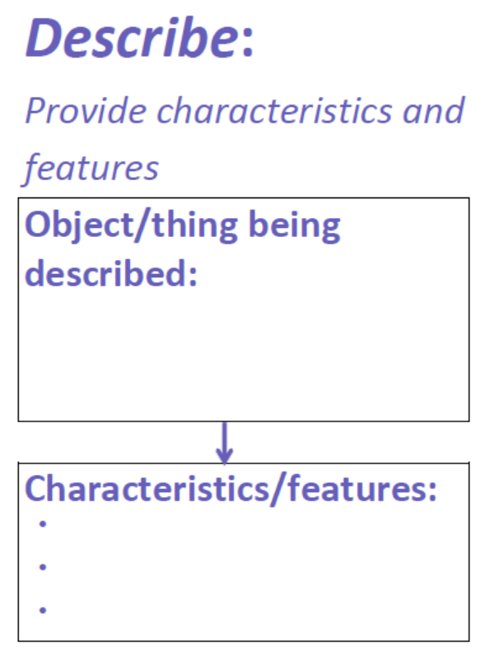
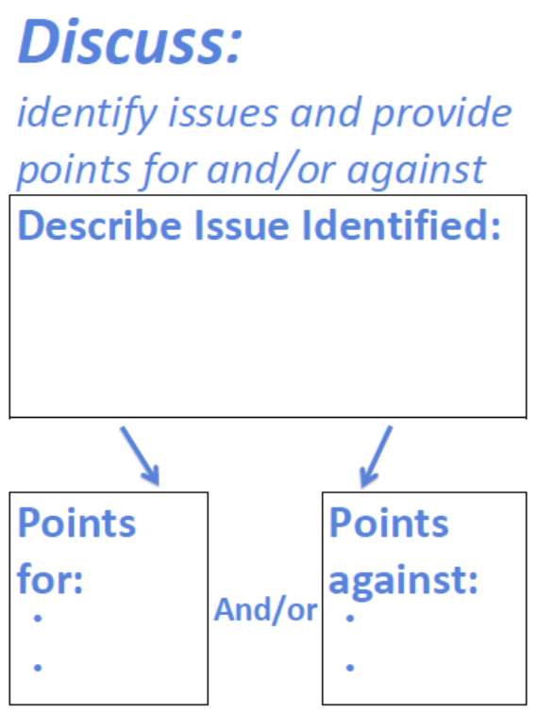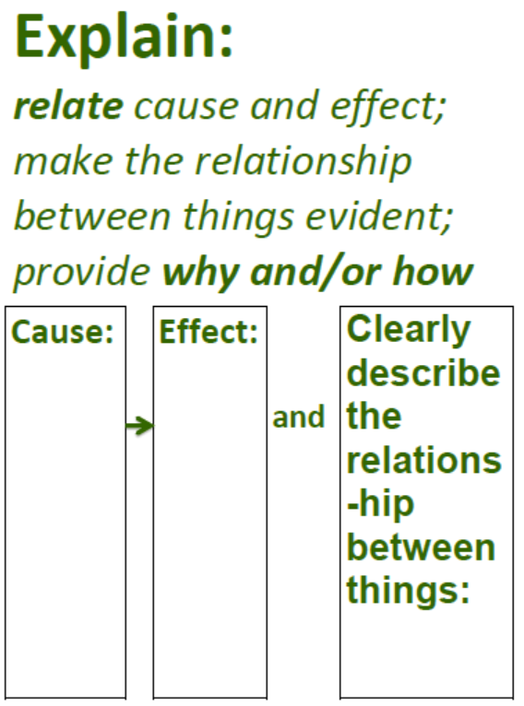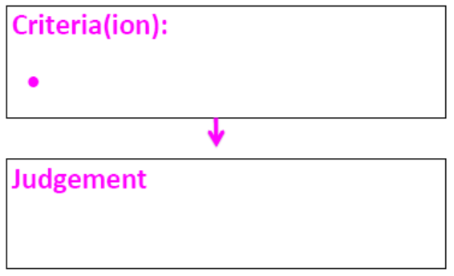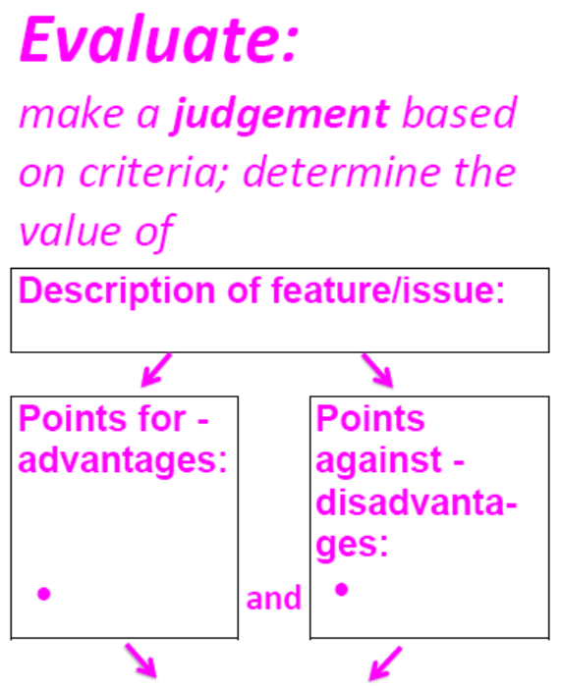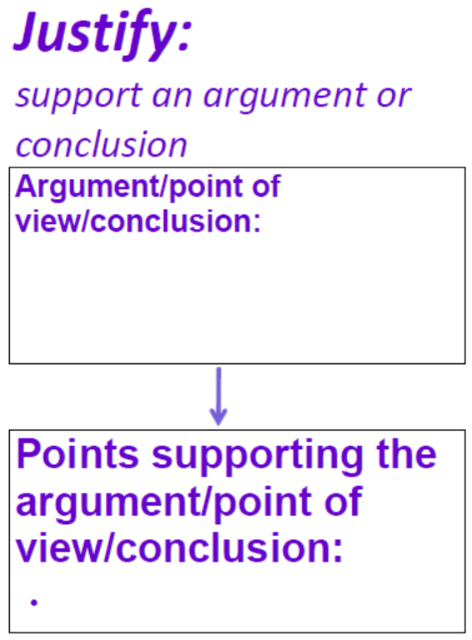
Another useful tool to assist students in constructing written responses is ALARM (a learning and response matrix) as shown in Figure 2 and 3 (sourced from virtuallibrary.info/alarm.html). These tools can likewise assist you in breaking down a question and what is required in the response.
Figure 2 – ALARM scaffold © State of New South Wales (Department of Education), 2020

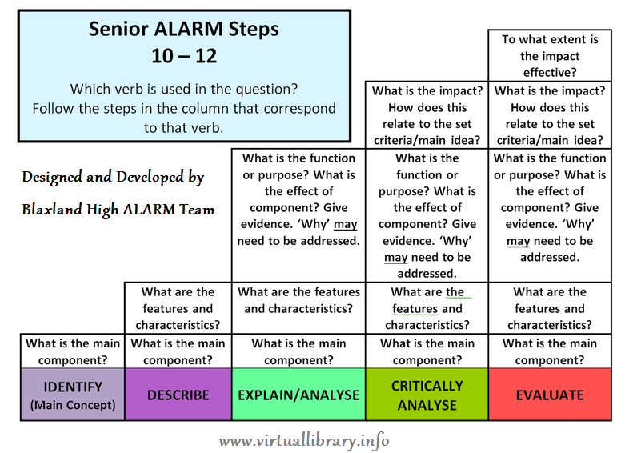
Figure 3 - NESA key words aligned with ALARM levels© State of New South Wales (Department of Education), 2020
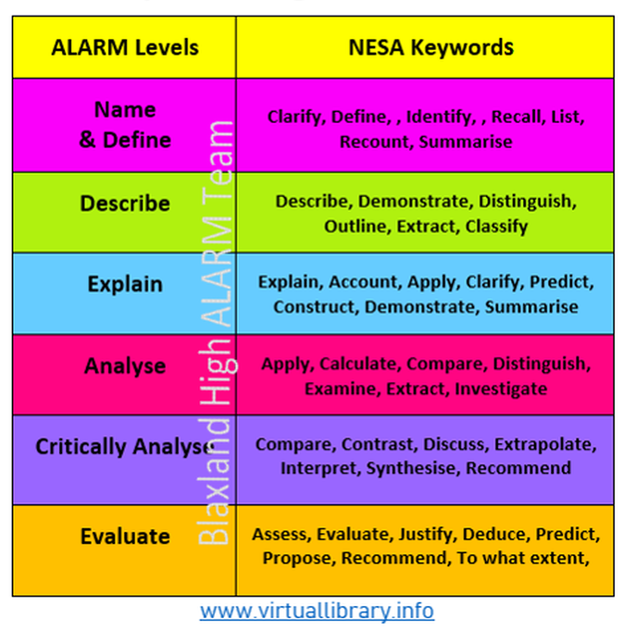

Acknowledgements
National Literacy Learning Progressions, ACARA are licensed under a creative commons Attribution-NonCommercial 4.0 International (CC BY-NC 4.0) licence. See (creativecommons.org/licenses/by-nc/4.0/).
Investigating Science SYLLABUS © NSW Education Standards Authority (NESA) for and on behalf of the Crown in right of the State of New South Wales 2017. See the NESA website for additional copyright information.
Investigating Science - sample examination materials, © 2019 NSW Education Standards Authority (NESA) for and on behalf of the Crown in right of the State of New South Wales.
Blaxland High School ALARM team, © State of New South Wales (Department of Education), 2020
Investigating Science Performance Band descriptions, NESA © 2019 NSW Education Standards Authority (NESA) for and on behalf of the Crown in right of the State of New South Wales.
Presenter: Ms Katarina Parry, Head Teacher Science, Auburn Girls High School

