Non-infectious disease questions

Question 1 (7 marks)
Percentage of Australian population (18yrs+) of regular smokers 1944-2016
Year | Male | Female
1944 | 72 | 26
1962 | 58 | 28
1968 | 45 | 28
1974 | 45 | 30
1980 | 41 | 30
1986 | 34 | 28
1992 | 29 | 24
1998 | 27 | 25
2004 | 22 | 18
2010 | 19 | 16
2016 | 16 | 12
Historical trends in smoking prevalence in Australia

Question 1a
Graph the data on the grid below (2 marks)

Marking guidelines
Criteria | Marks
Plots points accurately to draw a line graph for both males and females  Correctly labels the axes and scale on axes  Includes a key or labels the lines for males and females | 2
Draws a line graph for both males and females. | 1

2 mark answer

Note the gap between the 1944 data and the 1962 data. The x axis must be scaled correctly

Question 1b
Compare and contrast the trends shown in the data. (2 marks)

Marking guidelines
Criteria | Marks
Describes trends in both males and females with some quantitative analysis  Makes a comparison between male and female trends | 2
Outlines trends in male and female data  Makes a comparison between trends | 1
Compare and contrast means what is the same and what is different. If you don’t make any comparison then there are no marks available.

2 mark answer
The prevalence of male smokers has generally steadily decreased from 72% in 1944 to 16% in 2016. This is an average decrease of 4.2% per 6 years. There was a more rapid decline of 13 % between 1962 and 1968.
In contrast, the prevalence of females who smoke slowly increased from 26% in 1944 to 30% in 1980. This is average rate of increase of 0.6% per 6 years. Apart from a very slight increase from 1992 to 1998 (1%), the prevalence of smoking in females has decreased since 1980 with much the same trend as the decline in male smokers.
Comment: You can be expected to calculate the average increase/decrease in data. Calculating averages is one of the working scientifically skills: Processing data and information – apply quantitative processes where appropriate.
Note the calculation of the average decrease in smokers for males and females. The example answer has used the 6 year intervals in the data as the unit of time as this will show the differences more clearly. However, you could calculate the average change per year. For men that would be 0.9% per year decrease for 1944 -2016. The rapid decline between 1962 -1968 was 2% per year. For women it is a 0.1% per year increase from 1944 to 1980. Apart from a very slight increase from 1992 to 1998 (0.1% per year), the prevalence of smoking in females has decreased since 1980 with much the same trend as the decline in male smokers.

1 mark answer
The prevalence of male smokers is decreasing over the time period, whereas the prevalence of female smokers has increased until 1980, then decreased.

Question 1c
People who smoke have the greatest risk of lung cancer. The graph below shows the incidence of lung cancer in Australia, 1982 to 2015, by sex.

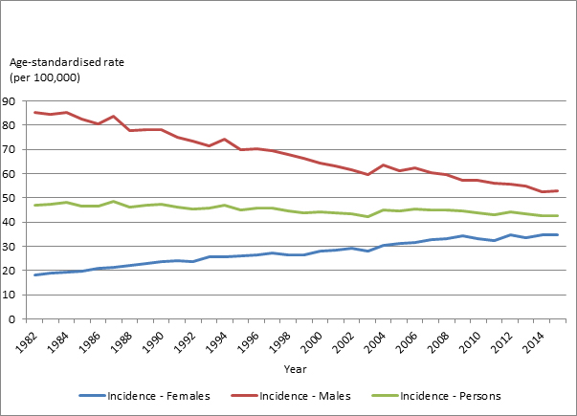
Lung cancer in Australia statistics
Use data from your graph in part (a) to account for the trends shown in the incidence rates for lung cancer for males and for females in the above graph. (3 marks)

Marking criteria
Criteria | Marks
Relates the trends in the incidence of lung cancer for both males and females to the prevalence of smoking trends and the delayed onset of lung cancer | 3
Relates the trends in the incidence of lung cancer for both males and females to the prevalence of smoking trends | 2
Identifies the trends in the incidence of lung cancer for both males and females | 1

3 mark answer
Because people do not usually get lung cancer until they have been smoking for several years there is a lag between when there is a change in the prevalence of smoking and when there is a change in the incidence of lung cancer.
Because the prevalence of smoking in males has been steadily declining since 1944 the incidence of lung cancer in the period since 1982 has also steadily declined.
The prevalence of smoking in women increased from 1944 to 1980 so the incidence of lung cancer for females has shown a steady increase since 1982. Even though the numbers of females smoking has declined since 1980, there is yet to be a decrease in the rate of lung cancer for women.

2 mark answer
Because the prevalence of smoking in males has been steadily declining since 1944 the incidence of lung cancer in the period since 1982 has also steadily declined.
The prevalence of smoking in women increased from 1944 to 1980 so the incidence of lung cancer for females has shown a steady increase since 1982.
This answer notes the relationship between incidence of lung cancer and the prevalence of smoking, but has not discussed the time delay between smoking and developing lung cancer.

1 mark answer
The incidence of lung cancer is decreasing for men and increasing for women
The incidence of lung cancer for males and females is noted but not connected to the prevalence of smoking data.

Question 2 (9 marks)
Melanoma is a non-infectious disease caused by exposure to UV radiation from the sun or tanning beds. An ongoing public education program about melanoma was introduced in 1980. The data below shows the incidence of and mortality from melanoma in Australia.

Year | Incidence (/100,000) | Mortality rate (deaths/100,000)
1982 | 26.6 | 4.7
1987 | 37.7 | 5.7
1992 | 40.7 | 5.5
1997 | 47.5 | 5.1
2002 | 49.5 | 5.3
2007 | 47.5 | 5.9
2012 | 48.7 | 5.9
2016 | 48.8 | 6.2
Australian Institute of Health and Welfare: Skin cancer in Australia

Question 2a
Graph the data from the table onto the grid below. (2 marks)

Marking guidelines
Criteria | Marks
Plots points accurately to draw a line graph for both incidence and mortality  Correctly labels the axes and scale on axes  Includes a key or labels the lines for incidence and mortality | 2
Draws a line graph for both incidence and mortality | 1

2 mark answer

Question 2b
Account for the trends in both incidence and mortality shown in the graph. (4 mark)

Marking guidelines
Criteria | Marks
Describes the 2 trends in incidence in melanoma in quantitative terms.  Explains the lag between the public education campaign and the stabilisation of incidence in melanoma  Describes the trend in mortality due to melanoma in quantitative terms  Explains the difference between mortality and incidence trends | 4
Identifies the 2 trends in incidence in melanoma.  Explains the lag between the public education campaign and the stabilisation of incidence in melanoma  Identifies the trend in mortality due to melanoma.  Explains the difference between mortality and incidence trends | 3
Identifies the 2 trends in incidence in melanoma.  Relates levelling of incidence trend to public education campaign  Identifies the trend in mortality due to melanoma. | 2
Identifies one trend in the data. | 1

4 mark answer
The incidence of melanoma shows an 87% increase from 1982 -2002 (from 26.6 people / 100,000 to 49.9 people/100,000). From 2002 the incidence has remained relatively steady.
Time between exposure to an environmental element and the development of symptoms of disease depends on length and intensity of exposure. Because UV radiation is relatively weak source of radiation, for most people there will be many years between UV exposure and the appearance of melanoma. Therefore any preventative measures will take some time show an effect on incidence. Even though the public education campaign began in 1980 and people began to take precautions to prevent melanoma, the incidence of melanoma increased until 2002 when the effect of the public education campaign became apparent and the incidence stabilised.
The mortality rate for melanoma has remained relatively steady at around 5 (+/- 1.3) /100,000) in the 34 years of data, despite the increasing incidence of melanoma. This could be due to early detection and more effective treatments of melanoma.
‘Account for the trends’ means what are the trends and why do they occur. You can be expected to calculate the percentage increase/decrease in data. It is one of the working scientifically skills: Processing data and information – apply quantitative processes where appropriate.

3 mark answer
The incidence of melanoma shows an increase from 1982 -2002. From 2002 the incidence has remained relatively steady.
For most people there will be many years between UV exposure and the appearance of melanoma. Therefore any preventative measures will take some time show an effect on incidence. Even though the public education campaign began in 1980 and people began to take precautions to prevent melanoma, the incidence of melanoma increased until 2002 when the effect of the public education campaign showed and the incidence stabilised.
The mortality rate for melanoma has remained relatively steady, even though there has been an increasing incidence of melanoma. This could be due to early detection and more effective treatment of melanoma.
This answer has no quantitative analysis of trends.

2 mark answer
The incidence of melanoma shows an increase from 1982 -2002. From 2002 the incidence has remained relatively steady. This is due to the public education campaign and people did the ‘slip, slop, slap’
The mortality rate for melanoma has been fairly constant.
This answer contains general statements about trends for incidence and mortality. It relates the trends to the public education campaign. There is no explanation for the mortality trend.

1 mark answer
The incidence of melanoma increased from 1982 to 2002.
By making one correct comment about one trend, one mark is available.

Question 2c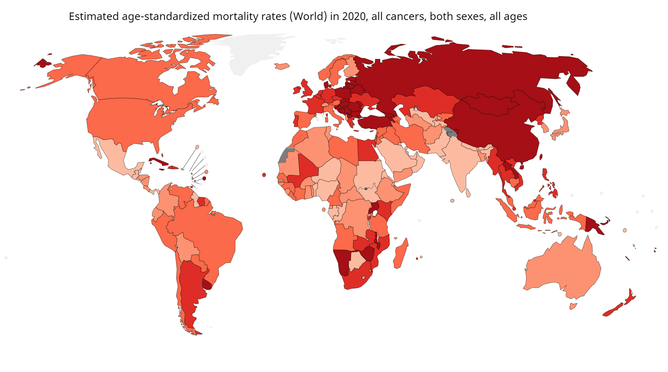
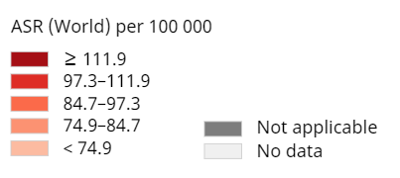
Data source: GLOBOCAN 2020
Graph production: IARC (http://gco.iarc.fr/today)
World Health Organization
Propose a hypothesis to explain the high mortality due to melanoma in Australia. Design an investigation to gather data to test your hypothesis. (3 marks)

Marking guidelines
Criteria | Marks
Proposes a hypothesis that is consistent with the data presented in the map.  Designs a valid investigation that tests the hypothesis | 3
Proposes a hypothesis that is consistent with the data presented in the map.  Designs an investigation that tests the hypothesis | 2
Proposes a hypothesis.  Designs an investigation | 1

3 mark answer
Melanoma is highest in North America, Europe, Australia and NZ. These countries have a higher proportion of their population with fair skin than countries in the tropical regions.
Hypothesis: In Australia, if people have fair skin then they are more likely to die from melanoma than people with dark skin.
Investigation:
- Undertake a cohort study. In a cohort study it is important that the two groups of are similar in all ways other than what is the potential cause of the disease. Select a large sample of (2500) dark and (2500) light skinned tradesmen of 20-30 years of age in Australia who do not have melanoma.
- The groups should be followed over a long period of time (50 years).
- All deaths from melanoma should be recorded. If a significantly higher number of fair skinned men died from melanoma then the hypothesis would be supported.
Valid features include:
1. The two groups are similar in all ways other than what is the potential cause of the disease. The participants:
- are all tradesmen, therefore they will have similar exposure to the sun
- are 20-30 years old – same age – appearance of melanoma will not be age related
- all live in Australia
- do not have melanoma
2. There is a large sample (5000) size – reduces random errors such as life style differences between the participants
3. The groups should be followed over a long period of time (50 years).

2 mark answer
- Countries on the map who have a large proportion of fair skinned people have the highest death rate from melanoma
- Hypothesis: If people have fair skin then they are more likely to die from melanoma than people with dark skin.
- Investigation:
  - Select a large sample (5000) of dark and light skinned people in Australia.
  - The groups should be followed over a long period of time (50 years).
  - All deaths from melanoma should be recorded. If a significantly higher number of fair skinned people developed and died from melanoma then the hypothesis would be supported.
While there is a large sample size, there has been no attempt to make the groups the same in all other respects. The people in this study could be men and women, of different ages and different occupations and lifestyles all of which could potentially affect the results. Therefore the investigation is not valid.

1 mark answer
People in Australia are more likely to die from melanoma because they are fair skinned. See how many fair skinned people and dark skinned people die from melanoma in Australia in a year.
The investigation is not testing likelihood (chance) of dying from melanoma because only total deaths are being recorded. There are many more fair skinned people in Australia than dark skinned people so even if the chance of developing melanoma was the same for dark and light skinned people there would be more light skinned people dying from melanoma.

Question 3 (4 marks)
Researchers have been investigating if paracetamol use by pregnant women is linked to a higher risk of autism in their children.
The researchers measured paracetamol levels in blood taken from the umbilical cords at birth of 996 babies whose mothers had taken paracetamol in the last 24 hours. Paracetamol levels in blood drop by half every 3.5 hours. The levels were recorded as high, medium and low.
The children were tracked for up to twenty years. Of those children who undertook neurodevelopmental testing during that period, babies who were exposed to high levels of paracetamol were four times more likely to have developed autism spectrum disorder than those who were exposed to low levels.
Evaluate the method used in this epidemiological study.

Marking guidelines
Criteria | Marks
Describes two positive aspects of the study  Describes two negative aspects of the study  Makes an evaluation | 4
Identifies two positive aspects of the study  Identifies two negative aspects of the study  Makes an evaluation | 3
Identifies a positive AND a negative aspect of the study. | 2
Identifies a positive OR a negative aspect of the study. | 1

4 mark answer
There are some valid aspects of this study:
- The large original sample size of 996 reduced the effect of random errors.
- Tracking the children over 20 years allows time for any disorders to be diagnosed.
There are, however, several problems with this study.
- There was no pregnant patient group who had not taken paracetamol, that is no control group to determine the baseline incidence of autism spectrum disorder.
- Only those children who had neurodevelopmental testing, not the whole cohort, were included in the analysis. This is called selection bias. It is not considering all those children who were not tested for neurodevelopment disorders.
This makes it invalid to claim that paracetamol was the cause of the ASD.
Problems with the study could also include:
- The study is only looking at paracetamol levels in cord blood.
- Paracetamol levels drop by half every 3.5 hours so it is only looking at paracetamol use by the mother in the last day of pregnancy. It is not considering the intake throughout the pregnancy.

3 mark answer
The large original sample size of 996 and tracking the children over 20 years are valid parts of the study.
There are, however, problems with this study. There was no patient group who had not taken paracetamol. Only those children who had neurodevelopmental testing, not the whole cohort, were included in the analysis.
This makes it invalid to claim that paracetamol was the cause of the ASD.

2 mark answer
The large original sample size is a valid part of the study.
A problem with this study is there was no patient group who had not taken paracetamol.

1 mark answer
The large original sample size is a valid part of the study.

Mapping grid

Question | Marks | Content | Syllabus outcomes
1a | 2 | Mod 8 Epidemiology | Bio 12-4
1b | 2 | Mod 8 Epidemiology | Bio 12-5
1c | 3 | Mod 8 Causes and Responses, Epidemiology | Bio 12-6, Bio 12-15
2a | 2 | Mod 8 Causes and Responses | Bio 12-4
2b | 4 | Mod 8 Epidemiology | Bio 12-5, Bio 12-15
2c | 3 | Mod 8 Epidemiology | Bio 12-1, Bio 12-2
3 | 4 | Mod 8 Epidemiology | Bio 12-5, Bio 12-7, Bio 12-15

