Infectious disease questions

Question 1 (4 marks)
The following is an extract from a science magazine.
Barry Marshall and Robin Warren have guts
For most of the 20th century it was known with certainty that stress and lifestyle caused stomach ulcers, a widespread, painful, often-debilitating condition for which treatment ranged from diet modification to surgery.
But then, in 1979, Robin Warren, a pathologist at Royal Perth Hospital in Western Australia, observed spiral-shaped bacteria in a biopsy of the stomach lining from a patient – and continued gathering samples from other patients.
He and Doctor Barry Marshall initiated a study of biopsies from 100 patients and found that the organism was present in all patients with gastric inflammation, duodenal ulcer or gastric ulcer. However their work was not well received by the medical profession.
“Marshall grew desperate”, according to a 2010 Discover magazine profile of the scientist, headlined “The doctor who drank infectious broth, gave himself an ulcer, and solved a medical mystery”.
“He ran an experiment on the only human patient he could ethically recruit: himself.” He took some of the bacteria from the gut of an ailing patient, stirred it into a broth, incubated it for a few hours and drank it.
He developed gastritis, the precursor to an ulcer. In the lab, he biopsied his own gut, culturing a hitherto unknown bacterial species (identical to those present in his patient), later denoted Helicobacter pylori, “and proving unequivocally that bacteria were the underlying cause of ulcers”.
COSMOS: Barry Marshall and Robin Warren have guts
Robert Koch (1843-1910) made many contributions to the field of microbiology and infectious disease. One of these was Koch’s postulates.
Complete the flow chart A to show the steps in Koch’s postulates. Complete the flow chart B to show how Marshall and Warren’s work that resulted in them winning the Nobel Prize in Physiology or Medicine in 2005, followed the criteria of Koch’s postulates. (4 marks)
Flow chart A Flow chart B

Marking guidelines
Criteria | Marks
Correctly places Koch’s postulates into the flow chart  Correctly allocates the steps in Warren and Marshall’s procedure to the four steps in Koch’s postulates in the flow chart | 4
Correctly places Koch’s postulates into the flow chart  Correctly allocates some steps in Warren and Marshall’s procedure to Koch’s postulates in the flow chart | 3
Correctly aligns some of Warren and Marshall’s procedure to some of Koch’s postulates | 2
Correctly identifies some of Koch’s postulates | 1

4 mark answer
Flow chart A Flow chart B

3 mark answer
Flow chart A Flow chart B

2 mark answer
Flow chart A Flow chart B

1 mark answer
Flow chart A Flow chart B

Question 2 (8 marks)
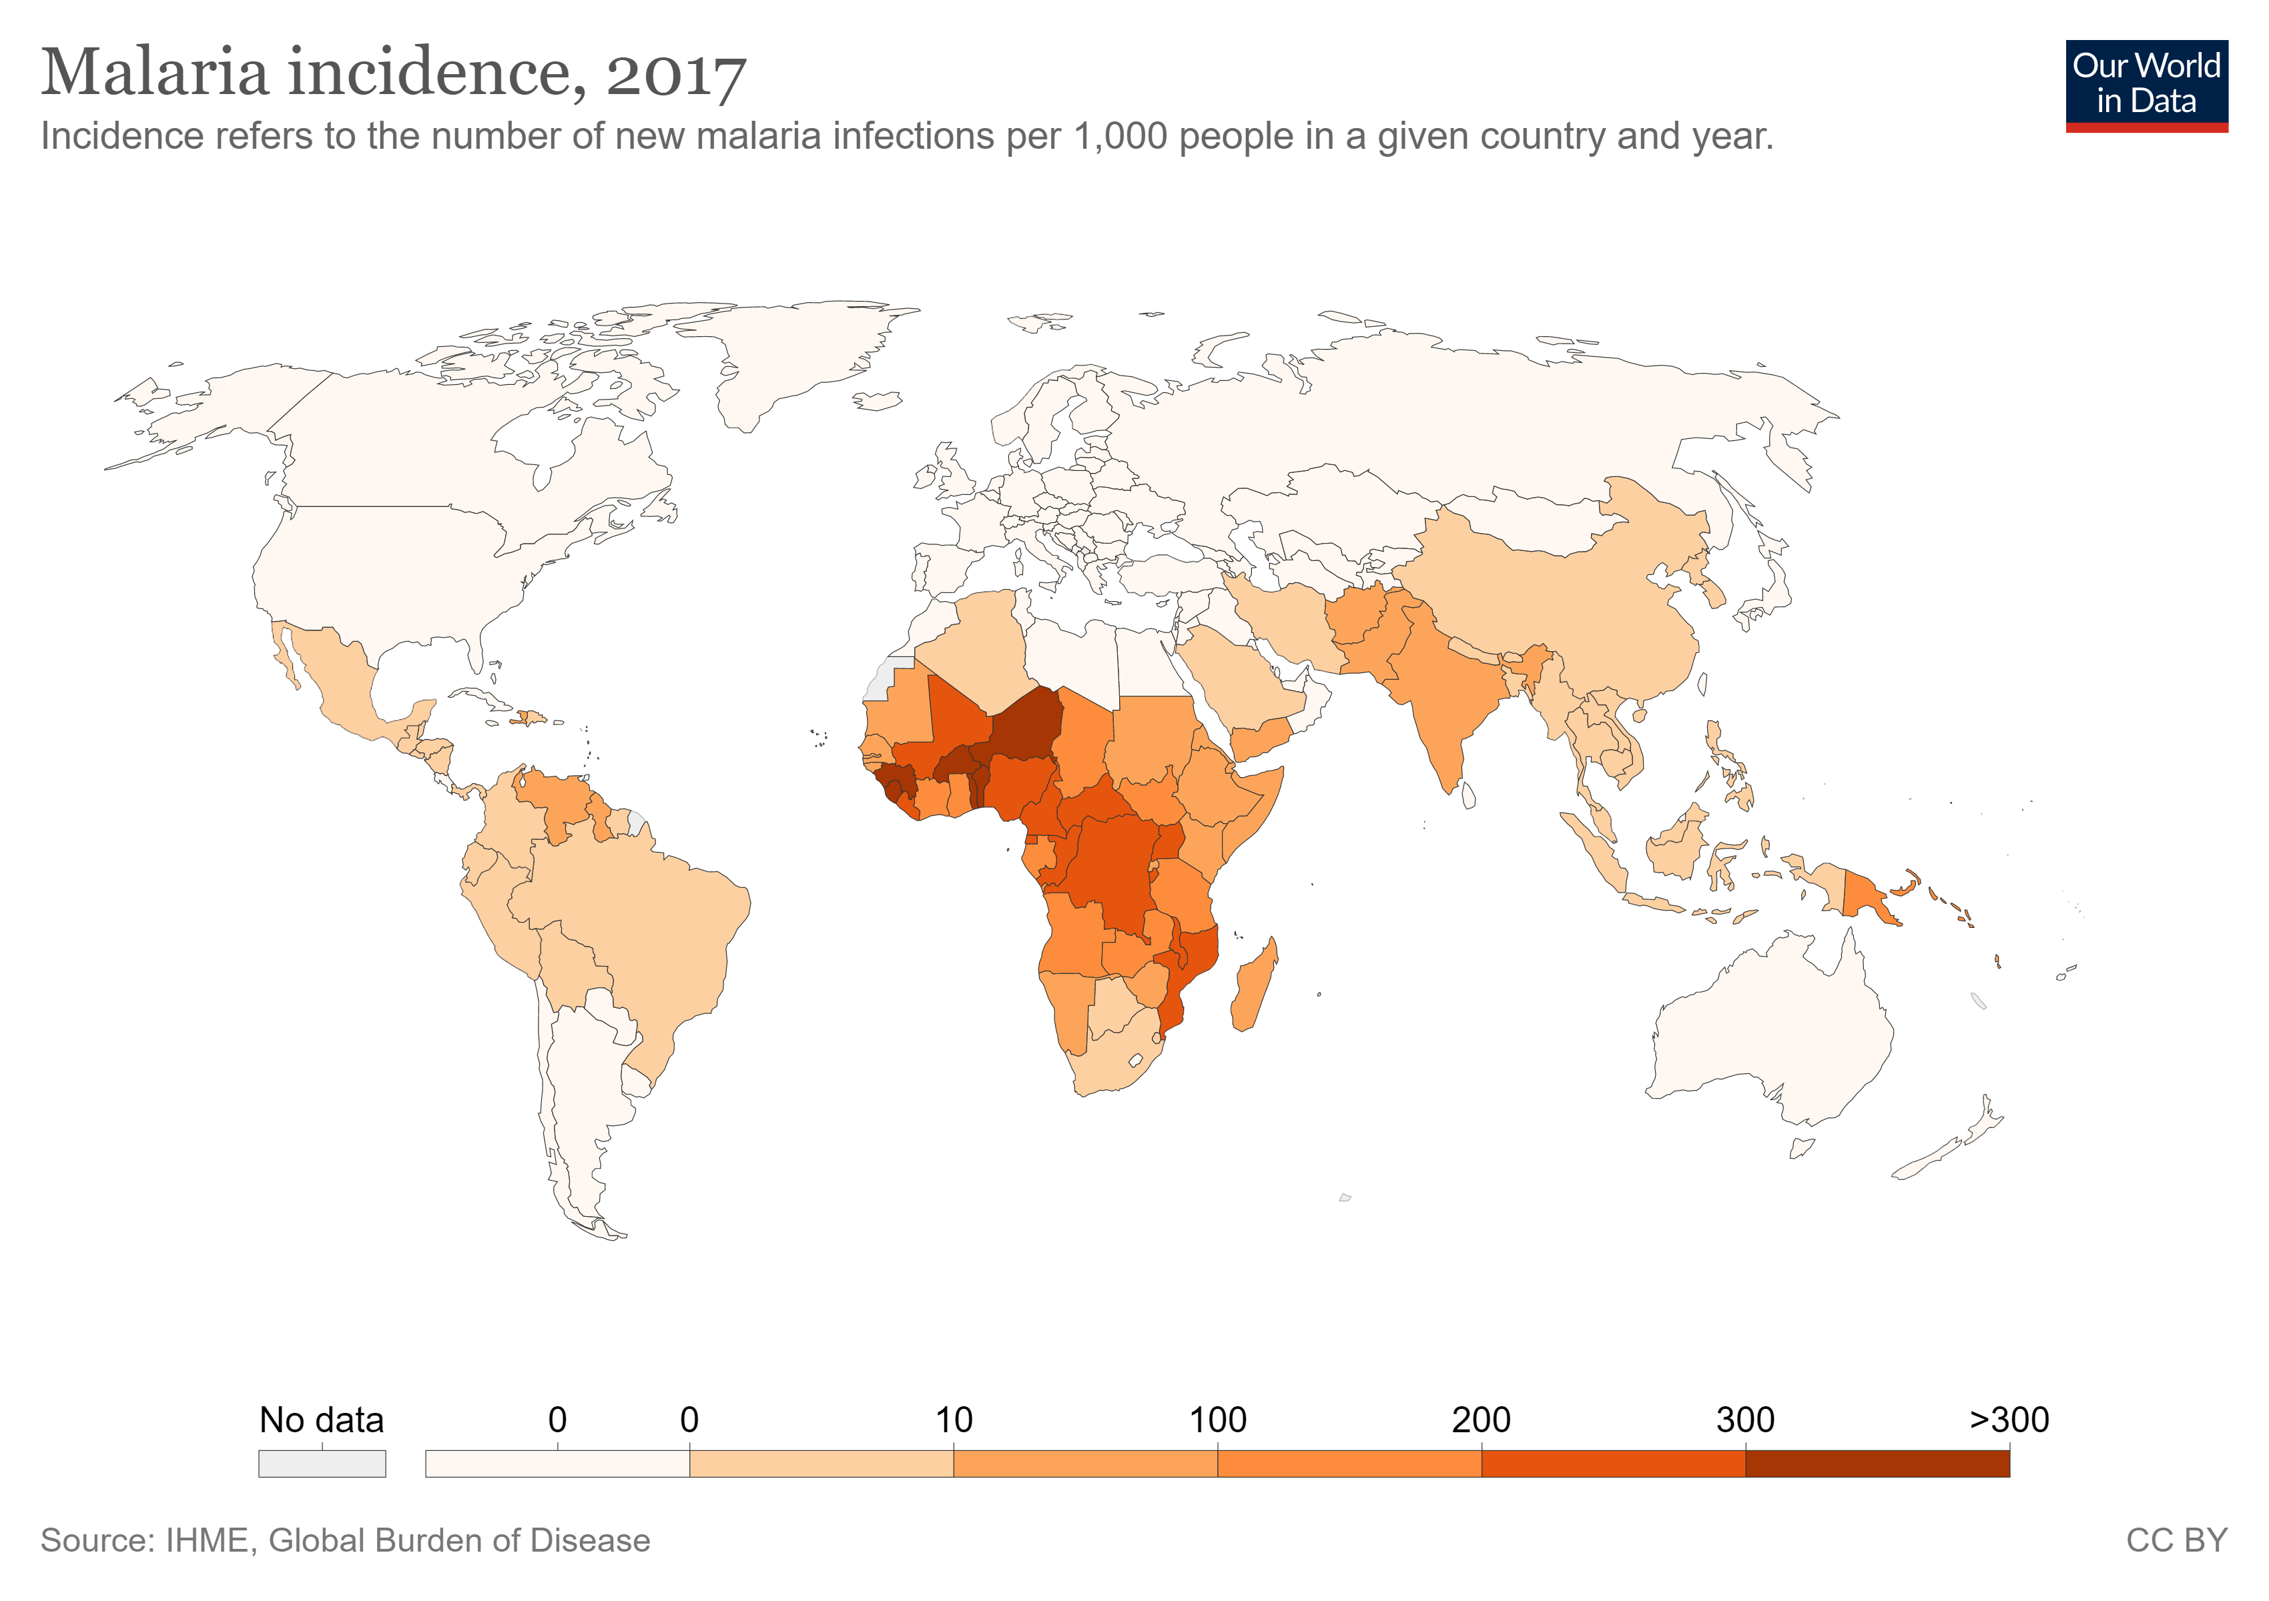
Our World in Data: Incidence of malaria 2017

Question 2a
Account for the incidence of malaria shown in the map. (3 marks)

Marking guidelines
Criteria | Marks
Explains the relationship between incidence of malaria and the climate and the mosquito  AND  Explains the relationship between the incidence of malaria and the economic status of developing nations and their capacity to provide adequate eradication programs, housing and health care | 3
Explains the relationship between incidence of malaria and the climate and the mosquito  OR  Explains the relationship between the incidence of malaria and the economic status of developing nations and their capacity to provide adequate eradication programs, housing and health care | 2
Provides some relevant information | 1
While the question does not ask for a specific number of reasons to explain the incidence of malaria, the fact that it is a 3 mark question and that you have done a whole descriptor on the interpreting of data relating to the incidence and prevalence of Malaria, means that you should be familiar with the range of factors affecting this.

3 mark answer
There is a much higher incidence of malaria in the tropical and sub-tropical countries. The disease is transmitted by a mosquito vector which will be common in these countries due to the high rainfall and temperature.
Many of the countries with the highest incidence are developing nations which do not have sufficient funds to provide adequate eradication (of the mosquito) programs, housing and health care. This explains why the incidence is high (100-200/1000 population) in New Guinea but there is no malaria in north Queensland.
‘Account for’ means ‘why’. This answer clearly explains two reasons why the incidence of malaria is high in some countries but not others.

2 mark answer
The incidence of malaria is highest in the countries with a tropical climate. This suits the mosquito which transmits malaria.
This answer accounts for why the disease has a high incidence in the tropical regions but does not explain the variation in incidence between countries in the tropical region

1 mark answer
There is more malaria in the tropical countries.
This is a true and relevant observation of the data in the map, but does not explain why (account for) there is more malaria in the tropics.

0 mark answer
Malaria is caused by a protozoa called Plasmodium and transmitted by an insect vector the Anopheles mosquito. Malaria incidence can be reduced by using insect repellents, covering your arms and legs and using mosquito nets. There are also anti malaria drugs that can be taken.
While this is correct information, it does not answer the question. It does not refer to the data in the map. It is referring to cause, transmission and prevention of the disease, not incidence.

Question 2b (4 marks)
Outline how Koch’s postulates may be used to determine if malaria in humans is caused by a pathogen.

Marking guidelines
Criteria | Marks
Correctly lists 4 steps of Koch’s postulates and relates them to the pathogen, malaria and the human | 4
Correctly identifies 2-3 steps of Koch’s postulates and relates them to the pathogen, malaria and the human | 3
Lists Koch’s postulates | 2
Provides some relevant information | 1

4 mark answer
- The pathogen must be present in every case of malaria
- The pathogen must be isolated from the human with malaria and cultured in the laboratory
- A sample of the pure culture of the pathogen is then injected into a healthy human and the person must contract malaria.
- The pathogen must be recoverable from the experimentally infected human and be cultured and identified as the same as the original pathogen.
All four steps are included and related to malaria, Pathogen A and the human.

3 mark answer
- The pathogen must be taken from human with malaria and grown in the lab.
- Then a sample of pure pathogen is injected into a human to see if they get malaria.
2-3 steps have been included and related to malaria, Pathogen A and the human

2 mark answer
- The same microorganism must be present in every host with a specific disease
- The microorganism must be isolated from the host with the disease and cultured in the laboratory.
- A sample of pure culture is then inoculated into a healthy host and this host must contract the disease.
- The microorganism must be isolated from the second host and be cultured and identified as the original species.
These are the 4 correct steps of Koch’s postulates but they are not applied to this specific example - the pathogen, malaria and humans.

1 mark answer
Take some blood from a human with malaria and put into a healthy human to see if they get the disease.
There is some recognition that something has to be taken from human with malaria and injected into a healthy human to result in the disease.

0 mark answer
Malaria is an infectious disease caused by Plasmodium parasites. The parasites are spread by the bite of infected female Anopheles mosquitos. When a human is bitten by an infected mosquito the parasites enter the blood stream and travel to the liver. After infection there is usually an incubation period of 7-30 days, after which the parasites enter red blood cells and symptoms develop. Some people don’t develop symptoms for several months, particularly if they took inadequate doses of anti-malarial medication.
Like the zero marks in part a, this answer contains high quality information but it does not answer the question. It is describing the cause, transmission and development of the disease in the body. It also mentions preventative measures. There is no reference to any of Koch’s postulates.

Question 2c (1 mark)
Explain why it would be difficult, ethically, to justify the use of Koch’s postulates on a pathogen that may affect humans.

Marking guidelines
Criteria | Marks
Relates ethics to infecting a healthy human with pathogen | 1

1 mark answer
It would be unethical to infect a healthy person with pathogen to cause the onset of disease.

Question 3 (5 marks)
On 13th December 2019, the World Health Organisation commemorated the 40th anniversary of smallpox eradication. Smallpox is an acute disease caused by the variola virus which only infects humans. It can only be transmitted by person to person contact. The smallpox vaccine contains a live vaccinia virus which is similar to the variola virus, but less harmful.
Tetanus is a serious illness contracted through wound exposure to the spores of the bacterium, Clostridium tetani, which are found in soil, saliva, dust and manure. The bacteria are anaerobic and produce a toxin. The DTP3 vaccine is highly effective in preventing tetanus.

Explain why, despite the similar widespread uptake of effective vaccines, eradication of smallpox was achievable, but eradication of tetanus is impossible.

Marking guidelines
Criteria | Marks
Distinguishes between the structure, metabolism and reproduction of viruses and spore forming bacteria.  Identifies that vaccinations stimulate the immunological memory to destroy the virus, bacteria and toxin and hence prevent disease  Relates survival and transmission of the virus to its reproduction in a human cell.  Identifies the widespread nature of the Clostridium tetani spore as being integral to its survival. | 5
Identifies the difference between reproduction in viruses and bacteria.  Identifies that vaccinations stimulate the immunological memory to destroy the virus, bacteria and toxin and hence prevent disease  Relates survival of the virus to its reproduction in a human cell.  Identifies the widespread nature of the Clostridium tetani spore as being integral to its survival. | 4
Identifies a difference between viruses and bacteria.  Identifies that vaccinations prevent disease  Relates survival of the virus to its survival in a human cell.  Identifies the widespread nature of the bacteria as being integral to its survival | 3
Identifies a difference between viruses and bacteria.  Relates this difference to eradication | 2
Provides any relevant information. | 1

5 mark answer
The reason that smallpox has been eradicated while it is impossible to eradicate tetanus is because they are caused by microorganisms that ‘live’ in different places and reproduce in different ways.

Smallpox is caused by a virus. Viruses are non-cellular. They are a strand of DNA or RNA in a protein coat. Viruses can only reproduce and metabolise in a host cell, in this case human cells. The protein coat of the virus attaches to the human cell allowing the DNA or RNA to enter the cell and take over the reproductive mechanism of the cell making many copies of itself which can then be transmitted to other people. The smallpox vaccine stimulates the immune response producing memory cells which will set a chain of events that will destroy any subsequent infection by the smallpox virus. The vaccine was highly effective in allowing eradication as the virus now had nowhere else to metabolise and reproduce so could not survive, nor be transmitted to other people.
Tetanus is caused by a spore forming bacteria. Unlike viruses, bacteria are cellular and can live outside a host. Additionally, spores are produced by the tetanus bacteria, as a means of lying dormant and resisting desiccation in the soil for decades. The spores enter deep, dirty penetrating wounds where they germinate and the bacteria rapidly reproduce by binary fission. The bacteria produce a toxin. While the vaccine in highly effective in stimulating the immune system to destroy the tetanus bacteria and their toxin, the spores which are in soils throughout the world cannot be eliminated and consequently tetanus cannot be eradicated.

This answer clearly relates eradication to the difference in structure, metabolism, reproduction and transmission of viruses and bacteria.

4 mark answer
Smallpox is caused by a virus. Viruses can only reproduce in living cells. The smallpox vaccine stimulates the immunological memory to destroy later invading variola viruses so the person does not get smallpox. If enough humans are vaccinated, the virus can’t reproduce and it will be eradicated.

Tetanus is caused by a bacteria. Bacteria can reproduce in a wide range of conditions. When a person is infected with a tetanus spore through a cut, the bacteria reproduces very rapidly and produces a toxin. The DTP3 vaccine stimulates the immunological memory to destroy later infection by the bacteria and its toxin. The bacteria spores are in the soil everywhere, so it is impossible to eradicate tetanus.

This answer:
identifies there is a difference between reproduction in viruses and bacteria but does not provide the mechanisms for reproduction.
does not identify the difference in structure and the effect of that difference on where the microorganism ‘lives’.

3 mark answer
Smallpox is caused by a virus. Viruses can only survive in living cells. The smallpox vaccine destroys invading variola viruses, so the person does not get smallpox. There is nowhere for the virus to live so it is eradicated.

Tetanus is caused by a bacteria. Bacteria can survive in a wide range of conditions. When a person is infected with a tetanus bacteria the vaccine destroys the bacteria and toxin but there will still bacteria in the soil so they cannot be eradicated.

This answer:
distinguishes between survival of viruses and bacteria but does not mention reproduction.
relates vaccines to disease prevention but suggests that the vaccine destroys the microorganism rather than stimulating the immunological memory to allow the immune system to do this.
mentions that viruses will not survive but bacteria in soil will survive.

2 mark answer
Smallpox is caused by a virus. Viruses can only survive in living cells. If you kill all the viruses in humans, then the virus can be eradicated.

Tetanus is caused by a bacteria. Bacteria can survive in a wide range of conditions. Bacteria in the soil cannot be eradicated

This answer:
distinguishes between survival of viruses and bacteria but does not mention reproduction.
identifies that viruses in cells can be killed but bacteria in soil cannot.

1 mark answer
Smallpox is caused by a virus. Viruses can only survive in living cells. Tetanus is caused by a bacteria. Bacteria live in the soil.

This answer correctly identifies a difference between bacteria and viruses but has not related it to eradication.

1 mark answer
Smallpox is caused by a virus. Viruses are non-cellular. They are a strand of DNA or RNA in a protein coat. Viruses can only reproduce and metabolise in a host cell, in this case human cells. The protein coat of the virus attaches to the human cell allowing the DNA or RNA to enter the cell and take over the reproductive mechanism of the cell making many copies of itself. The smallpox vaccine stimulates the immune response producing memory cells which will set a chain of events that will destroy any subsequent infection by the smallpox virus.

Tetanus is caused by a spore forming bacteria. The spores enter deep, dirty penetrating wounds where they germinate and the bacteria rapidly reproduce by binary fission. The bacteria produce a toxin. The vaccine in highly effective in stimulating the immune system to destroy the tetanus bacteria and their toxin.

This answer provides an excellent description of the reproduction of viruses and bacteria but it does not relate this to eradication of the diseases. The key part of the question is to explain why there is difference in eradicating the diseases. If you do not attempt to explain why, then no matter how well you describe viruses, bacteria and vaccination, you will only receive one mark.

Question 4 (3 marks)
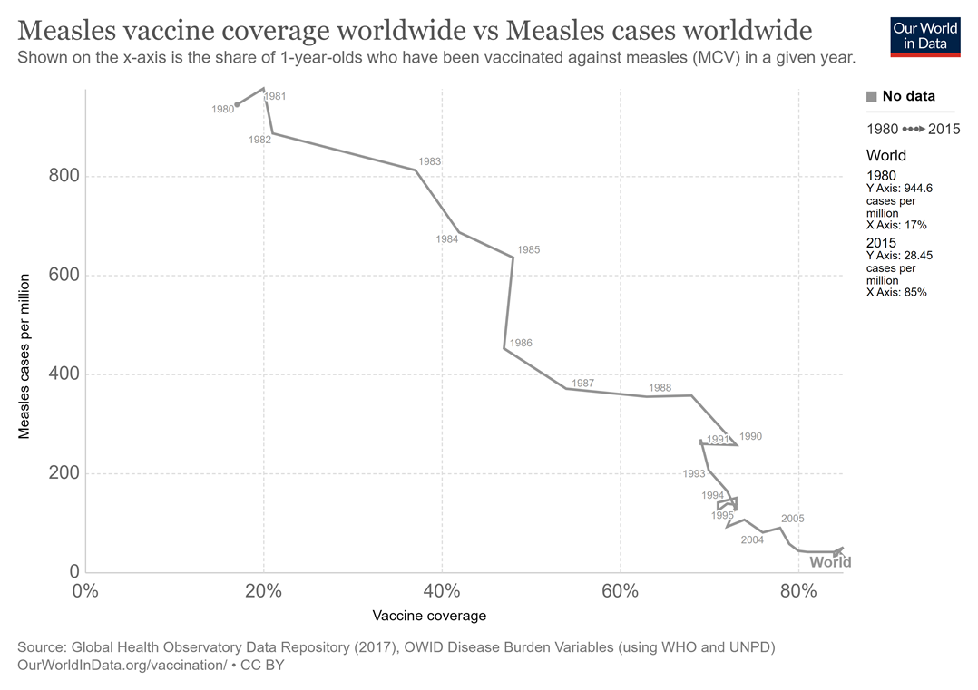
Our world in data: vaccination - measles
Account for the trends shown in the data displayed in the graph.

Marking guidelines
Criteria | Marks
Identifies and explains the 2 stage trend in the vaccine coverage over time  Identifies and explains two reasons for the trend in measles cases with respect to vaccine coverage | 3
Identifies and explains the 2 stage trend in the vaccine coverage over time  OR  Identifies and explains the trend in measles cases with respect to vaccine coverage | 2
Identifies one or two trends in the graph | 1

3 mark answer
One trend shown in the graph is that measles vaccine coverage worldwide has increased rapidly from 17% of 1 year olds in 1980 to approximately 62% of 1 year olds in 1990. It has increased more slowly over the following 15 years to 85% of one year olds in 2015.
The initial rapid increase in measles vaccine coverage occurred because of increased funding from WHO, UNICEF, philanthropists, charities and individual governments. The increased funding allowed education campaigns to be introduced and provided funds for vaccination programs. The subsequent slower rate of increase in vaccination coverage is due to health workers slowly gaining access to areas where they previously could not access due to civil wars or social policies of individual countries.
A second trend shown in the graph is that as vaccine coverage has increased from 17% in 1980 to 85% in 2015, the number of measles cases per million has steadily fallen from 944.6 to 28.5.
This decrease has occurred because the vaccine is highly effective in preventing children from contracting measles. Additionally the greater proportion of people who are immunised, the better the protection for everyone in the population, including those who are too young to be vaccinated. This is called herd immunity. While 80% world-wide coverage is below the herd immunity threshold of 92-95% for measles, many individual countries will have reached this threshold so that those countries should have no measles cases.
The two stage trend in the vaccine coverage over time is difficult to observe. You need to realise that time (the year) is not equally spaced horizontally.

2 mark answer
The trend shown in the graph is that as vaccine coverage has increased from 17% in 1980 to 85% in 2015, the number of measles cases per million has steadily fallen from 944.6 to 28.5. This decrease has occurred because the vaccine is highly effective in preventing children from contracting measles.
Additionally herd immunity will have some effect on lowering the incidence of measles. While 80% world-wide coverage is below the herd immunity threshold of 92-95% for measles, many individual countries will have reached this threshold so that those countries should have no measles cases.
1 trend explained

1 mark answer
As vaccine coverage has increased, the number of measles cases per million has steadily fallen.
1 trend identified

Mapping grid
Question | Marks | Content | Syllabus outcomes
1 | 4 | Mod 7 Causes of Infectious Disease | Bio 12-4, Bio 12-7, Bio 12-14
2a | 3 | Mod 7 Prevention, Treatment and Control | Bio 12-5, Bio 12-6, Bio 12-14
2b | 4 | Mod 7 Causes of Infectious Disease | Bio 12-2, Bio 12-6, Bio 12-14
2c | 1 | Mod 7 Causes of Infectious Disease | Bio 12-2, Bio 12-14
3 | 5 | Mod 7 Causes of Infectious Disease, Prevention, Treatment and Control | Bio 12-7, Bio 12-14
4 | 3 | Mod 7 Prevention, Treatment and Control | Bio 12-4, Bio 12-7, Bio 12-14
Outcomes referred to above are from the Biology Stage 6 Syllabus © 2017 NSW Education Standards Authority (NESA) for and on behalf of the Crown in right of the State of New South Wales

