DNA replication
Key learning area – science
Course –biology
Module – Module 5 – Heredity
Topic – DNA replication
Resource type – YouTube video, activity, problem-solving questions
Description – This lesson describes the structure of DNA and explains how DNA replication occurs including the enzymes involved.

Lesson content
Inquiry questions
- What is the Watson and Crick model of DNA?
- How does DNA replicate?

Part 1 - The Watson and Crick model of DNA
DNA is the genetic code which contains the instructions for every physical feature and physiological function of an organism. In 1953, two scientists, constructed a model of DNA showing it to be a three-dimensional double-helix.
Watch DNA structure (duration 4:21) to learn about the structure of DNA, which is based on the model constructed by Watson and Crick.

Video quiz
- What is the shape of DNA?

- With which base does cytosine always pair?

- With which base does adenine always pair?

- What type of bond joins base pairs?

- Which to molecules make up the backbone of DNA?

- Which 3 molecules make up a nucleotide?

- Are nucleobases always attached to the sugar or phosphate on the backbone?

Activity
- In the space below, draw a simple diagram of the structure of DNA. Your diagram should be 4 base pairs in length, demonstrate the double-helix shape and include the following labelled features:
- Adenine
- Thymine
- Guanine
- Cytosine
- Deoxyribose sugar
- Phosphate
- Hydrogen bonds

Problem-solving questions
- Draw a box around ONE nucleotide in the diagram below. 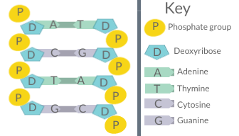
DNA diagram by Christine Miller is licenced under CC BY 4.0

- A sample of DNA is found to be comprised of 35% of the nucleobase guanine. What is the percentage the nucleobase thymine in this DNA sample?
  - 25%
  - 35%
  - 60%
  - 15%
- Choose the answer that correctly identifies each part of the model of DNA below:
  - P – sugar, Q – thymine, R – phosphate, S – adenine,
  - P – sugar, Q – thymine, R – phosphate, S – guanine,
  - P – phosphate, Q – sugar, R – adenine, S – thymine,
  - P – phosphate, Q – cytosine, R – sugar, S – guanine,
Figure 1 Model of DNA
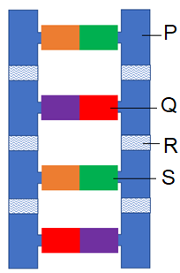

PART 2 – DNA replication
Watch the video on DNA Replication (8 minutes 11 seconds) to learn about the process of DNA replication.

Activity
- In the space below, summarise the process of DNA replication.
Part a – The DNA double helix is unwound by the helicase

Part b –

Part c –

Part d –

Part e –

- For each enzyme listed below, summarise its function in DNA replication:
- Helicase –

- DNA polymerase III –

- DNA polymerase I –

- Ligase –

Problem-solving questions
- a) The diagram below shows a model of DNA replication. Draw in the missing step. 3 marks
b) With reference to the advantages and disadvantages of the model in Part a, discuss the effectiveness of using models for processes like DNA replication. 3marks

Suggested answers

Part 1 Video quiz
- Double helix
- Guanine
- Thymine
- Hydrogen bonds
- Deoxyribose sugar, phosphate
- Nitrogenous base, deoxyribose sugar, phosphate
- Sugar

Part 1 Activities
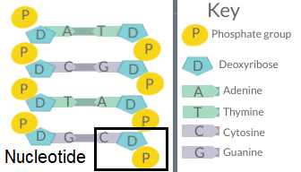
DNA diagram by Christine Miller is licenced under CC BY 4.0

Marking guidelines – Part 1 Problem-solving questions
- The answer is D. Guanine always pairs with cytosine, so there must be 35% each of guanine and cytosine. The remaining 30% of the bases must be adenine and thymine which always pair together, so half of remainder, which is 15%, must be thymine.
- The answer is B. Bases are always attached to sugars so P must be sugar and R must be phosphate, ruling out options C and D. If Q (red) is thymine, then the purple must be adenine, and the green either guanine or cytosine.

Suggested answers – Part 2 activities
- Part a –The DNA double helix is unwound by helicase.
Part b – Hydrogen bonds between bases are broken by helicase and the DNA unzips and the two strands separate.
Part c – DNA polymerase III adds complimentary nucleotides opposite to the bases on the original DNA strands synthesise a new strand alongside each original strand. Part d – DNA polymerase I checks the strands for errors and edits the DNA where necessary.
Part e – The pairs of original and new strands are sealed together by ligase and the two resultant DNA molecules re-wind to form double helices.

- Helicase – Unwinds the DNA double helix. Breaks the hydrogen bonds between baes, causing the two DNA strands to separate and expose the nucleotides.
- DNA polymerase lll – Cerates new DNA strands using original DNA strands as templates. Bases added to the new strand are complimentary to the original strand.
- DNA polymerase l – Checks newly formed DNA strands for errors in base pairing. If errors are found, it splices out the incorrect base and inserts a new correct base.
- Ligase – Seals DNA fragments together to produce new double-stranded DNA molecules.

Marking guidelines – Part 2 Problem-solving questions
- a)
3 marks – draws a clear diagram that includes all of the following:
- DNA unzipping
- Exposed nucleotides
- Free nucleotides joining to exposed nucleotides
- Correct base pairing between free nucleotides joining to exposed nucleotides
2 marks – draws a clear diagram the includes at least three of the following:
- DNA unzipping
- Exposed nucleotides
- Free nucleotides joining to exposed nucleotides
- Correct base pairing between free nucleotides joining to exposed nucleotides
1 mark – Draws a diagram the includes at least one of the following:
- DNA unzipping
- Exposed nucleotides
- Free nucleotides joining to exposed nucleotides
- Correct base pairing between free nucleotides joining to exposed nucleotides
Sample answer (3/3):
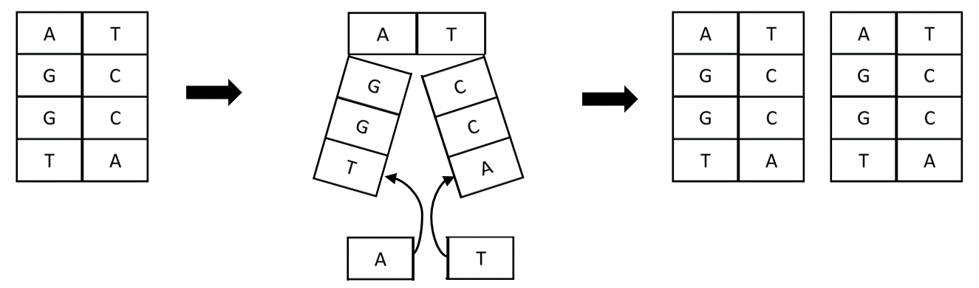

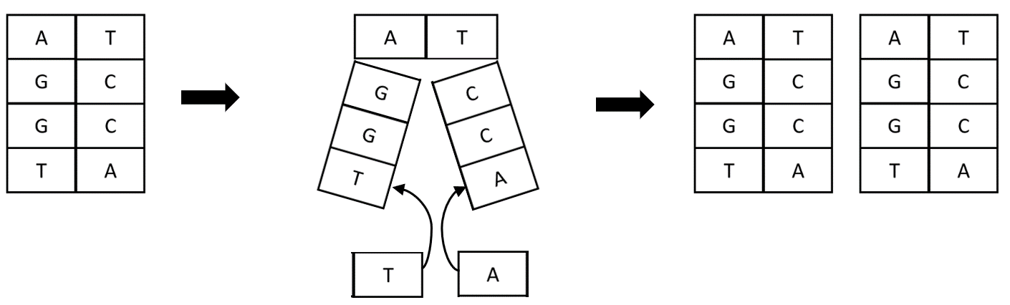
Sample answer (2/3):
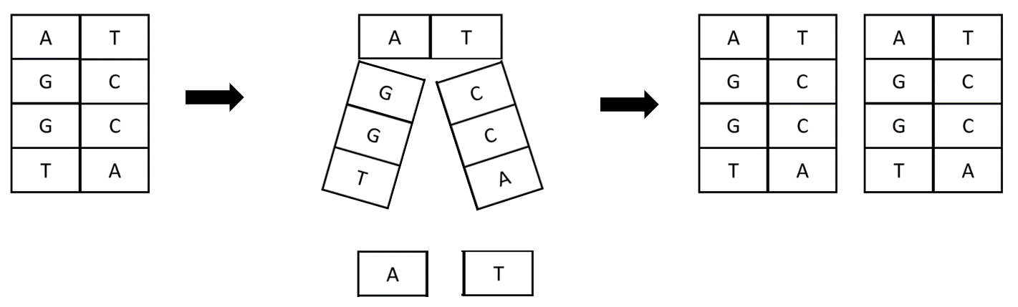OR
Sample answer (1/3):
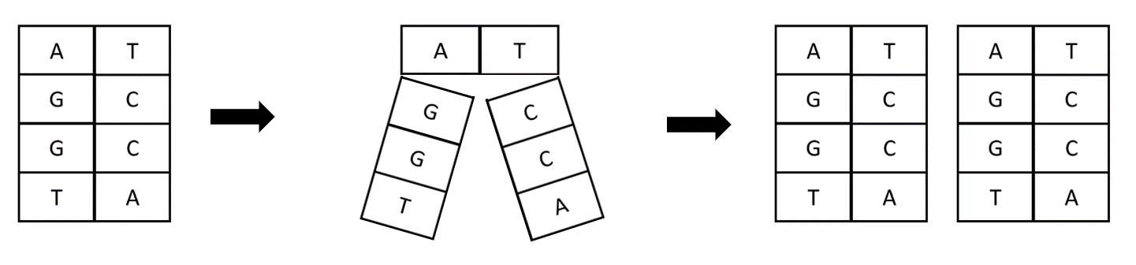

b)
3 marks – Explains why scientists use models. Describes advantages AND disadvantages of the model provided.
2 marks – Explains why scientists use models. Describes advantages OR disadvantages of the model provided.
1 mark – Identifies a reason for using models OR
Identifies an advantage of the model provided OR
Identifies a disadvantage of the model provided
Sample answer (3/3):
Scientists use models to explain processes that occur on a scale that is too small to be seen and to visualise and simplify complex processes. The model provided simplifies the process of DNA replication by using only a few bases of DNA and allows students to visualise the multi-step process that occurs at a cellular level, whilst maintaining key features like the complimentary base pairing of nucleotides. The disadvantage in the model provided is that it uses only singe rectangular boxes to represent entire nucleotides, this does not account for the fact that nucleotides are made of a sugar and a phosphate as well as a nitrogenous base.
Sample answer (2/3):
Scientists use models to explain processes that occur on a scale that is too small to be seen and to visualise and simplify complex processes. The model provided simplifies the process of DNA replication by using only a few bases of DNA and allows students to visualise the multi-step process that occurs at a cellular level, whilst maintaining key features like the complimentary base pairing of nucleotides.
Sample answer (1/3):
Scientists use models to explain processes that occur on a scale that is too small to be seen and to visualise and simplify complex processes.

Biology 6 Syllabus outcome
BIO12-12 – Explains the structures of DNA and analyses the mechanisms of inheritance and how processes of reproduction ensure continuity of species
NSW Biology Syllabus © NSW Education Standards Authority (NESA) for and on behalf of the Crown in right of the State of New South Wales 2017

