Year 12 Earth and Environmental Science

Module 7 - Climate Science

Duration: 3 weeks
The Earth’s climate is dynamic. Evidence suggests global temperature, rainfall patterns, sea levels and other climatic factors have varied over Earth’s history. This section of the module investigates some of the scientific causes of these natural variations, with particular focus on temperature, and the various timescales over which they occur. This provides a platform for a better appreciation of human-induced climate changes and their impacts, which will be investigated later on in the module.

Inquiry question
How long does it take for the climate to change naturally and what causes these changes?

Outcomes
A student:
- EES11/12-1 develops and evaluates questions and hypotheses for scientific investigation
- EES11/12-6 solves scientific problems using primary and secondary, critical thinking skills and scientific processes
- EES11/12-7 communicates scientific understanding using suitable language and terminology for a specific audience or purpose
- EES12-14 analyses the natural processes and human influences on the Earth, including the scientific evidence for changes in climate
Content descriptor | Learning and Teaching | Evidence of learning
Use modelling to explain the causes of the natural greenhouse effect and examine the timescales in which changes occur | Diagnostic assessment:  Many possible student misconceptions may exist for this inquiry question, including confusion around terminologies such as “the greenhouse effect”, “global warming” and “climate change”. Students may have assumptions that climate change is something that is only affected by human activities. Teachers may need to invest some significant time into diagnostic assessment strategies to address these.  Teacher instruction:  Use diagrams and video to explain the natural greenhouse effect.  Global ideas – What is the greenhouse effect? (basic explanation)  Fuse School – What is the natural greenhouse effect? (more advanced)  Activity:  Students to summarise a simplified model on the natural greenhouse effect in a labelled diagram or flow chart.  Research task:  Students to research and report on examples of greenhouse gases (e.g. carbon dioxide, methane, water vapour) and the natural sources of these gases (e.g. volcanic activity, animal respiration). Students present their findings in a table or other organised format and assess the credibility of the secondary sources accessed.  Data analysis activity:  Students are provided with historical data on past atmospheric carbon dioxide levels and atmospheric temperatures. They could be asked to predict the relationship between the two, construct graphical data and draw conclusions from it, assess any possible error in the data and evaluate the credibility of secondary sources accessed.  ANSTO – data sets on historic greenhouse gas concentrations from Antarctic ice core sampling  Practical investigation:  Students to propose hypotheses and design an investigation to model how a greenhouse can trap heat. All variables would need to be identified, and quantitative data could be gathered, graphed and analysed. Students could consider possible sources of error and assess validity, accuracy and reliability. The benefits and limitations of the model could be discussed. This could be presented in the form of a scientific report. | Students develop skills in obtaining information from a range of secondary sources, including videos and websites. There are opportunities to assess the relevance, reliability and accuracy of these sources.  Students successfully explain how the natural greenhouse effect has worked and plays an important role in regulating temperature.  Students demonstrate and communicate a scientific process in diagrammatic form.  Students collate and tabulate information gathered from secondary sources.  Students understand the purpose of a scientific model and consider benefits and limitations.  Students propose a hypothesis, design and conduct a practical investigation related to the impacts of the greenhouse effect.
Using secondary sources, assess the different causes of natural climate variation and the timescales in which changes occur, including:  - The plate tectonic supercycle  - Massive volcanic eruptions, in the Deccan and Siberian Traps  - Changes in the Earth’s orbit around the Sun  - Changes in ocean currents and ocean circulation | Teacher instruction:  Students learn that natural climatic cycles occur over various periods and that many factors contribute to these changes (aside from the greenhouse effect).  Students revise the plate tectonic supercycle and relate the movement of continents to changing ocean currents that enable heat distribution (thermohaline circulation) and to the formation of explosive volcanism at subduction zones.  Research task:  Students analyse evidence and report on the past existence of supervolcanoes at the Deccan and Siberian Traps and their impacts on global climate. Students could be asked to predict potential impacts on climate if a supervolcano were to erupt to today (e.g. Yellowstone).  Catastrophe: Planet of Fire (extended documentary)  Siberian Traps likely triggered end-Permian mass extinction (brief overview)  Inquiry task:  Students could be asked to develop their inquiry question relating to the predicted impacts of natural climate changes into the future and the relative contributions of different processes. They could then investigate this using secondary sources. Their findings could be presented to the class in the form of a video or PowerPoint presentation. | Students assess the evidence for natural climate change in secondary sources. They can consider the credibility of these sources to draw meaningful conclusions  Students work collaboratively to develop hypotheses, research problems and devise conclusions based on evidence  Students effectively demonstrate their conclusions using appropriate forms of ICT to their target audience
Revision/additional activities | Students could be supplied with the Module 7 Workbook – this contains topical information, revision questions and practical activities.  Further practical activity/depth study:  Students could be asked to investigate the consequences of changing climates on the biosphere, e.g. how an increase in temperature affects plant growth.  Other factors that affect the climate:  The teacher uses diagrams and video clips to explain how the relationship between the relative movements of the Earth and Sun (Milankovitch cycles) affect global climate, with reference to historical icehouse and greenhouse conditions.  Philosophical investigations: 5 minutes on Milankovitch cycles  Summative assessment:  Students construct an extended response to the question: Assess the evidence that climate changes naturally over time | Students provide an extensive response to the original inquiry question, using relevant examples

Reflection and evaluation

Module 7 – Resource booklet
Inquiry question – How long does it take for the climate to change naturally and what causes these changes?
The Earth’s climate is not constant; it naturally varies over time. Atmospheric and ocean temperatures, rainfall patterns, sea levels and other climatic factors have fluctuated, and as investigated in Module 2, there is evidence to support this. For example, geological signatures carved from the movement of glaciers in places that are now considered to exist in warm climates indicate periods of great ice ages. Discoveries of fossilised coal seams and corals in what are now cooler regions tell of great periods of worldwide warmth.
These climatic changes are thought to be due to a variety of reasons, some of which will be discussed below. These include volcanic activity, ocean current patterns, solar patterns and various other processes occurring over long or short timeframes. Later in Module 7, the human-influenced changes to the climate will be investigated.

The greenhouse effect
The Earth’s atmosphere acts like a greenhouse; it allows the Sun’s radiation to reach the surface but traps some of the heat which would otherwise radiate outwards again.
Some gases, most notably carbon dioxide (CO₂) and methane (CH₄), can absorb incoming sunlight and then re-radiate the energy at longer wavelengths which cannot easily escape into space. These gases trap heat near the Earth’s surface, and this leads to a warming effect known as the ‘greenhouse effect’.
Here is a simplified description of how the greenhouse effect works:
- Radiation from the sun enters the atmosphere and warms the Earth.
- Infrared radiation is produced by the Earth. Some of this heat travels through the atmosphere and escapes into outer space.
- Some of this heat is absorbed by greenhouse gases in the atmosphere and is reflected back to Earth. This causes the temperature of the Earth to rise.
- Increased levels of greenhouse gases in the atmosphere trap more of the emitted heat. This leads to a greater increase in the Earth’s temperature.
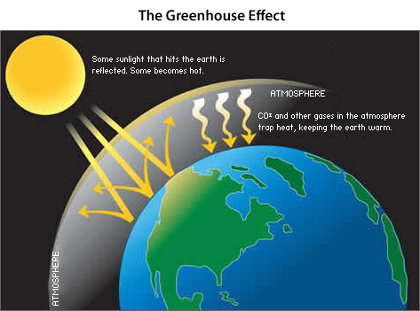
Elmore, D, 2012
Some of the natural sources of carbon dioxide and methane are summarised here:

Natural sources of CO₂ include:
- Volcanic eruptions.
- Natural forest fires.
- Respiration in life forms.
- The decay of organic matter.

Natural sources of CH₄ include:
- Fermentation caused by the decay of organic matter without oxygen, usually in swamps or wetlands.
- Fermentation in the gut of herbivorous animals.
- Released from oceans.
Methane is actually 20 times more potent at trapping heat than CO₂, but because it is found in lower concentrations in the air, it is only the second most influential greenhouse gas.
The natural greenhouse effect is important for ecosystems on Earth as it allows for life to exist within a set of temperature boundaries. Some scientists have predicted that without the moderating effects on the atmosphere, Earth’s temperature range may resemble that of the Moon (-233°C - 123°C).
Questions
- Use a simple diagram to show the process of the natural greenhouse effect.
- Explain the importance of the greenhouse effect for life on Earth.
- Explain the relative importance of both carbon dioxide and methane as greenhouse gases.
- Predict how levels of greenhouse gases might affect future climate on Earth.

______________________________________________________________________________
______________________________________________________________________________
______________________________________________________________________________
______________________________________________________________________________
______________________________________________________________________________
______________________________________________________________________________
______________________________________________________________________________
______________________________________________________________________________
______________________________________________________________________________
______________________________________________________________________________
______________________________________________________________________________
______________________________________________________________________________
______________________________________________________________________________
______________________________________________________________________________
______________________________________________________________________________
______________________________________________________________________________
______________________________________________________________________________
______________________________________________________________________________
______________________________________________________________________________
______________________________________________________________________________

Investigation – modelling the greenhouse effect
Aim: To model the heating of the Earth’s atmosphere due to the greenhouse effect
Materials: 3 x large conical flasks, 3 x rubber stoppers with thermometers, heat lamp, dry ice (source of carbon dioxide), distilled water, forceps, gloves, safety glasses.
Risk assessment: explain safety precautions needed when consider when experimenting with dry ice. Also consider safe amounts of dry ice to use when sublimating inside a sealed container.
______________________________________________________________________________
______________________________________________________________________________
______________________________________________________________________________
Hypothesis:
______________________________________________________________________________
______________________________________________________________________________
Method:
- Add exactly 200ml of distilled water into each conical flask.
- Place the cork with a thermometer on top of each of the flasks and record the initial temperature of the air inside each flask. Be sure not to secure the cork too tightly.
- In flask 1, carefully remove the cork and add a very piece of dry ice using the forceps. As soon as the dry ice is added, replace the cork.
- In flask 2, repeat the above procedure using twice the amount of dry ice.
- Leave flask 3 unchanged.
- Place all three flasks at an equal distance from the heat lamp.
- Record the temperature inside each flask every 2 minutes for 20 minutes.
Labelled diagram of the apparatus:

Results:
Time (minutes) | Flask 1 temperature (°C) | Flask 2 temperature (°C) | Flask 3 temperature (°C)
0

Line graph:

Discussion questions:
- Explain how different aspects of the apparatus modelled the components of the greenhouse effect.
- Identify the independent and dependent variables for this investigation.
- Explain your results and determine if your hypothesis is supported.
- Justify the need for flask 3.
- Account for any potential errors which may have affected the investigation.
- Assess the accuracy and reliability of your data.
- Suggest an inquiry question that could investigate this concept further.

______________________________________________________________________________
______________________________________________________________________________
______________________________________________________________________________
______________________________________________________________________________
______________________________________________________________________________
______________________________________________________________________________
______________________________________________________________________________
______________________________________________________________________________
______________________________________________________________________________
______________________________________________________________________________
______________________________________________________________________________
______________________________________________________________________________
______________________________________________________________________________
______________________________________________________________________________
______________________________________________________________________________
______________________________________________________________________________
______________________________________________________________________________
______________________________________________________________________________
______________________________________________________________________________
______________________________________________________________________________
______________________________________________________________________________
______________________________________________________________________________
______________________________________________________________________________
______________________________________________________________________________
______________________________________________________________________________
______________________________________________________________________________
______________________________________________________________________________
______________________________________________________________________________
______________________________________________________________________________
______________________________________________________________________________
______________________________________________________________________________
______________________________________________________________________________
______________________________________________________________________________
______________________________________________________________________________
______________________________________________________________________________
______________________________________________________________________________
______________________________________________________________________________
______________________________________________________________________________
______________________________________________________________________________
______________________________________________________________________________
______________________________________________________________________________

Climate variations and the geological timescale
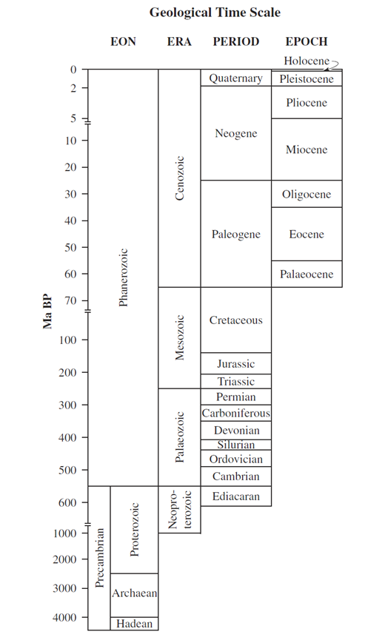
The timescales over which climate changes occur can be examined with respect to the geological timescale, as was introduced in Module 1. Scientists have divided the history of the Earth into different eons, eras, periods and epochs, according to evidence of major geological and biological changes that have occurred in the past.
Many of these changes are observable in the fossil record, and sometimes in the form of mass extinction events. A mass extinction, usually defined as a loss of 60% or more of the Earth’s species, can result from natural climate changes. For example, fossil evidence indicates the sudden extinction of the dinosaurs approximately 66 million years ago. This event marks the Cretaceous/Paleogene boundary.
Despite being attributed to a meteorite impact, it is suggested that consequential climate changes were responsible for the majority of species extinctions. Suspended dust particles in the atmosphere from the impact itself may have reduced sunlight penetration and lowered global temperatures. The temperature is predicted to have recovered quickly in a geological sense, due to an abundance of CO₂ in the atmosphere. These climate variations are believed to have occurred over a time frame from a few hundred thousand years to a few million years, too quick for many species to adapt, hence the mass extinction.
NESA (2019)

Climate variations since the Cretaceous period
Since the end of the Cretaceous Period, evidence suggests that the Earth has experienced an overall cooling trend. Sixty million years ago, the sea levels were also much higher due to an absence of polar ice caps. This resulted in shallow seas covering much of Australia, North America and Europe. Fossil discoveries suggest that some of the most common plants and animals were those that thrived in hot and wet climates, such as; corals, crocodiles, insects, and rainforest plants species. Some of these fossils have been found in places that are now considered arid zones.
By 25 million years ago, the Earth was cooler and drier. At this time, Australia was dominated by plant species that included eucalyptus and wattle and others that were adapted to dry and warm conditions.
Around 2 million years ago, the cooling trend reached a critical point which allowed ice ages to become possible. A series of glacial and interglacial periods have been regularly occurring since then, roughly every 100,000 years or so.
During glacial periods, the ice caps at the poles would expand and as water became locked up as ice, causing the sea levels to drop. Parts of continents became deserts, as the world becomes not only cold but very dry.
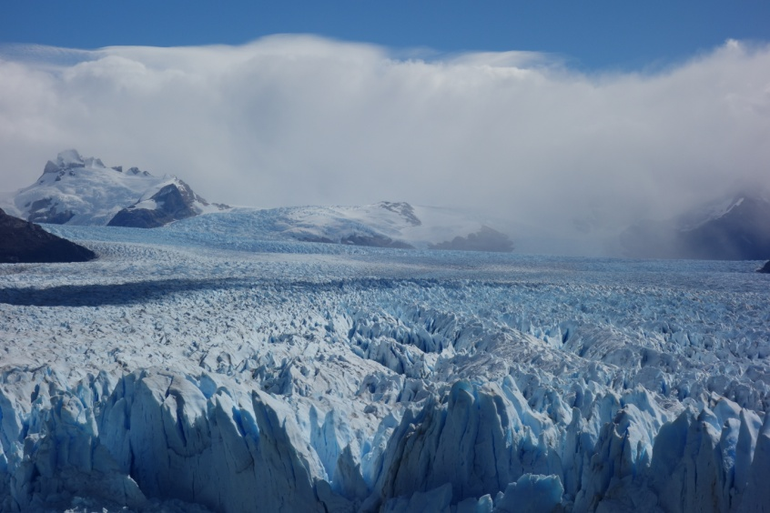
Murada (2016)

During interglacial periods, the polar ice caps shrink, causing sea levels to rise and climates to become warmer and wetter. Since the last ice age ended only about 15,000 years ago, the world has been warming into a new interglacial period. Recent human activities have also contributed to an increase in global temperatures; this concept will be discussed in detail later in the module.
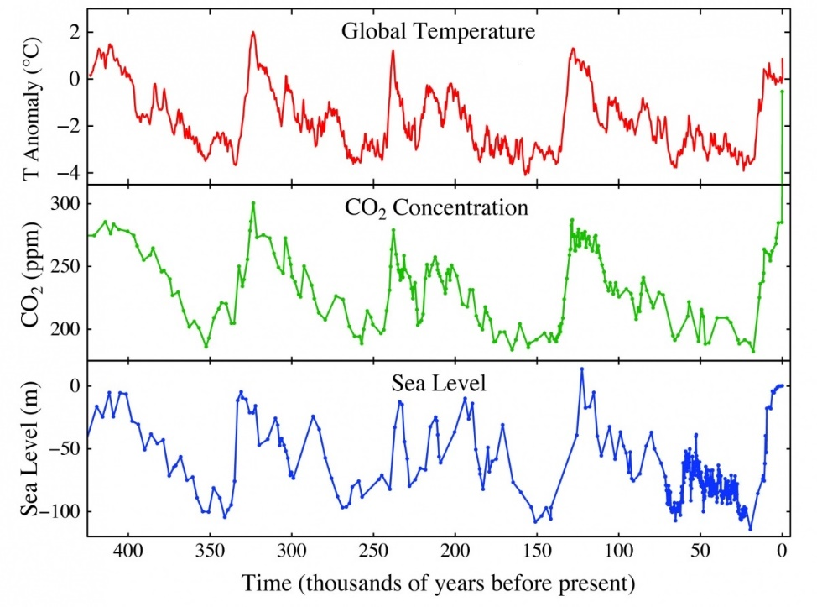

Englander (2013)
Questions:
- Explain one example of how climate changes have influenced the construction of the geological timescale.
- Explain, using an example, how fossil discoveries can provide information about past climates.
- Distinguish between features of ‘glacial’ and ‘interglacial’ periods in Earth’s history.
- Using the graph above, explain the relationship between global temperature and sea level.

______________________________________________________________________________
______________________________________________________________________________
______________________________________________________________________________
______________________________________________________________________________
______________________________________________________________________________
______________________________________________________________________________
______________________________________________________________________________
______________________________________________________________________________
______________________________________________________________________________
______________________________________________________________________________
______________________________________________________________________________
______________________________________________________________________________
______________________________________________________________________________
______________________________________________________________________________
______________________________________________________________________________
______________________________________________________________________________

Causes of natural climate variations

Changes in the Earth’s orbit
The Earth orbits around the Sun in an elliptical path. This orbit fluctuates as the degree of the elliptical path changes over a cycle that lasts about 100,000 years. Changes in the shape of Earth’s orbit are called the ‘eccentricity’.

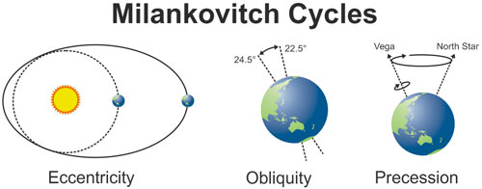

Sceptical Science (2015)
The axial tilt, or ‘obliquity’, varies over a period of 40,000 years. Obliquity can be defined as the angle between the Earth’s orbit and its axis of rotation, and it can affect the extremes of the seasons.
The third orbital variable is known as ‘precession’, and it can be defined as the wobble of the Earth’s orbit. This affects how the cycle of seasons corresponds to the eccentricity of the orbit. For example, at the moment, when the Earth is closest to the Sun; it is summer in the southern hemisphere. However, this relationship is reversed every 21,000 years or so.
These orbital variations, known as ‘Milankovitch Cycles’, combine to cause complicated yet predictable climate cycles. Strong correlations between Milankovitch Cycles and the Earth’s climate changes can be seen when analysing the climate data for the past 2 million years.

The Plate Tectonic Supercycle
In Module 5, the plate tectonic supercycle concept was investigated. It describes how, due to plate movements, continents will converge towards a single landmass, then separate again. The last single landmass, named Pangaea, began to break up approximately 170 million years ago. It is predicted that the landmasses will eventually collide to form another single supercontinent over the next few hundred million years. Several supercontinent cycles are thought to have existed in Earth’s history, and these have likely had significant influences on global climates.
In periods of Earth’s history when a single supercontinent has existed, global temperatures tend to be cooler and the air drier, with lower sea levels. This may be due to a lack of volcanic activity as there is less rifting and subduction at plate boundaries. This could lead to lower levels of CO₂ in the atmosphere, causing a reduction in the greenhouse effect, keeping temperatures relatively low. This decrease in heat, in turn, could keep evaporation from oceans lower and reduce rainfall. Cooler temperatures will likely also increase amounts of polar ice, keeping sea levels lower.
When continents are distributed around the Earth, much like today, there is likely more volcanic activity, from rifting and subduction at plate boundaries. The increase of CO₂ warms the Earth, leading to a rise in evaporation and rainfall. Ice caps are reduced, and so sea levels are higher.

Ocean currents
Plate movements not only affect the continents, but also the shape of the oceans. Moving continents have a huge effect on ocean currents, which are major controlling factors of climate. Ocean currents move heat around the Earth as warm currents generally flow towards the poles, and cold currents generally flow towards the equator. This concept was investigated in Module 3.
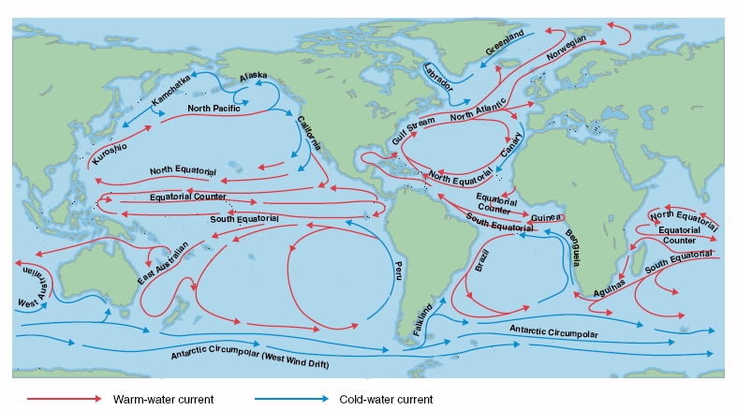
Satellite Applications for Geoscience Education (n.d.)

Parts of Western Europe, such as the United Kingdom, Ireland and Norway, are warm enough to farm during the summer. At the same latitudes across the Atlantic, Greenland and northern Canada consist of frozen arctic tundra, where few people can live because agriculture is very limited. The difference in climate between these regions is largely caused by the Gulf Stream, a warm ocean current which flows from the Caribbean across the Atlantic to warm the coastal areas of Europe. Meanwhile, Canada and Greenland are kept frozen by the cold ocean currents flowing down from the Arctic Sea. After that heat is pulled out, what is left behind is colder water with a higher salt concentration. That makes it denser and heavier. That cold, dense, heavy water sinks at a rate of 19 billion litres per second and pulls the current back south.
At the end of the last ice age, as glaciers were melting across the continent of North America, a giant pool of freshwater formed - The Great Lakes are the remnants of this. An ice dam on the eastern border formed, but it was not stable and eventually collapsed. All the freshwater that once made up the glacier came rushing out into the North Atlantic, diluting the salty, dense, cold water. This made it fresher and lighter, so water stopped sinking, the current to stopped flowing, and the heat transfer stopped. It is thought that this is the reason that Europe went back into an ice age for another 900 to 1000 years. This change is an example of how changes to ocean currents have the potential to drastically change local or global climate patterns over relatively short periods.

Massive volcanic eruptions
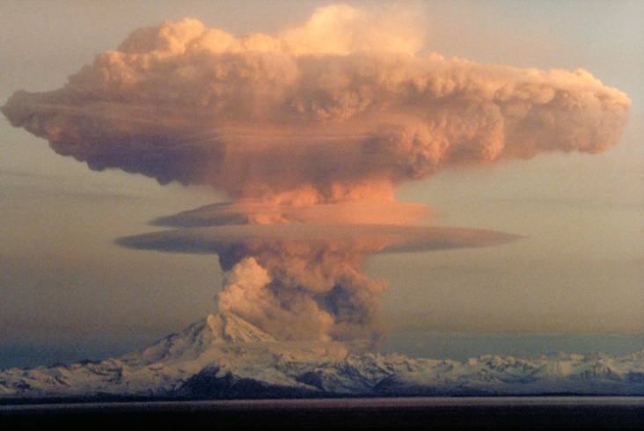
In Module 6, the relationship between large, explosive eruptions and their impacts on the atmosphere was investigated. The volcanic activity that occurs in only one place has the potential to rapidly affect the global climate if the volcanism is large enough. Massive eruptions can eject volcanic material so high that it enters the stratosphere. At such high altitudes, the volcanic material is actually above the troposphere where clouds form and weather events occur, meaning that it is unlikely to be washed out by rain. Despite most of the solid particles falling under gravity, the very finest ash and dust can remain suspended for years.
Clucas (1990)
Aerosols are microscopic liquid droplets suspended in the air and are also made by massive eruptions. Most of the liquid is sulfuric acid, which forms from erupted sulphur dioxide (SO₂). This can cause acid rain, which kills forests and poison waterways all around the world. Once they reach the stratosphere, volcanic dust and aerosols can affect global climate by spreading around the world.
Initially, ash, dust and aerosols reduce the sunlight that reaches the Earth by blocking, reflecting and scattering the light. This reduction in radiation reaching the surface can lower the average global temperature. Temperatures can be reduced for several years from a single, brief eruption. Eventually, the dust and aerosols settle out and disappear, leading to a second possible climate change. Vast quantities of carbon dioxide gas are emitted by every volcanic eruption. This CO₂ can lead to global warming due to the greenhouse effect.
There have been several recent large eruptions that have been shown to reduce the average global temperature in the years that follow. The most famous of these could be the Tambora eruption of 1815 in Indonesia, which led to the “Year Without Summer” in 1816. The decrease in temperatures led to disruptions to major weather systems, and human communities far away from the volcano, including those in Europe and North America, faced crop failures, epidemic disease and civil unrest.

The Deccan Traps
The Deccan Traps are located in central India are one of the largest volcanic features on Earth. The region began forming 66 million years ago at the end of the Cretaceous period. Multiple layers of solidified basalt 2km thick cover an area of around 500,000km². It is predicted that the Deccan Traps may have originally been approximately three times larger, about half the size of modern India, but have since eroded to their current size due to weathering and plate tectonic processes.
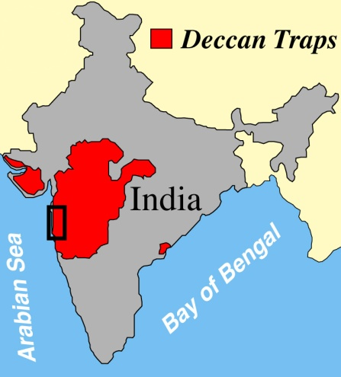
UC Berkeley (2015)
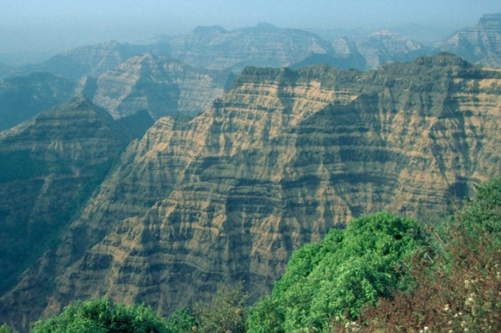
Nicholas (n.d.)

The release of volcanic gases during the formation of the traps contributed to climate change and data indicates an average drop in temperature of 2°C in this period. There is some evidence to link the Deccan Traps eruptions to the asteroid impact which created the Chicxulub crater in Yucatán, Mexico, causing the mass extinction. It is suggested by some that although the Deccan Traps began erupting well before the impact, the meteorite impact increased the eruptive volume.

The Siberian Traps
The Siberian Traps are found in modern-day Russia and formed from a massive eruptive event at the end of the Permian Period, which continued for as much as one million years. Today the area covered is about 2 million km², roughly equal to Western Europe in land area, and estimates of the original coverage are as high as 7 million km².
This massive eruptive event spanned the Permian-Triassic boundary and is cited as a possible cause of the Permian extinction event. One of the major questions is whether the Siberian Traps were directly responsible, or if they were themselves caused by some other larger event, such as an asteroid impact. A recent hypothesis put forward describes that the volcanism was a trigger that led to an explosion of the growth of Methanosarcina, a microbe that then spewed enormous amounts of methane into Earth's atmosphere.
This extinction event affected all life on Earth and is estimated to have killed about 90% of all species living at the time. It is sometimes referred to as “The Great Dying”. Calculations of seawater temperature from ¹⁸O-¹⁶O isotope measurements indicate that at its peak, the Earth underwent lethally hot global warming, in which equatorial ocean temperatures exceeded 40°C. Life on land took at least 30 million years to fully recover from the environmental disruptions which may have been caused by the eruption of the Siberian Traps.
Questions
- Complete the table below which summarises information about natural causes of climate variations
- Outline two examples of evidence that support the idea that the traps are related to mass extinction events.
________________________________________________________________________________
________________________________________________________________________________
________________________________________________________________________________
________________________________________________________________________________
________________________________________________________________________________
________________________________________________________________________________
________________________________________________________________________________
________________________________________________________________________________
________________________________________________________________________________
________________________________________________________________________________
______________________________________________________________________________
______________________________________________________________________________
______________________________________________________________________________

Causes of Natural Climate Variations
Use the table provided to summarise the information about the causes of natural climate variations.
Cause of natural climate variation | Description of this factor | Assessment of the impact this factor has on the climate | Over what timescale does this factor cause change?
Changes in the Earth’s orbit
The plate tectonic supercycle
Ocean currents
Massive volcanic eruptions

References

Texts
‘An Inconvenient Truth’, 2006, documentary film, Paramount Classics, Hollywood California, directed by David Guggenheim, written by Al Gore.
Benton, M. J., 2005, ‘When Life Nearly Died: The Greatest Mass Extinction of All Time’, Thames & Hudson.
Che, J., 2014, ‘What really killed the dinosaurs? Before an asteroid wiped out the dinosaurs, Earth experienced a short burst of intense volcanism’, MIT News Office.
Keep It Simple Science, 2006-2007, ‘Planet Earth’, Keep It Simple Science, Port Macquarie, pages 16-17.
Keep It Simple Science, 2007, ‘Water Issues’, Keep It Simple Science, Port Macquarie, page 4.
Keep It Simple Science, 2007, ‘Tectonic Impacts’, Keep It Simple Science, Port Macquarie, page 5.
Keep It Simple Science, 2007, ‘Caring for Country’, Keep It Simple Science, Port Macquarie, page 18.
Keller, G., 2014, ‘Deccan volcanism, the Chicxulub impact, and the end – Cretaceous mass extinction: Coincidence? Cause and effect?’, in Volcanism, Impacts, and Mass Extinctions: Causes and Effects, GSA Special Paper 505, Pp. 29-55.
Royer, D. L., Berner, R. A., Montañez, I. P., Tabor, N. J., Beerling, D. J., 2004, ‘CO2 as a primary driver of Phanerozoic climate’, GSA Today, 14 (3): pages 4-10.
Sahney, S. & Benton, M.J., 2008, ‘Recovery from the most profound mass extinction of all time’, Proceedings of the Royal Society: Biological. 275 (1636): pages 759–65.
Schulte, Peter, et al., 2010, ‘The Chicxulub Asteroid Impact and Mass Extinction at the Cretaceous-Paleogene Boundary’, Science AAAS, 327 (5970): pages 1214-1218.
Singh, R. N.; Gupta, K. R., 1994, ‘Workshop yields new insight into volcanism at Deccan Traps, India’, Eos, 75: page 356.

Images
Elmore, D, 2012, ‘The Greenhouse Effect’, image, Green Action Centre
Murada, J, 2016, ‘Puerto Merino Glacier’, image, personal collection.
NSW Education Standards Authority (NESA), 2019, ‘Geological Timescale’, image, Earth & Environmental Science HSC Sample Paper.
Englander, J, 2013, ‘Sea-Level Change over 400,000 Years’, image, Climate Science Investigations, NASA.
Skeptical Science, 2015, ‘Milankovitch Cycles’, image, CO2 Lags Temperature - What Does it Mean?
Clucas, R., 1990, ‘Picture of Mount Redoubt Eruption’, image, USGS.
UC Berkeley, 2015, ‘Deccan Traps’, image, Asteroid Impact, Volcanism Were One-Two Punch for Dinosaurs.
Nicholas, A., n.d., ‘The Western Ghats at Matheran in Maharashtra’, image, Alchetron.

