Problem set: Year 12 Earth and Environmental Science

Introduction
This document contains questions to probe students’ understanding of various concepts in the Year 12 course of the Stage 6 Earth and Environmental Science (EES) syllabus. The questions have been designed by NSW EES teachers who attended the ‘Teaching the Year 12 modules in Stage 6 Science’ workshops in 2019, as well as the science curriculum support officers at the Learning and Teaching Directorate. The problem set may be used as classroom activities or in assessments to evaluate student understanding. Teachers are free to adapt or modify the questions in this problem set to suit the learning needs of their students.

Acknowledgements
The Learning and Teaching Directorate at the NSW Department of Education developed this resource for science teachers. The department acknowledges the efforts of the EES teachers at the ‘Teaching the Year 12 modules in Stage 6 science’ workshops for contributing to this resource.

Multiple choice questions
Use the data below to answer questions 1 and 2.
A scientist, concerned with volcanic materials impacting upon acidity in local waterways, investigated the issue.
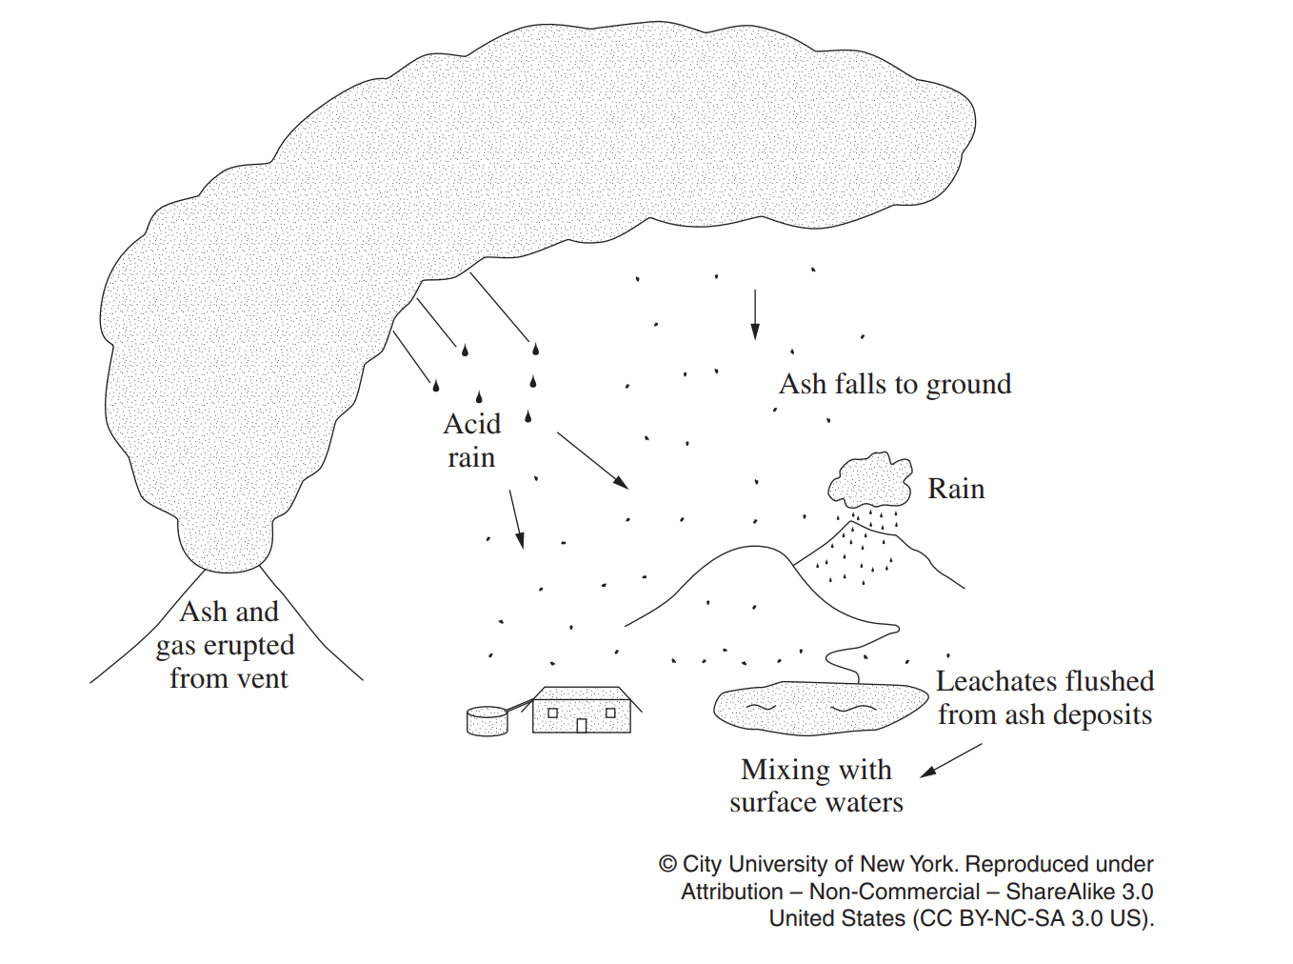
Image credit: NESA

Question 1 (Module 6)
Which volcanic material would the scientist be concerned with for this investigation?
  - Fine ash particles
  - Carbon dioxide
  - Carbon monoxide
  - Methane

Question 2 (Module 6)
Which of the following methods would provide the most accurate reading for the investigation?
  - Measuring the pH of surface waters with Universal Indicator and colour chart
  - Measuring the pH of atmospheric gases near the volcanic vent with a calibrated electronic pH probe
  - Measuring the pH of surface waters with a calibrated electronic pH probe
  - Determining whether acids are present using litmus paper with 10 separate measurements

Question 3 (Module 7)
The graph shows carbon dioxide emissions from four activities in Australia from 1990-2007.
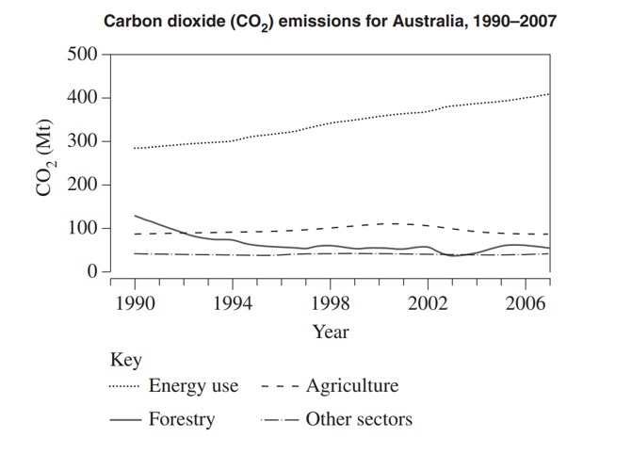
Image credit: NESA
Based on the graph, which of the following statements represents a valid conclusion?
  - CO₂ emissions due to energy use are in steady decline
  - In 1990 forestry was the second-largest producer of CO₂ emissions in all of Australia
  - Society has embraced the use of renewable energy sources towards 2007
  - There is an overall decline in CO₂ emissions due to forestry activities from 1990-2007
Use the data below to answer questions 4 and 5.
The combustion of methane was experimentally analysed (Experiment 1 and 2). In these experiments, methane was burnt under two sets of conditions. The products of the burning were analysed, and the results are shown in the graphs.
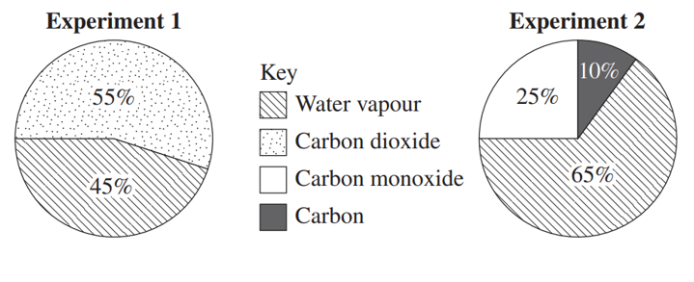
Image credit: NESA

Question 4 (Module 7)
The independent variable in the experiment is
  - The different conditions under which methane is burnt
  - The products of combustion
  - The volume of methane
  - The amount of heat released

Question 5 (Module 7)
For this investigation to be valid, it should
  - Have equal volumes of methane to start with
  - Produce equal volumes of carbon dioxide
  - Be repeated multiple times
  - Be measured with digital instruments only

Extended response questions

Question 6 (Module 6)
The diagram below shows the locations of some different tectonic plates. The arrows indicate the directions of movement for each plate.
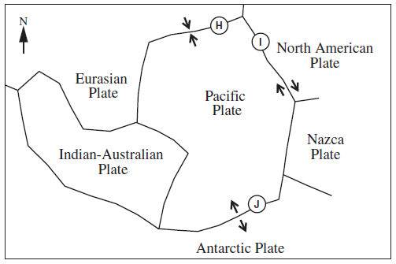
Image credit: NESA
  - Predict and explain how the properties of the magma at locations H and J would impact on the frequency and magnitude of volcanic eruptions in those regions (6 marks).
  - Explain one hazard that could occur as a result of the most likely tectonic event at location I (3 marks).

Marking criteria (a)
Criteria | Marks
- Demonstrates a thorough understanding of convergent and divergent plate boundaries  - Relates each boundary type to magma composition and/or viscosity  - Accurately relates the properties of magma to predict both the frequency and magnitude of volcanic eruptions | 5-6
- Demonstrates a sound understanding of convergent and divergent plate boundaries  - Relates each boundary type to magma composition or viscosity  - Accurately relates the properties of magma to predict the frequency or magnitude of volcanic eruptions | 3-4
- Demonstrates a basic understanding of convergent and divergent plate boundaries  - Makes some links between boundary type and/or magma properties of eruptions | 2-3
- Some relevant information | 1

Sample answer
Different plate boundaries produce magma with different properties. Divergent boundaries such as the one at location J tend to have magmas that are relatively low in silica or mafic magma. Mafic magma has low viscosity, which means it can run freely. The volcanoes that form here typically erupt more frequently and don’t allow the build-up of gases. This means the magnitude of eruptions tends to be relatively low.
Convergent boundaries such as the one at location H tend to have magma that is relatively high in silica or felsic magma. Felsic magma has high viscosity. Because of the high viscosity, volcanoes that produce felsic magma at convergent boundaries typically only erupt occasionally, some lying dormant for decades or even centuries. The magnitude of those eruptions tends to be relatively high because the magma can have difficulty flowing. This leads to a build-up of pressure, due to blockages and a build-up of gases, which results in explosive and often violent eruptions.

Marking criteria (b)
Criteria | Marks
- Identifies earthquakes as the most likely tectonic event  - Identifies an appropriate hazard that could occur due to earthquakes  - Relates the hazard to the existence of a transform boundary at a location I | 3
- Identifies earthquakes as the most likely tectonic event  - Identifies an appropriate hazard that could occur due to earthquakes  OR  - Identifies location I as on a transform boundary | 2
- Any relevant information | 1

Sample answer
The location exists on a transform boundary where two plates slide past one another. This can build up stress in the crust that can result in an earthquake when that stress is released. If an earthquake occurs near enough to a building, the ground motion can cause the collapse of buildings, which can threaten lives nearby.

Question 7 (Module 5)
Annotate the graph to explain the changes in atmospheric oxygen over time. Refer to at least four parts of the graph (4 marks).
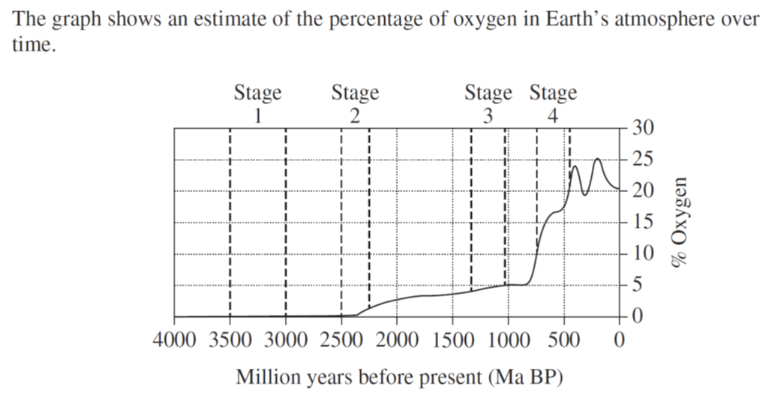
Image credit: NESA

Marking criteria
Criteria | Marks
- Explains, using appropriate annotations, any four changes in oxygen concentration | 4
- Describes four of the major changes in oxygen concentration  OR  - Explains, using annotations, some of the major changes in oxygen concentration | 2-3
- Some relevant information | 1

Sample answer
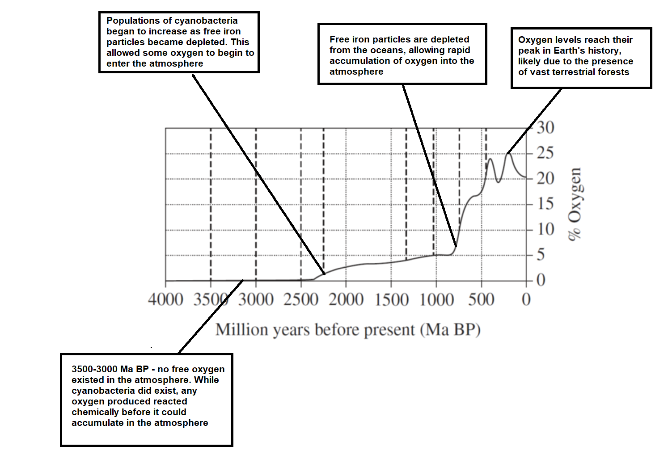

Question 8 (Module 7)
The graph below shows some of the changes in temperature and carbon dioxide on Earth over the past 160 000 years. Explain the temperature and carbon dioxide concentration trends shown in the graph. In your answer, refer to natural phenomena that contribute to these trends (4 marks).
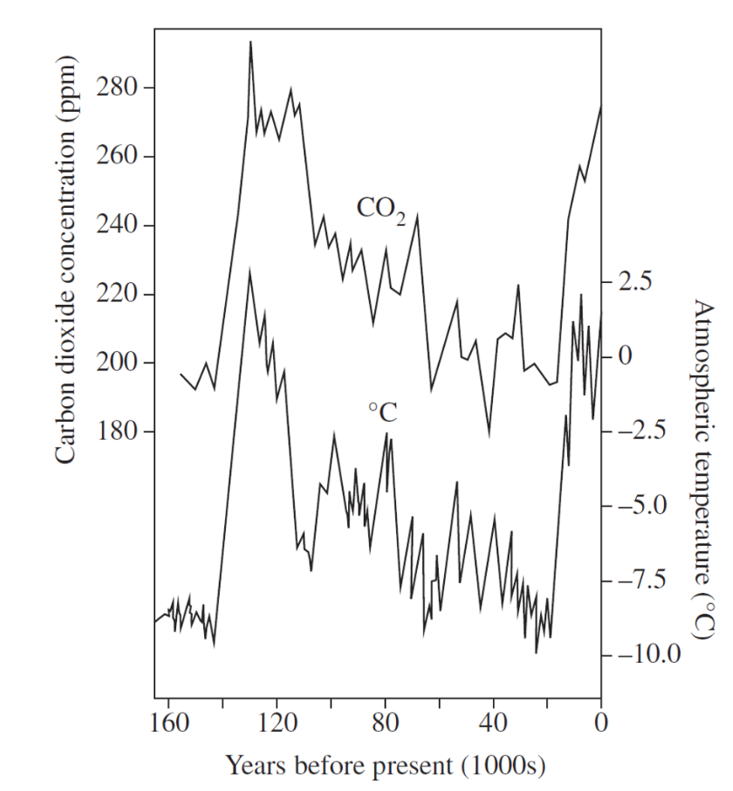
Image credit: NESA

Marking criteria
Criteria | Marks
- Demonstrates a sound understanding of the different ways climate can change naturally  - Provides an explanation of the relationship between carbon dioxide and temperature  - Can incorporate specific data from the graph to explain trends | 4
- Demonstrates basic knowledge and understanding of the different ways climate can change naturally  - Can link changes in carbon dioxide to temperature or uses specific data from the graph in explaining changes | 2-3
- Any relevant information | 1

Sample answer
Over the past 160 000 years, the concentration of carbon dioxide in the atmosphere and the atmospheric temperature have both fluctuated. There appears to be a relationship between the two. The greenhouse effect occurs when certain gases, including carbon dioxide, trap solar radiation. This explains why warmer temperatures coincided with those times when carbon dioxide concentration is relatively higher, e.g. ~130 000 years ago. At other times, when carbon dioxide levels are lower, e.g. 40 000 years ago, global average temperatures are lower. Some of the natural causes of these changes in carbon dioxide concentration include large volcanic eruptions, natural forest fires and the decay of organisms. It should also be noted that other natural processes can affect temperature (without any influence from carbon dioxide), such as Earth’s pattern of orbit around the Sun.

Question 9 (Module 6)
Describe how the reliability of technologies used in meteorology has improved to better predict and prevent damage to life and infrastructure as a result of natural weather events (4 Marks).

Marking criteria
Criteria | Marks
- Demonstrates sound knowledge and understanding of the reliability of multiple technologies used in meteorology to predict natural weather events and prevent damage to life and infrastructure that may result from adverse events. | 3-4
- Demonstrates basic knowledge and understanding of the reliability of one or more technologies used in meteorology to predict natural weather events, and prevent damage to life and infrastructure that may result from adverse events. | 2-3
- Outlines limited understanding of the reliability of a technology used in meteorology to predict natural weather events and prevent damage to life and/or infrastructure that may result from adverse events | 1

Sample answer
In decades past, weather forecasts have been unreliable and inconsistent. In modern times, the reliability of weather predictions is far more advanced, and technologies in use ensure a far greater rate of successful prediction. The ongoing research to better understand climate systems would not be possible without the data from these modern technologies. Meteorologists can predict and give warnings about dangerous weather conditions. The BoM regularly issues warnings about dangerous hailstorm possibilities, rough surf conditions or the track of an approaching tropical cyclone. These predictions can prevent/reduce hazards which could cause damage to life and buildings, through early warning procedures, e.g. implementing procedures like locking down materials, remaining indoors, and evacuating areas at risk.
Modern meteorological technologies can monitor global weather events to allow general warnings of impending droughts or floods due to the ENSO cycle. This allows early preparations to be made, such as by extra controlled burns to minimise bushfire threats, or early flood warnings when heavy rains are imminent. This provides preventative measures to reduce damage to lives and infrastructure. Technology developments which are having major impacts on emergency warnings and responses include the rise of smartphones and social media including SMS messaging, Twitter, etc. to assist in the prevention of loss of life and damage to infrastructures.
Overall, the ability to predict natural weather events due to technologies has increased over time to enable meteorologists to reasonable predict and prevent the damage to life and infrastructure within a short time frame.

Question 10 (Module 8)
The map shows the location and type of Australia’s renewable power plants.
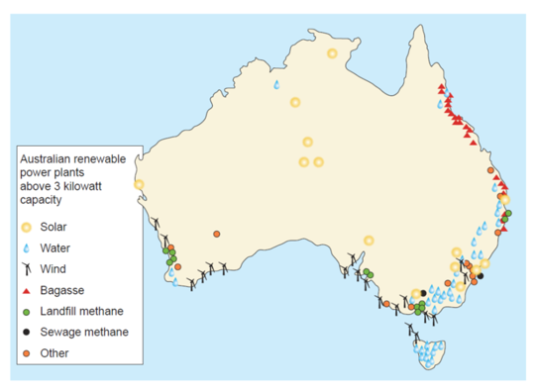
Image credit: NESA
  - Construct a table to compare the distribution of water and solar power plants in Australia (2 marks).
  - Discuss the potential benefits and limitations of expanding the use of wind and landfill methane as options for future renewable power plants (4 marks).

Marking criteria (a)
Criteria | Marks
- Distribution of both water and solar accurately outlined  - Information organised logically into a table | 2
- Distribution of either water or solar accurately outlined | 1

Sample answer
 | Water | Solar
Distribution | Located only around coastal fringes of eastern Australia and a small pocket in the SW on the coast | Pockets located in both coastal and central parts of the continent

Marking criteria (b)
Criteria | Marks
- Demonstrates a sound understanding of one societal benefit and one limitation of wind farm expansion  - Demonstrates a sound understanding of one societal benefit and one limitation of expanding landfill methane operations | 3-4
- Can provide some valid information around the benefits or limitations of wind farms and/or landfill methane operations | 1-2

Sample answer
A benefit of expanding more wind farms is their impact on the atmosphere – they will not contribute to air pollution/increase greenhouse gas emissions, which are linked to global warming. A limitation could be that many residents will not be pleased with the visual appearance of a high number of wind farms and some may claim the value of their land could be diminished as a result.
A benefit for developing more energy from landfill is that gases that may normally escape into the atmosphere at landfill sites could now be trapped and recycled. A limitation could be that encouraging more landfill sites will not act to shift attitudes towards the production of excess solid wastes or seek renewable energy sources such as wind and solar which do not contribute to global warming.

Question 11 (Module 5)
The maps show landmasses in the same region at two different points in time.
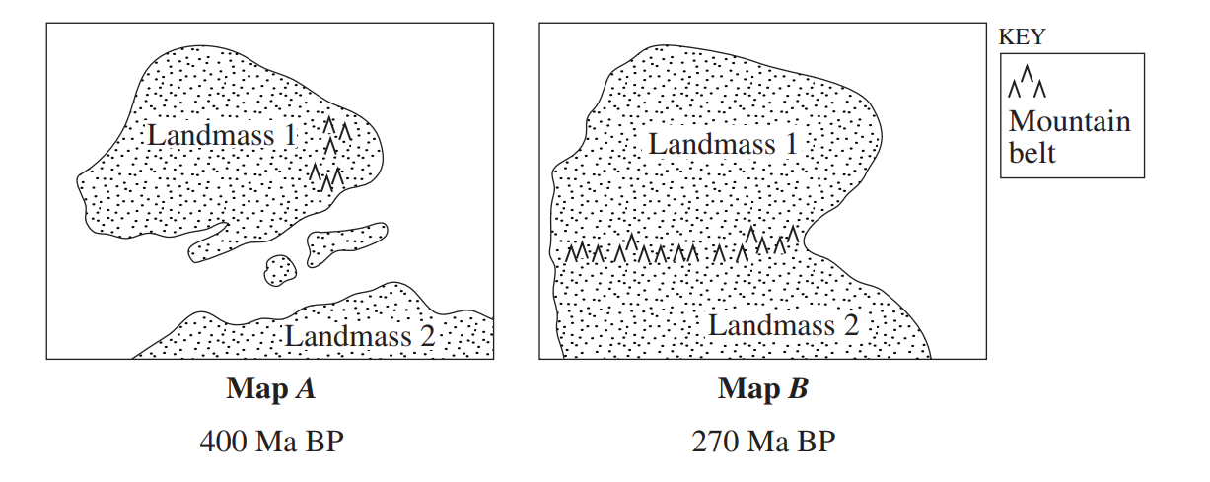
Image credit: NESA
Use your knowledge of the plate tectonic supercycle to explain what has occurred (3 marks).

Marking criteria:
Criteria | Marks
- Cleary explains tectonic processes involved in the changes, using evidence from the diagram | 3
- Can describe some aspects of tectonic processes involved in changes | 2
- Any relevant information | 1

Sample answer
There is a subduction zone that exists between both landmasses, meaning that the 2 plates on which they exist will converge together as the ocean floor is consumed. Eventually, the two plates containing continental crust will collide. This will create uplift as indicated by the new mountain belt that has formed. The original mountain belt from Landmass 1 has likely eroded away over the 130 Ma.

Question 12 (Module 8)
The diagram below shows a cross-section of the oceanic floor and the processes leading to the formation of a base metal mineral deposit.
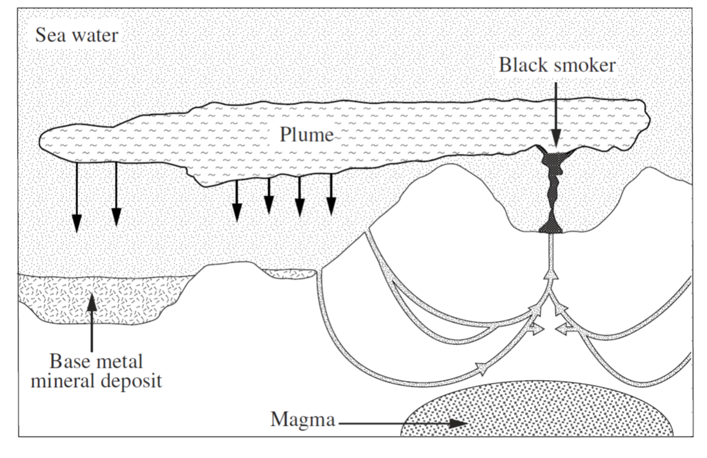
Image credit: NESA
Construct a flow chart to outline the steps involved in the formation of the base metal mineral deposit (3 marks).

Marking criteria
Criteria | Marks
- Accurately outlines 3 or more steps in sequential order, separated by arrows | 3
- Accurately outlines 2 steps in sequential order, separated by arrows  OR  - Accurately outlines 3 or more steps without arrows | 2
- Any relevant information | 1

Sample answer
Volcano erupts releasing materials into the water column → plume is carried away by ocean currents → denser particles of the metal sink to the ocean floor and are deposited.

Question 13 (Module 6, Module 7)
The following diagram shows atmospheric temperature changes at the time of the Mount Pinatubo eruption.
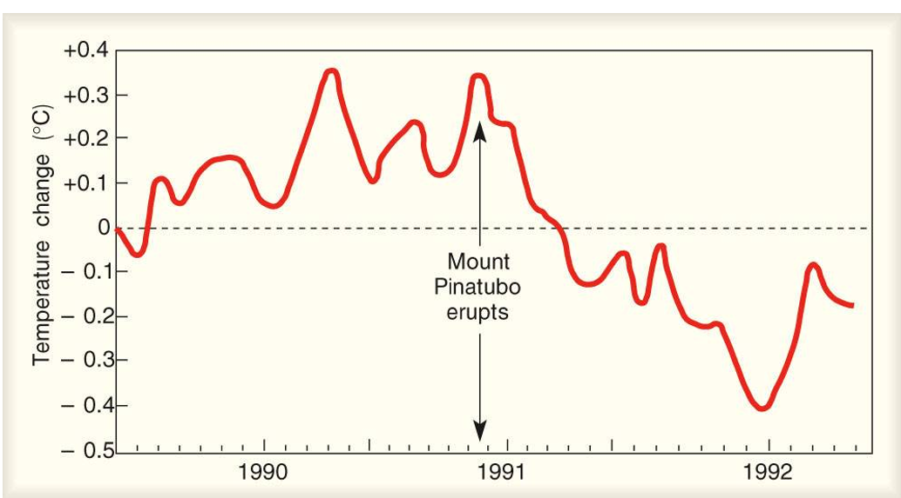
Image credit: Northern Vermont University
  - Explain the impact of the Mount Pinatubo eruption on global temperatures (2 marks).
  - Describe the evidence for massive volcanic eruptions that have occurred in the ancient past (3 marks).

Marking criteria (a)
Criteria | Marks
- Identifies a decrease in global temperature following the eruption  - Relates this to the release of volcanic aerosols | 2
- Identifies a decrease in global temperature following the eruption | 1

Sample answer
In the years following the eruption, the global temperature decreases. This is because large eruptions can release aerosols and ash, which can reflect solar radiation.

Marking criteria (b)
Criteria | Marks
- Describes in detail TWO examples of evidence past massive volcanic eruptions | 3
- Outlines TWO examples of evidence of past massive volcanic eruptions | 2
- Any relevant information | 1

Sample answer
Scientists have discovered and dated two major volcanic deposits called large igneous provinces that likely resulted from massive and ongoing volcanic eruptions. A major flood basalt, called the Deccan traps, was deposited at what is now India around 66 Ma. The other exists in modern-day Russia, called the Siberian Traps, which have been dated at around 250 Ma.

Question 14 (Module 6)
The map below shows the epicentres of earthquakes with a magnitude of 7.0 and above on the Richter Scale from 1991-1997. The table shows the frequency of these earthquakes for each year.
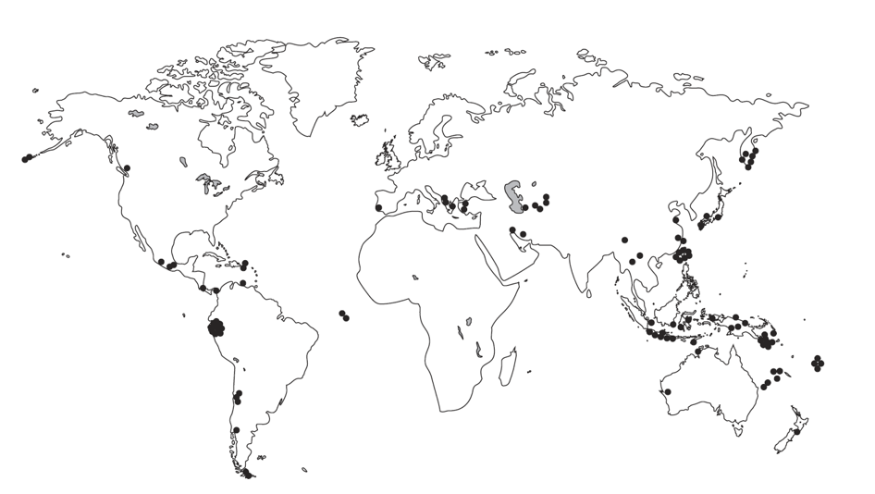
Image credit: NESA
  - Account for the distribution of epicentres shown in the map (2 marks).
  - Compare the risk of tsunami threat from these events in Australia and Africa (2 marks).

Marking criteria (a)
Criteria | Marks
- Identifies a higher concentration around convergent boundaries/subduction zones  - Relates these events to a greater build-up of stress | 2
- Any of the above | 1

Sample answer
Most of the earthquakes with a high magnitude are found along convergent boundaries. This is because the pressure in the crust can build up due to compressional forces between two plates, which eventually are released as earthquakes.

Marking criteria (b)
Criteria | Marks
- Identifies Australia as a higher risk/Africa as a lower risk  - Relates this to the proximity/exposure of more earthquake epicentres that could trigger tsunamis in the direction of Australia but not Africa | 2
- Any of the above | 1

Sample answer
Australia would be at a higher risk of being affected by a tsunami since there are multiple recent sites for high magnitude earthquakes with epicentres just off the north and east coast. Africa has very few of these, so would be at a lower risk.

Question 15 (Module 8)
A class was divided into four groups to measure the pH of groundwater seeping out of a landfill. Each group took multiple readings of the groundwater. A sample was also submitted to the Environmental Protection Agency (EPA) for analysis. The pH was determined by the EPA to be 5.0. The results of the four groups are shown in the graph:
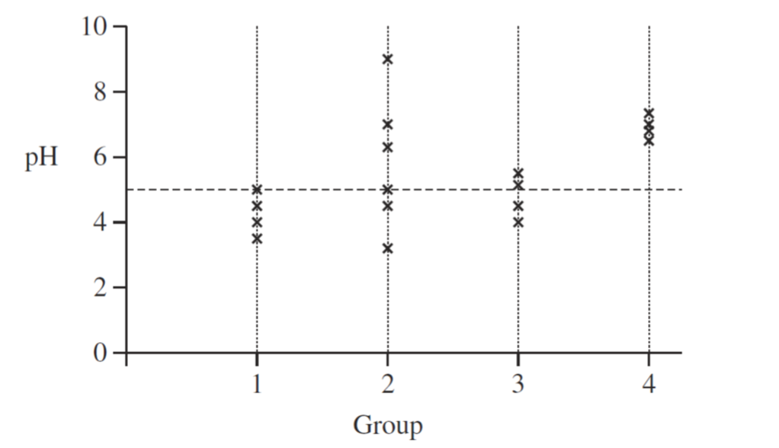
Image credit: NESA
  - Identify the dependent variable in the investigation (1 mark).
  - Justify the group with the most accurate results (2 marks).
  - Justify the group with the most reliable results (2 marks).

Marking criteria (a)
Criteria | Marks
- Identifies pH as the dependent variable | 1

Sample answer
pH.

Marking criteria (b)
Criteria | Marks
- Identifies that Group 3 has the most accurate result  - Relates reason to being closest to EPA reading | 2
- Any of the above | 1

Sample answer
Group 3 had the most accurate results, as their readings were very close to the accepted EPA reading of 5.0.

Marking criteria (c)
Criteria | Marks
- Identifies that Group 4 has the most reliable result  - Relates reason to each repetition of reading being consistent | 2
- Any of the above | 1

Sample answer
Group 4 had the most reliable results. This is because the data from repeated measurements had the lowest spread around the mean.

Question 16 (Module 6)
The diagram below shows information about the Volcanic Explosivity Index (VEI) and the intervals between eruptions.
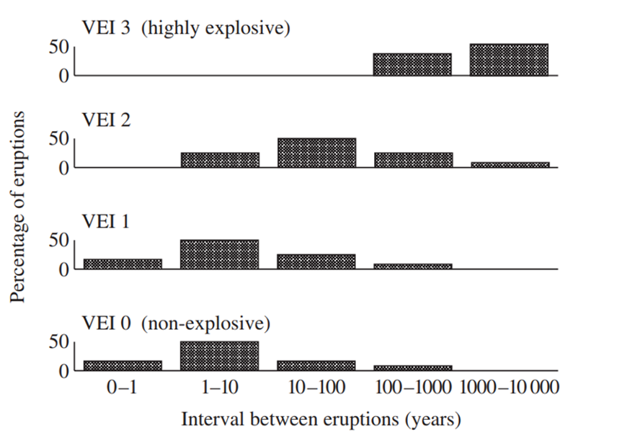
Image credit: NESA
Explain the relationship that exists between VEI, percentage of eruptions and interval between eruptions (3 marks).

Marking criteria
Criteria | Marks
- Explains both relationships using reasoning | 3
- Describes both relationships without reasoning | 2
- Identifies one relationship | 1

Sample answer
There is an overall trend that suggests that as VEI increases, the percentage of eruptions and their frequency decreases. More frequent and ongoing eruptions will occur with a low VEI. These are non-explosive (effusive) because they usually don’t form at subduction zones and won’t build up pressure in magma chambers over extended periods. More explosive eruptions with a higher VEI tend to be less common and less frequent, as it takes time to build up pressure as the plates converge before an eruption.

Question 17 (Module 6)
The table below shows images of 6 different igneous rocks.
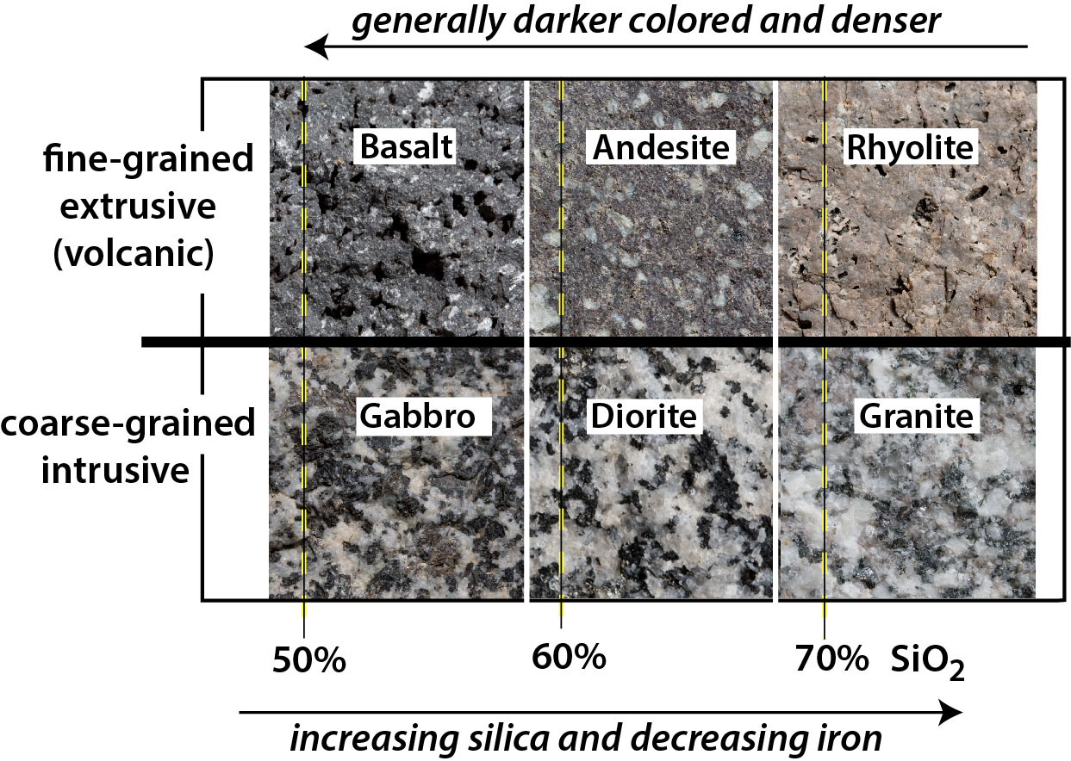
Image credit: Geologictimepics
  - Describe the relationship between the colour and the chemical makeup in igneous rocks (1 mark).
  - An igneous rock was collected, which was coarsely grained, and found to contain around 85% silica. What would this rock most likely be (1 mark)?
  - Explain which of the above rocks would most likely be discovered at the surface near the site of an explosive volcanic eruption (2 marks).

Marking criteria (a)
Criteria | Marks
- Correctly relates colour to the chemical makeup | 1

Sample answer
As igneous rocks become darker, they contain a lower proportion of silica and a higher proportion of iron.

Marking criteria (b)
Criteria | Marks
- Correctly identifies granite as the rock that was collected | 1

Sample answer
Granite.

Marking criteria (c)
Criteria | Marks
- Correctly identifies andesite as the rocks collected near the site of an active volcano  - Relates the formation of andesite to tectonic setting and formation of explosive volcanoes | 2
- Correctly identifies andesite | 1

Sample answer
Explosive volcanic eruptions often occur at the surface above a subduction zone. The erupted lava will often cool to form andesite.

Question 18 (Module 5)
The diagram below represents an apparatus used in an investigation.
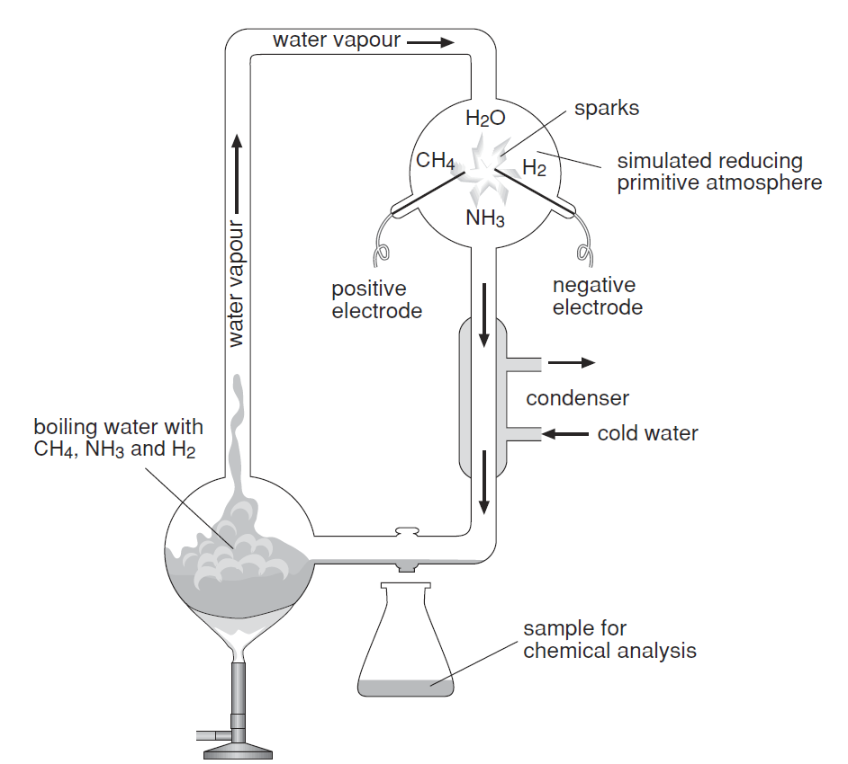
Image credit: TALE, DoE
Explain the purpose of the investigation, how it was conducted and the significance of the findings (4 marks).

Marking criteria
Criteria | Marks
- Clearly describes the purpose of the investigation by Urey and Miller  - Clearly explains examples of how the investigation modelled the early Earth’s environment  - Explains the significance of the discovery of organic molecules | 3-4
- Identifies the purpose of the investigation  - Provides one example of how the apparatus modelled the early Earth’s environment  OR  - Identifies the discovery of organic molecules | 1-2

Sample answer
The famous Urey and Miller experiment attempted to model the environmental conditions thought to be present on the early Earth, to determine if organic molecules for life could be formed from inorganic ones. They circulated the gases predicted to have existed in the atmosphere in an upper chamber with boiling water in the lower chamber, which represented the primitive oceans. An electric spark was provided as an energy source to mimic violent lightning strikes. After a few weeks, the liquid from the condensed gases was tested and found to be rich in various types of amino acids and other organic molecules. This is highly significant because amino acids are the building blocks of life, so it supports the idea that the molecules to build the first cells were formed chemically on the Earth rather than from extra-terrestrial sources.

Question 19 (Module 5)
The image below is a drawing of Ichthyostega, one of the earliest known terrestrial vertebrates from the Devonian Period.
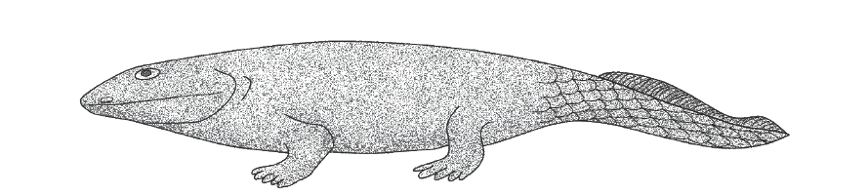
Image credit: TALE, DoE

Annotate the diagram to describe two evolutionary adaptations that allowed for the colonisation of the land (2 marks).

Marking criteria
Criteria | Marks
- Labels and describes any TWO suitable features that allowed a better adaptation to life on land | 2
- Labels and describes any ONE suitable feature that allowed a better adaptation to life on land  OR  - Labels two features that allowed a better adaptation to life on land, without description | 1

Sample answer
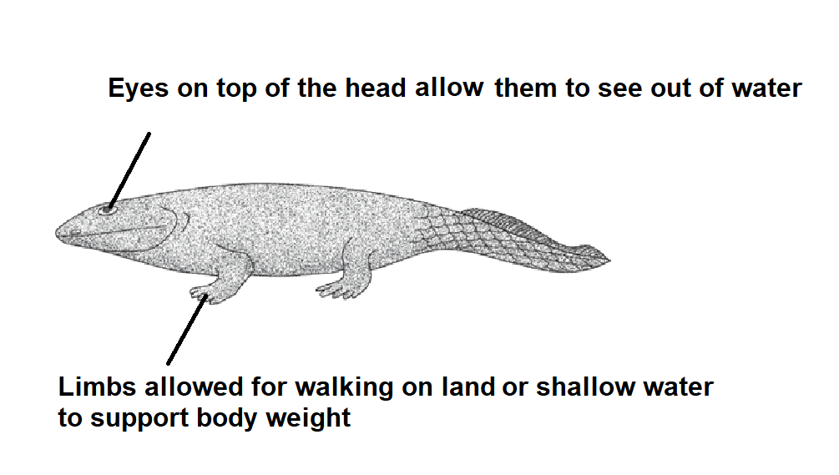

Answers for the Multiple-choice questions
Question | Answer
1 | B
2 | C
3 | D
4 | A
5 | A

Mapping grid
Question | Marks | Content area | Syllabus Outcomes
6a) | 6 | Module 6: Hazards  Inquiry question: How and why do geological disasters occur? | EES 12-4  EES 12-6  EES12-13
6b) | 3 | Module 6: Hazards  Inquiry question: How and why do geological disasters occur? | EES 12-6  EES12-13
7 | 5 | Module 5: Earth’s Processes  Inquiry question: How did today’s biosphere originate and develop?  Inquiry question: How did the changes to the biosphere affect the Earth’s geosphere, atmosphere and hydrosphere? | EES 12-4  EES 12-6  EES 12-7  EES 12-12
8 | 5 | Module 7: Climate Science  Inquiry question: What scientific evidence is there of climate variations in the past? | EES 12-6  EES 12-14
9 | 6 | Module 6: Hazards  Inquiry question: What technologies enable prediction of natural disasters and minimisation of their effects on the biosphere? | EES 12-13
10a) | 3 | Module 8: Resource Management  Inquiry question: How are Australia’s natural resources extracted, used and managed? | EES 12-5  EES 12-7  EES 12-14
10b) | 4 | Module 8: Resource Management  Inquiry question: How are Australia’s natural resources extracted, used and managed?  Inquiry question: Is there scientific evidence to show that human activity has led to a variation in the Earth’s climate since the Industrial Revolution? | EES 12-6  EES 12-13  EES 12-14
11 | 3 | Module 5: Earth’s Processes  Inquiry question: What effect does the plate tectonic super cycle have on Earth? | EES 12-6  EES 12-12
12 | 3 | N/A | EES 12-6  EES 12-7
13a) | 2 | Module 6: Hazards  Inquiry question: How do natural disasters such as explosive volcanic eruptions, earthquakes and extreme weather events influence the biosphere and atmosphere? | EES 12-6  EES 12-13

Question | Marks | Content area | Syllabus Outcomes
13b) | 3 | Module 7: Climate Science  Inquiry question: What scientific evidence is there of climate variations in the past? | EES 12-7
14a) | 2 | Module 6: Hazards  Inquiry question: How and why do geological disasters occur? | EES 12-6  EES 12-13
14b) | 2 | Module 6: Hazards  Inquiry question: How and why do geological disasters occur? | EES 12-6  EES 12-13
15a) | 1 | Module 8: Resource Management  Inquiry question: How is waste managed? | EES 12-2  EES 12-15
15b) | 2 | Module 8: Resource Management  Inquiry question: How is waste managed? | EES 12-5  EES 12-15
15c) | 2 | Module 8: Resource Management  Inquiry question: How is waste managed? | EES 12-5  EES 12-15
16 | 3 | Module 6: Hazards  Inquiry question: How and why do geological disasters occur? | EES 12-5  EES 12-13
17a) | 1 | N/A | EES 12-5
17b) | 1 | N/A | EES 12-6
17c) | 2 | Module 6: Hazards  Inquiry question: How do natural disasters such as explosive volcanic eruptions, earthquakes and extreme weather events influence the biosphere and atmosphere? | EES 12-13
18 | 4 | Module 5: Earth’s Processes  Inquiry question: How did today’s biosphere originate and develop? | EES 12-12
19 | 2 | Module 5: Earth’s Processes  Inquiry question: How did today’s biosphere originate and develop? | EES 12-6  EES 12-12

This document references the Stage 6 Earth and Environmental Science syllabus © 2019 NSW Education Standards Authority (NESA) for and on behalf of the Crown in right of the State of New South Wales.

