Problem set - Year 12 chemistry

Introduction
This document contains questions to probe students’ understanding of various concepts in the Year 12 course of the Stage 6 Chemistry syllabus © 2019 NSW Education Standards Authority (NESA) for and on behalf of the Crown in right of the State of New South Wales. The questions have been designed by NSW chemistry teachers who attended the ‘Teaching the Year 12 modules in Stage 6 Science workshops in 2019, as well as the science curriculum support officers at the Learning and Teaching Directorate. The problem set may be used as classroom activities or in assessments to evaluate student understanding. Teachers are free to adapt or modify the questions in this problem set to suit the learning needs of their students.

Acknowledgements
The Learning and Teaching Directorate at the NSW Department of Education developed this resource for science teachers. The department acknowledges the efforts of the chemistry teachers at the ‘Teaching the Year 12 modules in Stage 6 science’ workshops for contributing to this resource.

Module 5

Question 1 (8 marks)
A student is investigating the following reaction system.
2NO_{2(g)} | ⇌ | N₂O_{4(g)} | ΔH < 0
brown |  | colourless

The graph below, for this reaction, was produced using secondary data at 22°C.

  - At time$, t=10$, the volume of the system was halved, while the temperature was maintained at 22°C. The system was then allowed to reach equilibrium. On the figure above, complete the graphs for NO_{2(g)} and N₂O_{4(g)} to indicate how the change in volume will affect their concentrations. Annotate the graph to explain the trends in the graphs. (5 marks)

Marking criteria and sample answers
Marking Criteria | Marks
- annotates on graphs to explain trends for both reactants and products  - explains trends by referring to Le Chatelier’s principle  - graphs responses to change and trends towards a new equilibrium position | 5
- explains trends, using Le Chatelier’s principle and annotations on the graph for reactants and/or products  - graphs responses to change and trends towards a new equilibrium position | 4
- graphs response to change and/or new equilibrium reached  - describes the trend/s observed using annotations | 2-3
- any relevant information | 1

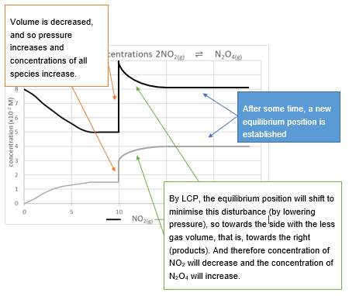

Question 2 (5 marks)
Models are often used to help explain complex concepts.
  - Outline a simple model that explains the difference between static and dynamic equilibrium. (2 marks)
  - A model of an open and closed system is set up with 2 identical beakers of water being heated. One beaker has a lid and the other is open. Assess the validity of the model. (3 marks)

Marking criteria and sample answers:
Marking criteria (a) | Marks
- outlines and relates model/s to static and dynamic equilibrium | 2
- outlines a model of either static or dynamic equilibrium | 1
A static equilibrium is one in which there is no movement of the reactant or product particles in either forward or reverse directions. For example, using a stationary seesaw as a model, the people on the see-saw are not moving, and no change is occurring. The see-saw is in equilibrium because there is no net force on the system.
A dynamic equilibrium appears as if there is no change is happening to the system (macroscopic properties remain the same), but at a particle level, the reaction is proceeding at equal rates in both forward and reverse directions. A model to illustrate this could be a full carpark, wherein, as one car leaves, another enters so that the carpark is always full, and no change is observed in the number of cars in the car park. Another model could be a water tank with water entering the top and leaving the bottom at equal rates so that the level in the tank is always the same.
Marking criteria (b) | Marks
- discusses factors that promote validity and/or indicates the limitations of the model that compromise the validity  - indicates the main features of a physical model that demonstrates equilibrium in both open and closed systems | 3
- discusses factor/s that support or limit the validity  - indicates the main feature/s of a physical model that demonstrates equilibrium | 2
- any relevant information | 1
Beaker 1, with no lid on it, represents an open system. An open system is one which interacts with its environment. This means that both energy and matter can move in and out of the system. This is indicated by the loss of heat (energy) and water (matter), as the water level continues to drop in beaker 1, but not in beaker 2. It is, therefore, a valid model, as both energy and matter can be transferred to and from the surroundings. Beaker 1 is open, so evaporation can continue as
H₂O_{(l)} ⇌ H₂O_{(g)}
until the air above the water becomes saturated with water vapour (100% humidity).
Beaker 2, which has a lid, represents a closed system. In a closed system, energy may still be able to flow between the system and the environment, but matter cannot enter or leave the system. Beaker 2 is closed; water will evaporate until the rate of evaporation,
H₂O_{(l)} ⟶ H₂O_{(g)}
is equal to the rate of condensation as
H₂O_{(g)} ⟶ H₂O_{(l).}
This happens when the space above the liquid is saturated with water vapour. From that point, the liquid level will remain constant.
This shows the observable difference between the two systems of dynamic equilibrium. The only difference in the systems was the cover on top. The amount of energy and the initial amount of water in both systems were identical. The energy is able to move in and out of both components of the model. The loss of water from beaker 1 and not in beaker 2 clearly demonstrates the transfer of matter in an open system, indicating that this experiment is a valid model of the differences between open and closed systems.

Question 3 (8 marks)
A student set up the following apparatus to measure the effect of temperature on the rate of a chemical reaction below. The conical flask containing the reactants was placed on a white mat, marked with a black cross. As the yellow precipitate of sulphur (S), began to form, the cross began to disappear when viewed from the top of the flask.

Na₂S₂O_{3(aq)} | + H₂SO_{4(aq)} | ⇌ | Na₂SO_{4(aq)} | + S_{(s)} + SO_{2(g)} + H₂O_{(l)}
colourless | colourless |  | colourless | yellow

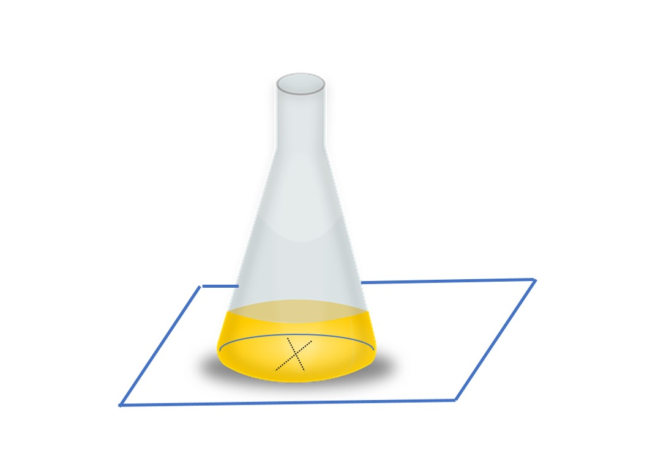
- Outline the variables in this investigation. (3 marks)
- Explain how potential systematic errors may be reduced in this investigation. (3 marks)

Marking Criteria and Sample answers
Criteria (a) | Marks
- outlines the different types of variables in the investigation | 3
- outlines TWO types of variables required in the investigation | 2
- provides some relevant information | 1

- Independent Variable: Temperature of reactants (ºC).
- Dependent Variable: Reaction Time (seconds)
- Controlled Variables: Concentrations of Na₂S₂O₃ and H₂SO₄. Same sized conical flask and the same volume of the chemicals used. Amount of agitation of the solutions is the same.

Criteria (b) | Marks
- explains how to reduce two systematic errors | 3
- describes two systematic errors OR  - explains how to reduce one systematic error | 2
- identifies an error that may occur | 1

b. Ensure the temperature is correctly measured by immersing the thermometer to the desired depth or use a temperature probe to improve the precision. A digital temperature probe should be calibrated. The temperature may change as reactants are added to the flask, so separate reactants should be brought to temperature separately before being mixed. It is difficult to look through the solution while constantly agitating the flask. A magnetic stirrer would be the most effective way to reduce this error. The time at which the cross disappears may be subjective, and this could be improved by always using the same judge, or alternatively by using a colour meter app or conductivity probe.

Question 4 (5 marks)
25.0 mL of 0.00200 M potassium hydroxide is mixed with 75.0 mL of 0.000125 M lead (II) nitrate. With the aid of a balanced equation, determine whether a precipitate will form.

Marking Criteria and Sample answers:
Marking criteria | Marks
- writes a balanced chemical equation  - constructs a correct expression for K_{sp}  - justifies precipitate with correct calculation and reference to the datasheet | 4
- determines the concentration of species  - writes an equation or expression for K_{sp}  - identifies K_{sp} from the datasheet | 2-3
- any relevant step | 1
The overall and the net-ionic equations for the reaction that occurs when the two solutions are mixed are:
KOH_{(aq)} + Pb(NO₃)_{2(aq)} ↔ 2KNO_{3(aq)} + Pb(OH)_{2(s)}
Pb²⁺_{(aq)} + 2OH⁻_{(aq)} $↔$ Pb(OH)_{2(s)}
Using the dilution equation, C₁V₁= C₂V₂, determine the initial concentration of each species once mixed (before any reaction takes place).
$$(0.0020 M KOH)(25.0 mL) = (c_{2})(100.0 mL)$$
$$c_{2} for KOH= 0.00050 M$$A similar calculation for the lead (II) nitrate yields:
$$c_{2} for {Pb(NO3)}_{2}= 0.00009375 M$$
Using the initial concentrations, calculate the reaction quotient Q, and compare to the value of the equilibrium constant, K_{sp}.
Pb(OH)_{2(s)} → Pb²⁺_{(aq)} + 2OH⁻_{(aq)}
K_{sp} = [Pb²⁺][OH⁻]²
$$Q = {(0.00009375)(0.00050)}^{2} = 2.344 x {10}^{-11}$$
From the data sheet, K_{sp} for lead hydroxide is 1.43 x 10⁻¹⁵
Q is greater than K_{sp}, so a precipitate of lead (II) hydroxide will form.

Question 5 (6 marks) Modules 5 and 8
Discuss how our knowledge of equilibrium reactions in chemical processes and synthesis has impacted on society.

Marking Criteria and Sample answer:
Marking Criteria | Marks
- discusses impacts on society of chemical processes involving equilibrium reactions with some examples  - relates knowledge of equilibrium reactions to chemical processes | 6
- discusses the impact on society with some examples  - outlines a link between equilibrium reactions and chemical processes | 5-4
- discusses impact/s with example AND/OR  - links equilibrium reactions to a chemical process | 2-3
- any relevant information | 1

Many chemical processes involve equilibrium reactions. Equilibrium reactions are reversible reactions that do not go to completion: some portion of the reactants and products will be present at all times, despite the conversion between them. If these occur in a closed system, then a point will be reached when the rate of the forward reaction equals the rate of the reverse reaction.
Understanding these equilibrium processes allows equilibrium constants to be calculated. These constants provide information about the position of the equilibrium, whether reactions have reached equilibrium, and, if not, in which direction will they proceed. This is important for the manufacturing industry, which tries to maximise productivity and yields. Many manufacturing processes are equilibrium processes. For example, the synthesis of ammonia via the Haber process and the synthesis of sulphuric acid via the Contact process both require knowledge of how changing reaction conditions, such as temperature and pressure, will impact on yield (Le Chatelier’s Principle) and rate of product formation.
N_{2(g)} + 3H_{2(g)} $\underset{⇔}{high pressure}$ 2NH_{3(g)}
The Haber process has been essential in the production of ammonia, allowing for the manufacture of ammunitions as well as fertilisers for crops and pasture. The production of ethene from ethane, to produce polyethylene, a polymer essential in packaging, milk bottles and a wide range of other products, also requires a knowledge of equilibrium. Ethane from fossil fuel sources is dehydrogenated to ethene, using high temperatures, as the reaction is endothermic, and as the ratio of reactant gases to product gases is 1:2 the forward reaction is favoured by low pressure.

C₂H_{6(g)}$\underset{→}{high Temp, low Pressure}$ C₂H_{4(g)} + H_{2(g)}

Another impact on society from a knowledge of equilibrium reactions is the knowledge of buffers. Buffers are mixtures of an acid and its conjugate base, or a base and its weak conjugate acid. Buffers maintain consistent pH by resisting the effects of added acids and bases. Buffers are essential in natural systems, such as maintaining pH of blood, and knowledge of which is important for diagnosing and maintaining patient health. Buffers are also essential in managing the health of water bodies, including lakes, aquariums and swimming pools by maintaining the carbon dioxide/carbonic acid equilibrium. This buffer system helps to maintain the pH of the water bodies.
Therefore, knowledge of equilibrium reactions and chemical processes has had a major impact on society, both in understanding and optimising of natural processes and in the production of essential chemicals for everyday life.

Module 6

Question 6 (3 marks)
Human blood contains a natural buffer solution based on the hydrogen carbonate ion. Describe how a buffer system could be prepared and tested in the laboratory to model the action of a natural buffer.

Marking Criteria and Sample answer:
Criteria | Marks
- describes a valid procedure to make a buffer, naming its components  - describes the effect of the change on the system when buffered | 3
- describes the composition of a buffer  - describes a substantially correct procedure | 2
- describes the component composition of a buffer or  - describes the role of a buffer | 1
A buffer system is prepared by mixing a weak acid (or base) with its conjugate base (or acid). In the case of human blood, H₂CO₃ (carbonic acid), together with its conjugate base, the hydrogen carbonate ion, HCO₃⁻ forms a buffer. This buffer system could be prepared by the addition of sodium hydrogen carbonate NaHCO₃ to water that has been acidified by the bubbling of CO₂ gas through it. To see if the buffer will resist a change in pH when both acid and base are added to the system, the following procedure could be carried out.
- Have two identical beakers containing the same volume of identical dilute (0.1M) solutions of NaHCO₃
- To beaker 2, add CO_{2 (g)} from a generator, soda machine or blow through a straw into the solution for 1 minute, ensuring no solution is spilled from the beaker.
- Use pH probes connected to data loggers to log the pH in each beaker
- To each beaker add 0.1M NaOH solution in dropwise and stir. Repeat until no more change in pH is observed in either beaker.
- Repeat steps 1-4, using dilute HCl instead of NaOH.
- Download the data, which should show that the buffer solution resisted a change in pH for a substantial volume of strong base or strong acid added.
Alternative method: use an indicator which changes colour, such as bromothymol blue, which will be green in the buffer, and count the number of drops of strong acid or base added to effect a colour change.

Question 7 (3 marks)
A student has been asked to compare the acidic or basic nature of substances using items that can be found at home. Describe a method they could employ to do this, along with the expected results.

Marking Criteria and Sample answer:
Marking criteria | Marks
- describes a relevant procedure  - describes the changes expected  - links changes observed to the action of acids and/or bases on indicators | 3
- describes a relevant procedure AND/OR  - describes the changes when acid and/or base react with an indicator | 2
- any relevant information | 1

An indicator can be made from vegetables:
1. Heat cut red cabbage in a saucepan of hot water for a few minutes, until the water is very dark purple. Let the cabbage water cool and strain off the solids.
2. Using a pipette put a few centimetres of cabbage water indicator in an egg cup or glass.
3. Add a very small amount of test substance found in the pantry. If it is solid, it should be dissolved in a little water before adding to the cabbage water indicator.
4. If the substance is acidic, the cabbage water will turn from purple to pink or red, if it is neutral it stays purple, and if it is basic it will go yellow or green,

Question 8 (7 marks)
Oxalic acid is a diprotic acid with the formula (COOH)₂.2H₂O. It is a soluble crystalline solid. The 2H₂O is called water of hydration, and it is part of the solid crystal structure. Therefore, any calculations involving mass would need to include it. 3.16g of solid oxalic acid was weighed and used to make a solution in a 500mL volumetric flask.
  - Calculate the concentration of oxalic acid in molL⁻¹. (2 marks)
  - A student used 25.0mL portions of the oxalic acid solution to calculate the concentration of a sodium hydroxide solution using titration. Write the equation for the neutralisation reaction. (1 mark)
  - Explain the effect on the calculated concentration of sodium hydroxide, of using the molar mass of oxalic acid and not the molar mass of the hydrated form. (2 marks)
  - Describe the advantage of using oxalic acid rather than hydrochloric acid as a standard solution (2 marks)

Marking criteria and sample answers
Criteria (a) | Marks
- correctly calculates the concentration of the oxalic acid solution and displays correct units | 2
- provides some relevant calculation | 1
$$n = 0.02507 mol$$
$$c=\frac{n}{V}=\frac{0.02507}{0.500}=0.0501 molL^{-1}$$
(COOH)_{2(aq)} + 2NaOH_{(aq)} ↔ (COONa)_{2(aq)} + 2H₂O_{(l)}
Criteria (b) | Marks
- correct equation with correct stoichiometric ratios | 1

Criteria (c) | Marks
- explains the effects of using incorrect molar mass | 2
- recognises one effect of using incorrect molar mass | 1
$c =\frac{ 0.025}{0.5}=0.050molL^{-1}$ and $n = \frac{m}{MM}$.
If the molar mass (MM) used in the calculation for n is less than the molar mass of the hydrated oxalic acid, then the number of moles, n, will be larger ($n α \frac{1}{MM}$).
For the neutralisation reaction, the ratio of oxalic acid to NaOH is 1:2. $n = cV$ is used to calculate the concentration of the NaOH, so if n is greater, and volume is the same, c will be greater. Therefore, the calculated concentration of NaOH will be greater than the actual concentration if the wrong molar mass is used.

Criteria (d) | Marks
- describes the procedure to standardise an unknown solution  - provides advantage/s of using oxalic acid as a primary standard | 2
- describes the procedure to standardise an unknown solution | 1

Oxalic acid is a stable, crystalline solid that dissolves in water and can, therefore, be used to make a primary standard. Most commercially-purchased acids are not primary standards but are concentrated solutions. This means the concentration of NaOH can be calculated in one step, rather than having to use a primary standard like Na₂CO₃ and then standardising the HCl and then the NaOH.

Question 9 (6 marks)
Oxalic acid is a diprotic acid with the formula (COOH)₂.2H₂O. The 2H₂O is called water of hydration, and they are part of the crystal structure when this acid is in its solid (crystal) form. Therefore, any calculations involving mass would need to include them.
- Describe a safe procedure to compare the strength of oxalic acid with 2 different acids. (4 marks)
- Sketch the pH vs time titration graph for a weak acid, like oxalic acid, titrated with NaOH. (2 marks)

Marking Criteria and Sample answers:
Marking Criteria (a) | Marks
- explains how the suggestion can be tested safely  - includes measures to ensure accuracy, validity and reliability of data | 4
- describes a safe procedure that is valid and reliable | 3
- describes a safe procedure that is valid or reliable | 2
- any relevant information | 1
Procedure:
As all acids are corrosive, eye protection and other PPE should be worn (leather shoes, covering the foot and a lab coat). All splashes should be washed with water. To decrease the risk of chemical burns to skin and eyes from acid splashes, the concentration of the acids used will be kept in a dilute range of about 0.1molL⁻¹
  - Place 100 mL of oxalic acid solution and 2 other acids, all of the same concentration (0.1M) into separate small beakers.
  - Measure the pH of each solution with a digital pH probe
  - Calculate the [H⁺] using $\left[H^{+}\right]={10}^{-pH}$to determine the relative strength of each acid, with stronger acids producing higher concentrations of H⁺.
Using the same concentration for each acid is required for comparisons of strength to be valid. Using a digital pH probe allows accurate measurement of pH and repeating the measurement will improve the precision of the results. Rinsing the pH probe between measurements different acids will reduce error and improve reliability.
Marking Criteria (b) | Marks
- the curve has labelled axes and shows a very gradual increase for the weak diprotic acid and very steep section for the strong base | 2
- shows a general sketch of any weak acid vs strong base | 1

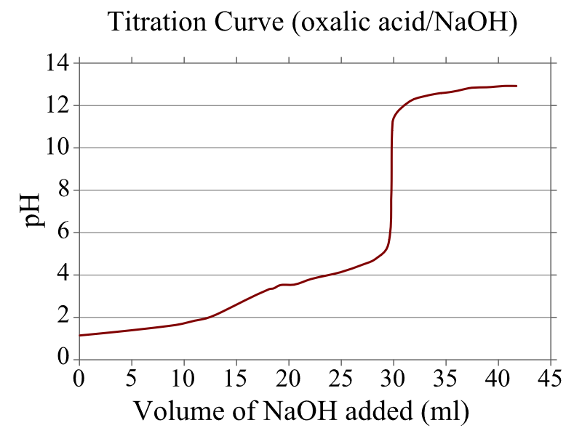
Figure 1 Oxalic acid titration
Note: Oxalic acid titrated against NaOH, shows a gradual changes, as the

Question 10 (6 marks)
“Over time, definitions of acid and base have been refined to broaden the definition of acids and bases based on newly available evidence.”
With your understanding of the historical development of ideas from various scientists, evaluate this statement.

Marking Criteria and Sample answer:
Marking criteria | Marks
- comprehensive understanding of Arrhenius and Bronsted-Lowry and/or other theories, and the evidence used to support each successive model  - evaluation of the statement with examples of broadening the definition of acids and bases as each new model is applied | 6
- comprehensive understanding of Arrhenius and Bronsted-Lowry acid/base theories  - links to evidence used to support successive models  - application of the model/s to the definition of an acid/base | 5
- understanding of two models of acid/base theories  - links to evidence used to support successive models | 3-4
- description of acid/base theories and/or  - describe evidence for models | 2-3
- some relevant information | 1

In the past, acids were characterised by their common properties, such as sour taste, reacting with metals and turning litmus pink; and then later as substances that contained hydrogen. Arrhenius’ theory described acids and bases in terms of their dissociation in water into ions. His idea was that acids produce hydrogen ions and bases produce hydroxide ions when dissolved in water.

HCl_{(aq)} → H⁺_{(aq)} + Cl⁻_{(aq)} (acid) and NaOH_{(aq)} → Na⁺_{(aq)} + OH⁻_{(aq)} (base)

According to the Arrhenius model, strong acids and bases completely dissociated into ions, while weak acids and bases only partially dissociate. This model was consistent with acids and bases that were known at the time, and even today is an easily understood model that describes weak and strong acids and bases. One limitation of the Arrhenius model was that some acids and bases, such as gases, insoluble bases and acidic and basic salts, could not be adequately described. An example of this limitation is the reaction between gases such as HCl and NH₃.

HCl_{(g)} + NH_{3(g)} → NH₄Cl_{(s)}
Also, the salt produced in acid-base neutralisation reactions should be neutral according to Arrhenius. However, not all neutralisation reactions produced neutral salts. Thus the definitions of acids and bases had to be broadened. Bronsted and Lowry solved the problem with ammonia, by redefining bases as proton acceptors that will accept protons from acids, which are proton donors. The theory was able to accurately predict the amphiprotic nature of water and other ions such as HCO₃⁻, and it accounted for the pH of various salts, such as sodium acetate which dissolves in water to form a weak acid and a strong base.

CH₃COO⁻_{(aq)} + H₂O_{(l)} ⇌ CH₃COOH_{(aq)} + OH⁻_{(aq)} (the Na⁺ is a spectator ion)

Even though this theory was a great improvement in accounting for the amphiprotic nature of substances, and for reactions between gases, it did not help explain the acid-base behaviour where no proton transfers were involved. The Lewis definition broadened this model by defining an acid as an electron pair acceptor. This solved the issues that were present with the earlier models.

Question 11 (5 marks)
Paper clips are used to model the dissociation and concentration of both nitric acid in water and ethanoic acid in water. The diagrams show various models for the acids. Assess the accuracy of the model, using equations to illustrate your reasoning.

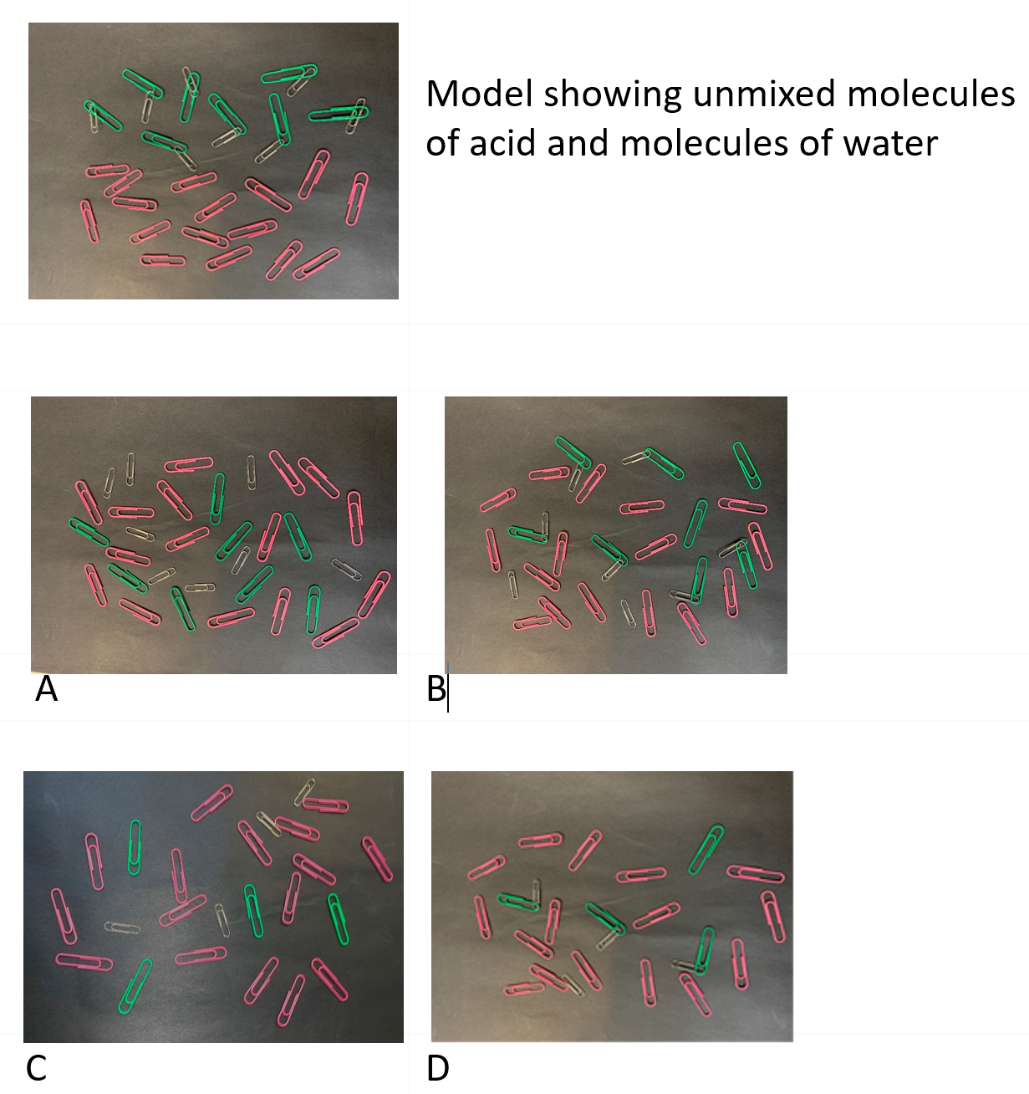

Marking Criteria and Sample answers
Marking criteria | Marks
- equations demonstrate complete and partial dissociation  - correct identification of diagrams referring to concentration and dissociation  - discusses features of the model that explain and predict properties of both acids  - makes a judgement of the model | 5
- demonstrates a clear understanding of concentration and strength  - correct identification of diagrams referring to concentration and dissociation  - discusses features of the model that explain and predict properties of both acids OR makes a judgement of the model | 4
- identifies diagrams of strong/weak and concentrated/dilute acid  - describes features of models of acid dissociation and concentration | 2-3
- some relevant information | 1

Sample answer:
Diagram A is a model of a concentrated, strong acid, as there are many acid molecules, and they are all dissociated. Model C is a dilute strong acid as there are few molecules that are all dissociated. This model clearly shows that a strong acid, such as nitric acid will completely dissociate and there are no molecules of undissociated acid left, regardless of how many molecules were dissolved in the solution.
HNO_{3(aq)} → H⁺_{(aq)} + NO₃⁻_{(aq)}
Diagram B represents a concentrated weak acid. Weak acids, such as ethanoic acid, only partially dissociate in water. This can be seen by there being some molecules of acid remaining, no matter how concentrated or dilute the solution is. B is, therefore, a concentrated weak acid, while D is a dilute weak acid.
CH₃COOH_{(aq)} ⇌ CH₃COO⁻_{(aq)} + H⁺_{(aq)}
The model is useful in showing the difference between weak and strong acids and the degree of dissociation. However, it does not accurately show the degree of dissociation of a weak acid, which may be as little as about 1%. Nor does it accurately show the actual number of water molecules typically present and how the ions are surrounded by water molecules. The model is useful in predicting properties of concentrated and dilute acids, even in cases where there is little water and the acid exists primarily as molecules. For this reason, the model is suitable for predicting some properties of acids.

Question 12 (3 marks)
An analytical chemist found that 20.00mL of 0.500M NaOH is required to reach the endpoint in a titration with 35.00mL of an unknown monoprotic acid.
Calculate the concentration of the unknown acid. (3 marks)

Marking Criteria and Sample answer:
Criteria | Marks
- shows complete working out of calculation steps  - shows the correct answer to the calculation, to the three significant figures | 3
- shows some working out of calculation steps  - shows a substantially correct answer to the calculation | 2
- any relevant calculation step | 1

Sample Answer:
20.00mL of 0.500M NaOH
35.00mL of c₂ M unknown acid

Assume Base:Acid ratio of 1:1 (as the acid is monoprotic)
So therefore, c₁V₁ = c₂V₂
c₁ = 0.500M
V₁ = 20.00mL
c₂ = ?
V₂ = 35.00mL

c₁V₁ = c₂V₂
0.500 x 20.00 = 35.00 x C₂
10.00 = 35.00 x C₂
C₂ = 0.2857142857
C₂ = 0.286 M (to 3 sig figs)

Question 13 (6 marks)
  - Construct labelled diagrams of ions and molecules in the beakers below to represent hydrochloric acid dilute solution and acetic acid dilute solution

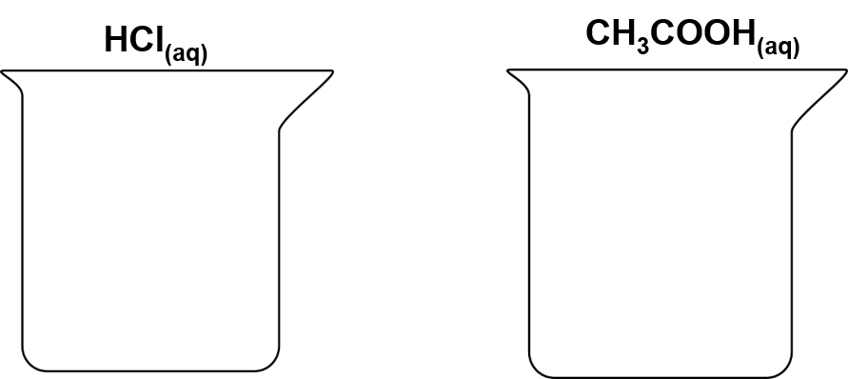

  - Explain, with the aid of equations, how the degree of ionisation for each acid was represented in the drawings

Marking Criteria and Sample answer
Marking Criteria (a) | Marks
- annotates diagram or uses a key  - Shows all species correctly in both beakers | 3
- annotates diagram or uses a key  - Show most species correctly in both beakers | 2
- any relevant information | 1

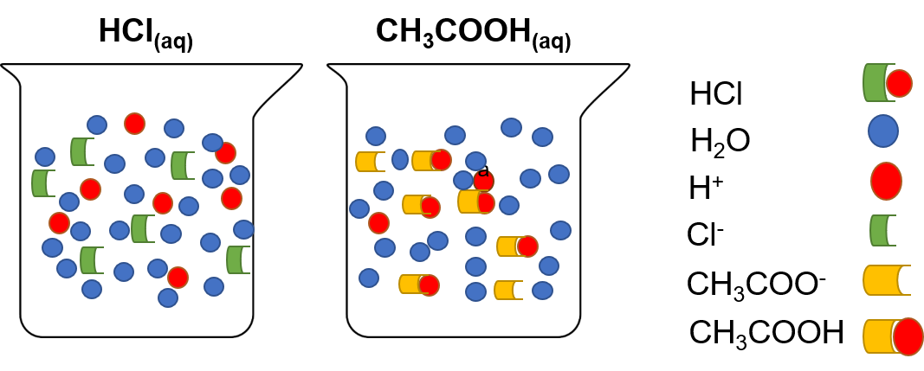

Marking Criteria (b) | Marks
- explains why dilute strong acids and weak acids vary in the degree to which they ionise  - uses a chemical equation to describe ionisation of acid/s | 3
- explains how dilute strong acids completely ionise and that there are no molecules left, and that dilute weak acids partially ionise | 2
- identify either as strong acid and weak acid or identify the degree to which acid/s are ionised | 1

HCl is a strong acid. It completely ionises in water.
HCl_{(aq)} → H⁺_{(aq)} + Cl⁻_{(aq)}
Therefore, the diagram shows only H⁺ and Cl⁻ ions and no HCl molecules. The model shows the ions are surrounded by polar water molecules. The beaker on the right shows acetic acid, which is a weak acid. Acetic acid will only partially dissociate in water, forming some of the H⁺ and CH₃COO⁻ ions. Most of the acetic acid molecules have not ionised.

Question 14 (3 marks)
In your chemistry course, you prepared a buffer and investigated its properties. Describe the importance of a named buffer in a natural system, with reference to the properties of buffers. (3 marks)

Marking Criteria and Sample answer
Criteria | Marks
- outlines a specific buffer example  - explains the relevant properties of buffers  - relates the properties of the buffer to its role in a natural system. | 3
- outlines a specific buffer example AND  - explains the relevant properties of buffers OR  - relates the properties of a buffer to its role in a natural system | 2
- any relevant information | 1

A chemical buffer is a weak acid in equilibrium with a similar concentration of its conjugate base. In this way, a buffer works by reducing the changes to the pH of a system when an acid or alkali is added to the system. One specific example is the H₂CO₃/HCO₃⁻ buffer in human blood.
The pH of blood is approximately neutral. The bicarbonate –carbonic acid buffer system in the blood resists changes in pH within the blood that may occur because of activities such as exercise or other metabolic processes.
H₂CO_{3(aq)} + H₂O_{(l)} ⇌ HCO₃⁻_{(aq)} + H₃O⁺_{(l)} ↔ CO_{2(g)} + 2H₂O_{(l)}

When H₃O⁺ accumulates in the blood, the pH of the blood will decrease. This causes the equilibrium position of the bicarbonate-carbonic acid buffer system to shift to the left, as per Le Chatelier’s principle. pH will thus return to neutral, despite the addition of an acid. Conversely, the accumulation of OH⁻ ions in the blood will cause its pH to rise. However, the OH⁻ ions will react with the H₃O⁺ ions and reduce its concentration. According to Le Chatelier’s principle, the equilibrium will shift towards the right to maintain the H₃O⁺ concentration and maintain a neutral pH. In this way, the reaction overall creates a cycle of regulating pH changes, indicative of a specific buffer system.

Question 15 (8 marks)
A chemist wanted to determine the percentage of calcium carbonate in a seashell. In the first step, the chemist added a known amount of hydrochloric acid, in excess, until the reaction reached completion. The excess acid was then titrated with sodium hydroxide.
  - Write the chemical equation for each step.
  - Suggest a valid and reliable procedure that can be carried out to determine the percentage of calcium carbonate in seashells.

Marking Criteria and Sample answer

Marking Criteria (a) | Marks
- TWO correct balanced equations, with states | 2
- any ONE correct balanced equation, with states | 1

CaCO_{3(s)} + 2HCl_{(aq)} → CaCl_{2(aq)} + H₂O_{(l)} + CO_{2(g)}
HCl_{(aq)} + NaOH_{(aq)} → NaCl_{(aq)} + H₂O_{(l)}

Marking Criteria (b) | Marks
- describes a safe and correct procedure for the investigation  - describes procedures to improve validity and reliability | 6
- describes a safe and substantially correct procedure for the investigation  - describes procedures to improve validity or reliability | 4-5
- describes a safe and substantially correct procedure for the investigation  - Identifies a measure to address validity or reliability | 2-3
- any relevant information | 1

b. Acid and base are both corrosive, therefore wear eye protection to reduce the likelihood of serious injury. Wash all splashes with water. Shells may splinter and enter the eyes when being crushed - wear eye protection to prevent injury from flying seashells.
- Wash and dry the seashells thoroughly to remove any surface debris.
- Crush a seashell of known type and weigh the mass on digital scales to 2 decimal places
- To a 250mL conical flask, add the crushed shell along with 200mL of 1M HCl and wait until reaction (fizzing) ceases. Add 50mL amount of additional acid to ensure all the CaCO₃ has reacted, and calculate the total number of moles of acid added to the shells
- Using a pipette, transfer 25 mL of the HCl reaction mix to a clean conical flask. Ensure that the pipette has been rinsed with distilled water and then the HCl reaction mix.
- Fill a rinsed burette with 0.1M NaOH solution and record the initial volume.
- Add 2 drops of phenolphthalein indicator into the flask and run NaOH from the burette until a permanent colour change from clear to pink occurs. Record the volume on the burette.
- Repeat steps 4-6 with 25 mL aliquots of the HCl reaction mix until the results are within 0.1mL of each other. This will improve the precision of the method.
- Repeat steps 1-7 for two other seashells of the same type. It is important that the same steps be followed every time the experiment is repeated.
- Calculate the moles of NaOH required to neutralise the excess acid ( n=cV), and hence moles of excess acid: HCl_{(aq)} + NaOH_{(aq)} → NaCl_{(aq)} + H₂O_{(l)}
- Using the moles of HCl added and the moles HCl remaining (step 9), calculate the moles of HCl required to react with the shells.
- From step 10, calculate the moles of CaCO₃
CaCO_{3(s)} + 2HCl_{(aq)} → CaCl_{2(aq)} + H₂O_{(l)} + CO_{2(g)}
convert the moles of CaCO₃ to its mass in grams. Finally, by dividing this value with the masses of the shells, determine the percentage (w/w) of CaCO₃ per gram of shell.

Question 16 (1 mark)
The diagram shows the titration curve of a solution of dilute sodium hydroxide and a solution of dilute oxalic acid. The accompanying table shows a list of indicators and the pH ranges over which they change colour.
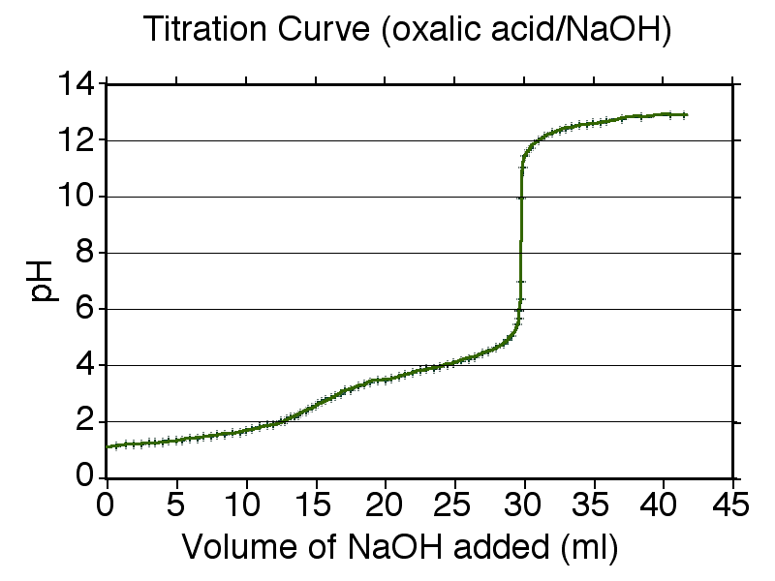
Figure 2: From J. W. Schmidt at English Wikipedia

Indicator | pH range
Bromocresol green | 3.8 – 5.4
Methyl red | 4.4 – 6.0
Methyl orange | 3.1 – 4.4
Phenol red | 6.8 - 8.2

The most suitable indicator for this titration is
- Methyl orange
- Bromocresol green
- Methyl red
- Phenol red

Sample answer
D

Question 17 (4 marks)
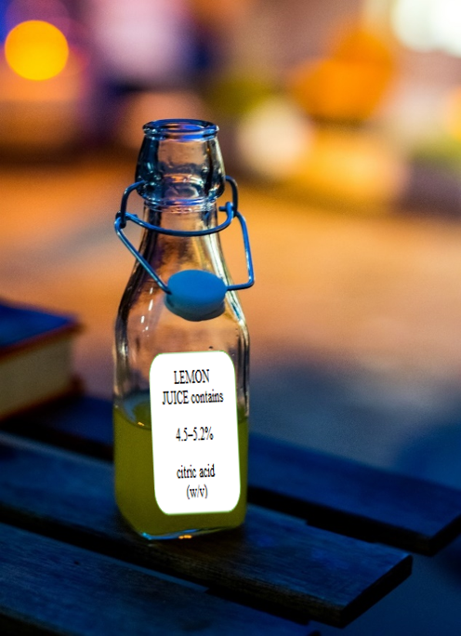
Figure 3 Lemon Juice

A bottle of lemon juice was analysed by titration to determine the citric acid concentration. Citric acid is a tricarboxylic acid with formula C₆H₈O₇ and molar mass of 192.124 gmol⁻¹.

a. The lemon juice was first diluted by a factor of 10. Then 25.00 mL aliquots of the diluted sample were titrated against a standardised 0.0925 mol L⁻¹ sodium hydroxide solution using phenolphthalein indicator. Results are shown in the table below. Calculate the average titre.

Initial burette reading  NaOH (mL) | Final burette reading  NaOH (mL)
0.00 | 21.75
22.0 | 43.00
0.00 | 21.10
22.00 | 43.05

b. Determine the percentage (%) citric acid concentration of the original lemon juice and assess the validity of the manufacturer’s claim that this juice contains 4.5 – 5.2% (w/v) citric acid.

Marking criteria and sample answers

Marking Guidelines (a) | Mark
- averages 3 titre values, excluding the rough | 1

$$21.00 + 21.10 + 21.15 = 21.08mL$$

Marking Guidelines (b) | Marks
- supports assessment of claim using calculation or something similar | 3
- substantially correct calculation | 2
- any relevant step | 1

Step 1: Known (NaOH)
$$n = cV$$
$$= 0.0925 × 21.08/1000$$
$$=0.00195 mol$$

Step 2: (stoichiometry)
3NaOH_{(aq)} + C₆H₈O₇(aq) ⇌ 3NaC₆H₅O_{7(aq)} + 3H₂O_{(l)}
3mol NaOH is required to neutralise 1mol citric acid, therefore
0.00195 mol NaOH will neutralise 0.00195/3mol citric acid = 0.00065mol

Step 3: (unknown)
$n_{citric acid}= 0.00065mol in 25mL$
$= \frac{0.00065}{25} × 1000 mol/L$
$= 0.026mol/L and this was diluted by a factor of 10$
$= 0.26mol/L.$
$$n = m/MM; m = nMM, where MM = 192.124 (given)$$
$$m = 0.26×192.124$$
$$m = 49.952g$$
$Concentration \left(\frac{w}{v}\right)= \frac{49.952g}{1000ml} =\frac{4.99052g}{100mL} =4.99\%w/v.$

Therefore, the manufacturer’s claim is valid.

Question 18 (6 marks)
The titration curve below shows the pH change during the addition of sodium hydroxide to acetic acid. Explain how the shape of this curve demonstrates the action of a buffer.
Figure 4 Quantumkinetics: Titration curve strong base vs weak acid
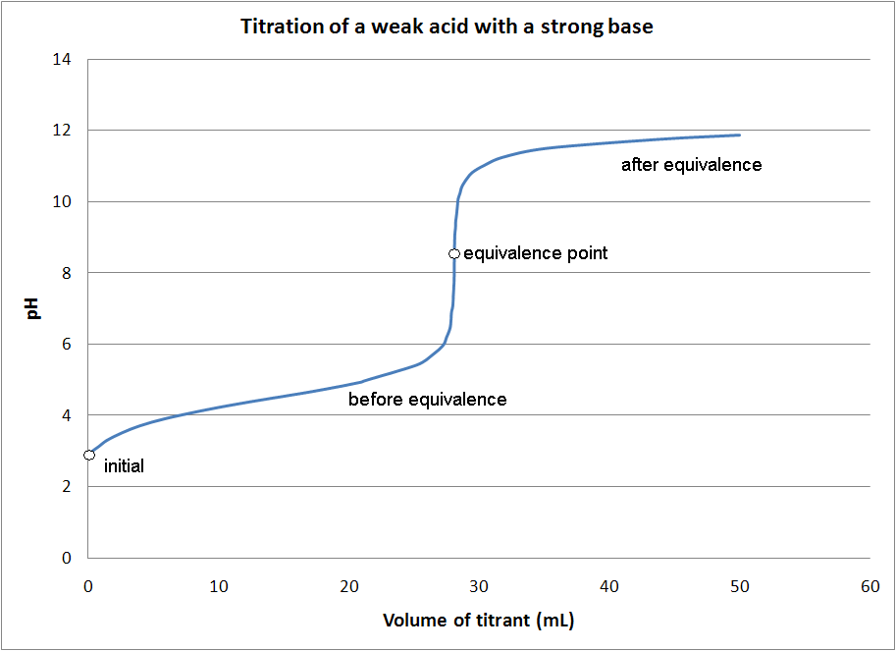

Marking Criteria and Sample answers:
Marking criteria | Marks
- Accounts for the shape of the curve  - Explains the action of a buffer in a titration | 6
- Accounts for the gradual change in pH  - Explains the action of a buffer | 4-5
- Describes the action of a buffer  - Describes the shape of the curve | 2-3
- Any relevant information | 1
A buffer resists a change in pH as either a base or an acid is added. A buffer consists of a weak acid mixed with its conjugate base, or weak base/conjugate acid. For example, acetic acid, a weak acid, only partially dissociates into conjugate base (acetate) ions. As the acid is neutralised by the addition of NaOH, more of the weak acid is dissociated as the H+ ions are used up by the neutralisation, by Le Chatelier’s principle. This means there will be a considerable amount of acetate ion and acetic acid in the solution, which will behave as a buffer:

CH₃COOH | + H₂O | ⇌ | CH₃COO⁻ | + H₃O⁺
Weak acid |  |  | conjugate base

In the titration curve, between 5-25 mL of NaOH added, there is both the weak acid and its conjugate base, and the concentration of H⁺ ions is reasonably constant. Therefore, the change in pH is gradual, even when significant amounts of NaOH are added. However, once most of the acid has been used up, the pH quickly changes, accounting for the vertical part of the curve. When the NaOH is in excess, the pH changes until it is the same as the pH of the original NaOH solution.

Question 19 (5 marks)
With the aid of diagrams, compare the changing pH during titration reactions between two different types of monoprotic acids and bases, and justify the choice of indicator/s used to monitor the reactions.

Marking Criteria and Sample answer
Marking criteria | Marks
- compares the shape of sketches demonstrating the reaction between acids and bases  - justifies the choice of indicator, using graphical evidence | 5
- describes reactions between a strong or weak acid and a strong or weak base  - uses a sketch to display information  - identifies an appropriate indicator used in an acid-base reaction | 3-4
- describes a reaction between a strong or weak acid and a strong or weak base  - uses a sketch to display information OR  - identifies an appropriate indicator used in an acid-base reaction | 2
- any relevant information | 1
Sodium hydroxide is a strong base, and hydrochloric acid is a strong acid. The pH of the strong base is high. When titrating with the strong acid, the equivalence point will be around pH 7. An indicator that changes colour in this pH range will be needed, such as bromothymol blue. Its colour will change from blue to yellow.
Sodium hydroxide is a strong base, and ethanoic acid a weak acid. Starting at a high pH and salt produced will have a pH >7 Indicator: Equivalence point is around pH 9. An indicator that changes colour in this pH range will be needed, such as phenolphthalein (range 10 - 8.3) and the colour change will be violet to colourless.
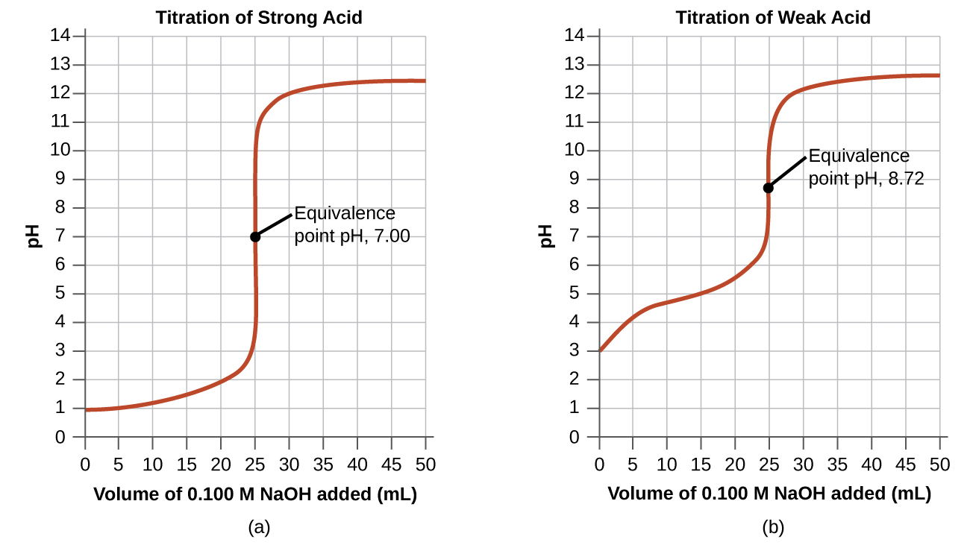
Figure 5 https://opentextbc.ca/chemistry/chapter/14-7-acid-base-titrations/

Question 20 (8 marks)
Design an investigation that demonstrates the role of a buffer in a chemical system, supported by relevant chemical equations. Explain how this chemical system can be tested accurately, validly and reliably.

Marking Criteria and Sample answers:
Marking Criteria | Marks
- explains how the suggestion can be tested with accuracy, validity and reliability  - relates the investigation to the role of buffers in chemical systems | 8
- describes a process for testing the suggestion that addresses validity and reliability and/or accuracy  - describes the role of buffers in chemical systems | 6-7
- outlines some relevant steps for testing the suggestion  - show some understanding of accuracy and/or reliability and/or validity  - describes the action of a buffer | 4-5
- outlines a relevant step  - outlines the action of a buffer | 2-3
- any relevant information | 1
A buffer consists of a weak acid in solution with its conjugate base or a weak base in solution with its conjugate acid. For example, acetic acid and NaCH₃COO solution:
Where,
CH₃COOH | + | H₂O | ⇌ | CH₃COO⁻ | + | H₃O⁺
Weak acid |  |  |  | Conjugate base
A buffer resists a change in pH as strong acid or base are added. This is important is many natural systems, such as the buffering of blood by HCO₃⁻ in the human body. Considering the above reaction, if strong acid is added (H₃O⁺), the equilibrium position will shift towards the left to minimise the change, while if strong base is added, (OH⁻), it will react with the H₃O⁺, removing it from the equilibrium reaction above, hence the equilibrium position will shift towards the right to maintain the equilibrium and maintain pH. To test this action, a strong acid will need to be added to the buffer, and the pH monitored. Similarly, the buffer could be tested with a strong base.
The buffer described above can be made in the laboratory: dissolving NaCH₃COO to make a 0.1M solution and mixing with equal volumes of a 0.1M solution of CH₃COOH. To test the action of the buffer:
- Add 100mL of prepared buffer to a beaker and use a pH probe to measure the pH.
- Add 0.1M HCl to the buffer from a burette in 1mL lots and measure the pH after each addition. Alternatively, a data logger can be used as HCl is run in from a burette. Repeat the experiment three times.
- Repeat step 1-2 with 0.1M NaOH solution (from the burette).
- Repeat Steps 2-3 with distilled water in the beaker
This investigation demonstrates a valid investigation, with all variables controlled, the dependent variable is the pH and the independent, the addition of acid/base to the buffer system. The results are compared with an experimental control, that is, a system that is not buffered, such as distilled water. The accuracy is determined by using a pH probe which has been calibrated and rinsed with distilled water between each use. Reliability is ensured by repeating each change several times and for several different solutions.

Question 21 (4 marks)
A bottle of HCl with a faded label was found in a science laboratory. Describe the process to be followed to determine its concentration, and address the safety aspects that would need to be considered in conducting this analysis?

Marking Criteria and sample answer
Marking criteria | Marks
- describes a valid procedure  - thoroughly addresses safety aspects | 4
- describes a method of analysis  - addresses a safety aspect | 3
- describes an appropriate method of analysis  OR  - addresses a safety aspect | 2
- any relevant information | 1
Acids are corrosive. The wearing of PPE: a lab coat, leather shoes and eye protection are necessary to reduce the risk of chemical burns to the skin and eyes. Testing should be conducted in a fume hood, as concentrated acids can give off corrosive fumes. Gloves are suggested until after the acid is diluted. Any splashes should be rinsed immediately with plenty of water.
- First, dilute the acid by adding a small amount (10mL) of the acid to a large amount of water (900mL), and after mixing it, make it up to exactly 1litre (using a volumetric flask). Record the exact amount of acid added to the water.
- Measuring the pH of the resulting solution can indicate the approximate [H₃O⁺]
- Then titration with a known standard, such as sodium carbonate, can be carried out. The concentration of the standard should be similar to the approximate concentration of the [H₃O⁺].
- The concentration, c_{1,} of the bottle can then be calculated, knowing the dilution factor.
c₁V₁ =c₂V₂ c₁ =c₂ $\frac{1000}{10}$

Module 7

Question 22 (6 marks)
Yeast was added to 100mL of glucose solution in a conical flask, and the mass of the flask was recorded every day for 7 days. The conical flask had an airlock on the top that did not allow air to enter the flask but allowed any gas produced during the fermentation reaction to be released. The initial mass of the conical flask and airlock, without any contents, was 180.0g. The glucose solution in the flask was placed in an incubator at 25°C and 100kPa for 8 days
  - Write a balanced equation to represent the reaction that occurs (1 mark)
  - The following data table was recorded. Calculate and record the mass of gas produced in the table below. (2 marks)
Day | Mass of flask and contents (g) | Total mass of gas produced (g)
0 | 280.1
1 | 279.6
2 | 279.2
3 | 278.8
4 | 278.5
5 | 278.3
6 | 278.2
7 | 278.2

  - In the space provided, draw a graph to show the total mass of gas produced over the observed time period. Use the graph to calculate the total volume of gas produced. (3 marks)

Marking Criteria and Sample answers:
Marking criteria (a) | Marks
- Balanced equation including states, for fermentation of glucose | 1
C₆H₁₂O_{6 (aq)} → 2C₂H₅OH _{(l)} + 2CO_{2 (g)}

Marking criteria (b) | Marks
- All mass changes calculated and recorded | 2
- Substantially correct calculations | 1

Day | Mass of flask and contents (g) | Total mass of gas produced (g)
0 | 280.1 | 0
1 | 279.6 | 0.5
2 | 279.2 | 0.9
3 | 278.8 | 1.3
4 | 278.5 | 1.6
5 | 278.3 | 1.8
6 | 278.2 | 1.9
7 | 278.2 | 1.9

Total mass of CO_{2(g)} produced = 1.9 g

Marking criteria (c) | Marks
- a smooth curve of best fit plotted  - correct calculation of the volume of gas | 3
- substantially correct graph  - substantially correct calculation of gas volume | 2
- some correct information show in the graph OR  - some step in the calculation completed | 1

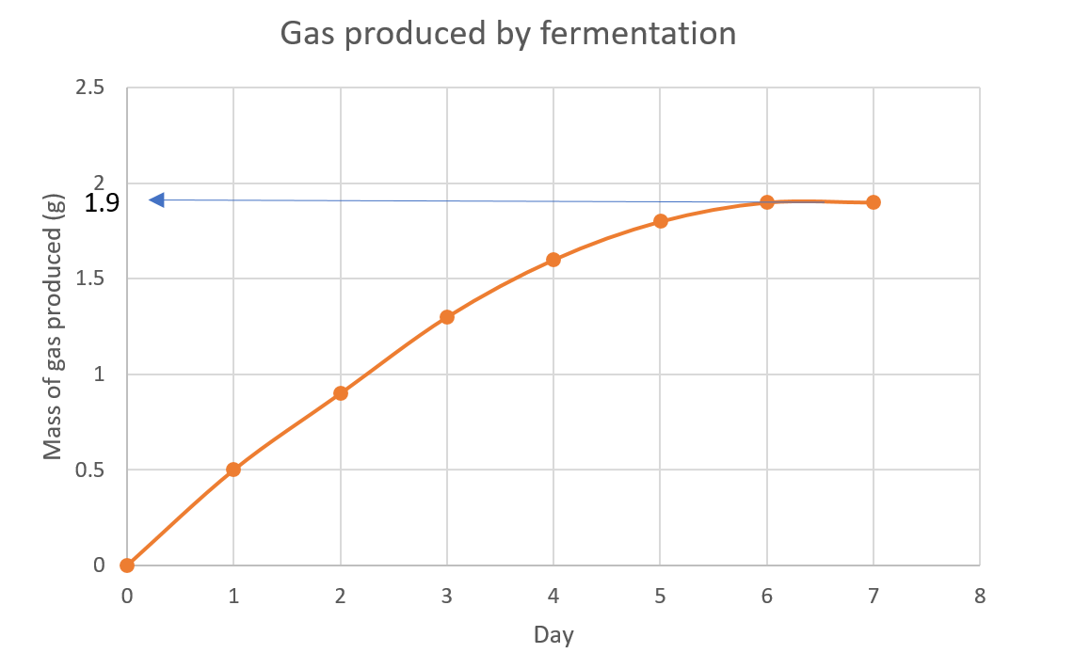

$$n = \frac{m}{MM} = \frac{1.9}{(6×12.01) + (12×1.008) + (6×16.00)}= 0.010546 moles$$
V_{m} of any gas at RTP = 24.79L
$$n = \frac{v}{V_{m}}$$
$$v = 0.01546×24.79=0.261 L or 261 mL$$

Question 23 (9 marks)
Enthalpy of combustion for alcohols increases as the molecular mass increases. Evaluate how this suggestion can be tested accurately, validly and reliably.

Marking Criteria

Criteria | Mark
- designs and explains how the suggestion can be tested  - justifies and evaluates measures to ensure validity, reliability and accuracy | 9
- justifies and evaluates variables and controls  - evaluates measures to ensure validity, reliability and/or accuracy | 7-8
- describes a process to test the suggestion  - demonstrates an understanding of validity, reliability and/or accuracy | 5-6
- outlines steps to test the suggestion  - demonstrates an understanding of validity, reliability or accuracy | 3-4
- identifies a relevant step AND/OR  - shows a basic understanding of validity or reliability or accuracy | 1-2
Independent variable: molar mass of hydrocarbon (alcohols)
Dependent variable: enthalpy of combustion (measured by the temperature increase of water)
Controlled variables: volume of water, container, burner assembly type, the height of container above the burner, position of the thermometer, amount of stirring of the water, time of burning, atmospheric temperature.
Safety: Alcohols are flammable and volatile. Fill the burner away from naked flames, and keep the lid on, when not using, to prevent risk from the ignition of vapour. Operate in a well-ventilated space. PPE such as lab coats, eye protection and leather shoes will reduce risk of injury from naked flames.
Procedure:
- Accurately measure 200mL of tap water into a copper beaker and elevate using a retort ring
- Weigh a burner containing ethanol
- Take the initial temperature of the water
- Heat the water, using the burner for a short time and then reweigh the burner.
- Calculate the heat gained by the water by $q= mCΔT$, where m is mass water, C is the heat capacity of water and ΔT is the temperature change of the water.
- Calculate the Δ_{c}H for ethanol using, $Δ_{c}H = \frac{q}{n}$where n is moles of fuel burnt
- Repeat 3 times for ethanol
- Repeat for other alcohols, such as propanol, butanol and pentanol
- The data may be graphed to identify trends

Discussion:
By repeating the experiment several times and taking average, for a variety of straight-chain alcohols, the results of the experiment can be averaged, reducing error. The controlling of all variables listed, only changing the type of alcohol, and measuring temperature change the investigation should ensure the experiment is valid, however, the assumption that all the heat released from the burning of the alcohol is absorbed by the water, led to random errors in the experiment. The alcohols used should be all primary alcohols to improve validity of the method. The accuracy of the temperature measurements could have been improved using a calibrated digital thermometer. Heat was lost to the surroundings, including the copper container. The heat gained by the container can be calculated and factored in to the calculation to improve the validity of the method. On plotting the results, regardless of the experimental error and a lack of accuracy, there is a clear trend demonstrating that the enthalpy of combustion is proportional to the mass of the alcohol, demonstrating that the procedure is a reasonable model.

Question 24 (9 marks)
Methanol and butanoic acid are reacted together using a catalyst. The mixture is heated, and the products are refluxed.
a. Using a chemical equation, describe the results expected for this reaction. (2 marks)
b. Justify the use of the refluxing apparatus. (2 marks)
c. Explain the reactions conditions and how the chemical risks may be safely managed. Also describe, with the aid of an annotated diagram, how to carry out this reaction efficiently in a school laboratory. (4 marks)

Marking Criteria and Sample answer
Criteria (a) | Marks
- Correct equation with states and showing functional groups  - Describes an observation of the product or reactants | 2
- Substantially correct equation OR  - Observation of reactants or products | 1

methanol + butanoic acid$↔$methyl butanoate + water
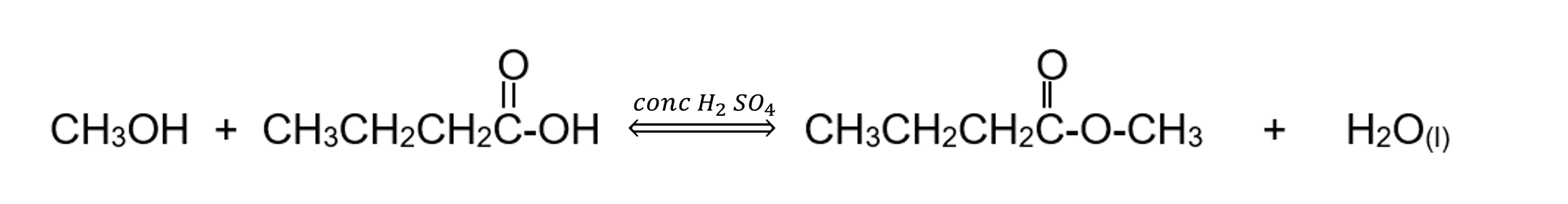
The smell of the contents changes from pungent vomit-like smell of butanoic acid to a sweet fruity smell. The thermometer near the top registers the boiling point of the ester.

Criteria (b) | Marks
- states reasons to justify the use of the refluxing apparatus | 2
- some relevant information | 1

Methanol and butanoic acid undergo an esterification reaction to produce methyl butanoate. The esterification must be carried out in a refluxing apparatus, as heating is required to overcome the high activation energy of reaction and because the reactants and ester product may be very volatile and easily lost when heated. Refluxing is a process that involves heating a mixture in a vessel with a cooling condenser attached to prevent the loss of volatile substances by condensing them back into the reaction mixture. This allows the reaction to proceed at much higher temperatures and returns the higher boiling point liquids back to the flask. Otherwise, all the contents would simply evaporate into the atmosphere and the reaction products would be lost. The reflux apparatus prevents gas build-up, which could cause an explosion.
Criteria (c) | Marks
- explains the conditions of heating and adding a catalyst to efficiently carry out this reaction in a school laboratory  - explains the managing of risks and hazards and how they are addressed  - Includes an annotated diagram | 4
- outlines the conditions to efficiently carry out this reaction in a school laboratory  - outlines the managing of risks and hazard  - includes a labelled diagram of refluxing apparatus | 3
- includes a sketch of the apparatus  - identifies the conditions to efficiently carry out this reaction in a school laboratory and/or  - identifies the risks and hazards and/or how they are addressed | 2
- shows some understanding of the conditions OR how to manage safety risks to carry out this reaction in a school laboratory OR includes a sketch of the apparatus | 1

To increase the rate of the reaction, concentrated sulphuric acid is used as a catalyst. It also acts as a dehydrating agent, shifting the position of equilibrium to the right, thereby increasing the yield of the ester. Heating the mixture also increases the rate of the reaction. Since this reaction contains flammable chemicals, the mixture should be heated with a heating mantle or in a water bath to allow for safe heating with no naked flames.

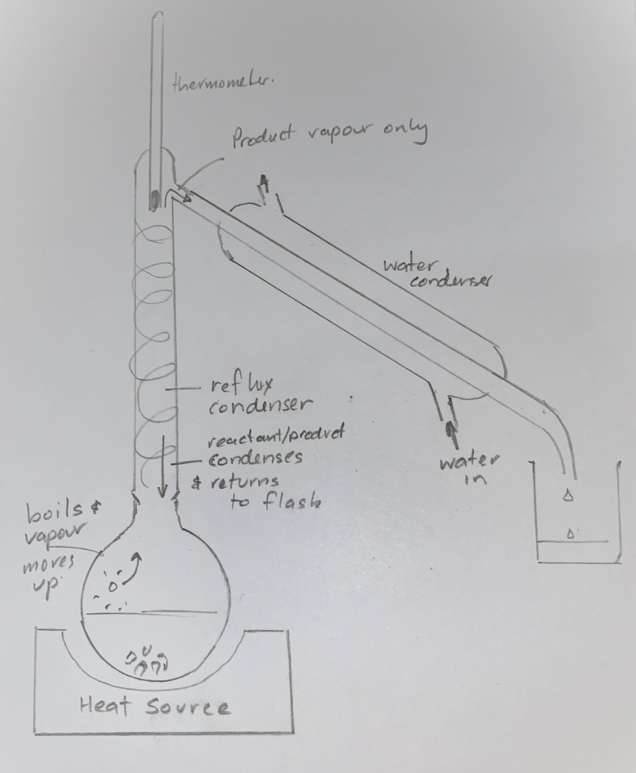
Figure 6: refluxing apparatus

Question 25 (5 marks)
Explain the difference in boiling points of alcohols, ketones and carboxylic acids. Support your answer with diagrams and with reference to the information from the table below. (5 marks)

 | Alcohols | Ketones | Carboxylic acids
Number of Carbons in the chain | Boiling Point (°C) | Boiling Point (°C) | Boiling Point (°C)
2 | 78 | N/A | 118
3 | 97 | 56 | 141
4 | 117 | 80 | 164
5 | 138 | 101 | 186

Marking Criteria and Sample answer
Marking criteria | Marks
- accounts for trends observed due to the action of intermolecular forces  - illustrates the explanation with labelled diagrams  - refers to the information in the table | 6
- accounts for the relationship between boiling point and intermolecular forces  - illustrates the explanation with a labelled diagram  - refers to the information in the table | 4-5
- relates boiling point to intermolecular forces | 2-3
- any relevant information | 1
As the number of carbons in the chain increases, the boiling point (BP) increases within each group. This is because when the length of the carbon chain increases, there are more sites available for intermolecular bonding (dispersion forces) to act. See the diagram for 1-heptanol:
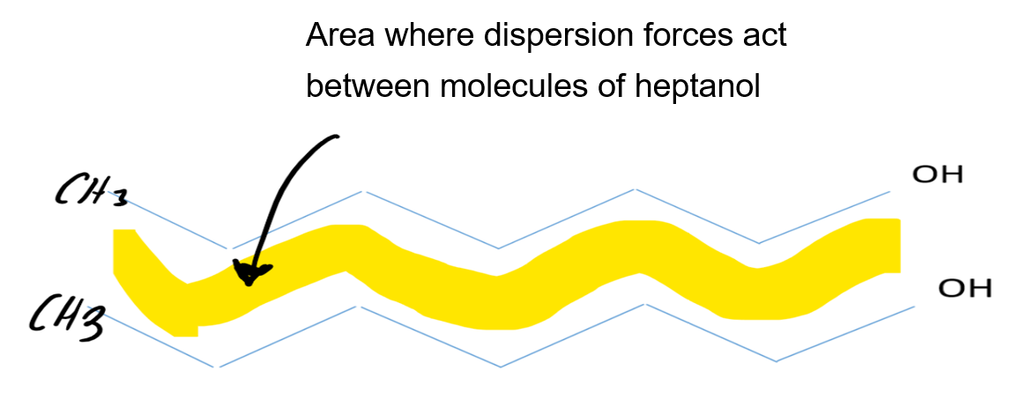
Area where strong hydrogen bonding can occur.
With more bonding, more energy is required for molecules to be separated from their neighbours (which occurs during boiling). Hence the BP will increase as the length of chain increases.
For hydrocarbons with carbon chains of the same length, the differences in BP is due to the functional groups present in those molecules. The ketone has a double-bonded oxygen in the middle of the chain. This is polar, so as well as dispersion forces, there will also be attractions between the permanent carbonyl dipoles from nearby molecules. This makes the boiling point of ketones higher than corresponding alkanes, but the oxygen atom in the ketone is not bonded to a hydrogen atom, and therefore strong hydrogen bonding cannot occur between ketone molecules.
The presence of the polar –OH group, on alcohols and carboxylic acids is a site for strong intermolecular bonding (hydrogen bonding) to occur. For alcohols, there is a single site for the H in the hydroxyl group of one molecule to make a strong intermolecular bond with the O of the hydroxyl group from another molecule, however, with carboxylic acids, the H of the hydroxyl group can hydrogen bond with either O from a neighbouring molecule. This makes the BP of the carboxylic acid higher than the corresponding alcohol.
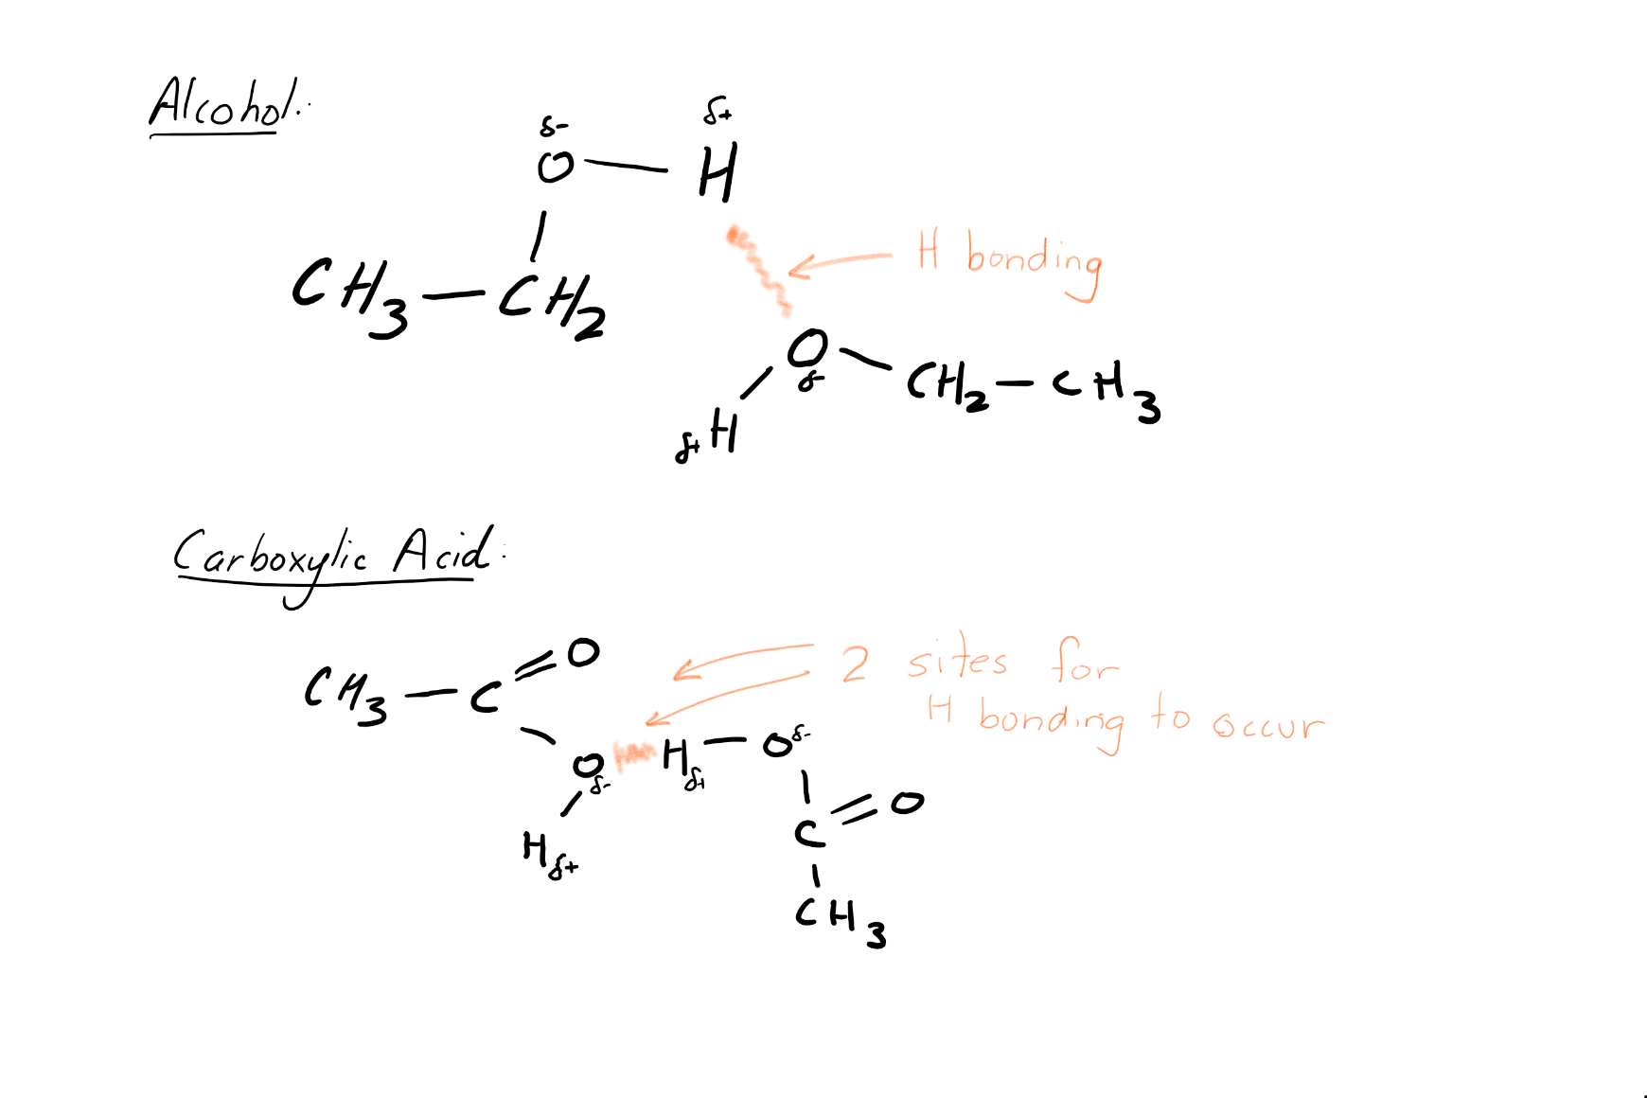

Question 26 (9 marks)
A student has samples of two straight-chain hydrocarbon liquids, of between 6 and 8 carbons in length, and is unsure which of the two hydrocarbons is an alkane, and which is an alkene.
a. Outline a method for testing the hydrocarbons, managing the chemical risks and describe the results expected for the alkane and alkene. (5 marks)
b. Assess the accuracy of this method in distinguishing between saturated and unsaturated hydrocarbons. (4 marks)

Marking Criteria and Sample answer

Criteria (a) | Marks
- describes a complete and concise method  - recognises the risk and states how to manage these risks  - correct details of the outcomes for alkane and alkene | 5
- describes a complete method  - states the risk and states how to manage these risks  - correct details of the outcomes for alkane and alkene | 4
- describes a simple method and  - states a risk or how to manage a risk in the experiment  - correct details of the outcomes for alkane and alkene | 3
- describes a simple method AND/OR  - states a risk or how to manage a risk in the experiment OR  - correct details of the outcomes for alkane and alkene | 2
- any relevant information | 1
a. Safety: Perform the experiment in a fume hood or with good cross ventilation due to the fumes produced by the bromine water and hydrocarbons. Wear nitrile gloves, a lab coat and safety glasses to protect skin, clothes and eyes from the corrosive nature of the bromine water. Keep the hydrocarbons away from a flame. Dispose of products immediately after use in a waste bottle.
Method: Pipette 1mL of each hydrocarbon into separate test tubes. Pipette 3mL of bromine water into each test tube and then gently shake the contents to mix. The test tubes will have two layers of liquid in them. The top layer is the hydrocarbon, the bottom is the bromine water. In the test tube with the alkene, bromine water will decolourise, as the alkene reacts with the bromine water. For example:
C₆H_{12(l)} + HOBr_{(l)} → C₆H₁₂OHBr_{(l)}
hexene → 2-bromocyclohexan-1-ol.
However, in the test tube with the alkane, the bromine water will not decolourise.

Criteria (b) | Marks
- assesses the accuracy using evidence  - describes examples where inaccuracies could occur in this method | 4
- describes the observations for saturated and/or saturated hydrocarbons  AND/OR  - describes possible errors | 2-3
- any relevant information | 1

The reaction of bromine water with alkenes is a qualitative method, with a positive test for alkenes resulting in a decolouration of the bromine water. To ensure that the results are valid, the bromine water must be the limiting reagent. Reactions containing an excess of bromine water will not decolourise sufficiently, making it difficult to distinguish the positive result. Furthermore, the results need to be observed within 5 minutes of adding the bromine water. This is because ultraviolet radiation will allow the alkane to react with the bromine water via an addition reaction. At this point, a false-positive result would be obtained when the chemical is an alkane.
As long as these conditions are managed appropriately, this method will produce an accurate result to distinguish between an alkane and alkene.

Question 27 (8 marks) Modules 7 and 8
Critically analyse the following statement: “The production and use of organic compounds such as alcohols and hydrocarbons have significant positive and negative environmental, economic and socio-cultural implications for all life on earth. These organic compounds are produced by the chemical industry. Hence any problems associated with their use will require chemical solutions.”

Marking criteria and sample answer:

Marking criteria | Marks
- analyses the environmental, economic and social implications of using organic compounds  - describes the production and sources of organic compounds  - relates an example of solutions to problems of the use of organic compounds proposed by industry  - provides a judgement that assesses the statement | 8
- relates the environmental, economic and social implications to the use of hydrocarbons  - describes the production and sources of organic compounds  - relates an example of solutions to problems of the use of hydrocarbons proposed by industry | 6-7
- describes the production and sources of organic compounds  - compares the use and source of organic compounds | 4-5
- describes the production and/or use of organic compounds  - describes the environmental, economic and social implications of using organic compounds | 2-3
- any relevant information | 1

Organic compounds are those based on carbon. Hydrocarbons, containing carbon and hydrogen are organic compounds. Hydrocarbons, obtained from the Earth as oil and gas, are used as fuel and feedstock for other chemical synthesis. The burning of hydrocarbons for fuel uses a finite fossil fuel resource and produces carbon dioxide, which contributes to climate change and air pollution.
2C₈H_{18(l)} + 25O_{2(g)} ↔ 16CO_{2(g)} + 18H₂O_{(l)}
As a solution to these issues, ethanol is an organic compound that can be made alternatively by the fermentation of glucose from plants.
C₆H₁₂O_{6(aq)} → 2C₂H₅OH_{(l)} + 2CO_{2(g)}
Ethanol from plants (bioethanol) can also be burned to provide energy, such as that required for transport, but will contribute to the production of carbon dioxide and therefore contribute to climate change.
C₂H₆O_{(l)} + 3O_{2(g)} → 2CO_{2(g)} + 3H₂O_{(l)}
The production of bioethanol also uses up large amounts of land that are needed for food production. Alternatives for energy are being developed that include renewable energy sources, such as wind and hydroelectricity. The industry is also trying to solve the problems with the development of battery storage for solar energy.
Oil can also be the feedstock for the production of polymers, such as polythene. Single-use plastic is becoming a global waste problem. Single-use plastics do not degrade easily in landfills and burning of plastics produce carbon dioxide and other toxic gases.
Chemical Industry is making polymers using genetically engineered bacteria that are biodegradable, but these bioplastics are expensive and are not widely used as yet. Trials with plastic waste breakdown and e-waste ‘mining’ are being conducted by industry.
Oil-based chemicals have been instrumental in improving people’s quality of life, with cheap access to energy and products used in every part of our life. However, the issues with waste production and climate change, will need to be addressed by a range of strategies, such as consumer education, government policies, as well as academic research and industrial solutions.

Question 28 (9 marks) Modules 7 and 8
2-methylbut-2-ene gas and its derivatives are used in the pharmaceutical industry. Evaluate the factors that need to be considered when designing a chemical synthesis process as shown by reactions, A, B and C.
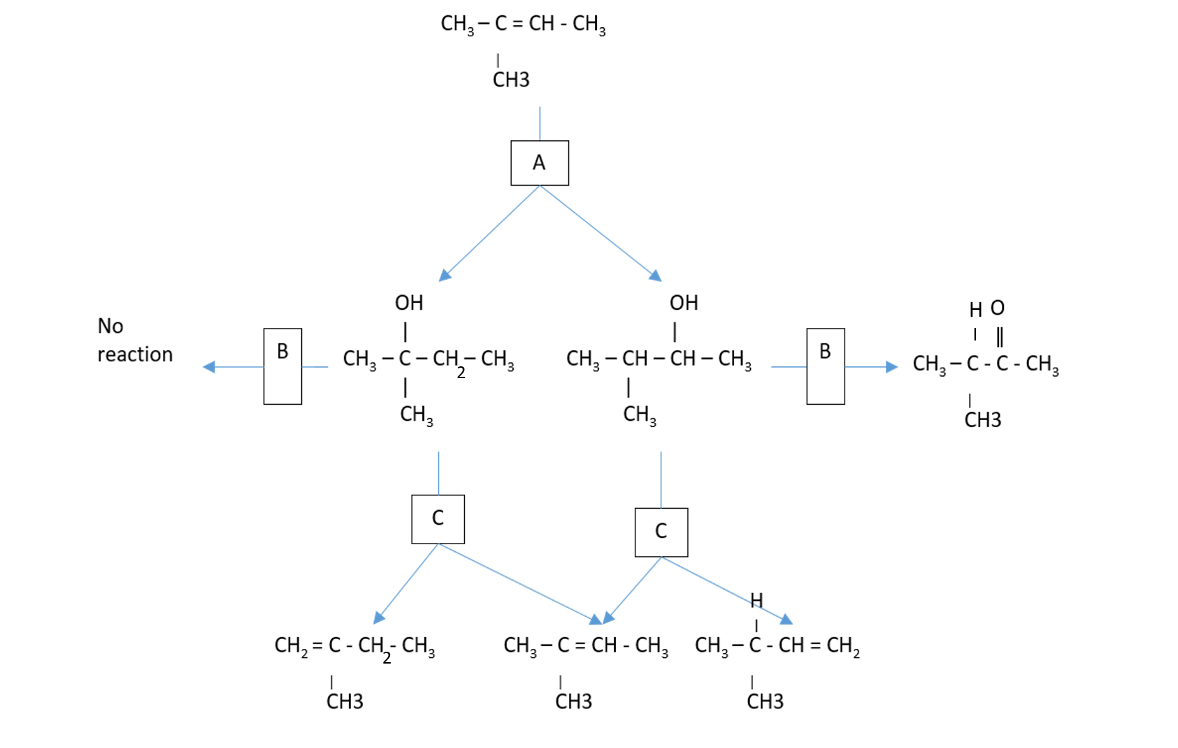

Marking Criteria and Sample answer
Criteria | Mark
- evaluates the issues and implications for society of chemical synthesis  - justifies practices, conditions and reagents in chemical synthesis in considering uses, purity and yield | 9
- evaluates issues that need to be considered when designing chemical synthesis  - describes reaction conditions, reagents, yield and/or purity | 7-8
- describes issues that need to be considered when designing chemical synthesis  - identifies reagents and conditions and/or yield | 5-6
- identifies environmental, economic or social issues/s  - identifies reagents and/or conditions and/or risk management practices | 3-4
- any relevant information | 1-2

Sample answer
The reaction A shows the addition of water across the double bond. This requires reaction with a dilute solution of a strong acid, like sulphuric acid, as concentrated acid would drive the reaction in the opposite direction, resulting in poor yield. 2-methylbut-2-ene is a gas and 2-methylbutan-2-ol a volatile liquid and are both very flammable. Therefore, to ensure safe working conditions, no naked flames should be present, and that the containers can withstand gas pressure. The acid would need to be stored in a safe area, capable of holding any spill, and at a concentration that is not too high.
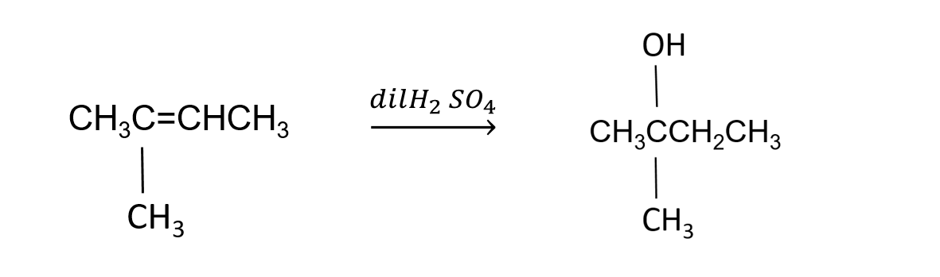
In reaction B, the alcohol is oxidised, using warm acidified dichromate solution. The tertiary alcohol on the left will not oxidise, and the solution stays yellow-orange. The secondary alcohol on the right oxidises to a ketone, and the solution turns green. If the alcohol was primary, the product would be an acid, which can be tested with a pH indicator.
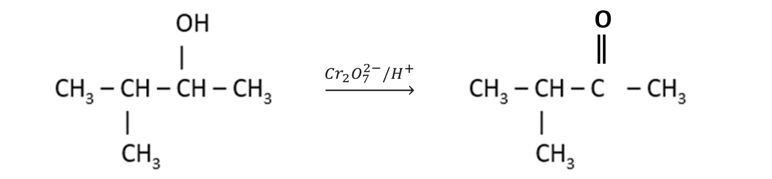

In reaction C, the alcohols are dehydrated with concentrated sulphuric acid, or with hot aluminium oxide catalyst to form alkenes. However, a mixture of 2 alkenes is formed, unlike the original single product. The catalyst will reduce the activation energy so that the reaction can occur at a lower temperature. The concentrated acid will react with the water, causing the equilibrium position to shift towards the products.
These chemicals must be carefully monitored to ensure an economical yield of product in a reasonable time. Care must be taken so that no acids or volatile gases escape into the environment. Acids should be contained in walls around reaction vessels if a spill occurs to prevent leakage into waterways and harmful effect on aquatic life. Workers should wear protective clothing and eye protection to minimise corrosive action on skin and eyes if there is a spill. With careful management, we can ensure these chemicals are used to manufacture important pharmaceuticals needed for the health of society and not cause harm to workers or the environment.

Question 29 (9 marks) Modules 7 and 8
Ethanol as both a product and a reactant is very important for society. Glucose (C₆H₁₂O₆) can be fermented to produce ethanol. Ethanol can be oxidised to manufacture ethanoic acid. Ethanol can also be reacted with organic acids to manufacture esters. With the aid of a flow chart to demonstrate the processes required, evaluate the factors and issues that need to be considered when designing chemical synthesis of an ester from ethanol.

Marking Criteria and Sample answer

Criteria | Mark
- evaluates the issues and implications for society of chemical synthesis of esters  - justifies practices, conditions and reagents in chemical synthesis of esters in considering uses, purity and yield | 9
- evaluates issues that need to be considered when designing chemical synthesis of esters, such as yield or purity  - describes reaction conditions and reagents using a flow chart  - constructs balanced chemical equations | 7-8
- describes issues that need to be considered when designing chemical synthesis of esters  - identifies reagents and conditions and/or yield using a flow chart | 5-6
- identifies environmental, economic or social issues/s  - identifies reagents and/or conditions and/or risk management practices | 3-4
- any relevant information | 1-2
Fermentation: glucose can be fermented to produce ethanol, by placing a solution of glucose in a reaction vessel with yeast. The vessel should be warmed, and CO₂ gas should be allowed to escape via an airlock, which prevents air from entering the vessel.
C₆H₁₂O_{6(aq)} + 6H₂O_{(l)} → 6C₂H₅OH_{(l)} + 6CO_{2(g)}
When the reaction stops bubbling, the mixture can be distilled, boiling off the volatile ethanol and leaving behind the water and unreacted contents. The ethanol vapour is collected by condensation, but careful monitoring is needed to ensure the temperature is controlled, as both water and ethanol are close together, and both will be present in the vapour. The use of a reflux condenser will improve the separation based on boiling point and produce a more pure product.
Oxidation: the pure ethanol can be oxidised to ethanoic acid by heating with acidified dichromate solution to produce ethanoic acid
C₂H₅OH_{(l)} $\underset{→}{{{{Cr}_{2}O}_{7}^{2-}/H}^{+}}$ CH₃COOH_{(l)}.
This reaction needs heat and time so that it does not stop at the ethanal stage and all product is ethanoic acid, so therefore monitoring of the presence of any intermediate ethanal will be required, by taking off a sample and checking to see if the contents react and decolourise acidified dichromate.
Esterification: the ethanoic acid and the ethanol can be heated together in the presence of concentrated sulphuric acid catalyst to manufacture the ester ethyl ethanoate. This reaction should be performed using reflux to prevent the loss of volatile reactant and product, and increase the temperature and therefore, the rate at which the reaction can occur. The addition of the concentrated sulfuric acid enables the reaction to be pushed towards the right by Le Chatelier’s principle as concentrated acid will react with and remove the product water. Therefore, considering both rate and equilibrium will ensure good conversion to the ester.

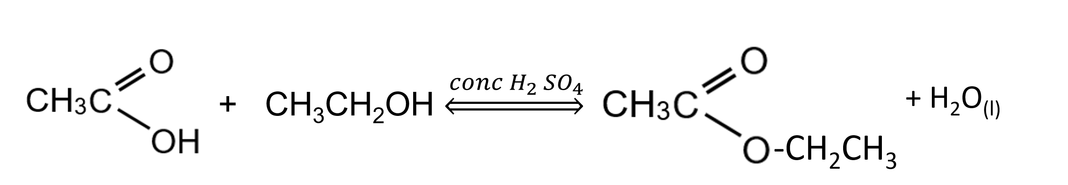
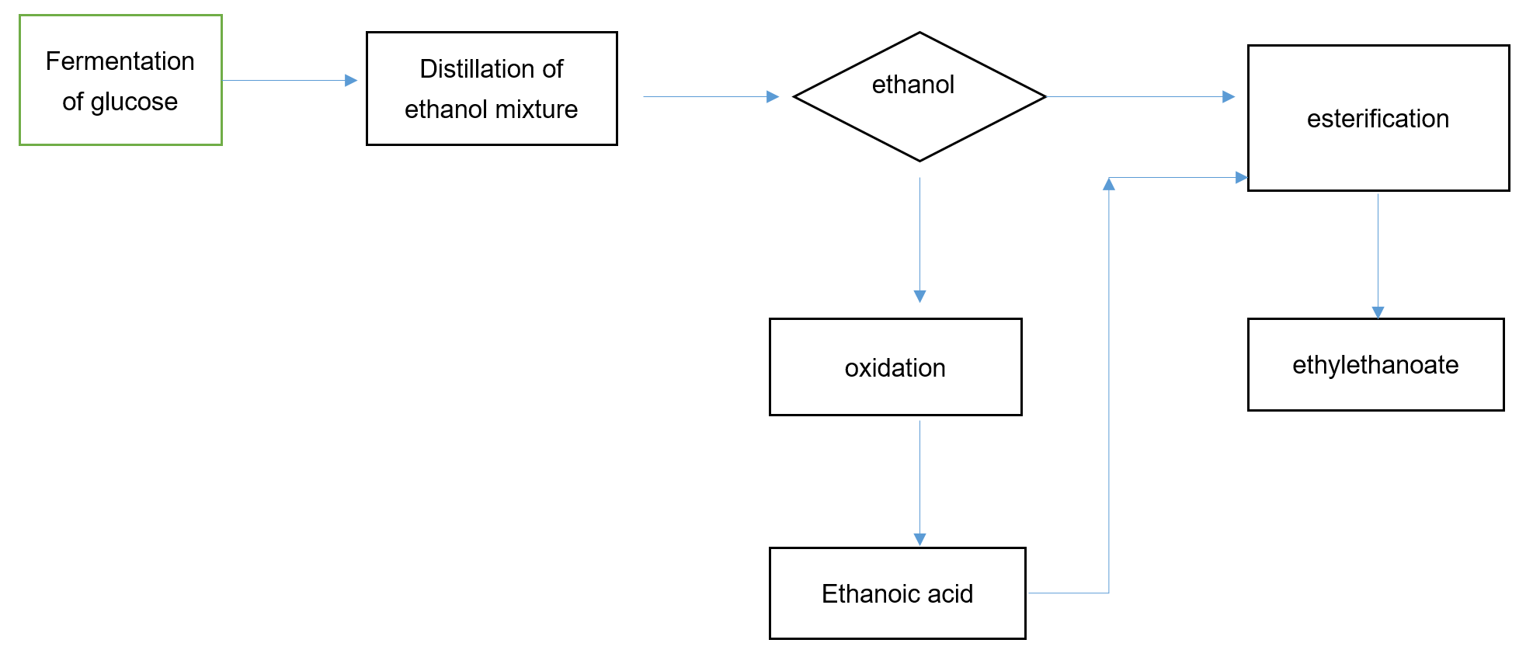

Question 30 (7 marks) Modules 7 and 8
Ethanol can be synthesised by two methods: from organic sources and as bioethanol. Compare and evaluate the two synthesis processes in terms of availability of raw materials, yield, reaction conditions and impacts on the environment.

Marking Criteria and Sample answer
Marking criteria | Marks
- communicates scientific understanding logically and succinctly using correct and precise terminology  - supports analysis/comparison/evaluation with relevant chemical equations  - represent relevant processes in a logical, coherent form  - make valid conclusions using the information provided | 6
- compares issues which are relevant to the evaluation of each process method  - supports analysis/comparison/evaluation with relevant chemical equation/s | 4-5
- analyses the structure of, and predicts reactions involving, carbon compounds AND/OR  - describes or compares methods | 2-3
- any relevant information | 1

Ethanol can be produced from by the hydration of ethene, which is derived from the steam cracking of heavier fractions of crude oil.
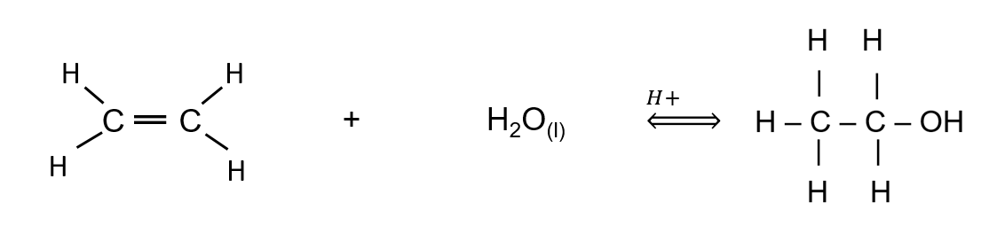 Alternatively, it can be produced by the fermentation of glucose.
Fermentation requires a low temperature, normal atmospheric pressure and the absence of air. The fermentation process is:
C₆H₁₂O_{6(aq)} ↔ 2C₂H₅OH_{(l)} + 2CO_{2(g)}

 | Hydration of Ethene | Fermentation
Raw Materials | Organic Crude oil; non-renewable | biomass (glucose); renewable
Process | Continuous | Batch
Labour | Automated, and requires fewer workers | Crop production is a more labour-intensive process
Reaction rate | Fast | Slow
Conditions | High temperature and pressure. Therefore, the energy requirements are high. | Low temperature and normal pressure. Therefore, the energy requirements are low. Additionally, energy is required to run machinery to process crops and to recover ethanol through distillation.
Yield | Pure, no by products | Needs to be purified and waste products.
Environment concerns | - Uses a finite natural resource - fossil fuel  - Risk of oil spills  - CO₂ emissions from the energy required for processing. | - Land clearing  - Use of arable land needed for food production  - Disposal of waste  - CO₂ emissions from the energy required for processing.
The production of ethanol through fermentation should consider the carbon dioxide emissions associated with the energy required in the growing, harvesting and transporting the crops, or separating the ethanol by distillation and so it can be said that it does contribute to climate change. Land clearing, world-wide, is a current issue, and land clearing to produce crops for ethanol production only, would not be viable. Alternatives, such as fermenting agricultural waste, may address some issues. Presently, there is still demand for fuels made from organic fuels such as petroleum, despite biofuels addressing concerns about their use.

Module 8

Question 31 (9 marks)
An investigation was carried out to determine the barium ion concentration in a water sample using gravimetric analysis.
Sodium sulfate solution was added to a water sample in a flask and heated until no more precipitate was formed. The water sample was then filtered.
The filtration apparatus consisted of a sintered glass filter set into the top of a sidearm flask which was connected to a vacuum pump. The precipitate was then dried and weighed, and the amount of chloride ion calculated.
Explain how the procedure and equipment were used to accurately, validly and reliably determine the barium ion concentration.

Marking Criteria and Sample answer
Marking Guidelines | Marks
- explains how the barium ion concentration in a water sample can be determined  - includes evaluation of accuracy, validity and reliability of data | 9
- describes how the barium ion concentration in a water sample can be determined  - describes how the accuracy, validity or reliability of data was ensured | 7-8
- outlines relevant steps for the determination of barium ion concentration in a water sample  - shows some understanding of accuracy, validity or reliability of data | 5-6
- outlines relevant steps for the determination of barium ion concentration in a water sample AND/OR  - shows some understanding of accuracy and/or validity and/or reliability of data | 3-4
- outlines a step to determine barium ion concentration OR  - shows some understanding of accuracy or validity or reliability of data | 2
- any relevant information | 1

The procedure outline allows barium ions to form a precipitate with sulfate ions,
SO₄²⁻_{(aq)} + Ba²⁺_{(aq)} ⇌ BaSO_{4(s)}
To ensure that the process is valid, an experimental control should be used. In this case, the experimental control could be distilled or deionised water. If the procedure is valid, no precipitate should be found in the control sample. If other anions may be present, precipitation or other methods (such as adding HCl to remove carbonate ions) may be required to remove them. An excess quantity of sodium sulfate should be added to the water sample so that the barium ions are quantitatively precipitated out.
Furthermore, the sodium sulfate solution should be added to the water sample while the latter is stirred. Sufficient time should be provided to ensure complete precipitation of the barium ions. During filtration, the precipitate should be thoroughly washed in many volumes of water. The residue should be completely dried (in a desiccator) before being weighed, using digital scales to 2 decimal places, to improve the accuracy and precision of the measurement. These steps will also enhance the validity of the investigation, by ensuring all the barium ions have been transferred and no water is adding to the mass of the precipitate.
The number of moles of BaSO_{4(s)} can be determined using the mass. Since the ratio of Ba²⁺ to SO₄²⁻ is1:1, the number of moles of BaSO₄ is equivalent to the number of moles of barium ions. Therefore the concentration of barium ions = [mass Ba²⁺ ions/(mass of water)] x 100%.
To ensure reliability, multiple samples of water from the same source, at the same time, can be tested in different labs, to ensure the concentration of Ba²⁺ is consistent.

Question 32 (8 Marks)
Six standard solutions of copper (I) chloride were prepared as follows and were placed in a colourimeter to measure the absorbance of light of copper ions.
a. Calculate the concentration of copper ions in the six standard solutions and enter your answers into the table below (2 marks)

Test-tube | 0.1M Copper sulfate (ml) | H₂O added (ml) | [Cu²⁺] (M) | Absorbance
1 | 0.0 | 10.0 |  | 0.00
2 | 2.0 | 8.0 |  | 0.15
3 | 4.0 | 6.0 |  | 0.28
4 | 6.0 | 4.0 |  | 0.46
5 | 8.0 | 2.0 |  | 0.60
6 | 10.0 | 0.0 |  | 0.73

b. Draw a calibration graph of absorbance vs concentration of copper ions in the grid provided (3 marks)
c. Excess copper (I) chloride was added to a test tube filled with water. The undissolved copper (I) chloride was filtered out, and the solution was placed in a colourimeter to measure the absorbance. The absorbance reading was 0.37. Determine the concentration of copper (I) ions present in solution. (1 Mark)
d. Calculate the solubility product for the dissolution of copper (I) chloride, in part (c). (2 Marks)

Marking Criteria and Sample answer

Marking Criteria (a) | Marks
- determine the correct concentration of copper ions for all six standard solutions | 2
- determines some correct concentrations | 1

a.
Test-tube | 0.1M Copper sulfate (ml) | H₂O added (ml) | [Cu²⁺] (M) | Absorbance
1 | 0.0 | 10.0 | 0.0 | 0.00
2 | 2.0 | 8.0 | 0.02 | 0.15
3 | 4.0 | 6.0 | 0.04 | 0.28
4 | 6.0 | 4.0 | 0.06 | 0.46
5 | 8.0 | 2.0 | 0.08 | 0.60
6 | 10.0 | 0.0 | 0.10 | 0.73

Marking Criteria (b) | Marks
- provides a correct graph that includes labelled axes with units, appropriate scales, plotted points and smooth line of best fit | 3
- provides a substantially correct graph | 2
- Provides some basic features of the graph | 1

b.
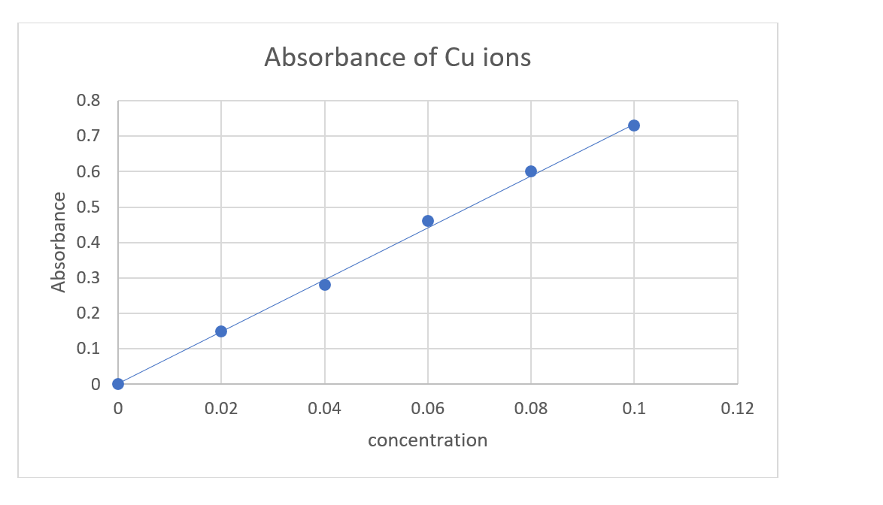

Marking Criteria (c) | Marks
- correct [Cu⁺] ions determined from graph | 1

c. from the graph, an absorbance of 0.37 corresponds to concentration = 0.05molL⁻¹

Marking Criteria (d) | Marks
- correctly determines K_{sp} for Copper (I) chloride with correct units | 2
- writes correct K_{sp} expression or performs correct mathematical substitutions and solves | 1

d.
CuCl_{(s)} → Cu⁺_{(aq)} + Cl⁻_{(aq)}

Where,
[CuCl] = 0.05
[Cu⁺] = x
[Cl⁻] = x

K_{sp} = [Cu⁺][Cl⁻]
= 0.05 X 0.05
= 0.0025

Question 33 (8 marks)
Soil from an industrial site was suspected of being contaminated with mercury. A single sample of the soil was extracted using an approved method. The resulting solution was analysed five times by atomic absorption spectroscopy (AAS). The results are shown in the table.

Measurement Number | Absorbance
1 | 0.90
2 | 0.89
3 | 0.89
4 | 0.64
5 | 0.91

The concentration of mercury in the soil sample was calculated using an average absorbance of 0.85. Assess the validity and reliability of the concentration of mercury determined using the procedure outlined above, including suggestions to improve the reliability and validity of the mercury concentration.

Marking criteria and Sample answer
Marking criteria | Marks
- comprehensive assessment of the validity and reliability of the data  - appropriate suggestions on how the reliability and validity could be improved | 5
- comprehensive assessment of the validity and reliability of the data | 4
- some aspects of both validity and reliability of the data are addressed | 3
- either the validity or reliability of the data is addressed | 2
- any relevant information | 1
The procedure is neither valid nor reliable. The procedure is not valid as the outlier in the data (0.64) should be discarded before averaging. This will result in greater precision of data. Additionally, a single site is not a valid procedure, and multiple soil samples across the site must be analysed for the investigation across the entire site to be valid. The validity can be improved by ensuring that the procedure is followed, and an appropriate lamp is chosen, where the light emitted will be absorbed by the mercury in the sample, and by no other metals. The AAS should have been calibrated with standardised samples before any measurements, making the results more accurate. In this question, no information on this procedure was provided.
The data is also unreliable, as the analysis was made from a single sample. Repetition at each single soil sample site by taking several samples will improve the reliability of the data, as will repeating the analysis for multiple measurements at different positions across the site.

Question 34 (3 marks)
Compare colourimetric methods to identify and measure the concentration of coloured species in the environment. (3 marks)

Marking criteria | Marks
- compares methods to measure the concentration of coloured species | 3
- describes methods to measure the concentration of coloured species | 2
- describes a method of measuring the concentration of coloured species | 1
Coloured species, can be analysed using methods such as atomic absorption spectroscopy (AAS), colourimetry and UV-visible spectrophotometry. Colourimetry is a technique that measures the intensity of colour in a sample solutions. Visible light is passed through a filter chosen to absorb the sample, and the intensity of light passing through the sample is measured the absorbance of the light is calculated. A calibration curve can be constructed from a series of standard solutions and then the concentration of the unknown sample can be determined from the calibration curve. Colourimetry will determine the concentration of any coloured species, and is useful to determine the concentration of ions in water, such as water supplies or waste water.
In AAS, an amount of light of a specific wavelength is absorbed by the sample ions when the sample is sprayed into a flame, and the absorbance of the light, which is directly proportional to the concentration of the ions in the sample is measured. This is completed for a range of standards and a calibration curve constructed. This is only suitable for solutions of metal ions and for metals where a cathode lamp with a filament of the metal exists. It is a very sensitive technique, much more so than colourimetry. AAS can determine the concentration of trace elements in biological samples, food and drugs.
UV-vis spectrometry, measures the radiation absorbed by coloured species across a range of frequencies in the UV-visible part of the electromagnetic spectrum. When sample molecules are exposed to the wavelength that corresponds to the transition of electrons between energy levels, the light energy is absorbed. UV-vis produces a graph of wavelength vs absorbance, where absorbance is proportional to concentration, for a number of chromophores (atoms that absorb in the UV-vis region of the spectrum). By setting the wavelength of radiation, using a monochromator that gives the greatest absorbance (λ_{max}), for a particular species, a set of standards can construct a calibration curve, to which the sample can be compared. UV-vis is suitable across a range of coloured organic and inorganic species and could be used to analyse gases as well as solutions. It is capable of measuring a wider range of species compared to AAS and colourimetry, and can be used for qualitative analysis as well as quantitative.

Question 35 (6 Marks)
Using examples, compare qualitative and quantitative methods used to analyse ions in the environment.

Marking criteria and sample answer
Criteria | Marks
- compares the qualitative and quantitative analysis of named ions  - communicates scientific understanding the analysis of ions | 6
- describes tests for both the detecting the presence of and determining the concentration of named ions in the environment | 4-5
- describes qualitative and/or qualitative methods to analyse ions  AND/OR  - describes test/s for named ion/s | 2-3
- any relevant information | 1
Qualitative testing can tell us what ions are present in a sample. Some metal ions can be identified through flame tests, which are performed by spraying a sample into a flame, such as the pale green colour of barium ions. The flame promotes electrons into higher energy states, which release light energy as they fall back to lower levels. If an atom or an ion is excited by very strong heating, electrons can be promoted from their normal unexcited state into higher orbitals. As they fall back down to lower levels (either in one go or in several steps), energy is released as light. Different atoms will emit light of a different wavelength.
The presence of both cations and anions can be confirmed with simple precipitation tests, using the solubility rules. For example, the addition of HCl to a sample may cause:
- Bubbling: this indicates the presence of carbonate anion. Carbonate anions act as a buffer in aquariums, protecting freshwater fish from large changes in pH. The bubbles are CO_{2(g)}:
HCl_{(aq)} + CO₃²⁻_{(aq)} → H₂O_{(l)} + CO_{2(g)}
- Precipitation: this indicates the presence of lead or silver ions. Lead is toxic and causes nerve and organ damage. It is therefore important to be able to detect the presence of toxic ions in water samples.
Pb²⁺_{(aq)} + HCl_{(aq)} → Pb(Cl)_{2(s)} + H⁺
Sometimes, it is vitally important to know the level at which ions are present in food, water or other products. It may be an environmental or health issue or a quality control issue. Mercury and lead ions are toxic to humans, and water around mining industries should be monitored to ensure heavy metals are not being ingested from local water supplies or food products. For this reason, it is important to monitor the concentration of ions in the environment.
To quantitatively determine the concentration of cations that may be present in samples, we can use gravimetric analysis, such as finding the barium ions present in fertiliser, or the concentration of silver ions in a water sample. Other methods of quantitative analysis include precipitation titration, which is a very accurate method of determining the concentration of cations. For example, silver ions are precipitated with sodium chloride solution; when all the chloride and silver have reacted, the excess silver ions from the burette then react with chromate ions in the indicator, and the precipitate formed, silver chromate, is red. This is the endpoint of the titration and can be used to determine the concentration of Ag ions accurately. Very accurate determination of metal ions can be performed using instrumental analysis such as AAS or colourimetry of coloured solutions.
Both qualitative and quantitative methods are useful to collect data about ions in the environment, and the type of analysis will depend on what is required, whether it is the presence of an ion or the concentration of an ion that is required.

Question 36 (6 marks)
Evaluate the use of spectroscopic analyses to identify and quantify chemicals in samples.

Marking criteria and Sample answer:
Marking criteria | Marks
- Makes an evaluation of spectroscopic techniques  - Discusses the use of quantitative technique/s to analyse chemicals  - Discusses the use of qualitative technique/s to analyse the structure of organic compounds | 6
- Outlines the use of quantitative technique/s to analyse chemicals  - Outlines the use of qualitative technique/s to analyse the structure of organic compounds | 4-5
- Outlines technique/s to analyse compound/s | 2-3
- Any relevant information | 1

Sample answer:
Spectroscopy is a range of techniques that use light and other electromagnetic radiation to provide information about materials. Atomic absorption spectroscopy (AAS), is a quantitative technique that accurately determines the concentration of metal ions in a sample. For AAS, a series of metal ion standard solutions (over a range of concentrations) are prepared. Those solutions are sprayed into a flame and the ions vaporised. A cathode ray lamp with a filament of metal produces light of a wavelength that is absorbed by the metal. The light is shone through a sample which is sprayed in a flame and atomised. The gas-phase ions absorb the light energy, and the absorbance or difference in light energy is then detected by the machine. This absorbance of light energy can be shown to be directly proportional to the concentration of metal ions present in the sample, and a calibration curve can be constructed from the average absorbance of the standard solutions. Next, the absorbance of the unknown samples are measured and the calibration curve is used to calculate the concentration of the ions in each sample. This technique is very sensitive, and will give quantitative results for metal ions in samples, such as the levels of toxic lead ions in drinking water samples. The limitations of the technique, are that it is limited to ions in aqueous solution and metal ions that have a matching cathode ray tube made of that filament. AAS is much more sensitive than colourimetry, a quantitative spectroscopic technique which measures the colour intensity of solutions, by comparing the visible light absorbed with a series of standards. Colourimetry is cheap and easily performed in a laboratory for a range of coloured solutions.
Methods such as infrared (IR) spec, nuclear magnetic resonance (NMR) and UV-vis spec are used for qualitative analysis to identify organic structures in molecules. These methods produce data about the number and type of bonds and the symmetry of the molecule. IR-spec will provide information about the bond types and functional groups present in an organic molecule.
NMR is a quantitative analytical technique which can quantify the known components of a mixture or determine the structure of a pure unknown compound. Proton ¹H NMR spectra will show peaks on a chemical shift diagram, which will identify the number of hydrogen atoms and the environments in which they are found. The same type of H1 nuclei in different locations around the molecule will produce peaks at different shifts in the spectrum. ¹³C NMR can provide information on the functional groups in organic molecules, and similarly to proton NMR, the different peak shifts and the area under each peak represent the type, and the relative number of that type of environment in the compound, of carbon atoms, hence the structure of an organic compound, such as chloroethane may be able to be deduced, and structural differences such as isomers can be resolved.
Spectroscopic methods are accurate techniques that provide quantitative and qualitative information on chemical abundance and structure. They need only small amounts of samples and provide sensitive measurements of ions and organic structures. However, the equipment used for spectroscopy can be expensive and is suited to laboratory use rather than use in the field.

Question 37 (5 marks)
The diagram below is the Infrared spectrum for an unknown organic molecule, with molar mass 46 gmol⁻¹.
- Identify the molecule by identifying the bonds which are represented by the absorption bands in the diagram (2 marks)
- Describe, with the aid of an equation, a chemical test that would confirm the presence of this type of molecule (3 marks)
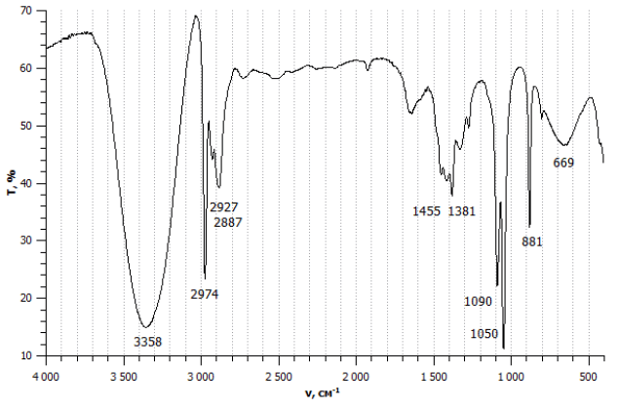
Figure 7 IR spectra for unknown organic compound

Marking Criteria and Sample answer

Marking criteria (a) | Marks
- Identifies 3 bonds correctly and names the compound ethanol | 2
- Identifies one bond correctly or identifies ethanol | 1

1050cm⁻¹ is a C-O bond
2974 is a C-H bond and
3358 (broad), is an O-H (alcohol) bond.
The molecule containing only C-O, C-H and O-H bonds, with a molar mass of 46, is ethanol.

Marking criteria (b) | Marks
- Describes a chemical test for a primary alcohol and includes an equation | 3
- Identifies a part of a valid procedure to identify a primary alcohol | 2
- Any relevant information | 1
b. To test for an alcohol, add acidified potassium dichromate and heat. A colour change from orange to green will be observed if a primary or secondary alcohol is present. Ethanol is a primary alcohol and so should give a positive test. 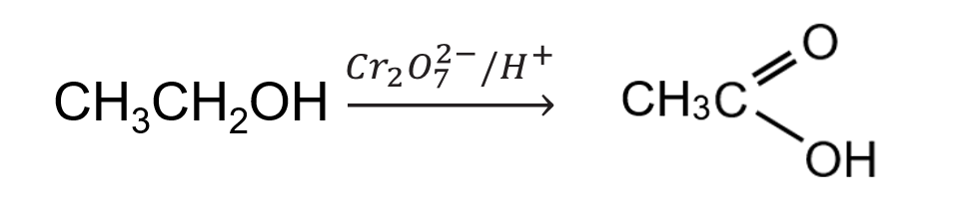
Further testing would be necessary if it were unclear if it was a secondary or primary alcohol, such as reacting with a mixture of HCl/ZnCl₂ which reacts slowly in secondary, but not at all with a primary alcohol.

