Chemistry module 6: acid base reactions

Table of contents
Teaching the Year 12 Modules 3
Course overview 4
Module summary 4
within the content areas of: 5
Big ideas 5
Relationship to other modules 5
Core concepts 6
Opportunities for extending concepts 7
Alternative conceptions and misconceptions 7
Conceptual difficulties 9
Suggested teaching strategies 11
IQ6-1 What is an acid and what is a base? 11
IQ6-2 What is the role of water in solutions of acids and bases? 13
IQ6-3 How are solutions of acids and bases analysed? 15
Appendices 19
Appendix one: models 19
From the concrete to the abstract: modelling and analogical reasoning 21
Appendix two: pH range of indicators 22
Investigation: pH ranges of indicators 22
Appendix three: Titration and conductivity graphs 24
Strong acid–strong base titration 24
Strong acid–weak base titration 26
Weak acid–strong base titration 27
Appendix four: K_{a} and pK_{a} calculations 28
Calculation and meaning of pK_{a} 31
Appendix five: formative assessment items 32
Appendix six: claim evidence reasoning (CER) and scientific argumentation 33
Claim 34
Evidence 34
Reasoning 34
Sample teaching sequence: What is an acid? 34
Appendix 7: possible extension 35
Determining the equivalence point 35
Polyprotic acids 36
Ampholytes 37
Resources 38

Teaching the Year 12 Modules
The new Stage 6 Chemistry course was implemented in NSW schools in 2018-2019. This syllabus incorporates new content and learning activities such as Depth Studies. The syllabus is designed around inquiry questions and formal assessment tasks emphasise the skills for working scientifically.
The Year 12 course builds on the concepts introduced in Year 11 by the examining of particular classes of chemicals, processes and a variety of chemical reactions which incorporate organic compounds and acid/base and equilibrium reactions. The application of this knowledge to the investigation of a range of methods used in identifying and measuring quantities of chemicals, leads to a deep understanding of the structure, properties and trends of, and between, classes of chemicals. The Working Scientifically skills and processes are applied to predict outcomes by using physical, conceptual and mathematical models and assessing the limitations of models.
Therefore, pedagogies that promote inquiry and deep learning should be employed in the Chemistry classroom. The challenge presented by the additional content and the change in pedagogical approach were the catalysts for the preparation of these module guides for Stage 6. These guides are intended to assist teachers deliver Chemistry effectively by outlining overarching concepts (big ideas), core and extended ideas, strategies for teaching the modules, uncovering of alternative conceptions, and strategies to address them. The guides support the teacher in facilitating the development of deep knowledge structures, such as the relationships between concepts. The module guides do not cover all aspects of the syllabus, as that was not within the scope of the project.
It is essential that teachers note that the module guides do not substitute the syllabus, but only support teachers to teach it. The information contained in these documents are correct at the time of publication. While every effort has been made to eliminate errors, any errors or omission that are identified after the release of these documents will be corrected and released as resource updates. It is recommended that teachers access the Curriculum website for the latest version of these documents.

Course overview
The chemistry course develops student ability to apply processes that underpin the understanding of the nature and practice of science and enables students to interpret the interconnection between nature and practice of science, and knowledge of chemistry. Through applying the Working Scientifically skills processes, the course aims to examine how theories, models and practices are used and developed.
The fundamentals developed in Year 11, include:
- knowledge, understanding of the properties and structures of matter, and relating properties and structures to trends in data and reactions
- knowledge and understanding of the types of and drivers of chemical reactions
- skills in making hypotheses and designing valid and reliable practical investigations
- skills in conducting investigations and solving problems
- constructing models
- conducting investigations by measuring and/or collecting relevant data and information from first-hand practicals and secondary sources and determining the accuracy, reliability and validity of data and information
The Year 12 course builds on the concepts introduced in Year 11 by:
- the examining of classes of chemicals, processes and a variety of chemical reactions which incorporate organic compounds and acid/base equilibrium reactions
- the application of this knowledge to the investigation of a range of methods used in identifying and measuring quantities of chemicals, which leads to a deep understanding of the structure, properties and trends of, and between, classes of chemicals
- using physical, conceptual and mathematical models to predict outcomes and assessing the limitations of models.

Module summary
Acid/base reactions is an opportunity to investigate changes in definitions and models of acids and bases. Through an acid/base context, students learn about the nature of science and how scientific thinking changes over time. Students investigate the practice of science to address the skills:
- develop questions and test hypotheses
- design and evaluate investigations
- conduct investigations to collect valid and reliable data and information
- analyse and evaluate data and information;

within the content areas of:
- identifying and predicting patterns of reactions of acids with a variety of substances, including neutralisation reactions with bases
- definitions and models of acids and bases
- the application of knowledge about acids and bases to everyday life, industry and the environment
- the quantitative analysis of acids and bases
- the qualitative analysis and monitoring of acids and bases.

Big ideas
This module allows for deep understanding of how conceptual models change and develop with the availability of new evidence, by examining different definitions and models of acids and bases. Some investigations in this module relate to co-existing theories and models of acids and bases. By embedding skills within the context of acid/base reactions, students explore the differences between qualitative and quantitative analysis of common substances and construct and analyse graphical representations of data. Students are provided with the opportunity to design scientific investigations (ensuring observations and measurements are repeated and/or replicated to ensure reliability and strategies are employed to ensure variables are controlled and the investigation is fair and valid), use technology to gather data, and analyse and relate primary and secondary data to models. The use of mathematical models to describe strength and concentration, helps students construct knowledge that can be applied to a range of applications and techniques.
The module addresses the importance of the application of the knowledge about acids and bases and neutralisation reactions as well as monitoring acidity to:
- the body
- our everyday lives and homes
- industry and agriculture
- the environment, natural systems and Aboriginal and Torres Strait Islander peoples
The practice of science uses multiple methods to investigate acids and bases and the interconnectedness of chemical ideas, such as that between:
- neutralisation, equilibrium and titration, indicators and buffers
- neutralisation, enthalpy, equilibrium and the dissociation of acids and bases

Relationship to other modules
This module links to:
- calculation of concentration in module 2
- metals and carbonates reactions with acids in module 3
- concept of enthalpy regarding dissociation of ionic substances in module 4
- equilibrium and equilibrium constants in module 5. Knowledge of module 5 is applied to a range of observations, such as the shape of titration curves, explaining the nature of indicators and observing the action of a buffer. It is therefore recommended that module 5 be taught before module 6. There is some overlap with module 5, with respect to calculation of K_{a} and pK_{a} and the last point of module 5, IQ5-3, dissociation of acids and bases, may be moved into the module 6 teaching and learning sequence. This may assist students struggling to understand the concept of strong and weak acids and bases. If students wish to participate in the RACI national titration competition, term 1 is a good time to start this topic.
- organic acids and bases in module 7
- analysis of organic substances and precipitation titrations in module 8. The study of precipitation titrations could be completed as part of a depth study on titration.

Core concepts
- Indicators illustrate the properties of acids and bases and the features of neutralisation reactions. Neutralisation is the focus of IQ6-1, and explorations of enthalpy changes and applications of neutralisation are based on interactions between strong acids and strong bases. The qualitative and quantitative nature of pH is related to indicators, particle theory and neutralisation
- The investigation of models, such as that of Arrhenius, and concepts about neutralisation and weak and strong acids/bases provide the basis for discussions around the nature of science and how theories, models and laws are developed over time. The knowledge and understanding outcome for this module is to describe, explain and quantitatively analyse acids and bases using contemporary models, and the syllabus content requires students to explain the limitations of each model. This is central to the conception that models are representations of ideas about real-world objects/events that can be used to simplify the understanding of causality and predict future events. Models such as those ideas developed by Antoine and Marie Lavoisier, Humphry Davy and Gilbert Lewis can be included, but are not compulsory, to help address the outcome regarding the limitations of models. Appendix one provides details regarding types of models that can be addressed in this module.
- Brønsted-Lowry theory forms the basis of investigations around the formation of conjugates, the reversibility of equilibrium neutralisation reactions and the calculation of the pH of salts
- The investigation of quantitative analysis includes the exploration of:
  - the process of titration and the use of mathematical models, such as titration curves and conductivity graphs
  - the use of technology and instruments to analyse acid/base reactions
  - the use of acid/base techniques by Aboriginal and Torres Strait Islander peoples, households and modern industries
- The link between equilibrium, and macroscopic, microscopic and symbolic representations of equilibrium, to acid strength, acid/base dissociation, dissociation of water, pH, salt hydrolysis and buffers. The equilibrium constant, K, can be expressed as K_{eq}, K_{w}, K_{b} and K_{a} within this module
- Content knowledge about acids and bases is applied to a range of real-world applications. This includes linking the properties of buffers to Brønsted-Lowry theory and titration curves and an investigation of the role of acid/base reactions in natural systems.

Opportunities for extending concepts
Depth studies provide the time and opportunity for students to investigate concepts about acids and bases, for example:
- Dissociation constant of polyprotic acids
- Modelling of neutralisation reactions of polyprotic acids
- Investigation of the pH of salts
- Quantitative analysis of buffer solutions
- Modelling of, and/or application of Lewis acid theory
- Amphoteric properties of substances
- Indicators and pK_{ind}
- Degree of ionisation and the nature of K_{a}, pK_{a}, K_{b} and pK_{b}.

Alternative conceptions and misconceptions
- The latest model is the most correct model. An alternative view of the nature of scientific knowledge about acids and bases, is that its growth represents a progression, and as a consequence, it is always possible to decide in principle whether a particular model or theory is right or wrong. This suggests that views in opposition to what is widely known and understood should be labelled misconceptions. Pre-existing knowledge in contradiction with scientific knowledge as well as beliefs and attitudes from family, environment or culture, will have an effect on student learning. However, in an environment that supports and challenges students to develop their knowledge by testing their own experiences, the learner is engaged to restructure their alternative conceptions, a view that focuses attention more on how knowledge was produced, than on scientific products. Module 6 allows teachers the time to deeply explore student perceptions and also challenge beliefs about the nature of science, when several competing models of acids and bases can all be considered valid
- All acids and bases are hazardous or poisonous. Activities such as measuring pH and constructing dissociation equations for a variety of substances can address this by allowing students to explore and challenge their conceptions
- Water is not an acid nor a base. There is widespread understanding that water is neutral and that therefore water is neither acid nor base. This idea is challenged with the calculation of pH using the ionic product of water, demonstrating that water can behave as both an acid and a base. When the Brønsted-Lowry model is introduced, the amphiprotic nature of water can be revealed. 2H₂O_{(l)} ⇌ H₃O⁺_{(aq)} + OH⁻_{(aq)}
- Only substances containing an OH⁻ ion are bases. Investigating the reaction between an acid and a carbonate will challenge the misconception that carbonates are not bases, and the explanation may require the introduction of alternate theories such as that of Brønsted-Lowry or as an extension, Lewis
- There is no OH⁻ in an acidic solution. The calculation of pH, pOH, [H⁺] and [OH⁻] will clarify some of this alternative conception
- Indicators can only indicate pH. The activity in appendix 2 can be used to challenge ideas about indicators, with the change in colour occurring at different pH values and therefore not providing sufficient evidence as to whether a substance is an acid or base. A depth study could be constructed around using an appropriate model to explain for example, an indicator as a weak acid with a different coloured conjugate base or alternatively investigating pK_{ind} values.
- Alternative conceptions surrounding pH can be addressed by formative assessments items that address specific misconceptions and will provide information about student progress about these misconceptions such as:
  - pH is a measure of acidity and pOH is a measure of basicity
  - pH can only be from 1 to 14
  - pH=0 means there is no acidity or basicity
  - pH=0 means that [H⁺]=0
  - Dilution decreases pH and/or acidity/basicity.
- Acid-base reactions will always result in a neutral solution and the equivalence point always occurs at pH =7. This is true of reactions between strong acids and strong bases. Investigations such as titrations and the pH of salts may be conducted and students can question the difference between neutralisation reactions and the products being a neutral solution. Students can use these activities and questions to investigate the limitations of previous models (such as Arrhenius), features of the Brønsted-Lowry model and how the Brønsted-Lowry model addresses the limitations.
- Students confuse acidic solution with acid, and basic solution with base. Graphic organisers, concept maps and diagrams of models can be constructed to compare and contrast different models and theories. A clear distinction between the symbolic representations of ionic equations and formula equations used by the models, such as Arrhenius and Brønsted-Lowry has to be made.
- Neutralisation is irreversible, and the reactions are not equilibrium systems. In fact, acid/base reactions are equilibrium reactions and are affected by temperature, just as other equilibrium reactions are. Writing dissociation equations for weak acids and bases and calculating K_{a} and/or K_{b} as an extension will strengthen concepts about equilibrium in acid/base reactions.
- Misconceptions exist about the general features of acid and base, features of strong and weak acids and bases, the ionic nature of acids and bases and features of salts that occur as a result of acid and bases reactions. One way to close the gap between alternative conceptions and scientists’ views is to use a conceptual change learning model, where teachers use diagnostics to ascertain existing conceptions and the reasons for them, design strategies and activities which will lower the status of the existing problematic knowledge and raise the status of competing ideas, and finally provide opportunities for learners to express themselves and provide evidence for newer ideas. The samples in appendix five may assist teachers to design further formative assessment activities that question ideas about the features of acids and bases.

Conceptual difficulties
- The reaction between acids and bases does not reinforce the notion that neutralisation is a reversible reaction, nor does it challenge the alternative conception that the product of neutralisation is always a neutral solution. Teachers should choose the sequence according to their local contexts: student engagement, local resources and local issues.
- pH and the conception of what pH means, what it measures and how it relates to sub-microscopic models is often misunderstood. Formative assessment, using Predict-Observe-Explain can inform teachers about the depth of student understanding. Samples of formative assessment items can be found in appendix five.
- Students may experience difficulty in using Arrhenius’ theory to explain strong and weak acids/bases in terms of the degree of their ionisation in water, and in the construction of models to support their conceptualisation. Considerable time may need to be expended on a range of explorations within the Arrhenius conceptual model. Investigations regarding models are detailed in appendix one.
- Where did the H⁺ go? Identification and understanding of the hydrogen ion, H⁺ and proton as being the same particle is necessary, as these are used interchangeably by texts and teachers. Texts and other resources may use the hydronium ion (H₃O⁺) or the hydrogen ion (H⁺)as the situation warrants, without explaining why one is used over the other. Teachers need to explain with examples, how and why the hydrogen ion or hydronium ion is used and when they are used interchangeably. Bare protons (that is H⁺) do not exist in solution. Protons are associated and react with surrounding water molecules. This is sometimes represented as H₃O⁺ (the hydronium ion) but this one-proton-to-one-water relationship is also inaccurate. This would be extremely inconvenient to use, so we continue to speak of the hydrogen ion (H⁺) simply out of convenience, for example, the data sheet provides the definition of pH =-log[H⁺]. Students should be confident when writing equations whether the use of H⁺ or H₃O⁺ is appropriate or whether it is of no consequence which is used.
- Different models of acids and bases do not replace each other, they co-exist. Students have difficulty in accepting that one theory cannot explain all acid/base reactions. It is suggested that class activities and detailed discussion of the co-existence of multiple models (extension can include that of Lewis) is part of the learning sequence. Some students learn when the overview is presented and explained to them, before the learning is unpacked. Students could learn about Brønsted-Lowry theory and then examine other models with a historical lens. Alternatively, students struggling with Brønsted-Lowry theory can apply Arrhenius theory and complete titration analysis and pH calculations. Explaining the view that neutralisation is an equilibrium system, can be less difficult after reviewing equilibrium and equilibrium constants and significant interrogation of the Brønsted-Lowry concept of strong and weak acids/bases. Regardless of the sequence that is applied, the notion that different models co-exist is central to the module.
- Acids and bases can be defined as both substances and particles. Acid/base reactions can be described at the phenomenological (macroscopic) level and at the particle (sub-microscopic) level. Online simulations and accompanying worksheets, such as PhET, as detailed in appendix one, will enable formative assessment of student understanding of pH, the concept of strong and weak acids/bases and the relationship to models and theories.
- Quantitative analysis of acids and bases could follow intensive instruction around Arrhenius, but the syllabus suggests that a deep knowledge of the application of Brønsted-Lowry theory is required. There is considerable tension about how to introduce models to students, and whether to introduce them to the big picture or build up layers of understanding. Some student are unable to make links between the different models and concepts. To differentiate the course, for those students struggling with Brønsted-Lowry theory, much of the module can be taught using Arrhenius theory, including the technique and calculations for titration, especially those between strong acids/strong bases. The syllabus states that analysis of titration curves and conductivity graphs may be taught using strong acid/strong base as an example. Teachers will usually include examples of strong acid/weak base and weak acid/strong base as later analysis of household substances as well as knowledge and understanding of buffers, relies on the concept of neutralisation of strong acid/weak base and weak acid/strong base.
- Analysis of the shape of titration curves for weak/strong acid/bases will require the use of Brønsted-Lowry theory, and for some students the concrete example of titration and the analysis of provided data and/or construction and analysis of their own graphs may conversely assist their understanding of Brønsted-Lowry theory.
- Students find it difficult to articulate the difference between end point and equivalence point. Equivalence point is the actual point where the reactants are at the stoichiometric ratio. It gives the point where the unknown analyte has completely reacted with the titrant and is not always indicated by the colour change of the reaction mixture. End point is the point where the colour change occurs. It does not always give the point where the unknown analyte has completely reacted with the titrant and is always indicated by the colour change of the reaction mixture.
- The difference between titration curves and conductivity graphs are often confused, due to the fact that the conductivity measurements are taken during a titration. This simple model can be used to describe conductivity graphs for strong acid/strong base. The use of digital technologies to collect data during a titration may depend on local access and some schools share equipment with their local community of schools. pH and conductivity probes are relatively inexpensive, although teachers or lab technicians should understand how to calibrate them. Data loggers and probes for data loggers are a more expensive proposition and require consideration by schools before purchase. Sample data, supplied by teacher, could be used to construct graphical representations instead of the collection of primary data. Teachers and/or students can collect titration data using a digital probe and data logger, see construction of a titration curve using a digital probe (duration 4:30) for instructions of how to set up the equipment to produce graphs like those in appendix three and appendix seven.
- Finding K_{a} using a titration curve can reinforce the relationship between equilibrium and neutralisation. See appendix 4 for more information about the relationship between pH and pK_{a}. Calculation of the dissociation constant K_{a} and pK_{a} can be used to compare the strength of weak acids.
- The amphiprotic nature of some species may be taught with an overview of the theory and supporting equations, prior to the experimental investigations, detailed in teaching strategies.

Suggested teaching strategies

IQ6-1 What is an acid and what is a base?
The initiation of this topic is to build on what learners already know. Students may be pretested on their definition of, and properties of, acids and bases. Quizzes or a design task involving a first-hand investigation to demonstrate the properties of acids and bases can elicit information about existing understanding. For students needing differentiation, students can observe a number of supplied acids and bases and follow an investigation using indicators, to form conclusions about the properties of acids and bases. Making and testing an indicator of their own making, such as those made from red cabbage, beetroot or flowers, will allow for the comparison of the action of acids and bases on a variety of indicators and address CH12/2 content (assessing risk and selecting appropriate materials and technologies in planning investigations). Indicators may be used to test a range of household substances, water and soil in order to make connections with everyday applications of acids and bases.
First-hand investigations are suggested to review the reactions of acids (with bases, carbonates and metals). The writing of balanced equations to represent these reactions may be practised regularly and assessed using exit tickets or quizzes. The use of modelling to demonstrate the rearrangement of atoms and ions to form new substances is helpful to aid student understanding of neutralisation. Using different representations/models such as symbolic (equations), macroscopic (qualitative descriptions) and the sub-microscopic (drawing and modelling of particles) will encourage deep understanding and make visible the relationships between them. Simple foam cup calorimetry can identify enthalpy changes for reactions of acids with bases, carbonates and metals, and link acid-base reactions to energy absorbed and released during chemical reactions. The use of Predict-Observe-Explain as a scaffold for students to construct written responses.
A secondary-sourced investigation on the history of acid and base theories, resulting in a recount, podcast, role play or performance is an engaging way to produce a timeline, and generate intense discussion on the evidence to support theories and the limitations with each theory. Role playing can result in deep discussion about models from the scientist’s perspective. This research can also from part of a depth study of about 5-6 hours. The analysis and evaluation of different theories addresses the content of outcome CH12-5. Information and strategies about the teaching of models can be found in appendix one. Students would benefit from scaffolds to summarise the characteristics, pros and cons of the models, to assist them in forming an argument to support a particular theory. One such scaffold is based on Claim Evidence Reasoning, as described in appendix six.
The following are attributes of the Arrhenius model:
- acids and bases are substances
- in an acid-base reaction, acids and bases consume each other
- an acid-base reaction results in a neutral solution
- in an acid-base reaction, salt and water are formed
- substances react, forming new substances.
The following are attributes of the Brønsted-Lowry model:
- acids and bases are particles
- it is a proton transfer reaction, an acid donates protons and a base accepts protons
- mixing of equivalent amounts of an acid and a base will not always result in a neutral solution
- in an acid-base reaction an acid reacts with a base forming a new acid and a new base
- the formation of a salt is not a prerequisite for an acid-base reaction
- spectator ions should be deleted in the reaction formula.
The syllabus outcome requires students to explain the limitations of each model, including Brønsted-Lowry, and therefore teachers may wish to introduce Lewis acid theory. The Lewis model is mostly beyond the requirements of the syllabus however, a generalised discussion, specifically about models and how limitations in models drives the search for better models in the context of Lewis acids is recommended. The ideas of Gilbert Lewis are an interesting study, especially in terms of electrons, Lewis diagrams and covalent bonds.

IQ6-2 What is the role of water in solutions of acids and bases?
Misconceptions and conceptual difficulties around pH, and acid/base strength and formative assessment regarding pH are discussed in other parts of this document. As previously discussed, differentiation of the course can include a deep investigation of the dissociation of strong/weak acids/bases and representations using models using only the Arrhenius model.
Classroom investigations around pH could include:
- performing dilutions and calculating concentrations of dilutions and pH of strong acids/bases
- constructing the equation for the ionic product of water
- calculating pH, pOH, [H⁺] and [OH⁻] A good working understanding of the logarithmic nature of the pH scale by the explicit teaching and learning of logs and how to use a calculator to determine pH and [H+] will allow students to calculate pH, pOH, [H+] and [OH-] for simple examples using the ionic product of water (or for students experiencing difficulty in understanding, the application of pH + pOH = 14). An understanding of logs will allow students to understand that both methods are the same. The determination of the pH of diluted solutions and acid-base mixtures can follow, once pH, pOH, [H⁺] and [OH⁻] calculations are mastered. Textbooks have many examples of calculations once the basics are mastered.
- See appendix two for an experiment to investigate the ranges of pH at which indicators change colour.
- See appendix one for an experiment to construct and analyse models of strong/weak acids/bases.
There is some tension around when to teach the modelling of neutralisation of strong/weak acids/bases and quantitative analysis by titration. Textbooks will usually address the elaborations in the order in which they are presented in the syllabus. Teachers are best placed to sequence the learning to meet the needs of their learners. For this reason, when discussing Arrhenius in IQ6-1, (Properties of Acids and Bases) and constructing models of strong/weak acids/bases in IQ6-2 (Using Brønsted-Lowry theory), some teachers choose to also sequence the modelling of neutralisation and analysis of acid/base concentration from IQ6-3 (Quantitative Analysis) in this unit plan on IQ6-2. This allows teachers to dive deep into Brønsted-Lowry theory, conjugates, equilibrium and comparing the strength of weak acids/bases, amphiprotism, buffers and the mathematical models that represent these ideas. When using Brønsted-Lowry theory to describe the reactions of weak acids and bases, an equilibrium arrow is invariably used, due to the behaviour and partial dissociation of weak acids/bases. A one-way arrow is only used where a strong acid and/or strong base dissociate completely to react with other species.
The basic concepts regarding Brønsted-Lowry definitions of acid/base must be practised and used. A compound that can donate a proton (a hydrogen ion) to another compound is called a Brønsted-Lowry acid. The compound that accepts the proton is called a Brønsted-Lowry base. The species remaining after a Brønsted-Lowry acid has lost a proton is the conjugate base of the acid. The species formed when a Brønsted-Lowry base gains a proton is the conjugate acid of the base. Thus, an acid-base reaction occurs when a proton is transferred from an acid to a base (with formation of the conjugate base of the reactant acid and formation of the conjugate acid of the reactant base). The use of formative assessment, such as asking students to explain phenomena using more than one model is suggested. The following example could follow an investigation about the pH of salts:
- Discuss how the following two equations are the same:
  - Acid + Base → Salt + Water (Arrhenius)
  - Acid1 + Base2 ⇄ (conjugate)Base1 + (conjugate)Acid2 (Brønsted-Lowry)
- Discussion: Since water can act both as an acid and as a base, we may assume that salt in the first equation could also be either an acid or a base and, therefore, the two models are one and the same. This works well for weak acid/strong base or strong acid/weak base. However, for a strong acid/strong base reaction, such as that between HCl and NaOH, where the product is NaCl, this salt is not an acid nor a base. This then provides an example of reactions where Arrhenius and Brønsted-Lowry models can sometimes be the same and sometimes they can be different. It shows that the 2 models can co-exist.
- Alternatively, an investigation could follow this class discussion into the pH of salts, based around a prediction, which will help students to provide evidence for Brønsted-Lowry theory.
Amphiprotic species can act as both proton donors and proton acceptors. Water is the most important amphiprotic species. It can form both the hydronium ion, H₃O⁺, and the hydroxide ion, OH⁻, when it undergoes ionisation:
$$2H_{2}O_{\left(l\right) }↔ H_{3}O_{ \left(aq\right)}^{+}+ {OH}_{ (aq)}^{-}$$
The ionic product of water, Kw is the equilibrium constant for the ionisation reaction:
$$K_{w }= \frac{\left[H_{3}O_{ \left(aq\right)}^{+}][{OH}_{ (aq)}^{-}\right]}{2H_{2}O_{\left(l\right) }}$$
And as [$2H_{2}O_{\left(l\right) }]=1, then:$
$K_{w }= \left[H_{3}O_{ \left(aq\right)}^{+}][{OH}_{ (aq)}^{-}\right] = {10}^{-14}$
By taking the log of each side:
$$pH+pOH=14$$
This can be applied to calculate the pH of supplied solutions, the pH of mixed solutions and the concentration of${ H}_{3}O_{ \left(aq\right)}^{+} or {OH}_{ (aq)}^{-}$.
Due to the fact that a buffer is made from a weak acid or base being in solution together with its conjugate, buffers from IQ6-3, could be taught here. Possible investigations include:
- investigating a buffer and its importance in natural systems.
- investigate Preparing Tris Buffer (duration 3:27)
- investigate the use of amphiprotic substances in industry. What substances can be used, how and why can it be used?
- investigate how the build-up of lactic acid in the blood affects blood pH. Using Le Chatelier’s principle explain how the blood buffer system works to regulate this pH change.
- investigate the effect of cardiac arrest on blood pH.

IQ6-3 How are solutions of acids and bases analysed?
In the teaching and learning sequence, the focus on quantitative analysis takes a considerable amount of laboratory time and is ideal to ensure the Working Scientifically Skills outcomes and content have been addressed. The syllabus suggests that CH12-1, CH12-2, CH12-3 and CH12-5 content should be addressed in this module. Specifically, students:
- assess and manage risk
- evaluate and modify investigations (for example choosing the indicator to use in a titration)
- ensure procedure is valid and data collection reliable
- select and use appropriate technologies to ensure accuracy (indicators, pH meters, probes and/or data loggers)
- assess error, uncertainty and limitations in data, and the relevance, accuracy, validity and reliability of data
- derive trends, patterns and relationships in data.

Titrations
Student investigations of quantitative analysis could include the exploration of:
- different types of apparatus needed for titration, and explanation of why each is necessary
- techniques for a valid and reliable titration. A review of the making of a primary standard (module 2) and the evaluation of the accuracy and validity of the procedure is suggested
- analysis of the unknown concentration of a reagent by a strong acid/strong base titration. Calculate the concentration of unknown solutions using titration and assess the error, uncertainty and limitations in data
- prediction of the outcome of an investigation, the planning and conducting of an investigation when a weak acid or base is titrated with a strong base or acid
- the selection, use and evaluation of technology and instruments to analyse acid/base reactions. A smartphone can also be used to monitor the colour intensity of phenolphthalein indicator using the google science journal app
- monitoring of pH during a titration to produce titration curves for different acid-base combinations. Appendix three describes the trends observed in a variety of graphical representations
- the use of mathematical models, to plot and analyse the trends and patterns in titration curves and conductivity graphs (data provided or from first-hand investigation of using a data logger in class). See appendix three for strong acid/weak base and weak acid/strong base titration curves and conductivity graphs and also the guide to a conductimetric titration.
- the conducting of a chemical analysis of a common household substance (alcohol-free wine, juice, medicine, soft drink) for its acidity or basicity. Common household substances are mostly weak acids/bases. It is suggested that teachers and students choose carefully, the best substances to test are colourless and contain only one acid or base and no buffers or additives, such as antioxidants, preservatives or acidity regulators. Some brands of soda water/lemonade contain a buffer. Wine and juice are generally mixtures of acids, and one must make an assumption as to the acidic component. Some suggestions are that de-alcoholised wine contains mostly tartaric acid, apple juice may be assumed to contain mostly malic acid and lemon juice can be assumed to be mostly citric acid. A depth study could be conducted around this.

Weak acids
Representations of equilibrium include macroscopic, sub-microscopic, and symbolic representations. Student understanding of concepts should be assessed with diagnostic assessment regarding:
- proton transfer reactions (Brønsted-Lowry theory)
- dissociation of water, weak base and weak acid
- acid/base strength and pH.
This will allow students to then investigate salt hydrolysis and buffers from a solid knowledge base. As previously stated, teachers may choose to teach equilibrium, K_{a} and pK_{a} earlier in the teaching sequence. K_{a} is the dissociation constant describing the equilibrium formed between an acid and it’s dissociated or ionised form. Appendix 4 includes more detail about calculating K_{a} and pK_{a .} The equilibrium ionisation reaction represents the fraction of the acid which has ionised in solution, we normally describe this as the ‘strength’ of the acid. A weak acid would have a lower K_{a}. Just like with calculations of pH from [H⁺], the use of the pK_{a} calculation puts all values of K_{a} on a simple number scale to make comparisons between acids easier using whole number values instead of very small decimals. A higher value of pK_{a} corresponds to a lower value of K_{a} and indicates a weaker acid (pK_{a} is calculated by ${pK}_{a}=\log_{10}{(K_{a})}$).
Student investigations of acid strength could include the exploration of:
- the measurement of the pH a variety of common substances and salts using technology such as pH meters and probes
- problem solving when weak acids are used in analysis. The textbooks have many examples of problems involving weak acids
- the comparison of acid strength determined from K_{a} and from volumetric analysis
- data analysis of data from the data sheet.
Depth studies into K_{b} and pK_{b} or successive K_{a} for polyprotic acids, or an investigation of the Henderson-Hasselbalch equation could be developed.

Buffers
Whilst some may have already addressed the making of a buffer and types of buffers, student investigations of buffers could include the exploration of:
- the properties of buffers and the links to Brønsted-Lowry theory
- the properties of buffers and the links to the shape of titration curves
- the use of buffers in industrial processes to maintain a narrow pH range, such as fermentation
- the importance of buffers in natural systems such as the human body and waterways.

Applications of acids and bases
Student secondary-sourced investigations of the applications of a knowledge of acids and bases could include the exploration of:
- Acid base analysis techniques that were used by Aboriginal and Torres Straight Islanders. This includes the use in bush medicine to neutralise insect stings and the preparation of pigments (charcoal, calcium oxide) and other substances such as quicklime (calcium oxide), acid (pyroligneous acid), plaster (calcium sulphate) and alkali salts (salts of potassium and sodium. Students could also investigate the pH of a range of bush tucker fruits and saps/juices or the antioxidant capacity of native Australian fruits, herbs and spices and compare the capacity graphically. Further support can be found on the curriculum support website.
- acid/base techniques used in industries, such as the analysis of foods and beverages by titration, the analysis of waterways by titration, buffering action in processes used in pharmaceuticals, fermentation, leather and printing, and a range of other processes
- the role of acid/base reactions in natural systems.

Appendices

Appendix one: models
We continuously create, test and revise models that represent significant aspects of our world. Models are representations of ideas about real-world objects or events that can be used to simplify the understanding of causality and predict future events. Students’ perceptions of models as 2D or 3D physical representations of reality, may not extend to the nature of models as representations of different theoretical views. Models can be applied to a variety of situations to describe, explain, or predict physical events or to design experiments. Models:
- are not reality
- help bridge the gap between observations and the real world
- provide the means to test predictions and develop ideas and theories about acids and bases
- can promote scientific literacy and understanding of knowledge as a human construct.
Learners can be supported to construct more accurate mental models of scientific theories and ideas through teacher constructed models which aid learners’ understanding of a consensus model. Creating opportunities for students to validate their own model, by comparing their model’s predictions to observations made, will increase student understanding of their model’s limits. Formative assessment can determine student understanding of the underlying assumptions of the model, applicability of the model to the theory/event/object and can help students gain an appreciation of what the model can and cannot do.
Different types of models could include:
- Interactive visualisations - such as map overlays, image manipulation, image analysis and animations. Animations from PhET or the molecular workbench are physical models of systems that assist students to visualise molecular interactions, and participate in activities, many of which are provided in online teacher guides or teacher submitted worksheets. Students can participate in teacher guided or independent activities, ideal for formative assessment about for example, dissociation and concepts of weak and strong acids/bases.
Students can:
  - predict the outcome of the demonstration. Individually, and then with a partner, students explain to each other which of a set of possible outcomes is most likely to occur.
  - experience the animation or model. Working in groups, students conduct an experiment or work with data to determine whether their initial beliefs were confirmed (or not).
  - reflect on the outcome of the demonstration. Students think about why they held their initial belief and in what ways the demonstration confirmed or contradicted this belief.
After comparing their thoughts with other students, students could individually prepare a written product to formatively assess their learning.
- Conceptual models are qualitative models that help highlight important connections in real world systems and processes. They are used as a first step in the development of more complex models. Conceptual models can represent a single concept, as a mental model of the target system being modelled and may be formed by an individual or a group. The external representation of the system generated from mental models and expressed through any mode of representation, can be developed into a consensus model, that has been tested by scientists and which about which it is agreed, can explain some phenomena. The use of graphic organisers such as hexagons as a concept mapping tool can demonstrate the links between concepts. To illustrate how this can be used, a concept map of Brønsted-Lowry theory can help students visualise the application of Brønsted-Lowry theory to other concepts such as: conjugate acids/bases, acid/base reactions not involving water, the ionic product of water, K_{a} and K_{b} (and pK_{a} and pK_{b}) for weak acids and bases, equilibrium reactions of amphiprotic species, the pH of salts, buffers and the formation of a buffer in strong/weak titrations.
- Mathematical models may involve solving relevant equations representative of a system that uses an experimental procedure to obtain data about the model’s behaviour over time. Data can be used to generate a table and/or graph. The construction of graphs showing the concentration of reactants and products is one example. Titration curves and conductivity graphs for other than monoprotic strong acid/strong base provide opportunity for investigation. Creating opportunities for students to analyse and comment on the model’s mathematical behaviour increases their understanding of the relationships between different inputs and rates. Statistical models that characterise a system based upon mean, mode, variance or regression coefficients may help identify patterns and underlying relationships between data sets. The ionic product of water, Kw, as well as pH and pOH, Ka and Kb, pKa and pKb and the Henderson-Hasselbalch equation are mathematical models used to describe acid/base behaviour.

From the concrete to the abstract: modelling and analogical reasoning
The construction of physical models to build analogical reasoning in the context of Arrhenius’ theory is recommended as a core activity. A range of explorations can be completed within the Arrhenius conceptual model. Engaging students in analogical reasoning allows them to improve their mental models and compare them with accepted conceptual models. Scaffolding analogical reasoning by allowing students to make observations of first-hand practical investigations, and then constructing analogies will assist students to explicitly map the connections between the macroscopic (observed) and the sub-microscopic (particles/atoms/bonds). Deep analysis of the analogy or model, its similarities and differences to the macro, the limitations of the analogy and conclusions can then be made regarding the concept. Students can make connections and build reasoning by integrating the symbolic chemistry with macroscopic representations and the sub-microscopic (particle) domain. Allowing students to form their own comparisons will lead students to form appropriate relational schemas which will encourage retrieval of phenomena and interpret new information in light of their current knowledge.
An example based on Arrhenius ideas about weak and strong acids/bases follows:
- Chemical observation: Students design and conduct an investigation to measure the pH of strong and weak acids/bases. (The contrasting of the use of universal indicator with a pH meter can address the working scientifically content of outcome CH12-3, use appropriate technologies to ensure and evaluate accuracy).
- Representations: Students construct analogies and/or models (or visual representations) of strong and weak acids/bases and use the models to predict properties of strong and weak, acids and bases. Clarification of the use of terms such as strong vs concentrated and dilute vs weak can occur through the construction of 2D or 3D models and animations. The use of the model to make and test predictions is an example of analogical reasoning. Students reflect on the similarities between the model and for example, the observed pH and the ability of the model to predict behaviour and pH, such as that observed in neutralisation reactions.
- Symbolic representations: Students write ionic equations for a range of reactions encountered in the laboratory, such as the dissociation of strong and weak acids/bases and neutralisation reactions.
- Higher-order thinking: Students can apply their conceptual models to predict the observations that could be made in new investigations such as dilutions, dissociation of polyprotic acids/bases or the pH of salts.

Appendix two: pH range of indicators
Teacher preparation - Students design and conduct an experimental investigation to prepare and test an indicator. The indicator should be bottled, labelled and set aside for the following investigation. If the indicator is cabbage water, 1-2 drops of an antiseptic, such as Dettol, will keep it from fermenting and smelling bad. Print out and laminate a full size A4 sheet with the grid shown below, for each group. Use micro-techniques by adding 1 drop of each indicator to 1 drop of each solution in each cell of the grid. Uploading digital photos of the results is an appropriate way to present the results. Grids can be washed with soap and water and rinsed very thoroughly before re-use. Spotting plates could be used as an alternative but are not as visually informative as they generally cannot show the range of pH in a single row.
Table 1: Results grid for indicator colour at various pH levels
pH | 1 | 2 | 3 | 4 | 5 | 6 | 7 | 8 | 9 | 10 | 11 | 12 | 13 | 14
Cabbage water
Bromothymol blue
Methyl orange
Phenolphthalein
Litmus
Universal
My mixture

Investigation: pH ranges of indicators
Aim:
To observe the range of pH over which indicators change.
Procedure:
Acids and bases are corrosive. Follow appropriate safety guidance and protocols.
Print out and laminate a full size A4 sheet with the grid shown above, for each group. Use micro-techniques
- Mark a set of medium test tubes with numbers 1-14
- Place 10mL of 0.1M HCl in tube 1
- Using a teat pipette or measuring cylinder, transfer 1mL (read off side of pipette) from tube 1 to tube 2
- Add 9mL of distilled water to tube 2 using a clean, rinsed 10mL cylinder. Mix well using a pipette
- Repeat this procedure, by adding 1mL of tube 2 to 9mL water in tube 3
- Repeat for test tubes 4, 5 and 6.
- In tube 7 put 10mL distilled water
- Place 10mL of 0.1M NaOH in tube 14
- Using a clean teat pipette or measuring cylinder, transfer 1mL from tube 14 to tube 13
- Add 9mL of distilled water using a 10mL cylinder. Shake or use your pipette to mix
- Repeat this procedure by adding 1mL of tube 13 to 9mL water
- Repeat for test tubes 11, 10, 9 and 8. You now have a range of solutions with pH ranging from 1 to 14
- Put 1 drop of each solution, in the boxes on the laminated sheet. Use a clean pipette for each solution
- Add 1 drop of each indicator, including cabbage water, in the boxes on the sheet
Extension:
Try making your own universal indicator by blending different indicators. Compare to the ready-made universal indicator.
Analysis:
- Record your observations and inferences. You can include a digital photo
- In your discussion, address the contexts in which indicators may be used, and what indicator would be most appropriate.
Additional questions for investigation:
- Can particular indicators distinguish between strong and weak acids/bases and/or acidic/neutral solutions?
- Contrast the use of litmus with phenolphthalein as indicators of whether a substance is an acid or a base.
- Investigate commercial uses of indicators, such as pool and aquarium testing.

Appendix three: Titration and conductivity graphs
Note: The titration curves and conductivity graphs in this module guide were produced in the classroom using conductivity and pH probes and a data logger, which then populated an excel spreadsheet.

Strong acid–strong base titration
A method, such as an indicator, is used in a titration to locate the equivalence point in a strong acid (such as HCl)-strong base (such as NaOH) titration. When titrating, acid can either be added to base or base can be added to acid, both will result in an equivalence point, which is the condition at which the reactants are in stoichiometric proportions. They consume each other, and neither reactant is in excess. The equivalence point is when enough base has been added to the acid, that the concentration of [H⁺] in the solution equals the concentration of [OH⁻]. Since [H⁺] = [OH⁻] at the equivalence point, they will combine to form the following equation:
$${H^{+}}_{(aq)}+ {OH}_{(aq)}^{-} ↔H_{2}O_{(l)}$$
An example of the graph for pH vs volume of base added to a monoprotic acid will look like the example in figure 2:
Figure 1: Titration curve for HCl and NaOH
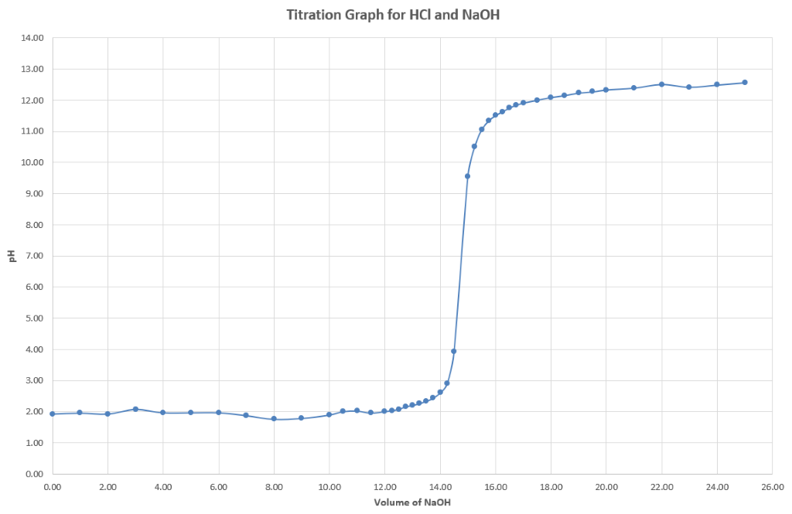
The graph starts low in pH with the excess strong acid, known as the titrand (known volume, unknown concentration to be determined in the titration) in the conical flask with the strong base as the titrant (known volume and concentration, the standard solution) being added from the burette. The pH of the acid in the conical flask stays low, while the acid is in excess, and then slowly begins to rise as there becomes significant amounts of water, compared to the amount of free hydrogen ions. The pH rapidly rises, passing the equivalence point of the titration, as the moles of acid and base are equivalent. The pH beyond the equivalence point represents the excess base in the conical flask which no longer has any acid to neutralise it and so remains high.
A method, such as an indicator, is used in a titration to locate the equivalence point. When titrating, acid can either be added to base or base can be added to acid, both will result in an equivalence point, which is the condition in which the reactants are in stoichiometric proportions. They consume each other, and neither reactant is in excess. The equivalence point is when enough base has been added to the acid, that the concentration of [H⁺] in the solution equals the concentration of [OH⁻]. Since [H⁺] = [OH⁻] at the equivalence point, they will combine to form water, which has a neutral pH of 7:
$${{ H}^{+}}_{(aq)}+ {OH}_{(aq)}^{-} ↔H_{2}O_{(l)}$$
The pH at the equivalence point is 7.0 because the solution only contains water and a salt that is neutral. Further adding acid or base after reaching the equivalence point will lower or raise the pH, respectively.
Conductivity measurements of these titrations shows a maximum at the start and end of the titration where the strong acid and base ions are completely ionised in solution regardless of which one is in excess. The high degree of ionisation of both strong acids and bases contributes to the high conductivity of their solutions. As the titration progresses towards the equivalence point, the conductivity reduces as the neutralisation reaction replaces the highly conductive H⁺ and OH⁻ ions with less conductive water. The minimum in this graph represents the equivalence point:
Figure 2: Conductivity graph for HCl and NaOH
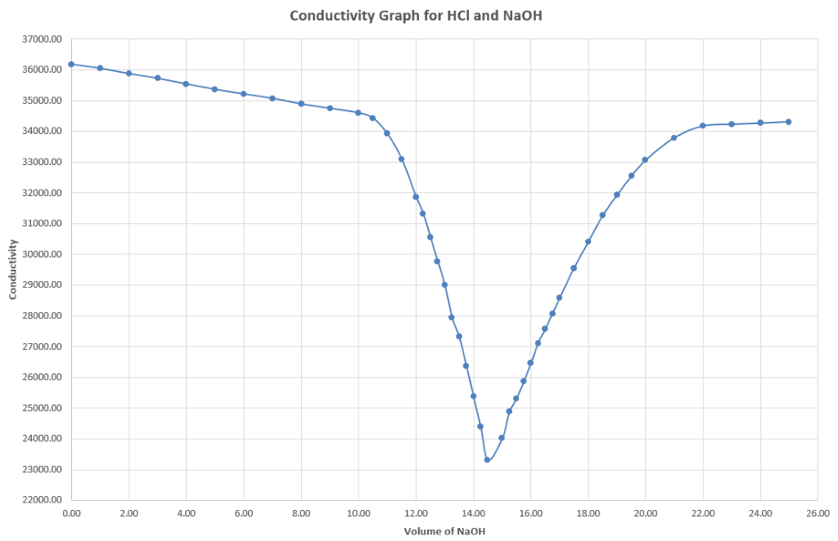
More information on strong acid/strong base titrations can be found on Chemistry LibreTexts-Titration of a Strong Acid With A Strong Base, and the RSC guide to a Conductimetric titration.

Strong acid–weak base titration
Strong acids such as hydrochloric acid and weak bases such as ammonia, neutralise and produce an equivalence point with a pH < 7. An example of the graph for pH vs volume of base added to a monoprotic acid will look like this example:
Figure 3: Titration curve for HCl and NH3
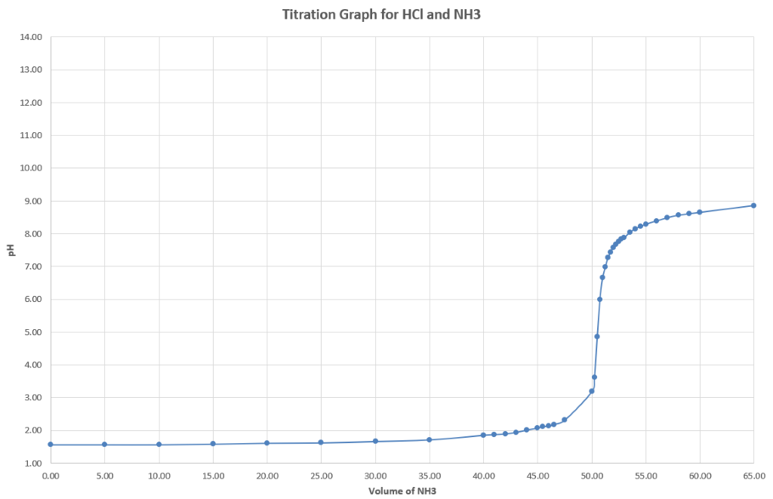
The graph starts low in pH with the strong acid as the titrand (known volume, unknown concentration to be determined in the titration) in the conical flask with the weak base as the titrant (known volume and concentration, the standard solution) being added from the burette. The pH of the conical flask very slowly rises as the buffering region of the strong acid is very slowly overpowered by the weak base. The buffer arises from the formation of NH₄Cl, the conjugate acid of the weak base NH₄OH:
$$NH_{4}OH+HCl ↔NH_{4}Cl+ H_{2}O$$
Once this buffer system breaks down, the pH rapidly rises passing the equivalence point of the titration. The pH beyond the equivalence point represents the excess base in the conical flask which no longer has any acid to neutralise it. The pH is high, but not as high as the pH of a strong base.
Conductivity measurements of these titrations shows a maximum at the start of the titration where the strong acid ions in solution are in excess. Strong acids are highly ionised in solution and so contribute to a high conductivity of their solutions. As the titration progresses towards the equivalence point the conductivity reduces as the neutralisation reaction replaces the highly conductive H⁺ ions with less conductive water. The minimum in this graph represents the equivalence point. Beyond the equivalence point the weak base in solution does not contribute a significant amount to the conductivity so the graph remains roughly flat:
Figure 4: Conductivity graph for HCl and NH₃
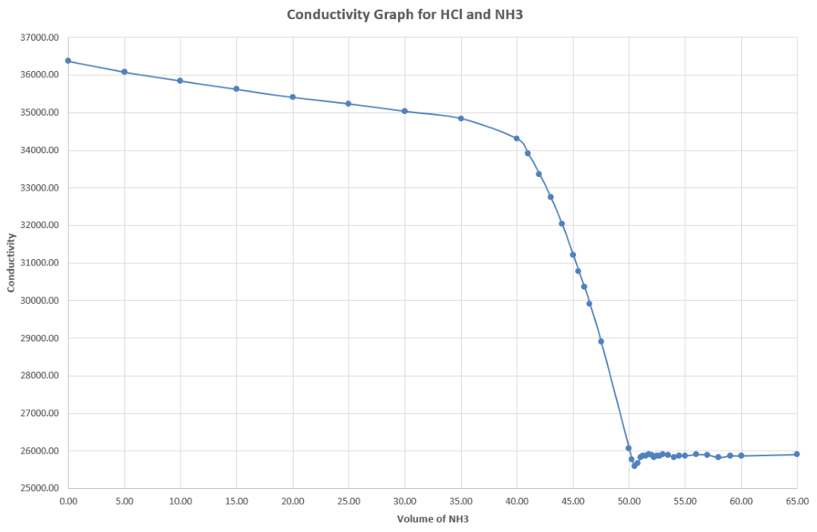
More information on strong acid/weak base titrations can be found on Chemistry LibreTexts-Titration of a Weak Base with a Strong Acid.

Weak acid–strong base titration
Weak acids such as Acetic Acid and strong bases such as sodium hydroxide neutralise and produce an equivalence point with a pH > 7. An example of the graph for pH vs volume of base added to a monoprotic acid will look like this example:
Figure 5: Titration curve for CH₃COOH and NaOH
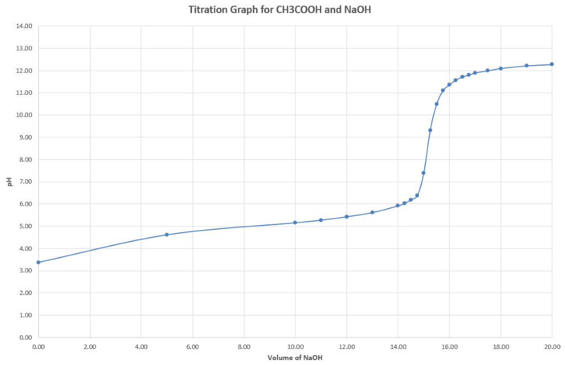
The graph starts at a moderate pH with the weak acid as the titrand (known volume, unknown concentration to be determined in the titration) in the conical flask with the strong base as the titrant (known volume and concentration, the standard solution) being added from the burette. The pH of the conical flask rises more quickly as the buffering region of the weak acid is rapidly overpowered by the strong base. Once this buffer system breaks down, the pH rises passing the equivalence point of the titration. The pH beyond the equivalence point represents the excess base in the conical flask which no longer has any acid to neutralise it and so remains high:
Figure 6: Conductivity graph for HCl and CH₃COOH
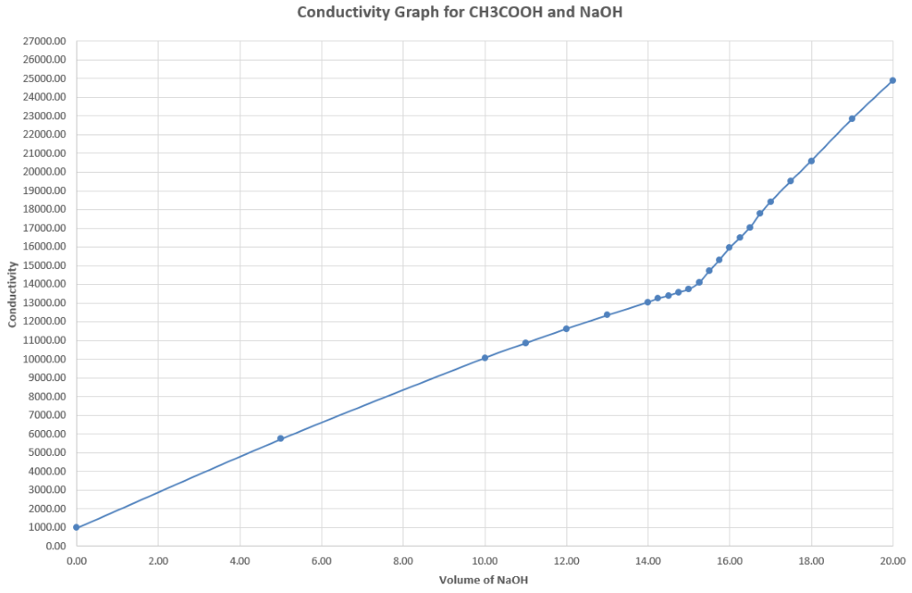
Conductivity measurements of these titrations shows a low conductance at the start and a very high conductance at the end of the titration. The weak acid is poorly ionised in solution at the start and does not contribute much to the conductance of the solution. As the titration progresses towards the equivalence point the conductivity increases as the ions in solution from the strong base increase. The kink in this graph represents the equivalence point. The strong base ions in solution are now in excess without any acid to reduce their concentration at the end of the titration and are highly conductive solutions.
More information on weak acid/strong base titrations can be found on Chemistry LibreTexts-Titration of a Weak Acid with a Strong Base.

Appendix four: K_{a} and pK_{a} calculations
Just like previous uses of K for K_{eq} and K_{sp}, the use of K_{a} is the dissociation constant describing the equilibrium formed between an acid and its dissociated or ionised form. For polyprotic acids such as sulfuric acid and phosphoric acid multiple K_{a} values are calculated for each successive hydrogen ion released from the acid. The equilibrium formed with the ionisation represents the fraction of the acid which has ionised in solution, we normally describe this as the ‘strength’ of the acid. K_{a} for the ionisation of the generic acid HA is shown as:
$$1{HA}_{(aq)} \overset{⇔}{}{1H}_{(aq)}^{+}+{1A}_{(aq)}^{-}$$
$$K_{a}=\frac{{[H_{\left(aq\right)}^{+}]}^{1}×{[A_{\left(aq\right)}^{-}]}^{1}}{{[{HA}_{\left(aq\right)}]}^{1}}$$
For strong acids such as hydrochloric acid virtually all the acid is ionised, so K_{a} is very high, the ionisation equilibrium position favours the products. Weak acids such as acetic acid are much more sparingly ionised in solution and so the K_{a} is much lower, the ionisation equilibrium position favours the reactants. K_{a} can be used to calculate the percentage ionisation, to do this we must use an ICE table. As an example we can compare 0.1M hydrochloric acid where K_{a} = 1.3×10⁶ to 0.1M acetic acid where K_{a} = 1.8×10⁻⁵.
Creating an ICE table from the data given, both acids are monoprotic, the ICE table is the same for both hydrochloric acid and acetic acid:
Table 2: ICE table for a monoprotic acid ionisation
 | $${1HA}_{(aq)}$$ | $${1H+}_{(g)}$$ | $${1H-}_{(g)}$$
Initial | 0.1M | 0M | 0M
Change | -x | +x | +x
Equlibrium | 0.1M-x | 0m+x | 0m+x
For the 0.1M hydrochloric acid:
$$1{HCl}_{(aq)} ↔{1H}_{(aq)}^{+}+{1Cl}_{(aq)}^{-}$$
$$K_{a}=\frac{{[H_{\left(aq\right)}^{+}]}^{1}×{[{Cl}_{\left(aq\right)}^{-}]}^{1}}{{[{HCl}_{\left(aq\right)}]}^{1}}$$
$$1.3×{10}^{6}=\frac{{(x)}^{1}×{(x)}^{1}}{{(0.1-x)}^{1}}$$
In the case of a strong acid the magnitude of $x$ is significant and so we have no other way except utilising the quadratic formula to calculate its value:
$$1.3×{10}^{6}=\frac{x^{2}}{0.1-x}$$
$$1.3×{10}^{6}×(0.1-x)=x^{2}$$
$$1.3×{10}^{5}-1.3×{10}^{5}x=x^{2}$$
$${-1x}^{2}-1.3×{10}^{5}x+1.3×{10}^{5}=0$$
$$x=\frac{-b±\sqrt{b^{2}-4ac}}{2a}$$
We are not interested in negative values for $x$ as the concentration it represents will only be a positive value. The ± can be changed to + and we are then calculating the real value for $x$ shown by |$x$|:
$$\left|x\right|=\frac{-b+\sqrt{b^{2}-4ac}}{2a}$$
$$=\frac{-1.3×{10}^{5}+\sqrt{{(1.3×{10}^{5})}^{2}-4(1×1.3×{10}^{5})}}{2×1}$$
$$\left|x\right|=\frac{-1.3×{10}^{5}+\sqrt{1.69×{10}^{10}-5.2×{10}^{5}}}{2}$$
$$\left|x\right|=\frac{-1.3×{10}^{5}+1.3×{10}^{5}}{2}$$
$$\left|x\right|=0.$$
For all strong acids (where Ka > 1) the effective equilibrium concentration of the un-ionised acid is zero. All the acid has ionised into the products of the equilibrium and we say they are 100% ionised.
For the 0.1M acetic acid:
$$1{CH_{3}COOH}_{(aq)} ↔{1H}_{(aq)}^{+}+{1CH_{3}COO}_{(aq)}^{-}$$
$$K_{a}=\frac{{[H_{\left(aq\right)}^{+}]}^{1}×{[{CH_{3}COO}_{\left(aq\right)}^{-}]}^{1}}{{[{CH_{3}COOH}_{\left(aq\right)}]}^{1}}$$
$$1.8×{10}^{-5}=\frac{{(x)}^{1}×{(x)}^{1}}{{(0.1-x)}^{1}}$$
For weak acids where the ionisation is much lower, we can simplify this calculation and negate the x in the denominator (as it would be very small, the error introduced by this decision is minimal) and so eliminate the need for a quadratic calculation:
$$1.8×{10}^{-5}=\frac{{(x)}^{1}×{(x)}^{1}}{{(0.1)}^{1}}$$
$$1.8×{10}^{-5}=\frac{x^{2}}{0.1}$$
$$1.8×{10}^{-5}×0.1=x^{2}$$
$$\sqrt{1.8×{10}^{-6}}=x$$
$$x=1.34×{10}^{-3}$$
For 0.1M Acetic Acid the equilibrium concentration of the non-ionised acid is 1.34×10⁻³M. Calculating this as a percentage of the original 0.1M gives the degree of ionisation:
$$\% ionisation= \frac{1.34×{10}^{-3}}{0.1}×100$$
$$\% ionisation= 1.34\%$$

Calculation and meaning of pK_{a}
Just like with calculations of pH from [H+], the use of the pK_{a} calculation puts all values of K_{a} on a simple number scale to make comparisons between acids easier using whole number values instead of very small decimals. A higher value of pK_{a} corresponds to a lower value of K_{a} and indicates a weaker acid. pK_{a} is calculated by:
$${pK}_{a}=\log_{10}{(K_{a})}$$
The pK_{a} and hence K_{a} value can also be determined from the titration curve of an acid. If an acid is titrated with a base, pK_{a} is the pH at half the volume of the equivalence point. This is where half of the acid has been ionised and $\left[A_{\left(aq\right)}^{-}\right]=\left[{HA}_{\left(aq\right)}\right]$. This relationship can be demonstrated by the Henderson-Hasselbalch approximation, which is not necessary for this course, however, it is useful to prove that at the half-equivalence point, the pH is equal to the pK_{a}. It can be used to calculate the pK_{a} (and thus K_{a}) of an acid.
For the dissociation of any weak acid, HA:
$${HA}_{(aq)}↔ H_{(aq)}^{+}+ A_{(aq)}^{-}$$
The derivation of the Henderson-Hasselbalch equation (duration 7:23) finds that:
$$pH=pK_{a}+\log\left(\frac{\left[A^{-}\right]}{\left[HA\right]}\right)$$
At the equivalence point, the volume of base added is just enough to exactly neutralise all of the acid. At one-half of this volume of added base, called the half-equivalence point, enough has been added to neutralize half of the acid.
$$where \left[A_{\left(aq\right)}^{-}\right]=\left[{HA}_{\left(aq\right)}\right]$$
$$pH≈{pK}_{a}+\log_{10}{(1)}$$
$$pH≈{pK}_{a}+0$$
$$pH≈{pK}_{a}$$
An example is the addition of a strong base such as sodium hydroxide to a weak acid such as acetic acid creating a build-up of the weak base salt and a buffering effect. The pH of the equivalence point corresponds to the pH of the conjugate base, CH₃COO - which hydrolyses in water. All these effects are related to the strength (or degree of dissociation) of the acid being titrated. Because of the incomplete dissociation of the acid, the reaction is in equilibrium with an acid dissociation constant, K_{a}, which is specific to that acid as shown above.

Appendix five: formative assessment items
The following items are reproduced as a sample only. It is suggested that teachers employ their own assessment of their cohort as needed. An activity does not have to be performed as part of the items but for some items has been included for teachers wishing to integrate practical experimentation with formative assessment. These sample items can be used informally, as an activity, class demonstration and discussion, as one-on-one oral discussions between teacher and student, or more formally as written responses. The feedback to students is important for the items to be used as formative and not merely diagnostic assessment. The use of Predict-Observe-Explain (POE) as a method of capturing student understanding is recommended. There is value in students accounting for their prediction:
- On the bench is 100mL of water and universal indicator in a 250mL beaker. 0.01M NaOH, a base, will be added to universal indicator in water. Predict the effect the base will have on the indicator and account for your reasoning. Complete the task and record your observations. Explain your observations and give reasons why your prediction was correct or not
- Using your knowledge about different acid-base models, explain your understanding of pH and neutralisation
- Complete the activity or teachers to provide the following text and/or a suitable diagram: On the bench is 100mL of 0.10M NaOH, a base, in a 250mL beaker. 110mL of 0.10M HCl, an acid, is now slowly added to the beaker. Describe what has occurred in the beaker as fully as you can
- On the bench is 100mL of 0.10M NaOH, a base, in a 250mL beaker, along with a few drops of an indicator called phenolphthalein. As you can see, it is pink. 110mL of 0.10M HCl, an acid, is now added to the beaker. The colour has changed to colourless. Describe what has occurred in the beaker, when the indicator changed colour, as fully as you can.
- On the bench are three 600mL beakers containing colourless solutions of pH 3, 5 and 11 respectively. Using labelled drawings, predict and explain the sub-microscopic composition in each beaker
- Describe the concentrations of H⁺ and OH⁻ in a solution of pH = 0
- Describe the nature of K_{a} in a weak acid
- Describe how K_{a}, pH and equilibrium in solution vary as temperature varies
- Complete the activity or provide the following text and/or a suitable diagram and table of results: On the bench, the teacher has set up a titration apparatus, in which a pH probe and data logger are immersed in a solution of (25mL 0.1M HCl) acid in the beaker underneath the burette. The burette contains (50mL 0.1M NaOH) base:
  - Predict how the pH will change as the base is run into the beaker
Optionally:
  - Graph the pH against volume of base added, every 1mL for 5 mL. Explain the shape of the graph
  - Continue graphing for every 1mL of base added until 27mL of base has been added. Explain the shape of the graph where rapid change is observed
  - Continue graphing the pH for every 1mL of base added until 35mL of base has been added. Explain the shape of the graph now.
- Predict the observations when stoichiometric amounts of strong acid and base are reacted together and account for your reasoning. Complete a first-hand investigation to measure the pH of various reactions between stoichiometric amounts of various strong acids and bases:
  - Describe neutralisation in words
  - Describe neutralisation using diagrams of the sub-microscopic particles
  - Describe neutralisation with symbols
  - Describe the products of neutralisation as completely as you can.
- Measure the pH for various concentrations from 2M to 0.001M for both a strong acid and a strong base:
  - Describe in words what pH measures
  - Describe the pH scale
  - What is the numerical definition of pH?
  - How does pH of a solution relate to the sub-microscopic particles present in the solution? An activity could be conducted where pH is measured for various concentrations of strong acid and/or base.

Appendix six: claim evidence reasoning (CER) and scientific argumentation
Claim-Evidence-Reasoning (duration 2:20) is published by Bozeman Science.

Claim
A claim is a statement that answers the question. It will usually only be one sentence in length. The claim does not include any explanation, reasoning, or evidence so it should not include any transition words such as “because.”

Evidence
The evidence is the data used to support the claim. It can be either quantitative or qualitative depending on the question and/or lab. Evidence is often gathered in the lab through research, or from results presented in a data table that the student creates. Students should only use data within their evidence that directly supports the claim, (that is, evidence which is relevant). There should be enough evidence to support the claim. The evidence should be specific and should not itself contain any explanation or reasoning but should include the analysis and interpretation of the data.

Reasoning
The reasoning is the explanation of “why and how” the evidence supports the claim. It should include an explanation of the underlying science concept or principle that produced the evidence or data. It is the logical connection between the evidence and the claim. There should be a justification for each piece of evidence, why the evidence is relevant and why it provides adequate support for the claim.
The argument uses words, phrases and sentence structures to create cohesion and clarify the relationships amongst claim(s), counterclaims, reasons, and evidence and should establish and maintain a formal style in full sentences. A concluding statement or section that follows from and supports the argument is presented.

Sample teaching sequence: What is an acid?
- Teachers provide the question and some guiding questions regarding the features of a CER response:
  - Where will you look for evidence?
  - How will you know if the evidence is good?
  - What is the audience and what language will you need to use? (Link words such as because, if, then; sequencing words such as first and last and uncertainty words like usually, generally and suggests).
- Small groups or pairs make a claim. For example, an acid contains hydrogen or an acid turns blue litmus pink or an acid is a proton donor.
- Teachers may provide templates for students to record: the claim; the observations/evidence and the justification/reasoning using scientific principles that connects a sufficiency of valid evidence to the claim.
- Students record evidence.
- Teachers facilitate self-reflection, peer feedback and also provide specific feedback.
- Students individually or in pairs construct an argument demonstrating how, why, and to what extent the evidence supports the claim (or not).
- Students present their argument to the teacher or class.

Appendix 7: possible extension

Determining the equivalence point
From the titration graph it is important to accurately determine the equivalence point, this is the point of inflection or the point with the steepest gradient on the curve. Instead of estimating this point it can be calculated using the spreadsheet template provided. By graphing the first and second derivative (calculations and graphing is automatic in the spreadsheet) of pH to volume you can very accurately find the equivalence point. The first derivative graph shows the rate of change in the gradient, the point of inflection has the highest gradient and is shown as a peak on this graph that represents the equivalence point of the titration. In the case of hydrochloric acid titrated with sodium hydroxide the rising side of the peak on this graph represents the end of the positive titration curve (rising towards the equivalence point) and the falling side of the peak on this graph represents the start of the negative titration curve (falling away from the equivalence point):
Figure 8: First derivative for a HCl and NaOH titration
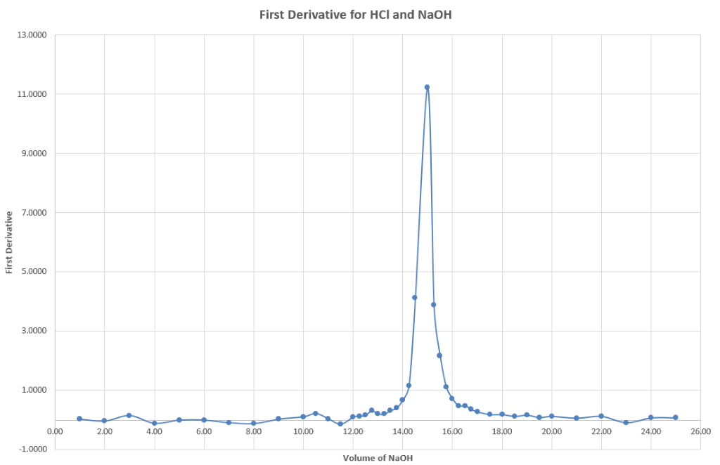
In titrations using weak acids and bases or if the data around the titration equivalence point are not discrete enough the first derivative peak may be unclear, in this case the second derivative graph is useful. The second derivative graph shows the rate of change in the first derivative, the peak in the first derivative graph is equal to the x-intercept of the second derivative graph. This represents the equivalence point of the titration:
Figure 9: Second derivative for a HCl and NaOH titration
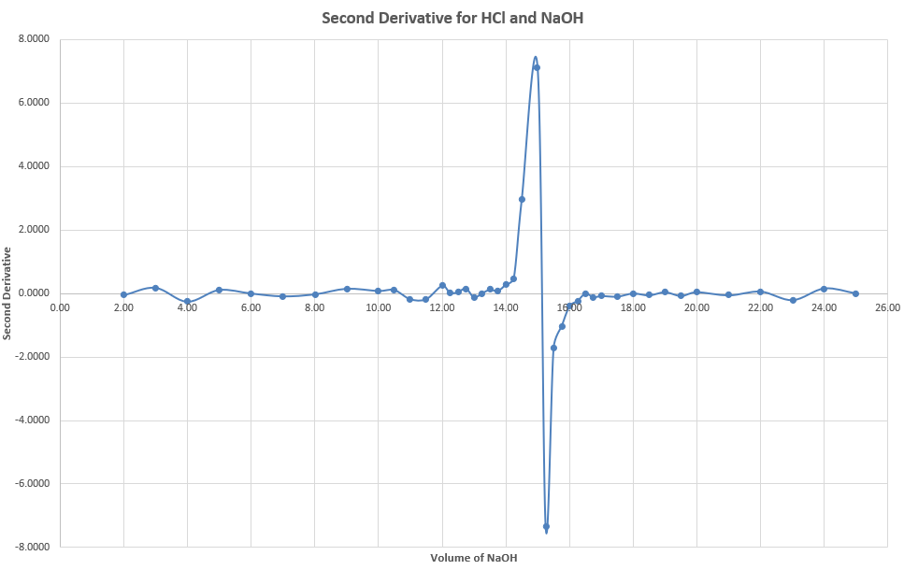
If the titration is completed with a chemical indicator instead of a pH probe it is important to select an indicator which has a colour change pH as close to the equivalence point as possible. The colour change pH of the indicator is known as the indicator endpoint. There is a small error introduced where the indicator endpoint does not exactly match the reaction equivalence point. The further apart the pH of the indicator endpoint and titration equivalence point, the larger this error will be.

Polyprotic acids
Polyprotic acids can ionise over several stages. The K_{a} or degree of dissociation will affect the titration curve. A strong acid, such as sulfuric acid will completely ionise in the first reaction, as the K_{a} is large, and only a single inflection point will be observed in the titration curve. In the case of a titration of sulfuric acid and sodium hydroxide this results in the following reactions:
$$H_{2}{SO}_{4(aq)}+NaOH_{(aq)}↔ NaH{SO}_{4(aq)}+H_{2}O_{(l)}$$
$$NaH{SO}_{4(aq)}+NaOH_{(aq)}↔ {Na}_{2}{SO}_{4(aq)}+H_{2}O_{(l)}$$
In the case of a titration of phosphoric acid and sodium hydroxide this results in three different reactions, only the last two of which are observed in the titration curve:
$$H_{3}{PO}_{4(aq)}+NaOH_{(aq)} ↔ NaH_{2}{PO}_{4(aq)}+H_{2}O_{(l)}$$
$$NaH_{2}{PO}_{4\left(aq\right)}+NaOH_{\left(aq\right)} ↔{Na}_{2}H{PO}_{4\left(aq\right)}+H_{2}O_{\left(l\right)}$$
$${Na}_{2}H{PO}_{4(aq)}+NaOH_{(aq)}↔ {Na}_{3}{PO}_{4(aq)}+H_{2}O_{(l)}$$
More information on titrations with polyprotic acids can be found on Chemistry LibreTexts-Titration of a Weak Polyprotic Acid.

Ampholytes
Students should be able to use Brønsted-Lowry theory to define an amphiprotic substance as one that is able to both accept and donate a proton. Amphoteric oxides are oxides that can behave (react) as both an acid and a base. An amphiprotic substance is therefore also amphoteric. Investigations can be conducted to observe the acid/base nature of oxides across a period of the periodic table. This can be used to discuss the use of pK_{a} and pK_{b} to describe weak acids and bases. Students interested in ampholytes may wish to follow up with a depth study. Ampholytes are molecules with at least two pK_{a} values, at least one of which is acidic and at least one is basic, so therefore they contain both acidic and basic groups, amino acids are good examples of this. Ampholytes will exist mostly as zwitterions in a certain range of pH.

Resources
- Molecular Workbench software provides visual interactive simulations for teaching and learning science including animated models and worksheets for models of dissociation and dissolving.
- PhET delivers access to interactive simulations for science and maths, such as animated models of Acid-Base Solutions
- Conductivity Titrations (duration 4:30), demonstration and model that describes what is happening on the ionic/molecular level when the conductivity of a solution is measured as hydroxide is added to a strong acid like hydrochloric
- Libretexts Titration of a weak polyprotic acid describes titration curves in detail.
- Shirly Avargil et al, Students’ Understanding of Analogy after a CORE (Chemical Observations, Representations, Experimentation) Learning Cycle, General Chemistry Experiment. Published: August 13, 2015 J. Chem. Educ. 2015, 92, 1626 −1638, uses polymerisation as an example of analogy. This article has some excellent background information on macro, micro and symbolic representations of ideas and theories.
- Royal Society of Chemistry, Chemical Misconceptions II- Acid strength is an online downloadable excerpt from a publication by Keith Taber, Chemical Misconceptions: Prevention, diagnosis and cure: Classroom resources, Volume 2. Published by RSC, 2002.

