Chemistry Module 4: Drivers of reactions

Table of contents
Chemistry Module 4: Drivers of reactions 1
Table of contents 2
Teaching the Year 11 Modules 3
Course overview 4
Module summary 4
Big ideas 5
Relationship to other modules 5
Core concepts 6
Opportunities for extending concepts 6
Misconceptions 7
Suggested teaching strategies 10
IQ 4-1 What energy changes occur in chemical reactions? 10
IQ 4-2 How much energy does it take to break bonds, and how much is released when bonds are formed? 20
IQ 4-3 How can enthalpy and entropy be used to explain reaction spontaneity? 31
Appendices 40
Appendix one: Exothermic and endothermic calculations 40

Teaching the Year 11 Modules
The new Stage 6 Chemistry course was implemented in NSW schools beginning in 2018. This syllabus incorporates new content and learning activities such as depth studies. The syllabus is designed around inquiry questions and formal assessment tasks that emphasise the Working Scientifically skills. The Year 11 course focusses on developing student knowledge and understanding of the relationships between the structure and the properties of atoms and molecules using macroscopic, microscopic and symbolic representations. The Working Scientifically skills and processes are applied to predict outcomes by using physical, conceptual and mathematical models and assessing the limitations of models. Through scientific investigations, students identify and measure quantities of chemicals, leading to a deep understanding of different classes of chemicals including their structure, properties and trends. The role of energy as a driver of chemical change and the relationship between energy and matter are explored in Year 11 as the basis for understanding of chemical change in the Year 12 course.
As the syllabus is written as a series of inquiry questions and depth studies are a mandatory component of the course, pedagogies that promote student inquiry and deep learning should be employed in the chemistry classroom. New and challenging course content, along with the change in pedagogical approach were the catalysts for the preparation of these module guides for Stage 6. These guides are intended to assist teachers deliver the chemistry syllabus effectively by outlining the big ideas, core concepts, strategies for teaching the modules, uncovering alternative conceptions and providing strategies to address them and suggesting opportunities for extension. The guides support the teacher in facilitating the development of deep knowledge structures, such as the relationships between concepts. It is essential that teachers note that the module guides are not a substitute for the syllabus, but only support teachers to teach it. The module guides do not cover all aspects of the syllabus, as that was not within the scope of the project.
The information contained in these documents is correct at the time of publication. While every effort has been made to eliminate errors, any errors or omission that are identified after the release of these documents will be corrected and released as resource updates. It is recommended that teachers access the Curriculum website for the latest version of these documents.

Course overview
The Chemistry Stage 6 Syllabus explores the structure, composition and reactions of and between all elements, compounds and mixtures that exist in the Universe. The course develops an understanding of chemistry through the application of Working Scientifically skills. It focuses on the exploration of models, the understanding of theories and laws, and the examination of the relationships between energy, matter and change.
The chemistry course enables students to interpret the interconnection between the nature and practice of science, and the knowledge of chemistry. The course addresses the discovery and synthesis of new compounds, the monitoring of elements and compounds in the environment, an understanding of industrial processes and their applications to life processes, our energy needs and uses, the development of new materials, and sustainability issues.
The fundamentals developed in Year 11, include:
- knowledge and understanding of:
  - Properties and structures of matter.
  - The relationship between observable properties and structures to trends in data and reactions.
  - Types and drivers of chemical reactions.
  - Role of energy in bonding within and between particles.
- the use of differing scales, measurements and specialised representations to explain scientific phenomena and chemical interactions.
- skills in making hypotheses and designing valid and reliable investigations.
- skills in conducting investigations, solving problems and explaining using cause and effect.
- constructing models, explaining phenomena using particle theory and discussing atomic models.
- conducting investigations by measuring and/or collecting relevant data and information from first-hand practicals and secondary sources and determining the accuracy, reliability and validity of data and information.

Module summary
Students investigate factors that initiate and drive a reaction. They examine the relationship between enthalpy and entropy in calculating the Gibbs free energy. They also examine the roles that enthalpy and entropy play in the spontaneity of reactions. Students are provided with opportunities to understand that all chemical reactions involve the creation of new substances and have associated energy transformations. These are commonly observable as changes in temperature of the surrounding environment and/or emission of light.
Students conduct investigations to measure the heat energy changes that occur in chemical reactions. They describe reactions using the terms endothermic and exothermic, and explain reactions in terms of the Law of Conservation of Energy. They use Hess’s Law to calculate enthalpy changes involved in the breaking and making of bonds.
In this module, students focus on developing questions and hypotheses to analyse trends, patterns and relationships in data in order to solve problems and communicate scientific understanding of ideas about the driving forces in chemical reactions. Students should be provided with opportunities to engage with all the Working Scientifically skills throughout the course.

Big ideas
- The underlying chemical structure of substances is a key factor in determining their properties.
- Chemical systems are described using models based on particle theory. Models are revised as new evidence becomes available.
- Chemical bonding and reactions occur in predictable patterns according to their atomic and molecular structures.
- Energy changes can instigate chemical reactions. The underlying structure of the chemicals determines how they react to energy changes.
- Patterns can be determined by making observations, conducting fair tests, analysing data, and explaining trends in observable properties of substances and the periodic table.

Relationship to other modules
This module gives students a mathematical representation for how and why chemical reactions proceed under specific conditions. Module 4 explores Hess’s Law as a representation of bond energies and energy change during the breaking and formation of a range of chemical bonds as introduced in module 1. Module 4 also builds on the following content from module 2 and 3:
- Ongoing practice and application of balanced chemical equations and mole calculations for the energy calculations undertaken in enthalpy, Hess’s Law and Gibbs Free Energy calculations.
- Exploring chemical reactions using the mathematical equations to explain their observations

Core concepts
- Energy is a core commodity in chemical reactions and must be accounted for according to the Law of Conservation of Energy in the same way as atoms are accounted for according to the Law of Conservation of Mass.
- Calorimetry is a useful technique for determining enthalpy changes in chemical reactions.
- Energy profile diagrams are useful visualisations of energy changes in chemical reactions showing the relative energy of reactants and products. These diagrams can be used to represent endothermic and exothermic reactions including the impact of catalysts on the activation energy.
- Average bond enthalpy can be related to the relative strength of the bond. Breaking chemical bonds is an endothermic process, forming chemical bonds is an exothermic process.
- Hess’s Law is a mathematical representation of the bond energies in reactants and products to assist explaining the enthalpy of chemical reactions by the energy excess or deficit in the reaction equation.
- Entropy is the measure of the disorder in a system (the second law of thermodynamics). Processes which seek to reduce entropy require energy input (work) for the system.
- Entropy is increased in decomposition chemical reactions where there are more product molecules than reactants.
- A negative Gibbs free energy can be used to determine if a given chemical reaction (known enthalpy and entropy change) is spontaneous at any given temperature.
- Using the enthalpy and entropy change, a chemical reaction can be classified as:
  - Spontaneous at all temperatures
  - Spontaneous at low temperatures only (non-spontaneous at high temperatures)
  - Spontaneous at high temperatures only (non-spontaneous at low temperatures)
  - Non-spontaneous at all temperatures

Opportunities for extending concepts
- Exploration of a wider range of chemical reactions which exhibit endothermic and exothermic profiles, for example, precipitation reactions.
- Modifications of the calorimeter apparatus in order to increase the accuracy of the measurements taken with respect to literature values.
- Exploration of a wider range of chemical reactions to analyse using Hess’s Law, for example, any of the endothermic and exothermic reactions covered previously.
- Exploration of a wider range of chemical reactions to analyse using Gibbs free energy, for example, any of the endothermic and exothermic reactions covered previously.
EAL/D strategies
One of the most significant challenges in Module 4 is the large amount of new terminology that students are exposed to. It is important that students are explicitly taught the skills necessary to develop a glossary that can be consistently added to during module 4.
- Explore with students different methods of storing glossary terms, for example using physical flash cards or utilising one of the many digital flash card apps available (Brainscape, Cram, Quizlet, CheggPrep).
- Model for students how to define terms using their own words.
- Encourage students to use analogies and metaphors when appropriate and include diagrams/images.
Videos such as Enthalpy: Crash Course Chemistry #18 and Entropy: Embrace the Chaos! Crash Course Chemistry #20 define this terminology. Regularly discussing terminology will reinforce learning. Sentence frames can assist in students constructing sentences independently. Formative assessments and short responses, designed to allow students to practice the use of technical language, link ideas and construct explanations and cause and effect relationships should be frequent with feedback regarding student use of technical language and complex sentences. Teaching the root of words can help students decode unfamiliar words. For example:
- Spontaneous, spontaneity.
- Endothermic and exothermic.
- Quantify, evaluate (as in solve).
- Dissociation, associate, dissociate, dissolve, dissolution.
- Enthalpy, entropy, Gibbs free energy.

Misconceptions
- Students may find difficulty using clear and consistent terminology for system/surroundings and exothermic/endothermic. Strategies to reduce this confusion of terminology are described in the teaching strategies for IQ1-4.
- In calorimetry, students may become confused with what they are actually measuring the temperature of. A clear definition of system and surroundings will help explain why we measure the temperature of the surroundings and being able to relate this to the system for the purposes of analysing and comparing different chemical reactions.
- Students may confuse the positive and negative enthalpies and entropies of a chemical reaction, resulting in a mismatch between their calculations and observations. Strategies to reduce this confusion of directionality are described in the teaching strategies for IQ1-4 for enthalpy and IQ3-4 for entropy.
- Students may treat catalysts as a reactant by including them in chemical equations or considering them in calculations, resulting in many difficulties with the calculations in this module. Reminding students of the concepts which were also covered in IQ3-3 will help students treat catalysts appropriately in all calculations.
- Average bond enthalpy could be considered as potential energy stored within chemical bonds. This commonly stems from early years where fuels were typically described as having chemical energy which is then released during combustion reactions. To address this, it is important to clearly define average bond enthalpy and the bonding changes in chemical reactions by relating the relative strength of bonds in the reactants and products giving a negative or positive difference.
- Due to the energy input required, students may believe that endothermic reactions cannot be spontaneous. Using endothermic reactions which demonstrate spontaneity (for example, mixing barium hydroxide and ammonium thiocyanate) will help students recognise this misconception.
- Hess’s law can pose several difficulties for students to perform the calculations and prepare the corresponding diagrams. Presenting a series of clear examples to scaffold how the bond energies in the reactants and products are calculated and how to then represent these as diagrams is a key strategy. Examples are described in the teaching strategies for IQ2-4.
- Students may find difficulty in retaining the definition of entropy as a measure of disorder and default back to entropy as a measure of order in a substance. This is particularly common if students are associating entropy with the chemical bonding complexity in a molecule. Exploring examples of entropy from literature values and modelling changes with molecular modelling kits may assist students in gaining a clear understanding of entropy and entropy changes during chemical reactions.
- Gibbs free energy can be mistakenly associated as a scale of reaction rate. A more negative value of Gibbs free energy is not indicative of a spontaneous reaction which proceeds at a faster rate. Clearly defining the difference between reaction rate from IQ3-3 and the spontaneous/non-spontaneous nature of the Gibbs free energy calculation will help break down any misconceptions.
- Students may believe that heating a chemical reaction is able to increase the rate of all chemical reactions. This is a misconception that could have been accidentally reinforced in IQ3-3 through the activities undertaken. Using Gibbs free energy calculations to demonstrate that increasing the temperature will only promote a chemical reaction to a certain extent (based on particle movement) and beyond this, some chemical reactions are hindered (exothermic reactions which result in a decrease in entropy). Resolving this misconception now will also assist with students understanding temperature and Le Chatelier’s principle in IQ2-5.
Conceptual difficulties
- Mastery in IQ1-4 and the associated terminology is required for students to advance to IQ2-4 and IQ3-4. A deep knowledge of the role of energy is required for modules 5-8 and to be able to articulate their understanding of chemical reactions.
- When measuring the surroundings to describe the inverse changes in the system, students may become confused about the direction of energy flow and struggle to use the correct terminology to describe these changes.
- Students may struggle to adequately analyse the role of catalysts in chemical reactions because of limited options to practically explore these concepts in the laboratory.
- Students may have difficulty analysing enthalpy in a system/surroundings model where energy is said to be ‘lost’ to the surroundings in what appears to violate the Law of Conservation of Energy.
- Students may not understand the enthalpy of formation (${∆H}_{f}$) for one mole of an element is assigned a value of zero. The standard enthalpy of formation of any element in its most stable form is zero by definition, independent of the path taken to get there (Hess’s Law).
- Entropy is a novel concept, except for students who also study Physics. The definition and justification appear, at first, to defy logic. Using concrete examples of natural order/disorder, and the natural procession of events towards disorder, before moving into chemical reaction examples will assist in resolving this confusion.
- Students may have difficulty calculating Gibbs free energy and using this to describe the conditions under which chemical reactions are spontaneous or non-spontaneous.

Suggested teaching strategies

IQ 4-1 What energy changes occur in chemical reactions?
Students model chemical reactions and make comparisons with practical experiences and observations. By making quantitative measurements to support the theoretical calculations, students can discuss any variations.
This inquiry question focusses on the practical demonstration of both endothermic and exothermic reactions, taking accurate temperature measurements, performing enthalpy calculations and producing and interpreting energy profile diagrams. The calculation of enthalpy (q) is the amount of energy gained by the system from the surroundings or lost by the system to the surroundings. The definition of system and surroundings is vitally important as it will help with understanding these calculations:
- System – the objects included for analysis. This could be the solids, liquids or gases involved in a chemical reaction or potentially components of the apparatus.
- Boundary – the delineation between the system and surroundings, a system can be open or closed to the exchange of energy or matter based on the nature of its boundary with the surroundings. This could be the solid or liquid interface to the atmosphere.
- Surroundings – all matter and energy external to the system and its boundary. This could be the atmosphere or vessel containing a chemical reaction.
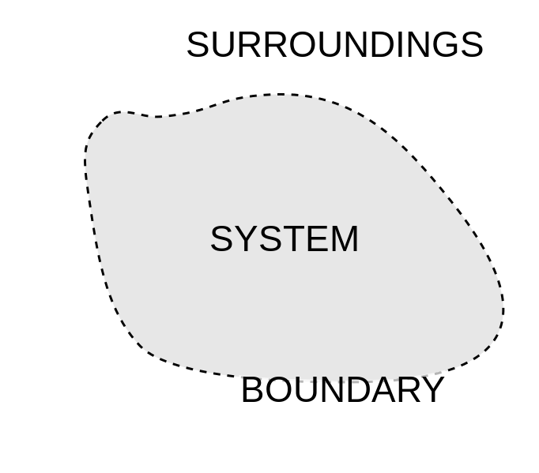
Figure 1: System, boundary, and surroundings diagram. Source: This file is licensed under the Creative Commons Attribution-Share Alike 4.0 International license.
For this guide, the system will be defined as the reactants, products and solvents of any chemical reactions described. The reaction apparatus and measuring instruments are considered to be part of the surroundings.
In open systems, energy can be exchanged between the system and surroundings. When heat energy passes between the system and the surroundings the internal energy of the system changes according to the Law of Conservation of Energy. Heat energy spontaneously moves from areas of high temperature to low temperature.
Beginning with qualitative explorations of exothermic and endothermic reactions is a valuable activity to ensure students are well versed in the metalanguage which can be defined here with respect to the observations made of each particular system:
Reaction type | Etymology | Heat energy movement
Exothermic | Exo (Greek) “outer”  Thermos (Greek) “hot” | 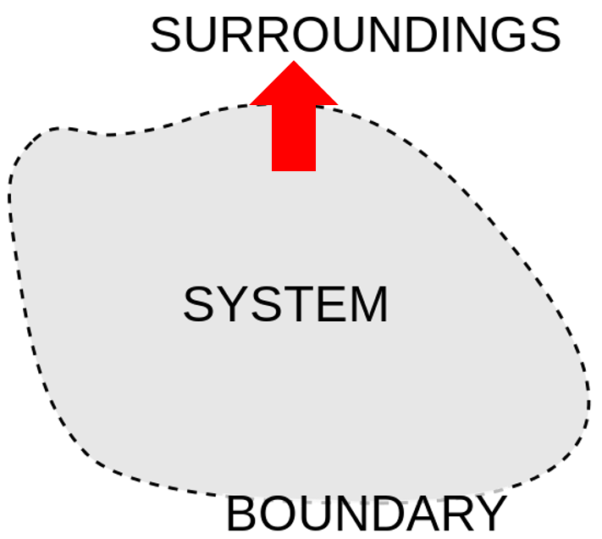  The system loses energy to the surroundings. The temperature of the surroundings increases until the system and surroundings form thermal equilibrium. For example, instant hot packs containing a saturated sodium acetate solution.
Endothermic | Endon (Greek) “within”  Thermos (Greek) “hot” | 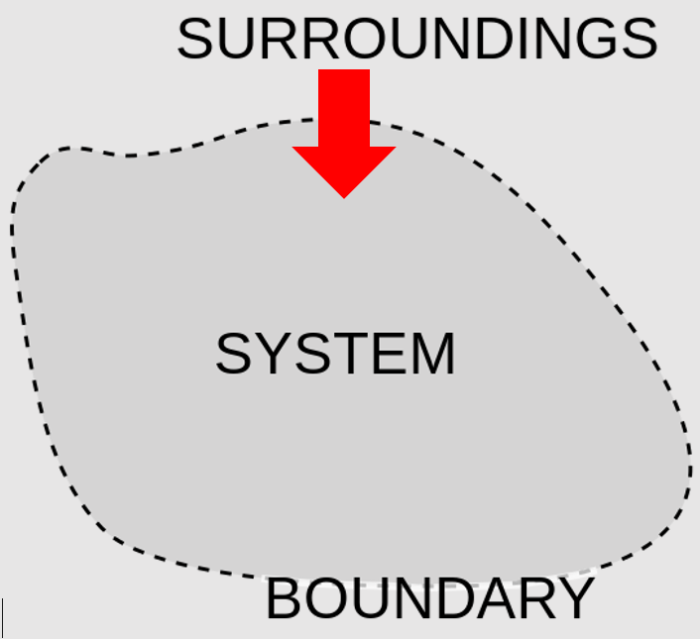  The system gains energy from the surroundings. The temperature of the surroundings decreases until the system and surroundings form thermal equilibrium. For example, instant cold packs containing solid ammonium nitrate.

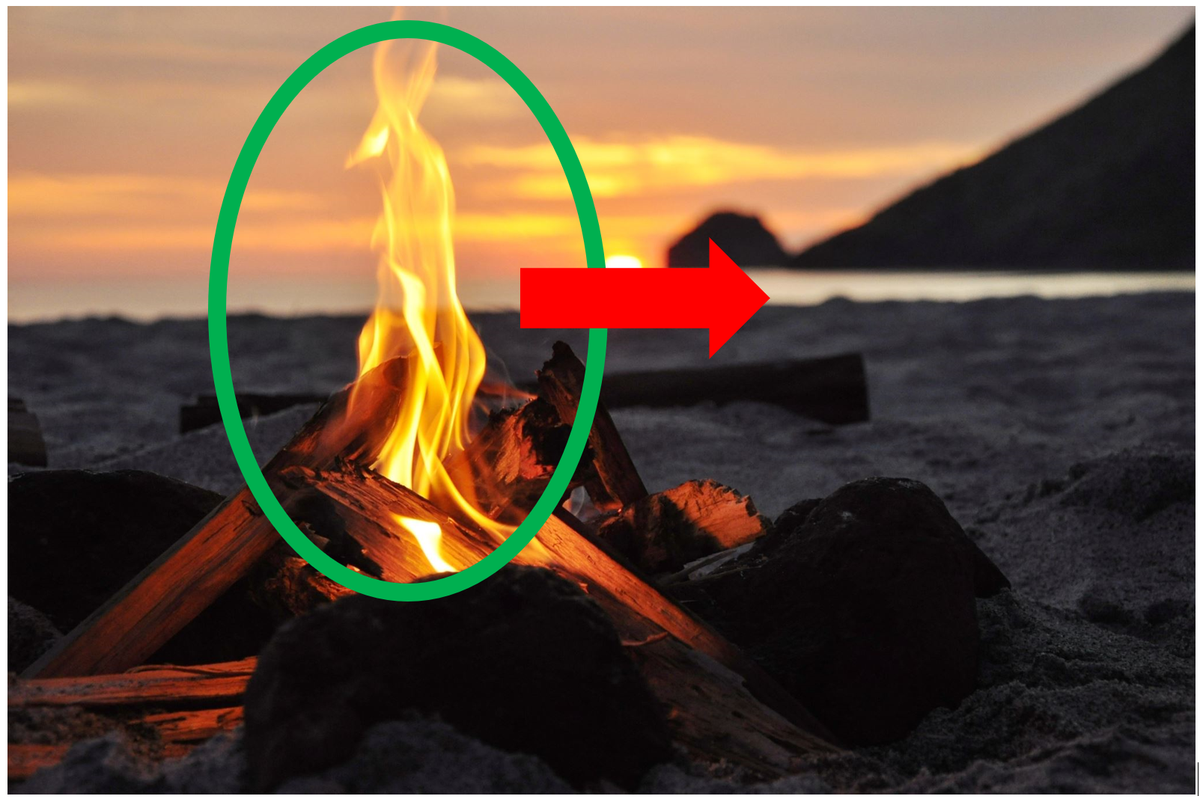
Figure 2: A bonfire, example of an exothermic combustion reaction where the system loses energy to the surroundings. Source: Microsoft royalty-free stock images.
Figure 3: An ice cream melting, example of an endothermic process where the system gains energy from the surroundings. Source: Microsoft royalty-free stock images.

Calorimetry
Students are able to explore these reactions practically to obtain quantitative data for their calculations of $∆H$. There are many different practical examples for students to explore:
Reaction type | Examples
Exothermic | - Any combustion reaction, for example, burning ethanol in air.  - Dissolving solid sodium hydroxide in water.  - Any strong acid/base neutralisation reaction, for example, 1M sodium hydroxide with 1M hydrochloric acid.  - Any active metal and acid, for example, magnesium and hydrochloric acid.
Endothermic | - Any weak acid/base neutralisation reaction, for example, acetic/citric acid and sodium hydrogen carbonate.  - Dissolving solid ammonium nitrate in water.  - In a fume hood or well-ventilated area, the reaction between solid barium hydroxide and solid ammonium chloride, available as a video demonstration. Take caution with the production of ammonia gas.
Using any of these first-hand practical or secondary-sourced data as examples, students can calculate the energy movements in each case. The formula used is:
$$q=mc∆T$$
Where:
- $q$ is the enthalpy (energy) involved in this process, measured in joules (J).
- $m$ is the mass of the system, measured in kilograms (kg).
- $c$ is the specific heat capacity of the system, measured in joules per kilogram kelvin (Jkg⁻¹K⁻¹).
- $ΔT$ is the change in temperature, measured in kelvin (K).
The mass in these calculations is the total mass of the solvent and solute while using the specific heat capacity of the solvent in the calculation of $q$. The error given from this approximation is acceptable when the mass of solute is much smaller than the mass of solvent, meaning a very dilute solution is produced. This results in the specific heat capacity of the solvent being equivalent to the specific heat capacity of the solution.
The specific heat capacity is a measure of how much energy is required to raise the temperature of 1kg of the substance by 1K. Given an identical energy input and mass, a substance with a larger specific heat capacity will have a smaller rise in temperature than substances with lower specific heat capacities. Concrete has a lower specific heat capacity compared to soil; this is one of the reasons why a concrete path will be at a higher temperature throughout the day compared to the adjacent soil under the same solar exposure. In the case of water, the very strong intermolecular hydrogen bonds are responsible for the high specific heat capacity. A higher energy input is required to disrupt the hydrogen bonds in order to increase particle movement.
There are additional opportunities to explore simulations of these scenarios which may assist students in collaboration with first-hand investigations:
- Coffee Problem
- Camping Problem
- Hot/Cold Pack Problem - Part 1 and Part 2
It is important the temperature change is large enough to be accurately measured by the thermometers available. Digital thermometers or data loggers offer greater precision and would be ideal for this activity.
Literature values for comparison are reported as ‘molar enthalpy’. This is the amount of energy released or gained by a mole of the substance when the particular process occurs, for example, the molar enthalpy of combustion (${∆H}_{C}$) or the molar enthalpy of solution (${∆H}_{soln}$). This molar quantity is calculated by:
$$∆H=\frac{-q}{n}$$
Where:
- $∆H$ is the change in molar enthalpy. Various subscripts are possible to denote which type of molar enthalpy it represents, measured in kilojoules per mole (kJmol⁻¹).
- $q$ is the enthalpy of this process, measured in kilojoules (kJ).
- $n$ is the moles of substance involved in this process, measured in moles (mol).
The $∆H$ calculation includes a negative sign to invert the direction of the previous $q$ calculation. The thermometer is part of the surroundings and therefore calculating $q$ using temperature changes in the thermometer gives the direction of heat transfer with respect to the surroundings, not the system.
- A measured temperature rise is due to energy gained by the thermometer from the energy lost by the system.
- A measured temperature fall is due to energy lost by the thermometer from the energy gained by the system.

Process in the system | $$∆T$$ | $$q$$ | $$∆H$$
Exothermic | Positive $(∆T>0)$ | Positive $(q>0)$ | Negative $(∆H<0)$
Endothermic | Negative $(∆T<0)$ | Negative $(q<0)$ | Positive ($∆H>0)$
Appendix one contains a practical outline and worked examples of dissolution and combustion reaction calculations which can be performed by students or demonstrated by the teacher. These opportunities provide students the ability to see a range of chemical reactions which demonstrate the concepts being discussed.
While investigating enthalpy changes in reactions using calorimetry, reflect on the demonstrations or investigations by asking, what do students need to know about measuring enthalpy changes? This is a good opportunity to:
- appreciate the limitations of experimental procedures when measuring the enthalpy change using simple laboratory apparatus.
- understand how to modify the experimental procedure when measuring the enthalpy change to improve the accuracy of the data obtained.
When making comparisons to literal values for the enthalpy of solution or combustion it is important to discuss the reliability of these values from secondary sources. Chemistry LibreTexts have some enthalpies of solution and enthalpies of combustion which can be used for comparison. Alternative online sources can show some variation in the reported literal values. Colorado State University has an open-access folder with a range of extracts from the CRC Chemistry 91st edition including the enthalpies of solution of electrolytes.
When comparing the experimentally determined ${∆H}_{c}$ to literature values, it is normal in laboratory activities to have results lower than literature values. This could be attributed to many factors, outside of human error, relating to the assumptions made regarding the transfer of energy.
- The fuel in the spirit burner had an initial temperature of $25℃$ (standard conditions for literature values of ${∆H}_{c}$).
- Every mole of fuel underwent a complete combustion reaction (no loss of fuel and no loss of energy through incomplete combustion).
- The combustion reaction is thermally isolated (the only heat transfer occurring was between the fuel and calorimeter).
- The thermometer was in perfect thermal equilibrium with the water (every joule of energy gained or lost by the water also occurred in the thermometer).
When comparing the experimentally determined ${∆H}_{soln}$ to literature values it is normal in laboratory activities to have results lower than literature values. This could be attributed to many factors, outside of human error, relating to the assumptions made regarding the transfer of energy.
- The solute and water had an initial temperature of $25℃$ (standard conditions for literature values of ${∆H}_{soln}$).
- Every mole of solute instantaneously dissolved in the water (no loss of solute and no loss of energy over time).
- The system is thermally isolated (the only heat transfer occurring was between the solution and thermometer).
- The thermometer was in perfect thermal equilibrium with the water (every joule of energy gained or lost by the water also occurred in the thermometer).
There are several useful videos which demonstrate the operation of an analytical bomb calorimeter which can be used to describe and discuss key differences in the apparatus and methods used to the laboratory activities undertaken. These devices provide increased accuracy for calorimetry measurements. The reactants are contained in the gas-tight “bomb,” which is submerged in water and surrounded by insulating material. however, this increased accuracy comes at a significantly higher cost of analysis.
Figure 2: A typical bomb calorimeter. Source: licensed under a Creative Commons Attribution 4.0 International License.
There is an opportunity for a depth study into these various enthalpy types and the processes used to measure them accurately. Students can explore the practical apparatus used and investigate a line of inquiry to improve the accuracy of their measurements with reference to literature values or quantify the effect of specific changes to their methods. In addition, these practical opportunities allow us to connect this work to IQ4-7, the measurement of enthalpy of combustion by using a range of alcohols.

Energy profile diagrams
Energy profile diagrams are a one dimensional graph which shows the changes in energy of a system on the y-axis. The layout of the x-axis is arbitrary and only serves to demonstrate the progression of a reaction from reactions through to products. This is sometimes called the 'reaction coordinate'. Reactants and products are separated by a hump representing the activated complex. This is where reactants have satisfied the activation energy of the chemical reaction and are in progress towards becoming products.
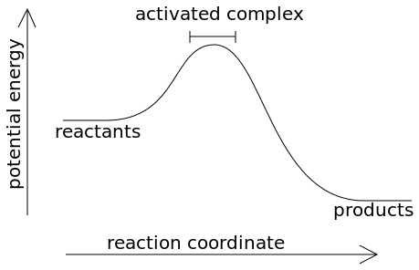
Figure 3: Energy profile diagram. Source: Public domain.
Energy profiles diagrams must be introduced carefully, highlighting enthalpy change and graphing skills. The difference between endothermic and exothermic in terms of enthalpy change, and its sign being positive or negative, must be shown explicitly.
Depending on the vertical arrangement of reactants and products in the energy profile diagram, the reaction can be classified as either exothermic or endothermic.
- Where the products of the system have less energy than the reactants, the excess energy in the system is lost to the surroundings. These reactions have a negative $∆H$ ($∆H<0$)
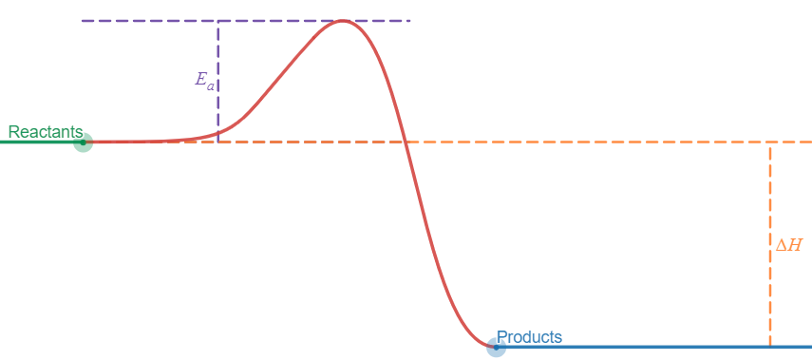
Figure 4: Exothermic reaction energy profile diagram. NSW Department of Education, 2021.

- Where the products of the system have more energy than the reactants, the energy deficit in the system is gained from the surroundings. These reactions have a positive $∆H$ ($∆H>0$)
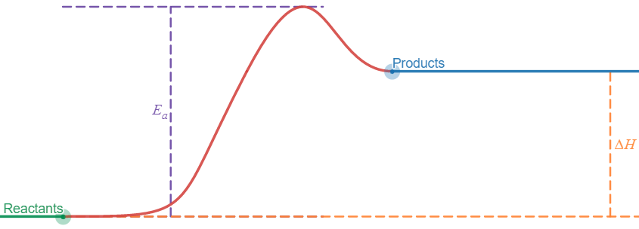
Figure 5: Endothermic reaction energy profile diagram. NSW Department of Education, 2021.
Interact with these energy profile diagrams on Desmos.
The activation energy represents the minimum energy input required to progress any chemical reaction to proceed. Some reactions have large activation energies, in particular endothermic reactions, whilst some reactions have very minor activation energies. The size of the activation energy is one factor which determines the rate of a chemical reaction. Larger activation energy reactions will proceed to products slower than another reaction at the same temperature which has a lower activation energy.

Catalysts
A catalyst is a substance which is added to a reaction in order to provide favourable conditions for a chemical reaction to occur. This may be the promotion of a reactant intermediate product or providing a surface on which a reaction can occur. Catalysts:
- reduce the activation energy for a given chemical reaction, so less energy input is required for the reactants to form the activated complex.
- arrange particles into more favourable orientations in space, enabling collisions where reactions can occur. This increases the rate of reaction.
- are not consumed by the reaction and so are not included in the reaction equation as a reactant or product. They are denoted on top of the reaction arrow only.
- are only required in small quantities for a large amount of reactant.
If no catalyst is added, higher temperatures would be needed to promote the reaction. Higher temperatures often lead to undesirable by products and can result in the decomposition of the reactants or products. By initiating the catalysed reaction at a lower temperature, the process is more controlled and the desired product is more likely to be produced.
In the energy diagrams depicted below the solid line represents the uncatalysed pathway for the reaction and the dotted line represents the catalysed pathway. Interact with these energy profile diagrams on Desmos:
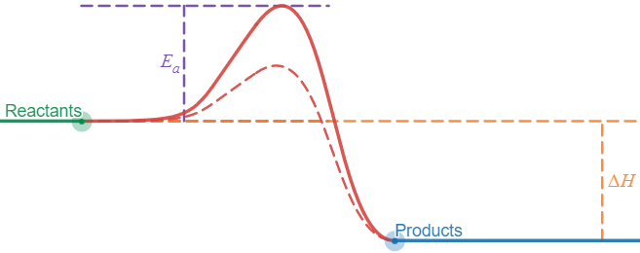
Figure 6: Exothermic reaction with a lower activation energy catalysed pathway. NSW Department of Education, 2021.
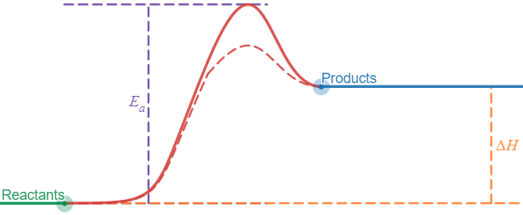
Figure 7: Endothermic reaction with a lower activation energy catalysed pathway. NSW Department of Education, 2021.
A range of practical examples can be explored by students to observe the effect of catalysed and uncatalysed reactions:
- Hydrogen peroxide decomposition using different catalysts and Creative Problem Solving in Chemistry - Hydrogen peroxide
- Iodine clock reaction
- Traffic lights (combined with the notes in a visible activated complex)
- Catalysing the reaction of sodium thiosulfate and hydrogen peroxide
- Catalysis of a sodium thiosulfate and iron(III) nitrate reaction
- Catalysis of the reaction between zinc and sulfuric acid
- Creative Problem Solving in Chemistry: Aluminium foil
- Enzymes and jellies (this option offers a connection to Biology)

Students could explore the important work currently underway in catalyst research and development. The examples explored in class can be further expanded upon by reviewing the far reaching implications of this learning, for example:
- Making ethanol from lignin
- No longer valueless - a new recycling method that turns waste into useful chemicals
- Turning PVC production into a greener industry
- Carbon dioxide catalysis making jet fuel
- Turning mixed plastic waste into natural gas with catalysis
- Sun shines for iron catalyst to convert carbon dioxide to methane
- Catalyst metal recovery adds greener notes to whisky production
- Catalyst makes liquid fuels from renewable resources
- Catalyst for change - making catalysis safer and more sustainable for the future
- Exceptional enzymes (this option offers a connection to Biology)

IQ 4-2 How much energy does it take to break bonds, and how much is released when bonds are formed?
For the rest of this module, it is important to continually use the terms endothermic and exothermic to describe the processes being investigated. This will seek to reinforce the connection between this terminology and the calculation of results obtained.

Conservation of energy
Energy can neither be created nor destroyed - only converted from one form of energy to another. This means that the universe always contains a constant amount of energy, and a system always has the same amount of energy unless it is added from, or lost to, its surroundings. The only way to use energy is to transform energy from one form to another. This is the first law of thermodynamics.
Experimentally, this law can be observed through various stages of a reaction using calorimetry. Using a suitable chemical reaction, for example, the neutralisation of hydrochloric acid and sodium hydroxide. This reaction has two possible pathways, the direct reaction of aqueous hydrochloric acid with solid sodium hydroxide:
$${NaOH}_{(s)}+{HCl}_{(aq)}\overset{→}{}{NaCl}_{(aq)}+H_{2}O_{(l)}$$

The two step reaction of:
- dissolving solid sodium hydroxide to form an aqueous solution:
$${NaOH}_{\left(s\right)}\overset{→}{}{NaOH}_{\left(aq\right)}$$
- the reaction of aqueous hydrochloric acid with aqueous sodium hydroxide
$${NaOH}_{(aq)}+{HCl}_{(aq)}\overset{→}{}{NaCl}_{(aq)}+H_{2}O_{(l)}$$
Each reaction can be undertaken and the enthalpy change measured per mole of sodium hydroxide. Comparisons can be made to determine if the enthalpy change in the one step reaction is equal to the sum of the two stages of the two step reaction (inclusive of reasonable experimental error).
When selecting sources for reaction enthalpies, be aware of small discrepancies between different sources. Highlight the issues with accurate measurements of these values and the importance of selecting a reliable source, and consistently use these values.

Standard enthalpy of formation
The standard enthalpy of formation ($∆H_{f}$) is the enthalpy change when one mole of a substance is formed from its elements in their standard states under standard conditions (101.325kPa and 298.15K). The value is specific to each individual compound in this standard state.
The enthalpy of formation of elements in their most stable form have a standard enthalpy of formation of zero. Forming nitrogen gas ($N_{2(g)}$) from nitrogen atoms (N) is the most stable form of nitrogen, $∴∆H_{f}=0$.
Using the standard enthalpy of formation values for each reactant and product, the overall reaction enthalpy can be determined:
$$∆H=\sum{∆H_{f\left(products\right)}}-\sum{∆H_{f\left(reactants\right)}}$$
The reaction to produce ammonia from nitrogen and hydrogen undertaken at 101.325kPa and 298.15K has all reactants and products in their gas phase:
$$N_{2(g)}+{3H}_{2(g)}\underset{⇔}{}{2NH}_{3(g)}$$

Nitrogen and hydrogen gas are the most stable forms and have $∆H_{f}=0$. The standard enthalpy of formation of ammonia is -45.90kJmol⁻¹ giving a reaction enthalpy of:
$$∆H=({2NH}_{3(g)})-(N_{2(g)}+{3H}_{2(g)})$$
$$∆H=\left(2mol×-45.90kJ{mol}^{-1}\right)-(0+0)$$
$$∆H=-91.8kJ$$
In any chemical reaction, a similar calculation can be undertaken, for example the complete combustion of ethanol under standard conditions:
$$C_{2}H_{5}OH_{(l)}+{3O}_{2(g)}\overset{→}{}{2CO}_{2(g)}+{3H}_{2}O_{(l)}$$
The standard enthalpy of formation values for each reactant and product are:
Substance | $∆H_{f}$ (kJmol⁻¹)
C₂H₅OH_{(l)} | -234.7
O_{2(g)} | 0 (elemental state)
CO_{2(g)} | -393.5
H₂O_{(l)} | -285.8
$$∆H=\left({2CO}_{2(g)}+{3H}_{2}O_{(l)}\right)-{(C}_{2}H_{5}OH_{(l)}+{3O}_{2(g)})$$
$$∆H=\left(2mol×-393.5kJ{mol}^{-1}+3mol×-285.8kJ{mol}^{-1}\right)-(1mol×-234.7kJ{mol}^{-1}+0)$$
$$∆H=\left(-787kJ+-857.4kJ)-(-234.7kJ\right)$$
$$∆H=\left(-1644.4kJ\right)-\left(-234.7kJ\right)$$
$$∆H=-1879.1 kJ$$
For combustion reactions, it is important to remember that the standard enthalpy of combustion is defined as the energy released per mole of fuel completely combusted.
The standard enthalpy of formation is given for the standard state under standard conditions. In many cases we are using aqueous solutions of pure substances made by dissolving the standard state of the substance in water. In this case the standard enthalpy of formation must be modified to include the enthalpy of solution. For example, the aqueous reaction of sodium hydroxide with hydrochloric acid:
$$NaOH_{(aq)}+{HCl}_{(aq)}\overset{→}{}{NaCl}_{(aq)}+H_{2}O_{(l)}$$

The standard enthalpy of formation values for each reactant and product are:
Substance | $∆H_{f}$ (kJmol⁻¹) | $∆H_{sol}$ (kJmol⁻¹) | $∆H$ (kJmol⁻¹)
NaOH_{(aq)} | -425.93 (solid) | -44.50 | -470.43
HCl_{(aq)} | -92.3 (gas) | -74.84 | -167.14
NaCl_{(aq)} | -411.12 (solid) | 3.9 | -407.22
H₂O_{(l)} | -285.8 (liquid) | n/a | -285.8
$$∆H={(NaCl}_{(aq)}+H_{2}O_{(l)})-(NaOH_{(aq)}+{HCl}_{(aq)})$$
$$∆H=\left(1mol×-407.22kJ{mol}^{-1}+1mol×-285.8kJ{mol}^{-1}\right)-(1mol×-470.43kJ{mol}^{-1}+1mol×-167.14kJ{mol}^{-1})$$
$$∆H=\left(-693.02kJ)-(-637.57kJ\right)$$
$$∆H=-55.45 kJ$$
For neutralisation reactions, it is important to remember that the standard enthalpy of neutralisation is defined as the energy released per mole of water produced in the neutralisation reaction.
Standard enthalpies of formation are easily available online using simple search terms. Some suggested sources could include:
- Newtown South High ACP Chemistry (821) Resources (linking to the file “Standard Enthalpy of Formation Table”)
- ThoughtCo - Heat of Formation Table for Common Compounds

Average bond enthalpy
Average bond enthalpy is a measure of how much energy is required to break a mole of a substance in its gas phase into its constituent elements in their gas phase. These values are all positive as they refer to the endothermic process of breaking bonds. Additionally, the bond enthalpies are averaged over a large number of molecules containing the particular type of bond.
Where available it is more accurate to use standard enthalpy of formation ($∆H_{f}$) data than average bond enthalpy data to calculate reaction enthalpies.
Average bond enthalpies provide a reasonable estimate of reaction enthalpy where the standard enthalpy of formation data may not be available. The error when calculating reaction enthalpy using average bond enthalpies is minimised where:
- The standard state under standard conditions of reactants and products are in their gas phase.
- The bonds in the reactants and products use simpler bonds which are likely to have a lower variation in the calculation of the average bond enthalpy.
Using the average bond enthalpy values for each reactant and product, the overall reaction enthalpy can be determined:
$$∆H=\sum{reactant bonds broken}-\sum{product bonds formed}$$
Note the reversal of this equation (in terms of reactants and products) compared to the similar equation used with the standard enthalpy of formation data.
The reaction to produce ammonia from nitrogen and hydrogen undertaken at 101.325kPa and 298.15K has all reactants and products in their gas phase:
$$N_{2(g)}+{3H}_{2(g)}\underset{⇔}{}{2NH}_{3(g)}$$
Figure 8: Molecular diagram showing the bonds broken in the reactants. NSW Department of Education, 2021.
Bonds broken in reactants | Average bond enthalpy (kJmol⁻¹)
Nitrogen-Nitrogen triple covalent bond | 945
Hydrogen-Hydrogen single covalent bond | 436
$$\sum{reactants=\left(1mol×945kJ{mol}^{-1}+3mol×436kJ{mol}^{-1}\right)}$$
Figure 9: Molecular diagram showing the bonds formed in the products. NSW Department of Education, 2021.
Bonds broken in reactants | Average bond enthalpy (kJmol⁻¹)
Nitrogen-Hydrogen single covalent bond | 391
$$\sum{products=\left(6mol×391kJ{mol}^{-1}\right)}$$
This gives a reaction enthalpy of:
$$∆H=\left(1mol×945kJ{mol}^{-1}+3mol×436kJ{mol}^{-1}\right)-\left(6mol×391kJ{mol}^{-1}\right)$$
$$∆H=2253kJ-2346kJ$$
$$∆H=-93kJ$$
When comparing this value ($∆H=-93kJ$) to the same reaction using the standard enthalpy of formation data ($∆H_{f}=-91.8kJ$) there is only a small variation. In this reaction, this is due to:
- all reactants and products are in their gas state; and
- nitrogen-nitrogen triple covalent bonds and hydrogen-hydrogen single covalent bonds have no alternative uses to distort the average bond enthalpy.
This calculation can also be undertaken for chemical reactions where other states exist, for example the complete combustion of ethanol under standard conditions:
$$C_{2}H_{5}OH_{(l)}+{3O}_{2(g)}\overset{→}{}{2CO}_{2(g)}+{3H}_{2}O_{(l)}$$
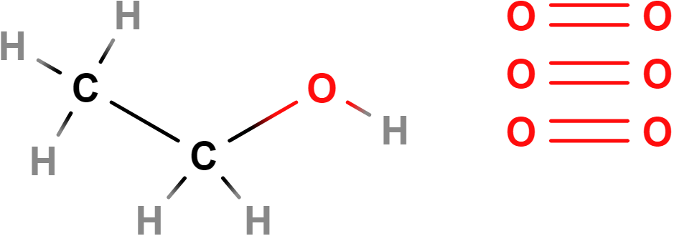
Figure 10: Molecular diagram showing the bonds broken in the reactants. NSW Department of Education, 2021.
Bonds broken in reactants | Average bond enthalpy (kJmol⁻¹)
Carbon-carbon single covalent bond | 346
Carbon hydrogen single covalent bond | 414
Carbon-oxygen single covalent bond | 358
Oxygen-hydrogen single covalent bond | 463
Oxygen-oxygen double covalent bond | 498
$$\sum{reactants=\left(1mol×346kJ{mol}^{-1}+5mol×414kJ{mol}^{-1}+1mol×358kJ{mol}^{-1}+1mol×463kJ{mol}^{-1}+3mol×498kJ{mol}^{-1}\right)}$$
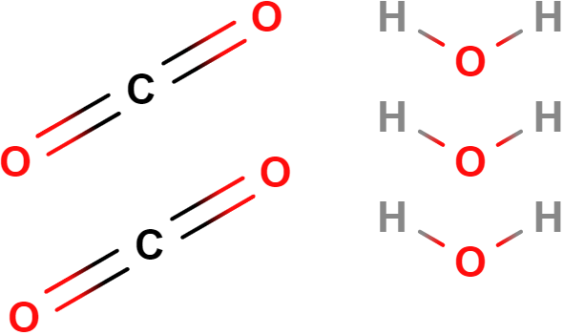
Figure 11: Molecular diagram showing the bonds formed in the products. NSW Department of Education, 2021.
Bonds broken in reactants | Average bond enthalpy (kJmol⁻¹)
Carbon-oxygen double covalent bond | 804
Oxygen-hydrogen single covalent bond | 463
$$\sum{products=\left(4mol×804kJ{mol}^{-1}+6mol×463kJ{mol}^{-1}\right)}$$

This gives a reaction enthalpy of:
$$∆H=\left(1mol×346kJ{mol}^{-1}+5mol×414kJ{mol}^{-1}+1mol×358kJ{mol}^{-1}+1mol×463kJ{mol}^{-1}+3mol×498kJ{mol}^{-1}\right)-\left(4mol×804kJ{mol}^{-1}+6mol×463kJ{mol}^{-1}\right)$$
$$∆H=4731kJ-5994kJ$$
$$∆H=-1263kJ$$
When comparing this value ($∆H=-1263kJ$) to the same reaction using the standard enthalpy of formation data ($∆H_{f}=-1879.1 kJ$) there is a significant variation. In this reaction, this is due to:
- all reactants and products are not in their gas state (as defined for average bond enthalpies); and
- the bonds of reactants and products are common for a wide range of compounds which causes the average bond enthalpy to be less accurate.
Average bond enthalpies are easily available online using simple search terms. Some suggested sources can include:
- Newtown South High ACP Chemistry (821) Resources (linking to the file “Table of Average Bond Enthalpy Values”)
- Chemistry LibreTexts – Bond Energies

Hess’s Law
When chemical bonds are changed during chemical reactions, energy is required to break the existing bonds in the reactants and energy is released by the formation of bonds in the products. The difference between these two energies is the reaction enthalpy, measured in joules. Some chemical reactions will directly convert reactants into the respective products, whereas others will take a range of steps forming intermediate products which are subsequently decomposed to form the final products.
Irrespective of which path a reaction takes, or how many intermediate products are involved, the overall reaction enthalpy remains constant.
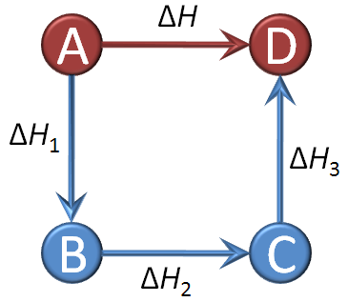
Figure 12: Hess's Law. Source: licensed under the Creative Commons Attribution-Share Alike 3.0 Unported license.
The above reaction can either proceed directly from A to D or via the intermediate products B and C. Irrespective of the path taken, the overall energy involved in the same:
$$∆H=∆H_{1}+∆H_{2}+∆H_{3}$$
This is similar to the concept presented in the physics of distance and displacement. You can travel from point A (reactants) to point B (products) and take a variety of paths, although each path may have different distances (number of steps required), the overall displacement remains constant (the reaction enthalpy).
For these calculations, it is equally valid to use the standard enthalpy of formation or average bond enthalpy data as we are making a comparison between two different mechanisms for the same reaction and not directly commenting on the energy value itself.

In the formation of carbon dioxide from carbon and oxygen, two different pathways exist:
- a one-step reaction with excess oxygen:
$$C_{\left(s\right)}+O_{2\left(g\right)}\overset{→}{}{CO}_{2\left(g\right)}$$
$$∆H_{f}=-393.5kJ{mol}^{-1}$$
- a two-step reaction with restricted oxygen available:
- Carbon reacting with oxygen to form carbon monoxide:
$$C_{\left(s\right)}+{\frac{1}{2}O}_{2\left(g\right)}\overset{→}{}{CO}_{\left(g\right)}$$
$$∆H_{f}=-110.5kJ{mol}^{-1}$$
- Carbon monoxide reacting with more oxygen to form carbon dioxide:
$${CO}_{\left(g\right)}+{\frac{1}{2}O}_{2\left(g\right)}\overset{→}{}{CO}_{2\left(g\right)}$$
$$∆H_{f}=-283kJ{mol}^{-1}$$
Irrespective of the path chosen, the combined reactions from the two-step are identical to the one-step reaction. The sum totals of the reaction enthalpies are also equal.
 | One-step reaction | Two-step reaction
Reaction equation | $$C_{\left(s\right)}+O_{2\left(g\right)}\overset{→}{}{CO}_{2\left(g\right)}$$ | $$C_{\left(s\right)}+{\frac{1}{2}O}_{2\left(g\right)}\overset{→}{}{CO}_{\left(g\right)} \\ {CO}_{\left(g\right)}+{\frac{1}{2}O}_{2\left(g\right)}\overset{→}{}{CO}_{2\left(g\right)}$$
Net equation | $$C_{\left(s\right)}+O_{2\left(g\right)}\overset{→}{}{CO}_{2\left(g\right)}$$ | $$C_{\left(s\right)}+O_{2\left(g\right)}\overset{→}{}{CO}_{2\left(g\right)}$$
Net enthalpy change | $$∆H_{f}=-393.5kJ{mol}^{-1}$$ | $$∆H_{f}=-110.5kJ{mol}^{-1}+-283kJ{mol}^{-1}$$  $$∆H_{f}=-393.5kJ{mol}^{-1}$$
Photosynthesis and respiration are both vital reactions in living cells. Photosynthesis enables the storage of solar energy in the chemical structures of carbohydrates:
$$6CO_{2(g)}+{6H}_{2}O_{(l)}\overset{→}{}C_{6}H_{12}O_{6(aq)}+{6O}_{2(g)}$$
Respiration then allows the extraction of this energy for use by cellular processes:
$$C_{6}H_{12}O_{6(aq)}+{6O}_{2(g)}\overset{→}{}6CO_{2(g)}+{6H}_{2}O_{(l)}$$

In its standard state the enthalpy of formation for glucose is given as a solid. For both of these reactions, however, it must be aqueous:
Substance | $∆H_{f}$ (kJmol⁻¹) | $∆H_{sol}$ (kJmol⁻¹) | $∆H$ (kJmol⁻¹)
C₆H₁₂O_{6(aq)} | -1274 (solid) | 11 | -1263
For all other reactants and products, the standard enthalpy of formation is:
Substance | $∆H_{f}$ (kJmol⁻¹)
O_{2(g)} | 0 (elemental state)
CO_{2(g)} | -393.5
H₂O_{(l)} | -285.8
In terms of the chemical reactions they are the inverse processes of each other. It is then apparent that the energy change for each process will be the inverse of each other, by using standard enthalpy of formation data and Hess’s Law, both processes can be compared:
$$∆H=\sum{∆H_{f\left(products\right)}}-\sum{∆H_{f\left(reactants\right)}}$$
 | Photosynthesis | Respiration
$$\sum{∆H_{f\left(reactants\right)}}$$ | $$6CO_{2(g)}+{6H}_{2}O_{(l)}$$  $$∆H=\left(6mol×-393.5kj{mol}^{-1}+6mol×-285.8kj{mol}^{-1}\right)$$  $$∆H=-4075.8kJ$$ | $$C_{6}H_{12}O_{6(aq)}+{6O}_{2(g)}$$  $$∆H=\left(1mol×-1263kj{mol}^{-1}+0\right)$$  $$∆H=-1263kJ$$
$$\sum{∆H_{f\left(products\right)}}$$ | $$C_{6}H_{12}O_{6(aq)}+{6O}_{2(g)}$$  $$∆H=\left(1mol×-1263kj{mol}^{-1}+0\right)$$  $$∆H=-1263kJ$$ | $$6CO_{2(g)}+{6H}_{2}O_{(l)}$$  $$∆H=\left(6mol×-393.5kj{mol}^{-1}+6mol×-285.8kj{mol}^{-1}\right)$$  $$∆H=-4075.8kJ$$
$$∆H$$ | $$∆H=-1263kJ--4075.8kJ$$  $$∆H=2812.8kJ$$ | $$∆H=-4075.8kJ--1263kJ$$  $$∆H=-2812.8kJ$$
As shown in this calculation, photosynthesis is an endothermic process where 2812.8kJ of energy is absorbed by the production of one mole of glucose. When a mole of glucose undergoes cellular respiration an exothermic process occurs, releasing 2812.8kJ of energy.

IQ 4-3 How can enthalpy and entropy be used to explain reaction spontaneity?

Entropy
The definitions of entropy here are sufficient for the study of chemical reactions in module 4. Using these definitions beyond chemical reactions may introduce some problems.
The most common definition for entropy is the ‘measure of disorder’ within a system. Although this is no less accurate, this definition does present some conceptual difficulties in terms of chemical reactions. A more convenient description of entropy for chemists is:
Entropy is the measure of how many ways a chemical substance can be arranged. Crystalline structures in solids are highly organised and have little flexibility in the ways they can be arranged, therefore they have low entropy. Gases have little structure and can be arranged in a wide variety of ways; therefore, they have high entropy.
The second law of thermodynamics states that the entropy of a system will spontaneously increase. In order to decrease the entropy of a system work must be done. This is best explained through examples of common observable effects of entropy changes.
An ice cube is made up of solid water, covalent molecules arranged in a highly ordered crystalline structure, with low entropy. At room temperature (298.15K) the ice cube will spontaneously melt and change to a liquid state; the water becomes less strictly organised and the entropy increases in line with the second law of thermodynamics. At no point will the liquid water spontaneously reorganise into an ice cube.
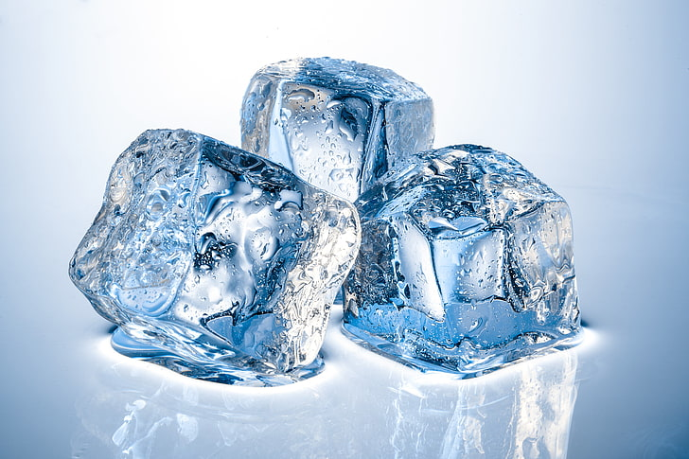
Figure 13: Ice cubes, slowly melting. Source: Microsoft royalty-free stock images.

Students may come to the questions, or they may be prompted:
- How does this observation compare of an ice cube at $-10℃$ (263.15K)? If we have an ice cube in this very cold environment, the ice cube will not melt as previously observed at room temperature. This shows students this process is temperature dependant and, at this temperature, allows the melting process to be indefinitely delayed.
- What happens to the entropy of the system if we take this puddle of liquid water and cool it to $-10℃$ (263.15K) in a freezer? Work being done by the freezer allows the entropy of the water to be reduced. As the temperature drops below the melting point, the water will solidify into a crystalline structure with a lower entropy than the water.
Standard molar entropies are listed for standard conditions (101.325kPa and 298.15K). Just like enthalpies of formation, entropies depend on the physical state of the substance. It is important to check the state of each reactant and product to ensure the correct entropy values are being used.
The entropy of a substance shows a trend with a range of physical properties:
- Entropy increases with molar mass:
  - F_{2(g)} (38 gmol⁻¹) = 203 Jmol⁻¹K⁻¹ vs. I_{2(g)} (253.8 gmol⁻¹) = 261 Jmol⁻¹K⁻¹
- Entropy increases with melting and vaporisation:
  - H₂O_{(l)} = 70 Jmol⁻¹K⁻¹ vs. H₂O_{(g)} = 189 Jmol⁻¹K⁻¹
- Entropy increases when solids or liquids dissolve in water:
  - NaCl_{(s)} = 72 Jmol⁻¹K⁻¹ vs. NaCl_{(aq)} = 115 Jmol⁻¹K⁻¹
- Entropy is lower in hard, brittle substances than in malleable solids like metals:
  - Diamond (C) = 2.4 Jmol⁻¹K⁻¹ vs. Pb = 65 Jmol⁻¹K⁻¹
- Entropy increases with chemical complexity:
  - NaCl_{(s)} = 72 Jmol⁻¹K⁻¹ vs. AlCl_{3(s)} = 167 Jmol⁻¹K⁻¹

There are a range of YouTube videos which can provide alternative ways to define and describe entropy for students:
- Brian Cox explains why time travels in one direction - Wonders of the Universe - BBC Two
- What is entropy? - Jeff Phillips (TedEd)
- Entropy: Embrace the Chaos! Crash Course Chemistry #20
Entropy and enthalpy are two distinct characteristics used to describe the thermodynamic properties of a chemical system. Enthalpy is the measure of the energy content of a system. This can be of a highly ordered (low entropy) system or a less ordered (high entropy) system.

Entropy changes in chemical reactions
When examining a range of chemical reaction equations, it can be determined if entropy is likely to be increasing or decreasing as reactants are converted into products. Considering the range of chemical reactions addressed in IQ1-3 some generalisations about entropy changes can be made (as per normal, exceptions are always possible):
Reaction type | Entropy change is typically:
Synthesis | negative, as the products are fewer in number and more chemically complex than the reactants.
Decomposition | positive, as the products are increased in number and less chemically complex than the reactants.
Combustion | positive, as the numerous combustion products are gaseous and less chemically complex than the reactant fuels.
Precipitation | negative, as the solid products come from aqueous ions and the compounds formed increase the chemical complexity of the products.
acid/base | unable to generalise as this is incredibly variable depending on the particular acids and bases involved producing a range of products.
acid/carbonate | positive, as the products include gases which increase in number and are less chemically complex than the reactants.

Calculating the entropy change from the entropy values of all reactants and products looks very similar to calculating enthalpy change in a chemical reaction:
$$∆S=\sum{S_{\left(products\right)}}-\sum{S_{\left(reactants\right)}}$$
For example, the formation of ammonia from nitrogen and hydrogen:
$$N_{2(g)}+{3H}_{2(g)}\underset{⇔}{}{2NH}_{3(g)}$$
This process is taking four moles of reactants (one mole of nitrogen gas and three moles of hydrogen gas) and converting them into two moles of ammonia. All reactants and products are gaseous so the primary driving factor of entropy will be the number of moles. With a lower number of moles, the products will have a lower entropy than the reactants, resulting in a forward reaction which reduces entropy (a negative entropy change).
By substituting in each entropy value for the reactants and products, the entropy change for this chemical reaction can be determined:
Substance | S (Jmol⁻¹K⁻¹)
$$N_{2}$$ | $$191.6$$
$$H_{2}$$ | $$130.68$$
$$NH_{3}$$ | $$192.77$$
$$∆S=({2NH}_{3(g)})-(N_{2(g)}+{3H}_{2(g)})$$
$$∆S=(2mol×192.77J{mol}^{-1}K^{-1})-(1mol×191.6J{mol}^{-1}K^{-1}+3mol×130.68J{mol}^{-1}K^{-1})$$
$$∆S=(385.54JK^{-1})-(583.64JK^{-1})$$
$$∆S=-198.1JK^{-1}$$
This calculation yields a negative entropy change, which agrees with the previous assessment from the reaction equation showing this forward reaction reduces the entropy of the system. This result means the production of ammonia, via this chemical reaction, requires work to be done in order to progress.
In the complete combustion of octanol (petrol) in excess oxygen gas, the entropy change can be calculated:
$$C_{8}H_{18(l)}+{\frac{25}{2}O}_{2(g)}\overset{→}{}{8CO}_{2(g)}+{9H}_{2}O_{(g)}$$
This process is taking 13.5 moles of reactants (one mole of octane liquid and 12.5 moles of oxygen gas) and converting them into 17 moles of products (8 moles of carbon dioxide and 9 moles of water). The products have a higher number of moles and they are entirely gaseous. The products will have a higher entropy than the reactants, resulting in a forward reaction which increases entropy (a positive entropy change).
It is a standard representation for combustion reactions to write the balanced chemical equation per mole of fuel. This can result in fractional mole ratios in the balanced chemical equation. This is acceptable practice and can make it easier to compare different fuels and their respective enthalpy and entropy change values.
By substituting in each entropy value for the reactants and products, the entropy change for this chemical reaction can be determined:
Substance | S (Jmol⁻¹K⁻¹)
C₈H_{18(l)} | 329.3
O_{2(g)} | 205
CO_{2(g)} | 213.79
H₂O_{(g)} | 189
$$∆S=({8CO}_{2(g)}+{9H}_{2}O_{(g)})-(C_{8}H_{18(l)}+{\frac{25}{2}O}_{2(g)})$$
$$∆S=(8mol×213.79J{mol}^{-1}K^{-1}+9mol×189J{mol}^{-1}K^{-1})-(1mol×329.3J{mol}^{-1}K^{-1}+12.5mol×205J{mol}^{-1}K^{-1})$$
$$∆S=(3411.32JK^{-1})-(2891.8JK^{-1})$$
$$∆S=519.52JK^{-1}$$
This calculation yields a positive entropy change, which agrees with the previous assessment from the reaction equation showing this forward reaction increases the entropy of the system. This result means the combustion of octane via this chemical reaction does not require work to be done in order to progress.
Not all entropy changes are obvious from inspecting the reaction equation. Selecting more obvious examples before introducing more complicated examples is key to building student confidence in these concepts.

Gibbs free energy
Gibbs free energy is a calculation that is able to indicate whether a reaction occurs spontaneously or non-spontaneously at a given temperature. This calculation examines a particular reaction equation considering the changes in enthalpy and entropy at a particular temperature to assess spontaneity. If the result of this calculation is negative the reaction is considered to be spontaneous.
Spontaneous reactions are those which favour the formation of the products under the current conditions. Once the reaction is initiated, they will continue (at this temperature) until one of the reactants is exhausted (the limiting reagent).
It is important to remind students, ‘once initiated’ refers to the provision of the necessary activation energy. These reactions are then self-propagating.
Gibbs free energy is calculated by:
$$∆G=∆H-T∆S$$
Where:
- $∆G$ is the Gibbs free energy
- $∆H$ is the change in enthalpy of the reaction
- $T$ is the reaction temperature
- $∆S$ is the change in entropy of the reaction
It is critical to correct the unit differences in entropy before undertaking the final $∆G$ calculation. Entropy measurements (and therefore $∆S$) are in Joules.
In order to change the units of entropy, the entropy change value must be divided by 1000 in order to convert it to kilojoules for use in the calculation of Gibbs free energy, for example the entropy change from the combustion of octane:
$$∆S=\frac{J}{K}÷\frac{1000J}{kJ}$$
$$∆S=519.52JK^{-1}÷\frac{1000J}{kJ}$$
$$∆S=0.51952kJK^{-1}$$
It is important to note that the direction of the Gibbs free energy relates to spontaneity as a true or false answer. The magnitude of the result cannot be used to compare relative degrees of spontaneity of different chemical reactions.
In general terms, the relationship between $∆G, ∆H$ and $∆S$ can be more easily described with temperature as the variable under consideration:
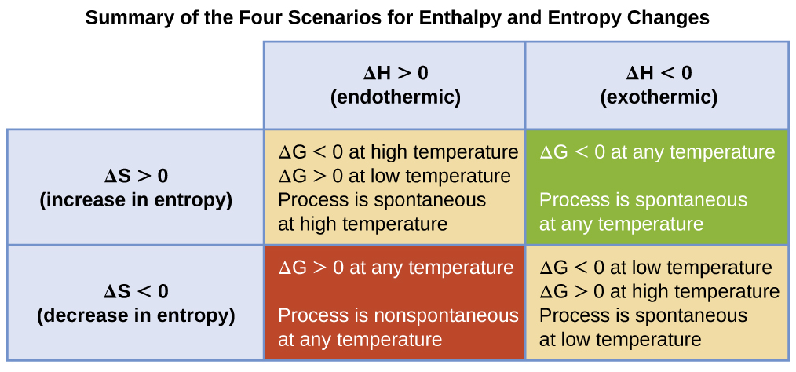
Figure 14: The four possible outcomes of Gibbs free energy calculations for chemcial reactions with positive and negative enthalpy and entropy. Source, licensed under the Creative Commons Attribution-NonCommercial-ShareAlike 3.0.
Chemical reactions can fall in any of the four scenarios of the above diagram. Although a large number of exothermic reactions typically produce higher entropy products and are therefore spontaneous, this does not apply to all. For example, the production of ammonia:
$$N_{2(g)}+{3H}_{2(g)}\underset{⇔}{}{2NH}_{3(g)}$$
$$∆H=-91.8kJ{mol}^{-1}$$
$$∆S=-198.3J{mol}^{-1}K^{-1}=-0.1983kJ{mol}^{-1}K^{-1}$$
With a negative enthalpy change and entropy change, the exothermic production of ammonia is spontaneous only at lower temperatures, for example at 298K:
$$∆G=-91.8kJ{mol}^{-1}-298K×-0.1983kJ{mol}^{-1}K^{-1}$$
$$∆G=-34.3kJ{mol}^{-1}$$
Above the temperature where $∆G=0$, this reaction is non-spontaneous:
$$T=\frac{∆H}{∆S}$$
$$T=\frac{-91.8kJ{mol}^{-1}}{-0.1983kJ{mol}^{-1}K^{-1}}$$
$$T=463K$$
The formation of ammonia is spontaneous up to 463K, for example at 700K the reaction is non-spontaneous:
$$∆G=-91.8kJ{mol}^{-1}-700K×-0.1983kJ{mol}^{-1}K^{-1}$$
$$∆G=47.01kJ{mol}^{-1}$$
At this point it is necessary to consider the kinetic effects and other influences on this chemical reaction. Non-spontaneous does not mean not possible, just that work must be done for the forward reaction to occur. The production of ammonia at 298K would occur at a very slow rate, the temperature is raised higher to increase the rate with increased pressures and catalysts to encourage the production of ammonia despite the positive Gibbs free energy result at these temperatures.
The reaction of solid barium hydroxide with ammonium chloride is an endothermic process:
$$Ba{\left(OH\right)}_{2}.8H_{2}O_{(s)}+2NH_{4}{Cl}_{(s)}\overset{⇔}{}Ba{Cl}_{2}.2H_{2}O_{(aq)}+2NH_{3(aq)}+8H_{2}O_{(l)}$$
$$∆H=63.5kJ{mol}^{-1}$$
$$∆S=368J{mol}^{-1}K^{-1}=0.368kJ{mol}^{-1}K^{-1}$$
With a positive enthalpy change and entropy change, the reaction of solid barium hydroxide with ammonium chloride reaction is spontaneous only at higher temperatures, for example at 298K:
$$∆G=63.5kJ{mol}^{-1}-298K×0.368kJ{mol}^{-1}K^{-1}$$
$$∆G=-46.2kJ{mol}^{-1}$$
Above the temperature where $∆G=0$, this reaction is spontaneous:
$$T=\frac{∆H}{∆S}$$
$$T=\frac{63.5kJ{mol}^{-1}}{0.368kJ{mol}^{-1}K^{-1}}$$
$$T=173K$$
The reaction of solid barium hydroxide with ammonium chloride is spontaneous above 173K, for example at 100K the reaction is non-spontaneous:
$$∆G=63.5kJ{mol}^{-1}-100K×0.368kJ{mol}^{-1}K^{-1}$$
$$∆G=26.7kJ{mol}^{-1}$$

Appendices

Appendix one: Exothermic and endothermic calculations

Dissociation of ionic substances in aqueous solution
The enthalpy of solution can be calculated from the dissolution reaction of a range of solutes. Students can explore alternative apparatus and methods, for example the coffee cup calorimeter (depicted below), a thermos, metal beakers and standard beakers (depicted below) to investigate differences in the accuracy of each setup with respect to literature values:
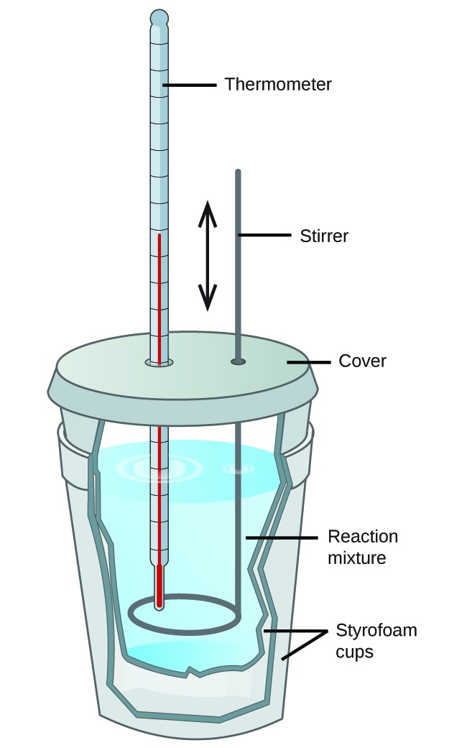
Figure 15: A simple calorimeter can be constructed from two polystyrene cups. A thermometer and stirrer extend through the cover into the reaction mixture. Source: licensed under a Creative Commons Attribution 4.0 International License.
When undertaking the direct measurement of the enthalpy of solution (${∆H}_{soln}$) using a thermometer held in the water, it is important that the thermometer bulb is placed as central to the water volume as possible, whilst the solute is rapidly added while stirring with a stirring rod (not with the thermometer):

Calculation | Exothermic | Endothermic
Scenario | 4g of solid sodium hydroxide is dissolved in 100g of distilled water at $25.0℃$, resulting in a final temperature of $34.5℃$. | 8g of solid ammonium nitrate is dissolved in 100g of distilled water at $25.0℃$, resulting in a final temperature of $19.7℃$.
$$q$$ | $$m=4g+100g$$  $$m=104g=0.104kg$$  $$∆T=\left(34.5℃+273.15K\right)-\left(25.0℃+273.15K\right)$$  $$∆T=307.65K-298.15K=9.50K$$  $$q=mC∆T$$  $$q=0.104kg×4.18×{10}^{3}J{kg}^{-1}K^{-1}×9.50K$$  $$q=4130J$$  This dissolution has a positive $∆T$ and $q$, indicating the surroundings have gained energy from the system during this exothermic dissolution process. | $$m=8g+100g$$  $$m=108g=0.108kg$$  $$∆T=\left(19.7℃+273.15K\right)-\left(25.0℃+273.15K\right)$$  $$∆T=292.85K-298.15K=-5.30K$$  $$q=mC∆T$$  $$q=0.108kg×4.18×{10}^{3}J{kg}^{-1}K^{-1}×-5.30K$$  $$q=-2390J$$  This dissolution has a negative $∆T$ and $q$, indicating the surroundings have lost energy to the system during this endothermic dissolution process.
$${∆H}_{soln}$$ | $$m=4g$$  $$MM=(NaOH)$$  $$MM=Na+O+H$$  $$MM=22.99+16+1.008$$  $$MM=40.07g{mol}^{-1}$$  $$n=\frac{m}{MM}$$  $$n=\frac{4g}{40.07g{mol}^{-1}}$$  $$n=0.1mol$$  $$q=-4130J×\frac{1kJ}{1000J}$$  $$q=4.130kJ$$  $${∆H}_{soln}=\frac{-q}{n}$$  $${∆H}_{soln}=\frac{-(4.130kJ)}{0.1mol}$$  $${∆H}_{soln}=-41.30kJ{mol}^{-1}$$  This dissolution has a negative ${∆H}_{soln}$, indicating the system has lost energy to the surroundings during this exothermic dissolution process. | $$m=8g$$  $$MM=(NH_{4}NO_{3})$$  $$MM=N+4\left(H\right)+N+3(O)$$  $$MM=14.01+4\left(1.008\right)+14.01+3\left(16\right)$$  $$MM=80.052g{mol}^{-1}$$  $$n=\frac{m}{MM}$$  $$n=\frac{8g}{80.052g{mol}^{-1}}$$  $$n=0.1mol$$  $$q=-2390J×\frac{1kJ}{1000J}$$  $$q=-2.390kJ$$  $${∆H}_{soln}=\frac{-q}{n}$$  $${∆H}_{soln}=\frac{-(-2.390kJ)}{0.1mol}$$  $${∆H}_{soln}=23.90kJ{mol}^{-1}$$  This dissolution has a positive ${∆H}_{soln}$, indicating the system has gained energy from the surroundings during this endothermic dissolution process.
Literature value for ${∆H}_{soln}$ | -44.51kJmol⁻¹ | 25.69kJmol⁻¹
Comparison of results | The experimental value is less than the literature indicating that not all of the energy liberated in this reaction was captured in the calorimeter and measured by the thermometer.  Error of 7.2% | The experimental value is less than the literature indicating that not all of the energy absorbed in this reaction was captured in the calorimeter and measured by the thermometer.  Error of 7.0%

Combustion
The indirect measurement of the enthalpy of combustion (${∆H}_{c}$) using calorimetry involves measuring the temperature change in water heated by a combustion reaction. In this case, the thermometer is also placed as central to the water volume as possible. In the calculation for $q$ use the mass of the water in the calorimeter, assuming that all of the energy liberated during the combustion reaction is absorbed by the water:
$${-∆H}_{fuel}={∆H}_{water}$$
This energy calculation is then used to calculate ${∆H}_{c}$ for the fuel, using the moles of fuel only.
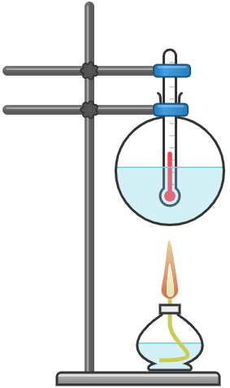
Figure 16: Basic practical apparatus for measuring the enthalpy of combustion. NSW Department of Education, 2021. Created with Chemix.

Calculation | Methanol
Scenario | 100g of distilled water at $25.0℃$ is heated by a spirit burner of methanol. When the spirit burner is extinguished, the final temperature of the water was $76.0℃$, and the mass of the spirit burner had reduced by 1.21g.
$$q$$ | $$m_{water}=100g=0.1kg$$  $$∆T=\left(76.0℃+273.15K\right)-\left(25.0℃+273.15K\right)$$  $$∆T=349.15K-298.15K=51.0K$$  $$q=mC∆T$$  $$q=0.1kg×4.18×{10}^{3}J{kg}^{-1}K^{-1}×51.0K$$  $$q=21318J$$  This combustion has a positive $∆T$ and $q$, indicating the surroundings have gained energy from the system during this exothermic combustion process.
$${∆H}_{c}$$ | $$m_{fuel}=1.21g$$  $$MM=(CH_{3}OH)$$  $$MM=C+3\left(H\right)+O+H$$  $$MM=12.01+3\left(1.008\right)+16+1.008$$  $$MM=32.042g{mol}^{-1}$$  $$n=\frac{m}{MM}$$  $$n=\frac{1.21g}{32.042g{mol}^{-1}}$$  $$n=0.0378mol$$  $$q=21318J×\frac{1kJ}{1000J}$$  $$q=21.32kJ$$  $${∆H}_{c}=\frac{-q}{n}$$  $${∆H}_{c}=\frac{-(21.32kJ)}{0.0378mol}$$  $${∆H}_{c}=-564kJ{mol}^{-1}$$  This combustion has a negative ${∆H}_{c}$, indicating the system has lost energy to the surroundings during this exothermic combustion process.
Literature value for ${∆H}_{c}$ | -726kJmol⁻¹

