Chemistry module 8 – applying chemical ideas

Table of contents
Table of contents 2
Teaching the Year 12 Modules 3
Course overview 4
Module summary 4
Big ideas 5
Relationship to other modules 5
Core concepts 6
Opportunities for extending concepts 7
Alternative conceptions and misconceptions 8
Conceptual difficulties 8
Suggested teaching strategies 10
IQ8-1: How are ions present in the environment identified and measured? 10
IQ8-2: How is information about the reactivity and structure of organic compounds obtained? Chemical Tests 12
Instrumental analysis 16
IQ8-3: What are the implications for society of chemical synthesis and design? 26
Appendices 27
Appendix 1: Gravimetric Analysis 27
Appendix 2: Precipitation Titrations 29
Appendix 3: CER, Claim Evidence Reasoning and scientific argumentation 31

Teaching the Year 12 Modules
The new Stage 6 Chemistry course was implemented in NSW schools in 2018-2019. This syllabus incorporates new content and learning activities such as Depth Studies. The syllabus is designed around inquiry questions and formal assessment tasks emphasise the skills for working scientifically.
The Year 12 course builds on the concepts introduced in Year 11 by the examining of particular classes of chemicals, processes and a variety of chemical reactions which incorporate organic compounds and acid/base and equilibrium reactions. The application of this knowledge to the investigation of a range of methods used in identifying and measuring quantities of chemicals, leads to a deep understanding of the structure, properties and trends of, and between, classes of chemicals. The Working Scientifically skills and processes are applied to predict outcomes by using physical, conceptual and mathematical models and assessing the limitations of models.
Therefore, pedagogies that promote inquiry and deep learning should be employed in the Chemistry classroom. The challenge presented by the additional content and the change in pedagogical approach were the catalysts for the preparation of these module guides for Stage 6. These guides are intended to assist teachers deliver Chemistry effectively by outlining overarching concepts (big ideas), core and extended ideas, strategies for teaching the modules, uncovering of alternative conceptions, and strategies to address them. The guides support the teacher in facilitating the development of deep knowledge structures, such as the relationships between concepts. It is essential that teachers note that the module guides do not substitute the syllabus, but only support teachers to teach it. The module guides do not cover all aspects of the syllabus, as that was not within the scope of the project.
The information contained in these documents are correct at the time of publication. While every effort has been made to eliminate errors, any errors or omission that are identified after the release of these documents will be corrected and released as resource updates. It is recommended that teachers access the Curriculum website for the latest version of these documents.

Course overview
The chemistry course develops student ability to apply processes that underpin the understanding of the nature and practice of science and enables students to interpret the interconnection between nature and practice of science, and knowledge of chemistry. Through applying the Working Scientifically skills processes, the course aims to examine how theories, models and practices are used and developed.
The fundamentals developed in Year 11, include:
- knowledge, understanding of the properties and structures of matter, and relating properties and structures to trends in data and reactions
- knowledge and understanding of the types of and drivers of chemical reactions
- skills in making hypotheses and designing valid and reliable practical investigations
- skills in conducting investigations and solving problems
- constructing models
- conducting investigations by measuring and/or collecting relevant data and information from first-hand practicals and secondary sources and determining the accuracy, reliability and validity of data and information
The Year 12 course builds on the concepts introduced in Year 11 by:
- the examining of classes of chemicals, processes and a variety of chemical reactions which incorporate organic compounds and acid/base equilibrium reactions
- the application of this knowledge to the investigation of a range of methods used in identifying and measuring quantities of chemicals, which leads to a deep understanding of the structure, properties and trends of, and between, classes of chemicals
- using physical, conceptual and mathematical models to predict outcomes and assessing the limitations of models.

Module summary
Students describe and evaluate the application of chemistry to scientific research, medicine, environmental management and industries. Technological advances in analytical techniques can not only be used to detect, measure and monitor chemicals, but also allow the chemical structures to be identified and both chemical and biological reactivity predicted. This has implications in the design and production of chemical substances such as fuels, pharmaceuticals and cleaning products as well as future industries.
Students evaluate factors and implications for society when chemical synthesis processes are designed. Students:
- develop and evaluate questions and hypotheses
- design and conduct valid and reliable investigations
- qualitatively and quantitatively analyse organic and inorganic substances using a range of chemical tests and instrumental techniques to identify the content, purity and structure of chemical substances
- analyse trends, patterns and relationships in data to deduce or confirm water quality and the structure and identity of organic compounds.

Big ideas
- The understanding of industrial processes and their applications and the monitoring of chemicals in the environment and in industries, often in very small trace amounts, is vitally important as chemicals can impact the management and economics of processes and the health and wellbeing of society, sustainability and the environment.
- To analyse information about substances, for example spectroscopic data, students must use procedural knowledge and algorithms; a set of well-defined rules to analyse data and interpret information. Heuristics (simple strategies that may be used to quickly form judgments, make decisions, and find solutions to complex problems) may often be employed by students to help them identify evidence for argumentation problems.
- Knowledge and understanding of chemical technologies, industrial processes and their applications are central to our preparation for changing workplaces and future study, environmental sustainability, the progress of society, and our ability to develop as global citizens. Through case studies, students develop understanding of the economic, political and societal influences that impact on the development of scientific knowledge.

Relationship to other modules
Module 8, Inquiry Question: Analysis of Organic Substances has multiple links to Module 7 and teachers may choose to incorporate some of Module 8 into the teaching of Module 7, such as conducting investigations to test for carbon-carbon double bonds, hydroxyl groups and carboxylic acids.
Alternatively, parts of module 7 such as properties and uses of polymers, production of soaps and detergents and ethanol could be taught in Module 8 as case studies of industrial processes.
This module is best taught at the end of the course as a unit on the applications of chemistry or as revision, and is an appropriate resource/unit for a depth study where students can conduct fieldwork, such as measuring ions in the environment; or a depth study on synthesis and design where students develop a research question on a product such as uses, production and impacts.
This module has the following links:
- The Chemistry Stage 6 Syllabus rationale and aim - developing the understanding of materials and their properties, structure and related applications and the examining of how chemical practices are used and developed. The importance of the monitoring of chemicals in the environment and the understanding of industrial processes and their applications being central to human progress and our ability to develop future industries and sustainability. A knowledge and understanding of chemistry are often the unifying link between STEM related fields and supports participation in a range of careers in chemistry and related interdisciplinary industries.
- Values and attitudes objectives: recognise the importance and relevance of chemistry in their lives, recognise the influence of economic, political and societal impact on the development of scientific knowledge, and an appreciation of the influence of imagination and creativity in scientific research.
- Learning across the curriculum content: cross-curriculum priority of sustainability and general capabilities including ethical understanding, civics and citizenship and work and enterprise.
- Module 5, IQ 4, solution equilibria and solubility rules. In addition, this module may investigate case studies of industrial processes that use a knowledge and understanding of equilibrium in their processes, such as the Haber process (NH₃) and the Contact process (H₂SO₄)
- Module 6, IQ3, acid/base analysis techniques used in industries. In addition, this module may investigate case studies of industrial processes that use a knowledge and understanding of acids/bases in their processes, such as the manufacture of NaOH by the membrane process or the manufacture of Na₂CO₃ by the Solvay process.
- Module 7, structure of alkenes, alcohols and carboxylic acids. In addition, this module may investigate case studies of industrial processes that use a knowledge and understanding of reactions of organic chemicals including chemical synthesis pathways and flowcharts to produce alcohols, soaps, polymers, detergents and esters.

Core concepts
- Inorganic substances can be identified using qualitative and quantitative methods, in classroom laboratories. Qualitative tests for inorganic ions use a knowledge and understanding of emission spectra, solubility rules and precipitations and the formation of coloured complexes.
- Valid and reliable investigations can be designed, planned and conducted using experimental techniques for quantitatively analysing inorganic substances in the environment including precipitation, gravimetric analysis and colorimetry.
- Students should be able to analyse the errors, uncertainty and limitations in the data, determine accuracy and defend the use of standards. Accuracy is not just precision but also whether the measurement is correct or true. Students can be taking precise pH measurements, but they can be inaccurate if the meter is not calibrated with a standard. The role of standards is essential is any quantitative measurement in chemical analysis techniques.
- Spectroscopic techniques can detect low concentrations of inorganic substances (that are too low to precipitate) by atomic absorption spectrometry (AAS), colorimetry and UV-visible spectrophotometry (UV-vis). Depending on the resources locally available, investigations may require students to analyse and make conclusions from secondary-sourced data. The use of a claim-evidence-reasoning template will facilitate student construction of scientific argumentation.
- Qualitative techniques in the classroom laboratory can be used to determine the structure and properties of some simple organic compounds, such as alcohols, carboxylic acids and alkenes. The reactivity of organic molecules is described by models, sub-microscopic and symbolic, and the models linked to the macroscopic phenomena observed.
- Structures of a broad range of known and unknown organic compounds can be analysed through a range of analytical techniques such as proton and carbon NMR, mass spectrometry and infrared spectrometry (IR) and UV-Visible spectrophotometry (UV-vis). The use of procedural knowledge and algorithms or heuristics to analyse data and interpret information must be employed by students to help them identify evidence for scientific argumentation problems. Depending on the resources locally available, investigations may require students to analyse and make conclusions from secondary-sourced data. The use of a claim-evidence-reasoning template will facilitate student construction of scientific argumentation.
- The integration of case studies is fundamental to this module and indeed the syllabus, applying content knowledge and skills to industrial processes and the development of sustainability, future industries and STEM related careers.

Opportunities for extending concepts
The following areas could be the basis for a depth study:
- Model organic structures and present the model as it relates to and explains reactivity.
- Monitor the presence of ions in soils.
- Construct flow charts for the identification of ions in a mixture.
- Conduct field work and monitor the water quality of a local waterway.
- Monitor the air quality over time.
- Investigate the formation of precipitates and the relationship to equilibrium constants, K_{sp.}
- Research:
  - the role of analytical chemistry in society
  - the uses of analytical chemistry, such as measuring substances in soil, water, air, food and medical products
  - different analytical techniques such as chromatography or spectroscopy.
- Investigate the analysis of data and information about the concentration of ions from a data set, identifying the errors, uncertainty and limitations in the data and/or discussing accuracy in readings, standards and the standardisation of tests for ions.

Alternative conceptions and misconceptions
Describing what happens at the particle level during precipitation, following alternative conceptions of dissolving and the nature of ionic bonding may be poorly understood. Completing experiments in precipitation and explaining the observations using diagrams and/or models can assist those students who require additional support. It is important to let students explore precipitation reactions of ions to construct knowledge about which qualitative tests are conclusive and what issues may arise (such as solutions that are fresh and not too dilute, the need for several samples, the order in which tests are carried out, tests that are dependent on the pH of the solution and the need for confirmatory flame tests). A deep understanding will enable the constructing, rather than rote memorisation, of ion testing procedures. The syllabus does not indicate that ion testing is for solutions with mixtures of more than one ion, and therefore the memorisation of complex flow charts is not necessary.
Students widely misunderstand the application of equilibrium, rates of reaction and yields to optimising industrial processes. Teachers may need to revise Q, the reaction quotient and K, the equilibrium constant. The use of assessment for learning items to diagnose misunderstandings about rate vs equilibrium will also inform teachers and students about misconceptions.

Conceptual difficulties
This module will bring together student learning across the Chemistry course. Some concepts may need to be revised, as they are encountered and after some assessment for learning:
- Solubility rules and the relationship between solubility and equilibrium. In chemistry, learners are asked to make sense of teaching about the macro (concrete, observable and visible), the sub-micro (molecules and ions) and the symbolic (mathematical, graphical, models and formulae, such as the formula equation representing sodium chloride dissolving). Students can find it difficult to manage the cognitive load of multiple representations and teachers are encouraged to consider the sequence of learning and to scaffold the main learning points. An example of how to manage this could be in setting up an experiment prior to the class arriving, such as using micro-techniques (spotting plates or films) to demonstrate solubility rules for example. Students make macro observations, and compete a scaffold for the reasoning or justification, based on either the theory or symbolic representations to make a conclusion or argument. The organisation and clutter of having to plan and conduct an experiment had been taken out of the lesson, with the focus being on collecting evidence (making observations) and reasoning (explaining). Extension or a depth study could be conducted around the concept of solubility equilibria.
- Organic functional groups and reactivity. Some teachers will have taught organic naming conventions as one unit in Module 7, while others have taught each homologous group, their naming, structure and bonding, representations and reactions as they are encountered. Students will need revision and practise to ensure that compounds with hydroxyl groups, carbon-carbon double bonds and carboxylic acids are confidently distinguished and their structures may be applied during instrumental analysis.
- Emission spectroscopy may be confused with absorption spectroscopy. Flame tests are taught in Year 11 Properties of Matter where the emission of light, or wavelength, is linked to atomic structure. The emission of visible radiation in a flame test is the result of electrons returning to the ground state after being excited by EMR, electron bombardment, heat, laser or electrical discharge. It is used in the identification of cations in this module. Emission spectra are generally observed as a series of narrow coloured lines on a black background. Absorbance spectroscopy is the blocking or absorbance of light of a specific wavelength by the atomization or vaporisation of a sample. More blocking of the light and therefore more absorbance are caused by a higher concentration of the sample. This technique is used in colorimetry, AAS, UV-Vis, and IR spectrometry which are studied in this module. Absorption spectroscopy such as colorimetry and AAS, only works for low concentrations, such as ppm (the same as mg/L) or ppb (the same as µg/L). Absorption spectra are generally observed as a series of narrow black lines on the coloured background representing the rest of the visible spectrum.
- Colorimetry is a method that determines the concentration of a substance based on its ability to absorb wavelengths over the full range of the visible spectrum. Simple samples can be identified through matching of the visible absorbance spectra to a known standard, but colorimetry is more useful as a quantitative method. By selecting a wavelength of light which is most strongly absorbed by the sample, the concentration can be determined through comparison to a series of known concentration standards. Standard comparison is the most common method for quantification in all these analysis processes. This involves a set of known concentration standards of the analyte being prepared and analysed to produce a graph of concentration vs absorbance where the linear line of best fit is called the calibration curve. By using the straight-line equation for the calibration curve the concentration of the analyte in the sample can be calculated from the measured absorbance. If teachers and students spend time in exploring colorimetry, the concept of AAS and UV-vis which use a similar procedure, are easier to understand and discuss. Students can collect data for colorimetry calibration curves in the classroom laboratory, using coloured solutions of crystal violet or copper sulfate for example. This allows students to design procedures to collect reliable data, analyse errors, uncertainty and limitations in the data, determine accuracy and defend the use of standards. Many schools have purchased colorimeters, and some may still have the Streamwatch ‘black kits’ in their storerooms. The Streamwatch kits can be used to determine phosphate concentration using colorimetry. Increasingly, mobile phone apps, such as Google Science journal, are being developed that can be used for analysis, such as colorimetry. Commercial manufacturers of colorimeters, such as IEC, PASCO and Vernier will also include laboratory procedures for their products which are available through school science suppliers. Schools may not have access to analytical instrumentation and data, however there are several tertiary institutions that run outreach laboratory days for Year 12 Chemistry students.
- Supporting students in their understanding of the equilibrium/rate trade-off can be achieved through the investigation of a case study, such as the Haber process as an industrial example of equilibrium in action (as suggested in the Module 5 Module guide), reviewing the simple reaction, determining gas moles, balancing the equation and describing conditions that influence the reaction. The strength in this case study is in the simplicity of the equilibrium reaction equation, as all species being in the gaseous state facilitates easier analysis of pressure, volume and temperature considerations. Weakness exists in the simulation on the cost of production/profits however this is a useful talking point about the need to monitor equilibrium from a commercial perspective. A review of rates of reaction and a discussion about percentage of product yield vs the rate at which product is produced, may help misconceptions about the difference between rate and yield. A good understanding of both equilibrium and rate is essential to be able to discuss the Haber process.

Suggested teaching strategies

IQ8-1: How are ions present in the environment identified and measured?
Teachers are encouraged to activate or engage learning, by using a 5E’s or similar model – there are unknown substances in your local waterways, what are they? How did they get there? Are they dangerous? How do you know? Discuss a legal case, such as water fluoridation (the ABC News article New legal advice puts council fluoridation programs on shaky ground may be helpful) or a natural disaster, such as NSW bushfires affecting local water supply during a fire and after rain.
This inquiry question, ‘How can ions in the environment be identified and measured?’ can be taught with a focus on inquiry-based learning. Students can explore the identification of ions by making a hypothesis about the effect of the local environment on water or soil quality. Students can conduct secondary sourced investigations of qualitative analysis of ions in different samples, such as the pH of soil or Department of Primary Industry - salinity of soils collected from different locations or students can collect evidence to discuss how ions (such as H⁺, HCO₃⁻, Cl⁻) are released into the environment. Subsequently, students could compare water or soil qualitative analysis to quantitative analysis, such as concentrations of common ions with standards, such as NHMRC Drinking Water Guidelines for different samples (this can be a secondary sourced investigation, such as comparing the analysis of bottled mineral water).
Students can review solubility rules from Module 5 and research, plan and conduct investigations to explore and identify the presence of cations using precipitation can be completed: Ba²⁺, Ca²⁺, Mg²⁺, Pb²⁺, Ag⁺, Cu²⁺, Fe²⁺ and Fe³⁺. Flame tests can be carried out to distinguish Ba²⁺, Ca²⁺ and Cu²⁺. Flame tests should not be carried out on heavy metals such a Pb²⁺ and Ag^{+.} The planning and conducting for testing of anions – Chloride, Hydroxide, Carbonate, Sulfate, Phosphate, Bromide, Iodide and Acetate ions will comprise the explore and explain stage. The last three ions are additions to the new Chemistry syllabus, and teachers will need to check recent textbooks for information regarding their testing. Solubility Rules (Call Me Maybe Parody) (duration 3:16) or flash cards can be a fun way to drill tests and solubility rules. Solubility constants in the data table will also assist indicate the insolubility of some salts. Some useful acronyms to aid students about general solubility rules are:
- NAGSAG: all nitrates, acetates, group one, sulfates, ammonium and group seven are soluble
- CHOPS: all carbonates, hydroxides, oxides phosphates and sulfides are insoluble.
The exceptions are not included in the acronyms. Deeper elaborations can include the investigation of mixtures of ions and the evaluation of procedures that may include false positives. One such inquiry question could be “How do we test mixtures of ions?” The product could be a flow chart, procedure or a secondary sourced report. The appendices contain details of some investigations, such as gravimetric analysis and precipitations.
The use of colorimetry to determine ion concentration has been discussed in the conceptual difficulties, however it is strongly suggested that students master the use of calibration curves to make valid conclusions. This allows students to design procedures to collect reliable data, analyse the errors, uncertainty and limitations in the data, determine accuracy and defend the use of standards. These skills are used again in the processing of data to determine the concentration of metal ions by atomic absorption spectroscopy (AAS). There is plenty of information in textbooks for both the old and new course regarding the role of AAS in detecting very low concentrations of metal ions and the role of AAS in modern analytical chemistry, the uses of AAS and the impact of its use. In addition, the skills learned in colorimetry regarding validity, reliability, and processing data can be applied to AAS procedures. Past papers from NESA pre-2019 HSC course have a treasure trove of excellent questions on AAS.
UV-visible spectrophotometry has a pivotal role in detecting organic and inorganic substances. Organic analytes readily absorb characteristic UV wavelengths and many inorganic substances of interest are coloured and absorb wavelengths in the visible region of the EMR spectrum. In both cases, the absorbance can be compared to a known standard for quantification of the analyte in the sample. The Beer-Lambert Law, $A=εlc=\log_{10 }\frac{I_{0}}{I}$ is present in the Chemistry data sheet, however, there is no need to use this equation to be able to meet the syllabus elaboration ‘conduct investigations and/or process data to determine the concentration of coloured species and/or metal ions in aqueous solution, including but not limited to, the use of: UV-visible spectrophotometry’:

IQ8-2: How is information about the reactivity and structure of organic compounds obtained? Chemical Tests
Students need to be able to clearly articulate the link between chemical tests and instrumental analysis to identify chemical substances. Detailed analysis of chemical tests should include the reactants, products and conditions of the reactions.

Bromine test for alkenes
Carbon-carbon double bonds are a nucleophilic region in organic structures, this means they have a higher density of electrons in the bonds than elsewhere. Electrophilic species, such as bromine, are attracted to these regions and can draw electrons away to form new chemical bonds. The classic test for alkenes in hydrocarbons is the bromine test. Bromine in an organic solvent or as bromine water solution (see note below) has an intense brown-red colour and can be added to a sample of hydrocarbon to determine if it contains any unsaturated bonds. This test is unable to distinguish between alkenes and alkynes without additional tests being completed on the sample. The non-polar alkene/alkane will float on top of the aqueous layer. Bromine, which is non-polar but nevertheless does dissolve somewhat in water, will dissolve more readily into the organic layer and is then able to react with it.
A positive result is a reduction in the brown-red colouration of the solution (due to the consumption of the bromine). No visible reaction can indicate the absence of alkenes (or alkynes), but it is not conclusive evidence. Some unsaturated bonds may be protected by the structure or react so slowly that the result is determined as a false negative. The use of simple alkanes and corresponding alkenes such as cyclohexane and cyclohexene are recommended to avoid this situation. Please review CSIS for cyclohexane, cyclohexene and bromine (or bromine water) before conducting this activity with students.
Bromine test with cyclohexane giving no reaction:
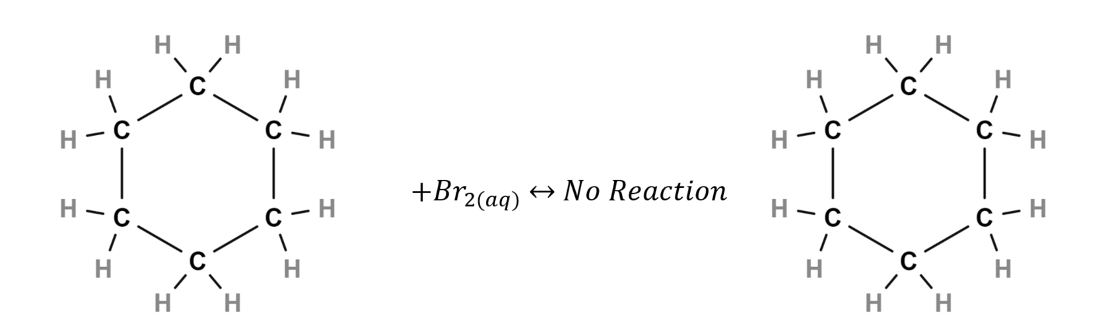
Bromine test with cyclohexene giving 1,2-dibromocyclohexane:
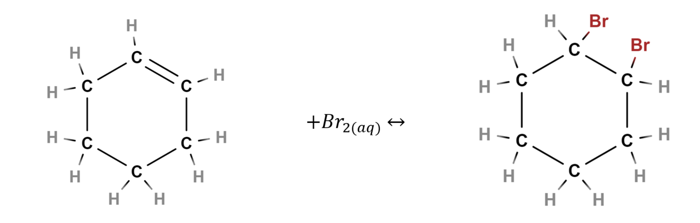
This reaction is also photosensitive, bromine can react and substitute for hydrogen on alkanes in the presence of UV light giving a false positive result. It is therefore important to protect the test from light. Bromine water contains hydrobromous acid and hydrobromic acid (due to the reaction of Bromine with water) that provide alternative products in this addition reaction. Although the positive and negative test results are identical and the 1,2-dibromocyclohexane product is still produced, it is not the most common product in this circumstance:
$${Br}_{2(aq)}+H_{2}O_{(l)}↔HO{Br}_{(aq)}+H{Br}_{(aq)}$$
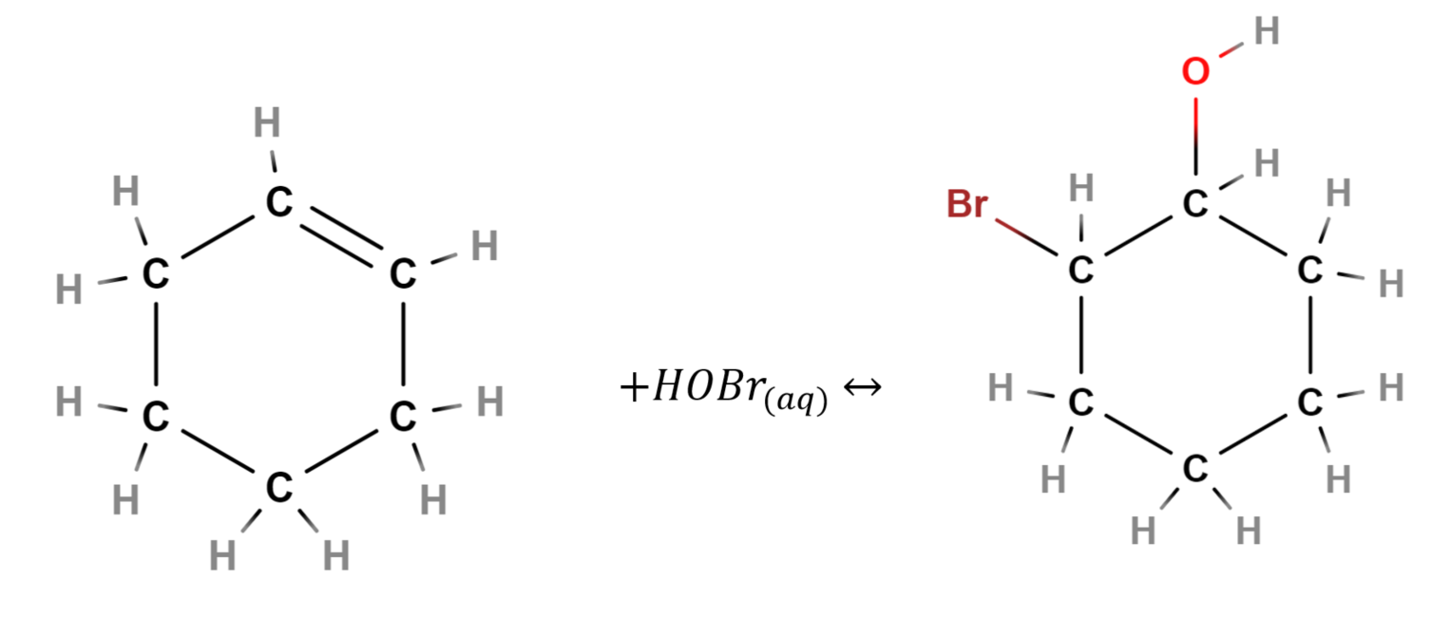
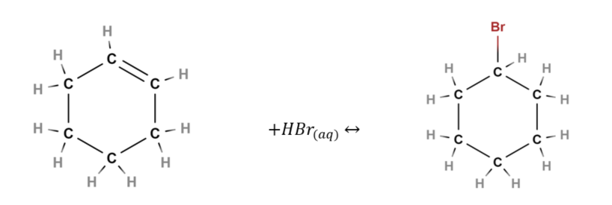
ChemGuide–Halogenation of Alkenes, Chemistry LibreTexts–Reactions of Alkenes with Bromine and Chemistry LibreTexts–Individual Tests have more information on alkenes. The understanding of the mechanism and the reason for the reactivity of the alkene is more important for students than the identification of the major product of the reaction. A common mistake in this test is to use an excess of the Bromine water, this results in students recording a false negative result due to the excess of the coloured Bromine water masking the decolourisation. Using a few drops of Bromine water in this test is a simple way to avoid this confusion.

Oxidation tests for alcohols
Alcohols are either primary, secondary or tertiary and the Jones oxidation test can give an indication of the presence of a primary or secondary alcohol functional group. This test is unable to distinguish between aldehydes and primary/secondary alcohols or between primary and secondary alcohols without additional tests being completed on the sample. Jones oxidation involves the use of potassium dichromate acidified with dilute sulfuric acid to oxidise the alcohol to the corresponding aldehyde (for primary alcohols) or ketone (for secondary alcohols). A positive result is the solution changing colour from orange to green indicating the oxidation reaction has occurred. Please review CSIS for potassium dichromate, sulfuric acid, ethanol, isopropanol and tert-butanol before conducting this activity with students:
- Primary alcohols (ethanol) oxidise to their corresponding aldehyde (acetaldehyde):
$$3CH_{3}CH_{2}OH_{\left(aq\right)}+{Cr}_{2}O_{7\left(aq\right)}^{2-}+8H_{\left(aq\right)}^{+}↔3CH_{3}C{HO}_{\left(aq\right)}+2{Cr}_{\left(aq\right)}^{3+}+{7H}_{2}O_{\left(l\right)}$$
- Secondary alcohols (isopropanol) will oxidise to their corresponding ketone (acetone):
$$3CH_{3}CHOHCH_{3(aq)}+{Cr}_{2}O_{7(aq)}^{2-}+8H_{(aq)}^{+}↔3CH_{3}COCH_{3(aq)}+2{Cr}_{(aq)}^{3+}+{7H}_{2}O_{(l)}$$
- Tertiary alcohols (tert-Butanol or 2-methyl-2-propanol) are unable to be oxidised due to no hydrogen being attached to the same carbon as the alcohol functional group. They will not react with the Jones reagent giving a negative result for this test indicated by no colour change.
$$C_{4}H_{9}OH_{(aq)}+ {Cr}_{2}O_{7(aq)}^{2-}+8H_{(aq)}^{+}↔No Reaction$$
Safety precaution - this test causes the formation of chromic acid if not performed correctly. It is vital to ensure that all solid potassium dichromate has dissolved, and the mixture is homogeneous before use.
ChemGuide–Oxidation of alcohols, Chemistry LibreTexts–The oxidation of alcohols and Chemistry LibreTexts–Individual Tests have more information about oxidation of alcohols or schools could perform a micro-scale experiment. A common mistake in this test is to use an excess of the Jones reagent, this results in students recording a false negative result due to the excess of the coloured potassium dichromate masking the colour change. Using a few drops of Jones reagent in this test is a simple way to avoid this confusion. In some cases, the reaction can be slow to progress, using a warm water bath to gently warm the mixture can aid the reaction.
The Lucas test may be used to classify tertiary alcohols of low molecular weight (less than C-6). The alcohol functional group undergoes substitution with the chloride from the Lucas reagent (anhydrous ZnCl₂ in concentrated HCl). A positive test changes colour from clear to turbid, demonstrating the formation of a chloroalkane. The distinguishing of primary alcohols from secondary alcohols requires more complex procedures, such as the distilling the products of the oxidation (aldehyde or ketone) and then performing tests such as such as those using Tollen’s reagent or Schiff’s reagent and this is not necessary at this level. More simple tests such as the permanganate or iodoform tests can be conducted in a school laboratory following appropriate risk assessment. Tests for alcohols have become obsolete as instrumental analysis methods become more available. Students should understand

Sodium Carbonate test for carboxylic acids
Carboxylic acids will react with sodium carbonate in a neutralisation reaction. The bubbles of carbon dioxide gas produced in this reaction can then be confirmed with a calcium hydroxide (limewater) gas trap to produce the characteristic white precipitate of calcium carbonate. Please review CSIS for acetic acid, sodium carbonate and calcium hydroxide before conducting this activity with students:
$$CH_{3}COOH_{(aq)}+{Na}_{2}CO_{3(aq)}↔CH_{3}COO{Na}_{(aq)}+CO_{2(g)}+H_{2}O_{(l)}$$
$$CO_{2(g)}+Ca{(OH)}_{2(aq)}↔CaCO_{3(s)}+H_{2}O_{(l)}$$
ChemGuide–carboxylic acids as acids and Chemistry LibreTexts–Individual Tests have more information about carboxylic acids.

Instrumental analysis
There are many types of instrumental analysis that will provide qualitative and quantitative information about organic compounds. Whilst the syllabus includes UV-visible spectrophotometry in the quantitative analysis of coloured inorganic solutions, it can also be used in the qualitative analysis of organic compounds, and UV absorption data for some organic chromophores are included in the data sheet. A section on UV-visible spectroscopy of organic substances is included here.
Students undertaking the analysis of spectroscopic data must be able to use algorithms, that is, follow a set of well-behaved rules, to successfully pull relevant information from a spectrum. In characterizing data analysis and interpretation as procedural knowledge, the assumption is that the spectra supplied by the teacher or the problems to be analysed are for simpler compounds and that more advanced conceptual knowledge is not required for interpretation. Each procedure is likely learned as activation of a series of several algorithms such as:
- Determining the number of carbon environments by counting the peaks in a ¹³C NMR spectrum
- Recognizing the presence or absence of functional groups (such as hydroxyl and carbonyl functionality) in an infrared spectrum
- Determining the number of protons on carbons adjacent to a given environment from the splitting of a ¹H NMR peak
- Determining the number of protons in each environment from the integration (area underneath) of a ¹H NMR peak
Helping students compile resources that make up each algorithm into a more comprehensive resource that can be deployed with little mental effort is important to build their confidence and capacity. Students may bring other resources to bear, such as heuristics of tongue, sword and hairy beard in IR spectra to solve argumentation problems. Teachers should investigate how best to assist their students to summarise, practice and demonstrate proficiency in various types of instrumental spectra analysis. A range of online sources contain a variety of spectra for the above analysis techniques. Care must be taken to review the sources carefully prior to use as many are targeted at higher level education and may confuse some students with the complex examples. The assumption is that the spectra supplied by the teacher or the problems to be analysed are unambiguous and that more advanced conceptual knowledge is not required for interpretation. Website database sources for example compound spectra such as NIST Chemistry WebBook and. Spectral Database for Organic Compounds are also handy to provide examples to students of common compounds linked to the spectra reference tables in the Chemistry Data Sheet.
Several online websites have a vast range of modelling tools and self-assessment items to provide challenging activities to identify unknown compounds for NMR/MS/IR spectra and provide some useful tools to help extend student understanding (examples are listed under each technique). It is important for teachers to remember to remind students of the examples online which represent the level to which they are expected to work for the content elaboration and those examples which are suitable extension items. When combining different types of spectra to identify an unknown compound there are some simplified steps and key questions to ask on Chemistry LibreTexts–Determine structure with combined spectra. A useful tool for students to practice for proficiency with combining all the instrumental data is the app ‘Chemical Detectives’ available on the App Store for apple and Google Play for android devices.
It is important for students to be able to link the chemical tests in this module to the instrumental analysis detailed in this section.

Nuclear Magnetic Resonance (NMR)
Nuclear magnetic resonance (NMR) spectroscopy is a spectroscopic technique used in analytical chemistry for the determination of the content, purity and the molecular structures (in this case, hydrogen and carbon atoms) present in a sample. The basis of NMR is each nuclei in a compound having a charge (from the protons) and some having a spin which causes these nuclei to behave as small magnets. Nuclei without spin (those with an even number of protons and an even number of neutrons such as ¹²C) are known as ‘NMR silent’ and are not detected by this technique. Two common ‘NMR active’ nuclei are ¹H (also called proton NMR) and ¹³C which are routinely used in NMR analysis.
The sample compound is placed in a strong magnetic field, which forces NMR active nuclei to align parallel or antiparallel to the field. Each nucleus experiences a slightly different magnetic field depending on their position in the compound. A radio frequency pulse can cause these nuclei to flip alignment. The radio frequency required for a nucleus to flip is characteristic of its position in the compound. As each nucleus relaxes to its original alignment, it releases energy which can be detected by the instrument and used to record a spectrum of frequency vs amplitude. The same type of nuclei in different positions around the compound will produce peaks at different positions in the spectrum. Equivalent nuclei are those with magnetic environments that are identical in every way and can’t be distinguished from each other based on relative position. Non-equivalent nuclei are those with magnetic environments that are not identical in one or more ways and can be distinguished based on relative position.
The different peak positions are referred to as chemical shift. The area under each peak represents the relative number of that type of nucleus in the compound. By matching a peak in the NMR spectrum to a reference table for the known chemical shift values (and by various other techniques), the structure that the NMR active nuclei are part of can be determined.
An analogy can be used to introduce the concept of NMR with students. This technique can be likened to the game marco polo. The NMR sends out a radio pulse and the nuclei which resonate with that frequency respond much in the same way as the game involves someone calling out “marco” and the other players must respond “polo”. This analogy needs careful use as it is important to recognise the difference in radio frequencies causing a response from different nuclei in the sample. Different pronunciations or enumerated pairs could be used if this was to be played such as “marco1” causes a response from “polo1” only.

Proton NMR
Proton NMR information is not included in the data sheet; however, it is explicitly referred to in the syllabus and therefore students should understand the technique and its use. The word "proton" is often used for "hydrogen atom", because it is the proton in the nucleus of the ¹H isotope that is observed in these experiments. The peaks in these spectra are frequently present as spin-spin coupled peaks or ‘peak splitting’ due to the influence of one nuclei’s spin on another. Where a peak represents a ¹H nucleus, that peak is typically split into n+1 peaks, where n represents the number of other 1H nuclei attached to adjacent structures in the compound (more information on the n+1 rule). The ¹H NMR spectrum for simple compounds such as ethanol can be used to show how to label peaks and peak splitting that exist in these spectra:
Figure 1: Proton NMR spectra for ethanol
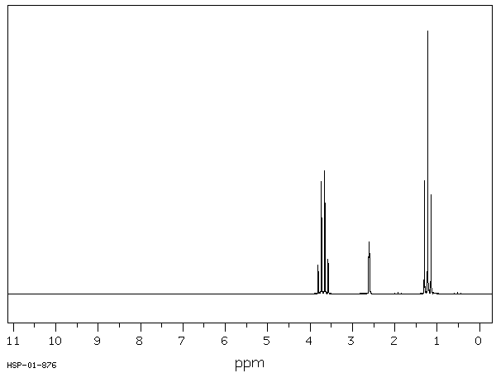
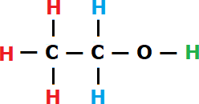
The colours of each hydrogen atom represent the different environments in which the nucleus exists, this is the types of structures which hold hydrogen atoms. In the diagram for ethanol there are three different hydrogen environments (colour coded red, blue and green). The three red hydrogens attached to the CH₃ carbon, furthest from the alcohol functional group, are equivalent (1st environment). The two blue hydrogens attached to the CH₂ carbon, where that carbon atom is connected to carbon with the alcohol functional group are equivalent (2nd environment). The green hydrogen is attached to the oxygen as part of the alcohol functional group (3rd environment). Using the n+1 rule we can determine which peak is which hydrogen environment in the Proton NMR spectrum for ethanol:
- The three red hydrogen nuclei of the 1st environment are adjacent to the two blue hydrogen nuclei of the 2nd environment, this peak would be expected to split into 2+1 peaks, looking for the triplet peak we can see this at ~1.2ppm.
- The two blue hydrogen nuclei of the 2nd environment is adjacent to the three red hydrogen nuclei of the 1st environment but not adjacent to the lone green hydrogen of the 3rd environment due to the shielding effect of the oxygen nuclei which separates them (this is also the same for amines with shielding from the nitrogen atom). This peak would be expected to split into 3+1 peaks, looking for the quartet peak we can see this at ~3.6ppm.
- The lone green hydrogen of the 3rd environment is not adjacent to any other hydrogen atoms due to the shielding effect. This peak would be expected to split into 0+1 peaks, looking for the singlet peak we can see this at ~2.5ppm.
Some interesting online tools exist to model the number of hydrogen environments and model organic compounds to dissect spectra and then assess student understanding of Proton NMR. A simple reference table for ¹H NMR can be found on Compound Interest – A guide to Proton NMR, Chemistry LibreTexts – High resolution proton NMR spectra and Kahn Academy – Proton NMR.

Carbon-13 NMR
¹³C NMR utilises the spin of the carbon-13 nuclei in a compound. No peak splitting is normally observed in ¹³C NMR spectra due to the low natural abundance of these nuclei. The chance of two carbon-13 nuclei being adjacent to each other is very low, carbon-12 is also NMR silent so cannot split the signal of an adjacent carbon-13 nucleus. The ¹³C NMR spectrum for simple compounds such as ethanol can be used to show how to label peaks in these spectra:
Figure 2: Carbon-13 NMR spectra for ethanol
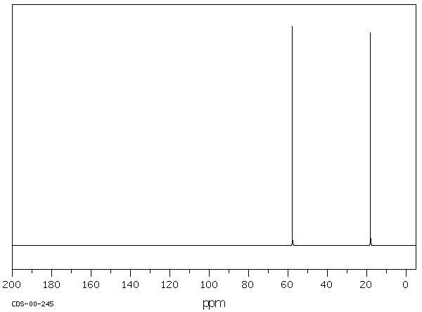
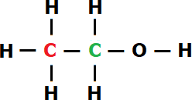
The colours of each carbon atom represent the different environments in which the nucleus exists. In the diagram for ethanol there are two carbon environments (coloured red and green). The red carbon on the end furthest from the alcohol functional group, is a CH₃ group (1st environment). The green carbon attached to the alcohol functional group, is a CH₂OH group (2nd environment). These non-identical carbon environments will show up in the spectrum as two peaks. Due to the absence of peak splitting it is important to compare the peak positions to the reference table in the Chemistry Data Sheet:
- The red CH₃ carbon would be expected to show a peak of 5-40ppm, in this spectrum there is a peak at ~18ppm which is within this range and is therefore assigned to this carbon.
- The green CH₂OH carbon would be expected to show a peak of 50-90ppm for a carbon connected to an alcohol functional group, the peak at ~58ppm falls within this range and is therefore assigned to this carbon.
A useful online tool is available to model organic compounds and dissect ¹³C spectra and can be combined with simple reference tables for ¹³C NMR which can be found on Compound Interest – A guide to 13-carbon NMR and Chemistry LibreTexts–Interpreting C-13 NMR Spectra.

Mass Spectrometry (MS)
MS is a technique used to determine the identity of compounds in a sample. This requires pure samples and therefore to analyse mixtures MS is normally placed after an instrumental separation technique such as gas chromatography (GC) which creates a GC-MS device.
In MS the sample is first ionised by an electron gun inside a vacuum, the ions produced by the sample will typically fragment into a variety of different pieces, with some types of fragments more likely to form when certain structures in the sample compound are present. The fragments are drawn through the MS by electric fields and accelerated towards a mass selector. Using a mass selector such as a magnetic sector the ions are forced around a curved path where a strong magnetic field is applied. Due to the charge on the fragment ions and their respective mass they are drawn around the curved path on slightly different trajectories (this can be likened to lighter and heavier vehicles travelling around a curved road). The strength of the magnetic field is swept through a range to focus a specific mass ion onto the detector at the end of the path. As each ion strikes the detector it is recorded as a graph of the mass/charge ratio to the abundance of that ion in the sample. Peaks on the MS spectrum represent the ratio of ions in the sample and their respective ion masses. Peaks are observed at a range of mass values; the largest mass commonly belongs to the ‘molecular ion’ (M⁺) which represents the ionised sample compound without any fragmentation, in some cases the M⁺ peak is very small due to higher instability of the ionised molecule leading to more complete fragmentation of the sample. The most abundant peak (relative intensity = 100) is called the ‘base peak’ and is the most commonly produced fragment for the compound. Peaks can be generically written as a difference to the molecular ion such as [M-18] meaning a peak at m/z 18 units less than the molecular ion.
An analogy can be used to introduce MS to students by describing the shattering pattern of glass. In every attempt to break identical panes of glass there are slightly different lines on which the glass fragments, however some fragments are more common than others. The molecular ion is represented by the unbroken glass pane. By breaking many identical panes of glass, you start to see a pattern of fragmentation which is characteristic to that pane of glass. Breaking different panes of glass can show some similar fragments but the final fragmentation pattern will be unique.
The MS spectrum for simple compounds such as ethanol can be used to show how to label peaks in these spectra:
Figure 3: Mass spectrum for ethanol
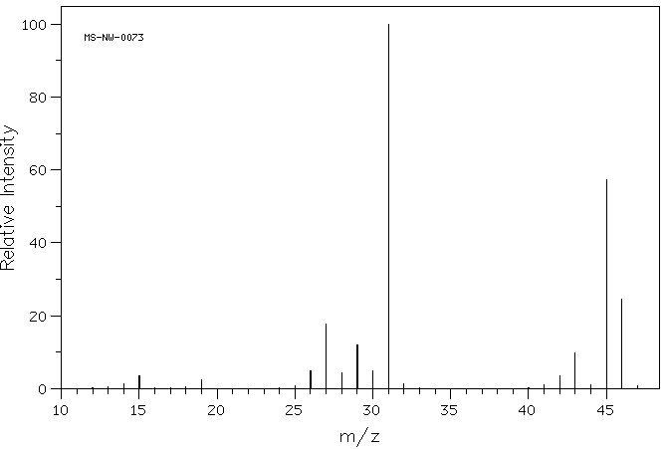
The M+ peak for ethanol is observed at m/z 46 which is the molar mass of ethanol. Fragment peaks are observed at many masses < 46. Labelling every single peak is usually not required to determine the structure. Exact fragmentation patterns are incredibly complex, however, some peaks observed are more characteristic for certain types of compounds. For simple compounds the patterns are more well-known and usually easy to spot in the mass spectrum. It is commonly easier to identify the fragment lost from the molecular ion rather than trying to identify the ion itself to identify a peak in the MS spectrum:
- The base peak at m/z 31 is easier to identify by instead referring to it as the [M-15] peak. The loss of 15 mass units is easier to identify as the CH3 leaving group rather than trying to identify the m/z 31 peak directly. By identifying the fragment removed the remaining [CH₂OH]⁺ ion can be more easily identified which is the base peak ion for ethanol. This also accounts for the peak at m/z 15 as the [CH₃]⁺ leaving group. The m/z 31 peak is a very common base peak for primary alcohols due to the stability of this ion when fragmented from the rest of the molecular ion.
- The peak at m/z 45 can be referred to as [M-1], this where the alcohol hydrogen atom has fragmented leaving behind the [CH₃CH₂O]⁺ ion. This is a very commonly observed peak for alcohols.
- The peak at m/z 28 can be referred to as [M-18], this where the alcohol OH has fragmented and the ion steals a hydrogen from the adjacent carbon creating water and leaving behind the [CH₃CH]⁺ ion. No peak is observed for water at m/z 18 as it is not charged so cannot be influenced by the MS magnetic field. This is a very commonly observed peak for alcohols.
A useful online tool is available to test student understanding of MS spectra. Common fragment ions for a range of functional groups can be found in these publications from Chemguide and Chemistry LibreTexts–Fragmentation Patterns. A simple graphic table for mass spec can be found on Compound Interest–A guide to MS which may be a simpler starting resource for students interpreting mass spectra.

Infrared Spectrometry (IR)
Infrared (IR) spectroscopy is a technique which produces the infrared wavelength absorbance pattern (the output graph is typically shown as the inverse, transmittance pattern) of a sample which can be used to identify a compound or the purity of a sample. That is, the peaks ‘hang downwards’. IR causes either stretching or bending of the bonds when they are excited by the frequency they absorb. Peaks can be strong or weak (relating to their height in the spectra) and sharp or broad (relating to their width in the spectra). To the right of the spectrum at 1500-500cm⁻¹ is the ‘fingerprint region’. This contains a large mixture of absorbance peaks, although peaks in this region could be used to identify bonds it is typically ignored and only used for final confirmation of a compound’s identity when comparing to a database of known spectra. IR is not generally used to determine the whole structure of an unknown molecule, with access to NMR and other techniques, we do not need to analyze every single peak. IR is great for identifying certain specific functional groups, like alcohols and carbonyls. In this way it’s complimentary to other techniques (like NMR) which do not yield this information as quickly.
An analogy can be used to introduce IR to students by describing the vibrational patterns represented by the peaks. Using a series of the springs of varying gauge or length (not both). Holding the spring, representing the covalent bond, between both hands, representing the atoms of the bond students can explore the different stretching and bending vibrational modes that can occur in these bonds. Each spring will require different amounts of energy to stretch and bend based on the bond strength and types of atoms involved in the bond. This varying energy requirement is represented as different locations of the IR peaks on the spectrum. Peaks to the left of the IR spectrum represent a lower energy and so an easier bond to vibrate.
When confronted with a new IR spectrum, prioritise your time by asking two important questions first:
- Is there a broad, rounded peak in the region around 2500-3550cm⁻¹? That’s where hydroxyl groups (OH) appear. It looks like a tongue.
- Is there a sharp, strong peak in the region around 1680-1750cm⁻¹? That’s where carbonyl groups (CO double bonded) show up. It is like a sword.
If you have a tongue and no sword you would start to think about an alcohol, a sword and no tongue would make you think about aldehydes and ketones or having both a tongue and sword you would start to think about a carboxylic acid.
Figure 4: IR spectrum for ethanol
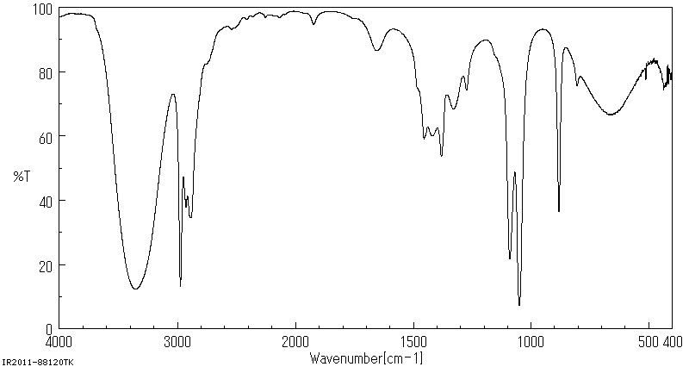
Peaks (dips in transmittance) are observed where the bonds in ethanol absorbs the IR frequency. We can determine which peak is which in the IR spectrum for ethanol by comparing the peak positions to the reference table in the Chemistry Data Sheet:
- The CH bond has a characteristic IR peak at 2850-3300cm⁻¹ and are typically observed in all organic compounds. These peaks are shown in this spectrum at 2850-3000cm-1.
- The CC bond gives a peak at 750-1100cm⁻¹ and again are typically observed in all organic compounds. These peaks are shown in this spectrum at 900cm⁻¹.
- The CO single bond gives a peak at 1000-1300cm⁻¹ and this peak is shown at 1050-1100cm⁻¹.
- The OH bond is an obvious peak (the tongue) unlike any other, typically being very broad due to the wide IR absorbance range of this bond. The absorbance of the OH bond depends on the nature of the functional group it is attached to, either as an alcohol or part of a carboxylic acid. Alcohols give a broad peak at 3230-3550cm⁻¹. This peak is shown in this spectrum at 3400cm⁻¹.
The common confusion here is alcohols vs carboxylic acids when assigning the broad “tongue” peak. Alcohols typically give a nice smooth tongue peak whereas hydroxyl groups in carboxylic acids can appear as a rougher peak, like a hairy beard. This is because the peak can be so broad that it extends beyond 3000cm⁻¹ and appears to “take over” the left-hand part of the spectrum resulting in other peaks poking through the bottom of the broad OH peak. Analysis can be complex as these broad peaks can mask the presence of other groups with absorbances close to this range such as the amines. This can be observed in the below spectrum for acetic acid, the peaks at 2850-3000cm⁻¹ for the CH bonds has been almost totally masked by the OH “hairy beard” broad peak, the characteristic sword at 1700cm⁻¹ is also clearly visible representing the CO double bond:
Figure 5: IR spectrum for acetic acid
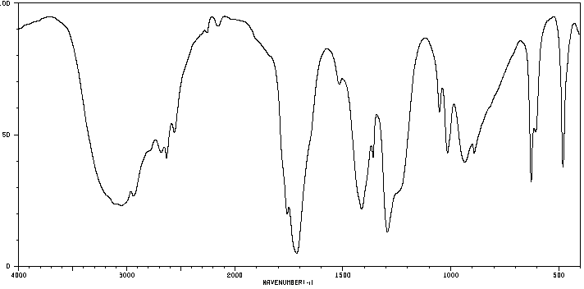
Useful online tools exist for students to browse IR spectra for modelled substances and determine the structure of small molecules based on the infrared spectrum. More information and a simple reference table for IR can be found on Compound Interest–Infrared Spectroscopy and Kahn Academy–Introduction to IR spectroscopy.

UV-visible spectrophotometry
UV-visible spectrophotometry is used to determine the concentrations of coloured species and/or metal ions in aqueous solutions as shown in IQ8-1. However, it can also be used in the qualitative analysis of organic compounds in IQ8-2. UV absorption data for some organic chromophores are included in the Chemistry Data Sheet for this purpose.
While interaction with infrared light causes molecules to undergo vibrational transitions, the shorter wavelength, higher energy radiation in the UV (200-400nm) and visible (400-700nm) range of the electromagnetic spectrum causes many organic molecules to undergo electronic transitions. What this means, is that when the energy from UV or visible light is absorbed by a molecule, one of its electrons jumps from a lower energy to a higher energy molecular orbital.
In a typical UV-visible spectrometer, the sample is exposed to radiation in these ranges. When the energy matches that required to excite an electron from one level to another, absorption occurs. Otherwise, the radiation passes through and no absorption occurs. Like an inverted IR spectrum, the wavelength or wavenumber of the radiation is plotted on the x-axis and the amount of radiation absorbed at each wavelength or wavenumber is plotted on the y-axis. At wavelength or wavenumbers where no absorption occurs, the absorption is zero. An absorption corresponds to a 'peak' in the curve. Most UV-visible spectra are like the one shown below, consisting of one or more broad bands which can be used to identify the sample compared to a known standard:
Figure 6: UV-visible spectrum for β-carotene, adapted from scilearn.sydney.edu.au
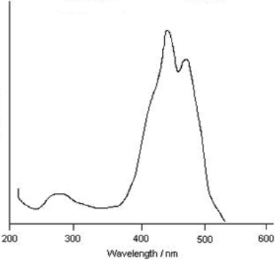

IQ8-3: What are the implications for society of chemical synthesis and design?
Students must be able to discuss the environmental, economic issues and impacts for production processes, energy use, mining, land use transport and waste issues. This inquiry question can be addressed through teaching these processes in context with the other modules using these suggested chemical synthesis case studies:
- The Contact process to produce sulfuric acid and the Haber process to produce ammonia are useful to discuss equilibrium and yield considerations and can be investigated as a case study in IQ5-2 and IQ5-3 with the considerations for equilibrium and calculation of K_{eq}.
- The Solvay process to produce sodium carbonate and the Membrane process to produce sodium hydroxide are useful to discuss the purity and environmental issues and can be investigated as a case study in IQ8-1 with ion analysis of the environmental outflow and product analysis.
- The manufacture of soaps, detergents, polymers and esters can also be studied within this inquiry question are useful to discuss the industrial uses and can be investigated as a case study in IQ7-5, IQ7-6 and/or IQ8-2.
Textbooks for the former NSW Chemistry course included case studies for several industrial processes under the Chemical Monitoring and Management and Industrial Chemistry units. By addressing this inquiry question through teaching these processes in context with the other modules it provides a clear link between theory and application for both students and teachers.

Appendices

Appendix 1: Gravimetric Analysis
Students can conduct experiments using gravimetric analysis, such as determining total dissolved solids in water samples. Gravimetric analysis is only useful for ions in relatively high concentrations in samples. Gravimetric analysis when used to analyse ion concentration, is a technique that determines the mass of ions in a sample where the stoichiometric relationship between the ion and a reagent are known. By forcing the formation of a precipitate through solubility equilibria, all the ions from the sample can be precipitated, weighed and the original concentration of the ion in the sample determined.
As an example, the determination of sulfate content in fertiliser is possible using gravimetric analysis through the precipitation of barium sulfate. Soluble solid lawn fertilisers are a good source for this activity as the sulfate content is listed on the analysis table printed on the container. This experiment is difficult to achieve complete precipitation and is an opportunity for students to design a procedure, or if given a basic procedure, to optimise that procedure and increase the accuracy using evidence gathered first-hand.
Sample Procedure with explanations:
- Carefully grind the fertiliser pellets with a mortar and pestle to ensure a fine powder is used, this ensures a high surface area of the particles to participate in the precipitation reaction.
- Weigh out as accurately as possible the fine powdered fertiliser and record this mass as the sample mass used. No more than approximately 1.0g of the sample is advised due to the amount of filtration needed if more sample is used.
- Transfer the known fertiliser mass to a clean 150mL beaker and add 50mL of distilled water and 20mL of 2M hydrochloric Acid. This will react with any carbonate ions present in the sample, producing carbon dioxide, removing them from the sample. Barium carbonate would also precipitate with barium sulfate causing a significant inaccuracy in the result. Stirring of this mixture will encourage the fertiliser to dissolve and the elimination of carbonate ions. Additional 2M hydrochloric acid can be used to ensure all the carbonate ions have been consumed.
- Filtration of this initial solution using vacuum filtration (if possible) assists with the removal of any insoluble components of the fertiliser that could contaminate the following steps.
- The filtered sample is added to a clean 250mL beaker and heated gently while 2M barium chloride solution is very slowly added with stirring. Continue stirring under gentle heat and adding barium chloride until no further white precipitate of barium sulfate is observed. Add a slight excess of barium chloride to ensure you drive equilibrium to precipitate all the sulfate from the sample.
- Allow the solution to cool to room temperature and add approximately 50mL of acetone. This will act as a coagulant, encouraging the very fine precipitate particles to form larger clumps for filtration. Gentle stirring of this mixture helps with the coagulation of the precipitate.
- Obtain the original mass (as accurately as possible) of a piece of quantitative filter paper. Ideally, the filter paper has been washed through with distilled water and dried to a constant mass, but this is a very time-consuming activity. Accepting the original mass of dried quantitative filter paper without repeated washing only introduces the possibility of a very small error.
- Filter the solution using vacuum filtration (if possible) through the known mass quantitative filter paper, washing the precipitate with small volumes of warm distilled water. The warm water ensures the precipitate is cleaned of any reagents used (which are all highly soluble in water) leaving behind only the wet barium sulfate solid.
- Dry the filter paper slowly so the precipitate is not disturbed and potentially lost. Drying to a constant mass is ideal but time consuming, the filter paper would be vacuum filtered with warm water washing of the precipitate and dried repeatedly until a constant mass of the dried filter paper and precipitate is measured. Accepting the first mass of dried quantitative filter paper and precipitate without repeated washing introduces the possibility of a small error.
- The mass of precipitate is found by subtracting the filter paper mass in step 7 from the final mass in step 9. This precipitate mass is the known product of the reaction, barium sulfate, from this mass we can calculate the mass of sulfate obtained from the original sample mass in step 2. This mass of sulfate is normally reported as % w/w which can then be compared to the analysis table printed on the container.
- Consider all the assumptions and the procedure? Is sulfate the only ion that would precipitate with the barium ions? Did all the sulfate precipitate? Was all the sulfate separated from the filtrate?
Sample working out and procedures for gravimetric analysis can be found in several textbooks, both for the current and past chemistry course. The calculation for this is a practical application of learned and practised problem-solving routines, such as the formal IDEAL (identify problem, define goal, explore strategies, anticipate outcome, look back and learn) or informal 3-step chemical problem solving (Known, Stoichiometry, Unknown). In step 10, the 3-step process would be:
- Known: calculate moles of BaSO₄ from mass.
- Stoichiometry: Construct an equation for the formation of the precipitate and determine the moles on unknown SO₄⁻².
- Unknown: Determine the mass of SO₄⁻² and divide by the mass of the original sample, then multiply by 100 to find the %w/w.
Chemistry LibreTexts–Precipitation Gravimetry has more information on gravimetric analysis.

Appendix 2: Precipitation Titrations
Investigating or processing data for a precipitation titration for the quantitative analysis of chloride ions in water samples can be related to the measurement of soil salinity or drinking water quality from the beginning of the module. Teachers and students need only investigate or process data involving one method involving a precipitation titration. Several methods for indicating the endpoint of a precipitation titration are used depending on the analyte in the titrand, including Mohr, Volhard and Fajan. Precipitation titrations are like acid/base titrations where a titrand (known volume, unknown concentration to be determined in the titration) in the conical flask, is titrated against a titrant (known volume and concentration, the standard solution) being added from the burette. The endpoint of a precipitation titration can be determined using a chemical indicator suited to the precipitation reaction between the titrant and titrand.
A requirement of any method is that the precipitation reaction that occurs between the titrant and titrand must proceed to completion very quickly (the precipitate must have a very low K_{sp}) and the indicator reaction needs to be clearly distinguishable from the analyte precipitation reaction. Once the endpoint of the titration is determined, the analyte concentration in the titrand can be calculated using the known stoichiometric relationship of the precipitate. Components of the matrix (solution in which the analyte is located) can complicate precipitation titrations through co-precipitates and complexation reactions rendering the analyte unavailable to precipitate and therefore pre-treatment of samples is usually a requirement to improve accuracy of the titration.
Mohr’s method is a common precipitation titration procedure to analyse halide concentration, other indicators include Volhard’s and Fajan’s methods. Mohr’s method is used in the food industry to measure the salt content in foods. Mohr’s method involves titrating the halide titrand with silver nitrate, using potassium chromate as the indicator. The endpoint is shown as the presence of silver chromate as a brick-red precipitate. A requirement of Mohr’s method is the titrand has a pH between 7 and 10 to prevent the chromate ion indicator turning into chromic acid in the acidic pH range (inhibiting the indicator) and also prevent the formation of silver hydroxide in the alkaline pH range (brown precipitate which masks the indicator colour). Sodium hydrogen carbonate is normally used to buffer the pH of the titrand into an appropriate pH range. To correct for the positive error of the endpoint for this indicator a titration blank containing the chromate indicator and no chloride ions is used. By determining the volume of silver nitrate needed to reach the endpoint this correction volume can be subtracted from the titrant trial volumes before the calculation steps are undertaken.
An example is the Mohr’s method analysis for chloride: 0.1M silver nitrate solution is titrated with 0.025L of a sodium chloride solution, this takes 0.0415L of silver nitrate to reach the endpoint indicated by the formation of brick-red silver chromate. A titration blank used 0.001L of 0.1M silver nitrate to reach the same endpoint:
$$AgNO3(aq)⇔{Ag}_{(aq)}^{+}+{NO}_{3(aq)}^{-}$$
$$AgCl(s)⇔{Ag}_{(aq)}^{+}{+ Cl}_{(aq)}^{-}$$
$$Ksp=1.77×10^{-10}$$
At the start of the titration there is an excess of chloride ions in solution, any silver ions added will be immediately consumed and form the white silver chloride precipitate. The equivalence point of this reaction will be where the concentration of the silver and chloride ions are equal, calculated by subtracting the titration blank volume from the endpoint volume:
$$VAg+=Vendpoint-Vblank=0.0415L-0.001L=0.0414L$$
$$nAg+=CAg+×VAg+=0.1M×0.0414L=4.14×10^{-3}mol$$
$$[{Ag}_{(aq)}^{+}]=nAg+(VNaCl+VAgNO3)=4.14×10^{-3}mol(0.025L+0.0414L)=6.23×10^{-2}M$$
$$[{Ag}_{\left(aq\right)}^{+}]={[ Cl}_{\left(aq\right)}^{-}]=6.23×10^{-2}M$$
Beyond the equivalence point the chloride ions are consumed and now silver ions can remain in solution. The chromate ions from the indicator now react with the excess silver ions and form the brick-red precipitate of silver chromate giving the endpoint of the titration:
$$Ag2CrO4(s)⇔2{Ag}_{(aq)}^{+}+CrO_{4(aq)}^{+2}$$
$$Ksp=1.1×10^{-12}$$
In order to perform this precipitation titration method, it is important to remember that silver ions are precipitated as silver by light, so protecting the solutions from excess light is very important. The chromate indicator solution must also be concentrated enough to see the endpoint, but not so concentrated to allow the yellow chromate ion to mask the titration endpoint. More information can be found about Mohr’s method from University of Canterbury School of Science or on Precipitation Titrations can be found at Chemistry LibreTexts–Precipitation Titration.

Appendix 3: CER, Claim Evidence Reasoning and scientific argumentation
Claim-Evidence-Reasoning (duration 7:24), is published by Bozeman Science.

Claim
A claim is a statement that answers the question. It will usually only be one sentence in length. The claim does not include any explanation, reasoning, or evidence so it should not include any transition words such as “because”.

Evidence
The evidence is the data used to support the claim. It can be either quantitative or qualitative depending on the question and/or lab. Evidence is often gathered in the lab through research, or from results presented in a data table that the student creates. Students should only use data within their evidence that directly supports the claim, (that is, evidence which is relevant). There should be enough evidence to support the claim. The evidence should be specific and should not itself contain any explanation or reasoning but should include the analysis and interpretation of the data. Instrumental analysis spectra will provide evidence to support or disprove the claim.

Reasoning
The reasoning is the explanation of “why and how” the evidence supports the claim. It should include an explanation of the underlying science concept or principle that produced the evidence or data. It is the logical connection between the evidence and the claim. There should be a justification for each piece of evidence, why the evidence is relevant and why it provides adequate support for the claim.
The argument uses words, phrases and sentence structures to create cohesion and clarify the relationships amongst claim(s), counterclaims, reasons, and evidence and should establish and maintain a formal style in full sentences. A concluding statement or section that follows from and supports the argument is presented.

