Year 11 Biology

Module 2: Organisation of Living Things
“

Table of contents
Year 11 Biology 1
Module 2: Organisation of Living Things 1
Table of contents 2
Teaching the Year 11 Modules 3
Course overview 4
Module summary 5
Big Ideas 5
Relationship to other modules 6
Core concepts 6
Misconceptions 7
Conceptual difficulties 9
Suggested teaching strategies 10
IQ1- How are cells arranged in a multicellular organism? 10
IQ 2-2 What is the difference in nutrient and gas requirements between autotrophs and heterotrophs? 12
IQ 2-3 How does the composition of the transport medium change as it moves around an organism? 12
Opportunities for extending concepts 21
Unicellular, colonial and multicellular organisms 21
Levels of organisation in multicellular organisms 22
Plant systems and requirements 23
Animal systems and requirements 24
Appendices 25
Resources 25

Teaching the Year 11 Modules
The Biology Stage 6 Syllabus is a sequential development of concepts that lead the student to a deep understanding of life processes, from the molecular level to the ecosystem level. This understanding, together with science inquiry skills, will allow students to apply knowledge from across the modules to
“take an informed part in science-based decisions and take appropriate actions that affect their own wellbeing and the wellbeing of the society and the environment”. (Harlen, 2010)
Biology can often be best understood through the lens of evolution. Students should develop a deep understanding of the concept that all species are descended from a common ancestor, and patterns can therefore be observed in the living world. This will be essential for students to appreciate heredity and genetic processes, manipulation of genetic material, the concept of biodiversity and the understanding of diseases covered in the Year 12 course.
In Biology, like all science disciplines, new evidence can refine views about concepts. This is illustrated in the development of disciplinary ideas in areas such as evolutionary biology and climate change. New evidence often arises from the development and use of new technologies. Students need a sound understanding of the role of new technologies in improving the understanding of various concepts in the Year 11 course, including ideas around cell and organism structure and function and evolution.
The understanding of biological processes has been significantly impacted upon by societal, cultural and economic factors. Students should be provided with opportunities to engage in work that allows them to acknowledge these influences.
Students should develop a deep understanding of humans’ impacts on ecosystems and appreciate the importance of sustainability in its various forms. This includes understanding the roles of Aboriginal and Torres Strait Islander Peoples in caring for Country and Place.
During the Year 11 course, it is expected that students will be provided with opportunities to develop all seven of the Working Scientifically skills. Ideally, these would be embedded into the teaching of the Knowledge and Understanding components of the course, allowing students to develop a sound knowledge of the structure and function of living things, from the sub-cellular level to the ecosystem level.
In preparation for the Year 12 course, students in Year 11 will benefit from work that engages them in the following areas:
- Propose questions and hypotheses and design and conduct valid and reliable practical investigations that enable data collection and analysis. There are many opportunities to conduct practical investigations beyond where the syllabus explicitly states the need to conduct one.
- Collect and analyse data from primary and secondary sources, including tables and graphs, and determine the data’s accuracy, reliability and validity. Many of the investigations will require students to obtain information from the Internet or other sources. Students will benefit from learning how to access and acknowledge valid and reliable sources of information
- Assess the uses, benefits and limitations of various types of scientific models. Many biological processes occur on a cellular or molecular level (for example, movement across a cell membrane) or happen over a long period (for example, natural selection). Models help us to better understand these processes.
- Construct labelled diagrams, flowcharts and other methods of communicating information. This skill is important for students to explain processes such as the movement of substances across cell membranes and the relationships in an ecosystem.
This module guide indicates which Working Scientifically skills are developed in each learning activity, for example, BIO11/12-5. By embedding the Working Scientifically skills, students develop and apply a sound understanding of the role scientific inquiry plays in proposing explanations for biological processes.
While preparing this module guide, Adobe Flash Player became disabled. Many biology interactives and simulations were built on this platform. The science curriculum team will update this document with information on the rebuilt interactives and simulations (using HTML5).
Throughout the syllabus, content descriptors will have the statement “including but not limited to”. This specifically allows for the opportunity to differentiate student activities and extend students’ understanding.

Course overview
The Year 11 course underpins the Year 12 course. Students are expected to access and apply the concepts developed in Year 11 to their learning in Year 12. Students are also expected to draw from knowledge and understanding across modules and apply it to new and unfamiliar situations using their Working Scientifically skills. The modules and years are not to be seen as standalone entities but rather as interrelated and interdependent.
The major themes or big ideas that weave throughout the Year 11 modules are:
- Being alive: Biology is the study of life. Living things have organised structures and coordinated functions to facilitate life.
- Interactions occur within and between organisms to supply energy and materials necessary for life.
- Living things are dynamic and diverse. Life has not always been, and will not always be, the same.
- Tools and technologies are used to make observations about living things. They help us better understand life in the present and the past and enhance life in the future.

Module summary
Module 2 explores the following inquiry questions
- IQ2-1: How are cells arranged in a multicellular organism?
- IQ2-2: What is the difference in nutrient requirements between autotrophs and heterotrophs
- IQ2-3: How does the composition of the transport medium change as it moves around an organism?
Module 2 builds on the knowledge of cell structure and function from Module 1 to how specialised cells, tissues, organs and systems operate to keep complex multicellular organisms alive. Organisms differ in their required inputs and how these are obtained, processed and transported around the organism.

Big Ideas
- Being alive: Living things are organised on a cellular basis. In multicellular organisms, cells are differentiated, specialised and arranged to form organised tissues, organs and systems with coordinated functions that maintain life.

- Living things are dynamic and diverse. While living things have the same basic requirements for life, autotrophs and heterotrophs differ in how they obtain their nutrient and gas requirements using specialised systems and processes.

- Interactions occur within and between organisms. Cells, tissues, organs and systems in organisms are coordinated to obtain and process requirements.

- Tools and technologies are used to make observations about living things. A range of imaging technologies has allowed a deeper knowledge of organism structure and function. Technologies can be used to trace the movement of substances through organisms, demonstrating processes such as transpiration, translocation and circulation.

Relationship to other modules
Module 2 builds on Module 1, moving from individual cell structure and function to the specialisation of cells and how they are organised into tissues, organs and systems in multicellular organisms.
The specialisation of these tissues, organs and systems forms the basis of organisms’ physiological and structural adaptations. Changes in these structures in species over generations provide evidence for evolution. These concepts are explored in Module 3.
The understanding of the concept of a system is applied in Module 5 when investigating reproductive systems.
In Module 7, a knowledge of respiratory, digestive and circulatory system function is necessary to understand disease transmission and the strategies used to prevent and control the spread of infectious disease. The circulatory system is integral to the immune response.
The non-infectious diseases and disorders investigated in Module 8 occur when organ and system functioning is impaired.

Core concepts
- Cells have specialised structures that allow for optimal functioning.
- Cells in multicellular organisms are organised as specialised tissues, organs and systems to optimise organism function.
- Autotrophs’ and heterotrophs’ gas and nutrient requirements are similar in some respects but different in others.
- Autotrophs and heterotrophs have different mechanisms for obtaining, processing and transporting their requirements.
- The transport medium's composition changes as it moves around the organism.

Misconceptions

Plants derive all their requirements from the soil. Movement in plant transport systems is only from the roots to the above-ground parts of the plant.
Students may believe that every substance the plant requires is absorbed through the roots. They may not understand that:
- plants absorb gases through the stomata
- there is movement of substances from the leaves to all other parts of the plant
This misconception is addressed in IQ2-2 when discussing the processes, claims and conclusions that have led scientists to develop hypotheses, theories and models about the structure and function of plants. (See: Suggested teaching strategies IQ2-2 Plant systems and requirements)
Throughout the teaching of plant systems and requirements, students should regularly refer back to diagrams and trace the movement of the reactants and products of photosynthesis through the plant. They should also refer to the equation for photosynthesis and identify where each reactant and product enters and/or leaves the plant. Colour code each substance in the equation for photosynthesis. Draw matching coloured lines showing the movement of these substances into and throughout the plant to where it is required.

Plants do not have a transport medium or vessels.
Students will most likely know that water moves from the soil to the leaves, but may not understand that water is the medium that transports solutes from the soil to all other parts of the plant. Illustrate the movement of water through the xylem using food dye. Place either celery stalks or white flowers (for example, chrysanthemums) in a food dye solution to show students the movement through xylem vessels. A method for this is available at Practical Biology: Investigating transport systems in a flowering plant
Translocation and phloem vessels are usually less well understood. Exploring the feeding behaviours of hemipteran insects (for example, aphids) can elicit student discussion about what the insects are actually feeding on. For example, is it just water, or are aphids getting something else from the plant, and, if so, what? This activity can then link into IQ2-2 and IQ2-3 when discussing technologies used to observe changes in the composition of the transport medium.

All plant cells photosynthesise.
Students may assume that all plant cells photosynthesise, producing the oxygen and glucose needed for cellular respiration. Micrographs of root cells can be shown to students to illustrate that they do not have chloroplasts and are therefore non-photosynthetic. Reinforce the concept from Module 1 that all living cells undergo cellular respiration. Ask, “Where does the oxygen and glucose required for cellular respiration in the root cells come from?” The glucose produced by photosynthesis must be moved via transport vessels to reach every plant cell for cellular respiration.

Breathing = gas exchange = cellular respiration.
Students may not distinguish between breathing and gas exchange and confuse these physical processes with the chemical process of cellular respiration. Students should be encouraged to carefully define these terms and use them consistently in the correct context.
- Remind students that cellular respiration is a chemical process (from Module 1).
- Ask the students how the oxygen required for cellular respiration is obtained and how the carbon dioxide is removed. Gas exchange is the process by which these gases move across respiratory surfaces between the internal and external environment. In mammals, this is the alveoli in the lungs. Students can consider the difficulty they have in obtaining oxygen when they have a chest infection with mucous obstructing the respiratory surfaces. Other organisms have different respiratory surfaces.
- Breathing refers to the movement of air in and out of terrestrial animals.
- Comparing the respiratory systems of different animals helps students understand that ‘breathing’ does not apply to all animals. Therefore, the term gas exchange surface is much more specific when describing the surface over which gases diffuse.

Food is digested by making it into smaller particles.
Students readily understand the concept of physical digestion, i.e. chewing food makes smaller pieces.
Students may have a limited understanding of the role of chemical digestion. Students are aware that chemicals such as stomach acid and bile are part of the digestive process, however, they may need prompting to deepen their understanding of how the chemicals act on the food particles. Use this opportunity to link back to Module 1, IQ1-2, and remind students of the monomer units that make up carbohydrates, fats and proteins. Ask students where do the nutrients from food go? When students identify the bloodstream, challenge their understanding of what form these nutrients are found in by asking, do we have tiny particles of food floating in our blood? If not, what molecular form must they be in, and how is the food broken down into those molecules?
Excretion = elimination
Students will often believe these are the same process and the sources of the waste are the same. When discussing the mammalian digestive system in IQ2-2, discuss the different processes undertaken in the digestive system - ingestion, digestion, absorption, assimilation, and elimination. Once students have traced the digestion of food and are aware that undigested food is then eliminated from the body, ask students what makes excretion different? Have students identify excretory organs such as the kidneys and lungs. Prompt students with questions such as:
- What wastes are excreted?
- Where do these wastes come from?
- How are these wastes different from substances that are eliminated by the digestive system?
Students should understand that eliminated substances have never left the digestive system nor passed into the body’s cells. In contrast, excreted substances (metabolic wastes) have been produced by cellular processes, such as respiration, within the body.

Conceptual difficulties
Aquatic organisms have respiratory surfaces
Students are often confused by the respiratory surfaces of aquatic organisms because they think of gas exchange as the movement of air (breathing). When comparing respiratory surfaces of different organisms, explicitly show students that moist respiratory surfaces are necessary for the diffusion of gases. Discuss with students why land animals have internal lungs rather than external respiratory surfaces.
Practical investigation: Students may be unaware that gases dissolve in water. To show this, have students blow air through a straw into a beaker of limewater to test for carbon dioxide. Use a dissolved oxygen probe to measure oxygen levels of different water samples, for example, stagnant water, fresh running water or sea water. BIO11/12-3

The digestive system is continuous with the external environment.
Students often think that the digestive system is part of the internal environment because when something is swallowed, it is ‘inside’ the body. The concept that the digestive system is continuous with the external environment can be aided by using simple models such as making plasticine animals and inserting a plastic tube through them to illustrate the digestive system. This helps students understand that objects moving through the tube are not in the plasticine and are external to the plasticine body. BIO11/12-6
Distinguishing between closed and open circulatory systems.
Blood in a closed system is always contained in vessels. The vessels and individual body cell are separated by membranes. In open systems, the transport medium (blood or haemolymph) is not held in vessels.
Always ensure that when students draw diagrams to show the exchange of materials in closed transport systems, the membranes of both the transport vessel and the body cell involved in the exchange are illustrated. This is particularly important when drawing diagrams of the exchange surfaces between the
- alveoli and capillaries in the lungs
- intestinal villi and capillaries in the digestive system.

Suggested teaching strategies

IQ1-1 How are cells arranged in a multicellular organism?

Unicellular, colonial and multicellular organisms.
Show images and videos of various
- Unicellular organisms: for example Euglena, Paramecium,
- Colonial organisms: for example Stromatolites, Volvox, Sponges
- multicellular organisms,
without using the terms unicellular, colonial and multicellular. Have small groups of students work together to group/classify these organisms based on similar structures and/or organisation. Students will probably find it easy to identify two main groups of unicellular and multicellular organisms, although they may not be using these terms initially. They may find it challenging to place the colonial organisms into a group. Ask a member of each group to explain how they sorted the organisms. Ask the students if there were organisms that they had difficulty placing in a group and, if so, why. Introduce the terms ‘unicellular’, ‘colonial’ and ‘multicellular’ and then repeat the grouping/classification activity. BIO11/12-5
Read the article and watch the video of The 100-foot sea critter that deploys a net of death (Matt Simon) (duration: 2:49) and Sponge reaggregation, BBC First Life (duration: 2:04). Ask students to classify siphonophores and sponges as either colonial or multicellular. Ask each group to explain their reasoning for their classification. Discuss the difficulty in classifying these organism and others such as bees and ants (which are multicellular organisms but must exist in a colony to survive). BIO11/12-6

Levels of organisation in multicellular organisms.
Provide students with laminated cards containing:
- the terms - cell, tissue, organ, system and organism
- definitions and descriptions of the above levels of organisation in multicellular organisms and
- images that illustrate each level of organisation, for example, cardiac muscle, heart.
Ask students to correctly match each term, definition/description and image, and then arrange from the simplest level of organisation to the most complex. If students are confident in using this terminology, they should develop their own definitions and find images to describe each level of organisation. BIO11/12-5
Students then reflect on the grouping/classification activity and explain why, unlike unicellular organisms, the multicellular ones become relatively large. Students should incorporate their knowledge of surface area to volume ratios in their explanations.
Explicitly teach the difference between the terms cell ‘differentiation’ and ‘specialisation’. Use the students as an analogy. The students are unspecialised as they do not have a specific job/career yet. The way that they will become specialised is to differentiate. This means that they must go through education or training to become specialised and take on that specific job. Explain that analogies have limitations. To apply this analogy to cells we need to consider what becomes differentiated as they mature. Students observe and draw longitudinal sections of root tips, identifying that the cells become differentiated in structure (not education and training) as they mature further from the root tip. This allows them to undertake specialised roles.
Have students create a resume for a cell of their choosing. Have students include information such as:
Name: state the type of specialised cell
Address: identify where in the body the cell is found
Place of birth: where is the cell created or formed in the body (depending on the cell chosen this may not be straightforward)
Appearance: find appropriate images/diagrams
Skills: list the role/s of the cell in the body and explain how the appearance (structure) of the cell helps them complete these roles.
Organisations: what tissue or organ does this cell form associations with
Why the cell should be hired: a concluding paragraph that states the job that the cell is looking for and why it would be ideal for that job. BIO11/12-7

IQ 2-2 What is the difference in nutrient and gas requirements between autotrophs and heterotrophs?

IQ 2-3 How does the composition of the transport medium change as it moves around an organism?

Suggested teaching sequence
Students may find it difficult to switch between learning about the structures in plants and animals if the order of content statements in the syllabus is followed. Often students find it easier if plants’ nutrient and gas requirements and transport systems are studied first. Animals’ requirements and systems are subsequently investigated. The gas exchange surfaces and transport systems of these two groups of organisms can then be compared at the conclusion of the unit. Teaching in this manner may aid students in tracing the movement of nutrients and gases into and through organisms. Reiterate the concepts of active and passive transport across membrane surfaces from Module 1. The following is a suggested teaching sequence:
- Plant systems and requirements
  - Organism: What is an autotroph?
  - Nutrient and gas requirements: What are the requirements of an autotroph?
  - Gas exchange structures: How do plants access their gas requirements?
  - Transport structures: How do plants transport water and nutrient requirements?
- Animal systems and requirements
  - Organism: What is a heterotroph?
  - Nutrient and gas requirements: What are the requirements of a heterotroph?
  - Gas exchange structures: How do animals access their gas requirements?
  - Transport structures: How do animals transport gas and nutrient requirements?
- Compare autotrophs and heterotrophs

Plant systems and requirements

Nutrient and gas requirements
As a class, students brainstorm the substances plants require. Place these on the board or on separate sheets of large A3 paper. Have students write down on sticky notes their ideas about how each nutrient or gas enters the plant and the structures involved in the entry. Consider using a stimulus material to start the discussion, such as Veritasium - Where do trees get their mass? (duration: 4:09).
Trace the development of scientific understanding of plant structure and function by viewing the video BBC Botany: A Blooming History (2) Photosynthesis (duration: to 45:55), Allocate each student, or groups of students, one of the scientists discussed in the video - Van Helmont, Ingenhousz, Sachs, Benson and Calvin as well as Senebier, Julius von Mayer and Priestley. Students use the information in the video and online, such as What did these early researchers contribute to the history of photosynthesis?, to write on different coloured sticky notes:
- the scientist,
- the time of their contributions,
- their experiments and conclusions,
- the role developments in technology played in their discoveries.
Place these sticky notes on the board/paper in a timeline. Students then identify how each scientist’s work built on the work of previous scientists and how scientific understanding has changed over time as a result of new evidence. BIO11/12-4
Practical investigation: Conduct a variety of practical investigations to observe the structure of plant leaves. The website, MicroscopeMaster – Leaf structure under the microscope, outlines appropriate methods to examine external leaf structure, stomata, vascular bundles, epidermal layer and leaf cross-sections. Where possible, students should investigate a range of leaves and record the common structures between them. Students can add to this activity by selecting micrographic images from sciencephoto and gettyimages. BIO11/12-3
Students should label a diagram showing a cross-section of a leaf. In it, they should identify the cells and other structures in the leaf, such as cuticle, epidermis, palisade layer, spongy mesophyll layer, stomata, vascular bundles. Question students on the role of each cell type or structure. They should support their answers with information from the images, such as the cells' structures and location.
Provide students with the roles of cells and have them match each role with the correct cell type and structure. Students can use a table to discuss the relationship between the structure and function of leaf cell layers, using the following column headings:
- Name of the cell layer.
- Structure – What does it look like?
- Function – What is its role? Why is it necessary?
- How is the function achieved? How does the structure help it to function? BIO11/12-7
Show students the equation of photosynthesis and ask them where carbon dioxide is entering the leaf. Students draw arrows on their diagrams, tracing the movement of carbon dioxide in the leaf.

Transport
From their investigation of leaf structure, students will have seen vascular bundles. Ask students:
- What is the function of these?
- What is transported around the plant?
Show students the equation for photosynthesis and ask them how water enters the plant.
Practical investigation: An activity that explores the challenge of moving water in plants can be found at Science and Plants for Schools – Can you beat the giant redwood? BIO11/12-2, BIO11/12-3, BIO11/12-6
Practical Investigation: Sprout seeds (peas and beans work well) and observe root hairs under the microscope. Discuss the role of root hairs in increasing SA:V (module 1). Root hair cells do not contain chloroplasts. Ask students how these cells obtain their glucose for cellular respiration. BIO11/12-3
Practical Investigation: Observe xylem and phloem vessels and the arrangement of vascular bundles in transverse and longitudinal sections of stems and roots. Wet-mount slides can be produced using toluidine blue stain. The xylem appears purple-blue, and the phloem appears pink-purple. Instructions and teacher notes are available at Science and Plants for Schools – dissection and microscopy of a plant stem.
Eosin and safranin solutions may also be used as a stain. These stain the xylem pink, and the phloem will appear green. Other appropriate methods are outlined in Science & Plants for Schools – looking at xylem and specialised cells and Royal Society of Biology – Observing water moving through plants. BIO11/12-3, BIO11/12-4
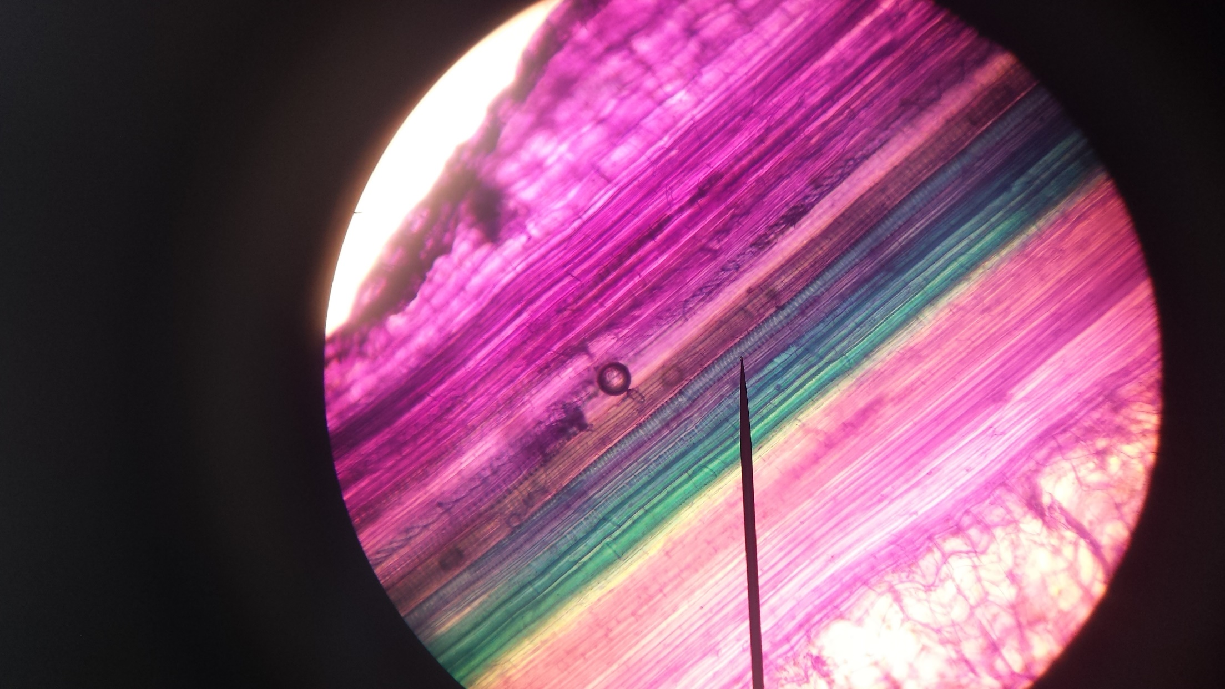
Slide of celery stem longitudinal section (x400) showing xylem (pink/purple) and phloem (green). Image captured using a phone camera. Source: NSW Department of Education
Observe the movement of materials through xylem and phloem using an interactive such as Science & Plants for Schools – Transport of water and sugar in plants. Have students label a diagram of xylem and phloem and explicitly teach the different types of cells present in these vessels. Students compare these transport vessels by completing a table comparing the following:
- Cells: living or dead
- Materials transported
- Direction of movement
- The relative speed of movement
Practical Activity: Observe water movement through a plant by setting up a simple potometer. The instructions can be found at Science & Plants for Schools – Making and using a straw potometer. This includes suggestions for determining the effect of different independent variables. BIO11/12-3, BIO11/12-4 This activity could be used as an introduction to a depth study. Refer to Opportunities for extending concepts.
Explicitly teach the transpiration-cohesion-tension theory using the terms cohesion, adhesion, capillarity (capillary movement). Students will be aware of these forces from observing water rising in a straw and forming a meniscus. Relate back to the engagement activity about the giant redwoods. Students can observe the strength of cohesive and adhesive forces by placing a few drops of water between two clean microscope slides and then pulling the slides apart. Another demonstration involves placing the edge of a paper towel tube at the surface of coloured water and observing the movement of the water up the tube.
Students label a diagram showing the direction of water movement through a plant.
Explicitly teach translocation and the movement of organic compounds through the phloem by the source-to-sink pathway. Students should understand that the source is a leaf or other photosynthetic tissue. The sink is any site in the plant where respiration is taking place and may be in the leaf, stem, flower or roots. Translocation is multi-directional, unlike the movement of water in xylem vessels. Students define the term turgor pressure and explain how a pressure gradient is created by the active transport of sugars into the sieve elements of the phloem with the water following by osmosis. This drives movement along the phloem, both up and down plant. At the sink, sugars are removed from the phloem by active transport. The water moves by osmosis from the xylem into the surrounding plant tissues.

Animal systems and requirements

Nutrient and gas requirements
Assess students’ prior knowledge of the structures that make up the human respiratory system (for example, bronchi, alveoli, trachea, larynx) and label a diagram. Some revision of these structures and their function may be necessary before examining the gas exchange surface in more detail.
Practical Activity: Observe prepared slides of alveoli and have students identify the two types of pneumocytes and red blood cells. If slides are unavailable, good micrographs are available at BioNinja – Lung Tissue and BioNinja – Pneumocytes. Refer to Module 1 cell specialisation and differentiation of cells to suit a particular function. Outline the main features of these cells that increase SA:V and allow for maximum rate of gaseous exchange. BIO11/12-3, BIO11/12-4
Ask students
- What are the requirements for cellular respiration?
- What gases would be exchanged across the alveolar surface?
- How would these gases move across the alveolar surface?
Prompt students to refer back to their understanding of cellular respiration developed in Module 1.
Have students draw and label a diagram of the lungs showing the following:
- Red blood cells
- Capillary
- Direction of oxygen (O₂) movement
- Direction of carbon dioxide (CO₂) movement
- Alveolus
Practical Activity: Mammal lung dissection, fish gill dissection, and/or insect dissection. Spiracles of insects may be observed using a dissecting microscope or a USB microscope. Instructions are available at Dissection of the Ventilation System of a Locust and Dissecting Lungs. If possible, examine first-hand a variety of respiratory systems and have students identify similarities and differences between them. For example, discuss why mammals have internal lungs compared to fish which have external gills. BIO11/12-3, BIO11/12-4
For a class that works independently, form small groups of students to conduct research into the respiratory systems of different animals such as mammals, amphibians, fish, invertebrates (for example, insects). Students find images and diagrams of the different gaseous exchange surfaces found in these systems and produce a table and/or Venn diagram that summarises their similarities and differences. Students who may struggle to research this information independently may be provided with stimulus material such as diagrams and brief summaries to construct a table or Venn diagram. BIO11/12-5
Determine students’ prior knowledge of the structures of the digestive system by providing them with laminated life-size cut-outs of organs in the digestive system. Students attempt to identify and arrange the organs correctly within an outline of a students’ body.
Provide students with a food item and ask them to describe what happens when they eat it, for example, chewing, saliva added. Then ask students to explain why these processes are necessary. Introduce the idea of chemical and physical digestion. Watch TED-Ed – How your digestive system works and Science Learning Hub – Digestion of Food videos, and have students identify the organs responsible for physical and chemical digestion. Revise students' understanding of enzymes and apply their knowledge to the action of enzymes, such as amylase and pepsin, in the digestive system.
Practical Activity: View microscope slides of intestinal villi. Micrographs can also be viewed at BioNinja – Structure of the Small Intestine. Have students draw and label a diagram of the intestinal villi. Students then identify structural features of villi and explain how these features aid in the function of these cells. BIO11/12-4, BIO11/12-5
Practical Activity: Model diffusion across the intestinal villi using dialysis tubing and solutions of glucose and starch. A suitable method is outlined in the Royal Society of Biology – Evaluating Visking tubing as a model for a gut (Visking tubing is also known as dialysis tubing). This can be run as a demonstration as it is similar to practical investigations carried out in Module 1. However, it is helpful to repeat this for students to apply their understanding of diffusion to the absorption of nutrients in the intestines. Extend this investigation to include an evaluation of the effectiveness of this model and a broader discussion as to why models are used in science. BIO11/12-6
Students:
- List what they have for lunch that day.
- Identify the nutrients in the foods, for example, starch, protein.
- Reflect on the practical investigation and ask them why the starch molecules cannot move across the dialysis tubing? Students should identify that only small molecules can diffuse across the membrane and link this to their understanding of enzyme action in breaking down biological macromolecules into the small monomers/subunits that make up carbohydrates, proteins and fats. More information regarding this can be found at Science Learning Hub – Digestion breaking the large into the small.
- Identify what will be absorbed from their food in their digestive system, for example, sugars, amino acids.
- Determine if all of their lunch will be absorbed. If not, what happens to the leftover material?
Explicitly teach the processes undertaken by the digestive system as ingestion, digestion, absorption, assimilation and elimination (Science Learning Hub – The human digestive system). Students label a diagram of the digestive system showing these processes acting on a food item from their lunch, for example, a sandwich. BIO11/12-7

Transport
Practical Activity: Heart dissection, instructions at the Royal Society of Biology – Looking at a heart. Students identify the four chambers of the mammalian heart and describe the direction of blood flow through the heart. Students observe structures such as valves and attached blood vessels, and determine the destination of the blood leaving the heart, based on the thickness of the left and right ventricle walls. BIO11/12-3, BIO11/12-6
As a class, discuss the heart's function and identify the role of the circulatory system as a transport system. Examine the different circulatory systems found in various animals and compare diagrams of open and closed circulatory systems. Students compare the size of animals with an open and closed circulatory system and link to their understanding of SA:V. Have students compare open and closed circulatory systems by constructing a table (BIO11/12-4) using the following headings:
- Type of transport fluid
- Speed of fluid flow
- Pressure in the transport system
- Efficiency of the transport system
- Examples of organisms with this system
Compare the blood vessels (arteries, veins and capillaries) found in closed circulatory systems. Students can conduct their own research or be provided with various diagrams from which they construct a table (BIO11/12-4) using the following headings:
- Function of blood vessel
- Diameter of blood vessel
- Thickness of blood vessel walls
- Tissues found in blood vessel walls
- Presence of additional structures (for example, valves)
- Direction of blood flow (towards or away from the heart)
Practical Activity: Examine prepared blood slides and have students distinguish between red and white blood cells. Revise students’ understanding of scale diagrams (Module 1) by calculating the size of red and white blood cells and drawing appropriate scaled diagrams. Compare the size of blood cells with the diameter of capillaries and discuss the relevance to SA:V and diffusion. BIO11/12-4, BIO11/12-6
Discuss blood donation (Australian Red Cross Lifeblood) with students and ask questions such as:
- Why do we have blood?
- Why is donated blood needed?
- When blood is donated, is whole blood collected or only some parts of the blood?
- What parts of the donated blood are used?
Students summarise the role of each blood component, including plasma (BioNinja – Blood Composition). Refer to Module 1, cell specialisation and differentiation of cells to suit a particular function. Outline the main features of red blood cells that increase SA:V and allow for maximum rate of gaseous exchange.
Provide students with a diagram showing blood flow to major organs of the body. In small groups, ask students to annotate the diagram to show what they believe to be the movement of substances into and out of the bloodstream as it moves around the body. Once students have added their own ideas, provide them with a section from a textbook or internet sources outlining the changes occurring in the blood composition as it circulates around the body. Ask students to review their initial prediction against the information in the textbook or internet sources. They should correct any mistakes they made and include relevant information they extract from the reading.
Using their annotated diagram, students write a short story of the life of a red blood cell as it travels around the body. Ask the students to write this as a children’s story or a story that could be shared with Stage 4 students who are learning about the role of body systems. BIO11/12-7 The story should include:
- interactions with all relevant molecules and substances, for example, oxygen, carbon dioxide, amino acids, fatty acids, glucose and
- the locations where these interactions take place, for example, the lungs, intestines.
- Encourage students to add further detail to their story by describing the structures of these locations and how substances are moving across membrane surfaces.

Autotrophs & Heterotrophs
Have a class discussion about the differences in energy requirements observed between plants and animals. Ask questions such as:
- What do plants and animals need for energy?
- What do plants and animals need energy for?
- Where do plants get their energy from?
- Where do animals get their energy from?
Students should realise that both plants and animals undergo cellular respiration to generate energy as ATP (Adenosine Triphosphate).
Students should define the terms autotroph and heterotroph, and then design and complete tables to compare the
- nutrient and gas requirements of autotrophs and heterotrophs
- structures and functions of transport systems in plants and animals

Opportunities for extending concepts

Unicellular, colonial and multicellular organisms
The evolution of multicellular organisms may be explored to extend and deepen understanding by combining information from Modules 1, 2, 3 and 4. Scientific theories are constantly reviewed and revised based on new evidence provided by technological developments, such as studying DNA. The Theory of Endosymbiosis proposed by Lynn Margulis is an excellent example of how the working scientifically skills are applied to propose and/or revise theories. See Appendix 1.

Levels of organisation in multicellular organisms
Stem cells and their use in regenerative medicine can be explored to extend students understanding of cell differentiation and specialisation. Teaching resources can be found in the links in TED-Ed – What are stem cells? These resources could be used in class to extend students’ understanding or as stimulus material for students to develop their own inquiry question (BIO11/12-1) for a depth study based on secondary research. This area of biology research may be of particular interest to students who are interested in medical science. The resources could also be used to develop a debating activity based on ethics in scientific research. BIO11/12-7

Plant systems and requirements
When discussing processes, claims and conclusions that have led scientists to develop hypotheses, theories and models about the structure and function of plants, students can be further extended to look at experiments using aphid stylets to measure the composition of phloem solution and rate of translocation in a plant. An easy to understand summary of this process can be found at BioNinja – Translocation Rate. This provides an example of how new technologies, such as radioisotopes, can increase understanding of biological processes such as changes to the composition of transport medium in plants. This resource could be used as the basis for an activity where students are encouraged to develop their own testable inquiry questions or hypotheses about factors that affect the translocation rate. BIO11/12-1
In addition to water, plants require essential minerals such as nitrates, magnesium, phosphorous, potassium, and calcium from the soil. Students could undertake a depth study to investigate the effect of different concentrations of one of these minerals on plant growth. These minerals are essential for the correct functioning of enzymes in the plant. Students could apply their knowledge of enzymes from Module 1 to explain why these minerals are essential for optimal plant growth and justify their importance for plant growth.
Structural adaptations in plants could be investigated as part of a depth study. Students can investigate various leaves, for example, and record the number and position of stomata, how the leaf is oriented on the plant, the presence of leaf hairs and waxy cuticle. BIO11/12-3 Students could collect data on various native species and then describe their roles, or their evolutionary significance. Students could then form hypotheses about the structures they think they would find on plants from more tropical or arid locations (BIO11/12-1) and test this hypothesis by completing secondary source research. BIO11/12-3
Students could undertake a depth study to investigate the factors that affect transpiration rate. A suitable method for measuring transpiration rate can be found in Appendix 2.

Animal systems and requirements
A resource such as The Science Show – Nine stories about our nine pints of blood could be used as a stimulus material for students to generate inquiry questions for a depth study on blood. BIO11/12-1 This could incorporate resources from the Australian Red Cross Lifeblood. Students can investigate the use of blood products from blood donations and the type of donations collected by the Australian Red Cross. If possible, the activity could be linked to a visit to a blood donation facility or an interview with either someone who works in a blood donation facility or a blood donor/recipient.
Students can investigate different structural adaptations in the digestive system of a range of species and justify the function of these adaptations. Students could propose their own inquiry question to investigate based on provided stimulus material such as Cosmos - Why do wombats do cube-shaped poo? BIO11/12-1
As an extension activity, students could work in small groups to conduct a jigsaw activity to study the digestive systems of herbivores, ruminants, carnivores and omnivores. Students describe the structural adaptations observed and justify the function of these based on the organism's diet and the movement of required nutrients/water into the body.
The BioInteractive, Blood Glucose Data Analysis, can extend students’ understanding of chemical digestion and their data analysis skills. Students infer whether someone is likely to be lactase persistent or non-persistent based on the data from two different test - the blood glucose test and the hydrogen breath test. The lesson involves watching a video (duration 15 minutes) about the evolution of lactose tolerance and then graphing and analysing actual research data. BIO11/12-4, BIO11/12-5

Appendices

Appendix 1: Using the working scientifically skills to propose and revise theories.
The TED-Ed lesson – How we think complex cells evolved could be used as stimulus material, and then appropriate sites such as Ask A Biologist – Cells Living in Cells, BioNinja – Endosymbiosis, Understanding Evolution – Endosymbiosis and PNAS – Lynn Margulis, 1938-2011 could be used by students to gather information about the Endosymbiotic theory and the evidence gathered. Students could then use the working scientifically flowchart in the syllabus to match the steps/stages of developing the theory with the skills for working scientifically.
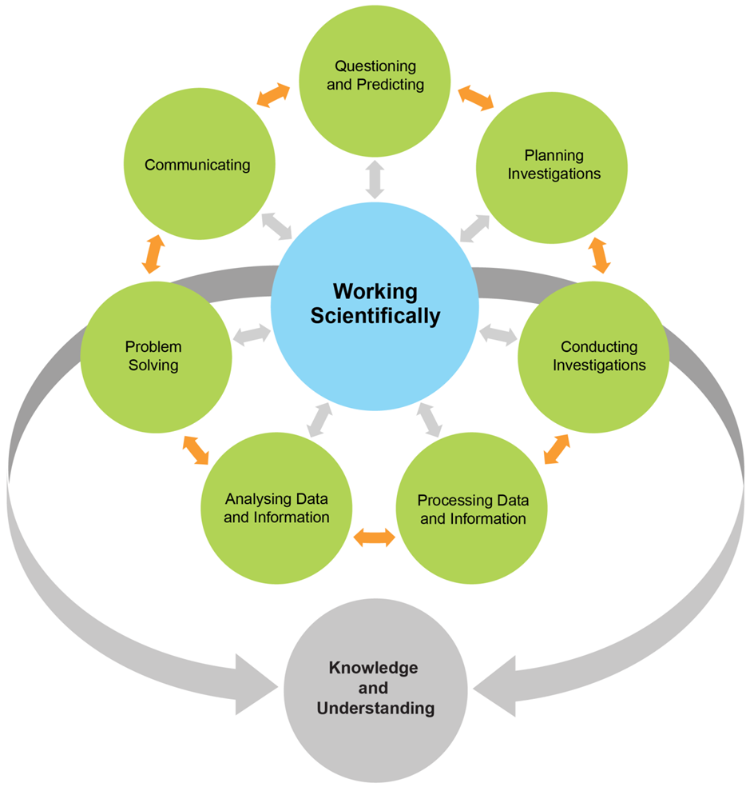
NESA Biology Stage 6 Syllabus

For example, Questioning and Predicting would be the question proposed by Lynn Margulis of ‘How did complex cells evolve?’ Her hypothesis would be that chloroplasts originated as free-living cyanobacterium engulfed by a protozoan. Planning would involve identifying the relevant technologies to use, such as genetic testing genes in chloroplasts. In this way, students can be challenged to see the scientific process as a whole rather than just focusing on one or two sections of the process.

Appendix 2: Measuring transpiration rate
A suitable method for measuring transpiration rate can be found at the Royal Society of Biology – Estimating the rate of transpiration from a plant cutting. This technique does not require a potometer and can be used for cuttings of plants, such as flat-leaf parsley, that are easily accessible. Students can investigate various factors, although an easy investigation is to determine the effect of stomata distribution. This can be carried out by covering the leaf surface with Vaseline and comparing leaf cuttings with no Vaseline applied, the underside covered, upper side covered, and both sides covered. Students can then make predictions about the distribution of stomata on the leaf; for example, most stomata are on the upper side of the leaf or equally distributed on both sides of the leaf. These predictions can then be tested in a second investigation using stomatal leaf peels and recording the number of stomata. Depending on the students, these investigations could be highly scaffolded or less scaffolded and/or may incorporate small group work or individual practical skills. BIO11/12-3, BIO11/12-4, BIO11/12-5

Resources
When preparing this module guide, Adobe Flash Player became disabled. Many highly valuable interactives and simulations used this platform. The authors of the module guide will update this document when the providers of the interactives rebuild their resources using HTML5.
For the present, the following websites provide a range of practical investigations, simulations, interactives and videos in an accessible format.
- HHMI BioInteractive: A USA site that has a range of lesson activities that focus on working scientifically. Teacher notes and student worksheets are provided.
- Science learning hub: The University of Waikato is gradually changing its interactive resources from Flash to HTML5. Check regularly to see what is available.
- Science and Plants for Schools: has a range of simulations, videos and practical investigations arranged according to the UK level system.
- Royal Society of Biology, encompassing the Nuffield Foundation. Another UK site that has several detailed practical investigations.
BioNinja is a website designed for the IB. It has some excellent diagrams and micrographs relevant the Biology stage 6 syllabus.

