HSC Biology

Module 3: Biological Diversity

Module 4: Ecosystem Dynamics

Biology Stage 6 Syllabus © (2017) NSW Education Standards Authority (NESA) for and on behalf of the Crown in right of the State of New South Wales.

Table of contents
HSC Biology 1
Module 3: Biological Diversity 1
Module 4: Ecosystem Dynamics 1
Table of contents 2
Teaching the Year 11 modules 5
Course overview 7
Module summary 7
Big Ideas 8
Relationship to other modules 8
Core concepts 9
Misconceptions 9
An individual organism can adapt to its environment 9
All traits of an organism are adaptations 11
New species are formed in one or two generations 11
Predation and competition have only negative consequences 12
Evolution is ‘just a theory’ 12
Conceptual difficulties 13
Geological time 13
Relative vs absolute dating 13
Using models to make predictions and manage future ecosystems 14
Suggested teaching strategies 14
Inquiry question 3-1: How do environmental pressures promote a change in species diversity and abundance? 15
Inquiry question 4-1: What effect can one species have on other species in a community? 15
Effects of biotic and abiotic selection pressures on organisms 15
Predicting consequences for populations 17
Measuring populations 17
Selection pressures change populations over time 18
Inquiry question 3-2: How do adaptations increase the organism’s ability to survive? 19
Charles Darwin and the theory of evolution by natural selection 20
Inquiry question 3-3: What is the relationship between evolution and biodiversity? 20
Evolution by natural selection explains the diversification of life 21
Microevolution drives evolutionary change and speciation 21
Convergent vs divergent evolution 23
Gradualism vs punctuated equilibrium 23
Inquiry question 3-4: What is the evidence that supports the theory of evolution by natural selection? 24
Modern-day examples of evolutionary change 27
Inquiry question 4-2: How do selection pressures within an ecosystem influence evolutionary change? 27
Technologies to determine evidence for past changes in ecosystems 30
Changes in Australian ecosystems and the evolution of organisms in Australia 31
Inquiry question 4-3: How can human activity impact on an ecosystem? 33
Investigating the past to inform future ecosystem management 33
Restoring damaged ecosystems 35
Opportunities for extending concepts 35
Appendices 37
Appendix 1: Glossary of key terms 37
Appendix 2: Hot potato – abiotic factors affecting organisms 42
Appendix 3: Predicting consequences for populations 43
Appendix 4: Measuring abundance – quadrat sampling 44
Appendix 5: Measuring abundance: capture, mark, recapture with crickets 47
Appendix 6: Measuring the distribution of a plant species 50
Appendix 7: Adaptations 52
Appendix 8: Darwin in Australia 54
Appendix 9: Modelling geological time 57
Appendix 10: Evolution of the horse 59
Appendix 11: Evolution of the platypus 60
Appendix 12: Gradualism vs Punctuated Equilibrium 61
Appendix 13: Biogeographical evidence for evolution 62
Appendix 14: Antibiotic resistant strains of bacteria 66
Appendix 15: Tusklessness in elephants 68
Appendix 16: Dating rocks and fossils 70
Appendix 17: Changes in Australia’s ecosystems 71
Appendix 18: Role of human-induced selection pressures on the extinction of species. 72
Appendix 19: What trends are evident in the world’s climate? 73
Appendix 20: What are the effects of climate change? 77
Appendix 21: Mine rehabilitation 84
Other resources 85
Prickly pear 85
Evolution 85
Past ecosystems 85
Future ecosystems 86
References 87

Teaching the Year 11 modules
The Biology Stage 6 Syllabus is a sequential development of concepts that leads the student to a deep understanding of life processes from the molecular level to the ecosystem level. This understanding, together with science inquiry skills, will allow students to apply knowledge from across the modules to:
Take an informed part in science-based decisions and take appropriate actions that affect their own wellbeing and the wellbeing of the society and the environment. (Harlen, 2010)
Biology can often be best understood through the lens of evolution. Students should develop a deep understanding of the concept that all species are descended from a common ancestor, and patterns in the structure and function of organisms can therefore be observed in the living world. This will be essential for students to appreciate heredity and genetic processes, manipulation of genetic material, the concept of biodiversity, and the understanding of diseases covered in the Year 12 course.
In biology, as in all science disciplines, new evidence can result in a refinement or rejection of contemporary ideas. This is illustrated in the development of disciplinary ideas in evolutionary biology and climate change areas. In addition, new evidence often arises from the development and use of new technologies. Therefore, students need a sound understanding of the role of new technologies in improving scientific understanding, including the understanding of concepts in the Year 11 course.
Societal, cultural, and economic factors have significantly impacted the development of scientific knowledge. Therefore, students should be provided with opportunities to engage in work that allows them to acknowledge those influences.
Students should develop a deep understanding of humans’ impacts on ecosystems and appreciate the importance of sustainability in its various forms. This includes understanding the roles of Aboriginal and Torres Strait Islander Peoples in caring for Country and Place.
During the Year 11 course, it is expected that students should develop all 7 of the Working Scientifically skills. Ideally, these would be embedded with the teaching of the Knowledge and Understanding components of the course, allowing students to develop a sound knowledge of the structure and function of living things from the sub-cellular level to the ecosystem level.
In preparation for the Year 12 course, students in Year 11 will benefit from work that engages them in the following areas:
Propose questions and hypotheses and design and conduct valid and reliable practical investigations that enable data collection and analysis. There are many opportunities to conduct practical investigations beyond those explicitly indicated in the syllabus.
Collect and analyse data from primary and secondary sources, including tables and graphs, and determine the data’s accuracy, reliability, and validity. Many of the investigations will require students to obtain information from the Internet or other sources. Students will benefit from learning how to access and acknowledge valid and reliable sources of information
Assess the uses, benefits and limitations of various types of scientific models and develop an understanding of scale. For example, many biological processes occur on a cellular or molecular level (such as movement across a cell membrane) or happen over a long period (such as natural selection). Models help us to understand these processes better.
Construct labelled diagrams, flowcharts and other methods of communicating information. This skill is important for students to explain complex biological processes.
This module guide indicates which Working Scientifically outcomes are developed in each learning activity, indicated as BIO11/12-5 in the text. By embedding the Working Scientifically skills, students develop and apply a sound understanding of the role scientific inquiry plays in proposing explanations for biological processes.
While preparing this module guide, Adobe Flash Player became disabled. Many biology interactives and simulations were built on this platform. The science curriculum team will update this document with information on the rebuilt interactives and simulations (using HTML5).
Throughout the syllabus, content descriptors will have the statement ‘including but not limited to’. This specifically provides the opportunity to differentiate student activities and extend students’ understanding.

Course overview
The Year 11 course underpins and is assumed knowledge for the Year 12 course. Students are expected to access and apply the concepts developed in Year 11 to their learning in Year 12. Students are also expected to draw from knowledge and understanding across modules and apply it to new and unfamiliar situations using their Working Scientifically skills. The individual syllabus modules are not standalone, but interrelated and interdependent.
The major themes or big ideas that weave throughout the Year 11 modules are:
- Being alive – biology is the study of life. Living things have organised structures and coordinated functions to facilitate life.
- Interactions occur within and between organisms to supply energy and materials necessary for life.
- Living things are dynamic and diverse. Life has not always been, and will not always be, the same.
- Tools and technologies are used to make observations about living things. They help us better understand life in the present and the past and enhance life in the future.

Module summary
In Modules 3 and 4, students build on their understanding that cells and body systems are specialised to perform specific functions to keep an organism alive. Students investigate adaptations, broader structures, processes, and behaviours that assist organisms to survive in their specific habitats.
Students continue their study by investigating the dynamic selection pressures that exist within ecosystems and how these result in evolution through natural selection. They supplement this investigation by exploring technologies used to develop the understanding of evolution and extend it to studying past ecosystems. Finally, students coalesce their knowledge in determining how understanding past and present ecosystems allows for predictions and better management of future ecosystems.

Big Ideas
The big ideas that weave though the Year 11 course apply to these modules in the following ways:
- Being alive. Living things are organised on a cellular basis. Organisms will survive and flourish if their structures and functions are suited to their environment. Variations that originate at the subcellular level result in variations at the cellular, organ, and system level. Some of these variations are more favourable to life under specific conditions and form the raw material of natural selection. This contributes to the survival of species.
- Interactions occur within and between organisms. Relationships within and between species have positive, negative, and neutral influences on the survival of the interacting individuals and populations.
- Living things are dynamic and diverse. The naturally occurring variations in organisms have allowed diversification of life as environments have changed over time. Organisms display a range of adaptations that increase their ability to survive in their environment. Populations that do not have beneficial variations may become extinct. This diversification and change in life is called evolution.
- Tools and technologies are used to make observations about living things. A range of technologies provide evidence that support the theory of evolution by natural selection. Scientific models can predict changes in, conserve, and restore ecosystems.

Relationship to other modules
Students build on their understanding from Modules 1 and 2 that cells and body systems are specialised to perform specific functions to keep an organism alive. They investigate adaptations, broader structures, processes, and behaviours that assist an organism to survive in its specific habitat in Module 3. Students link this to ecological dynamism and the evolution of life in Module 4.
An understanding of selection pressures, adaptations, natural selection, and evolution is important when investigating several concepts in the Year 12 course, including:
- mechanisms contributing to genetic variation and biodiversity (Modules 5 and 6)
- allele frequencies and the role of gene flow (Modules 5 and 6)
- population genetics relating to human evolution (Module 5)
- the difference between natural selection and genetic drift (Module 6)
- investigating plant and animal diseases (Module 7)
- adaptations of pathogens (Module 7)
- resistance of bacteria to antibiotics (Module 7)
- adaptations that aid in thermoregulation in animals and mechanisms in plants to maintain water balance (Module 8).
Introducing students to the process of DNA sequencing provides a foundational knowledge of this technology, which is studied in more detail in Module 5.

Core concepts
- Populations in ecosystems are impacted by a range of biotic and abiotic selection pressures.
- Organisms display a range of adaptations that increase their ability to survive in their environment.
- Natural selection is a mechanism by which evolution can occur.
- A range of evidence supports the theory of Natural selection. In addition, various modern technologies enable scientists to analyse the evidence of past and changing ecosystems.
- Humans have impacted biodiversity directly and indirectly and can utilise science to manage damaged ecosystems sustainably.

Misconceptions

An individual organism can adapt to its environment
Students may use the term ‘adapt’ in its colloquial sense in biology. This is because they think that individual organisms can change their characteristics and behaviours in response to changes in their environment and that their offspring will inherit these. They may say an organism has adapted and the changes are called adaptations.
Students may not realise that there are multiple versions of characteristics in every population. Some variations are advantageous for survival and reproduction as the environment changes, and other versions are not competitive or disadvantageous for survival and reproduction. The favourable variations are called adaptations.
To address the misconception that variation doesn’t already exist in populations, conduct a survey of the class looking at easily visible characteristics, such as eye colour, free and fused ear lobes, and ability to roll the tongue. Create a tally for each variation and discuss how many variations exist despite all students in the class belonging to the same species BIO11/12-3.
While eye colour, ear lobe attachment, or tongue rolling will not affect survival or reproduction, the following example demonstrates how selection for survival characteristics can increase the proportion of the adapted individuals in the population. In the Peppered Moth Game (Arizona State University 2021), equal numbers of dark and light peppered moth are released into either a dark or light forest. Students apply a selective force, such as a predatory bird, to the population. The unfavourably coloured moths are more likely to be preyed on by the bird. The prevalence of the moths of a particular colour changes due only to the camouflaged survivors reproducing and passing on their traits for colour. This is called natural selection. The interactive also shows that an inherited characteristic that is favourable in one environment, and therefore an adaptation, may not be favourable in other environments BIO 11/12-6.
Another specific example of this misconception is around antibiotic resistance. Students may think that individual bacteria can change to acquire the trait of resistance when they encounter a new antibiotic. Just as in other populations, there is variation in bacteria populations. Within a population of bacteria, some bacterial cells will be resistant to an antibiotic, while others will be susceptible. This resistance can be passed on through reproduction or gene transfer, but even through gene transfer, the bacteria is not choosing to change itself in response to the antibiotic. To address this misconception, students play a game of Bacterial Survivor (Govindan 2018) (see Appendix 14) BIO 11/12-5, BIO 11/12-6. A student worksheet and pre- and post-activity diagnostic questions are included in the activity. This activity is an interactive and engaging way of showing students that:
- only the surviving bacteria reproduce and pass on their genotype to the next generation
- mutations and horizontal gene transfers are random
- antibiotics do not cause mutations in individual bacteria.
Student may also believe that natural selection is purposeful and deliberately improves a species’ biological traits. However, natural selection has no foresight and is not aiming at any outcome. Instead, it is a term identifying a process by which certain members of a population are more suited to environmental conditions than others and therefore more successfully survive and reproduce.

All traits of an organism are adaptations
Because organisms possess many favourable adaptations, students may assume that all the features of an organism are adaptations and that all features are for a particular purpose. However, many traits are not adaptations. For example, having a particular hair colour is of no survival value.
Some traits are by-products of other characteristics. For example, blood containing haemoglobin, which is able to carry oxygen, is an adaptation to living in an oxic environment and is certainly of survival value. Blood is red because haemoglobin reflects red light, but this is not related to its capacity to carry oxygen. Blood being red is of no survival value, so we cannot say that blood being red is an adaptation.

New species are formed in one or two generations
Students may believe that natural selection results in significant, clearly defined changes to an organism over one or two generations, instead of resulting from a series of much smaller changes across a much longer time period.
To address this, students use the information from Evolution of the Horse (Britannica 2021) to construct a timeline to show how the size, tooth structure, and leg and forefoot structure demonstrate changes caused by various selection pressures acting on different species over geological time BIO11/12-4 (Appendix 10). Teachers should focus on how the horse did not evolve straight from Hyracotherium to the very different Equus in one step, but rather that this evolution happened over a long period of time through a long series of small changes.

Predation and competition have only negative consequences
Students assume that because predation and disease result in the loss of life, they are negative interactions. As a result, students are focusing on the individual interaction rather than considering broader consequences for whole populations and ecosystems.
To address this misconception:
- View Wolves of Yellowstone (5:19) (National Geographic Society 2015) (to 2:36). Have students draw a bubble map (Mindmanager 2022) showing the negative effects of the removal of wolves from Yellowstone National Park. Resume watching the video (2:36 to 4:19) with students drawing a second bubble map showing the effects of the reintroduction of wolves into the park. An extensive set of resources related to this is available at Wolves of Yellowstone lesson plan (The Nature Conservancy 2015) BIO11/12-4, BIO11/12-5, BIO11/12-6, BIO11/12-7.
- Alternatively, have groups of students research and prepare a short presentation about the role of the following predators in their ecosystems: wolves, mountain lions, coyotes, river otters, sea otters, badgers, cheetahs BIO11/12-3, BIO11/12-4, BIO11/12-7.
These activities could be combined to form a small depth study, as described in suggested teaching strategies, IQ 3-1, IQ 4-1, discussing effects of biotic factors on organisms.

Evolution is ‘just a theory’
This misconception arises from using the term ‘theory’ in everyday conversation to mean an idea, speculation, or hunch on which there is some level of uncertainty. A scientific theory is:
A well-substantiated explanation of some aspect of the natural world that can incorporate facts, laws, inferences, and tested hypotheses … In science, theories do not turn into facts through the accumulation of evidence. Rather, theories are the end points of science. They are understandings that develop from extensive observation, experimentation, and creative reflection. They incorporate a large body of scientific facts, laws, tested hypotheses, and logical inferences. In this sense, evolution is one of the strongest and most useful scientific theories we have. (Science and Creationism, National Academy of Sciences 1999)
Having students explore and justify how different lines of evidence supports the theory of evolution in IQ 3-4 will allow them to reflect on the nature of a scientific theory.

Conceptual difficulties

Geological time
Most students comprehend timespans of greater than a century or two and are confident when discussing the times of ancient Greek or Roman civilisations. However, students have difficulty visualising and working with the much larger numbers associated with evolutionary timescales.
Whilst most Stage 6 students will understand that humans did not evolve until late in the Earth’s history, they have difficulty in comprehending just how recent this evolution is. They may confuse the term ‘recent’ in biology with the colloquial use of the word, thinking only of their own family history, or history defined by modern record-keeping.
Although detailed knowledge of the geological timescale is not required in this syllabus, modelling it will allow students to deepen their understanding of the scale of geological time related to extinctions and the evidence for evolution. Activities that model the geological timescale are described in Appendix 9 BIO 11/12-3. The History of the Earth (11:35) (Algol 2020) video models geological time, aligning it to a 24-hour clock.

Relative vs absolute dating
Students may confuse the different processes used for dating rocks and fossils. While students can investigate many different dating methods, it is useful to distinguish relative and absolute dating, identifying the process and outcomes of each type of dating. The activities in the suggested teaching strategies and Appendix 16 can help to address this conceptual difficulty.

Using models to make predictions and manage future ecosystems
Students can find it difficult to visualise populations and population changes over time. Students require practice in modelling populations as they change with new selection pressures and using these models to make predictions. To address this, students use the simulation African Lions: Modelling Populations (Concord Consortium 2015) outlined in IQ4-3.

Suggested teaching strategies
Modules 3 and 4 have been considered in the one module guide because the inquiry questions are closely interrelated. The writers have suggested the teaching sequence below to develop understanding.
As in Modules 1 and 2, many new biological terms are introduced in these modules and students need to use the terms correctly. If commencing the Year 11 biology course with Modules 3 and 4 students should be explicitly taught how to develop their own glossary that can be expanded as required.
- Explore with students the different methods of generating glossaries. For example using physical flash cards or utilising one of the many digital flash card apps available, such as Brainscape (Bold Learning Solutions 2022), Cram (Cram 2022), or CheggPrep (Chegg Inc 2022). Alternatively, a table is included in Appendix 2.
- Model for students how to define terms using their own words.
- Encourage students to use analogies and metaphors when appropriate and include diagrams/images BIO11/12-7.
- Include pictures and diagrams in the glossary. This is especially helpful for EALD students, allowing them to visualise and relate to the terminology.
- The Department has resources to support writing in Stage 6 Science (DoE 2022).

Inquiry question 3-1: How do environmental pressures promote a change in species diversity and abundance?

Inquiry question 4-1: What effect can one species have on other species in a community?
One fieldwork exercise must be completed in Year 11 biology. These two inquiry questions are ideally investigated in the fieldwork exercise. A list of Environmental Education Centres (DoE 2021) in NSW is provided on the DoE website. Several centres offer virtual field studies if schools cannot attend an environmental centre. To enable students to gain the most from the fieldwork, some skills and knowledge should be developed at school before undertaking the fieldwork.
The explanation of a recent extinction event may be addressed later in IQ 4-3 when investigating changes in past ecosystems.

Effects of biotic and abiotic selection pressures on organisms
Determine prior knowledge with students collaborating to construct a mind map of ecosystems. This can be done:
- in groups or as a class
- as a hard copy or online using GitMind (GitMind 2022) or Miro (Miro 2022).
Watch Introduction to Ecology (4:47) (SchoolTube 2020) and define key terms (ecology, interdependence, biosphere, ecosystem, community, population, organism, habitat, biotic, abiotic, niche) in the glossary (Appendix 1).

Abiotic factors
Students should be familiar with a range of abiotic factors from their study of Ecology in Stages 4 and 5. Review these and extend student thinking about the effect of abiotic factors on organisms by undertaking the Hot Potato activity in Appendix 2.
An example of the impact of environmental pressures on species diversity and abundance can be viewed at Remembering Tasmania's Underwater Forests (Kean 2021). Students design a flow chart showing the changes in the environment and the consequential changes in species diversity and abundance BIO11/12-7.

Biotic factors
To introduce the variety of relationships between organisms, have students read On the savannah, mixed company is good: Interspecies mingling brings strategic survival benefits. (Parletta 2019). Students then identify all the relationships described in the article. Following the discussion of definitions in the following activity, students determine the type of each identified relationship on the savannah.
Use the activities at National Geographic – Ecological Relationships (Cowan and Hunter 2022) to investigate biotic relationships. Follow the instructions to define key terms (prey, predator, competition, symbiosis, mutualism, commensalism, parasitism, disease), view the videos, complete the questions, and undertake discussion. Complete the PDF worksheet as a formative assessment quiz.
Another article, Symbiosis: when living together is win-win, (McElroy 2021) provides a range of examples of symbiotic relationships. Students could compile a table identifying the species, the relationship, and the benefit to each species.
Depth Study: the following two activities could be combined to form a depth study with students working collaboratively for the first part (Wolves of Yellowstone) to develop their skills. The second part would be completed individually with each student questioning and predicting the role of their chosen predator in its ecosystem and then carrying out an investigation BIO11/12-1, BIO11/12-3, BIO11/12-4, BIO11/12-7.
To investigate the role and value of predators in ecosystems:
- view Wolves of Yellowstone (5:19) (National Geographic Society 2015) (to 2:36). Have students draw a bubble map (Mindmanager 2022) showing the negative effects of removal of wolves from Yellowstone National Park. Resume watching the video (2:36 to 4:19) with students drawing a second bubble map showing the effects of the reintroduction of wolves into the park. An extensive set of resources related to this is available at Wolves of Yellowstone (5:19) (The Nature Conservancy 2015) BIO11/12-4, BIO11/12-5, BIO11/12-6, BIO11/12-7.
- alternatively, have groups of students research and prepare a short presentation about the role of the following predators in their ecosystems: wolves, mountain lions, coyotes, river otters, sea otters, badgers, cheetahs BIO11/12-3, BIO11/12-4, BIO11/12-7.
These activities are also recommended to address the misconception that predation and competition have only negative consequences.

Predicting consequences for populations
Students often find it challenging to analyse graphs and determine the relationship between variables to draw conclusions and make predictions. To address this:
- graphs for predation and competition are abundant in published resources such as biology textbooks and workbooks. Print graphs in the centre of A3 paper and have students in pairs annotate the key features, describe the trends, and infer reasons for the changes in population BIO11/12-5, BIO11/12-6.
- the HHMI BioInteractive, Predator-prey relationship dynamics (HHMI BioInteractive 2020), is a more challenging activity showing a non-linear regression and a logarithmic scale for the prey population BIO11/12-5, BIO11/12-6.
- use the population simulation Deer Mice (Connected Biology n.d.) to predict and observe changes to the deer mouse population depending on changes to the habitat BIO11/12-5, BIO11/12-6. For details see Appendix 3.

Measuring populations
Students often confuse the terms ‘abundance’ and ‘distribution’. A useful analogy is the school playground. Abundance is the number of students in the playground at lunch. Distribution is how the students are spread out across the playground. At the beginning of lunch, the distribution of students is clustered around the canteen and seated areas. As lunch progresses, the distribution changes when some students move to the oval and/or active areas.
The following activities should be undertaken before the field study to enable students to be confident with the skills and terminology.
A clear description of the use of quadrats and transects in measuring populations is available at BioNinja: Species distribution (Cornell 2016).
A procedure for using quadrats and random sampling to estimate the abundance of a plant species in a school lawn is provided in Appendix 4. This can be adapted to your own school environment BIO11/12-3, BIO11/12-4, BIO11/12-5.
An activity that uses live crickets in a capture, mark, re-capture activity is provided in Appendix 5 BIO11/12-3, BIO11/12-4, BIO11/12-5. Crickets are available at pet shops and online pet food suppliers.
Alternatively, there are numerous activities in texts and online that use coloured beads or counters to model this technique for measuring the abundance of animal populations.
Transects are used to measure the distribution of organisms and can lead to inferences about the influence of abiotic and biotic factors in the environment. Direct counts of large organisms such as trees, or use quadrats to count the number of smaller organisms at intervals along the transect. See Appendix 6.
Use The Great Elephant Census (HHMI BioInteractive 2017), to extend students’ understanding of how abundance is determined in a real-life study. A video and worksheet that includes calculations and analysis of data are included BIO11/12-4, BIO11/12-5, BIO11/12-6.
A field study can be undertaken at one of the many Environmental Education Centres (DoE 2021). They are NSW Public Schools, staffed by trained teachers.

Selection pressures change populations over time

Cane toad
Students conduct research to construct a case study of the introduction and spread of the cane toad across Australia using information widely available in textbooks and the internet. The case study should include:
- a map showing the distribution of the cane toads across Australia
- data on the rate of spread of the cane toads
- an annotated diagram of the cane toad explaining its adaptations concerning their ability to survive the abiotic factors of their environment and their predators
- a comparison of the key characteristics of cane toads in early locations and cane toads on the invasion front, focusing on traits like increased leg length that are directly related to the increasing spread of cane toads.
Students can use this information to make predictions about the future abundance and distribution of cane toads. Students can also investigate how the cane toad has been a selection pressure on the red-bellied black snake population, changing the prevalence of head sizes BIO11/12-3.

Prickly pear
Orient the students by viewing the video Conquest of the prickly pear (13:58) (NFSA 2020) from the National Film and Sound Archives. Students use information widely available in textbooks and online to construct a case study of prickly pear in Australia. Further resources are included in the other resources section. Students should:
- include an annotated diagram of the prickly pear plant explaining its adaptations
- investigate how a lack of selection pressures in Australia allowed for the proliferation of prickly pear
- explain the effects of the prickly pear on native ecosystems
- explain how biological measures controlled the spread of prickly pear.

Inquiry question 3-2: How do adaptations increase the organism’s ability to survive?
Introduce the concept of adaptations by carrying out the Battle of the beaks (Linnean Learning 2019) activity. Models of various beaks are made using everyday items to collect various types of modelled food sources. Students discuss how each ‘beak’ is suited to particular foods. Students compare the model beaks with a various bird species provided in the activity. The link provides lesson instructions, a student worksheet, and opportunities for extension. The model beaks and foods can be altered depending on the materials available. Identify the different types of beaks as variations in structure BIO11/12-1, BIO11/12-3, BIO11/12-4, BIO11/12-5, BIO11/12-7.
Draw on students’ prior knowledge to define ‘adaptations’ in the glossary (Appendix 1) as traits of an organism that increase its chance of surviving in its environment. For a characteristic to be an adaptation, it must be heritable, functional, and increase fitness. Emphasise the importance of explaining how an adaptation helps an organism survive, not just describing the characteristic as an adaptation.
Investigate a range of structural, physiological, and behavioural adaptations by reading the articles, viewing the videos, and answering the questions listed in Appendix 7.

Charles Darwin and the theory of evolution by natural selection

Galapagos finches
Introduce Darwin’s observations in the Galapagos Islands by viewing National Geographic’s video Darwin in the Galapagos (3:38) (Nat Geo Wild 2010).
Undertake the activity Natural Selection and the evolution of Darwin’s finches (HHMI Biointeractive 2020). In this activity, students develop arguments for the adaptation and natural selection of Darwin’s finches, based on evidence presented in the film, The Origin of Species: The Beak of the Finch (16:09) (HHMI BioInteractive 2019). Students watch segments of the film and then engage in discussion, make predictions, create models, interpret graphs, and use multiple sources and types of evidence to develop arguments for the evolution of Darwin’s finches. Educator materials, resources, and student worksheet are provided BIO11/12-1, BIO11/12-4, BIO11/12-5, BIO11/12-6, BIO11/12-7.

Australian flora and fauna
Students will usually be aware that Charles Darwin visited the Galapagos Islands but often are unaware that he visited Australia as part of the Beagle’s voyage. It is suggested that Darwin’s diary and the commentaries on his diary are used to immerse the students in his journey. These are provided, along with some activities, in Appendix 8 BIO11/-3, BIO11/12-4, BIO11/12-7.

Inquiry question 3-3: What is the relationship between evolution and biodiversity?
As described in the Conceptual Difficulties section, students struggle with the concept of geological time. They may confuse the term ‘recent’ in biology with the colloquial use of the word. The terms modern, ancient, and prehistoric are often used colloquially with no clear guide as to the time frame. Ask students for their colloquial definition of ‘recent’ and provide examples of recent events in their lives. What do they consider ‘modern’, ‘ancient’, and ‘prehistoric’?
Although detailed knowledge of the geological timescale is not required in this syllabus, modelling it will allow students to improve their understanding of the scale of geological time related to extinctions and the evidence for evolution. Through targeted questioning, ascertain the students’ understanding of the age of the Earth, and then undertake the activities that model the geological timescale provided in Appendix 9 BIO 11/12-3.
To view a different model of geological time, view the History of the Earth (11:35) video (Algol 2020). This model scales geological time to a 24-hour clock. Students indicate when significant developments in the diversification of life on this model BIO 11/12-3.

Evolution by natural selection explains the diversification of life
Support students to review and define key terms in their glossary, such as biodiversity, aerobic, and anaerobic (Appendix 1).
Students explore the evolution of life from the simplest organisms to the most complex in the Wellcome Trust: Tree of life (Wellcome Trust 2019) activity. This links the evolution of life to selection pressures such as oxygen availability, and how selection pressures have changed over time. The activity visually shows students that the evolution of life is not linear. Use the Interactive Tree of Life to complete the Activity Sheet (16-19), which can be opened and printed using the link at the bottom of the Tree of Life webpage. Teacher Notes that provide guidance for the activity (instructions discussion topics, sample answers) can be opened and printed using the link at the bottom of the Tree of Life webpage BIO 11/12-3, BIO 11/12-6.

Microevolution drives evolutionary change and speciation
Microevolution and macroevolution are new concepts in the Biology syllabus and there is a diversity of definitions in textbooks and online resources.
Microevolution happens on a small scale, within a population, and over a short time frame. It arises from mutations in gene pool, the migration of individuals into the population, random changes in the frequency of genes in the population, and natural selection.
The changing colour of the population of peppered moths in the industrial midlands of England is an example of microevolution. Other examples include bacteria evolving resistance to antibiotics, and mosquitoes evolving resistance to DDT. The effects of microevolutionary changes can accumulate over time and sometimes result in the development of a new species. We call this speciation, and it leads to macroevolution.
Macroevolution as described in the pattern on the tree of life (in the previous activity), occurs across many species and over an extended period of time. It explains evolutionary patterns above the species level, for example, the evolution of mammals.
View the video, The Origin of Species: Lizards in an Evolutionary Tree (18:00) (HHMI BioInteractive 2020) (to 13:16). Students identify the selection pressures and the resulting structural adaptations of the lizards. The experiment carried out is an example of microevolution. Speciation and macroevolution in the lizards are explained.
Define the terms microevolution, macroevolution, and speciation in glossary (Appendix 1).

Evolution of the horse
The evolution of the horse is a well-documented example of macroevolution. Focus on how the horse did not evolve straight from Hyracotherium to Equus in one step, but rather that this evolution happened over a long period of time and with a series of many small changes.
Students complete the activity Compare Horse Hoof and Tooth Fossils [PDF 240KB] (AMNH 2008) from the American Museum of Natural History to understand how the changes in the hooves and teeth were adaptations to the environment of the ancestral horses BIO11/12-3, BIO11/12-5, BIO11/12-7.
Students use the information from Evolution of the Horse (Britannica 2021) to construct a timeline in a table in Appendix 10, to show how the size, tooth structure, and leg and forefoot structure have changed. Relate these structures to the selection pressures existing in the environments of each species over time BIO11/12-4, BIO11/12-5.

Evolution of the platypus
Students view the video, Evolution of the platypus (9:25) (Moth Light Media 2020) and Australian Museum information sheets on Steropodon galmani (Musser 2018), Riversleigh Platypus (Musser 2020) and Platypus (Divljan 2021) to compare the structures of the modern-day platypus to its ancestors in relation to changing selection pressures. A table is provided in Appendix 11 BIO11/12-3.

Convergent vs divergent evolution
Undertake the National Geographic activity, Examining convergent evolution (Pennock A and Wood D (n.d.), to identify how unrelated animals have evolved to have similar (analogous) structures because they have evolved in similar environments BIO11/12-3, BIO11/12-5, BIO11/12-6.
Identify the evolution of the Galapagos finches investigated in IQ 3-2 as divergent evolution. Additionally, the current textbooks provide multiple activities to identify convergent and divergent evolution, and analogous and homologous structures. The key idea is that both types of evolution and structures arise from natural selection.
Students define key terms (convergent, divergent, homologous, analogous) in their glossary (Appendix 1). It is helpful to use analogies or address the roots of these terms:
- for convergent and divergent evolution, relate to images of converging and diverging roads
- Homo – Latin for the same, so homologous structures share a common evolutionary origin. For example, the pentadactyl limb of mammals, birds, reptiles, and amphibians
- Ana – Latin for corresponding to, so analogous structures have a corresponding function. For example, wings on birds, bats, and insects.

Gradualism vs punctuated equilibrium
Through class discussion and information from The pace of evolution (UCMP 2022), students construct a Venn diagram (Appendix 12) to compare gradualism and punctuated equilibrium BIO11/12-5.
The key points are:
- natural selection is the mechanism for both types of evolution. It is the rate of change that is different
- both are considered valid models of evolution.
An example of the discreet changes in punctuated equilibrium can be investigated in the Cosmos article Why mammals have such complex backbones (Connellan 2019). This highlights again the role of natural selection in evolution, and that characteristics of organisms cannot be considered in isolation but are interrelated to maximise the organism’s survival.

Inquiry question 3-4: What is the evidence that supports the theory of evolution by natural selection?
As this topic has been in the biology syllabus for many years, there are extensive explanations of each type of evidence in textbooks and online resources. Rather than providing information about each type of evidence and then give examples, approach this with an inquiry focus. Provide students with examples of evidence and have them investigate how they provide evidence of evolution.

Fossil evidence
View the video, Great Transitions: The Origin of Tetrapods (17:11) (HHMI BioInteractive 2014). An in-depth film guide [PDF 2.9MB] (Strode and Bonetta 2017) is provided with guiding questions for discussion when pausing and at the completion of the video. A summative quiz [PDF 3.3MB] (Strode and Bonetta 2017) is also included along with suggestions of how it can be used. At the completion of the activity, draw key points together about transitional forms and the limitations of palaeontology as evidence.
It is suggested that techniques used to date fossils are addressed when learning about technologies in IQ 4-2.

Comparative anatomy
The tetrapod activity also introduces the concept of comparative anatomy by describing the pentadactyl limb. Show students a diagram of the pentadactyl limb in a human and ask them to label the bones (humerus, radius, ulna, carpals, metacarpals, and phalanges). Provide students with pages 1 to 4 of Comparative Anatomy ‒ Guided Practice [PDF 779KB] (Denton ISD 2013). Students colour code of the bones of the pentadactyl limbs of different organisms, infer reasons for specialisation of each pentadactyl limb, and investigate comparative anatomy (homologous structures can be used to demonstrate divergent evolution) BIO11/12-1, BIO11/12-5.
Alternatively, students can undertake the interactive at The origin of birds: comparative anatomy of the domestic chicken (HHMI BioInteractive 2019). As an additional exercise, students may complete the worksheet provided BIO11/12-5.

Comparative embryology
Students investigate different embryos by completing Evidence of Evolution: Comparative Embryology [PDF 165KB] (SD308 n.d.) and PBS nova interactive (PBS media n.d.) BIO11/12-5, BIO11/12-7.

Biogeography
Biogeography is the study of the geographical distribution of organisms. The activity in Appendix 13 allows students to investigate examples of biogeographical evidence for evolution BIO11/12-2, BIO11/12-6.

Biochemical evidence
Assist students (particularly EALD) in understanding the meaning of the metalanguage when it is introduced by breaking down the word into its components:
- biochemistry – bio / chemistry
- macromolecule – macro / molecule
- phylogenetic – combines the Greek word ‘phylos’ meaning race, with ‘geneia’, meaning origin. So, a phylogenetic tree shows the origins or relationships of different species of organisms
- DNA-DNA hybridisation – students will be familiar with hybrid animals when two different breeds are crossed, such as, a labradoodle. Here, ‘hybridisation’ means to combine two different DNA strands.
This is an area where the intersection of technology and science can be highlighted. Over the last 50 years, developments in technology have allowed the detailed structure of biochemical macromolecules, proteins, and DNA, to be determined. This allowed scientists to compare the biochemistry of different organisms to test the hypothesis that those organisms with the most recent common ancestor would have the most similar proteins and DNA. Ever-improving technology has allowed quantitative measurement of the similarities and differences between the components of the macromolecules.

Amino acid sequencing
Students undertake the activity at NOVA scienceNOW: Bird Brains (Cutraro 2008). Follow the instructions (questions, discussion topics, videos, interactives, and worksheets) to compare amino acid sequences from various species to determine their evolutionary relatedness BIO11/12-1, BIO11/12-4, BIO11/12-5, BIO11/12-6.

DNA-DNA hybridisation
Most students would have learned about DNA in Stage 5 science, but teachers should revisit this prior learning. At this stage of Year 11, students need to be aware of:
- the double helix structure
- the pairing of the bases
- the sequence of bases that determines the genes of the organism.
Use information widely available in textbooks and at the National Human Genome Research Institute (Brody n.d.) to construct a flow chart showing the process of DNA-DNA hybridisation and discuss how it can provide insight into evolutionary relatedness between species.

DNA Sequencing
Use information widely available in textbooks and the National Human Genome Research Institute (NHGRI 2020) to construct a flow chart showing the process of DNA sequencing and discuss how the comparison of DNA sequences can provide insight into evolutionary relatedness between species.
Revisit the video, The Origin of Species: Lizards in an Evolutionary Tree (18:00) (HHMI BioInteractive Video 2020) and view from 13:16. Students answer the question: ‘What has DNA evidence shown about the evolution of the Anole lizards on the Caribbean Islands?’
A more challenging activity is provided in opportunities for extending concepts.

Modern-day examples of evolutionary change

Cane toad
Remind students of their case study of the cane toad in IQ3-1. This is an example of how selection pressure has changed a population over time, and therefore illustrates modern-day evolutionary change. Ask students to recall how the cane toad has changed due to natural selection.

Antibiotic resistance
Students watch the video Catalyst Series 17 Antibiotic resistance (29:13) (McKenna 2016) and complete questions included in Appendix 14.
If not undertaken as an activity to address the misconceptions students may have around natural selection, the class can play the game Bacterial Survivor (Govindan 2018). Details are provided in Appendix 14.

Selection for tusklessness in elephants
The absence of tusks in African elephants, called tusklessness, is a natural but usually rare trait. Scientists are studying how the rates of tusklessness in elephant populations have changed and are continuing to change in elephants in Gorongosa National Park in Mozambique. Students investigate this artificial selection by undertaking the BioInteractive Mystery of the missing tusks (Snodgrass 2020). The Educator Materials document includes background information and multiple implementation suggestions that develop working scientifically skills. A student handout with images and background information is also supplied as an editable Google doc. Some scaffolds are provided in Appendix 15. BIO11/12-1, BIO11/12-4, BIO11/12-5, BIO11/12-6, BIO11/12-7.

Inquiry question 4-2: How do selection pressures within an ecosystem influence evolutionary change?

Palaeontological and geological evidence for past ecosystems
Include all terminology in the Glossary (Appendix 1).

Aboriginal rock paintings
This is a new topic in the syllabus. While there are some detailed academic articles suitable for teacher reference listed in resources, there are limited resources available that are suitable for student use.
Introduce Aboriginal rock paintings by viewing the National Museum of Australia First rock art (NMA 2022). Discuss the difference between petroglyphs and pictographs and what limits the location of pictographs.
Aboriginal rock art reflects the environment of the artists and therefore provides a record of past ecosystems. The syllabus requires students to analyse Aboriginal rock paintings. Analysis of art is a skill that the students may not have developed. To address this, provide students with the articles:
- Interaction between humans and megafauna depicted in Australian rock art? (Akerman 2009). Have the students identify each feature of the art and the inference(s) drawn from it.
- Newly Documented Aboriginal Rock Art Is ‘Unlike Anything Seen Before’ (Gershon 2020). Describe what evidence for past changes in ecosystems is depicted in the newly discovered Arnhem Land rock art BIO11/12-5.

Geological evidence
Banded iron formations
Watch the video Banded iron formation (3:19) (Huffman 2019) or listen to the podcast Banded iron formations and what they tell us about the Earth’s evolution (10:00) (Lewis 2021). If using the podcast, add some images of banded iron formations (BIFs), including the Hamersley Ranges.
Figure 1 – Banded iron formation at Fortescue Falls
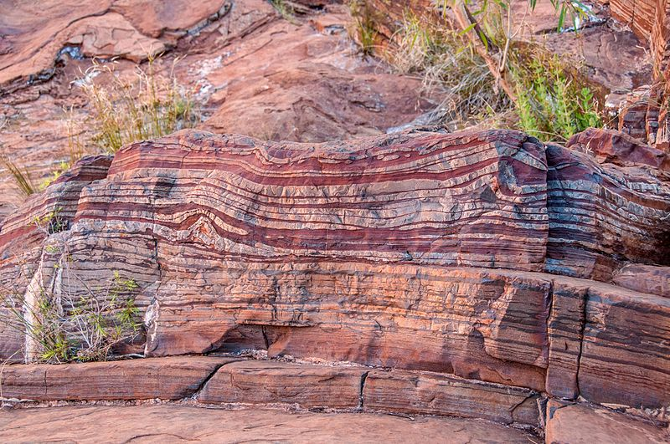
"Dales Gorge" by Graeme Churchard is licensed under CC BY 2.0
Students draw a flow chart showing the steps in the formation of the BIFs and explain how the BIFs provide evidence of past ecosystems BIO11/12-7.
Relate BIFs to key changes in geological history, such as the great oxygenation event, that created selection pressure favouring organisms not affected by the harmful effects of oxygen and the subsequent evolution of aerobic respiration. Have students recall from Module 1 the greater efficiency of aerobic respiration in comparison to anaerobic respiration. Therefore, aerobic respiration allowed the development of larger more complex organisms.
Fossil evidence
Provide students with the Cosmos article Fossil sheds light on ancient climate change (Masterson 2018). Discuss how the fossils provide evidence of a changing ecosystem.
Students undertake a jigsaw activity to investigate Australian fossil sites, describing how the fossils provide evidence of an ecosystem different to today BIO11/12-3.
- Introduce 'Home groups' – students work in small 'home' groups. Each member of the home group selects a different Australian fossil site from the list which they study independently.
- Break into 'Expert groups' – students who have selected the same fossil site gather together to compare information and become 'experts', discussing how to best teach the content to their peers.
- Regroup with 'Home groups' – students return to their original groups where they each take a turn presenting their information.

Technologies to determine evidence for past changes in ecosystems
Techniques used to date fossils from IQ3-4 are included here. As described in the conceptual difficulties section, students can become confused with the principles underlying the law of superposition, index fossils, and absolute dating. Start by introducing students to stratigraphy by undertaking the activities in Appendix 16.

Relative dating – law of superposition
Relative dating puts geological samples in chronological order without a specific numerical age being assigned to each sample. The first 2 activities in Appendix 16 look at the relative dating of layers of rocks with no mention of fossils. Students undertake a hands-on activity to visualise the law and then apply this understanding to natural rock strata. The third and fourth activities introduce fossils and how their location in the rock strata determines their relative age BIO11/12-6.

Relative dating – index fossils
Index fossils are characteristic of specific periods of geological time and can determine the relative age of other fossils in the rock strata. A good index fossil has the following characteristics. It is:
- distinctive
- globally widespread
- abundant
- limited to a particular geologic time
- robust and preserves well.
The video, A Brief History of Geological Time (12:07) (PBS Eons 2017) (to 2:32), explains the use of index fossils.

Radiometric or absolute dating
Absolute dating is assigning a numerical age to a geological or paleontological sample. It relies on the natural radioactive decay of elements such as potassium and carbon to provide a numerical measurement. In biology, students only need to know the basic principle, not the mechanism, of radioactive decay. An excellent explanation of radiometric dating is provided at Dating Rocks and Fossils Using Geologic Methods (Peppe and Deino 2013), under the heading ‘Determining the numerical age of rocks’.
Half of life of Candium [PDF 202KB] (Dixie Middle School Science n.d.) is one of many activities using M&Ms to model radioactive decay BIO11/12-4, BIO11/12-6. By replacing the ‘decayed’ M&Ms with green split peas at each half-life students can visualise how the proportion of parent atoms to daughter atoms changes. The questions provided with this activity allow students to see the limitations of C-14 dating and that dating using other radioisotopes can be used for much older rocks. However, this is only accurate in igneous and metamorphic rocks, as sedimentary rocks contain a mixture of samples from the weathering of other rocks. Since fossils are only found in sedimentary rocks, dating fossils older than 70,000 years (the limit for C-14 dating) is done by absolute dating the igneous or metamorphic rocks in the stratigraphic sequence and then estimating the age of the fossils using relative dating.
In the ANSTO activity, Radiocarbon dating Aboriginal and Torres Strait Islander cultures and histories [DOC 180KB] (ANSTO 2020), students explore Australian examples of using radiocarbon dating.

Ice cores and gas analysis
View the video, Scientists drill deep in Antarctic ice cubes for climate change (2:35) (University of Washington 2020) and CO2 in the ice core record (3:01) (Earth: The Operator’s Manual 2012) for brief descriptions of how ice core drilling is undertaken and the evidence collected from ice cores.
The ANSTO activity, Concentration of greenhouse gases [PDF 734KB] (ANSTO 2019), provides information about the value of ice core analysis and several exercises in which students process and analyse the authentic data provided. Students use the knowledge and understanding acquired from reading the suggested articles and their constructed graphs to answer questions BIO11/12-4, BIO11/12-5, BIO11/12-7.

Changes in Australian ecosystems and the evolution of organisms in Australia
This section provides an opportunity to tie all that has been covered over the two modules together in the context of evolution in Australian ecosystems.
Introduce the concept of the change in Australia’s biota by viewing the CSIRO video Australia’s biodiversity – major features (6:01) (CSIRO 2021). Students identify major factors affecting the evolution of Australian biota and how new technologies are changing the understanding of species and their evolutionary lineages. Students then investigate the changes in Australia’s ecosystems over the past 220 million years by developing a PowerPoint (or other digital presentation) as described in Appendix 17 BIO11/12-4, BIO11/12-7.
It is suggested that the investigation of a recent extinction event be moved from IQ4-1 and IQ4-3 to here. In terms of geology, ‘recent’ refers to the current epoch, the Holocene, which started approximately 10,000 years ago at the end of the last glacial period (ice age). ‘Near time’ is considered as being the last 50,000 years.
Ask students to define extinction and provide familiar examples. Students will most probably refer to an individual species. An extinction event is when many species die out relatively quickly. This is also called a mass extinction. There have been five mass extinctions in the past and we are living through a sixth, the Holocene extinction. This is sometimes called the Anthropocene extinction because of the role humans have played in the decline of biodiversity. It is the only extinction event that meets the ‘recent’ criteria.
View the video from Nature Atlas Films, Extinct & enormous: The massive marsupials of Australia (12:05) (Nature Atlas Films 2018). Other suitable videos are listed in the Other Resources section. Students then further investigate the hypotheses proposed in the video to explain the extinction of the Australian megafauna BIO11/12-3.
Alternatively, students could investigate the Holocene extinctions on other land masses such as New Zealand, Madagascar, or North America.
Whichever example of extinction is investigated, students should focus on:
- linking the selection pressures to the difference in traits between the organisms that became extinct and the organisms that survived, and the consequent effects on biodiversity
- evidence that supports the hypotheses
- problems or inconsistencies with the hypotheses.
This process of assessing hypotheses is demonstrated in End of the Megafauna with Ross MacPhee – AMNH SciCafe (29:50) (AMNH 2018), a lecture by Ross MacPhee, author of the book, End of the Megafauna. He looks at megafauna on a global scale and discusses the theories for their extinction, the evidence supporting those theories, and the inconsistencies with each theory.
Students select a small Australian mammal and sclerophyll plant (for example, acacia or eucalypt) and investigate its evolution. The important concept here is not that the student has a deep knowledge of the phylogenetic tree for the chosen species, but that they can explain the impact of the changing environment on the evolution of the species.

Inquiry question 4-3: How can human activity impact on an ecosystem?
Because this inquiry question raises many topical issues, such as extinction of species, biodiversity, climate change, mine rehabilitation, and land degradation, it lends itself to students following an area of interest and developing a depth study. Encourage students to propose probing questions as you work your way through the unit. Other topics not directly mentioned in the syllabus but inspired by it include:
- How does Aboriginal land/fire management preserve biodiversity?
- How should wilderness areas be best protected?
With guidance, and using the Developing an Inquiry Question (Western Libraries n.d.) activity, students can develop a question suitable for a depth study BIO11/12-1, BIO11/12-3, BIO11/12-6, BIO11/12-7.

Investigating the past to inform future ecosystem management

Human-induced selection pressure
Introduce the role of human-induced selection pressures on species extinction by viewing the video The megafauna demise (4:13) (Pickett 2016), which focuses on the extinction of the Tasmanian tiger. Students identify hunting (the bounty) as the primary reason for their extinction and describe how the alley effect contributed to their demise.
Australia’s Science Channel’s article, Scientists re-counted extinct Australian species and the result is devastating (Legge 2019), describes the extent of extinction and loss of biodiversity in Australia. An activity is provided in Appendix 18 BIO11/12-3, BIO11/12-5, BIO11/12-6.
The Cosmos article Conserve ecosystems, not individual species: Fossils reveal that ecosystems persist for millions of years while mammals come and go (Parletta 2021) approaches the problem of preservation of biodiversity from a different angle and could be used to promote class discussion about a local ecosystem under threat.
The Conversation article, Extinction of ice age giants likely drove surviving animals apart, (Blanka Toth 2019) looks at how the loss of megafauna affected ecosystems and then uses this to predict what the impact of the loss of current endangered large species may be. Students complete the following activities:
- Propose a hypothesis for the changed distribution of the two smaller species shown in the diagram.
- Referring to the information provided, discuss the benefits of studying the changes that occurred in past ecosystems BIO11/12-7.

Modelling
Students use the simulation African Lions: Modelling Populations (Concord Consortium 2015) to predict and analyse the impacts of various selection pressures on populations and investigate the uses, advantages, and limitations of population models BIO11/12-1, BIO11/12-5, BIO11/12-6, BIO11/12-7.
Modelling is also included in the climate change activities below.

The role of changing climate on ecosystems
As this is a topic that frequently appears in the popular and scientific press, there is an enormous range of material available as articles and videos. A number of activities focused on scientific data are provided in Appendix 19 and Appendix 20.
- Appendix 19 contains a sequence of activities designed to develop students understanding of the link between carbon dioxide concentrations and average global temperatures BIO11/12-5, BIO11/12-6, BIO11/12-7.
- Appendix 20 provides a variety of activities where students investigate the effects of climate change on a range of ecosystems. Select those that suit your students’ interests and your context BIO11/12-4, BIO11/12-5, BIO11/12-6, BIO11/12-7.

Restoring damaged ecosystems

Mining sites
Mine rehabilitation is a legal obligation for all mining projects in Australia. The mine rehabilitation brochure accessed at Environmental Management (Minerals Council of Australia n.d.) shows the process in mine rehabilitation from planning, through operation, to closure. Prepare a document with each of these processes randomly arranged. Students then cut and paste the processes into a flowchart. A class discussion about the need for each step can be undertaken BIO11/12-7.
If possible, arrange a visit to a site to see how a mine site has been rehabilitated. Alternatively, students work in groups to investigate a case study of mine rehabilitation. An outline is provided in Appendix 21 BIO11/12-3, BIO11/12-4, BIO11/12-7.

Degraded agricultural sites
Introduce the concept of land degradation from agricultural practices by viewing the video, Land degradation and restoration (6:41) (IPBES 2019). This is produced by the International Institute for Sustainable Development and gives a world view of the problem.
If a particular type of land degradation occurs in your area, contact your local soil conservation office (SCS n.d.) and arrange a field study.
Alternatively, students research a type of degradation of interest to them. They describe the problem, explain how it occurs, describe the effects of the problem, and explain how to address it BIO11/12-3, BIO11/12-4, BIO11/12-7.
Examples include:
- acid sulfate soils
- dry land salinity
- irrigation salinity
- soil erosion.

Opportunities for extending concepts
- Adaptations – While dinosaurs are not specifically part of the syllabus, this TED Talk, The secret weapon that let dinosaurs take over the planet (Shachner 2019) could provide some stimulus for a student to investigate why dinosaurs were so successful in their environment for so long.
- DNA sequencing – To extend students skills in DNA sequencing, undertake the challenging activity Using DNA to explore lizard phylogeny (part 2) (HHMI BioInteractive 2016).
- Solving evolutionary relationship problems – Students can extend their understanding of evolution by evaluating evidence and applying their knowledge to real-life scenarios. Provide students with the current and an earlier cladogram showing evolutionary relatedness between primates. Students investigate the evidence upon which the earlier cladogram was constructed, and the evidence that was used to change the cladogram to the current model. In doing so, students should explore the advantages and limitations of each type of evidence for evolution and construct an evaluation of each type of evidence.
- Radiocarbon dating – The Conversation article, From cave art to climate chaos: how a new carbon dating timeline is changing our view of history (Turney et al. 2020), describes radiocarbon dating. It also looks at how newly-calibrated curves allow for variations in the carbon cycle, cosmic radiation, and the industrial revolution to make the measurement more accurate.
- Depth Study – Kurnell case study: Past, present, future. Students can extend their understanding of ecosystem dynamism by investigating the ecosystem at Kurnell, particularly how it has changed over time as a result of human activity and rehabilitation efforts. There is ample research on Kurnell available online and students can conduct field work on-site. Based on their research, students make predictions about the future of the ecosystem at Kurnell.

Appendices

Appendix 1: Glossary of key terms
Students should be explicitly taught the skills necessary to develop a glossary that can be expanded as required.
Explore with students the different methods of generating glossaries. For example, using physical flash cards or utilising one of the many digital flash card apps available such as Brainscape (Bold Learning Solutions 2022), Cram (Cram 2022), or CheggPrep (Chegg Inc 2022).
Model for students how to define terms using their own words.
Encourage students to use analogies and metaphors when appropriate and include diagrams/images BIO11/12-7.
Include pictures and diagrams in the glossary. This is especially helpful for EALD students, allowing them to visualise and make connections to the terminology.
The Department has resources to support writing in Stage 6 Science (DoE 2022).
Students should add additional unfamiliar words.
Table 1 – Student glossary of key terms
Key term | Definition | Example/diagram
abiotic
absolute dating
abundance
adaptation
aerobic
allelopathy
anaerobic
analogous
antibiotic resistance
autotroph
bacteria
banded iron formation
behavioural adaptation
biodiversity
biogeography
biological control
biotic
carbon-14
cladogram
climate
climate change
commensalism
community
comparative anatomy
comparative embryology
competition
convergent evolution
detritivore
distribution
divergent evolution
DNA-DNA hybridisation
ecology
ecosystem
environment
equilibrium model
evolution
extinction
fossil
gradualism
greenhouse effect
habitat
heterotroph
homologous
ice core
index fossil
introduced species
isolation
macroevolution
microevolution
mining
model
mutation
mutualism
natural selection
niche
organism
palaeontology
parasitism
pentadactyl limb
photosynthesis
population
predator
prey
quadrat
radioisotope
radiometric dating
relative dating
respiration
selection pressure
structural adaptation
transitional form

Appendix 2: Hot potato – abiotic factors affecting organisms
Provide each group of students with a large picture of a different ecosystem and a sheet of paper. Students write two significant abiotic factors in the ecosystem on the paper. After 30 seconds, the picture and paper are passed on to the next group who will add another two factors. Repeat until 8 factors have been determined.
Each group then decides on the 4 most significant factors in the ecosystem they currently have. Introduce the term ‘selection pressure’ – a factor that affects the survival and reproduction of individuals in a population. Students complete the table below to:
- describe why each abiotic feature is important. Consider Modules 1 and 2 – how does each factor affect the functioning of organisms?
- show how the features of a named plant and a named animal allow them to survive with these abiotic factors.
Students share their findings, showing that different ecosystems have different selection pressures, and therefore different organisms. This is called species diversity.
Table 2 – Abiotic factors and features impacting various ecosystems
Ecosystem | Significant abiotic factors | Why is the abiotic feature important? | Features of a plant that enable it to survive in the environment with each of these abiotic factors | Features of an animal that enable it to survive in the environment with each of these abiotic factors
Desert
Rainforest
Tundra or Savannah
Estuary or rocky shore

Appendix 3: Predicting consequences for populations
Students use the population simulation Deer Mice (Concord Consortium n.d.) to predict and observe changes to the deer mouse population in response to changes in their habitat. There are two habitats to consider (field and beach), for each:
- Students predict if the populations of the three variations of deer mouse will change (without predators), run the simulation for 12 months, and observe the population data on the line graph and pie charts. Students compare the population data at Month 0 and Month 12 to their prediction.
- Students reset the simulation and add predators to the simulation. Students predict if the populations of the three variations of deer mouse will change, run the simulation for 12 months, observe the population data on the line graph and pie charts. Students draw a line of the population data, describe the trends, and infer reasons for the population changes.

Appendix 4: Measuring abundance – quadrat sampling
Use the school oval or a lawn area to determine the abundance of a particular plant species. Do a preliminary survey and determine which plant species will be most appropriate for the students to identify and count. Insert the name of your selected plant for species A in the instructions below.

Equipment
- Quadrats (1 per 3 students)
- 2 x 30m tape measures
- 2 sets of cards numbered 1 to 30 in each of two bags.

Method
- Stand in the lawn area to be surveyed and make a simple plan of the key features – the direction of north, any nearby buildings and trees, slope, paths.
- Identify the plant species to be counted.
- Lay out the tape measures at right angles along two sides of the area to be sampled.
- One student from each group takes a number card from bag 1, and a second student takes a number card from bag 2. Students 1 and 2 stands at the appropriate mark on each tape measure. Student 3 uses their colleagues as place markers and places the quadrat on the lawn in line with them. For example, student 1 draws 15 and student 2 draws 25. Student 3 places the quadrat as shown.
Figure 2 – Example random sample quadrat placement
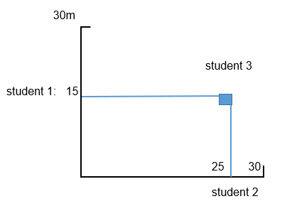
- The group counts the number of the identified plant species. If a plant does not lie completely within the quadrat, only count it if more than half the plant lies inside the quadrat. Record the count in a table.
- Repeat steps 4 and 5 four times.

Results
Table 3 – Quadrat sampling
Quadrat number | Number of species ‘A’ present
1
2
3
4
5

Calculations
- Calculate the area of the quadrat.
- Calculate the total area of the lawn sampled.
- Calculate the average number of species A plants in the area of your quadrat.
- Calculate the average number of species A plants per square metre.
- Using your estimate of the lawn area, calculate and record your estimate of the total size of the plant population on the lawn.
- Combine the class’s data on an Excel spreadsheet to find an average population of species A.

Discussion
- What kind of information can be obtained by using quadrats to investigate a plant population?
- Did the estimates of the total population size calculated using your group’s data differ from those calculated using the combined data? Suggest a reason for any difference.
- Which of the two population size estimates from the previous question should be more accurate? Which is more reliable? Explain the reasons for your answers.
- What limitations would need to be considered if using quadrats for measuring animal populations? Suggest any animal populations that could be investigated by using quadrats.

Appendix 5: Measuring abundance: capture, mark, recapture with crickets

Background Information
One commonly-used technique to estimate the size of natural populations is capture, mark, recapture. In this method, animals are captured, counted, given an identifying mark such as a paint spot or a tag with a number, and then released back to their habitat. At a later date, traps are set again in the same places. The numbers of marked and unmarked animals are counted. The ratio of marked to unmarked animals during the second capture event can be used to estimate the size of the population. This method provides a simple means to estimate the population size of animals.
In this experiment, the animals used are crickets. The crickets will naturally seek shelter in dark places. Dark places are provided by the portions of egg cartons placed in the large container.

Equipment
- Large container/aquarium
- Crickets
- Cardboard ‘traps’ (egg cartons)
- Acrylic non-toxic paint pens.
Figure 3 – Brown Cricket
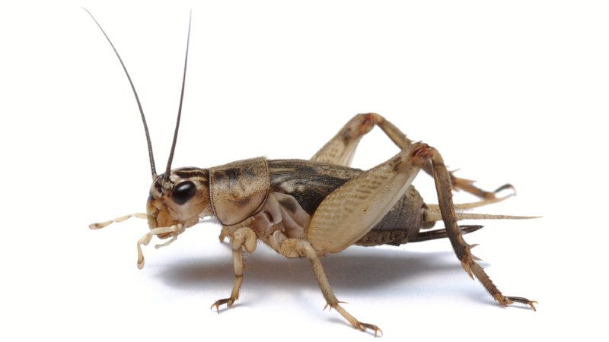

"Brown Cricket" by Onyxastra is licensed under CC BY 4.0

Method
- Collect crickets from the large container by removing one ‘trap’, a small portion of the egg carton, and gently shake the crickets from the egg carton into a plastic container.
- Use a paint pen to mark the crickets. One student holds the cricket while another dabs the specified body part with paint. Mark part of the thorax or one of the legs of the crickets.
- A third student records the number of crickets marked (this is $n_{1}$ in the equation).
- Return the crickets to the large container.
- Wait 15 minutes for crickets to settle back into their traps and redistribute themselves in the container.
- Repeat the same process of capturing crickets. Record $m_{2}$ (the number of marked crickets captured during this session) and $n_{2}$ (the total number of crickets recaptured).

Results
Record your group tallies for n₁, n₂ and m₂ in a table.

Calculations
- Use this equation to estimate population size:
$$N= \frac{n_{1}n_{2}}{m_{2}}$$
$N= estimate of population size$
$n_{1}= number of animals marked and released during the first capture$
$n_{2}= number of animals in the second capture$
$m_{2}= number of animals marked animals recaptured$
- Collect the other groups’ estimates and calculate the mean (average) estimate of the population size of the crickets in the large container.

Discussion
- What assumptions about the population of animals are being made using this model of estimating population size?
- What factors might lead to differences between the estimated population size and the true population size?
- What value does estimating the size of naturally occurring populations bring to society?

Extension
- The standard deviation is the average amount of variability in the class’s dataset. It tells you, on average, how far each group’s estimate of the cricket population lies from the mean of all the groups’ estimates. A high standard deviation means that values are generally far from the mean, while a low standard deviation indicates that values are clustered close to the mean.
- To calculate the standard deviation:
$$σ= \sqrt{\frac{{\sum{(X-μ)}}^{2}}{N}}$$
Formula Explanation:
σ = population standard deviation
∑ = sum of…
X = the number of crickets that each group calculated
μ = mean of the class results
N = number of groups in the class
  - What does the calculated mean and standard deviation tell you about the efficacy of using this model to estimate population size in this scenario?
  - 95% of values will lie within two standard deviations of the mean. If your value lies within this range, you can state that your estimate of population size is reliable. Determine if your estimate is reliable.
- Choose one of the following events – immigration, disease, or reproduction. Design a method for incorporating this event into your population in between each trial. Then conduct this experiment again using your redesigned method, record the data in a similar table, and calculate the average population size. Compare the two population estimates and evaluate the validity of both models.

Appendix 6: Measuring the distribution of a plant species

Advice to teachers
Adapt this outline to use in your school environment.
Use the school oval or a lawn area to determine the distribution of specific plant species. Do a preliminary survey to determine an area where there will be a measurable change in distribution due to, for example, a foot traffic area, shade, water logging, or slope. Determine:
- which plant species will be most appropriate for the students to identify and count. Insert the name of your selected plant(s) in the instructions below
- how the plant species will be counted. For example
  - quadrats at set intervals
  - count the number of plants the tape passes over
  - count the number of plants within a set distance of the tape (usually used for trees and shrubs).
- if height and width of the plant will be recorded
- how you want the students to record the data
- if abiotic factors (for example, temperature, light intensity, pH) will be measured and what equipment is required for this.
Adjust the following student instructions with the above considerations in mind.

Equipment
- Measuring tape or trundle wheel
- Pencil
- Ruler
- If required, equipment for measuring abiotic factors

Method
- Students measure out the transect line.
- Students identify the plant species they will be counting as previously determined by the teacher.
- Students prepare a scale drawing of the transect line that will allow them to record the number of plant species. It must include a compass heading, topography, a scale, and a key for the different species.
- Walking along the line, students:
- count and record the numbers of the identified species of plants
- measure the abiotic factor at the designated intervals.
- Direct students to record their results appropriately.

Discussion
- What kind of information can be obtained by using a transect to investigate a plant population?
- Discuss the positioning of transects. Why is it better to collect data from more than one transect if possible?
- What did the information obtained from your transect suggest about the distribution of the plant species and its relationship to the abiotic factor measured/recorded?
- Share your transect with the other students in your class. Explain any changes in your knowledge of the distribution of plant species after sharing information with other groups.

Appendix 7: Adaptations
Students read four Cosmos articles and a TED-Ed video that feature different adaptations BIO11/12-1, BIO11/12-4, BIO11/12-7.

Activity 1: Whales
Read the article: Why are whales so big, but not bigger?: Researchers identify biological drivers and ecological limits (Parletta 2019).
Answer the following questions.
- What is the difference between the feeding habits and adaptations of filter-feeding whales and toothed whale species?
- Why does the structural adaptation of filter-feeding whale species allows some of them (the Blue Whale, for example) to grow larger than the toothed whales?

Activity 2: Egg shells
Read the article: Darker eggs have their purpose (Connellan 2019).
Answer the following questions.
- What question were the scientists investigating in this article?
- What was their hypothesis?
- Why was the initial evidence about shell colour inconclusive?
- What process did the scientists undertake to investigate their question?
- How did their findings support their hypothesis?
- In summary: What is the adaptation being investigated, and why does it increase the birds’ ability to survive in their environment?

Activity 3: Leopard seals
Read the article and view the links in the article: Buffet buddies: footage reveals that fierce leopard seals work together when king penguin is on the menu (Hocking et al. 2019)
Explain the ‘normal’ feeding behaviour of leopard seals.
- What was the changed behaviour observed in leopard seals in South Georgia?
- Identify two hypotheses that have been proposed to explain this behaviour. For each hypothesis, state one piece of supporting evidence.

Activity 4: Living at altitude
Read the articles: How do Sherpas thrive up here? (Biegler 2019) and High altitude training (Cornell 2016).
- Explain why altitude affects where humans can live.
- What physiological adaptation do humans have that allows them to live at high altitudes?
- Why can this adaptation be a problem?
- How did the red blood cell concentration of the Sherpa of the Tibetan Plateau compare to that of the people from the Peruvian Andes? Why was this considered to be unusual?
- After rejecting the presence of a particular gene as the reason for the Sherpa’s ability to survive at high altitude, what hypothesis did Mike Stenbridge ultimately propose?
- What evidence did he find that supported his hypothesis?
- What adaptation would need to be present in the Sherpa’s kidneys for this hypothesis to be further supported?

Activity 5: Platypus
Watch the TED-Ed video A year in the life of one of the Earth’s weirdest animals - Gilad Bino (4:55) (Bino 2021).
- Design a table showing the adaptations of the platypus and identify each adaptation as structural, physiological, or behavioural. For each adaptation, explain how it increases the platypus’s ability to survive in its environment.

Appendix 8: Darwin in Australia
Orient the students by providing a map of Darwin’s voyage, showing that the visit to Australia occurred after the Galapagos Islands. His diary, letters, and notes show that his 11-day visit to the Blue Mountains and west to Bathurst stimulated his questioning of creationism and initiated his idea of evolution. The article Charles Darwin’s evolutionary revelation in Australia (Nicholas 2016) provides a good description of his time here.

Fauna
Provide students with images of the following:
- European water rat (the water vole) and platypus
- potoroo and rabbit.
Ask the students, ‘Does each member of the pairs look alike?’
The animals can be viewed in their habitats in the following videos. Ask students to focus on the habitat and the animals’ behaviours in their habitat.
- The Water Vole – A Quick Guide (4:03) (de Vere 2015) (first minute). Inform the students that this video is from the UK. It uses language such as ‘we’ and ‘our’, and the students could think that the Water Vole is an Australian animal unless this is discussed before watching the video.
- Drying habitat makes platypus vulnerable, scientists say (2:12) (Reuters 2020) (first 45 seconds).
- Long nose potoroo (1:37) (LERAKO 2018) from the Cape Otway Conservation Ecology Centre
- Brave rabbit grazing (5:17) (Feldspar 2012) (0:56 - 1:20)
Ask the students what they observed about the habitat and behaviour of each member of the pairs.
- Discuss Darwin’s observations of the platypus and long nose potoroo at Wallerawang, that both members of each pair occupied the same (what we now call) niche, and displayed similar behaviours but are distinctly different. The entry on page 402 of Charles Darwin's Beagle Diary (Keynes 2001) shows he questions why the Creator would create such different animals for such similar environments. He then suggests that the two species may have been created independently. While it was 20 years before Darwin’s theory was publicly proposed, these observations may have initiated his development of the theory of evolution.

Flora

Activity 1
Students to read Charles Darwin’s diary entry of Jan 12th, 1836
The extreme uniformity in the character of the Vegetation, is the most remarkable feature in the landscape of all parts of New S. Wales. Everywhere we have open woodland, the ground being partially covered with a most thin pasture. The trees nearly all belong to one peculiar family; the foliage is scanty & of a rather peculiar light green tint; it is not periodically shed; the surface of the leaves are placed in a vertical, instead of as in Europe a nearly horizontal position: This fact & their scantiness makes the woods light & shadowless; although under the scorching sun of summer, this is loss of comfort, it is of importance to the farmer, as it allows grass to grow where it otherwise could not. (Darwin C, The Voyage of the Beagle)
Students may have difficulty understanding the ‘old fashioned’ style of writing in Darwin’s diary. To address this, discuss the use and meaning of the following terms and phrases:
- extreme uniformity in the character of the Vegetation
- open woodland – show Figure 4, for example.
Figure 4 – Open woodland –Totness Recreation Park
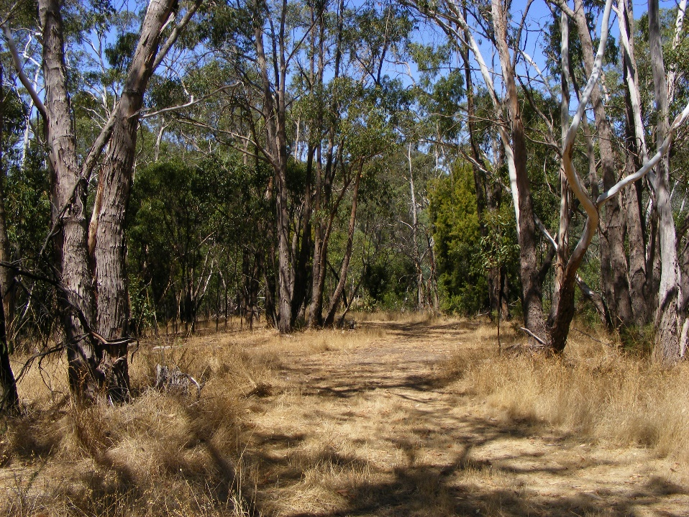
"Open woodland - Totness recreation Park" by Peripitus is licensed under CC BY-SA 4.0
- the ground being partially covered with a most thin pasture
- one peculiar family
- scanty
- a rather peculiar light green tint
- not periodically shed
- makes the woods light & shadowless.
Students can now summarise the text. Then ask students how Darwin’s observations of the flora underpinned his later ideas about adaptations and natural selection.

Activity 2
Provide students with the following extract: Darwin as a plant scientist – a Southern Hemisphere perspective [PDF 1.8MB] (Hopper and Lambers 2009), page 7, second paragraph under ‘Spatial isolation and speciation’.
The language of the text may be challenging for students. Provide a map of Australia to show the areas mentioned – King George Sound, Adelaide and the Nullarbor Plain, along with images of the Nullarbor to illustrate the arid environment.
Discuss the meaning of the following terms and phrases:
- encounter
- reinforced his conviction
- spatial isolation
- anomalous richness
- high endemism
- geographical barriers
- plant dispersal
- local endemism.
Discuss the significance of Darwin’s observations to the explanations for the development of species he proposed in later years.

Appendix 9: Modelling geological time
Ask students to discuss their colloquial definition of ‘recent’ and provide examples of recent events in their lives. Ask them ‘How long ago would an event in the Earth’s geological history be no longer considered recent?’
Allocate each student a card with a key event in geological history (listed below) without the time and ask them to arrange themselves in a line in the order in which they think these events occurred. Take a photo of the students in the line.
Re-issue the cards, but with the time the event occurred, including:
- formation of the Earth: 4600 mya
- first oceans: 4400 mya
- first life – anaerobic prokaryotic organisms: 3850 mya
- oxygen in the ocean – first photosynthetic prokaryotes: 3400 mya
- first eukaryotic organisms: 2700 mya
- oxygen in the atmosphere: 2000 mya
- first multicellular animals: 600 mya
- first vertebrates: 505 mya
- first plants on land: 465 mya
- first insects, fish, ferns and conifers: 410 mya
- first vertebrates on land: 360 mya
- first reptiles: 320 mya
- first dinosaurs: 245 mya
- first mammals: 220 mya
- first birds: 160 mya
- first flowering plants: 130 mya
- extinction of dinosaurs: 65 mya
- first apes: 25 mya
- first modern humans evolved: 200,000 years ago
- end of the last glacial period (ice age): 10,000 years ago.
Use the school oval or an area where 100m can be measured. This represents 5 billion (5,000 million) years. Each metre will therefore represent 50 million years. Students place themselves on the line.
Note: Students are not expected to recall the times of these events. The exercise is about the general order, the relative gaps between events, and what might be considered recent.
Take a photo of the students and project both pictures onto a screen.
Discuss the following questions:
- Which events were significantly misplaced in the first round?
- Approximately how much of the earth’s existence had passed before:
- life appeared
- multicellular organisms appeared
- vertebrates appeared on land
- flowering plants appeared
- humans evolved.
- Why have human fossils never been found with dinosaur fossils?
- What time period would you now consider to be recent?
Recent can be used as a comparative term – one event is more recent than another. In terms of geology, recent is considered to be the current epoch, the Holocene. It started approximately 10,000 years ago at the end of the last glacial period.

Appendix 10: Evolution of the horse
Use the information from Evolution of the Horse (Britannica 2021), and further research to construct a timeline in a table to show how the size, tooth structure, and leg and forefoot structure have changed. Relate these structures to the selection pressures existing in the environments of each species over time BIO11/12-4, BIO11/12-5.
Table 4 – Timeline of the evolution of the horse
Time (million years ago) | Species | Description of habitat and selection pressures | Body size: (height and shape, relate structure to selection pressure) | Tooth structure: (diagram, relate structure to selection pressure) | Leg and forefoot structure:  (diagram, relate structure to selection pressure)
 | Hyracotherium
 | Miohippus
 | Merychippus
 | Pliohippus
 | Equus

Appendix 11: Evolution of the platypus
Use information from the links below to complete the table:
- Steropodon galmani (Musser 2018)
- Riversleigh Platypus (Musser 2020)
- Platypus (Divljan 2021)
Table 5 – History of evolution of different platypus species
Time (million years ago) | Species | Description of habitat and selection pressures | Description of key structural feature in relation to selection pressures
 | Steropodon galmani
 | Riversleigh Platypus
 | Platypus

Appendix 12: Gradualism vs Punctuated Equilibrium
Use the information from The pace of evolution (UCMP 2022) and content learned in class to complete the Venn diagram (Figure 5) to compare gradualism and punctuated equilibrium. You will need to consider the:
- definition
- time frame
- evidence
- mechanism
- environment.
Figure 5 – Venn diagram – Gradualism vs Punctuated Equilibrium
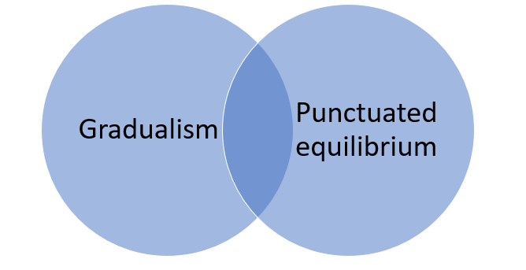

Appendix 13: Biogeographical evidence for evolution
This activity has been prepared as a worksheet. However, it could be broken up into separate activities interspersed with verbal questions and class discussion.
- Mark and label the Hawaiian, Galapagos, Canary, and Cape Verde Islands.
Figure 6 – Line art world map
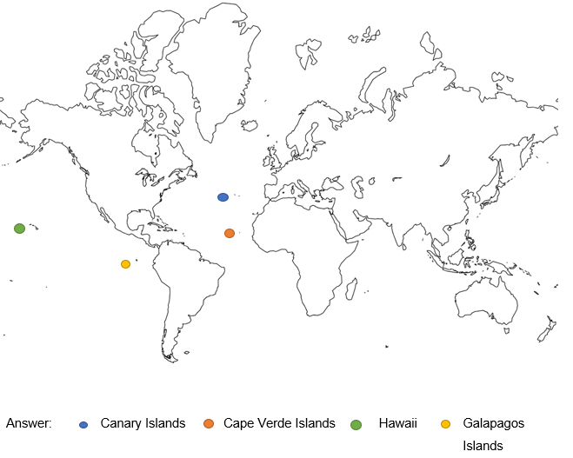
"Line art world map" by Free SVG is in the Public Domain, CC0 1.0
- Investigate what terrestrial mammals are native to these islands.
Sample answer – except for the Canarian shrew in the Canary Islands and the Hawaiian hoary bat in Hawaii, there are no native terrestrial mammals on any of the islands.
- Propose ideas as to why there are limited species of terrestrial mammals on these islands.
Sample answers:
- any mammals that may have been present have died off from disease
- humans or any predators they introduced may have killed off the mammals
- because the islands are small, they can only sustain a small population of a species. Therefore, there would be limited genetic variation. If the environment changed, there may not have been sufficient individuals with favourable variations that allowed them to survive, breed, and pass on the favourable characteristics to their offspring. Therefore, the mammals became extinct
- the islands came into existence after mammals evolved, and they are too far from the mainland for terrestrial mammals to migrate there.
- Investigate how Darwin explained the lack of terrestrial mammals on the islands.
Sample answer – Darwin proposed that no terrestrial mammal would travel more than 500km of ocean to reach the isolated islands. He proposed that geographical structures, such as oceans, rivers, mountains, and islands, provide barriers to the movement of species. The lack of mammals on the islands supports Darwin’s proposition that mammals originally branched off at a particular point far down an evolutionary tree on the continents, instead of arising separately on various landmasses around the Earth.
- Propose ideas for how the Canarian shrew and Hawaiian hoary bat may have reached the islands. How did they become a different species from their mainland relatives?
Figure 7 – Canarian shrew
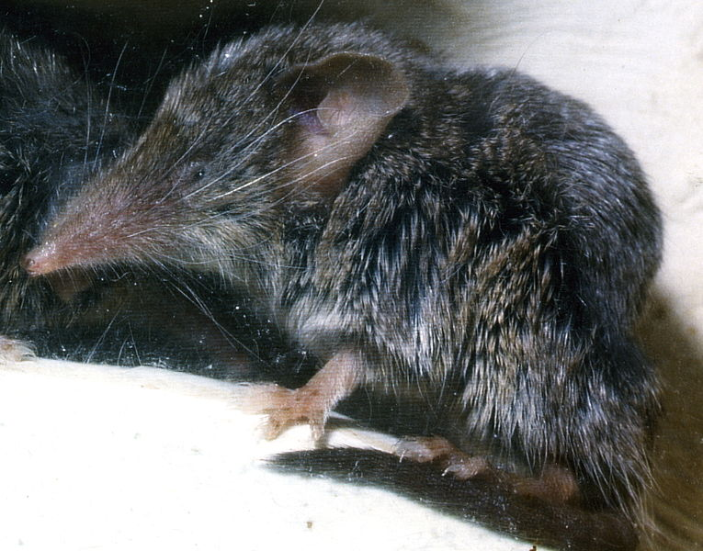
"C canariensis" by R Hutterer is licensed under CC BY-SA 3.0 DE
Figure 8 – Hawaiian hoary bat
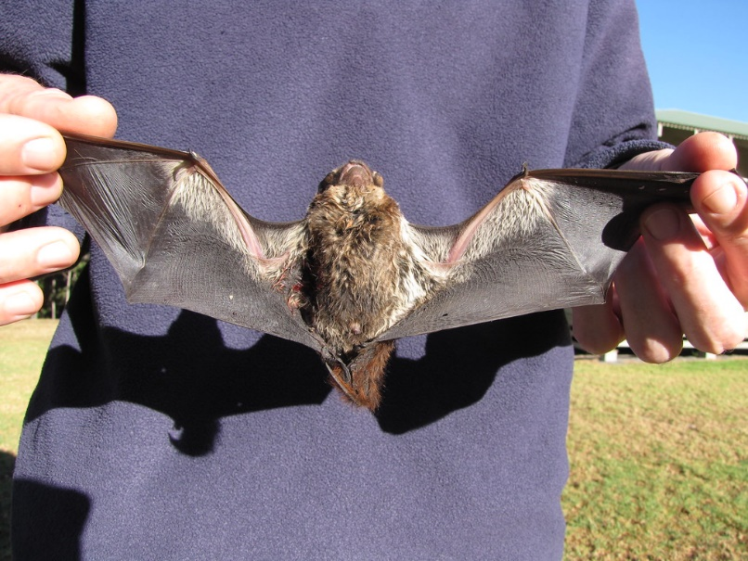
"Hawaiian hoary bat" by Forest and Kim Starr is licensed under CC BY 2.0
Sample answer – the bats may have flown and been blown a large distance by the wind. The Canarian shrew and also the bat may have floated on driftwood. The species then diverged through natural selection, adapting to the island environment in isolation.
- The movement of tectonic plates provides a strong explanation for the geographic distribution of organisms on Earth. Recall your knowledge about plate tectonics and the supercontinents from stage 5. What was the first landmass on the Earth called and when did it break apart? What were the resulting land masses called?
Sample answer – the supercontinent Pangea broke up about 200 Mya into Laurasia and Gondwana.
- The images below show species of the Proteaceae group of plants endemic to Australia (waratah), South Africa (pincushion protea) and South America (Embothrium coccineum). Why are the Proteaceae group of plants only found in the continents of Australia, Africa and South America? Hint: recall that flowering plants evolved 130 mya.
Figure 9 – Waratah
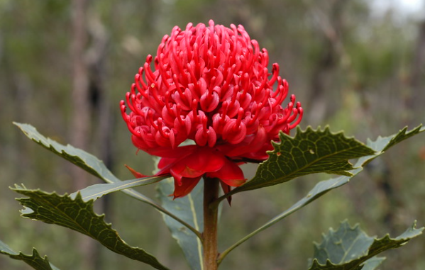
"Waratah" by Doug Beckers is licensed under CC BY-SA 2.0
Figure 10 – Pincushion protea
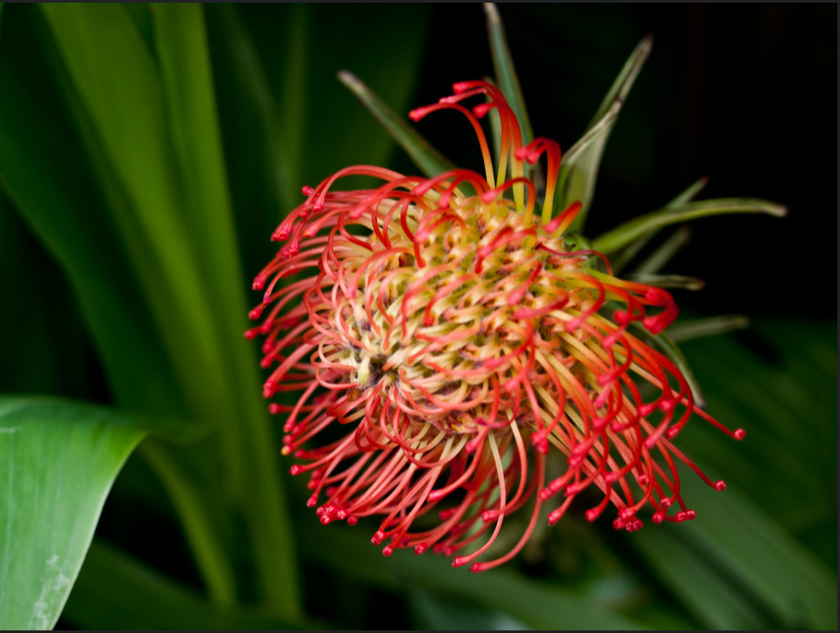
"Pincushion Protea" by William Warby is licensed under CC BY 2.0
Figure 11 - Embothriuim coccineum
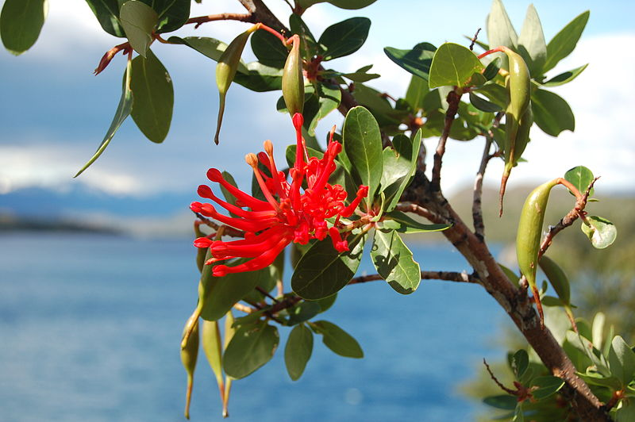
"Embothrium coccineum" by Anaximander is licensed under CC BY-SA 3.0
Sample answer – These 3 continents made up Gondwana, the southern hemisphere supercontinent. Flowering plants evolved 130 mya (see Appendix 9) so those that evolved on Gondwana, such as the Proteaceae would not occur in northern hemisphere continents.

Appendix 14: Antibiotic resistant strains of bacteria

Activity 1
Watch the video Catalyst Series 7 Antibiotic resistance (29:13) (McKenna 2016) and answer the following questions.
- Define:
- sepsis
- antibiotic resistance.
- Explain the statement that we need to live ‘harmoniously with bacteria’.
- What proportion of the population died from bacterial infections in the 1930s before the use of antibiotics? How did the development of antibiotics change this?
- What happens in a bacterial population when an antibiotic does not kill all the pathogenic bacteria?
- In the documentary, a patient with an E. coli infection develops a population of resistant E. coli within 24 hours. What features of the bacteria were identified that allowed this to happen so quickly?
- Why should antibiotics not be used to treat viral infections?
- 70% of all antibiotic use is on farm animals and pets. Explain why should this be a concern.
- How do antibiotic-resistant bacteria develop in the environment? Explain why this is a problem.
- Clearing forests is a concern for species conservation, biodiversity and climate change. Explain why it is also a concern in combating antibiotic resistance.
- Explain how phage therapy is used to destroy pathogenic bacteria. What benefits and limitations of phage therapy?
- How is genetic modification being used in mice to combat antibiotic resistance?
- Having watched this video, what are three precautions you can take to avoid developing a population of antibiotic-resistant bacteria?

Activity 2
This activity models a modern-day example of evolutionary change. It also can be used earlier in the module to address the misconception that students may think that individual bacteria can become resistant when they encounter a new antibiotic. Students play a game of Bacterial Survivor (Govindan 2018). The website includes pre- and post-activity diagnostic questions (which could be presented as a Kahoot) and an analysis worksheet BIO 11/12-5, BIO 11/12-6.
- Each student represents a bacterium. Each student then spins a spinner to choose three characteristics to make up their phenotype.
- The teacher randomly chooses a specific antibiotic from the list. Based on their phenotype, students determine whether or not they will survive exposure to the antibiotic. Only those bacteria that survive will ‘reproduce’ and continue playing in the next round. The ‘killed’ bacteria sit out of the next rounds.
- Surviving bacteria spin three times to determine three characteristics to make up their new phenotype. This represents the mutations that occur during reproduction.
- Repeat step 2.
- Steps 3 and 4 are repeated for two more rounds, with a new random selection pressure (antibiotic) introduced each round.
- At the conclusion of the game, the survivors reveal their ‘winning’ phenotype.
This activity is an interactive and engaging way of showing students that:
- only the survivors reproduce and pass on their genotype on to the next generation
- mutations and horizontal gene transfers are random
- antibiotics do not cause mutations in individual bacteria.

Appendix 15: Tusklessness in elephants
The following templates can be used to support the activities in the BioInteractive, Mystery of the missing tusks (Snodgrass 2020).

I Notice/I Wonder
- Study the pair of images and:
- generate a list of observations about the images using the sentence stem “I notice…”
- next, generate a list of wonderings using the sentence stem “I wonder…”
- Prioritise: pick your top 3 questions that will best help you understand these images by highlighting.
- Select a spokesperson to share your top 3 questions.
I notice: |  | I wonder:

Think-Pair-Share
A range of templates are available on the Digital Learning Selector.

Making an Argument: Claim – Evidence – Reasoning
Claim: [your answer to the question: How does poaching affect the prevalence of tusklessness in elephant populations?]
Evidence: [data that supports your claim]
Reasoning: [scientific principles that explain how your evidence supports your claim]

Appendix 16: Dating rocks and fossils

Relative dating – law of superposition
The two activities look at the relative dating of layers of rocks with no mention of fossils. The third activity introduces fossils and how their location in the rock strata determines their relative age.
- Sandwich stratigraphy [PDF 196KB] (Arizona Sonora Desert Museum n.d.) is a simple activity where students model layers of sedimentary rocks, faulting and folding using different types of bread and fillings.
- In the Science Learning Hub’s Rock layers and relative dating (Science Learning Hub 2018) activity, students observe a photo and diagram of a cliff face near Whanganui in New Zealand, complete an interactive, and answer questions. Background information for teachers, teacher instructions and student instructions are provided BIO11/12-6.
- Students complete the Layers of time (AMNH n.d.) interactive to demonstrate how fossils can be used to determine the relative age of fossils in rock strata. An alternative, more challenging activity is Who’s on first? (Barber and Scheidle Bartos n.d.) BIO11/12-6.

Appendix 17: Changes in Australia’s ecosystems
Students develop a PowerPoint with one page for each of the following periods.
- 220-110 mya.
- 65 mya.
- 45 mya.
- 20 mya.
- 8 mya.
- 100,00 years ago.
- 10,000 years ago.
Each slide should include:
- time
- map showing Australia’s position
- abiotic and biotic environmental conditions
- images of dominant ecosystems and characteristic species
- evidence (may include images)
- a concluding slide that summarises how and why Australian ecosystems have changed over the past 220 million years.

Appendix 18: Role of human-induced selection pressures on the extinction of species.
Students read the article Scientists re-counted extinct Australian species and the result is devastating (Legge 2019).
- Explain the phrase ‘biodiversity loss is more than extinctions alone’.
- Describe the trend shown in the graph.
- Propose why there has been a relatively slow increase in extinctions for the first 50 years.
The article proposes the following human-induced selection pressures have contributed to species extinction:
- habitat loss by land clearing for agriculture and urban development
- introduced species
- pollution
- climate change.
In groups, students undertake a jigsaw activity investigating the selection pressure allocated to them. Following this, they:
- explain what the selection pressure is
- explain how the selection pressure works
- provide examples of the selection pressure
- describe what species are most affected and explain why this occurs
- propose ways in which humans can reduce the selection pressure.
Students compile their research on a shared class PowerPoint and present their information to the class.

Appendix 19: What trends are evident in the world’s climate?
Anomalies show how much measurements vary from normal. When studying climate data, temperature anomalies are more important than absolute temperature. A temperature anomaly is the difference between a measured temperature and an average or baseline temperature. The baseline temperature is usually the average of 30 or more years of temperature data.
A positive anomaly indicates the temperature was warmer than the average or baseline. A negative anomaly indicates the temperature was cooler than the baseline.

Task 1: World temperature data
Provide students with the'Global warming: monthly temperature anomaly' graph (Our World in Data 2022) which shows the global monthly temperature anomalies from 1880 to the present.
- What 30-year period is the baseline period?
- Describe the trend in temperature anomalies.
Watch How temperature has changed in each country (0:54) (Lipponen 2018) from the Finnish Meteorological Institute, which shows a different data visualisation for temperature anomalies by country.

Task 2: Australian temperature data
The maps provided by the Australian Bureau of Meteorology on 112 years of Australian temperatures (BOM 2022) represent temperature anomalies for Australia differently.
- What are two things you notice?
- What are two things you wonder?

Task 3: Long term data
Ask students what they know about global temperature change over the Earth’s history. Students will probably identify that there have been periods of warming and cooling (ice ages). Show the students the graph below (Figure 12), which shows the temperature change from present (2015) over the past 400,000 years.
Figure 12 – Global temperature change
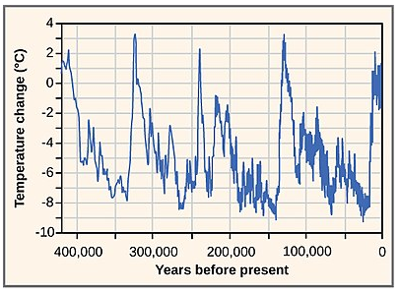
"Figure 44 05 01" by CNX OpenStax is licensed under CC BY 4.0
- What do you notice about the graph?
- What do you think was happening in the world when the graph is at its lowest points?
Recall the students’ knowledge of:
- the greenhouse effect from Stage 5
- ice core drilling and gas analysis from earlier in this module.
The graph below (Figure 13) shows changes in the concentration of atmospheric CO_{2,} over the last 400,000 years (the same period as the temperature graph above).
Figure 13 – Long term carbon dioxide concentration
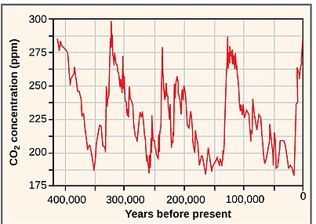
"Figure 44 05 01" by CNX OpenStax is licensed under CC BY 4.0
- What do you notice about this graph (Figure 14) compared to the graph of temperature change?
This graph, called the Keeling curve, shows monthly data from 1958 to 2020.
Figure 14 – Mauna Loa carbon dioxide monthly mean concentration
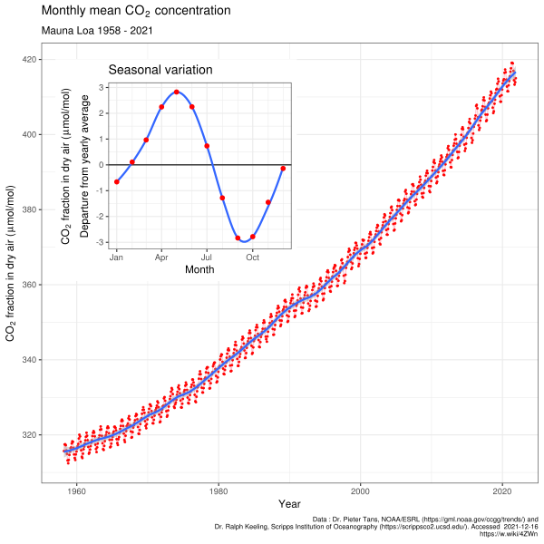
"Mauna Loa carbon dioxide monthly mean concentration" by Delorme is licensed under CC BY-SA 4.0
- What trend is shown in this graph?
- Compare this to the long-term graph in Figure 13. How do the current carbon dioxide levels compare to the long-term levels?
- Using your understanding of the greenhouse effect and the data presented here, propose what effect these recent carbon dioxide levels have on temperature? Justify your answer.
The small insert in Figure 14 shows the variation in carbon dioxide levels over the year. This makes the oscillating red line in the large graph.
- Why do you think there is a regular cycle of carbon dioxide concentration each year? Hint: Look at the map in Figure 15. Which hemisphere contains the majority of the world’s land mass? What are the dominant biomes are there? Consider the seasonal variation in the inset graph in Figure 14.
Figure 15 – World location map
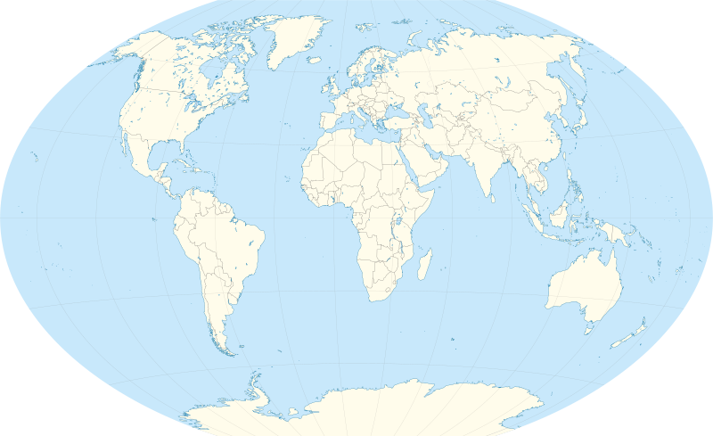
"World location map" by TUBS is licensed under CC BY-SA 3.0

Appendix 20: What are the effects of climate change?
Some examples are provided. Select the activities most suited to your students’ interests and your context.

What is the effect of rising temperatures on Arctic ecosystems?

What is happening to sea ice?
Go to the following NASA interactives and explore what has happened to the Arctic sea ice over the past 30 years.
- Before and After: Bering Sea ice at record low (NASA 2018)
- Early sea ice break up in Beaufort Sea (NASA 2016)
- Arctic sea ice coverage hits record low (NASA 2016)
Figure 16 – Climate change: Arctic minimum sea ice extent
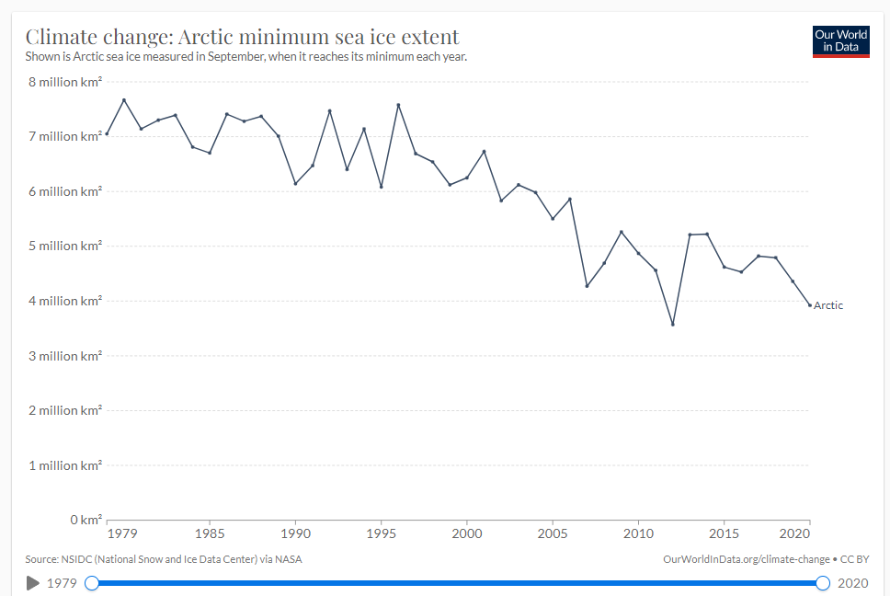
"Climate change: Arctic minimum sea ice extent" by Our World in Data is licensed under CC BY 4.0
Discuss what the images and graph show.

What is the effect of reduced sea ice on ecosystems?
Watch the video, The impacts of vanishing Arctic sea ice | Prof TRACEY ROGERS (5:13) (Rogers 2018) to find out how the loss of sea ice affects ecosystems.
Draw a mind map to show how increasing temperatures are affecting polar bears.
To further develop the student’s understanding, watch the video Carbon cycles and climate change in the tundra (24:00) (Conway et al. 2019). This could form the stimulus for a depth study.

What is the effect of rising water temperature on the oceans?

What is the relationship between ocean temperature and air temperature?
Watch the video, Oceans of climate change (3:19) (NASA 2009).
- Why is this property of water so important to maintaining Earth as a habitable place?
Figure 17 – Global warming: heat content in the top 700 meters of the world's oceans
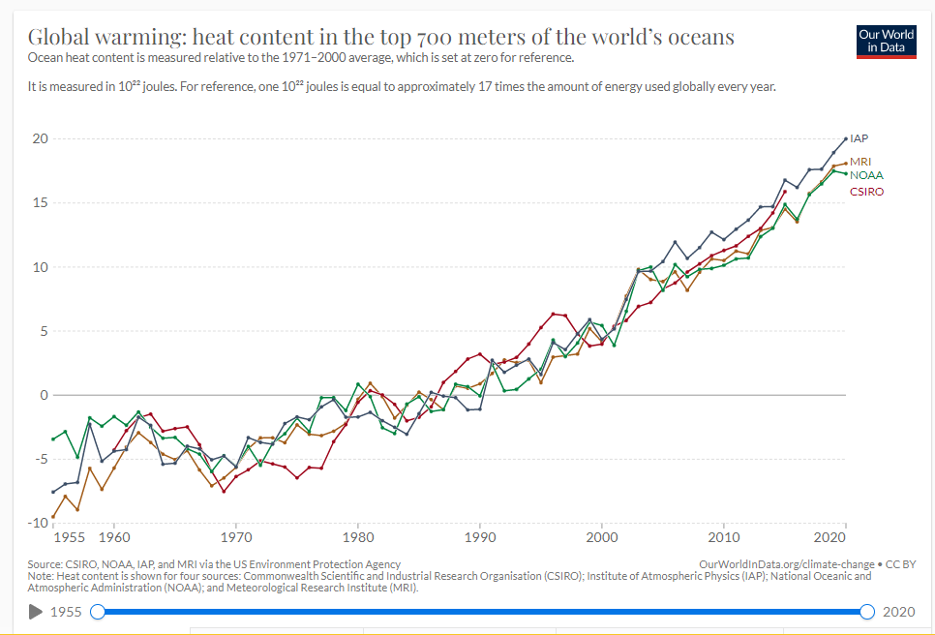
"Global warming: heat content in the top 700 meters of the world's oceans" by Our World in Data is licensed under CC BY 4.0
- Describe the trend shown in the graph.
- How does this show how important the ocean is in maintaining the environment of the Earth?

How does increasing ocean temperature affect ecosystems?
Go to the Great Barrier Reef Marine Park Authority webpage, Sea temperature (GBRMPA 2022).
- Draw a mind map showing the effects of increasing temperature on the GBR
Watch the video, Learn #withme about some impacts of our warming oceans | Prof TRACEY ROGERS (4:31) (Rogers 2018).
- What is the natural vegetation of Sydney’s temperate waters?
- Why is this vegetation of importance to the other organisms in the ecosystem?
- How will warmer waters affect this vegetation?
- How has the interference of humans upset the food chain in kelp forests and resulted in their destruction?

How is increasing air temperature affecting sea level?
Watch the video, Rising tides: understanding sea level rise (1:54) (NASA/JPL-Caltech 2020)
- Describe ways that increasing ocean temperatures cause a rise in sea levels.
- Which of the following are problems associated with rising sea levels? (select all that apply)
- higher king tides
- flooding
- shoreline erosion
- freshwater ecosystems will be destroyed by salt water
- over the next 80 years, millions of people around the world may have to relocate.
Figure 18 – Sea level rise
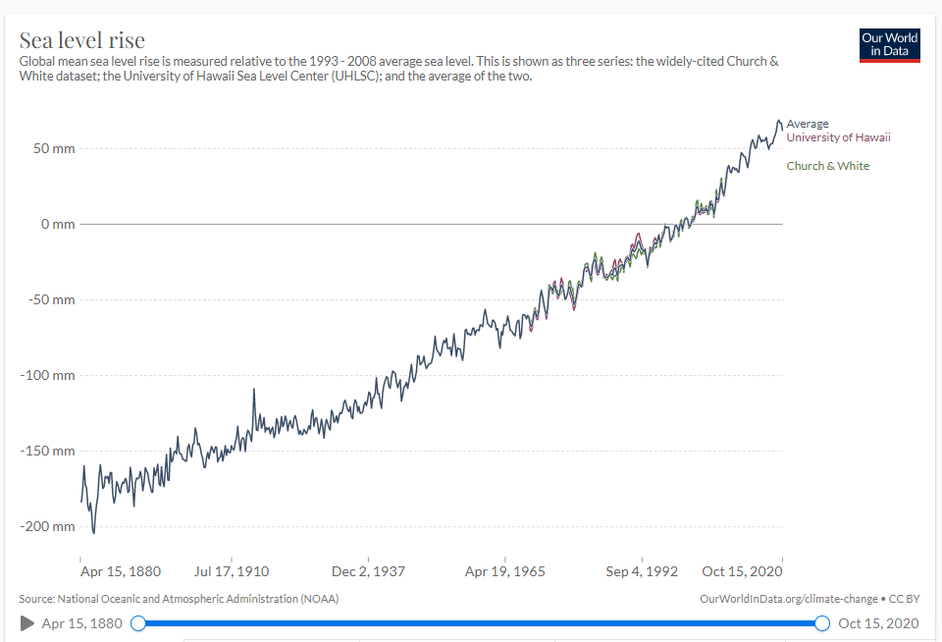
"Sea level rise" by Our World in Data is licensed under CC BY 4.0
- How much has the average sea level risen over the past 140 years?

How is increasing carbon dioxide affecting ocean chemistry?
Watch the video, Demystifying ocean acidification and biodiversity impacts (12:12) (California Academy of Sciences 2014).
- How much of the carbon dioxide produced on Earth is dissolved in the ocean?
- From 1751 to 1990, the surface ocean pH decreased from 8.25 to 8.14. Calculate the percentage change in ocean pH. Does this represent a decrease or increase in acidity?
- When carbon dioxide dissolves in water, what is produced?
- What are the consequences of a more acidic ocean? (select all that apply)
- drops in metabolic rate
- drops in immune response
- destruction of calcium carbonate exoskeletons in corals, molluscs and crabs
- unicellular organisms at the base of the food webs are destroyed
- changes in the acoustic properties of seawater.
Observe Figure 19 below of ocean pH from 1988 to 2019
Figure 19 – Ocean acidification: mean seawater pH
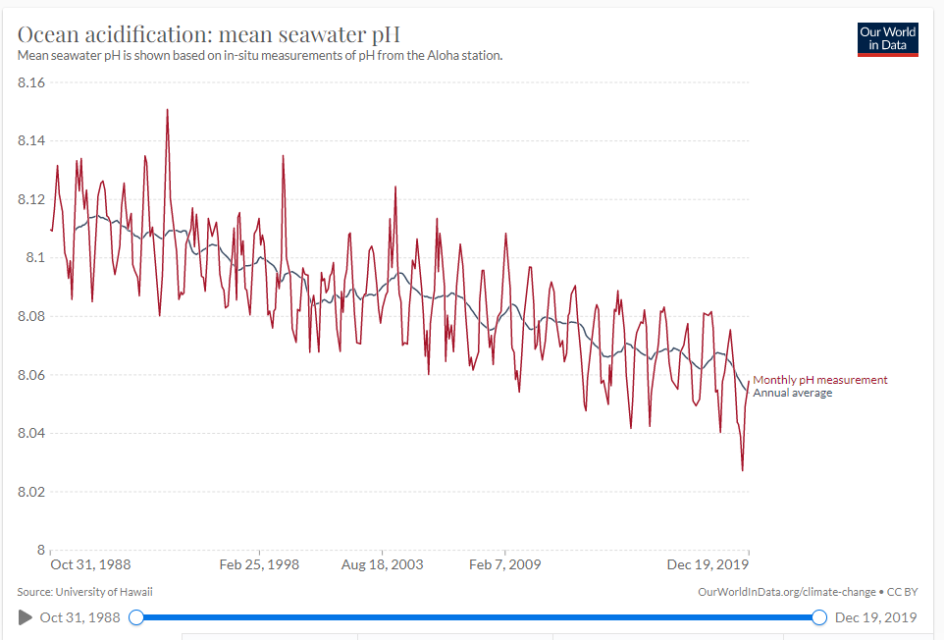
"Ocean acidification: mean seawater pH" by Our World in Data is licensed under CC BY 4.0
- What has been the change in pH over these 31 years?
- Compare this to the change mentioned in the video for the 239 period from 1751 to 1990. What can you say about the rate of change of the ocean pH?

What is the effect of rising temperatures on terrestrial ecosystems?
How is climate change affecting a key species in Australia?
Watch the video, The Human Impact of Climate Change: Personal Stories from Australia (6:16) (Climate Reality 2013), from ‘A species critical to forest health succumbs to intense heat’ (1:44 – 3:42).
- Why do grey-headed flying foxes die at temperatures above 42 degrees?
- Why are flying foxes considered a key species?
- What is proposed to be the flow-on effects of losing the population of grey-headed flying foxes?

How is climate change affecting the seed dispersal?
Read Loss of animal biodiversity spells doom for some plants (Perfetto 2022) and answer the questions.
- How do plants move to a more suitable location if their environment changes?
- What types of animals are involved in seed dispersal?
- How is modelling being used in this study?
- What does the modelling show?

How can the study of past ecosystems assist in managing current ecosystems?
Read Moving home because the fossils say so (Carne 2019) and answer the questions.
- What is the role of snow in providing suitable conditions for hibernating mountain pygmy possums?
- How is climate change impinging the survival of mountain pygmy possums in their current environment?
- What does the fossil record show about the environment of closely-related species to the mountain pygmy possum?
- Propose how evolution allowed the mountain pygmy possum to hibernate.
- Why is it thought that the mountain pygmy possum will survive in the Lithgow area?
- How can the study of past ecosystems assist the management of current ecosystems?
- Undertake your own research to find an example of how changing climate is impacting ecosystems. Prepare a poster to inform the general public of your researched issue. Some suitable resources include:
- Great Barrier Reef study shows how reef copes with rapid sea-level rise (Strom 2019)
- Heat-resistant coral could help rescue threatened reefs (Bruer 2019)
- Animal adaptations ‘not keeping pace with climate change’ (Carne 2019)
- I studied what happens to reef fish after coral bleaching. What I saw still makes me nauseous (Rummer 2020)
- Mangroves threatened by sea level rise (Carne 2020)
- Learning from the past could save diversity: Scientists gain insights from ancient warming events (Parletta 2020)
- Remembering Tasmania's underwater forests (Kean 2021)
- Climate change alters plankton populations (Carne 2019).

Appendix 21: Mine rehabilitation
Students work in groups to investigate a case study of mine rehabilitation. They produce a poster or presentation that includes:
- a map showing the location of the mine
- a brief outline of what mining operations were carried out
- the challenges the site provided to the rehabilitation
- the process of rehabilitation
- the end use of the site
- an assessment of the rehabilitation
- images of before and after rehabilitation.
Suitable references:
- Mine rehabilitation: Leading Practice Sustainable Development Program for the Mining Industry [PDF 10.2MB] (Department of Industry, Science, Energy and Resources 2016) is a government publication produced to share Australia’s world-leading experience and expertise in mine management and planning. Case studies are provided.
- Mine rehabilitation in the Australian Minerals Industry [PDF 4.4MB] is a report by the Minerals Council of Australia (Mattiske 2015). It provides details on each of the examples described in Environmental Management (Minerals Council of Australia 2018) as well as some other sites.
- Mine rehabilitation – an ecological rehabilitation case study at Mt Owen mine (3:54), (Glencore 2015) is a video showing mine rehabilitation at Mt Owen, a coal mine in the Hunter Valley.

Other resources

Prickly pear
Prickly Pear (1933) (1:16) (British Pathe 1933). A video with historic footage of prickly pear invasion.
Australasian Gazette – Prickly Pear Infested Areas of Australia (3:38) (Australasian Gazette 1926). This clip shows an excerpt from a silent, black-and-white newsreel item about the prickly pear infestation in Australia in 1926, and the steps taken by scientists to control it. Educator notes are included.
The conquest of the prickly pear (13:58) (NFSA 2020) An historic 1933 video from the National Film and Sound Archive that documents the damage of the invasive prickly pear and the development of its biological control.

Evolution
Charles Darwin’s evolutionary revelation in Australia (Nicholas 2016). An article that highlights the importance of Darwin’s observations in Australia to his development of the theory of evolution.
Misconceptions about evolution (UCMP 2022). A comprehensive list of misconceptions about evolution, together with a succinct correction for each.

Past ecosystems
Changing ecological concerns in rock-art subject matter of north Australia's Keep River region (Tacon et al. 2003). Extensive academic article suitable for teacher reference.
Of bunyips and other beasts: living memories of long-extinct creatures in art and stories (Nunn and Ponciano 2019). The Conversation reports on a collaboration between scientists in Australia and Brazil, showing many similarities in the oral and visual records of now-extinct creatures. Ideal for further investigation into the role of Aboriginal rock paintings as geological evidence.
Tiny Australian wallaby the last living link to extinct giant kangaroos (Queensland University of Technology 2018). A Science Daily article about the evolution of wallabies and suitable for student use.
Rock art thematic study [DOC 9.33MB] (McDonald and Clayton 2016). An extensive article which, in section 2.3, discusses the role of rock art in providing evidence for the coexistence of megafauna and Aboriginal people.
What killed the giant wombats? (Curnoe 2017). A Cosmos article that looks at one piece of evidence supporting the human hunting hypotheses for the extinction of the megafauna.
Megafauna fossils found in tropical Australia: Rich site suggest climatic change drove extinction (Parletta 2020). A Cosmos article that proposes the alternate view, that climate change caused the megafauna extinction. Studied in conjunction with the previous article, students are guided to develop an understanding hypotheses and evidence.

Future ecosystems
Bird populations are collapsing and it’s a sign of a bigger problem (Kilvert 2019). An ABC article that that summarises several research reports into bird and insect populations in North America, Europe, and Australia. Shifting baseline syndrome is explained as a reason for missing the signs of ecological and climate change. This article can be used as a further example of human-induced selection pressure on the extinction of species.
This adorable mouse was considered extinct for over 100 years — until we found it hiding in plain sight (Roycroft 2021). A Cosmos article discussing how genomic testing has shown that the native Gould's mouse, thought to be extinct, is still alive on predator-free islands in WA. The article relates the management of past ecosystems to how future ecosystems should be managed.
Soil salinity in Australia (5:48) (Gartner 2001). A CSIRO video that clearly explains the cause of salinity and how to mitigate the problem.

References
Links to third-party material and websites
Please note that the provided (reading/viewing material/list/links/texts) are a suggestion only and implies no endorsement, by the New South Wales Department of Education, of any author, publisher or book title. School principals and teachers are best placed to assess the suitability of resources that would complement the curriculum and reflect the needs and interests of their students.
If you use the links provided in this document to access a third party's website, you acknowledge that the terms of use, including licence terms set out on the third party's website apply to the use which may be made of the materials on that third-party website or where permitted by the Copyright Act 1968 (Cth). The department accepts no responsibility for content on third-party websites.
All material © State of New South Wales (Department of Education), 2021 unless otherwise indicated. All other material used by permission or under licence.
Biology Stage 6 Syllabus © 2017 NSW Education Standards Authority (NESA) for and on behalf of the Crown in right of the State of New South Wales.
Akerman K (2009) 'Interaction between humans and megafauna depicted in Australian rock art?' Antiquity, 83(322):1–4, accessed 1 April 2022.
Algol (5 January 2020) 'History of the Earth' [video], Algol, YouTube, accessed 1 April 2022.
AMNH (American Museum of Natural History) (n.d.) 'Layers of Time', PaleontOLogy, AMNH website, accessed 1 April 2022.
AMNH (2008) Compare Horse Hoof and Tooth Fossils [PDF 240KB], AMNH, accessed 1 April 2022.
AMNH (23 December 2018) 'End of the Megafauna with Ross MacPhee – AMNH SciCafe' [video], American Museum of Natural History, YouTube, accessed 1 April 2022.
ANSTO (Australian Nuclear Science and Technology Organisation) (2019) Concentration of Greenhouse Gases [PDF 734KB], ANSTO, accessed 1 April 2022.
ANSTO (2020) Radiocarbon dating Aboriginal and Torres Strait Islander cultures and histories [DOC 180KB], ANSTO, accessed 1 April 2022.
Arizona Board of Regents (2021) 'Peppered Moth Game', Activities, Ask a Biologist website, accessed 1 April 2022.
Arizona Sonora Desert Museum (2006) Sandwich Stratigraphy [PDF 196KB], Arizona Sonora Desert Museum, accessed 1 April 2022.
Australasian Gazette (1926) 'Prickly Pear Infested Areas of Australian' [video], Newsreels: Australian Screen Online, National Film and Sound Archive website, accessed 1 April 2022.
Barber M and Scheidle Bartos D (n.d.) ‘Who’s on First? A Relative Dating Activity’, Learning from the Fossil Record, The Museum of Paleontology of The University of California, Berkeley website, accessed 1 April 2022.
Biegler P (30 July 2019) ‘How do Sherpas thrive up here?’, Evolution, Cosmos, accessed 1 April 2022.
Bino G (July 28, 2021) 'A year in the life of one of Earth's weirdest animals – Gilad Bino' [video], TED-Ed, YouTube, accessed 1 April 2022.
Blanka Toth A (21 November 2019) ‘Extinction of ice age giants likely drove surviving animals apart’, The Conversation, accessed 1 April 2022.
Bold Learning Solutions Inc (2022) Brainscape [website], accessed 1 April 2022.
British Pathé (14 April 2014) 'Prickly Pear (1933)' [video], British Pathé, YouTube, accessed 1 April 2022.
Brody LC (n.d.) ‘Hybridization’, Talking Glossary of Genetic Terms, National Human Genome Research Institute website, accessed 1 April 2022.
Bruer M (17 September 2019) ‘Heat-resistant coral could help rescue reefs’, Sustainability, Cosmos, accessed 1 April 2022.
California Academy of Sciences (1 July 2014) 'Demystifying ocean acidification and biodiversity impacts' [video], California Academy of Sciences, YouTube, accessed 1 April 2022.
Carne N (22 May 2019) ‘Climate change alters plankton populations’, Marine Life, Cosmos, accessed 1 April 2022.
Carne N (23 July 2019) ‘Animal adaptations “not keeping pace with climate change”’, Climate, Cosmos, accessed 1 April 2022.
Carne N (4 November 2019) ‘Moving home because the fossils say so’, Animals, Cosmos, accessed 1 April 2022.
Carne N (5 June 2020) ‘Mangroves threatened by sea level rise’, Climate, Cosmos, accessed 1 April 2022.
Chegg Inc (2022) Flashcards, Chegg website, accessed 1 April 2022.
Climate Reality (24 October 2013) 'The Human Impact of Climate Change: Personal Stories from Australia' [video], Climate Reality, YouTube, accessed 1 April 2022.
Commonwealth of Australia, BOM (Bureau of Meteorology) (2022) ‘112 Years of Australian temperatures’, History, BOM website, accessed 1 April 2022.
Connellan I (28 October 2019) ‘Darker eggs have their purpose’. Birds, Cosmos, accessed 1 April 2022.
Connellan I (7 November 2019) ‘Why mammals have such complex backbones’, Evolution, Cosmos, accessed 1 April 2022. 2022.
Conway K, Davies G, Digby B, Ball S and Sweet J (production team) (2019) Carbon Cycles and Climate Change in the Tundra [documentary], Pumpkin Interactive, UK, accessed 1 April 2022.
Cornell B (2016) ‘High Altitude Training’, D6: Transport of Respiratory Gases, BioNinja website, accessed 1 April 2022.
Cornell B (2016) ‘Species Distribution’, C1: Species and Communities, BioNinja website, accessed 1 April 2022.
Cowan AM and Hunter N (2022) ‘Ecological Relationships’. Resource Library, National Geographic Society website, accessed 1 April 2022.
Cram (2022) Cram [website], accessed 1 April 2022.
CSIRO (Commonwealth Scientific and Industrial Research Organisation) (2021) 'Chapter 2: Australia’s Biodiversity: major features', CSIRO's Biodiversity Book, CSIRO website, accessed 1 April 2022.
Curnoe D (9 July 2017) ‘What killed the giant wombats?: Did climate change or people see off Australia’s megafauna?‘, Palaeontology, Cosmos, accessed 1 April 2022.
Cutraro J (2008) ‘NOVA scienceNOW: Bird Brains’, Nova Teachers, Public Broadcasting Service (PBS) website, accessed 1 April 2022.
Darwin C (1997) The Voyage of the Beagle, Project Gutenburg, accessed 1 April 2022.
De Vere S (29 March 2015) ‘The Water Vole – A Quick Guide’ [video], British Nature Films, YouTube, accessed 1 April 2022.
Denton ISD (International School District) (2013) Comparative Anatomy – Guided Practice [PDF 779KB], Denton ISD, accessed 1 April 2022.
Department of Industry, Science, Energy and Resources (2016) Leading Practice Handbook: Mine Rehabilitation [PDF 10.2 MB], Leading Practice Handbooks for sustainable mining, Department of Industry, Science, Energy and Resources website, accessed 1 April 2022.
Divljan A (2022) 'Platypus', Animal factsheets, Australian Museum website, accessed 1 April 2022.
Dixie Middle Science (n.d.) Extension: Half-Life of Candium: Radioactive Dating Determining Absolute Age [PDF 202KB], Dixie Middle Science website, accessed 1 April 2022.
Earth: The Operators' Manual (10 April 2012) 'C02 in the Ice Core Record' [video], Earth: The Operators' Manual, YouTube, accessed 1 April 2022.
Feldspar I (8 May 2012) ‘Brave Rabbit Grazing’ [video], Irving P. Feldspar, YouTube, accessed 1 April 2022.
Free SVG (2020) Line art world map vector illustration, Free SVG website, accessed 1 April 2022
Gartner S (1 June 2001) ‘Soil Salinity in Australia (2001)’ [video], CSIROpedia, CSIRO website, accessed 1 April 2022.
GBRMPA (Great Barrier Reef Marine Park Authority) (2022) Sea temperature, GBRMPA website, accessed 1 April 2022.
Gershon L (5 October 2020) ‘Newly Documented Aboriginal Rock Art Is “Unlike Anything Seen Before”’, Smithsonian Magazine, accessed 1 April 2022.
GitMind (2022) GitMind, [website], accessed 1 April 2022.
Glencore (2 April 2015) ‘Mine rehabilitation: an ecological rehabilitation case study at Mount Owen Mine, Hunter Valley, NSW’ [video], Glencore, YouTube, accessed 1 April 2022.
Govindan B (2018) 'Bacterial Survivor: An Interactive Game that Combats Misconceptions about Antibiotic Resistance', Journal of Microbiology & Biology Education, 19(3):19.3.101, doi:10.1128/jmbe.v19i3.1675, accessed 1 April 2022.
Harlen W (2010) Principles and Big Ideas of Science Education, The Association for Science Education, accessed 1 April 2022.
HHMI (Howard Hughes Medical Institute ) BioInteractive (2014) ‘Great Transitions: The Origin of Tetrapods’, Classroom Resources, HHMI BioInteractive website, accessed 1 April 2022.
HHMI BioInteractive (2016) ‘Using DNA to Explore Lizard Phylogeny’, Classroom Resources, HHMI BioInteractive website, accessed 1 April 2022.
HHMI BioInteractive (2017) ‘The Great Elephant Census’, Classroom Resources, HHMI BioInteractive website, accessed 1 April 2022.
HHMI BioInteractive (2019) ‘Comparative Anatomy of the Domestic Chicken’, Classroom Resources, HHMI BioInteractive website, accessed 1 April 2022.
HHMI BioInteractive (2020) ‘Predator-Prey Relationship Dynamics’, Classroom Resources, HHMI BioInteractive website, accessed 1 April 2022.
HHMI BioInteractive (2020) ‘Mystery of the Missing Tusks’, Classroom Resources, HHMI BioInteractive website, accessed 1 April 2022.
HHMI BioInteractive (2020) ‘Natural Selection and the Evolution of Darwin's Finches’, Classroom Resources, HHMI BioInteractive website, accessed 1 April 2022.
HHMI BioInteractive (2019) ‘The Origin of Species: The Beak of the Finch’, Classroom Resources, HHMI BioInteractive website, accessed 1 April 2022.
HHMI BioInteractive (2020) ‘The Origin of Species: Lizards in an Evolutionary Tree’, Classroom Resources, HHMI BioInteractive website, accessed 1 April 2022.
Hocking D, Evans A and Robbins J ( 2019) 'Buffet buddies: footage reveals that fierce leopard seals work together when king penguin is on the menu', The Conversation, accessed 1 April 2022.
Hopper S and Lambers H (2009) Darwin as a plant scientist: a Southern Hemisphere perspective [PDF 1769KB], Trends in Plant Science, 14(8):421–435, doi:10.1016/j.tplants.2009.06.004, accessed 1 April 2022.
Huffman C (28 August 2019) 'Banded Iron Formation' [video], carriehuffman, SchoolTube, accessed 1 April 2022.
IPBES (Intergovernmental Science-Policy Platform on Biodiversity and Ecosystem Services) (14 January 2019) 'IPBES Land Degradation and Restoration Assessment' [video], IPBES Secretariat, YouTube, accessed 1 April 2022.
Kean Z (2021) ‘Remembering Tasmania’s underwater forests’, ABC Science, ABC News website, accessed 1 April 2022.
Keynes RD (ed) (2001) Charles Darwin’s Beagle Diary, Cambridge University Press, UK, accessed via Darwin Online webpage on 1 April 2022.
Kilvert N (2019) 'Bird populations are collapsing, and it's a sign of a bigger problem', ABC Science, ABC News website, accessed 1 April 2022.
Legge S (2019) ‘Scientists re-counted extinct Australian species and the result is devastating’, Our Planet, Australia’s Science Channel website, accessed 1 April 2022.
LERAKO (23 May 2018) 'Long-nosed Potoro - Conservation Ecology Centre - Cape Otway' [video], LERAKO , YouTube, accessed 1 April 2022.
Lewis G (host) (2021) ‘Banded Iron Formations and what they tell us about the Earth's evolution’ [podcast], GEO Podcast, Apple Podcasts, accessed 1 April 2022.
Linnean Learning (2019) 'Battle of the Beaks', Resources, STEM Learning website, accessed 1 April 2022.
Lipponen A (28 August 2018) 'How temperature has changed in each country' [video], Carbon Brief, YouTube, accessed 1 April 2022.
Masterson A (2018) 'Fossil sheds light on ancient climate change', Palaeontology, Cosmos website, accessed 1 April 2022.
Mattiske A (2015) Mine rehabilitation in the Australian minerals industry [PDF 4.41MB], report to Parliament of Australia, Minerals Council of Australia, accessed 1 April 2022.
MCA (Minerals Council of Australia) (2018) ‘Mine Rehabilitation Brochure 2018’, Environmental management, MCA, accessed 31 March 2022.
"McDonald J and Clayton L (2016) Rock Art Thematic Study [DOC 9.33MB], Report to the Department of the Environment and the Australian Heritage Council, accessed 1 April 2022.
McElroy K (2021) 'Symbiosis: when living together is win-win’, Animals, Cosmos website, accessed 1 April 2022.
McKenna G (producer) (2016) 'Antibiotic Resistance' [television program], Catalyst, ABC iview, accessed 1 April 2022.
MindManager (2022) The Ultimate Guide to Understanding Bubble Maps, MindManager website, accessed 1 April 2022.
Minerals Council of Australia (n.d) 'Environmental Management', Policy, Minerals Council of Australia website, accessed 1 April 2022.
Miro (2022) Miro [website], accessed 1 April 2022.
Moth Light Media (1 May 2020) 'Evolution of the Platypus' [video], Moth Light Media, YouTube, accessed 1 April 2022.
Musser A (2018) 'Steropodon galmani', Australia’s extinct animals, Australian Museum website, accessed 1 April 2022.
Musser A (2020) 'Riversleigh Platypus', Australia's extinct animals, Australian Museum website, accessed 1 April 2022.
NASA JPL (21 April 2009) 'Oceans of Climate Change' [video], NASA Global Climate Change, NASA JPL website, accessed 1 April 2022.
NASA JPL (2016) 'Before and After: Arctic sea-ice coverage hits record low', NASA Global Climate Change – Images of Change, NASA JPL website, accessed 1 April 2022.
NASA JPL (2016) 'Before and After: Early sea-ice breakup in Beaufort Sea, Arctic', NASA Global Climate Change – Images of Change, NASA JPL website, accessed 1 April 2022.
NASA JPL (2018) 'Before and After: Bering Sea ice at record low', NASA Global Climate Change – Images of Change, NASA JPL website, accessed 1 April 2022.
NASA/JPL-Caltech (10 March 2020) 'Rising Tides: Understanding Sea Level Rise' [video], NASA Global Climate Change, NASA JPL website, accessed 1 April 2022.
Nat Geo WILD (National Geographic Wild) (22 October 2010) 'Darwin in the Galapagos' [video], Nat Geo WILD, YouTube, accessed 1 April 2022.
National Academy of Sciences (1999) Science and Creationism: A View from the National Academy of Sciences, 2nd edn, National Academy Press, USA, accessed via the National Academy of Sciences website on 1 April 2022.
National Geographic Society (30 January 2015) 'Wolves of Yellowstone' [video], Resource Library, National Geographic Society website, accessed 1 April 2022.
Nature Atlas Films (20 February 2018) 'Extinct & Enormous: The Massive Marsupials of Australia' [video], Nature Atlas Films, YouTube, accessed 1 April 2022.
NFSA (National Film and Sound Archive of Australia) (23 November 2020) 'The Conquest of the Prickly Pear' [video], NFSA Films, YouTube, accessed 1 April 2022.
NHGRI (National Human Genome Research Institute) (2020) ‘DNA Sequencing Fact Sheet’, Fact Sheets about Genomics, NHGRI website, accessed 1 April 2022.
Nicholas F (12 January 2016) ‘Charles Darwin’s evolutionary revelation in Australia’, The Conversation, accessed 1 April 2022.
NMA (National Museum of Australia) (2022) 'First rock art', Defining moments, NMA website, accessed 1 April 2022.
Nunn P and Ponciano L (15 April 2019) 'Of bunyips and other beasts: living memories of long-extinct creatures in art and stories', The Conversation, accessed 1 April 2022.
Parletta N (28 November 2019) 'On the savannah, mixed company is good: Interspecies mingling brings strategic survival benefits', Animals, Cosmos, accessed 31 March 2022.
Parletta N (15 December 2019) 'Why are whales so big, but not bigger?: Researchers identify biological drivers and ecological limits', Marine Life, Cosmos, accessed 1 April 2022.
Parletta N (19 May 2020) 'Megafauna fossils found in tropical Australia: Rich site suggest climatic change drove extinction', Australia, Cosmos, accessed 31 March 2022.
Parletta N (28 August 2020) 'Learning from the past could save biodiversity: Scientists gain insights from ancient warming events', Animals, Cosmos, accessed 31 March 2022.
Parletta N (18 April 2021) 'Conserve ecosystems, not individual species: Fossils reveal that ecosystems persist for millions of years while mammals come and go', Animals, Cosmos, accessed 1 April 2022.
PBS Eons (7 November 2017) 'A Brief History of Geologic Time' [video], PBS Eons, YouTube, accessed 1 April 2022.
PBS Nova (n.d.) Guess the Embryo, WGBH Educational Foundation website, accessed 1 April 2022.
Pennock M and Wood D (n.d.) ‘Examining Convergent Evolution’, Resource Library, National Geographic Society website, accessed 1 April 2022.
Peppe DJ and Deino AL (2013) 'Dating Rocks and Fossils Using Geologic Methods', Nature Education Knowledge, 4(10):1, accessed 1 April 2022.
Perfetto I (14 January 2022) 'Loss of animal biodiversity spells doom for some plants', Plants, Cosmos, accessed 1 April 2022.
Pickett E (19 September 2016) 'The megafauna demise' [video], Evan Pickett, YouTube, accessed 1 April 2022.
Queensland University of Technology (10 December 2018) 'Tiny Australian wallaby the last living link to extinct kangaroos', ScienceDaily, accessed 1 April 2022.
Reuters (23 November 2020) 'Drying habitat makes Australia's platypus vulnerable, scientists say' [video], Reuters, YouTube, accessed 1 April 2022.
Rogers T (13 December 2018) 'Learn #withme about some impacts of our warming oceans | Prof TRACEY ROGERS' [video], Tracey Rogers UNSW Sydney, YouTube, accessed 1 April 2022.
Rogers T (14 December 2018) 'The impacts of vanishing Arctic sea ice' [video], Tracey Rogers UNSW Sydney, YouTube, accessed 1 April 2022.
Roycroft E (29 June 2021) 'This adorable mouse was considered extinct for over 100 years – until we found it hiding in plain sight', Animals, Cosmos, accessed 1 April 2022.
Rummer J (27 March 2020) 'I studied what happens to reef fish after coral bleaching. What I saw still makes me nauseous', The Conversation, accessed 1 April 2022.
SchoolTube (19 August 2020) 'Introduction to Ecology' [video], SchoolTube_, SchoolTube, accessed 1 April 2022.
Science Learning Hub (2018) Rock layers and relative dating, Science Learning Hub website, accessed 1 April 2022.
SCS (Soil Conservation Service) (n.d.) Contact the Soil Conservation Service, SCS website, accessed 1 April 2022.
SD308 (Oswego School District 308) (n.d.) Evidence of Evolution: Comparative Embryology [PDF 5.3MB], SD308, accessed 1 April 2022.
Shachner E (March 2019) 'The secret weapon that let dinosaurs take over the planet' [video], TEDxLSU, TED website, accessed 1 April 2022.
Strode P and Bonetta L (2017) In-Depth Film Guide: Great Transitions: The Origins of Tetrapods [PDF 2.9MB], HHMI BioInteractive, accessed 1 April 2022
Strode P and Bonetta L (2017) Student Quiz: Great Transitions: The Origins of Tetrapods [PDF 3.3MB], HHMI BioInteractive, accessed 1 April 2022
Strom M (4 December 2019) 'Great Barrier Reef study shows how reef copes with rapid sea-level rise', News & Opinion, The University of Sydney, accessed 1 April 2022.
Sustainable Schools New South Wales (2022) 'Environmental Education Centres' Connect, Connect, Sustainable Schools NSW website, accessed 1 April 2022
Tacon P, Mulvaney K, Ouzman S, Fullagar R and Head L (2003) ‘Changing ecological concerns in rock-art subject matter of north Australia's Keep River region’. Research Online, University of Wollongong Australia, accessed 1 April 2022.
The Concord Consortium (2015) ‘African Lions: Modelling Populations’, Activities, SmartGraphs – activities website, accessed 1 April 2022.
The Concord Consortium (n.d.) Deer Mice, Connected Biology website, accessed 1 April 2022.
The Nature Conservancy (2015) ‘Wolves of Yellowstone: Lesson Plan’, EARTH A New Wild, PBS Learning Media website, accessed 1 April 2022.
Turney C, Hogg A, Reimer P and Heaton T (13 August 2020) 'From cave art to climate chaos: how a new carbon dating timeline is changing our view of history', The Conversation, accessed 1 April 2022.
UCMP (UC Museum of Paleontology Understanding Evolution) (2022) 'Misconceptions about evolution', Teach Evolution, UCMP website, accessed 1 April 2022.
UCMP (2022) 'The Pace of Evolution', Evolution 101, UCMP website, accessed 1 April 2022.
UW (University of Washington) (9 December 2020) 'Scientists drill deep in Antarctic ice for clues to climate change' [video], UW (University of Washington), YouTube, accessed 1 April 2022.
Wellcome Trust (2019) Wellcome Trust: Tree of life, STEM Learning website, accessed 1 April 2022.
Western Washington University (n.d.) 'Developing an Inquiry Question', Self-Paced Online Tutorials, Western Libraries website, accessed 1 April 2022.

Note that the concepts of individual adaptations are not incorrect, but do not apply to evolutionary theory. The theory focuses on heritable adaptations. This implies that there is a genetic basis for those adaptive traits.

