Science Stage 5 – learning sequence –metal and acid investigation
Contents
Overview 3
Information for teachers 4
Introduction 4
Outcomes 4
Learning intentions and success criteria 5
Teaching and learning activities 6
Activity 1: planning the investigation 6
Teacher preparation for the task 6
Aim, introduction and hypothesis 6
Variables 7
Materials and diagram 7
Risk assessment 8
Method 9
Teacher demonstration 11
Reading the scale on a measuring cylinder 11
Activity 2: conducting the experiment 11
Equipment and materials 12
Collection of data 12
Activity 3: interpreting and discussing the results 13
Results 13
Discussion and conclusion 13
Student resources 19
Resource 1: reading scale on a measuring cylinder 19
Resource 2: first-hand investigation scaffold 20
Aim 20
Introduction 20
Hypothesis 21
Variables 21
Materials and equipment 22
Procedure 22
Method 23
Risk assessment 24
Results 25
Discussion 26
References 28
Support and alignment 29
References 31
Further reading 32

Overview
Stage and Learning Area: Science Stage 5
Description: this resource has been designed to address a variety of the working scientifically outcomes including planning investigations, conducting investigations, processing and analysing data and information, and communicating. This resource also addresses content within Chemical World.
This learning sequence builds students’ understanding of conducting valid and reliable experiments and writing scientific reports.
Timing: while timing will vary based on the mode of delivery, differentiation strategies employed and class or school context, this series of activities should take approximately 3 to 4 one-hour lessons.

Information for teachers

Introduction
In this learning sequence students will:
- conduct an experiment in class to observe the reaction between magnesium metal and hydrochloric acid
- write a scientific report on the experiment.
This resource is designed for students who need additional support to write a scientific report. It includes completed sections to model for students what these parts of a report may look like. The intent is that students can use this highly scaffolded report to assist them in completing future scientific reports. Additional teaching and learning opportunities have been included to meet the learning needs of students. Further differentiation of the task may include, but is not limited to, removing some of the scaffolds for students already familiar with, and capable of writing scientific reports.

Outcomes
A student:
- undertakes first-hand investigations to collect valid and reliable data and information, individually and collaboratively SC5-6WS
- processes, analyses and evaluates data from first-hand investigations and secondary sources to develop evidence-based arguments and conclusions SC5-7WS
- presents science ideas and evidence for a particular purpose and to a specific audience, using appropriate scientific language, conventions and representations SC5-9WS
- discusses the importance of chemical reactions in the production of a range of substances, and the influence of society SC5-17CW
Science Years 7–10 Syllabus © NSW Education Standards Authority (NESA) for and on behalf of the Crown in right of the State of New South Wales, 2018.

Learning intentions and success criteria
Students:
- undertake a first-hand investigation to collect valid and reliable data
- process, analyse and evaluate the data to develop an evidence-based conclusion
- present science ideas and evidence using appropriate language, conventions and representations.
Students can:
- investigate the reaction between a metal and an acid
- specify the dependent, independent and controlled variables for an experiment
- safely construct, assemble and manipulate equipment to collect valid and reliable data
- use appropriate units to measure physical quantities
- describe relationships between variables
- assess the validity and reliability of collected data.
Differentiation consideration: learning intentions should not be differentiated. All students need access to the same core content, big ideas and concepts. Differentiation should be evident in the success criteria, or the activities or support needed to achieve the success criteria (Wiliam and Leahy 2015). Teachers may co-construct the success criteria with students or adjust them to suit their class context, for example using the strategies and resources for curriculum planning on the Planning programming and assessing 7-12 webpage.

Teaching and learning activities
The learning is broken up into 3 activities or lessons which support the completion of a scaffolded scientific report:
- planning the investigation
- conducting the experiment
- analysing and discussing the results.
Differentiation: you may choose to have students complete more or less of the report with the provided scaffold. For some students further explicit instruction will be required, and for students who require extending, removal of the scaffold would be appropriate.

Activity 1: planning the investigation

Teacher preparation for the task
The teacher will need to have on hand, a set of the equipment and materials so that the method for conducting the experiment can be demonstrated to the students. Each student will need a copy of Resource 1: Reading scale on a measuring cylinder and Resource 2: First-hand Investigation scaffold. The method should be demonstrated to students prior to Activity 2.

Aim, introduction and hypothesis
Read through the aim, introduction and hypothesis with the students and unpack the content and language within it. You could use a concept map to draw out the key concepts covered in the introduction and draw on prior learning. Some of the content in the introduction is beyond the scope of the syllabus and the concept of limiting reagents could be used to extend capable students. The intent of the introduction is to model for all students how to provide relevant background information that gives context to the scientific report.
Figure 1 – concept map template to assist students in drawing out the information in the first-hand investigation report introduction.
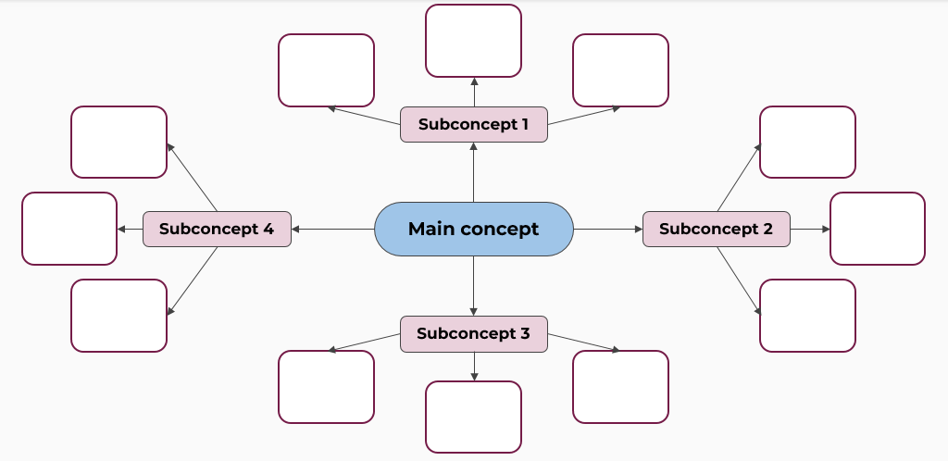
Image from Digital Learning Selector.
Differentiation: EAL/D students will need the topic language unpacked. The use of a glossary and translations would assist with this.

Variables
By reading the aim, introduction, and hypothesis, students should be able to identify the independent and dependent variables in this experiment. Students could complete a Think-Pair-Share activity to identify the variables that need to be controlled in this experiment.
Differentiation: EAL/D students may benefit from being provided a matching activity which includes the terms, definitions and the specific variables for this task.

Materials and diagram
Students should read the method and look at the equipment setup used for the demonstration to compose a list of materials and equipment required for this task.
Students draw a scientific diagram of the equipment set up and label it. When drawing diagrams, students:
- represent objects in two-dimensions
- use a sharp pencil and ruler
- label the diagrams neatly without overlapping the lines
- may construct their diagram electronically using Chemix or a similar program.
Figure 2 – equipment setup to measure the volume of gas produced in the reaction between different lengths of magnesium metal in 2M hydrochloric acid
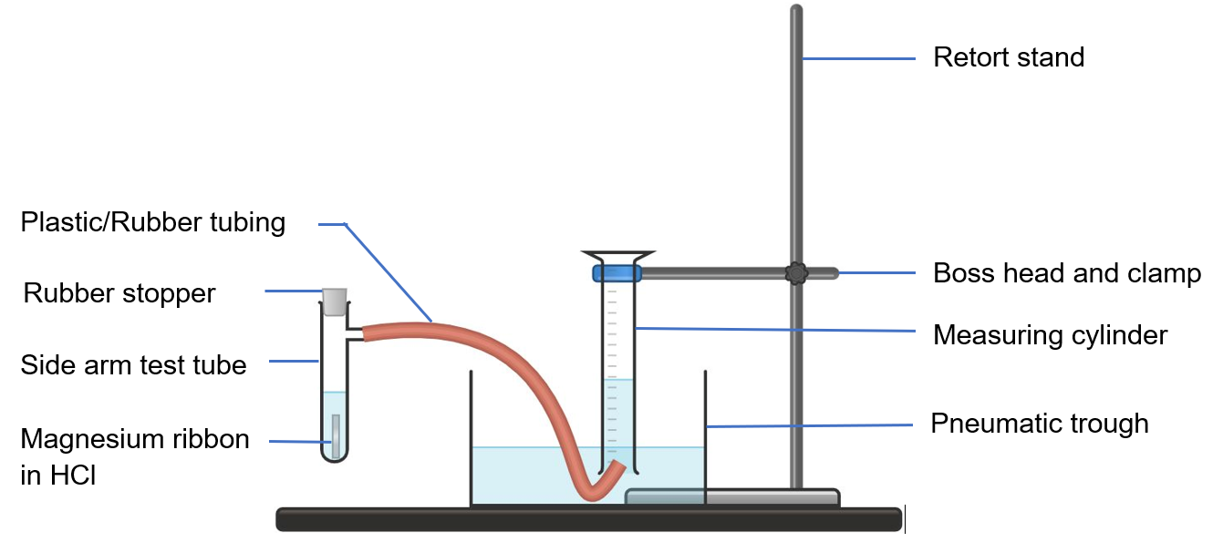
Image created in Chemix.
Differentiation: some students would benefit from having a table of correctly drawn and labelled scientific equipment to assist them in constructing their diagram of the equipment setup.

Risk assessment
Note: A full risk assessment should be conducted prior to completing this task with students. This should follow any procedures set by your school.
A sample student risk assessment has been provided in Resource 2: First-hand Investigation scaffold. Review this with students and explicitly unpack the potential hazards in this experiment and how they will be controlled.
Differentiation: for EAL/D students including visuals with the statements may help them access the information. To extend students delete information from the risk assessment table and have the students identify the hazards and control measures.

Method
A scientific method is often written in passive voice and past tense. Students should practice writing a method by converting the provided procedure into past tense and passive voice. Space for this activity has been provided in the first-hand investigation scaffold. Explain to students the difference between active and passive voice and provide an example of how to change the procedure into passive voice and past tense.
Differentiation: provision of a word bank containing a variety of relevant terms in past tense would cater to the learning needs of many students. Breaking down the language features that make this a procedure would assist EAL/D students to consolidate the learning, for example, use and location of action verbs.
Figure 3 – examples of active and passive voice in a method
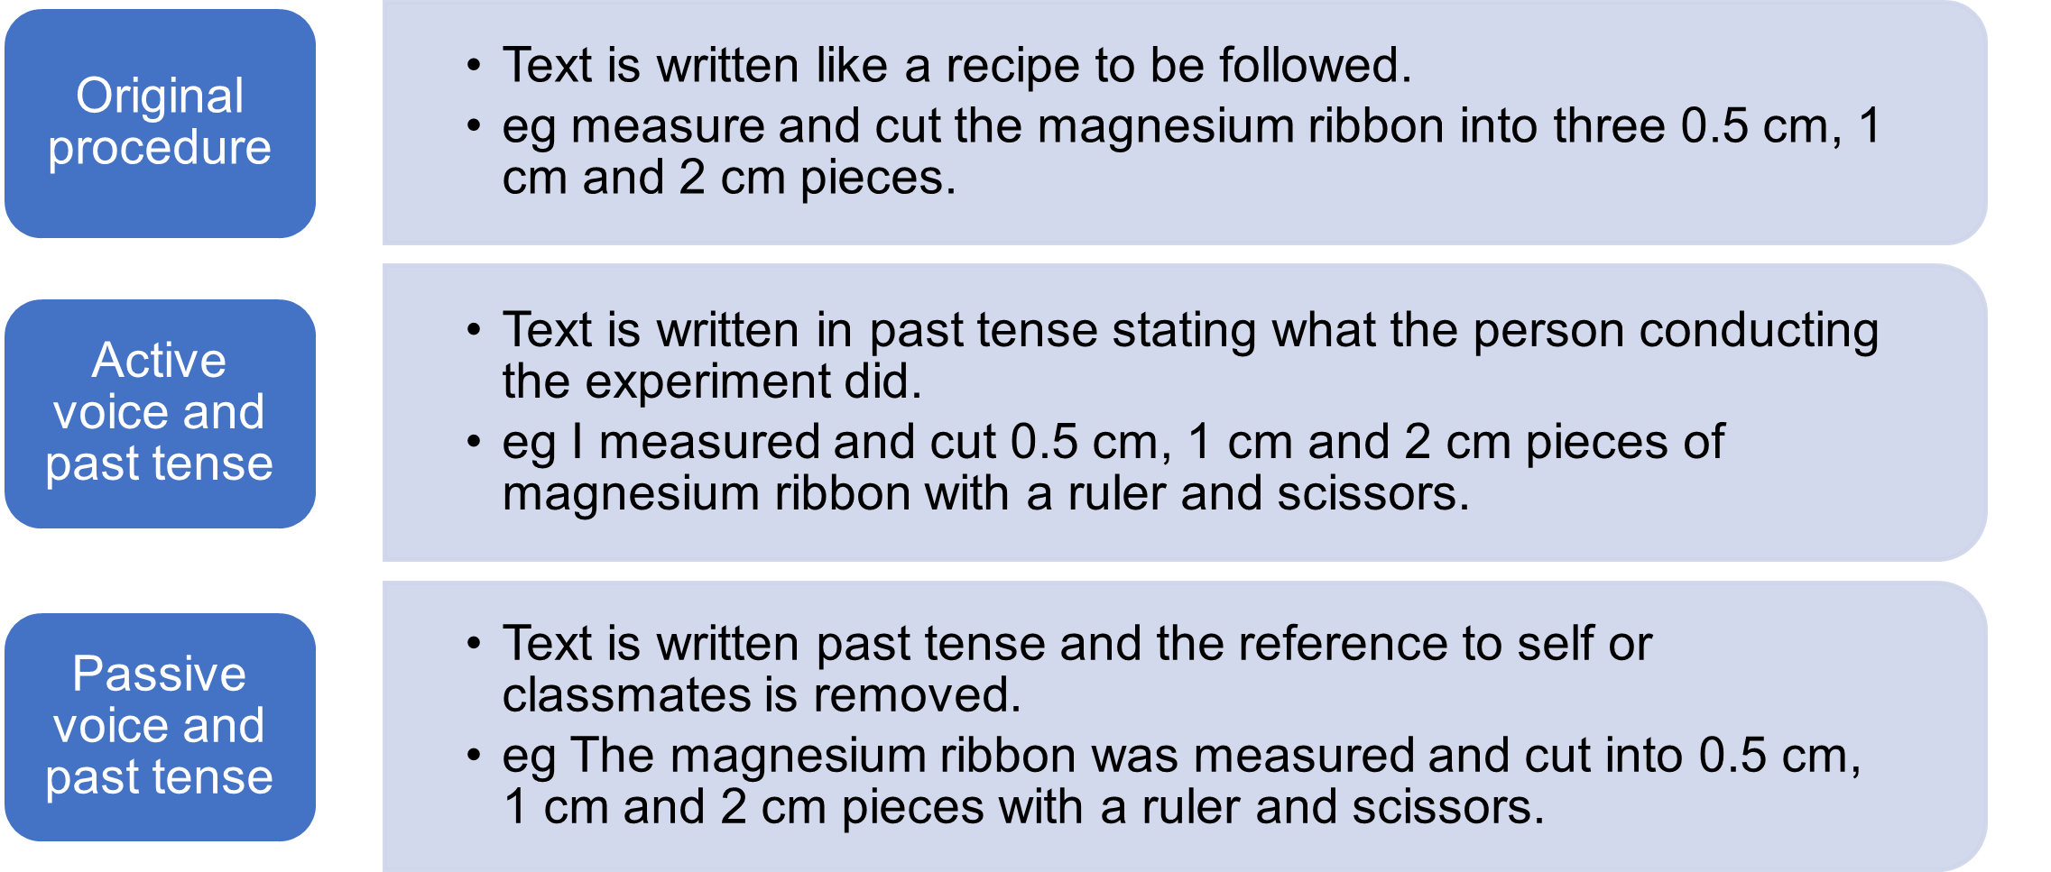

Note: there should be an excess of acid so all the magnesium will react. Therefore, there should be a clear linear trend in the graph. If a lower concentration of acid is used or a longer piece of magnesium, then the acid may limit the complete reaction of the magnesium and the graph will level out. For capable groups of students, you could provide an extension by giving them a longer piece of magnesium to test this and get them to try and explain why it does not follow the trend.
Note: since a method written in past tense and passive voice is usually written after the experiment is conducted, you could leave this activity until after the students have conducted the investigation. However, completing it prior is a good way to ensure that the students have engaged with, and understand how, to conduct the experiment.

Results table
Explain to the students that prior to collecting experimental data, a table should be developed to record the results. Explicitly teach the features of a table that make it a suitable way to represent data. Figure 4 – features of a well-presented results table, shows an annotated results table for this task.
Differentiation: some students may have a sound understanding of table construction, you could delete the table that has been included in the scaffold and have the students design their own table to record the results in. Feedback on their table design should be provided.
Figure 4 – features of a well-presented results table
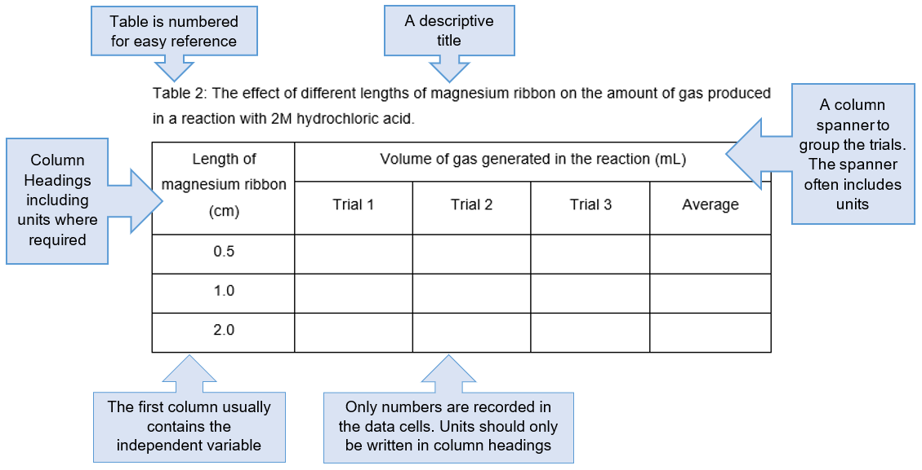

Teacher demonstration
Demonstrate to students how to set up the equipment correctly, and how to conduct the experiment to collect the gas produced in the reaction.

Reading the scale on a measuring cylinder
Students read the scale on an inverted measuring cylinder to measure the volume of gas produced in the chemical reaction. Student Resource 1: Reading scale on a measuring cylinder, provides a quick way of formatively assessing the students’ ability to correctly read the volume. It may be necessary to explicitly teach some students how to read the scale on a measuring cylinder.

Activity 2: conducting the experiment
Teacher note: students should have a good understanding of how to conduct the experiment from the planning conducted in the previous lesson. Students will need access to their report scaffold to follow the method and to record their results.
In this lesson, students will conduct the experiment in groups of 3 or 4. All equipment should be accessible to the students to allow them to get started promptly and get through the 9 trials. To reduce waste, it is recommended that the teacher dispense the given volume of acid and length of magnesium metal to each group. There will inevitably be some errors in the set up or collection of data that lead to null results for some trials. You may wish to have some additional acid and magnesium to supply if required.

Equipment and materials
You will need the following equipment for each group of students:
- 120 mL 2M hydrochloric acid
- 12 cm magnesium ribbon
- retort stand
- boss head and clamp
- 100 mL measuring cylinder
- 10 mL measuring cylinder
- side arm test tube with approximately 25-30 cm of plastic tubing attached
- rubber stopper (which fits the top of the test tube)
- 150 mL beaker (labelled, to hold the HCl)
- pneumatic trough (or similar)
- scissors
- ruler.

Collection of data
Students work collaboratively to conduct the experiment and accurately record their results. Students should identify the units in the column headings of their table. The teacher may wish to collect the results from the class in a combined table to enable a discussion about reliability.
Students can be introduced to outliers in data at this stage. For example, if a group gets an unusual result due to an equipment setup or measurement error. Also, groups may discuss how any inaccuracies in the way they performed the method could influence their results.

Activity 3: interpreting and discussing the results

Results
Students will calculate the average result for each length of magnesium. Discuss why some data may be invalid (for example, having air bubbles in the measuring cylinder) and why this data should not be included in the calculations. This data should be identified (for example an asterisk and a note below the table).
Students should graph the average volume of gas produced in the reaction for each length of magnesium either using Excel or by hand on graph paper. Explain to the students that by convention, the independent variable generally goes on the x-axis and the dependent variable on the y-axis.
Discuss with the students why a line graph is the most appropriate graph for this data. As the data is continuous it should be a line graph. A column graph is used for discrete or categorical data. Students should include the following components in their graph:
- a descriptive title
- labels on both axes
- evenly spaced values on the axes
- a line of best fit.
Assess: use the graph as an opportunity to formatively assess students’ ability to use a scale to evenly space units, and to plot data accurately.

Discussion and conclusion
The discussion and conclusion section of the report have been broken down into scaffolded paragraphs. Unpack each of the paragraphs with the students to help them understand what is expected. Questioning can help students to develop the sentences and paragraphs that they write (Polias 2016). In Figure 5 below, you can see how student writing can improve by asking specific questions along the way.
Figure 5 – example of improving student writing through asking targeted questions
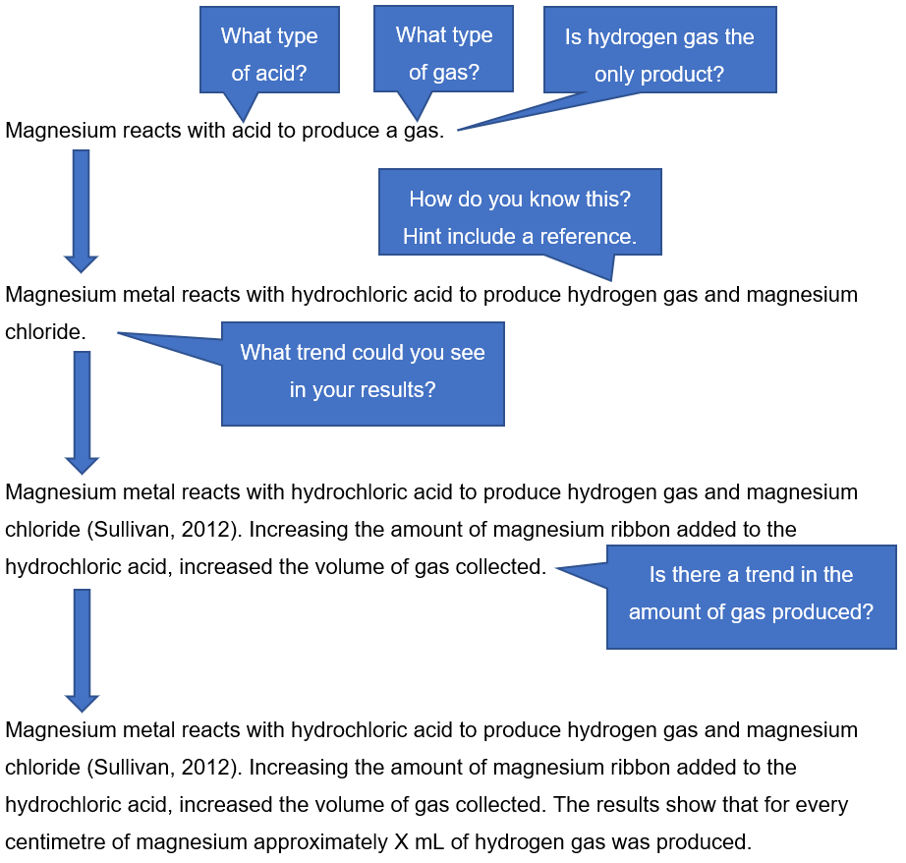
Image adapted from Polias (2016).
Evaluating the validity and reliability of the method is a good way for students to identify weaknesses in the experimental design and then propose improvements.
Validity refers to the extent which the processes and resultant data measure what was intended (Science Years 7–10 Syllabus © 2018). For an experiment to be valid, all variables other than the independent variable must be suitably controlled, the measurements collected should be accurate.
Reliability refers to the degree to which repeated observations and/or measurements taken under identical circumstances will yield the same results (Science Years 7–10 Syllabus © 2018). Reliability can be improved by using more accurate and precise measuring device such as an electronic balance to weigh the magnesium and repeating the experiment to reduce the effect of random errors.
Question prompts that could be asked to guide students in how to discuss the validity and reliability of the experiment in their report are outlined below.
Validity
- Had the magnesium finished reacting before you measured the volume of gas?
- Was the same batch of magnesium used? If you used a different batch, how might this affect the experiment?
- Did you ensure that there was no air in the inverted measuring cylinder prior to adding the magnesium?
- Did you measure the magnesium accurately? How could you have improved the accuracy?
Reliability
- Were the results for each treatment similar?
- How do your results compare to others?
- Were there enough repetitions to each treatment, to reduce the impact of random errors?
- Were results excluded due to errors that occurred (eg the tubing slipping out from under the measuring cylinder)? Does this limit your ability to calculate an accurate volume of gas produced?
The conclusion forms the last paragraph of the discussion. The Claim, Evidence, and Reasoning model (CER model) can be used to develop a conclusion for a scientific report. The CER model is a writing strategy to help students to use their analytical skills to link scientific ideas to the evidence that supports a claim.
Figure 6 – claim, evidence, reasoning model
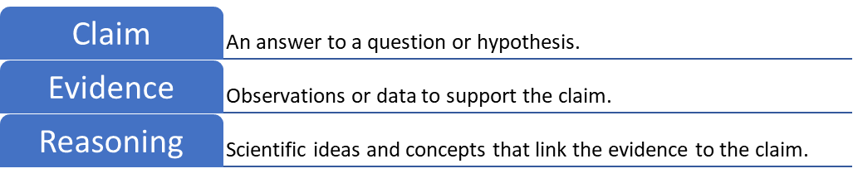
Language resources for expressing cause and effect should be taught to students to improve their ability to express causal relationships in the discussion and conclusion. The table below summarises language resources that are useful for expressing such relationships. Demonstrate the use of some of these language resources in sample sentences so that students can apply the learning in their own discussion. Further information to assist in teaching this can be found at Connecting ideas.
Table 1 – resources for expressing causal relations (Polias 2018:132).
Language resources | Examples
Causal conjunctions | Conjunctions that join clauses to make sentences: because, so, since, as, since, hence, consequently…  Conjunctions that join sentences and paragraphs: Therefore, Thus, As a result, As a consequence, …
Causal processes | results in, leads to, causes, produces, resulting in, …
Causal prepositions | because of, due to, …
Causal nominals | Cause, reason, factor effect, consequence, outcome, product, …
Teacher note: providing feedback to students on their discussion and allowing them to re-write it is an effective way to assist them in developing their analysis and report writing skills.
Differentiation: the paragraph scaffolds could be removed for students who have a good understanding of how to analyse and discuss experimental results. The example discussion could be used as a dictogloss activity to reinforce the language of the target writing for EAL/D learners.
Example discussion and conclusion
Magnesium metal reacts with hydrochloric acid to produce hydrogen gas and magnesium chloride (Sullivan 2012). Increasing the amount of magnesium ribbon added to the hydrochloric acid, increased the volume of gas collected. The results show that for every centimetre of magnesium approximately X mL of hydrogen gas was produced.
The Royal Society for Chemistry (2016) stated that 3 cm of magnesium ribbon would produce approximately 40 cm³ or 40 mL of hydrogen gas. Although a 3 cm length was not tested, it can be extrapolated from the graph that if 3 cm of magnesium was added, then approximately X mL of gas would have been produced. Therefore, the results from this experiment are similar to the experimental results collected by others.
The method was valid because only one variable was changed, and all other variables were controlled. The same batch of magnesium ribbon was used which ensured that there were no variations in the width or thickness of the ribbon. The experiment was reliable as the repeat measurements were very similar, all being within +/- 3 mL. The reliability of this experiment could have been improved by using a more precise method of measuring and cutting the magnesium ribbon, or by using an electronic balance to measure the mass of each piece of magnesium. Small errors in these measurements could lead to inaccurate results.
There is a linear relationship between the amount of magnesium and the volume of gas produced in its reaction with excess hydrochloric acid. The volume of gas produced in the reaction increased with the length of the magnesium. For every 1 cm of magnesium approximately X of hydrogen gas was produced, which is consistent with other results. This result supports the hypothesis that the longer the magnesium ribbon, the larger the volume of gas that will be produced.
Forms of feedback that appear to be particularly effective include feedback about a student’s process or effort, for example, ‘I can see you tried hard to improve X. The result is much better than last time because you did Y’; and feedback that encourages students’ self-regulation, for example, ‘You already know the key features of the opening of an argument. Check to see whether you have incorporated them in your first paragraph’.
CESE What works best update 2020

Student resources

Resource 1: reading scale on a measuring cylinder
You are measuring the volume of gas produced in a chemical reaction by collecting the gas in an inverted (upside down) measuring cylinder. Practice recording the volumes of gas in the following measuring cylinders and get your teacher to check your answers.
Figure 6 – formative assessment activity: reading volume of gas collected in an inverted measuring cylinder
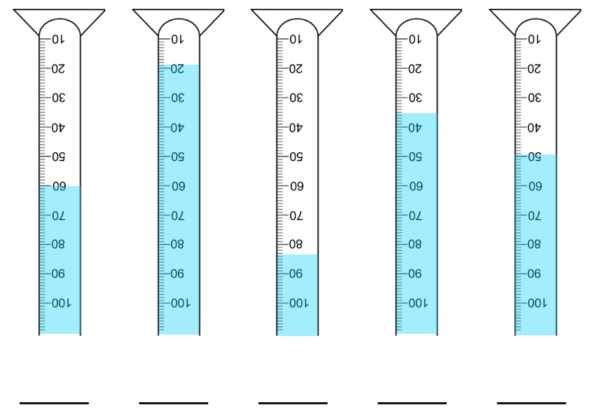

Resource 2: first-hand investigation scaffold
Investigating the volume of gas produced in the acid metal reaction: Hydrochloric acid + magnesium.

Aim
To determine the volume of gas produced during an acid-metal reaction between magnesium and hydrochloric acid.

Introduction
A chemical reaction is defined as a process in which one or more reactants, are converted to, one or more products (Treichel 2006). A variety of factors can be used to identify when a chemical reaction has taken place, including change in temperature, formation of a gas, formation of a solid (precipitate), change in colour and emission of light (CK-12 Foundation, 2021) This report will look at the exothermic, acid metal reaction between magnesium metal and hydrochloric acid.
Acids react with most metals to form a salt and hydrogen gas as shown by the simple word equation:
$$acid + metal → salt + hydrogen$$
(Lawson et al. 2020). Magnesium reacts with hydrochloric acid according to the equation:
$$magnesium + hydrochloric acid → magnesium chloride + hydrogen$$
(Sullivan 2012). This word equation can also be written as the balanced chemical equation:
$Mg_{\left(s\right)}+ 2HCl_{\left(aq\right)}→MgCl_{2\left(aq\right)}+H_{2\left(g\right)}$This indicates that one atom of magnesium metal will react with 2 molecules of hydrochloric acid to produce one molecule of magnesium chloride and one molecule of hydrogen gas.
A range of factors can influence chemical reactions and need to be considered when designing experiments. Factors include the temperature of the reactants and concentration
of the reactants (Theopold et al. 2020). A limiting reagent in a chemical reaction is a reactant that is totally consumed in the reaction when the reaction is completed (Theopold et al. 2020).
The signs of a chemical change in this experiment will include the production of heat, the evolution of a gas and the solid magnesium metal will eventually disappear (Sullivan 2012). In this experiment, different lengths of magnesium metal ribbon will be added to 2M hydrochloric acid to determine the amount of gas produced in the reaction. The Royal Society of Chemistry (2016) states that 3 cm of magnesium ribbon has a mass of approximately 0.04 g and yields 40 cm³ of hydrogen gas when reacted with excess acid. An excess of acid will be used to ensure that only the magnesium is responsible for the volume of gas that is produced in each trial.

Hypothesis
The longer the piece of magnesium ribbon, the larger the volume of gas that will be produced.
Read the aim, introduction and hypothesis to help you identify the independent, dependent and controlled variables for this experiment.

Variables
Independent variable (the variable that is changed on purpose).
Dependent variable (the variable that is measured/observed to obtain results).
Controlled variables (The variables that are kept the same, so they do not influence the results. Include how the variable was kept the same).
Use the procedure to determine an accurate equipment list. Don’t forget to include sizes, quantities, and concentrations.

Materials and equipment

Procedure
- Measure and cut the magnesium ribbon into three 0.5 cm, 1 cm and 2 cm pieces.
- Fill the measuring cylinder to the brim with water and invert (turn upside down) in the trough (as shown in the below diagram). Make sure no air bubbles get in and secure it with the clamp on the retort stand.
- Position the plastic tubing from the side arm test tube so that it directs the gas into the measuring cylinder.
- Place 10 mL of 2M hydrochloric acid in a large side arm test tube.
- Drop a 0.5 cm piece of magnesium in the test tube and immediately place the stopper over the opening. (The gas will travel through the tubing and displace the water in the upturned measuring cylinder.)
- Measure and record the volume of gas produced.
- Repeat Steps 2–6 with the remaining two 0.5 cm lengths of magnesium.
- Repeat Steps 2–7 with the 1 cm and 2 cm lengths of magnesium.
Re-write the procedure above into a method section below. Convert the method into passive voice and past tense in the space provided.

Method
Draw a scientific diagram of the equipment set up and include labels. Remember that scientific diagrams are drawn in 2D with a pencil and ruler. The labels should be neatly ruled, and the lines should not cross each other.

Risk assessment
Table 1 – an outline of the hazards in the experiment and the control measures put in place to reduce the risk.
Items/Chemicals | Hazard | Control measures
Beakers, measuring cylinders | Breakage of beaker. Cuts from chipped glassware. | Use standard handling procedures. Inspect and discard broken glassware. Sweep up broken glass with a dustpan and brush; do not use fingers to clean up broken glass. Wear enclosed leather shoes.
Hydrochloric acid | Splashing chemicals in eyes or on skin. | Wear safety glasses throughout the experiment. Wear enclosed leather footwear. Wash splashes off the skin with cool water.
Water spills, bags, chairs | Slips, trips and falls. | Bags are to remain away from the work area. Spills are to be cleaned immediately. No running in the lab.

Results
Use Table 2 to record the results from your experiment. Add the correct units in the column headings inside the brackets, and the lengths of the magnesium ribbon being tested in the first column.
Table 2 – the effect of different lengths of magnesium ribbon on the amount of gas produced in a reaction with 2M hydrochloric acid
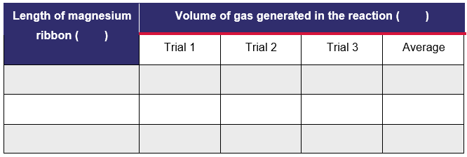
Graph the average volume of gas produced in the reaction for each length of magnesium. Remember the independent variable should go on the x-axis and the dependent variable on the y-axis. Your graph should include the following: a descriptive title, labelled axes, evenly spaced units, and a line of best fit. You can use Excel or graph paper to draw your graph. Include it in the space provided.

Discussion
Paragraph 1: describe what happened in the experiment. Outline what the results show, referring to the data in your response.

Paragraph 2: link your findings back to the theory of reaction of a metal with an acid. To do this you will have to re-read the introduction, and perhaps look up some more information.
Paragraph 3: assess the validity and reliability of this experiment. Identify potential sources of error and how they can be overcome if you repeated the experiment again.
Conclusion: write your conclusion below. The conclusion should summarise the findings from the experiment and link it back to the hypothesis being supported or refuted.

References
When conducting a first-hand investigation, you should first do some research. It is important that all sources of information used to write your report are recorded in a reference list. The references used to write the introduction for this report are recorded in APA format below.
CK-12 Foundation. (2021). Signs of Chemical Reactions. Retrieved July 9, 2021, from https://www.ck12.org/chemistry/signs-of-chemical-reactions/lesson/Recognizing-Chemical-Reactions-MS-PS/
Lawson, P., Alviar-Agnew, M., & Agnew, H. (2020). 14.5: Reactions of Acids and Bases. Chemistry LibreTexts. Retrieved July 9, 2021, from https://chem.libretexts.org/Bookshelves/Introductory_Chemistry/Map%3A_Introductory_Chemistry_(Tro)/14%3A_Acids_and_Bases/14.05%3A_Reactions_of_Acids_and_Bases
RSC Education. (2016) The rate of reaction of magnesium with hydrochloric acid. Royal Society of Chemistry: Education. Retrieved July 9, 2021, from https://edu.rsc.org/experiments/the-rate-of-reaction-of-magnesium-with-hydrochloric-acid/1916.article#!cmpid=CMP00006119
Sullivan, R. (2021). Magnesium and Hydrochloric Acid. ChemDemos. Retrieved July 9, 2021, from https://chemdemos.uoregon.edu/demos/Magnesium-and-Hydrochloric-Acid#
Theopold, P. F., Langley, K. and Langley, R. (2020). Factors Affecting Reaction Rates (Kinetics). Chemistry LibreTexts. Retrieved July 12, 2021, from https://chem.libretexts.org/@go/page/236769
Treichel, P. M. (2006). Chemical reaction. Brittanica. Retrieved July 9, 2021, from https://www.britannica.com/science/chemical-reaction

Support and alignment
Resource evaluation and support: all curriculum resources are prepared through a rigorous process. Resources are periodically reviewed as part of our ongoing evaluation plan to ensure currency, relevance and effectiveness. For additional support, advice or feedback contact the Science Curriculum team by emailing Science7-12@det.nsw.edu.au.
Differentiation: further advice to support Aboriginal and Torres Strait Islander students, EALD students, students with a disability and/or additional needs and High Potential and gifted students can be found on the Planning programming and assessing 7-12 webpage.
Assessment: further advice to support formative assessment is available on the Planning programming and assessing 7-12 webpage.
Professional learning: relevant professional learning is available on the Science statewide staffroom.
Related resources: further resources to support Stage 5 Science can be found on the Science Curriculum page.
Consulted with: Inclusive Education, Multicultural Education, Literacy and Numeracy and subject matter experts.
Alignment to system priorities and/or needs: School Excellence Policy, School Success Model.
Alignment to the School Excellence Framework: this resource supports the School Excellence Framework elements of curriculum (curriculum provision) and effective classroom practice (lesson planning, explicit teaching).
Alignment to Australian Professional Teaching Standards: this resource supports teachers to address Australian Professional Teaching Standards 2.5.2, 3.2.2, 3.3.2.
Author: Science 7-12 Curriculum Team
Resource: classroom resource
Creation date: December 2022

References
NSW Science Years 7–10 Syllabus © 2018 NSW Education Standards Authority (NESA) for and on behalf of the Crown in right of the State of New South Wales.
CK-12 Foundation (2023) Signs of Chemical Reactions, CK-12 website, accessed 09 July 2021.
Lawson P, Alviar-Agnew M and Agnew H (2020) 14.5: Reactions of acids and bases in chemistry, LibreTexts Chemistry, accessed 9 July 2021.
NESA (NSW Education Standards Authority) (2022) ‘Proficient Teacher: Standard descriptors’, The Standards, NESA website, accessed 24 November 2022.
Polias J (2016) Apprenticing Students Into Science: Doing, Talking & Writing Scientifically, Lexis Education, Australia.
RSC Education (Royal Society of Chemistry) (2016) The rate of reaction of magnesium with hydrochloric acid, Royal Society of Chemistry: Education, accessed 9 July 2021.
State of New South Wales (Department of Education) and CESE (Centre for Education Statistics and Evaluation) (2020) ‘What works best: 2020 update’, CESE, NSW Department of Education, accessed 24 November 2022.
State of New South Wales (Department of Education) and CESE (Centre for Education Statistics and Evaluation) (2020) ‘What works best in practice’, CESE, NSW Department of Education, accessed 24 November 2022.
Sullivan R (2012) Magnesium and Hydrochloric Acid, University of Oregon ChemDemos website, accessed 9 July 2021.
The Bell Foundation (2023) Dictogloss, The Bell Foundation website, accessed 24 February 2023.
Theopold PF, Langley K and Langley R (18 July 2020) 8.3: Factors Affecting Reaction Rates (Kinetics), LibreTexts Chemistry website, accessed 12 July 2021.
Treichel PM and Kotz JC (23 February 2006) ‘Chemical Reactions: Definitions, Equations, Examples & Types’, Encyclopedia Britannica, accessed 9 July 2021.
Wiliam D and Leahy S (2015) Embedding formative assessment: practical techniques for K-12 classrooms, Learning Sciences International, US.

Further reading
State of New South Wales (Department of Education) (2022) Literacy and numeracy priorities, NSW Department of Education website, accessed 24 February 2023.
State of New South Wales (Department of Education) (2022) Literacy and numeracy, NSW Department of Education website, accessed 9 March 2023.
© State of New South Wales (Department of Education), 2023
The copyright material published in this resource is subject to the Copyright Act 1968 (Cth) and is owned by the NSW Department of Education or, where indicated, by a party other than the NSW Department of Education (third-party material).
Copyright material available in this resource and owned by the NSW Department of Education is licensed under a Creative Commons Attribution 4.0 International (CC BY 4.0) licence.
This licence allows you to share and adapt the material for any purpose, even commercially.
Attribution should be given to © State of New South Wales (Department of Education), 2023.
Material in this resource not available under a Creative Commons licence:
- the NSW Department of Education logo, other logos and trademark-protected material
- material owned by a third party that has been reproduced with permission. You will need to obtain permission from the third party to reuse its material.
Links to third-party material and websites
Please note that the provided (reading/viewing material/list/links/texts) are a suggestion only and implies no endorsement, by the New South Wales Department of Education, of any author, publisher, or book title. School principals and teachers are best placed to assess the suitability of resources that would complement the curriculum and reflect the needs and interests of their students.
If you use the links provided in this document to access a third-party's website, you acknowledge that the terms of use, including licence terms set out on the third-party's website apply to the use which may be made of the materials on that third-party website or where permitted by the Copyright Act 1968 (Cth). The department accepts no responsibility for content on third-party websites.

