Science Stage 4 – learning sequence – escape room: working scientifically on the soccer field
Contents
Overview 2
Information for teachers 3
Introduction 3
Outcomes 4
Learning intentions and success criteria 4
Teaching and learning activities 5
How to play: (digital version) 5
How to play: (paper version) 6
Introduction 7
The challenges 8
Student resources 11
Resource 1 – challenge 1: Observation or inference? worksheet 11
Resource 2 – challenge 2: Scientific method worksheet 13
Resource 3 – challenge 3 (part A): Variables worksheet 15
Resource 4 – challenge 3 (part B): Variables worksheet 16
Resource 5 – challenge 3 (Part C): Variables worksheet 17
Resource 6 – challenge 3 (part D): Variables worksheet 18
Resource 7 – challenge 4: Soccer game variables worksheet 19
Resource 8 – challenge 5: ‘The best goal scorer is going to be captured!’ worksheet 22
Resource 9 – challenge 6: Graphing goals worksheet 24
Resource 10 – challenge 7: Scoring goals worksheet 27
Resource 11 – challenge 8: ‘And the winner is…!’ worksheet 29
Answer sheet 31
Suggested answers 36
Support and alignment 42
References 44
Further reading 45

Overview
Stage and Learning Area: Science Stage 4
Description: this resource has been designed to address the Science Years 7–10 Syllabus Working Scientifically skills.
This learning sequence builds understanding of questioning and predicting and processing and analysing data.
Duration: while timing will vary based on the mode of delivery, differentiation strategies employed and class or school context, this series of activities should take approximately one period.

Information for teachers
This task consists of a series of puzzles that focus on the difference between an aim and a hypothesis as well as variables, reading tables and graphs. Students use their problem-solving skills and scientific knowledge to break codes and move through challenges. This learning task can be used in digital form via a link on your preferred learning platform. Alternatively, paper copies can be used. The beauty of using a paper copy is the interaction between teacher and student as the students challenge themselves and development resilience as they solve the problems.

Introduction
This learning sequence is designed to build skills gradually throughout the task. Teachers may wish to modify the task or focus on specific sections based on their class context, student ability and current mastery of content.

Suggestions for use
Escape rooms can be used in a variety of ways. This task is a fun activity to be used at the conclusion of a learning sequence to consolidate learning or as an engaging way to informally assess student learning. The digital version of an escape room could be allocated as a homework task; however, this removes the collaboration and the element of competition inherent in the classroom. It is suggested that students complete the escape room in teams.
This escape room can be completed in either digital or paper form.
Digital format: A link to the escape room can be placed on your preferred learning platform. Students work through each challenge individually or part of a small group. As each challenge is completed, the next challenge opens.
Science digital resources – on the soccer field.
Paper format: this resource works well as a paper resource. A copy of each challenge can be printed and placed around the room creating eight stations. Students work in small groups to complete the challenges. As each challenge is completed, students fill out the answer sheet and bring it to the teacher. If they have the answer correct, they can move on to another station. If students are experiencing difficulty with a station, the teacher may provide guidance, or they can skip it and come back to it.

Outcomes
A student:
- identifies questions and problems that can be tested or researched and makes predictions based on scientific knowledge SC4-4WS
- processes and analyses data from a first-hand investigation and secondary sources to identify trends, patterns and relationships, and draw conclusions SC4-7WS
Science Years 7–10 Syllabus © NSW Education Standards Authority (NESA) for and on behalf of the Crown in right of the State of New South Wales, 2018.

Learning intentions and success criteria
Students:
- process and analyse data to develop their Working Scientifically skills.
Students can:
- distinguish between an aim and hypothesis
- distinguish between and identify the different types of variables
- process and analyse data in tabular, graphical and diagrammatic form
- solve problems in a variety of scenarios.
Differentiation consideration: learning intentions should not be differentiated. All students need access to the same core content, big ideas and concepts. Differentiation should be evident in the success criteria, or the activities or support needed to achieve the success criteria (Wiliam and Leahy 2015). Teachers may co-construct the success criteria with students or adjust them to suit their class context, for example using the strategies and resources for curriculum planning on the Planning, programming and assessing 7-12 webpage.

Teaching and learning activities
This sequence of activities is available in digital form at the following link: Working Scientifically escape room.
Alternatively, the task can be used in paper form using the following resources. Each challenge has teacher instructions and a worksheet. A student answer sheet and sample answers are also provided.

How to play: (digital version)
Science digital resources – on the soccer field.
How much do you understand the Working Scientifically skills you have learned in class? This escape room asks you to apply your knowledge and solve problems to work through the challenges and escape the program.
Let’s go to the Ultimate Clash, solve some problems, and find out who wins the game. Work together as a team and use everyone’s skills.
Read the newspaper article and click on the link Solve these challenges embedded in the article to begin your adventure.
As you move through each challenge, you will solve problems and answer questions. If you answer correctly, you will be able to move on to the next challenge. If you are incorrect, you will have to go back and try again. You can try as many times as you need. We want everyone to succeed.
Each challenge has its own set of instructions so read them carefully before you start.
Bring your friends, your imagination, and a sense of fun.
Let’s go!

How to play: (paper version)
How much do you understand the Working Scientifically skills you have learned in class? This escape room asks you to apply your knowledge and solve problems to work through the challenges and escape the classroom.
Let’s go to the Ultimate Clash, solve some problems, and find out who wins the game. Work together as a team and use everyone’s skills.
Read the newspaper article to set the scene before you begin your adventure.
As you move through each challenge, you will solve problems and answer questions. Check your answer with your teacher, if you answer correctly, you will be able to move on to the next challenge. If you are incorrect, you will have to go back and try again. You can try as many times as you need. We want everyone to succeed.
Each challenge has its own set of instructions so read them carefully before you start.
Bring your friends, your imagination, and a sense of fun.
Let’s go!
Differentiation: some students may need adjustments to participate in group activities. This could include explicit teaching of group work skills, allocation of roles within groups or thoughtful allocation and selection of groups. Consider your class needs and adjust accordingly.
Some students may require support in recall of the vocabulary used in this task. This could be conducted at the start of the lesson as a whole class review or with individuals on an ‘as needs’ basis.

Introduction
Figure 1 – newspaper image outlining details of the Ultimate Clash soccer game
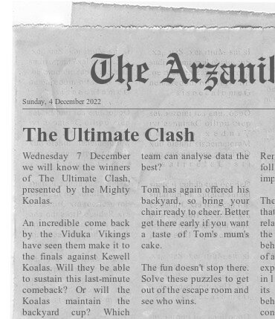
Image created using The Newspaper Clipping Generator by fodey.com.

The challenges

Challenge 1: observations and inferences
This puzzle requires students to decode a puzzle using Morse code. They then answer a question based on the decoded phrase.
Note: students may not have experience with Morse code and the structure of the code and how to read it may need to be explained to them.

Challenge 2: scientific method
In this challenge, students will answer questions using their knowledge of aims and hypotheses to solve the problem.

Challenge 3: variables
This challenge requires students to solve a cryptogram. The students then answer the question in the cryptogram to solve the puzzle.
It may be necessary to explain how to solve cryptograms to students. The easiest starting point is with the short words where there are few options of letters that can be used. For example, ‘i__’, the missing letter can only be ‘f’, ‘s’, ‘t’ or ‘n’.
That letter can then be substituted below the corresponding number above and into any other spaces with the same letter.
The QR code below will take you to an instructional video showing students how to solve a cryptogram.
Differentiation: four cryptograms of varying levels of difficulty have been included in the student resources section. Choose the correct level of difficulty for your class.

Challenge 4: soccer game variables
In this challenge students are presented with 3 tickets that are almost the same. They will need to inspect each ticket carefully to identify the independent variable, dependent variable and controlled variables and answer a question.
The variables could be laminated and cut out for students to organise into the table to increase engagement and use organisational skills.
Differentiation: reading tickets may be unfamiliar to some students and may require explicit teaching of this skill.

Challenge 5: the best goal scorer is going to be captured
Students read the ransom note and answer the question using the tabulated data. The students will need to calculate the average for each player to find their average goal strike rate. They will then compare the averages to determine the player with the highest average goal strike rate.

Challenge 6: graphing goals
In this challenge, the students will read a table and graph to calculate the number of saved goals and answer the questions to move on to the next challenge.
Students will also interpret a graph to answer questions and identify trends.

Challenge 7: scoring goals
In this challenge, students will inspect a heat map showing the probability of goals being scored and actual goals scored. The students may not have been exposed to a heat map before, however, allow them time to process and problem solve before stepping in to provide assistance.
Note: the transparent dots show the probability of a goal being scored from that position. The white dots show successful goal attempts. A larger diameter indicates a higher probability of the goal being scored.

Challenge 8: And the winners are…!
Students will read a competition ladder to determine which teams will be in the competition finals.

Student resources

Resource 1 – challenge 1: Observation or inference? worksheet
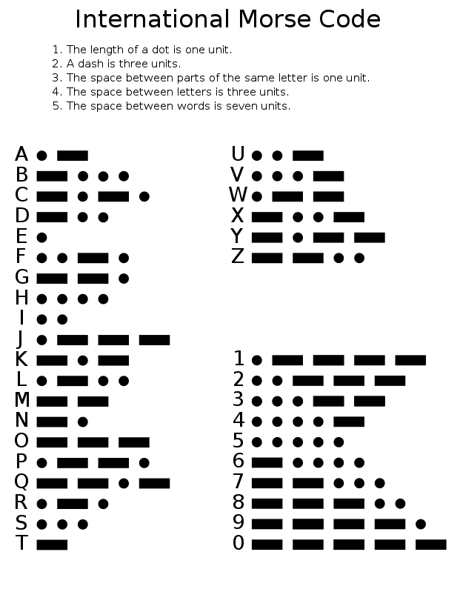
‘Chart of the Morse code letters and numerals’ by Rhey T. Snodgrass and Victor F. Camp is in the Public domain.
The following statement is written in Morse code. Use the code above to decipher the message below.

Is this an example of an observation or an inference? _____________________________

Resource 2 – challenge 2: Scientific method worksheet
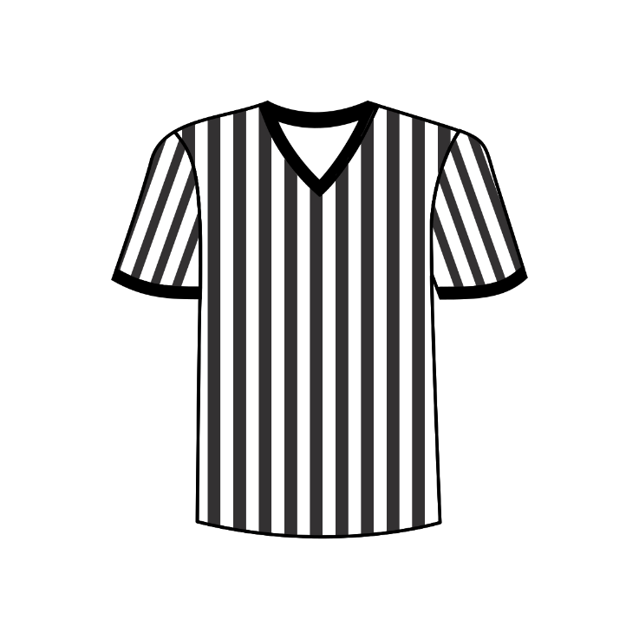
‘Football referee shirt’ by Casino is in the Public domain.

Knowing the rules
Just like soccer, Working Scientifically requires us to understand the rules and definitions of key terms.
- An aim is a formal statement of the purpose of the investigation.
- A hypothesis is a formal testable statement or prediction of the expected outcome of the investigation.
Answer the questions below to help you solve the next challenge.
- ‘The referee will trip over the dog’ is an example of a(n):
- Aim
- Hypothesis
- Prediction
- Conclusion
- ‘To determine how many times the referee trips over the dog on the field during the game’ is an example of a(n):
- Aim
- Hypothesis
- Prediction
- Conclusion
- ‘The referee will only trip over the dog once during the game because the owner will come and get it’ is an example of a(n):
- Aim
- Hypothesis
- Prediction
- Conclusion
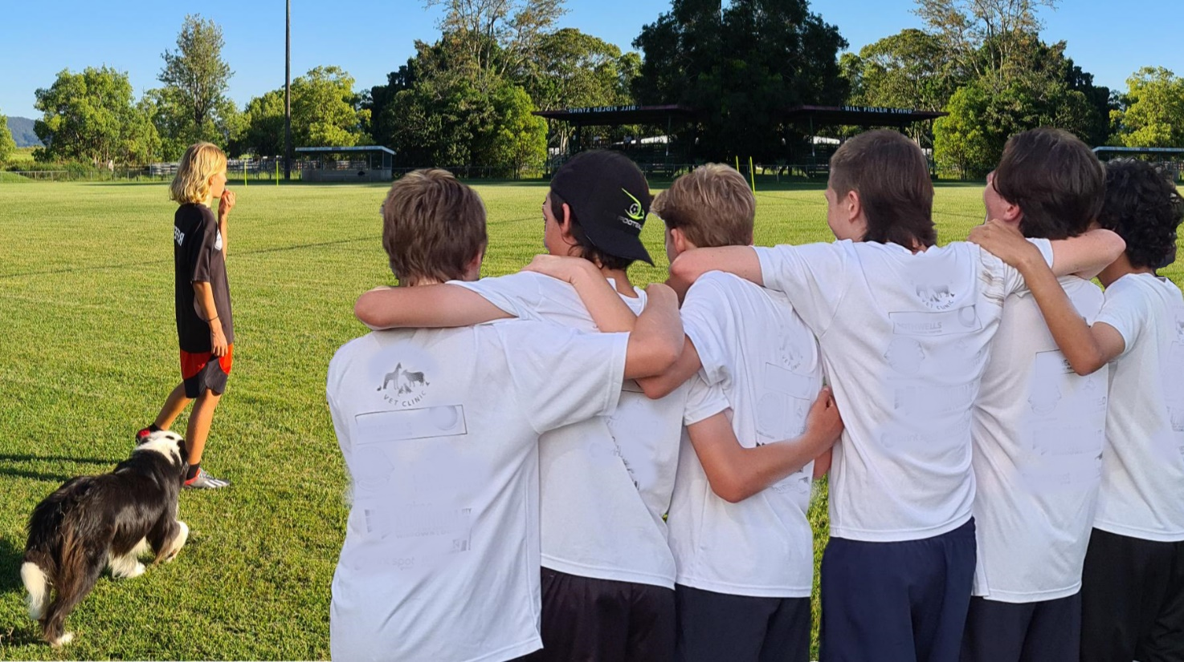

Resource 3 – challenge 3 (part A): Variables worksheet
Solve the cryptogram below.
When you have solved the puzzle answer the question.
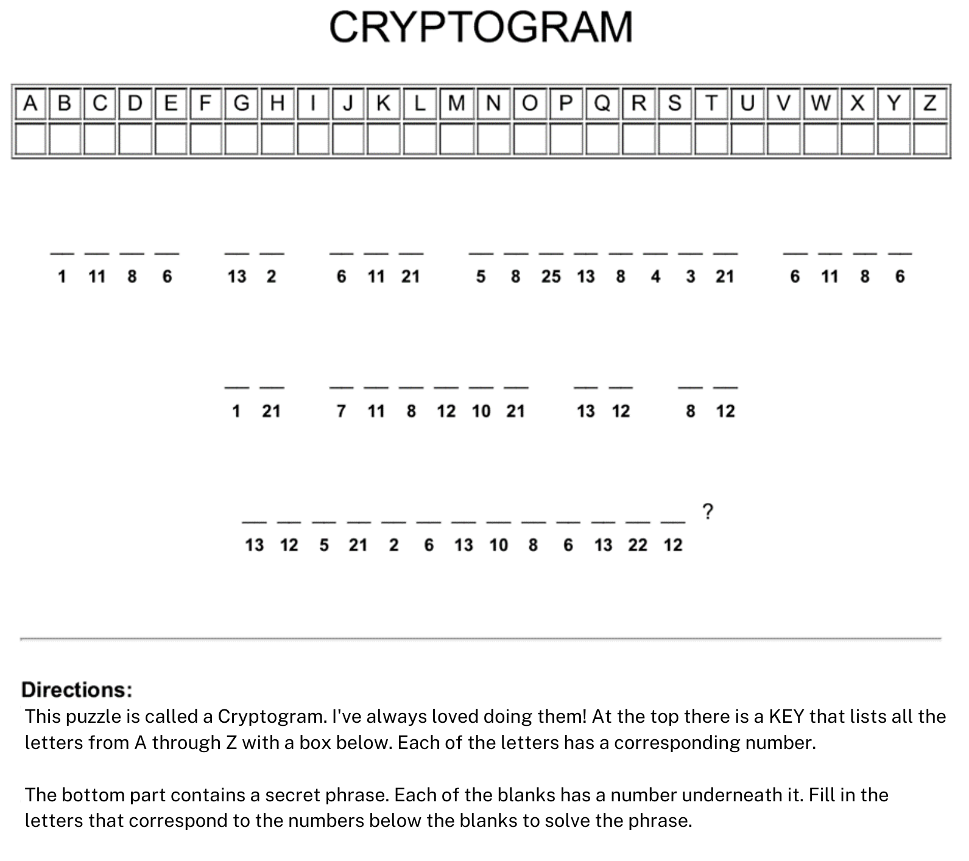
Cryptogram generated at KidZone.ws.

Resource 4 – challenge 3 (part B): Variables worksheet
Solve the cryptogram below.
When you have solved the puzzle answer the question.
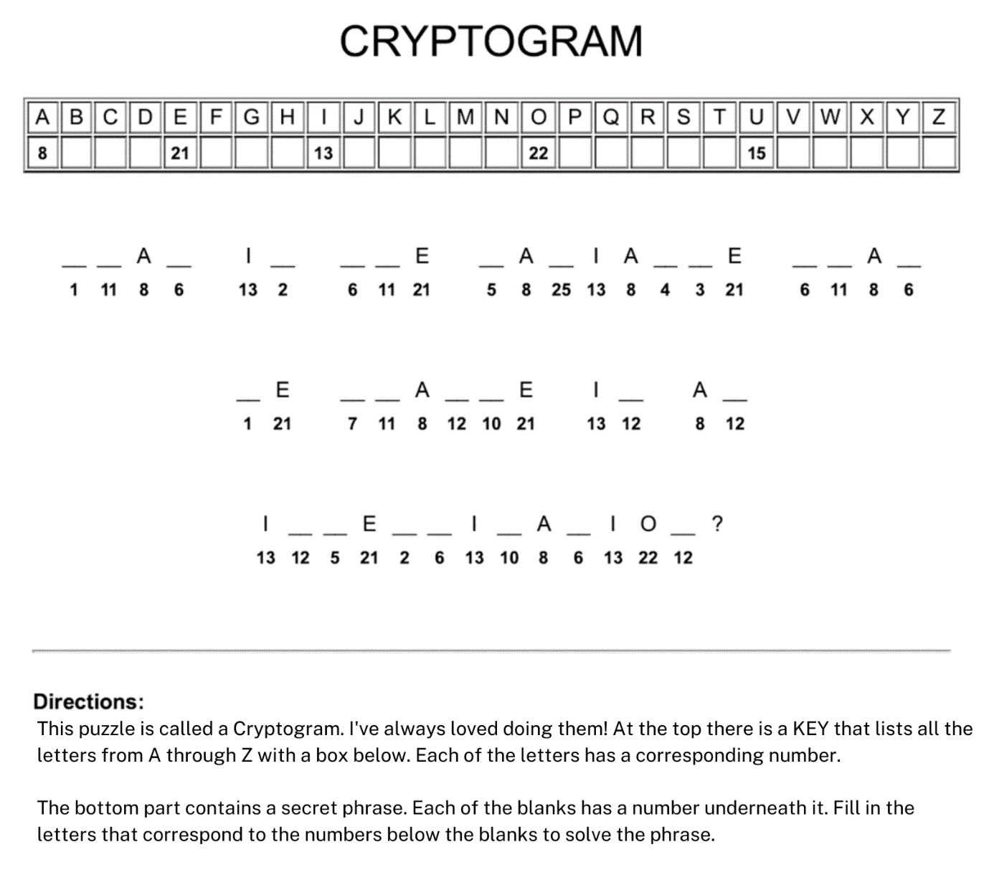
Cryptogram generated at KidZone.ws.

Resource 5 – challenge 3 (Part C): Variables worksheet
Solve the cryptogram below.
When you have solved the puzzle answer the question.
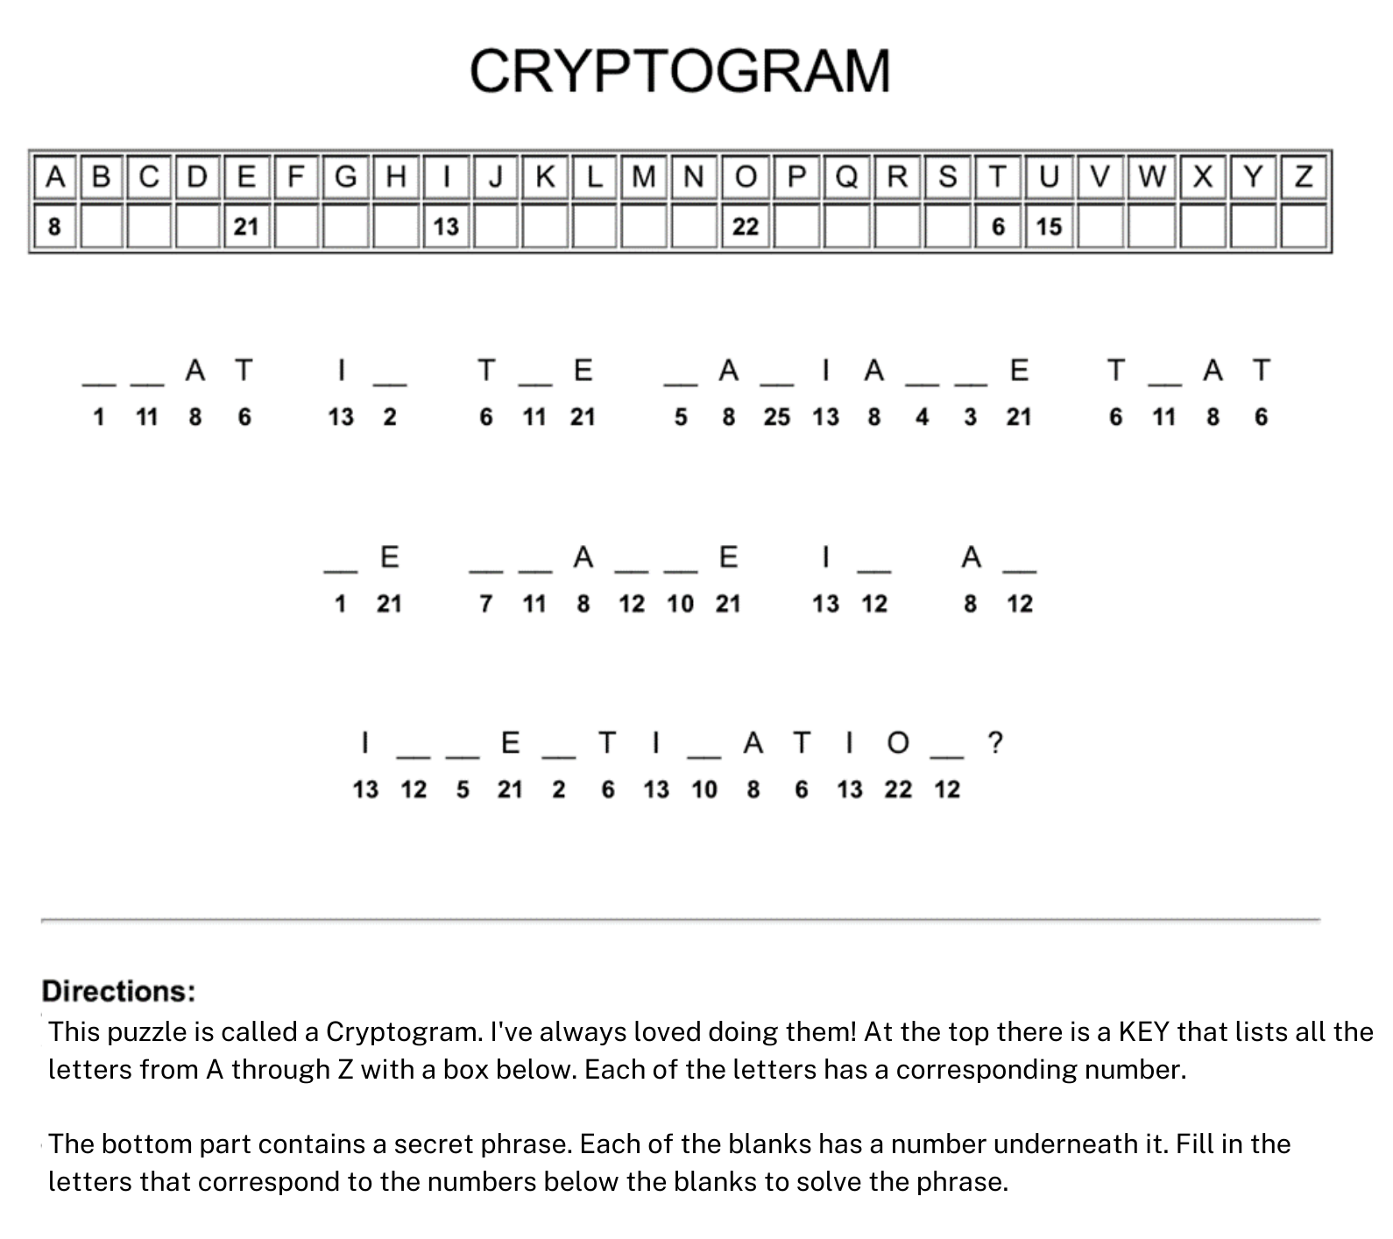
Cryptogram generated at KidZone.ws.

Resource 6 – challenge 3 (part D): Variables worksheet
Solve the cryptogram below.
When you have solved the puzzle answer the question.
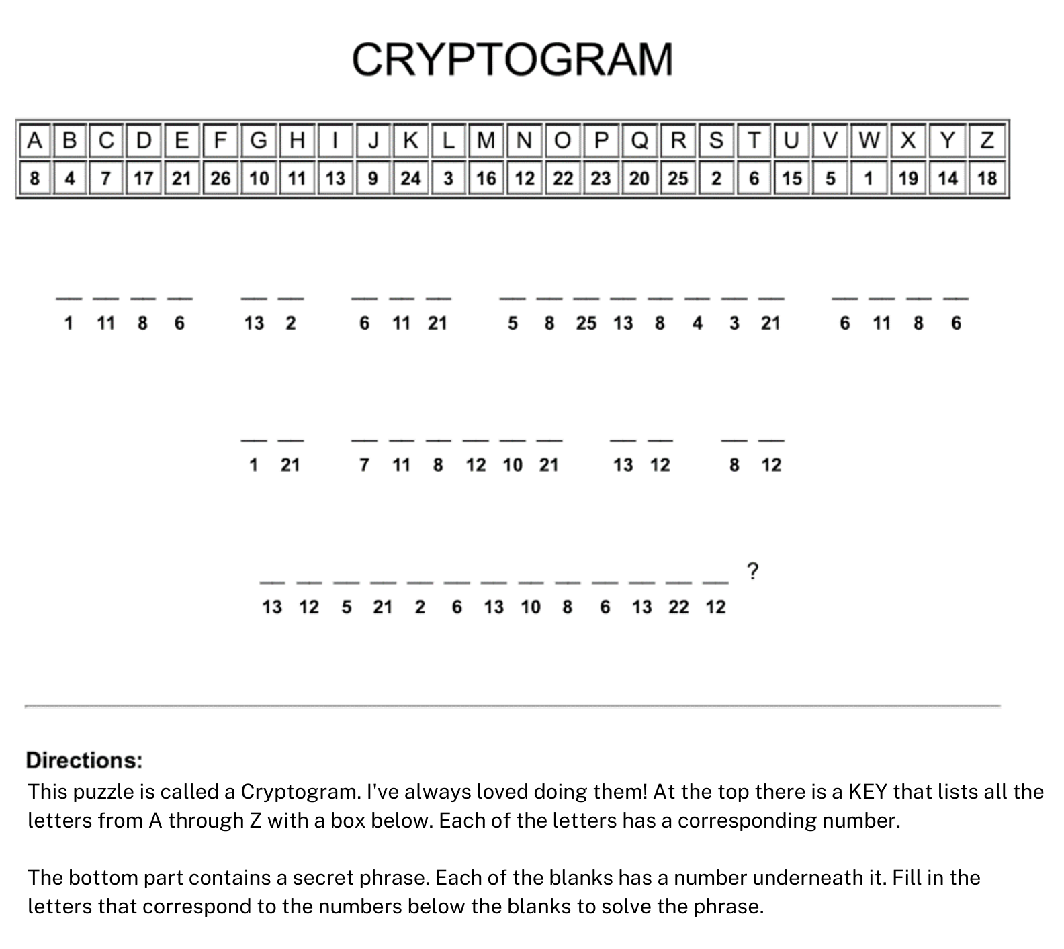
Cryptogram generated at KidZone.ws.
Answer:

Resource 7 – challenge 4: Soccer game variables worksheet
Look carefully at the 3 tickets below.
Imagine that a soccer game is like a scientific investigation. Each match is an investigation that has a different variable.
Use the information from the tickets to categorise each of the following variables.
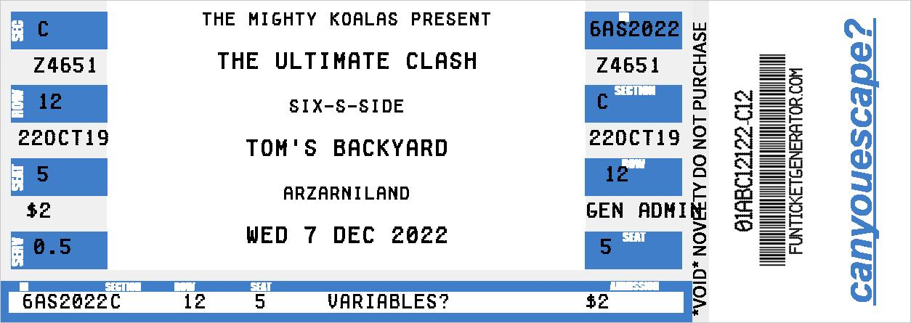
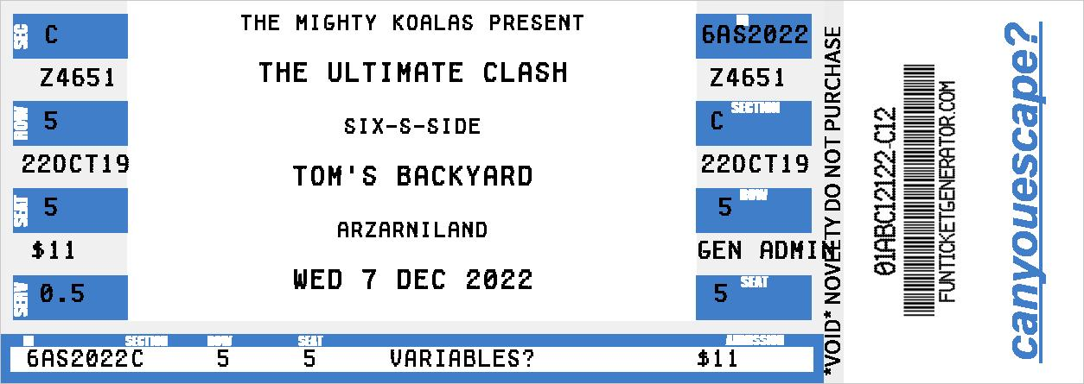
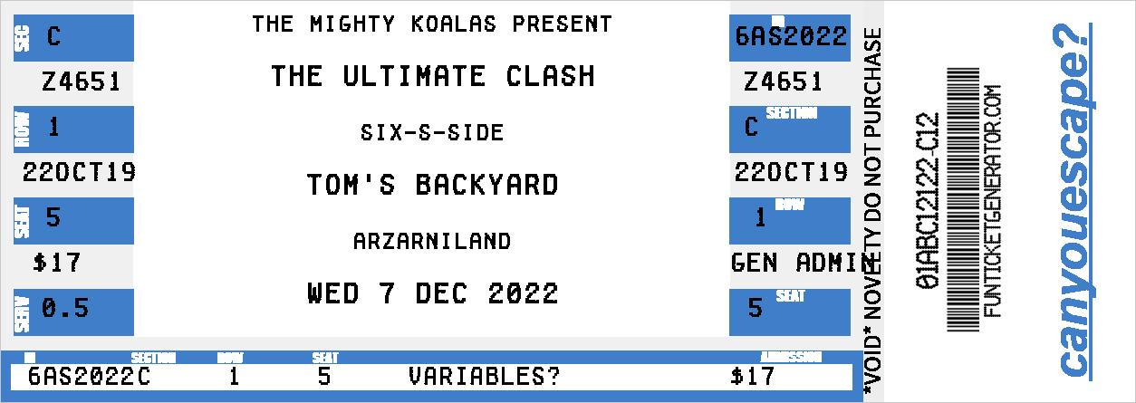
Images sourced from Fun Ticket Generator.
Place the variables in the correct column.
Table 1 – table of variables
Controlled variable | Dependent variable | Independent variable
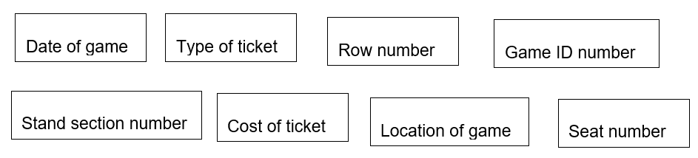
In our soccer game analogy, the independent variable is…
- the date of the game
- the stand section number
- the type of ticket
- the row number
- the game ID number
- the cost of the ticket
- the location of the game
- the seat number

Resource 8 – challenge 5: ‘The best goal scorer is going to be captured!’ worksheet
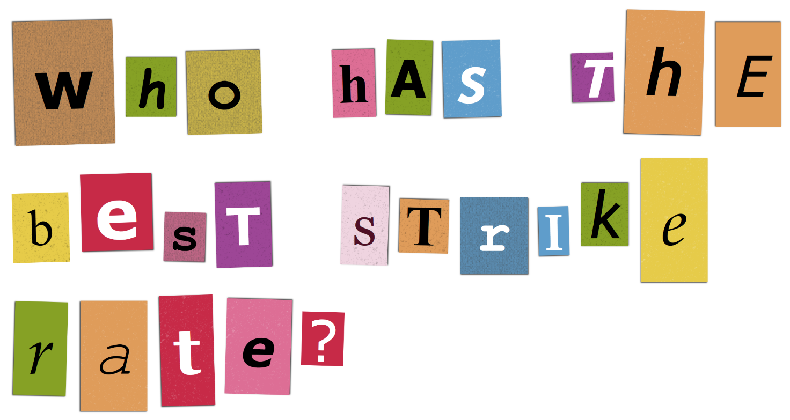
Image sourced from The Ransomizer.
Table 2 – strike stats: Goals scored per game
Player | Week 1 | Week 2 | Week 3 | Week 4 | Week 5 | Week 6
Jacko | 2 | 1 | 0 | 8 | 5 | 1
Raj | 1 | 2 | 1 | 0 | 3 | 5
Stretch | 5 | 6 | 6 | 8 | 1 | 5
Lachie | 6 | 7 | 7 | 7 | 5 | 3
Yasgo | 6 | 10 | 6 | 6 | 2 | 6
Gussy | 3 | 2 | 1 | 0 | 0 | 4

- Fill in the missing word.
The best way to determine (figure out) which player has the best goal strike rate is to compare their _________________ goal strike rates.
- Use the information in the table to work out the average goal strike rate for each player.
Table 3 – player strike average
Player | Average goal strike rate
Jacko
Raj
Stretch
Lachie
Yasgo
Gussy
- Which player has the best goal strike rate? Calculate correctly to save them from capture. ____________________________

Resource 9 – challenge 6: Graphing goals worksheet
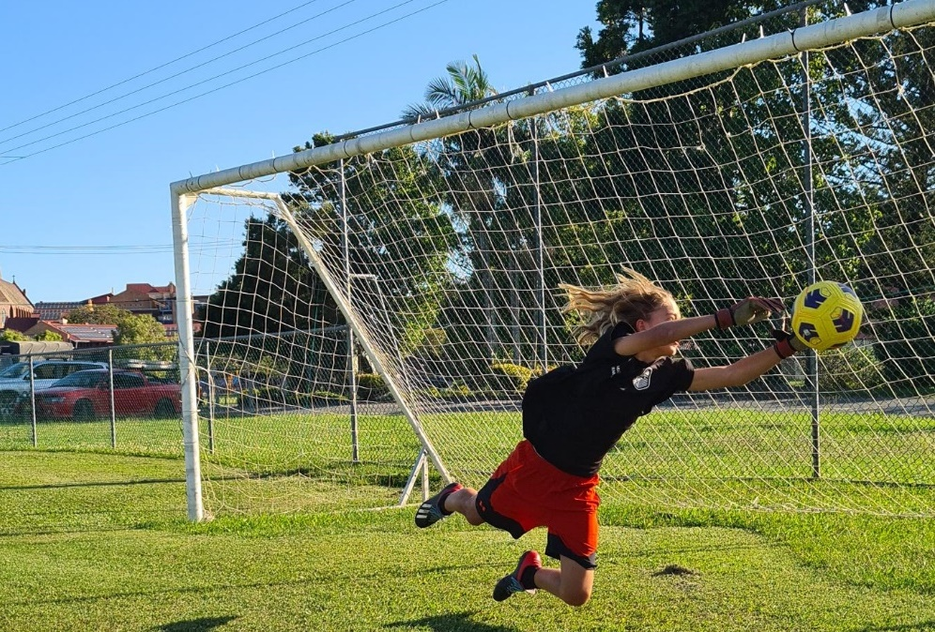
Inspect the table and graph below. Can you read the stats to find the trend?
Table 4 – shots on target and save percentage
Player | Shots on target faced | Save percentage | Goals saved
Jacko | 6 | 66
Raj | 2 | 50
Stretch | 4 | 75
Lachie Lock | 15 | 33
Yasgo | 10 | 60
Gussy | 3 | 66
Figure 2 – goalie ratings
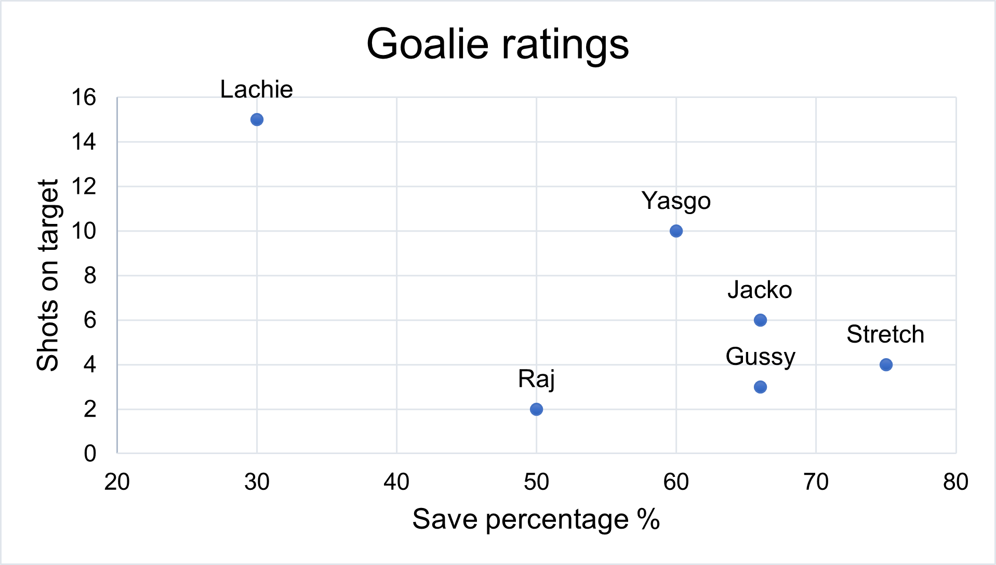
Note: The higher the save percentage, the easier the goals were to save!
- Fill in the table above to show how many goals were saved by each player.
- What is the name of the player that had the highest save percentage of goals this season?
- Lachie
- Yasgo
- Stretch
- Raj
- Which player saved the most shots on target?
- Lachie
- Yasgo
- Stretch
- Raj
- Which player saved the most goals?
- Lachie
- Yasgo
- Gussy
- Raj
- Look at the data on the graph. What is the trend that you see?
The player who saves the _______ goals, saves the least ________ goals.
- Which player does not follow the trend above?

Resource 10 – challenge 7: Scoring goals worksheet
This type of graph is also known as a heat map. They are used to look at probability and actuality. You may not have seen one of these before but there are hints in the image. Use your problem-solving skills to read the heat map, find the hints and interpret the data.
Inspect the graph carefully and answer the questions below.
Figure 3 – heat map of goal probability
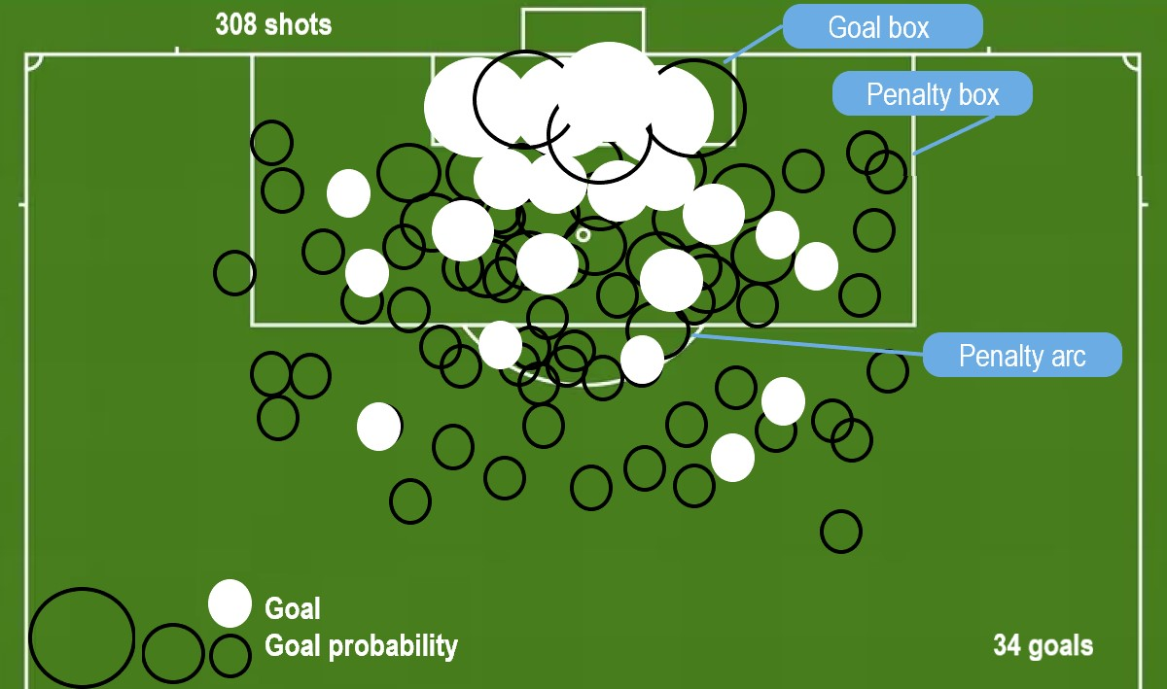
- What does the diameter of the dot represent?
- more attempts at goal
- more likely to score a goal
- less attempts at goal
- less likely to score a goal
- Where should you kick from if you want to increase your chances of scoring a goal?
- Inside the goal box
- Inside the penalty box
- The penalty arc
- It doesn’t really matter if you are a good shot
- How any attempts at goals did Viduka Vikings make this season?
- 30
- 34
- 39.5
- 308
- How many goals did Viduka Vikings score this season
- 30
- 34
- 39.5
- 308

Resource 11 – challenge 8: ‘And the winner is…!’ worksheet
So, who has made it into the finals?
Use the information in the ladder below to find out who the Viduka Vikings will play in the grand final.
Figure 4 – ladder for the Ultimate Clash soccer competition
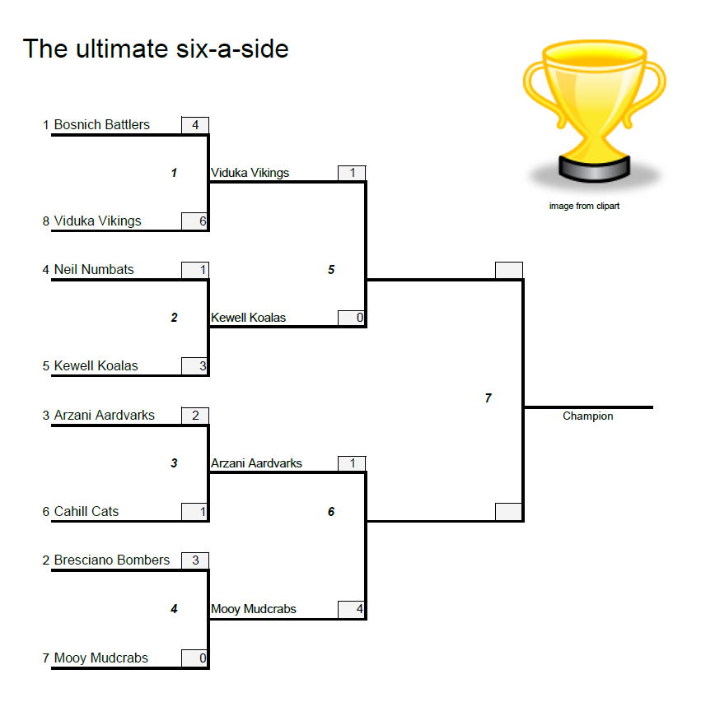
- Who do Bosnich Battlers play in round one?
- Mooy Mudcrabs
- Kewell Koalas
- Viduka Vikings
- Neil Numbats
- Which team wins by the greatest margin in round 1?
- Bresciano Bombers
- Mooy Mudcrabs
- Arzani Aardvarks
- Bosnich Battlers
- Which team has scored the most goals overall?
- Kewell Koalas
- Arzani Aardvarks
- Mooy Mudcrabs
- Viduka Vikings
- Who will the Viduka Vikings play in the finals?

Answer sheet
As you complete each challenge, write your answer in the space provided.
First group to complete all the challenges wins.
Challenge 1: observation or inference?
The decoded phrase says:
This is an example of an ____________________________________________________
Challenge 2: scientific method
1.
2.
3.
Challenge 3: variables
The question in the cryptogram is:
The answer to the question in the cryptogram is _________________________________
Challenge 4: soccer game variables
Table 5 – table of variables
Controlled variable | Dependent variable | Independent variable
In our soccer game analogy, the independent variable is ________________________
Challenge 5: the best goal scorer is going to be captured!
- Fill in the missing word.
The best way to determine (figure out) which player has the best goal strike rate is to compare their _________________ goal strike rates.
- Use the information in the table to work out the average goal strike rate for each player.
Table 6 – player strike average
Player | Average goal strike rate
Jacko
Raj
Stretch
Lachie Lock
Yasgo
Gussy
- Which player has the best goal strike rate? Calculate correctly to save them from capture. ____________________________
Challenge 6: Graphing goals
Table 7 – shots on target and save percentage
Player | Shots on target faced | Save percentage | Goals saved
Jacko | 6 | 66
Raj | 2 | 50
Stretch | 4 | 75
Lachie Lock | 15 | 33
Yasgo | 10 | 60
Gussy | 3 | 66
- What is the name of the player that had the highest save percentage of goals this season?
- Lachie
- Yasgo
- Stretch
- Raj
- Which player saved the most shots on target?
- Lachie
- Yasgo
- Stretch
- Raj
- Which player saved the most goals?
- Lachie
- Yasgo
- Gussy
- Raj
- Look at the data on the graph. What is the trend that you see?
The player who saves the _______ goals, saves the least ________ goals.
- Which player does not follow the trend above?
Challenge 7: scoring goals
- What does the diameter of the dot represent?
- more attempts at goal
- more likely to score a goal
- less attempts at goal
- less likely to score a goal
- Where should you kick from if you want to increase your chances of scoring a goal?
- Inside the goal box
- Inside the penalty box
- The penalty arc
- It doesn’t really matter if you are a good shot
- How any attempts at goals did Viduka Vikings score this season?
- 30
- 34
- 39.5
- 308
- How many goals did Viduka Vikings score this season?
- 30
- 34
- 39.5
- 308
Challenge 8: and the winner is…!
- Who does Bosnich Battlers play in round one?
- Mooy Mudcrabs
- Kewell Koalas
- Viduka Vikings
- Neil Numbats
- What team wins by the greatest margin in round 1?
- Bresciano Bombers
- Mooy Mudcrabs
- Arzani Aardvarks
- Bosnich Battlers
- Which team has scored the most goals overall?
- Kewell Koalas
- Arzani Aardvarks
- Mooy Mudcrabs
- Viduka Vikings
- Who will the Viduka Vikings play in the finals?

Suggested answers
As you complete each challenge, write your answer in the space provided.
First group to complete all the challenges wins.
Challenge 1:
The decoded phrase says: The players are celebrating because their friend is back from an injury.
This is an example of an inference.
Challenge 2:
- C
- A
- B
Challenge 3:
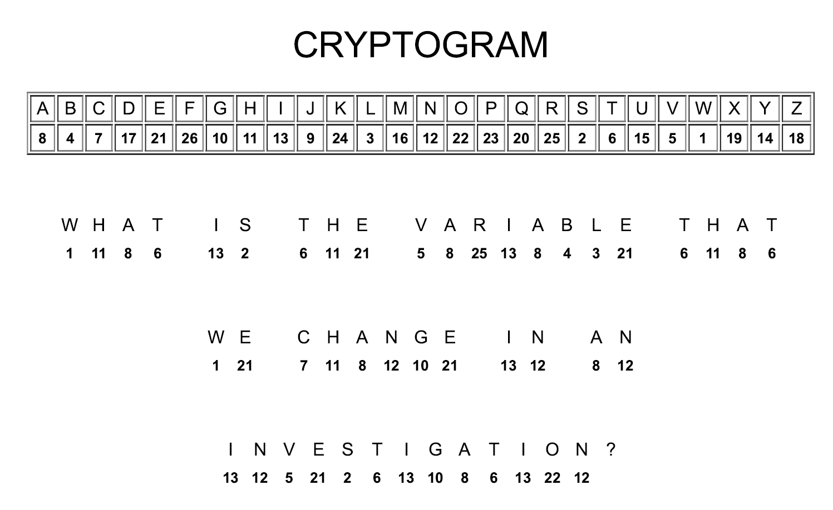
Cryptogram generated at KidZone.ws.
The answer to the question in the cryptogram is: Independent variable
Challenge 4:
Table 8 – table of variables
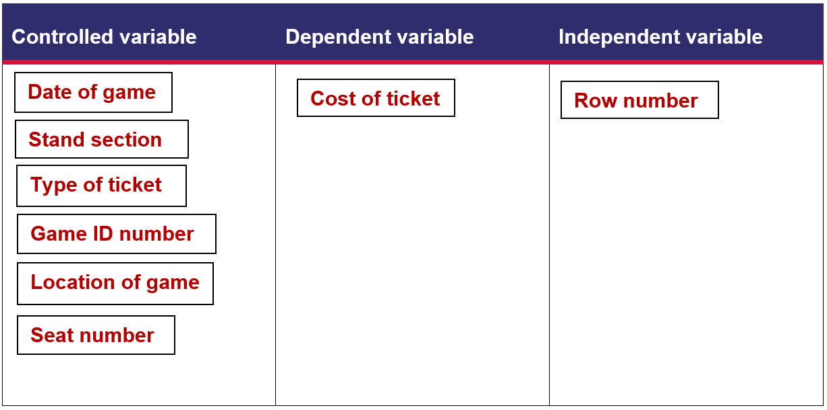
In our soccer game analogy, the independent variable is… the row number.
Challenge 5:
- Fill in the missing word.
The best way to determine (figure out) which player has the best goal strike rate is to compare their average goal strike rates.
- Use the information in the table to work out the average goal strike rate for each player.
Table 9 – player strike average
Player | Average strike rate
Jacko | 2.83
Raj | 2
Stretch | 5.17
Lachie Lock | 5.83
Yasgo | 6
Gussy | 1.67
Which player has the best goal strike rate? Calculate correctly to save them from capture. Yasgo
Challenge 6: Graphing goals
Table 10 – shots on target and save percentage
Player | Shots on target faced | Save percentage | Goals saved (not shown to students)
Jacko | 6 | 66 | 4
Raj | 2 | 50 | 1
Stretch | 4 | 75 | 3
Lachie | 15 | 30 | 5
Yasgo | 10 | 60 | 6
Gussy | 3 | 66 | 2
- What is the name of the player that had the highest save percentage of goals this season?
- Lachie
- Yasgo
- Stretch
- Raj
- Which player saved the most shots on target?
- Lachie
- Yasgo
- Stretch
- Raj
- Which player saved the most goals?
- Lachie
- Yasgo
- Gussy
- Raj
- Look at the data on the graph. What is the trend that you see?
The player who saves the most goals, saves the least accurate goals.
- Which player does not follow the trend above? Raj
Challenge 7: Scoring goals
- What does the diameter of the dot represent?
- more attempts at goal
- more likely to score a goal
- less attempts at goal
- less likely to score a goal
- Where should you kick from if you want to increase your chances of scoring a goal?
- Inside the goal box
- Inside the penalty box
- The penalty arc
- It doesn’t really matter if you are a good shot
- How any attempts at goals did Viduka Vikings make this season?
- 30
- 34
- 39.5
- 308
- How many goals did Viduka Vikings score this season?
- 30
- 34
- 39.5
- 308
Challenge 8: And the winner is…!
- Who does Bosnich Battlers play in round one?
- Mooy Mudcrabs
- Kewell Koalas
- Viduka Vikings
- Neil Numbats
- What team wins by the greatest margin in round 1?
- Bresciano Bombers
- Mooy Mudcrabs
- Arzani Aardvarks
- Bosnich Battlers
- Which team has scored the most goals overall?
- Kewell Koalas
- Arzani Aardvarks
- Mooy Mudcrabs
- Viduka Vikings
- Who will the Viduka Vikings play in the finals?
Mooy Mudcrabs

Support and alignment
Resource evaluation and support: all curriculum resources are prepared through a rigorous process. Resources are periodically reviewed as part of our ongoing evaluation plan to ensure currency, relevance and effectiveness. For additional support, advice or feedback contact the Science Curriculum team by emailing Science7-12@det.nsw.edu.au.
Differentiation: further advice to support Aboriginal and Torres Strait Islander students, EALD students, students with a disability and/or additional needs and High Potential and gifted students can be found on the Planning, programming and assessing 7-12 webpage.
Assessment: further advice to support formative assessment is available on the Planning, programming and assessing 7-12 webpage.
Professional learning: relevant professional learning is available on the Science statewide staffroom identify areas where teachers can seek further support with assessment, for example HSC Professional Learning. Stage 6 Literacy in context provides further advice to teachers to improve student writing.
Related resources: further resources to support Science Years 7–10 Syllabus © 2018 can be found on the Science Curriculum page.
Consulted with: Inclusive Education, Multicultural Education, Literacy and Numeracy
and subject matter experts.
Alignment to system priorities and/or needs: School Excellence Policy, School Success Model.
Alignment to the School Excellence Framework: this resource supports the School Excellence Framework elements of curriculum (curriculum provision) and effective classroom practice (lesson planning, explicit teaching).
Alignment to Australian Professional Teaching Standards: this resource supports teachers to address Australian Professional Teaching Standards 3.2.2, 3.3.2.
Author: Science 7-12 Curriculum Team
Resource: classroom resource.
Creation date: 11 November 2022.

References
NSW Science Years 7–10 Syllabus © 2018 NSW Education Standards Authority (NESA) for and on behalf of the Crown in right of the State of New South Wales.
DLTK’s Inc. (1998-2023) Cryptogram Maker, kidzone.ws. accessed 17 October 2022.
Driblab (2020) Expected Goals (xG): what it is and how it works, Driblab website, accessed 28 October 2022.
Festisite (n.d.) Maze, Festisite website, accessed 28 October 2022.
Funticketgenerator.com (2020) Fun Ticket Generator, Fun Ticket Generator website, accessed 20 October 2022.
Hirche C (n.d.) The Newspaper Clipping Generator, fodey.com, accessed 20 October 2022.
Melvix (2011-2022) The Ransomizer, The Ransomizer website, accessed 24 October 2022.
NESA (NSW Education Standards Authority) (2022) ‘Proficient Teacher: Standard descriptors’, The Standards, NESA website, accessed 24 November 2022.
Phillips SC (2015-2022) Morse Code Translator, MorseCode.World website, accessed 17 October 2022.
State of New South Wales (Department of Education) and CESE (Centre for Education Statistics and Evaluation) (2020) ‘What works best: 2020 update’, CESE, NSW Department of Education, accessed 10 November 2022.
State of New South Wales (Department of Education) and CESE (Centre for Education Statistics and Evaluation) (2020) ‘What works best in practice’, CESE, NSW Department of Education, accessed 10 November 2022.
Vertex 42 LLC (2012–2023) Single Elimination Tournament Brackets spreadsheet [data set], accessed 28 October 2022.
Wikipedia Foundation, Inc. (2023) Morse code, Wikipedia website, accessed 1 November 2022.
Wiliam D and Leahy S (2015) Embedding formative assessment: practical techniques for K-12 classrooms, Learning Sciences International, US.

Further reading
State of New South Wales (Department of Education) (2022) Literacy and numeracy priorities, NSW Department of Education website, accessed 24 February 2023.
State of New South Wales (Department of Education) (2022) Literacy and numeracy, NSW Department of Education website, accessed 24 February 2023.
State of New South Wales (Department of Education)(2022) ‘Planning programming and assessing K-12’, Curriculum, NSW Department of Education, accessed 24 February 2023.
© State of New South Wales (Department of Education), 2023
The copyright material published in this resource is subject to the Copyright Act 1968 (Cth) and is owned by the NSW Department of Education or, where indicated, by a party other than the NSW Department of Education (third-party material).
Copyright material available in this resource and owned by the NSW Department of Education is licensed under a Creative Commons Attribution 4.0 International (CC BY 4.0) licence.
This licence allows you to share and adapt the material for any purpose, even commercially.
Attribution should be given to © State of New South Wales (Department of Education), 2023.
Material in this resource not available under a Creative Commons licence:
- the NSW Department of Education logo, other logos and trademark-protected material
- material owned by a third party that has been reproduced with permission. You will need to obtain permission from the third party to reuse its material.
Links to third-party material and websites
Please note that the provided (reading/viewing material/list/links/texts) are a suggestion only and implies no endorsement, by the New South Wales Department of Education, of any author, publisher, or book title. School principals and teachers are best placed to assess the suitability of resources that would complement the curriculum and reflect the needs and interests of their students.
If you use the links provided in this document to access a third-party's website, you acknowledge that the terms of use, including licence terms set out on the third-party's website apply to the use which may be made of the materials on that third-party website or where permitted by the Copyright Act 1968 (Cth). The department accepts no responsibility for content on third-party websites.

