Science Stage 4 – learning sequence – plant requirements for growth
Contents
Overview 2
Information for teachers 3
Introduction 3
Outcomes 3
Learning intentions and success criteria 4
Teaching and learning activities 5
Teacher preparation for the task 5
Activity 1: See-Think-Wonder 7
Activity 2: investigation design 10
Activity 3: data processing and analysis 11
Student resources 13
Resource 1: learning map 13
Resource 2: See-Think-Wonder 14
Resource 3: designing an investigation – What do plants need to grow? 15
Resource 4: designing an investigation – What do plants need to grow? (differentiated) 20
Resource 5: investigation Evaluation tool 28
Resource 6: exit ticket 29
Support and alignment 30
References 32
Further reading 32

Overview
Stage and Learning Area: Science Stage 4
Description: this resource has been designed to address the SC4-14LW, by relating the structure and function of living things to their classification, survival and reproduction in Living World.
This learning sequence builds understanding of plant requirements for growth through the development of critical thinking and problem-solving using an inquiry-based learning model. Students will develop content knowledge while developing a range of working scientific skills.
Duration: while timing will vary based on the mode of delivery, differentiation strategies employed and class or school context, this series of activities should take approximately 3 × 50-minute lessons over 2 weeks. Allow 2 lessons for See-Think-Wonder, investigation design and setup and one period at the end to analyse results and draw conclusions. Ten minutes should be allocated during lessons to monitor and care for the seedlings.

Information for teachers

Introduction
This learning sequence allows students to investigate the requirements for plant growth using an inquiry-based learning activity. Two punnets of seedlings should be purchased a week before the first lesson of this learning sequence. Keep one punnet well maintained and healthy and neglect the other punnet. The neglect could take the form of lack of sunlight, lack of water or other appropriate form of lack of care. After one week, the 2 punnets of seedlings are presented to students to make observations, hypothesise and ask questions. The students are then guided through the process of developing and conducting a first-hand investigation.
This learning sequence is designed to build skills gradually throughout the task. Teachers may wish to modify the task or focus on specific sections based on their class context, student ability and current mastery of content. For more information relating to curriculum planning for every student see the Planning programming and assessing K-12 website.

Outcomes
A student:
- identifies questions and problems that can be tested or researched and makes predictions based on scientific knowledge SC4-4WS
- collaboratively and individually produces a plan to investigate questions and problems SC4-5WS
- processes and analyses data from a first-hand investigation and secondary sources to identify trends, patterns and relationships, and draw conclusions SC4-7WS
- selects and uses appropriate strategies, understanding and skills to produce creative and plausible solutions to identified problems SC4-8WS
- relates the structure and function of living things to their classification, survival and reproduction SC4-14LW
Science Years 7–10 Syllabus © NSW Education Standards Authority (NESA) for and on behalf of the Crown in right of the State of New South Wales, 2018.

Learning intentions and success criteria
Students:
- identify and communicate the requirements for plant growth
- design and conduct an investigation into plant growth
- analyse first-hand data.
Students can:
- describe various factors that influence plant growth
- identify variables that could be investigated
- collaboratively develop an aim, hypothesis and valid method to investigate one variable
- collect and analyse data collected and relate it to plant growth
- draw conclusions from first-hand data.
Differentiation consideration: learning intentions should not be differentiated. All students need access to the same core content, big ideas and concepts. Differentiation should be evident in the success criteria, or the activities/support needed to achieve the success criteria (Wiliam and Leahy 2015). Teachers may co-construct the success criteria with students or adjust them to suit their class context, for example using the strategies and resources for curriculum planning on the Planning programming and assessing 7-12 webpage.

Teaching and learning activities

Teacher preparation for the task
The teacher will need to obtain 2 trays of seedlings a week prior to the first lesson. Additionally, purchase one tray of seedlings per student group.
One tray of teacher seedlings should be neglected in some way. For example, they could be left without water, sunlight or fertiliser. The type of neglect can be used as a differentiation strategy for more able students. The other trays of seedlings should be well looked after.
Students could be provided with a scaffold to create a glossary of key terms or new terms that they encounter as they progress through the task.
See, Think, Wonder
This activity is based on the See-Think-Wonder model of learning which teaches students the difference between an observation and inference and encourages the inquiry process. Students are presented with a puzzling observation. They are encouraged to make careful observations, think critically about what is happening and be curious. Students use their observations to develop a hypothesis, and from this, an investigation that tests their hypothesis.
Figure 1 – See-Think-Wonder chart
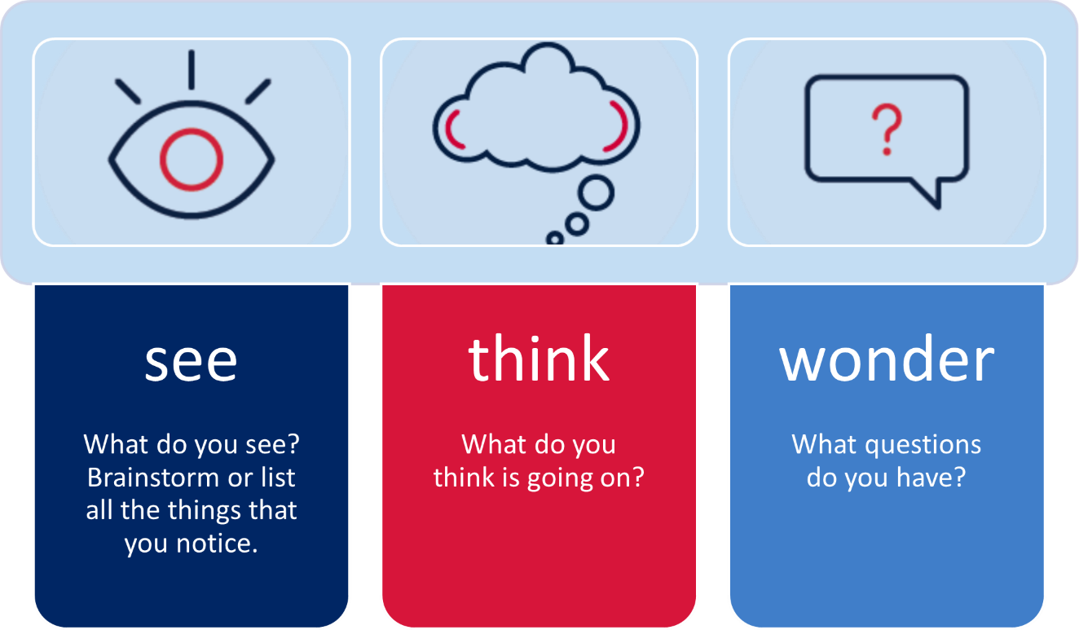
Students will undertake a series of activities to make observations, hypothesise, design and investigate the conditions essential for the growth of healthy plants. The activities are designed to be student driven with the support and guidance of the teacher.

Activity 1: See-Think-Wonder
Note: students use Resource 1: learning map to inform their progress through the task.
Teachers guide students through the See-Think-Wonder process. This could be achieved using the Modelling through think alouds process.
In this learning sequence, students are provided with a scenario with a puzzling observation and 2 punnets of seedlings, bought at the same time and from the same place, that have a different appearance. Students examine them closely looking for observations from which to create a list of possible variables. They develop a hypothesis and design an investigation into a plant’s requirements for growth. There are opportunities to encourage stories about experiences of growing plants at home to encourage links to land and experiential knowledge during sharing and class discussions.
Differentiation: the term ’yarn-up’ is used in the learning map. Consider the students in your class and the possible need to explain this term.
See
This activity could be completed individually, as a class on a Jamboard, or in small groups, followed by a class discussion or gallery walk.
- Set up the 2 trays of seedlings – one neglected and one well looked after.
- Have the students look carefully at the seedlings and list as many observations about them as possible.
- Students share their observations with the class.
Note: students are collecting observations at this stage of the investigation.
Think
- Guide students to think about what has happened to the seedlings.
- Use questions such as:
- What do you think is happening?
- What has caused the changes to the seedlings?
- Why do you think that?
- Have the students list as many possible causes as they can. Encourage them not to get caught up thinking they know the answer. Instead, look at all the possibilities, no matter how far-fetched.
Note: students begin to create plausible explanations for their observations.
Wonder
- Ask students to list the questions that their observations raise. These questions will be developed into a hypothesis for investigation in the next activity.
- Guide students to use what they have learned today to develop a set of requirements for plant growth. For example, water, light, nutrients, carbon dioxide, temperature and space.
Note: students create a hypothesis based on their observations.

Assessment for learning
This activity could be used as formative assessment of the development of an aim and hypotheses. Use the See-Think-Wonder worksheet for students to complete their work and inform class discussions.
Explicit teaching practices involve teachers clearly showing students what to do and how to do it, rather than having students discover that information themselves. Students who experience explicit teaching practices make greater learning gains than students who do not experience these practices.
CESE What works best update 2020

Activity 1: See-Think-Wonder sample response
Your teacher will provide you with 2 trays of seedlings. Use these to fill out this worksheet.
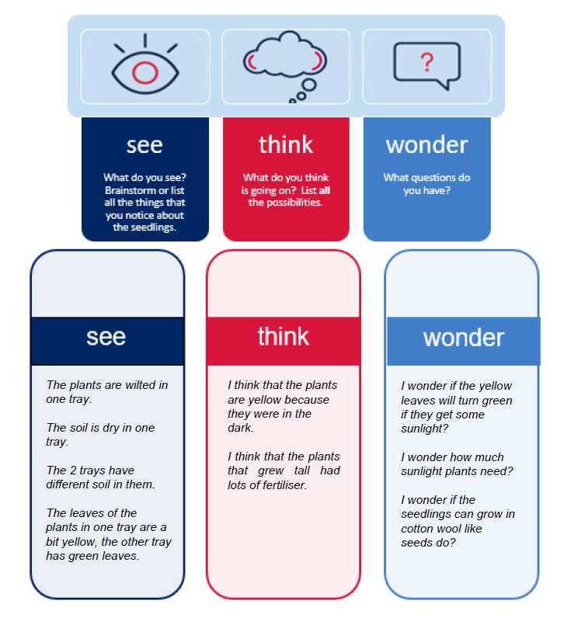

Activity 2: investigation design
Note: this activity can be teacher-led, to model investigation design, or used as a formative assessment tool with teacher support. It could be conducted in small groups followed by a gallery walk with students evaluating the methods created by others (see scaffold attached).
- Guide the students to create a set of variables for plant growth that could be tested. This list could include the amount of water, type of soil, amount of soil, temperature, amount of light and plant crowding.
- The students choose one variable to be investigated and create an aim and hypothesis.
- Support students in developing a valid, reliable method to investigate the aim.
Differentiation: the activity could be differentiated for lower ability classes or those learning investigation design, by conducting it as a whole class activity with discussion of the elements that make a valid and reliable method.
Conducting this activity as a whole class would also support the learning of EALD students in the early stages of English acquisition.
Consider the needs of your class and the requirement for explicit teaching or revision of terminology such as independent, dependent variables, hypothesis, mitigation, observation, systematic error, and random error.
Students may require guidance in the type of graph used in this task. Consider the need for review of graphing techniques.

Assessment for learning
This activity could be used as formative assessment for the development of an investigation. If the task is to be used for formative assessment, Resource 3: Designing an investigation scaffold or Resource 4: Designing an investigation (differentiated) scaffold can be used. The scaffold can be removed to extend students or for use as summative assessment.

Activity 3: data processing and analysis
Note:
- Accuracy is a measure of how close an answer is to the true value.
- Precision is a measure of how close multiple measurements are to each other.
- Reliability is a measure of how close multiple measurements are to each other.
- Validity is a measure of whether the investigation answers the aim (does it test what you want it to test).
- Lead a discussion to decide whether the data gathered should be quantitative, qualitative, or both.
- Discuss the design of a table to record the results, based on dependent and independent variables.
- The students tabulate and graph their gathered data.
Differentiation: this learning sequence can be modified for extension students by encouraging them to calculate the mean and standard deviation of gathered data.
- Guide the students to analyse the data and draw conclusions.
- Discuss sources of error, accuracy, precision, reliability, validity and improvements.
- Encourage students to use the gathered data and conclusions to raise another question.
Differentiation: this learning sequence can be modified for extension students through the removal of scaffolding and the encouragement of deep questioning by the students. The level and cause of neglect of the seedlings can also provide a means of differentiation. A differentiated scaffold is included and can be further modified as needed to suit individual students. Some students may require explicit teaching of some terminology, for example, quantitative and qualitative. Deconstruction of the terms during explicit teaching could improve the support of EALD students.

Assessment for learning
This activity could be used as formative assessment for the analysis of an investigation. If the task is to be used for formative assessment, the Resource 3: Designing an investigation scaffold or Resource 4: Designing an investigation (differentiated) scaffold can be used. The scaffold can be removed to extend students or for use as summative assessment.

Student resources

Resource 1: learning map
Figure 2 – learning map
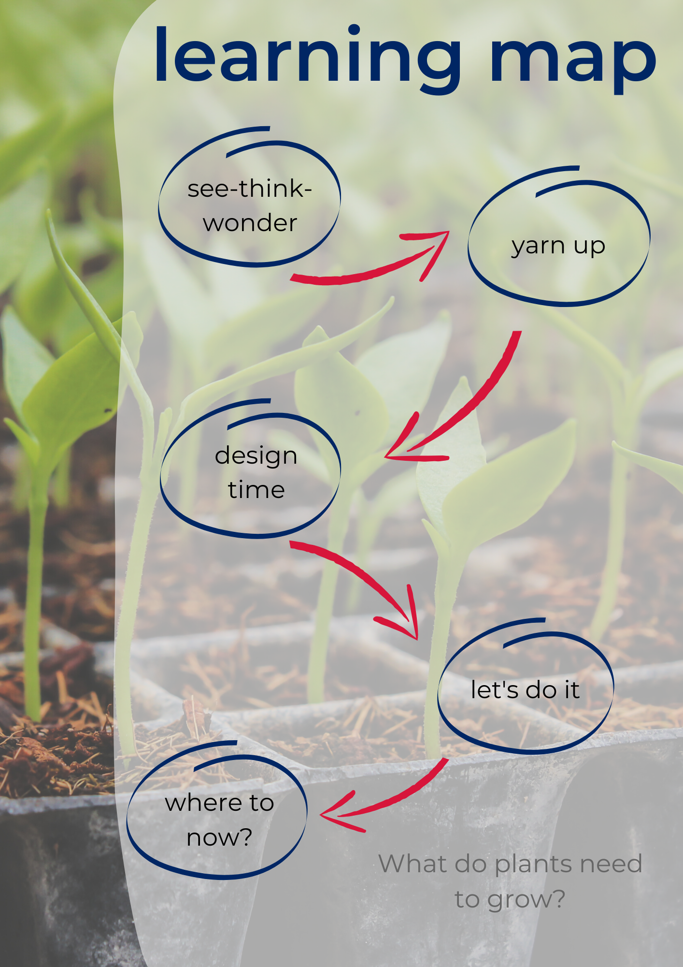

Resource 2: See-Think-Wonder
Your teacher will provide you with 2 trays of seedlings. Use these to fill out this worksheet.
Figure 3 – See-Think-Wonder chart
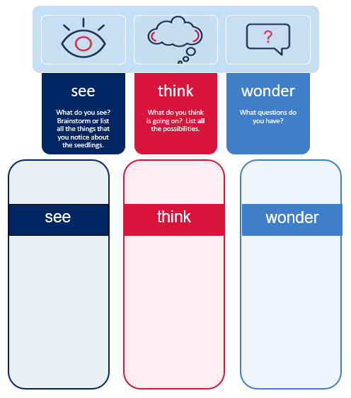

Resource 3: designing an investigation – What do plants need to grow?
Look at the information that you gathered in the previous activity. You will use this information to develop an investigation into plant growth. Check with your teacher at the end of each section before you go on.
Variables
List all the variables that affect plant growth that you can.
Independent variable:
Choose one variable to test.
How will you change it?
Dependent variable:
Which variable will you measure?
How will you measure it?

Questioning and predicting
Write an aim for your investigation.
(What do you want to find out?)
Write a hypothesis for your investigation.
(What do you think the results will be, and why do you think that?)
Method design
What equipment will you need?
What variables will you need to control?
How will you control each one?
Write the steps of your method.
- Use numbered steps.
- Start each step with a verb.
- Make each step short.
Remember to make your method:
- valid by changing only one variable
- reliable by repeating it to reduce random errors.
Draw a labelled diagram of your equipment setup.
(Use a pencil and ruler)
Risk assessment
What are the risks involved in the investigation? (Include risks to yourself, others and property)  How will you prevent the risks? (Mitigation) | Risk | Mitigation

Results
What observations do you need to make?
What data do you need to collect?
Design a table for your results.
(Hint: the independent and dependent variables are usually the headings.)
Analysing data
Design a graph for your results.
What patterns do you see?
What do the results mean?
Is your hypothesis supported? Use evidence from your investigation to support your answer.
Do your results raise any other questions?
What sources of error are there in your investigation? (Identify systematic and random errors and how they can be overcome)
Discuss the accuracy, precision, reliability and validity of your investigation. Support your argument with evidence.
How could you improve your investigation? (Address any issues identified above.)
Conclusion
What have you found out?
(Answer the question in the aim)

Resource 4: designing an investigation – What do plants need to grow? (differentiated)
Look at the information that you gathered in the previous activity. You will use this information to develop an investigation into plant growth. Check with your teacher at the end of each section before you go on.
Variables
List all the things that you think might help plants grow.  (These are called variables). | - Amount of water  - ______________________________  - ______________________________  - ______________________________  - ______________________________
Independent variable:  Pick one variable from the list above to test.  How will you change it? | I will change the _________________________________  __________________________________  I will change it by __________________________________  __________________________________  __________________________________
Dependent variable:  Which variable will you measure?  How will you measure it? | I will measure the __________________________________  __________________________________  I will measure it by __________________________________  __________________________________  __________________________________  __________________________________
Questioning and predicting
Write an aim for your investigation.  (What do you want to find out?) | __________________________________  __________________________________  __________________________________  __________________________________
Write a hypothesis for your investigation.  (What do you think the results will be, and why do you think that?) | __________________________________  __________________________________  will make the plant grow __________________________________  __________________________________  because ___________________________  ___________________________________
Method design
What equipment will you need? | - seedlings  - pots  - ______________________________  - ______________________________  - ______________________________  - ______________________________  - ______________________________
Choose 2 variables you will keep the same.  How will you do this? | For example: Each seedling will get the same amount of sunlight by keeping them on the same windowsill.  - ______________________________  ______________________________  - ______________________________  ______________________________
Write the steps of your method.  - Use numbered steps.  - Start each step with a doing word  - Make each step short.  Remember to make your method:  - valid by changing only one variable  - reliable by repeating it to reduce random errors. | For example: Plant each seedling in a 10cm pot with 2 cups of potting mix.  - ____________________________________________________________________________  - ___________________________________________________________________________  - ____________________________________________________________________________  - ____________________________________________________________________________
Draw a labelled diagram of your equipment setup.
(Use a pencil and a ruler.)
Risk assessment
What are the risks involved in the investigation?  (Include risks to yourself, others and property)  How will you prevent the risks? (Mitigation) | Risk  Infection from bacteria in potting mix | Mitigation  Wear gloves and wash hands well when finished
Results
What observations do you need to make?  What will you measure?  How often will you measure it?  Design a table for your results.  (Hint: the independent and dependent variables are usually the headings). | - ________________________________________  - ________________________________________  - ________________________________________  - ________________________________________  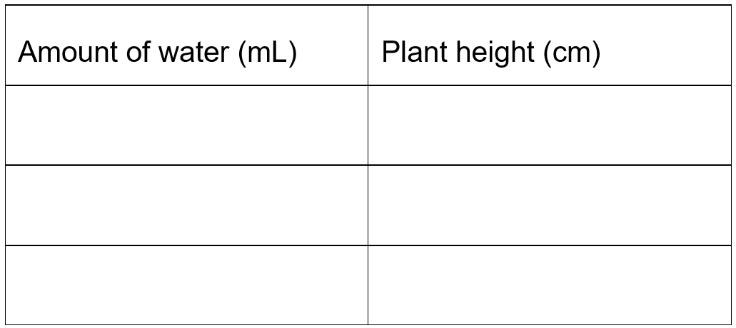

Analysing data
Ask your teacher for some graph paper to create a graph for your results.
What patterns do you see?  What do the results mean?  Is your hypothesis correct? How do you know? (Look at your results).  Do your results raise any other questions?  What sources of error are there in your investigation? How can you fix these errors? Systematic errors are errors that are always there because of a poor method or incorrect use of equipment.  Random errors are not predictable, often they are because people make mistakes.  Discuss the accuracy, precision, reliability and validity of your investigation. Support your argument with evidence.  How could you improve your investigation? (Address any issues identified above.)  What else could you investigate? | _____________________________________________  _____________________________________________  _____________________________________________  _____________________________________________  The pattern in the results means that _______________  _____________________________________________  _____________________________________________  The hypothesis was supported because _____________  _____________________________________________  _____________________________________________  A question that I have is __________________________  _____________________________________________  _____________________________________________  A systematic error in the experiment was ____________  _____________________________________________  It could be fixed by ______________________________  _____________________________________________  A random error in the experiment was _______________  ______________________________________________  It could be fixed by _____________________________________________  _____________________________________________  The experiment was accurate because ______________  _____________________________________________  The experiment was precise because _______________  _____________________________________________  The experiment was reliable because _______________  _____________________________________________  The experiment was valid because _________________  _____________________________________________  The experiment could be improved by ______________  _____________________________________________  Other topics to investigate include: _________________  ______________________________________________
Conclusion
What have you found out?  (Answer the question in the aim | In this investigation it was found that ________________  ______________________________________________  ______________________________________________  ______________________________________________

Resource 5: investigation Evaluation tool
This tool will assist you to evaluate an investigation design. You should be able to justify each answer with evidence from the investigation.
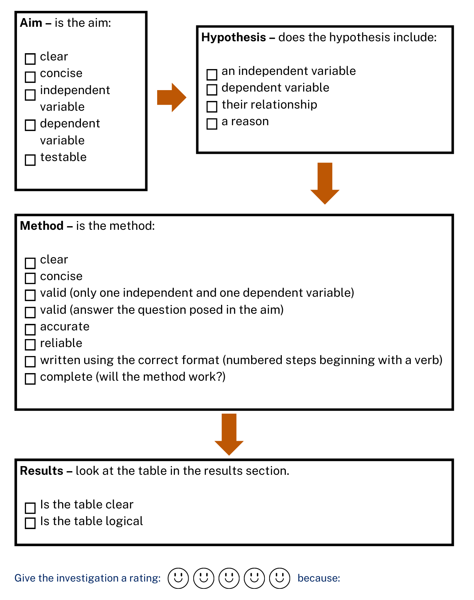

Resource 6: exit ticket
Printable Exit tickets can be found in the Exit tickets – Rose, bud, thorn PowerPoint

Support and alignment
Resource evaluation and support: all curriculum resources are prepared through a rigorous process. Resources are periodically reviewed as part of our ongoing evaluation plan to ensure currency, relevance and effectiveness. For additional support, advice or feedback, contact the Science Curriculum team by emailing Science7-12@det.nsw.edu.au.
Differentiation: further advice to support Aboriginal and Torres Strait Islander students, EALD students, students with a disability and/or additional needs and High Potential and gifted students can be found on the Planning programming and assessing 7-12 webpage.
Assessment: further advice to support formative assessment is available on the Planning programming and assessing 7-12 webpage.
Professional learning: relevant professional learning is available on the Science statewide staffroom.
Related resources: further resources to support Stage 4 Science can be found on the Science Curriculum page.
Consulted with: inclusive Education, Multicultural Education, Literacy and Numeracy and subject matter experts.
Alignment to system priorities and/or needs: School Excellence Policy, School Success Model.
Alignment to the School Excellence Framework: this resource supports the School Excellence Framework elements of curriculum (curriculum provision) and effective classroom practice (lesson planning, explicit teaching).
Alignment to Australian Professional Teaching Standards: this resource supports teachers to address Australian Professional Teaching Standards 3.2.2, 3.3.2
Author: Science 7-12 Curriculum Team
Resource: classroom resource
Creation date: 15 September 2022

References
Science Years 7–10 Syllabus © NSW Education Standards Authority (NESA) for and on behalf of the Crown in right of the State of New South Wales, 2018.
State of New South Wales (Department of Education) and CESE (Centre for Education Statistics and Evaluation) (2020a) ‘What works best: 2020 update’, CESE, NSW Department of Education, accessed 23 May 2022.
State of New South Wales (Department of Education) and CESE (Centre for Education Statistics and Evaluation) (2020b) ‘What works best in practice’, CESE, NSW Department of Education, accessed 23 May 2022.
Wiliam D and Leahy S (2015) Embedding formative assessment: practical techniques for K-12 classrooms, Learning Sciences International, US.

Further reading
State of New South Wales (Department of Education) (2022) Literacy and numeracy priorities, NSW Department of Education website, accessed 24 February 2023.
State of New South Wales (Department of Education) (2022) Teaching strategies for reading by learning stage, NSW Department of Education website, accessed 27 February 2023.
© State of New South Wales (Department of Education), 2023
The copyright material published in this resource is subject to the Copyright Act 1968 (Cth) and is owned by the NSW Department of Education or, where indicated, by a party other than the NSW Department of Education (third-party material).
Copyright material available in this resource and owned by the NSW Department of Education is licensed under a Creative Commons Attribution 4.0 International (CC BY 4.0) licence.
This licence allows you to share and adapt the material for any purpose, even commercially.
Attribution should be given to © State of New South Wales (Department of Education), 2023.
Material in this resource not available under a Creative Commons licence:
- the NSW Department of Education logo, other logos and trademark-protected material
- material owned by a third party that has been reproduced with permission. You will need to obtain permission from the third party to reuse its material.
Links to third-party material and websites
Please note that the provided (reading/viewing material/list/links/texts) are a suggestion only and implies no endorsement, by the New South Wales Department of Education, of any author, publisher, or book title. School principals and teachers are best placed to assess the suitability of resources that would complement the curriculum and reflect the needs and interests of their students.
If you use the links provided in this document to access a third-party's website, you acknowledge that the terms of use, including licence terms set out on the third-party's website apply to the use which may be made of the materials on that third-party website or where permitted by the Copyright Act 1968 (Cth). The department accepts no responsibility for content on third-party websites.

