Module 6: Geological hazards

Earthquakes at plate boundaries
Watch the YouTube video, Earthquakes of the 20th Century (duration 2:36)
Read the information on the National Oceanic and Atmospheric Administration website, Earthquakes of the 20th Century.
Explain (cause-and-effect) each of the three notable features at the bottom of the webpage. Include direct references to the website information and the YouTube clip where appropriate.

Ground motion of Tsunamis
Use information from Geoscience Australia, Tsunami, to create a flowchart to illustrate cause of a tsunami. Include tectonic interactions that might cause factors that displace water leading to tsunami event.
Despite not sitting on tectonic plate boundaries, rare tsunami events have been observed in Australia. Geoscience Australia has assessed the likelihood of an observable tsunami event occurring on the coast of Australia. Account for the results of the study shown below, using direct references to the study.
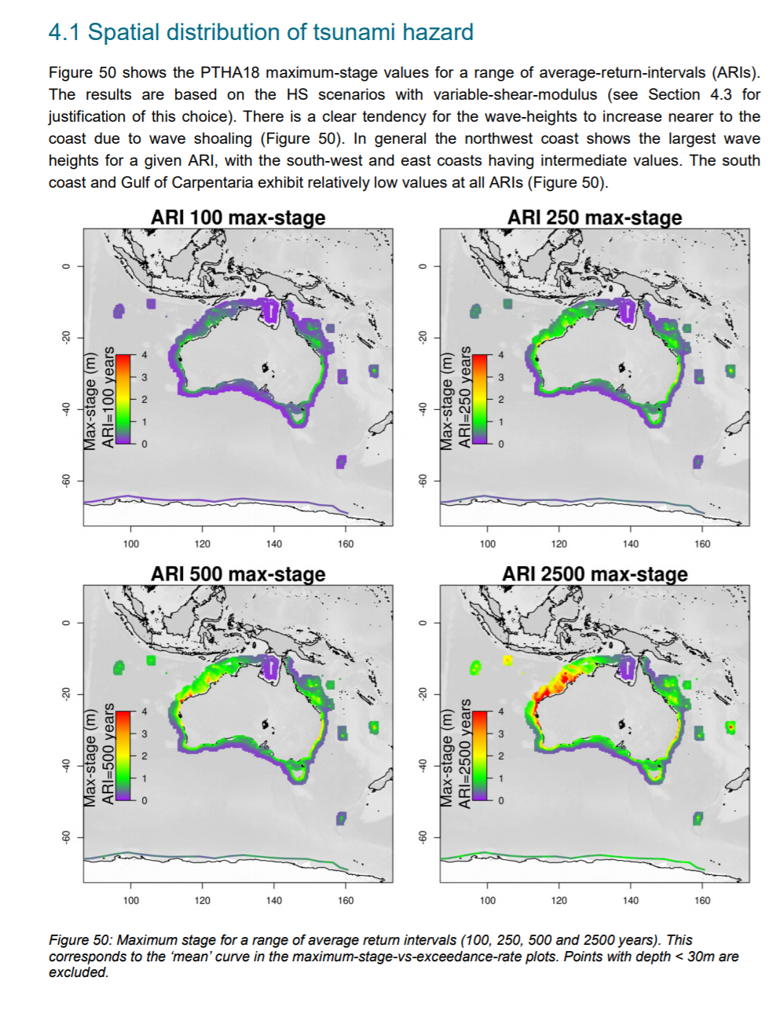
Geoscience Australia (2018). Tsunami. Australian Government, ACT. The 2018 Australian probabilistic tsunami hazard assessment: hazard from earthquake generated tsunamis. Licensed under the Creative Commons Attribution 4.0 International Licence

