Chemistry Stage 6 – learning sequence – modelling in chemistry: equilibrium and polymerisation

Contents
Overview 3
Information for teachers 4
Introduction 4
Outcomes 4
Learning intentions and success criteria 5
Teaching and learning activities 6
Note for teacher 6
Activity 1: scientific models 7
Activity 2: modelling dynamic equilibrium 8
Activity 3: modelling polymerisation 15
Student resources 21
Resource 1 – activity 2: modelling dynamic equilibrium 21
Resource 2 – activity 3: modelling polymerisation 24
Appendix 28
Support and alignment 31
References 33
Further reading 34

Overview
Stage and Learning Area: Chemistry Stage 6
Description: this resource has been designed to address the following syllabus references in Modules 5 and 7: model dynamic equilibrium and the structure of addition and condensation polymers.
This learning sequence builds a deeper knowledge and understanding of scientific concepts by using scientific modelling. It addresses the common misconceptions in the features of dynamic equilibrium and structures of addition and condensation polymers.
Duration: while timing will vary based on the mode of delivery, differentiation strategies employed, and class or school context, this series of activities should take approximately 2 × 60-minute lessons.

Information for teachers

Introduction
Due to the abstract nature of chemistry concepts, which require understanding the reaction chemistry at the microscopic scale, students often struggle to visualise what is happening at an atomic level. Models and analogies are powerful tools to assist them with their understanding of a chemical process.
In these activities, students will use different models to improve their understanding of dynamic equilibrium and the polymerisation process. Students then evaluate the models to demonstrate their understanding that scientific models can explain most, but not all, of the features of a process. Furthermore, they understand that scientific models may be revised as new evidence comes to light or discarded if those models cannot explain new observations.

Outcomes
A student:
- solves scientific problems using primary and secondary data, critical thinking skills and scientific processes CH11/12-6
- communicates scientific understanding using suitable language and terminology for a specific audience or purpose CH11/12-7
- explains the characteristics of equilibrium systems, and the factors that affect these systems CH12-12
- analyses the structure of, and predicts reactions involving, carbon compounds
CH12-14
Chemistry Stage 6 Syllabus © NSW Education Standards Authority (NESA) for and on behalf of the Crown in right of the State of New South Wales, 2017.

Learning intentions and success criteria
Students:
- use models or analogies for demonstrating a chemical process and evaluate the model's effectiveness in explaining that process.
Students can:
- model dynamic equilibrium and polymerisation process
- explain the features of both chemical processes, using a model
- evaluate the effectiveness of a model in demonstrating each chemical process.
Differentiation consideration: learning intentions should not be differentiated. All students need access to the same core content, big ideas and concepts. Differentiation should be evident in the success criteria, or the activities or support needed to achieve the success criteria (Wiliam and Leahy 2015). Teachers may co-construct the success criteria with students or adjust them to suit their class context, for example using the strategies and resources for curriculum planning on the Planning, programming and assessing 7-12 webpage.

Teaching and learning activities

Note for teacher
The teaching and learning activities in this resource include modelling, simulations, video links and firsthand investigations for in-depth conceptual understanding of equilibrium and polymerisation processes.
Recommendations to support all learners:
- Turn on closed captions for videos.
- Guide and support students with conducting investigations as required.
- For activity 1, refer to visuals on pages 24 to 26 for experiment set up and expected results.
- Teachers could provide glossary of important terms and scaffold for the response, with sentence starters or layout outlines.

Activity 1: scientific models
Teachers show the video on Tools of Science: Modeling (6:10) and What is Scientific Modeling? (2:12) to provide a context for using scientific models to explain complex scientific processes.

Activity 2: modelling dynamic equilibrium
Teaching note: reversible reactions and dynamic equilibrium are complex chemistry concepts to understand. However, good analogies and models assist students in understanding and applying the concept to unfamiliar situations.
Common misconceptions students have about reversible reactions and equilibrium, along with suggested analogies or simulations to clarify them, are:
- Physical changes are reversible, but chemical changes are not. The video, What are reversible reactions? (2:45), addresses this misconception. Emphasise that some chemical changes can be reversed with an input of energy (which varies depending on the type of reaction).
- Chemical reactions stop when equilibrium is reached, as there is no visible change. The video, Escalator equilibrium (0:57), uses an analogy to assist in introducing the concept of reversible reactions and demonstrating that both forward and reverse reactions are occurring at the same rate at equilibrium.
- The concentration of reactants equals the concentration of products at equilibrium. Students confuse reaction rate with concentration. Reversible Reactions is a PhET simulation that shows, with illustrations, changes happening at a microscopic level for a reversible reaction and clarify that the concentrations of reactants and products vary at equilibrium.
- Forward and reverse reactions are isolated from each other. Use the PhET simulation on Reversible Reactions to highlight that forward and reverse reactions occur simultaneously but at different rates until equilibrium is established.
- Refer to page 17 for printable student resources.

Procedure for modelling dynamic equilibrium in a reversible reaction

Part A: establishing chemical equilibrium in a reversible reaction
- Collect two 600 ml beakers and label them A (reactants) and B (products).
- Use a measuring cylinder to add 400 ml of water to beaker A.
- Use a measuring cylinder to add 50 ml of water to beaker B. Then add 15–20 drops of blue food colouring.
- Place these beakers next to each other on a paper towel.
Figure 1 – the experiment set up for modelling dynamic equilibrium
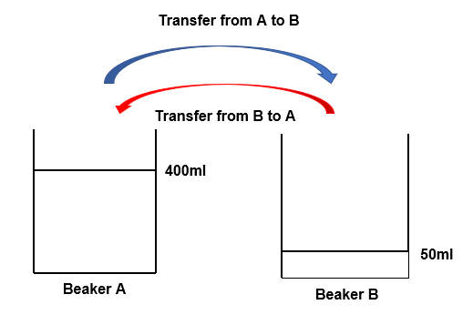
Teacher note: sample responses are provided, however, they can be deconstructed to meet the learning needs of students, if required.
Question 1: If you transfer water from A to B, and B to A using the same-sized beakers (or measuring cups), then the water level will or will not become equal after a certain number of transfer cycles. Give reason(s) for your response.
Sample response: The water level in beakers A and B may appear similar, however, they will not necessarily be equal. Equilibrium is established when the rate of forward and reverse reactions (the rate at which water is transferred) becomes equal, not the concentration of reactants and products (level of water in beakers A and B).
Teaching note: as previously stated, students may confuse the reaction rate with concentration; some students will predict that the water level in both beakers will become equal because the system is in equilibrium.
- Use a 50 ml beaker to transfer water from beaker A to B. Then use another 50 ml beaker to transfer water from B to A. Repeat the process until the colour intensity of water in both beakers appears to be the same.
- Observe the level of water in both beakers. Use a marker to indicate the level of water in each beaker.
Question 2: Does your observation confirm your prediction in Question 1? Why or why not?
Sample response: Answers may vary based on students’ predictions.
After a few transfer cycles the water level in both beakers were different, however the colour intensity was the same which shows that the system has reached equilibrium.
Teaching note: discuss with students that the speed of transferring water from A to B is an analogy for the forward reaction rate and moving from B to A is the reverse reaction rate. It is important to point out that the colour intensity is a macroscopic property of the system that becomes constant at equilibrium. Likewise, the volume of water is analogous to reagent concentration, which also becomes constant. However, the reactant concentration is not necessarily equal to that of the product. This is explained by the different water levels in the 2 beakers when the system reaches equilibrium.

Part B: disturbing chemical equilibrium
- Add 250 ml of water to beaker A (from Part A).
- Transfer water from A to B, and B to A using a 50 ml beaker until both beakers' colour intensity becomes the same.
- Observe the water level in beakers A and B. Use a marker to indicate the water level in each beaker.
Question 3: Is the water level in each beaker the same as in Part A, step 7? Why or why not?
Sample response: No, the water level will not be the same as before because disturbing the equilibrium will result in establishing a new one. This is because the system counteracts to minimise the disturbance (when more water is added) but does not bring it back to the initial position.

Question 4: Did the paper towel become wet during the transfer cycles? How does it impact the validity of the model?
Sample response: Answers may vary depending on the spillage of water. Answers may include water spillage changed the system from a closed one to an open one. In that case, it invalidates Le Chatelier's principle.
Teaching note: if there is water spillage during transfer cycles, it indicates that some reactants or products are lost. Consequently, the model will not represent a closed system. Students should use their observations to justify the validity of the model.

Part C: evaluating the model
The following scaffold could be used to evaluate the effectiveness of a given model.
- List all the features of the chemical process.
- Explain how the model does or does not demonstrate the features of the chemical process.
- Use evidence(observations or data) to support your explanation.
- Provide overall judgement to conclude if the model is effective or ineffective in modelling the chemical process.
- Provide suggestions for improving the model. In case the model is ineffective, suggest an improved model.
Teaching note: CER scaffold is helpful for students with structuring scientific arguments and explanations. Watch CER - Claim Evidence Reasoning (7:24)
Claim: answer to the question (usually, a statement)
Evidence: supports your claim (it may include observations or data from an experiment, data from a graph or flow chart, information from the stimulus material, facts, or any other relevant information)
Reasoning: logic that links evidence to the claim (it may include an explanation using scientific principle or chemical concept)
Question 5: Evaluate the effectiveness of your model in demonstrating dynamic equilibrium.
- Claim: answer to the question (usually, a statement)
- Evidence: supports your claim (it may include observations or data from an experiment, data from a graph or flow chart, information from the stimulus material, facts, or any other relevant information)
- Reasoning: logic that links evidence to the claim (it may include an explanation using scientific principle or chemical concept).
Sample response: This model demonstrates the following features of dynamic equilibrium:
- Closed system: although the beakers were not covered, water was not spilled during the transfer cycles, as evident from the dry paper towel, modelling a closed system.
- The reversible nature of the reaction was modelled by transferring water from A to B (forward reaction) and B to A (reverse reaction).
- Rate of forward reaction is equal to the rate of reverse reaction at equilibrium: although the beakers were the same size, the amount of water transferred from A to B was greater than the reverse transfer at the beginning of the process, but slowly it became nearly the same. This indicates that the forward reaction rate is greater at the beginning but becomes equal to the reverse reaction when the equilibrium is reached.
- Macroscopic properties: the change in the colour intensity of water refers to the macroscopic properties of the reactants and products. The constant colour intensity at equilibrium indicates the dynamic nature of the equilibrium where the colour intensity is unchanged despite the water transfer (forward and reverse reaction).
- Equilibrium is sensitive to temperature and pressure (for gases only): this model could not demonstrate the effects of varying temperature or pressure on the chemical equilibrium.
It is a simple and effective model to explain some, but not all features of systems in dynamic equilibrium. Factors like temperature and pressure that affect equilibrium cannot be understood by using this model. Other systems, such as the sublimation of iodine in a stoppered Erlenmeyer flask could be used to model the effect of varying temperature on state of equilibrium.
Figure 3 – example of an experiment set up for modelling equilibrium using iodine
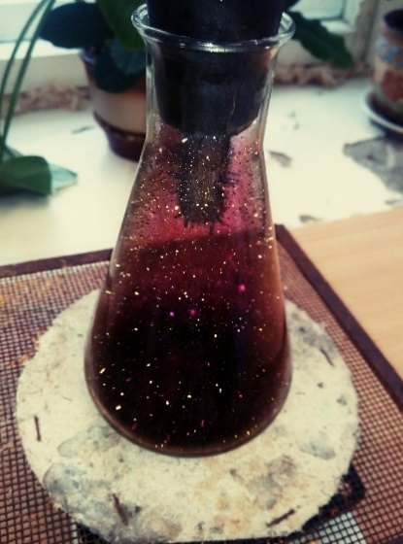
‘sublimation and crystallisation of iodine’ by Ershova Elizaveta is licensed under CC BY-SA 4.0
The picture above shows a model of dynamic equilibrium between solid and gaseous iodine in the sublimation process. Iodine crystals are in a stoppered conical flask with a test tube containing ice cubes. The flask is kept on a hot plate or hot water bath. Iodine crystals are seen at the bottom of the flask and outside the test tube.
This could be used as a teacher demonstration to model equilibrium, and the effects of temperature could be demonstrated by varying the temperature.
Teaching note: before carrying out this demonstration, a risk assessment must be conducted, and the relevant control measures must be implemented.
Differentiation considerations
Extension: students research examples of dynamic equilibrium from everyday life and evaluate one of them as an effective model for demonstrating dynamic equilibrium using the CER scaffold. For example, a sealed bottle of soft drink is an example of dynamic equilibrium, where carbon dioxide is in equilibrium with carbonic acid. Refer to Equilibrium and soft drinks for this example.

Activity 3: modelling polymerisation
Note: polymers play a vital role in everyday applications. Addition polymerisation and condensation polymerisation are 2 types of polymerisation reactions in forming polymers. Models help students visualise what is happening in these 2 processes on a molecular level. The following activity introduces to students the main concepts of polymerisation. The activity requires a student group size of at least 10 and is inspired by Addition Polymerisation (2:33) from Flinn Scientific.
In this activity, students pair up to model an ethene monomer, with each arm representing a covalent bond in the double-bonded structure. It is important to reinforce the nature of electron sharing in covalent bonding, represented by each student's contribution of one arm. In case of an odd number of students, the left-over student can take the role of the initiator.
Explain the importance of the initiator (typically some form of a free radical, which is unstable) to begin the polymerisation process and how it attains a lower energy state (stable) when the electrons are paired. Remind students that this process occurs in many monomers, not just one, and we only model one for simplicity. The polymerisation process is modelled by student pairs (monomers) forming a linear chain of carbon atoms representing HDPE.

Addition polymerisation of HDPE
- Pair students up and have them hold both hands in front to model an ethene monomer.
Teaching note: each arm represents a covalent bond in the double-bonded structure. Reinforce the nature of electron sharing in this bond with the contribution of one arm from each student. One student can take the role of the initiator.
- A student (initiator) holds one hand with monomer pair. This leaves the initiator and one of the students in the ethene pair with a free arm.
Figure 4 – representation of the initiation step in the polymerisation process
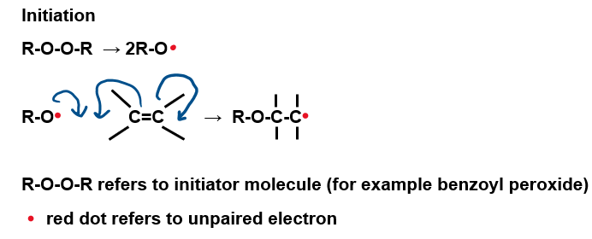
Question 1: What does the free arm represent?
Sample answer: Free arm represents the unpaired electron in the ethene monomer and the peroxide molecule. They are called free radicals as they are unstable and extremely reactive.
Teaching note: the ethene double bond is an electron-dense region and attracts this free radical. The free radical will attack the double bond, breaking one of the 2 covalent bonds in ethene and bonding with one of the carbon atoms. This step is referred to as initiation. Consequently, the other carbon atom of the ethene molecule will have an unpaired electron (a free arm in this demonstration). Free radicals have unpaired electron due to which they are highly reactive. The free radical state is transferred from one molecule to the next.
- This group of 3 students (initiator and one ethene monomer) now seek another double bond to eliminate the free radical.
Teaching note: further reaction on additional ethene monomers occurs, and the process repeats. This is called propagation. The chain grows, and they continue to attack other monomers.
Figure 5 – the propagation step in the polymerisation process
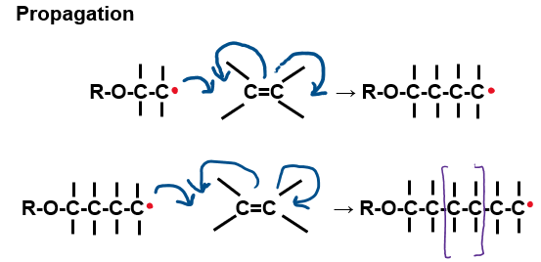
Question 2: How will this process naturally cease?
Sample response: When all the monomers and initiator free radicals pair up.
There are one of 2 options:
      - Two different propagation chains with their respective free radicals can combine and cancel each other out. Then, propagation ceases, and the polymerisation terminates.
      - A terminator can be included. Terminators are substances that absorb the free radical without creating a new one in place. Thus, polymerisation is terminated.
Figure 6 – the termination step in the polymerisation process
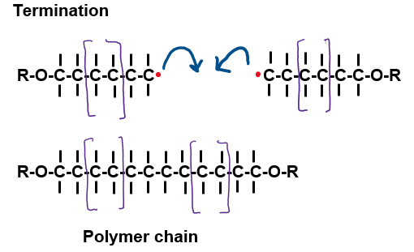
Teaching note: the linear chain of carbon atoms (with their respective 2 hydrogens each, not shown in this modelling) represent HDPE.
Differentiation considerations:
Extension: students model addition polymerisation of LDPE as well. This is done by repeating the first 3 steps in activity 3 to demonstrate side branching in the polymerisation of ethene. It is important to explain that sometimes the final carbon atom of this polymer is a free radical (a student with a free arm).
At that point, rather than terminating, the polymer doubles back on itself. It means the free radical end attacks a carbon-hydrogen covalent bond somewhere on the polymer chain. As a result, the terminal carbon atom bonds with the hydrogen atom, leaving the carbon atom a free radical.
This free radical continues to attack ethene monomers in the same manner described above (propagation), but in this case, the chain grows off the side of the main chain. This represents LDPE.

Condensation polymerisation
Condensation polymers are modelled slightly differently. Either, a one-unit monomer polymer or a two-unit dimer polymer, can be modelled. The modelling steps are the same for both.
- Each student can be a monomer or a dimer unit for this polymer model.
- Give 2 different coloured post-it notes to each student. One colour has ’OH’ (part of the COOH for a polyamide or the OH on the alcohol functional group for a polyester) written on it. The other colour has ’H’ (part of the COOH for a polyester or one hydrogen from part of the NH2 amine functional group for a polyamide) written on it.
- Each student holds one note in each hand to their side (this represents the functional groups that combine as polymerisation occurs).
- Polyester such as polyethylene terephthalate (PET/PETE):
Figure 7 – the condensation polymerisation of monomers (terephthalic acid and ethylene glycol) to form polyester polymer. n represents a large number. It is generally greater than 1000
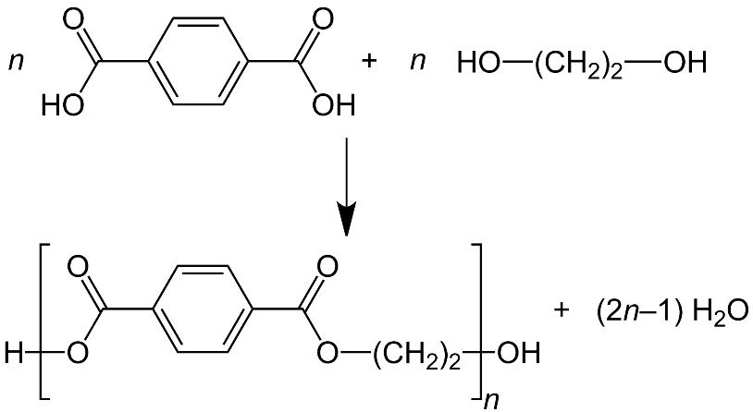
‘Polymerisation of terephthalic acid and ethylene glycol to form Polyester (polymer)’ by Jü is licensed under CC BY-SA 4.0.
- Polyamide such as nylon:
Figure 8 – the condensation polymerisation of 2 monomers. 'n' represents a large number. It is generally greater than 1000
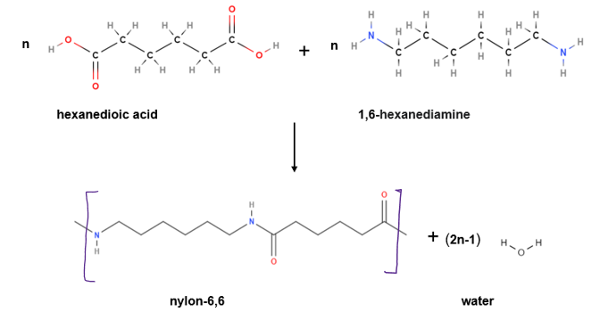
- Imagine that the room contains free-floating acid catalysts to promote the reaction between the monomers or dimers. Alternatively, the tables in the room may be considered the catalysts.
Teaching note: the polymerisation occurs on the table surface (where the sticky notes are linked), and the elongated polymer leaves the catalyst (tables).
- Students model polymerisation by linking hands with opposite coloured sticky notes. First, stick the sticky notes together and then throw them on the floor. Finally, hold hands to form a polymer chain.
Question 3: Why does the throwing of sticky notes and holding hands after that model condensation polymerisation?
Sample answer: Throwing of sticky notes models the release of a molecule of water (H+OH sticky notes make water H2O). Holding hands models the covalent bond between the monomer or dimer units.
- Continue this process until no further monomer or dimer units are available.
Question 4: Is the chain termination step required in condensation polymerisation?
Sample response: due to the absence of a free radical group, there is no need for a termination step in condensation polymerisation.
Teaching note: students who experience explicit teaching practices make greater learning gains than students who do not experience these practices. Explicit teaching recognises that learning is a cumulative and systematic process. Explicit teaching helps students develop sophisticated and well organised ways of thinking, understanding, and doing. Include the necessary support and scaffolding for EAL/D students.
Extension: students use CER scaffold to evaluate the models for addition polymerisation and condensation polymerisation.

Student resources

Resource 1 – activity 2: modelling dynamic equilibrium

Procedure for modelling dynamic equilibrium in a reversible reaction

Part A: establishing chemical equilibrium in a reversible reaction
- Collect two 600 ml beakers and label them A (reactants) and B (products).
- Use a measuring cylinder to add 400 ml of water to beaker A.
- Use a measuring cylinder to add 50 ml of water to beaker B. Then add 15-20 drops of blue food colouring.
- Place these beakers next to each other on a paper towel.
Figure 1 – the experiment set up for modelling equilibrium.
Question 1: If you transfer water from A to B and B to A using same-sized beakers (or measuring cups), will the water level become equal after a certain number of transfer cycles? Give reason(s) for your response.
- Use a 50 ml beaker to transfer water from beaker A to B. Then use another 50 ml beaker to transfer water from B to A. Repeat the process until the colour intensity of water in both beakers appears to be the same.
- Observe the level of water in both beakers. Use a marker to indicate the level of water in each beaker.
Question 2: Does your observation confirm your prediction in Question 1? Why or why not?

Part B: disturbing chemical equilibrium
- Add 250 ml of water to beaker A (from Part A).
- Transfer water from A to B and B to A using a 50 ml beaker until both beakers' colour intensity become the same.
- Observe the water level in beakers A and B. Use a marker to indicate the water level in each beaker.
Question 3: Is the water level in each beaker the same as in Part A, step 7? Why or why not?

Question 4: Did the paper towel become wet during the transfer cycles? How does it impact the validity of the model?

Part C: evaluating the model
- List all the features of the chemical process.
- Judge if the model demonstrates or does not demonstrate that feature.
- Use evidence(observations or data) to support your judgement. Overall judgement is provided based on the evidence or features demonstrated by the model.
- Provide suggestions for improving the model. In case the model is ineffective, suggest an improved model.
Question 5: Evaluate the effectiveness of your model in demonstrating dynamic equilibrium.
Use the CER scaffold to structure a response for this question.
- Claim: answer to the question (usually, a statement)
- Evidence: supports your claim (it may include observations or data from an experiment, data from a graph or flow chart, information from the stimulus material, facts, or any other relevant information)
- Reasoning: logic that links evidence to the claim (it may include an explanation using scientific principle or chemical concept).

Resource 2 – activity 3: modelling polymerisation

Addition polymerisation of HDPE
- Pair students up and have them hold both hands in front to model an ethene monomer.
- A student (initiator) holds one hand with monomer pair. This leaves the initiator and one of the students in the ethene pair with a free arm.
Figure 2 – the initiation step in the polymerisation process.
Question 1: What does the free arm represent?
- This group of 3 students (initiator and one ethene monomer) now seek another double bond to eliminate the free radical.
Figure 3 – the propagation step in the polymerisation process.
Question 2: How will this process naturally cease? Use (a) diagram(s) to show the termination step for this polymerisation process.

Condensation polymerisation
Condensation polymers are modelled slightly differently. Either, a one-unit monomer polymer or a two-unit dimer polymer, can be modelled. The modelling steps are the same for both.
- Each student can be a monomer or a dimer unit for this polymer model.
- Give 2 different coloured sticky notes to each student. One colour has ’OH’ (part of the COOH for a polyamide or the OH on the alcohol functional group for a polyester) written on it. The other colour has ‘H’ (part of the COOH for a polyester or one hydrogen from part of the NH2 amine functional group for a polyamide) written on it.
- Each student holds one note in each hand to their side (this represents the functional groups that combine as polymerisation occurs).
- Polyester such as polyethylene terephthalate (PET/PETE):
Figure 4 – the condensation polymerisation of monomers (terephthalic acid and ethylene glycol) to form polyester polyner. 'n' represents a large number. It is generally great than 1000
- Polyamide such as nylon:
Figure 5 – the condensation polymerisation of monomers (hexanedioic acid and 1,6-hexanediamine) to form nylon-6,6 polymer. n represents a large number. It is generally greater than 1000
- Imagine that the room contains free-floating acid catalysts to promote the reaction between the monomers or dimers. Alternatively, the tables in the room may be considered the catalysts.
- Students model polymerisation by linking hands with opposite coloured sticky notes. First, stick the sticky notes together and then throw them on the floor. Finally, hold hands to form a polymer chain.
Question 3: What does the throwing of sticky notes and holding hands after that model condensation polymerisation?
- Continue this process until no further monomer or dimer units are available.
Question 4: Is the chain termination step required in condensation polymerisation?

Appendix
The following pictures show the setup and progress of modelling equilibrium.
Figure 1 – equipment for Activity 2: modelling dynamic equilibrium. Beaker A is on left hand side and beaker B is on right hand side
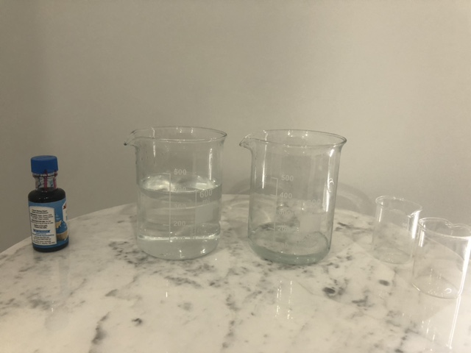
Figure 2 – set up for Activity 2-modelling dynamic equilibrium. Beaker A is on left hand side and beaker B is on right hand side
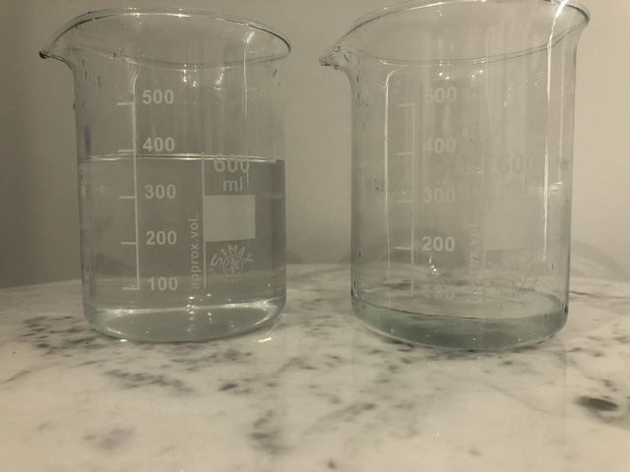
Figure 3 – step 3 of Activity 2-modelling dynamic equilibrium. Beaker A is on left hand side and beaker B is on right hand side
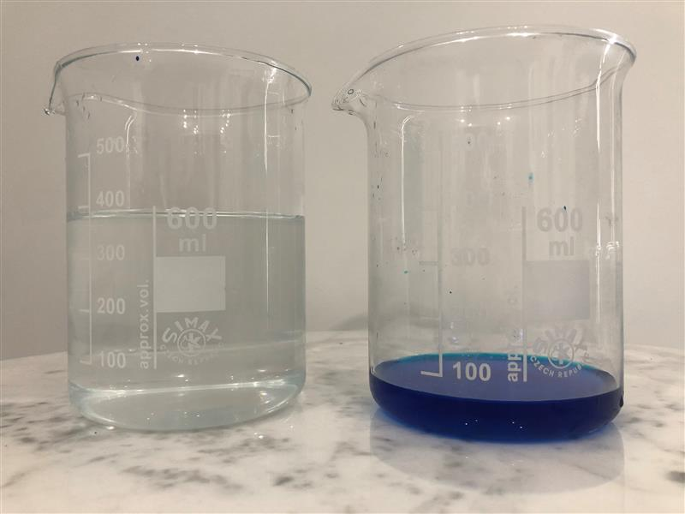
Figure 4 – a stage in Activity 2-modelling dynamic equilibrium, before the equilibrium is established. Beaker A is on left hand side and beaker B is on right hand side
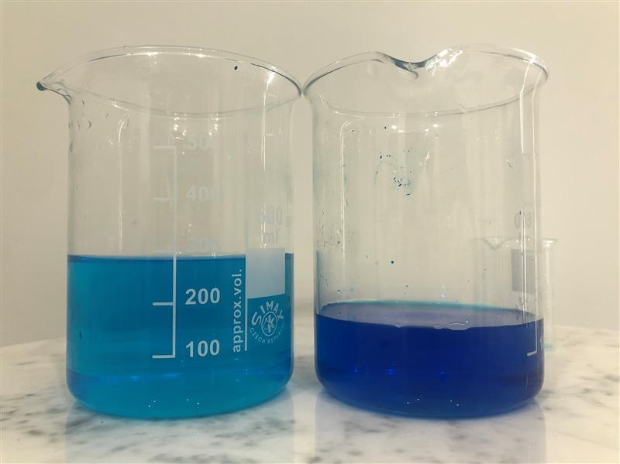

Figure 5 – a stage in Activity 2-modelling dynamic equilibrium, when the equilibrium is established. Beaker A is on left hand side and beaker B is on right hand side
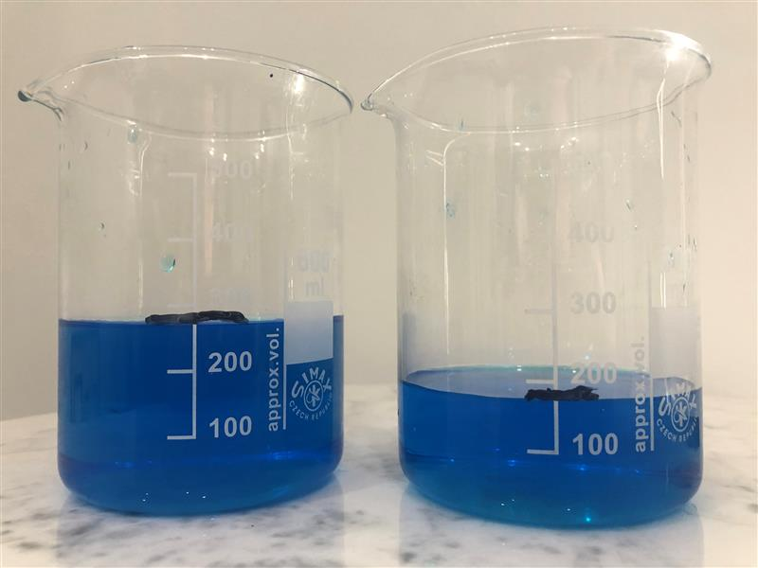
Figure 6 – a stage in Activity 2: modelling dynamic equilibrium, where the equilibrium is re-established after the disturbance. Beaker A is on left hand side and beaker B is on right hand side
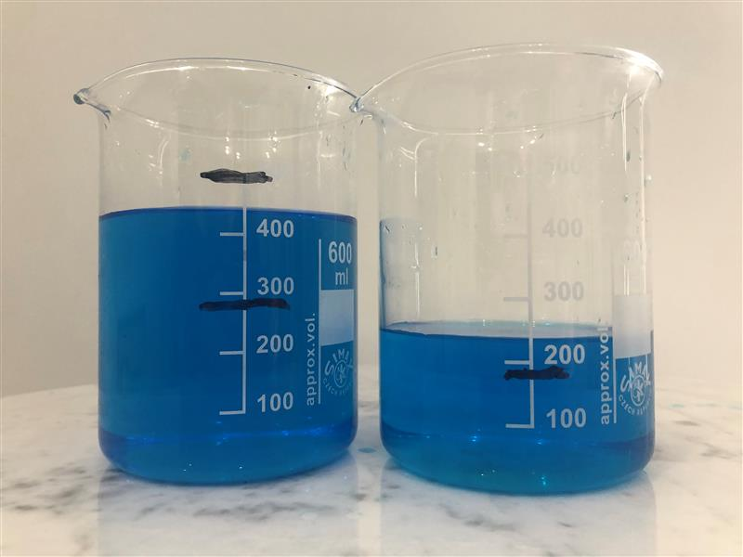

Support and alignment
Resource evaluation and support: all curriculum resources are prepared through a rigorous process. Resources are periodically reviewed as part of our ongoing evaluation plan to ensure currency, relevance and effectiveness. For additional support, advice or feedback, contact the Science Curriculum team by emailing Science7-12@det.nsw.edu.au.
Differentiation: further advice to support Aboriginal and Torres Strait Islander students, EALD students, students with a disability and/or additional needs and High Potential and gifted students can be found on the Planning programming and assessing 7-12 webpage.
Assessment: further advice to support formative assessment is available on the Planning programming and assessing 7-12 webpage.
Professional learning: relevant professional learning is available on the Science statewide staffroom and HSC Professional Learning. Stage 6 Literacy in context provides further advice to teachers to improve student writing.
Related resources: further resources to support Stage 6 Chemistry can be found on the HSC hub and the Science Curriculum page.
Consulted with: Curriculum and Reform, Inclusive Education, Multicultural Education, Aboriginal Outcomes and Partnerships and subject matter experts.
Alignment to system priorities and/or needs: School excellence policy, School Success Model.
Alignment to the School Excellence Framework: this resource supports the School Excellence Framework elements of curriculum (curriculum provision) and effective classroom practice (lesson planning, explicit teaching).
Alignment to Australian Professional Teaching Standards: this resource supports teachers to address Australian Professional Teaching Standards 3.2.2, 3.3.2.
Author: Science Curriculum team and Joshua Westerway, Head Teacher Science, Ulladulla High School
Resource: classroom resource
Updated: 10/01/24

References
Chemistry Stage 6 Syllabus © 2017 NSW Education Standards Authority (NESA) for and on behalf of the Crown in right of the State of New South Wales.
Damelin D, Reiser B and Forbes C (11 November 2017) 'What is Scientific Modeling?' [video], CADREK12, YouTube, accessed 8 September 2022.
Flinn Scientific, Inc. (21 December 2012) 'Addition Polymerization' [video], FlinnScientific, YouTube, accessed 21 August 2022.
Andersen P (9 January 2017) 'CER - Claim Evidence Reasoning' [video], Bozeman Science, YouTube, accessed 8 September 2022.
Schillio P (23 April 2013) 'Escalator Equilibrium' [video], Paul Schilio, YouTube, accessed 8 September 2022.
Rutgers University - Department of Marine and Coastal sciences (25 April 2018) 'Tools of Science: Modeling' [video], Tools of Science, YouTube, accessed 8 September 2022.
State of New South Wales (Department of Education) and CESE (Centre for Education Statistics and Evaluation) (2020) ‘What works best: 2020 update’, CESE, NSW Department of Education, accessed 2 September 2022.
State of New South Wales (Department of Education) and CESE (Centre for Education Statistics and Evaluation) (2019) ‘Revisiting gifted education’, CESE, NSW Department of Education, accessed 2 September 2022.
The Fuse School (17 May 2013) 'What Are Reversible Reactions? | Reactions | Chemistry | FuseSchool' [video], FuseSchool – Global Education, YouTube, accessed 8 September 2022.
University of Colorado (2023) Reversible Reactions, PhET Interactive Simulation, accessed 8 September 2022.
Wiliam D and Leahy S (2015) Embedding Formative Assessment: Practical Techniques for K-12 Classrooms, Learning Sciences International, United States.

Further reading
State of New South Wales (Department of Education) (2022) Literacy and numeracy priorities, NSW Department of Education website, accessed 24 February 2023.
State of New South Wales (Department of Education) (2022) Literacy and numeracy, NSW Department of Education website, accessed 24 February 2023.
© State of New South Wales (Department of Education), 2023
The copyright material published in this resource is subject to the Copyright Act 1968 (Cth) and is owned by the NSW Department of Education or, where indicated, by a party other than the NSW Department of Education (third-party material).
Copyright material available in this resource and owned by the NSW Department of Education is licensed under a Creative Commons Attribution 4.0 International (CC BY 4.0) licence.
This licence allows you to share and adapt the material for any purpose, even commercially.
Attribution should be given to © State of New South Wales (Department of Education), 2023.
Material in this resource not available under a Creative Commons licence:
- the NSW Department of Education logo, other logos and trademark-protected material
- material owned by a third party that has been reproduced with permission. You will need to obtain permission from the third party to reuse its material.
Links to third-party material and websites
Please note that the provided (reading/viewing material/list/links/texts) are a suggestion only and implies no endorsement, by the New South Wales Department of Education, of any author, publisher, or book title. School principals and teachers are best placed to assess the suitability of resources that would complement the curriculum and reflect the needs and interests of their students.
If you use the links provided in this document to access a third-party's website, you acknowledge that the terms of use, including licence terms set out on the third-party's website apply to the use which may be made of the materials on that third-party website or where permitted by the Copyright Act 1968 (Cth). The department accepts no responsibility for content on third-party websites.

