Science and technology workbook Stage 3 – Living world
Name:
Class:

Overview
You will learn about adaptations as existing structures or behaviours in living things. You will describe how adaptations help living things to survive in their specific environment. You will complete an investigation about birds’ beaks. You will research adaptations of native Australian animals and plants.

Resources

Activity 1
- coloured pencils
- parental supervision
- camera (optional)

Activity 2
- none

Activity 3
- teacher handout of the investigation PowerPoint
- ‘food items’ (for example you could use pasta, craft match sticks, paddle pop sticks, rice bubbles, popcorn, rice, lollies)
- 'beaks' (for example you could use tongs, tweezers, skewers, small thin branches that have fallen from a tree, pliers, scissors, chopsticks)
- bowls or other types of containers to put the ‘food items’ in
- container to put all the 'beaks' in
- stop-watch or timer
- ruler or tape measure, rope or string, sticks or pegs to create a 1 metre square area
- student workbook
- a clipboard or book to put the copy of slide 8 so that it is easier for you to record

Activity 4
- Teacher handout from ABC Education

Activity 5
- none

Activity 1 - Adaptation
What is an adaptation?
An adaptation is a feature or trait, such as a specific colour, shape or shelter. Adaptations provide an advantage for a living thing to survive better in its environment. For example, a plant might have small leaves to minimise moisture loss or an animal might have colours that camouflage (hide) it from predators.
Choose five living things from your list. You will now suggest possible adaptations of these living things you observed outdoors. Think about what an adaptation is and suggest possible adaptations for each living things you observed outdoors. Write your ideas in the second column of the table.
Living thing | Possible adaptation(s)

Activity 2 – Types of adaptations
During this activity you will explore adaptations of living things.
There are two main types of adaptations seen in living things – structural adaptations and behavioural adaptations.

Structural adaptations
Structural adaptations are physical features, such as specialised body parts, that help living things to survive. For example, spines on an echidna or a barbed tail on a stingray helps to protect these animals from predators.
Look at this photo of a saltwater crocodile. Identify three possible structural adaptations of this living thing. Suggest a survival purpose for each of your ideas. List your ideas. For example, a saltwater crocodile has a strong body to roll its prey.
________________________________________________________________________________________________________________________________________________________________________________________________________________________
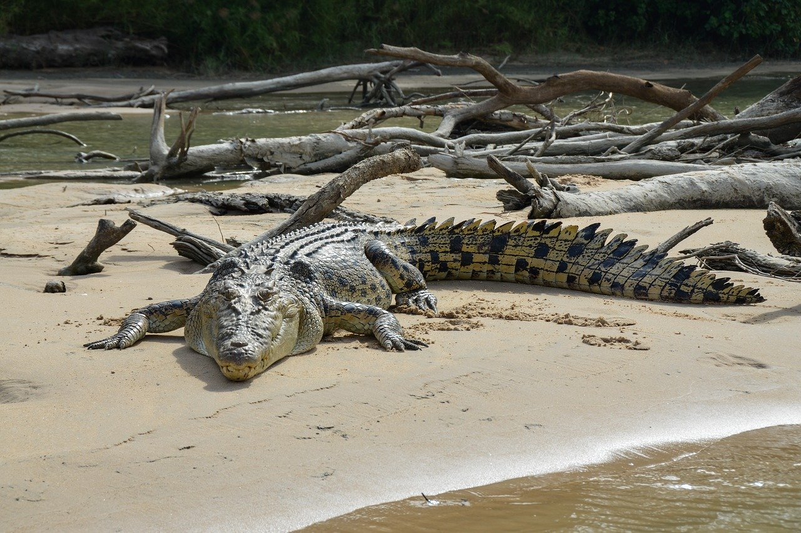
Image from Pixabay.
Read this information about the banksia plant. Look at the three photos.
Banksia is a native Australian plant found throughout Australia. There are lots of different types of banksia. Some grow to be very tall trees while others grow to be small shrubs. Banksia plants grow flowers. The flowers can vary in colour from yellow to orange to red and pink and usually appear in autumn or winter (first and third photo). The banksia flower is not just one big flower, it is lots and lots of tiny little flowers. When the flowers die, the hard, woody fruit is left (second photo). Inside the fruit are the seeds that will grow into new banksia plants. The fruit protects the seeds from animals that might eat the seeds. These seeds must wait for special conditions for them to be released from the fruit. They will only be released in very high temperatures or when they are completely dry. Bushfires provide the high temperatures needed for the seed pods to open. Some gardeners put the fruit in their oven to make the seed pods open. The second photo shows the banksia fruit with the seed pods open after a bushfire.
Information sourced from Australian National Botanic Gardens
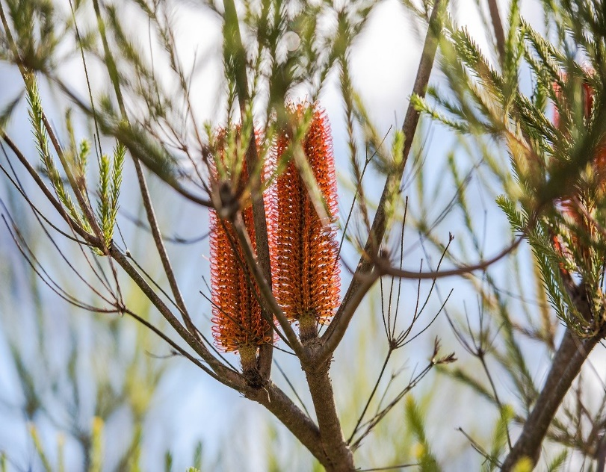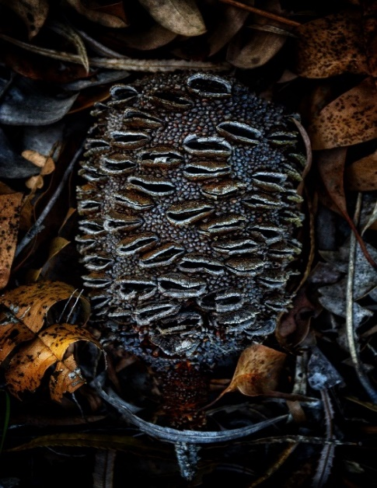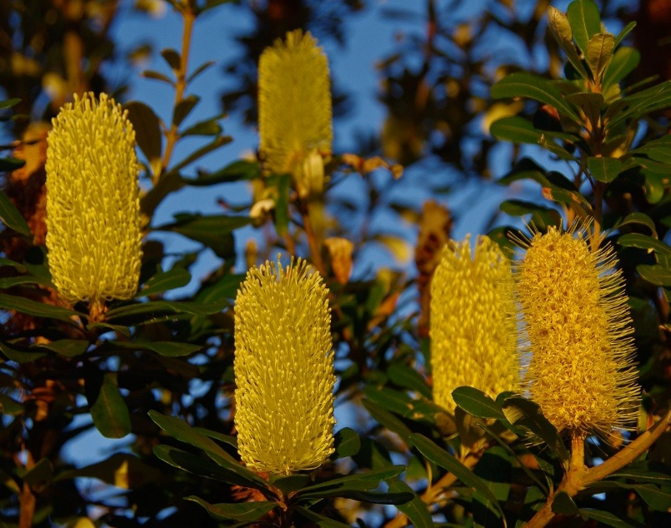
Images from Pixabay
Draw a labelled diagram of a banksia plant, showing at least two structural adaptations.
Diagram of a banksia plant

Think about animals you know. Identify some possible structural adaptations that help these animals to survive in their environment. Describe some of the structural adaptations you thought of.
________________________________________________________________________________________________________________________________________________________________________________________________________________________________________________________________________________________________________________________________________________________________________

Behavioural adaptations
Behavioural adaptations are actions taken by living things to support their survival in specific environments. For example, when humans get hot, they find shade to keep cool. Similarly, Red kangaroos rest in shade through the hottest part of the day. Many plants are also able to move to reduce evaporation and water loss on hot days. For example, eucalyptus trees are able to turn their leaves side-on, so that the thinnest part of the leaf faces the sun during the hottest part of the day. This helps to reduce evaporation and water loss.
Think about animals you know. Identify some possible behavioural adaptations that help these animals to survive in their specific environment. Describe some of the behavioural adaptations you thought of.
________________________________________________________________________________________________________________________________________________________________________________________________________________________________________________________________________________________________________________________________________________________________________

Reflection
Think about what you have learnt in this activity. Use the two stars and a wish structure to guide your reflection.
Star  Something that went well! | Star  Something that went well! | Wish  A goal for next time…

Activity 3 – Stick-bird investigation
During this activity you will investigate how birds’ beaks have adapted to suit their environment.
Living things that are best adapted to their environment are usually the ones that survive. Birds have different types of beaks and for good reason. Depending on their environment, depends on the type of food that they eat. Their beaks are of different sizes and shapes so that they can capture their food. For example the hummingbird has a long thin beak so that it can get its food from inside a flower while the pelican has a pouch-like beak that can expand when it is trying to scoop up fish.
For this investigation, you will pretend to be a hungry stick bird. You will use different types of beaks to pick up as many food items as they can. The resources that you need are in the PowerPoint. You will need a partner to assist you during the investigation. You will analyse the data and form a conclusion about which beaks were most successful.
Read the instructions in the PowerPoint handout your teacher gave you. Complete the data table on slide 8. Before you begin your investigation, predict which ‘beak’ will be the most successful with picking up the most food. Explain your prediction.
________________________________________________________________________________________________________________________________________________________________________________________________________________________
After you have analysed the data in your table, complete the following questions.
- Check your prediction. Was it correct? Explain what went well for your prediction to be true. If it wasn’t correct? Why?
_______________________________________________________________________________________________________________________________________________________________________________________________________________

- What patterns or trends did you identify after you analysed the data?
_______________________________________________________________________________________________________________________________________________________________________________________________________________

- Which type of beak picked up the most food? Why?
_______________________________________________________________________________________________________________________________________________________________________________________________________________
- Which type of beak wasn’t as successful? Why?
_______________________________________________________________________________________________________________________________________________________________________________________________________________
- What didn’t work well in this investigation?
_______________________________________________________________________________________________________________________________________________________________________________________________________________
- What would you change in this investigation so that there were more successes?
_______________________________________________________________________________________________________________________________________________________________________________________________________________

Activity 4 – adaptations for changing environments
During this activity you will explore how animals and plants adapt to changes in their specific environment.
View the ABC Education resource or read the handout provided by your teacher. Topic 3 discusses the adaptations (survival strategies) of several plants and animals such as migration and hibernation, to survive temporary or seasonal changes in their specific environments.
Choose one animal or plant, identify its adaptations and state whether they are structural or behavioural.
_______________________________________________________________________________________________________________________________________________________________________________________________________________________.
Living things are adapted to survive in specific environments. If conditions in those environments change, living things must adapt to those changes to survive. Changes that can occur to specific environments could be physical such as rising sea levels, drought, deforestation or chemical such as pollution. If animals and plants are unable to adapt to changes in their environment they may not survive. for example, endangered Tasmanian Devils.

Reflection
Think about what you have learnt in this activity. Use the two stars and a wish structure to guide your reflection.
Star  Something that went well! | Star  Something that went well! | Wish  A goal for next time…

Activity 5 - presentation
During this activity you will create a product to communicate your learning.
You will create an information brochure, poster, written report or television news item. This product will describe the structural and/or behavioural adaptations of your chosen animal or plant in its specific environment. You will choose one change to the physical conditions of the environment and consider how your animal or plant might adapt to survive these changing conditions.
In your product, make sure you include the following.
- Identify structural and/or behavioural adaptations of your animal or plant.
- Describe how the adaptations support the survival of your animal or plant in its specific environment.
- Identify a change to the conditions in the environment of your animal or plant.
- Predict how your animal or plant might adapt to changing environmental conditions.

Reflection
Think about what you have learnt in this activity. Use the two stars and a wish structure to guide your reflection.
Star  Something that went well! | Star  Something that went well! | Wish  A goal for next time…

