Material world workbook Stage 3
Name:
Class:

Overview
In this learning sequence you will investigate how different properties of materials affect their use for constructing products, and understand that the choice of materials used when designing is important for the success of your product. You will get a chance to manipulate materials and see how they behave and have the opportunity to design and make an entertaining game for a younger child to play.

Resources
- You may need help from an adult to read all the information in this student workbook, discuss your ideas, or research further online for more understanding.
- materials to investigate the property of strength.
- Pencil, rubber, coloured pencils, recycled cardboard, scissors.
- Recycled materials (The resources needed will depend on what game you choose to create) - paper, cardboard, aluminium, bottle tops, art supplies, craft supplies, glue, sticky tape etc. – an adult may be able to help you locate what you need.

Activity 1
During this activity you will explore why the characteristics of materials are important when designing and producing products.

Activity 1.1 – investigating materials
During this activity you will describe materials, their structural properties and possible uses.
Have you wondered about the world around you and what objects are made from? What is the same and what is different about objects in the world? How are they connected? Discuss these questions with an adult or peer.
What are materials and how are they used?
Materials are the matter or substance that objects are made from. Each material can be used to make a range of different products. For example, wood can be used to make tables, chairs, spoons, pencils, shoes, doors, floors and many more things. An object can be made from different materials combined or manipulated together. For example, a chair can be made from metal, wood and plastic. The properties of materials determine the purpose for which they are used.
Complete the mind map, or develop your own, to demonstrate your understanding about materials in our world. Challenge yourself to add as much detail as possible. There are some headings provided– try to add more of your own. Drawings and pictures will enhance the mind map. If you have access to a digital device, you may like to conduct your own research and create the mind map in an online program such as in Word or PowerPoint. Upload the finished product or print and add to your student workbook.

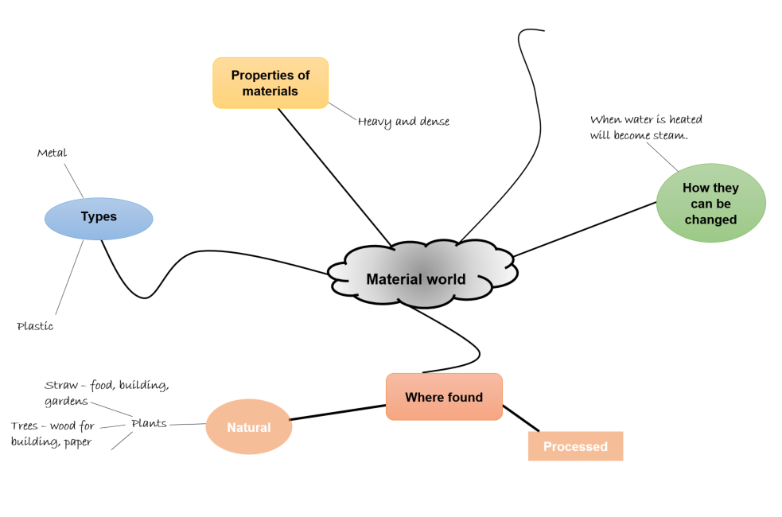

Activity 1.2 – structural properties of materials.
During this activity you will explore the structural properties of materials.
A structural property of a material represents the characteristics that can be observed. For example, bendy (flexible), stretchy (flexible), stiff (rigid), brittle (breaks easily), durable (doesn’t break easily) smooth, rough, waterproof, absorbent, transparent, opaque, shiny, dull.
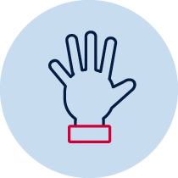Choose ten different objects from around your home/classroom. After you have finished collecting your objects, pick them up and move them, squeeze them softly, feel how heavy they are, what they feel like. Write the name of each object. Identify the material(s) it is made from. List the structural properties you can observe for each material.
Object | Material(s) | Structural properties

Activity 1.3 – uses of materials
During this activity you will explore how the structural properties of materials determine the use of materials.
The properties of different materials make them suitable for specific purposes. Answer these three questions, then think of two more questions you could ask to justify the suitability of materials for a purpose.
Question | Answer
Why is aluminium metal used to make playground seats?

Why isn’t gold used to make pillows?

What if plastic had never been invented?

Activity 1.4 – properties determine use of materials
During this activity you will investigate the structural property of strength in a range of materials to determine the material best suited to carry a group of objects from one place to another.
Think about the scientific investigations you have planned and conducted at school. What are the important steps when planning and conducting a scientific investigation? Discuss your ideas with an adult or peer.
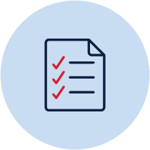Did you include these steps?
- Identify a question to investigate.
- Make a prediction.
- Plan the steps and identify the materials needed.
- Identify the variables to make sure it is a fair test.
- Choose the variable that you will change, measure and what will stay the same.
- Decide what data/evidence you will collect.
- Choose how you will present the data.
- Decide how many times you will repeat your test.
- Communicate observations and justify the answer to the question.
You need to carry a load (objects) a short distance. Investigate the strength of a range of materials. Decide which material is best suited for this task.
Question: Which material is the strongest and best suited to carry a load?
Plan a scientific investigation to determine the strength of a range of materials.
- Choose 5-6 different materials to test such as paper, cardboard, aluminium foil, plastic wrap, newspaper, tissue.
- List the variables in this investigation, such as:
  - type of material
  - load/number of objects
  - size of material
  - distance carried
- Collect the data
- Create a table for the data.
- Repeat the test to compare results.
- Share your observations and justify your choice of material.
Think about these questions.
- What materials will you test?
- How will you judge if the material is suitable or not suitable for the task? (For example, it bends, tears/breaks or loses the load.)
- What objects will you use for the load?
- What variables will you have to keep the same for a fair test? (For example, size of material, distance moved)
Describe the materials you will need, identify variables and list the steps you will take to conduct your fair test to determine the strength of different materials.
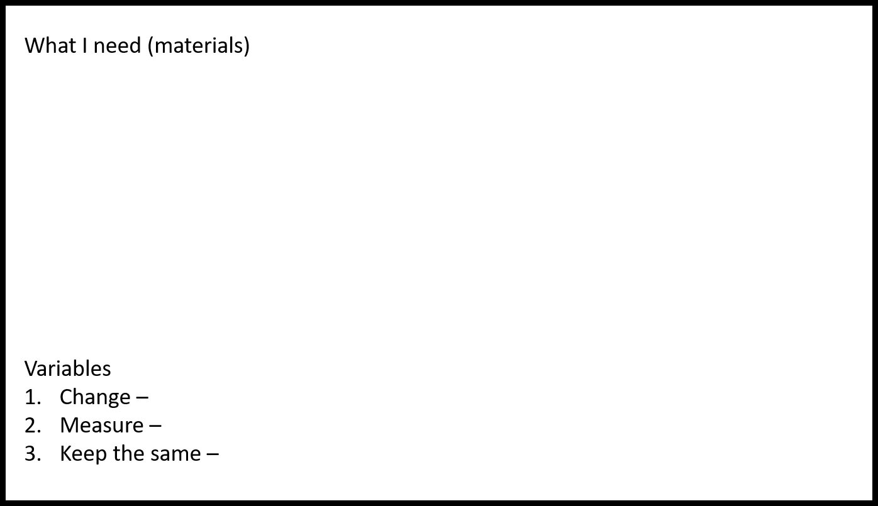
What I will do (steps)
Write your prediction. Write a reason for the choice you make.
I think the strongest, most suitable material will be ________________________________________________________________________
________________________________________________________________________
________________________________________________________________________
Conduct your investigation and draw a labelled drawing of what you did.
Record your data in the table.
Material | Load 1 | Load 2 | Load 3 | Load 4
Which material do you think is the most suitable to carry the load? Explain reasons for your choice. Make sure you refer to your data in your explanation and compare your prediction with your actual test results.
______________________________________________________________________
______________________________________________________________________
______________________________________________________________________
______________________________________________________________________
______________________________________________________________________
______________________________________________________________________
______________________________________________________________________
______________________________________________________________________
Have you completed each of these tasks?
- Recorded a prediction.
- Chosen and tested a range of materials.
- Used technical language to describe the investigation steps such as predict, fair test, variable, record, data.
- Completed a labelled drawing of what was done.
- Recorded data for repeat tests and compared data with prediction.
- Used collected data and compared original prediction to justify final choice (conclusion).

Activity 2 – design and produce a game
During this activity you will design and produce a game to entertain a younger child.

Activity 2.1 – using materials for a purpose
During this activity you will explore sustainable use of materials by recycling.
Recycling is the process of turning waste materials into new materials and objects. Some materials can be recycled through waste management systems such as cardboard, glass, paper, metal cans and some plastics. Some materials cannot be recycled using the recycling bin. For example, some plastics and packaging materials such as Gladwrap and Styrofoam.
Why do you think it is important to recycle materials? What do you think will happen if we don’t recycle materials? Write and draw your ideas.
Can you think of new products that could be made from recycled materials? Draw your ideas.
When we recycle, recyclable materials are reprocessed into new products, and as a result the amount of rubbish sent to landfill sites is less. We can choose to upcycle instead. Upcycling is a way to transform old things and turn them into something new without reprocessing the product into its raw materials. Instead, upcycling can take an old object and give it new life. Our planet has a lot of people on it and we produce a lot of rubbish.
Look at the photos. Can you identify the products that have been upcycled?
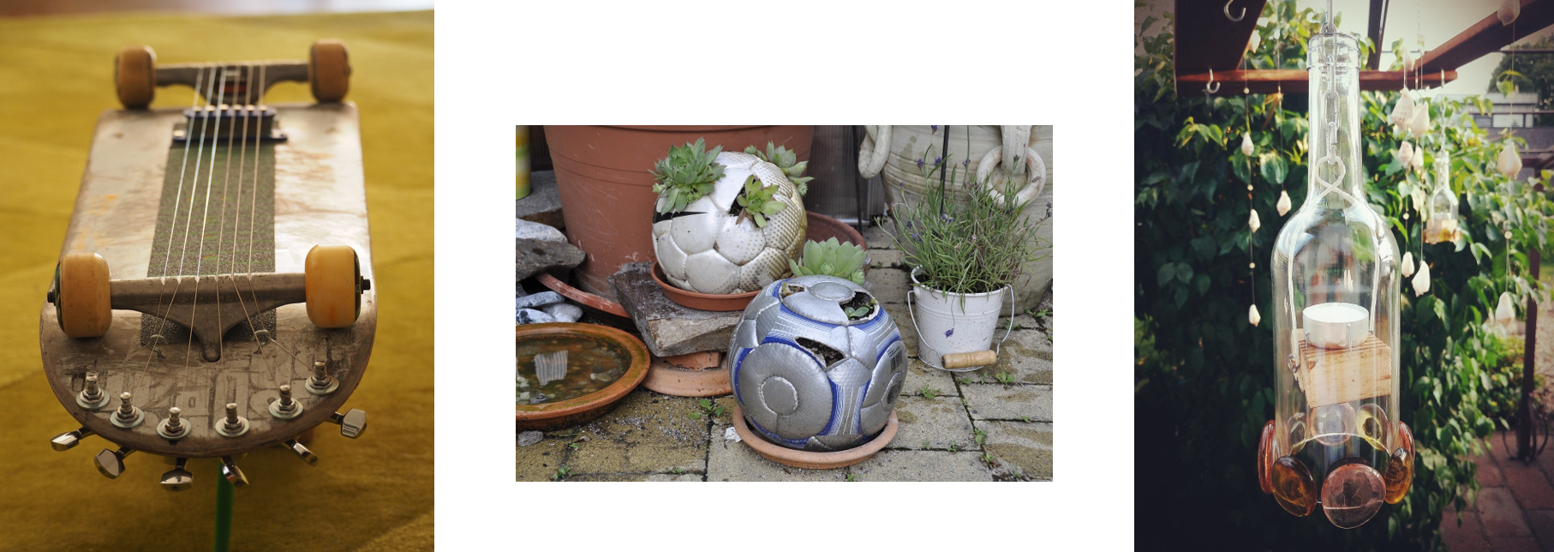All images from pixabay
Brainstorm ways that people could ‘upcycle’ items to be re-purposed. Draw and label your ideas for upcycling to turn trash into your treasure.

Activity 2.2 – games, games, games
During this activity you will begin designing your own game.
What are some games you, your friends and family like to play? Think about the materials you need for these games. They can be inside or outside games (that don’t need an electronic device). Here are some ideas to help you think of your own.
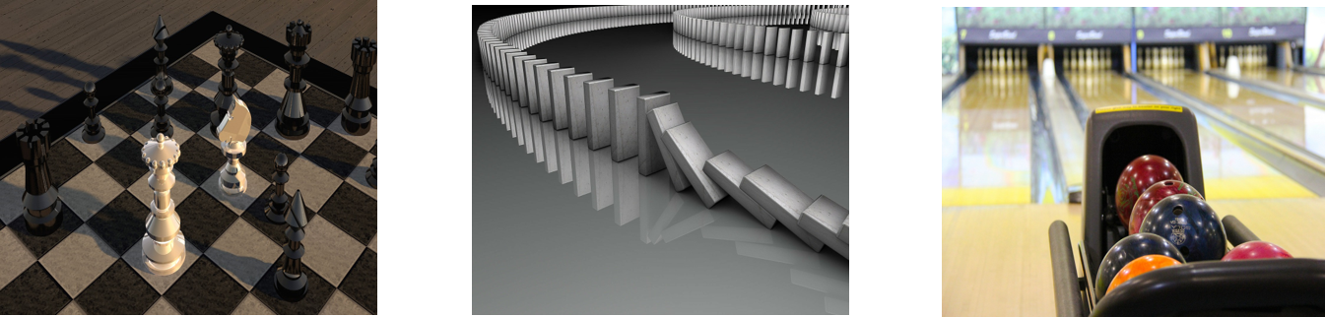Images from pixabay
List and/or draw some games you like to play with your friends and family.
Using what you know about games, choose one game or create a brand-new game that you could make from recycled materials. You may like to use a game you know well and change it slightly to suit your purpose. It could be a board game, throwing game such as, ring toss, maze run, ten pin bowling or a carnival game like mystery fishing game, water squirt, guess how many, stilt racer or milk bottle pyramid throw game. You may also like to create an arcade game like mouse-hole roll, marble race, target golf or frisbee challenge.
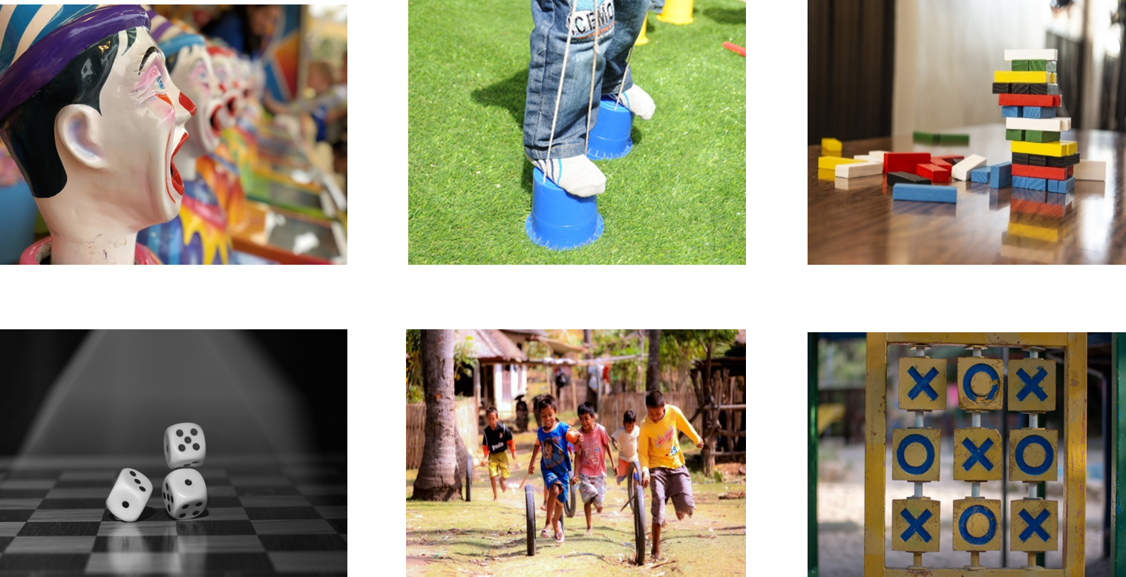Images from pixabay
Choose the game you would like to create. Your game will be designed for a younger child to play. Research the needs, likes and dislikes of your audience (kindergarten student or younger sibling) by interviewing them. Write or record your interview questions. For example, What games do you like to play? Do you have a favourite game? Why do you like playing it? Is there a favourite character or game piece you like? Is the game easy or hard to play? Do you like games that have a dice or games you play on your own?
_______________________________________________________________________
_______________________________________________________________________
_______________________________________________________________________
_______________________________________________________________________
_______________________________________________________________________
_______________________________________________________________________
_______________________________________________________________________

Activity 2.3 – planning
During this activity you will plan your game design.
You could research information about your idea. Planning is a very important part of the design process. Plan the materials and steps you will have to follow to make your game. First summarise what you learnt from the interview with the person you will make the game for (intended audience). Explain how this information will impact your game design.
_______________________________________________________________________
_______________________________________________________________________
_______________________________________________________________________
_______________________________________________________________________
_______________________________________________________________________
_______________________________________________________________________
_______________________________________________________________________
_______________________________________________________________________

Draw an annotated, labelled, scaled drawing of your idea to explain how it will work. This will help you visualise your design. Write a list of the materials you will need to collect to make your game. Circle the recycled materials you will use.
Annotated drawing | Materials

Activity 2.4 – create and make
During this activity you will produce a sample scale model of your design idea.
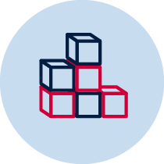It is important to make a sample scale model of your design before building the final product. This is called a prototype. You can test the prototype and make improvements, or modifications, before you make the final version of your game.
Collect the materials you will need to make your sample scale model.
Accurately measure, cut and join the materials to build your prototype.
Remember when you make your game there are many ways to join pieces of cardboard without using sticky tape. Before you build the prototype, gather some bits of cardboard and practise different ways of joining them together such as cutting slots in the cardboard and sliding two pieces together, using fasteners (split pins), using a hole punch and string to tie cardboard pieces together or glue a stand to the back of a shape. Some of these techniques could be applied when using other materials. Gather some bits of cardboard and practise some of these types of cardboard attachments. Think about the ones that will best suit your game.
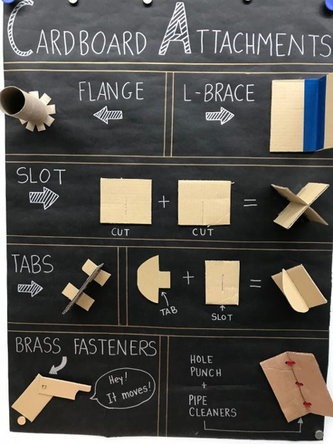
by Pana Asavavatana out-of-a-sticky-situation CC BY-NC-SA 4.0
Demonstrate at least one other idea for attaching pieces of cardboard not listed on the poster. Draw a picture or take photos.

Test the prototype to see if it works the way you think it should. Make changes to improve your design if you need to.
Draw your prototype or take photos of the model and add them to this student workbook.

Reflection
Think about your prototype. Were you happy with how it turned out? Did you enjoy the design process in Activity 2? Write your reflections using the two stars and a wish format.
Star  Something that went well! | Star  Something that went well! | Wish  A goal for next time…
Have you completed these tasks?
- Identified and incorporated needs and likes into design ideas after interviewing a younger child (game audience).
- Drawn an annotated, labelled, scaled drawing of game design.
- Listed materials and identified recycled materials.
- Built a small-scale model (prototype) of the game and included drawing or photos.
- Reflected on the design product and process.

Activity 3
During this activity you will make the final product of your design idea and reflect on the design process.

Activity 3.1 – play your game
Make a final version of your game. It will take some time. You may need help from an adult.
Spend time thinking of new ways to use your recycled materials. Test and check that it works as you are designing and building.
Play your game and gain feedback from others to make your game the best it can be. Take photos of your game or you could bring it to school to share with others. It would be wonderful if your game could come into school on a games day and each class member has a go at playing each other’s games.
You will be asked to present your game to the class and tell them:
- Which materials you chose and why.
- How your game works.
- What other people think of your game. Did they have fun playing it? How? Why?
- Did you make changes from the feedback you received?
- What changes did you make?
- Was your game suitable for your audience?
- What did you learn from your mistakes?
- What would you do differently if you could make another game?
- Could you use other materials to make your game last longer? What would they be?
- Could you adjust this game to create a new game?
Have lots of fun!

Reflection
Once you have completed your project reflect on the process and record your responses to these sentence starters.
I really enjoyed___________________________________________________________
________________________________________________________________________
________________________________________________________________________
I learned a lot about________________________________________________________
________________________________________________________________________
________________________________________________________________________
________________________________________________________________________
________________________________________________________________________
I could improve___________________________________________________________
________________________________________________________________________
________________________________________________________________________
________________________________________________________________________
I’m still wondering about____________________________________________________
________________________________________________________________________
________________________________________________________________________
________________________________________________________________________
________________________________________________________________________
________________________________________________________________________

