Earth and space workbook Stage 3
Name:
Class:

Overview
You will learn that the Earth is part of a system known as the solar system. It is the only planet in the solar system that’s known to have water (Jupiter’s moon Europa may have frozen water, but this has yet to be confirmed). Because of this, Earth is the only planet with life. Through research you will find more interesting information and then have a choice to present your understandings from a few different options. You will use this rubric to guide you in the development of your product.
Research Product Rubric: Earth and the solar system
Choice of infographic, artwork, data table, written report, video, Power Point, speech, model, prototype or in a multi-modal form.
Category | Awesome | Great | Good | Need some help
Organisation | Information is very organised with well-constructed content easily seen in your chosen product. | Information is organised where content helps convey the information. | Information is organised, but some content is missing. | The information appears to be disorganised.
Creativity | Diagrams and illustrations are creative in their design, neat, accurate and add to the reader's understanding of the topic. | Diagrams and illustrations are accurate and add to the reader's understanding of the topic. | Diagrams and illustrations are neat and accurate and sometimes add to the reader's understanding of the topic. | Diagrams and illustrations are not accurate OR do not add to the reader's understanding of the topic.
Quality of Information | Information clearly relates to the solar system. It includes several supporting details and/or examples. | Information clearly relates to the solar system. It provides 1-2 supporting details and/or examples. | Information clearly relates to the solar system. No details and/or examples are given. | Information has little or nothing to do with the solar system.
Mechanics | No grammatical, spelling or punctuation errors. | Almost no grammatical, spelling or punctuation errors | A few grammatical, spelling, or punctuation errors. | Many grammatical, spelling, or punctuation errors.
Completed product  Infographic, artwork, data table, written report, speech or model | Product is complete and shows clear, logical relationships between all content and annotations. | Product is complete and shows clear, logical relationships between most of the content and annotations. | Product is complete and shows, logical relationships between some of the content and annotations. | Product has not been completed.
Resources

Activity 1
- May need help from an adult to read all the information or access information online through a device. Note taking paper and pencil.

Activity 2
- coloured pencils, art supplies, craft supplies, glue, sticky tape etc. – an adult may be able to help you locate what you need. (This will depend on what product you choose to create)
- a piece of paper or cardboard for annotated drawing or detailed outline

Activity 1
During this activity you will explore the Earth and our solar system.
Resources – pencil, note paper

From what you already know, discussions with an adult, readings at the end of this booklet and notes taken when accessing a device, complete the table.
Questions | Answers
What is a planet?
Name some planets
Which planets in our solar system are rocky planets?
Which planets in our solar system are gas giants?
What do all planets in our solar system have in common?
What are dwarf planets?
What is Kepler?

Activity 2

Brainstorm/think
You are now required to demonstrate your understanding by teaching what you have learned to someone else by creating a resource that will help you get your messages clearly to your audience. Choose the information that you have found, and think is most important to publish. Brainstorm some ideas of how you would like to present your information. Check and see what time and resources you have available to you and whether you need help from an adult to gather them or you need extra help to make something you have in mind.
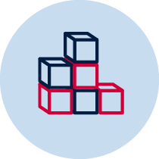 Create/make
You now need to publish!
You may choose to use an infographic, artwork, data table, written report, speech, prototype or model to represent the solar system. You may even decide to create a space craft that would be suitable to either travel through the solar system or on a planet of your choice. Remember to make it as detailed as possible so the person you are teaching has all the facts. You must create a detailed drawing with annotations or draft an outline of how you are going to create your product first. This must accompany your final product.

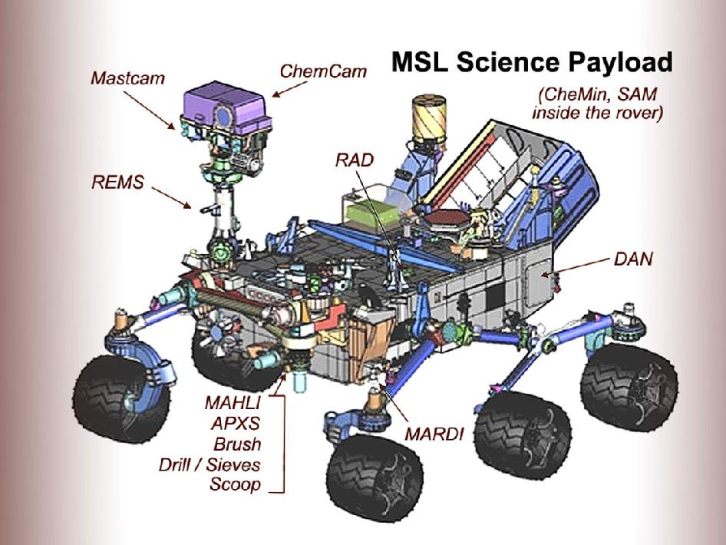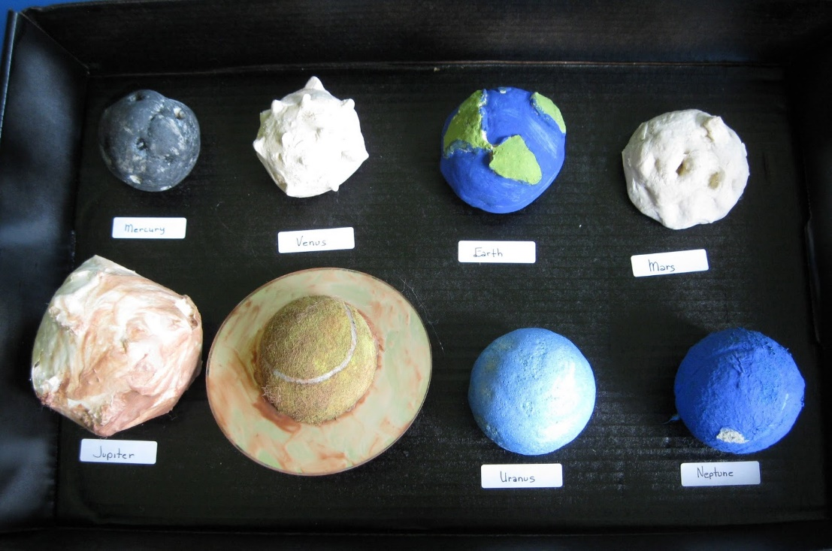
Image credit: NASA/JPL-Caltech
Instruction
It is now time to share your great work. Use what you have created to help you demonstrate your new knowledge. Your work should have all the information you need to inform your audience about our solar system. Choose an audience that is accessible to you and present your learning. Try to get feedback from them to further improve your product.

Reflection
One you have completed your project please answer these questions.
Your answers
I really enjoyed...
I learned a lot about...
I could improve ...
I’m still wondering about ...

Before you choose your product to develop, read through the information below and on the following pages.
Information taken from www.solarsystem.nasa.gov/planets/
The information is presented in order from the sun. In addition, asteroids, meteorites and comet information is presented in the order in which they appear in the solar system.
SUN  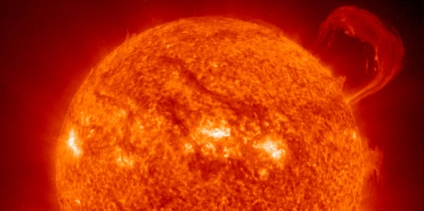 | The sun is a star, a hot ball of glowing gases at the heart of our solar system. Without the sun's intense energy and heat, there would be no life on Earth. Although it is special to us, there are billions of stars like our sun scattered across the Milky Way galaxy.
Sun-scorched Mercury is only slightly larger than Earth's Moon. Like the Moon, Mercury has very little atmosphere to stop impacts, and it is covered with craters. Mercury's dayside is super-heated by the sun, but at night temperatures drop hundreds of degrees below freezing. Mercury's egg-shaped orbit takes it around the sun every 88 days. | MERCURY  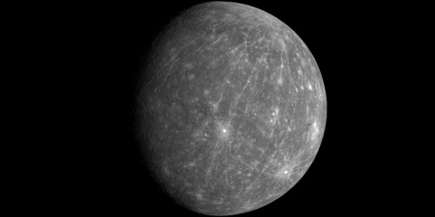
VENUS  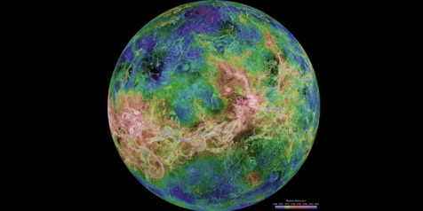 | Venus is a dim world of intense heat and volcanic activity. Similar in structure and size to Earth, Venus' thick, toxic atmosphere traps heat in a runaway "greenhouse effect." The scorched world has temperatures hot enough to melt lead. Venus spins slowly in the opposite direction of most planets.
Earth is an ocean planet. Our home world's abundance of water -- and life -- makes it unique in our Solar System. Other planets, plus a few moons, have ice, atmospheres, seasons and even weather, but only on Earth does the whole complicated mix come together in a way that encourages life -- and lots of it. | EARTH  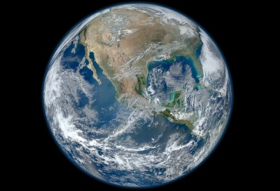
MARS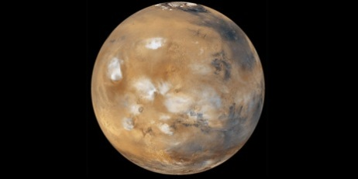 | Mars is a cold desert world. It is half the diameter of Earth and has the same amount of dry land. Like Earth, Mars has seasons, polar ice caps, volcanoes, canyons and weather, but its atmosphere is too thin for liquid water to exist for long on the surface. Evidence for water now exists mainly in icy soil and thin clouds.
Asteroids are rocky, airless worlds that orbit our sun, but are too small to be called planets. Tens of thousands of these "minor planets" are gathered in the main asteroid belt, a vast doughnut-shaped ring between the orbits of Mars and Jupiter. Asteroids that pass close to Earth are called Near-Earth Objects (NEOs). | ASTEROIDS  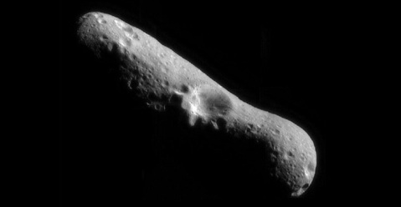
METEORITES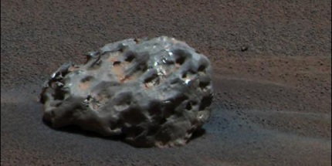 | Little chunks of rock and debris in space are called meteoroids. They become meteors -- or shooting stars -- when they fall through a planet's atmosphere; leaving a bright trail as they are heated to a bright glow by the friction of the atmosphere. Pieces that survive the journey and hit the ground are called meteorites.
Jupiter, the most massive planet in our Solar System -- with dozens of moons and an enormous magnetic field -- forms a kind of miniature Solar System. Jupiter does resemble a star when viewed from the Earth. The planet's swirling cloud stripes are punctuated by massive storms such as the Great Red Spot, which has raged for hundreds of years. | JUPITER  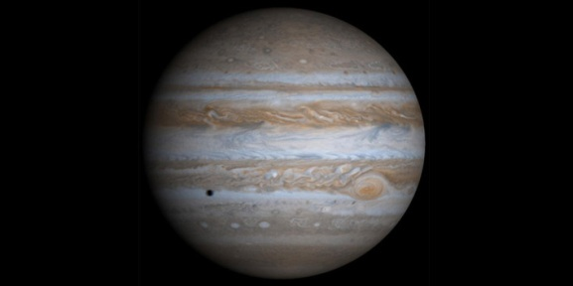
SATURN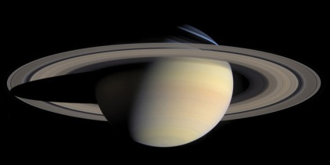 | It is not a solid planet but made up of gases! Adorned with thousands of beautiful ringlets, Saturn is unique among the planets. All four gas giant planets have rings -- made of chunks of ice and rock. Like the other gas giants, Saturn is mostly a massive ball of hydrogen and helium.
It is not a solid planet but made up of gases. Nearly a twin in size to Neptune, Uranus has more methane in its mainly hydrogen and helium atmosphere than Jupiter or Saturn. Methane gives Uranus its blue tint. | URANUS  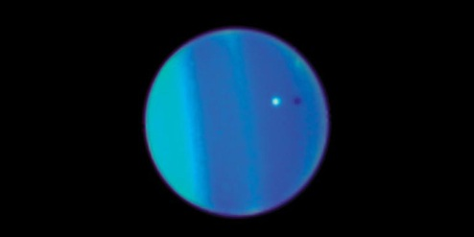
NEPTUNE  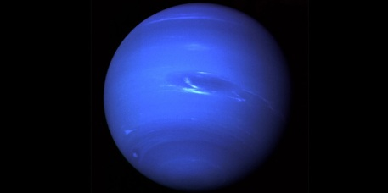 | Dark, cold and whipped by supersonic winds, Neptune is the last of the hydrogen and helium gas giants in our Solar System. It is not solid. More than 30 times as far from the sun as Earth, the planet takes almost 165 Earth years to orbit our sun. In 2011 Neptune completed its first orbit since its discovery in 1846.
Comets are cosmic snowballs of frozen gases, rock and dust roughly the size of a small town. When a comet's orbit brings it close to the sun, it heats up and spews dust and gases into a giant glowing head larger than most planets. The dust and gases form a tail that stretches away from the sun for millions of kilometres. | COMETS  