Design and production investigation – Wind turbine
Science and technology Stage 3 – Physical world
Focus question
What types of energy transformations can be observed using electricity in a product or system?

Task
Students will complete a design and production investigative task to implement the skills and knowledge associated with understanding energy transformations between kinetic (movement), electric and light energies. Students will design, test and evaluate a system that uses energy transformations to meet an identified need.
Students work in pairs to design and construct a wind turbine tower that demonstrates how different types of energy can transform. The blades of the wind turbine generate kinetic energy, through motion, which is then transformed to electrical energy as the blades turn the shaft of a small hobby motor. A small red LED, attached to the terminals at the back of the hobby motor, illuminates as this electrical energy is transformed to light energy. No soldering, alligator clips or wires are needed for this investigation.
Task duration – estimated to be 4-5 hours, which can be delivered over a sequence of lessons.

Assessment
Formative assessment opportunities, where teachers gather evidence about the impact of their teaching to move students forward with their learning, are referenced throughout the learning experiences. These opportunities are elaborated upon in the Formative assessment section at the end of this document, where they are also connected to the Quality Teaching and Learning Framework elements.

Resources
- rigid paper cups – small, medium and large
- plastic cups – small, medium and large
- scissors
- plastic PVC binding covers (or similar)- 1 per wind turbine
- hobby motor – 1 per windmill (6V-12V)
- paddle pop sticks – maximum of 15 per wind turbine
- hot glue guns – at least 6 (with approximately 30 glue sticks)
Note – student safety – instruct students on the safe use of hot glue guns and use only with adult supervision.
- red 2-pin 5mm LED (1.6 – 2V) – 1 per wind turbine (red LEDs need less volts to function than other colours)
- hand held manual craft drill – this can be used by students with supervision.
Note – Student safety – if only an electric drill is available then it should not be used by students, only an adult.
- drill bit that matches the shaft diameter on the hobby motor – approximately 1.5mm - 2mm
Online support videos:
- holland holiday (27 December 2019) 'Dutch Windmill Inside [video]', Holland Holiday, holland holiday website, accessed 30 June 2020
- ABC (Australian Broadcasting Corporation) (4 September 2016) 'Windmill warriors', Landline, ABC Education website, accessed 30 June 2020
- ABC (Australian Broadcasting Corporation) (11 August 2009) 'Windfarms', Behind The News, ABC website, accessed 30 June 2020
- Statkraft (n.d.) 'How our wind farms work [video]', Statkraft, Statkraft website, accessed 30 June 2020
- Origin Energy (11 November 2013), 'How do Wind Turbines work? [video] ', Origin Energy, YouTube, accessed 30 June 2020
- ACCIONA (24 February 2016) 'How does wind turbine work? Sustainability - ACCIONA [video]', ACCIONA, YouTube, accessed 30 June 2020

Syllabus outcomes and content
ST3-8PW-ST explains how energy is transformed from one form to another
- identify different types of energy transformations
- investigate how electrical energy can be transferred and transformed in electrical circuits and can be generated from a range of sources
- investigate how electrical energy can control movement, sound, or light in a product or system
- design, test and evaluate a product or system that involves an energy transformation to meet an identified need using electrical energy
ST3-2DP-T plans and uses materials, tools and equipment to develop solutions for a need or opportunity
- select and use tools competently for specific purposes
- accurately cut, join, bend and measure a range of selected materials to construct the designed solution
- demonstrate safety and sustainability when choosing resources to produce designed solutions, managing constraints and maximising opportunities
- develop project plans that consider resources when producing designed solutions individually and collaboratively
- negotiate criteria for success based on defined needs, sustainability and aesthetics
- develop appropriate and fair processes to test a designed solution according to criteria
- evaluate design ideas, processes and solutions according to criteria for success
ST3-3DP-T defines problems, and designs, modifies and follows algorithms to develop solutions
- design, modify and follow simple algorithms
Science and Technology K-6 © 2017 NSW Education Standards Authority (NESA) for and on behalf of the Crown in right of the State of New South Wales.

Prior content knowledge and skills
Students have:
- investigated some common sources and uses of electrical energy and described different ways that electrical energy can be generated sustainably e.g. solar, hydroelectric, geothermal, wave power.

Addressing student misconceptions
Students understand:
- LED stands for "light emitting diode." A diode is an electrical component with two terminals which conduct the electricity only in one direction
- voltage is what makes electric charges move. It is the 'push' that causes charges to move in a wire or other electrical conductor. Volt and voltage are two different things. The volt is a unit by which we measure voltage
- an energy transformation is the change of energy from one form to another. For example, electrical energy can transform to heat energy in an electric oven.
- kinetic energy is the energy of mass (an object) in motion (moving). The faster an object is moving, the more kinetic energy it has. Any object that is moving has kinetic energy – the moving object has energy because of its motion
- iteration in digital technologies refers to a loop, or a procedure or instruction, that is repeated multiple times by a program to complete a task e.g. a beebot iterates a 90 degree turn to the left 4 times to achieve a full revolution. An iterative process in scientific design and production is the repeated cycle needed to make adjustments and refinements to improve a product. Small changes each time this cycle is implemented brings the product closer to its optimal function.

Investigation – Wind turbine
Students are learning to:
- identify different types of energy transformation
- explore and describe how wind can generate electricity through the transformation of kinetic (movement) energy
- explore and describe how electric energy can transform into light energy
- design, test and evaluate a product that uses energy transformation to meet a need.

Design and production learning experiences

Identifying and defining
- Teacher introduces the topic of wind generated energy and explain to students they will be designing their own wind turbine tower that will transform kinetic (movement) energy into electric energy through a hobby motor, which will then transform to light energy to illuminate an LED.
- Using a KWLH chart, students contribute their existing, background knowledge about what they already know about wind generated energy or energy transformations and what they want to find out.
Formative assessment opportunity 1 – teacher observes student background knowledge and understanding of energy created by the wind through student contributions to the KWLH chart. Teachers are looking for students connecting everyday life experiences to the concepts of wind generated kinetic/electric energy as well as demonstrate curiosity to define and set learning goals. Teachers are also using this opportunity to inform the direction of their teaching. Learning should be started without re-teaching consolidated knowledge.
- Students identify and define how windmills have been traditionally used for hundreds of years. After they have viewed the two video resources, Dutch windmill inside and Windmill warriors, students collaborate with a partner to complete a YChart which shows how the traditional windmills can
  - function
  - appear
  - fulfil a purpose
- Students now consider the modern wind power generators they might have observed in different parts of Australia, used to transform kinetic energy to electrical energy. Students view the BTN wind farm video about the Australian school that has a wind-farm on the property next door. Students complete a PMI (Plus, Minus, Interesting) about how these students, politicians and the Australian population regard this wind-power technology being used in our rural landscapes. Discuss if the positives of wind generated electricity outweigh the negatives.
Formative assessment opportunity 2 – teacher collects PMI and examines how students understand, examine and critique the ideas and concepts of wind powered energy from different perspectives.

Research and planning
- Students independently, or in pairs, research how a wind turbine works. Using the diagram below, students create an algorithm (a sequence of steps) which shows the process of
  - kinetic energy from the movement of the blades in the wind, turning the generator shafts
  - the turning generator shafts creating electrical energy in the generator
  - electrical energy transferred from the generator to electricity sub stations
  - electricity transferred into the power grid which feeds into homes and businesses.
Ask students to research online resources about wind turbines to assist their understanding of the wind turbine components and function, for example wind power explained, How does a wind turbine work? Sustainability - ACCIONA.
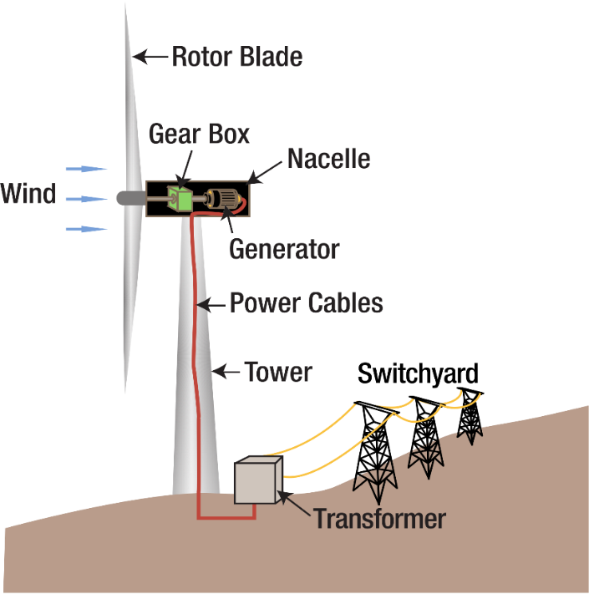

Tennessee Valley Authority Wind turbine diagram“, marked as public domain, more details on Wikimedia Commons

Formative assessment opportunity 3 – teachers use the written algorithms to determine if students understand the operational process of a wind turbine. The algorithm needs to be clear, detailed and sequential and reflects the labelled diagram. If student understanding is not comprehensive, further teaching may be required before producing and implementing begins.
- Show the students the hobby motors that will be their wind turbine’s electricity generator. Pass them around for the students to examine. Explain that:
  - the blades will be attached directly to the generator shaft, which will spin using the kinetic energy from the wind
  - as the shaft spins due to the kinetic energy, electricity will be produced inside the generator
  - the LED, attached to the terminals at the back of the generator, will transform this electrical energy to light energy we can see.
- In their groups of two, students collect their resources and begin discussing and planning their wind turbine design. A labelled diagram, demonstrating how the blades, tower and generator are engineered from the available resources, needs to be completed before construction begins. Their plan needs to reflect the following quality criteria:
  - the blades are functional, both in design and materials, which effectively turn the generator shaft with the force of wind (natural or man-made)
  - the generator is held securely as part of the tower
  - the tower is at least as tall one of the large cups (see resources) and is structurally sound
  - the LED illuminates when the blades turn with the force of wind.
- Students peer conference with other groups to discuss and examine their labelled diagram in the context of the quality criteria. Peers give early feedback using accountable language discussion prompts to trigger higher order thinking skills such as synthesis, analysis, evaluation, and problem-solving.
Formative assessment opportunity 4 – the teacher observes student interactions during peer conferencing to assess if the labelled diagram conveys enough detail to start construction. Target groups after the peer conferencing to ask students to add details to relevant parts of their plan needing improvement and to re-conference with the teacher when they are prepared.

Producing and implementing
- Teacher reviews safety considerations with students before wind turbine production begins (see Student safety above)
- Students collect their resources and begin constructing their wind turbine working in pairs. Students need to use the process of trial and error to investigate and discover:
  - the most effective blade material(s) to catch the wind consistently
  - the number of blades that effect kinetic energy the most to efficiently turn the generator shaft
  - the length/width of the blades that effect kinetic energy the most to efficiently turn the generator shaft
  - the shape of the blades that effect the kinetic energy the most to efficiently turn the generator shaft
  - how the blades, generator and tower design work in harmony to produce multiple energy transformations (kinetic/electric/light)
- Students need to document any changes to their design (the iterative process) on their diagram while they are in production.
Formative assessment opportunity 5 – teachers observe students constructing their wind turbines, while they use the process of trial and error to engineer their resources, to achieve the 4 functional criteria elements.
Troubleshooting: Due to LEDs only working one direction in a circuit, the pins may need to have their orientation reversed in the terminals to achieve a successful connection.

Testing and evaluating
- Students test their wind power designs using a desk fan. Using the different speed settings on the fan, students evaluate how efficiently the blade and material design harnesses the wind to make the LED illuminate. The more effective the design, the less wind speed from the fan would be needed to generate the electricity to light the LED.
- On a windy day, take the designs outside to different locations to investigate if the wind turbine can produce enough electricity to make the LED light up. Relate this to one of the ‘Minus’ points from the PMI that wind doesn’t blow all day, every day, in all locations, hence wind powered electricity not being as reliable as other electricity sources.
- Students present their wind power turbines to the class and explain the design process iterations, successes, challenges and reflections of their investigation in the context of the quality criteria. They explain and justify how/why their original plan has been altered, through trial and error, to accommodate unexpected needs of the design and production process.
Formative assessment opportunity 6 – teachers determine how deep students’ understanding is of energy transformation, and if they have achieved the 4 quality criteria elements, through their explanation, justification and reflection of their design and production investigation.

- Document and take photos/video of the wind turbine for future reflection and a record of learning. The wind turbine models should have their hobby motor disconnected to be re-used for future investigations and projects requiring electricity.
- Students complete the KWLH chart from the start of the investigation. Add what they have ‘Learnt’ and ‘How’ more learning can occur on this topic.
- Students complete a learning log, digitally or using a hard copy, to reflect on their learning and the evaluations they have made about their investigation. This is an unmarked document that is not summative in any way.

Formative assessment opportunity | Purpose | Quality Teaching Framework assessment element | Digital Learning Selector
1- identifying and defining | Teachers are looking for students connecting everyday life experiences to the conceptual knowledge of wind, movement and electrical energy as well as demonstrate curiosity to define and set learning goals. Teachers use this information to direct their teaching to where learning should start without re-visiting learnt information. | Background knowledge | KWLH chart  Learning intentions success criteria
2 – identifying and defining | Knowledge is problematic when it is socially constructed, and subject to political, social and cultural influences and implications. Students understand, examine and critique the ideas and concepts of wind powered energy from different social perspectives. | Problematic knowledge | PMI
3 – research and planning | Students are required to address the complexity of wind turbine key concepts and to articulate these relatively complex relationships through forming a detailed algorithm. | Deep knowledge
4 – research and planning | Peer conferencing used to trigger higher order thinking skills such as synthesis, analysis, evaluation, and problem-solving, builds on peer contributions through a range of discussion strategies. | Higher order thinking skills | Peer discussion and conferencing
5 – producing and implementing | Teachers observe students independently constructing their wind turbines while they use the process of trial and error to engineer their resources to achieve the 4 functional criteria elements. | Explicit quality criteria  Student direction
6 – testing and evaluating | Deep understanding is evident when students provide information, arguments or reasoning that demonstrate their grasp of central concepts. | Deep understanding | Learning Log  KWLH chart

