Science and technology workbook Stage 2 – Living world
Name:
Class:

Overview
You will learn explore the differences between living and non-living things and how to sort them into groups.

Resources
- help from an adult
- lead pencil
- coloured pencils
- camera (optional)
- collection of items from a room in the home (optional)
- list of items

Activity – Characteristics of living things
During this activity you will explore an environment describe the difference between living and non-living things.
Safety is important. Stay safe when observing living things outdoors. For example look but don’t touch any animals, be careful when lifting rocks or looking in leaf litter, use a stick to move small rocks and leaves. Always wash your hands after being outside.
Scientists use their senses to make observations. You will observe, identify and justify living and non-living things. Go for a walk with your parent or carer to a local park, the beach or in your backyard. If you are unable to explore outdoors, you could explore your home.
Record your observations in this table. Name the environment and date of your exploration. Then list each item you observed under the living or non-living column. Think about what features the thing has that made you decide it was living or non-living. Write some those reasons in the last column. You could also take photographs, or make drawings on paper, of your observations.
Environment:_________________________________________ Date:_______________
Living thing | Non-living thing | Reasons
You could also choose to explore a second, different environment and compare your observations with the first environment you explored.

Activity 2 – Classifying things
During this activity you will explore how to classify or group items.
Scientists conduct field studies to learn about their local environment. This includes living things. You will conduct a field study of your home, backyard or local neighbourhood to identify, observe and record your ideas. You may need to ask your parent or carer for assistance. You might record your observations using labelled drawings, written descriptions, photos or a video recording.
What are some different ways we can group items? You have two options for this activity. The first activity is indoors, the second activity is outdoors.
Activity 2a:
Safety is important, dangerous items such as sharp knives or electrical appliances should not be included in your collection.
- Identify, collect and list 15-20 items from the kitchen or bedroom.
- Sort the items into different groups.
- Make a list of the items in each group and the number of items in each group.
- Explain and justify why you have grouped specific items together. Remember to use observable (external) features and characteristics in your explanation for example, colour, texture, shape, or material it is made from. Here are some examples of different ways to group kitchen utensils. What features were used to group the utensils?
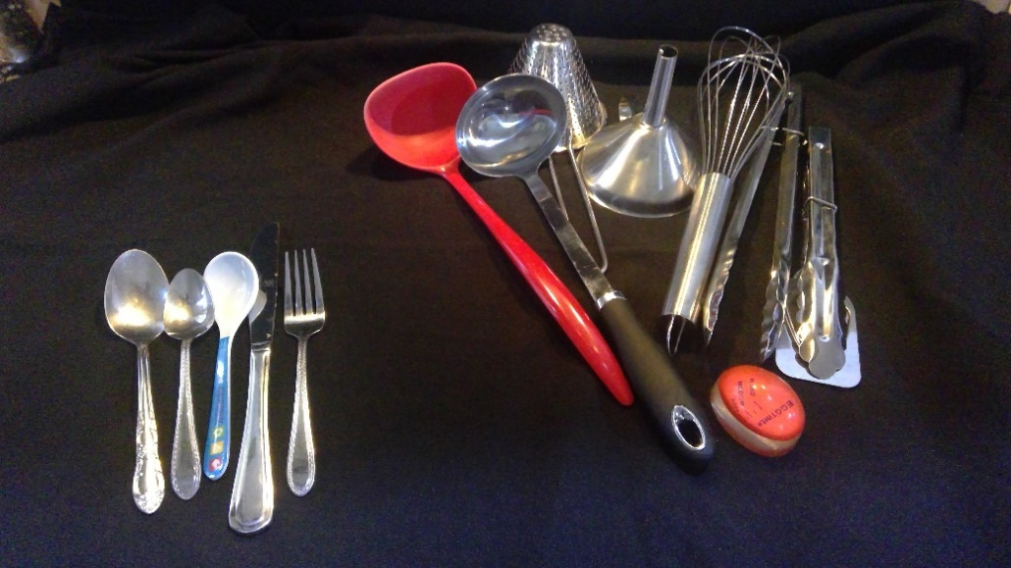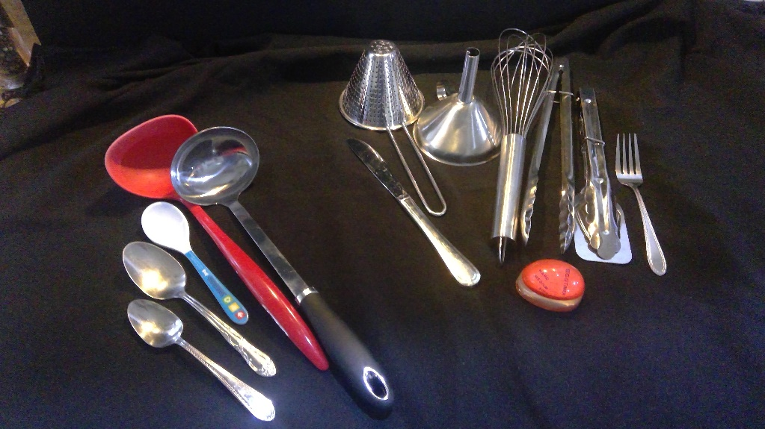
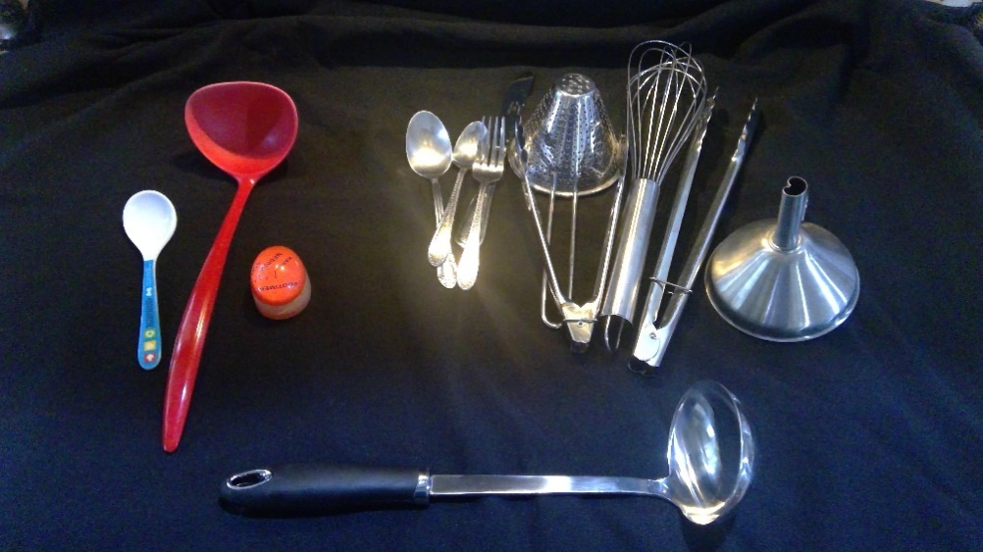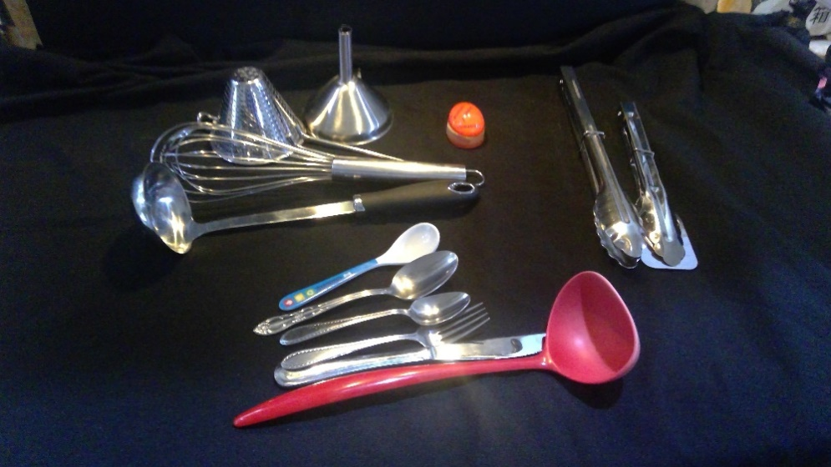
List of items
Activity 2b
Safety is important. Stay safe when observing living things outdoors. For example look but don’t touch any animals, be careful when lifting rocks or looking in leaf litter, use a stick to move small rocks and leaves. Always wash your hands after being outside.
- Explore your backyard or local neighbourhood (with supervision from a parent/caregiver).
- Identify, observe and record features of 5-10 different plants. Features such as, height, colour, texture (bark/leaves), presence of flowers/fruit/cones/nuts, leaves (colour/shape).
- Sort your plant observations into different groups.
- Make a list of the plants in each group and the number of items in each group.
- Explain and justify why you have grouped specific items together. Remember to use observable (external) features and characteristics in your explanation. For example, you could put all the plants with flowers into one group or all the plants with the same colour leaves in another group.
List of items

Activity 3 – Aboriginal plant use
Many living things were grouped by Aboriginal and Torres Strait Islander peoples based on their use. For example, the Bracken’s root which is found in the ground was used for food to make pancakes.
There are many plants that we use for food and medicine. Can you work out how we might use some of these plants below? You may need to ask a parent to help you.
Plants | Uses
Cucumbers
Apples
Olive tree
Eucalyptus leaves
Aloe Vera
Tea tree plant

Activity 4 - Branching
During this activity you will explore how to use a sequence of steps to sort/group/classify specific items.
Play 20 questions with a family member. Choose a category. “I’m thinking of a [category such as, animal].” Remember questions can only be answered using yes or no.
Branching is a decision making tool. Computers use branching instructions to make decisions. An instruction in a computer program, or algorithm, involves branching if it causes different actions to be performed depending on specified conditions.
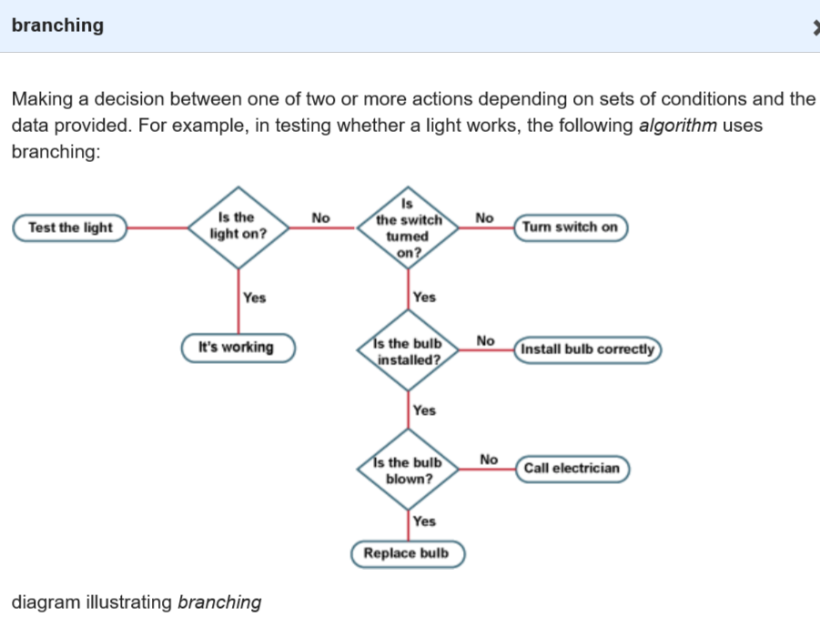
AC digital technologies CC BY 4.0
You will create your own branching set of instructions to sort/group/classify a set of items.
- Choose a category of items to classify. Write your list of items in the table. You could use the items identified in the previous activity or select a different category of items such as toys, clothing, pantry items, leaves, animals. You will need to make a list of 10-15 items to sort.
- Identify patterns in your group of items. Identify similarities and differences between your items.
- Use yes/no questions to create a step-by-step process of branching questions (branching algorithm) to sort the items. For example, if you use kitchen utensils a question could be ‘Is it made of metal?’ (yes or no) or ‘Is it used to mix ingredients?’ (yes or no)
- After creating the branching questions, use your classification system, or branching key, to classify the 10-15 items. You could take a photo to upload to a digital classroom. Ask a family member to try out your classification system.
- Use a written explanation or a video recording to explain your reasons for choosing the questions in your classification system.

List of items

Classification system
Explain your choices for grouping items.
_______________________________________________________________________________________________________________________________________________________________________________________________________________________________________________________________________________________________________________________________________________

Reflection
Star  Something that went well! | Star  Something that went well! | Wish  A goal for next time…

