Parental advice and support

Science and technology stage 2 learning sequence
This learning sequence develops student understanding of processes that change the Earth’s surface.

Background notes
Erosion and weathering are processes that form part of the rock cycle. In this sequence, students will work scientifically by conducting a field study and an experiment to demonstrate erosion. They will follow a design process to develop a solution to mitigate erosion at home.
In this sequence, students learn to draw a scientific diagram, summarise information, synthesise ideas by linking with their own every-day and life experiences.

Resources
You are an important support for your child in their learning. Key opportunities for you to help your child are:
- Activity 1 – help your child to read the information and instructions in the workbook. Help your child create a scientific diagram. Proofread their work and edit their work with them. Accompany your child on a walk around the neighbourhood to help them conduct a field study. Your child may need help sourcing materials and setting up the investigation outlined in the student workbook. They may also require supervision and assistance when conducting this.
- A scientific diagram is a line drawing with clear labels. Lines join each label to show the corresponding part on the diagram. Below is an example of scientific diagram.
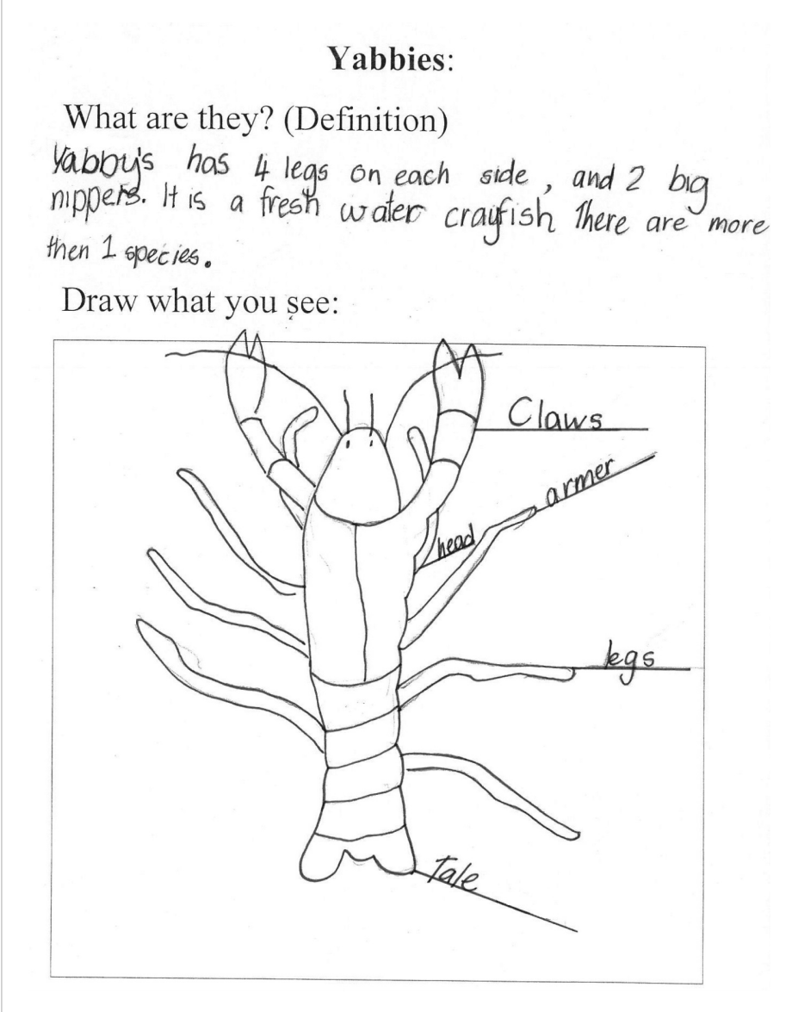
Example of a scientific diagram by a Year 4 student. Image credit: ACARA

- Activity 2 – Help your child to read the information and instructions in the workbook. In this activity your child will be designing and constructing an invention to help prevent erosion at home. Your child may need help to identify a point and source of erosion. They may also need help to interpret the pictures in their workbook showing erosion and develop their design innovation. Your child may also need help to source and use tools such as sticky tape, glue, scissors and stapler. If your child is learning through an online platform they will need access to a computer and the internet.
During this sequence your child may require the following resources.
- coloured pencils, ruler
- sticky tape, glue, stapler, scissors
- repurposed cardboard, wood, cloth or string for construction
- extra writing paper or school exercise book

Further support
For support or more information please contact your school or class teacher or visit https://education.nsw.gov.au/teaching-and-learning/curriculum/learning-from-home/advice-to-parents-and-carers
The learning in this sequence contributes to student achievement of NSW Science and Technology K-6 syllabus outcomes – ST2-1WS-S. ST2-2DP-T and ST2-10ES-S.

