Science and technology workbook ES1 – Earth and space
Name:
Class:

Overview
You will learn about how the weather can change each day and how the weather can affect what you wear, eat and do each day.

Resources

Activity 1
- coloured pencils
- student workbook
- help from an adult

Activity 2
- coloured pencils
- help from an adult

Activity 1
During this activity you will watch (observe) the weather each day and draw (record) what it looks like and feels like.
Resources – coloured pencils, workbook, adult help.

Weather watching
Look out a window or go outside with an adult. What is the weather like today? Think about what the weather looks and feels like. It might look sunny or cloudy or rainy or windy or stormy. It might feel warm or hot or cool or cold or wet.
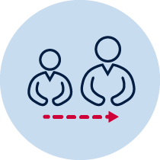Tell a parent/carer what you observe. For example:
Today the weather is sunny. It feels hot.
Use words like, sunny, cloudy, rainy, windy, stormy, warm, hot, cool, cold, wet,

Weather recording
Observe the weather every day for a week.
Tell your parent/carer about the weather each day.
Draw a picture (symbol) for the weather each day.
You can choose one of these symbols or make your own.

Monday | Tuesday | Wednesday | Thursday | Friday
It feels________ | It feels________ | It feels________ | It feels________ | It feels________

Weather predicting
Think about what the weather might be like tomorrow. This is called a weather prediction.
Write your weather prediction for each day.
On Tuesday I think the weather will be ______________________________________
____________________________________________________________________.
On Wednesday I think the weather will be ___________________________________
____________________________________________________________________.
On Thursday I think the weather will be _____________________________________
_____________________________________________________________________.
On Friday I think the weather will be ________________________________________
_____________________________________________________________________.
Compare your weather prediction with the weather the next day.

Reflection
Think about what you have learnt in this activity. Use the two stars and a wish structure to guide your reflection.
Star  Something that went well! | Star  Something that went well! | Wish  A goal for next time…

Activity 2
During this activity you will explore how the weather can affect what you do each day.
Resources – help from an adult, coloured pencils.

Daily choices
1. Think about how the weather affects what clothes you wear each day.
Draw the clothes you wear if it is hot and sunny weather.
Draw the clothes you wear if it is cold and rainy weather.
Draw the clothes you wear if it is windy weather?
2. Think about how the weather affects the activities you can do each day.
Draw two activities you can do if it is sunny weather.
Draw two activities you can do if it is rainy weather.
Read the words and make up their own tune.
How’s the weather today?
How’s the weather? How's the weather? How's the weather today?
Is it sunny? Is it rainy? Is it cloudy? Is it snowing? How’s the weather today?
Let’s look outside. How’s the weather? Is it sunny today?
Let’s look outside. How’s the weather? Is it rainy today?
Let’s look outside. How’s the weather? Is it cloudy today?
Let’s look outside. How’s the weather? Is it snowing today?
How’s the weather? How's the weather? How's the weather today?
Is it sunny? Is it rainy? Is it cloudy? Is it snowing? How’s the weather today?

Student makes a rain gauge
Equipment
A clear tall container, blocks the same size, marker and funnel.
Method
Use blocks the same size to mark lines on the container that are the same distance apart. Place a funnel into the container. Put it outside and wait for it to rain. Check the rain gauge same time everyday. You can see just how much rainfalls where you live.
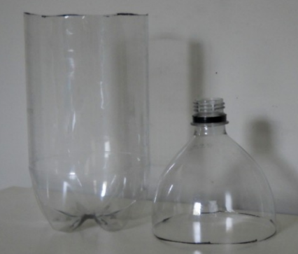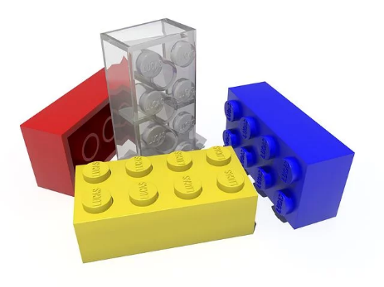
Clear tall container blocks funnel
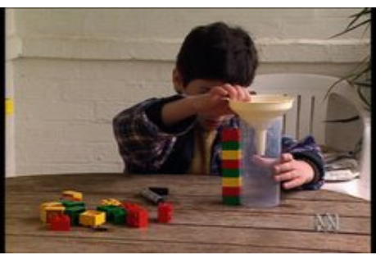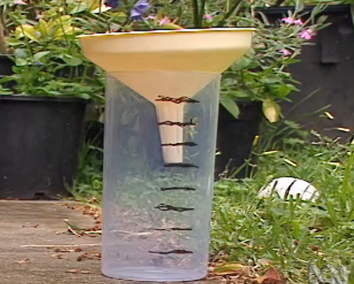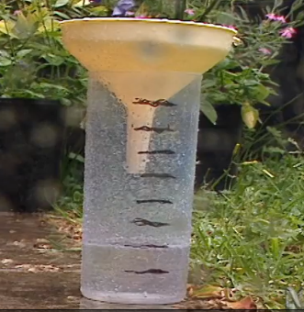

3. Think about how the weather affects the food you eat each day.
Draw the food you like to eat when the weather is hot.
Draw the food you like to eat when the weather is cold.
Write one of your answers for each column.
Clothes | Activities | Food

Reflection
Think about what you have learnt in this activity. Use the two stars and a wish structure to guide your reflection.
Star  Something that went well! | Star  Something that went well! | Wish  A goal for next time…

