Equilibrium and acid reactions

Acknowledgement of country
I would like to acknowledge the Wiradjuri people who are the Traditional Custodians of the Land I am presenting from in West Wyalong. I would also like to pay respect to the Elders both past, present and emerging of the Wiradjuri Nation and extend that respect to other Indigenous Australians who are present
Questions to help build your understanding:
1. When solutions of Iron Nitrate Fe(NO₃)₃ and Potassium Thiocyanate KSCN are mixed a red solution is formed due to the presence of Iron Thiocyanate ions.
a) Write a balanced ionic equation for this reaction

b) Predict the change in equilibrium of adding a small volume of Ag NO₃ which will react to form insoluble AgSCN

2.
  - Recall the balanced chemical equation for the Haber process for the synthesis ammonia.

  - Explain using enthalpy the exothermic nature of this process and how this effects the equilibrium of the reaction using Le Chatelier’s Principle.

  - Explain using the diagram how activation energy is affected by the addition of a catalyst not the yield.

  - Analyse why we use high temperature and pressure in a Haber plant?

- Use the diagram below and indicate on the graph to explain in terms of equilibrium the change in the concentrations of the three gases if at T2, most of the ammonia was removed by dissolving it in water.
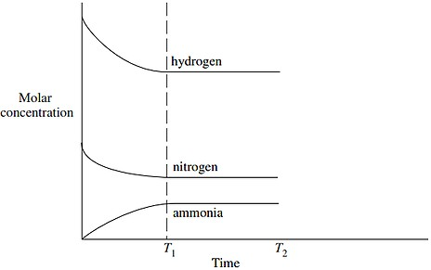

5 a) For the reaction where dinitrogen pentoxide decomposes into nitrogen dioxide and oxygen gas write a balanced equation.

__________________________________________________________________________

b) Write the equilibrium expression:

_____________

c) If N2O4 is a colourless gas and it decomposes into the reddish brown gas NO2 as it is heated in a sealed ampule describe and explain what this means for the enthalpy of this reaction.
__________________________________________________________________________________________________________________________________________________________________________________________________________________________________________________________________________________________________________________________________________

Circle the correct answer:

- A B C D

- A B C D

- A B C D

- A B C D

10. A B C D

Q 11.
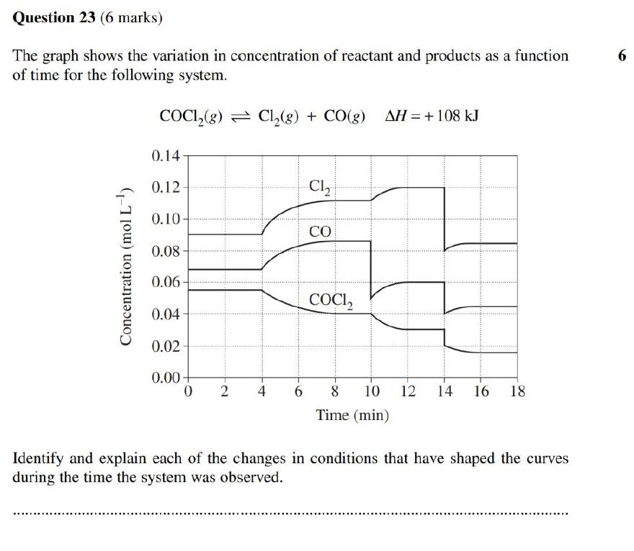
______________________________________________________________________________________________________________________________________________________________________________________________________________________________________________________________________________________________________________________________________________________________________________________________________________________________________________________________________________

Q 12.
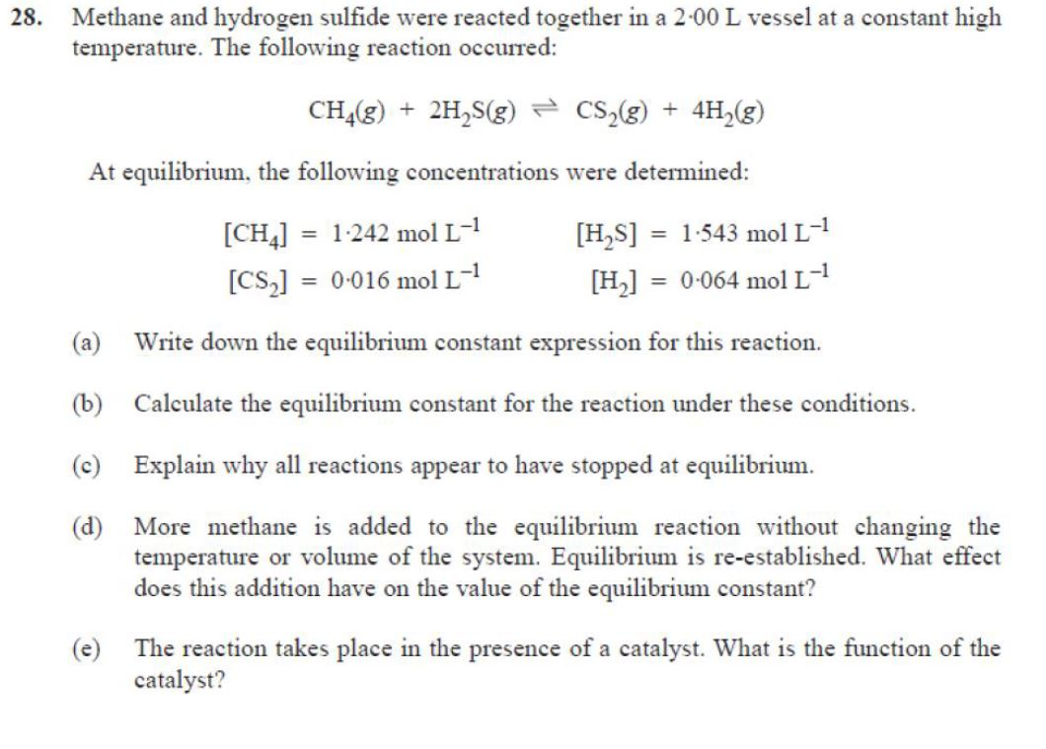

____________________________________________________________________________________________________________________________________________________________________________________________________________________________________________________________________________________________________________________________________________________________________________________________________________________________________________________________________________________________________________________________________________________________________________________________________________________________________________________________________________________________________________________________________________________________________________________________________________________________________________________________________________________________________________________________________________________________

Q13.
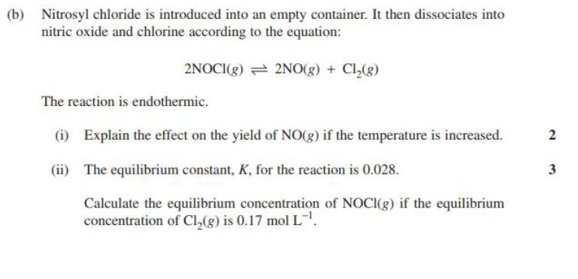

____________________________________________________________________________________________________________________________________________________________________________________________________________________________________________________________________________________________________________________________________________________________________________________________________________

Q 14.
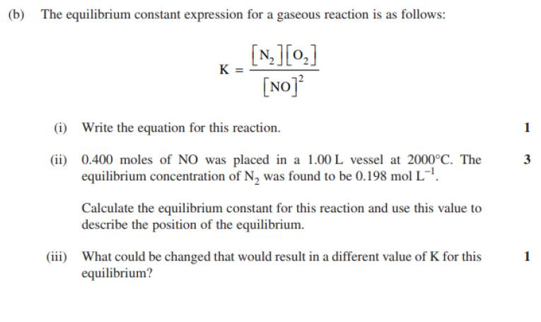

____________________________________________________________________________________________________________________________________________________________________________________________________________________________________________________________________________________________________________________________________________________________________________________________________________

Q 15.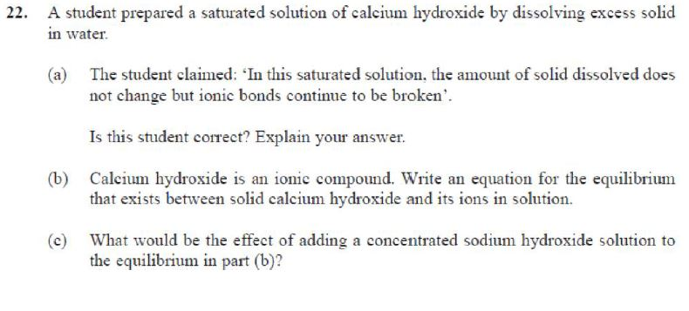
____________________________________________________________________________________________________________________________________________________________________________________________________________________________________________________________________________________________________________________________________________________________________________________________________________
____________________________________________________________________________________________________________________________________________________________________________________________________________________________________________________________________________________________________________________________________________________________________________________________________________

Q 16.



