Physical activity treasure hunt – tactical movement focus Stage 5
Duration: 2-3 lessons (50-60 minutes in length)

Educative purpose
This lesson sequence encourages students to analyse the opportunities that exist within an environment to engage in physical activity. In this example, their home environment is used, but the home environment could be easily substituted for school, a holiday location or a recreation space. This learning sequence encourages students to engage their family in an enjoyable physical activity experience. The learning sequence highlights how the tactical movement aspect of the NSW Physical Literacy continuum can be used to focus on educative purpose.

Syllabus content
Outcome PD5-8 designs, implements and evaluates personalised plans to enhance health and participation in a lifetime of physical activity
Outcome PD5-5 appraises and justifies choices of actions when solving complex movement challenges
All outcomes referred to in this unit come from PDHPE K-10 syllabus © NSW Education Standards Authority (NESA) for and on behalf of the Crown in right of the State of New South Wales, 2018.
Key inquiry question | Syllabus content
How can I plan and advocate for health, safety, wellbeing and participation in a lifetime of physical activity? | - design, implement and evaluate creative interventions for enhancing their own and others’ fitness levels and participation in a lifetime of physical activity  - investigate and prepare plans that promote the use of natural settings within the local community for physical activity and analyse their effectiveness in enhancing a lifetime of physical activity and/or improving fitness levels
How can I include, assist and lead others during physical activity? | - devise, implement and refine strategies demonstrating leadership and collaboration skills when working in groups or teams  - evaluate individual strengths and the contribution they make to teamwork and leadership to encourage enjoyable participation for everyone in movement activities

Physical literacy markers

Tactical movement
Includes understanding of physical activity contexts, rules and tactics. This understanding is used to plan for tactical movement and demonstration of critical and creative thinking through movement.
Continuum aspect | End of Year 8  Cluster 5 | End of Year 10  Cluster 6
Thinking while moving | - Applies multiple tactics appropriately to achieve success within a range of physical activities  - Transfers tactics across physical activities | - Transfers and adapts tactics according to purpose to participate successfully across a range of physical activities  - Evaluates tactics according to purpose to participate successfully across a range of physical activities
Knowledge of physical activity contexts | - Compares tactics and how they can be used across multiple physical activities  - Creates a plan to succeed in physical activity which takes account of the abilities of self and others | - Assesses the relationship between rules and tactics to create plans for achieving success in physical activities  - Reflects on and creates new plans that take account of a number of variables (e.g. own team’s and opposition’s strengths, the effectiveness of previous plans) to succeed in a range of physical activities

Learning activity description

Design a physical activity treasure hunt

Learning intention:
Students will develop the knowledge, understanding and skills required to incorporate their home environment in lifelong physical activity.

Success criteria
- Design a physical activity treasure hunt that successfully incorporates their home environment.
- Identify and utilise personal strengths and team strengths to succeed in a range of physical activities.
- Reflect on personal and team members decision making to succeed in a range of physical activities.

Activity 1: Your home
Students
- identify 10 key landmarks in and around their home. For example, lemon tree, loungeroom, letterbox, garage, trampoline.
- create a map of their home that identifies these key landmarks. Refer to appendix for an example.
  - Students may wish to create riddles, instead of a map, as clues to the landmarks. For example, go to where the fruit is yellow and sour and difficult to devour.

Activity 2: Way to be active
Students:
- design 10 physical activity challenges, e.g. 20 double under skips, 20 squats, 10 successful basketball shots.
- allocate one challenge for each landmark.
Requirements
- The physical activity challenges should incorporate the environment or objects of the particular landmark they will be completed at. For example, tricep dips on the TV cabinet, kangaroo hops up the stairs.
- Opportunities and challenges of each landmark environment should be incorporated to maximise the enjoyment and excertion at each point. Examples may include a steep driveway, stairs, front step, retaining wall.
- Be creative. The more creative the activities are the more enjoyable it will be for participants.
- Incorporate the equipment available. Including balls, skipping ropes, trampoline, basketball hoop, heavy things (eg. rocks, paint tins, chairs).
- Engage the ‘whole body’ across the various activities. That includes lower body, core and upper body
- To increase decision making, include two ‘road block’ activities that require participants to choose one of two options. The first option is ‘harder’ but can be completed in a shorter time if the participant is successful. The second option is ‘easier’ but will take the participant longer to complete. An example may include:
  - 100 skips or 20 double unders
  - 10 free throws or 4 three pointers
  - 20 ‘throw, spin and catch’ or 10 ‘throw, double spin and catch’
Refer to the example in the appendix for more ideas.

Activity 3: Get active
Students:
- challenge their family members and themselves to complete the physical activity treasure hunt in as short a time as possible.
- time the completion of the treasure hunt in its entirety or the completion of each individual landmark to maintain results for themselves and family members. Use the result recorder in the appendix to track results.
- Video record their completion of the physical activity treasure hunt and share with the teacher. Students may use time-lapse recording on their phone to compress the length of the video.
- complete the physical activity treasure hunt everyday for a minimum two weeks.
Included in the appendix is a proforma for recording results.

Activity 4: Teamwork
Students are required to complete the physical activity treasure hunt as a team. This could be done with family members or fellow students.
Using the form in the appendix, as a group:
- Team members consider the strengths that they bring to their team. Team members should consider the activities that they are most competent in, as well as the personal strengths they can bring to enhance teamwork.
- Work together to devise a strategy to complete the treasure hunt in as quick a time as possible. Each member is required to complete an equal amount of activities.
- Complete the physical activity treasure hunt as a team, record the time it took to complete and video record. Team members are reminded to apply the skills of teamwork identified throughout to support the completion of the activity.
- Reflect upon overall performance by responding to the following questions:
  - What was the difference between completing the treasure hunt as an individual and as a team?
  - Which one did you prefer and why?
  - Describe how each member of the team contributed to the team’s overall success.
  - How would you revise your strategy to complete the physical activity treasure hunt next time?

Activity 5: Reflection
Students reflect upon their contribution to the team by responding to the following statements:
- I contributed to my team by:
- The impact of this was:
- Next time we complete it as a team I will:
At the completion of two weeks, students:
- reflect on their goals and respond to the following statements:
  - As a result of setting a goal and completing the treasure hunt, I have achieved:
  - I will continue to improve:
- complete a reflection identifying how effective the treasure hunt was in promoting physical activity and improving fitness levels for themselves and their family. Students respond to the following questions:
  - Describe the impact the physical activity treasure hunt had on your level of physical activity and physical fitness.
  - Describe the impact the physical activity treasure hunt had on the physical activity and physical fitness level of your family.
  - Explain the greatest challenge you faced in completing the physical activity treasure hunt? Provide reasons.
  - What personal strengths and strategies did you call on and use to be successful?
  - What did you learn about your home environment regarding physical activity?
  - Describe how you could alter the physical activity treasure hunt to continue to ensure it positively impacts your physical fitness level? Explain how each change will positively impact your physical fitness level.
  - Design an infographic or a poster that highlights how people can incorporate their home environment into physical activity. This could be completed on Canva, Microsoft Publisher, Google Slides or offline in the form of a brochure or poster.

My fitness treasure hunt example
Landmark | Activity | Equipment
1.Letter box | 10 drive way ‘suicides’
2.Front step | 20 two footed jumps, 20 step ups, 20 hop ups.
3.Netball ring | 10 successful shots | netball
4.Trampoline | 10 forward rolls
5.Back steps | Carry 10kg (large rock/ 3x 3l milk bottles) up and down stairs 5 times | large rock/ 3x 3l milk bottles
6.Back grass | 20 ‘double under’ skips | Skipping rope
7.My bed | Locking feet under bed complete 30 sit ups
8.Garden retaining wall | 20 push ups
9.TV cabinet | 30 tricep dips
10.Bin | Successfully hit bin with tennis ball from 10 metres away | Tennis ball

My home
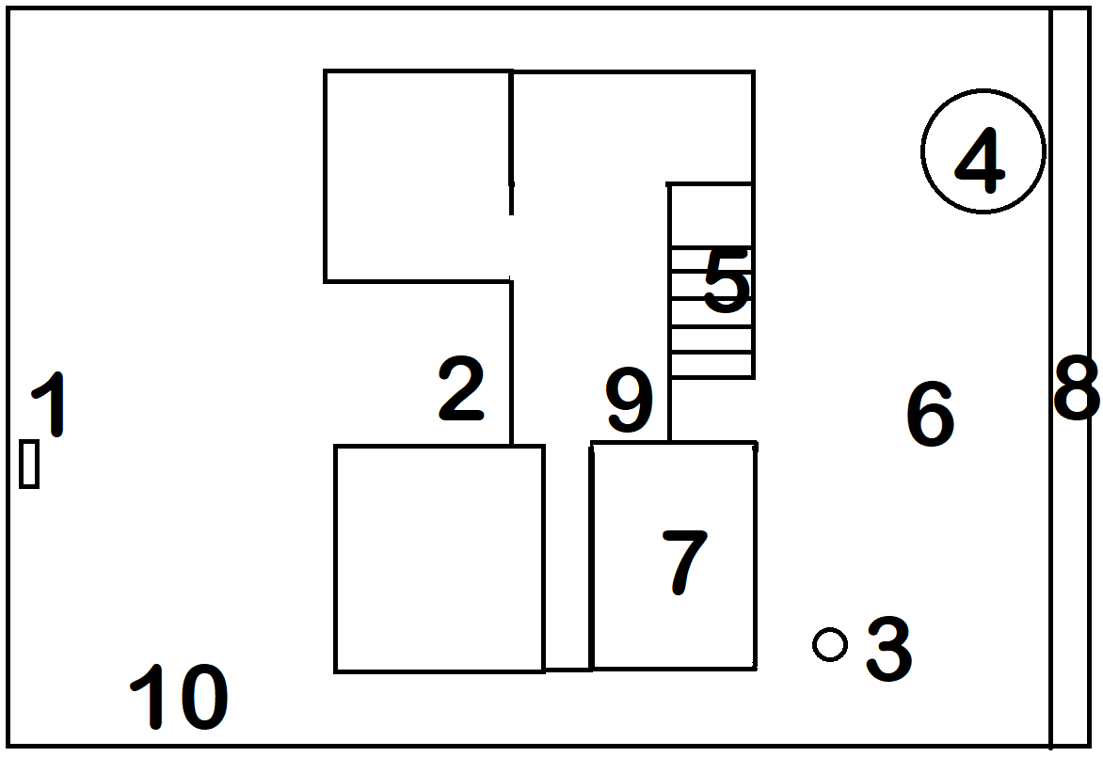

My fitness treasure hunt
Landmark | Activity | Equipment

1.

2.

3.

4.

5.

6.

7.

8.

9.

10.

My home

Draw picture here

Family physical activity treasure hunt recording sheet
Name | Att 1 | Att 2 | Att 3 | Att 4 | Att 5 | Att 6 | Att 7 | Att 8 | Att 9 | Att 10

Team physical activity treasure hunt
Complete this section individually:
Person 1:
Preferred activities that suit your fitness strengths:
Personal Strengths to contribute to the team:
Person 2:
Preferred activities that suit your fitness strengths:
Personal Strengths to contribute to the team:
Person 3:
Preferred activities that suit your fitness strengths:
Personal Strengths to contribute to the team:
Person 4:
Preferred activities that suit your fitness strengths:
Personal Strengths to contribute to the team:
Complete this section as a team:
Number | Activity | Participant | Review  (Any changes)
1.
2.
3.
4.
5.
6.
7.
8.
9.
10.

