Connect me, include me, empower me. How do I stay connected? Stage 4
Duration: 4 lessons (50-60 minutes duration)

Description
In this learning sequence, students explore why connection, inclusion and empowerment are important for the health, safety, wellbeing and physical activity levels of the wider community.

Educative purpose
Developing health literacy skills through recognising and processing information from a variety of non-traditional sources will support students to actively engage with the global health crisis COVID-19. Students will develop deeper knowledge, understanding and a variety of skills through critical inquiry approaches that enable research, analysis and critiquing of information to influence their own and others’ health, safety and wellbeing.

Syllabus outcomes
- PD4-3 investigates effective strategies to promote inclusivity, equality and respectful relationships
- PD4-7 investigates health practices, behaviours and resources to promote health, safety, wellbeing and physically active communities
- PD4-10 applies and refines interpersonal skills to assist themselves and others to interact respectfully and promote inclusion in a variety of groups or contexts
All outcomes referred to in this unit come from PDHPE K-10 Syllabus © NSW Education Standards Authority (NESA) for and on behalf of the Crown in right of the State of New South Wales, 2018

PDHPE skills
Self-management | Interpersonal
- Decision-making and problem solving | - Collaboration, inclusion and relationship building  - Social awareness

Teaching notes
Schools are advised that resources embedded within this unit are not endorsed by the NSW Department of Education.

Creating a safe and supportive learning environment
There are a number of strategies that can be used to create a supportive learning environment which enables students to feel safe to learn and ask questions. They include:
- making students aware at the beginning of PDHPE sessions that disclosing personal information that indicates they may be at risk of harm will be reported to the school principal in all instances. This includes personal disclosures related to instances of abuse, drug use, neglect or sexual activity under the legal age of consent.
- being aware that some parts of PDHPE can be confronting and sensitive for some students.
- enabling students to withdraw if they find issues personally confronting to protect them from making harmful disclosures. Equally, it is important to be prepared for issues that arise as a result of a student making a public disclosure in the classroom.
More information on creating a safe and supportive learning environment can be found on the PDHPE website.

Evaluating resources before use
Preview and evaluate all strategies, resources and teaching and learning approaches in full before use with students to determine suitability for student learning needs, stage of development and local school context. Consider the age, maturity, cultural background, sexuality, gender, sex, health and other characteristics of students in your care. Apply professional judgements to all strategies, teaching and learning approaches and resources including audio visual materials (for example videos, media clips and YouTube), interactive web-based content (for example games, quizzes and websites) and texts.
Use the resource review flowchart to decide about the suitability of teaching and learning resources.
Materials should be reviewed in full and endorsed by the school principal before use in NSW government schools.

Communication with parents and caregivers
Some aspects of PDHPE may be viewed as sensitive or controversial, such as learning about abuse, child protection, drugs, respectful relationships, sexual health, sexuality and violence. Inform parents and carers, prior to the occasion, of the specific details of the PDHPE program, so that parents and caregivers have time to exercise their rights of withdrawing their child from a particular session. In this regard, a parents or caregiver’s wish must be respected.
Establishing how parents and caregivers will be informed about programs and involved in consultation is a school-based decision. Where parents and caregivers indicate they wish to withdraw their child from a program it is useful to negotiate which parts of the PDHPE program they are concerned about. A sample information letter is available on the PDHPE website.

Lesson sequence overview
Syllabus content | Teaching, learning and assessment experiences
Why are connection, inclusion and empowerment important for the health, safety, wellbeing and physical activity levels of the wider community?  - examine influences on peoples’ behaviours, decisions and actions (ACPPS074)  - discuss the influence of contextual factors on individual decisions and actions, for example response to emerging world issues | The power of Influence (1-3 lessons)  Learning intentions  Students:  - understand how connection, inclusion and empowerment support individuals during a global health crisis to support their own and others health and wellbeing  - can support their own and others ability to stay connected using a variety of strategies  - explore an emerging global health issue (in this case COVID-19) and identify the impact on self and others’ behaviours, decisions and actions  Teacher note: Contextual factors in our new 7-10 syllabus are the range of factors that can impact and influence individual, group and community health, safety, wellbeing and participation in physical activity. These factors may include individual (knowledge, skills, attitudes, beliefs, ability, sex, gender), socio-cultural (religion, parents/carers, family, media, culture, peers, language, politics), socio-economic (education, income, employment) and environmental (geographic location, access to health services) across population groups.  Brainstorm reflection task: What are my greatest influences?  Brainstorm activity  Create a brainstorm list of what factors influence an individuals’ decisions and actions. (see above teacher note)  - Students categorise these in a table with the contextual headings from above: individual, socio-cultural, socio-economic, and environmental. (Teacher note: see suggested worksheet below.)  - Students choose ten of their top influences and rank these 10 influences on a scale of 1-10. 1 being not very influential, to 10 being extremely influential by placing the number beside each term/ concept.  - Students share 3 of these on the common sharing platform, or write these down on their worksheet for others to see.  - Perspective forming/ taking Activity – depending on your current teaching situation choose the most appropriate teaching and learning strategy for the statements below.  Teacher note: Offer students a brief introduction into the significance of being socially aware of others and how it supports their ability and capacity to relate to and interact collaboratively with others. It is important to ensure students understand that when they consider others viewpoints, it contributes to their own skillsets around being able to respond to, and understand others ideals, values and points of view. (Social awareness- perspective forming and perspective taking) It also supports their ability to collaborate, include others and build relationships to support and enrich their own and others’ lives. (Collaboration, inclusion and relationship-building)  - Statements could include:  - Friends influence me most with bullying  - Gender is important to me with friendships  - I will always defend my family and friends beliefs  - My ability to get support for my health and wellbeing is really easy in high school  - I don’t need to understand politics until I can legally vote  - Education is only important to those who wish to go to university  - Living in the city is the same as living in rural and remote areas at 13 or 14  - Language and understanding language is not important for my future  - An individual’s sporting ability is important to me  - Earning a good income is more important to me than being happy when I am older.  Strategy 1- Barometer activity (similar to an opinion line/ where you stand/ values line)  Teacher note: Barometer activity- this strategy can be used to present different perspectives. As one of the skill domains “Social Awareness” covers perspective forming and perspective taking- this activity supports the application of the skill through the content. The Barometer activity helps students to share their opinions by asking them to line up on a continuum line based on their position/ idea/ value around an issue. It is especially useful when students have a wide range of opinions. As this activity effectively gets ideas out in the open- it can be a useful strategy to use prior to a writing task.  - Teacher will read out an influence as indicated by the students, and students will move to a designated area of the classroom or home environment.  - Prepare the space- Areas in the room will be set up as Strongly Agree, Agree, Disagree, Strongly Disagree  - Ensure you reiterate your classroom expectations around Supportive Learning Environments. Some ideas may include; respecting others opinions, listening respectfully to others, remind students of ways to constructively disagree, use I language when giving their opinion or defending their opinion, wait their turn and be kind, specific and helpful.  - Students formulate their opinion- some may need to have a written list in their books/ post-it notes  - Students take a stand  - Students explain positions if willing to or if they are prompted (allow students the choice prior to prompting a response from one of your students)  - Following hearing students' reasons, teachers offer students to change their position. If they would change their position, consider why? (Social awareness skills- perspective forming/ taking)  - Students and teachers “debrief”. This can be done verbally where they reflect on others ideas. A great way to record this is on the whiteboard in columns for main ideas in table of two columns- points for and points against. Another way to debrief is get them to do a 3, 2, 1 activity. 3 things they learnt, 2 ideas whereby they changed their perspective and 1 idea they would like to find out more about. A reflection paragraph can be used also around- “From this activity how did your perspectives remain the same, and how did your perspectives change”.  Strategy 2  - Online- Poll feature on your online learning platform. Use this feature for your students to raise their hand if they agree. Hand stays down if they disagree. Allow students time to either speak to the reason they raised their hand or not  - Offline- students provide a yes or no beside each statement and give reason/ s why in their workbook or on their sheet.  Teacher Note: Post Strategy 1 and 2 reflection: Decision making is an important self-management skill. Decision making impacts our actions, behaviours and attitudes towards every day choices and the activities we may or may not participate in. The decision making process has a series of steps and is a skill that can support what course of action an individual will take with regard to keeping themselves and others safe.  - Student consider one of the choices made above.  - Use decision making steps below to reflect on and write what you encountered for each step.  - How will this model support you in the future? What types of decisions will you use this decision making process with? Do you notice you do this at times without going through the steps?  Literacy reflection task. This task is to check for understanding of how influences can be an asset and provide support to individuals and the choices they make, how they behave, and what actions they take. This is also a way that you can check for understanding of the content before moving on, “assessment for” learning or formative assessment opportunity.  Students explore the question “How can these influences support my actions and behaviours both now and in the future?” Access the scaffold in the Teacher Resource Section for an outline of the activity.  Class discussion - Connection and its importance when adversity strikes  Connection in our PDHPE context is when a relationship occurs with another person where there is a link or bond between two or more people. This connection can occur due to a similar interest, or by birth (family). Connection improves the health sense of safety and wellbeing of all individuals, promoting the Interpersonal skill of collaboration, inclusion and relationship building.  Teacher note: these graphic organisers below allow students to record their answers in an organised, strategic and purposeful way.  Y-charts are a type of graphic organiser/ chart that asks students to think about concepts from three perspectives- Looks like, sounds like, feels like (typically the sensory, however, can be the emotional / feelings aspect). Y charts are a great way to get students thinking about in depth concepts and situations as they move the concrete idea to an abstract idea.  T-Charts are a two column graphic organiser/ chart in which student lists down ideas around a particular topic addressing two main ideas. Headings can be Pros/ Cons, advantages/ disadvantages, facts versus opinions, problems v solutions, strengths/ challenges/ weaknesses, cause/ effect, barriers/ enablers. They can also be used to take notes and organise main ideas for a writing/ literacy task.  Students answer the following questions/ finish the following statements.  - Connection is…  - Connection is important because…  - I feel connected when…  - What does connection look like/ sound like/ feel like for you? Use a Y-chart to explore. (see resources below)  - What activities or interests can support an individual to stay connected? How is this different with the current global health issue- COVID-19?  - What role does connection play during a challenging or difficult time? Use a T-chart to explore (see resources below)  Social distancing and self – isolation and it’s link to inclusion and connection  Students listen to and read the articles below and consider other students’ ideas as they work together. i  - Social distancing: As we pull away, how can we maintain connection?” (duration 7:57) As students listen to this audio broadcast, they gather 5 questions from the audio that they will ask in the chat stream of their online platform.  - For offline students see social distancing facts from a variety of sources below.  - Students are to read the article Coronavirus FAQs: Answers to your most common questions in one place.  - Students define and compare the two terms (social distancing and self-isolation).  - Students share their definitions and comparisons with a classmate.  - Alternatively, teachers can set up an assignment to hand in for these sections of the learning sequence.  - Students review the stimulus resources. Stimulus 1: Working together to provide for all Australians. Stimulus 2: Love letter from Italy. Students explore how connection has been impacted with the recent COVID-19 outbreak.  - Teaching strategy 1: Students use a table to list the positive and negative impacts on individuals and communities.  - Teaching strategy 2: Students use a circle Venn diagram to show the positive impacts on connection and the negative impacts on connection. The overlap between the circles show factors which could be a positive and negative impact.  - Invite students to share their answers.  Assessment opportunity  From the chosen teaching strategy above, students are to create a positive message that their school can post on their Facebook page around what positive support is occurring in the community, despite the challenges of social distancing and being isolated from a variety of sources in their local community. It may be from their local medical centre or hospital, their supermarket, their community or local neighbourhood centre or simply from their neighbours within their street. The message delivered needs to highlight the support the community is providing, which in turn allows self and others to feel included and connected during this difficult time of a global health crisis. There is a 200 word limit.
What positive actions contribute to the health, safety, wellbeing and participation in physical activity levels of the wider community?  - Investigate the benefits to individuals and communities of valuing diversity and promoting inclusivity (ACPPS079)  - research how stereotypes and prejudice are challenged in local, national and global contexts (I)  - discuss how challenging and resisting stereotypes can help young people to be themselves (S, I) | Inclusion can change the way we respond in times of challenge (1-2 lessons)  Lesson intentions  Students:  - understand how inclusivity can support decisions, actions and behaviours during challenging times.  - can articulate in writing and discuss how inclusion supports an individual's ability to cope with challenge and concerns around a global health issue.  Inclusion investigation  Teacher Note: During this activity, students will work through aspects of the Interpersonal Skill, Collaboration, inclusion and relationship building. It is important to discuss with students that valuing the contributions and differences in others, recognising abilities and strengths, being considerate of others needs and emotions, expressing thoughts/ emotions/ opinions with honesty and openness, acknowledging strengths of others, valuing others and own worth, showing sincere interest, adapting your roles within a group where you support and encourage others and recognising how values/ attitudes/ input/ judgement can be a major influence and transferred into many areas of their everyday and future situations.  - Students divide into four groups. Each group will be allocated a stimulus clip.  - Sesame Street: Mila Kunis: Include (duration 1:42)  - Inclusion - Sheena Sihvonen (duration 2:19)  - What Is Inclusion - Inclusion Imperative (duration 2:15)  - To Speak Up for Inclusion, we need to speak about inclusion (duration 4:07)  - Students collaborate and record their answers to the following questions. For each question, groups can only have one answer.  - Define Inclusion? Why is it important? Provide an example in your answer.  - What does inclusion look like/ sound like/ feel like? Provide 3 examples in each.  - Does inclusion look different for individuals? Describe what this looks like and give two examples. (Y-chart/ T-chart)  - Which groups in our communities would be most likely to be excluded? Why?  - Students report back to entire group  Stereotype challenge: Be the journalist  Teacher Note: Prejudice is when an individual has a pre-conceived opinion or idea that is not based on their own experiences or facts. Examples can be racial prejudice whereby you may not like someone due to the fact they are of an Asian background or you may not like someone as they follow a specific religion. Stereotypes are formed when a person has an idea or picture of a person based on a fixed or widely held opinion or belief of another person or group of people.  - Students are to take on the role of a research journalist.  - Students take the UNICEF Australia quiz to find out more before you investigate further. Fact or Fiction- Unicef Australia  - Review the three stimulus resources and create an article (as the journalist) and series of questions. Both (article and questions) should focus on:  - prejudice and stereotypes  - how people can resist these behaviours  - how people can challenge the behaviours of others who may display these divisive behaviours  - what advice students could give their readers.  The World Health Organisation (WHO) clip What can you do to fight stigma associated with COVID-19? (duration 1:32)  Voices of Youth- Covid-19 voices against stigma and discrimination  New York Times- Article “Trump defends using “Chinese Virus” Label, ignoring growing criticism  - Upload, email or place your article and questions in your workbook for teacher to check. Teachers may wish to partner up students and use peer assessment here for students to provide feedback around the article and the questions they pose from their research. Teachers can use some of the questions students have created as a check in/ do now activity at the beginning of the next lesson to check for understanding of key terms- prejudice, stereotype, impact of these on behaviours and suggested advice for students who may be experiencing these behaviours/ attitudes/ actions from peers or others.  Reflection station  Students discuss the following questions.  - How can young people challenge and resist stereotypes to support themselves and others?  - In what ways, and to what extent, does inclusion impact an individuals’ decisions, behaviours or actions when dealing with a global crisis?
Why are connection, inclusion and empowerment important for the health, safety, wellbeing and physical activity levels of the wider community?  - examine influences on peoples’ behaviours, decisions and actions (ACPPS074)  - discuss the influence of contextual factors on individual decisions and actions, for example response to emerging world issues | How can data empower me to make informed decisions (1-2 lessons)?  Lesson intention  Students:  - interpret current data around COVID-19 and determine how it could be used to support self and others with managing the current health issue  - identify reasons data can support and influence communities in response to a global health crisis.  Teacher note: Data can be used to effectively educate individuals and communities about the patterns of health and disease. In this current context, COVID-19, governments and medical specialists have been working together to make informed decisions based on the data that is being collected globally, as well as here in Australia. Looking at the number of cases, age groups, which communities have been impacted as well as comparing our information with that of other countries has informed our political and medical leaders to make informed decisions about how Australians will respond with this global health issue. Data predicts epidemics (epidemiology ) through health tracking, it supports health professionals with cures for disease, it improves the quality of life for those at risk within a community, increases preventable care, reduces cost of rising numbers who may have the disease, can inform governments and communities to begin early preventative care and inform and assess high risk patients, spot and control emerging warning signs, allows for advancement in health sector supporting science and technology with finding solutions for disease and illness. Hence, with any emerging global health issue, data is an effective, informative and strategic tool to enable and improve the health, safety and wellbeing of a population.  Empower is to give confidence, energy, enthusiasm, knowledge, skills and enable individuals to succeed with an activity or experience. Success with empowerment can look different depending on the situation where empowerment has been experienced.  Discussion on empowerment.  Students answer the following questions.  - When we empower an individual, group or community, what does this look like? See ideas in teacher note above  - How can we use statistics and data to feel empowered in a global health crisis?  How can interpreting data empower individuals during a global health crisis?  Note: See worksheet 1. Students can investigate another graph in this section. Please add another row to worksheet.  Students are to go to Coronavirus data reveals how COVID-19 is spreading in Australia  - What is this data showing us? Students can consider the titles of each graph here.  - Why are visual representations like these important in a global health crisis? For example, for a line graph, which shows us continuous numerical data, why is a line graph important information for us as individuals?  - What can it tell us? How can this information support us with keeping healthy?  - How can it empower or support our next steps as a country?  - How can it empower you as an individual to change what you are doing or not doing?  Students compare these two graphs Grattan Institute. Number of confirmed cases by country. 9 March 2020 versus Number of confirmed cases updated 17 March 2020 see worksheet 2  - What are the main messages in these two graphs (and their readings)?  - What did you find out, what is new?  - What can you take away from these graphs to empower what you do to manage the current health crisis?  Students listen to the broadcast from Thursday 12 March 2020. Coronavirus: What public health measures should Australia take? (duration 3:28) This can be emailed or place on an online learning platform.  - What key messages can you take away from this audio?  - What suggestions were made to reduce transmission of COVID-19?  - How can we empower others to deal with this current situation or other emerging global health issues in the future?
Reflection station
Literacy focus for this learning sequence. Teacher provides opportunity at the end of the learning sequence to write using the “Ink shedding technique”. This enables students to reflect not only on what they have learnt, but also on what others’ have learnt. It can teach students how to engage with perspective forming and taking. (Skill domain- Interpersonal- Social Awareness)
Focus question: How can data support how we manage our health, particularly during a global health crisis? Consider how it will change your behaviours and attitudes during this challenging time.
“Ink shedding technique”- teacher introduces a topical question to the students. You can either develop a question. You can either develop a question for the day, or a series of them to use over a few weeks. Ask the students to spend 5 minutes writing down their thoughts on the question. That writing should be what language teachers call ‘freewriting’, that is, the student writes whatever comes to mind, without anyone making judgments about it or corrections to it. (Make this clear to students when you introduce the activity.) Freewriting helps generate thoughts and ideas, so it’s an excellent starting place for discussions. The students finish their 5 minutes of freewriting and then pass their notebook to another student. Everyone reads the notebook in front of them and then spends another 5 minutes freewriting in response to the first student’s thoughts. That process continues through several iterations, until —after 20 or 25 minutes — the students have engaged in an extended dialogue with each other, all on paper, and are ready to start talking about their ideas out loud.

Evidence of learning
Type of assessment | Examples
Assessment for Learning | 3,2,1 – Entry from previous lesson, Exit slips (3, 2, 1 or I see, I think, I wonder  Traffic light activity- ask students at the end of a discussion/ activity whether they are sitting at red/ amber or green prior to moving on.  Fist to 5. Signal how confident students are by indicating 1- they don’t understand or are not confident with the content/ activity, or 5 they feel confident with the content and main idea of the activity.  Reflection stations, 5/4/3/2/1 questions relating to graphs
Assessment as Learning | Peer assessment via questions answered and shared.  Self-assessment through reflection at the end of each lesson, or, checking for understanding when answering questions and adjusting their responses accordingly prior to moving on to next activity  60 second strategy: TAG Feedback
Assessment of Learning | Reflection stations- answering one of these questions and submit for marking  Facebook task  Students create an online storyboard of the key concepts from the outcomes and skills and where within this unit students have encountered

Resources

What are my greatest influences? worksheet
- Brainstorm- write a list or create a mind-map of what factors influence an individuals’ decisions and actions below.
Students categorise their ideas from brainstorm/ mind map above in a table with the contextual headings below.
Individual | Socio-cultural | Socio-economic | Environmental
Students are to rank their top ten. Key: 1- not very influential - 10 extremely influential. Place number beside each in table above.
Choose 3 to share with someone now in your home, or with your teacher/ class for you to explain: “Why these influences are important to you?”(Share via telephone buddy, online platform, online email buddy-cc’ing teacher in)
Consider the following statements below. Write yes-agree or no-disagree with an explanation as to why you made this decision:
  - Friends influence me most with bullying
  - Gender is important to me with friendships
  - I will always defend my family and friends beliefs
  - My ability to get support for my health and wellbeing is really easy in high school
  - I don’t need to understand politics until I can legally vote
  - Education is only important to those who wish to go to university
  - Living in the city is the same as living in rural and remote areas at 13 or 14
  - Language and understanding language is not important for my future
  - An individual’s sporting ability is important to me
  - Earning a good income is more important to me than being happy when I am older.

Decision making reflection
Decision making is an important self-management skill. Decision making impacts our actions, behaviours and attitudes towards every day choices and the activities we may or may not participate in. The decision making process has a series of steps and is a skill that can support what course of action an individual will take with regard to keeping themselves and others safe.
- Student consider one of the choices made above from “5”.
Use decision making steps below to reflect on and write what you encountered for each step above or below on the diagram.

- How will this model support you in the future? What types of decisions will you use this decision making process with? Do you notice you do this at times without going through the steps?

Connection worksheet
Connection in our PDHPE context is when a relationship occurs with another person where there is a link or bond between two or more people. This connection can occur due to a similar interest, or by birth (family). Connection improves the health sense of safety and wellbeing of all individuals, promoting the Interpersonal skill of collaboration, inclusion and relationship building.
Students are to complete the following stem statements/ questions in the space provided below:
- Connection is…
- Connection is important because…
- I feel connected when…
- What does connection look like/ sound like/ feel like for you? Use a Y-chart (example below) to explore this.
- What activities or interests can support an individual to stay connected? How is this different with the current global health issue- COVID-19?
- What role does connection play during a challenging or difficult time? Use a T-chart below to explore this.
The Y chart - lo.unisa.edu.au/mod/book/view.php?id=611321
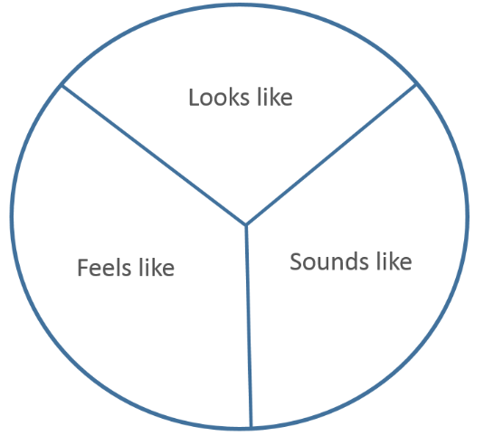

The T chart

Social distancing and self – isolation and it’s link to inclusion and connection worksheet
Students read facts from the articles below and consider other family members or students ideas.
Online - Social distancing: As we pull away, how can we maintain connection?” (duration 7:57). As students listen to this audio broadcast, they gather 5 questions from the audio that they will ask in the chat stream of their online platform.
As students read this information, they gather 5 questions from the audio that they will ask in the chat stream of their online platform.
Offline- Print the social distancing guidelines pdf and issue to students. health.gov.au/sites/default/files/documents/2020/03/coronavirus-covid-19-information-on-social-distancing.pdf
Questions to consider
What is social distancing and why is it important?
What can I do?
Social distancing at home | Social distancing in schools | Social distancing in public

Literacy reflection task scaffold
How can these influences support my actions and behaviours both now and in the future?
Students:
- Consider the influences from their own brainstorm list above from influences activity. Students can consider ideas from class peers/ teacher contributions
- Examine how these influences (from above) support their actions and behaviours right now with a current global health issue that is immediately impacting their community (COVID-19.) See scaffold below.
Table 1: Scaffold for Literacy reflection task
Examine- inquire into, inspect something carefully and in great detail. It means to look at something very closely and usually with the purpose of making a judgement. | Student brainstorming/ working area
Introduction: What is the issue to be examined? Place this into a paragraph here: | Brainstorm ideas around concepts in the question.
Body of your answer:
Point 1 (Influence 1- Introduce this influence by describing/ defining. It is opening sentence for this point)
Elaborate (How does this influence my actions and behaviours?) and provide supporting example. Provide a sentence that links back to question.
Point 2 (Influence 2- Introduce this influence by describing/ defining. It is opening sentence for this point):
Elaborate (How does this influence my actions and behaviours?) and provide supporting example. Provide a sentence that links back to question.
Point 3 (Influence 3- Introduce this influence by describing/ defining. It is opening sentence for this point):
Elaborate (How does this influence my actions and behaviours?) and provide supporting example. Provide a sentence that links back to question.
Conclusion: write overall conclusion around the influences and examples you have provided, bringing concepts in answer above together

How can data empower me to be make good choices that will support my own and others health? Worksheet 1
(Students can investigate another graph in this section. Please add row below)
Graph Sample | Graph Considerations, questions and answers
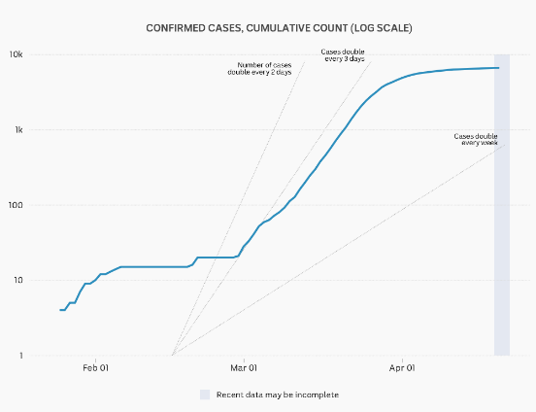  Confirmed cases, cumulative amount | - What is the data in the graph showing us?  - What is the horizontal axis showing us?  - Why is the vertical axis numerical increments (what the numbers go up by) not even? What do they go up by-is there a pattern?  During March,  What steps did our political and medical leaders take to change the gradient (steep line) within this graph and empower us to be and stay healthy?  These decisions from 4 above empowered us a country to make good health decisions, how is this represented in the graph?
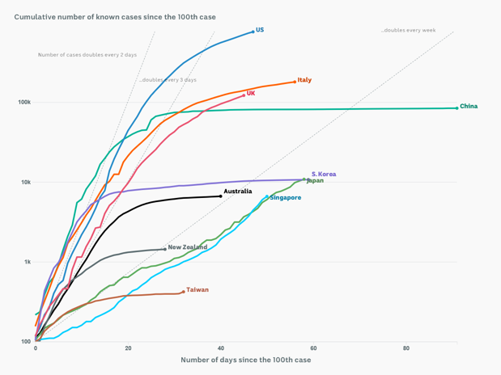  Confirmed cases since the 1000th case per country | - What are 5 things you notice in this graph?  - What are 4 things you wonder?  - What are three things you know about coping with an emerging health issue like COVID-19?  - What are 2 things that have empowered you with being healthier as you have investigated these graphs in relation to a global health issue?  - What is one thing you can suggest to others about data supporting health?
Choose your own graph to consider from the above website. | - What is the title of the graph?  - What do you notice about each axis?  - What information can you get from this to support your own, and others’ wellbeing?

How can data empower me to be make good choices that will support my own and others health? Worksheet 2

Graph Sample | Graph Considerations, questions and answers
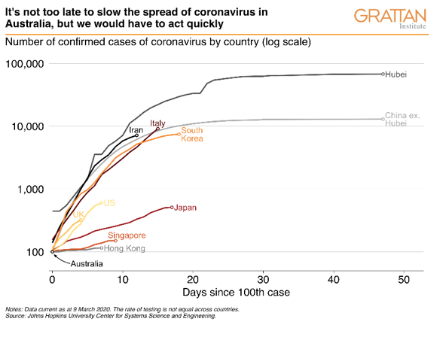  GRATTAN Institute – Graph displaying number of confirmed cases on March 9, 2020. | - What are the main messages in this graph?  - What did you find out, what is new?  - What can you take away from this graph to empower what you do to manage the current health crisis?
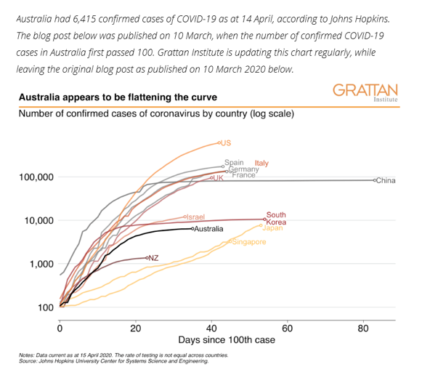  Find the most recent and updated graph via this blog from 10 March on Updated GRATTAN Institute graph of global COVID-19 cases | - How does the message and visual representation differ from the above graph?  - What is new in this graph? Consider the axis, numbers on each axis, gradient of lines and where they may be steep or flat.  - Why has the curve flattened in some countries and not others?  - What is the casual factors of the curve flattening in countries?  - How can looking at data empower an individual? Why/ how? Please explain your answer.  - How have governments contributed to supporting this global health issue?  - From the factors mentioned in Q6, how has the restrictions supported your own and others health with COVID-19?

What empathy may look like/ sound like/ feel like- consider these points when students are sharing in an open forum.
Students can add to this list. Teacher to use for discussion ideas.
- Listening with full attention to the speaker and looking for the feelings behind the words, facial expressions, and body language.
- Respecting the thoughts of a friend who has shared his or her feelings.
- Acknowledging the emotions of someone by saying something like, “I can see that you are really uncomfortable about this”.
- Showing appropriate reactions to someone who is sharing his or her feelings (I.e.: nodding, smiling, paraphrasing) and asking questions at appropriate times.
- Allowing the person to share his or her feelings without interrupting, judging, or trying to solve his or her problem.
- Trying to understand a person’s feelings and motives, even when you may disagree with the actions of a person.
- Speaking from “I” and owning your emotions.
- Understanding that we are all a lot more alike than we think, even if on the outside we look and act differently.
- Seeing ourselves in others – even those people we think are very different from us.

