PDHPE Stage 4

Upstander behaviour
Suggested duration: 2 × 45 minutes
This activity has been designed to explore what it means to be an upstander through Stage 4 PDHPE. It is designed to build on the Stage 4 teaching and learning activity Stairs to inclusivity
Students will build on their knowledge and understanding of the Stairs to inclusivity to identify attitudes, behaviours or actions which promote inclusiveness and encourage others to move beyond tolerance and acceptance.
NOTE: It is important that teachers review the Stairs to inclusivity terms and have a strong understanding of the terms and definitions before implementing this activity. Teachers may have differing definitions of the key terms.

PDHPE outcomes
- PD4-2 examines and demonstrates the role help- seeking strategies and behaviours play in supporting themselves and others
- PD4-3 investigates effective strategies to promote inclusivity, equality and respectful relationships
- PD4-6 recognises how contextual factors influence attitudes and behaviours and proposes strategies to enhance health, safety, wellbeing and participation in physical activity
- PD4-10 applies and refines interpersonal skills to assist themselves and others to interact respectfully and promote inclusion in a variety of groups
What do we want students to know, understand or be able to do?
- Understand the difference between inclusive and non-inclusive behaviours
- Recognise the difference between bullying, bystander and upstander behaviours
- Identify the stairs to inclusivity that demonstrate a positive use of power
- Describe how upstander behaviour is a positive use of power
- Understand the impacts and effects of bullying and bystander behaviours
- Demonstrate how upstander behaviour can help to support others

PDHPE skills focus
Table 1 – Skill domain and evidence of learning
Skill domain and skills | Evidence of learning - what do we want students to be able to do?
Interpersonal skills  - communication  - collaboration, inclusion and relationship building  - empathy building  - leadership and advocacy | - Communicate clearly with others  - Share thoughts and emotions appropriate to the situation  - Actively listen to others  - Understand the needs and circumstances of others and express that understanding  - Value an individual’s or group’s worth  - Adopt a variety of roles such as group member to support and encourage others  - Relate to others experiences and circumstances  - Show compassion  - Encourage people to look out for themselves  - Encourage and guide others in a positive way  - Contend the negative attitudes and behaviours of others
Self-management skills  - decision making and problem solving  - help seeking | - Locate relevant and reliable information and services  - Seek help where required  - Justify why a particular option has been chosen over others  - Locate support services  - Find out where to go or how to access support services/networks

Syllabus content
Table 2 – Key inquiry questions and syllabus content
Key inquiry question | Relevant syllabus content
What skills and strategies can be used to manage change, challenges and seek help? | - practise and apply skills and strategies to seek help for themselves and others (ACPPS072)  - propose individual support networks and external support services S  - identify barriers to seeking help and propose strategies to overcome these barriers S  - recognise scenarios that involve change and challenge for young people and rehearse help-seeking strategies to overcome each situation S I
What skills and strategies can be used to promote inclusivity, equality and respectful relationships? | - investigate the benefits of relationships and examine their impact on their own and others’ health, safety and wellbeing (ACPPS074) I  - examine how culture and relationships with family and peers can influence people’s attitudes, behaviours, decisions and actions in different situations S  - analyse how behaviours, actions, and responses to situations can change depending on who they are with S  - explore skills and strategies needed to communicate and engage in relationships in respectful ways  - investigate personal, social and cultural factors that influence the way individuals respond emotionally to different situations and propose strategies for managing these S  - practise being respectful, sympathetic and empathetic to different viewpoints and plan alternative ways to respond to others S I  - discuss the impact of power in relationships and identify and develop skills to challenge the abuse of power  - discuss the influence of family, media and peer attitudes to power in relationships  - explore how external influences impact power in relationships in both a positive and negative way, eg bullying, homophobia, intolerance, help-seeking, social support, advocacy on one’s behalf, upstander behaviour S  - describe forms of bullying, harassment, abuse, neglect, discrimination and violence and how they impact health, safety and wellbeing
Why is connection, inclusion and empowerment important for the health, safety, wellbeing and physical activity levels of the wider community? | - examine influences on peoples’ behaviours, decisions and actions (ACPPS074)  - discuss the influence of contextual factors on individual decisions and actions

Assumed knowledge and understanding
To participate in this activity, it is assumed that students have a basic understanding of the following Stage 4 PDHPE content:
- Types and nature of relationships
- Caring and respectful relationships
- Power in relationships
- Bullying and harassment
- Completed the Stage 4 learning activity - Stairs to inclusivity

Teaching notes
The activity explores positive actions that can promote inclusivity and encourages students to move beyond the notion of tolerance and acceptance by challenging attitudes and actions that are not inclusive. It should be emphasised that the impact of our inaction, or tolerance, is even more significant to those who experience bullying and harassment all the time. Students will explore the meanings and behaviours associated with the terms bullying, bystander and upstander.
Students will compare upstander behaviour to that of by-stander behaviour and where each behaviour fits on the Stairs to inclusivity. There may be opportunities to work separately with individuals or groups of students to enhance their knowledge and understanding of the two terms and their definitions.

Background information
Bullying within the school environment is a serious social problem both in Australia and globally (Gini & Pozzoli 2009; Morrison 2001).Both those who bully and those who are bullied experience long-term psychological and social problems associated with their behaviour, such as depression and thoughts of suicide that may extend well beyond their schooling years, and are at greater risk of criminal conviction and school drop-out (Beaty & Alexeyev 2008; Brunstein-Klomek et al. 2007; Lodge 2008).
School bullying has been shown to adversely affect the social, emotional, educational and physical wellbeing of young people. Adolescents who were bullied reported higher absenteeism, felt less connected to school, experienced lower academic achievement and consequent lower vocational and social achievement, school failure, lower self-esteem, higher levels of physical harm, psychological and health problems (such as anxiety, depression, physical and somatic symptoms, and risk of suicide), and alcohol and substance use (Lodge 2008; Skues et al. 2005; Spector & Kelly 2006).
Young people, while they experience their world, may face the challenge of being subject to, observers of and/or promoters of bullying and harassment. Non-inclusive actions or behaviours such as bullying are sometimes tolerated or accepted by the wider community and this is generally labelled as bystander or onlooker behaviour. By exploring how young people can respond to bullying and harassment towards others, teachers can encourage students to demonstrate more inclusive attitudes and behaviours and therefore move beyond tolerance and acceptance. Being an upstander is an example of an inclusive behaviour that is explored through this learning activity.
Upstander behaviour can be observed as:
An individual or group standing up to show their appreciation and support for human rights and taking action in support of themselves and/or others i.e. combatting negative attitudes and behaviours. Upstander behaviour differs to by-stander behaviour which often involves standing by with little interference or no action/involvement in situations that reflect discriminatory attitudes or behaviours such as derogatory jokes, offensive language, excluding comments, bullying, harassment, violence or abuse.
The BULLY Project Australia defines an upstander as – “someone who recognises when something is wrong and acts to make it right. When an upstander sees or hears about someone being bullied, they speak up. Being an upstander is being a hero: we are standing up for what is right and doing our best to help support and protect someone who is being hurt.”
Students who have previously experienced or been subject to exclusion, bullying and harassment may find this activity very empowering, however, it is important that they are supported by additional information or referral as needed.
While for some resilient young people bullying and harassment may not be a matter of concern, the majority of young people experiencing this will be affected emotionally, physically and/or socially at some time in their adolescence. Bullying and harassment is a common experience in the school environment and is one that can bring with it an extreme amount of distress and a sense of isolation with its consequent impact on feelings of self-worth. Whilst counselling has an important role to play in supporting young people, teachers should also respond to issues of bullying and harassment within the school as per school policy and procedures.

Considerations when selecting activities
- Preview and evaluate all strategies, resources and teaching and learning approaches in full before use with students to determine suitability for student learning needs, stage of development and local school context.
- Consider the age, maturity, cultural background, sexuality, gender, sex, health and other characteristics of students in your care.
- Apply professional judgements to all strategies, teaching and learning approaches and resources including audiovisual materials (e.g. videos, media clips and YouTube), interactive web-based content (e.g. games, quizzes and websites) and texts.
- Seek endorsement by the school principal before use of materials in NSW government schools.
- Select the activities most suitable for your students.
- Individual students within the group have differing needs and backgrounds. Modify or extend some aspects of suggested activities accordingly.
- Consider and tailor lessons to cater for differing cultural perceptions of what should be taught at a certain age.
- Undertake a comprehensive step by step process to assess any physical or psychological risks associated with an activity before following using a variety of teaching strategies.
- Enable students to withdraw if they find issues personally confronting.
- Recognise that some students may find it difficult to contribute to class discussions and may say little in group activities. Don’t assume they are not engaged in the activities but rather provide all students with the opportunity to contribute in less public ways.
- Be guided by the department's Sexuality and sexual health education in NSW government schools fact sheet when planning and implementing any sexuality or sexual health education lesson.
- Access more information about child protection education on the department’s PDHPE curriculum website.
- Use the resource review flowchart to decide about the suitability of teaching and learning resources.

Communication with parents and caregivers
Some aspects of PDHPE/ Crossroads may be viewed as sensitive or controversial, such as learning about abuse, child protection, drugs, respectful relationships, sexual health, sexuality and violence. Inform parents and carers, prior to the occasion, of the specific details of the PDHPE or Crossroads program, so that parents and caregivers have time to exercise their rights of withdrawing their child from a particular session. In this regard, a parents or caregiver’s wish must be respected.
Establishing how parents and caregivers will be informed about programs and involved in consultation is a school-based decision. Where parents and caregivers indicate they wish to withdraw their child from a program it is useful to negotiate which parts of the PDHPE program they are concerned about. Sample information letters are available on the PDHPE curriculum website.

Creating a safe and supportive learning environment
There are a number of strategies that can be used to create a supportive learning environment which enables students to feel safe to learn and ask questions. They include:
- making students aware at the beginning of PDHPE lessons that disclosing personal information that indicates they may be at risk of harm will be reported to the school principal in all instances. This includes personal disclosures related to instances of abuse, drug use, neglect or sexual activity under the legal age of consent.
- being aware that some parts of PDHPE can be confronting and sensitive for some students.
- enabling students to withdraw if they find issues personally confronting to protect them from making harmful disclosures. Equally, it is important to be prepared for issues that arise as a result of a student making a public disclosure in the classroom.
It is recommended that staff use a question box to allow for students to ask difficult questions anonymously through the unit. The question box provides staff with information on student prior and post knowledge by assessing the questions which arise through the question box. Students should be provided with a piece of paper at the beginning of each lesson which they can write their question on and submit. All students should submit a piece of paper, even if it is blank to ensure anonymity.
More information on creating a safe and supportive learning environment can be found on the PDHPE curriculum website.

Required resources and materials for preparation
- Stairs to inclusivity visual layout – 1 per student (A4)
- Body outline example – teacher copy
- Stairs to inclusivity cards - respect, mutual understanding and celebration (A3)

Learning experiences

Activity 1 – Review the stairs to inclusivity (10 minutes)
- Review student’s prior knowledge and understanding of each of the Stairs to inclusivity terms and their respective definitions.
- Provide students with a copy of the stairs to inclusivity visual layout. Reinforce the following key messages with regards to the stairs to inclusivity words – tolerance and acceptance:
- Tolerance and acceptance bring with them a sense of power or control over diversity and the need to give permission for difference to exist.
- There are benefits to society if we move beyond acceptance and reconsider how we use the words tolerance and acceptance in our everyday language.
- Tolerance can also be perceived as consent e.g. knowledge without action is consent. When you know something is not right but you do nothing about it, others may think that you agree with the situation.

Activity 2 – Bullying and bystander behaviours (35 minutes)
- In three groups, students draw a human size outline of a body onto large paper. Allocate one of the following headings to each group to write at the top of their body outline
- a person who is bullying
- a person who is bullied
- a person who is being a bystander
- Students record any words and/or meanings they associate with their respective heading along the outline of the body similar to the body outline example provided. These body outlines can be re-visited in Stage 5 PDHPE to progress student’s knowledge and understanding using the Looking into Homophobia teaching and learning activity.
- As a class, determine the difference between a person who is bullying and a person who is being a bystander. Use the following questions for class discussion:
- What are the differences between each person?
- Are these differences related to the actual person and who they are, or the behaviour and actions they are displaying? (Key messages to note here are: bullying and being a bystander can both be defined as behaviours or actions and the term ‘bully’ should not be used to label people)
- What is different about the way a person acts or behaves in each circumstance?
- Is it possible for a person who is being a bystander to become a person who is bullying or a person who is bullied? If so, why?
- Is it possible for a person who is bullying to also be a person who is bullied? Why or why not?
- As a class, explain to students the similarity between bullying behaviour and bystander behaviour in that each involves some form of action or behaviour related to the stairs to inclusivity which is non-inclusive. For example, both bullying and bystander behaviours could be placed on the stairs to inclusivity from acceptance down to hatred/violence depending on the type of action or behaviour being demonstrated.
- In small groups, students discuss where they would place bullying behaviour and bystander behaviour on the stairs to inclusivity.
Questions for groups to consider could include:
- Would you place bullying behaviour in the same place as bystander behaviour? If so, why?
- What do you think the thoughts of a person who is a bystander might be? (The teacher should encourage students to provide specific de-personalised examples to respond to this question. E.g. a person who is being a bystander could be placed on the tolerance stair because they might not agree with the bullying but still do nothing about it. However, in another situation the person being a bystander could be placed on the dislike stair because even though they might not get involved in the bullying behaviour, they might agree with what is going on because they dislike the person who is being bullied).
- What are the different types of bullying behaviours or actions and bystander behaviours or actions? Are these all placed on the same Stair to inclusivity? Why or why not?
- Would you place any of the behaviours or actions of a bystander higher on the Stairs to inclusivity than acceptance? Why or why not?
- Do you think bystander behaviour would have the same impact/effect as bullying behaviour, on the person being bullied? Why or why not?
- As a class, discuss the impacts of bullying and bystander behaviour.
Teacher note: Students should have prior knowledge and understanding of the effects of bullying and harassment from previous lessons which should allow for students to explore bystander behaviour and its effects in more depth. There may be opportunities to work separately with individuals or groups of students to enhance their knowledge and understanding of the effects of bullying behaviour where necessary.
Questions for class discussion could include:
- What might be some thoughts and feelings of a person who is bullied?
- What impact would bullying behaviour have on the self-esteem and confidence of a person being bullied?
- If bullying behaviour was continuously targeted towards the same person how would this impact on the person being bullied?
- What might a person who is being bullied think about a person who is displaying bystander behaviour?
- If the person who is displaying bystander behaviour was a friend of the person being bullied, how might this have an impact on the friendship?
- What impact does bullying behaviour have on a person being bullied, in terms of school life, mental health and friendships?
- What impact does bystander behaviour have on a person being bullied, in terms of school life, mental health and friendships?

Activity 3 – What is upstander behaviour? (45 minutes)
- Introduce another body outline to the class with the following heading – a person who is an upstander, and ask students how this might differ to the other three bodies previously discussed. Questions that could be used for discussion include;
- What do you think the word upstander means?
- What would the actions or behaviours of an upstander look like?
- How would the thoughts and feelings of an upstander differ to a bystander?
- Why would someone be an upstander?
- As a class discuss where upstander behaviour would be placed on the Stairs to inclusivity visual layout.
- Place the stairs to inclusivity cards for respect, mutual understanding and celebration onto the board.
- As a class discuss the definitions of each term taking note of the specific behaviours demonstrated in each one.
- Explain to students that each of these stairs to inclusivity show how an individual or group, by acting or behaving in an inclusive way, can demonstrate a positive use of power.
- Identify the elements within each definition that demonstrates a positive use of power.
- As a class, students use their knowledge and understanding of the stairs to inclusivity, bystander behaviours and positive use of power to develop a class description of what upstander behaviour is. Students can be given the following information to clarify or confirm the class description:
The BULLY Project Australia defines an “upstander” as “someone who recognises when something is wrong and acts to make it right. When an upstander sees or hears about someone being bullied, they speak up. Being an upstander is being a hero: we are standing up for what is right and doing our best to help support and protect someone who is being hurt.”
Upstander behaviour can be observed as:
- An individual or group standing up to show their appreciation and support for human rights and taking action in support of themselves and/or others i.e. combatting negative attitudes and behaviours. Upstander behaviour differs to by-stander behaviour which often involves standing by with little interference or no action/involvement in situations that reflect discriminatory attitudes or behaviours such as derogatory jokes, offensive language, excluding comments, bullying, harassment, violence or abuse.
- Upstander behaviour is dynamic and can fit on the Stairs to inclusivity at respect, mutual understanding and celebration.
- In small groups, students develop a role play to demonstrate the following messages:
- Bystander thinking and behaviour is different to upstander thinking and behaviour
- Upstander behaviour can help to support people who are bullied.
Teacher note: Students should be encouraged to use the ’pause and rewind’ effect where the group performs the role play showing bystander thoughts and behaviours first and then they ‘pause and rewind’ the situation to then show the same individual/s demonstrating upstander behaviour. An example of the pause and rewind can be found on YouTube
Extension activity: Role plays could be recorded on video and then edited using multimedia software to create the pause and rewind effect.

Extension activity
Fellow peers could critically assess the group role plays, or video productions, to critique their effectiveness in portraying the following key messages:
- Bystander thinking and behaviour is different to upstander thinking and behaviour
- Upstander behaviour can help to support people who are bullied.

Stairs to inclusivity – Visual layout
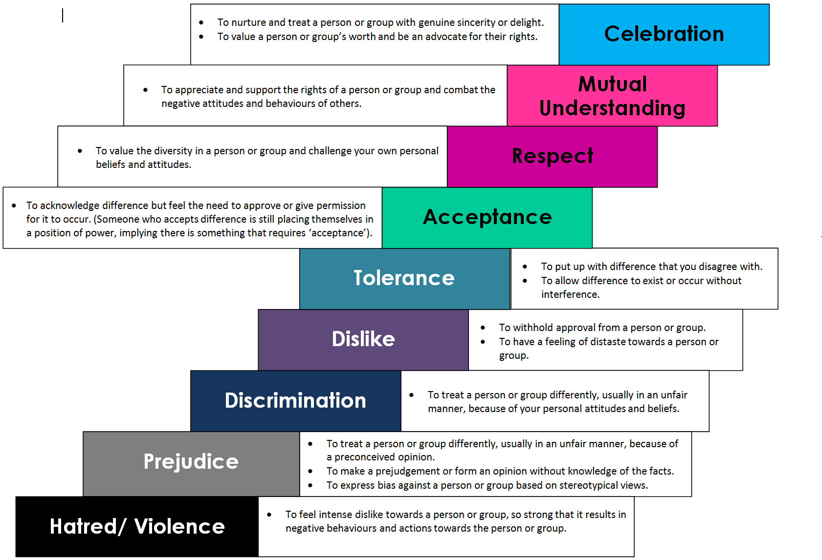

Body outline example
A person who is bullying
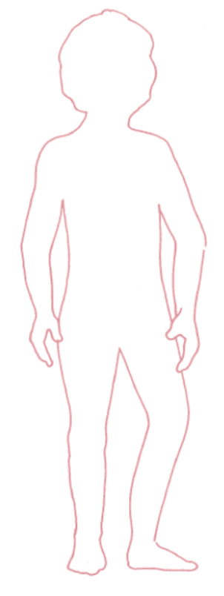 | - angry  - mean  - name calling  - teases people  - violent  - bossy  - aggressive  - insecure  - discrimination  - uses power to hurt others  - abusive  - intimidates  - forceful  - physical fights

Stairs to inclusivity cards
Cards can be printed and laminated for future use.
Celebration
To nurture and treat a person or group with genuine sincerity or delight.
To value a person or group’s worth and be an advocate for their rights.

Mutual Understanding
To appreciate and support the rights of a person or group and combat the negative attitudes and behaviours of others.

Respect
To value the diversity in a person or group and challenge your own personal beliefs and attitudes.

Acceptance
To acknowledge difference but feel the need to approve or give permission for it to occur. (Someone who accepts difference is still placing themselves in a position of power, implying there is something that requires ‘acceptance’).

Tolerance
To put up with difference that you disagree.
To allow difference to exist or occur without interference.

Dislike
To withhold approval from a person or group.
To have a feeling of distaste towards a person or group.

Discrimination
To treat a person or group differently, usually in an unfair manner, because of your personal attitudes and beliefs.

Prejudice
To treat a person or group differently, usually in an unfair manner, because of a preconceived opinion.
To make a prejudgement or form an opinion without knowledge of the facts.
To express bias against a person or group based on stereotypical views.

Hate/Violence
To feel intense dislike, towards a person or group, so strong that it results in negative behaviours and actions towards the person or group.

