Applying relationship skills for enthusiastic consent: Stage 4 PDHPE
This learning activity sequence aims to explore the importance of enthusiastic consent as part of a respectful relationship. It uses the metaphor of cycling to develop student understanding. Students will apply interpersonal skills to practise asking for and giving enthusiastic consent.
Duration: 30 minutes

Educative purpose
Big idea – Why is this learning important?
Developing the knowledge and skills required to express and recognise signs of interest and willingness be engage in sexual and non sexual activities is crucial for the formation of a variety of respectful relationships, including intimate relationships.
Through this sequence, students will investigate the strategies they can apply to establish and maintain respectful relationships online and offline. They will develop and apply skills of self awareness to recognise their physical and emotional response to different situations and understand the importance of trusting gut instincts. Students will build on their understandings of consent and recognise consent as an important right and responsibility in respectful relationships. They will apply interpersonal skills to practise negotiating consent and consider the factors which influence individual’s decisions to engage in sexual activity
Syllabus learning context – Personal identity, Relationships, Sexuality and sexual health

PDHPE skills focus
Skill domain and skills | Evidence of learning - what do we want students to be able to do?
Interpersonal skills  - Communication  - verbal and nonverbal communication  - assertiveness | - demonstrate ways to clearly ask for and receive consent  - identify ineffective and unclear ways to ask for and receive consent
Self-management skills  - Self-awareness  - self-monitoring thoughts, feelings and actions | - identify the physical and emotional response to situations  - links the body’s response to situations to levels of safety and risk  - select and apply the most appropriate strategy to stay safe in a situation (scenarios)

Syllabus content
Outcomes
PD4-3 investigates effective strategies to promote inclusivity, equality and respectful relationships
PD4-9 demonstrates self-management skills to effectively manage complex situations
PD4-10 applies and refines interpersonal skills to assist themselves and others to interact respectfully and promote inclusion in a variety of groups or contexts
All outcomes referred to in this unit come from the PDHPE K-10 syllabus. © NSW Education Standards Authority (NESA) for and on behalf of the Crown in right of the State of New South Wales, 2018.
Content
Key inquiry question | Relevant syllabus content (dots and dashes)
What skills and strategies can be used to promote inclusivity, equality and respectful relationships? | - explore skills and strategies needed to communicate and engage in relationships in respectful ways  - practise communication skills that establish and maintain respectful relationships in an online and offline environment and describe how these show respect (or not) for self and others, eg reporting inappropriate behaviour S I  - practise interpersonal skills required to negotiate safe intimate relationships, eg consent I

Assumed knowledge and understanding
This learning activity sequence assumes that students have some understanding of:
- the concept of consent and a definition of consent as permission to engage in something
- the impact of social norms on the behaviour of individuals and groups.

Learning intentions and success criteria
Learning intentions | Success criteria
- Explore and define what sex is (PD4-3)  - Understand the laws related to consent and age of consent in NSW (PD4-3)  - Demonstrate the skill of assertiveness (PD4-9)  - Understand and apply strategies which can be used to keep safe (PD4-9)  - Understand what consent is in sexual relationships (PD4-10)  - Understand the importance of consent (PD4-10)  - Recognise consent as a key component in a respectful relationship (PD4-10)  - Recognise the importance of trusting gut instincts (PD4-9) | - define the term sex (pd4-3)  - identify the broad range of behaviours that may be part of a definition of sex (pd4-3)  - recognise how people’s views and definitions of sex may vary (pd4-3)  - identify factors which influence decisions to be sexually active (PD4-3)  - make links between personal decisions, contextual factors, and personal values in relation to sexual behaviours (PD4-9)  - select and apply the most appropriate strategy to stay safe in a situation (scenarios) (PD4-9)  - demonstrate a variety of strategies to protect themselves and others identify the importance of consent (PD4-9)  - demonstrate ways to clearly ask for and receive consent (PD4-10)  - identify ineffective and unclear ways to ask for and receive consent (PD4-10)  - identify the physical and emotional response to situations  - links the body’s response to situations to levels of safety and risk

Teaching notes

Considerations when selecting activities
- Preview and evaluate all strategies, resources and teaching and learning approaches in full before use with students to determine suitability for student learning needs, stage of development and local school context.
- Consider the age, maturity, cultural background, sexuality, gender, sex, health and other characteristics of students in your care.
- Apply professional judgements to all strategies, teaching and learning approaches and resources including audiovisual materials (e.g. videos, media clips and YouTube), interactive web-based content (e.g. games, quizzes and websites) and texts.
- Seek endorsement by the school principal before use of materials in NSW government schools.
- Select the activities most suitable for your students.
- Individual students within the group have differing needs and backgrounds. Modify or extend some aspects of suggested activities accordingly.
- Consider and tailor lessons to cater for differing cultural perceptions of what should be taught at a certain age.
- Undertake a comprehensive step by step process to assess any physical or psychological risks associated with an activity before following using a variety of teaching strategies.
- Enable students to withdraw if they find issues personally confronting.
- Recognise that some students may find it difficult to contribute to class discussions and may say little in group activities. Don’t assume they are not engaged in the activities but rather provide all students with the opportunity to contribute in less public ways.
- Use the resource review flowchart to decide about the suitability of teaching and learning resources.

Communication with parents and caregivers
Some aspects of PDHPE may be viewed as sensitive or controversial, such as learning about abuse, child protection, drugs, respectful relationships, sexual health, sexuality and violence. Inform parents and carers, prior to the occasion, of the specific details of the PDHPE program, so that parents and caregivers have time to exercise their rights of withdrawing their child from a particular session. In this regard, a parents or caregiver’s wish must be respected.
Establishing how parents and caregivers will be informed about programs and involved in consultation is a school-based decision. Where parents and caregivers indicate they wish to withdraw their child from a program it is useful to negotiate which parts of the PDHPE program they are concerned about. Sample information letters are available on the PDHPE curriculum website.

Creating a safe and supportive learning environment
There are a number of strategies that can be used to create a supportive learning environment which enables students to feel safe to learn and ask questions. They include:
- making students aware at the beginning of PDHPE lessons that disclosing personal information that indicates they may be at risk of harm will be reported to the school principal in all instances. This includes personal disclosures related to instances of abuse, drug use, neglect or sexual activity under the legal age of consent.
- being aware that some parts of PDHPE can be confronting and sensitive for some students.
- enabling students to withdraw if they find issues personally confronting to protect them from making harmful disclosures. Equally, it is important to be prepared for issues that arise as a result of a student making a public disclosure in the classroom.

Learning experiences

Activity focus: the importance of consent
Creating a safe, supportive, respectful, and inclusive classroom
It is important that students feel that the classroom environment is safe, supportive, respectful, and inclusive. Activities provided in this unit are designed to help students contribute to, build, and maintain a safe, supportive, respectful, and inclusive environment. The collaborative skills explored during the lesson help students to learn and have fun whilst practising skills that contribute to a happy and safe environment.
Introduce the question box to the class.
The question box allows for anonymity and establishment of student prior knowledge in relation to PDHPE concepts. Allowing students to ask questions in an anonymous manner will increase student access to reliable information. Even though anonymous, it is expected that teachers will reasonably be able to work out the identity of a student should a disclosure be made, so a child protection response can be provided. If it is a large group or the teacher is not familiar with students’ work, they could invite students to add their name, if they wish, saying it will not be shared with the group. Although not all students will, this should assist with identification, if it is needed. The box should be a material item such as a shoe box, bowl, or hat.
Explain to students:
- The question box can be used to ask questions that they want to know but don’t want to ask in front of everyone.
- The question box is anonymous, but you might choose to add your name if you wish.
- Everyone will be given a blank piece of paper at the end of each lesson.
- Everyone must record something on their piece of paper whether it is a question or something else, for example, last night’s dinner to ensure the questions remain anonymous or a drawing.
- They must place their own paper into the question box.
- Questions will be answered at the next lesson.

Resources
- Sticky-notes
- Am I ready? Age group cards
- Am I ready? Teacher notes regarding consent
- Consent? Yes or No? cards (one per group of eight)
- Consent? Yes or No? worksheet (one per student)
- Consent? Yes or No? scenarios
- Consent? Yes or No? Teacher notes

Introduction
Introduce the learning goals and discuss them with the class.
Inform students that the focus of their learning will now be narrowed to intimate relationships.

Defining sex
Students write a definition for sex. What does the word mean to you?
Sex can be defined as any form of activity one does with the body that leads to sexual arousal
Students brainstorm a range of activities and behaviours which would fall within the definition of sex.
- Encourage students to think broadly in terms of sexual activity, from eye contact to intercourse.
- Depending on the nature of the group it may be more appropriate to use suggestions from the list.
Examples might include:

Oral sex
Viewing pornography
Holding hands
Sex toys
Anal intercourse
Vaginal intercourse
Cuddling
Body and or genital rubbing
Kissing
Talking dirty
Sexting or sending explicit texts
Eyeing someone off
Masturbation
Fantasy
Love letters
Massage

- Ensure all students have a common understanding of each term listed. Accept all sexual activities without values-based judgement to avoid unintentionally ostracising students who may be engaging in the activities.
Explain to students that all of these activities and behaviours can be defined as part of sex and therefore consent needs to be sought and provided in this range of intimate behaviours with other people.

Inference – What’s going on in this picture?
Introduce the learning goals and discuss them with the class.
Inform students that the focus of their learning will now be narrowed to intimate relationships.
The next activity uses a clip which relies on the inference skills of students. It is suggested that an activity to build the inference skills of students is used prior to the clip.
Inference can be defined as the process of drawing a conclusion based on the available evidence plus previous knowledge and experience. Inference questions are the types of questions that involve reading between the lines. Students are required to make an educated guess, as the answer will not be stated explicitly. Students must use clues from the text, coupled with their own experiences, to draw a logical conclusion.
The teaching of inference skills is extremely important to our students. It is a higher order skill that is essential for students to develop to afford them access to the deepest levels of comprehension.
Access the New York Times, What’s going on in this picture? website. Select an image to suit your student context.
Ask students to share:
- What is going on in this picture?
- What do you see that makes you say that?
- What more can you find?
Access the correct information for the image at the bottom of the post. Share with students and ask them to reflect:
- What was your inference?
- What information did you use to make this inference?
- How good was your thinking?
- Do you need to change your thinking?
Share as a class.

Cycling through consent
Show the short clip Cycling through consent (Source: Western University 2015)
Individually ask students to answer the following questions:
- What question/s is the cycling video investigating?
- What evidence does the video use?
- What inferences does the video make?
Discuss the following as a whole group:
- What does the ‘bike ride’ metaphor represent in the clip? Suggested answer: engaging in sexual behaviours.
- Who are the ‘bike-riders’? Suggested answer: people in relationships that may engage in sexual behaviours.
- What does asking someone if they like to go for a bike ride represent in this clip? Suggested answer: giving consent or agreeing to sexual behaviours. Explain to students that this concept will be unpacked in more detail in the next activity.
- What important messages were there about communication on the ‘bike ride’ i.e. consenting to sexual behaviours? Suggested answer: No, is no. The absence of a yes means No. People can change their mind. Don’t make assumptions. Consent must be given every time. A person cannot consent if they are under the influence of alcohol or drugs, unconscious or asleep. People cannot use their power to coerce someone to participate in sexual behaviours. People should never feel pressured to participate in any form of sexual behaviours.
- What was the important point made at the end of the clip? Suggested answer: Sexual behaviours can be a positive and enjoyable experience for people if everyone agrees to participate ie gives consent
Am I ready? (Adapted from Catching On Later AusVELS Level 8 Sexuality Education Activities)
Explain to students that making the decision about whether or not you are ready for sexual behaviours is a personal choice. There are a number of contextual factors that may influence an individual’s decision, but it is still a personal choice.
Students record and share examples that influence a person’s decision to participate in sexual behaviours. Highlight to students that they need to consider all different types of people when developing their answers. This activity could be done by students recording influences on sticky-notes and using these for the next part of the activity. Alternatively, verbal sharing could be used, and a class collection of influences developed.
Explain to students that there are a number of factors that influence people’s behaviours, decisions and actions.
Display the table and briefly explain by defining the table headings and offering examples of what might fit within each section and why.
Individual | Sociocultural | Socioeconomic | Environmental
- knowledge  - skills  - attitudes  - beliefs  - ability  - sex  - gender  - sexuality  - age | - religion  - parents/carers  - family  - media  - culture  - peers  - language  - politics  - laws | - education  - income  - employment | - geographical location  - access to health services.

Students identify examples for each section of the table. This could be done by students placing their sticky notes from the previous activity under the appropriate heading. Discuss as a class. Leave displayed for the next activity.
Highlight to students that these factors influence people in different ways and that is ok.
Explain to students that you are going to ask for their opinions about the ‘right age’ for a list of different scenarios. Remind students of the class agreement before beginning this activity.
Place the Am I ready? Age group cards along the wall with age 12 at one end and age 36–40 at the other.
Read out statement ‘a’ from the list below then ask students to move to the card that best represents the age at which they think this scenario should occur. Students who have chosen the same card should then discuss amongst themselves why they have chosen this particular age, with reference to the factors discussed in the previous activity.
Invite one representative from each group to report the factors discussed back to the class.
Invite students to change where they positioned themselves originally once they have considered all the perspectives:
- the age to have a relationship
- the age to have a sexual relationship (you could also ask: the age to engage in any of the activities or behaviours brainstormed at the start of this lesson e.g kissing, intercourse or oral sex. Note that these could be considered separately and draw out discussion around perspectives of sex and safer sex practices).
Display and discuss consent laws at this point. See Teacher notes resource.
- the age to have a baby
- the age to use contraception.
Read out statement ‘b’ then repeat the steps.
Read and discuss the information in the ‘Teacher notes’ regarding the age of consent. Again, invite students to change groups now they have new information.
Repeat the process with statements ‘c’ and ‘d’.
As a class discuss.
- Did you agree with your classmates about the right age for each scenario?
- Does your opinion about the appropriate age ever change?
- How do your choices now match your values and what is important to you?
- Why do you think that people we know very well may still have chosen differently from ourselves?
- Where would your parents stand? A representative of your school? Your peers? People from different cultures and religions?
- Do you agree that these factors influence people’s decisions about whether to go on a ‘bike ride’ or not?
Remind students that giving consent or not giving consent is their right in a relationship. At the same time, your responsibility is to respect your partner’s right to consent or not consent. Rights and responsibilities related to consent promotes respectful relationships.

What consent sounds like?
Remind students to keep the laws related to consent in mind when completing the activities below.
Explain to students that two-way communication is a very important skill related to consent. People need to clearly express if they give consent and also need to listen if their partner gives consent. Everyone needs to be clear that they are going to go on a ‘bike ride’.
Remind students of the importance of both verbal and non-verbal communication when expressing consent. Verbal communication involves using words or sounds to say “yes” or “no”. Non-verbal communication can include gestures or behaviours and can be used to support verbal communication or is very powerful on its own.
Students interpret the meaning of the following non-verbal behaviours as demonstrated by the teacher. Pause for discussion after each one.
- Leaning back in a chair with arms crossed
- Leaning forward in a chair
- Smiling
- Frowning
- Yawning
- Nodding
- Resting chin in both hands
- Resting chin on knuckles
- Rubbing your temples
- Tapping fingers on the table
- Looking at your watch
- Staring around the room.
As a class, discuss the following:
- Was it easy to interpret the meaning of each gesture?
- Did everyone always agree with what they thought the gesture meant?
- What could this tell us about using non-verbal communication to express or gain consent?
There are two options for the following activity:
- Option A: Students find a partner with a set of What consent sounds like? cards. They sort them into two piles; What consent sounds like? or What consent doesn’t sound like?
- Option B: Read out the statements below and students raise their hand if it sounds like consent and cross their arms if it does not sound like consent.

What consent sounds like | What consent DOESN'T sound like
"YES!" | "No"
"Yassssss" | "Stop"
"Absolutely" | "Maybe"
"That sounds great" | "I'm not sure"
"That feels awesome" | "I don't want to"
"Let's do that more" | "I don't think I'm ready"
"I'd like to..." | "Can we slow things down"
"Would you please..." | Pulling away or resisting
"I want to keep doing this" | Being silent or not responding
"I'm enjoying this" | Agreeing to go on a date
"Can we..." | Not showing interest in you
Highlight to students that ‘sounds like’ can also include non-verbal communication. Ask students to offer some examples of non-verbal communication that indicates a person does not give consent.

Assertiveness
Introduce the skill of assertiveness.
Being assertive means being able to stand up for your own or other people’s rights in a calm and positive way, without being either aggressive, or passively accepting ‘wrong’.
Assertive individuals are able to get their point across without upsetting others or becoming upset themselves.
Characteristics of assertiveness include: asserting your own point of view, reflecting your views through your behaviours and actions, respectfully stating your needs, wants, and feelings, and saying no, and being able to resist peer pressure.
Assertiveness is important as it is a healthy way of communicating. It's the ability to speak up for ourselves in a way that is honest and respectful. Assertiveness links to other important skills we develop, such as communication, expressing our feelings, conflict management, help seeking, refusal skills and negotiation skills. These skills are applicable to all life situations.
As a class, discuss the question:
- How might assertiveness support young people in relationships?
Explain the concept of enthusiastic consent.
Enthusiastic consent encourages people to make sure the person they are about to have sex with is enthusiastic about the sexual interaction and wants to engage in every action from start to finish. It is given and received when we are assertive. Assertiveness comes in this situation from confidence (knowing partner, knowing rights, positive decision making).
Allocate time for students to explore the information on the Kids helpline-Consent website. Alternatively, you could explore the site together as a class group.
Discuss the indicators that consent has been respected.
What is consent?
Mutual  You both need to agree, every single time. | Freely given  A choice you make without pressure, guilt or threats. | Informed  You understand what’s about to happen. | Certain & Clear  It’s a YES, not a ‘maybe’ or ‘I think so’ or ‘I guess so’.
Enthusiastic  You’re excited and WANT to do the sexual activity. | Reversible  You can stop or change your mind at any time. | Specific  Saying yes to one thing doesn’t mean yes to everything. | Ongoing  You need it before and during the activity, as well as next time!
Source: Kids Helpline https://kidshelpline.com.au/teens/issues/what-consent

Consent? Yes or no?
Explain to students that they are going to apply what they have learnt about consent to a range of scenarios.
Students form groups of eight with a set of Consent? Yes or No? cards, plus a copy of the Consent? Yes or No? worksheet for each student.
Outline the activity.
- Ask a group leader to shuffle the Consent? Yes or No? cards and give one to each person. Read the scenario the group has been given.
- Each person must decide and then share with the group if the indicators of consent they have has been respected.
- Record Yes, No or NA on your Consent? Yes or No? worksheet.
- The group must also answer the questions at the bottom of each scenario about the legal aspect of the scenario.
- Repeat for each scenario, ensuring each person does not get a card they have already had.
- As a class, discuss the following:
- Was it easy to decide if consent had been given in each scenario?
- How did verbal and non-verbal communication assist your group with making the decision if consent had been given?

Consent out loud
Students revisit the Kids helpline – consent website and explore the How to get consent section of the page. Acknowledge to students that asking for consent could feel awkward even if they are in a respectful relationship.
Revisit the class agreement.
Students read through the list on the website to know what to say if ever in the situation for real.
Refer back to the Consent? Yes or No? scenarios about Manny, and Lina, and Dimitri, and Alana. Would any of these statements have been useful for those involved?
Students role play ways Lina and Alana could assertively refuse consent to sexual activity, expressing how a specific indicator of consent has not been respected. This could be done live in pairs or via camera/webcam to share at a later time. Remind students to include examples of non-verbal communication to support their message.
As a class, discuss the following.
- Do you think is it important for someone to practise ways of giving and refusing consent before being in the actual situation? What makes you say that?
- Do you think it is also important for someone to imagine ways others may communicate refusal of consent before being in the actual situation? What makes you say that?
Emphasise with students that there are many ways of refusing consent to sexual activity. Some ways are less clear than others, but it is always valuable to be as clear as possible. If someone is asking for consent, they need to listen and respect the response. Where a young person is unsure about whether consent is being given or not, they should stop and clarify whether consent has been given by asking again. Never assume consent has been given.
Remember that enthusiastic consent is what you want. This comes with assertively asking for consent and your partner assertively giving consent. This would mean both parties can state their own point of view, reflect those views through behaviours and actions, respectfully state needs, wants, and feelings.
Assertiveness is important as it is a healthy way of communicating. It's the ability to speak up for ourselves in a way that is honest and respectful. Assertiveness links to other important skills we develop, such as communication, expressing our feelings, conflict management, help seeking, refusal skills, and negotiation skills. These skills are applicable to all life situations.

Activity focus: Trust your gut

Resources
- Gut instincts placemat activity
- The good, the bad, the ugly cards
- The good, the bad, the ugly sorting activity teacher notes
- Taking action scenarios
- Assertiveness advice handout (formative assessment – collect from students
- Trust, Talk, Take control handout (formative assessment – collect from students)
- Trust, Talk, Take control A4 image

Switch on to learning
Introduce the learning goals and discuss them with the class.
Explain to students that the focus of the learning in this part of the lesson is the skill of recognising emotion. When we can recognise emotion, we have greater capacity to monitor thoughts, feelings, and actions. This allows us to have greater control and responsibility for our action, feelings, and behaviours. Self-awareness, and emotion, and stress management are key self-management skills. Our ability to manage emotion can also influence our decision making and problem-solving skills. We will explore this more in this lesson in relation to online sexual behaviours.
Display the following quote or image of the quote.
“Always, always trust your gut instincts. If you feel something’s wrong, it usually is.”
Students reflect on the quote and write an explanation for what it means, using an example to show understanding.
As a class, unpack the concept that each of us develops our antennae about situations which make us feel uncomfortable or unsafe by tuning into our body reactions, feelings, thoughts, and external warning signs, over time. Our ability to recognise emotions and trust our feelings, thoughts, and reading of a situation can be tuned and developed with exposure to different situations.
As a class, brainstorm how the quote can be linked to judging the level of safety in a situation.
Teacher note: Risk can also produce excitement and anticipation which may be experienced as pleasurable. Reference could be made to the flight or fight response. Even these responses would be uncomfortable if they persist or are likely to reoccur.
Children experience varying degrees of feelings in response to situations. Some children may not experience warning signals in unsafe situations. In this activity, different responses need to be accepted and students’ different feelings and thoughts validated.
Some people ‘turn off’ to their feelings if they are taught that it is not OK to experience or respond to their feelings.

Gut instincts
Students work in four groups. Allocate one of the following to each group:
- emotional signs of our ‘gut instincts’ (positive)
- emotional signs of our ‘gut instincts’ (negative)
- physical signs of our ‘gut instincts’ (positive)
- physical signs of our ‘gut instincts’ (negative)
Groups discuss and record as many examples of indicators and signs as they can.
For example, physical signs of gut instincts – butterflies in the tummy (negative), tension in the neck, shaking, sweating, clenched teeth or fists, fidgeting (negative), smiling, laughter, butterflies in the tummy (positive).
For example, emotional signs of gut instincts – feeling anxious, crying, blank thoughts, feeling frozen, fear, sadness (negative), happy, relieved, clear mind (positive).
Invite each group to share their examples with the rest of the class.
Groups discuss the questions:
- How can we use our ‘gut instincts’ when it comes to assessing how happy, and safe we feel in our relationships?
- What factors could make us question our ‘gut instincts’ when it comes to assessing how happy and safe, we feel in our relationships?
Students work in pairs with a copy of the Gut instincts placemat activity. Students list the physical and emotional signs of Alana’s ‘gut instincts’, both positive and negative, for each scene in the scenario.
Scene 1: Dimitri and Alana meet at the school disco; they are both 15. They are having fun telling jokes and talking about movies they have both seen recently.
Scene 2: Dimitri reaches over to kiss Alana. Alana enjoys it.
Scene 3: Dimitri then starts to touch Alana. Alana does like it for a little while and then she starts feeling a little uncomfortable and unsure with where things are headed.
Scene 4: She tells Dimitri she doesn’t want to go any further right now. Dimitri ignores her and continues.
Explain to students that exploring and practising responding to a range of scenarios can assist them to develop their capacity to trust their gut instincts when it comes to intimate relationships.
In your discussion of the scenes, it should be explained that continuing a sexual act when someone has not given consent is criminal.

The good, the bad, the ugly
Explain to students that there are signs people need to keep an eye out for in intimate relationships that can indicate someone’s health, safety, and wellbeing may be at risk. This isn’t only in our own relationships but in the relationships of other people we care about.
Students form groups of three with one set of the good, the bad, the ugly cards. In their groups, students sort the statements into three piles Good, Bad, Ugly. Once sorted, groups can check their answers with another trio.
Bring students attention to the Ugly statements:
- I have to watch what I do or say around them.
- I’m worried about what my partner might do if I tried to leave them.
- My partner makes me feel scared of them.
- My partner pressures or guilt-trips me into sex.
- They snoop and read my texts or messages.
Discuss the following:
- What might be a person’s ‘gut instinct’ if they found themselves in any of these situations? What feelings and thoughts might they have?
- Can you think of reasons why a person might not recognise the signs or choose to ignore them?
It is important that teachers are prepared to use protective interrupting if a student begins to disclose private information publicly. If a student discloses private information publicly and the teacher does suspect a student is at risk of significant harm they must inform their principal or workplace manager as per the Child Protection Policy: Responding to and reporting students at risk of harm. The Mandatory Reporter Guide (MRG) can assist in making an informed decision regarding child protection concerns. More information is available on the Child Protection website.
Stress to students that it is crucial we trust our thoughts and feelings in relationships, and we must act on them if we feel unsafe. We must also alert people we care about of warning signs in their relationships if they do not recognise them and encourage and support them to take action.
Exit slip: 3, 2, 1. 3 things that are new ideas they will keep in their dilly-bag and use in the future, 2 things that they found out about themselves and 1 point they found interesting,

Taking action
Explain to students that there are a range of protective strategies people can use to keep themselves safe in a relationship if they recognise warning signs. It is important that people can select the most appropriate protective strategy to maintain their safety and wellbeing.
Introduce the first protective strategy: Being assertive.
Use a Y chat to share the headings “looks like”, “feels like” and “sounds like” in a public space, for example, the board. As a class, brainstorm what students already know about being assertive and add their responses under the appropriate heading.
Explain to students that a person can choose to be assertive in situations where there is no immediate threat to safety. Being assertive helps you express yourself effectively and stand up for your point of view, while also respecting the rights and beliefs of others. Being assertive means:
- I SAY what I want, feel, think and I LISTEN to what others want, feel, think.
- I stand up for MY RIGHTS without violating the RIGHTS OF OTHERS.
TO BE ASSERTIVE I:
- stay calm
- say what I want clearly
- say what I feel and explain why
- repeat the message
- avoid giving excuses
- listen to what others say.
Read out the Consent? Yes or No? scenario about Manni and Lina.
Manny is 18, and Lina is 15, and they have been dating for 6 months. Manny has had sex before and is super keen for things to “get moving” with Lina. Manny invites Lina over to his house one weekend night when his parents are out of town. Alone in the house, Manny talks with Lina about wanting to have sex and Lina tells him she’s not ready. He gets a bit angry and says he’s not sure how much longer he can wait. A little later while making out in Manny’s room, he asks her again about having sex. Lina looks away and says, “I guess so”. Things start to happen; Lina freaks out and says, “stop!”. Manny replies with a frustrated “but you said yes?!!”.
Students create a script that picks up from the end of the story where Lina replies to Manny in an assertive way reinstating her rights.
Formative assessment opportunity. By collecting this work, students can demonstrate evidence towards outcomes PD4-2 and PD4-9, demonstrating the skill of assertiveness.
Include the information below:
- clearly states NO
- explains how she feels
- repeats the message of NO.
Students role-play or record their script with a partner ensuring their non-verbal communication reinforces the message.
- Students will pair with another pair to perform their role plays. Each pair will offer peer feedback. Pairs should select 3 items they would like feedback on.
- Perform the role plays and allow a short period of time for each pair to critique, discuss, and offer specific and helpful feedback on the 3 items identified by each pair.

Trust, talk, take control
Introduce the second protective strategy to students. Outline the steps of Trust, talk, take control. Use this strategy when you feel your safety or someone you know safety is at risk right now or in the future. This is when you must trust your ‘gut instinct’.
Trust your feelings, thoughts, and your reading of the situation
Talk about it to someone in your network
Take control by using your own plan to become comfortable and safe.
Read out the Consent? Yes or No? scenario about Dimitri and Alana.
Dimitri and Alana meet at the school disco, they are both 15. They are having fun telling jokes and talking about movies they have both seen recently. Dimitri reaches over to kiss Alana. Alana enjoys it. Dimitri then starts to touch Alana. Alana does like it for a little while and then she starts feeling a little uncomfortable and unsure with where things are headed. She tells Dimitri she doesn’t want to go any further right now. Dimitri ignores her and continues.
Students find a partner and act out or record the next part of the story as Dimitri is not fulfilling his responsibilities because he is ignoring Alana’s right to say no. The act or recording must include the following scenes where Alana:
- Trusts her feelings and assertively takes control of the situation
- Talks about what happened with a friend.
Both students have the opportunity to respond as Alana. Students give feedback to each other how effectively the situation was controlled and clearly her feelings about what happened were expressed to her friend.
In your discussion of the scenario, it should be explained that continuing a sexual act when someone has not given consent is criminal.

Getting it right
Explain to students that it is really important to choose or recommend the most appropriate protective strategy for each situation to ensure a person’s safety and wellbeing.
Students pair up. Distribute the Taking action scenarios 1 and 2 to half of the pairs, and scenarios 3 and 4 to the remaining pairs. Also give one copy of both the Assertiveness advice handout and the Trust, Talk, Take Control handout to each pair.
Students complete the following activities:
- Read their two scenarios.
- Discuss and decide which protective strategy is most suited for the situation ie Being assertive or Trust, Talk, Take control.
- Assume the role of a friend of the person in the scenario. Complete the Assertiveness advice handout.
Formative assessment opportunity. By collecting this work, students can demonstrate evidence towards outcomes PD4-2 and PD4-9, demonstrating application of knowledge to select and apply the most appropriate strategy to stay safe in a situation.
- Assume the role of the person in the scenario and complete the Trust, Talk, Take control handout.
Formative assessment opportunity. By collecting this work, students can demonstrate evidence towards outcomes PD4-2 and PD4-9, demonstrating application of knowledge to select and apply the most appropriate strategy to stay safe in a situation.
Ask the pairs to join up with a pair who completed the activities based on the other scenarios. Share and discuss answers.
As a class, discuss.
- Was it easy to decide which strategy would be most effective in each scenario?
- What information in the scenario assisted you in choosing the strategy?
- Did you find imagining you were the friend easier than imagining you were the person? What makes you say that?
To conclude, show the short clip Trusted moments by Victoria Legal Aid 2013.
Discuss:
- Were there any warning signs the girl could have recognised?
- What do you think her ‘gut instincts’ would have been?
- Do you think consent was negotiated? Explain your answer.
- How could the protective strategy of being assertive be used in this situation?
- How could Trust, Talk, Take Control have been used in this situation?
- Was this a respectful relationship? Explain your answer by identifying characteristics and features of respectful relationships which were or were not demonstrated by the characters, for example, respect, equality, and dignity.

Teacher notes: Am I ready? Regarding consent
Below are just two aspects involved in determining the appropriate age for a sexual relationship. There are countless more, such as family and religious values, cultural expectations etc.

Sex and emotional readiness
Sex is meant to be:
- something you decide to do when you’re ready to
- something that makes both participants feel good
- something both people agree to and are mentally old enough to be able to consent to
- something you can interrupt or stop at any time
- safe (because you’re both prepared with condoms to protect you from sexually transmissible
- infections and unwanted pregnancy)
- something you are legally old enough to engage in
- honest – emotionally and factually honest
- mutual – a shared, two-way intimate experience.

Sex isn’t meant to be:
- the only way to prove that you love someone
- something you feel pressured or forced into
- something you do because ‘everyone else is doing it’
- something that makes you feel used
- about using someone else for sex alone.

Sex and the law

Age of consent
There are no laws about when you can start to have a relationship with someone else but there are laws about when you can start to have sex.
If you are 12 to 15 years of age, a person can’t have sex with you, touch you sexually or perform a sexual act in front of you if they are more than two years older than you – even if you agree. And that means two years exactly. If they are two years and four days older, it is still against the law.
At 16 to 17 years of age, a person who is caring for you or supervising you, like a teacher, youth worker or foster carer, can’t have sex with you, sexually touch you or perform a sexual act in front of you – even if you agree – unless they are married to you.

When one person does not agree to sex
As well as imposing age limits, the law says that two people can’t have sex unless they both agree (consent) to. If you don’t agree and someone threatens you or touches you sexually they are breaking the law.
If someone has sex with you or touches you sexually when you are asleep, unconscious or so affected by alcohol or drugs that you are not able to agree, it is still sexual assault.

Mobile phone pictures and the risks of ‘sexting’
‘Sexting’ or sending ‘sext’ messages refers to situations where nude and/or sexual images are taken on a mobile phone, tablet, web-cam or other device, often by young people and their friends. This is a crime if the photo includes a person under the age of 18. ‘Sexting’ is already leading to young people being charged by the police with child pornography offences.
Taking or sending pictures of your friends on your mobile phone or other device, or posting them online, especially if they are not fully dressed and even if they agree, could end up with you being charged by police for committing a criminal offence.
Adapted from the Victoria Legal Aid website

Useful websites
- ‘Love: the good, the bad and the ugly’ produced by the Domestic Violence Centre Victoria
- Online safety information produced by the Australian Government

Recommended legal resources for teachers and students
Am I old enough? is a handy booklet for young people about the law. Order or download for free.
Young people and the law is a teachers’ kit. Order or download for free.

Cards: What consent sounds like?
What consent sounds like
What consent doesn’t sound like

Cards: Types of power
Sort the cards into piles, what consent sounds like and what consent doesn’t sound like.
"YES!" | "No"
"Yassssss" | "Stop"
"Absolutely" | "Maybe"
"That sounds great" | "I'm not sure"
"That feels awesome" | "I don't want to"
"Let's do that more" | "I don't think I'm ready"
"I'd like to ..." | "Can we slow things down"
"Would you please ..." | Pulling away or resisting
"I want to keep doing this" | Being silent or not responding
"I'm enjoying this" | Agreeing to go on a date
"Can we ..." | Not showing interest in you
Source: Kids Helpline: https://kidshelpline.com.au/teens/issues/what-consent

Cards: Consent? Yes or No?
Mutual  You both need to agree,  every single time. | Freely given  A choice you make without pressure, guilt or threats.
Informed  You understand what’s about  to happen. | Certain & Clear  It’s a YES, not a ‘maybe’ or  ‘I think so’ or ‘I guess so’.
Enthusiastic  You’re excited and WANT  to do the sexual activity. | Reversible  You can stop or change  your mind at any time.
Specific  Saying yes to one thing doesn’t mean yes to everything. | Ongoing  You need it before and during  the activity, as well as next time!
Source: Kids Helpline https://kidshelpline.com.au/teens/issues/what-consent

Teacher notes: Consent? Yes or No? Scenarios
What is consent?
Mutual  You both need to agree, every single time. | Freely given  A choice you make without pressure, guilt or threats. | Informed  You understand what’s about to happen. | Certain & Clear  It’s a YES, not a ‘maybe’ or ‘I think so’ or ‘I guess so’.
Enthusiastic  You’re excited and WANT to do the sexual activity. | Reversible  You can stop or change your mind at any time. | Specific  Saying yes to one thing doesn’t mean yes to everything. | Ongoing  You need it before and during the activity, as well as next time!
Source: Kids Helpline https://kidshelpline.com.au/teens/issues/what-consent

Scenario 1: Manny and Lina
Manny is 18 and Lina is 15 and they have been dating for 6 months.
Manny has had sex before and is super keen for things to “get moving” with Lina. Manny invites Lina over to his house one weekend night when his parents are out of town. Alone in the house, Manny talks with Lina about wanting to have sex and Lina tells him she’s not ready.
He gets a bit angry and says he’s not sure how much longer he can wait. A little later while making out in Manny’s room, he asks her again about having sex. Lina looks away and says “I guess so”. Things start to happen; Lina freaks out and says “stop!”. Manny replies with a frustrated “but you said yes?!!”.

- Is this consent?
No. Lina did not clearly indicate consent verbally or non-verbally. Also, when one person says “Stop” the other person has to listen otherwise they are breaking the law.
- Is it OK to withdraw consent?
Yes. It is ok to change your mind at any time.
- Is it OK to consent to some things and not others?
Yes. It is OK to say yes to some things and not others.

Scenario 2: Dimitri and Alana
Dimitri and Alana meet at the school disco, they are both 15.
They are having fun telling jokes and talking about movies they have both seen recently. Dimitri reaches over to kiss Alana. Alana enjoys it. Dimitri then starts to touch Alana. Alana does like it for a little while and then she starts feeling a little uncomfortable and unsure with where things are headed.
She tells Dimitri she doesn’t want to go any further right now. Dimitri ignores her and continues.

- Is this consent?
No. When one person says “Stop” the other person has to listen otherwise they are breaking the law.
- Is it OK to withdraw consent?
Yes. It is ok to change your mind at any time.
- Is it OK to consent to some things and not others?
Yes. It is OK to say yes to some things and not others.
- Will the experience be a positive experience for both of them?
No. They are likely to feel uncomfortable, regretful, violated.

Scenario 3: Ayla and Ahmed
On the weekend, Ayla goes out with Ahmed to the movies. Ayla is 13 years old and Ahmed is 17 years old.
After the movie Ayla and Ahmed make out. Ahmed then asks Ayla if she wants to have sex with him. She says yes. She really likes Ahmed and feels ready. They haven’t been drinking alcohol.

- Is this consent?
No. One person is under the legal age of consent (16 years old).
- Would the outcome be different if the gender of the people was the opposite?
In NSW it does not matter. Ayla could be the 17 year old and the outcome would be the same.

Scenario 4: Sam and Alex
Sam and Alex are a same-sex couple. They have been going out for one year now. They have been next door neighbours since they were little, so they know each other really well and really care for each other.
Sam is 13 and Alex is 15. Recently they have been talking about having sex together. They discuss what is OK and what is not OK with each other.

- Is this consent?
Yes, they are only talking at the moment.
- Is this legal?
Yes.
- If they have sex, will the experience be a positive experience for both of them?
Yes. It is consensual. Technically it is not legal because they are under the age of 16. However, if the situation was reported and investigated, it is unlikely to become a legal issue because it is ethically a consenting situation and the age difference between the two individuals is small indicating there is no power struggle.

Cards: Consent? Yes or No? Scenarios

Scenarios Scenario 1: Manny and Lina
Manny is 18 and Lina is 15 and they have been dating for 6 months.
Manny has had sex before and is super keen for things to “get moving” with Lina. Manny invites Lina over to his house one weekend night when his parents are out of town. Alone in the house, Manny talks with Lina about wanting to have sex and Lina tells him she’s not ready.
He gets a bit angry and says he’s not sure how much longer he can wait. A little later while making out in Manny’s room, he asks her again about having sex. Lina looks away and says “I guess so”. Things start to happen; Lina freaks out and says “stop!”. Manny replies with a frustrated “but you said yes?!!”.
Scenario 2: Dimitri and Alana
Dimitri and Alana meet at the school disco, they are both 15.
They are having fun telling jokes and talking about movies they have both seen recently. Dimitri reaches over to kiss Alana. Alana enjoys it. Dimitri then starts to touch Alana. Alana does like it for a little while and then she starts feeling a little uncomfortable and unsure with where things are headed.
She tells Dimitri she doesn’t want to go any further right now. Dimitri ignores her and continues.

Scenario 3: Ayla and Ahmed
On the weekend, Ayla goes out with Ahmed to the movies. Ayla is 13 years old and Ahmed is 17 years old.
After the movie Ayla and Ahmed make out. Ahmed then asks Ayla if she wants to have sex with him. She says yes. She really likes Ahmed and feels ready. They haven’t been drinking alcohol.
Scenario 4: Sam and Alex
Sam and Alex are a same-sex couple. They have been going out for one year now. They have been next door neighbours since they were little, so they know each other really well and really care for each other.
Sam is 13 and Alex is 15. Recently they have been talking about having sex together. They discuss what is OK and what is not OK with each other.

Worksheet: Consent? Yes or No?
What is consent?
Mutual  You both need to agree, every single time. | Freely given  A choice you make without pressure, guilt or threats. | Informed  You understand what’s about to happen. | Certain & Clear  It’s a YES, not a ‘maybe’ or ‘I think so’ or ‘I guess so’.
Enthusiastic  You’re excited and WANT to do the sexual activity. | Reversible  You can stop or change your mind at any time. | Specific  Saying yes to one thing doesn’t mean yes to everything. | Ongoing  You need it before and during the activity, as well as next time!
Source: Kids Helpline https://kidshelpline.com.au/teens/issues/what-consent

Scenario 1: Manny and Lina
Mutual  __ Yes __ N __ N/A | Freely given  __ Yes __ N __ N/A | Informed  __ Yes __ N __ N/A | Certain & Clear  __ Yes __ N __ N/A
Enthusiastic  __ Yes __ N __ N/A | Reversible  __ Yes __ N __ N/A | Specific  __ Yes __ N __ N/A | Ongoing  __ Yes __ N __ N/A
- Is this consent?
- Is it OK to withdraw consent?
- Is it OK to consent to some things and not others?

Scenario 2: Dimitri and Alana
Mutual  __ Yes __ N __ N/A | Freely given  __ Yes __ N __ N/A | Informed  __ Yes __ N __ N/A | Certain & Clear  __ Yes __ N __ N/A
Enthusiastic  __ Yes __ N __ N/A | Reversible  __ Yes __ N __ N/A | Specific  __ Yes __ N __ N/A | Ongoing  __ Yes __ N __ N/A
- Is this consent?
- Is it OK to withdraw consent?
- Is it OK to consent to some things and not others?
- Will the experience be a positive experience for both of them?

Scenario 3: Ayla and Ahmed
Mutual  __ Yes __ N __ N/A | Freely given  __ Yes __ N __ N/A | Informed  __ Yes __ N __ N/A | Certain & Clear  __ Yes __ N __ N/A
Enthusiastic  __ Yes __ N __ N/A | Reversible  __ Yes __ N __ N/A | Specific  __ Yes __ N __ N/A | Ongoing  __ Yes __ N __ N/A
- Is this consent?
- Would the outcome be different if the gender of the people was the opposite?

Scenario 4: Sam and Alex
Mutual  __ Yes __ N __ N/A | Freely given  __ Yes __ N __ N/A | Informed  __ Yes __ N __ N/A | Certain & Clear  __ Yes __ N __ N/A
Enthusiastic  __ Yes __ N __ N/A | Reversible  __ Yes __ N __ N/A | Specific  __ Yes __ N __ N/A | Ongoing  __ Yes __ N __ N/A
- Is this consent?
- Is this legal?
- If they have sex, will the experience be a positive experience for both of them?

Worksheet: Gut instincts placemat activity
List the physical and emotional signs of Alana’s ‘gut instincts’, both positive and negative, for each scene in the scenario.

Scene 1: Dimitri and Alana meet at the school disco; they are both 15. They are having fun telling jokes and talking about movies they have both seen recently. | Scene 2: Dimitri reaches over to kiss Alana. Alana enjoys it.
Scene 3: Dimitri then starts to touch Alana. Alana does like it for a little while and then she starts feeling a little uncomfortable and unsure with where things are headed. | Scene 4: She tells Dimitri she doesn’t want to go any further right now. Dimitri ignores her and continues.

Teacher notes: The good, the bad, the ugly

Sorting activity
Good | Bad | Ugly
I can see my friends or family whenever I want. | I feel overwhelmed by what they want. | I have to watch what I do or say around them.
I feel ok about saying ‘no’ to things I don’t want to do. | I feel stuck in this relationship. | I’m worried about what my partner might do if I tried to leave them.
My partner likes introducing me to his/her friends. | I hate it when my partner talks to other guys/girls. | My partner makes me feel scared of them.
They like me for who I am. | I wish my partner was different. | My partner pressures or guilt-trips me into sex.
They listen to me and care about my opinions. | I wish we didn’t see so much of each other. | They snoop and read my texts or messages.
We spend our spare time together. | I worry that my partner is cheating on me.
When we go out, we decide together what we’re doing. | They get jealous of who I hang out with.
When we’re together, I feel like I can be myself. | They ignore me when their mates are around.
When we’re together, we laugh and have fun. | We have the same fights over and over again.
With sex and affection, I can say what I like and don’t like. | When we’re hanging out, I wish I was somewhere else.

Cards: The good, the bad, the ugly

Sorting activity
Sort the statements into three piles good, bad or ugly.

I feel overwhelmed by  what they want. | I feel stuck in this relationship.
I hate it when my partner talks to other guys/girls. | I wish my partner  was different.
I wish we didn’t see so much of each other. | I worry that my partner is cheating on me.
They get jealous of who  I hang out with. | They ignore me when  their mates are around.
We have the same fights over and over again. | When we’re hanging out,  I wish I was  somewhere else.
I can see my friends or family whenever I want. | I feel ok about saying ‘no’ to things I don’t want to do.
My partner likes introducing me to his/her friends. | They like me for who I am.
They listen to me and care about my opinions. | We spend our spare  time together.
When we go out, we decide together what we’re doing. | When we’re together, I feel like I can be myself.
When we’re together, we laugh and have fun. | With sex and affection,  I can say what I like and don’t like.
I have to watch what I do  or say around them. | I’m worried about what my partner might do if I tried to leave them.
My partner makes me feel scared of them. | My partner pressures or guilt-trips me into sex.
They snoop and read my texts or messages.

Worksheet: Taking action scenarios

Scenario 1
Meg’s boyfriend won’t let her talk to other boys at school. If she does, he won’t speak to her or he gets really angry and yells. Meg feels really scared and avoids her male friends.

Scenario 2
Ali has liked Tara for ages and she finally agreed to go out with him. He really impressed her with a great first date which also included chocolates and her favourite flowers. Tara is nice to Ali when they are alone but she makes fun of him and puts her down in front of her friends and on her socials. Ali is feeling really down and doesn’t know what to do.
✂ - - - - - - - - - - - - - - - - - - - - - - - - - - - - - - - - - - - - - - - - - - - - - - - - - - - - - - - - - - - - - - -

Scenario 3
Leah and Joanie have been together for a year now. Joanie is Leah’s first real girlfriend and she is very into her. She is really worried about Leah cheating on her so is always checking up on what she is up to via her socials, and has even checked her phone messages when Leah is in the shower. She threatens to harm herself if Joanie breaks up with her. Joanie feels very trapped.

Scenario 4
Jack and Jess have been going out for a couple of months now. Jack tells Jess he will dump her if she does not have sex with him soon. He is sick of waiting. Jess is afraid of losing him so thinks she should have sex with him.

Worksheet: Assertiveness advice
If I were supporting the person in the scenario to be assertive, I would encourage them to:

Act by ...

Tell or talk it over with ...

Plan for the future by ...

Worksheet: Trust, Talk, Take control

The model
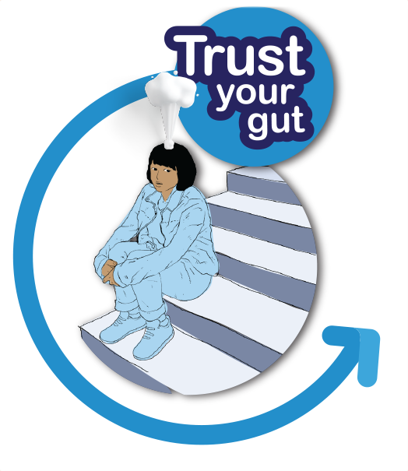1 | 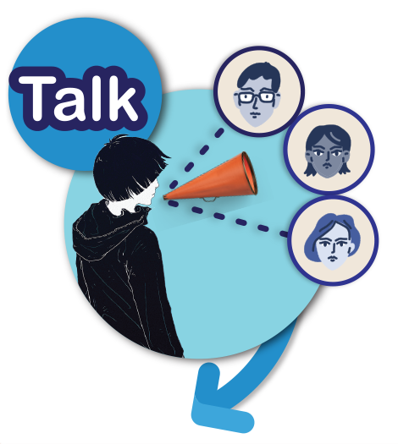2 | 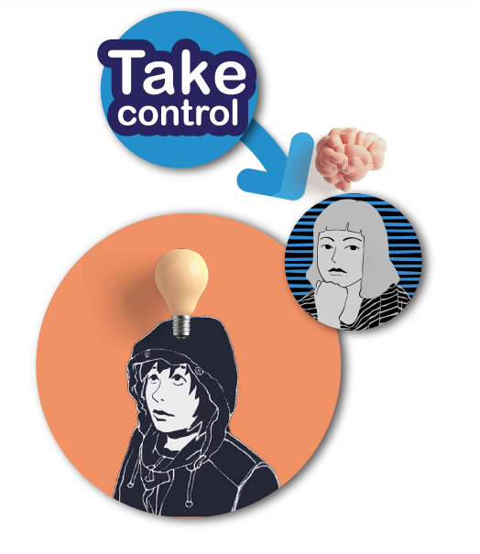3
- your feelings, thoughts and  - your reading of the situation | - talk about it to someone in your network | - by using your own plan  - become comfortable and safe.

The best course of action is the one that keeps us safe and
reduces our risk of being harmed.

How to put it into action:
- What’s my gut feeling?
- Who will I talk to?
If they aren’t available or aren’t helpful, who will I talk to next?
- My plan to become comfortable and safe is:
I know it will help me if I TRUST, TALK, TAKE CONTROL.

Trust your gut
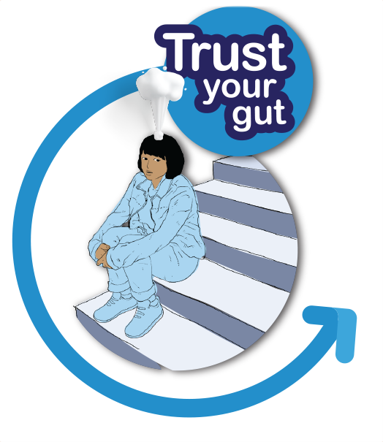1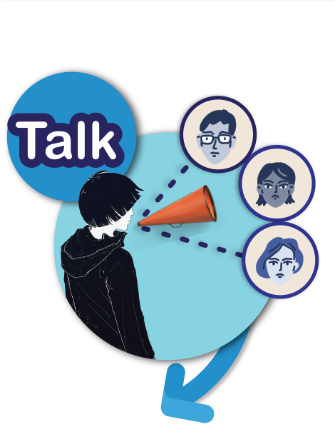2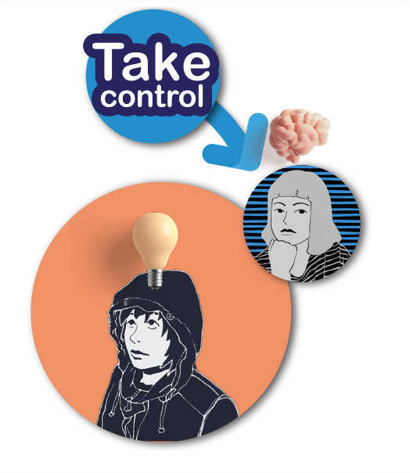3

Cards: Respectful relationships in an online continuum

Signs
Strongly
agree
Agree

Disagree
Strongly
disagree

Copyright register
1 Trust your gut girl: Image by Cdd20 from Pixabay.
2 Talk boy: Image by Cdd20 from Pixabay
3 Take control thinking girl and idea boy: Image by Cdd20 from Pixabay.

