Moving through food – Stage 4 and Life Skills
Duration: 5 lessons (50-60 minutes in length)

Educative purpose
Developing healthy eating habits from an early age is crucial for good health. The use of self-management skills such as self-reflection encourages students to plan and implement strategies to improve the health and wellbeing of themselves and others.
Students will critically inquire into healthy food choices by participating in a number of kinaesthetic learning activities. Kinaesthetic learning assists students to make connections between body movements (learn through doing) and the concept of healthy eating to improve their ability to retain, understand and recall information.
Students will explore the Australian dietary guidelines and reflect on how they can make healthier food choices that will benefit their long term health. Students will examine the contextual factors that influence food choices, proposing appropriate and realistic ways to improve eating and overall health.

Syllabus outcomes
A student:
PD4-6 Recognises how contextual factors influence attitudes and behaviours and propose strategies to enhance, health, safety and wellbeing and participation in physical activity
PD4-7 Investigates health practices, behaviours and resources to promote health, safety, wellbeing and physical activity communities

Life Skills outcomes
A student:
PDLS-7 Explores factors that enhance health, safety, wellbeing and participation in physical activity
PDLS-9 Engages with components of a healthy, safe and balanced lifestyle
All outcomes referred to in this unit come from PDHPE K-10 syllabus © NSW Education Standards Authority (NESA) for and on behalf of the Crown in right of the State of New South Wales, 2018.

Syllabus content
Key inquiry question | Syllabus content
How can I effectively manage my own and support others’ health, safety, wellbeing and participation in physical activity? | Students:  - plan and use health practices, behaviours and resources to enhance the health, safety, wellbeing and physical activity participation of their communities (ACPPS077)  - investigate different approaches and develop personal plans for promoting their own positive wellbeing, e.g. healthy eating
Why are connection, inclusion and empowerment important for the health, safety, wellbeing and physical activity levels of the wider community? | Students:  - examine influences on people’s behaviours, decisions and actions (ACPPS074)  - review the dietary patterns of young people in relation to the Australian Government dietary guidelines and advice for young people and discuss how contextual factors influence food choices and eating habits

Life Skills content
Life skills key inquiry question | Life skills syllabus content
How can we improve our overall health and wellbeing? | Students:  - recognise the relationship between diet, physical activity and health  - recognise foods in the different food groups that they should eat most, moderately and least in the context of their lifestyle  - select food from the different food groups to provide a balanced diet  - identify the properties of foods that contribute to personal health  - examine the elements of a nutritious and balanced diet  - make healthy choices when selecting foods in a range of situations  - identify factors that influence food choices, eg advertisements, peer pressure, culture

PDHPE skills
Skill domain | Skills | Evidence of learning
Self-management (S) | - self awareness  - reflective practice  - developing greater control and responsibility for our actions, feelings and behaviours | - Recognise that reflective practice plays an important role in being able to self-evaluate behaviours.  - Use data as a stimulus to reflect on their own eating habits and propose appropriate and realistic ways to improve them.  - Creates and modifies their food plate based on their knowledge of the Australian dietary guidelines.

Learning across the curriculum
General capability | Sub-element | Evidence of learning
Personal and social capability | - Develop reflective practice | - Predict the outcomes of personal and academic challenges by drawing on previous problem-solving and decision making strategies and feedback from peers and teachers (reflection time activity page 14)

Literacy opportunities

National Literacy Learning Progressions (NLLP)
Sub-element | Progression level | Progression indicators for a level
Understanding texts | UnT7 | Comprehension  - answers inferential questions  - identifies the main idea in a predictive text
Understanding texts | UnT8 | Comprehension  - identifies author’s perspective
Understanding texts | UnT9 | Comprehension  - builds meaning by actively linking ideas from a number of texts or a range of digital sources  - classifies ideas or information for a set task or purpose
Understanding texts | UnT10 | Comprehension  - analyses visual text to identify point of view

Numeracy opportunities

National Numeracy Learning Progressions (NNLP)
Sub-element | Progression level | Progression indicators for a level
Operating with percentages | OwP2 | Finding percentage as a part of a whole  - multiplies to calculate a percentage of an amount (finds 13% of 160)
Interpreting and representing data | IRD3 | Interpreting data scales  - interprets data displayed using a multi-unit scale, reading values between the marked units
Interpreting and representing data | IRD4 | Shape of data displays  - determines and calculates the most appropriate statistic to describe the data  - uses simple descriptive statistics (arithmetic mean or median) as measures to represent typical values of a distribution  - compares the usefulness of different representations of the same data

Assumed knowledge and understanding.
This learning sequence assumes that students have some understanding of:
- five food groups
- recommended daily servings
- essential nutrients
- the Australian guidelines for healthy eating
- dimensions of health and interrelatedness.

Differentiation or adjustments
Many of the activities throughout this learning sequence are suitable or can be easily adjusted to accommodate for students completing the Life Skills outcomes. The questioning throughout all activities can be modified to meet students’ specific learning needs. It is important to note that student need, strengths, goals, interests, prior learning and personal experiences should also be considered when programming.
Support with adjustments and how to individualise student learning can be found on the Disability, learning and support page – Adjustments to teaching and learning.
Considerations can be given to provide differentiation by accessing:
- strategies for differentiation on the teacher quality and accreditation web page
- HSC minimum standards resource - classroom ready teaching and learning activities resource
- differentiation adjustment tool strategies on the high potential and gifted education web page
- innovative differentiation which can be accessed on the School learning environments and change web page.

Learning activity description
Developing healthy eating habits from an early age is a necessary ingredient for good health and the prevention of illness and disease. As young people, being able to understand what healthy foods are to eat and why we should eat them, is important knowledge and understanding to have. However, being aware of your eating habits and the strategies to improve them allows you to make real change to ensure you maintain a healthy and active lifestyle. This then allows you to support others in their quest to be healthy and make good choices.
Self-reflection is key to self-awareness and a skill for life. Through self-reflection we are able to think about our behaviours, the thoughts we have that contribute to those behaviours and understand the feelings that were created. It allows us to think about the reasons that may lie behind what we do.
When focusing on food we often make decisions about what we eat to satisfy hunger, but rarely reflect about why we eat what we eat, and how that makes us feel. There are factors that influence our decisions around food. If we can acknowledge and highlight these contextual factors and self reflect, we can make changes and positive steps to improve our choices and habits around food.

Activity: Moving healthy food plate
Purpose: This activity is designed to gauge students’ prior knowledge. However, this activity can be repeated during, or at the end of a sequence of learning as a formative assessment strategy to determine student understanding. Picture cards of different foods or ingredients, props/play food or even real foods from student lunch boxes can be used to further enhance the kinaesthetic learning experience. Be aware of food allergies within the classroom before conducting this type of activity with real or play food.
Students will create a plate of food for a meal of their choice with other students in the class.
- Allocate each student a number of foods.
- Students walk around the classroom and attempt to join with other students to create a complete meal. For example – muesli with fresh fruit and yoghurt for breakfast.
- Students communicate and negotiate inclusions of food with peers to create their collective meal.
- Groups are to have consensus on proportions of the foods included.
Once their meal is formed, students work in this group, using the group meal reflection worksheet. Groups discuss and reflect on the following:
- Is our meal healthy? Why/why not?
- How do we know?
- What food groups are included/should be included?
- Does it comply with the Australian guide to healthy eating and recommended daily servings?
- What is positive about the foods you have chosen and what advice would you give to someone about why they should eat this?
- What other foods would you like to include and why?
Life skills adjustments: This activity supports students completing life skills content. Students will work collaboratively to select foods from the different food groups to provide a balanced diet. This assists with understanding, retention and recall due to a whole body experience (brain and body connection) to understand concepts. Depending on student need, adjustments to the group meal reflection worksheet may need to be made.
Teacher note: This activity is designed to gauge students’ prior knowledge of the Australian dietary guidelines for young people and concepts related to healthy eating, including the different food groups, recommended servings per day, essential nutrients and their role. Depending on students’ prior knowledge, revisiting these areas will provide greater clarity for future learning within this sequence.

Activity: Dietary patterns and healthy guidelines numeracy task and reflection
Purpose: The Australian guide to healthy eating is a food selection guide in the form of a plate, which visually represents the proportion of the five food groups, recommended for consumption each day. There are specific guidelines known as the Australian dietary guidelines which provide up to date advice about the amount and kinds of foods we should be eating for good health and wellbeing. There are specific guidelines for healthy eating for children.

Recap of the Australian dietary guidelines
Brainstorm the specific guidelines for healthy eating for children. What would be a government recommendation in relation to food, drinks and nutrients for to achieve and maintain good health?
As a class, read through the specific guidelines for healthy eating for children and discuss their importance. Were there any guidelines which the class did not come up with on their own? Why would these be a government focus? Discuss.
Students complete a think pair share activity using the following questions to initiate discussion.
- Why do you think the government has these suggested guidelines in place? What role does the government play in keeping people health, safe, well and active? Why would they focus on food choices?
- Am I currently adhering to most of the recommended guidelines? Which ones and why?
- Which guidelines could I improve on? Why do improvements need to be made? How can improvements be made? What do I need to do?

Using data to investigate and improve my own and others health
Explain to students that using data to gain an understanding of young people’s food choices is important. It allows us to measure and highlight habits, provide snapshots of current situations and have positive influence in setting goals and on our future decisions. It can be a starting point to self-reflection to hopefully make improvements in the way we eat.
Teacher note: The graphs for this activity have been taken from the Australian Institute of Health and Welfare (AIHW) - Nutrition across the life stages 2018 report. You may wish to use data that corresponds with the age of your students to ensure the activity is more authentic (such as the latest School Physical Activity and Nutrition Survey (SPANS). See within the AIHW document page 40 for 9-13 year olds and page 50 for 14-18 year olds.
A number of questions have been provided to assist in critical thinking and discussion. Depending on student ability, these can be modified and adjusted to suit the learning needs of your students.

Graphs
The following numeracy activity can be done as a kinaesthetic learning activity or done using the Dietary patterns of young people vs Australian dietary guidelines worksheet.
Teacher note: When interpreting graphs it is important to look at the title of the graph, title of each axis, scale of each axis and their increments/units and what they are representing. With your students be sure to unpack new words such as median/mean so they gain an understanding of the graph to be able to relate to their world. For example: Mean is the sum of the values divided by the number of values (average). This will support students in being able to reach the NNLP in particular IRD3 - Interprets data displayed using a multi-unit scale, reading values between the marked units.
Graph 1 Mean intake of food groups compared with the Australian dietary guidelines target, by sex, aged 12-13 years, 2011-2012.
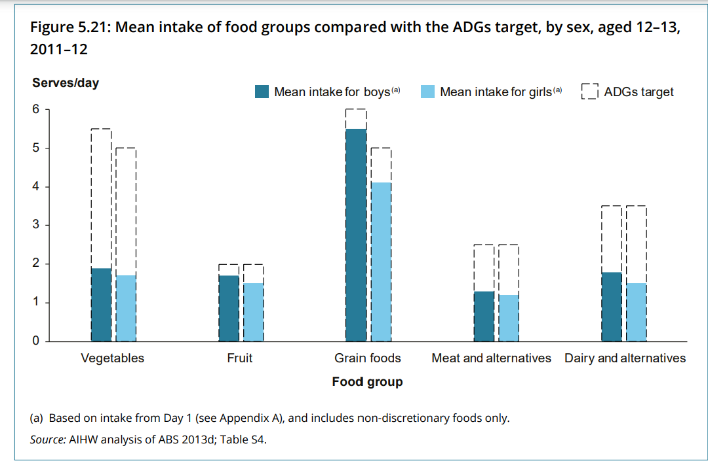
Graph 2 Proportion of the population with food group intakes below the recommended serves by sex, aged 12-13 years, 2011-2012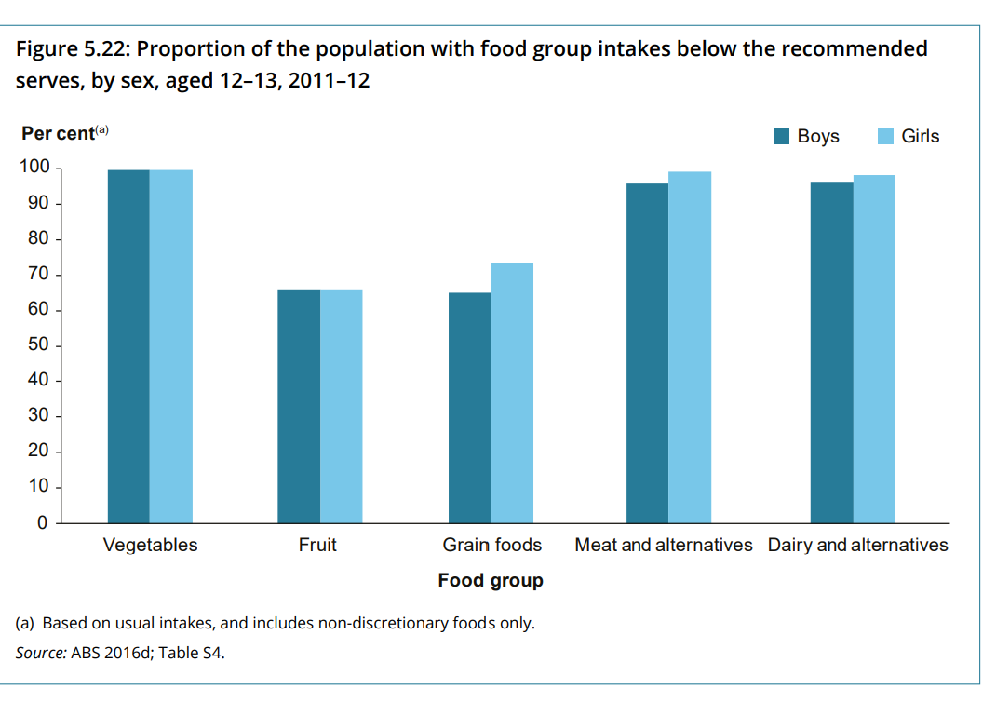

Task option 1: Kinaesthetic numeracy activity
Set up a graph scenario by having students physically represent aspects and numbers on the graphs. Picture cards of different foods or ingredients, props/play food or even real foods can be used to further enhance the kinaesthetic learning experience.
Life skills adjustments: The movement in this activity can support students completing life skills content. They are making connections between body movement (learn through doing) and the representation of the numbers within the graph in relation to their peers. This makes the numbers more relatable and relevant to them.

Graph 1
Nominate a food group and select the respective number of students that correlate to the recommended serves per day. For example, if choosing vegetables, six people should stand as this is the Australian dietary guidelines recommended serves per day for young people.
To represent vegetables in the graph, have two people remain standing and the remaining four sit. This shows that young people on average are eating two out of the six recommended daily serves of vegetables.
Complete for all the food groups in the graph. Use the questions on the Dietary patterns of young people vs Australian dietary guidelines worksheet to spark discussion. (NNLP – IRD3 and IRD4)

Graph 2
This could be done in groups of 10 for simplicity or as a whole class.
Nominate 10 students in the class to represent all of young people aged 12-13 who are featured in this study. Have all 10 students stand as this represents 100% (10% per student)
To represent a food group in the graph, for example fruit (60%) begin with all 10 students standing. Then have six students remain standing and the remaining four sit. This gives students a visual and feel as to how many are actually meeting the recommended serves and how many are not.
Repeat for each food group and use the questions on the Dietary patterns of young people vs Australian dietary guidelines worksheet to spark discussion. (NNLP - IRD3 and IRD4)
Extension: Depending on your classes’ ability, students may wish to convert the percentage of young people meeting the recommended serves in the graph to represent the proportional number of students in the class. This would require a number of mathematical calculations.
For example, pose the following question - If our class represented the population, how many students in this class would be meeting the recommended serves of fruit (60%). This would be 60% x number of students in your class.
Calculation example: From the graph we can see that 60% of students are below the recommended serves of fruit intake. If calculating based off 30 students in the class:
60% of 30 students
10% of 30 students = 3 students
60% of 30 students = 3 students x 6
= 18 students out of the 30 students are below the recommended serves.
Have 18 students stand in the class and the remaining sit. This shows the number below. To represent a more strengths based approach, flip the numbers and have 12 students stand and 18 sit. This then shows the proportion of students in the class meeting the recommended serves.
Teacher note: By doing these calculations, students see a visual representation in their classroom, which assists in understanding of the graph, engagement and learning. This also meets progression indicator from the National Numeracy Learning Progressions:
OwP2 - students can multiply to calculate a percentage of an amount as well as
IRD4 - students determine and calculate the most appropriate statistic to describe the data.

Task option 2: Dietary patterns of young people vs Australian dietary guidelines worksheet
Students are to work in pairs and complete the Dietary patterns of young people vs Australian dietary guidelines worksheet to review the graphs around young people and their eating habits.

Graph 1 Questions
Look at the title of the graph, what does this mean and predict what you think it will show us?
Now looking at the entire graph, what does this graph tell us? ((NNLP – IRD3)
- What is the same or different between boys and girls? Why do you think that is? (NNLP – IRD4)
- What do you think contributes to young people consuming less than the average daily serves for certain foods? How can this be changed or modified for self and other young people?
- How can this information support us in helping young people to make healthy food choices? For example, how much we spend on health, tell us what diseases are affecting more and are these disease preventable through healthy eating, e.g. diabetes?

Graph 2 Questions
Look at the title of the graph, what does this mean and predict what you think it will show us?
Now looking at the entire graph, what does this graph tell us? (NNLP – IRD3)
- What is the same or different between boys and girls? Why do you think that is? (NNLP – IRD4)
- Why do you think a large percentage of young people are below the recommended serves? What contributes to this?
- How can this data and other data support us in helping young people make healthy food choices?
- How can the messages in this graph empower you as an individual to change your food habits and behaviours to be more positive?
Students complete the graph self-reflection activity worksheet to reflect on their eating habits and formulate appropriate and realistic ways to improve them. (NLLP – UnT7)
Having completed these activities, and students develop an understanding of the dietary patterns of young people and Australian dietary guidelines, repeat the moving healthy food plate activity. Once their plate is created, combine with other healthy food plates in the class to create a suggested days’ worth of food for a young person. Include the three meals of the day and snacks.
- Would this combination meet the Australian dietary guidelines for the recommended daily servings? How and why?

Assessment opportunity
Students create a journal on their current eating habits. Students will compare their diet to the Australian dietary guidelines and assess how accurately their eating habits follow these guidelines. Students will:
- keep a food diary/ journal for a week listing everything they ate, drank and how much. This can be a written diary/ journal or using an online or mobile app to document food and drink choices.
- evaluate their eating habits by:
tallying up how many serves of each good group they consumed each day
  - comparing to the number of serves of each food group they should consume each day
  - identifying which groups they ate more serves than the recommended dietary intake and which they ate less.
- create a report to represent the findings of their evaluation in step 2. The report can be written, visual or verbal and should:
  - demonstrate how well they are currently following the recommendations of the Australian dietary guidelines with examples
  - discuss the differences noticed in their eating habits on weekdays compared to the weekends and reason for these differences
  - suggest changes they can make to their current eating habits and how they would make these changes.
  - provide an explanation as to what extent the suggested changes in their own eating habits could assist others.

Activity: Contextual factors
Purpose: Through this activity, students will unpack some of the contextual factors that influence food choices. This is a literacy activity whereby student will build meaning around contextual factors to understand how they can influence food choices. They will then reflect on their own habits and contextual factors that influence them and pose strategies to assist in making positive decisions regarding their eating.
Contextual factors
A range of factors existing in differing ways, with varying impacts on individual, group and community health, safety, wellbeing and participation in physical activity. Factors include, but are not limited to:
- individual – knowledge, skills, attitudes, beliefs, ability, sex, gender
- sociocultural – religion, parents/carers, family, media, culture, peers, language, politics
- socioeconomic – education, income, employment
- environmental – geographical location, access to health services.
Explain to students that there are a number of young people who regularly eat healthy food and who often meet the Australian dietary guidelines to healthy eating. There are several reasons as to why young people eat well and meet the guidelines. Contextual factors play a big part in impacting healthy food habits.
- Brainstorm all the things that influence our food choices.
- Students watch the video Raising children network: nutrition and eating well for teenagers (duration 2:21) or use the Food scenario worksheet provided. As they explore the text, students are to write down some of the factors that may have influenced young people to be healthy and make positive food choices. (NLLP – UnT7, UnT8 and UnT10)
Suggested answers:
  - Nutrition for teens - expectations of parents, boundaries around discretionary choices, what parents provide, education and prior experience impacting food choices, if parents are healthy then kids are healthy, developing knowledge and skills around cooking to understand good food, culture influences what people eat, for example vegetarian, knowledge of balanced lifestyle, environment access to garden to encourage healthy eating, social environment where certain foods are consumed.
  - Scenario - peer influence – normal to congregate after school, price of food, peer engagement and influence, location of shop is convenient, knowledge of impact of eating on health and ability to participate in physical activity.
- As a class, using the food scenario student and teacher copy. Reflect on and highlight the contextual factors that may have influence within this scenario. Consider which contextual factors John and Sarah have control of and which they do not have control of (barriers) for each situation. What can enable them to have better control around their habits?
- Students form pairs (student selected, or teacher directed) to share their thoughts around some of the factors that may influence young people’s food choices through the Raising children network: nutrition and eating well for teenagers clip and food scenario. Have each pair categorise these thoughts using the Contextual factors table worksheet into either individual, sociocultural, socioeconomic or environmental factors (NLLP - UnT9).
- In pairs students use the contextual factors table and pick two contextual factors from each category. For each they:
- give one example of how this factor can positively influence young people’s attitudes, values and behaviours around food choices. For example, peers/friends – peers can have a positive influence on our food choices. If deciding on lunch in a food court and peers are taking the healthy option, this often influences our decision to make a similar choice.
- give one example of how this factor can negatively influence young people’s attitudes, values and behaviours around food choices. For example, peers/friends – if friends regularly congregate at the local fast food restaurant which is opposite the school and buy chips every afternoon, you potentially may join them due to fear of missing out.
- Pairs join to make a group of four. Within their group, students discuss the following questions to help guide discussion.
  - How do contextual factors influence decisions?
  - Which contextual factor do you think has the greatest influence on young people? Why?
  - To what extent do young people have the power to make healthy food choices?
  - Do young people have control of all these contextual factors? Which ones if any do you believe young people can control? Why?
  - What are some of the more challenging influences and how can we take control of these? For example, enough income to buy healthy food.
  - What strategies could young people employ to gain greater control of some of these factors which influence their food choices? For example, providing healthier options at social events, choosing the healthier option on the menu.
- Invite groups to share their responses with the class. This can be done in a variety of ways, for example live discussion, presentation, infographic, podcast style interview with an “expert” from the group.

Reflection time
Purpose: To support students in their ability to address the Personal and social capability sub-element and develop reflective practice (learning across the curriculum content), students will now reflect on the food choices they make.
Students may wish to think about regular eating habits throughout the day or events they often attend. Students are to write down a particular aspect of their diet, providing detail of the following:
  - what part of the day/event does this take place? For example, breakfast, lunch, dinner, morning tea, a snack.
  - what are you doing when you eat it? For example, socialising with friends,
  - who if any are you eating it with?
  - why did you decide to eat this option?
  - what influenced your decision to eat that? Consider the influencing contextual factors.
- Students form pairs and discuss their food choices and the contextual factors that influenced their situation (provide opportunity for both to discuss). Students work together to reflect on their situations and develop enablers to improve food choices and eating habits.
- Students create a small scenario for their situation including some added details. Students are to write their scenario in the third person to ensure anonymity as this will be used for a continuum task to determine what the contextual factors are, and which factors students have control over and which ones they don’t.
  - For example - A Year 8 student who lives with their sister and mum. As their mum is working, they prepare their own lunch each day. They often include snacks and packaged foods such as rice crackers and rollups as it is convenient and easier to pack.
- Collect these scenarios to be distributed for the next continuum task.
Teacher note: For this task it is advised to create a number of additional scenarios to be added to the class. This again assures anonymity. Be sure to revisit class expectations around always supporting each other, respecting other’s cultural traditions, beliefs, values and languages, everyone has the right to offer an opinion.
You may wish for students to access a critical friend to peer review the scenario to ensure enough detail is provided and the scenario is appropriate.

Continuum task
- Explain to students that the continuum is based on the ability to be able to control the contextual factors that influence food choices.
- Using the continuum headings worksheet, place control and no control across the classroom to create a continuum.
- Give each student a scenario. For each they are to think about:
  - what are the contextual factors influencing this scenario?
  - do they have control over the contextual factors?
  - where would they stand on the continuum of control to no control and why?
- To stimulate discussion, choose someone on the continuum to read their scenario, highlight the contextual factors and justify why they have placed it there. Pose to the class to suggest some potential enablers to allow students to gain more control and move up the continuum to control their eating habits.

Activity: Self-reflection and personal planning to create change
To allow students to gain greater control and responsibility for their actions and behaviours around food habits, they will complete a number of self-reflection questions to assist in reflective practice.
Ask students to self reflect, by posing a number of questions.
  - What are some of the positive nutritional habits you have? For example, drink lots of water, eat from the five food groups in most meals, take the healthier option when given a choice and being more mindful when I eat.
  - When do you find you eat less healthy? For example, around friends, at parties, when others are, when I’m in a rush.
  - Why do you think that is?
  - Can the strategies you apply when you make healthy food choices be applied to adjust some of the poorer choices you make around eating?
  - What modifications can be made by you to change any poor choices?
  - What are you going to plan?
  - What will be the challenges? For example, some of the contextual factors.
  - What are some of the enablers to allow a better choice to be made?
- Students complete the Planning to create change table worksheet by identify three areas that they want to improve around their nutritional choices. For example, increase their daily water intake, eat more vegetables, ensure they have enough calcium in their diet and eat less discretionary choices.
- For each of the three areas students are to:
  - suggest the improvements that need to be made
  - highlight what they can do to create change.
- Students set a realistic goal to improve each of the identified nutritional changes to be made, highlighting time frames and evidence of success.

Resources

Group meal reflection
Compete the table of questions below by marking whether the areas mentioned were highly considered, considered or not considered in your group discussion in the creation of your group’s meal.
A: highly considered
B: considered
C: not considered
Group self-assessment criteria | A | B | C
Consideration of the five food groups
Consideration to limiting discretionary choices
Consideration of the recommended daily serves
Consideration of the nutrients found within the food
Alignment to the dietary guidelines

As a group, reflect on the following:
- Is our meal healthy?
- How do we know?
- What food groups are included/should be included?
- Does it comply with the Australian guide to healthy eating and recommended daily servings?
- What is positive about the foods you have chosen and what advice would you give to someone about why they should eat this?
- What other foods would you like to include and why?

Dietary patterns of young people vs Australian dietary guidelines
Interpret the graphs below and answer the questions that follow.
Graph 1 Mean intake of food groups compared with the Australian dietary guidelines target, by sex, aged 12-13 years, 2011-2012.
- Look at the title of the graph, what does this mean and predict what you think it will show us?
- Now looking at the entire graph, what does this graph tell us?
- What is same or different between boys and girls? Why do you think that is?
- What do you think contributes to young people consuming less than the average daily serves for certain foods? How can this be changed or modified for ourselves and other young people?
- How can this information support us in helping young people to make positive food choices? For example, how much we spend on health, tell us what diseases are affecting more and are these disease preventable through healthy eating, for example diabetes?
Graph 2 Proportion of the population with food group intakes below the recommended serves by sex, aged 12-13 years, 2011-2012Interpret the graphs below and answer the questions that follow.
- Look at the title of the graph, what does this mean and predict what you think it will show us?
- Now looking at the entire graph, what does this graph tell us?
- What is the difference between boys and girls? Why do you think that is?
- Why do you think a large percentage of young people are below the recommended serves? What contributes to this?
- How can this data and other data support us in helping young people make good food choices?
- How can the messages in this graph empower you as an individual to change your food habits and behaviours to be more positive?

Graph self-reflection activity
From the graphs and the questions just answered, self-reflect on your own eating habits.
- Do the graphs represent what you expected for young people and their eating habits for this age? Why or why not? Is there anything that was surprising?
- Do you feel these are a reflection of your eating habits?
- What things impact on your eating?
- What adjustments if any need to be made to your own eating habits or attitudes towards eating? Are these in your control?
- Many young people know they are not meeting the recommendations for healthy eating, but still continue with the habits they have? How can we support young people to improve their eating habits?
- What things would help improve your eating habits? To what extent do you think your suggestions would improve the eating habits other young people in the population?

Food scenario – teacher copy
John (14 years old) and his sister Sarah (13 years old) always go to the Fish ‘n’ Chips shop in the food court after school. It’s just down the road from the school and all John and Sarah’s friends hang out for a while. Some of the kids are older and many of them are popular. Most of them buy $4 worth of hot chips and a soft drink while they talk about the school day and what is happening on the weekend.
John usually buys $4 worth of chips for him and Sarah to share before they catch the four o’clock bus home which leaves just outside the Fish ‘n’ Chips shop. John and Sarah don’t usually go on Tuesdays because they have squad swimming training for 2 hours. All other trainings are morning sessions.
Teacher suggested points of discussion:
- Sociocultural – normal after school hang out, peer engagement and influence
- Socioeconomic – relatively cheap snack
- Environmental – location of shops is convenient
- Individual - knowledge of the impact of nutrition on performance, attitude to health eating.
Annotate the scenario by highlighting some of the contextual factors that may have influence on the characters.
- What contextual factors do John and Sarah have control of?
- Which do they not have control of (barriers) and why?
- What can enable them to have better control over their habits?
- What changes in behaviour can take place to ensure healthier food choices are made?

Food scenario – student copy
John (14 years old) and his sister Sarah (13 years old) always go to the fish ‘n’ chips shop in the food court after school. It’s just down the road from the school and all John and Sarah’s friends hang out for a while. Some of the kids are older and many of them are popular. Most of them buy $4 worth of hot chips and a soft drink while they talk about the school day and what is happening on the weekend.
John usually buys $4 worth of chips for him and Sarah to share before they catch the four o’clock bus home which leaves just outside the fish ‘n’ chips shop. John and Sarah don’t usually go on Tuesdays because they have squad swimming training for 2 hours. All other trainings are morning sessions.
Task
Annotate the scenario by highlighting some of the contextual factors that may have influence on the characters.
- What contextual factors do John and Sarah have control of?
- Which do they not have control of (barriers) and why?
- What can enable them to have better control over their habits?
- What changes in behaviour can take place to ensure healthier food choices are made?

Contextual factors table
Contextual factors are factors that exists which have varying impacts on people’s health and ability to make healthy decisions.
Factors include, but are not limited to:
- individual – knowledge, skills, attitudes, beliefs, ability, sex, gender
- sociocultural – religion, parents/carers, family, media, culture, peers, language, politics
- socioeconomic – education, income, employment
- environmental – geographical location, access to health services.

Activity –
- Categorise the factors identified from the Raising children network: nutrition and eating well for teenagers clip and food scenario, using the table below.
Individual | Sociocultural | Socioeconomic | Environment
- Choose two contextual factors from each column above. For each you are to:
- Give one example how this factor can positively influence young people’s attitudes, values and behaviours around food choices.
- Give one example how this factor can negatively influence young people’s attitudes, values and behaviours around food choices.

Continuum headings
Control

No control

Planning to create change
Current eating habit or nutritional choice | Improvements to be made | What can I do to create a change?

Goal and timeframe
Set a realistic goal to improve each of the identified nutritional changes to be made in column one of the above table. Highlight the time frames and evidence of success. The more detail the better to ensure greater success.
Goal to meet | Time frame | Evidence of change/success

