Year 8 invasion game – solving a tactical problem (invasion game)

Student peer assessment
Task – solving a tactical problem: Maintaining possession of the ball

Outcomes
This document references the PDHPE 7-10 Syllabus © 2003 Copyright Board of Studies NSW for and on behalf of the Crown in right of the State of New South Wales.

Knowledge and understanding outcomes
- 4.4 - Strand 2: Movement skill and performance
  - Demonstrates and refines movement skills in a range of contexts and environments

Skill outcomes
- 4.14 - Moving
  - Engages successfully in a wide range of movement situations that displays an understanding of how and why people move
- 4.12 - Decision-making
  - Assesses risk and social influences and reflects on personal experience to make informed decisions

Physical literacy continuum markers

Cluster 5

Aspect - Tactical movement (thinking in action)
- Applies multiple tactics appropriately to achieve success within a range of physical activities

Situation – selecting the correct attacking option based on the game situation
This is a 5 vs 5 game. You are on team O and your team has possession of the ball.
You are player O2 with the ball. Your teammates (O1, O3 and O4) are not in very good positions - you cannot pass to them because they are too close to or behind players in opposition team X.
Draw arrows on the field to show where your teammates can move to so that they give you more than one option to pass to, allowing your team to maintain possession and advance play or attack the goal.
Write a statement to explain your placements. Explain your decisions and player movements to show your understanding of the correct attacking option based on the situation.
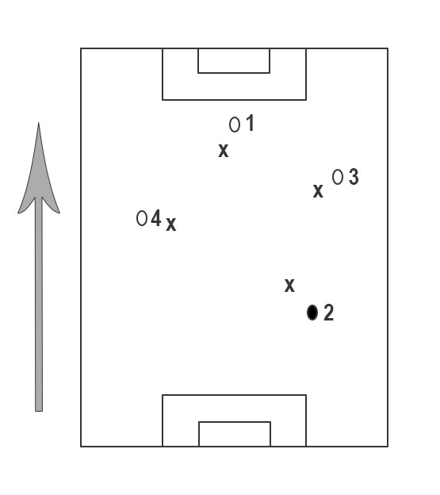
Signed:

