Kinaesthetic learning in PDHPE

Be the healthy food plate
This activity uses kinaesthetic learning by providing a hands on experience and immersion in the learning experience for students. It is focused on students feeling and experiencing what they are trying to learn.
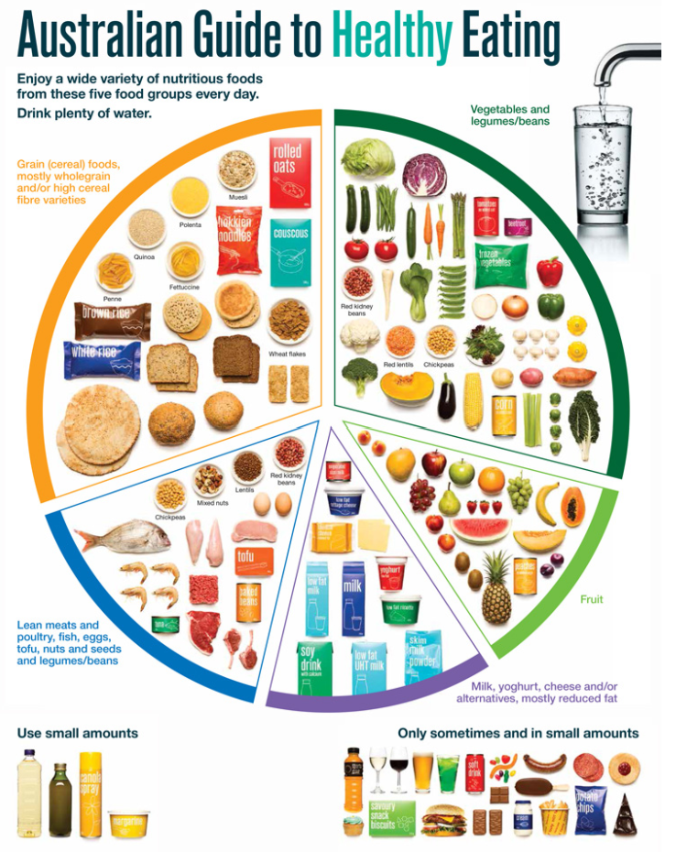

Educative purpose
This activity can be used to gauge students’ prior knowledge of concepts related to healthy eating. It is a great formative assessment strategy that allows students to demonstrate their knowledge of the different food groups, recommended servings per day, essential nutrients and their role as well as some prior knowledge surrounding the Australian dietary guidelines for young people. This activity can be repeated during, or at the end of a sequence to determine student understanding and to assist in where to next.
Note: Picture cards of different foods or ingredients, props/play food or even real foods from student lunch boxes can be used to further enhance the kinaesthetic learning experience. Be aware of food allergies within the classroom before conducting this type of activity with real food.

Outcomes and content

Outcomes
PD4-7 Investigates health practices, behaviours and resources to promote health, safety, wellbeing and physical activity communities
PDLS-9 Engages with components of a healthy, safe and balanced lifestyle

Syllabus content
Key inquiry question | Syllabus content
Why are connection, inclusion and empowerment important for the health, safety, wellbeing and physical activity levels of the wider community? | Students:  - Examine influences on people’s behaviours, decisions and actions (ACPPS074)  - Review the dietary patterns of young people in relation to the Australian Government dietary guidelines and advice for young people and discuss how contextual factors influence food choices and eating habits

Life Skills content
Life skills key inquiry question | Life skills syllabus content
How can we improve our overall health and wellbeing? | Students:  - recognise the relationship between diet, physical activity and health  - recognise foods in the different food groups that they should eat most, moderately and least in the context of their lifestyle  - select food from the different food groups to provide a balanced diet  - identify the properties of foods that contribute to personal health  - examine the elements of a nutritious and balanced diet  - make healthy choices when selecting foods in a range of situations
Note: Completing this activity in isolation will not meet all outcomes or content presented above. Teachers are to use their professional judgement to ensure outcomes are achieved. See the Moving through food teaching and learning sequence for further ideas.

Teaching and learning activity
Students are to create a life size human healthy food plate. They are to be an ingredient and will form with other ingredients (students) to create a plate of food for a meal of their choice.
- Allocate each student a number of foods.
- Students walk around the classroom and attempt to join with other students to create a complete meal. For example – muesli with fresh fruit and yoghurt for breakfast.
- Students communicate and negotiate inclusions of food with peers to create their collective meal.
- Groups are to have consensus on proportions of the foods included.
Once their meal is formed, students work in this group, using the group meal reflection worksheet. Groups discuss and reflect on the following questions.
- Is our meal healthy? Why/why not?
- How do we know?
- What food groups are included/should be included?
- Does it comply with the Australian guide to healthy eating and recommended daily servings?
- What is positive about the foods you have chosen and what advice would you give to someone about why they should eat this?
- What other foods would you like to include and why?
Combine with other healthy food plates in the class to create a suggested days’ worth of food for a young person. Include the three meals of the day and snacks.
- Would this combination meet the Australian dietary guidelines for the recommended daily servings? How and why?
Life skills adjustments: Through moving in this activity, students are able to work collaboratively with others to select foods from the different food groups to provide a balanced diet. This assists with understanding, retention and recall due to a whole body experience (brain and body connection) to understand concepts. Depending on student need, adjustments to the group meal reflection worksheet may need to take place.

Other opportunities
Be the graph - Using a graph from the Australian Institute of Health and Welfare (AIHW) - Nutrition across the life stages 2018 report, students as a class are to physically represent aspects and numbers on the graph. For example, if the graph chosen represents the mean intake of food groups compared with the Australian dietary guidelines target for 12-13 year olds and for vegetables it shows that 12-13 year olds are only eating two out of the six recommended servings per day of vegetables, have six students be involved in the activity and only two stand to represent this. Repeat for all food groups. Class discussion then takes place to assist in developing critical thinking skills.

Group meal reflection
Compete the table of questions below by marking whether the areas mentioned were highly considered, considered or not considered in your group discussion in the creation of your group’s meal.
- A: highly considered
- B: considered
- C: not considered
Group self-assessment criteria | A | B | C
Consideration of the five food groups
Consideration to limiting discretionary choices
Consideration of the recommended daily serves
Consideration of the nutrients found within the food
Alignment to the dietary guidelines
        - As a group, reflect on the following questions.
- Is our meal healthy?
- How do we know?
- What food groups are included/should be included?
- Does it comply with the Australian guide to healthy eating and recommended daily servings?
- What is positive about the foods you have chosen and what advice would you give to someone about why they should eat this?
- What other foods would you like to include and why?

