Kinaesthetic learning in PDHPE

Be the food graph
This activity uses kinaesthetic learning by providing a hands on experience and immersion in the learning experience for students. It is focused on students feeling and experiencing what they are trying to learn. This activity supports students to interpret graphs.
Graph 1: Mean intake of food groups compared with the Australian dietary guidelines target, by sex, aged 12-13 years, 2011-2012.
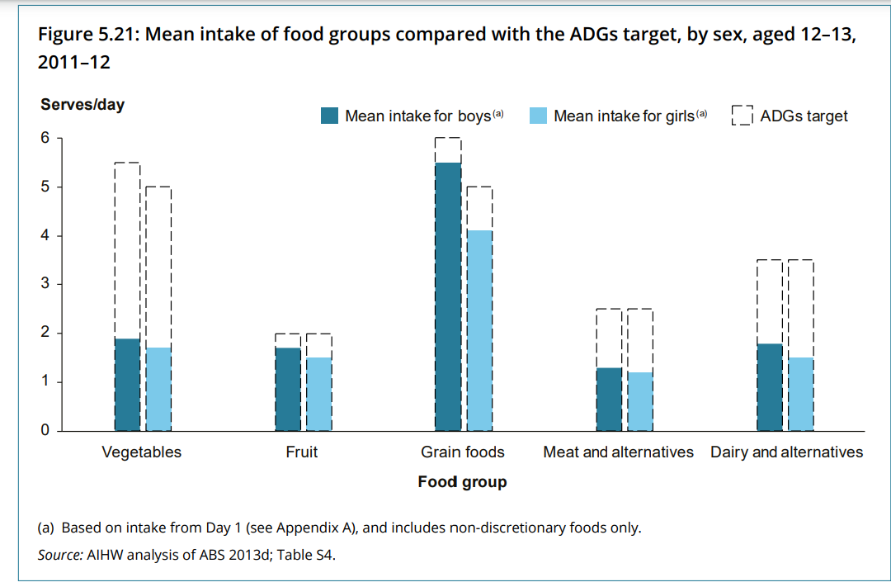
Source: Australian Institute of Health and Welfare (AIHW) - Nutrition across the life stages 2018 report.

Educative purpose
By exploring data within the graph through movement, the learning comes to life for students as they engage with the information within the vertical bar chart. This kinaesthetic movement activity provides a starting block for discussion and self-reflection as students develop their understanding of the features of graphs and what they mean.
Teacher note: Picture cards of different foods or ingredients, props/play food or real food from student lunch boxes can be used to further enhance the kinaesthetic learning experience. Be aware of food allergies within the classroom before conducting this type of activity with real food.

Syllabus outcomes and content

Outcomes
PD4-7 Investigates health practices, behaviours and resources to promote health, safety, wellbeing and physical activity communities
PDLS-9 Engages with components of a healthy, safe and balanced lifestyle

Syllabus content
Key inquiry question | Syllabus content
Why are connection, inclusion and empowerment important for the health, safety, wellbeing and physical activity levels of the wider community? | Students:  - Examine influences on people’s behaviours, decisions and actions (ACPPS074)  - Review the dietary patterns of young people in relation to the Australian Government dietary guidelines and advice for young people and discuss how contextual factors influence food choices and eating habits

Life Skills content
Key inquiry question | Syllabus content
How can we improve our overall health and wellbeing? | Students:  - recognise the relationship between diet, physical activity and health  - recognise foods in the different food groups that they should eat most, moderately and least in the context of their lifestyle  - select food from the different food groups to provide a balanced diet  - identify the properties of foods that contribute to personal health  - examine the elements of a nutritious and balanced diet  - make healthy choices when selecting foods in a range of situations
All outcomes referred to in this unit come from the PDHPE K-10 syllabus. © NSW Education Standards Authority (NESA) for and on behalf of the Crown in right of the State of New South Wales, 2018.
Note: Completing this activity in isolation will not meet all of the outcomes or content listed. Teachers are to use their professional judgement to ensure outcomes are achieved. Access the Moving through food teaching and learning sequence for further ideas.

Teaching and learning activity
Access a graph from a report such as the Australian Institute of Health and Welfare (AIHW) - Nutrition across the life stages 2018 report.
Students create a graph scenario by having students physically position themselves to represent aspects and numbers on the graphs.
Teacher note: When interpreting graphs, it is important to look at the title of the graph, title of each axis, scale of each axis, their increments/units and what they are representing. Drawing the axis on the floor with tape, using picture cards of different foods or ingredients, props/play food or even real foods can support students in their understanding of the graph and really enhance the kinaesthetic learning experience.

Graph 1
Before starting the graph activity, define and explain terminology such as median and mean to ensure students have an understanding to be able to relate to their learning.
Graph 1 Mean intake of food groups compared with the Australian dietary guidelines target, by sex, aged 12-13 years, 2011-2012.
Nominate a food group and select the respective number of students that correlate to the recommended serves per day. For example, if choosing vegetables, six people should stand as this is the Australian Dietary Guidelines (ADG) recommended serves per day for young people.
To represent the mean (average) intake compared with the ADG for vegetables in the graph, have two people remain standing and the remaining four sit. This shows that young people on average are eating two out of the six recommended daily serves of vegetables.
Complete for all the food groups in the graph. Use the questions on the Dietary patterns of young people vs Australian dietary guidelines worksheet to generate discussion.

Graph 2
Graph 2 Proportion of the population with food group intakes below the recommended serves by sex, aged 12-13 years, 2011-2012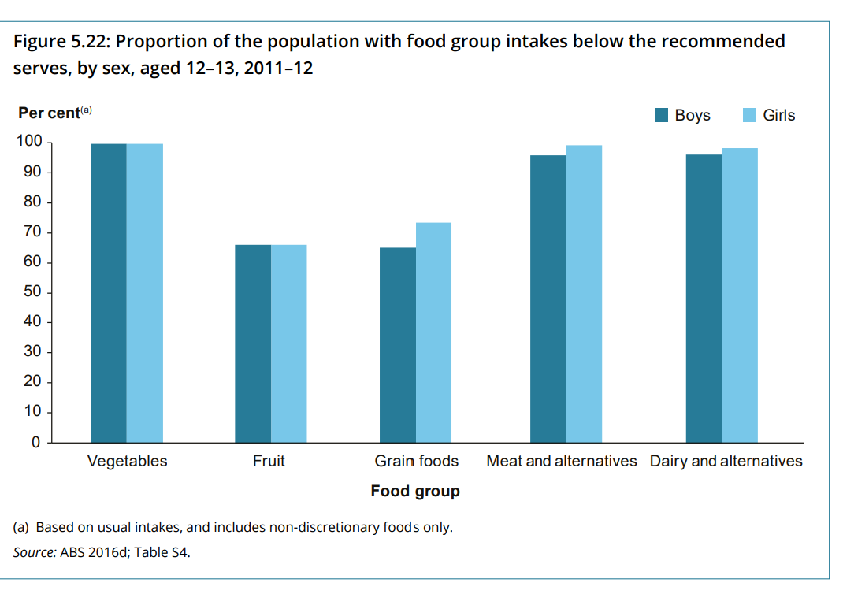
Kinaesthetic movement experiences linked to this graph could be completed in groups of 10 for simplicity or as a whole class.
Nominate 10 students in the class to represent young people aged 12-13 who are featured in this study. Have all 10 students stand, as this represents 100% (10% per student)
To represent a food group in the graph, for example fruit (approximately 60%) begin with all 10 students standing. Then have six students remain standing and the remaining four sit. This gives students a visual and feel as to how many are meeting the recommended daily serves for fruit and how many are not.
Repeat for each food group and use the questions on the Dietary patterns of young people vs Australian Dietary Guidelines worksheet to generate discussion.
After the activity, students self-reflect on their eating habits.
Extension: Depending on your classes’ ability, students may wish to convert the percentage of young people meeting the recommended serves in the graph to represent the proportional number of students in the class. This would require a number of mathematical calculations to be performed.
For example, pose the following question - If our class represented the population, how many students in this class would not be meeting the recommended serves of fruit (60%)? This would be 60% x number of students in your class.
Calculation example: From the graph we can see that 60% of students are below the recommended serves of fruit intake. If calculating based off 30 students in the class:
60% of 30 students
10% of 30 students = 3 students
60% of 30 students = 3 students x 6
= 18 students out of the 30 students are below the recommended serves.
Have 18 students stand in the class and the remaining students sit. Those 18 students standing show the number below the recommended daily serves for fruit. To represent a more strengths based approach, flip the numbers and have 12 students stand and 18 sit. This then shows the proportion of students in the class meeting the recommended serves.
Teacher note: By doing these calculations, students see a visual representation in their classroom, which assists in understanding of the graph, engagement and learning. This also meets progression indicator OwP2 (students can multiply to calculate a percentage of an amount) from the National Numeracy Learning Progressions.
Life skills adjustments: The movement in this activity can support students completing life skills content. They are making connections between body movement (learn through doing) and the representation of the numbers within the graph in relation to their peers. This makes the numbers more relatable and relevant to them.

Other opportunities
Moving healthy food plate- Students create a human size healthy plate of food. Each student is allocated different foods and walks around the room to join food with others to make a complete healthy meal. In the formation of their healthy food plate, students need to apply their knowledge of the different food groups, recommended servings per day, essential nutrients and their role in health, as well as some prior knowledge surrounding the Australian Dietary Guidelines for young people. This is a great formative assessment strategy and can be repeated during, or at the end of a sequence of learning to determine student understanding.

Dietary patterns of young people vs Australian Dietary Guidelines worksheet
Interpret the graphs below and answer the questions that follow.
Graph 1 Mean intake of food groups compared with the Australian dietary guidelines target, by sex, aged 12-13 years, 2011-2012.
- Look at the title of the vertical bar graph, what does this mean? Predict what you think it will show us?
- Now looking at the entire graph, what does this graph tell us?
- Compare the graphs for boys to the graph for girls. What is similar? What is different? Propose some reasons for the similarities and differences between boys and girls?
- What do you think contributes to young people eating less than the average daily serves for certain foods?
- How can this be changed or modified for ourselves and other young people?
- How can this information support us in helping young people to make positive food choices? For example, how much we spend on health, it can tell us what diseases are affecting more people and whether these diseases are preventable through healthy eating, for example diabetes.
Graph 2 Proportion of the population with food group intakes below the recommended serves by sex, aged 12-13 years, 2011-2012
Interpret the graphs below and answer the questions that follow.
- Look at the title of the vertical bar graph, what does this mean? Predict what you think it will show us?
- Now looking at the entire vertical bar graph, what does this graph tell us?
- Compare the data represented for both boys and girls. Why do you think that is?
- Why do you think a large percentage of young people are below the recommended serves? What contributes to this?
- How can this data and other data support us in helping young people make good food choices?
- How can the messages in this vertical bar graph empower you to change your food habits and behaviours to be more positive?

Graph self-reflection activity
From the graphs and the questions just answered, self-reflect on your eating habits.
- Do the vertical bar graphs represent what you expected for young people and their eating habits for this age? Why or why not? Is there anything that was surprising?
- To what extent, does the data in the vertical bar graphs reflect your eating habits?
- What factors impact your eating?
- What adjustments need to be made to your own eating habits or attitudes towards eating? Are these in your control?
- Many young people know they are not meeting the recommendations for healthy eating but continue with the habits they have. How can we support young people to improve their eating habits?
- What would help improve your eating habits? To what extent do you think your suggestions would improve the eating habits for other young people in the population?

