How can we solve problems when moving?
PDHPE Stage 3 student workbook
Name:
Class:

Overview of lessons 5 and 6
Students will:
- Refine and adapt kicking skills to cater for changing target game settings (lesson 5-6).
- Propose, explain and refine strategies to successfully complete a kicking challenge (lesson 5-6)
- Recognise and consider a number of solutions to target games and justify which solution is most appropriate or effective (lesson 6).
- Explain the rationale for particular rules, strategies and tactics (lesson 6).

Resources
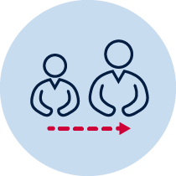
- help from an adult
- a soft ball/object to kick (for example, soft ball, pair of socks, soft toy, scrunched-up paper)
- 3 objects or landmarks to create targets or small goals for objects to hit or go through (for example, bucket, a long piece of string laid in a circle, an ‘X’ formed by two pieces of tape/material, a t-shirt laid on the ground, a chair/bench, a wall, a tree)
- 3 or more different unbreakable objects to act as an obstacle
- Refer to ‘Throlf’ game card for suggestions of what this activity could look like (Sport Australia, 2019. Playing for life)

Lesson 5 – Obstacle kicking golf - introduction
  - 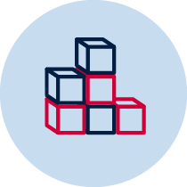 Create 3 targets or small goals that you can safely kick a soft ball/object towards. Choose a ‘starting point’ where you will kick the ball/object from. Place each target/goal at different distances from the ’starting point’.
  - Choose or create at least one object that will act as an obstacle. The obstacle needs to be placed between the ’starting point’ and the target.
Table 1 – Obstacle kicking golf examples
Obstacle golf examples
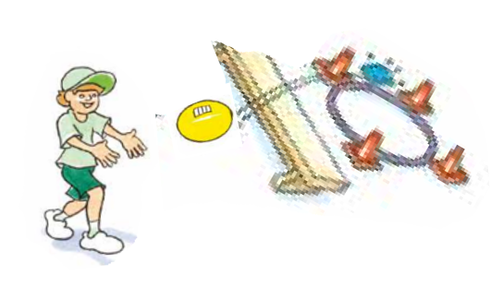  Sport Australia 2019, Playing for life | 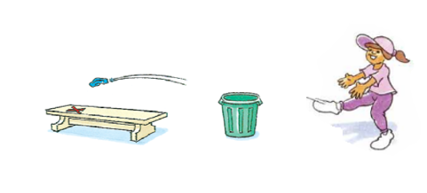 | 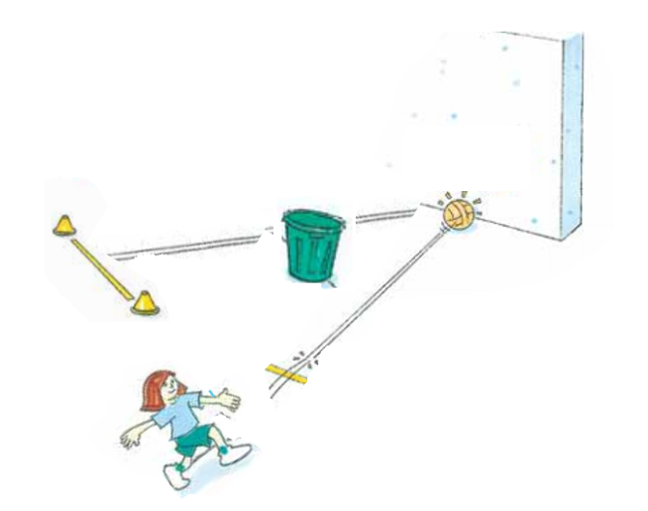

  - In previous lessons you have used a variety of throws to complete movement challenges. You will now start to use and adapt kicking skills to complete movement challenges.
Discuss with your teacher or parent/caregiver
- the type/s of throws you have used in previous weeks and when each one was most suitable
- what knowledge or skills related to throwing could you transfer to kicking challenges? For example, the best type of throw to send the ball a large distance was… The best type of throw to get the ball to travel high, drop quickly and only roll a small distance was … Therefore, the best type of kick to use would be…
- what types of kick could you use to hit the target or score a goal? Examples include a kick off the ground, a kick from a tee and a kick from your hands (also known as a punt) and your own kicking style.
  - Predict which type of kick you think will be most effective for each target. Explain your decision for each target/goal.

Target 1 -______________________________________________________________________________________________________________________________________________________________________________________________________________
Target 2 -______________________________________________________________________________________________________________________________________________________________________________________________________________
Target 3 -______________________________________________________________________________________________________________________________________________________________________________________________________________
  - Play ‘Obstacle kicking golf – intro’. Kick the ball/object towards the target/goal. You should aim to hit the target/score a goal. Pick up the ball/object from where it landed and kick it again until the target is hit or a goal is scored.
  - Repeat the challenge 5 times for each of the 3 targets
  - Record how many kicks it took to hit the target/score a goal.
Table 2 Obstacle golf intro
How many kicks did you it take to hit the target? | Attempt 1 | Attempt 2 | Attempt 3 | Attempt 4 | Attempt 5
Target 1
Target 2
Target 3

  - Reflect upon your performances in the game.
Explain how you propose to refine your kicking technique and the strategy you used during the game of ’Obstacle kicking golf’ to be more effective. Consider
- the type of kick you use
- the proposed path of the ball/object
- the amount of force used to kick the ball/object accurately
Explain your answer.
Target 1 -______________________________________________________________________________________________________________________________________________________________________________________________________________
Target 2 -______________________________________________________________________________________________________________________________________________________________________________________________________________
Target 3 -______________________________________________________________________________________________________________________________________________________________________________________________________________
  - Play the game of ‘Obstacle kicking golf again’ and apply your proposed changes to your kicking technique and strategy.
Repeat the challenge 5 times for each of the 3 targets
  - Record how many kicks it took to hit the target/score a goal.
Table 3 Obstacle kicking golf intro
How many kicks did you it take to hit the target? | Attempt 1 | Attempt 2 | Attempt 3 | Attempt 4 | Attempt 5
Target 1
Target 2
Target 3
  - How did you refine your kicking during the game of ’Obstacle kicking golf’? Was this effective? Explain your answer.

Target 1 -______________________________________________________________________________________________________________________________________________________________________________________________________________
Target 2 -______________________________________________________________________________________________________________________________________________________________________________________________________________
Target 3 -______________________________________________________________________________________________________________________________________________________________________________________________________________

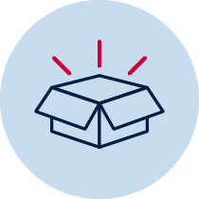 Resources
- A soft object to throw (for example, soft ball, pair of socks, soft toy, scrunched-up paper).
- 3 objects or landmarks to create a target for the object to hit (for example, bucket, a long piece of string laid in a circle, an ‘X’ formed by two pieces of tape/material, a t-shirt laid on the ground, a chair/bench, a wall, a tree).
- 3 or more different unbreakable safe objects to act as an obstacle.
Lesson 6 – Obstacle kicking golf - advanced
  - Create 3 targets or small goals that you can safely kick a soft ball/object towards. Choose a ‘starting point’ where you will kick the ball/object from. Place each target/goal at different distances from the ’starting point’.
  - Choose or create at least one object that will act as an obstacle. The obstacle needs to be placed between the ’starting point’ and the target.
Table 4 – Obstacle kicking golf examples
Obstacle kicking golf examples
Sport Australia 2019, Playing for life
  - Reflect upon your performances in the previous lesson where you played ‘Obstacle kicking golf – intro’.
Discuss with your teacher or parent/caregiver your strengths when playing obstacle golf. For example, ”I am very consistent when kicking the ball on the ground” or ”I am very good at kicking the ball from my hands so I can kick the ball high over the obstacle” or ”I am very good at rebounding the ball off the wall to avoid the obstacle.”

  - Explain what you have identified as your strengths while playing ’Obstacle kicking golf’.
______________________________________________________________________________________________________________________________________________________________________________________________________________

  - Create or change at least one rule that will challenge your strength.

For example
- your first kick must be with the ball on the ground as you find it harder to kick this as far as a kick from your hands, or
- you must use a kick on the ground when you’re within 5 steps of the obstacle. This makes it harder to kick the ball over the obstacle compared to a kick off a tee or from your hand.

Explain the rule you have created or changed.
______________________________________________________________________________________________________________________________________________________________________________________________________________

  - Create a different scoring system.

For example,
- The amount of kicks you record for each attempt is halved if you kick with your non-dominant foot
- The amount of kicks you record for each attempt is doubled if you use object 1 as opposed to object 2.
Remember:
- in obstacle golf, the fewer the kicks used the better.
- your dominant foot is the one you prefer to use when kicking. Non-dominant foot is the other foot.

Explain your new scoring system and how points are scored for easier and more difficult challenges.
______________________________________________________________________________________________________________________________________________________________________________________________________________

  - Play ‘Obstacle kicking golf – advanced’. Kick the ball/object towards the target/goal. You should aim to hit the target or score a goal. Pick up the ball/object from where it landed and kick it again until the target is hit or a goal is scored.
Repeat the challenge 5 times for each of the 3 targets
  - Record how many kicks it took to hit the target/score a goal.
Table 5 Obstacle kicking golf - advanced
How many kicks did you it take to hit the target? | Attempt 1 | Attempt 2 | Attempt 3 | Attempt 4 | Attempt 5
Target 1
Target 2
Target 3
6.9 Reflect upon your performances in the game of ‘Obstacle kicking golf – advanced’.
Explain how you propose to
adjust the rules that challenge your strengths (if necessary)
- adjust the scoring system to challenge your strengths (if necessary)
- refine your kicking technique and the strategy to be more effective. Consider the type of kick you use, the proposed path of the ball/object, the amount of force used to kick the ball/object and how you adjust this. Explain your answer.
__________________________________________________________________________________________________________________________________________________________________________________________________________________

6.10Play ‘Obstacle kicking golf – advanced’ again.
Repeat the challenge 5 times for each of the 3 targets
6.11 Record how many kicks it took to hit the target/score a goal.
Table 6 Obstacle kicking golf - advanced
How many kicks did you it take to hit the target? | Attempt 1 | Attempt 2 | Attempt 3 | Attempt 4 | Attempt 5
Target 1
Target 2
Target 3

  - How did you refine your kicking during the game of ’Obstacle kicking golf’ to effectively use the new rules and scoring system? Was this effective? Explain your answer.

Target 1 -______________________________________________________________________________________________________________________________________________________________________________________________________________
Target 2 -______________________________________________________________________________________________________________________________________________________________________________________________________________
Target 3 -______________________________________________________________________________________________________________________________________________________________________________________________________________
Resources
- A soft object to throw (for example, soft ball, pair of socks, soft toy, scrunched-up paper).
- 3 objects or landmarks to create a target for the object to hit (for example, bucket, a long piece of string laid in a circle, an ‘X’ formed by two pieces of tape/material, a t-shirt laid on the ground, a chair/bench, a wall, a tree).
- 3 or more different unbreakable objects to act as an obstacle.

