How is technology impacting on our health, safety and wellbeing?

– Stage 3
PDHPE unit.
Duration – 9 weeks

Table of contents
Big idea and key concept 1
Essential question 1
Unit description 1
Contextual statement 1
Propositions in action 2
Lesson 1 – Our technology 3
Key Inquiry Questions and syllabus content 3
Teaching and learning activities 4
Lesson 2 – Sharing information 6
Key Inquiry Questions and syllabus content 6
Teaching and learning activities 7
Lesson 3 – Respect 10
Key Inquiry Questions and syllabus content 11
Teaching and learning activities 11
Lesson 4 – Safe and unsafe use of technology 14
Key Inquiry Questions and syllabus content 14
Teaching and learning activities 15
Lesson 5 – Managing online behaviour 18
Key Inquiry Questions and syllabus content 18
Teaching and learning activities 20
Lesson 6 – Being a bystander 23
Key Inquiry Questions and syllabus content 24
Teaching and learning activities 25
Lesson 7 – Managing our own mental and physical health 28
Key Inquiry Questions and syllabus content 28
Teaching and learning activities 29
Lesson 8 – Guidelines for physical activity and screen time 32
Key Inquiry Questions and syllabus content 33
Teaching and learning activities 34
Lesson 9 – Technology and physical activity 36
Key Inquiry Questions and syllabus content 36
Teaching and learning activities 38
Unit evaluation 40
Glossary 41
Assessment framework 44
Appendix 1 – How does technology impact on our health, safety and wellbeing? 47
Appendix 2 – Device use 48
Appendix 3 – Concept map 49
Appendix 4a – Y chart – Respect example 49
Appendix 4b – Y chart – Respect template 50
Appendix 5 – Do’s and Don’ts of online usage 51
Appendix 6 – Y chart – Bullying template 52
Appendix 7a – 5 whys – Teacher example 52
Appendix 7b – 5 whys – student template 53
Appendix 8a – Strategies for positive mental health – teacher example 53
Appendix 8b – Strategies for positive mental health – student template 54
Appendix 9 – Daily guidelines journal 55

Outcomes and other syllabus material in this document are copyright.
PDHPE K-10 Syllabus © NSW Education Standards Authority (NESA) for and on behalf of the Crown in right of the State of New South Wales 2018.
© State of New South Wales (Department of Education), 2021

Big idea and key concept
Unit title: ‘Technology impacts our health, safety and wellbeing’.
The big idea is the over-arching concept that is being addressed or challenged throughout the unit. For example, ‘risk-taking is healthy’.

Essential question
This question drives both teaching and learning within the unit. Every activity should be working towards answering this question, ‘How is technology impacting on our health, safety and wellbeing?’

Unit description
Students investigate how technology impacts their health, safety and wellbeing. Using this information students will be empowered to make personal choices about how they use technology in their daily lives. They will reflect on their use of technology and develop strategies to seek help when needed.

Contextual statement
The increasing presence of technology in students’ lives continues to have an impact on their health, safety and wellbeing. There has been a marked increase in the amount of their screen time through the wider use of various devices and digital platforms. Statistics indicate a significant increase in the number of students who own a device with many owning multiple devices. This trend has implications for students’ levels of physical activity and issues relating to online safety. Developing students’ skills and understanding of the benefits of physical activity in maintaining mental and physical health, balanced with the recommended amount of recreational screen time, is essential. Providing students with an understanding of their digital footprint, appropriate cybersafety strategies and support networks, positively contributes to the development of safe and respectful online behaviour.

Propositions in action
This describes how specific propositions are embedded throughout the unit of work. The 5 propositions are outlined on pages 24-25 of the PDHPE K-10 syllabus.
Propositions
Describe how specific propositions are embedded throughout the unit of work. The 5 propositions are outlined on pages 24-25 of the PDHPE K-10 syllabus.
Focus on educative purpose
Students develop, practise, apply and evaluate the knowledge, understanding and skills that support a healthy, safe and active lifestyle.
Take a strengths-based approach
Students build upon their understanding of safe and respectful offline behaviour and transfer into online environments. They analyse influences on their decision-making and available resources to plan ways they can meet the ‘Guidelines for healthy growth and development for children and young people (5 to 17 years)’.
Critical inquiry approach
Students recognise and analyse the influences on their understanding of safe and respectful online behaviour in addition to resources that support them to be physically active.
Value movement
Students develop an understanding of how movement can positively impact their health, safety and wellbeing.
Developing health literacy
Students develop the knowledge, understanding and skills to access health information and services which promote positive health, safety participation in physical activity.

Skills in focus
What specific skills are being learned, developed and applied throughout this unit of work? Refer to pages 27-30 of the PDHPE K-10 syllabus.
Self-management skills (S)
- Strengthening personal identity
  - Self-evaluation
- Self-awareness
  - Developing greater control and responsibility for our actions, feelings and behaviours
  - Reflective practice
- Emotion and stress management
  - Recognising emotions
- Decision-making and problem-solving
  - Information-gathering
  - Finding solutions to problems
  - Analysis
  - Goal-setting and tracking
- Help-seeking
  - Recognising when help is needed
  - Goal setting and tracking
Interpersonal skills (I)
- Communication
  - Verbal and nonverbal communication
  - Expressing feelings
  - Assertiveness
- Empathy building
  - Understanding of others’ views
  - Understanding of others’ needs and circumstances
- Social awareness
  - Perspective forming
  - Perspective taking

Lesson 1 – Our technology
Lesson 1 – Assessment framework
Outcome | Unit learning goals  Students are learning to | Evidence of learning  Students can
PD3-6 – distinguishes contextual factors that influence health, safety, wellbeing and participation in physical activity which are controllable and uncontrollable | Identify and explain different factors which impact on your health, safety and wellbeing. | - Explain how technology impacts on our health, safety and wellbeing (Activity 1, 2, Reflection activity).  - Analyse factors that affect what resources people access to be physically active and how they manage their screen time (Activity 2).

Key inquiry questions and syllabus content
How do empathy, inclusion and respect have an impact on myself and others?
- Practise skills to establish and manage relationships, for example:
  - Describe actions that support caring and respectful relationships.
  - Plan for responsible and respectful use of mobile devices and social media in relationships.
How does a healthy, safe and active lifestyle enhance connection with others?
- Explore how media and people in the community influence personal attitudes, beliefs, decisions and behaviours, for example:
  - Explain how family, peers, popular culture and the media influence the way individuals interact and the decisions they make in given situations, for example, risk-taking, positive health decisions, offensive online material, gambling, gender expectations.

Teaching and learning activities
A detailed description of the teaching and learning strategies that the teacher will provide for students to learn, develop and apply knowledge, understanding and skills.
What evidence is the teacher looking to observe or collect of student learning? This is a direct alignment of ‘evidence of learning’ with the teaching and learning activity’.
Resources
- Appendix 1 – How does technology impact on our health, safety and wellbeing?
- Appendix 2 – Device use
Vocabulary
Technology, health, safety, wellbeing, devices.

Activity 1
Introduce the unit of learning to students by asking them to respond to the question ‘How is technology impacting my health, safety and wellbeing?’
Using appendix 1 – how does technology impact on our health, safety and wellbeing?, students identify the positive and negative impacts technology has on our daily lives. In addition, they list points they think will be interesting to explore further.
Share and discuss responses and respond to the following questions:
- What do you notice about your responses? Does one column have a significant amount more than another column?
- Do you have similar points to your peers? Why do you think this may be?
- Are there any points that appear in different columns?
Explain to students that they will explore how technology impacts our health, safety and wellbeing in both positive and negative ways. This PMI chart can be referred to and/or added to at any stage.

Activity 2
Using appendix 2 – device use, brainstorm and record answers to the questions provided. Alternatively, students may record their responses as an illustration, recorded verbal response or written response.
Teacher notes
Using the information generated by students, create a simple graph (bar, column, pie) to represent results. Collation of results will need to occur as a class. Graphs can be collaboratively generated as a class or by students. For each of the questions addressed, categorise responses to support students in identifying trends in usage. For example:
- What devices do you use to be online? Personal phone, parent/sibling phone, personal tablet, shared tablet, personal or shared PC/laptop.
- How do you use the device? For example, to complete homework, to communicate/socialise with other people, to find information, to play games.
- Why do you use this device? I have to use it to complete my homework, it is an efficient way to complete work, I enjoy using it to communicate with others, it is fun, I use it when I am bored.
- How often do you use the device for its intended purpose? Depending on usage time, collaboratively assign time periods. For example, zero time, 1-2 hours per day, 3-4 hours per day, 5-6 hours per day, 1-2 hours per week.
- Ask students ‘What do you notice?’ Discuss student observations.
- Split the data into males and females and compare the differences. Again, ask students ‘What do you notice?’ and discuss.
Teacher notes
If there is a disparity between genders, investigate why this may be and for those with low usage, what behaviours are in place of technology use.
Ask students to revisit their appendix 1 - how does technology impact on our health, safety and wellbeing? and add any points they think is appropriate.

Reflection
Students reflect upon the learning in this activity/lesson and consider how it contributes towards answering the essential question, ‘How is technology impacting our health, safety and wellbeing?’

Lesson 2 – Sharing information
Lesson 2 – Assessment framework
Outcome | Unit learning goals  Students are learning to | Evidence of learning  Students can
PD3-6 – distinguishes contextual factors that influence health, safety, wellbeing and participation in physical activity which are controllable and uncontrollable | Identify and explain different factors which impact on your health, safety and wellbeing. | Explain how technology impacts on our health, safety and wellbeing (reflection activity).
PD3-7 – proposes and implements actions and protective strategies that promote health, safety, wellbeing and physically active spaces | Suggest and implement strategies to promote health, safety and wellbeing for themselves and others. | Identify and explain safe and unsafe behaviours in online environments. (Lesson 2 – Activity 1, 2, 3).

Key inquiry questions and syllabus content
How do empathy, inclusion and respect have an impact on myself and others?
- Examine the influence of emotional responses on behaviour and relationships, for example:
  - Explore scenarios to identify behaviours which make a scenario safe or unsafe, for example, warning signs, secrets, threats, bribes, violence.
- Practise skills to establish and manage relationships, for example:
  - Plan for responsible and respectful use of mobile devices and social media in relationships.
What actions positively influence the health, safety and wellbeing of my community?
- Investigate and adopt practices that help promote and maintain health, safety, and wellbeing, for example:
  - Plan for personal safety online and ethical use of mobile devices and social media.
- Plan and practise assertive responses, behaviours and actions that protect and promote health, safety and wellbeing, for example:
  - Recognise and demonstrate safe behaviours and actions, for example, developing a personal safety plan, not getting into cars with strangers
How does a healthy, safe and active lifestyle enhance connection with others?
- Explore how media and people in the community influence personal attitudes, beliefs, decisions and behaviours, for example:
  - Explain how family, peers, popular culture and the media influence the way individuals interact and the decisions they make in given situations, for example, risk-taking, positive health decisions, offensive online material, gambling, gender expectations.

Teaching and learning activities
Resources
- eSafety Commissioner video – Cybersmart Forever –5:00 min
- Appendix 3 - Concept map
Vocabulary
Sharing, information, pictures (pics), images, online, offline, digital footprint
Discussion
Students share what device/s they have used since the previous lesson, observing what the main reason for this use was.

Activity 1
Watch Cybersmart Forever –5:00 min. Pause the video at the appropriate time to discuss the questions provided.
- If you were in my shoes, what would you do? This question encourages discussion about:
- Peer pressure
- Parent rules/ telling the truth
- Do you know anyone that has added people to their accounts that they didn’t know personally? What happened? This question encourages discussion about:
- Dangers/risks of friending strangers online
- When something is shared online, is there a way of deleting it? This question encourages discussion about:
- Reflecting before posting personal information, including pics, online
- Who owns our content once it’s posted online?

Activity 2
Individually or in small groups, students create a concept map. Refer to appendix 3 – concept map for an example. The centre bubble is themselves, for each response to the first question, create a bubble that branches off the centre bubble.
For each following question, the answers branch off the previous question:
- Who posts information about them online? For example, themselves, parents, siblings, other family members, friends, other adults such as friends’ parents or sporting coaches, teachers.
- What type of information do they post? For example, photos, whereabouts (holidays/ sporting activity/ school event), achievements, memories.
- Why do they post this information? For example, show others, show they are proud, rekindle memories, to communicate life events.

Activity 3
In pairs, create a list of what information allows students to be identified when online. This could include full name, date of birth, address, phone numbers, school, email address, username and password, bank details and/or photographs.
Students consider the questions:
- What personal information would you share online?
- Who would you share your personal information with online?
- Who would you not share your personal information with online?
- eSafety kids – How can I protect my personal information?
Teacher notes
To explore how some people willingly share information online differently to offline, ask students to identify:
- what information they share with people offline (in person)?
- who do they share this information with?
- why do they share this information?
- when they share this information, can other people access it?
- differences in how they share information? What problems may this cause?
Reflection
Students reflect upon the learning in this activity/lesson and consider how it contributes towards answering the essential question, ‘How is technology impacting our health, safety and wellbeing?’

Lesson 3 – Respect
Lesson 3 – Assessment framework
Outcome | Unit learning goals  Students are learning to | Evidence of learning  Students can
PD3-3 – evaluates the impact of empathy, inclusion and respect on themselves and others | Explain how interactions can impact on themselves and others. | Recognise and practise respectful behaviour in online environments (lesson 3 – activity 1, 2).
PD3-6 – distinguishes contextual factors that influence health, safety, wellbeing and participation in physical activity which are controllable and uncontrollable | Identify and explain different factors which impact on your health, safety and wellbeing. | - Explain how technology impacts on our health, safety and wellbeing (reflection activity).  - Explain how emotions can influence the way people respond online (activity 1).  - Explain how different perspectives and experiences can influence what we view as safe and/or respectful (activity 1, 2).
PD3-7 – proposes and implements actions and protective strategies that promote health, safety, wellbeing and physically active spaces | Suggest and implement strategies to promote health, safety and wellbeing for themselves and others. | Recognise and practise safe and respectful behaviours in an online environment (Activity 1, 2).
PD3-10 – selects and uses interpersonal skills to interact respectfully with others to promote inclusion and build connections | Use interpersonal skills to interact respectfully in online environments. | Understand factors that influence people’s perspectives about health, safety and wellbeing. (Activity 1).

Key inquiry questions and syllabus content
How do empathy, inclusion and respect have an impact on myself and others?
- Practise skills to establish and manage relationships, for example:
  - Describe actions that support caring and respectful relationships.
  - Plan for responsible and respectful use of mobile devices and social media in relationships.
What actions positively influence the health, safety and wellbeing of my community?
- Investigate and adopt practices that help promote and maintain health, safety, and wellbeing, for example:
  - Plan for personal safety online and ethical use of mobile devices and social media.
How does a healthy, safe and active lifestyle enhance connection with others?
- Explore how media and people in the community influence personal attitudes, beliefs, decisions and behaviours, for example:
  - Explain how family, peers, popular culture and the media influence the way individuals interact and the decisions they make in given situations, for example, risk-taking, positive health decisions, offensive online material, gambling, gender expectations.

Teaching and learning activities
Resources
- Appendix 4b – Y chart – Respect template
- Appendix 2 – Device use
Vocabulary
Respect, feelings, digital citizen.

Activity 1
Explore the question, ‘What does respect mean?’
- In pairs/small groups, students use appendix 4b – Y chart – respect template to define and describe what respect looks like, sounds like and feels like when offline and online.
- Pairs/small groups share responses. This provides the foundation for creating a class definition.
- Collaboratively compose a definition of ‘What is respectful online behaviour?’
Discuss the question ‘Why do you think we might have different interpretations of what is respectful online behaviour?’ For example, cultural, religious, family traditions, customs and beliefs influence our behaviour offline. This can also influence our online behaviour.
Teachers notes
Important issues to address in the above discussion include (refer to eSafety kids – Sharing photos and my personal information online):
- When sharing information (for example, pics, videos, text) about others, permission (consent) to publish this information must be received from all parties involved.
- Information (for example, comments about a person, pics, videos, captions) should be presented in a positive way. This includes anything related to information you have permission to share. For example, making comments about a pic you have permission to use and share.
- Reporting any abusive or unsafe online behaviour.

Activity 2
Explore the question, ‘Why is it important to treat others respectfully when online?’ For example, being kind while online will support you to:
- establish positive online relationships
- creates positive shared experiences
- understand the way we treat people online will likely transfer into how we treat others in person and how others will treat us.
Teacher notes
Explain that anything posted online is permanent, can be shared quickly. This reinforces the importance of carefully selecting what information they post/share online.
Reflection
Students reflect upon the learning in this activity/lesson and consider how it contributes towards answering the essential question, ‘How is technology impacting our health, safety and wellbeing?’

Lesson 4 – Safe and unsafe use of technology
Lesson 4 – Assessment framework
Outcome | Unit learning goals  Students are learning to | Evidence of learning  Students can
PD3-6 – distinguishes contextual factors that influence health, safety, wellbeing and participation in physical activity which are controllable and uncontrollable | Identify and explain different factors which impact on your health, safety and wellbeing. | - Explain how technology impacts on our health, safety and wellbeing (reflection activities).  - Explain how different perspectives and experiences can influence what we view as safe and/or respectful (activity 3).
PD3-7 – proposes and implements actions and protective strategies that promote health, safety, wellbeing and physically active spaces | Suggest and implement strategies to promote health, safety and wellbeing for themselves and others. | - Identify and explain safe and unsafe behaviours in online environments. (Activity 1, 2, 3, 4).  - Recognise and practise safe and respectful behaviours in an online environment (Activity 1).
PD3-10 – selects and uses interpersonal skills to interact respectfully with others to promote inclusion and build connections | Use interpersonal skills to interact respectfully in online environments. | Understand factors that influence people’s perspectives about health, safety and wellbeing. (Activity 3).

Key inquiry questions and syllabus content
How do empathy, inclusion and respect have an impact on myself and others?
- Examine the influence of emotional responses on behaviour and relationships, for example:
  - Explore scenarios to identify behaviours which make a scenario safe or unsafe, for example, warning signs, secrets, threats, bribes, violence.
- Practise skills to establish and manage relationships, for example:
  - Describe actions that support caring and respectful relationships
  - Plan for responsible and respectful use of mobile devices and social media in relationships
What actions positively influence the health, safety and wellbeing of my community?
- Investigate and adopt practices that help promote and maintain health, safety, and wellbeing, for example:
  - Plan for personal safety online and ethical use of mobile devices and social media.
- Plan and practise assertive responses, behaviours and actions that protect and promote health, safety and wellbeing, for example:
  - Recognise and demonstrate safe behaviours and actions, for example, developing a personal safety plan, not getting into cars with strangers
How does a healthy, safe and active lifestyle enhance connection with others?
- Explore how media and people in the community influence personal attitudes, beliefs, decisions and behaviours, for example:
  - Explain how family, peers, popular culture and the media influence the way individuals interact and the decisions they make in given situations, for example, risk-taking, positive health decisions, offensive online material, gambling, gender expectations.

Teaching and learning activities
Resources
- eSafety kids video – Cybersmart detectives – 9:54 min
- Appendix 5 – Do’s and Don’ts of online usage
Vocabulary
Safe, unsafe, technology, behaviour, consequences, respectful, rules.

Activity 1
Revise student understanding of respectful online behaviour and explore the question through think/pair/share ‘How can we encourage positive online behaviour? (Refer to Kids helpline – ‘Encouraging positive online behaviours’ section of the webpage)

Activity 2
Watch Cybersmart detectives – 9:54 min.
Discussion
Explore the following question, Why is it important to behave safely when online? For example, just as offline behaviour has consequences, so too does online behaviour. Every person using technology is responsible for their own actions.
Teacher notes
This discussion reinforces the safety messages about sharing personal information and who they interact with.

Activity 3
- Respond to the question, ‘What is safe and unsafe use of technology?’.
- Collaboratively list online behaviours that are safe and unsafe. Share and discuss. Identify and discuss any differences in the students’ responses. For example, Student 1 considers playing online video games with strangers as safe while Student 2 considers it to be unsafe.
- Explain why people may have different views of what is safe or unsafe.
- What experiences may influence these perspectives? For example, my parents have discussed potential dangers with me, I have older siblings or friends who have had negative experiences online, my parents have seen and shared stories from mainstream and social media about online dangers and events.

Activity 4
In small groups, complete appendix 5 – do’s and don’ts of online usage. Groups share responses.
As a class, develop an agreed set of rules for safe and respectful behaviour online.
Students reflect on the behaviour of the characters within Cybersmart detectives’ video and identify how their actions should be modified to comply with the class rules.
Teacher notes
Encourage students to use this agreed set of rules to ensure that they are safe and respectful users of online devices and social media.
Reflection
Students reflect upon the learning in this activity/lesson and consider how it contributes towards answering the essential question, ‘How is technology impacting our health, safety and wellbeing?’

Lesson 5 – Managing online behaviour
Lesson 5 – Assessment framework
Outcome | Unit learning goals  Students are learning to | Evidence of learning  Students can
PD3-3 – evaluates the impact of empathy, inclusion and respect on themselves and others | Explain how interactions can impact on themselves and others. | - Identify and explain support networks that assist in developing and maintaining positive online experiences (activity 3).  - Identify and explain cyberbullying behaviour and strategies to manage these situations (activity 1, 2, 3).
PD3-6 – distinguishes contextual factors that influence health, safety, wellbeing and participation in physical activity which are controllable and uncontrollable | Identify and explain different factors which impact on your health, safety and wellbeing. | - Explain how technology impacts on our health, safety and wellbeing (reflection activity).  - Explain how emotions can influence the way people respond online (activity 1, 2).
PD3-7 – proposes and implements actions and protective strategies that promote health, safety, wellbeing and physically active spaces | Suggest and implement strategies to promote health, safety and wellbeing for themselves and others. | Recognise and practise safe and respectful behaviours in an online environment (Activity 3).

Key inquiry questions and syllabus content
How do empathy, inclusion and respect have an impact on myself and others?
- Examine the influence of emotional responses on behaviour and relationships, for example:
  - Explore scenarios to identify behaviours which make a scenario safe or unsafe, for example, warning signs, secrets, threats, bribes, violence.
  - Discuss how appropriate emotional responses can have an impact on relationships, for example, empathy, excitement, happiness.
- Practise skills to establish and manage relationships, for example:
  - Describe actions that support caring and respectful relationships.
  - Select and practise appropriate ways to resolve conflict and deal with bullying, harassment, discrimination, coercion, abuse and violence, for example, negotiation, refusal skills.
  - Describe protective actions to develop respectful relationships and identify skills to address the abuse of power in relationships, for example, seeking help, persistence, assertive responses, problem-solving.
  - Plan for responsible and respectful use of mobile devices and social media in relationships.
What actions positively influence the health, safety and wellbeing of my community?
- Investigate and adopt practices that help promote and maintain health, safety, and wellbeing, for example:
  - Plan for personal safety online and ethical use of mobile devices and social media.
  - Propose a personal network of trusted adults who could provide advice and support, for example, parents/carers, teachers.
- Plan and practise assertive responses, behaviours and actions that protect and promote health, safety and wellbeing, for example:
  - Recognise and demonstrate safe behaviours and actions, for example, developing a personal safety plan, not getting into cars with strangers.
  - Practise safe and supportive upstander behaviour and discuss how they can prevent and/or stop bullying and forms of discrimination and harassment.
How does a healthy, safe and active lifestyle enhance connection with others?
- Explore how media and people in the community influence personal attitudes, beliefs, decisions and behaviours, for example:
  - Explain how family, peers, popular culture and the media influence the way individuals interact and the decisions they make in given situations, for example, risk-taking, positive health decisions, offensive online material, gambling, gender expectations.

Teaching and learning activities
Resources
- eSaftey Comissioner video – Cybersmart Hero – 5:48 min
- Appendix 6 – Y chart – Bullying template
Vocabulary
Bullying, unsafe, feelings, strategies, faceless, profile, identity, isolated, powerless, jealousy.

Activity 1
Student reflect upon the learning from the previous lesson and identify safe online behaviours they have used recently.
Watch the video, Cybersmart Hero – 5:48 min.
Students respond to the following questions:
- How would you feel if you were in Anna’s situation?
- How do you think people feel when they are bullied online (cyberbullying)? For example, people may feel isolated and lonely, low self-esteem, helpless, sad, angry and powerless.
- Why do you think they feel this way? For example, online bullying can be relentless and faceless. It can be very difficult to control, track down and stop.
- How do you think your emotions can affect your decision-making and how you respond online?
- Why do you think people bully others? What influences them to be a bully? For example, they may not realise the harm it could cause and think they are ‘only having some fun’, may have low self-confidence, may have been bullied themselves.
Teacher notes
Bullying is an ongoing and deliberate misuse of power in relationships through repeated verbal, physical and/or social behaviour that intends to cause physical, social and/or psychological harm. It can involve an individual or a group misusing their power, or perceived power, over one or more persons who feel unable to stop it from happening. Bullying can happen in person or online, via various digital platforms and devices and it can be obvious or hidden.
Bullying behaviour is repeated, or has the potential to be repeated, over time (for example, through sharing of digital records/images/posts). Bullying of any form or for any reason can have immediate, medium and long-term effects on those involved, including bystanders. Single incidents and conflict or a fight between equals, whether in person or online, are not defined as bullying.

Activity 2
Clarify student understanding of bullying by completing appendix 6 – Y chart – bullying template’ and answer the question ‘What does bullying look like, feel like, sound like?’ You may refer to the someone is being mean to me online eSafety webpage for examples.
Discussion
Students:
- Reflect on any conflicts they have had with friends, family or peers when using technology. For example. Misunderstandings, arguments, jealousy, growing apart, starting new things.
- Express how they felt during the conflicts. For example, sad, upset, angry, embarrassed, confused.
- Explain what they did to resolve the conflict. For example, apologised to parents for breaking the rules about the technology, spoke to friends in person and asked them to stop the inappropriate messages, sought advice from a teacher or other trusted adult about how to resolve the situation.

Activity 3
In small groups students:
- Identify strategies to manage when someone is being mean to me online.
- Identify their support network by listing who they can talk to for advice and help. For example, parents/caregivers.
- Explain how their support network will assist them to apply the strategies listed. For example, assist me to select appropriate webpages and applications to use, assist me to report cyberbullying – eSafey website.
- Think/pair/share who is in their network, why they are trusted and how their network is different to their peers.
Teacher notes
This could be an opportune time to:
- Advise students of the additional support available including the school’s counsellor and Kids Helpline if they are experiencing difficulties online.
Reflection
Students reflect upon the learning in this activity/lesson and consider how it contributes towards answering the essential question, ‘How is technology impacting our health, safety and wellbeing?’

Lesson 6 – Being a bystander
Lesson 6 – Assessment framework
Outcome | Unit learning goals  Students are learning to | Evidence of learning  Students can
PD3-3 – evaluates the impact of empathy, inclusion and respect on themselves and others | Explain how interactions can impact on themselves and others | - Recognise and practise respectful behaviour in online environments (activity 2)  - Identify and explain support networks that assist in developing and maintaining positive online experiences (activity 1, 2)  - Identify and explain cyberbullying behaviour and strategies to manage these situations (activity 1)
PD3-6 – distinguishes contextual factors that influence health, safety, wellbeing and participation in physical activity which are controllable and uncontrollable | Identify and explain different factors which impact on your health, safety and wellbeing. | - Explain how technology impacts on our health, safety and wellbeing (reflection activity)  - Explain how different perspectives and experiences can influence what we view as safe and/or respectful (activity 3)
PD3-7 – proposes and implements actions and protective strategies that promote health, safety, wellbeing and physically active spaces | Suggest and implement strategies to promote health, safety and wellbeing for themselves and others. | - Identify and explain safe and unsafe behaviours in online environments. (Activity 2)  - Recognise and practise safe and respectful behaviours in an online environment (Activity 1, 2)
PD3-10 – selects and uses interpersonal skills to interact respectfully with others to promote inclusion and build connections | Use interpersonal skills to interact respectfully in online environments. | - Recognise and practise safe and respectful behaviours in online environments (Activity 2, 3).  - Understand and practise safe and respectful upstander behaviour (Activity 3).  - Understand factors that influence people’s perspectives about health, safety and wellbeing. (Activity 3).

Key inquiry questions and syllabus content
How do empathy, inclusion and respect have an impact on myself and others?
- Examine the influence of emotional responses on behaviour and relationships, for example:
  - Explore scenarios to identify behaviours which make a scenario safe or unsafe, for example, warning signs, secrets, threats, bribes, violence.
  - Discuss how appropriate emotional responses can have an impact on relationships, for example, empathy, excitement, happiness.
- Practise skills to establish and manage relationships, for example:
  - Describe actions that support caring and respectful relationships
  - Select and practise appropriate ways to resolve conflict and deal with bullying, harassment, discrimination, coercion, abuse and violence, for example, negotiation, refusal skills.
  - Describe protective actions to develop respectful relationships and identify skills to address the abuse of power in relationships, for example, seeking help, persistence, assertive responses, problem-solving.
  - Plan for responsible and respectful use of mobile devices and social media in relationships.
What actions positively influence the health, safety and wellbeing of my community?
- Investigate and adopt practices that help promote and maintain health, safety, and wellbeing, for example:
  - Plan for personal safety online and ethical use of mobile devices and social media.
  - Propose a personal network of trusted adults who could provide advice and support, for example, parents/carers, teachers.
- Plan and practise assertive responses, behaviours and actions that protect and promote health, safety and wellbeing, for example:
  - Recognise and demonstrate safe behaviours and actions, for example, developing a personal safety plan, not getting into cars with strangers.
  - Practise safe and supportive upstander behaviour and discuss how they can prevent and/or stop bullying and forms of discrimination and harassment.
How does a healthy, safe and active lifestyle enhance connection with others?
- Explore how media and people in the community influence personal attitudes, beliefs, decisions and behaviours, for example:
  - Explain how family, peers, popular culture and the media influence the way individuals interact and the decisions they make in given situations, for example, risk-taking, positive health decisions, offensive online material, gambling, gender expectations.

Teaching and learning activities
Resources
- eSafety kids – I want help with
- Appendix 7b – 5 whys’
- Thinking skills example image – 5 whys – example umbrellas in Alice Springs
Vocabulary
Safe, respectful, manage, online, strategies, behaviours, decision-making.

Activity 1
Student reflect upon the learning from the previous lesson and identify strategies to manage when online behaviour is not safe and/or respectful. Discuss what strategies they have used or would feel comfortable to use when managing a difficult situation online.

Activity 2
Students role play a variety of scenarios where they apply strategies identified in the previous lesson to manage unsafe and disrespectful behaviours online. Refer to the I want help with on the eSafety webpage to select from a variety of scenarios that include specific strategies to manage the situation.
Teacher notes
The focus of this activity is on students’ role playing the strategies to manage the unsafe and/or disrespectful situation. Students do not role play the actual bullying behaviour.

Activity 3
Teacher notes
Explain to students that a bystander can play an important role in influencing the outcome of a cyberbullying situation. Their decision to step in and help someone has a greater chance of causing the cyberbullying to stop, than if they were to do nothing. Not all cyberbullying incidents are the same, and sometimes it can be difficult for bystanders to know how to intervene safely without making the situation worse for themselves and the target.
Discuss the difference between a positive bystander and a negative bystander:
- Positive bystander –Someone who takes safe action to help the target of cyberbullying behaviour. A positive bystander is often referred to as an upstander.
- Negative bystander – Someone who sees cyberbullying happening, but chooses to do nothing to help the target. Some bystanders might also get involved in the cyberbullying, for example by forwarding and sharing hurtful texts, posts or messages on social media sites that have been posted by someone else.
Discussion
Respond to the following questions:
- What makes a positive online bystander?
- Why might we feel uncomfortable to be a positive bystander when we see someone is experiencing cyberbullying? For example, we may not know how to use strategies to assist them, not wanting to become the target of the bullying, finding decision-making difficult in stressful situations.
Students complete appendix 7b – 5 whys. Share and discuss responses in small groups or as a class.
Analyse student responses to identify similarities and differences as to why students think being a positive bystander is important.
Reflection
Students reflect upon the learning in this activity/lesson and consider how it contributes towards answering the essential question, ‘How is technology impacting our health, safety and wellbeing?’

Lesson 7 – Managing our own mental and physical health
Lesson 7 – Assessment framework
Outcome | Unit learning goals  Students are learning to | Evidence of learning  Students can
PD3-6 – distinguishes contextual factors that influence health, safety, wellbeing and participation in physical activity which are controllable and uncontrollable | Identify and explain different factors which impact on your health, safety and wellbeing. | Explain how technology impacts on our health, safety and wellbeing (reflection activity)
PD3-7 – proposes and implements actions and protective strategies that promote health, safety, wellbeing and physically active spaces | Suggest and implement strategies to promote health, safety and wellbeing for themselves and others. | Understand and explain strategies that support positive mental and physical health (Activity 1, 2)

Key inquiry questions and syllabus content
How do empathy, inclusion and respect have an impact on myself and others?
- Practise skills to establish and manage relationships, for example:
  - Describe actions that support caring and respectful relationships.
  - Plan for responsible and respectful use of mobile devices and social media in relationships.
How responsible am I for my own and others’ health, safety and wellbeing?
- Recognise how regular physical activity and movement situations promote enjoyment and positive outcomes for participants, for example:
  - Examine the benefits of physical activity to social health and mental wellbeing.
What actions positively influence the health, safety and wellbeing of my community?
- Investigate and adopt practices that help promote and maintain health, safety, and wellbeing, for example:
- Investigate actions that support the mental health of themselves and others, for example, talking to a parent or friend, positive self-talk, regular sleep.
  - Plan for personal safety online and ethical use of mobile devices and social media.
  - Monitor and plan for action to meet recommendations for daily physical activity and screen time.
How does a healthy, safe and active lifestyle enhance connection with others?
- Explore how media and people in the community influence personal attitudes, beliefs, decisions and behaviours, for example:
  - Explain how family, peers, popular culture and the media influence the way individuals interact and the decisions they make in given situations, for example, risk-taking, positive health decisions, offensive online material, gambling, gender expectations.

Teaching and learning activities
Resources
- Appendix 8a – strategies for positive mental health – teacher example’
- Appendix 8b – strategies for positive mental health – student template’
- Appendix 9 – Daily guidelines journal’
Vocabulary
Mental health, physical health, strategies, positive bystander, physical activity, recreational screen time, sleep.
Student reflect upon the learning from the previous lesson and identify ways they can be a positive bystander and how this behaviour can improve how people feel.

Activity 1
Discussion
Explain that people may experience different degrees of positive and negative mental health throughout their lives. A person’s state of mental health may fluctuate as a result of various situations including events, actions, thoughts and feelings. For example, changes in their life such as puberty or a changing relationship, stressful situations such as bullying, school exams and starting a new job.
Explain to students that mental health is a general state of wellbeing that influences how we think, feel, and act. It helps determine how we handle stress, relate to others and make choices.
Discuss how managing stressful situations can impact negatively on their mental health.
Positive mental health supports us to deal with challenges, adapt to change, builds self-confidence and develop and maintain positive, respectful relationships.

Activity 2
Think/pair/share – using appendix 8b – strategies for positive mental health – student template, students.
- Identify activities they believe can improve their mental health (activities that influences how we think, feel, and act) – activities students can do, either individually or as a group.
- Identify why they believe each activity can be beneficial (Refer to appendix 8a – strategies for positive mental health – teacher example).
- Share responses and identify strategies they have not used previously. Consider how they could be implemented in their own lives to support positive mental health.
Teacher notes
Additional activities that support positive mental health may include breathing exercises, yoga, tai chi, sleeping, talking to a trusted person, positive self-talk.
In preparation for the next lesson, Students use appendix 9 – daily guidelines journal to record their daily physical activity, recreational screen time and the amount of sleep they have each night.
Reflection
Students reflect upon the learning in this activity/lesson and consider how it contributes towards answering the essential question, ‘How is technology impacting our health, safety and wellbeing?’

Lesson 8 – Guidelines for physical activity and screen time
Lesson 8 – Assessment framework
Outcome | Unit learning goals  Students are learning to | Evidence of learning  Students can
PD3-6 – distinguishes contextual factors that influence health, safety, wellbeing and participation in physical activity which are controllable and uncontrollable | Identify and explain different factors which impact on your health, safety and wellbeing. | - Explain how technology impacts on our health, safety and wellbeing (reflection activity).  - Explain how different perspectives and experiences can influence what we view as safe and/or respectful (activity 1, 2).  - Analyse factors that affect what resources people access to be physically active and how they manage their screen time (activity 1, 2).
PD3-7 – proposes and implements actions and protective strategies that promote health, safety, wellbeing and physically active spaces | Suggest and implement strategies to promote health, safety and wellbeing for themselves and others. | - Understand and explain strategies that support positive mental and physical health (Activity 1, 2).  - Identify strategies and plan ways to meet daily physical activity and screen time recommendations (Activity 1, 2).
PD3-10 – selects and uses interpersonal skills to interact respectfully with others to promote inclusion and build connections | Use interpersonal skills to interact respectfully in online environments. | Understand factors that influence people’s perspectives about health, safety and wellbeing. (Activity 1, 2).

Key inquiry questions and syllabus content
How do empathy, inclusion and respect have an impact on myself and others?
- Practise skills to establish and manage relationships, for example:
  - Plan for responsible and respectful use of mobile devices and social media in relationships.
How responsible am I for my own and others’ health, safety and wellbeing?
- Recognise how regular physical activity and movement situations promote enjoyment and positive outcomes for participants, for example:
  - Examine the benefits of physical activity to social health and mental wellbeing.
What actions positively influence the health, safety and wellbeing of my community?
- Investigate and adopt practices that help promote and maintain health, safety, and wellbeing, for example:
  - Investigate actions that support the mental health of themselves and others, for example, talking to a parent or friend, positive self-talk, regular sleep.
  - Plan for personal safety online and ethical use of mobile devices and social media.
  - Monitor and plan for action to meet recommendations for daily physical activity and screen time.
- Implement actions to maintain and improve the quality of an active lifestyle, for example:
  - Propose and participate in opportunities to increase their health and fitness levels at school and at home.
  - Recognise barriers to participation in physical activity and devise strategies to achieve personal active lifestyle goals.
How does a healthy, safe and active lifestyle enhance connection with others?
- Explore how media and people in the community influence personal attitudes, beliefs, decisions and behaviours, for example:
  - Explain how family, peers, popular culture and the media influence the way individuals interact and the decisions they make in given situations, for example, risk-taking, positive health decisions, offensive online material, gambling, gender expectations.

Teaching and learning activities
Resources
Appendix 9 – Daily guidelines journal
Vocabulary
Guidelines, recommendations, recreational screen time, physical activity, sedentary behaviour, sleep.

Activity 1
Introduce students to the NSW Health Guidelines for healthy growth & development for children & young people (5 to 17 years) – PDF 207 KB
Students access the guidelines and review the three components of physical activity, sedentary behaviour and sleep.
Students identify the recommendations for each component.
Students respond to the following questions:
- Why do you think these recommendations are important?
- What is the difference between recreational screen time and screen-based activities for educational uses?
- What activities do you do that contribute to meeting the physical activity guidelines?
- Why do you think sleep has recently been added to these guidelines? Regular sleep patterns that provide uninterrupted sleep improves energy levels, concentration and decision-making, safety, supports your immune system to fight infection, supports growth and development.

Activity 2
Students review the ‘Daily guidelines journal’ of their daily physical activity, recreational screen time and the amount of sleep they have each night and respond to the questions:
- Are you meeting the daily recommendations? What may be influencing whether you meet these or not?
- What factors influence whether people consider meeting these guidelines is important? For example, my parents regularly engage in health promoting behaviour such as physical activity, my family follow rules to manage screen time, my parents remind me that managing my screen time is important, my parents don’t enjoy being physically active, I have never seen these guidelines before.
- What impact do you think your habits have on you?
- What strategies could you use to consistently meet the daily recommendations?
- How is your use of technology impacting on your ability to meet these daily recommendations?
Reflection
Students reflect upon the learning in this activity/lesson and consider how it contributes towards answering the essential question, ‘How is technology impacting our health, safety and wellbeing?’

Lesson 9 – Technology and physical activity
Lesson 9 – Assessment framework
Outcome | Unit learning goals  Students are learning to | Evidence of learning  Students can
PD3-6 – distinguishes contextual factors that influence health, safety, wellbeing and participation in physical activity which are controllable and uncontrollable | Identify and explain different factors which impact on your health, safety and wellbeing. | Explain how technology impacts on our health, safety and wellbeing (activity 2, reflection activity).
PD3-7 – proposes and implements actions and protective strategies that promote health, safety, wellbeing and physically active spaces | Suggest and implement strategies to promote health, safety and wellbeing for themselves and others. | Identify strategies and plan ways to meet daily physical activity and screen time recommendations (Activity 1).

Key inquiry questions and syllabus content
How do empathy, inclusion and respect have an impact on myself and others?
- Examine the influence of emotional responses on behaviour and relationships, for example:
  - Explore scenarios to identify behaviours which make a scenario safe or unsafe, for example, warning signs, secrets, threats, bribes, violence.
- Practise skills to establish and manage relationships, for example:
  - Describe actions that support caring and respectful relationships.
  - Select and practise appropriate ways to resolve conflict and deal with bullying, harassment, discrimination, coercion, abuse and violence, for example, negotiation, refusal skills.
  - Describe protective actions to develop respectful relationships and identify skills to address the abuse of power in relationships, for example, seeking help, persistence, assertive responses, problem-solving.
  - Plan for responsible and respectful use of mobile devices and social media in relationships.
How responsible am I for my own and others’ health, safety and wellbeing?
- Recognise how regular physical activity and movement situations promote enjoyment and positive outcomes for participants, for example:
  - examine the benefits of physical activity to social health and mental wellbeing
What actions positively influence the health, safety and wellbeing of my community?
- Investigate and adopt practices that help promote and maintain health, safety, and wellbeing, for example:
  - Investigate actions that support the mental health of themselves and others, for example, talking to a parent or friend, positive self-talk, regular sleep.
  - Plan for personal safety online and ethical use of mobile devices and social media.
  - Propose a personal network of trusted adults who could provide advice and support, for example, parents/carers, teachers.
  - Monitor and plan for action to meet recommendations for daily physical activity and screen time.
- Plan and practise assertive responses, behaviours and actions that protect and promote health, safety and wellbeing, for example:
  - Recognise and demonstrate safe behaviours and actions, for example, developing a personal safety plan, not getting into cars with strangers.
  - Practise safe and supportive upstander behaviour and discuss how they can prevent and/or stop bullying and forms of discrimination and harassment.
- Implement actions to maintain and improve the quality of an active lifestyle, for example:
  - Propose and participate in opportunities to increase their health and fitness levels at school and at home.
  - Recognise barriers to participation in physical activity and devise strategies to achieve personal active lifestyle goals.

How does a healthy, safe and active lifestyle enhance connection with others?
- Explore how media and people in the community influence personal attitudes, beliefs, decisions and behaviours, for example:
  - Explain how family, peers, popular culture and the media influence the way individuals interact and the decisions they make in given situations, for example, risk-taking, positive health decisions, offensive online material, gambling, gender expectations.

Teaching and learning activities
Resources
Appendix 1 – How does technology impact on our health, safety and wellbeing?
Vocabulary
Technology, health, safety, wellbeing, resources, physical, mental, guidelines, recommendations, recreational screen time, physical activity, sedentary behaviour, sleep.
Discussion
Students consider the question ‘How can technology positively impact our physical and mental health?’

Activity 1
Students develop a list of resources that can support them to be physically active at home, school and in their local community. For example, equipment at home, sports equipment at lunch time, local facilities including leisure centre, park, bike track, swimming pool, walking tracks, sporting club.
- What challenges will student’s face in gaining access to these resources to be physically active? For example, cost, distance, location, access to transport, parental support.
- How can students overcome these challenges to be physically active? Accessing public transport (where safe), learning activities/games that require minimal equipment and space, organising games with family and/or friends, using technology to provide opportunities to learn new skills and games.
Students design an action plan they can use that supports them to be more physically active at home, school and in their local community. This may be in the form of a daily timetable, reminder notes/posters, planning events involving family and/or friends.

Activity 2
Revisit appendix 1 – how does technology impact on our health, safety and wellbeing? and modify where necessary.
Students discuss:
- any changes they made. These may be adding, editing or deleting comments made in lesson 1.
- The significant points/ideas/information they learned throughout the unit.
- How they will use the knowledge, understanding and skills developed and applied in this unit.
Reflection
Students reflect upon the learning in this activity/lesson/unit and consider how it contributes towards answering the essential question, ‘How is technology impacting our health, safety and wellbeing?’

Unit evaluation
Teacher analysis of the teaching and learning in the entire unit of work. Sample questions to support self- or collaborative reflection are listed below.
Evaluation | Teacher notes
How well did the class demonstrate understanding of key concepts? | Write notes here
What concepts/topics will I need to revisit to support student understanding? | Write notes here
When will these concepts be revisited? | Write notes here
How well were student learning needs met?  Did all students have opportunities to demonstrate their knowledge, understanding and skills? | Write notes here
Did adjustments provide adequate and appropriate access to all activities by all students? | Write notes here
Were the resources used accessible for all students? | Write notes here
Which activities in the learning sequence will I need to adapt to ensure better achievement of learning goals? | Write notes here
Did the learning sequence provide sufficient opportunities to make quality assessment judgements about student achievement? | Write notes here
Which activities and tasks were most engaging and effective? | Write notes here

Glossary
The key terms used throughout this unit of work that will deepen student knowledge and understanding of key concepts and skills addressed throughout the unit of work.
Bullying – an ongoing and deliberate misuse of power in relationships through repeated verbal, physical and/or social behaviour that intends to cause physical, social and/or psychological harm. It can involve an individual or a group misusing their power, or perceived power, over one or more persons who feel unable to stop it from happening. Bullying can happen in person or online, via various digital platforms and devices and it can be obvious or hidden. Bullying behaviour is repeated, or has the potential to be repeated, over time (for example, through sharing of digital records/images/posts). Bullying of any form or for any reason can have immediate, medium and long-term effects on those involved, including bystanders. Single incidents and conflict or a fight between equals, whether in person or online, are not defined as bullying.
Cyberbullying – The use of electronic communication and technology to bully or harass a person. This typically involves people receiving or sending harassing, intimidating or threatening calls, texts or emails, sharing embarrassing or inappropriate photos or information of someone online.
Digital citizen – a person who has the knowledge and skills to effectively use digital technologies to communicate with others, participate in society and create and consume digital content.
Digital footprint – the trail of information about you and your actions when online. This can be what you say and do in the form of comments, videos, pictures and your personal details (such as your name, address, phone number, email, bank account details)
Faceless – in this unit, it refers to online behaviour where the profile/identity of a person/s is unknown.
Health – can be viewed as the presence or absence of disease or medically measured risk factors in an individual. The World Health Organisation (WHO) defines health as ‘a state of complete physical, mental and social well-being and not merely the absence of disease or infirmity’. Our health depends on 2 things, determinants (factors that influence health such as genetics, our environment and bodyweight) and interventions (actions taken to improve health, and the resources required for those interventions such as medical treatment and regular exercise). The PDHPE K-10 syllabus defines health as ‘a state of complete physical, social, emotional, mental and spiritual wellbeing and not merely the absence of disease or infirmity. It includes the ability to lead a socially and economically productive life.’
Mental health – a general state of wellbeing that influences how we think, feel, and act. It helps determine how we handle stress, relate to others and make choices.
Negative bystander – Someone who sees cyberbullying happening, but chooses to do nothing to help the target. Some bystanders might also get involved in the cyberbullying, for example by forwarding hurtful texts, posts or messages on social media sites that have been posted by someone else.
Offline – a term used to describe behaviour that does not use the internet.
Online – a term used to describe behaviour when operating a device that uses the internet.
Online device – an object or machine with a purpose of performing a task while using the internet.
Physical activity – Any movement of the body that results in some expenditure of energy. Physical activity provides an opportunity for students to acquire and practise a range of personal, interpersonal, behavioural, social and cognitive skills. It provides the most health-related benefits for students when performed at moderate to vigorous levels of intensity. Moderate intensity physical activities require some effort and noticeably accelerate the heart rate, Vigorous intensity physical activities require a large amount of effort and a substantial increase in heart rate with these activities making students ‘huff and puff’.
Positive bystander – Someone who takes safe action to help the target of cyberbullying behaviour. A positive bystander is often referred to as an upstander.
Profile – in this unit, a term used to describe your personal identity when online.
Recreational screen time – time spent using an online device outside of screen-based activities for educational purposes.
Sedentary behaviour – Sitting or lying down, with the exception of sleeping. You can be sedentary at work, at school, at home, when travelling or during leisure time. Sedentary behaviour requires little energy expenditure.
Upstander – an individual and/or group standing up to show their appreciation and support for human rights. It involves taking safe actions to support themselves and/or others. Upstander behaviour differs to bystander behaviour, which may involve standing by with little interference or action.
Wellbeing – A sustainable state characterised by predominantly positive feelings, attitudes and relationships. It involves resilience, self-efficacy and a high level of satisfaction with self.

Assessment framework
Assessment framework
Outcome | Unit learning goals  Students are learning to | Evidence of learning  Students can
The syllabus outcomes that will be addressed throughout this unit of work. Refer to pages 14-19 of the PDHPE K-10 syllabus. | What the students are expected to know, understand and do as a result of the learning within this unit of work. These are derived from the identified syllabus outcomes. | The specific behaviours you will expect to observe and use as an indicator of student learning towards the Student learning goals and syllabus outcomes.
PD3-3 – evaluates the impact of empathy, inclusion and respect on themselves and others. | Explain how interactions can impact on themselves and others. | - Recognise and practise respectful behaviour in online environments.  Lesson 3 – Activity 1, 2  Lesson 6 – Activity 2  - Identify and explain support networks that assist in developing and maintaining positive online experiences.  Lesson 5 – Activity 3  Lesson 6 – Activity 1, 2  - Identify and explain cyberbullying behaviour and strategies to manage these situations.  Lesson 5 – Activity 1, 2, 3  Lesson 6 – Activity
PD3-6 – distinguishes contextual factors that influence health, safety, wellbeing and participation in physical activity which are controllable and uncontrollable | Identify and explain different factors which impact on your health, safety and wellbeing. | - Explain how technology impacts on our health, safety and wellbeing.  Lesson 1 – Activity 1, 2  Lesson 9 – Activity 2, all reflection activities  - Explain how emotions can influence the way people respond online.  Lesson 3 – Activity 1  Lesson 5 – Activity 1, 2  - Explain how different perspectives and experiences can influence what we view as safe and/or respectful.  Lesson 3 – Activity 1, 2  Lesson 4 – Activity 3  Lesson 6 – Activity 3  Lesson 8 – Activity 1, 2  - Analyse factors that affect what resources people access to be physically active and how they manage their screen time.  Lesson 1 – Activity 2  Lesson 8 – Activity 1, 2
PD3-7 – proposes and implements actions and protective strategies that promote health, safety, wellbeing and physically active spaces. | Suggest and implement strategies to promote health, safety and wellbeing for themselves and others. | - Identify and explain safe and unsafe behaviours in online environments.  Lesson 2 – Activity 1, 2, 3  Lesson 4 – Activity 1, 2, 3, 4  Lesson 6 – Activity 2  - Recognise and practise safe and respectful behaviours in an online environment.  Lesson 3 – Activity 1, 2  Lesson 4 – Activity 1  Lesson 5 – Activity 3  Lesson 6 – Activity 1, 2  - Understand and explain strategies that support positive mental and physical health.  Lesson 7 – Activity 1, 2, Lesson 8 – Activity 1, 2  - Identify strategies and plan ways to meet daily physical activity and screen time recommendations.  Lesson 8 – Activity 1, 2, Lesson 9 – Activity 1
PD3-10 – selects and uses interpersonal skills to interact respectfully with others to promote inclusion and build connections. | Use interpersonal skills to interact respectfully in online environments. | - Recognise and practise safe and respectful behaviours in online environments.  Lesson 6 – Activity 2, 3  - Understand and practise safe and respectful upstander behaviour.  Lesson 6 – Activity 3  - Understand factors that influence people’s perspectives about health, safety and wellbeing.  Lesson 3 – Activity 1  Lesson 4 – Activity 3  Lesson 6 – Activity 3  Lesson 8 – Activity 1, 2

Appendix 1 – How does technology impact on our health, safety and wellbeing?
Table of response – Plus, minus, interesting
Plus | Minus | Interesting
[Student responses] | [Student responses] | [Student responses]

Appendix 2 – Device use
What devices do you use when online?
Digital Learning Selector – Learning Activities
Table – What devices do you use when online?
Device | How do you use the device? | How often do you use the device for its intended purpose? | Why do you use this device?
Device 1
Device 2
Device 3
Device 4

Appendix 3 – Concept map
Figure 1 – Concept map
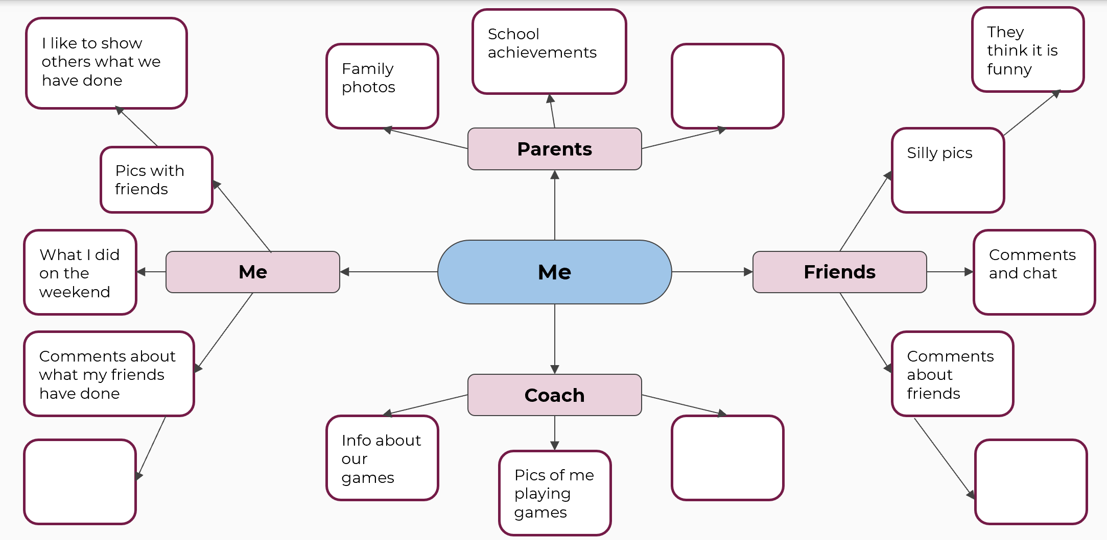

Appendix 4a – Y chart – Respect example
Figure 2 – Y chart – Respect example
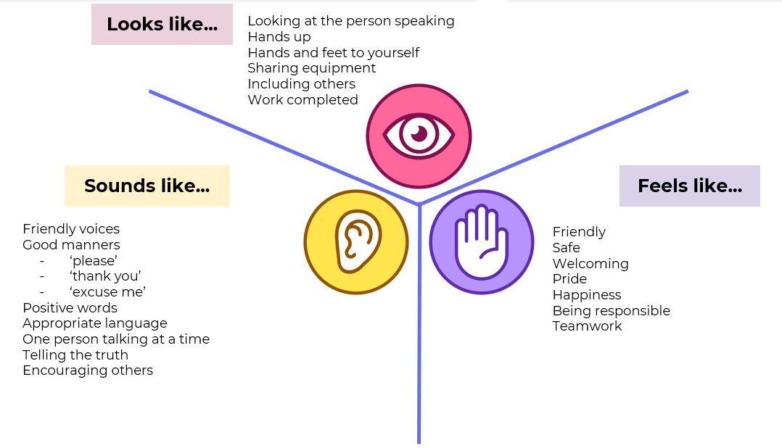

Appendix 4b – Y chart – Respect template
Figure 3 – Y chart – Respect template
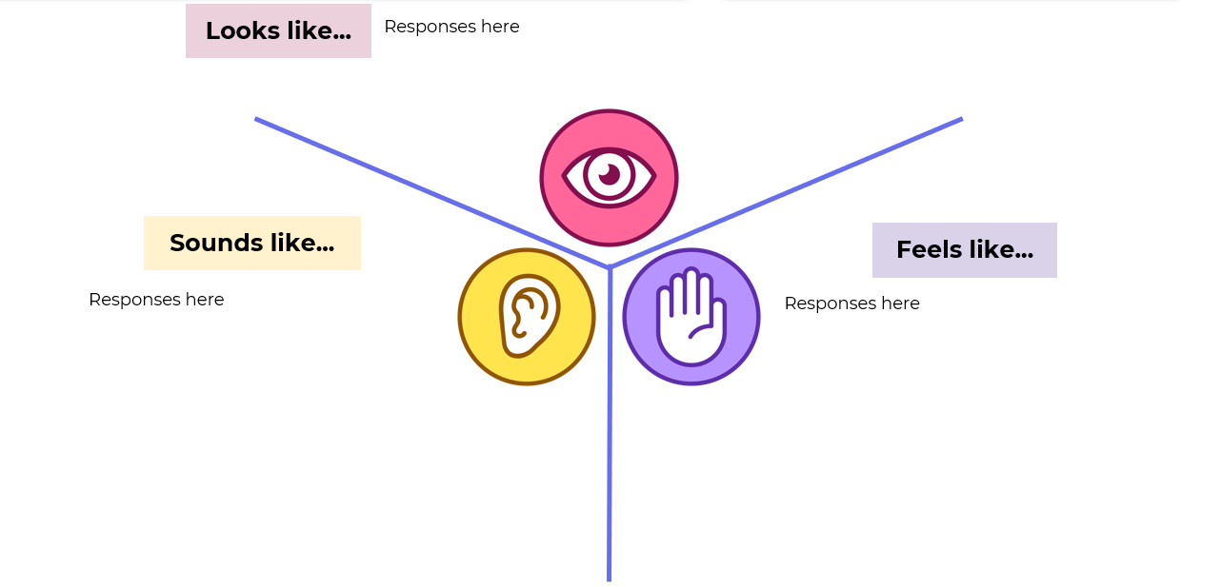

Appendix 5 – Do’s and Don’ts of online usage
List behaviours that are relevant for each column
Table – Do’s and Don’ts of online usage
Do’s of online usage | Don’ts of online usage
Write ‘do’s’ here. | Write ‘don’ts’ here.
Write ‘do’s’ here. | Write ‘don’ts’ here.

Appendix 6 – Y chart – Bullying template
Figure 4 – Y chart – Bullying template

Appendix 7a – 5 whys – Teacher example
Figure 5 – 5 Why’s – Teacher example
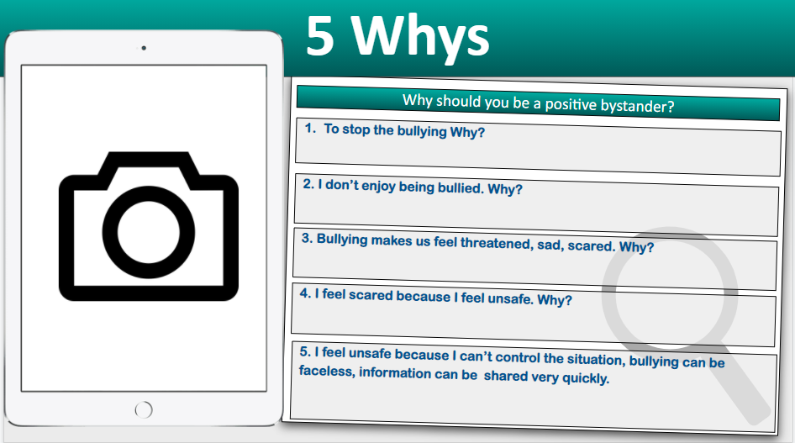

Appendix 7b – 5 whys – student template
Figure 6 – 5 Why’s – Student example
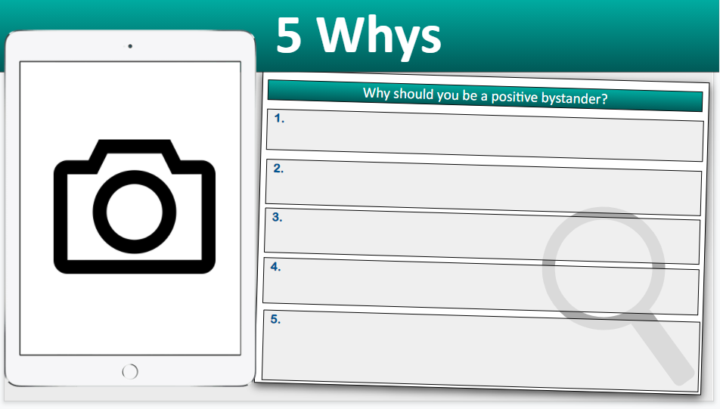

Appendix 8a – Strategies for positive mental health – Teacher example
Figure 7 – Strategies for positive mental health – Teacher example
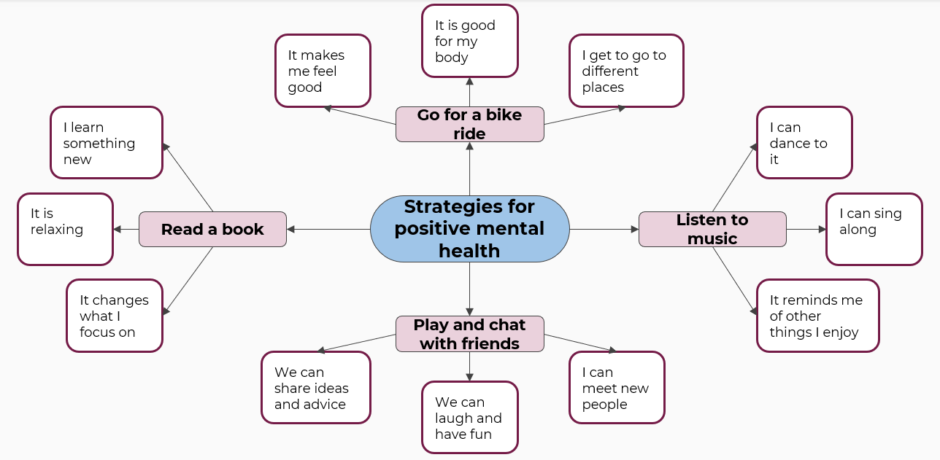

Appendix 8b – Strategies for positive mental health – student template
Figure 8 – Strategies for positive mental health – Student template
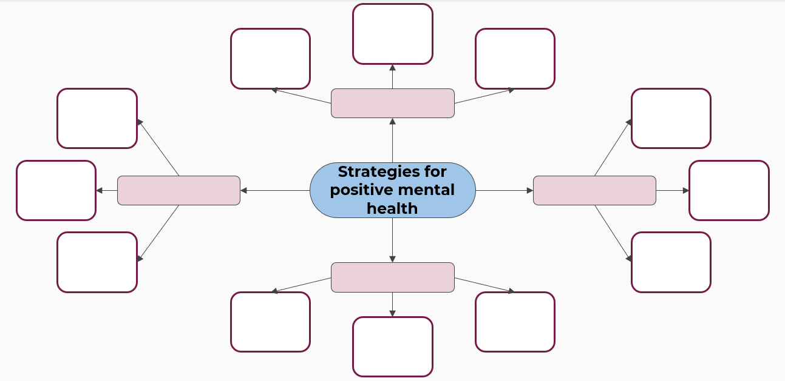

Appendix 9 – Daily guidelines journal
Table – Daily guidelines journal
Day | Physical activity | Duration (hours: minutes) | Recreational screen time activity | Duration (hours: minutes) | Sleep duration (hours: minutes)
Day 1
Day 1
Day 1
Day 2
Day 2
Day 2
Day 3
Day 3
Day 3
Day 4
Day 4
Day 4

