How can I use tactics to be successful in games? Stage 3
PDHPE.

Table of contents
Big idea and key concept 1
Essential question 1
Unit description 1
Contextual statement 1
Propositions in action 1
Focus on educative purpose 2
Take a strengths-based approach 2
Value movement 2
Skills in focus 3
Lesson 1 – Tactics for attacking 4
Key inquiry questions and syllabus content 5
Teaching and learning activities 6
Lesson 2 – Tactics for attacking 13
Key inquiry questions and syllabus content 14
Teaching and learning activities 15
Lesson 3 – Tactics for attacking 20
Key inquiry questions and syllabus content 20
Teaching and learning activities 22
Lesson 4 – Tactics for attacking 26
Key inquiry questions and syllabus content 27
Teaching and learning activities 28
Lesson 5 – Tactics for defending 32
Key inquiry questions and syllabus content 33
Teaching and learning activities 34
Lesson 6 – Tactics for defending 39
Key inquiry questions and syllabus content 40
Teaching and learning activities 41
Lesson 7 – Tactics for defending 45
Key inquiry questions and syllabus content 45
Teaching and learning activities 47
Lesson 8 – Tactics for defending 51
Key inquiry questions and syllabus content 51
Teaching and learning activities 53
Lesson 9 – Adjusting tactics 56
Key inquiry questions and syllabus content 56
Lesson 10 – Adjusting tactics 62
Key inquiry questions and syllabus content 63
Teaching and learning activities 64
Appendix 1 – Self assessment 68
Appendix 2 – Evaluation 70
Appendix 3 – Glossary 71
Appendix 4 – Assessment framework 72
Appendix 5 – Images to support key terms 75
Appendix 6 – Physical literacy cluster markers 90
Movement competencies 90
Tactical movement 90
Motivation and behavioural skills 90
Personal and social attributes 90
Appendix 7 – Attributions 91

Outcomes and other syllabus material in this document are copyright.
PDHPE K-10 Syllabus © NSW Education Standards Authority (NESA) for and on behalf of the Crown in right of the State of New South Wales 2018.

Big idea and key concept
The big idea is the over-arching concept that is being addressed or challenged throughout the unit.
Tactical application of movement concepts influences success in a game. Spatial awareness, relationships with people, objects and space.

Essential question
This question drives both teaching and learning within the unit. Every activity should be working towards answering this question, ‘How can I use tactics to be successful?’

Unit description
Students test, apply and combine various tactics incorporating movement, space, time, equipment and rules to improve their chance of success in territory games. They perform and refine movement skills and sequences to solve games-based problems. For example, they may combine various movements, body positions and speeds to move into space, receive a pass and maintain possession.

Contextual statement
Developing an understanding of tactics will support students to make decisions in more dynamic game-based movement environments. It will also allow students to apply movement skills and sequences in a more effective way.
Improving their ability to select, apply and modify tactical decisions will increase students’ chances of success in games. Achieving regular success contributes positively to student’s lifelong participation in physical activity.

Propositions in action
This describes how specific propositions are embedded throughout the unit of work. The 5 propositions are outlined on pages 24-25 of the PDHPE K-10 syllabus.

Focus on educative purpose
This describes how specific propositions are embedded throughout the unit of work. The 5 propositions are outlined on pages 24-25 of the PDHPE K-10 syllabus.

Take a strengths-based approach
Students will be encouraged to draw upon their own strengths and capabilities to further strengthen their knowledge, skills and understandings while they explore how to effectively select and apply various tactics in game play.

Value movement
Students participate in a wide range of movement experiences to develop skills across all 3 domains and understand how these skills can transfer to different contexts.
Activities are modified to meet the student needs and interests while maintaining relevancy and engagement in tactical game play. Students explore tactics and strategies to learn what can influence their level of success in game play.

Skills in focus
What specific skills are being learned, developed and applied throughout this unit of work? Refer to pages 27-30 of the PDHPE K-10 syllabus.
Self-management skills (S)
- Self-awareness
  - reflective practice.
- Decision making and problem solving
  - finding solutions to problems
  - analysis.
Interpersonal skills (I)
- Communication
  - giving and receiving feedback.
- Collaboration, inclusion and relationship-building
  - recognising and using their own abilities and strengths and those of others.
Movement skills (M)
- Fundamental and specialised movement skills and concepts
  - non-locomotor skills (body control, body positioning, spatial awareness, direction, force, precision)
  - locomotor skills (travel, rhythm, body control, coordination, safe landing, agility, direction, object locomotion).
- Tactical and creative movement
  - selecting, applying, transferring, adapting and evaluating movement skills
  - applying movement concepts, rules, strategies and tactics
  - assessing rules, strategies and tactics and how they influence movement and performance when applied across different movement contexts.
- Health and fitness enhancing movement
  - managing risk and promoting safety.

Lesson 1 – Tactics for attacking
Lesson 1 – Assessment framework
Outcomes | Unit learning goals Students are learning to: | Evidence of learning  Students can:
PD3-4 adapts movement skills in a variety of physical activity contexts. | Perform and adapt movement skills in a variety of activities or games. | Perform, combine and adapt locomotor, object control and/or stability skills in an activity or game. (activity 1, 2, 3).
PD3-5 proposes, applies and assesses solutions to movement challenges. | Use knowledge of previous performances to develop and adapt tactics that achieve a goal/success in a variety of activities or games. | Reflect on previous performances to propose, apply, assess and refine tactics to be effective in territory games (Activity 2, 3).
PD3-10 selects and uses interpersonal skills to interact with others to promote inclusion and build connections. | Identify and use inclusive practices and team work when participating in physical activities. | - Work collaboratively with others when working in small groups in movement tasks or challenges (Activity 1, 2, 3).  - Understand and explain the contribution of different positions/roles in a team playing a territory game and how individual strengths can be matched to these (Activity 2, 3).
PD3-11 selects, manipulates and modifies movement skills and concepts to effectively create and perform movement sequences. | Identify, adapt and use movement concepts and movement skills in territory games. | Combine multiple elements of movement (space/positioning, movement, time), use of equipment and/or communication to successfully attack in territory games (Activity 2, 3).

Key inquiry questions and syllabus content
How can we adapt and perform movement skills in different situations?
Perform and refine movement skills to a variety of situations, for example:
- Vary locomotor movement patterns to cater for variations in movement, for example
  - sprinting, distance running, sidestepping, dodging and defensive/offensive game skills.
Practise specialised movement skills and apply them in a variety of movement sequences and situations for example:
- Apply locomotor and stability skills to create deception in different movement situations example, dodging, faking a pass, field/court positioning.
- Refine object control skills to perform specialised movement patterns related to a variety of games and sports example, bowl/pitch, shoulder pass, chest pass, bounce pass, forehand, backhand strike, serve, punt, drop kick, tag/touch.
- Apply kicking, striking and throwing skills to propel an object for accuracy and/or distance to maintain possession and/or implement strategies in games and sports, physical activities.
How can we use strategies and tactics to create solutions to movement challenges?
Apply critical and creative thinking to generate, create and access solutions to movement challenges for example:
- Recognise and consider a number of solutions to movement challenges and justify which solution is most appropriate or effective.
- Demonstrate defensive and offensive play in modified games.
- Implement tactics which account for their own strengths and the strengths of others in group and team activities.
- Explain the rationale for particular rules, strategies and tactics in individual/group/team physical activities, games and sports.

How can we work with others to build positive relationships during physical activity?
Participate positively in groups and teams by encouraging others and negotiating roles and responsibilities for example:
- Respond appropriately to others when working in small groups on movement tasks or challenges.
How responsible am I for my own and others’ health, safety and wellbeing?
Recognise how regular physical activity and movement situations promote enjoyment and positive outcomes for participants for example:
- Observe and explain how individual strengths and teamwork contribute to achieving success in physical activities.
- Understand the contribution of different roles and responsibilities in games and physical activities.

Teaching and learning activities
Equipment
- netballs or other balls, markers, bibs.
Resources
Video – Territory/Invasion games (1:36 min).
Vocabulary
- tactic, movement, possession, success, tag, challenge, rule, attack, defend, bounce, time, space.
Teacher notes
This unit is designed to help students develop their tactical decision-making in territory games. It builds upon knowledge, understanding and skills developed in Early Stage 1, Stage 1 and Stage 2 units How can I use tactics to be more successful. Discuss students understanding of ‘what are tactics?’ and ‘why are they important?’. Tactics are a plan, idea or action to successfully achieve a goal or outcome during a movement activity.
Discuss with students ‘What do you think success looks like when playing a game?’ Students may suggest it means winning or getting the ‘best result’. This may form part of being successful. Emphasise with students that success can also mean improving their ability to perform a movement skill, increasing their knowledge, increasing their confidence, learning to communicate more effectively with others, improving their decision-making to solve a movement challenge. It does not have to mean ‘winning’. When students discuss questions during lessons or reflect at the completion of the lesson, they may consider that they have been successful for various reasons. This may be discussed and decided upon by the student and teacher.

Activity 1 – Treasure chest (Fast start)
Place a series of markers (the treasure) in a playing area of approximately 20 metres x 20 metres. Allocate one or two players as Navy officers (defenders wearing a bib or sash).
- The pirates (attackers) use a variety of movements to try and collect as much ‘treasure’ as possible without being tagged by the Navy officers (defenders).
- A point is scored when a defender tags an attacker, or an attacker collects a marker.
- Once tagged, a pirate must drop their treasure, return to the start line and begin again. Rotate defenders regularly.
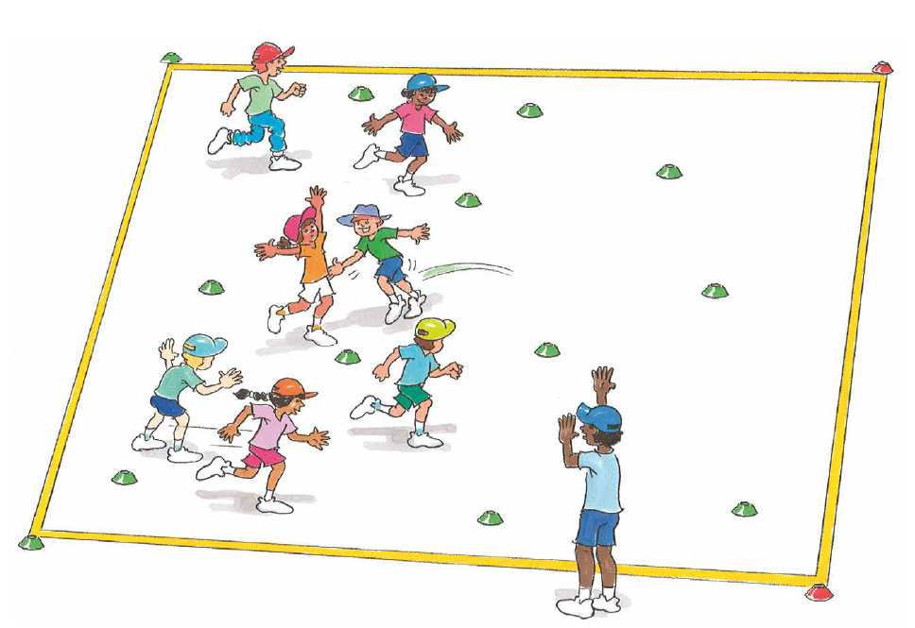
‘Treasure chest illustration’, Adapted from ‘Playing for life’ – Australian Sports Commission, https://www.sportaus.gov.au.

Variations
- Change the locomotor movement of the pirates. (For example, pirates hop while navy officers run).
- Introduce two sets of markers to allow two teams to play against each other.
Discussion
Explore the questions:
- What type of movements allowed the pirates to be successful? Sample student answers may include, locomotor movements such as dodge, side step, run, jump and non-locomotor movements such as bend, twist, turn.
- What if there were more navy officers? How would the game change? Sample student answers may include, the pirates would need to be more alert and look in all directions, pirates may have to communicate and warn each other.
- What are tactics? Sample student answers may include, are a plan, idea or action to successfully achieve a goal or outcome during a movement activity.
- What are some tactics you use when playing territory games? (examples of territory games include touch football, netball, soccer, capture the flag, AFL) Sample student answers may include, pass to a team member in space, move into space, use different movements to dodge defenders.
- Explain that this lesson will focus on the tactic/s that will support them to attack in a territory game and improve the chances of being successful.
Explore with students that the will need to consider how they can use the following when attacking:
- Movement – type of movement they use, the speed of their movement.
- Space and positioning – where they stand, where they move to, how they support team members, where they pass to.
- Timing – when they move, pass or tackle (for example, tackling in soccer).
- Equipment – how they hold and/or use the equipment (for example, passing style), the force applied to the equipment.
- Communication – types of communication, what can be communicated to help the team (for example, signal for the ball, tell a team member they are marked, tell a team member where to pass the ball – ‘up the line’, pass it back’).
View the Territory/Invasion games (1:36 min) video and allow students to reflect upon their responses of how they may use movement, space and positioning, timing, equipment and/or communication to attack in a territory game.
Teacher notes
You may choose to frame these four points as questions to test students’ prior knowledge. For example, how can you move in different ways to help your team maintain possession?
Tackle/tackling is a generic term used when a student attempts to gain/re-gain possession of the ball/object from an opposition student. Under no circumstances should students make physical contact with another student when tackling.

Activity 2 – Modified netball
Divide the class into 4 teams of 6-9 students. Mark the playing area to identify three sections of the court – as per a netball court.
Each team is divided into 3 groups, with each group allocated to a playing third. Each third of the court should have an even number of attackers and defenders.
Teacher notes
The aim of the game is to score goals by shooting the ball into the net/basket. To increase scoring opportunities the teacher and students may decide upon alternative and/or additional ways to score a goal/point. These may include:
- An attacker catches the ball over their attacking end line.
- The attacking team successfully completes 3 consecutive passes in their attacking third.
- The ball striking the ring scores 1 point and successfully shooting the ball through the ring/hoop scores 5 points.

The following rules may be applied and/or modified to suit student needs, abilities and interests:
- One team begins with the ball in the centre circle and passes the ball to their team members on the teacher’s whistle. The team without the ball should attempt to block or intercept the passes.
- If the ball leaves the court, the ball is passed in from the edge of the court where it left by the opposing team.
- Students are to remain in their third only.
- The ball must be touched by a team member in each third. If a ball travels from an end third to the opposite end third without being touched by a team member in the middle third the opposition receives the ball.
- When a goal is scored students rotate thirds. For example, attackers and defenders in ‘third A’ all move to ‘third B’, attackers and defenders in ‘third B’ move to ‘third C’ and attackers and defenders in ‘third C’ move to ‘third A’ (rotations may also be made at the discretion of the teacher depending on the time taken to score a goal).
- Students are not permitted to move with the ball, but may pivot around one foot.
- Defenders should remain 1 metre from the student in possession of the ball.
- The team who conceded a goal will start with the ball from the centre circle after the rotation of thirds.
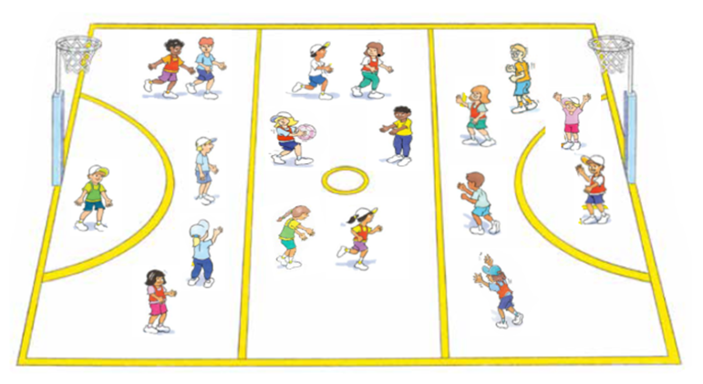
‘Modified netball illustration’, Adapted from ‘Playing for life’ – Australian Sports Commission, https://www.sportaus.gov.au.

Variations
- Place a time limit on how long a student can hold a ball. For example, 3-5 seconds.
- A minimum number of passes must be completed before shooting for a goal.
- Attackers and defenders are paired, only being allowed to mark each other.
Discussion
Explore the following question:
- When your team had possession of the ball, what tactics did you use to be successful?
  - Sample student answers may include, passing quickly to a team member when they were not marked by a defender, team members moved into space away from defenders, choosing the most appropriate passing technique (shoulder pass or bounce pass), timing the pass correctly to a moving team member, communicating to a team member where and how a pass should be delivered instead of just calling a name.

Activity 3 – Modified netball 2.0
Explain to students that in this game there is no rotation between the thirds. Teams discuss what strengths will be well suited to positions in each third. Each team then select students to play in each position/third (attackers, defenders or mid court players) based on personal strengths.
Discussion
Explore the questions:
- Explain which students you selected for the attacking roles and why.
  - Sample student answers may include, we selected the tallest players to play under the hoop, we selected the fastest players in the mid court to move the ball quickly to the goal shooters.
- Were there players that could have played in more than one position? How did you solve it?
  - Sample student answers may include, a student who is the most agile we placed under the hoop in attack even though they are great at intercepting. We placed them there because they are the best at shooting and we had other agile players for defence.
Teacher notes
Allow students to play multiple versions of the game so they can play against team/s from the other game and to adjust positions and other tactics used to improve chances of success in the game.
Reflection
Students reflect upon the learning in this activity/lesson and consider how it contributes towards answering the essential question ‘How can I use tactics to be successful in games?

Lesson 2 – Tactics for attacking
Lesson 2 – Assessment framework
Outcomes | Unit learning goals  Students are learning to: | Evidence of learning  Students can:
PD3-4 adapts movement skills in a variety of physical activity contexts. | Perform and adapt movement skills in a variety of activities or games. | Perform, combine and adapt locomotor, object control and/or stability skills in an activity or game. (activity 1, 2, 3).
PD3-5 proposes, applies and assesses solutions to movement challenges. | Use knowledge of previous performances to develop and adapt tactics that achieve a goal/success in a variety of activities or games. | Reflect on previous performances to propose, apply, assess and refine tactics to be effective in territory games (activity 2, 3).
PD3-10 selects and uses interpersonal skills to interact with others to promote inclusion and build connections. | Identify and use inclusive practices and team work when participating in physical activities. | - Work collaboratively with others when working in small groups in movement tasks or challenges (activity 1, 2, 3).  - Understand and explain the contribution of different positions/roles in a team playing a territory game and how individual strengths can be matched to these (activity 2, 3).
PD3-11 selects, manipulates and modifies movement skills and concepts to effectively create and perform movement sequences. | Identify, adapt and use movement concepts and movement skills in territory games. | Combine multiple elements of movement (space/positioning, movement, time), use of equipment and/or communication to successfully attack in territory games (activity 2, 3).

Key inquiry questions and syllabus content
How can we adapt and perform movement skills in different situations?
Perform and refine movement skills to a variety of situations for example:
- Vary locomotor movement patterns to cater for variations in movement, for example, sprinting, distance running, sidestepping, dodging and defensive/offensive game skills
Practise specialised movement skills and apply them in a variety of movement sequences and situations for example:
- Apply locomotor and stability skills to create deception in different movement situations for example, dodging, faking a pass, field/court positioning.
- Refine object control skills to perform specialised movement patterns related to a variety of games and sports for example, bowl/pitch, shoulder pass, chest pass, bounce pass, forehand, backhand strike, serve, punt, drop kick, tag/touch.
- Apply kicking, striking and throwing skills to propel an object for accuracy and/or distance to maintain possession and/or implement strategies in games and sports, physical activities.
How can we use strategies and tactics to create solutions to movement challenges?
Apply critical and creative thinking to generate, create and access solutions to movement challenges for example:
- Recognise and consider a number of solutions to movement challenges and justify which solution is most appropriate or effective.
- Demonstrate defensive and offensive play in modified games.
- Implement tactics which account for their own strengths and the strengths of others in group and team activities.
- Explain the rationale for particular rules, strategies and tactics in individual/group/team physical activities, games and sports.

How can we work with others to build positive relationships during physical activity?
Participate positively in groups and teams by encouraging others and negotiating roles and responsibilities for example:
- Respond appropriately to others when working in small groups on movement tasks or challenges.
How responsible am I for my own and others’ health, safety and wellbeing?
Recognise how regular physical activity and movement situations promote enjoyment and positive outcomes for participants for example:
- Observe and explain how individual strengths and teamwork contribute to achieving success in physical activities.
- Understand the contribution of different roles and responsibilities in games and physical activities.
- Participate safely and positively in groups and teams by encouraging others and negotiating roles and responsibilities during physical activity for example, initiative/challenge physical activities.

Teaching and learning activities
Equipment
- markers
- basketball.
Vocabulary
- tactics, modified, movement, space, positioning, time, equipment, communication, attack, defend, dodge, bounce, territory game.

Activity 1 – Treasure chest (Fast start)
Refer to instructions in Lesson 1 – Activity 1 and include an increased number of Navy officers (defenders). Different sample questions are provided below to explore how knowledge, understanding and skills have developed further.
Discussion
Explore the question:
- How did your tactics change with the increase in Navy officers (defenders)?
  - Sample student answers may include, the pirates would need to be more alert and look in all directions to identify the Navy officers, pirates may have to increase/improve communication to work as a team.

Activity 2 – Bounce attack (Modified basketball)
Define a playing area approximately 20 metres long x 10 metres wide, with an additional 2 metre scoring zone at the end of each long end. Refer to the image below.
- Divide students into teams of 4-5. The team with the ball (basketball) aims to pass or dribble the ball (basketball style) into their opponents’ scoring zone. The ball must be touched by a minimum 2 team members before a point can be scored.
- After scoring, the defending team restart the game with the ball from their defensive end. The team who has scored must then begin defending from anywhere on the playing area.
- The team without the ball must try to intercept the ball or tag a player with the ball. If the ball is intercepted or a player is tagged with the ball, possession is given to the opposition.
Points are scored for the following:
- 1 point when an attacking player catches a pass in the opposition scoring zone.
- 2 points if all players on a team touch the ball before catching a pass in the opposition scoring zone.
- 3 points if the ball is dribbled into the opposition scoring zone.
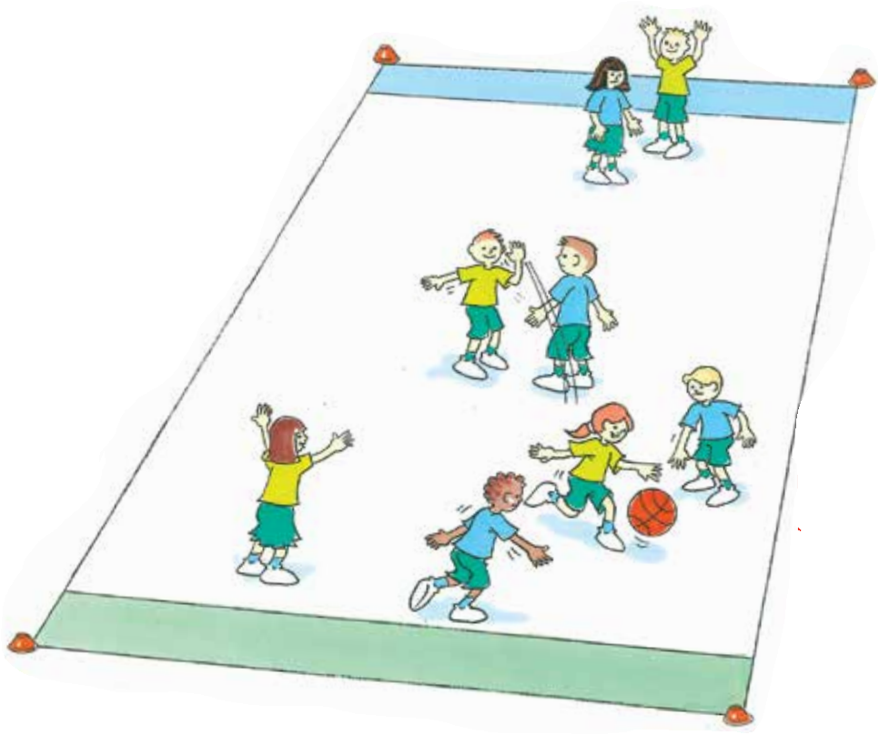
‘Bounce attack (modified basketball) illustration’, Adapted from ‘Playing for life’ – Australian Sports Commission, https://www.sportaus.gov.au.
Variations
Divide the playing area into 2 – allow a maximum of 3 players per team in each half.
- 3 hula hoops for the scoring zone – the ball must be bounced or placed in one of the hula hoops.
- Team members must take turns to score.
- A time limit is placed on the attacking team to score.
Discussion
Explore the following questions:
- How were your tactics similar between the modified netball and the modified basketball games when you were attacking?
  - Sample student answers may include, passing quickly to a team member when they were not marked by a defender, team members moved into space away from defenders, choosing the most appropriate passing technique (shoulder pass or bounce pass), timing the pass correctly to a moving team member, communicating to a team member where and how a pass should be delivered instead of just calling a name.
- How did the tactics when attacking differ between the modified netball and the modified basketball game?
  - Sample student answers may include, being able to move with the ball allowed me to take my time when deciding on a pass, in netball selecting the tallest player to score was an advantage but in this game any team member could be selected to score, bouncing the ball affected my ability to concentrate on who I was passing to, so I needed to slow my movements to maintain possession and complete an effective pass.

Activity 3 – Bounce attack 2.0 (Modified basketball)
Repeat ‘Bounce attack – Modified basketball’ from Activity 1. Teams are to select students based on personal strengths to be attackers, defenders or mid court players.
Teacher notes
Unlike the modified netball game this game does not have specific positions. However, students are encouraged to try to allocate themselves to a position. Examples may include attackers, centres, defenders. Throughout the game students may discover that a student selected to be a defender may be required to support the attackers to score.
Discussion
Explore the questions:
- Who did you select for the attacking roles? Why?
  - Sample student answers may include, we selected the tallest players to attack as we would be able to lob the ball to them and score, we selected the fastest players in the mid court to move the ball quickly to the attackers.
- Were there players that could have played in more than one position? How did you solve it?
  - Sample student answers may include, a student who is the most agile we placed as an attacker even though they are great at blocking and intercepting. We placed them there because they could evade the defenders and score easily.
Variation
When re-starting the game after a point, the team in possession selects the type of ball to play use. For example, tennis ball, rugby league ball, AFL ball.

Reflection
Students reflect upon the learning in this activity/lesson and consider how it contributes towards answering the essential question How can I use tactics to be successful in games?

Lesson 3 – Tactics for attacking
Lesson 3 – Assessment framework
Outcomes | Unit learning goals  Students are learning to: | Evidence of learning  Students can:
PD3-4 adapts movement skills in a variety of physical activity contexts. | Perform and adapt movement skills in a variety of activities or games. | Perform, combine and adapt locomotor, object control and/or stability skills in an activity or game. (Activity 1, 2, 3).
PD3-5 proposes, applies and assesses solutions to movement challenges. | Use knowledge of previous performances to develop and adapt tactics that achieve a goal/success in a variety of activities or games. | Reflect on previous performances to propose, apply, assess and refine tactics to be effective in territory games (Activity 2, 3).
PD3-10 selects and uses interpersonal skills to interact with others to promote inclusion and build connections. | Identify and use inclusive practices and team work when participating in physical activities. | Work collaboratively with others when working in small groups in movement tasks or challenges (Activity 1, 2, 3).
PD3-11 selects, manipulates and modifies movement skills and concepts to effectively create and perform movement sequences. | Identify, adapt and use movement concepts and movement skills in territory games. | Combine multiple elements of movement (space/positioning, movement, time), use of equipment and/or communication to successfully attack in territory games (Activity 2, 3).

Key inquiry questions and syllabus content
How can we adapt and perform movement skills in different situations?
Perform and refine movement skills to a variety of situations for example:
- Vary locomotor movement patterns to cater for variations in movement, for example, sprinting, distance running, sidestepping, dodging and defensive/offensive game skills.
- Adapt movement techniques to cater for the use of different equipment and physical activities or games settings for example, accuracy, force, speed, distance, direction and control.
Practise specialised movement skills and apply them in a variety of movement sequences and situations for example:
- Apply locomotor and stability skills to create deception in different movement situations for example, dodging, faking a pass, field/court positioning.
- Refine object control skills to perform specialised movement patterns related to a variety of games and sports for example, bowl/pitch, shoulder pass, chest pass, bounce pass, forehand, backhand strike, serve, punt, drop kick, tag/touch.
- Apply kicking, striking and throwing skills to propel an object for accuracy and/or distance to maintain possession and/or implement strategies in games and sports, physical activities.
How can we use strategies and tactics to create solutions to movement challenges?
Apply critical and creative thinking to generate, create and access solutions to movement challenges for example:
- Recognise and consider a number of solutions to movement challenges and justify which solution is most appropriate or effective.
- Demonstrate defensive and offensive play in modified games.
- Implement tactics which account for their own strengths and the strengths of others in group and team activities.
- Explain the rationale for particular rules, strategies and tactics in individual/group/team physical activities, games and sports.
How can we work with others to build positive relationships during physical activity?
Participate positively in groups and teams by encouraging others and negotiating roles and responsibilities for example:
- Respond appropriately to others when working in small groups on movement tasks or challenges.
How responsible am I for my own and others’ health, safety and wellbeing?
Recognise how regular physical activity and movement situations promote enjoyment and positive outcomes for participants for example:
- Participate safely and positively in groups and teams by encouraging others and negotiating roles and responsibilities during physical activity for example, initiative/challenge physical activities.

Teaching and learning activities
Equipment
- soccer balls
- tennis balls
- rugby/AFL ball
- markers.
Vocabulary
- tactics, modified, movement, space, positioning, time, equipment, communication, attack, defend, dodge, tag, kick, territory game.

Activity 1 – Tag and pass (Fast start)
Divide students into groups of 10, with each group split into 2 teams (passers and dodgers). Each group plays within a playing area approximately 10 metres x 10 metres.
- The passers aim is to pass the ball to each other and tag the dodgers with the ball. A tag is made when the passer uses the ball to touch the opposing player (the ball is not to be thrown).
- Passers cannot run with the ball but may move when not in possession. Once tagged, dodgers join the passing team. The aim is to tag everyone.
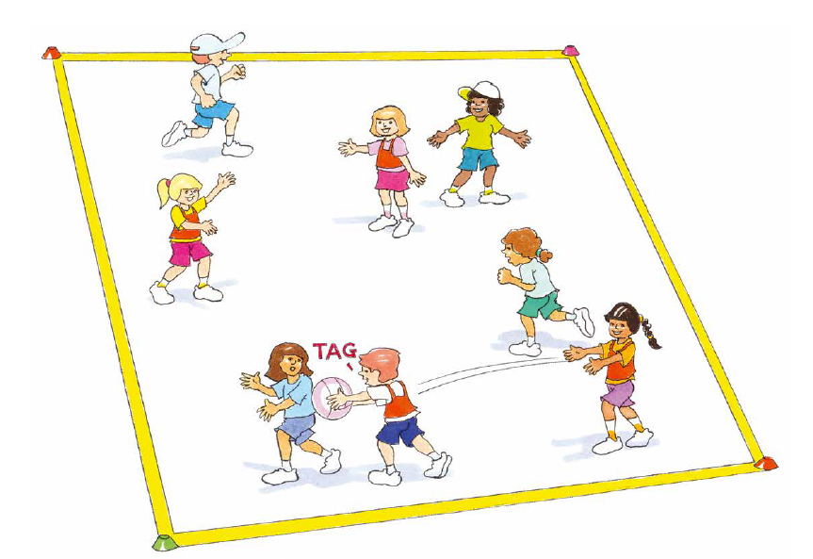
‘Tag and pass (fast start) illustration’, Adapted from ‘Playing for life’ – Australian Sports Commission, https://www.sportaus.gov.au.
Variations
- Increase or decrease the playing area.
- Change the ball.
- Start the game where each team has a different number of students.
Discussion
Explore with students:
- How did you move to effectively attack with the ball?
- Where did you position yourself so you could receive a pass and attempt to tag an opposition player?

Activity 2 – Modified soccer
Divide students into groups of 10, with each group split into 2 teams (Teams A and B). Each group plays within a playing area approximately 20 metres x 20 metres.
- Place 2 markers about 4-5 metres apart as small goals at each end. The aim is for the teams to pass the soccer ball to each other until they are able to score a goal. If a team kick the ball out of play the opposition team restart play with a pass from where the ball went out.
- When a goal is scored the opposition start with the ball from their goal line. At least 2 students must touch the ball before a goal can be scored, if all students touch the ball the goal is worth 3 points. When defending students are not allowed to take up a position as a goalie nor use their hands.
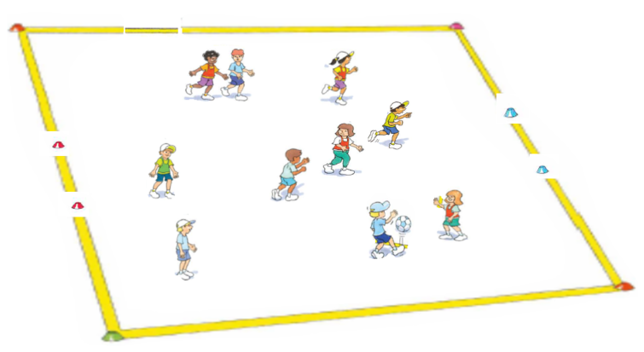
‘Modified soccer illustration’, Adapted from ‘Playing for life’ – Australian Sports Commission, https://www.sportaus.gov.au.
Variations
- Make the goal 1 marker only and students need to hit the marker to score a goal.
- Take turns at scoring goals.
- Increase the size of the goals and include a goalie.
Discussion
Explore the questions:
- When attacking, how were the tactics similar between the modified netball/basketball and modified soccer games?
  - Sample student answers may include, passing quickly to a team member when they were not marked by a defender, team members moved into space away from defenders, choosing the most appropriate passing technique and amount of force to use (instep or laces or the outside boot), timing when to pass to a moving team member, communicating to a team member where and how a pass should be delivered instead of just calling a name.
- How did the tactics when attacking differ between the modified netball/basketball and the modified soccer game?
  - Sample student answers may include, being able to move with the ball allowed me to take my time when deciding on a pass, in netball selecting the tallest player to score was an advantage but in this game any team member could be selected to score, using my feet it was more difficult to maintain possession, so I needed to slow down and concentrate on maintaining control of the ball.

Activity 3 – Modified soccer 2.0
Repeat the game with a different sized ball. This may be a tennis ball, large soft inflatable ball or a different shaped ball such as a rugby/AFL ball.
Discussion
Explore the following questions:
- How did the new piece of equipment change your tactics when attacking?
  - Sample student answers may include, a tennis ball made it harder to pass so we had to concentrate more on the ball when kicking, it is harder to intercept so we could take more risks with passing.
- What if you could select your own equipment other than a soccer ball to play this game? What would you choose and how would your tactics change when attacking?
Reflection
Students reflect upon the learning in this activity/lesson and consider how it contributes towards answering the essential question ‘How can I use tactics to be successful in games?’.

Lesson 4 – Tactics for attacking
Lesson 4 – Assessment framework
Outcomes | Unit learning goals  Students are learning to: | Evidence of learning  Students can:
PD3-4 adapts movement skills in a variety of physical activity contexts. | Perform and adapt movement skills in a variety of activities or games. | Perform, combine and adapt locomotor, object control and/or stability skills in an activity or game. (Activity 1, 2, 3).
PD3-5 proposes, applies and assesses solutions to movement challenges. | Use knowledge of previous performances to develop and adapt tactics that achieve a goal/success in a variety of activities or games. | Reflect on previous performances to propose, apply, assess and refine tactics to be effective in territory games (Activity 2, 3).
PD3-10 selects and uses interpersonal skills to interact with others to promote inclusion and build connections. | Identify and use inclusive practices and team work when participating in physical activities. | Work collaboratively with others when working in small groups in movement tasks or challenges (Activity 1, 2, 3).
PD3-11 selects, manipulates and modifies movement skills and concepts to effectively create and perform movement sequences. | Identify, adapt and use movement concepts and movement skills in territory games. | Combine multiple elements of movement (space/positioning, movement, time), use of equipment and/or communication to successfully attack in territory games (Activity 2, 3).

Key inquiry questions and syllabus content
How can we adapt and perform movement skills in different situations?
Perform and refine movement skills to a variety of situations, for example:
- Vary locomotor movement patterns to cater for variations in movement for example, sprinting, distance running, sidestepping, dodging and defensive/offensive game skills.
- Adapt movement techniques to cater for the use of different equipment and physical activities or games settings for example, accuracy, force, speed, distance, direction and control.
Practise specialised movement skills and apply them in a variety of movement sequences and situations for example:
- Apply locomotor and stability skills to create deception in different movement situations for example, dodging, faking a pass, field/court positioning.
- Refine object control skills to perform specialised movement patterns related to a variety of games and sports for example, bowl/pitch, shoulder pass, chest pass, bounce pass, forehand, backhand strike, serve, punt, drop kick, tag/touch.
- Apply kicking, striking and throwing skills to propel an object for accuracy and/or distance to maintain possession and/or implement strategies in games and sports, physical activities.
How can we use strategies and tactics to create solutions to movement challenges?
Apply critical and creative thinking to generate, create and access solutions to movement challenges for example:
- Recognise and consider a number of solutions to movement challenges and justify which solution is most appropriate or effective.
- Demonstrate defensive and offensive play in modified games.
- Implement tactics which account for their own strengths and the strengths of others in group and team activities.
- Explain the rationale for particular rules, strategies and tactics in individual/group/team physical activities, games and sports.
How can we work with others to build positive relationships during physical activity?
Participate positively in groups and teams by encouraging others and negotiating roles and responsibilities for example:
- Respond appropriately to others when working in small groups on movement tasks or challenges.
How responsible am I for my own and others’ health, safety and wellbeing?
Recognise how regular physical activity and movement situations promote enjoyment and positive outcomes for participants for example:
- Participate safely and positively in groups and teams by encouraging others and negotiating roles and responsibilities during physical activity for example, initiative/challenge physical activities.

Teaching and learning activities
Equipment
- markers
- touch football or various pieces of equipment to replace the touch football.
Resource
Appendix 1.
Vocabulary
- tactics, modified, movement, space, positioning, time, equipment, communication, attack, defend, dodge, tag, territory game.

Activity 1 – Tag and pass (Fast start)
Refer to instructions in Lesson 3 – Activity 1. Play Tag and pass while using a tennis ball. Different sample questions are provided below to explore how knowledge, understanding and skills have developed further.

Discussion
When did you pass the ball to a team mate so they could tag an opposition player?” Sample student answers may include, when team member was close to the opposition so they catch and tag quickly and before they had time to move away.
Variations
- Increase or decrease the playing area.
- Start the game where each team has a different number of students.

Activity 2 – Modified touch football
Define a playing area 30 metres long x 20 metres wide, with an additional 2 metre scoring zone at the end of each long end.
Divide students into 15 players per playing area. Further divide these students into three even teams of 5 in each playing area.
- One team start the game with a tap from halfway and begin attacking an opposition scoring zone.
- The two defending teams start on opposite scoring zones. The defending team attempt to make 3 touches to stop the attack. After a touch the attacking team member must stop where they were touched, taps the ball with their foot and passes it to a team member to continue play. Defending team members must retreat approximately 5 metres (or on the scoring zone line if play is within 5 metres of the scoring zone).
- After one defending team has affected three touches (or the attacking team scores a touchdown – placing the ball on the ground in the scoring zone), the attacking team may tap the ball and attempt to score past the second defending team who have been waiting on their scoring zone.
- The attacking team changes places with one of the defending teams (all teams move clockwise) once they have attempted to score at both scoring zones.
- When all three teams have had a turn as attackers, the team with the most touchdowns scored wins.

Variations
- Include a time limit each team is allowed to keep possession of the ball with unlimited tags.
- Increase the number of touches allowed before the attacking team must about face.
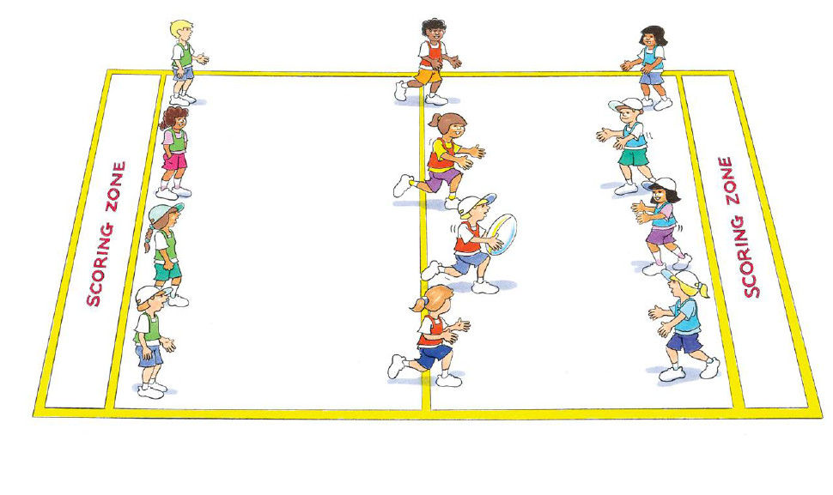
‘Modified touch football illustration’, Adapted from ‘Playing for life’ – Australian Sports Commission, https://www.sportaus.gov.au.
Discussion
Explore the questions:
- When attacking, how were the tactics similar between the modified netball/basketball/soccer and modified touch football games?
  - Sample student answers may include, passing quickly to a team member when they were not marked by a defender, team members moved into space away from defenders, choosing the most appropriate passing technique and force (short pass, long pass) timing the pass correctly to a moving team member, communicating to a team member where and how a pass should be delivered instead of just calling a name.
- How did the tactics when attacking differ between the modified netball/basketball/soccer and the modified touch football game? For example, in netball/basketball selecting the tallest player to score was an advantage however in this game the faster runners were more effective.

Activity 3 – Modified touch football 2.0
Repeat the game with a different sized ball. This may be a tennis ball, large soft inflatable ball or a different shaped ball such as a rugby/AFL ball.
Discussion
Explore the questions:
- How did the new piece of equipment change your tactics when attacking?
  - Sample student answers may include, a tennis ball is harder to catch so we had to concentrate more on the receiving of the ball before looking for space to run into, a tennis ball is harder to intercept so we could take more risks with passing, a vortex or frisbee allowed for longer passes so we could spread out.
- What if you could select your own equipment other than a touch football to play this game? What would you choose and how would your tactics change when attacking?
Variations
- Reduce the game to 2 teams and play 6 touches each before turnover.
Reflection
Students reflect upon the learning in this activity/lesson and consider how it contributes towards answering the essential question ‘How can I use tactics to be successful in games?’ by completing the self–assessment on Appendix 1. Alternatively, the self–assessment in Appendix 1 may be adapted using one or more of the assessment tools available via the Digital Learning Selector.

Lesson 5 – Tactics for defending
Lesson 5 – Assessment framework
Outcomes | Unit learning goals  Students are learning to: | Evidence of learning  Students can:
PD3-4 adapts movement skills in a variety of physical activity contexts. | Perform and adapt movement skills in a variety of activities or games. | Perform, combine and adapt locomotor, object control and/or stability skills in an activity or game (Activity 1, 2, 3).
PD3-5 proposes, applies and assesses solutions to movement challenges. | Use knowledge of previous performances to develop and adapt tactics that achieve a goal/success in a variety of activities or games. | Reflect on previous performances to propose, apply, assess and refine tactics to be effective in territory games (Activity 2, 3).
PD3-10 selects and uses interpersonal skills to interact with others to promote inclusion and build connections. | Identify and use inclusive practices and team work when participating in physical activities. | - Work collaboratively with others when working in small groups in movement tasks or challenges (Activity 1, 2, 3).  - Understand and explain the contribution of different positions/roles in a team playing a territory game and how individual strengths can be matched to these (Activity 2, 3).
PD3-11 selects, manipulates and modifies movement skills and concepts to effectively create and perform movement sequences. | Identify, adapt and use movement concepts and movement skills in territory games. | Combine multiple elements of movement (space/positioning, movement, time), use of equipment and/or communication to successfully defend in territory games (Activity 2, 3).

Key inquiry questions and syllabus content
How can we adapt and perform movement skills in different situations?
Perform and refine movement skills to a variety of situations, for example:
- Vary locomotor movement patterns to cater for variations in movement for example, sprinting, distance running, sidestepping, dodging and defensive/offensive game skills.
Practise specialised movement skills and apply them in a variety of movement sequences and situations for example:
- Apply locomotor and stability skills to create deception in different movement situations, for example, dodging, faking a pass, field/court positioning.
- Refine object control skills to perform specialised movement patterns related to a variety of games and sports for example, bowl/pitch, shoulder pass, chest pass, bounce pass, forehand, backhand strike, serve, punt, drop kick, tag/touch.
- Apply kicking, striking and throwing skills to propel an object for accuracy and/or distance to maintain possession and/or implement strategies in games and sports, physical activities.
How can we use strategies and tactics to create solutions to movement challenges?
Apply critical and creative thinking to generate, create and access solutions to movement challenges for example:
- Recognise and consider a number of solutions to movement challenges and justify which solution is most appropriate or effective.
- Demonstrate defensive and offensive play in modified games.
- Implement tactics which account for their own strengths and the strengths of others in group and team activities.
- Explain the rationale for particular rules, strategies and tactics in individual/group/team physical activities, games and sports.

How can we work with others to build positive relationships during physical activity?
Participate positively in groups and teams by encouraging others and negotiating roles and responsibilities for example:
- Respond appropriately to others when working in small groups on movement tasks or challenges.
How responsible am I for my own and others’ health, safety and wellbeing?
Recognise how regular physical activity and movement situations promote enjoyment and positive outcomes for participants for example:
- Observe and explain how individual strengths and teamwork contribute to achieving success in physical activities.
- Understand the contribution of different roles and responsibilities in games and physical activities.
- Participate safely and positively in groups and teams by encouraging others and negotiating roles and responsibilities during physical activity for example, initiative/challenge physical activities.

Teaching and learning activities
Equipment
- touch footballs
- netballs
- markers
- bibs.
Resource
Video – Territory/Invasion games (1:36 min).
Vocabulary
- tactics, modified, movement, space, positioning, time, equipment, communication, attack, defend, dodge, tag, territory game.

Activity 1 – Dynamite or modified touch football (Fast start)
Divide the class into pairs with one football per pair. Partners stand opposite each other 2 metres apart, as all pairs stand side by side across the middle of the playing area (students should now be standing in 2 lines facing their partner across the playing area 2 metres apart).
- Students pass the ball back and forth to their partner. When the teacher calls ‘dynamite’ the student with the ball (or about to receive the ball) must turn and run to an end line and score a touchdown.
- The end line distance can be determined by the teacher considering student ability and size of playing area. The student without the ball chases the ball carrier trying to tag them before they reach the end line.
- After scoring or being tagged students return to their starting positions ready to repeat the challenge.
Teacher notes
Monitor which students are carrying the ball, trying to ensure both partners have an even amount of turns as much as possible.
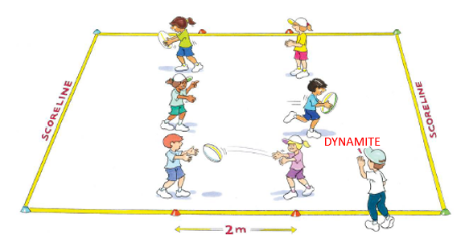
‘Dynamite or modified touch football (fast start) illustration’, Adapted from ‘Playing for life’ – Australian Sports Commission, https://www.sportaus.gov.au.

Discussion
- How did you carry the ball so you could run away quickly?
  - Sample student answers may include, under my arm with one arm so I could still use both my arms to run quickly.
- How did you position your body so you could be ready to turn and run or chase your opponent?
  - Sample student answers may include, I stood with one foot in front of the other and knees bent which would allow me to run quickly or turn and run away quickly.
Variations
Change the type of ball along with passing technique to match accordingly. For example, use an AFL ball and hand ball, a netball with a chest pass, a basketball and bounce the ball to the end line. A soccer ball kicking and passing with feet.
Discussion
Explain that this lesson will focus on the tactic/s that will support them to defend in a territory game and improve the chances of being successful.
Explore with students that the will need to consider how they can use the following when defending:
- Movement – type of movement they use, the speed of their movement.
- Space and positioning – where they stand, where they move to, how they support team members, where they stand to block or intercept a pass.
- Timing – when they move, pass or tackle (for example, tackling in soccer).
- Equipment – how they hold and/or use the equipment (for example, passing style), the force applied to the equipment.
- Communication – types of communication, what can be communicated to help the team (for example, signal for the ball, tell a team member they are marked, tell a team member where to pass the ball – ‘up the line’, pass it back’).
View Territory/Invasion Games video and allow students to reflect upon their responses of how they may use movement, space and positioning, timing, equipment and/or communication to defend in a territory game.
Teacher notes
Explain that this lesson will again focus on the tactic/s that will support them when attacking in a territory game. Remind students of how the elements of movement, space and positioning, timing, effort, using equipment and communication, as discussed in Lesson 5, can be used when defending in a game.

Activity 2 – Modified netball
Refer to instructions in Lesson 1 – Activity 2. Play Modified netball and ask students to consider how they may now reflect upon the tactics they use to attack, the tactics their opposition use to attack and how they can use this information to decide upon the most appropriate tactics to defend the space and goal.
Variations
- Place a time limit on how long a student can hold a ball.
- Every team member must touch the ball before shooting for a goal.
- Attackers and defenders are paired, only being allowed to mark each other.
Discussion
Explore the question:
- When your team did not have possession of the ball (defending) what tactics did you use? Prompt students to refer to the elements of movement, space and positioning, timing, equipment and communication when explaining the tactics they used.
  - Sample student answers may include, effective positioning in the space between the ball carrier and their team member to intercept the ball, timing their movement to intercept the ball, communicating with team members about marking and positioning, types of movements used to assist with marking and intercepting (side-galloping, hands up, jumping), watching and anticipating where the attackers were moving to and whether my team members were marking them.

Activity 3 – Modified netball 2.0
As per Lesson 1 – Activity 3, students do not rotate between the thirds. Teams are to select students based on personal strengths to be attackers, defenders or mid court players. Ask students to consider how they may now reflect upon the tactics they use to select positions when attacking, the tactics their opposition used to select positions when attacking and how they can use this information to decide upon the most appropriate positions for each student that enables the team to defend the space and goal.
Discussion
Explore the questions:
- Explain who you selected for the defending roles and why.
  - Sample student answers may include, we selected the most agile to defend the hoop as they can jump the highest to block the attackers, we selected the fastest person to play in the mid-court at they were good at changing directions and intercepting.
- Were there players that could have played in more than one position? How did you solve it?
  - Sample student answers may include, the tallest student we placed under the hoop in defence even though this would also be an advantage when shooting. We placed them there because their height and reach made it extremely difficult for shooters and they are able to gain possession easily through rebounds and intercepts.
- Did you make any changes in positions based on where the opposition placed their players? Why?
  - Sample student answers may include, we started with our tallest player as an attacker with the plan of scoring goals but we found it difficult to get the ball to them. The opposition also had their tallest player as an attacker and they were scoring a lot of goals so we moved our tallest player to mark their tallest player. This created an evenly matched contest.
Reflection
Students reflect upon the learning in this activity/lesson and consider how it contributes towards answering the essential question How can I use tactics to be successful in games?

Lesson 6 – Tactics for defending
Lesson 6 – Assessment framework
Outcomes | Unit learning goals  Students are learning to: | Evidence of learning  Students can:
PD3-4 adapts movement skills in a variety of physical activity contexts. | Perform and adapt movement skills in a variety of activities or games. | Perform, combine and adapt locomotor, object control and/or stability skills in an activity or game. (Activity 1, 2, 3).
PD3-5 proposes, applies and assesses solutions to movement challenges. | Use knowledge of previous performances to develop and adapt tactics that achieve a goal/success in a variety of activities or games. | Reflect on previous performances to propose, apply, assess and refine tactics to be effective in territory games (Activity 2, 3).
PD3-10 selects and uses interpersonal skills to interact with others to promote inclusion and build connections. | Identify and use inclusive practices and team work when participating in physical activities. | - Work collaboratively with others when working in small groups in movement tasks or challenges (Activity 1, 2, 3).  - Understand and explain the contribution of different positions/roles in a team playing a territory game and how individual strengths can be matched to these (Activity 2, 3).
PD3-11 selects, manipulates and modifies movement skills and concepts to effectively create and perform movement sequences. | Identify, adapt and use movement concepts and movement skills in territory games. | Combine multiple elements of movement (space/positioning, movement, time), use of equipment and/or communication to successfully defend in territory games (Activity 2, 3).

Key inquiry questions and syllabus content
How can we adapt and perform movement skills in different situations?
Perform and refine movement skills to a variety of situations, for example:
- Vary locomotor movement patterns to cater for variations in movement for example, sprinting, distance running, sidestepping, dodging and defensive/offensive game skills.
Practise specialised movement skills and apply them in a variety of movement sequences and situations for example:
- Apply locomotor and stability skills to create deception in different movement situations for example, dodging, faking a pass, field/court positioning.
- Refine object control skills to perform specialised movement patterns related to a variety of games and sports for example, bowl/pitch, shoulder pass, chest pass, bounce pass, forehand, backhand strike, serve, punt, drop kick, tag/touch.
- Apply kicking, striking and throwing skills to propel an object for accuracy and/or distance to maintain possession and/or implement strategies in games and sports, physical activities.
How can we use strategies and tactics to create solutions to movement challenges?
Apply critical and creative thinking to generate, create and access solutions to movement challenges for example:
- Recognise and consider a number of solutions to movement challenges and justify which solution is most appropriate or effective.
- Demonstrate defensive and offensive play in modified games.
- Implement tactics which account for their own strengths and the strengths of others in group and team activities.
- Explain the rationale for particular rules, strategies and tactics in individual/group/team physical activities, games and sports.

How can we work with others to build positive relationships during physical activity?
Participate positively in groups and teams by encouraging others and negotiating roles and responsibilities for example:
- Respond appropriately to others when working in small groups on movement tasks or challenges.
How responsible am I for my own and others’ health, safety and wellbeing?
Recognise how regular physical activity and movement situations promote enjoyment and positive outcomes for participants for example:
- Observe and explain how individual strengths and teamwork contribute to achieving success in physical activities.
- Understand the contribution of different roles and responsibilities in games and physical activities.
- Participate safely and positively in groups and teams by encouraging others and negotiating roles and responsibilities during physical activity for example, initiative/challenge physical activities.

Teaching and learning activities
Equipment
- markers
- basketballs
- bibs.
Vocabulary
- tactics, modified, movement, space, positioning, time, equipment, communication, attack, defend, dodge, bounce, territory game

Activity 1 – Dynamite or modified touch football (Fast start)
Refer to instructions in Lesson 3 – Activity 1. Play ‘Dynamite’ while using a tennis ball.
- Did you make any changes to the way you threw the ball so you could reduce the amount of time your opponent had to run away?
  - Sample student answers may include, I threw the ball up higher so my opponent had to wait for the ball while I started to chase them.
Discussion
Explain that this lesson will again focus on the tactic/s that will support them when attacking in a territory game. Remind students of how the elements of movement, space and positioning, timing, effort, using equipment and communication, as discussed in Lesson 5, can be used when defending in a game.

Activity 2 – Bounce Attack (Modified basketball)
Refer to instructions in Lesson 2 – Activity 2. Play Bounce attack and ask students to consider how they may now reflect upon the tactics they use to attack, the tactics their opposition use to attack and how they can use this information to decide upon the most appropriate tactics to defend the space and goal.
Variations
- Divide the playing area into 2 – allow a maximum of 3 players per team in each half.
- 3 hula hoops for the scoring zone – the ball must be bounced or placed in one of the hula hoops.
- Team members must take turns to score.
- A time limit is placed on the attacking team to score.
Discussion
Explore the questions:
- How were your tactics similar between the modified netball and the modified basketball game when defending? Prompt students to refer to the elements of movement, space and positioning, timing, equipment and communication when explaining the tactic/s they used.
  - Sample student answers may include, effective positioning in the space between the ball carrier and their team member to intercept the ball, timing their movement to intercept the ball, communicating with team members about marking and positioning, types of movements used to assist with marking and intercepting (side-galloping, hands up, jumping), watching and anticipating where the attackers were moving to and whether my team members were marking them.
- How did the tactics when defending differ between the modified netball and the modified basketball game?
  - Sample student answers may include, I could stand a lot closer to the opposition students in the basketball game which added more pressure to their passing. Because there were no zones I had to be more aware of where the opposition team members were moving. As the opposition could move with the ball, I had to use different movements to ensure I could still defend them and be ready to intercept the ball.

Activity 3 – Bounce Attack 2.0 (Modified basketball 2.0)
As per Lesson 2 – Activity 3, play Bounce attack 2.0 and allow teams are to select students based on personal strengths to be attackers, defenders or mid court players. Ask students to consider how they may now reflect upon the tactics they used to attack, the tactics their opposition used to attack and how they can use this information to decide upon the most appropriate tactics to defend the space and goal.
Teacher notes
Unlike the modified netball game this game does not have specific positions. However, students are encouraged to try to allocate themselves to a position. Examples may include attackers, centres, defenders. Throughout the game students may discover that a student selected to be an attacker may be required to support the defenders to block or slow down the attackers.
Discussion
Explore the following question:
- What did you discover about the positioning that was different to modified netball?
  - Sample student answers may include, because students could move across the entire playing area, defending became more difficult because the opposition had more space to move.
Reflection
Students reflect upon the learning in this activity/lesson and consider how it contributes towards answering the essential question How can I use tactics to be successful in games?

Lesson 7 – Tactics for defending
Lesson 7 – Assessment framework
Outcomes | Unit learning goals  Students are learning to: | Evidence of learning  Students can:
PD3-4 adapts movement skills in a variety of physical activity contexts. | Perform and adapt movement skills in a variety of activities or games. | Perform, combine and adapt locomotor, object control and/or stability skills in an activity or game. (Activity 1, 2, 3).
PD3-5 proposes, applies and assesses solutions to movement challenges. | Use knowledge of previous performances to develop and adapt tactics that achieve a goal/success in a variety of activities or games. | Reflect on previous performances to propose, apply, assess and refine tactics to be effective in territory games (Activity 2, 3).
PD3-10 selects and uses interpersonal skills to interact with others to promote inclusion and build connections. | Identify and use inclusive practices and team work when participating in physical activities. | Work collaboratively with others when working in small groups in movement tasks or challenges (Activity 1, 2, 3).
PD3-11 selects, manipulates and modifies movement skills and concepts to effectively create and perform movement sequences. | Identify, adapt and use movement concepts and movement skills in territory games. | Combine multiple elements of movement (space/positioning, movement, time), use of equipment and/or communication to successfully defend in territory games (Activity 2, 3).

Key inquiry questions and syllabus content
How can we adapt and perform movement skills in different situations?
Perform and refine movement skills to a variety of situations, for example:
- Vary locomotor movement patterns to cater for variations in movement for example, sprinting, distance running, sidestepping, dodging and defensive/offensive game skills.
- Adapt movement techniques to cater for the use of different equipment and physical activities or games settings for example, accuracy, force, speed, distance, direction and control.
Practise specialised movement skills and apply them in a variety of movement sequences and situations for example:
- Apply locomotor and stability skills to create deception in different movement situations for example, dodging, faking a pass, field/court positioning.
- Refine object control skills to perform specialised movement patterns related to a variety of games and sports, such as bowl/pitch, shoulder pass, chest pass, bounce pass, forehand, backhand strike, serve, punt, drop kick, tag/touch.
- Apply kicking, striking and throwing skills to propel an object for accuracy and/or distance to maintain possession and/or implement strategies in games and sports, physical activities.
How can we use strategies and tactics to create solutions to movement challenges?
Apply critical and creative thinking to generate, create and access solutions to movement challenges for example:
- Recognise and consider a number of solutions to movement challenges and justify which solution is most appropriate or effective.
- Demonstrate defensive and offensive play in modified games.
- Implement tactics which account for their own strengths and the strengths of others in group and team activities.
- Explain the rationale for particular rules, strategies and tactics in individual/group/team physical activities, games and sports.
How can we work with others to build positive relationships during physical activity?
Participate positively in groups and teams by encouraging others and negotiating roles and responsibilities for example:
- Respond appropriately to others when working in small groups on movement tasks or challenges.
How responsible am I for my own and others’ health, safety and wellbeing?
Recognise how regular physical activity and movement situations promote enjoyment and positive outcomes for participants for example:
- Participate safely and positively in groups and teams by encouraging others and negotiating roles and responsibilities during physical activity for example, initiative/challenge physical activities.

Teaching and learning activities
Equipment
- 1 hoop per student
- class set of braids/bibs
- soccer ball
- tennis ball.
Vocabulary
- tactics, modified, movement, space, positioning, time, equipment, communication, attack, defend, dodge, tag, territory game.

Activity 1 – Sharks and sailors (Fast start)
Mark out a playing area approximately 40 metres x 40 metres. In the playing area, evenly spread out 1 hoop (island) per student.
- Students (Sailors) begin by standing on an island (hoop).
- Three students, who are nominated as sharks wear braids/bibs. On the teachers signal "Sailors swim", the sailors (other students) skip to a new island.
- If caught by a shark, the sailor must put a braid on and become a shark in order to help capture the remaining sailors.
- Only one sailor is allowed on an island (hoop). Sailors can not immediately return to the island (hoop) they have just come from.
Begin a new game when there are only a few sailors (students) left.
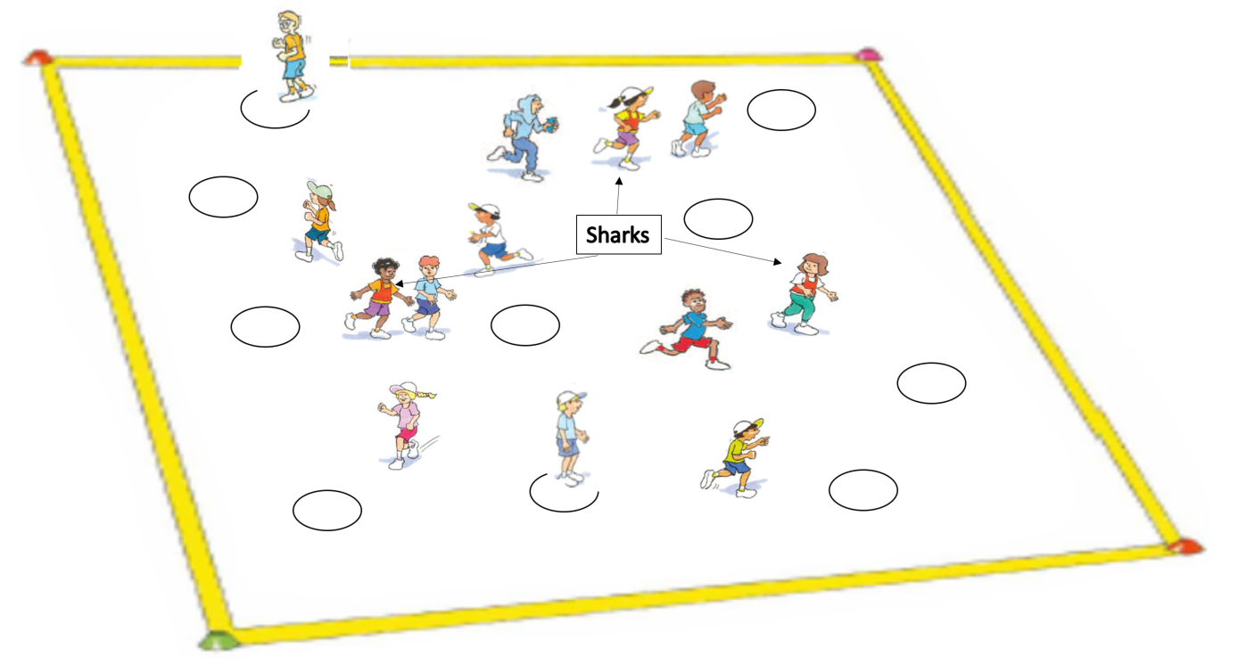
‘Sharks and sailors (Fast start) illustration’, Adapted from ‘Playing for life’ – Australian Sports Commission, https://www.sportaus.gov.au.
Discuss the questions:
- How did you decide when was an appropriate time to seek safety on an island away from a shark?
- How did you select the area or space to move in or towards? Consider both the shark and other sailors.
Variation
Change movements. For example, run, hop, jump, walk, side gallop. Ensure movements are inclusive of all student’s abilities.
Discussion
Explain that this lesson will again focus on the tactic/s that will support them when attacking in a territory game. Remind students of how the elements of movement, space and positioning, timing, effort, using equipment and communication, as discussed in Lessons 5 and 6, can be used when defending in a game.

Activity 2 – Modified soccer
Refer to instructions in Lesson 3 – Activity 2.
Play Modified soccer and ask students to consider how they may now reflect upon the tactics they use to attack, the tactics their opposition use to attack and how they can use this information to decide upon the most appropriate tactics to defend the space and goal.
Discussion
Explore the questions:
- When defending, how were the tactics similar between the modified netball/basketball and modified soccer games?
  - Sample student answers may include, positioning myself between the ball carrier and one of their team members to intercept the ball, timing my movements to interception the ball, communicating with team members about marking and positioning, effective movements to assist with marking and intercepting, watching where the attackers were moving to and whether my team members were marking them.
- How did the tactics when defending differ between the modified netball/basketball and the modified soccer game?
  - Sample student answers may include, in soccer the ball is on the ground so it was easier to regain possession by marking the other students closely and striking for the ball. We spread out more as defenders as the ball can be kicked further and travels faster in soccer so we had to be prepared to defend areas that weren’t as close to the ball.
Teacher notes
It is important to discuss with students that there are more similarities than differences with defensive tactics between these games.
The aim is for students to understand that the same defensive tactics can be applied to various game with minor adaptations and therefore their ability to play one game may be transferable to another.

Activity 3 – Modified soccer 2.0
Repeat the game with a different sized ball. This may be a tennis ball, large soft inflatable ball or a different shaped ball such as a rugby/AFL ball.
Discussion
- Explore the question, ‘How did your tactics change with the new piece of equipment when defending?’
  - Sample student answers may include, a tennis ball made it harder to pass so the defence had more opportunities to intercept. However due to the size of the tennis ball it is harder to intercept so we needed to watch the ball very carefully and move into better positions.
Reflection
Students reflect upon the learning in this activity/lesson and consider how it contributes towards answering the essential question How can I use tactics to be successful in games?

Lesson 8 – Tactics for defending
Lesson 8 – Assessment framework
Outcomes | Unit learning goals  Students are learning to: | Evidence of learning  Students can:
PD3-4 adapts movement skills in a variety of physical activity contexts. | Perform and adapt movement skills in a variety of activities or games. | Perform, combine and adapt locomotor, object control and/or stability skills in an activity or game. (Activity 1, 2, 3).
PD3-5 proposes, applies and assesses solutions to movement challenges. | Use knowledge of previous performances to develop and adapt tactics that achieve a goal/success in a variety of activities or games. | Reflect on previous performances to propose, apply, assess and refine tactics to be effective in territory games (Activity 2, 3).
PD3-10 selects and uses interpersonal skills to interact with others to promote inclusion and build connections. | Identify and use inclusive practices and team work when participating in physical activities. | Work collaboratively with others when working in small groups in movement tasks or challenges (Activity 1, 2, 3).
PD3-11 selects, manipulates and modifies movement skills and concepts to effectively create and perform movement sequences. | Identify, adapt and use movement concepts and movement skills in territory games. | Combine multiple elements of movement (space/positioning, movement, time), use of equipment and/or communication to successfully defend in territory games (Activity 2, 3).

Key inquiry questions and syllabus content
How can we adapt and perform movement skills in different situations?
Perform and refine movement skills to a variety of situations for example:
- Vary locomotor movement patterns to cater for variations in movement for example, sprinting, distance running, sidestepping, dodging and defensive/offensive game skills.
- Adapt movement techniques to cater for the use of different equipment and physical activities or games settings for example, accuracy, force, speed, distance, direction and control.
Practise specialised movement skills and apply them in a variety of movement sequences and situations for example:
- Apply locomotor and stability skills to create deception in different movement situations for example, dodging, faking a pass, field/court positioning.
- Refine object control skills to perform specialised movement patterns related to a variety of games and sports for example, bowl/pitch, shoulder pass, chest pass, bounce pass, forehand, backhand strike, serve, punt, drop kick, tag/touch.
- Apply kicking, striking and throwing skills to propel an object for accuracy and/or distance to maintain possession and/or implement strategies in games and sports, physical activities.
How can we use strategies and tactics to create solutions to movement challenges?
Apply critical and creative thinking to generate, create and access solutions to movement challenges for example:
- Recognise and consider a number of solutions to movement challenges and justify which solution is most appropriate or effective.
- Demonstrate defensive and offensive play in modified games.
- Implement tactics which account for their own strengths and the strengths of others in group and team activities.
- Explain the rationale for particular rules, strategies and tactics in individual/group/team physical activities, games and sports.
How can we work with others to build positive relationships during physical activity?
Participate positively in groups and teams by encouraging others and negotiating roles and responsibilities for example:
- Respond appropriately to others when working in small groups on movement tasks or challenges.
How responsible am I for my own and others’ health, safety and wellbeing?
Recognise how regular physical activity and movement situations promote enjoyment and positive outcomes for participants for example:
- Participate safely and positively in groups and teams by encouraging others and negotiating roles and responsibilities during physical activity for example, initiative/challenge physical activities.

Teaching and learning activities
Equipment
- markers
- 1 hoop per student
- touch football or equipment to replace the touch football.
Resource
Appendix 1.
Vocabulary
- tactics, modified, movement, space, positioning, time, equipment, communication, attack, defend, dodge, tag, territory game.

Activity 1 – Sharks and sailors (Fast start)
Refer to instructions in Lesson 7 – Activity 1. Different sample questions are provided below to explore how knowledge, understanding and skills have developed further.
Discussion
Discuss the questions:
- How did you communicate with other sailors to ensure you remained safe from the sharks?
- What tactics did you change from last lesson? Was this effective? What makes you say that?

Variation
Change movements. For example, run, hop, jump, walk, side gallop. Ensure movements are inclusive of all student’s abilities.
Discussion
Explain that this lesson will again focus on the tactic/s that will support them when attacking in a territory game.
Remind students of how the elements of movement, space and positioning, timing, effort, using equipment and communication, as discussed in Lessons 5-7, can be used when defending in a game.

Activity 2 – Modified touch football
Refer to instructions in Lesson 4 – Activity 2.
Play Modified touch football and ask students to consider how they may now reflect upon the tactics they use to attack, the tactics their opposition use to attack and how they can use this information to decide upon the most appropriate tactics to defend the space and goal.
Discussion
Explore the questions:
- When defending, how were the tactics similar between the modified netball/basketball/soccer and modified touch football games?
  - Sample student answers may include, positioning myself between the ball carrier and one of their team members to intercept the ball, timing my movements to intercept the ball, communicating with team members about marking and positioning, effective movements to assist with marking and intercepting, watching where the attackers were moving to and whether my team members were marking them.
- How did the tactics when defending differ between the modified netball/basketball/soccer and the modified touch football game?
  - Sample student answers may include, when defending in touch football we often had to perform the same movements at the same time to be effective as a team. In the other games we did not have to be in time with each other as often.
Teacher notes
This game of modified touch football builds on Lesson 7 by highlighting to students that there are more similarities than differences with defensive tactics across various games.
The aim is for students to understand that the same defensive tactics can be applied to many territory games with only minor adaptations and therefore their ability to play one game may be transferable to another.

Activity 3 – Modified touch football 2.0
Repeat the game with a different shaped or sized ball. This may be a tennis ball, large soft inflatable ball or a different sized rugby/AFL ball.
Discussion
Explore the following question:
- How did your tactics change with the new piece of equipment?
  - Sample student answers may include, a tennis ball was easier to run with and throw longer distances. However due to the size of the tennis ball it more difficult to catch so we had to be more accurate with our passes.
Reflection
Students reflect upon the learning in this activity/lesson and consider how it contributes towards answering the essential question ‘How can I use tactics to be successful in games?’ by completing the self–assessment on ‘Appendix 1’. Alternatively, the self–assessment in ‘Appendix 1’ may be adapted using one or more of the assessment tools available via the Digital Learning Selector.

Lesson 9 – Adjusting tactics
Lesson 9 – Assessment framework
Outcomes | Unit learning goals  Students are learning to: | Evidence of learning  Students can:
PD3-4 adapts movement skills in a variety of physical activity contexts. | Perform and adapt movement skills in a variety of activities or games. | Perform, combine and adapt locomotor, object control and/or stability skills in an activity or game. (Activity 1, 2, 3).
PD3-5 proposes, applies and assesses solutions to movement challenges. | Use knowledge of previous performances to develop and adapt tactics that achieve a goal/success in a variety of activities or games. | Reflect on previous performances to propose, apply, assess and refine tactics to be effective in territory games (Activity 2, 3).
PD3-10 selects and uses interpersonal skills to interact with others to promote inclusion and build connections. | Identify and use inclusive practices and team work when participating in physical activities. | Work collaboratively with others when working in small groups in movement tasks or challenges (Activity 1, 2, 3).
PD3-11 selects, manipulates and modifies movement skills and concepts to effectively create and perform movement sequences. | Identify, adapt and use movement concepts and movement skills in territory games. | Combine multiple elements of movement (space/positioning, movement, time), use of equipment and/or communication to successfully adjust tactics in response to rule changes in a game (Activity 2, 3).

Key inquiry questions and syllabus content
How can we adapt and perform movement skills in different situations?
Perform and refine movement skills to a variety of situations, for example:
- Vary locomotor movement patterns to cater for variations in movement for example, sprinting, distance running, sidestepping, dodging and defensive/offensive game skills.
- Adapt movement techniques to cater for the use of different equipment and physical activities or games settings for example, accuracy, force, speed, distance, direction and control.
Practise specialised movement skills and apply them in a variety of movement sequences and situations for example:
- Apply locomotor and stability skills to create deception in different movement situations for example dodging, faking a pass, field/court positioning.
- Refine object control skills to perform specialised movement patterns related to a variety of games and sports for example, bowl/pitch, shoulder pass, chest pass, bounce pass, forehand, backhand strike, serve, punt, drop kick, tag/touch.
- Apply kicking, striking and throwing skills to propel an object for accuracy and/or distance to maintain possession and/or implement strategies in games and sports, physical activities.
How can we use strategies and tactics to create solutions to movement challenges?
Apply critical and creative thinking to generate, create and access solutions to movement challenges for example:
- Demonstrate defensive and offensive play in modified games.
- Explain the rationale for particular rules, strategies and tactics in individual/group/team physical activities, games and sports.
How can we work with others to build positive relationships during physical activity?
Participate positively in groups and teams by encouraging others and negotiating roles and responsibilities for example:
- Respond appropriately to others when working in small groups on movement tasks or challenges.

Teaching and learning activities
Equipment
- markers
- basketball
- netball or various equipment to replace netball
- class set of bibs.
Vocabulary
- tactics, modified, movement, space, positioning, time, equipment, communication, attack, defend, dodge, bounce, territory game

Activity 1 – Pass and tag (Fast start)
Mark a playing area approximately 20 metres x 20 metres. Divide the class into pairs with one beanbag per pair. The pairs scatter around the playing area.
- When the teacher calls out ‘pass’, the students jog around the playing area, passing the beanbag to each other.
- When students hear the teacher call Tag, the student holding the beanbag chases their partner attempting to tag them. They have approximately 30 seconds to make a tag with the beanbag. Students return to jogging and passing around the playing area once the teachers calls ‘pass’.
Variations
- Change movements, for example, run, hop, jump, walk, side gallop.
- Include designated ‘safe zones’ where students cannot be tagged.
Discussion
Explain that this lesson will focus on modifying tactics to accommodate rule changes.
Explore with students that they will need to consider how they can use the following elements to be successful:
- Movement – type of movement they use, the speed of their movement.
- Space and positioning – where they stand, where they move to, how they support team members, where they stand to block or intercept a pass.
- Timing – when they move, pass or tackle (for example, tackling in soccer).
- Equipment – how they hold and/or use the equipment (for example, passing style), the force applied to the equipment.
- Communication – types of communication, what can be communicated to help the team (for example, signal for the ball, tell a team member they are marked, tell a team member where to pass the ball – ‘up the line’, pass it back’.)

Activity 2 – Modified netball
Refer to instructions in Lesson 1 – Activity 2.
Select from one of the following rule changes to implement. Where appropriate, allow students to choose the rule change. After playing the game for 5-10 minutes apply a new rule change. After applying several rule changes, the teacher may consider making multiple rule changes from the list below or one that has been selected or created by the students.
Rule changes may include:
- Replace the netball with a different piece of equipment, for example, tennis ball, rugby league ball, beanbag, vortex, soft frisbee.
- Nominate 1 player who is allowed to move across the entire court.
- All or a small selection of students must use a particular type of pass. For example, two-handed chest pass, bounce pass, shoulder pass, two-handed overhead pass.
Teacher notes
Ensure students have been briefed on appropriate safety measure that may be required with the new piece of equipment. For example, the use of a beanbag may lead to students colliding when attempting to pick it up.
Discussion
Explore the following questions:
- How did your tactics change with the new piece of equipment?
  - Sample student answers may include, a tennis ball made it easier to pass/harder to intercept so we could take more risks with passing, the rugby ball was harder to get into the hoop so I changed how I held and threw the ball, as the beanbag does not bounce I could concentrate on defending and intercepting aerial passes rather than bounce passes.
- What if you could select your own equipment other than a netball to play this game? What would you choose and how would your tactics change?
- How did your tactics change when one player was able to move across the different thirds of the court?

Activity 3 – Bounce attack (modified basketball)
Refer to instructions in Lesson 2 – Activity 2.
Select from one of the following rule changes to implement. Where appropriate, allow students to choose the rule change. After playing the game for 5-10 minutes apply a new rule change. After applying several rule changes, the teacher may consider making multiple rule changes from the list below or one that has been selected or created by the students.
Rule changes may include:
- All team members must touch the ball before scoring.
- Students must not hold the ball for any longer than 3 seconds.
- Introduce additional scoring zones.
Discussion
Explore the questions:
- How did your tactics change to suit the rule change?
  - Sample student answers may include, we made sure our strongest passers brought the ball forward first, moving into space/position quickly to support the ball carrier as they only had limited time to pass, we double marked an opposition team member so that it was difficult for them to have every team member touch the ball.
- What if you could select your own rule change to play this game? What would you choose and how would your tactics change?
Reflection
Students reflect upon the learning in this activity/lesson and consider how it contributes towards answering the essential question ‘How can I use tactics to be successful in games?’ by completing the self–assessment on Appendix 1. Alternatively, the self–assessment in ‘Appendix 1’ may be adapted using one or more of the assessment tools available via the Digital Learning Selector.

Lesson 10 – Adjusting tactics
Lesson 10 – Assessment framework
Outcomes | Unit learning goals  Students are learning to: | Evidence of learning  Students can:
PD3-4 adapts movement skills in a variety of physical activity contexts. | Perform and adapt movement skills in a variety of activities or games. | Perform, combine and adapt locomotor, object control and/or stability skills in an activity or game. (Activity 1, 2, 3).
PD3-5 proposes, applies and assesses solutions to movement challenges. | Use knowledge of previous performances to develop and adapt tactics that achieve a goal/success in a variety of activities or games. | Reflect on previous performances to propose, apply, assess and refine tactics to be effective in territory games (Activity 2, 3).
PD3-10 selects and uses interpersonal skills to interact with others to promote inclusion and build connections. | Identify and use inclusive practices and team work when participating in physical activities. | Work collaboratively with others when working in small groups in movement tasks or challenges (Activity 1, 2, 3).
PD3-11 selects, manipulates and modifies movement skills and concepts to effectively create and perform movement sequences. | Identify, adapt and use movement concepts and movement skills in territory games. | Combine multiple elements of movement (space/positioning, movement, time), use of equipment and/or communication to successfully adjust tactics in response to rule changes in a game (Activity 2, 3).

Key inquiry questions and syllabus content
How can we adapt and perform movement skills in different situations?
Perform and refine movement skills to a variety of situations for example:
- Vary locomotor movement patterns to cater for variations in movement for example, sprinting, distance running, sidestepping, dodging and defensive/offensive game skills.
- Adapt movement techniques to cater for the use of different equipment and physical activities or games settings for example, accuracy, force, speed, distance, direction and control.
Practise specialised movement skills and apply them in a variety of movement sequences and situations for example:
- Apply locomotor and stability skills to create deception in different movement situations for example, dodging, faking a pass, field/court positioning.
- Refine object control skills to perform specialised movement patterns related to a variety of games and sports for example, bowl/pitch, shoulder pass, chest pass, bounce pass, forehand, backhand strike, serve, punt, drop kick, tag/touch.
- Apply kicking, striking and throwing skills to propel an object for accuracy and/or distance to maintain possession and/or implement strategies in games and sports, physical activities.
How can we use strategies and tactics to create solutions to movement challenges?
Apply critical and creative thinking to generate, create and access solutions to movement challenges for example:
- Recognise and consider a number of solutions to movement challenges and justify which solution is most appropriate or effective.
- Demonstrate defensive and offensive play in modified games.
- Implement tactics which account for their own strengths and the strengths of others in group and team activities.
- Explain the rationale for particular rules, strategies and tactics in individual/group/team physical activities, games and sports.
How can we work with others to build positive relationships during physical activity?
Participate positively in groups and teams by encouraging others and negotiating roles and responsibilities for example:
- Respond appropriately to others when working in small groups on movement tasks or challenges.
How responsible am I for my own and others’ health, safety and wellbeing?
Students recognise how regular physical activity and movement situations promote enjoyment and positive outcomes for participants for example:
- Observe and explain how individual strengths and teamwork contribute to achieving success in physical activities.

Teaching and learning activities
Equipment
- markers
- bean bags.
Resources
Appendix 1.
Vocabulary
- tactics, modified, movement, space, positioning, time, equipment, communication, attack, defend, territory game.

Activity 1 -Tag and pass (Fast start)
Refer to instructions in Lesson 9 – Activity 1.
Variations
- Change movements. for example, run, hop, jump, walk, side gallop.
- Incorporate designated ‘safe zones’ where students cannot be tagged.
Discussion
Explore the question:
- What rules could we change to make the game more challenging and how would this affect your tactics?’ For example, increasing the playing area we would need to move quickly and time our tactical movements such as side steps/dodge to avoid being tagged.
Teacher notes
Rules can be applied to all aspects of the game, including type of equipment, positioning of students and/or zones of a playing area, number of students in a game or team, time limits, movement styles used, scoring systems. These can be suggested to students to prompt thinking.
Discussion
Reflect upon the previous lesson by discussing how rule changes can impact on the tactics used in games. Explore with students the nominated rule changes and impact on tactics in the games ‘Modified netball and basketball’ played in Lesson 9.
Explore with students that they will need to consider how they can use the following elements to be successful:
- Movement – type of movement they use, the speed of their movement.
- Space and positioning – where they stand, where they move to, how they support team members, where they pass to.
- Timing – when they move, pass or tackle (for example, tackling in soccer).
- Equipment – how they hold and/or use the equipment (for example, passing style), the force applied to the equipment.
- Communication – types of communication, what can be communicated to help the team (for example, signal for the ball, tell a team member they are marked, tell a team member where to pass the ball – ‘up the line’, pass it back’).

Activity 2
As a class select a game from this unit and discuss possible rule changes. Select one rule change and play the game with students applying their own tactical changes.
Teacher notes
The teacher and students may provide possible rule changes for Activity 3. The teacher may be able to identify a rule change/s that increase the difficulty of the tactical decisions to be made by students.
Discussion
Explore the questions:
- How did your tactics change?
- Did these changes help you be more successful in the game? Explain.

Activity 3
Select from the two options of:
- Playing the same game, select and implement another rule change and repeat the process of evaluating and changing tactics.
- Select a different game, select and implement a rule change and repeat the process of evaluating and changing tactics.
Discussion
Explore the questions:
- How did your tactics change?
- Did these changes help you be more successful in the game?
Reflection
Students reflect upon the learning in this activity/lesson and consider how it contributes towards answering the essential question How can I use tactics to be successful in games? by completing the self–assessment on Appendix 1. Alternatively, the self–assessment in Appendix 1 may be adapted using one or more of the assessment tools available via the Digital Learning Selector.

Appendix 1 – Self assessment
Student name:
Circle or colour the most appropriate box.
Self-assessment table
Success criteria | I need help to learn to: | I am still learning to: | I have learned to
By the end of lesson 4 | Combine and use elements of space/positioning, movement, time, equipment and communication to successfully attack in territory games. | Combine and use elements of space/positioning, movement, time, equipment and communication to successfully attack in territory games. | Combine and use elements of space/positioning, movement, time, equipment and communication to successfully attack in territory games.
By the end of lesson 4 | Work collaboratively with others in small groups to successfully attack in territory games. | Work collaboratively with others in small groups to successfully attack in territory games. | Work collaboratively with others in small groups to successfully attack in territory games.
By the end of lesson 8 | Combine and use elements of space/positioning, movement, time, equipment and communication to successfully defend in territory games. | Combine and use elements of space/positioning, movement, time, equipment and communication to successfully defend in territory games. | Combine and use elements of space/positioning, movement, time, equipment and communication to successfully defend in territory games.
By the end of lesson 8 | Work collaboratively with others in small groups to successfully defend in territory games. | Work collaboratively with others in small groups to successfully defend in territory games. | Work collaboratively with others in small groups to successfully defend in territory games.
By the end of lesson 10 | Combine and use elements of space/positioning, movement, time, equipment and communication to successfully adjust tactics in response to rule changes. | Combine and use elements of space/positioning, movement, time, equipment and communication to successfully adjust tactics in response to rule changes. | Combine and use elements of space/positioning, movement, time, equipment and communication to successfully adjust tactics in response to rule changes.
By the end of lesson 10 | Work collaboratively with in small groups to successfully adjust tactics in response to rule changes. | Work collaboratively with in small groups to successfully adjust tactics in response to rule changes. | Work collaboratively with in small groups to successfully adjust tactics in response to rule changes.

Appendix 2 – Evaluation
Teacher analysis of the teaching and learning in the entire unit of work. Sample questions to address include:
Unit evaluation and teacher notes
Evaluation | Teacher notes
How well did the class demonstrate understanding of key concepts? | Write notes here.
What concepts/topics will I need to revisit to support student understanding? | Write notes here.
When will these concepts be revisited? | Write notes here.
How well were student learning needs met? | Write notes here.
Did all students have opportunities to demonstrate their knowledge, understanding and skills? | Write notes here.
Did adjustments provide adequate and appropriate access to all activities by all students? | Write notes here.
Were the resources used accessible for all students? | Write notes here.
Which activities in the learning sequence will I need to adapt to ensure better achievement of learning goals? | Write notes here.
Did the learning sequence provide sufficient opportunities to make quality assessment judgements about student achievement? | Write notes here.

Appendix 3 – Glossary
Attackers – A team who are trying to score, usually with a ball/object.
Boundaries – A line which marks the limits of an area.
Defenders – A team trying to stop the opposition (attackers) from scoring.
Territory games – Games, usually team based, which the purpose is to invade the opponent’s territory and score points while keeping the opposing teams points to a minimum.
Locomotor skills – Locomotor movement is when you move from one place to another. Locomotor skills include walking, climbing, rolling, balancing, sliding, jogging, running, leaping, jumping, hopping, dodging, galloping, skipping, floating and moving the body through water to safety.
Modified games – Games or sports that are simplified to suit the skills, strategic understandings and characteristics of students through changes to the game’s constraints such as rules, equipment and/or the sizer of the playing area.
Non-locomotor skills – Moving on the spot without any change in location. These skills include bending, stretching, twisting, turning, swinging, inverted supports, landing/stopping, balancing.
Tackle/tackling – Tackle/tackling is a generic term used when a student attempts to gain/re-gain possession of the ball/object from an opposition student. Under no circumstances should students make physical contact with another student to achieve this.
Tactical knowledge – An understanding of when, how and why to apply tactics in game situations.
Tactics – A plan, idea or action to successfully achieve a goal or outcome during a movement activity.

Appendix 4 – Assessment framework
Assessment framework
Outcomes | Unit learning goals  Students are learning to: | Evidence of learning  Students can:
What syllabus outcomes will be assessed throughout this unit of work. Refer to pages 14-19 of the PDHPE K-10 syllabus. | What are students expected to know, understand and do as a result of the learning within this unit of work. These are derived from the identified syllabus outcomes. | What specific behaviours will you expect to observe and use as an indicator of student learning towards the Student learning goals.  These are derived from the Student learning goals, NSW Physical Literacy Continuum K-10 cluster markers and cluster examples. Refer to Appendix 2 for more detail.
PD3-4 adapts movement skills in a variety of physical activity contexts. | Perform and adapt movement skills in a variety of activities or games. | Perform, combine and adapt locomotor, object control and/or stability skills in an activity or game.  Lesson 1 – Activity 1, 2, 3  Lesson 2 – Activity 1, 2, 3  Lesson 3 – Activity 1, 2, 3  Lesson 4 – Activity 1, 2, 3  Lesson 5 – Activity 1, 2, 3  Lesson 6 – Activity 1, 2, 3  Lesson 7 – Activity 1, 2, 3  Lesson 8 – Activity 1, 2, 3  Lesson 9 – Activity 1, 2, 3  Lesson 10 – Activity 1, 2, 3.
PD3-5 proposes, applies and assesses solutions to movement challenges. | Use knowledge of previous performances to develop and adapt tactics that achieve a goal/success in a variety of activities or games. | Reflect on previous performances to propose, apply, assess and refine tactics to be effective in territory games.  Lesson 1 – Activity 2, 3  Lesson 2 – Activity 2, 3  Lesson 3 – Activity 2, 3  Lesson 4 – Activity 2, 3  Lesson 5 – Activity 2, 3  Lesson 6 – Activity 2, 3  Lesson 7 – Activity 2, 3  Lesson 8 – Activity 2, 3  Lesson 9 – Activity 2, 3  Lesson 10 – Activity 2, 3.
PD3-10 selects and uses interpersonal skills to interact with others to promote inclusion and build connections. | Identify and use inclusive practices and team work when participating in physical activities. | - Work collaboratively with others when working in small groups in movement tasks or challenges.  Lesson 1 – Activity 1, 2, 3  Lesson 2 – Activity 1, 2, 3  Lesson 3 – Activity 1, 2, 3  Lesson 4 – Activity 1, 2, 3  Lesson 5 – Activity 1, 2, 3  Lesson 6 – Activity 1, 2, 3  Lesson 7 – Activity 1, 2, 3  Lesson 8 – Activity 1, 2, 3  Lesson 9 – Activity 1, 2, 3  Lesson 10 – Activity 1, 2, 3.  - Understand and explain the contribution of different positions/roles in a team playing a territory game and how individual strengths can be matched to these  Lesson 1 – Activity 2, 3  Lesson 2 – Activity 2, 3  Lesson 5 – Activity 2, 3  Lesson 6 – Activity 2, 3.
PD3-11 selects, manipulates and modifies movement skills and concepts to effectively create and perform movement sequences. | Identify, adapt and use movement concepts and movement skills in territory games. | - Combine multiple elements of movement (space/positioning, movement, time), use of equipment and/or communication to successfully attack in territory games.  Lesson 1 – Activity 2, 3  Lesson 2 – Activity 2, 3  Lesson 3 – Activity 2, 3  Lesson 4 – Activity 2, 3).  - Combine multiple elements of movement (space/positioning, movement, time), use of equipment and/or communication to successfully defend in territory games  Lesson 5 – Activity 2, 3  Lesson 6 – Activity 2, 3  Lesson 7 – Activity 2, 3  Lesson 8 – Activity 2, 3.  - Combine multiple elements of movement (space/positioning, movement, time), use of equipment and/or communication to successfully adjust tactics in response to rule changes in a game  Lesson 9 – Activity 2, 3  Lesson 10 – Activity 2, 3.

Appendix 5 – Images to support key terms
These images are licensed under CC BY NC ND 3.0 AU. Image modified with the permission of the Australian Sports Commission (for use in this publication only).
Tag – to touch an opponent with your hand or other safe object.
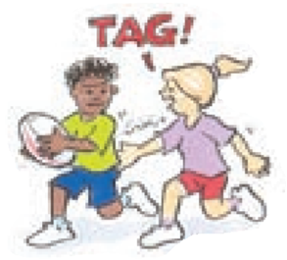
‘Tag illustration’, Adapted from ‘Playing for life’ – Australian Sports Commission, https://www.sportaus.gov.au.
Attackers – team who are to trying score, usually with the ball/object.
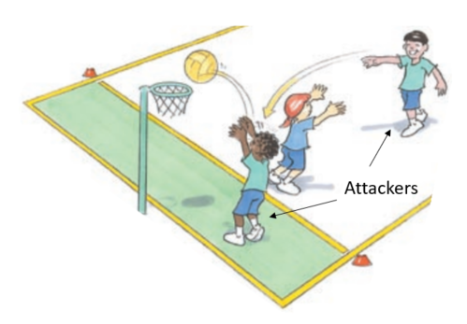
‘Attackers illustration’, Adapted from ‘Playing for life’ – Australian Sports Commission, https://www.sportaus.gov.au.

Defenders – team trying to stop the opposition from scoring.
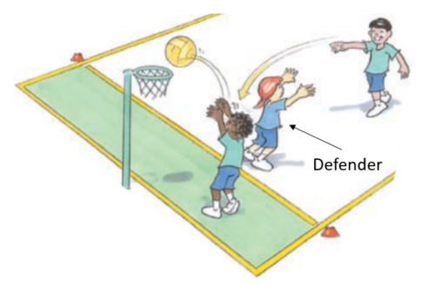
‘Defenders illustration’, Adapted from ‘Playing for life’ – Australian Sports Commission, https://www.sportaus.gov.au.
Equipment – items used to play a game.
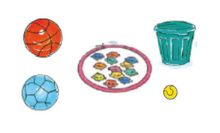
‘Equipment illustration’, Adapted from ‘Playing for life’ – Australian Sports Commission, https://www.sportaus.gov.au.

Space – an area away from other players.
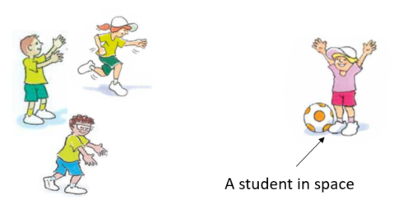
‘Space illustration’, Adapted from ‘Playing for life’ – Australian Sports Commission, https://www.sportaus.gov.au.
Boundaries – the limit of the playing area.
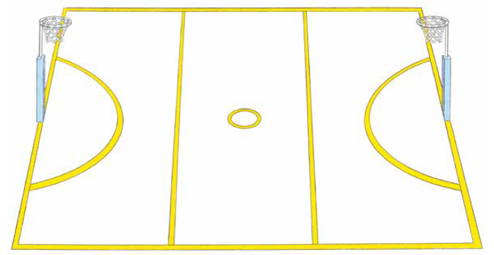
‘Boundaries illustration’, Adapted from ‘Playing for life’ – Australian Sports Commission, https://www.sportaus.gov.au.

Roll ball – to roll a ball under the foot, from front to back.
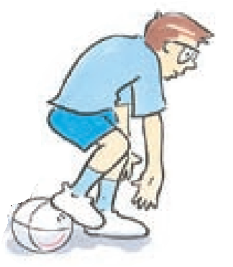
‘Roll ball illustration’, Adapted from ‘Playing for life’ – Australian Sports Commission, https://www.sportaus.gov.au.
Scoop up – to pick the ball up off the ground while moving.
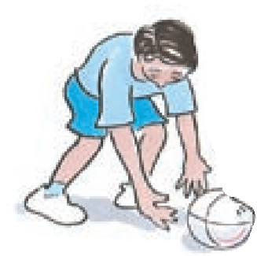
‘Scoop-up illustration’, Adapted from ‘Playing for life’ – Australian Sports Commission, https://www.sportaus.gov.au.

Intercept –to take possession of the ball when the opposition have passed it, usually with a throw, strike or kick.
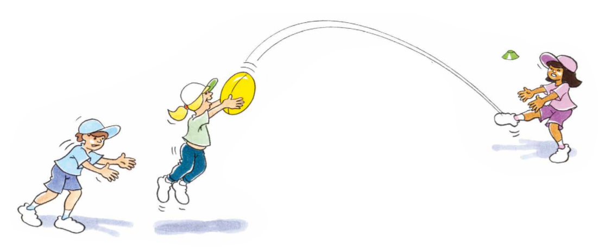
‘Intercept illustration’, Adapted from ‘Playing for life’ – Australian Sports Commission, https://www.sportaus.gov.au.
Team – players who are working together to achieve the same goal.
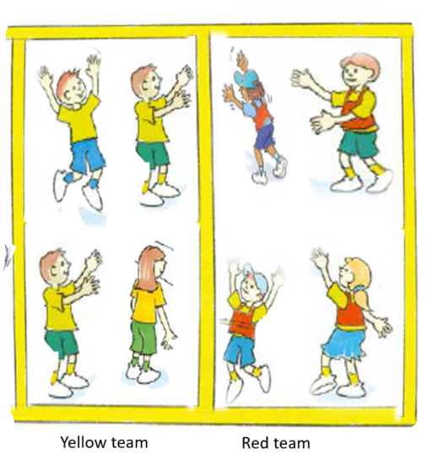
‘Team illustration’, Adapted from ‘Playing for life’ – Australian Sports Commission, https://www.sportaus.gov.au.
Scoring – to achieve the aim of the game, usually by putting an object in a goal or over a line.
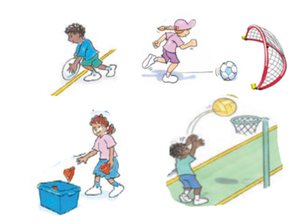
‘Scoring illustration’, Adapted from ‘Playing for life’ – Australian Sports Commission, https://www.sportaus.gov.au.
Dodging – changing directions quickly to avoid an opponent.
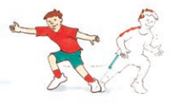
‘Dodging illustration’, Adapted from ‘Playing for life’ – Australian Sports Commission, https://www.sportaus.gov.au.

Kick – to hit an object with the foot.
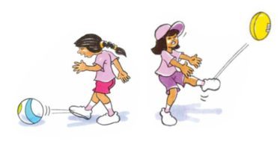
‘Kick illustration’, Adapted from ‘Playing for life’ – Australian Sports Commission, https://www.sportaus.gov.au.
Throw – to release a ball with force from a hand.
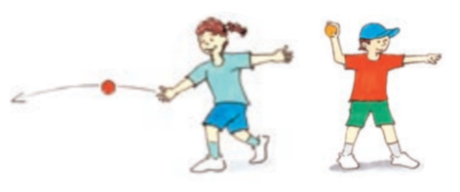
‘Throw illustration’, Adapted from ‘Playing for life’ – Australian Sports Commission, https://www.sportaus.gov.au.

Catch – using hands to prevent a ball from hitting the ground.
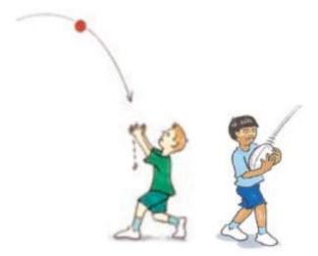
‘Catch illustration’, Adapted from ‘Playing for life’ – Australian Sports Commission, https://www.sportaus.gov.au.
Bounce – to drop or throw a ball to the ground and retain possession.
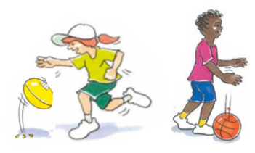
‘Bounce illustration’, Adapted from ‘Playing for life’ – Australian Sports Commission, https://www.sportaus.gov.au.

Balance an object – to keep one object on top of another without it hitting the ground or falling over.
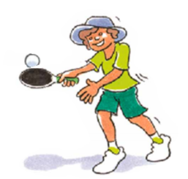
‘Balance an object illustration’, Adapted from ‘Playing for life’ – Australian Sports Commission, https://www.sportaus.gov.au.
Pass – when an object or ball is sent to a team mate, usually by throw, strike or kick.
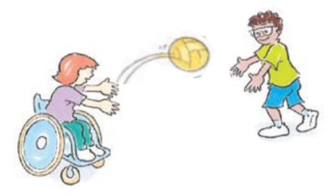
‘Pass illustration’, Adapted from ‘Playing for life’ – Australian Sports Commission, https://www.sportaus.gov.au.

Receive – to get a ball from a team mate, usually from a throw, strike or kick.
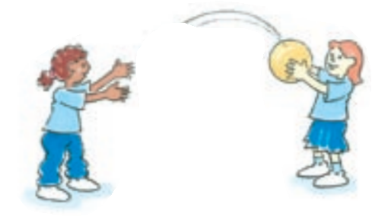
‘Receive illustration’, Adapted from ‘Playing for life’ – Australian Sports Commission, https://www.sportaus.gov.au.
Run – a locomotor movement alternating legs to move across the ground.
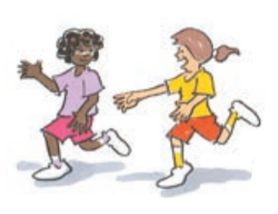
‘Run illustration’, Adapted from ‘Playing for life’ – Australian Sports Commission, https://www.sportaus.gov.au.

Jump – a locomotor movement using two feet to spring up into the air or across the ground.
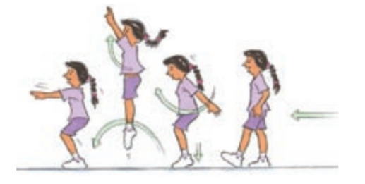
‘Jump illustration’, Adapted from ‘Playing for life’ – Australian Sports Commission, https://www.sportaus.gov.au.
Hop – a locomotor movement using the same foot touching the ground.
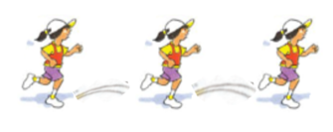
‘Hop illustration’, Adapted from ‘Playing for life’ – Australian Sports Commission, https://www.sportaus.gov.au.

Skip – a locomotor movement using a step-hop pattern or a term used when jumping over a rope.
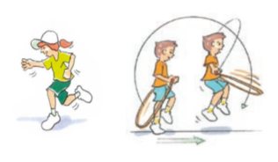
‘Skip illustration’, Adapted from ‘Playing for life’ – Australian Sports Commission, https://www.sportaus.gov.au.
Balance – to maintain stability and avoid falling over.
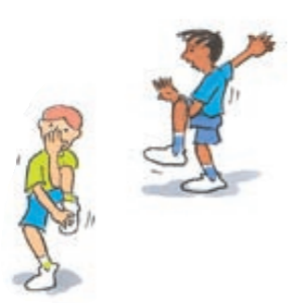
‘Balance illustration’, Adapted from ‘Playing for life’ – Australian Sports Commission, https://www.sportaus.gov.au.

Leap – a locomotor movement using a long stride from one foot and landing on the other.
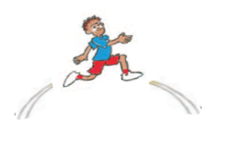
‘Leap illustration’, Adapted from ‘Playing for life’ – Australian Sports Commission, https://www.sportaus.gov.au.
Rolling – to rotate an object or person across the ground.
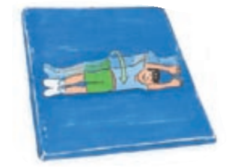
‘Rolling illustration’, Adapted from ‘Playing for life’ – Australian Sports Commission, https://www.sportaus.gov.au.

Striking – to hit an object or ball with another object such as a bat.
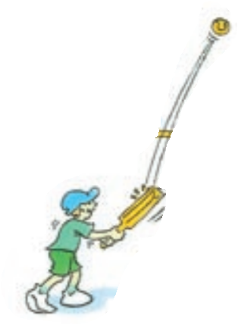
‘Striking illustration’, Adapted from ‘Playing for life’ – Australian Sports Commission, https://www.sportaus.gov.au.
Bend – to move the body by making the joint angles smaller.
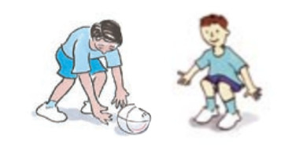
‘Bend illustration’, Adapted from ‘Playing for life’ – Australian Sports Commission, https://www.sportaus.gov.au.

Twist – to rotate the body around a central point.
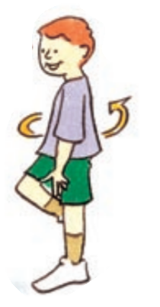
‘Twist illustration’, Adapted from ‘Playing for life’ – Australian Sports Commission, https://www.sportaus.gov.au.

Appendix 6 – Physical literacy cluster markers
The following NSW Physical Literacy Continuum K-10 cluster markers guided the development of the ‘Evidence of Learning’ (EoL) as observable behaviours to address the Student learning goals and identified syllabus outcomes.

Movement competencies
- Refines stability, locomotor and object control skills in controlled physical activity contexts to improve the efficiency (process) and effectiveness of movement (outcome).
- Applies movement skills to perform sequences in dynamic physical activity contexts.

Tactical movement
- Applies multiple tactics within a physical activity, for example, shows they have a number of options in a situation to change the way they move.
- Implements tactics which account for the strengths of self and others within a physical activity.
- Recognises similarities and differences between tactics used to achieve specific purposes in physical activities.

Motivation and behavioural skills
- Persists with challenging physical activities and understands how success through persistence can have positive outcomes.
- Takes initiative to work independently in a range of physical activities.
- Participates in physical activity with confidence and purpose.

Personal and social attributes
- Consciously participates within the rules and etiquette of different physical activities.
- Adopts roles where appropriate in physical activity, such as. leader.

Appendix 7 – Attributions
© State of New South Wales (Department of Education), 2021. All material in this resource, except as identified below, is licensed under the Creative Commons Attribution 4.0 International Licence. To view a copy of this licence, visit http://creativecommons.org/licenses/by/4.0/.’
Material that is not licensed under the Creative Commons Attribution 4.0 International Licence:
The following images by Australian Sports Commission – https://www.sportaus.gov.au are licensed under CC BY NC ND 3.0 AU. These images have been modified with the permission of the Australian Sports Commission (for use in this publication only):
- Page 7 – Treasure chest illustration.
- Page 10 – Modified netball illustration.
- Page 17 – Bounce attack (modified basketball) illustration.
- Page 23 – Tag and pass (fast start) illustration.
- Page 24 – Modified soccer illustration.
- Page 30 – Modified touch football illustration.
- Page 35 – Dynamite or modified touch football (fast start) illustration.
- Page 49 – Sharks and sailors illustration.
- Page 50 – Scoop tag illustration 1.
- Page 55 – Tricky touch down illustration 1.
- Page 63 – Tag illustration, Attackers illustration.
- Page 64 – Defenders illustration, Equipment illustration.
- Page 65 – Space illustration, Boundaries illustration.
- Page 66 – Roll ball illustration, Scoop-up illustration.
- Page 67 – Intercept illustration, Team illustration.
- Page 68 – Scoring illustration, Dodging, illustration.
- Page 69 – Kick illustration, Throw illustration.
- Page 70 – Catch illustration, Bounce illustration.
- Page 71 – Balance objects illustration, Pass illustration.
- Page 72 – Receive illustration, Run illustration.
- Page 73 – Jump illustration, Hop illustration.
- Page 74 – Skip illustration, Balance illustration.
- Page 74 – Leap illustration, Rolling illustration.
- Page 76 – Striking illustration, Bend illustration.
- Page 77 – Twist illustration.

