How can we solve problems when moving?
PDHPE Stage 1 student workbook lesson 5-6
Name:
Class:

Overview
You will:
- create rules to apply a scoring system with different targets (lesson 5)
- perform the overarm throw using 4 key components (lesson 5)
- reflect upon your performance and identify ways to perform a throw more successfully (lessons 5).
- demonstrate and compare different types of kicks and identify which ones are easier and harder (lesson 6).
- identify key components that positively contribute to a successful kick (lesson 6)
- demonstrate safe play by identifying appropriate equipment and places to use lessons 5-6).

Resources
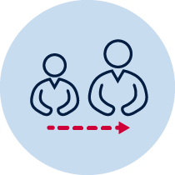
- Help from an adult
- A soft object to throw (for example, soft ball, pair of socks, soft toy, scrunched-up paper)
- An object or landmark to create a target for the object to hit (for example, bucket, a long piece of string laid in a circle, an ‘X’ formed by two pieces of tape/material, a t-shirt laid on the ground, a chair/bench, a wall, a tree)
Refer to ‘Hit the target’ game card for suggestions of what this activity could look like. (Sport Australia, 2019. Playing for life) Images are included in this workbook for guidance.

Lesson 5 – Choose your score
5.1 Discuss the following reflective questions before beginning:
- What types of throw have you used in previous weeks?
- Which type of throw did you prefer to use? Why?
- Name the four important components to remember when performing the overarm throw.
5.2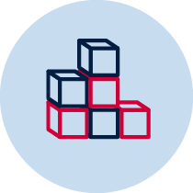Choose a safe playing area where you can throw a number of soft objects. Create 5 targets that you can safely throw a soft object towards. Place each of these targets at different distances from the ‘starting line’.
5.3Give each target a different point value. Consider how far the target is from the ‘starting line’ and the size of the target compared to others. The target you consider to be the hardest to hit should be worth 5 points. The easiest to hit should be worth 1 point.
5.4Discuss with your teacher or parent/caregiver how you decided the point value for your 5 targets.
5.5Review the pictures below for an example of the throw overarm. Focus on these important parts while throwing
- Eyes (Eyes focused on target area throughout the throw.)
- Side on (Stand side-on to target area.)
- Step forward (Step towards target area with opposite foot to throwing arm.)
- Follow through (Throwing arm follows through, down and across the body.)
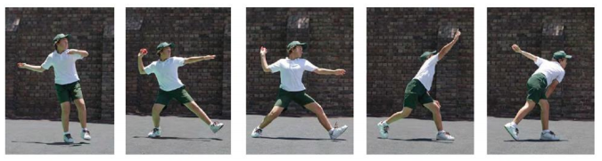
5.6Remember
Eyes
Side on
Step forward
Follow through
5.7Play ‘Choose your score’ using the overarm throw. To complete the challenge you need to hit all of your 5 targets and score 15 points. You may choose the order in which you attempt to hit the targets.
5.8Discuss with your teacher or parent/caregiver if you think the placement of your targets based on their point value is suitable. Make any adjustments that you think you need to.
5.9Play ‘Choose your score’ for a total of 5 times. Each time you play change the order that you try to hit the targets. Record how many throws were required to score 15 points.
Table 1 Choose your score
Attempt 1 | Attempt 2 | Attempt 3 | Attempt 4 | Attempt 5

5.10Discuss the following reflective questions with your teacher or parent/caregiver.
- Identify the four important parts of an overarm throw.
- How did you adjust your throw for each of the different targets?
- How do you think you could change your throwing so it is more accurate?
5.11Play ‘Choose your score’ again. You may choose the number of points needed and which targets you will aim for to make that score.
For example, you may choose the target score to be 24 points. You decide that you will try to hit the 5 point target four times then the 4 point target.
Record your target score and how many throws you needed to achieve it.
Table 2 Choose your score
Score | Attempt 1 | Attempt 2 | Attempt 3
5.12 Discuss the following reflective questions with your teacher or parent/caregiver.
- How did you adjust your throw for each of the different targets?
- How do you think you could change your throwing so it is more accurate?
Record your answers

Lesson 6 – Kicking – goals and goals - step or no step
Students:
6.1 In previous lessons you have performed and compared different types of throws. Discuss the following reflective questions before beginning:
- What types of throw have you used in previous weeks?
- Can you identify any parts of the throw that may also help you when you kick?
6.2Choose a safe playing area where you can kick a ball or soft object. Create a large goal that you can safely kick a ball/object towards.
Create a smaller goal in the centre of the large goal. This will provide you with an opportunity to refine your kicking.
Table 3 Step or no step examples
Step or no step examples
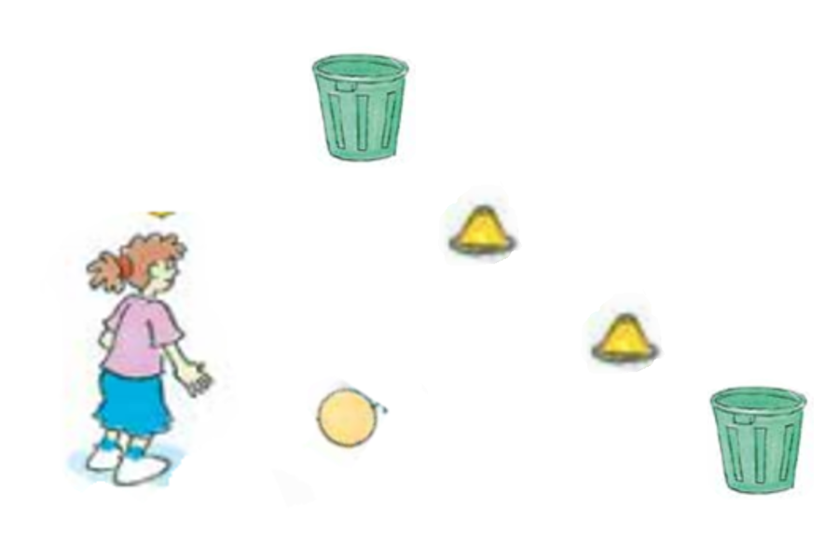  Two yellow cones form the small goal. Two green bins form the large goal. | 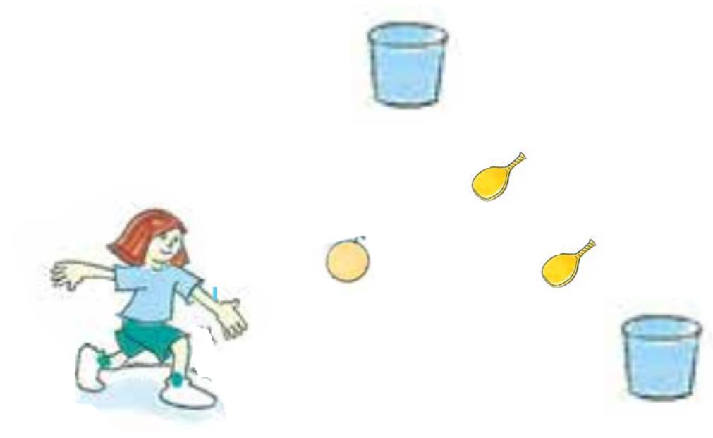  Two yellow racquets form the small goal. Two blue buckets form the large goal.
6.3Your challenge is to compare two different ways to kick your ball/object. The two ways are:
- Stand and kick
- Step forward and kick
6.4Kick the ball/object towards the goal. You should aim to score a goal by kicking the ball/object through the small goal.
6.5Repeat the challenge 5 times for each type of kick attempting to score a goal by kicking the ball/object through the goal.
6.6Record whether you scored through the small goal, large goal or missed the goal (no goal) by circling your result.
Table 4 Step or no step – Goal 1
Step or no step | Attempt 1 | Attempt 2 | Attempt 3 | Attempt 4 | Attempt 5
Stand and kick | Small goal  Large goal  No goal | Small goal  Large goal  No goal | Small goal  Large goal  No goal | Small goal  Large goal  No goal | Small goal  Large goal  No goal
Step and kick | Small goal  Large goal  No goal | Small goal  Large goal  No goal | Small goal  Large goal  No goal | Small goal  Large goal  No goal | Small goal  Large goal  No goal
6.7Discuss the following reflective questions with your teacher or parent/caregiver.
- What type of kick was most successful? Why?
- Which type of kick was most comfortable for you to perform? Why?
- Why do you think taking a step forward help you when you kick?
- How do you think you can adjust your kick to be more accurate?
6.8Move the goals or the starting line so you have to kick the ball/object a different distance.
6.9 Repeat the challenge 5 times for each type of kick attempting to score a goal.
Table 5 Step or no step – Target 2
Step or no step | Attempt 1 | Attempt 2 | Attempt 3 | Attempt 4 | Attempt 5
Stand and kick | Small goal  Large goal  No goal | Small goal  Large goal  No goal | Small goal  Large goal  No goal | Small goal  Large goal  No goal | Small goal  Large goal  No goal
Step and kick | Small goal  Large goal  No goal | Small goal  Large goal  No goal | Small goal  Large goal  No goal | Small goal  Large goal  No goal | Small goal  Large goal  No goal
6.10Discuss the following reflective questions with your teacher or parent/caregiver.
- What type of kick was successful? Why?
- How did you adjust your kick for the goal at a different distance when performing the stand and kick?
- How did you adjust your kick for the goal at a different distance when performing the step and kick?
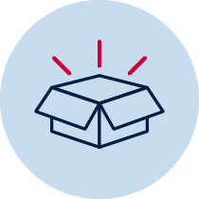
Resources
- Soft objects to throw (for example, soft ball, pair of socks, soft toy, scrunched-up paper)
- ‘Overarm throw Stage 1’ card

