Student workbook – How can we solve problems when moving?
Name:
Class:

Overview of lessons 3 and 4
You will:
- demonstrate and compare different types of throws and identify which ones are easier and harder (lesson 3-4).
- predict possible outcomes while using different types of throws and pieces of equipment (lesson 3).
- reflect upon your performance and identify ways to perform a throw more successfully (lessons 3-4).
- demonstrate safe play by identifying appropriate equipment and places to use lessons 3-4).

Resources
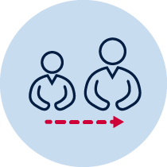
- Help from an adult
- A soft object to throw (for example, soft ball, pair of socks, soft toy, scrunched-up paper).
- An object or landmark to create a target for the object to hit (for example, bucket, a long piece of string laid in a circle, an ‘X’ formed by two pieces of tape/material, a t-shirt laid on the ground, a chair/bench, a wall, a tree).
- Refer to ‘Hit the target’ game card for suggestions of what this activity could look like. (Sport Australia, 2019. Playing for life) Images are included in this workbook for guidance.

Lesson 3 – Bullseye
Play the game ‘Bullseye’. Students:
3.1 Discuss the following reflective questions before beginning:
- What types of throw have you used in previous weeks?
- Which type of throw did you prefer to use? Why?
- Name the four important components to remember when performing the overarm throw.
3.2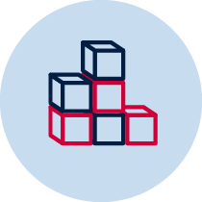 Create a target that you can safely throw a soft object towards. If possible, create two larger rings around the centre target to create a ‘bullseye’.
  - Select 1 soft object that is safe to throw.
3.4 Choose a ‘starting point’ where you will throw the object from.
3.5 Discuss the following predictive questions before beginning:
Which throwing style do you think will score most points? Why? (Throwing styles are underarm, overarm and your own chosen style)
3.6 Throw each object and attempt to hit the target as close to the centre as possible. Closer to the centre of the target scores more points.
Have 5 attempts using each throwing style (underarm, overarm and your own style). Adjust the position of the ‘starting point’ each time.

3.7 Revisit the predictive question before beginning throwing at a new target. The discussion question is:
  - Which throwing style do you think will score most points? Why?
Table 1 - Bullseye example
Bullseye
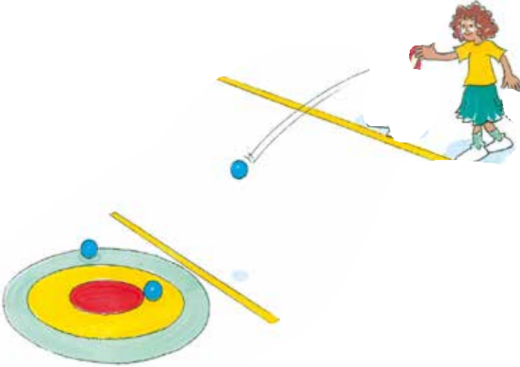 | 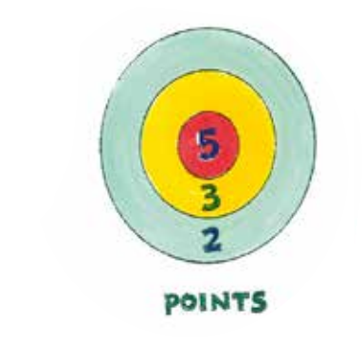
‘Starting point’ may be about 3-5 metres from the target for the first attempt.  Before beginning each attempt, discuss the questions with your teacher or parent/caregiver:  Which throwing style do you think will score most points? Why? | If you’re unable to create a target with three rings as shown above, a sample scoring system may be:  - 5 points if the object hits or lands on the target  - 3 points if the object lands within one step of the target  - 2 points if the object lands within two steps of the target

3.8Record the amount of points you score for each attempt. Remember, move the starting point for each attempt.
Table 2 – Points scored for each throwing style
Type of throw | Attempt 1 | Attempt 2 | Attempt 3 | Attempt 4 | Attempt 5
Underarm
Overarm
Your own throwing style
3.9Discuss the following reflective questions with your teacher or parent/caregiver.
- What type of throw was successful? Why?
- What type of throw was unsuccessful? Why?
- For each type of throw, what did you do with your body so your throw was accurate?
- How do you think you could change your throwing style so it is more accurate?
- Recently you have used the overarm throw, do you think any of the throwing styles you used were more effective than the overarm throw technique? Why?
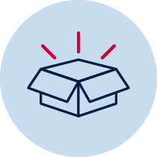 Resources
- A soft object to throw (for example, soft ball, pair of socks, soft toy, scrunched-up paper)
- An object or landmark to create a target for the object to hit (for example, bucket, a long piece of string laid in a circle, an ‘X’ formed by two pieces of tape/material, a t-shirt laid on the ground, a chair/bench, a wall, a tree)
- ‘Overarm throw Stage 1’ card

Lesson 4 – Overarm throw to bullseye
Students:
4.1 Discuss the following reflective questions before beginning:
- What types of throw have you used in previous weeks?
- Which type of throw did you prefer to use? Why?
4.2Choose a safe playing area where you can throw a number of soft objects. Create a target that you can safely throw a soft object towards. If possible, create two larger rings around the centre target to create a ‘bullseye’.
4.3Look at the pictures below for an example of how to throw overarm. Focus on these important parts while throwing
- EYES (Eyes focused on target area throughout the throw.)
- SIDE-ON (Stand side-on to target area.)
- STEP FORWARD (Step towards target area with opposite foot to throwing arm.)
- FOLLOW-THROUGH (Throwing arm follows through, down and across the body.)
Go to Fundamental Movement Skills in Action p.194
4.4Remember
EYES
SIDE-ON
STEP FORWARD
FOLLOW-THROUGH
4.5 Play ‘Bullseye’ using the overarm throw. Have 5 attempts for each target you have created.
4.6Use the same scoring system from lesson 3 (look at Table 1 on page 3 of this workbook) and record the amount of points you score on each attempt. After 5 attempts move the target or starting line so that the throwing distance has changed.
Table 3 - Points scored for each attempt at each target
Target | Attempt 1 | Attempt 2 | Attempt 3 | Attempt 4 | Attempt 5
Target 1
Target 2
Target 3
Target 4
Target 5
4.7Discuss the following reflective questions with your teacher or parent/caregiver.
- Identify the four important parts of an overarm throw.
- How did you adjust your throw for each of the different targets?
- How do you think you could change your throwing so it is more accurate?
- Was the overarm more effective than the throws you used in lesson? Why?
Resources
- Soft objects to throw (for example, soft ball, pair of socks, soft toy, scrunched-up paper)
- Fundamental Movement Skills in Action p.194

